NPFC-2017-SC02-MIP01

DETAILS FOR THE MEETINGS OF THE SCIENTIFIC COMMITTEE AND SMALL SCIENTIFIC COMMITTEES
17-27 April 2017
Shanghai, China

The 2nd Scientific Committee and Small Scientific Committee meetings of the North Pacific Fisheries Commission will be held in Shanghai, China during 17-27 April 2017. To facilitate your travel arrangement, the organizer has prepared information for your reference as below.

1. Dates
The meetings commence on 17 April 2017 and carry on through to 27 April 2017 as follows:
- 2nd SSC on Vulnerable Marine Ecosystems, 17-18 April 2017
- 2nd SSC on North Pacific Armorhead, 19-20 April 2017
- 2nd SSC on Pacific Saury, 21-22 April 2017
- 2nd Scientific Committee, 24-27 April 2017

2. Meeting Venue
The Small Scientific Committee and the Scientific Committee meetings will be held at HUAMEI Hall of Ramada Hotel, Wujiaochang, located at No. 1888 Huangxing Road, Yangpu District, Shanghai, China.

3. Meeting registration
Online registration service for participants will be launched on the upgraded NPFC website soon. Weblink and instructions will be circulated later. Please register through the web by March 16th.

4. Visa information:
Official invitation letter is essential for participants to apply for a Chinese visa. Each delegation is kindly requested to provide information in the form of Attachment 1 to the meeting coordinator, Mr. Lianyong FANG (admin1@tuna.org.cn), by March 9th, a list of planned participants, preferably in batch to facilitate the invitation letters from China for visa purposes.

5. Accommodation
Each participant is responsible for making his or her own hotel arrangement. There are many hotels in Wujiaochang Area. Two hotels are listed in the table below:

Hotel Name | Location | Reservation
Ramada Hotel, Wujiaochang  (recommended) | Meeting Venue | Address: 1888 Huangxing Road, Yangpu District, Shanghai  Phone: +86-21-55509999  http://www.ramadash.com/en/index.html  Note: If you select this hotel, please complete the reservation form (Attachment 2) and send it to Mr. Chuanxiang HUA (cxhua@shou.edu.cn) by March 16th. The room rate is variable because of spring tourism. Special room rate will be decided by 10th April, the estimated rate is about 100$/night.
Hyatt Regency Shanghai, Wujiaochang | About 15 min by walk to the Meeting Venue | Address: 88 East Guoding Road  Shanghai  Phone: +86-21- 2565 1234  https://shanghaiwujiaochang.regency.hyatt.com/en/hotel/home.html

6. Airport Information and Transfer to Hotel
The meeting venue is located near the Centre of Wujiaochang Area, consequently all directions from Shanghai Hongqiao International Airport (SHA) and Pudong International Airport (PVG) are intended to bring you to this area for hotels.
6.1 From Hongqiao Airport to Wujiaochang Area
  - By Taxi
The trip takes about 50 minutes and costs 120-180 RMB from the airport to the recommended hotel. Taxi driver accepts cash only.
  - By Metro
The trip takes about 90 minutes and costs 10-15 RMB to Wujiaochang Station by Line10.
6.2 From Pudong Airport to Wujiaochang Area
  - By Taxi
The trip takes about 50 minutes and costs 160-220 RMB from the airport to the recommended hotel. Taxi driver accepts cash only.
  - By Maglev (magnetic levitation train) and Metro
This trip takes about 60 minutes and costs 60-65 RMB (the cost of Maglev is about 50 RMB).
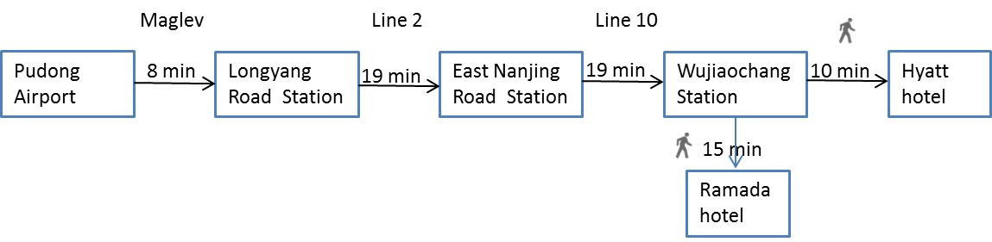
  - By Metro
This trip takes about 100 minutes and costs 15-20 RMB.
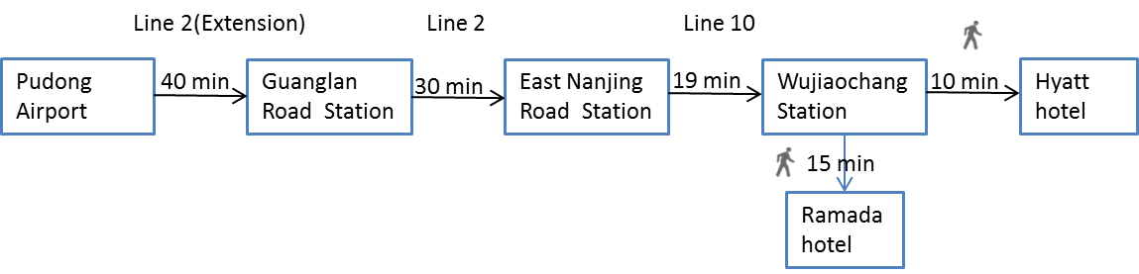
Note: If you take a taxi, for convenience, please show the following information in Chinese to the driver:
To Ramada Hotel:
我要去五角场华美达酒店
To Hyaat Hotel：
我要去五角场凯悦酒店

6.3 How to get to the meeting venue
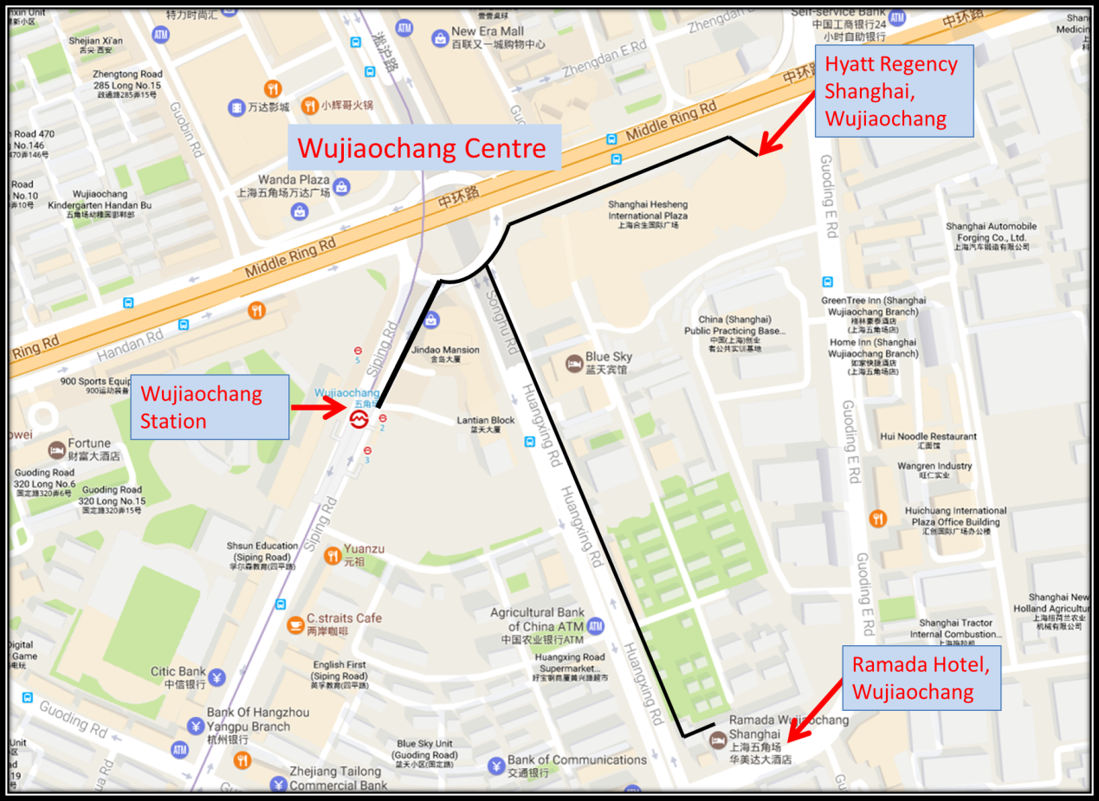

7. Social Events
- Shanghai Ocean University will be hosting a dinner reception during SSC PS meeting period. The date and venue will be announced in due course.
- The Bureau of Fisheries, Ministry of Agriculture of China will be hosting a dinner reception during SC meeting period. The date and venue will be announced in due course.

8. Others
The electricity in China is generally 220V, 50HZ. Most devices with their own transformers can be directly used, such as laptops, camera chargers and apple products. The sockets are shown at the pictures below:
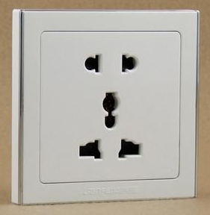 or 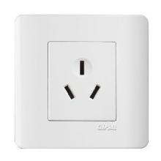
A portable plug adaptor may be necessary to use your electronic devices.

9. Meeting Registration
Participants will be able to register and pick up their information package from 8:30 to 9:00 on the first day of each meeting. If this registration time is not convenient for you, please ask the Secretariat staff in the meeting room for your registration.

If you have any questions regarding visas, please do not hesitate to contact:
Mr. Lianyong FANG
E-mail: admin1@tuna.org.cn
Tel: +86-10-65853488

If you have any questions regarding meeting preparations, please do not hesitate to contact:
Dr. Aleksandr ZAVOLOKIN
E-mail: azavolokin@npfc.int
Tel: +81-3-5479-8717

Attachment 1
The Bureau of Fisheries, Ministry of Agriculture of China is willing to prepare an Invitation Letter for your visa application to attend the NPFC Meetings in Shanghai, CHINA.
Please provide a list which includes the following information for each participant.

EXAMPLE

First Name: Chuanxiang
Last Name: HUA
Gender(F/M): M
Passport Number: PEXXXXX
Date of Birth: March 12, 1982
Job Title: Assistant Director
Agency/Organization: Shanghai Ocean University
Period of Stay in CHINA：April 16-Aril 28, 2017
Full Contact Address: 999 Huchenghuan Road, Shanghai, 201306 China
Email Address: cxhua@shou.edu.cn
Telephone: +86-21-61900304
Fax: +86-21-61900304

First Name:
Last Name:
Gender(F/M):
Passport Number:
Date of Birth:
Job Title:
Agency/Organization:
Period of Stay in CHINA：
Full Contact Address:
Email Address:
Telephone:
Fax:

Attachment 2

HOTEL RESERVATION FORM

RAMADA HOTEL

Please complete this form and send it to Mr. Chuanxiang HUA (cxhua@shou.edu.cn) by March 16th. Special room rate will be decided by 10th April. Breakfast is included.

First Name
Family Name
Mr / Ms
Passport No.
Address
Email
Check in Date
Check out Date
*Room Type (see below)
Occupancy | ☐ Single ☐ Double
Request for Smoking Room | ☐ Non Smoking ☐ Smoking
*Note: You can access the hotel website to select the room type.
The hotel possesses 383 refined guest rooms, luxurious facilities, simple and elegant layout to provide you with a comfortable, private relaxed environment. The unique self-catering kitchen design in some suites will bring you the feeling in your home.

Standard Queen Room 88Rooms
Standard Twin Room 102Rooms
Deluxe Queen Room 64Rooms
Deluxe Twin Room 32Rooms
Superior Queen Room 32Rooms
Handicapped Room 1Room

