NPFC-2017-TWG CMSA01-MIP01

**DETAILS FOR THE MEETINGS OF THE TECHNICAL WORKING GROUP ON CHUB MACKEREL STOCK ASSESSMENT AND**

**TECHNICAL WORKING GROUP ON PACIFIC SAURY STOCK ASSESSMENT**

**4-8 December 2017**

**Vladivostok, Russia**

This is general information to assist you in your travels to the meetings. This information package includes:

* Dates
* Venue of Meetings
* Meeting Contact Documentation
* Visa Information
* Accommodation Guide
* Airport Information and Transport to the Meeting Venue
* Map
* Meeting Registration
* Social Events
* Other Information

## DATES

The meetings commence on 4 December 2017 and carry on through to 8 December 2017 as follows:

* 1st Meeting of the Technical Working Group on Chub Mackerel Stock Assessment (TWG CMSA), 4-5 December 2017
* 2nd Meeting of the Technical Working Group on Pacific Saury Stock Assessment (TWG PSSA), 6-8 December 2017

## VENUE OF MEETINGS

The meetings will be held at the **HOTEL HYUNDAI**:

29 Semyonovskaya st., Vladivostok, Russia; Tel: +7-423-240-72-01;

<http://www.hotelhyundai.ru/en/>

Conference room: Emerald room, 3rd floor

Secretariat room: Room #301, 3rd floor

## MEETING CONTACT DOCUMENTATION

Online registration service for participants is on the NPFC website [www.npfc.int](http://www.npfc.int).

Please register for participation in the meetings through the web by **November 27th, 2017**.

## VISA INFORMATION

An invitation letter which includes your *invitation* *number* is essential for participants to apply for a Russian visa. Each delegation is kindly requested to provide information in the form of **Attachment 1**, together with scanned copies (not photo) of participants’ passport (page with photo), to Ms. Anna Skvortsova ([anna.skvortsova@tinro-center.ru](mailto:anna.skvortsova@tinro-center.ru)) **as soon as possible, but not later than by November 1st**.

Alternatively, participants from China and Japan can get an electronic visa to visit Vladivostok. To apply for the e-visa, fill in an application form on the website <http://electronic-visa.kdmid.ru/index_en.html>. The detailed description of the e-visa including conditions and restrictions is published on the website. The key points are:

* e-visa is free;
* it can be obtained online;
* no need any invitation letters or confirmations of hotel reservation and air tickets;
* the **permitted stay** in the Russian Federation with an e-visa is **up to 8 days** starting from the date of entry;
* you can fill in an **application form** for an e-visa on this website **not earlier than 20 days and no later than 4 days** before the intended date of entry into the Russian Federation;
* you should enter and leave the territory of the Russian Federation only through checkpoints which currently are Vladivostok international airport and Vladivostok maritime port;
* you are required to have a medical insurance valid in the Russian Federation's territory for the entire period of stay.

For more details, please go to the website <https://evisa.kdmid.ru/en-US/Home/Instruction>

## ACCOMMODATION

Each participant is responsible for making his or her own hotel arrangement. There are many hotels in Vladivostok’s downtown where the meeting venue is located. Recommended hotels are listed in the table below:

|  |  |  |
| --- | --- | --- |
| **Hotel Name** | **Location** | **Reservation** |
| Hyundai | Meeting venue | Address: 29 Semyonovskaya st., Vladivostok,  Tel: +7-423-240-72-01;  <http://www.hotelhyundai.ru/en/>  *The hotel provides a discount for NPFC meeting participants. Discounted price for a suite is 7,000RUB and valid for reservation until 15 October. If you wish to stay in the Hyundai Hotel please submit your reservation form (Attachment 2) to Ms. Anna Skvortsova (anna.skvortsova@tinro-center.ru) and Dr. Aleksandr Zavolokin (azavolokin@npfc.int) by 15 October.* |
| Sibirskoe Podvorie | 5-10 min walk to the venue | Address: 26 Okeanskiy Prospekt, Vladivostok  Tel: +7-423-222-52-66  <http://otelsp.com/en/> |
| Versailles | 10-15 min walk to the venue | Address: 10 Svetlanskaya St., Vladivostok  Tel: +7-423-226-42-01  <http://hotel-versailles.ru/main.html> |
| Arbat |  | Address: 4, Pogranichnya Street, Vladivostok  Tel: +7-423-262-11-11  <http://www.arbat-vl.ru/index.php?id=8> |

**AIRPORT INFORMATION AND TRANSPORT TO THE MEETING VENUE**

The meeting venue is located approximately 50 km from the Vladivostok International Airport. The following public transport is available between the airport and the meeting venue:

* + By taxi

The trip takes about 1 hour and costs about 1,500 RUB. The taxi dispatcher counter is located in the center of the airport’s terminal in front of the escalator. Visa and Mastercard are accepted to pay for this taxi.

* + By bus

The trip takes about 1.5-2 hours and costs about 200-300 RUB. Please take the bus #107 bound for Vladivostok railway station (VRS), change at VRS to the bus #7T and get off at Izumrud Station. Only cash is accepted to pay for the bus.

Bus schedule, airport -> Vladivostok: 08:25, 09:40, 10:45, 12:07, 13:00, 14:00, 15:50, 16:50, 17:45, 20:00. The schedule may be changed. For more information, visit <http://vvo.aero/en/passazhiram/transport/avtobusy.html>

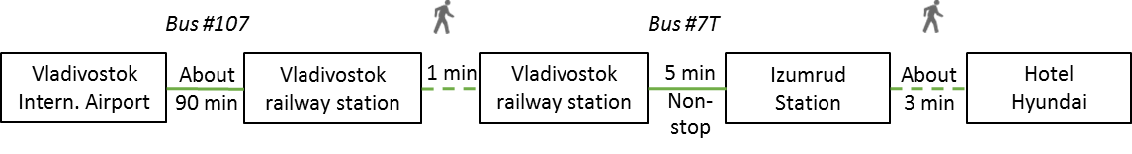

* + By express train

The trip takes about 70-80 min and costs 230RUB. Please take the train, change at Vladivostok railway station to the bus #7T and get off at Izumrud Station.

Train schedule, airport -> Vladivostok: 7:48, 8:32, 10:45, 13:15, 17:40. For more information, visit <http://vvo.aero/en/passazhiram/transport/aeroexpress.html>

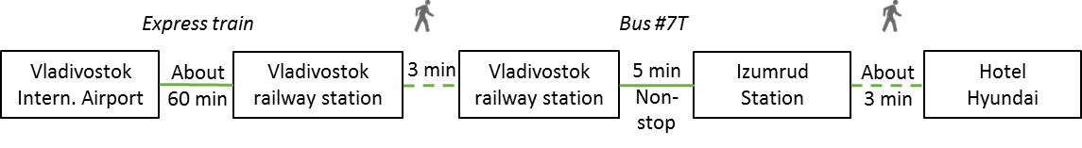

**MAP**



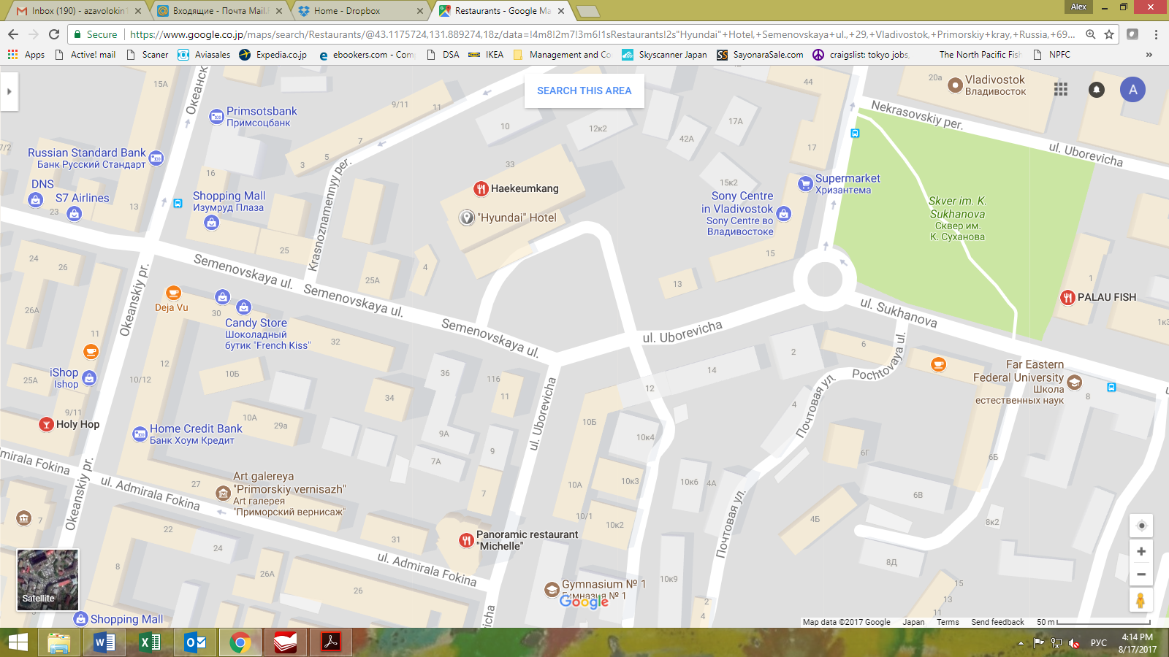

**MEETING REGISTRATION**

Participants will be able to register and pick up their information package from 8:30 to 9:00 on the first days of the meetings. If this registration time is not convenient for you, please ask the Secretariat staff in the meeting room for your registration.

## SOCIAL EVENTS

*Participants are invited to a reception which will be held in the restaurant “Rendezvous” located on the lobby level on* ***December 5th*** *at* ***6.30pm****.*

**OTHER INFORMATION**

**WiFi**

SSID: Hyundai_wifi

Password: no need

**Electricity**

The voltage in Russia is 220 Volt. Russian electrical plugs have two, non-polarized pins. Primary socket types are Europlug and Schuko. A portable plug adaptor may be necessary to use your electronic devices.

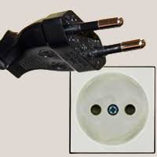

**EMERGENCY INFORMATION**

*Fire 101*

*Police 102*

*Ambulance 103*

******************************************************************************

If you have any questions regarding visas, please do not hesitate to contact:

Dr. Oleg Katugin

E-mail: [oleg.katugin@tinro-center.ru](mailto:oleg.katugin@tinro-center.ru)

Tel: +7-423-23-00-752

If you have any questions regarding meeting preparations, please do not hesitate to contact:

Dr. Aleksandr Zavolokin

E-mail: [azavolokin@npfc.int](mailto:azavolokin@npfc.int)

Tel: +81-3-5479-8717

**Attachment 1**

FORM FOR VISA SUPPORT

|  |  |
| --- | --- |
| **A FULL NAME**  **(SURNAME, GIVEN NAME)** |  |
| **NATIONALITY**  **(CITIZENSHIP)** |  |
| **DAY, MONTH, YEAR OF BIRTH** |  |
| **PLACE OF BIRTH**  (Please, precisely state the name of the certain town, city or village) |  |
| **1. NAME OF ORGANIZATION**  **2. DIVISION**  **3. POSITION** |  |
| **ADDRESS OF ORGANIZATION**  (Postal Code, Country, City, Address) |  |
| **TELEPHONE, FAX** |  |
| **E-MAIL** |  |
| **THE CONSULAR DISTRICT**  (name of the city (in your country) with the embassy/consulate where you will apply for your visa) |  |
| **INTENDED PERIOD OF STAY**  (Dates of arrival and departure*) |  |
| **INTENDED CITIES FOR VISITING**  **IN RUSSIA** |  |

* Please, note your travel dates (including ARRIVAL and DEPARTURE dates) for the application form and dates indicated in visa application must MATCH exactly

**Attachment 2**

**HOTEL RESERVATION FORM**

**HYUNDAI HOTEL**

Please complete this form and send it to Ms. Anna Skvortsova (anna.skvortsova@tinro-center.ru) **and** Dr. Aleksandr Zavolokin (azavolokin@npfc.int) **by October 15th**.

**SPECIAL RATE**

|  |  |  |
| --- | --- | --- |
| Date | Discounted rate  (per night, single use) | Remarks |
| 2017.12.03 – 2017.12.09 | 7,000 RUB  (tax included) | Breakfast included;  Standard room, non-smoking, queen-size bed;  Check-in 13:00PM / Check-out 12:00AM |

**GUEST INFORMATION**

|  |  |
| --- | --- |
| First Name |  |
| Family Name |  |
| Mr / Ms |  |
| Address |  |
| Email |  |

|  |  |  |  |
| --- | --- | --- | --- |
| Check in Date |  | Check out Date |  |

|  |  |  |  |
| --- | --- | --- | --- |
| Card Type |  | Card Holder’s Name |  |
| Card No. |  | | |

*Credit will not be charged for your advance deposit. However, card will be charged for late cancelation and no-show.

CANCELLATION POLICY

Reservation canceled less than six days prior to your reserved arrival date will be charged as follows:

Five days in advance: 50% of FULL room rate without discount (11,500RUB)

Less than 2 days in advance and no show: 100% of FULL room rate without discount (11,500RUB)