NPFC-2018-SC03-MIP01 (Rev. 2)

**DETAILS FOR THE MEETINGS OF THE SCIENTIFIC COMMITTEE AND SMALL SCIENTIFIC COMMITTEES**

**9-20 April 2018**

**Tokyo, Japan**

This is general information to assist you in your travels to the meetings. This information package includes:

* Dates
* Venue of the Meetings
* Meeting Contact Documentation
* Visa Information
* Accommodation
* Airport Information and Transport to the Recommended Hotels
* Map
* Meeting Registration
* Social Events
* Other Information

## DATES:

## The meetings commence on 9 April 2018 and carry on through to 20 April 2018 as follows:

## 3rd SSC on Vulnerable Marine Ecosystems, 9-10 April

## 1st SSC on Bottom Fish, 11-12 April

## 3rd SSC on Pacific Saury, 13, 14, 16 April

## 3rd Scientific Committee, 17-20 April

## VENUE OF THE MEETINGS

The meetings will be held at the Tokyo University of Marine Science and Technology:

Hakuyo Hall, Tokyo University of Marine Science and Technology, Shinagawa Campus,

4-5-7 Konan, Minato-ku, Tokyo.

<https://www.kaiyodai.ac.jp/english/>

Conference room: Multipurpose Conference room, 2nd floor

Secretariat room: NPFC Secretariat, 2nd floor.

## MEETING CONTACT DOCUMENTATION

Online registration service for participants is on the NPFC website [www.npfc.int](http://www.npfc.int). Please log in to be able to register. The deadline for registration is **April 1, 2018**.

## VISA INFORMATION

An official invitation letter is essential for participants to apply for a Japanese visa. Each delegation who applies for a Japanese visa is requested to provide information in the form of Attachment 1 **by March 09, 2018** to Mr. Ryotaro Okazaki ([ryotaro_okazaki770@maff.go.jp](mailto:ryotaro_okazaki770@maff.go.jp)).

## ACCOMMODATION

Each participant is responsible for making his or her own hotel arrangements. There are several hotels near Shinagawa station. Recommended hotels are listed in the table below:

|  |  |  |
| --- | --- | --- |
| **Hotel Name** | **Transportation** | **Reservation** |
| Shinagawa Prince Hotel | 15 minute walk to the meeting venue | 10-30 Takanawa 4-chome, Minato-ku Tokyo, 108-8611 Japan  <http://www.princehotels.com/shinagawa/> |
| Keikyu EX Inn Shinagawa-Ekimae | 15 minute walk to the meeting venue | 3-13-3 Takanawa, Minato-ku Tokyo, 108-0074  <http://www.keikyu-exinn.co.jp/hotel/shinagawa/en/index.html> |
| Keikyu EX Inn Takanawa | 15 minute walk to the meeting venue | 4-10-8 Takanawa, Minato-ku Tokyo, 108-0074  <http://www.keikyu-exinn.co.jp/hotel/takanawa/languages/en.html> |
| Toyoko Inn  Tokyo Shinagawa-eki Konan-guchi Tennozu | 10 minute walk to the meeting venue | 2-2-35, Higasi-shinagawa Shinagawa-ku, Tokyo, 140-0002  <https://www.toyoko-inn.com/index.php/eng/search/detail/00244.html> |

**AIRPORT INFORMATION AND TRANSPORT TO THE RECOMMENDED HOTELS**

The venue of the meetings, *Tokyo University of Marine Science and Technology*, is located near Shinagawa station in Tokyo. The first three recommended hotels are situated close to the station.

1. ***From Haneda International Airport to Shinagawa Station, Tokyo*** (recommended airport for easy access to the meeting venue)
   * By Train

The trip takes about 15-20 minutes and costs about 500 JPY. Please travel to Shinagawa Station by Keikyu Line. The recommended hotels (*Shinagawa Prince Hotel, Keikyu EX Inn Shinagawa-Ekimae and Keikyu EX Inn Takanawa*) are within walking distance (1-5 min).

If you stay in *Toyoko Inn Tokyo Shinagawa-eki Konan-guchi Tennozu*, please take Tokyo Monorail train. The trip takes about 15 minutes and costs 340 JPY.

* + By Limousine Bus

The trip takes about 25-60 minutes and costs 720 JPY. For timetable and more information on the Limousine Bus, please visit

<https://www.limousinebus.co.jp/en/bus_services/haneda/shinagawa.html>

* + By taxi

The trip takes about 25-50 minutes and costs about 5,000 JPY.

1. ***From Narita International Airport to Shinagawa Station, Tokyo***
   * By Train

The trip takes about 1 hour and costs about 3,000 JPY by Narita Express (N’EX). The recommended hotels (*Shinagawa Prince Hotel, Keikyu EX Inn Shinagawa-Ekimae and Keikyu EX Inn Takanawa*) are within walking distance (1-5 min). For timetable and more information, please visit: N’EX <http://www.jreast.co.jp/e/nex/index.html>

Alternatively, you can take Narita Skyaccess. The trip takes about 1 and a half hours and costs about 1,500 JPY.

* + By Limousine Bus

The trip takes about 90-105 minutes and costs 3,100 JPY. For timetable and more information on the Limousine Bus, please visit

<https://www.limousinebus.co.jp/en/platform_searches/index/1/38>

**MAP**

Location of the meeting venue, recommended hotels (●) and receptions ( )

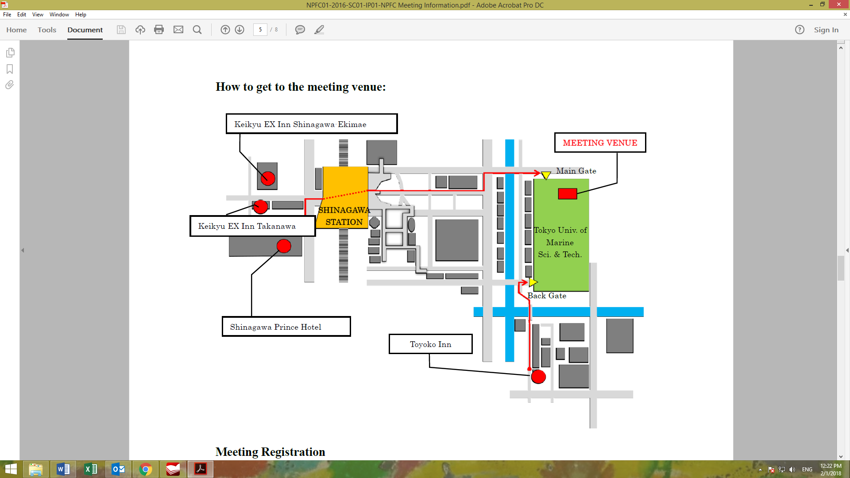

**Landmark Square**

**Tsubame Grill**

**MEETING REGISTRATION**

Participants will be able to register and pick up their information package from 8:30 to 9:00 on the first day of each meeting. If this registration time is not convenient for you, please ask the Secretariat staff in the meeting room for your registration.

**SOCIAL EVENTS**

*There will be two receptions organized by the host Member and the Commission:*

*10 April, 6:30-9:00pm – Tsubame Grill* [*https://goo.gl/maps/18JJsvPX1a32*](https://goo.gl/maps/18JJsvPX1a32)

*17 April, 6:30-8:30pm – The Landmark Square*

[*https://www.landmark-tokyo.com/banquet/facility.html*](https://www.landmark-tokyo.com/banquet/facility.html)

***All meeting participants are welcome!***

**OTHER INFORMATION**

**WiFi**

SSID: NPFC2018

Password: 20Tokyo18

**Electricity**

The voltage in Japan is 110 Volt. Japanese electrical plugs have two, non-polarized pins the fit into North American outlets, as shown on the picture. A portable plug adaptor may be necessary to use your electronic devices.

**EMERGENCY INFORMATION**

*Police* Emergency call – 110

*Fire, Ambulance or* Emergency call – 119

*Emergency Rescue*

******************************************************************************

If you have any questions regarding visas, please do not hesitate to contact:

Mr. Ryotaro Okazaki

E-mail: [ryotaro_okazaki770@maff.go.jp](mailto:ryotaro_okazaki770@maff.go.jp)

Tel: +81-03-3591-1086

If you have any questions regarding meeting preparations, please do not hesitate to contact:

Dr. Aleksandr Zavolokin

E-mail: [azavolokin@npfc.int](mailto:azavolokin@npfc.int)

Tel: +81-3-5479-8717

**Attachment 1**

Fisheries Agency of Japan is willing to prepare an Invitation Letter for your visa application to attend the meetings which will be held in Tokyo, JAPAN.

Please fill in the required information on the invitee as follows:

EXAMPLE

First Name: Kengo

Last Name: TANAKA

Sex (F/M): M

Organization: Fisheries Agency,

Title: Senior Fisheries Negotiator, Fisheries Agency

Passport Number: YYYY

Date of Birth: August 8, 1962

Date of Issue: March 06 2012

Date of Expiry: March 06 2022

Passport Issuing Authority: Ministry of Foreign Affairs, Japan

Period of Stay in JAPAN: January 20 – January 22, 2015

Place of Applying for visas: Embassy of JAPAN in Moscow, Russia

Arrival Airport: Narita International Airport

Departure Airport: Narita International Airport

Hotel Name: Shinagawa Prince Hotel

First Name:

Last Name:

Sex (F/M):

Organization:

Title:

Passport Number:

Date of Birth:

Date of Issue:

Date of Expiry:

Passport Issuing Authority:

Period of Stay in JAPAN:

Place of Applying for visas:

Arrival Airport:

Departure Airport:

Hotel Name: