NPFC-2019-TWG CMSA02-MIP01 (Rev. 2)

**DETAILS FOR THE TWG CMSA MEETING, BRP/HCR/MSE WORKSHOP AND TWG PSSA MEETING**

**27 February – 9 March 2019**

**Yokohama, Japan**

This is general information to assist you in your travels to the meetings. This information package includes:

* Dates
* Venue of Meetings
* Meeting Contact Documentation
* Visa Information
* Accommodation
* Airport Information and Transport to the Recommended Hotels
* Map
* Meeting Registration
* Social Events
* Other Information

## DATES

## The meetings commence on 27 February 2019 and carry on through to 9 March 2019 as follows:

## 2nd meeting of the Technical Working Group on Chub Mackerel Stock Assessment (TWG CMSA):

## Informal meeting of Small Working Group on Operating Model for CMSA, *27 February*

## Plenary of TWG CMSA, *28 February – 2 March*

## Biological Reference Point/Harvest Control Rule/Management Strategy Evaluation Workshop (BRP/HCR/MSE WS), *4-5 March*

## 4th meeting of the Technical Working Group on Pacific Saury Stock Assessment (TWG PSSA), *6-9 March*.

## VENUE OF MEETINGS

The meetings shall be held at *MM Park Building* in Yokohama:

5th Floor, TKP Garden City Premium Minato Mirai,

3-6-3, Minatomirai, Nishi-ku, Yokohama-shi, Kanagawa-ken 220-0012;

Tel: +81-45-650-6701;

Website: <https://www.kashikaigishitsu.net/facilitys/gcp-minatomirai/>

Meeting and Secretariat room: 5th Floor, Room G.

## MEETING CONTACT DOCUMENTATION

Online registration service for participants is on the NPFC website [www.npfc.int](http://www.npfc.int). Please log in to be able to register. The deadline for registration is **February 20, 2019**.

## VISA INFORMATION

An official invitation letter is essential for participants to apply for a Japanese visa. Please check in advance if you need a Japanese visa for your trip. Each delegation who applies for a Japanese visa is requested to provide information in the form of Attachment 1 **by January 28, 2019** to Mr. Ryotaro Okazaki ([ryotaro_okazaki770@maff.go.jp](mailto:ryotaro_okazaki770@maff.go.jp)).

## ACCOMMODATION

Each participant is responsible for making his or her own hotel arrangements. There are many hotels in central Yokohama. Recommended hotels are listed in the table below:

|  |  |  |
| --- | --- | --- |
| **Hotel Name** | **Transportation** | **Reservation** |
| New Otani Inn Yokohama Premium | 15-minute walk to the meeting venue. | 15,000+ JPY yen/night  1-1-7 Sakuragi-cho, Naka-ku, Yokohama City, Kanagawa Prefecture 231-8331  <http://www.newotani.co.jp/innyokohama/index.html> |
| Hotel Vista Premio Yokohama Minato-Mirai | 10-minute walk to the meeting venue. | 11,000+ JPY/night  6-3-4 Minatomirai, Nishi-ku, Yokohama City, Kanagawa Prefecture 220-0012  <https://www.hotel-vista.jp/yokohama-minato-mirai/index_e.html> |
| Washington Hotel Yokohama Sakuragicho | 15-minute walk to the meeting venue. | 13,000+ JPY/night  1-101-1 Sakuragi-cho, Naka-ku, Yokohama City, Kanagawa Prefecture 231-0062  <http://yokohama-s.washington-hotels.jp/> |

**AIRPORT INFORMATION AND TRANSPORT TO THE RECOMMENDED HOTELS**

The venue of the meetings, *MM Park Building*, is located near Minatomirai Station on the Minatomirai Line in Yokohama. Two of the recommended hotels, New Otani Inn and Washington, are situated close to Sakuragicho Stationon the JR Negishi Line. The hotel Vista Premio Yokohama Minato-Mirai is within 5-10-minute walk from Minatomirai Station.

1. ***From Haneda International Airport to hotels in Sakuragicho, Yokohama*** (recommended airport for easy access to the meeting venue)
   * By Train

The trip takes about 30 minutes and costs about 600 JPY. Please travel to Yokohama Station by Keikyu Line. Then change to Negishi Line and get off at the next station, Sakuragicho. The recommended hotels (New Otani Inn and Washington) are within walking distance (1-3 min).

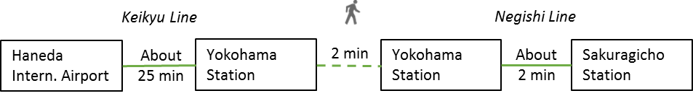

* + By Limousine Bus and Taxi

The trip takes about 40 minutes and costs 2,000-2,500 JPY. Please take the Limousine Bus bound for Yokohama City Air Terminal (YCAT). Then take a taxi to hotels in Sakuragicho area (New Otani Inn and Washington). For timetable and more information on the Limousine Bus, please visit <http://www.ycat.co.jp/en/>

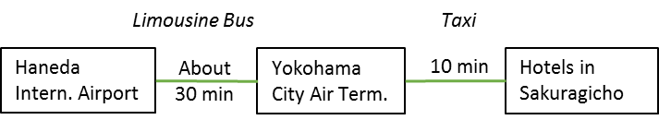

1. ***From Narita International Airport to hotels in Sakuragicho, Yokohama***
   * By Train

The trip takes about 90 minutes and costs about 4,000-4,500 JPY. Please travel to Yokohama by JR Narita Express (N’EX). Then change to Negishi Line and get off at the next station, Sakuragicho. The recommended hotels (New Otani Inn and Washington) are within walking distance (1-3 min). For timetable and more information, please visit: N’EX <http://www.jreast.co.jp/e/nex/index.html>

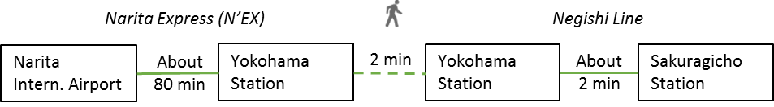

* + By Limousine Bus and Taxi

The trip takes about 2 hours and costs 5,000-6,000 JPY. Please take the Limousine Bus bound for Yokohama City Air Terminal (YCAT). Then take a taxi to hotels in Sakuragicho area (New Otani Inn and Washington). For timetable and more information on the Limousine Bus, please visit <http://www.ycat.co.jp/en/>

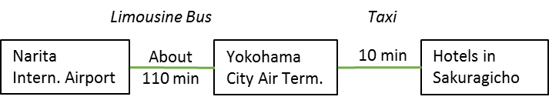

**MAP**

Meeting venue and recommended hotels in Sakuragicho and Minatomirai areas

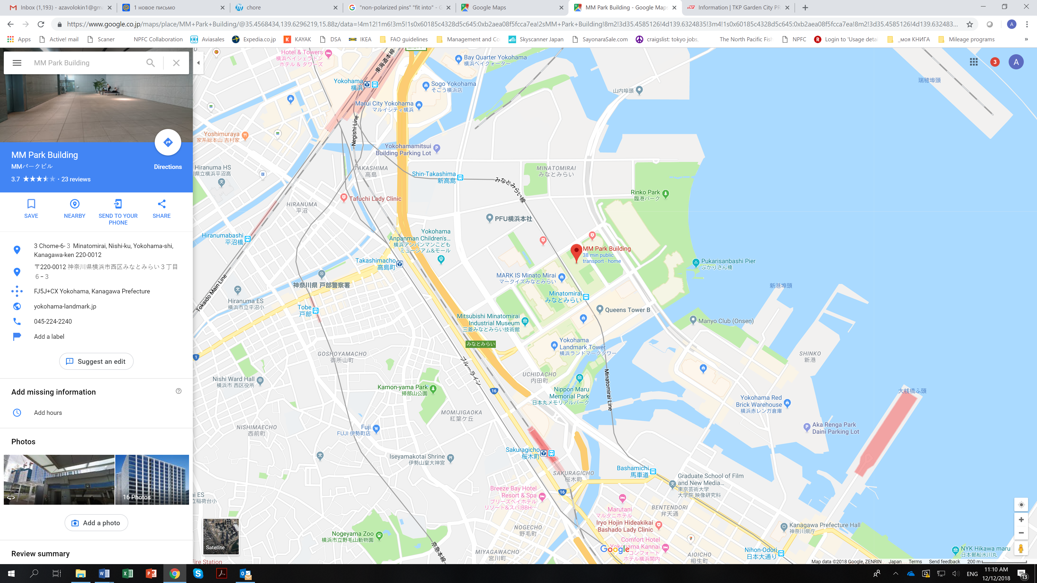

**Restaurant Musee**

**Meeting venue**

**Hotel Vista Premio**

**Washington Hotel**

**New Otani Inn**

**MEETING REGISTRATION**

Participants will be able to register and pick up their information package from 8:30 to 9:00 on the first day of each meeting. If this registration time is not convenient for you, please ask the Secretariat staff in the meeting room for your registration.

**SOCIAL EVENTS**

*Participants are invited to a reception which will be held in the* ***Restaurant Musée*** *(*[*www.musee-ts.com*](http://www.musee-ts.com)*) on* ***March 6*** *at* ***6:30-9:00pm.***

**OTHER INFORMATION**

**WiFi**

SSID: NPFC2019

Password: 20Yokohama19

**Electricity**

The voltage in Japan is 110 Volt. Japanese electrical plugs have two, non-polarized pins which fit into North American outlets, as shown on the picture. A portable plug adaptor may be necessary to use your electronic devices.

**EMERGENCY INFORMATION**

*Police* Emergency call – 110

*Fire, Ambulance or* Emergency call – 119

*Emergency Rescue*

******************************************************************************

If you have any questions regarding visas, please do not hesitate to contact:

Mr. Ryotaro Okazaki

E-mail: [ryotaro_okazaki770@maff.go.jp](mailto:ryotaro_okazaki770@maff.go.jp)

Tel: +81-03-3591-1086

If you have any questions regarding meeting preparations, please do not hesitate to contact:

Dr. Aleksandr Zavolokin

E-mail: [azavolokin@npfc.int](mailto:azavolokin@npfc.int)

Tel: +81-3-5479-8717

**Attachment 1**

Fisheries Agency of Japan is willing to prepare an Invitation Letter for your visa application to attend the scientific meetings which will be held in Yokohama, Japan.

Please fill in the required information on the invitee as follows:

EXAMPLE

First Name: Kengo

Last Name: TANAKA

Sex (F/M): M

Organization: Fisheries Agency,

Title: Senior Fisheries Negotiator, Fisheries Agency

Passport Number: YYYY

Date of Birth: August 8, 1962

Date of Issue: March 06 2012

Date of Expiry: March 06 2022

Passport Issuing Authority: Ministry of Foreign Affairs, Japan

Period of Stay in JAPAN: January 20 – January 22, 2015

Place of Applying for visas: Embassy of JAPAN in Moscow, Russia

Arrival Airport: Narita International Airport

Departure Airport: Narita International Airport

Hotel Name: Shinagawa Prince Hotel

First Name:

Last Name:

Sex (F/M):

Organization:

Title:

Passport Number:

Date of Birth:

Date of Issue:

Date of Expiry:

Passport Issuing Authority:

Period of Stay in JAPAN:

Place of Applying for visas:

Arrival Airport:

Departure Airport:

Hotel Name: