NPFC-2019-SSC PS05-MIP01

**DETAILS FOR THE 5th MEETING OF THE SMALL SCIENTIFIC COMMITTEE ON PACIFIC SAURY**

**13-16 November 2019**

**Shimonoseki, Japan**

This is general information to assist you in your travels to the meeting. This information package includes:

* Dates
* Venue of the Meeting
* Meeting Contact Documentation
* Visa Information
* Accommodation
* Airport Information and Transport to the Recommended Hotels
* Map
* Meeting Registration
* Social Events
* Other Information

## DATES

## 13-16 November 2019.

## VENUE OF THE MEETING

The meeting will be held at *Kaikyo Messe* in Shimonoseki:

3 Chome-3-1 Buzendacho, Shimonoseki, Yamaguchi, Japan 750-0018;

Tel: +81-83-231-5600;

Website: <http://www.kaikyomesse.jp/>

Meeting room: 9 Floor, Kaikyo Hall.

Secretariat room: 9 Floor, Conference Room 901.

## MEETING CONTACT DOCUMENTATION

Online registration service for participants is on the NPFC website [www.npfc.int](http://www.npfc.int). Please log in to be able to register. The deadline for registration is **November 6, 2019**.

## VISA INFORMATION

An official invitation letter is essential for participants to apply for a Japanese visa. Please check in advance if you need a Japanese visa for your trip. Each delegation who applies for a Japanese visa is requested to provide information in the form of Attachment 1 **by October 13, 2019** to Mr. Ryotaro Okazaki ([ryotaro_okazaki770@maff.go.jp](mailto:ryotaro_okazaki770@maff.go.jp)). Please note that applicants who belong to the same organization or institute are encouraged to provide compiled information in one file.

## ACCOMMODATION

Each participant is responsible for making his or her own hotel arrangements. Recommended hotels are listed in the table below:

|  |  |  |
| --- | --- | --- |
| **Hotel Name** | **Transportation** | **Reservation** |
| Plaza Hotel Shimonoseki | 10-15 minute walk to the meeting venue | 6,000+ JPY/night (including breakfast)  11-10 Hananochō, Shimonoseki, Yamaguchi, Japan 750-0014  Tel: +81-83-223-3333  <http://www.plazahotel.co.jp/>  *35 rooms have been blocked for meeting participants. The deadline for reservation is* ***30 October 2019****. Please fill in the form (Attachment 2) and send it to Ms. Miyoko Mita* [*mmita@npfc.int*](mailto:mmita@npfc.int) *and Secretariat* [*Secretariat@npfc.int*](mailto:Secretariat@npfc.int) |
| Toyoko Inn | 5-10 minute walk to the meeting venue | 6,000+ JPY/night  2-chōme-7-10 Buzendachō, Shimonoseki, Yamaguchi, Japan 750-0018  Tel: +81-83-234-1045  <https://www.toyoko-inn.com/search/detail/00174/> |
| Dormy Inn Premium Shimonoseki | 5-10 minute walk to the meeting venue | 12,000+ JPY/night  3-40 Hosoeshinmachi, Shimonoseki, Yamaguchi, Japan 750-0017  Tel: +81-83-223-5489  <https://www.hotespa.net/hotels/shimonoseki/> |

**AIRPORT INFORMATION AND TRANSPORT TO THE RECOMMENDED HOTELS**

The recommended hotels are located within 10-20-minute walk from Shimonoseki Station. Options for transportation from Tokyo and overseas to Shimonoseki Station are listed below.

1. ***From Fukuoka International Airport***
   * By Bus through Tenjin

The trip takes about 3 hours and costs about 1,800 JPY. Please take a bus to the Nishitetsu Tenjin Expressway Bus Terminal. Then change to a bus to the Shimonoseki Station. The bus schedule and fare are attached (Attachment 3).

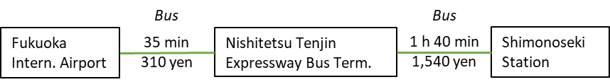

* + By Direct Bus to Shimonoseki

There is also a direct bus to the Shimonoseki Station, however it operates only three times per day. The trip takes about 2 h 20 min and costs about 1,500 JPY. The bus schedule and fare are attached (Attachment 3).

1. ***From Yamaguchi Ube Airport***
   * By Bus

The trip takes about 1 h 30 min and costs about 1,500 JPY. Please take a limousine bus from the airport to the Shimonoseki Station.

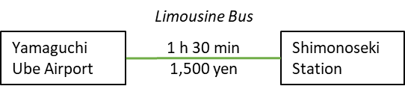

1. ***From Tokyo by Shinkansen***
   * By Shinkansen and Local Train

The trip takes about 5 h 30 min and costs about 20,000 JPY. Please take a Shinkansen train from Tokyo to the Kokura Station. Then change to Kagoshima/San-yo Line to the Shimonoseki Station.

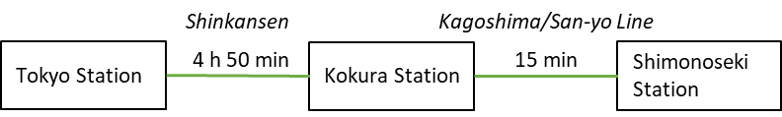

**MAP**

Meeting venue and recommended hotels

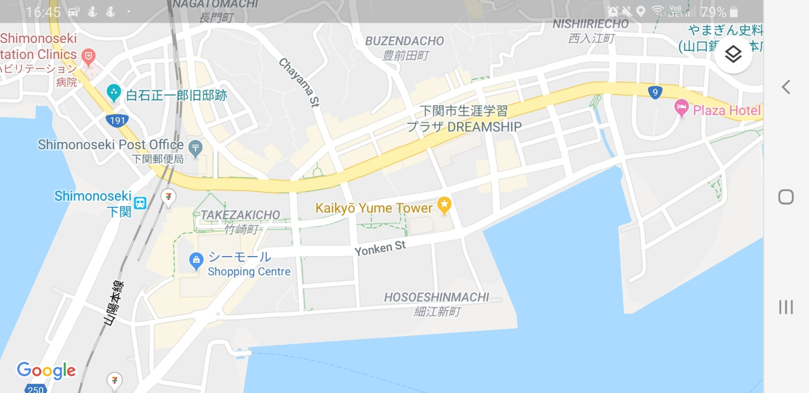

**Dormy Inn**

**Kaikyo Messe**

**Toyoko Inn**

**Restaurant Nagoya**

**Plaza Hotel**

**MEETING REGISTRATION**

Participants will be able to register and pick up their information package from 9:30 to 10:00 on the first day of the meeting. If this registration time is not convenient for you, please ask the Secretariat staff in the meeting room for your registration.

**SOCIAL EVENTS**

*Participants are invited to a reception which will be held in the* ***Nagoya restaurant*** *on* ***13******November*** *at* ***7:00-9:00pm.***

**OTHER INFORMATION**

**WiFi**

SSID: NPFC2019

Password: 20Shimonoseki19

**Electricity**

The voltage in Japan is 110 Volt. Japanese electrical plugs have two, non-polarized pins which fit into North American outlets, as shown on the picture. A portable plug adaptor may be necessary to use your electronic devices.

**EMERGENCY INFORMATION**

*Police* Emergency call – 110

*Fire, Ambulance or* Emergency call – 119

*Emergency Rescue*

******************************************************************************

If you have any questions regarding visa, please do not hesitate to contact:

Mr. Ryotaro Okazaki

E-mail: [ryotaro_okazaki770@maff.go.jp](mailto:ryotaro_okazaki770@maff.go.jp)

Tel: +81-03-3591-1086

If you have any questions regarding meeting preparations, please do not hesitate to contact:

Dr. Aleksandr Zavolokin

E-mail: [azavolokin@npfc.int](mailto:azavolokin@npfc.int)

Tel: +81-3-5479-8717

**Attachment 1**

Fisheries Agency of Japan is willing to prepare an Invitation Letter for your visa application to attend the scientific meeting which will be held in Shimonoseki, Japan.

Please fill in the required information on the invitee as follows:

EXAMPLE

First Name: Kengo

Last Name: TANAKA

Sex (F/M): M

Organization: Fisheries Agency,

Title: Senior Fisheries Negotiator, Fisheries Agency

Passport Number: YYYY

Date of Birth: August 8, 1962

Date of Issue: March 06 2012

Date of Expiry: March 06 2022

Passport Issuing Authority: Ministry of Foreign Affairs, Japan

Period of Stay in JAPAN: January 20 – January 22, 2015

Place of Applying for visas: Embassy of JAPAN in Moscow, Russia

Arrival Airport: Narita International Airport

Departure Airport: Narita International Airport

Hotel Name: Shinagawa Prince Hotel

First Name:

Last Name:

Sex (F/M):

Organization:

Title:

Passport Number:

Date of Birth:

Date of Issue:

Date of Expiry:

Passport Issuing Authority:

Period of Stay in JAPAN:

Place of Applying for visas:

Arrival Airport:

Departure Airport:

Hotel Name:

**Attachment 2**

Plaza Hotel Shimonoseki

**Room Reservation Form**

Please send the reservation form to Ms. Miyoko Mita [mmita@npfc.int](mailto:mmita@npfc.int) and the Secretariat [Secretariat@npfc.int](mailto:Secretariat@npfc.int) by **30 October 2019**.

|  |  |  |  |  |
| --- | --- | --- | --- | --- |
| **Name of Guest** |  | **Passport/Travel Document Number** |  | |
| **Check-in Date** |  | **Check-out Date** |  | |
| **Credit Card Number** |  | **Name of Credit Card Holder** |  | |
| **Type of Room** | **Rate per night** | | **No. of Guests** | **Smoking/**  **Non-smoking** |
| **Double** | 6,000+ JPY  (including breakfast and tax) | |  | Smoking  or  Non-smoking |
| **Twin** | 7,000+ JPY  (including breakfast and tax) | |  | Smoking  or  Non-smoking |
| **Payment Method** | The room charge shall be paid upon check-out by cash or credit card (Visa, MasterCard, UnionPay, JCB, American Express, Diners, PayPay) | | | |
| **Information** | 1. Check-in time is 14:00. The earlier check-in is subject to room availability. Check-out time is 11:00. | | | |
| 1. Cancellation policy:   Free cancellation until 2 days before check-in date;  20% of the room rate if cancelled on the day before check-in;  80% of the room rate if cancelled on the day of check-in;  100% for no-show. | | | |

**Attachment 3**

Bus schedule and fare from/to *Fukuoka International Airport* or *Nishitetsu Tenjin Expressway Bus Terminal* to/from Shimonoseki

