NPFC-2019-SSC PS05-WP08

**Update of biomass estimate through Japanese fishery independent survey for Pacific saury in 201****9**

Satoshi SUYAMA1, Hiroomi MIYAMOTO1, Miyako NAYA1, Taiki FUJI2, Midori HASHIMOTO2, Kazuhiro OSHIMA2 and Shin-ichiro NAKAYAMA3

1 *Tohoku National Fisheries Research Institute, Japan Fisheries Research and Education Agency*

2 *National Research Institute of Far Seas Fisheries, Japan Fisheries Research and Education Agency*

*3 National Research Institute of Fisheries Science, Japan Fisheries Research and Education Agency*

**Summary**

To estimate biomass of Pacific saury in the North Pacific, fishery independent surveys by Japanese scientific research vessels were conducted in 2019. The method to calculate the biomass was based on Kidokoro et al. (2018). Estimated biomass was 1,646 thousand metric tons which was about 70％ of that in 2018.

**1. Introduction**

Japan has been carrying out fishery independent surveys in June and July every year since 2003 using the sea surface trawl nets. We report the estimated biomass in 2019.

**2. Materials and methods**

The surveys in this year were conducted by Hokko Maru (902 tons) and Hokuho Maru (664 tons). Hokko Maru surveyed from 151 to 163 degrees E longitudes, and Hokuho Maru from 167 degree E to 165 degree W longitudes. The biomass was estimated following the method recommended by Kidokoro et al. (2018).

**3. Results**

There were apparent differences in distribution pattern of Pacific saury caught by the sampling gear between ages 0 and 1 (Fig. 1). Age 1 fish were caught in waters from 160 degree E to 170 degree W, whereas most of catch of age 0 fish distributed east of 175 degree W.

The total biomass was estimated at 1,646 thousand metric tons, which was the second lowest since 2003 (Table 1). The biomass, however, was about 70％ of that in 2018, which was the historical lowest. As a whole, the estimated biomass showed continuous decreasing trend from 2003 to 2019 (Fig. 2).

**Reference**

Kidokoro H, Suyama S, Fuji T, Miyamoto H, Naya M, Vijay D (2018) Pacific saury biomass estimated using fishery independent surveys by Japan with special consideration to uncertainties among stratification designs. NPFC-2018-SSC PS03-WP06.

Table 1 Annual biomass estimated for 2003 – 2019.



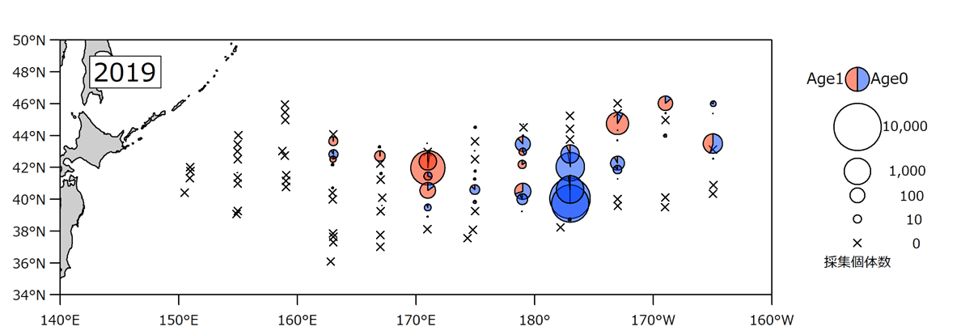

N. individuals

Fig. 1 Number of individuals collected, and sampling stations conducted by fishery independent surveys by Japanese scientific research vessels in 2019.

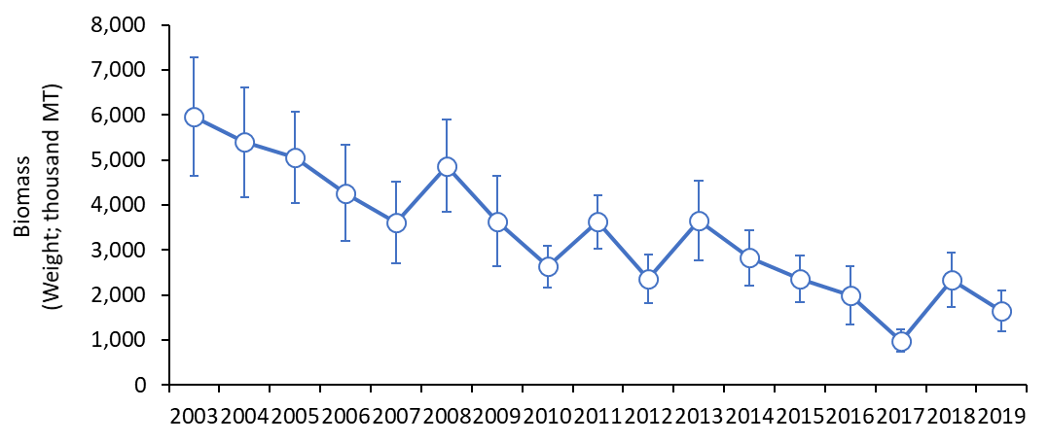

Fig. 2 Annual estimated biomass in weight from 2003 to 2019. Vertical bars indicate standard errors.