NPFC-2020-SSC BFME01-IP05

Overview of NOAA’s Deep Sea Coral database (https://deepseacoraldata.noaa.gov/)

NOAA’s Deep Sea Coral Research and Technology Program (DSCRTP) has created a spatial database for coral and sponge records world-wide. The database is housed at the Deep-Sea Coral Data Portal (Figure 1) and includes records of corals and sponges, model outputs, and photos.

The database can be queried using a variety of taxonomic search terms (Figure 2). Queries can also be spatially delimited (confined to certain regions, such as the North Pacific). The output can include web-based pictures, metadata and the locations by species. As an example, a simple query of Alcyonacea yielded >280K records from the North Pacific including both Gorgonian corals and soft corals (primarily gersemia; Figure 3).

The database itself has a formalized procedure for uptake of new data and QA/QC standards. The fields contained in the database are shown in Table 1 for reference, however a full description of the database can be found in McGuinn et al. (2020).

During the intersessional period, the Chair (C. Rooper) contacted Dr. Tom Hourigan (DSCRTP lead scientist). He provided information and links to the database, as well as the power point slides that will be presented at the November SSC BFME meeting. He was supportive of Members of the NPFC to work with the DSCRTP to submit VME data to the website, if this was deemed appropriate by Members. The DSCRTP has worked with SPRFMO to incorporate their records into the database and they hope to include global deep-sea coral and sponge records in future versions of the database.

Citations
McGuinn, RP, TF Hourigan, SL Cross, LM Dornback, PJ Etnoyer, DE Sallis, and HM Coleman. 2020. NOAA’s National Database for Deep-Sea Corals and Sponges: 2020 Status Update. NOAA Tech. Memo. NMFS-OHC-007. 56 p. LINK

Figure 1. Entry webpage to NOAA’s Deep Sea Data Portal

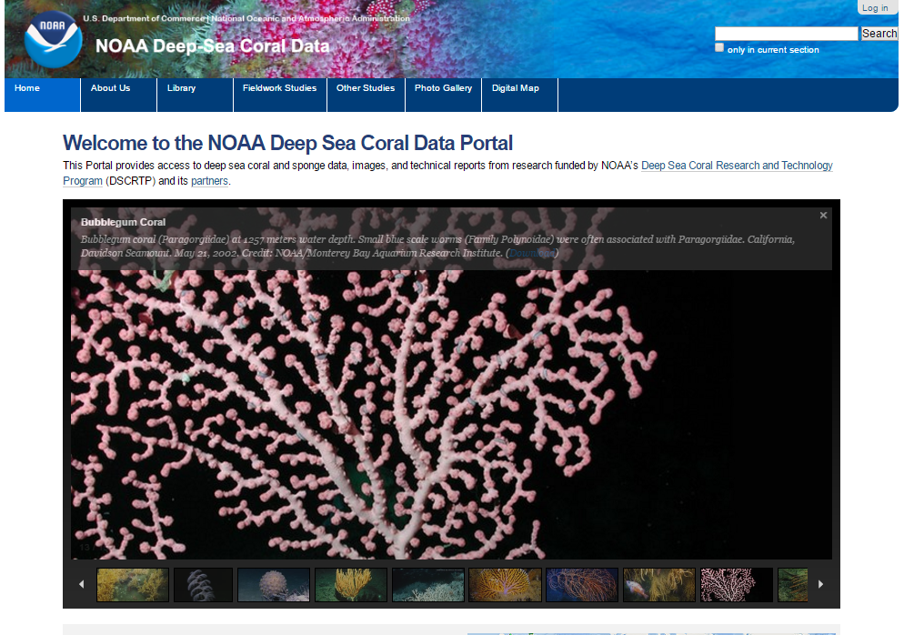

Figure 2. NOAA’s DSC mapping portal.

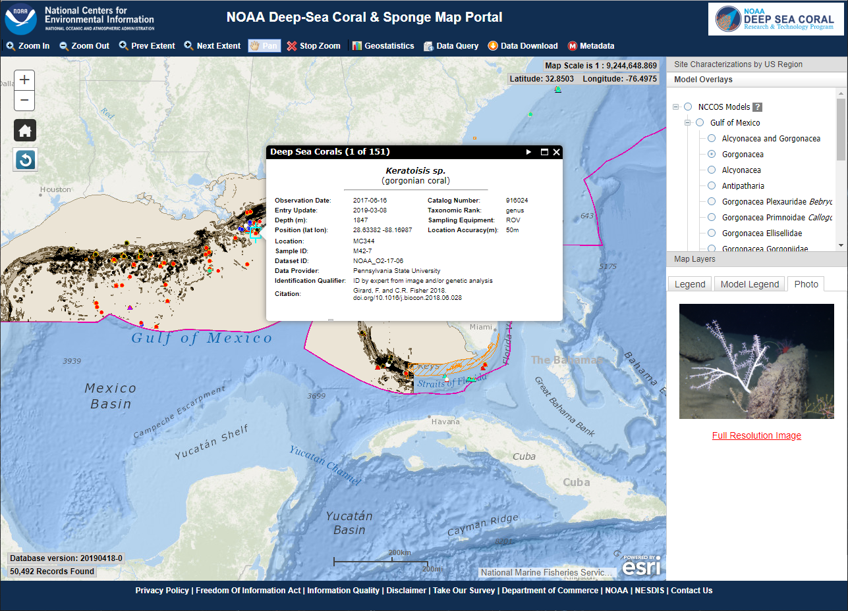

Figure 3. Records of “Gorgonian” and “Soft” corals from the NPFC Convention Area and surrounding EEZ’s.
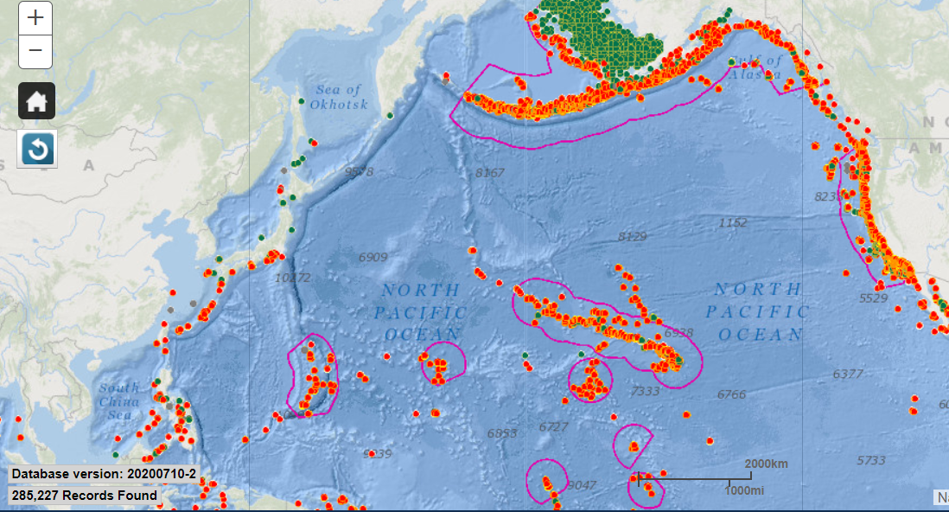

Table 1. Database Schema for NOAA’s Deep Sea Coral database

FieldName | FieldOrder | FieldDescription
Flag | 1 | A value of "1" means record is flagged as "do not release" for quality assurance. A value of "0" means that the record is not flagged and it can be released. "-999" means that the record has not yet been assessed for quality.
FlagReason | 2 | Reason why the record was flagged for QA. We may have multiple flag reasons separated by the pipe character with a leading a trailing space, " | ".
ShallowFlag | 3 | A value of 1 denotes a coral or sponge record where DepthInMeters is correct but it is less than 50 meters. A value of 0 denotes a coral that has a correct DepthInMeters greater than or equal to 50 meters.
DatabaseVersion | 4 | Version of the entire database indicated as a date-based version in the format YYYYMMDD_<iteration>. Example: '20190226_0' for the version created on February 26, 2019. The zero on the end indicates the iteration number on that day. If another version of the database was created on that same day, it would be indicated as '20190226_1'.
DatasetID | 5 | Standardized ID for dataset. The form of this ID is specfied in a separate internal document.
CatalogNumber | 6 | Unique record identifier assigned by the DSCRTP. It is persistent and the numbers are retired if records are deleted from the database.
SampleID | 7 | The primary identification label or code of the specimen or catch record exactly as reported by the "DataProvider". This field, along with "TrackingID", is used to establish record provenance at the "DataProvider" institution. Image-based records should also have a SampleID that is a filename or other identifier chosen by the 'DataProvider'. SampleID should be the primary link back to the original database owned by the "DataProvider". An individual SampleID can be repeated. For example, there may be multiple taxa in an single image that would require separate records, so that the same SampleID (ID of the image) may be listed multiple times.
TrackingID | 8 | Additional ID of the sample or observation provided by the "DataProvider" (e.g. an additional ID of the occurrence used during field activities or other sample tracking). May be used to indicate transects within an "EventID".
ImageURL | 9 | URL to the image on the DSC portal or appropriate archive that displays the specimen of record. This value is created by the Program.
Citation | 10 | A list (concatenated and separated) of identifiers (publication, bibliographic reference, global unique identifier, URI) of literature associated with the Occurrence. Equivalent to the term associatedReferences in Darwin Core. Multiple citations should be separated by the pipe character with a leading a trailing space, " | ". The preferred style guide is Chicago/Turabian. Michigan State University Libraries publishes a helpful guide on how to cite data at the following link: http://libguides.lib.msu.edu/citedata.
Repository | 11 | Location where the physical sample, or image is stored. This may be a museum, if samples are physical (e.g., "Smithsonian NMNH") or it may be an institution (e.g., "NOAA Central Library") that maintains master copies of images or video.
ScientificName | 12 | Taxonomic identification of the sample as a Latin binomial (e.g., Primnoa pacifica), or lowest practical level (e.g., Primnoidae).
VerbatimScientificName | 13 | The "ScientificName" exactly as reported by the "DataProvider".
VernacularNameCategory | 14 | Common (vernacular) name category of the organism.
VernacularName | 15 | Common name(s) of the observed species.
TaxonRank | 16 | The TaxonRank term is a companion to the ScientificName term. TaxonRank identifies the level in the taxonomic hierarchy of the ScientificName term.
AphiaID | 17 | AphiaID of ‘ScientificName’ from World Register of Marine Species (WoRMS). Access these numeric codes are here: http://www.marinespecies.org/index.php.
LifeScienceIdentifier | 18 | Life Science Identifiers are a way to name and locate pieces of information on the web. Essentially, an LSID is a unique identifier for some data, and the LSID protocol specifies a standard way to locate the data (as well as a standard way of describing that data). They are a little like DOIs used by many publishers. An LSID is represented as a uniform resource name (URN) with the following format:  urn:lsid:<Authority>:<Namespace>:<ObjectID>[:<Version>] . An example using WoRMS where genus = 'Thesea': 'urn:lsid:marinespecies.org:taxname:125315'.
Phylum | 19 | The Phylum in which the taxon is classified.
Class | 20 | The Class in which the taxon is classified.
Subclass | 21 | The Subclass in which the taxon is classified.
Order | 22 | The Order in which the taxon is classified.
Suborder | 23 | The Suborder in which the taxon is classified.
Family | 24 | The Family in which the taxon is classified.
Subfamily | 25 | The Subfamily in which the taxon is classified.
Genus | 26 | The Genus in which the taxon is classified.
Subgenus | 27 | The Subgenus in which the taxon is classified.
Species | 28 | The specific epithet in which the taxon is classified.
Subspecies | 29 | The Subspecies in which the taxon is classified.
ScientificNameAuthorship | 30 | Author who originally described the species or subspecies. The author should be consistent with AphiaID and TaxonRank.
TypeStatus | 31 | The type status (e.g., holotype, paratype, etc.), if any, of the specimen. Additional information (e.g., typified scientific name, publication) should be included in IdentificationComments.
OperationalTaxonomicUnit | 32 | Operational taxonomic unit number - number assigned to a particular taxon in the proposed reference image database (this would allow our database to cross reference that database).
Morphospecies | 33 | Allows the extra detail distinguishing among different morphs e.g. msp1, msp2, msp3, or in the case of sponges encrusting, vase, fig, sponge, massive globose etc..
CombinedNameID | 34 | CombinedNameID - ScientificName + Morphospecies; (Note: This is meant to be autogenerated, but I am not sure how well this would play with our existing system. ScientificName should contain the name of the lowest possible taxon rank that refers to the most accurate identification. E.g. if the specimen was accurately identified down to genus level, but not species level, then the scientificName should contain the name of the genus, the scientificNameID should contain the LSID of the genus.).
Synonyms | 35 | Other scientific names used for the specimen or observation, including outdated or synonymized names for the taxon, alternate spellings, or previous identifications.
IdentificationComments | 36 | Comments and other info about the characteristics (e.g., color) or taxonomy of the of the sampled or observed organism. If the record is of a type specimen (e.g., holotype), this should be identified in this field along with the associated scientific name and citation.
IdentifiedBy | 37 | Name of individual or institution that assigned the "ScientificName." Desired format is "LastName, FirstName" or a list of names delimited by the pipe character with a leading a trailing space, " | ".
IdentificationDate | 38 | UTC date (YYYY-MM-DD). Date on which the sample was identified. If day or month is unknown, use YYYY-MM or YYYY.
IdentificationQualifier | 39 | Taxonomic identification method and level of expertise. Desired format would be along the following lines: “genetic ID”; “morphological ID from sample by taxonomic expert”; “ID by expert from image”; “ID by non-expert from video”; etc. An additional qualifier may be included (e.g., “ID Uncertain”).
IdentificationVerificationStatus | 40 | IdentificationVerificationStatus - Score of the quality of the identification. 1 = identified from image only, 2 = identified from image and physical specimens sampled from the same region, 3 = identified from image and that specific physical specimen. (Note: This is pretty cool - but we would need to revise somewhat based to accomodate sample records).
AssociatedSequences | 41 | Additional ID of samples where genetic sequences have been submitted to GenBank, for example. Multiple sequences may be separated by the pipe character with a leading a trailing space, " | ".
Ocean | 42 | Ocean basin where the observation or sample was collected.
LargeMarineEcosystem | 43 | Large Marine Ecosystem using designations set forth at http://www.lme.noaa.gov/. “NA” = outside of LME boundary. This field is calculated by the Program based on occurrence location.
Country | 44 | Country in whose Exclusive Economic Zone the observation or sample was collected , based on Exclusive Economic Zones Boundaries (EEZ) [World EEZ v7 (2012-11-20)] from http://marineregions.org/downloads.php .
FishCouncilRegion | 45 | U.S. Fisheries Management Council (FMC) region where the occurrence is located. In cases of boundary overlap, two councils can be listed separated by the pipe character with a leading a trailing space, " | ". If the occurrence is in state waters, the adjacent FMC region will be listed. For a map, see: http://www.nmfs.noaa.gov/sfa/management/councils/ .
Locality | 46 | A specific named place or named feature of origin for the specimen or observation (e.g., Dixon Entrance, Diaphus Bank, or Sur Ridge). Multiple locality names can be separated by the pipe symbol," | ", arranged in a list from largest to smallest area (e.g., Gulf of Mexico; West Florida Shelf, Pulley Ridge).
Latitude | 47 | Latitude in decimal degrees where the sample or observation was collected. Precision should be the same as that originally reported. Geographic coordinate system should be WGS1984. Use "NavType" and "LocationAccuracy" to report measurement method and accuracy, respectively. Use "LocationComments" to make addtional notes about location determination.
Longitude | 48 | Longitude in decimal degrees where the sample or observation was collected. Precision should be the same as that originally reported. Geographic coordinate system should be WGS1984. Use "NavType" and "LocationAccuracy" to report measurement method and accuracy, respectively. Use "LocationComments" to make addtional notes about location determination.
DepthInMeters | 49 | Best single depth value for sample as a positive value in meters.
DepthMethod | 50 | Select method by which best singular depth in meters (DepthInMeters) was determined. Place method details in "LocationComments". Select "averaged" when start and stop depths were averaged. Select "assigned" when depth was derived from bathymetry at the location. Select "reported" when depth was reported based on instrumentation or described in literature.
MinimumDepthInMeters | 51 | Positive integer used to express the minimum depth of the observation. If "DataProvider" gives a single depth, the "MinimumDepthInMeters" and "MaximumDepthInMeters" will be equal. If no depth information was provided, both the min and max terms will be -999.
MaximumDepthInMeters | 52 | Positive integer used to express the maximum depth of the observation. If "DataProvider" gives a single depth, the "MinimumDepthInMeters" and "MaximumDepthInMeters" will be equal. If no depth information was provided, both the min and max terms will be -999.
LocationComments | 53 | Comments and other info about how the location (including depth) was determined. Also comment on any uncertainty regarding the geographic or depth coordinates.
ObservationDate | 54 | Date as YYYY-MM-DD. If month or day is unknown use YYYY-MM or YYYY. Please convert from local date to Universal Time Code (UTC).
ObservationYear | 55 | Year the observation was made in YYYY format (or beginning year of a range, if exact year is unknown).
ObservationTime | 56 | Time as hh:mm:ss when the sample/observation occurred. Use UTC.
SurveyID | 57 | Name or ID of the cruise or project in which the sample or observation was collected (e.g, "EX1202L2" or "Lophelia II: Reefs, Rigs, and Wrecks"). Many events ("EventID") can be associated with one survey ("SurveyID").
Vessel | 58 | Name of the vessel used for collecting the sample or observation. Provide the full name of the vessel, in plain text with no prefix, e.g; "Ronald H. Brown". A list of valid vessel names is maintained by DSCRTP to standardize the vessel naming convention.
PI | 59 | Principal Investigator or Chief Scientist of the cruise during which the sample was collected, or individual who collected the sample. Desired format is "LastName, FirstName".
PIAffiliation | 60 | Affiliation of the Principal Investigator. Well established acronyms or abbreviations are acceptable (e.g., MBARI or WHOI).
Purpose | 61 | Purpose of the cruise during which the sample or observation was collected (e.g. "deep-sea coral survey", "exploration", or "groundfish survey").
SurveyComments | 62 | Comments and other information about the cruise/survey or programs sponsoring the cruise/survey.
Station | 63 | Reference ID of the station where the sample or observation was collected. For example, "78G9-III".
EventID | 64 | ID of the survey event (e.g., dive number, transect, or trawl haul number) on which the sample was made.
SamplingEquipment | 65 | Method of data collection.
VehicleName | 66 | Name or ID of the AUV, ROV, submersible, etc. used to collect sample (e.g., "Jason II"). Provide the full name of the vehicle, in plain text with no prefix. Use the field 'SamplingEquipment' to indicate vehicle type. A list of valid vehicle names is maintained by DSCRTP to verify and standardize data entries in this field.
SampleAreaInSquareMeters | 67 | The area in square meters, if projected vertically to a plane representing the seafloor surface, of the sample space in which the observation was made. Use 'footprintWKT' field to specify the exact shape of the sampling space.
footprintWKT | 68 | A Well-Known Text (WKT) representation of the shape (footprint, geometry) that defines the sample area. As an example, for downward looking or oblique still images, this would be a polygon representing the footprint of the viewable area (an orthogonal projection using the sea floor as the projection plane). For a video transect, this would be a polygon that represents the footprint of the entire viewable area throughout the length of the video. To report the actual area of the sample, see 'SampleAreaInSquareMeters'. Also please report 'footprintSRS' if you report 'footprintWKT'. Example: the one-degree bounding box with opposite corners at (longitude=10, latitude=20) and (longitude=11, latitude=21) would be expressed in well-known text as POLYGON ((10 20, 11 20, 11 21, 10 21, 10 20)). For discussion see http://terms.tdwg.org/wiki/dwc:footprintWKT
footprintSRS | 69 | A Well-Known Text (WKT) representation of the Spatial Reference System (SRS) for the footprintWKT of the Location. Do not use this term to describe the SRS of the Latitude and Longitude, even if it is the same as for the footprintWKT. 'footprintSRS' must always be populated if 'footprintWKT' is given. Example: The WKT for the standard WGS84 SRS (EPSG:4326) is "GEOGCS["GCS_WGS_1984",DATUM["D_WGS_1984",SPHEROID["WGS_1984",6378137,298.257223563]],PRIMEM["Greenwich",0],UNIT["Degree",0.0174532925199433]]" without the enclosing quotes. For discussion see http://terms.tdwg.org/wiki/dwc:footprintSRS
IndividualCount | 70 | Number of individuals (e.g., sponges or non-colonial corals), colonies (e.g., octocorals, black corals) or patches (e.g., framework forming corals where individual colonies cannot be distinguished) as a positive integer. If categorical, use "CategoricalAbundance’. Write -999 if no count is available for presence-only data. Add "present" to the "CategoricalAbundance" field.
CategoricalAbundance | 71 | Abundance category of corals/sponges of the same ScientificName at the sample location. If data is presence only, write "present" in CategoricalAbundance and set IndividualCount = "-999".
Density | 72 | Number of individuals (or colonies) per square meter for an observation.
Cover | 73 | Percent of sampled area covered by organism of interest. This field is generally used for framework-forming stony corals for which individual counts are difficult.
VerbatimSize | 74 | This field is used to store the originally reported Size value if they were not in our required format. If the data provider is available to provide values in our required format, then that is preferable.
MinimumSize | 75 | Minimum size of the taxon observed. Methods for determining size (e.g., height or maximum diameter) should be noted in "OccurrenceComments."
MaximumSize | 76 | Maximum size of the taxon observed. Methods for determining size (e.g., height or maximum diameter) should be noted in "OccurrenceComments."
WeightInKg | 77 | The recorded weight in kilograms of the individuals in the observation. Use ‘OccurrenceComments’ for weight methods (e.g., dry weight), calculation or estimation procedures, or other details applied in determining weight.
Condition | 78 | Condition of the organism (coral or sponge) when collected or observed. Use 'Damaged' when greater than 20 % of the colony is damaged. If both live and dead organisms are present, use 'Live'.
AssociatedTaxa | 79 | Notable organisms that co-occur with the coral or sponge observation. A list of organisms may be separated by the pipe character with a leading a trailing space, " | ". Commercially fished species are of particular interest to regional fishery management councils. Methods for determining association (e.g., “touching” or “fish within one meter”) should be noted in "OccurrenceComments."
OccurrenceComments | 80 | Biological or other detail about the observation event that is not addressed elsewhere (e.g. fishing debris). May be remarks from a corresponding column in original data, or "IndividualCount" values reported as text "few scattered", or "pieces" when integers are expected.
StartLatitude | 81 | Starting latitude in decimal degrees for observations or samples collected over a distance (e.g., trawls, transects). Precision should be the same as that originally reported; ideally to five decimal places. Geographic coordinate system should be WGS1984. Use "NavType" and "LocationAccuracy" to report measurement method and accuracy, respectively. Use "LocationComments" to make addtional notes about location determination.
StartLongitude | 82 | Starting longitude in decimal degrees for observations or samples collected over a distance (e.g., trawls, transects). Precision should be the same as that originally reported; ideally to five decimal places. Geographic coordinate system should be WGS1984. Use "NavType" and "LocationAccuracy" to report measurement method and accuracy, respectively. Use "LocationComments" to make addtional notes about location determination.
EndLatitude | 83 | Ending latitude in decimal degrees for observations or samples collected over a distance (e.g., trawls, transects). Precision should be the same as that originally reported; ideally to five decimal places. Geographic coordinate system should be WGS1984. Use "NavType" and "LocationAccuracy" to report measurement method and accuracy, respectively. Use "LocationComments" to make addtional notes about location determination.
EndLongitude | 84 | Ending longitude in decimal degrees for observations or samples collected over a distance (e.g., trawls, transects). Precision should be the same as that originally reported; ideally to five decimal places. Geographic coordinate system should be WGS1984. Use "NavType" and "LocationAccuracy" to report measurement method and accuracy, respectively. Use "LocationComments" to make addtional notes about location determination.
VerbatimLatitude | 85 | Lattude exactly as reported in original data set. Place notes on original coodinate system in "LocationComments".
VerbatimLongitude | 86 | Longitude exactly as reported in original data set. Place notes on original coodinate system in "LocationComments".
LocationAccuracy | 87 | The horizontal distance (in meters) from the given Latitude and Longitude that describes the range of error in the position. Leave the value empty if the uncertainty is unknown or cannot be estimated. Zero is not a valid value for this term.
NavType | 88 | Navigation type used to determine coordinates (e.g., "USBL" or "ship GPS"). Further detail on NavType can be captured in "LocationComments"
OtherData | 89 | Other data types collected on the same event where this sample was taken. List of data types separated by a comma (e.g."CTD, push cores").
Habitat | 90 | A description of the geological and biotic environment in which the organism was sampled or observed, described in plain language, preferably in a manner consistent with Coastal and Marine Classification Standard (CMECS) or other regional habitat classification standards. Methods should be reported in "OccurrenceComments".
Substrate | 91 | Attachment or contact substrate (e.g., dropstone, outcrop, or boulder) of the organism observed. The purpose is to distinguish habitat (like a sandy plain) from attachment point (for instance, a dropstone in a sandy plain). Methods or classification system should be reported in "OccurrenceComments".
CMECSGeoForm | 92 | Tectonic or geologic features, such as shelf, canyon, or seamount. See the Coastal and Marine Ecological Classification Standard catalog for description https://www.cmecscatalog.org/cmecs/index.jsp .
CMECSSubstrate | 93 | Geologic or biogenic substrate. See the Coastal and Marine Ecological Classification Standard catalog for description https://www.cmecscatalog.org/cmecs/index.jsp .
CMECSBiotic | 94 | Biotic community present at the observation site. See the Coastal and Marine Ecological Classification Standard catalog for description https://www.cmecscatalog.org/cmecs/index.jsp .
Temperature | 95 | Temperature in degrees Celsius for "EventID". Use best value or averaged value. Methods should be reported in "OccurrenceComments".
Salinity | 96 | Salinity in PSU for "EventID". Use best value or averaged value. Methods should be reported in "OccurrenceComments".
Oxygen | 97 | Dissolved oxygen in mL/L for EventID. Use best value or averaged value. Methods should be reported in "OccurrenceComments".
pH | 98 | pH value in units of total pH. Methods should be reported in "OccurrenceComments".
pHscale | 99 | Scale used to measure pH. Methods should be reported in "OccurrenceComments".
pCO2 | 100 | Partial pressure of CO2 in seawater, units = microatmospheres. Methods should be reported in "OccurrenceComments".
TA | 101 | Total alkalinity, units should be micromoles per kilogram. Methods should be reported in "OccurrenceComments".
DIC | 102 | Dissolved inorganic carbon, units should be micromoles per kilogram. Methods should be reported in "OccurrenceComments".
RecordType | 103 | Denotes the origin and type of record. The options are: published literature ("literature"); a collected specimen, including those from literature ("specimen"); observation from a still image ("still image"); observation from video ("video observation"); cumulative observation from a video transect ("video transect"); notation without a specimen or image ("notation"); or observation from trawl surveys, longline surveys, and/or observer records ("catch record").
ImageFilePath | 104 | Full file path and file name to still image(s) that recorded the observation. The file path and name will provide the Program with enough information to link the image to the record. Two or more images can be submitted per observation, separated by the pipe character with a leading a trailing space, " | ". For example, an in-situ and on-deck image of the same organism. If multiple images are submitted, the first image in the list should be the one that you want displayed on the web mapping portal. This primary image will be displayed when a web mapping portal user clicks on a coral or sponge point in the map.
DataProvider | 105 | Identifies the originator of the data. This is the institution, publication, or individual, who ultimately deserves credit for acquiring or aggregating the data and making it available. A single institution or individual is preferred multiple. When an individual is listed, use "Last Name, First Name" format. Publications should be abbreviated as such, "Pante et al. 2012".
DataContact | 106 | The name and e-mail of the individual who is the primary representative of the "DataProvider". The preferred format is "Last Name, First Name; e-mail". "DataProvider" and "DataContact" may be the same person, if "DataProvider" is an individual and not an institution.
Modified | 107 | The most recent date the DataProvider updated or verified the record. Format: YYYY-MM-DD. If the DataProvider does not record or provide this information, the date the record became available to NOAA will be used.
EntryUpdate | 108 | The most recent date the DSCRTP Program updated or verified the record. Format: YYYY-MM-DD. This variable will only contain a value if the DSCRTP Program has updated a record which has previously been published in the database. Also see the related variables that inform record versioning: 'Modified' and 'EntryDate'.
WebSite | 109 | World Wide Web link (URL) to an online resource for the "SurveyEvent" (e.g., a web page devoted to this dataset or expedition). Multiple URLs can be listed and they should be separated the pipe character with a leading a trailing space, " | ".
EntryDate | 110 | The date on which the record was initially merged into the DSCRTP database by NOAA. Format YYYY-MM-DD. (UTC date).
Reporter | 111 | Person who submitted the data to the DSCRTP. This person does not have to be the same as DataContact, DataProvider, or PI. Format should be LastName, FirstName
ReporterEmail | 112 | E-mail of the reporter.
ReporterComments | 113 | Other comments by or about the "Reporter".
AccessionID | 114 | Internal field that holds the offficial identifier for a dataset as it is named upon receipt from the data provider and as it moves through the QA process. The form of this Accession ID [Data Provider Abbreviation]_[SurveyID or other short descriptive term if needed ]_[beginning ObservationYear]_[ending ObservationYear].

