NPFC-2020-SSC BFME01-WP02

A proposal to develop ‘Species Summary’ documents for the NPFC priority species

Based on discussions with the NPFC Science Manager, SC Chairperson and SSC BF-ME Chairperson, the following document has been put together to describe the purpose of and proposed format for a series of ‘species summary’ documents. An example is provided to serve as a basis for discussion about the concept, content and formatting. It is my hope that this example version can be the starting point for discussions on content and formatting that would allow these to be useful, relevant, and current products.

Document purpose – The purpose of the proposed ‘species summary’ document is to provide a concise summary of NPFC priority species data, including information about life history, fishery, assessment, and management. These documents could serve as a starting point for obtaining more detailed information and to track progress towards defining and meeting key management concepts, such as specifying biological reference points, management targets or limits, and stock status. Once established, the documents could be annually verified and updated, but are also intended to be simple and not create large administrative burdens. These documents could be linked from the ‘Priority Species’ internet page (https://www.npfc.int/priority-species), providing a more comprehensive source of information than is currently available.

Document availability and location – These documents are intended to be a summary of key issues of concern to the public and Commission and a source for more information, including other references. As such, these summary documents should not contain confidential information and should be available to the public via the NPFC website.

Document formatting and information content – The format and contents should be carefully chosen to summarize the most pertinent information necessary to get a high-level understanding of the life history, fishery, assessment, management, and data available. Data gaps should be readily apparent from the document as species with less data will have more ‘unknown’ or ‘not available’ content, but this is ok as it can be acknowledged that not all species may ever have similar types and amounts of data. However, acknowledging data gaps may help inform future research needs.

North Pacific Armorhead Pentaceros wheeleri)
Common names: Pelagic armourhead, Slender armorhead (English); Рыба-кабан (Russian); Kusakari-tsubodai (Japanese); 胸五棘鯛 (Chinese); Minsajagu (Korean)

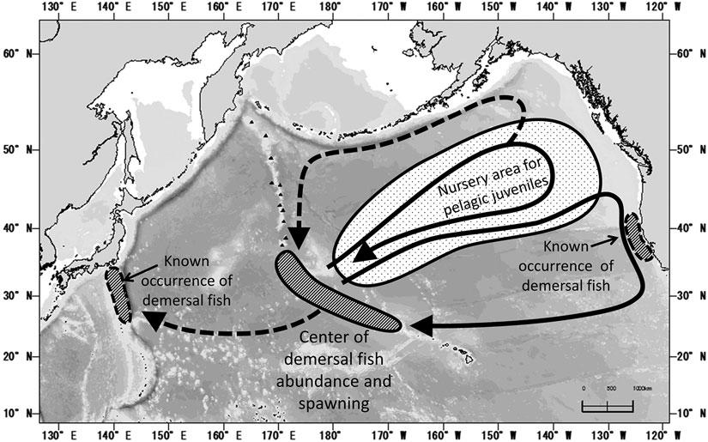
1. Known demersal habitats and hypothesized pelagic migration routes of Pentaceros wheeleri (Kiyota et al. 2016 Figure 4, modified from Boehlert and Sasaki 1988).
Biological Information
Distribution includes North Pacific – Gulf of Alaska to North Pacific Ocean off central California and south of Japan, with center of abundance at the seamounts of the southern Emperor-northern Hawaiian Ridge within the Convention area. North Pacific Armorhead (NPA) have a unique life history with extended pelagic phase (2+ years), followed by morphometric changes concurrent with recruitment to a demersal stage on seamounts.
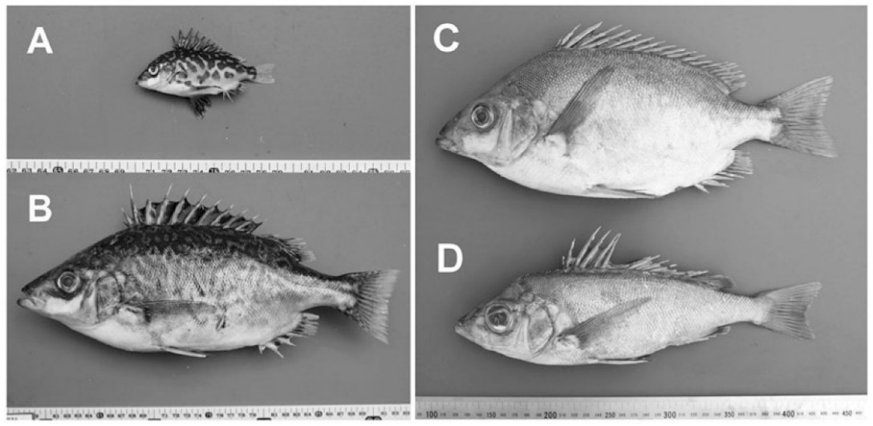
2. Photographs of Pentaceros wheeleri. A) Pelagic juvenile, B) pelagic subadult, C) demersal adult (fat type), D) demersal adult (lean type) (from Kiyota et al. 2016)
Management
Active Management Measure(s)
The following NPFMC conservation and management measures pertain to this species:
CMM 2019-05 For Bottom Fisheries and Protection of VMEs in the NW Pacific Ocean
CMM 2019-06 For Bottom Fisheries and Protection of VMEs in the NE Pacific Ocean
Available from https://www.npfc.int/active-conservation-and-management-measures

Management Summary
Convention/Management Principle | Status | Comment/Consideration
Biological reference point(s) |  | Not established.
Stock status |  | Status determination criteria not established.
Catch limit |  | Recommended catch, effort limits.
Harvest control rule |  | Not established.
Other |  | No expansion of fishing beyond established areas.

OK Intermediate Not accomplished Unknown

In 2019 an adaptive management plan was implemented for NPA (NPFC-2019-SSC BF02-WP05, CMM 2019-05). This plan specifies data collection via an annual monitoring survey to be conducted in March-June each year on Koko and Kammu Seamounts. If the survey finds evidence of strong recruitment (see CMM 2019-05 and NPFC-2019-SSC BF02-IP01 for details) some area in the Emperor Seamounts are closed and a 12,000 ton catch limit is encouraged. In low recruitment years, a 700 ton catch limit is encouraged.

Assessment
There is no current or accepted assessment for this species.
There are no biomass estimates available for NPA in NPFC waters. An age- or length-structured stock assessment is unlikely to be feasible given the life history of NPA (citation for more information). Data limited approaches may be examined in the future.

Monitoring survey results
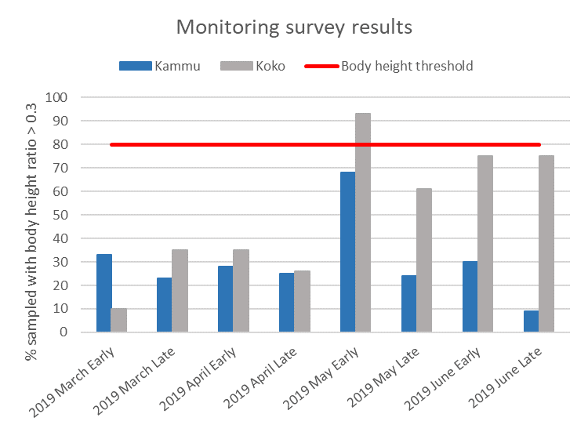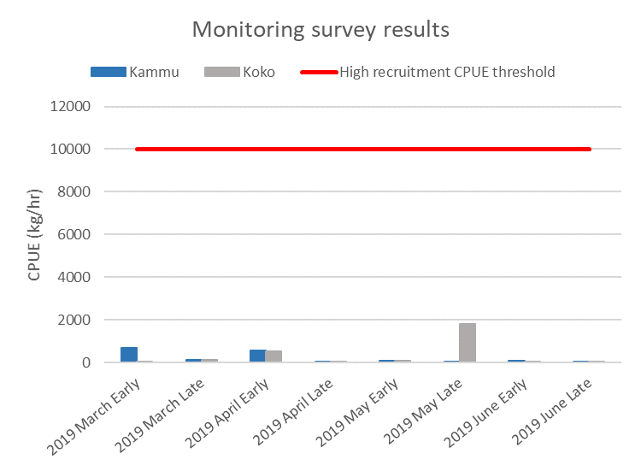

Two thresholds must be met for ‘high recruitment’ to be determined in the Koko or Kammu Seamount monitoring areas: 1) monitoring survey CPUE must exceed 10,000 kg/hr for four consecutive monitoring surveys in each monitoring area, and 2) the fat index (body height/fork length) ratio > 0.3 for 80% of the survey haul’s NPA.

Fishery

Historical catches (Russia and Japan) from the combined Emperor Seamounts were high and reached 1 million mt in 1975, followed by a crash (Kiyota et al. 2016). Currently NPA is caught by Japan and Korea on the Emperor Seamounts using bottom trawls and gillnets. This fishery is a potential source of SAI for vulnerable marine ecosystems due to bottom contact gear. Observers are required for NPFC bottom fishing (per CMM 2019-05).
Fishing typically begins in January and extends until [need date].
Data
Data Type | Source | Years Available | Comment
Catch | Japan | 2002-present | Historical catch data from 1968 available
 | Korea | 2004-present
 | Russia | 2002-present | Historical catch data from 1967 available
CPUE |  |  | not available
Survey | Japan | 2018-present | Monitoring survey: CPUE and fatness index
Age data |  |  | not available
Length data | Japan | 2018-present | Survey data, see 'Survey' above
Maturity/fecundity |  |  | not available

Special comments
None reported.

References
Boehlert, G. W., and T. Sasaki. 1988. Pelagic biogeography of the armorhead, Pseudopentaceros wheeleri, and recruitment to isolated seamounts in the North Pacific Ocean. Fish. Bull. 86:453–465.
Kiyota M., Nishida K., Murakami C. and Yonezaki S. 2016. History, biology, and conservation of Pacific endemics 2. The North Pacific armorhead, Pentaceros wheeleri (Hardy, 1983) (Perciformes, Pentacerotidae). Pacific Science 70(1): 1-20.

(https://www.fishbase.se/ComNames/CommonNamesList.php?ID=12364&GenusName=Pentaceros&SpeciesName=wheeleri& StockCode=12693; Kiyota et al. 2016)

