NPFC-2020-SSC BFME01-WP09

Proposed amendment to CMM2019-05, Annex 6
(Implementation of the Adaptive Management for North Pacific armorhead)

Japan

The number of Japanese bottom trawl fishing vessels which conducted fishing in the Emperor Seamounts in the 2020 fishing season was only one, since two Japanese trawl fishing vessels that had fished in the area for the past years have suspended their operation since November 2019. It is expected that the operational status of the Japanese trawl fishery is likely to remain unchanged towards the 2021 fishing season.

Given that only one Japanese bottom trawl fishing vessel is likely to be in operation in the Emperor Seamounts in the 2021 fishing season, Japan proposes amendment to CMM2019-05, Annex 6 “Implementation of the Adaptive Management for North Pacific armorhead” as attached track changes, to increase the number of monitoring blocks from two to four (addition of Yuryaku and Colahan seamounts as monitoring blocks). The amendment will enable the trawl fishing vessel to continue to conduct monitoring surveys at regular intervals while reducing the current operational difficulties of the trawl fishing vessel that has been required to move all the way to each of the two monitoring blocks every month.

Under the proposed protocols, the one Japanese trawling vessel will conduct a monitoring survey in one of the four monitoring blocks, which is the nearest from the location of the trawl fishing vessel every month as long as signs of high recruitment are not detected. When signs of possible high recruitment are detected, Japan will consider increasing the frequency of monitoring surveys while taking into account operational availability of the trawl fishing vessel.

Attachment

Annex 6

Implementation of the Adaptive Management for North Pacific armorhead
(in 2021)

- Monitoring survey for the detection of strong recruitment of North Pacific armorhead

- Location of monitoring surveys
Monitoring surveys for the detection of strong recruitment of North Pacific armorhead will be conducted by trawl fishing vessels in the pre-determined four (4) monitoring blocks of Koko (South eastern), Yuryaku, Kammu (North western) and/or Colahan seamounts.

Monitoring blocks

- Koko seamount (34°51’ –35°04’N, 171°49’ –172°00’ E)
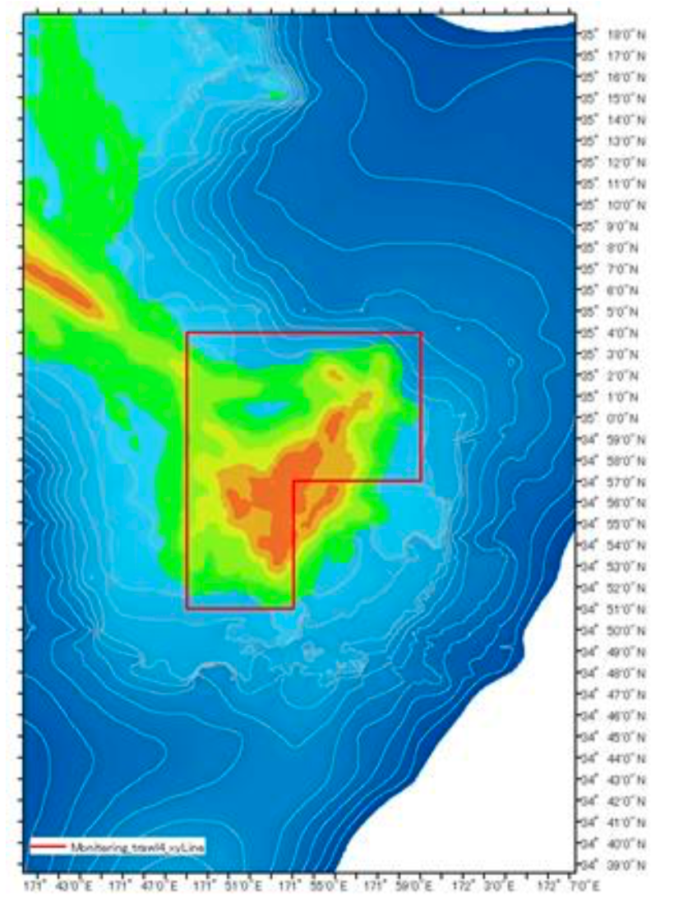

- Yuryaku seamount (32°35’ –32°45’N, 172°10’ –172°24’E)
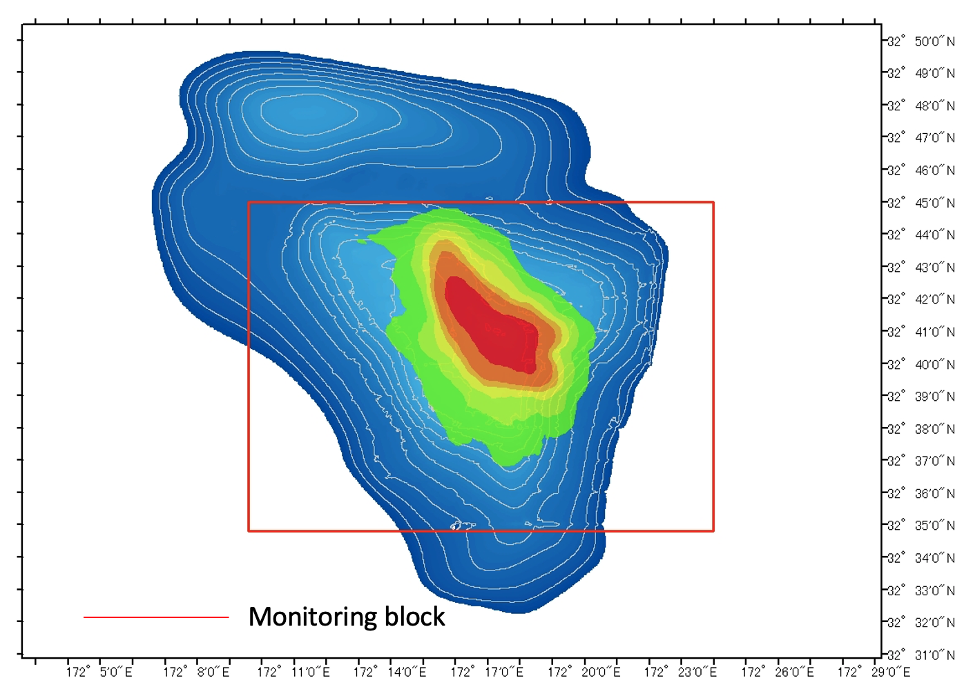

- Kammu seamount (32°10’–32°21’N, 172°44’–172°57’E)
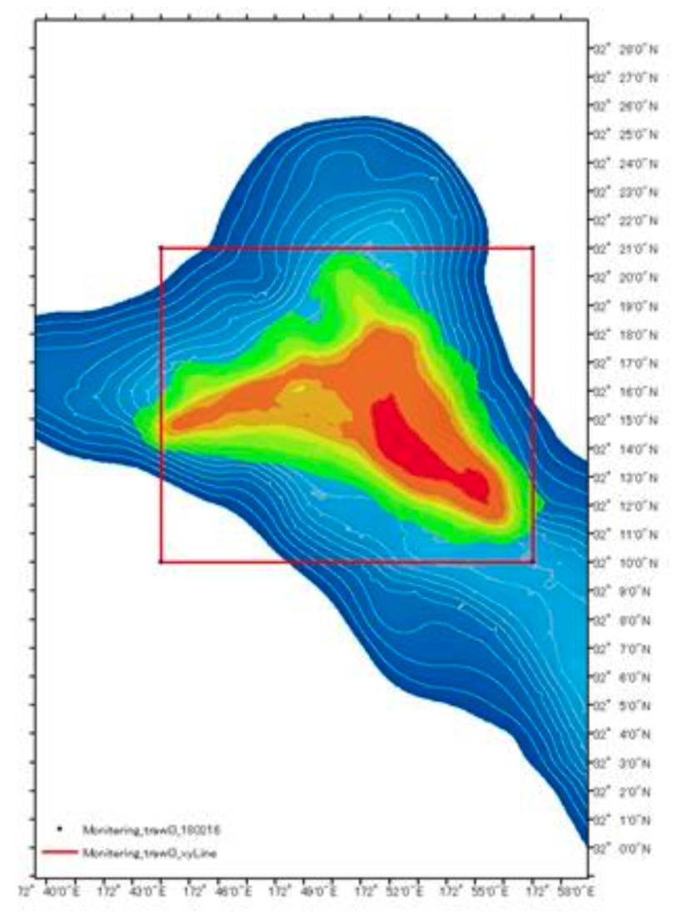

- Colahan seamount (30°57’–31°05’N, 175°50’–175°57’E)
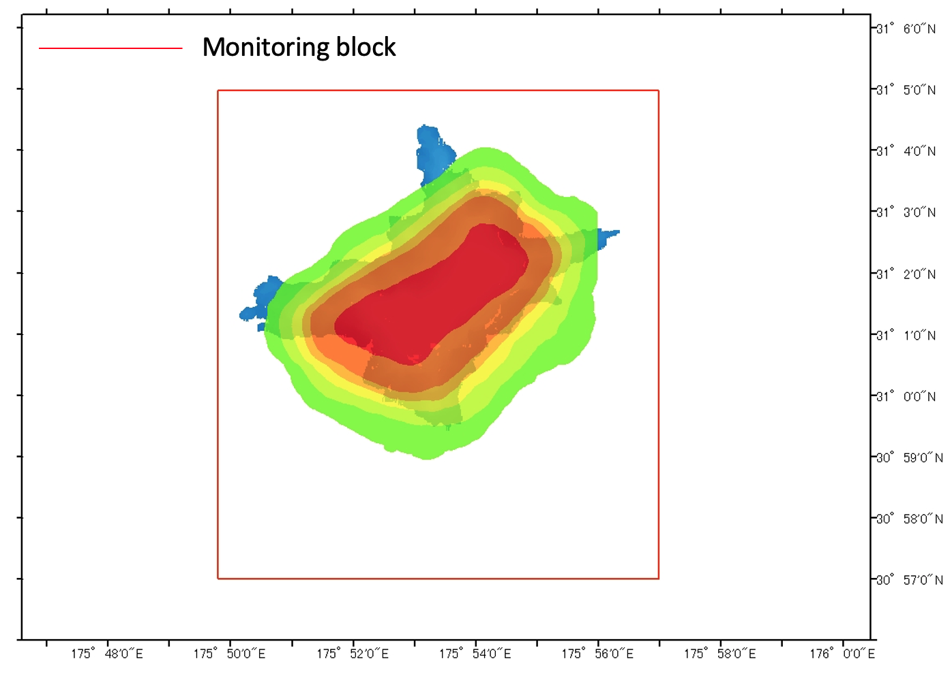

- Schedule for monitoring surveys
Monitoring surveys will be conducted from March 1st to June 30th each year, with at least a one-week interval between monitoring surveys. For each survey, a trawl fishing vessel will conduct a monitoring survey in one of the four monitoring blocks that is the nearest from the location of the trawl fishing vessel at the time of prior notification in (4) below.
The base schedule for monitoring surveys will be notified to the Executive Secretary by the end of February of each year. The base schedule may be revised during the year subject to prior notification to the Executive Secretary.
- Data to be collected during monitoring surveys
For each monitoring survey, a trawl net will be towed for one hour. A scientific observer onboard the trawl fishing vessel will calculate nominal-CPUE (kg/hour) of North Pacific armorhead. The scientific observer will also calculate fat index* (FI) of randomly sampled 100 individuals of North Pacific armorhead by measuring fork length (FL) and body height (BH) of each individual.
(*fat index (FI) = body height (BH) / fork length (FL) )

- Prior notifications and survey results
At least three (3) days before each survey, a prior notification with monitoring date/time, location and trawl fishing vessel name will be provided by the flag state of the trawl fishing vessel to the Executive Secretary.

No later than three (3) days after each survey, the survey result including date/time, location, catch, nominal-CPUE (kg/hour) and percentage of fish with fat index (FI)>0.3 will be provided by the flag state to the Executive Secretary.

The Executive Secretary will circulate these prior notifications and survey results to all Members of the Commission without delay.

2. Areas where bottom fishing with trawl gear is prohibited when high recruitment is detected

- Criteria for a high recruitment
It is considered that high recruitment has occurred if the following criteria are met in four (4) consecutive monitoring surveys.
- Nominal CPUE > 10t/h
- Individuals of fat index (FI)> 0.3 account for 80% or more

- Areas where bottom fishing with trawl gear is prohibited
Bottom fishing with trawl gear shall be prohibited in the following two (2) seamount areas (*) during the year when high recruitment is detected. In such a case, all monitoring surveys scheduled during the year will be cancelled.
- Northern part of Kammu seamount (north of 32°10.0′ N)
- Yuryaku seamount
(*) The catch of North Pacific armorhead in the above two seamounts accounts for a half of the total catch in the entire Emperor Seamounts area based on the catch records in 2010 and 2012.

- Notification by the Secretariat
When the criteria for high recruitment are met as defined in 2(1) above, the Executive Secretary will notify all Members of the Commission of the fact with a defined date/time from which bottom fishing with trawl gear is prohibited in the areas as defined in 2(2) above until the end of the year.

