NPFC-2020-SSC PS06-WP08
North Pacific Ocean Pacific Saury (Cololabis saira) 2020 Stock Assessment Update Report

Member: China

1. Introduction
The catch and standardized CPUE (catch per unit effort) indices data for the stock assessment of Pacific saury has been refined and updated up to 2018. Also, Japan has updated Pacific saury biomass series to 2019. Based on updated catch, biomass estimates and abundance indices data, this report presents an update of Pacific saury stock assessment using the Bayesian state-space production model (BSSPM). During the SSC PS05, the participants revised base case scenarios from the previous stock assessment. The participants agreed to conduct a stock assessment update with two new base cases and four sensitivity analyses (Table 1; NPFC-2019-SSC PS05-Final Report). For new base cases (NB1, NB2) and two sensitivity analyses (NS1, NS2), we summarize the estimates of MSY-based biological reference points and present the results from retrospective analysis and sensitivity analysis. We also conducted stochastic projections to provide estimated exploitable biomass from 2020-2024. The sensitivity analyses using the joint CPUE index (i.e. NS3 and NS4) will be shown at SSC PS06.

2. Materials and methods
2.1. Input data (Annex F in NPFC-2019-SSC PS05-Final Report)
- The catch data from 2003-2017 were different compared with previous assessments. The average change was 443.63 metric ton per year. The catch for 2018 was included.
- The 2019 fishery-independent survey biomass was included.
- Japanese late CPUE (1994-2018), Russian CPUE (1994-2018), Chinese Taipei CPUE (2001-2018), Korean CPUE (2001-2018) and Chinese CPUE (2013-2018) were updated.
2.2. Assessment methods (Annex F in NPFC-2018-TWG PSSA03-Final Report)
This assessment used catch data (1980-2019), fishery-independent biomass index (2003-2019), Japanese early CPUE (1980-1993), Japanese late CPUE (1994-2018), Russian only CPUE (1994-2018), Chinese Taipei CPUE (2001-2018), Korean CPUE (2001-2018) and Chinese CPUE (2013-2018) as input data (Figure 1). The assessment used a Bayesian state-space production model. The population dynamics were modeled by the following equations:
$B_{t}=B_{t-1}+r×B_{t-1}(1-{(\frac{B_{t-1}}{K})}^{M})-C_{t}$
$P_{t }=B_{t}/K$
$P_{t+1 }= (P_{t}+r×P_{t}×(1-P_{t}^{M})-\frac{C_{t}}{K})exp(μ_{t})$
$μ_{t}\sim N(0, τ^{2})$
Where $B_{t}$ and $C_{t}$ denote biomass and catch, respectively, in year t. r, K, M represent intrinsic population growth rate, carrying capacity, and production shape parameter respectively. $P_{t }$ and $μ_{t}$ denote the ratio between biomass and carrying capacity and the process error, respectively, in year t. $μ_{t}$ has a mean of zero and variance $τ^{2}$.
The multiple indices were modeled by the following equations:
$I_{i,t} = q_{i,t}{(KP_{t})}^{b_{i}}exp(ε_{i,t})$
$ε_{i,t}\sim N(0,σ_{i}^{2})$
Where $I_{i,t}$ is the relative abundance of index i at year t. $q_{i,t}$ is the catchability coefficient for index i at year t. $b_{i}$ is the hyperdepletion parameter. $ε_{i,t}$ is the observation error with a mean of zero and variance $σ_{i}^{2}$.
All base case and sensitivity case scenarios were built based on SSC PS05 recommendation and used uniform prior distribution for catchability (q; besides the catchability of Japanese early CPUE), carrying capacity (K), intrinsic population growth rate (r), initial biomass as a proportion of carrying capacity (P1), and shape (s) (Table 1; Table 2). Inverse gamma prior distribution was used for the process (τ²) and observation (σ²) error variance (Table 2).
Random walk approach was selected to estimate the time-varying catchability of Japanese early CPUE due to its relatively well performance and its ability to obtain a realistic increase of catchability over time (Wilberg et al. 2009; NPFC-2019-TWG PSSA04-WP08).
The convergence of the posterior distributions of those parameters was examined with Gelman and Rubin's statistics (Gelman and Rubin 1992). MSY-based biological reference points were estimated from the models. Mean error between predicted and observed indices was calculated to determine the model goodness of fit. Mean errors of each scenario were used to compare the performance of models. A lower mean error indicates a better fit. A retrospective analysis was conducted to verify whether any possible systematic inconsistencies exist among the model estimates of biomass and fishing mortality based on increasing periods of data (Mohn 1999). The data were removed from the year 2019 to 2014. A sensitivity analysis was conducted to understand whether the assessment model was robust with the change of prior range of Japanese biomass survey catchability (NS1-NS2).
Stochastic projections were applied to the assessment to show the possible changes in exploitable biomass. A five-year catch scenario was projected starting in 2020. The catch was set at 0, 0.7, 0.8, 0.9, 1.0, 1.1, 1.2, and 1.3 multiples average catch of the recent 3 years. A risk analysis was conducted to show how the probabilities of biomass fall in each quadrant of the Kobe plot change as projected catch changes in the future.

3. Assessment results
The posterior densities of model parameters from all case scenarios showed that the densities were smooth and unimodal (Appendix Figure 1-4). The inclusion of Japanese early CPUE will affect the results of posterior densities of model parameters from the case scenarios (Appendix Figure 1-4). The estimated mean, median, and 80% CI of posterior estimates of reference points were summarized in tables (Table 3 and Appendix Table 1-4). Mean, median, and 80% CI of the posterior estimates of model parameters from each scenario were summarized in tables (Appendix 5-8). The time series of biomass and fishing mortality, Bratio (B/BMSY), Fratio (F/FMSY), and B/K from each scenario were summarized and the trends varied largely among scenarios (Figure 2-11). The time trajectories of these parameters showed different patterns before year 2000. Base case scenarios 1 with incorporating Japanese early CPUE showed different trends compared with base case scenarios 2 without using Japanese early CPUE.

4. Diagnostics and caveats
- All parameters from the base case and sensitivity case scenarios showed well convergence of posterior distributions with Gelman and Rubin’s statistic for all parameters equal to 1.
- The standardized residuals between predicted and observed indices from base case scenarios and sensitivity case scenarios showed similar patterns (Appendix Figure 5-8). There was a strong temporal pattern from Chinese Taipei (Appendix Figure 5-8).
- Mohn's rho values of biomass and fishing mortality from all case scenarios were shown in Table 4 and the retrospective analysis suggested that case scenarios without Japanese early CPUE had a larger consistent pattern of bias in the estimates of the terminal exploitable biomass and fishing mortality (Table 4; Appendix Figure 9-16).
- The sensitivity analysis results showed that the relative changes (%) in estimated key parameters were small for all scenarios, indicating the assessment model was robust when expanding the upper bound of Japanese biomass survey catchability from 1 to 2.

5. Stock size and harvest rate
The time trajectories of Bratio and Fratio showed different trends between base case scenario 1 and base case scenario 2, indicating that incorporation of Japanese early CPUE would result in large changes in the time trajectories of Bratio and Fratio (Figure 6-9). For base case scenario 2 which did not use Japanese early CPUE, the biomass was over BMSY for most of the period of time, the biomass was only below BMSY around the year 2000 and 2017. The Bratio from base case scenarios 1 showed the biomass increased over time from below BMSY to above BMSY around 2000 and below BMSY again around 2015. The Fratio from base case scenarios 2 was below FMSY over time and started increase after 2000 while the Fratio from base case scenario 1 showed fluctuation over time. The Kobe plots showed that the Bratio and Fratio in initial years were largely varied among base case scenarios (Appendix Figure 17-18). The Bratio2018 and Fratio2018 from base case scenario 2 were in green quadrant and base case 1 was in red quadrant (Figure 12). Bratio (2017-2019) and Fratio (2016-2018) from base case scenario 1 fell in the red quadrant, and base case scenario 2 fell in the yellow quadrant of the Kobe plot (Figure 13).

6. Projection
A five-year projection was conducted for all scenarios. 0, 0.7, 0.8, 0.9, 1.0, 1.1, 1.2, and 1.3 of average catch over the last 3 years was assumed for the future projection. For all case scenarios, there were some mixed pictures on the exploitable biomass compared with BMSY (Appendix Figure 21-24). The probabilities of being in the green, yellow, orange, and red quadrants of Kobe plot under different catch scenarios were summarized in the Table 6. For all base case scenarios, the Pacific saury would have greater than 27% probability to be in the green quadrant.

7. Post hoc adjustment to terminal stock biomass and fishing mortality
Strong retrospective patterns have led to assessment models being rejected for management. Since the retrospective analysis results indicated that the stock biomass was consistently underestimated and the fishing mortality was consistently overestimated in all case scenarios (Table 4; Appendix Figure 9-16), a post hoc approach was used to adjust terminal biomass (B2019) and fishing mortality (F2018) by Mohn’s rho using (Brooks and Legault, 2016):
$θ_{adj}=\frac{θ}{1+ρ}$
Where $θ_{adj}$ is the adjusted value for stock biomass or fishing mortality in the terminal year. $θ$ is stock biomass or fishing mortality in the terminal year. $ρ$ is the corresponding Mohn’s rho value for each base case scenario. The adjusted values of stock biomass and fishing mortality in the terminal year for each base case scenario were summarized in Appendix table 9. The adjusted estimates of reference points over all 2 base case scenarios were shown in Appendix table 10.

8. Discussion
Some substantive changes have been made in the Pacific saury stock assessment relative to last year's stock assessment. The participants updated catch, abundance indices and biomass estimates and modified the input data of biomass as the one without a correction factor 0.179 during the SSC PS05. The current changes and inconsistency in results of key reference points and parameters relative to last update indicated that the current BSSPM was very sensitive to the model configuration in terms of catchability of Japanese survey. Strong retrospective patterns were found in most case scenarios, which is problematic for determining stock and harvest status. According to retrospective analysis results, current estimates of stock size were consistently lower and fishing mortality was consistently higher. We used Mohn’s rho values to adjust stock biomass and fishing mortality in the terminal year for recommendation of improving status determination. In general, more concern should be expressed on the robustness and reliability of the current BSSPM. Regarding the sensitivity analysis, the results showed that the change of upper bound of q_biomass from 1 to 2 did not greatly influence the model results. In addition, the two new base case scenarios showed different trends in time trajectories of biomass, fishing mortality, and other parameters. More careful discussions on how to summarize the results from different scenarios are needed.

Acknowledgement
We sincerely thank NPFC Secretariat, the participants from SSC PS for preparing and providing information on Pacific saury stock assessment.

References
Gelman, A., Rubin, D.B. 1992. Inference from iterative simulation using multiple sequences. Stat. Sci. 7, 457-511.

Mohn, R. 1999. The retrospective problem in sequential population analysis: An investigation using cod fishery and simulated data. ICES J. Mar. Sci. 56, 473-488.

Wilberg, M.J., Thorson, J.T., Linton, B.C., and Berkson, J. 2009. Incorporating time-varying catchability into population dynamic stock assessment models. Rev. in Fish. Sci. 18, 7-24.

Brooks, E.N., Legault, C.M., 2016. Retrospective forecasting-evaluating performance of stock projections for New England groundfish stocks. Can. J. Fish. Aquat. Sci. 73(6), 935-950.

Table 1. Definition of new base cases and sensitivity cases agreed in SSC PS05 (NPFC-2019-SSC PS05-Final Report Annex G).
 | New base case (NB1) | New base case (NB2) | Sensitivity case (NS1, NS2) | Sensitivity case (NS3, NS4)
Initial year | 1980 | 1980 | 1980 | 1980/2001
Biomass survey | B_obs=B_est*q1~  LN(log(q*B), s²) q~U(0, 1) | Same as left | q~U(0, 2) | q~U(0, 1)  2003-2019
CPUE | CHN(2013-2018)  JPN_early(1980-1993)  (with time-varying q)  JPN_late(1994-2018)  KOR(2001-2018)  RUS(1994-2018)  CT(2001-2018) | CHN(2013-2018)  JPN_late(1994-2018)  KOR(2001-2018)  RUS(1994-2018)  CT(2001-2018) | Two sets as on the left for NS1 and NS2, respectively | NS3: Joint CPUE 2001-2019 (no JPN_early)  NS4: Joint CPUE 2001-2019 and JPN_early
Variance component | Variances of logCPUEs are assumed to be common and 6 times of that logbiomass | Variances of logCPUEs are assumed to be common and 5 times of that logbiomass | Same as base cases 1 and 2, respectively | Same weight between biomass and joint CPUE
Hyper-  depletion/  stability | A common parameter for all fisheries but JPN_early, with a prior distribution, b~U(0, 1) but [b_JPN_early=1] | A common parameter for all fisheries with a prior distribution, b~U(0, 1) | Same as base cases 1 and 2, respectively | b~U(0, 1)
Prior for other than q_biomass | Own preferred options | Own preferred options | Own preferred options | Own preferred options

Table 2. Prior assumptions of parameters that are not listed in SSC PS05 Report Annex G.
 | q_CPUE | K | r | P1 | s | σ² | τ²
NB1 | U(0,1) | U(63,1890) | U(0,3) | U(0,1) | U(0,3) | 1/σ²~Gamma(0.001, 0.001) | 1/τ²~Gamma(0.001, 0.001)
NB2
NS1
NS2

Table 3. Summary of reference points for 2 new base case scenarios.
 | Mean | Median | Lower | Upper
C2018 | 43.91 | 43.91 | 43.91 | 43.91
AveC2016-2018 | 35.45 | 35.45 | 35.45 | 35.45
AveF2016-2018 | 0.38 | 0.33 | 0.08 | 0.77
F2018 | 0.38 | 0.33 | 0.07 | 0.79
FMSY | 0.33 | 0.32 | 0.12 | 0.56
MSY | 56.46 | 45.93 | 35.01 | 91.88
F2018/FMSY | 1.33 | 1.13 | 0.37 | 1.97
AveF2016-2018/FMSY | 1.34 | 1.13 | 0.39 | 1.91
K | 538.41 | 357.10 | 163.90 | 1249.00
B2018 | 249.45 | 132.90 | 55.69 | 596.90
B2019 | 194.87 | 103.00 | 42.22 | 471.21
AveB2017-2019 | 191.86 | 103.47 | 44.08 | 458.40
BMSY | 239.89 | 155.95 | 75.01 | 551.11
BMSY/K | 0.45 | 0.43 | 0.39 | 0.54
B2018/K | 0.43 | 0.40 | 0.23 | 0.67
B2019/K | 0.34 | 0.31 | 0.17 | 0.52
B2017-2019/K | 0.34 | 0.32 | 0.18 | 0.50
B2018/BMSY | 0.99 | 0.89 | 0.52 | 1.56
B2019/BMSY | 0.76 | 0.69 | 0.39 | 1.22
B2017-2019/BMSY | 0.76 | 0.69 | 0.41 | 1.18

Table 4. Summary of rho of biomass and rho of fishing mortality from new base case scenarios and sensitivity case scenarios.
 | Rho_B | Rho_F
NB1 | -0.17 | 0.16
NB2 | -0.35 | 0.54
NS1 | -0.21 | 0.23
NS2 | -0.31 | 0.49

Table 5. Relative changes (%) in estimated key reference points from sensitivity scenarios.
 | NS1 | NS2
AveF2016-2018 | 0.57 | -2.14
F2018 | 0.77 | -2.76
FMSY | 0.82 | 0.43
MSY | -0.46 | 1.25
F2018/FMSY | 0.46 | -2.05
AveF2016-2018/FMSY | 0.26 | -1.87
K | -1.09 | 0.49
B2018 | -0.76 | 2.86
B2019 | -0.55 | 2.77
AveB2017-2019 | -0.67 | 2.42
BMSY | -1.04 | 0.10
BMSY/K | 0.36 | 0.05
B2018/K | 0.14 | 0.98
B2019/K | 0.14 | 1.04
B2017-2019/K | 0.10 | 1.00
B2018/BMSY | -0.22 | 0.82
B2019/BMSY | -0.04 | 0.63
B2017-2019/BMSY | -0.25 | 0.90
*Relative changes = (Sensitivity case-Base case) / (Base case)*100

Table 6. Risk table over new base case scenarios.
Ratio | Year | Green | Yellow | Orange | Red
1.3 | 2020 | 0.27 | 0.08 | 0.04 | 0.61
1.3 | 2021 | 0.28 | 0.07 | 0.03 | 0.61
1.3 | 2022 | 0.29 | 0.06 | 0.03 | 0.62
1.3 | 2023 | 0.29 | 0.06 | 0.02 | 0.63
1.3 | 2024 | 0.29 | 0.05 | 0.02 | 0.64
1.2 | 2020 | 0.28 | 0.1 | 0.03 | 0.59
1.2 | 2021 | 0.3 | 0.09 | 0.02 | 0.59
1.2 | 2022 | 0.32 | 0.08 | 0.02 | 0.59
1.2 | 2023 | 0.32 | 0.07 | 0.02 | 0.59
1.2 | 2024 | 0.32 | 0.06 | 0.02 | 0.6
1.1 | 2020 | 0.29 | 0.13 | 0.02 | 0.56
1.1 | 2021 | 0.32 | 0.11 | 0.02 | 0.55
1.1 | 2022 | 0.34 | 0.1 | 0.01 | 0.54
1.1 | 2023 | 0.35 | 0.09 | 0.01 | 0.54
1.1 | 2024 | 0.36 | 0.08 | 0.01 | 0.54
1 | 2020 | 0.3 | 0.16 | 0.01 | 0.53
1 | 2021 | 0.34 | 0.14 | 0.01 | 0.51
1 | 2022 | 0.37 | 0.13 | 0.01 | 0.49
1 | 2023 | 0.39 | 0.12 | 0.01 | 0.49
1 | 2024 | 0.4 | 0.11 | 0.01 | 0.48
0.9 | 2020 | 0.3 | 0.21 | 0.01 | 0.48
0.9 | 2021 | 0.36 | 0.19 | 0.01 | 0.45
0.9 | 2022 | 0.4 | 0.16 | 0.01 | 0.43
0.9 | 2023 | 0.43 | 0.15 | 0.01 | 0.42
0.9 | 2024 | 0.45 | 0.13 | 0.01 | 0.41
0.8 | 2020 | 0.3 | 0.26 | 0.01 | 0.43
0.8 | 2021 | 0.38 | 0.23 | 0.01 | 0.39
0.8 | 2022 | 0.43 | 0.2 | 0.01 | 0.36
0.8 | 2023 | 0.47 | 0.18 | 0 | 0.34
0.8 | 2024 | 0.5 | 0.16 | 0 | 0.33
0.7 | 2020 | 0.3 | 0.33 | 0 | 0.37
0.7 | 2021 | 0.39 | 0.29 | 0 | 0.32
0.7 | 2022 | 0.46 | 0.25 | 0 | 0.29
0.7 | 2023 | 0.51 | 0.21 | 0 | 0.27
0.7 | 2024 | 0.55 | 0.19 | 0 | 0.26
0 | 2020 | 0.31 | 0.69 | 0 | 0
0 | 2021 | 0.5 | 0.5 | 0 | 0
0 | 2022 | 0.66 | 0.34 | 0 | 0
0 | 2023 | 0.75 | 0.25 | 0 | 0
0 | 2024 | 0.8 | 0.2 | 0 | 0

Appendix table 1. Summary of reference points from base case scenario 1.
 | Mean | Median | Lower 10th | Upper 10th
C2018 | 43.91 | 43.91 | 43.91 | 43.91
AveC2016-2018 | 35.45 | 35.45 | 35.45 | 35.45
AveF2016-2018 | 0.57 | 0.56 | 0.28 | 0.86
F2018 | 0.58 | 0.57 | 0.26 | 0.87
FMSY | 0.44 | 0.44 | 0.25 | 0.61
MSY | 46.03 | 43.18 | 34.32 | 52.66
F2018/FMSY | 1.35 | 1.31 | 0.70 | 1.86
AveF2016-2018/FMSY | 1.32 | 1.30 | 0.73 | 1.78
K | 276.75 | 221.10 | 118.40 | 340.20
B2018 | 96.95 | 77.27 | 39.68 | 121.60
B2019 | 74.76 | 59.61 | 29.21 | 95.08
AveB2017-2019 | 75.69 | 60.81 | 32.16 | 95.00
BMSY | 121.39 | 98.05 | 56.57 | 147.40
BMSY/K | 0.45 | 0.43 | 0.39 | 0.49
B2018/K | 0.37 | 0.37 | 0.22 | 0.52
B2019/K | 0.28 | 0.28 | 0.17 | 0.40
B2017-2019/K | 0.29 | 0.29 | 0.18 | 0.40
B2018/BMSY | 0.84 | 0.80 | 0.49 | 1.16
B2019/BMSY | 0.64 | 0.62 | 0.37 | 0.90
B2017-2019/BMSY | 0.65 | 0.63 | 0.40 | 0.90

Appendix table 2. Summary of reference points from base case scenario 2.
 | Mean | Median | Lower 10th | Upper 10th
C2018 | 43.91 | 43.91 | 43.91 | 43.91
AveC2016-2018 | 35.45 | 35.45 | 35.45 | 35.45
AveF2016-2018 | 0.20 | 0.15 | 0.03 | 0.30
F2018 | 0.19 | 0.15 | 0.03 | 0.30
FMSY | 0.23 | 0.21 | 0.06 | 0.35
MSY | 66.89 | 54.81 | 23.42 | 99.16
F2018/FMSY | 1.32 | 0.80 | 0.11 | 1.52
AveF2016-2018/FMSY | 1.35 | 0.83 | 0.12 | 1.52
K | 800.08 | 689.00 | 174.90 | 1252.00
B2018 | 401.95 | 295.85 | 55.40 | 601.30
B2019 | 314.97 | 231.10 | 37.87 | 471.80
AveB2017-2019 | 308.04 | 228.73 | 44.95 | 462.33
BMSY | 358.39 | 305.70 | 81.31 | 554.50
BMSY/K | 0.45 | 0.43 | 0.37 | 0.50
B2018/K | 0.50 | 0.47 | 0.19 | 0.71
B2019/K | 0.39 | 0.37 | 0.14 | 0.55
B2017-2019/K | 0.38 | 0.37 | 0.17 | 0.55
B2018/BMSY | 1.14 | 1.04 | 0.44 | 1.70
B2019/BMSY | 0.89 | 0.82 | 0.34 | 1.33
B2017-2019/BMSY | 0.87 | 0.81 | 0.33 | 1.26

Appendix table 3. Summary of reference points from sensitivity case scenario 1.
 | Mean | Median | Lower 10th | Upper 10th
C2018 | 43.91 | 43.91 | 43.91 | 43.91
AveC2016-2018 | 35.45 | 35.45 | 35.45 | 35.45
AveF2016-2018 | 0.58 | 0.57 | 0.27 | 0.86
F2018 | 0.59 | 0.57 | 0.24 | 0.86
FMSY | 0.45 | 0.44 | 0.26 | 0.62
MSY | 45.41 | 42.98 | 34.39 | 51.87
F2018/FMSY | 1.34 | 1.32 | 0.69 | 1.83
AveF2016-2018/FMSY | 1.32 | 1.30 | 0.74 | 1.77
K | 259.74 | 218.70 | 114.90 | 326.90
B2018 | 92.71 | 76.69 | 37.14 | 121.60
B2019 | 71.42 | 59.28 | 27.01 | 94.64
AveB2017-2019 | 72.36 | 60.40 | 30.28 | 95.28
BMSY | 114.44 | 97.03 | 55.77 | 142.60
BMSY/K | 0.45 | 0.43 | 0.39 | 0.49
B2018/K | 0.37 | 0.37 | 0.23 | 0.52
B2019/K | 0.29 | 0.28 | 0.17 | 0.40
B2017-2019/K | 0.29 | 0.29 | 0.19 | 0.40
B2018/BMSY | 0.84 | 0.80 | 0.48 | 1.14
B2019/BMSY | 0.64 | 0.62 | 0.36 | 0.88
B2017-2019/BMSY | 0.65 | 0.63 | 0.40 | 0.89

Appendix table 4. Summary of reference points from sensitivity case scenario 2.
 | Mean | Median | Lower 10th | Upper 10th
C2018 | 43.91 | 43.91 | 43.91 | 43.91
AveC2016-2018 | 35.45 | 35.45 | 35.45 | 35.45
AveF2016-2018 | 0.19 | 0.15 | 0.03 | 0.29
F2018 | 0.19 | 0.14 | 0.03 | 0.28
FMSY | 0.23 | 0.21 | 0.05 | 0.35
MSY | 67.50 | 55.50 | 20.16 | 97.08
F2018/FMSY | 1.22 | 0.79 | 0.10 | 1.48
AveF2016-2018/FMSY | 1.24 | 0.81 | 0.12 | 1.48
K | 800.05 | 692.40 | 179.50 | 1244.00
B2018 | 403.39 | 304.30 | 55.23 | 610.50
B2019 | 316.31 | 237.50 | 43.75 | 485.30
AveB2017-2019 | 309.26 | 234.27 | 46.84 | 471.97
BMSY | 359.10 | 306.00 | 90.80 | 563.00
BMSY/K | 0.45 | 0.43 | 0.37 | 0.51
B2018/K | 0.50 | 0.48 | 0.20 | 0.72
B2019/K | 0.39 | 0.37 | 0.16 | 0.56
B2017-2019/K | 0.38 | 0.37 | 0.16 | 0.54
B2018/BMSY | 1.14 | 1.05 | 0.43 | 1.66
B2019/BMSY | 0.89 | 0.82 | 0.32 | 1.28
B2017-2019/BMSY | 0.87 | 0.82 | 0.35 | 1.28

Appendix table 5. Summary of parameter estimates from base case scenario 1.
 | Mean | Median | Lower 10th | Upper 10th
r | 1.63 | 1.57 | 0.63 | 2.55
K | 276.75 | 221.10 | 118.40 | 340.20
qCHN | 0.48 | 0.48 | 0.27 | 0.68
qJPN1_1980 | 0.02 | 0.02 | 0.00 | 0.03
qJPN1_1981 | 0.02 | 0.01 | 0.00 | 0.03
qJPN1_1982 | 0.02 | 0.01 | 0.00 | 0.02
qJPN1_1983 | 0.02 | 0.01 | 0.00 | 0.03
qJPN1_1984 | 0.02 | 0.02 | 0.00 | 0.03
qJPN1_1985 | 0.02 | 0.02 | 0.01 | 0.03
qJPN1_1986 | 0.02 | 0.02 | 0.00 | 0.03
qJPN1_1987 | 0.02 | 0.02 | 0.01 | 0.03
qJPN1_1988 | 0.03 | 0.02 | 0.01 | 0.04
qJPN1_1989 | 0.03 | 0.03 | 0.01 | 0.04
qJPN1_1990 | 0.03 | 0.03 | 0.01 | 0.04
qJPN1_1991 | 0.04 | 0.04 | 0.02 | 0.06
qJPN1_1992 | 0.05 | 0.05 | 0.03 | 0.07
qJPN1_1993 | 0.06 | 0.06 | 0.04 | 0.09
qJPN2 | 0.06 | 0.06 | 0.04 | 0.09
qKOR | 0.27 | 0.28 | 0.17 | 0.39
qRUS | 0.69 | 0.71 | 0.50 | 1.00
qCT | 0.06 | 0.06 | 0.04 | 0.09
qBio | 0.53 | 0.52 | 0.25 | 0.80
Shape | 0.58 | 0.40 | 0.08 | 0.85
sigma_com | 0.33 | 0.33 | 0.30 | 0.36
sigma_Bio | 0.14 | 0.13 | 0.12 | 0.15
Tau | 0.29 | 0.28 | 0.20 | 0.36
FMSY | 0.44 | 0.44 | 0.25 | 0.61
BMSY | 121.39 | 98.05 | 56.57 | 147.40
MSY | 46.03 | 43.18 | 34.32 | 52.66
b | 0.77 | 0.77 | 0.68 | 0.84

Appendix table 6. Summary of parameter estimates from base case scenario 2.
 | Mean | Median | Lower 10th | Upper 10th
r | 1.07 | 0.85 | 0.05 | 1.86
K | 800.08 | 689.00 | 174.90 | 1252.00
qCHN | 0.57 | 0.57 | 0.41 | 0.73
qJPN2 | 0.08 | 0.08 | 0.06 | 0.10
qKOR | 0.35 | 0.35 | 0.27 | 0.44
qRUS | 0.84 | 0.88 | 0.74 | 1.00
qCT | 0.08 | 0.08 | 0.06 | 0.10
qBio | 0.17 | 0.13 | 0.02 | 0.27
Shape | 0.63 | 0.38 | 0.01 | 1.02
sigma_com | 0.32 | 0.32 | 0.29 | 0.36
sigma_Bio | 0.14 | 0.14 | 0.13 | 0.16
tau | 0.36 | 0.35 | 0.25 | 0.45
FMSY | 0.23 | 0.21 | 0.06 | 0.35
BMSY | 358.39 | 305.70 | 81.31 | 554.50
MSY | 66.89 | 54.81 | 23.42 | 99.16
b | 0.57 | 0.56 | 0.46 | 0.65

Appendix table 7. Summary of parameter estimates from sensitivity case scenario 1.
 | Mean | Median | Lower 10th | Upper 10th
r | 1.63 | 1.56 | 0.57 | 2.47
K | 259.74 | 218.70 | 114.90 | 326.90
qCHN | 0.48 | 0.48 | 0.27 | 0.68
qJPN1_1980 | 0.02 | 0.02 | 0.00 | 0.03
qJPN1_1981 | 0.02 | 0.01 | 0.00 | 0.03
qJPN1_1982 | 0.02 | 0.01 | 0.00 | 0.02
qJPN1_1983 | 0.02 | 0.01 | 0.00 | 0.03
qJPN1_1984 | 0.02 | 0.02 | 0.00 | 0.03
qJPN1_1985 | 0.02 | 0.02 | 0.01 | 0.03
qJPN1_1986 | 0.02 | 0.02 | 0.00 | 0.03
qJPN1_1987 | 0.02 | 0.02 | 0.01 | 0.03
qJPN1_1988 | 0.03 | 0.02 | 0.01 | 0.04
qJPN1_1989 | 0.03 | 0.03 | 0.01 | 0.04
qJPN1_1990 | 0.03 | 0.03 | 0.01 | 0.04
qJPN1_1991 | 0.04 | 0.04 | 0.02 | 0.06
qJPN1_1992 | 0.05 | 0.05 | 0.03 | 0.07
qJPN1_1993 | 0.06 | 0.06 | 0.04 | 0.09
qJPN2 | 0.06 | 0.06 | 0.04 | 0.09
qKOR | 0.28 | 0.28 | 0.17 | 0.39
qRUS | 0.69 | 0.72 | 0.50 | 1.00
qCT | 0.06 | 0.06 | 0.04 | 0.09
qBio | 0.54 | 0.52 | 0.24 | 0.80
Shape | 0.60 | 0.41 | 0.10 | 0.88
sigma_com | 0.33 | 0.33 | 0.30 | 0.36
sigma_Bio | 0.14 | 0.13 | 0.12 | 0.15
tau | 0.29 | 0.28 | 0.20 | 0.36
FMSY | 0.45 | 0.44 | 0.26 | 0.62
BMSY | 114.44 | 97.03 | 55.77 | 142.60
MSY | 45.41 | 42.98 | 34.39 | 51.87
b | 0.77 | 0.77 | 0.69 | 0.85

Appendix table 8. Summary of parameter estimates from sensitivity case scenario 2.
 | Mean | Median | Lower 10th | Upper 10th
r | 1.07 | 0.85 | 0.03 | 1.83
K | 800.05 | 692.40 | 179.50 | 1244.00
qCHN | 0.57 | 0.57 | 0.41 | 0.72
qJPN2 | 0.08 | 0.08 | 0.06 | 0.10
qKOR | 0.35 | 0.35 | 0.27 | 0.43
qRUS | 0.84 | 0.87 | 0.74 | 1.00
qCT | 0.08 | 0.08 | 0.06 | 0.10
qBio | 0.17 | 0.13 | 0.02 | 0.25
Shape | 0.64 | 0.38 | 0.02 | 1.05
sigma_com | 0.32 | 0.32 | 0.29 | 0.36
sigma_Bio | 0.14 | 0.14 | 0.13 | 0.16
tau | 0.36 | 0.35 | 0.26 | 0.46
FMSY | 0.23 | 0.21 | 0.05 | 0.35
BMSY | 359.10 | 306.00 | 90.80 | 563.00
MSY | 67.50 | 55.50 | 20.16 | 97.08
b | 0.56 | 0.56 | 0.46 | 0.64

Appendix table 9. Summary of adjusted values for stock biomass and fishing mortality in the terminal year from each base case scenario and over all 2 base case scenarios.
Base case | B2019 |  | F2018
 | Mean | Median | Mean | Median
1 | 90.07 | 71.82 | 0.50 | 0.49
2 | 484.57 | 355.54 | 0.12 | 0.10
Over all 2 | 287.32 | 139.88 | 0.31 | 0.25

Appendix table 10. Summary of reference points for 2 base case scenarios using adjusted terminal values.
 | Mean | Median | Lower | Upper
C2018 | 43.91 | 43.91 | 43.91 | 43.91
AveC2016-2018 | 35.45 | 35.45 | 35.45 | 35.45
AveF2016-2018 | 0.36 | 0.31 | 0.07 | 0.73
F2018 | 0.31 | 0.25 | 0.05 | 0.68
FMSY | 0.33 | 0.32 | 0.12 | 0.56
MSY | 56.46 | 45.93 | 35.01 | 91.88
F2018/FMSY | 1.01 | 0.88 | 0.25 | 1.58
AveF2016-2018/FMSY | 1.23 | 1.05 | 0.35 | 1.77
K | 538.41 | 357.10 | 163.90 | 1249.00
B2018 | 249.45 | 132.90 | 55.69 | 596.90
B2019 | 287.32 | 139.88 | 51.19 | 721.40
AveB2017-2019 | 222.68 | 115.70 | 47.12 | 542.30
BMSY | 239.89 | 155.95 | 75.01 | 551.11
BMSY/K | 0.45 | 0.43 | 0.39 | 0.54
B2018/K | 0.43 | 0.40 | 0.23 | 0.67
B2019/K | 0.47 | 0.41 | 0.23 | 0.79
B2017-2019/K | 0.38 | 0.35 | 0.20 | 0.59
B2018/BMSY | 0.99 | 0.89 | 0.52 | 1.56
B2019/BMSY | 1.07 | 0.91 | 0.51 | 1.83
B2017-2019/BMSY | 0.86 | 0.77 | 0.46 | 1.38

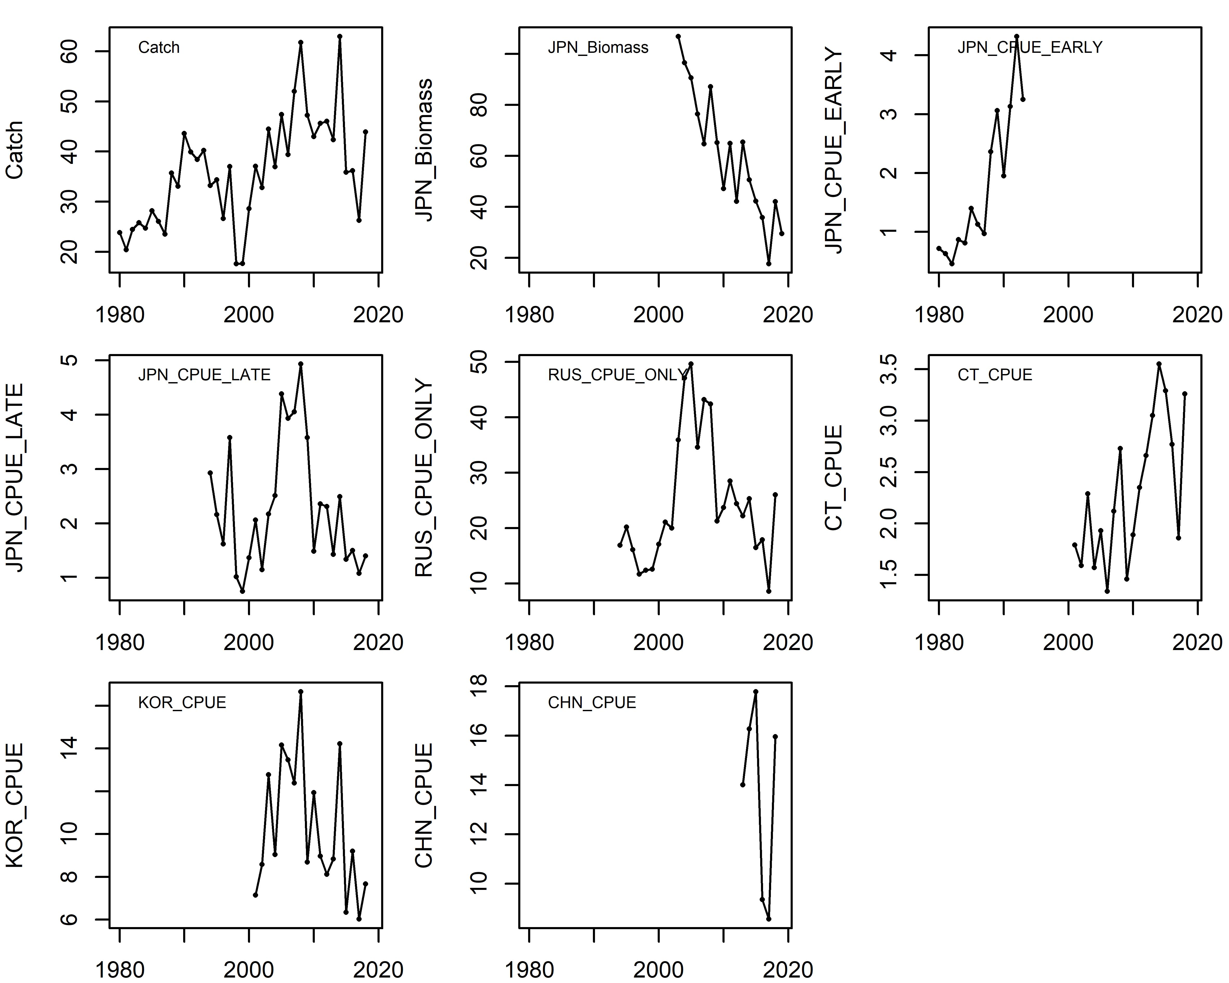
Figure 1. Input data for 2020 Pacific saury stock assessment.

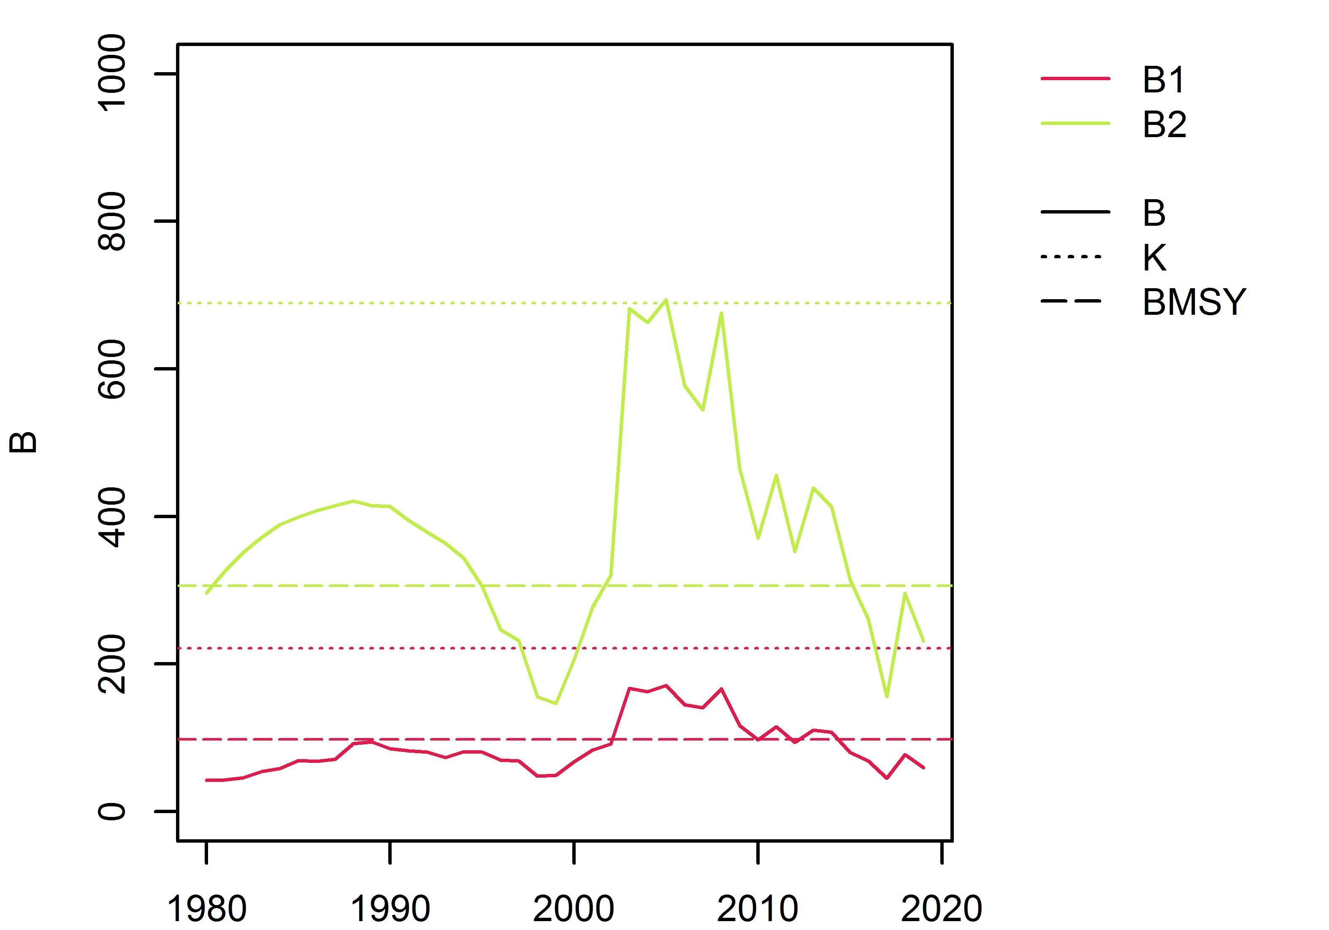
Figure 2. Median biomass over time from each base case scenario (NB1-NB2).
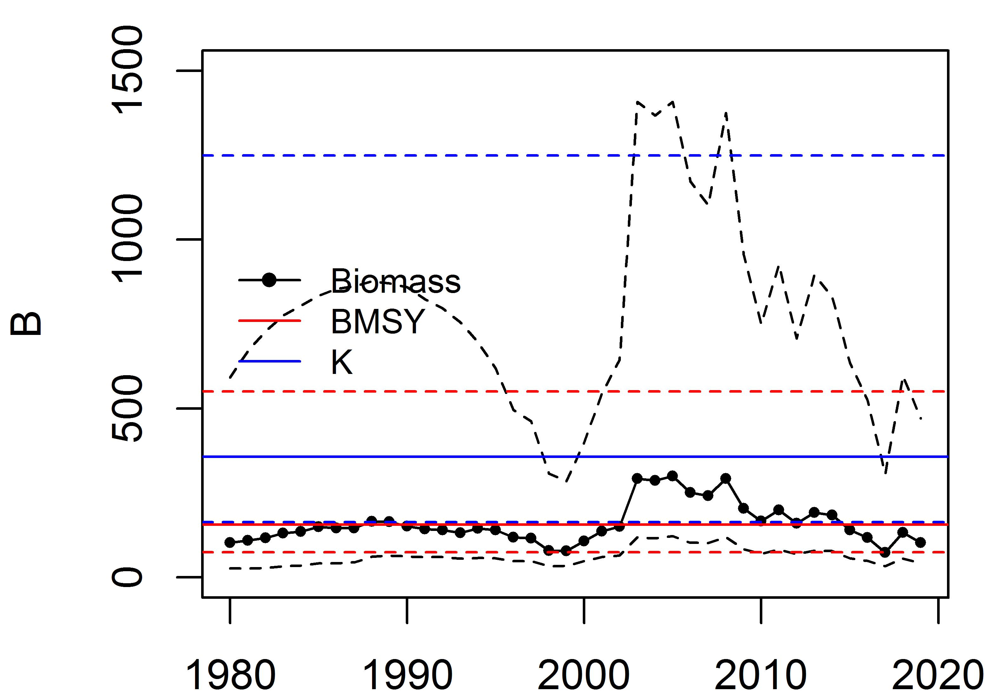
Figure 3. Median biomass and 80% CI over base case scenarios 1-2. The red line represents BMSY, and blue line represents K.
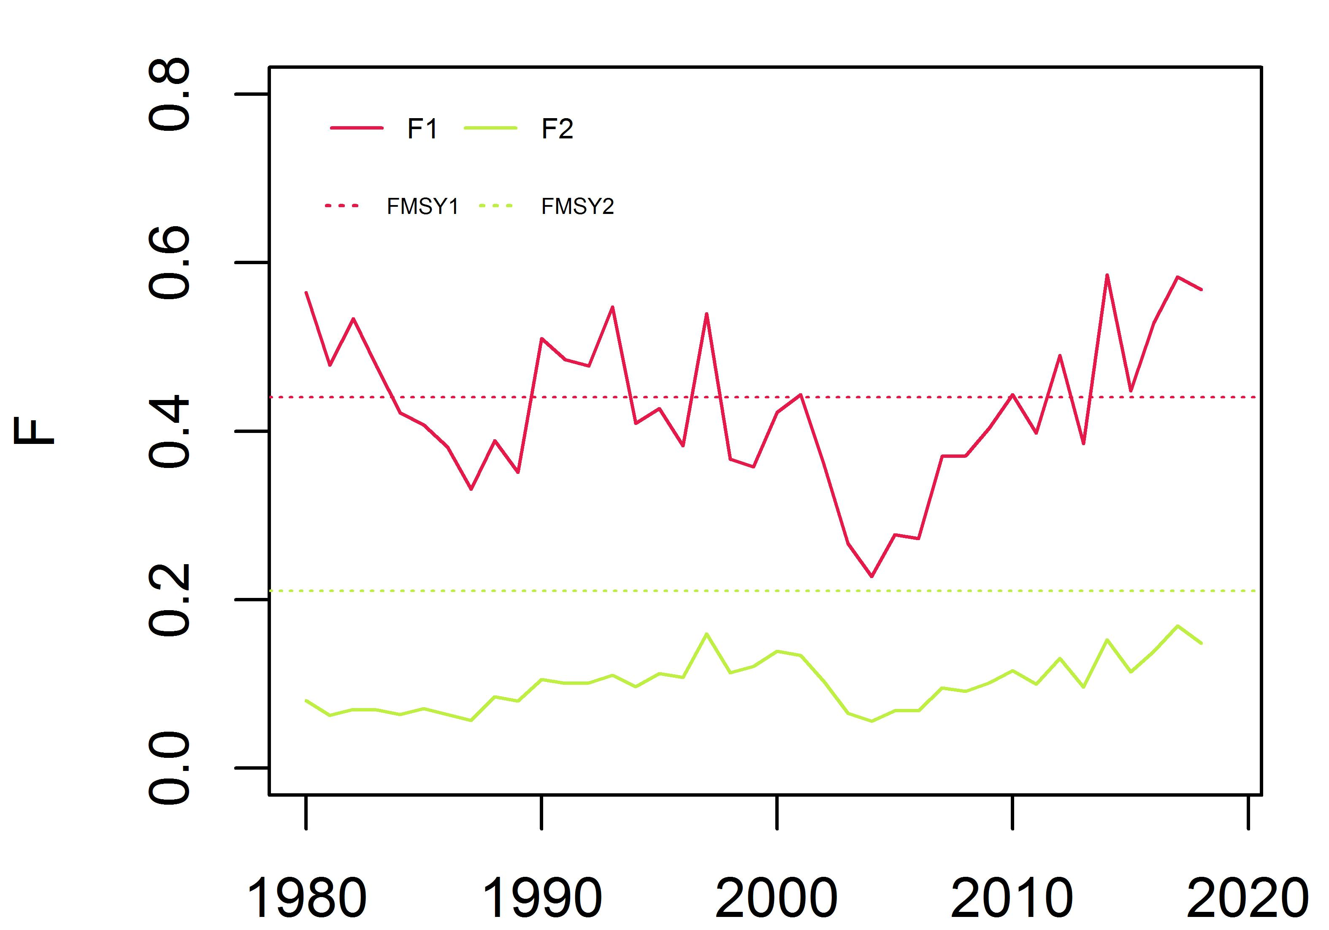
Figure 4. Median fishing mortality over time from two base case scenarios (NB1-NB2).
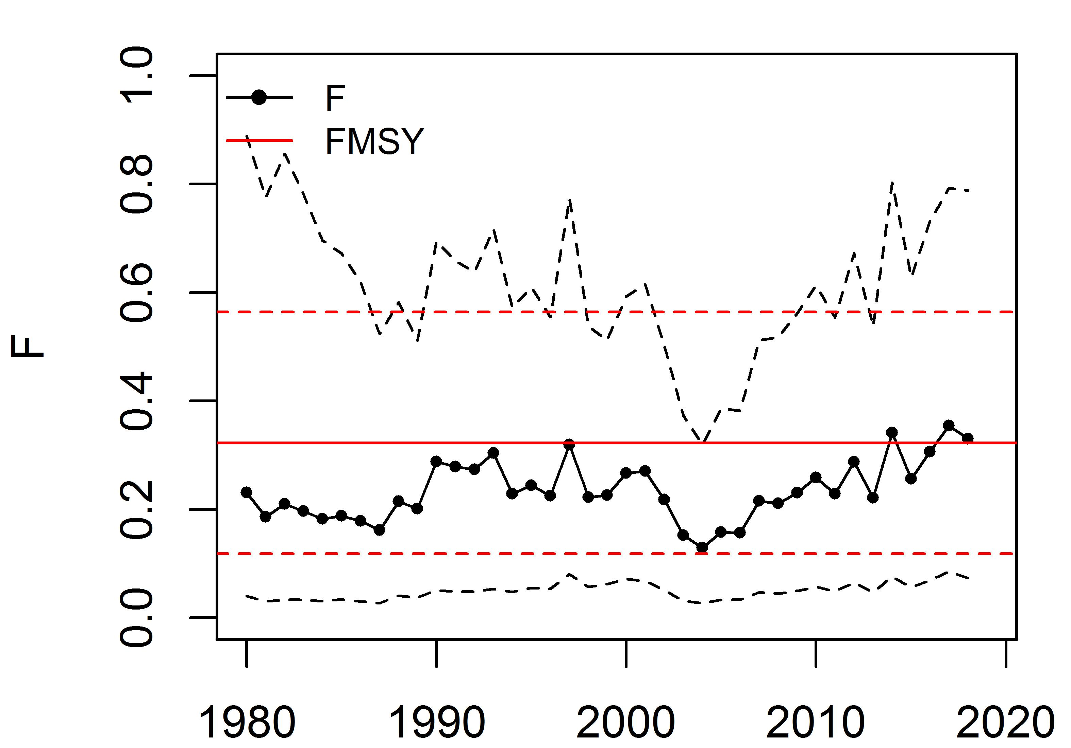
Figure 5. Median fishing mortality and 80% CI over base case scenarios 1-2.
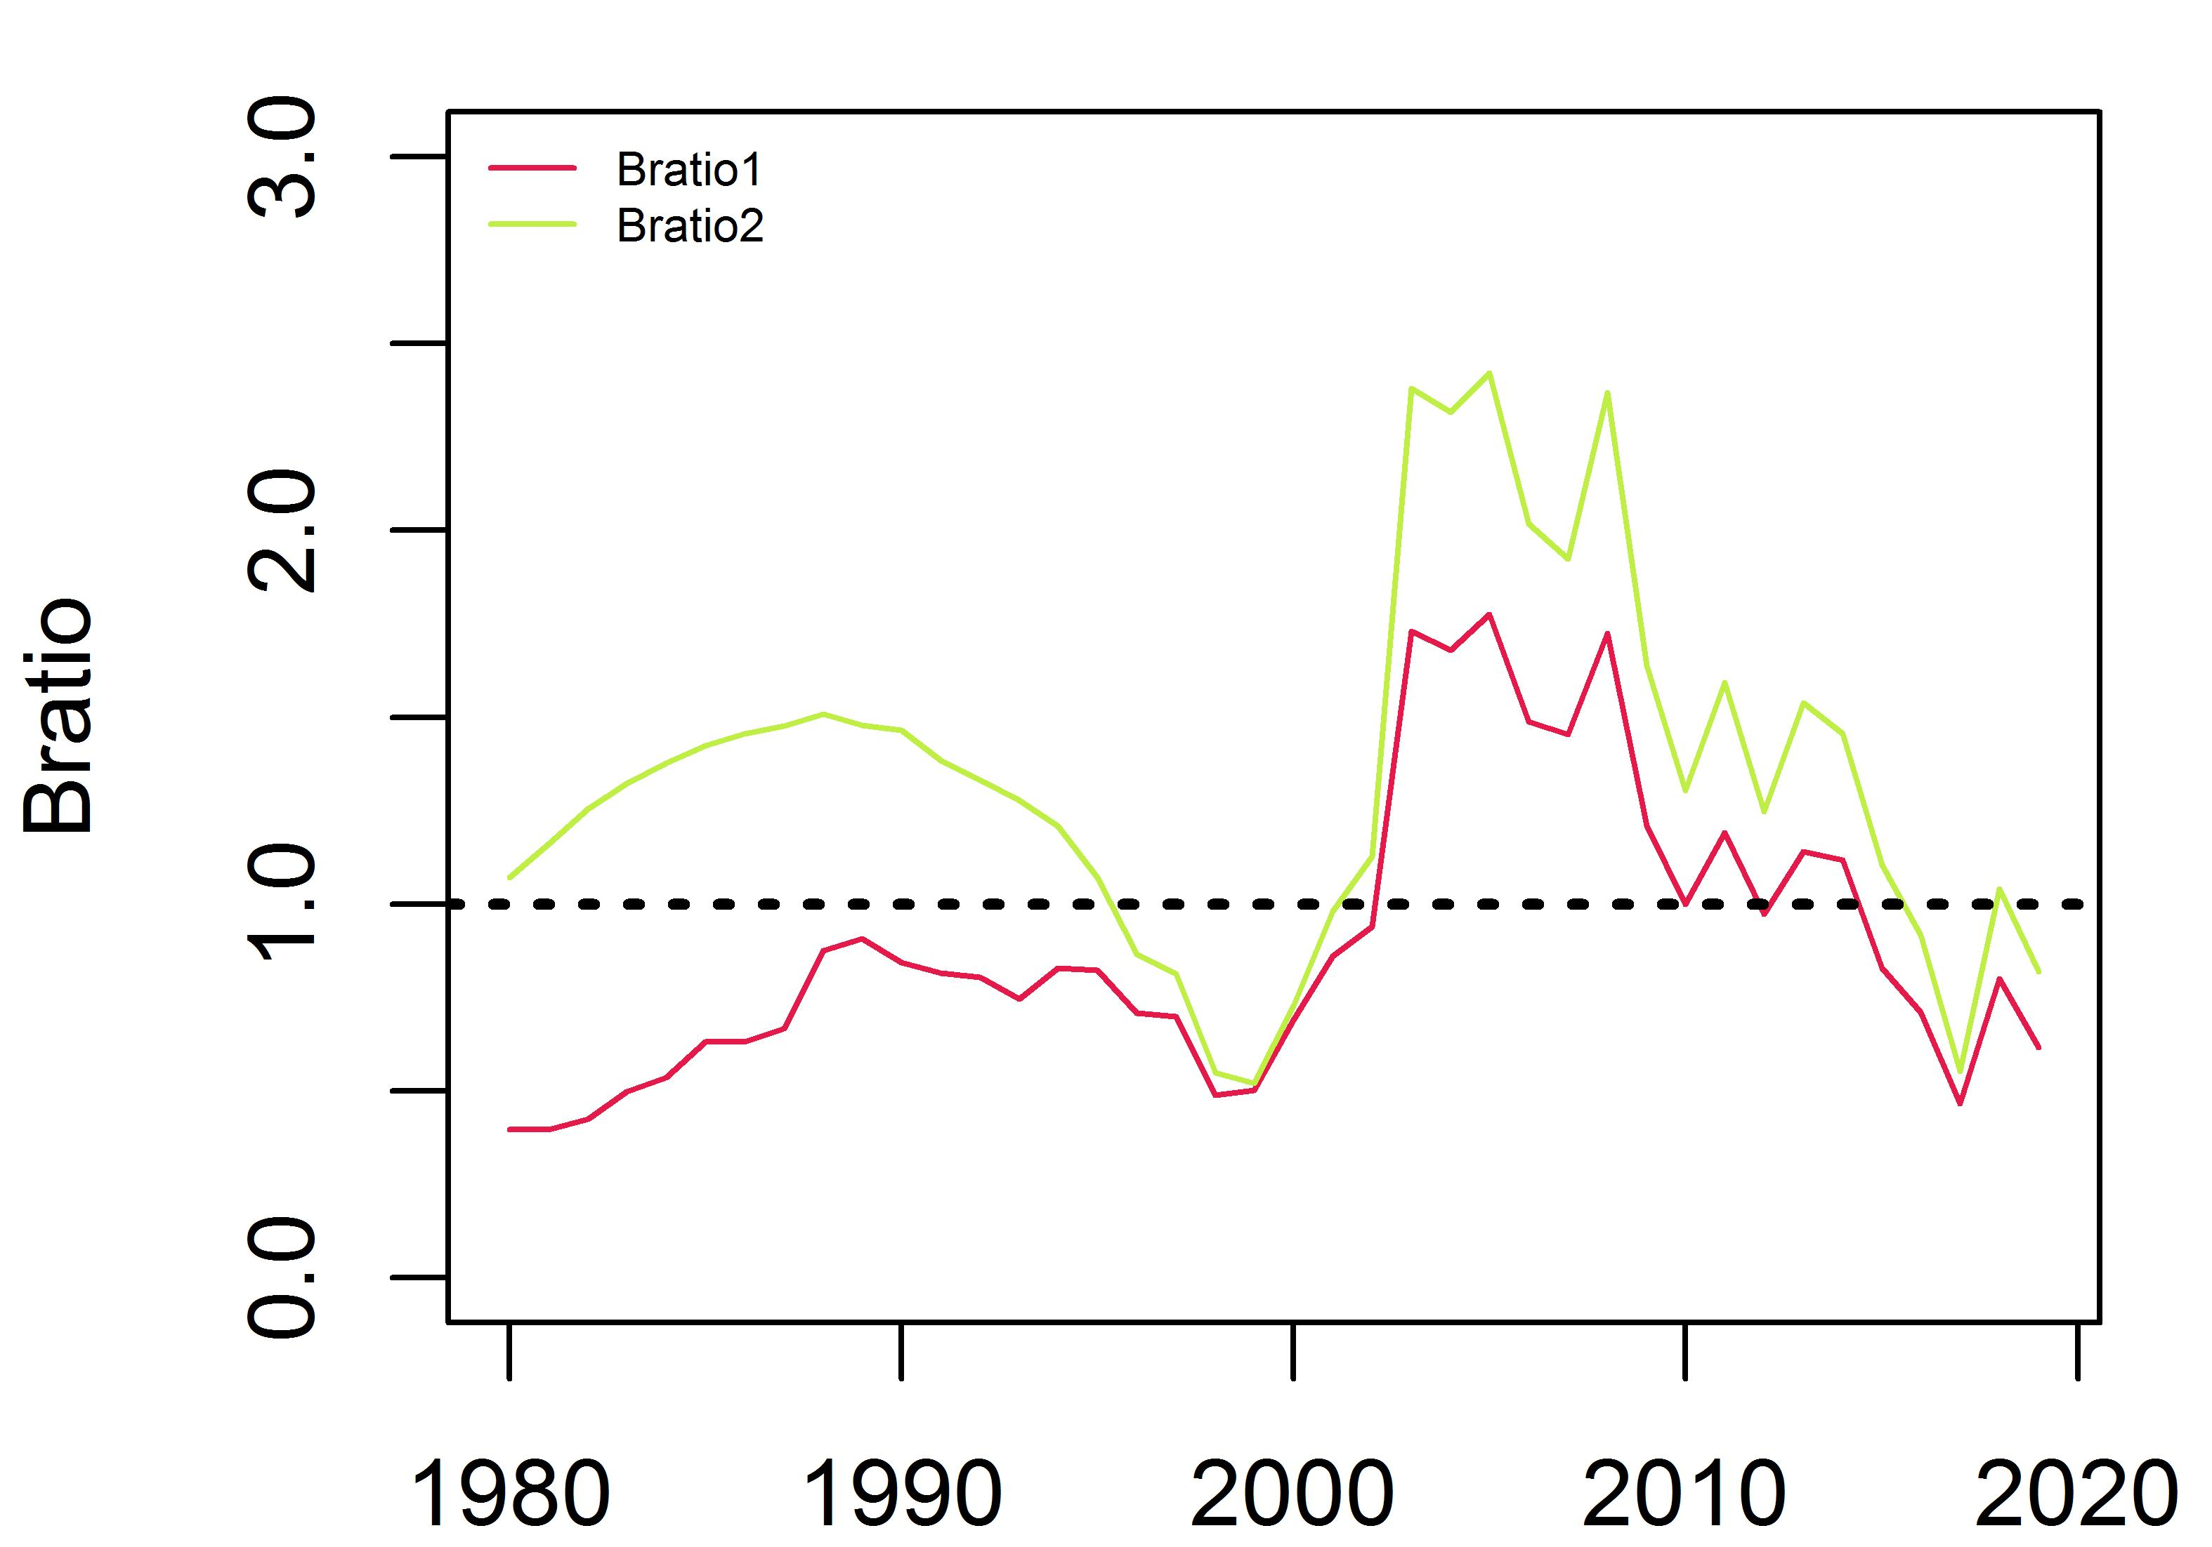
Figure 6. Median Bratio over time from each base case scenario (1-2).
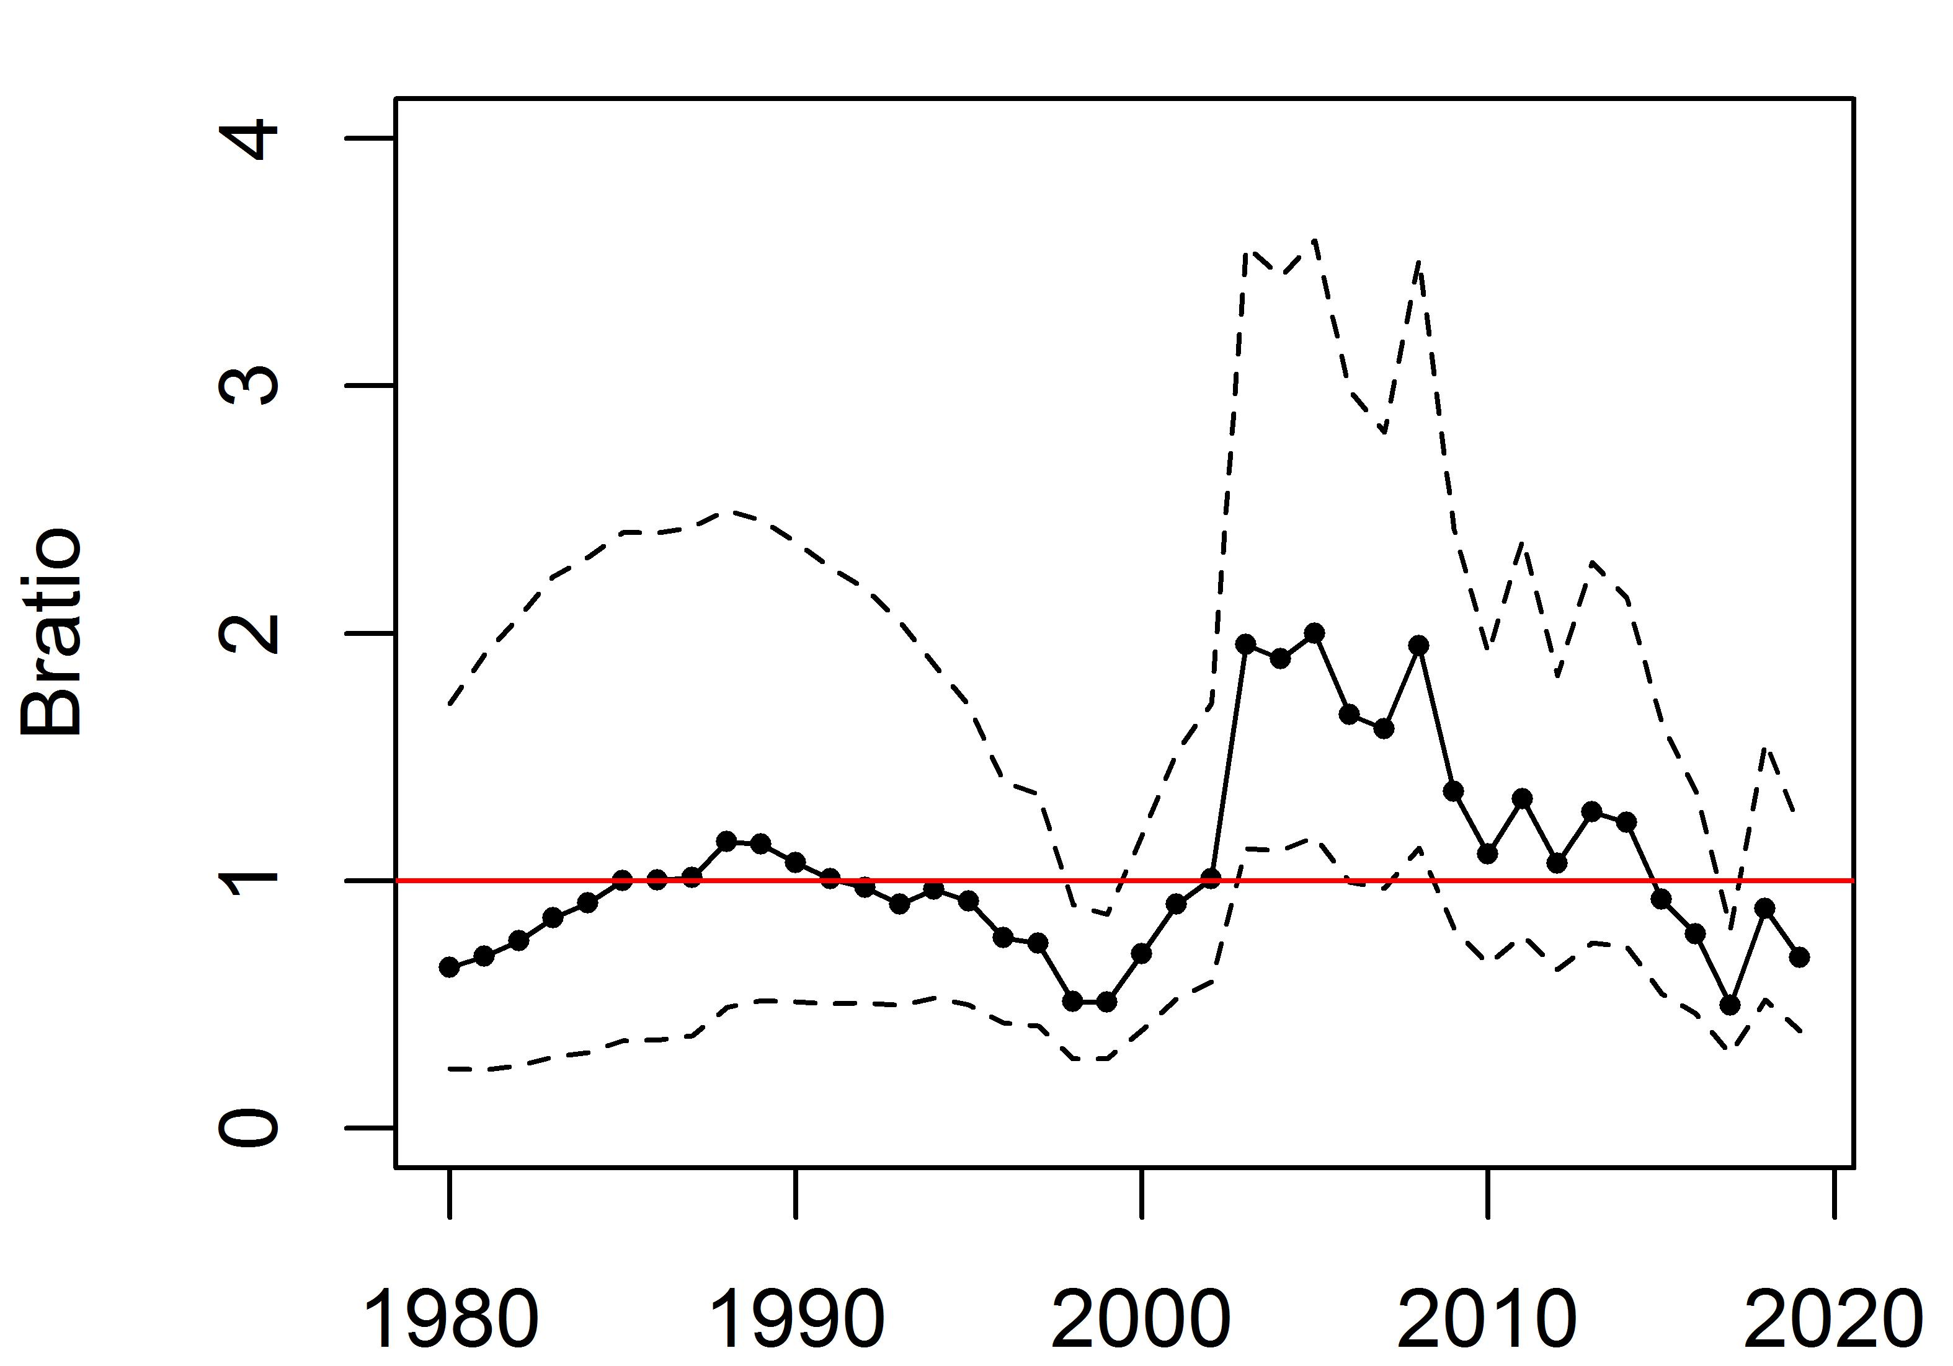
Figure 7. Median Bratio and 80% CI over base case scenarios 1-2.
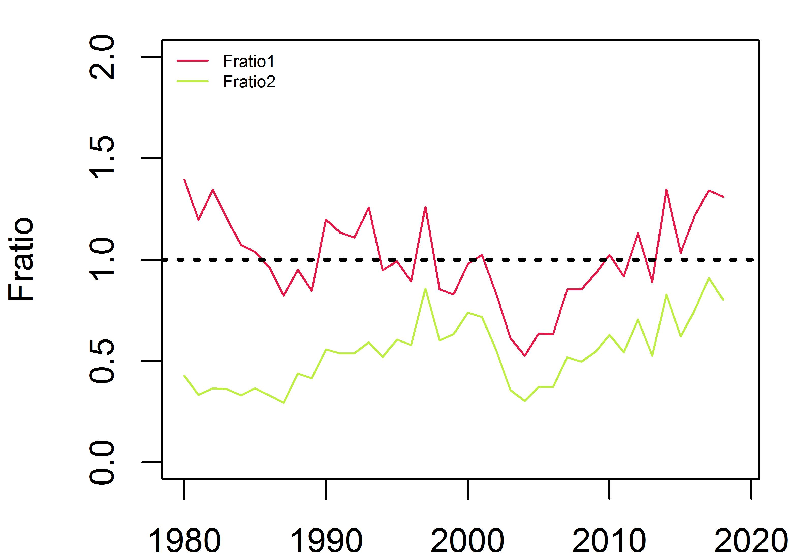
Figure 8. Median Fratio over time from each base case scenario (1-2).
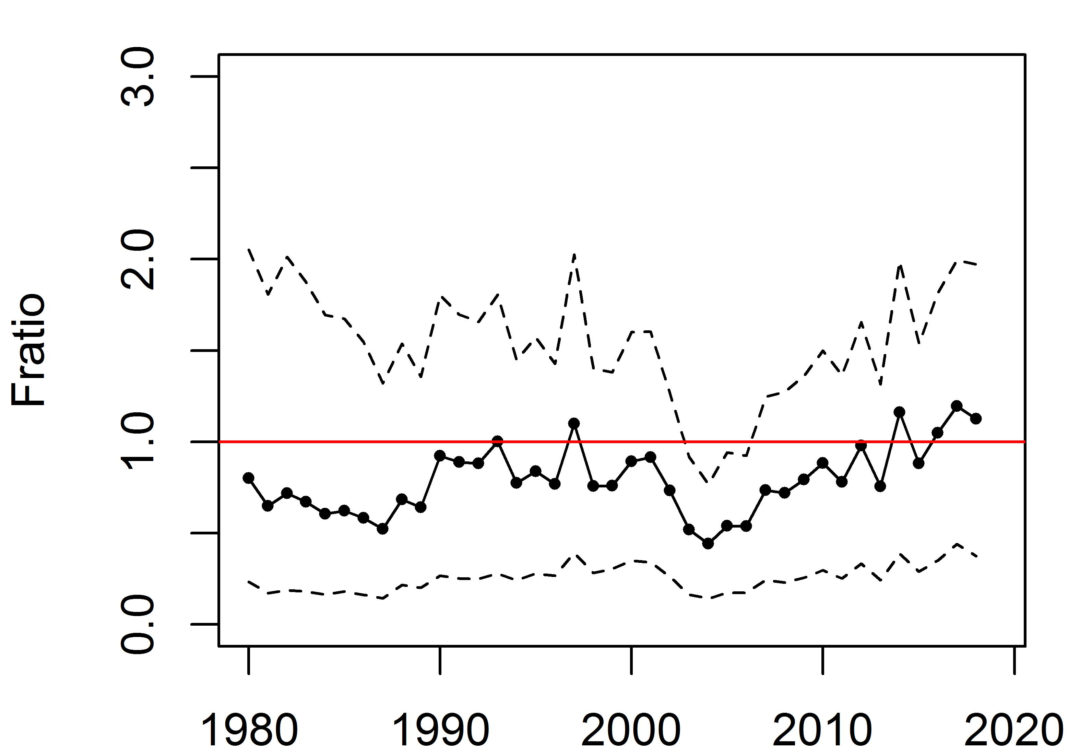
Figure 9. Median Fratio and 80% CI over base case scenarios 1-2.
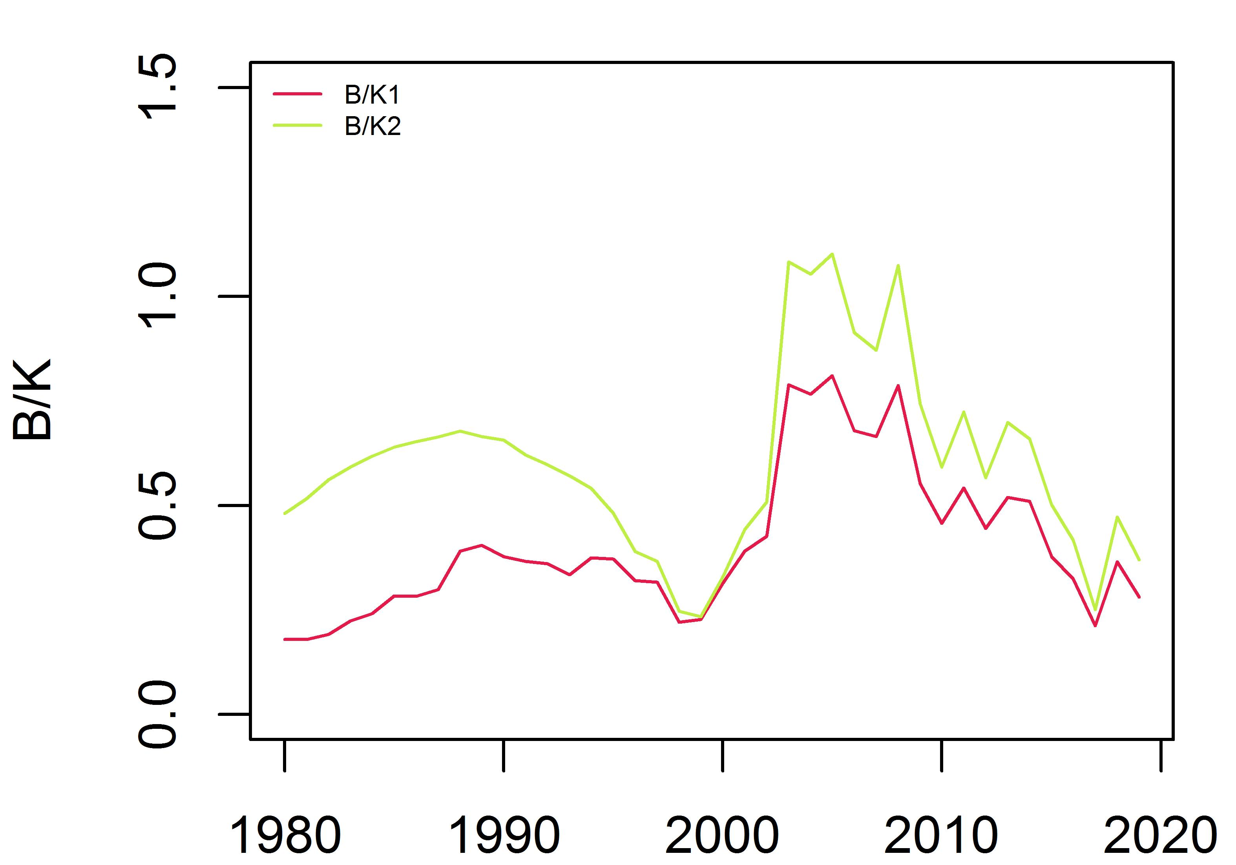
Figure 10. Median B/K over time from each base case scenario (1-2).
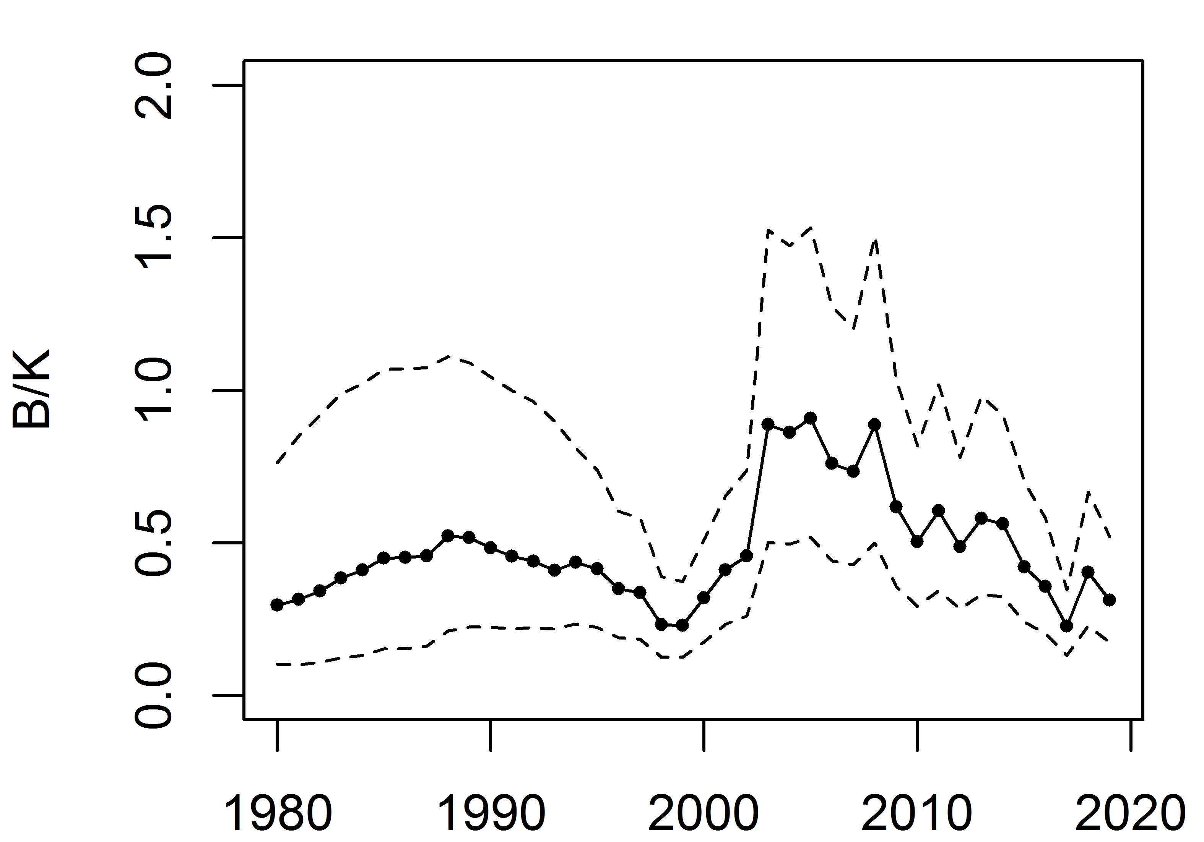
Figure 11. Median B/K and 80% CI over base case scenarios 1-2.

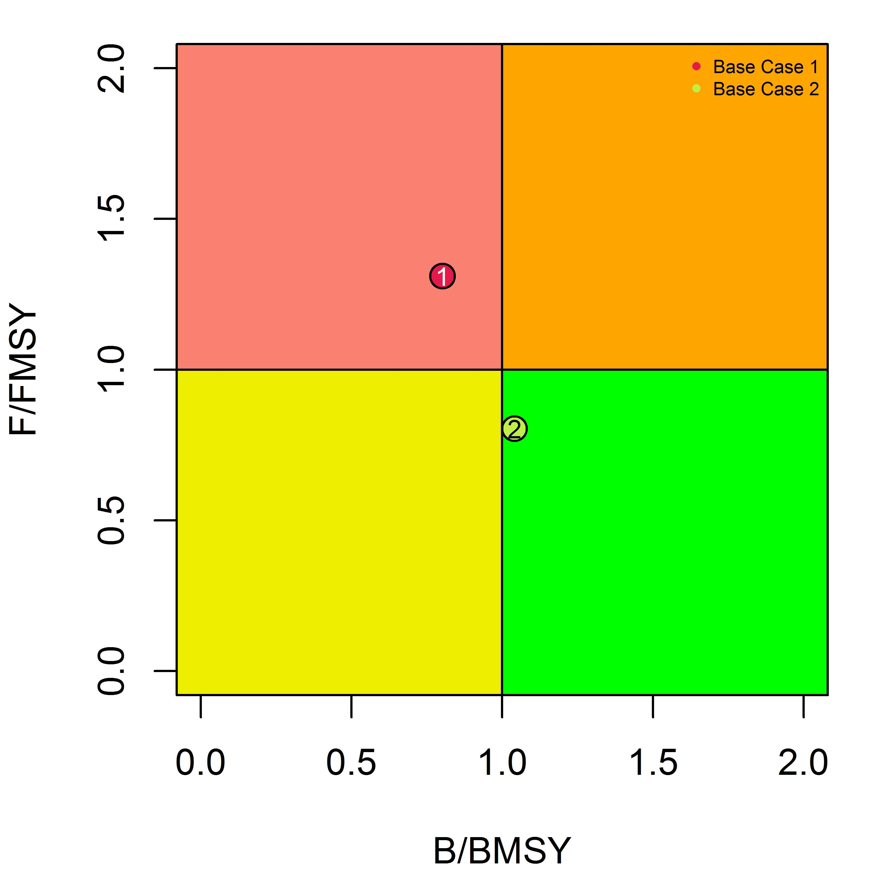
Figure 12. Median Fratio2018 and Bratio2018 calculated from each base case scenario (1-2).
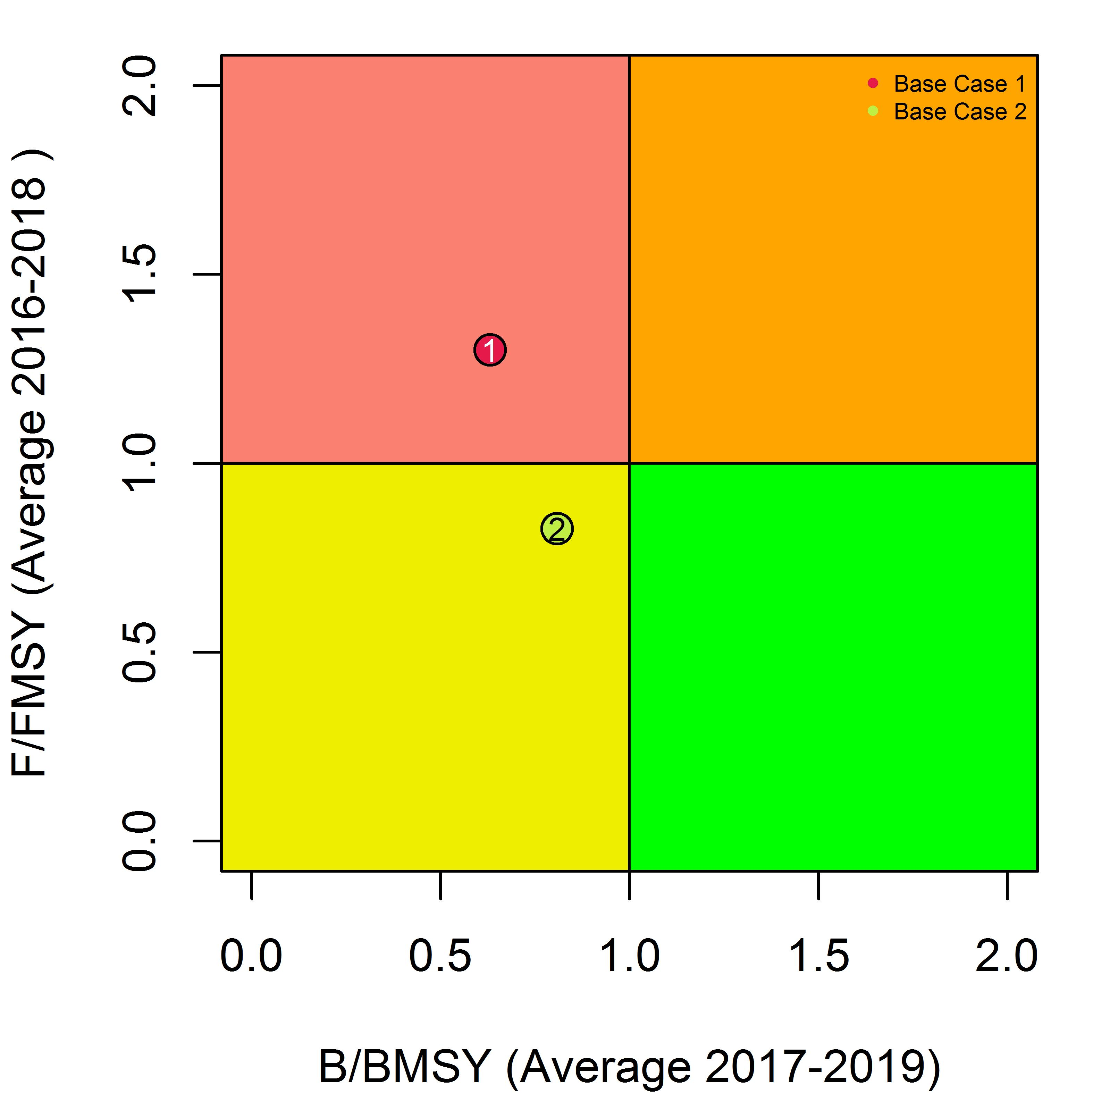
Figure 13. Median Fratio (average from 2016-2018) and Bratio (average from 2017-2019) calculated from each base case scenario (1-2).
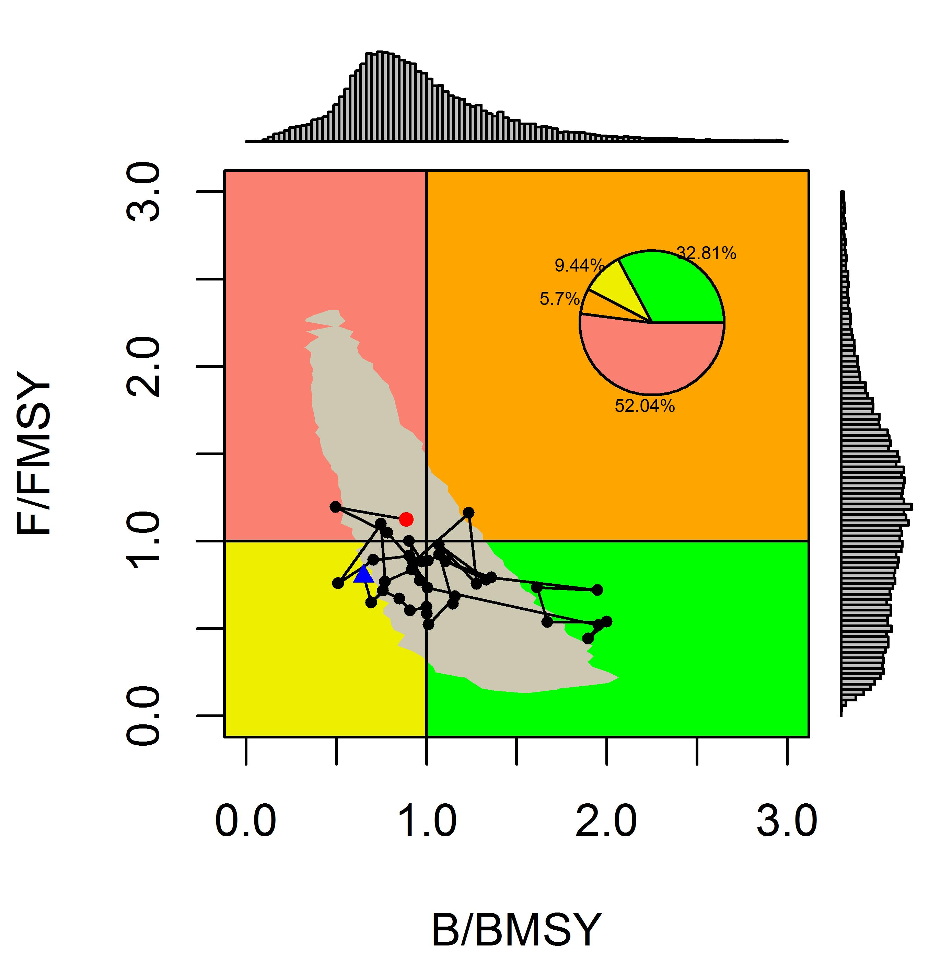
Figure 14. Kobe plot with time series median Fratio and Bratio from 1980 to 2018 over base case scenarios 1-2. The blue dot represents initial year 1980 and the red dot represents the terminal year 2018.
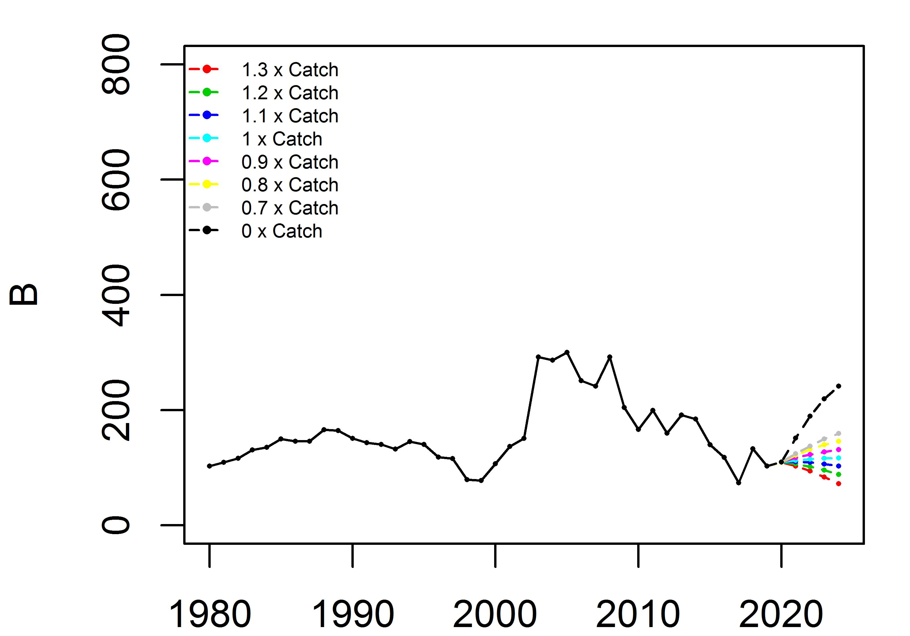
Figure 15. Median biomass trajectories (1980-2024) from 8 catch scenarios over two base case models.

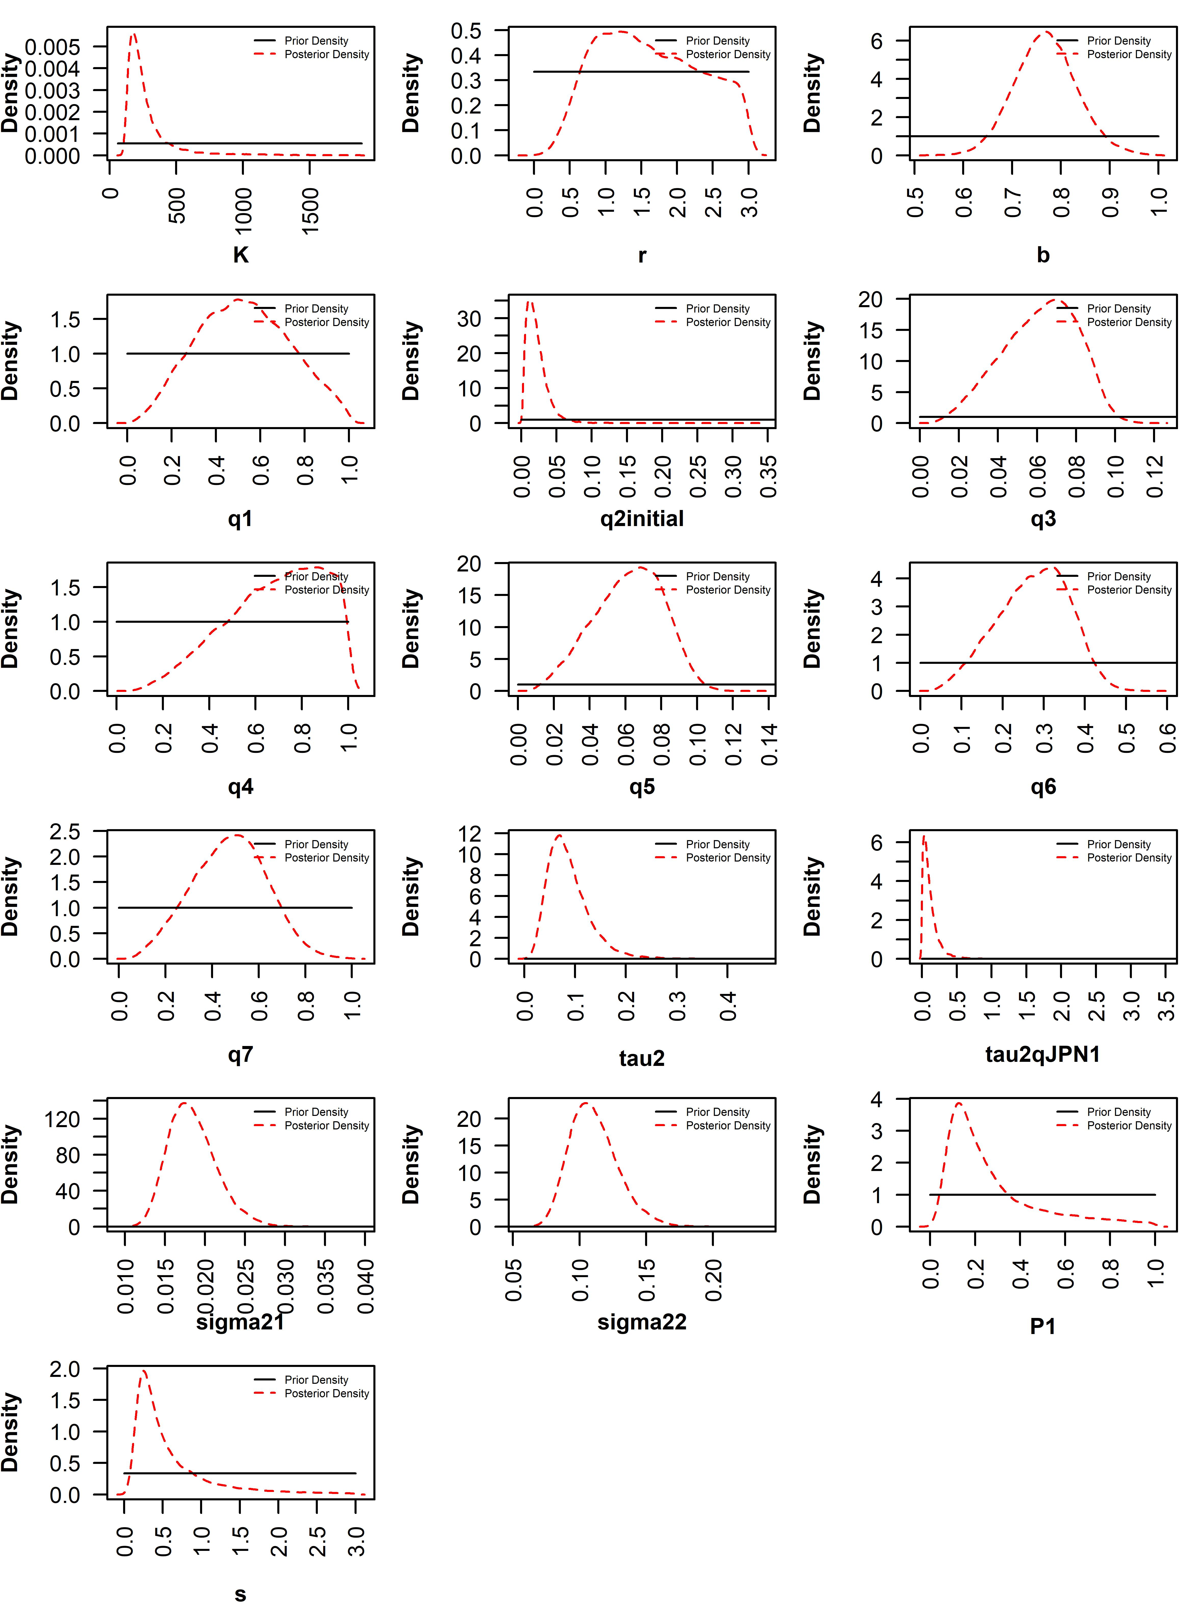
Appendix Figure 1. Prior and posterior distributions of parameters from base case scenario 1. q1 to q7 represent catchability of fishery-independent survey biomass index, Japanese early CPUE, Japanese late CPUE, Russian CPUE, Chinese Taipei CPUE, Korean CPUE, and Chinese CPUE respectively. q2initial represents q1980. tau2 represents process error variance, tau2qJPN1 represents error variance of Japanese early CPUE, sigma21 represents observation variance of biomass index, and sigma22 represents common observation variance of CPUE. P1 represents B1/K and s represents shape.

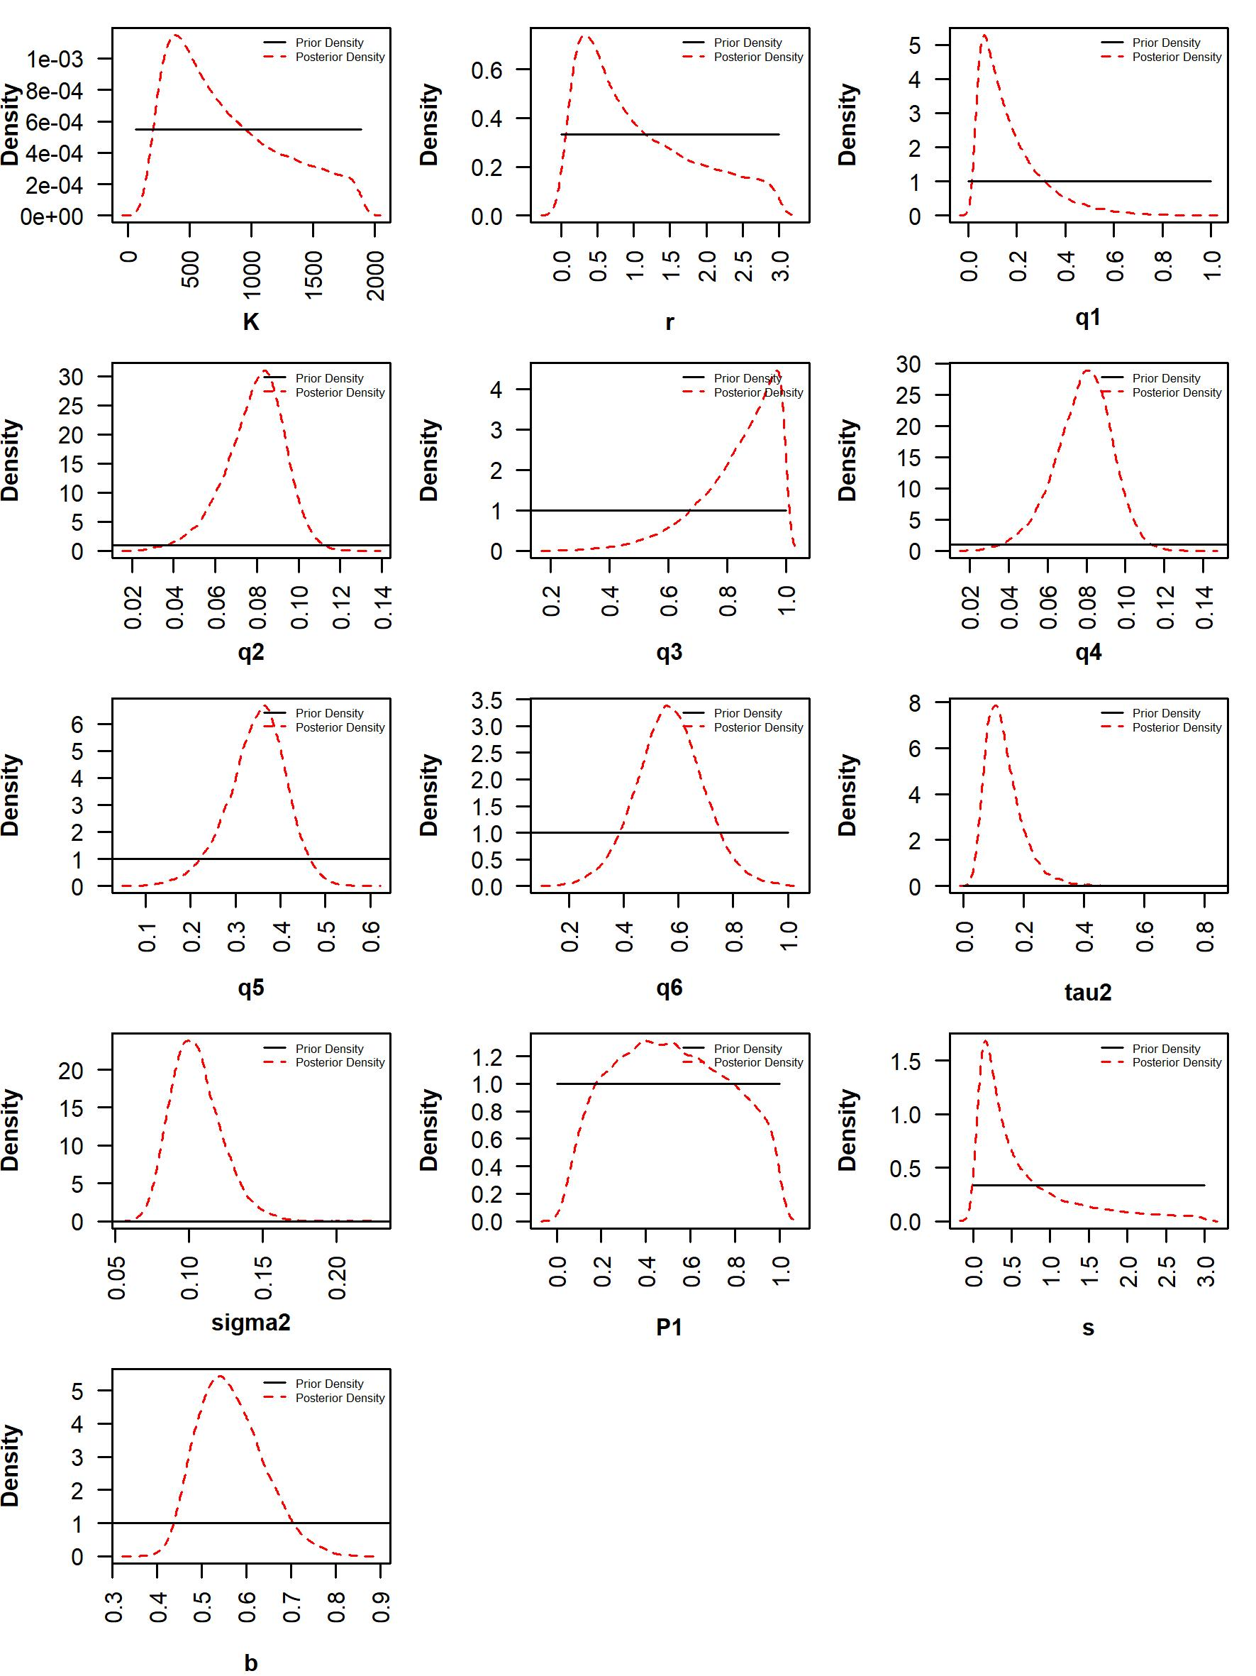
Appendix Figure 2. Prior and posterior distributions of parameters from base case scenario 2. q1 to q6 represent catchability of fishery-independent survey biomass index, Japanese late CPUE, Russian CPUE, Chinese Taipei CPUE, Korean CPUE, and Chinese CPUE respectively. tau2 represents process error variance, sigma2 represents common observation variance of CPUE. P1 represents B1980/K and s represents shape.
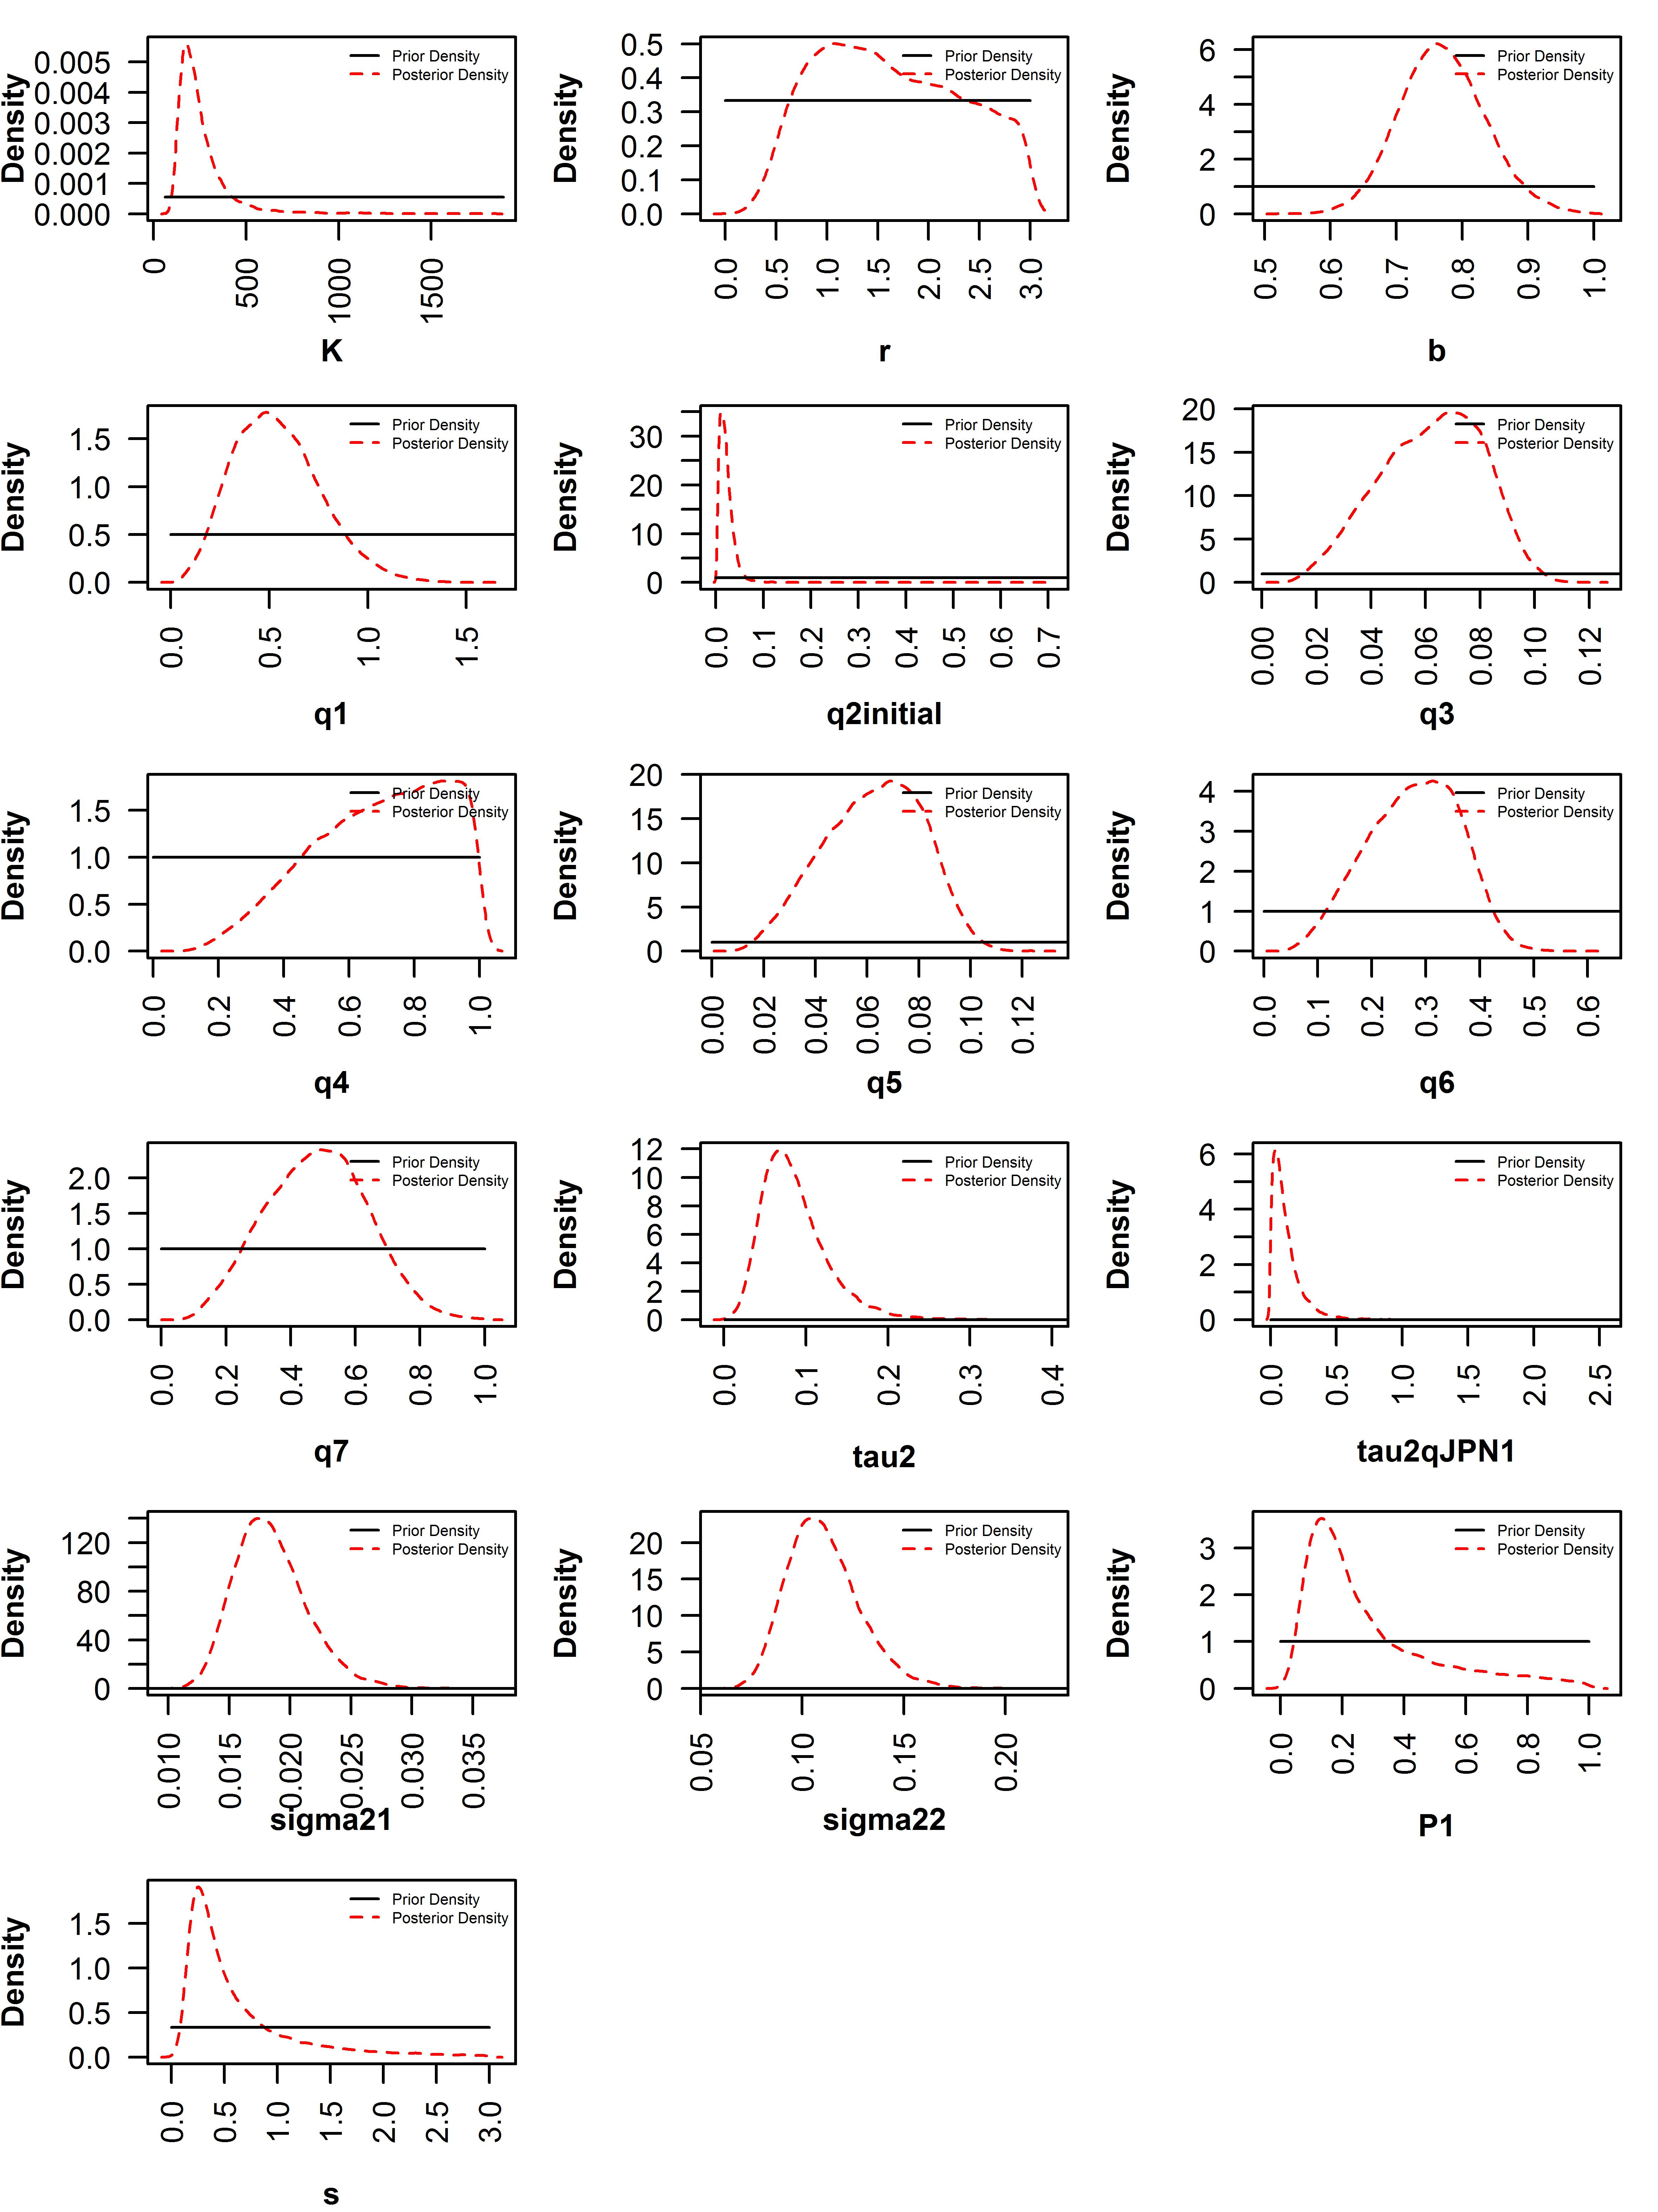
Appendix Figure 3. Prior and posterior distributions of parameters from sensitivity case scenario 1. q1 to q7 represent catchability of fishery-independent survey biomass index, Japanese early CPUE, Japanese late CPUE, Russian CPUE, Chinese Taipei CPUE, Korean CPUE, and Chinese CPUE respectively. q2initial represents q1980. tau2 represents process error variance, tau2qJPN1 represents error variance of Japanese early CPUE, sigma21 represents observation variance of biomass index, and sigma22 represents common observation variance of CPUE. P1 represents B1/K and s represents shape.

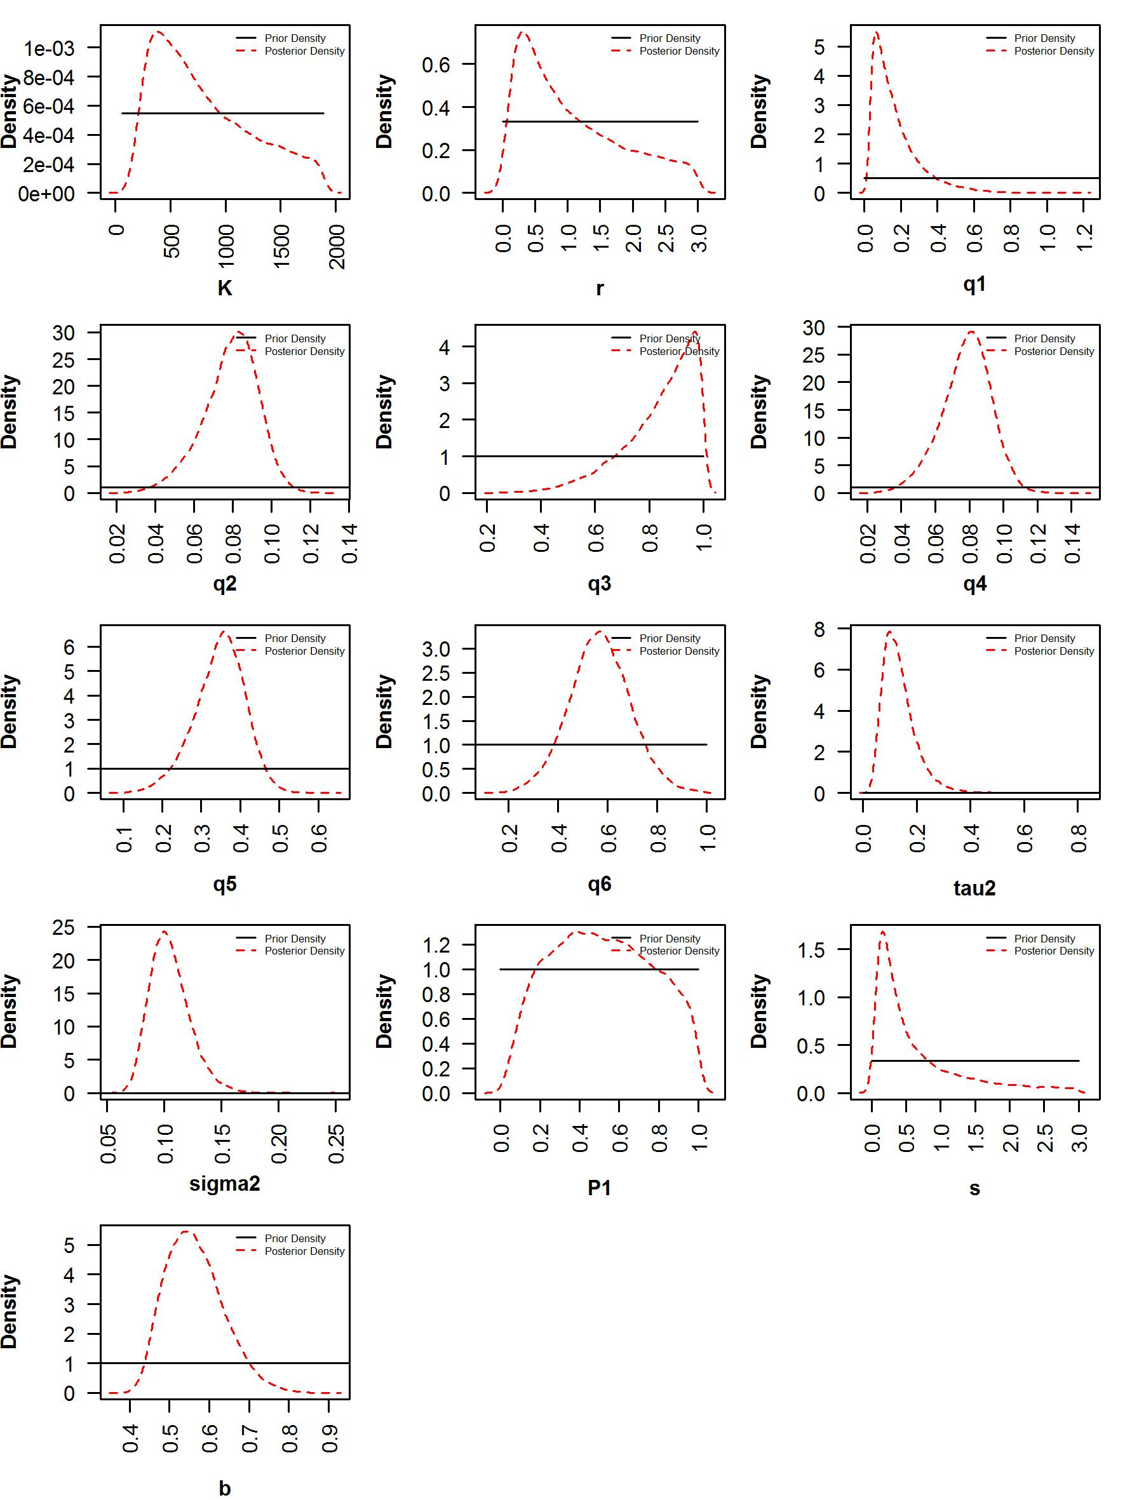
Appendix Figure 4. Prior and posterior distributions of parameters from sensitivity case scenario 2. q1 to q6 represent catchability of fishery-independent survey biomass index, Japanese late CPUE, Russian CPUE, Chinese Taipei CPUE, Korean CPUE, and Chinese CPUE respectively. tau2 represents process error variance, sigma2 represents common observation variance of CPUE. P1 represents B1980/K and s represents shape.

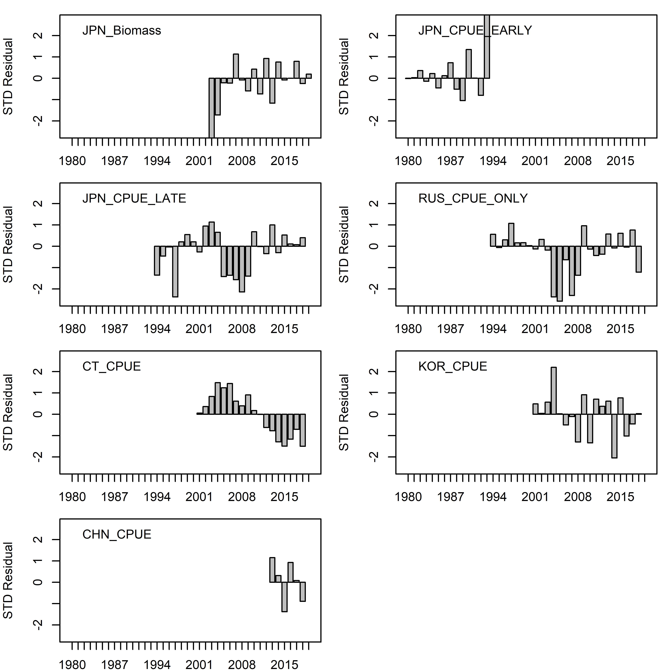
Appendix Figure 5. Standardized residuals between predicted and observed indices from base case scenario 1.
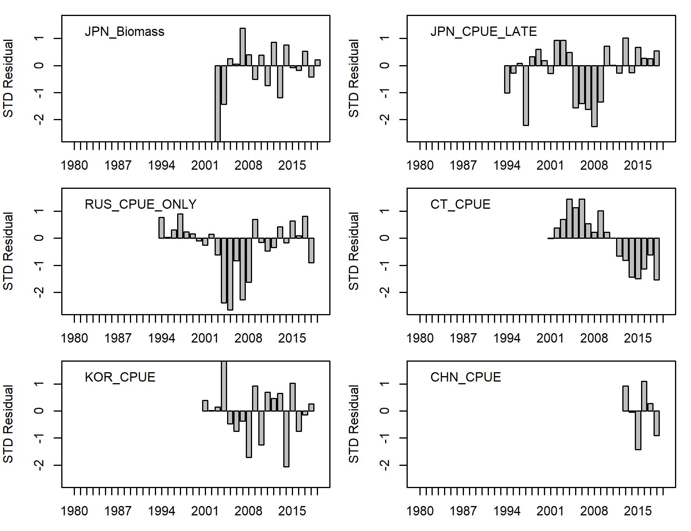
Appendix Figure 6. Standardized residuals between predicted and observed indices from base case scenario 2.
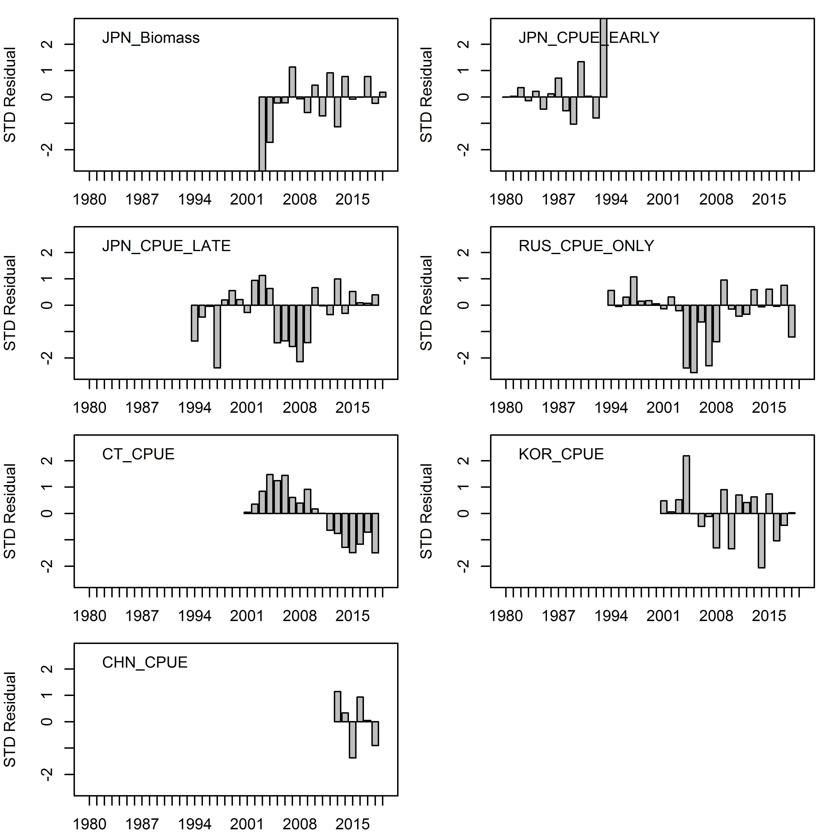
Appendix Figure 7. Standardized residuals between predicted and observed indices from sensitivity case scenario 1.

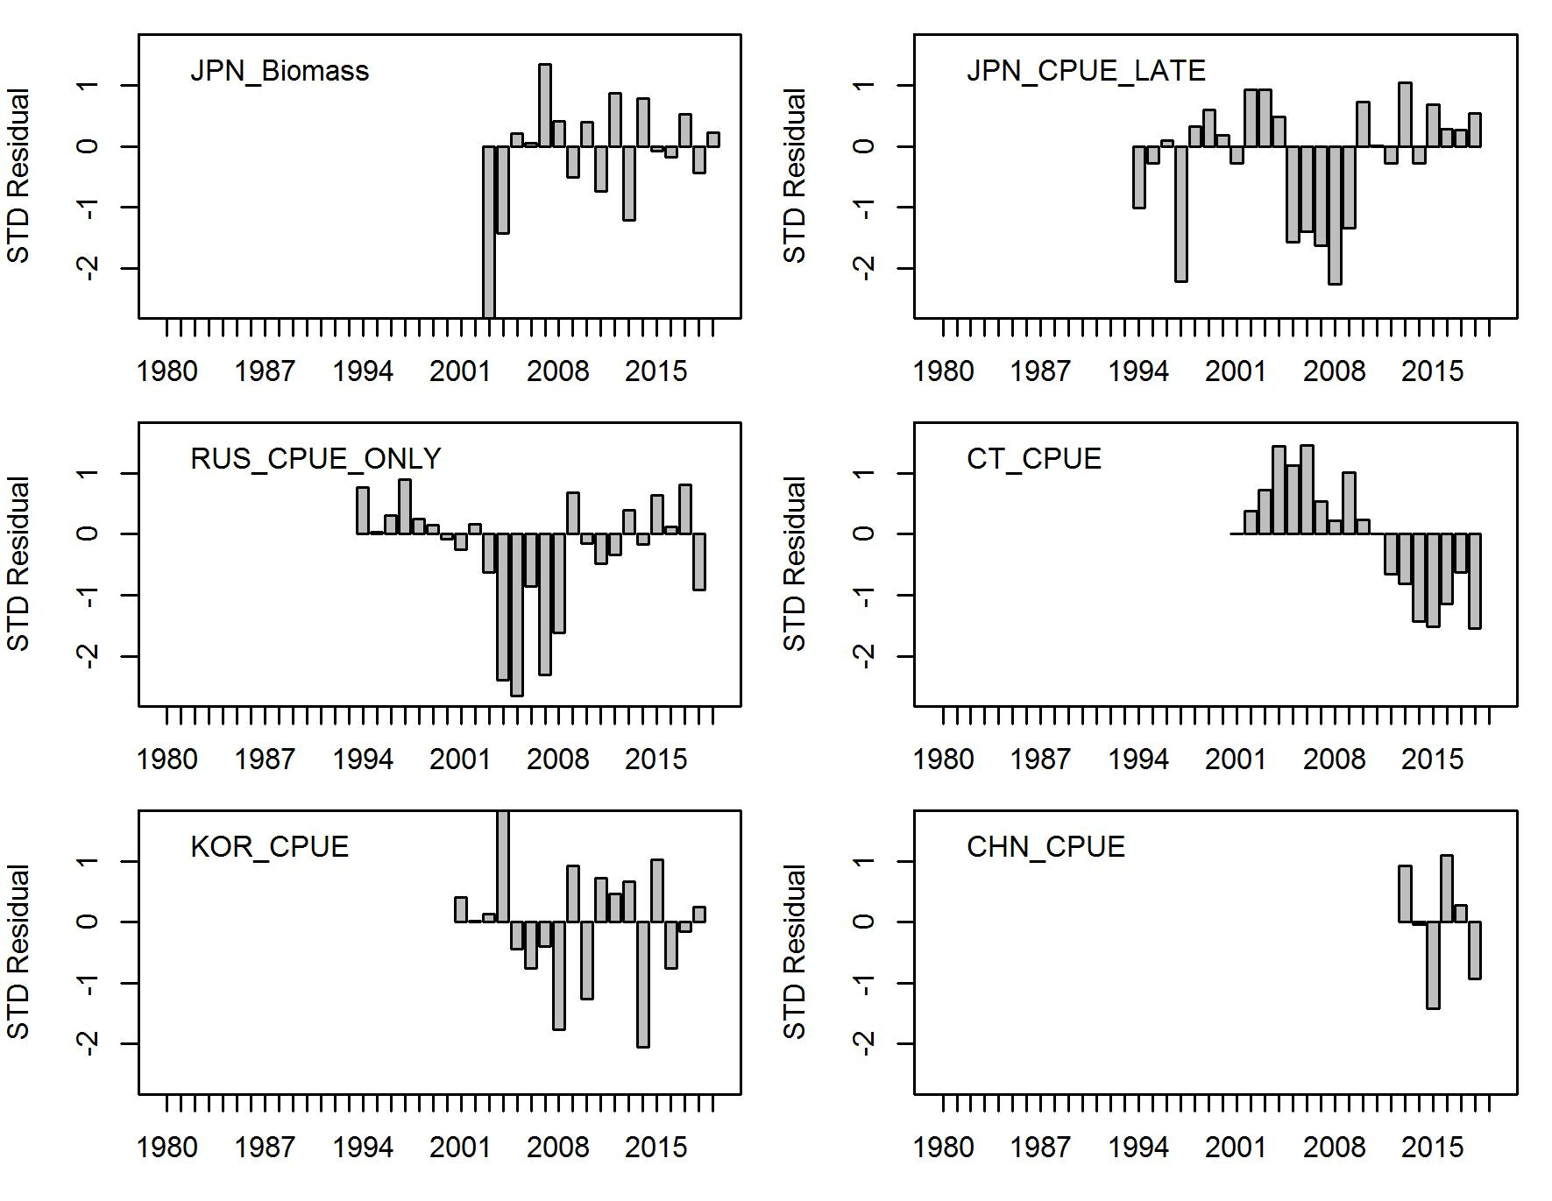
Appendix Figure 8. Standardized residuals between predicted and observed indices from sensitivity case scenario 2.

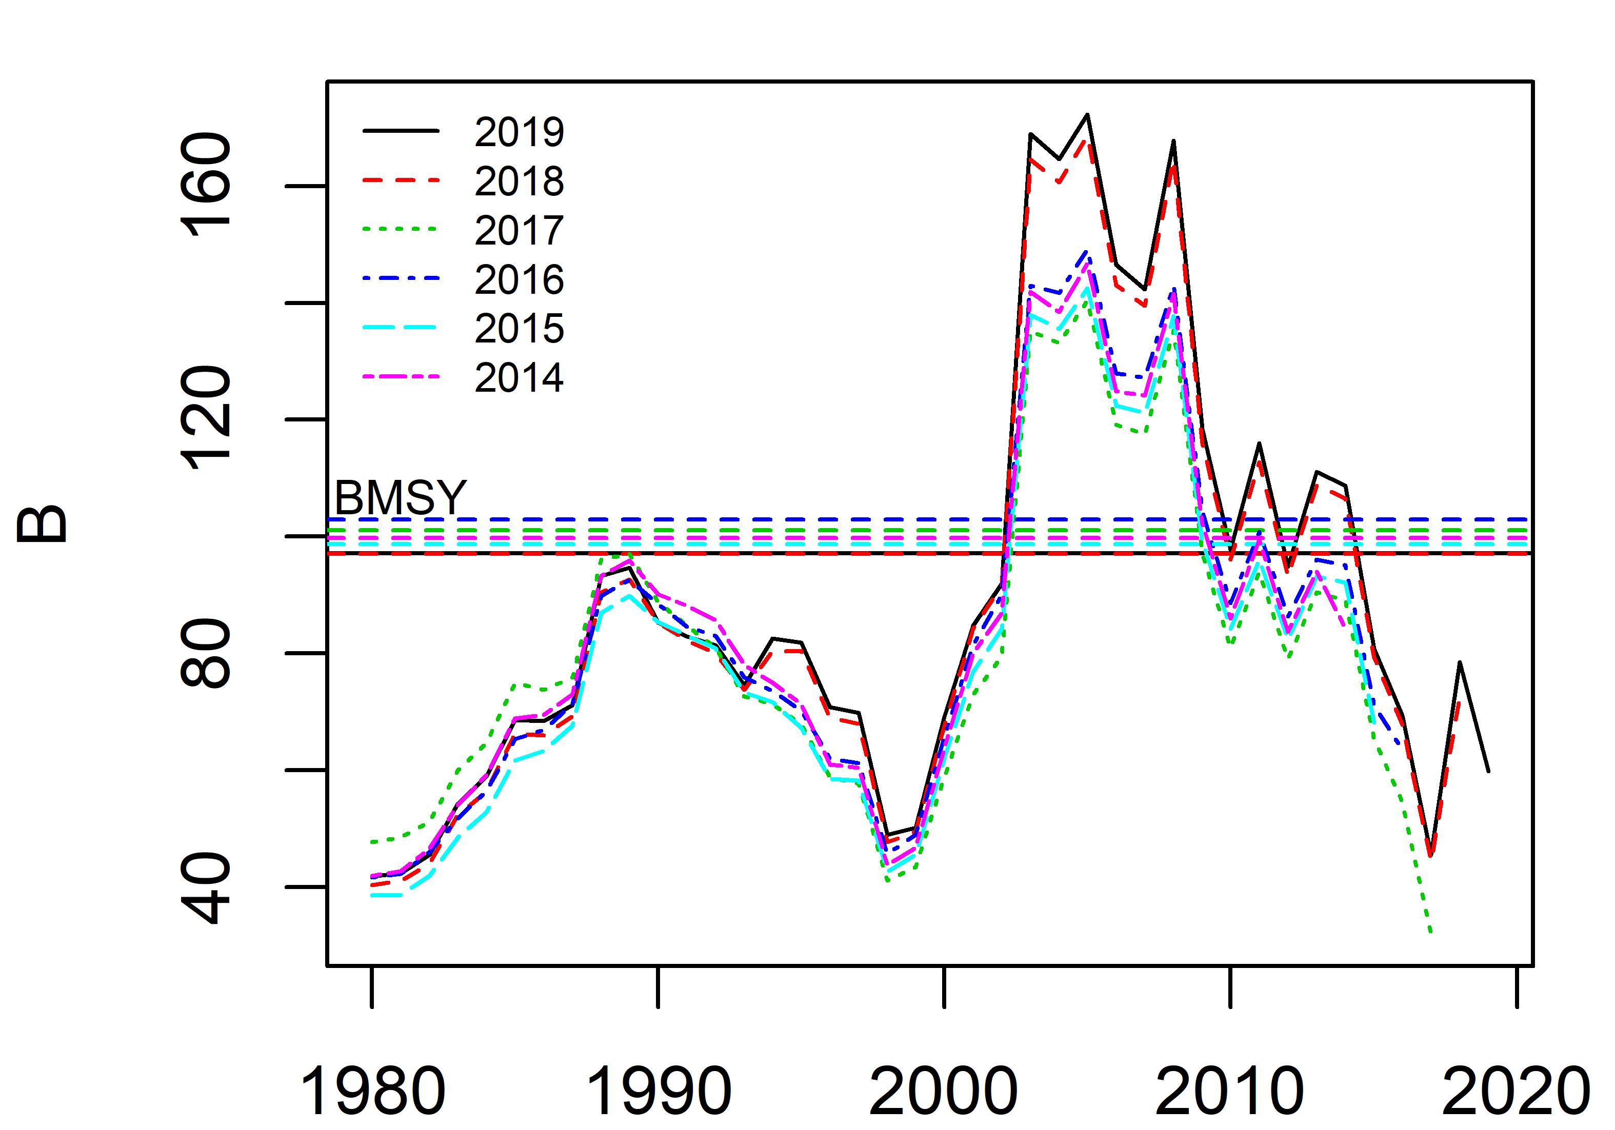
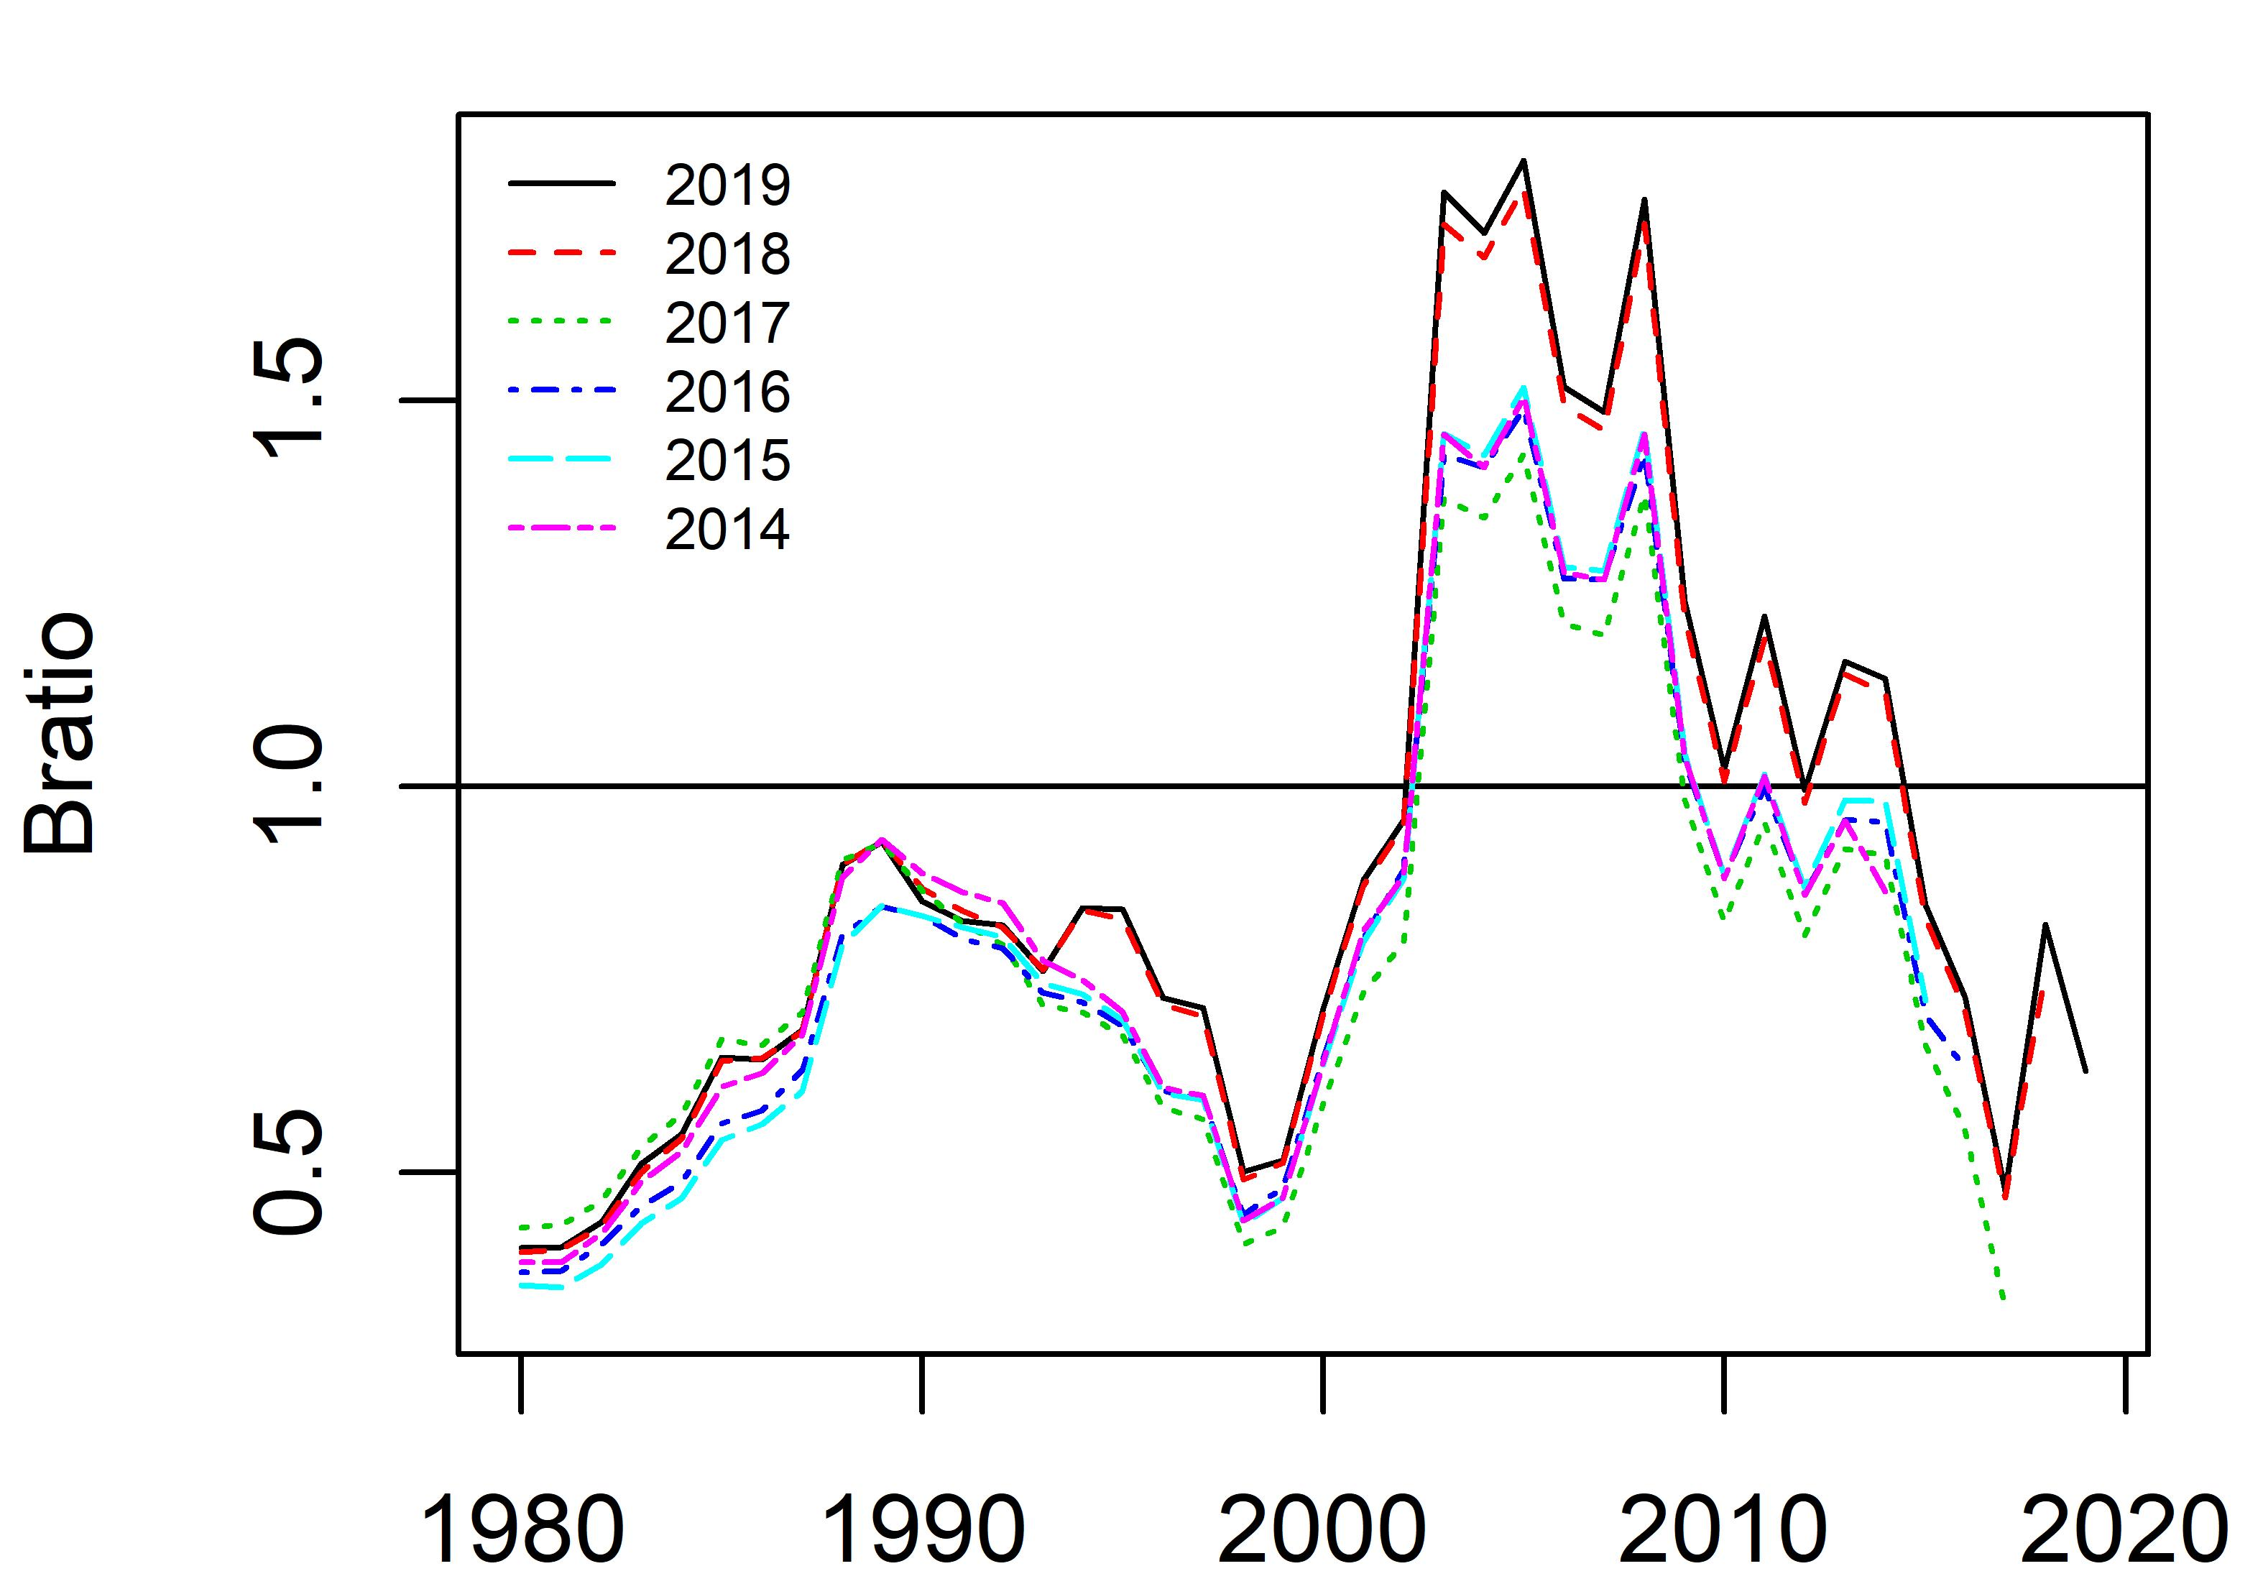
Appendix Figure 9. Time trajectories of biomass and Bratio from a retrospective analysis of base case scenario 1.

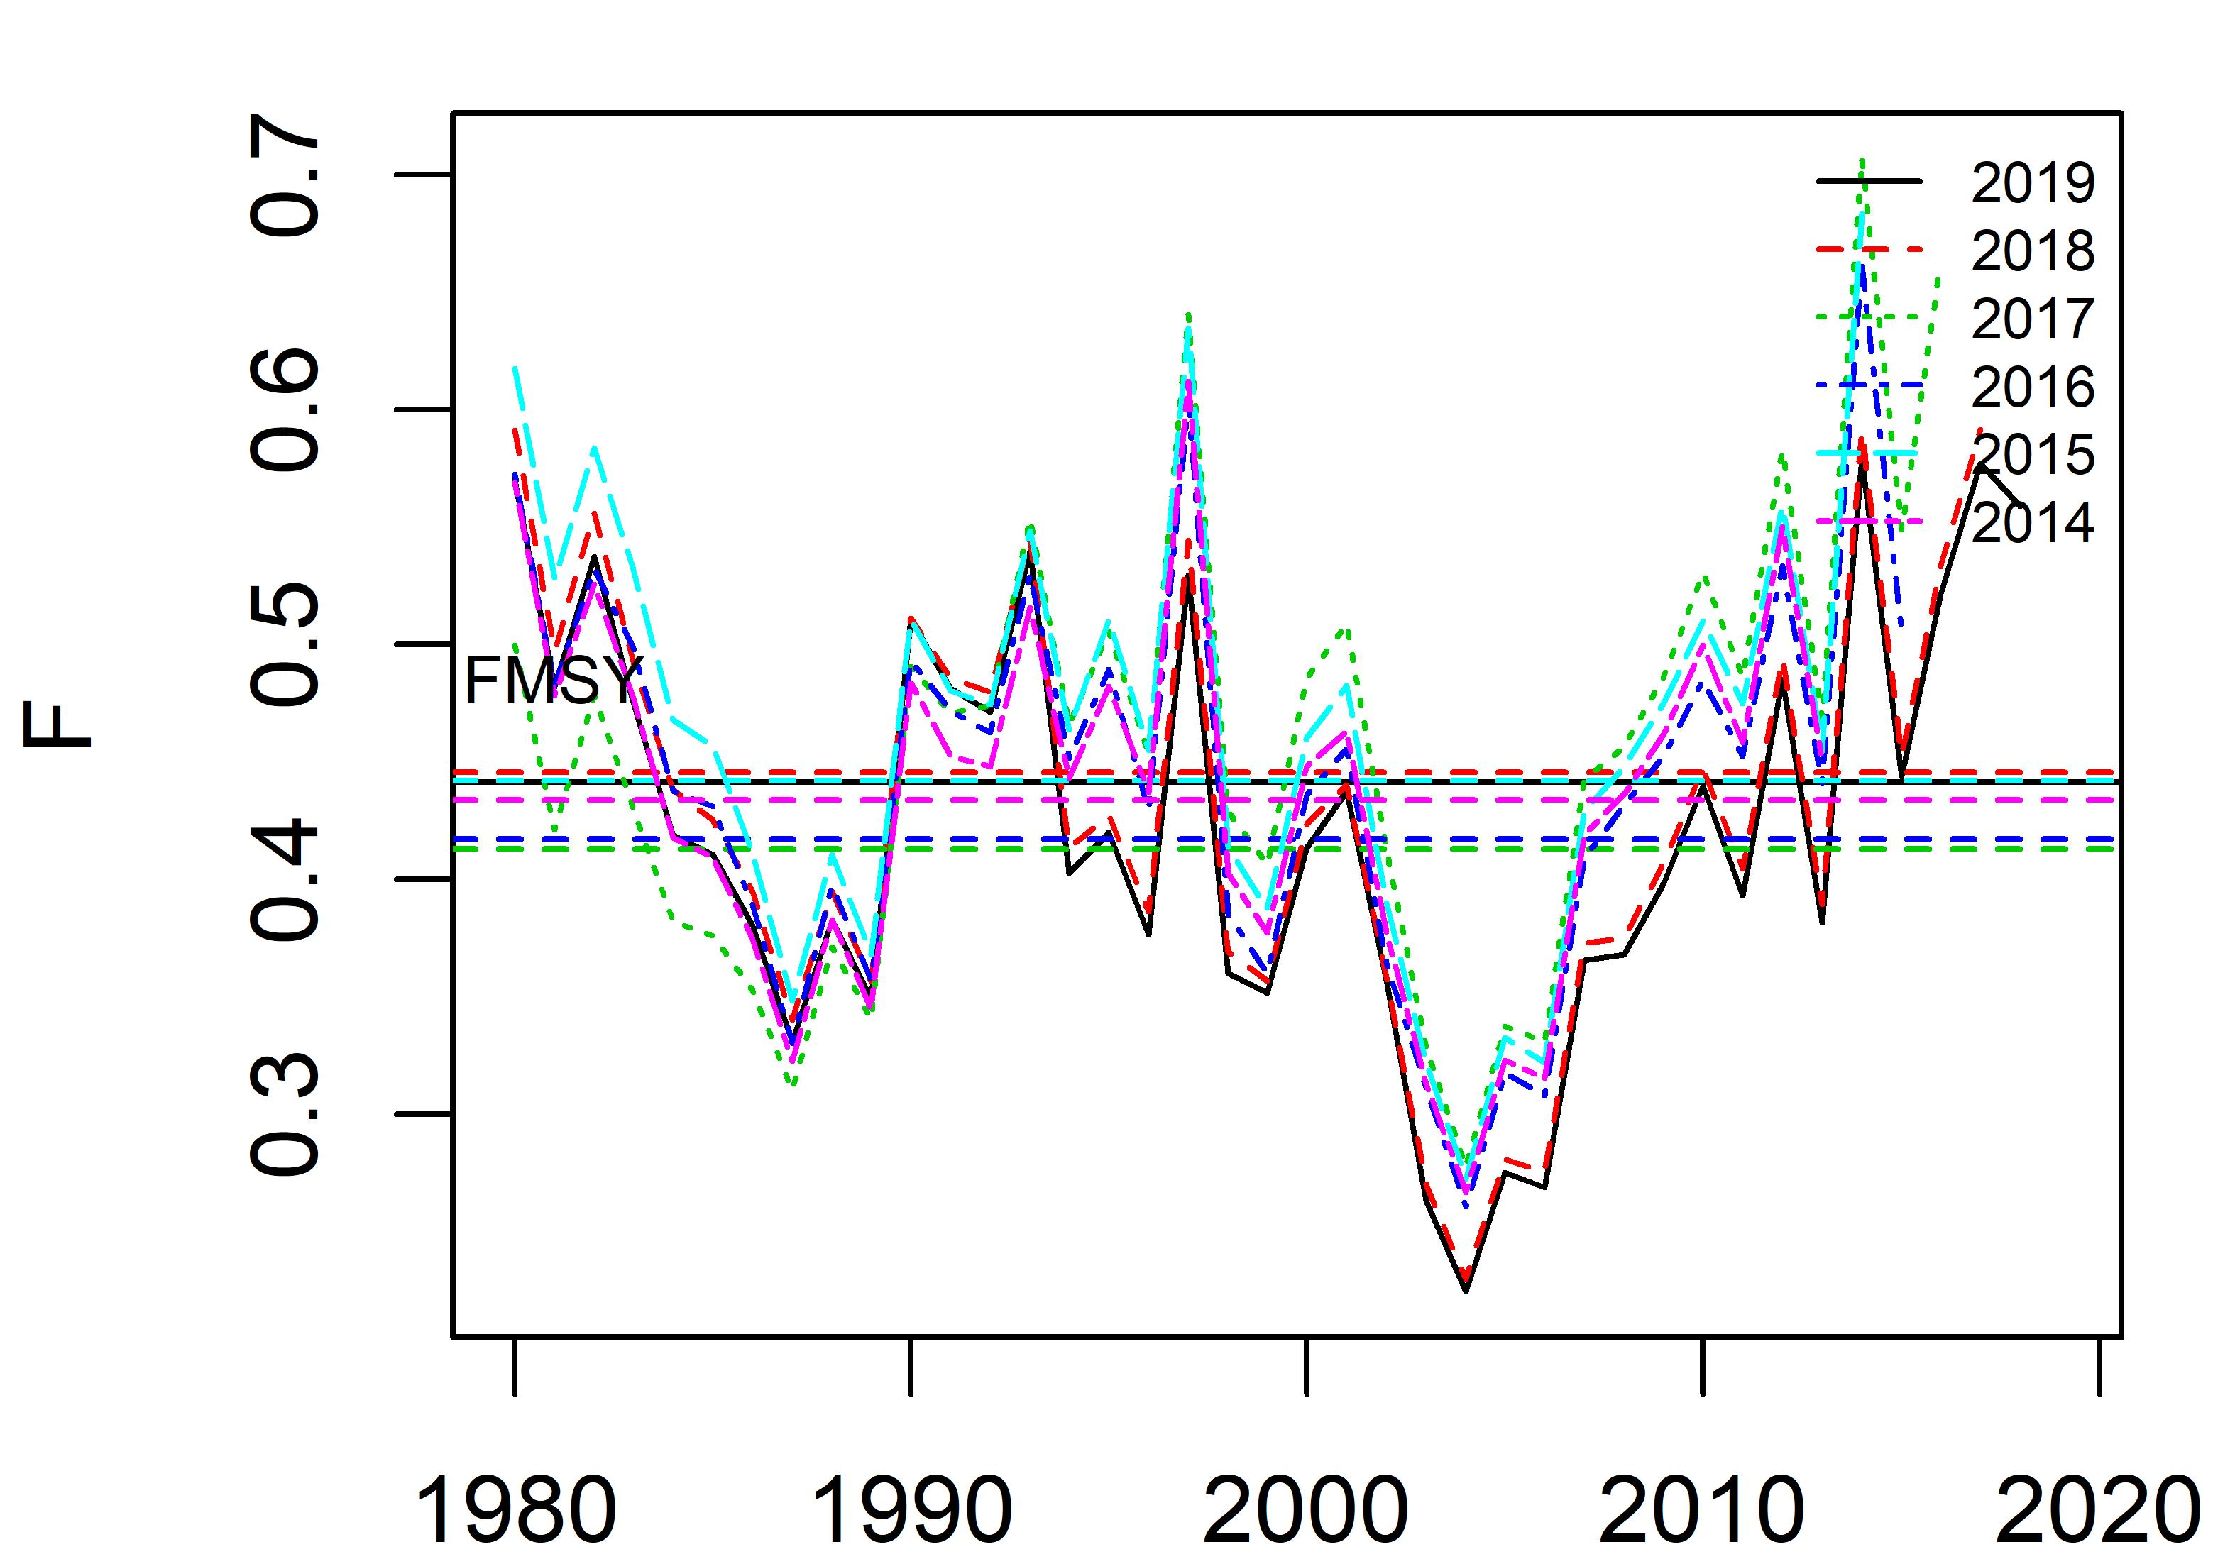
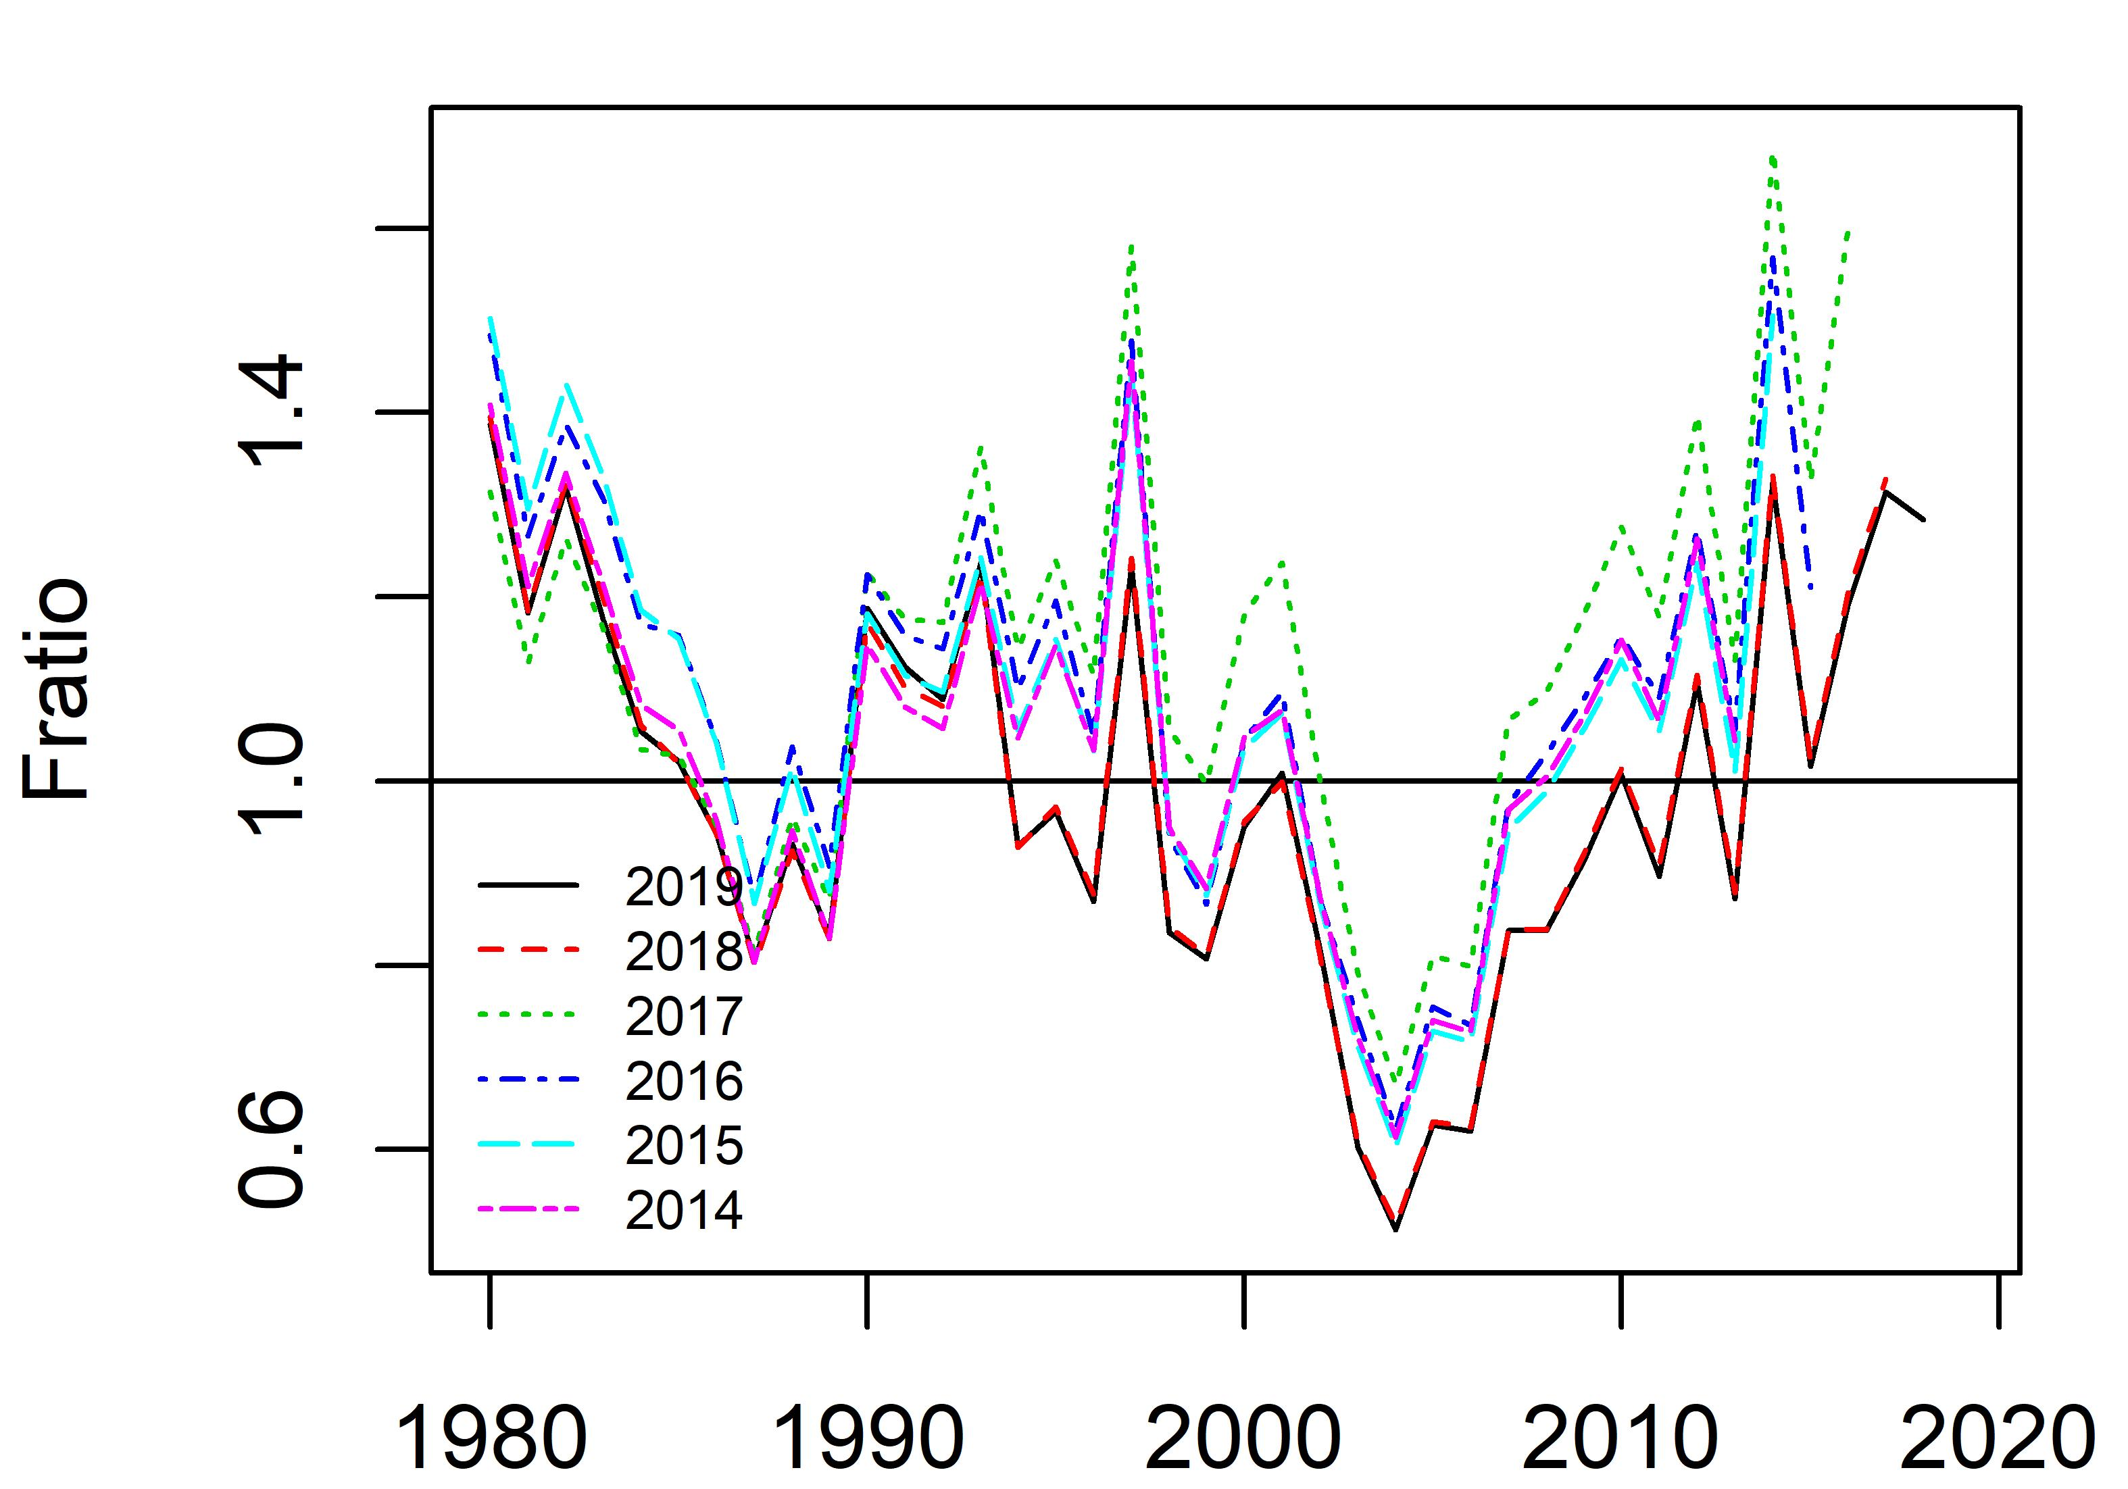
Appendix Figure 10. Time trajectories of fishing mortality and Fratio from retrospective analysis of base case scenario 1.

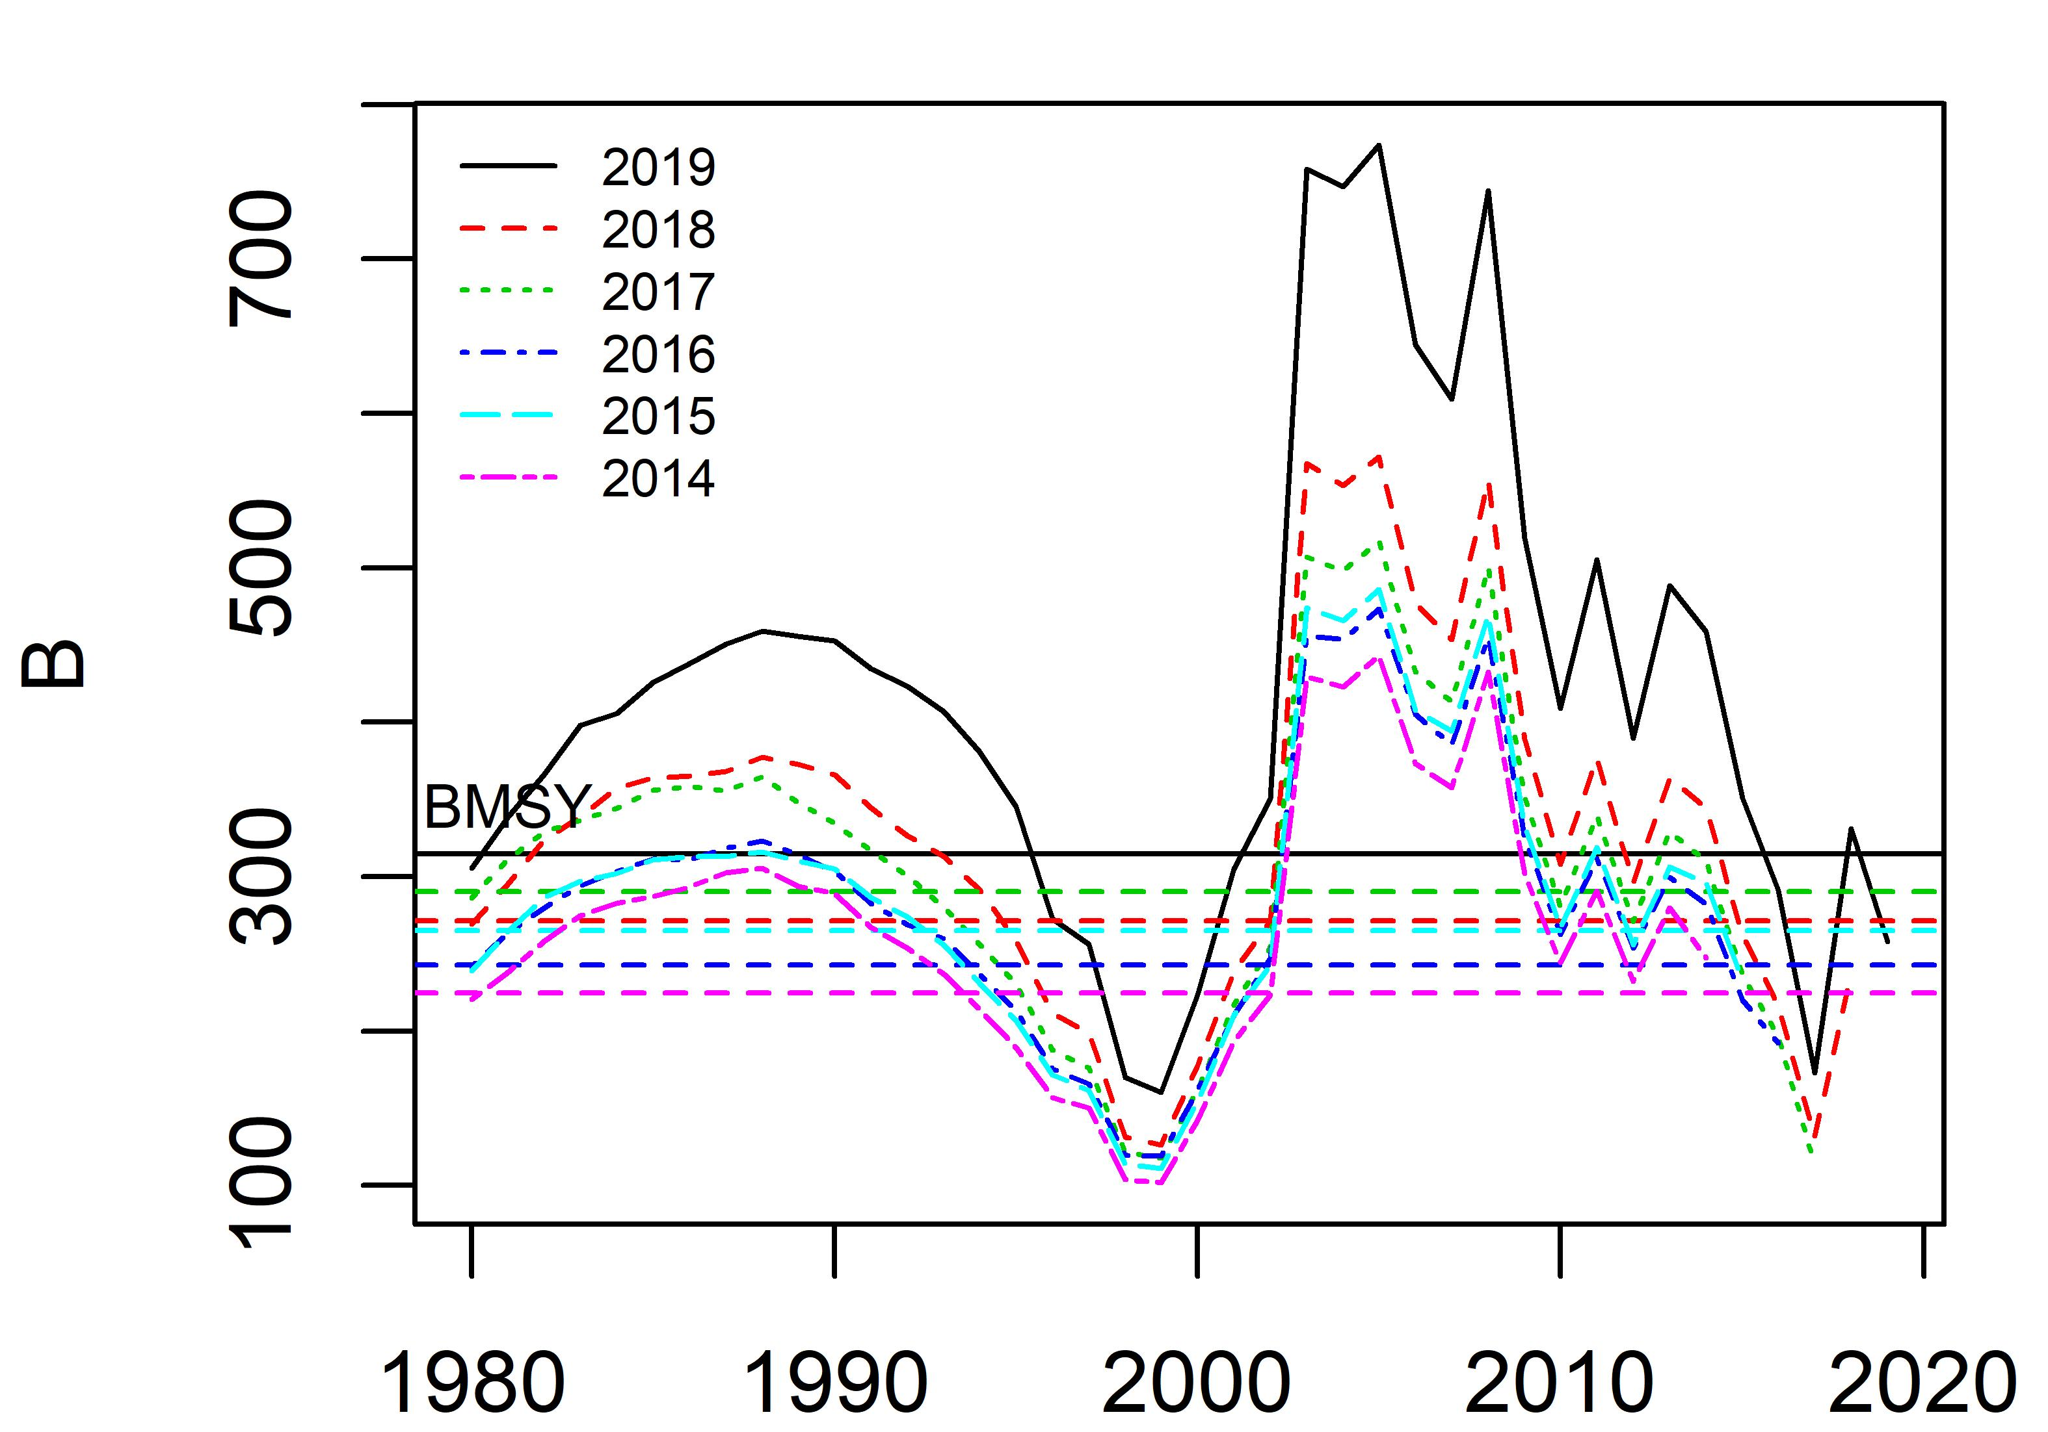
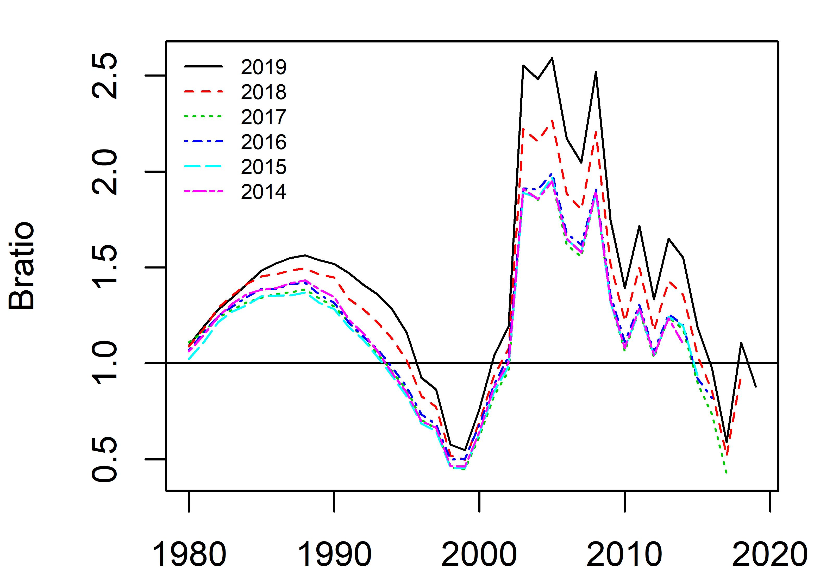
Appendix Figure 11. Time trajectories of biomass and Bratio from retrospective analysis of base case scenario 2.

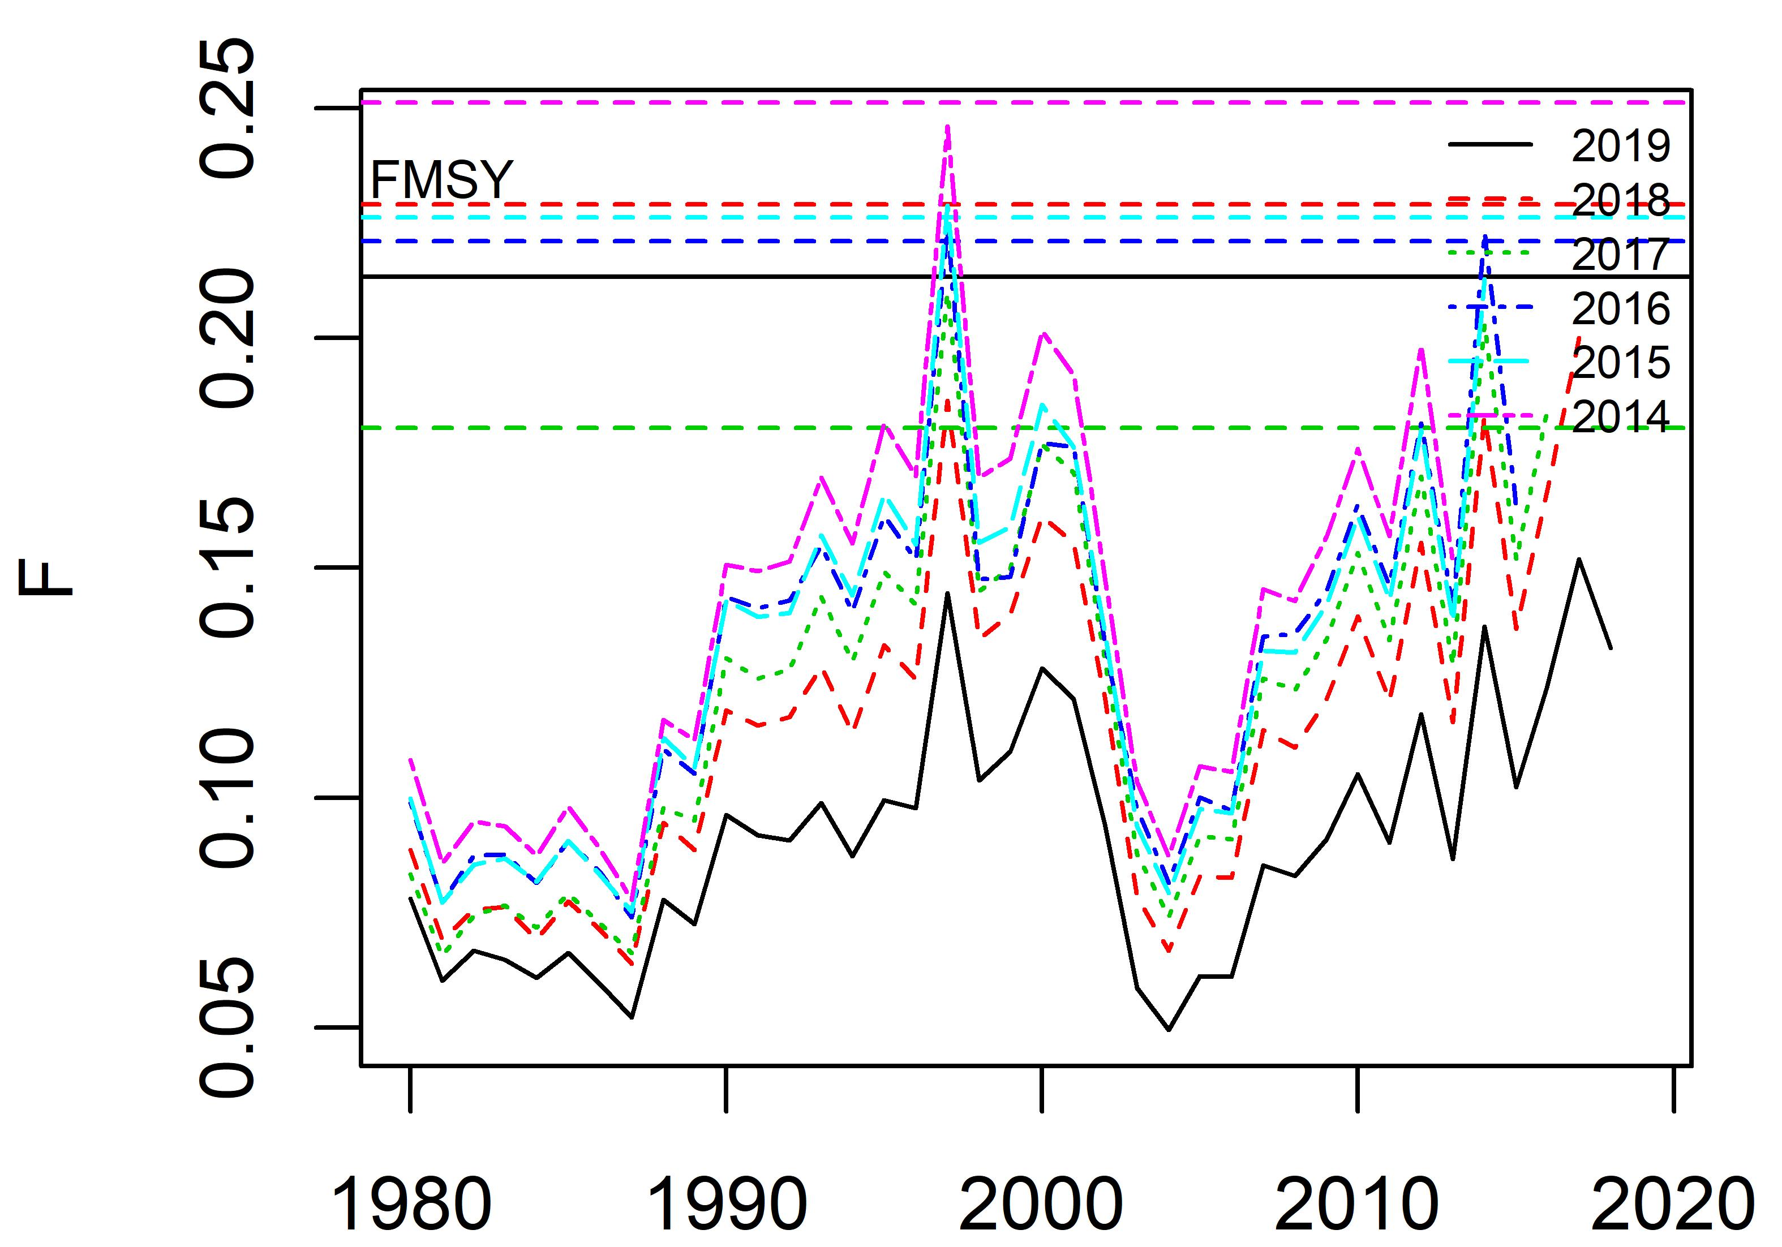
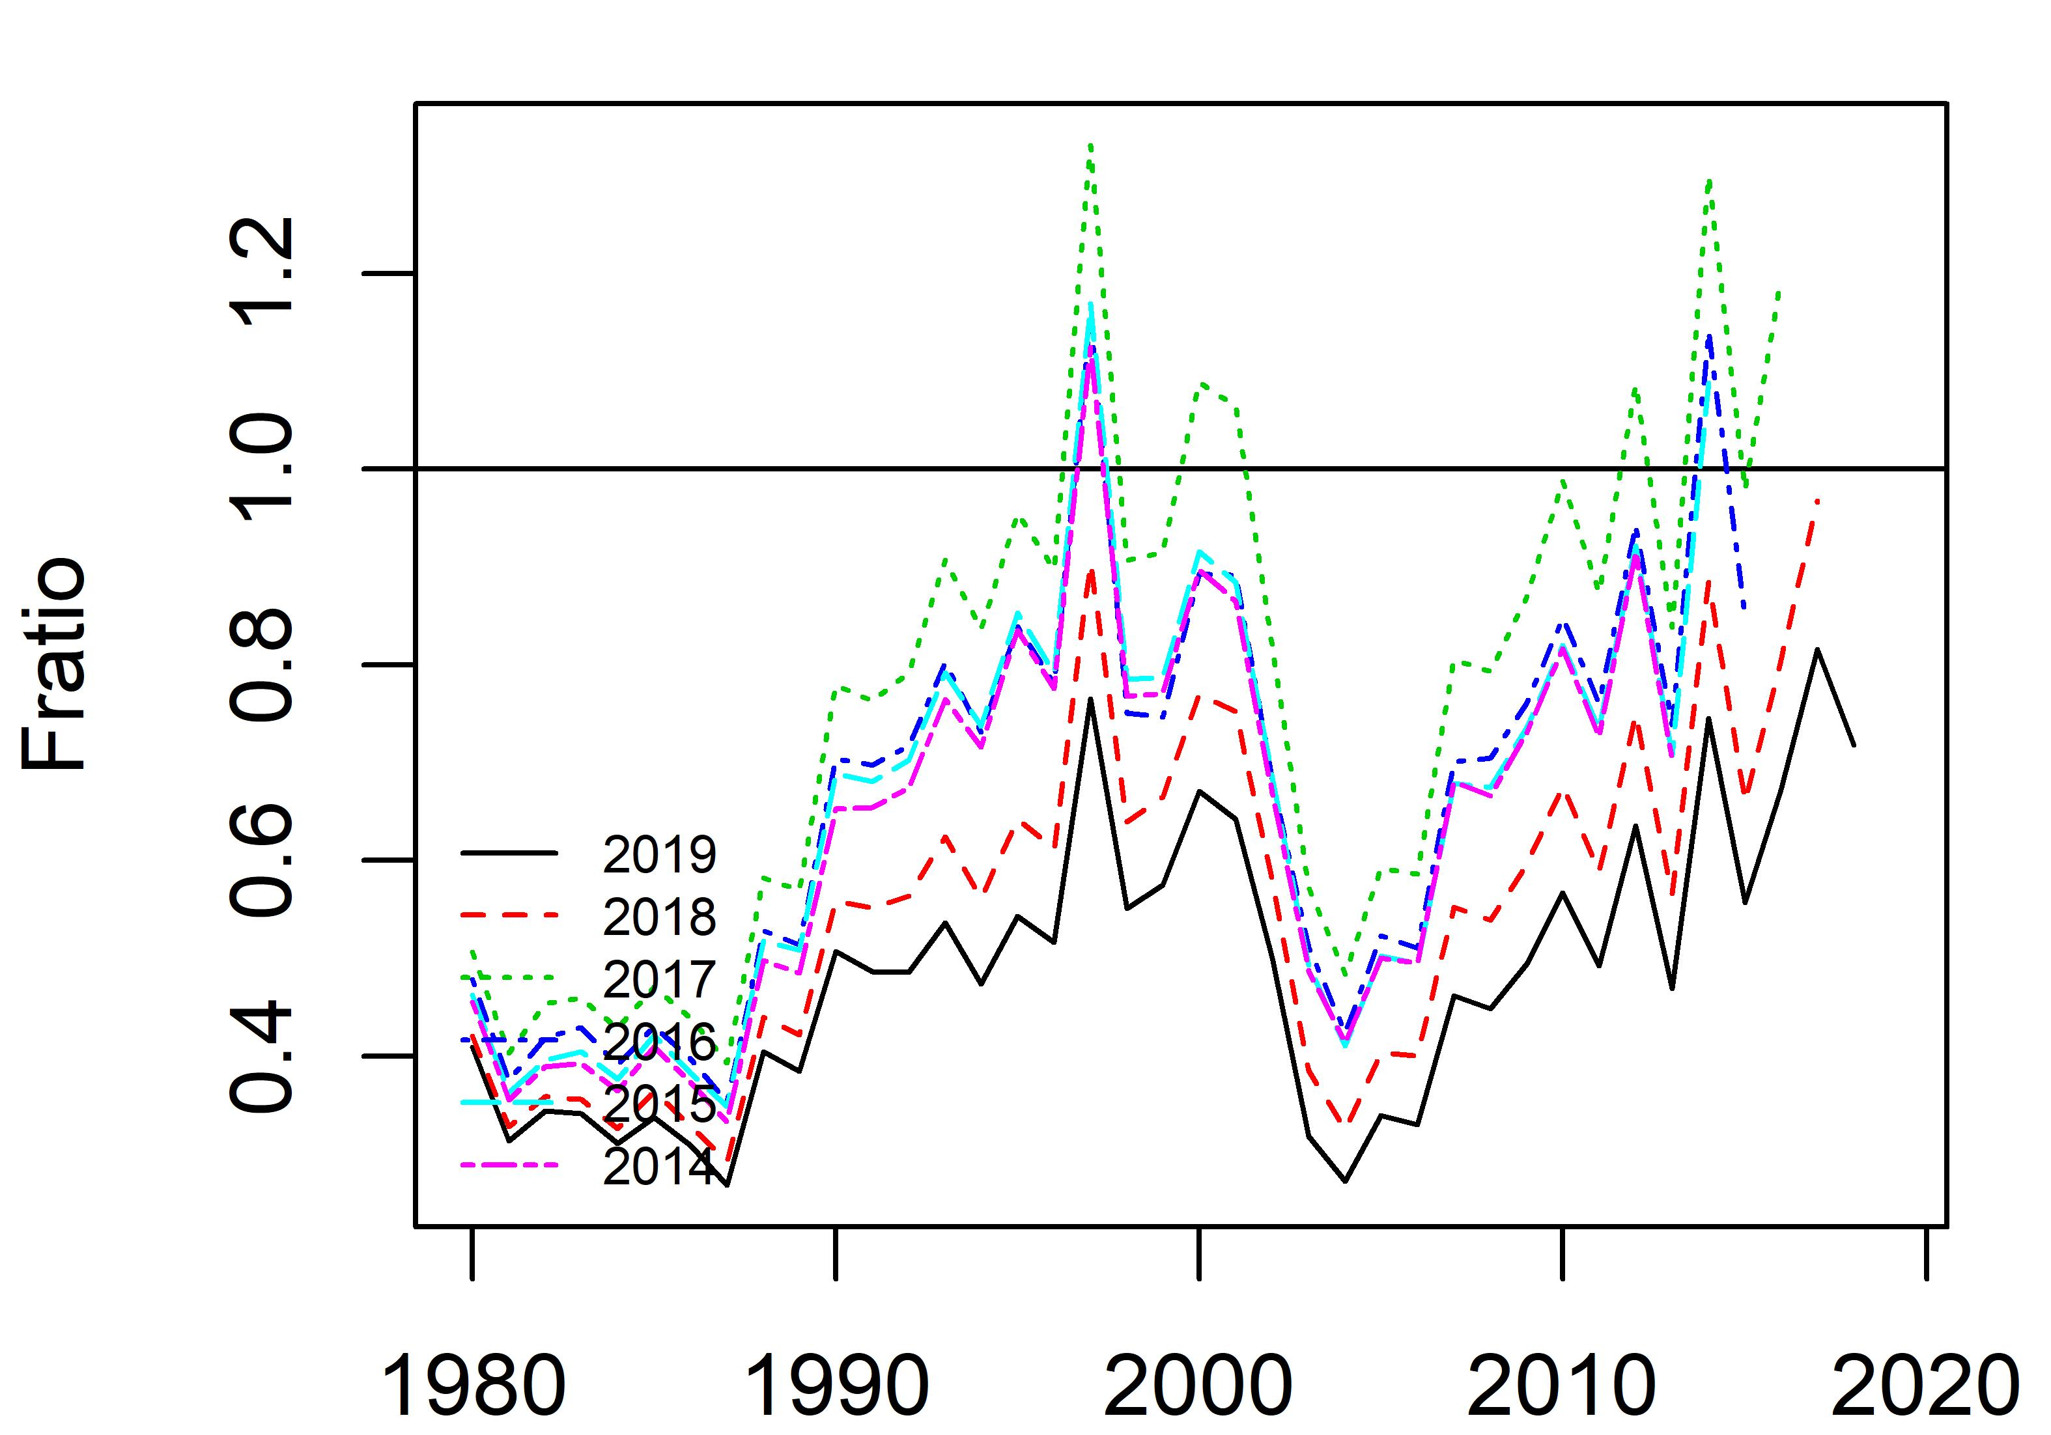
Appendix Figure 12. Time trajectories of fishing mortality and Fratio from retrospective analysis of base case scenario 2.

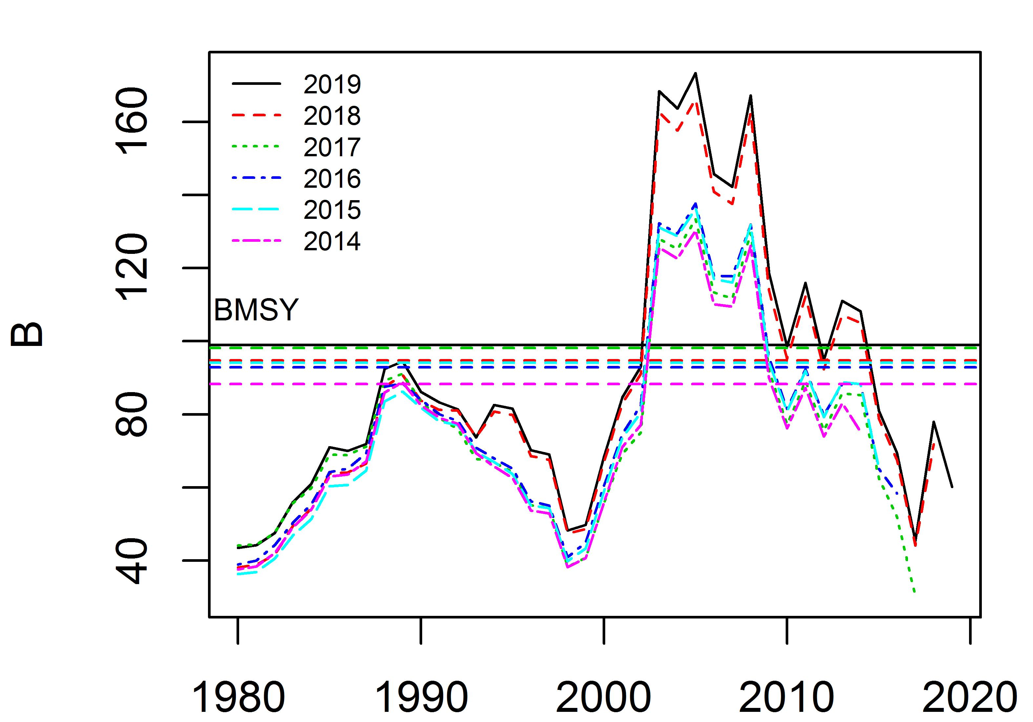
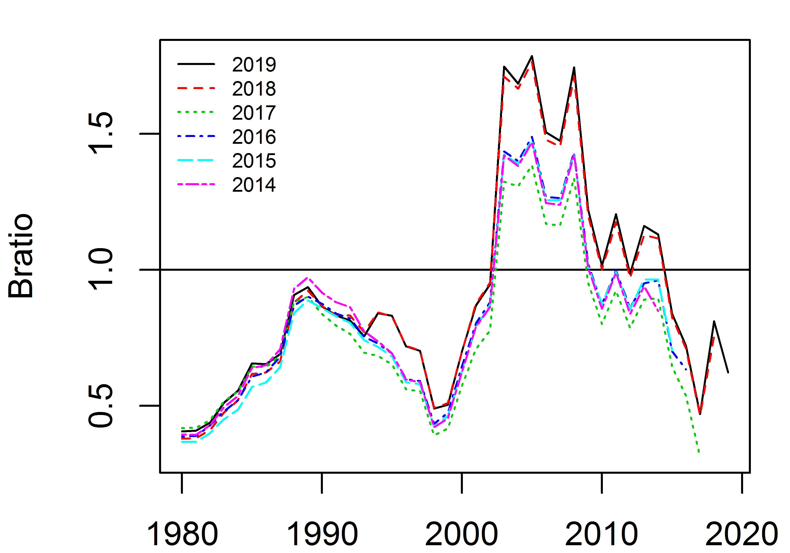
Appendix Figure 13. Time trajectories of biomass and Bratio from retrospective analysis of sensitivity case scenario 1.

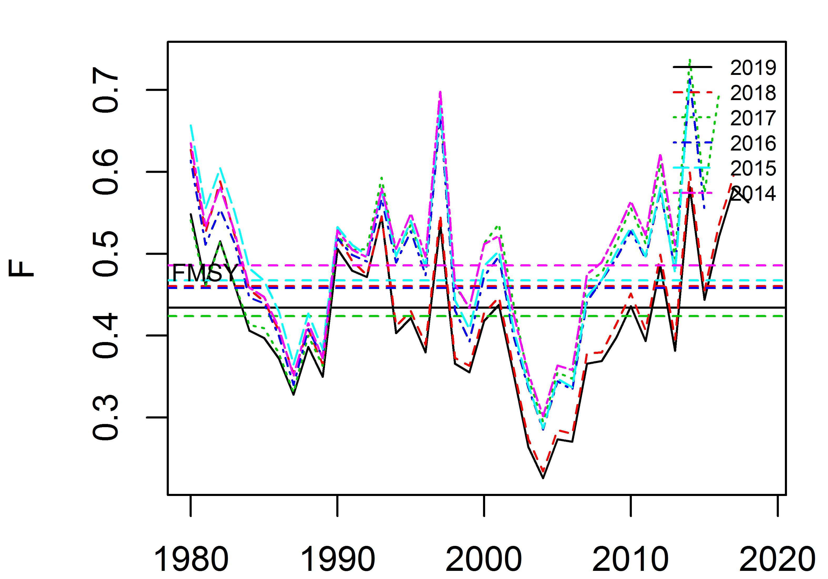
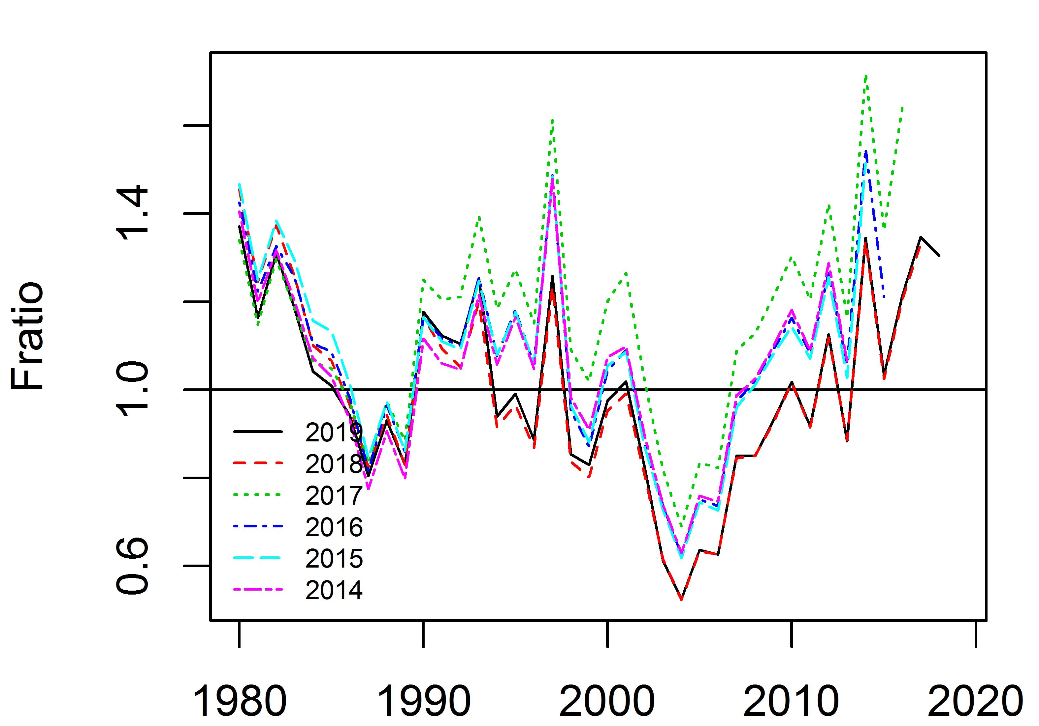
Appendix Figure 14. Time trajectories of fishing mortality and Fratio from retrospective analysis of sensitivity case scenario 1.

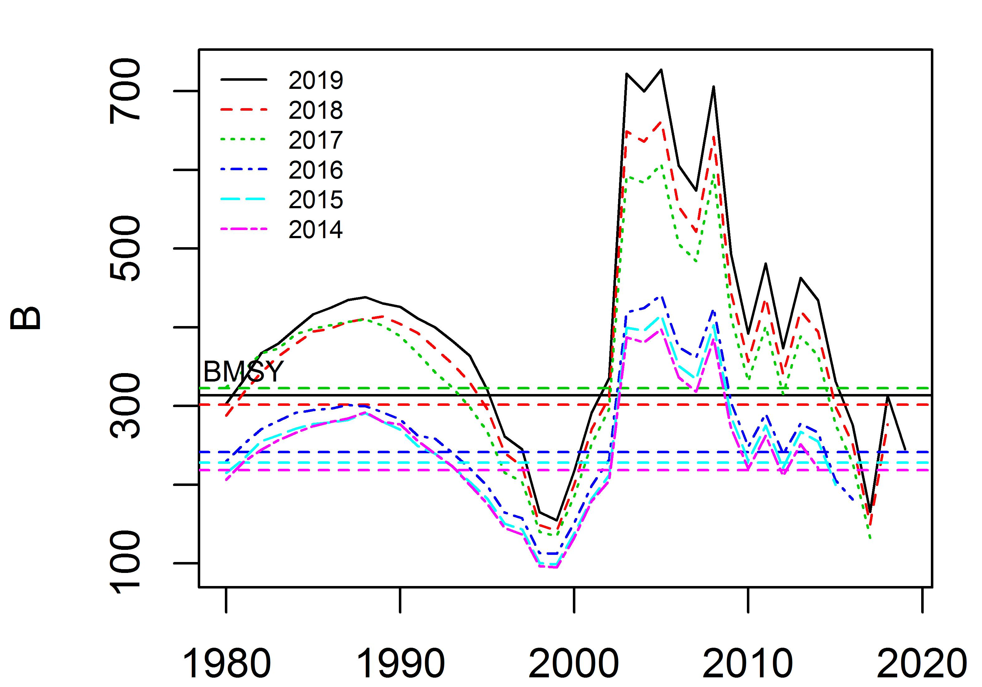
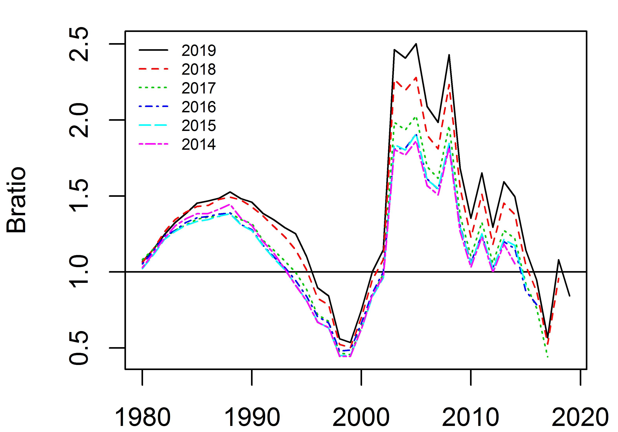
Appendix Figure 15. Time trajectories of biomass and Bratio from retrospective analysis of sensitivity case scenario 2.

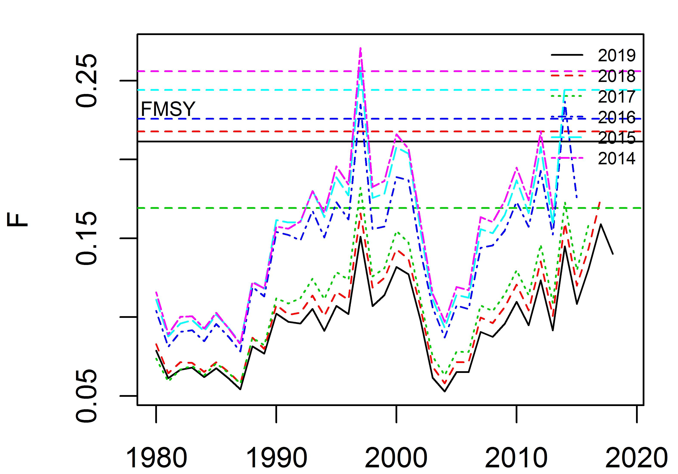
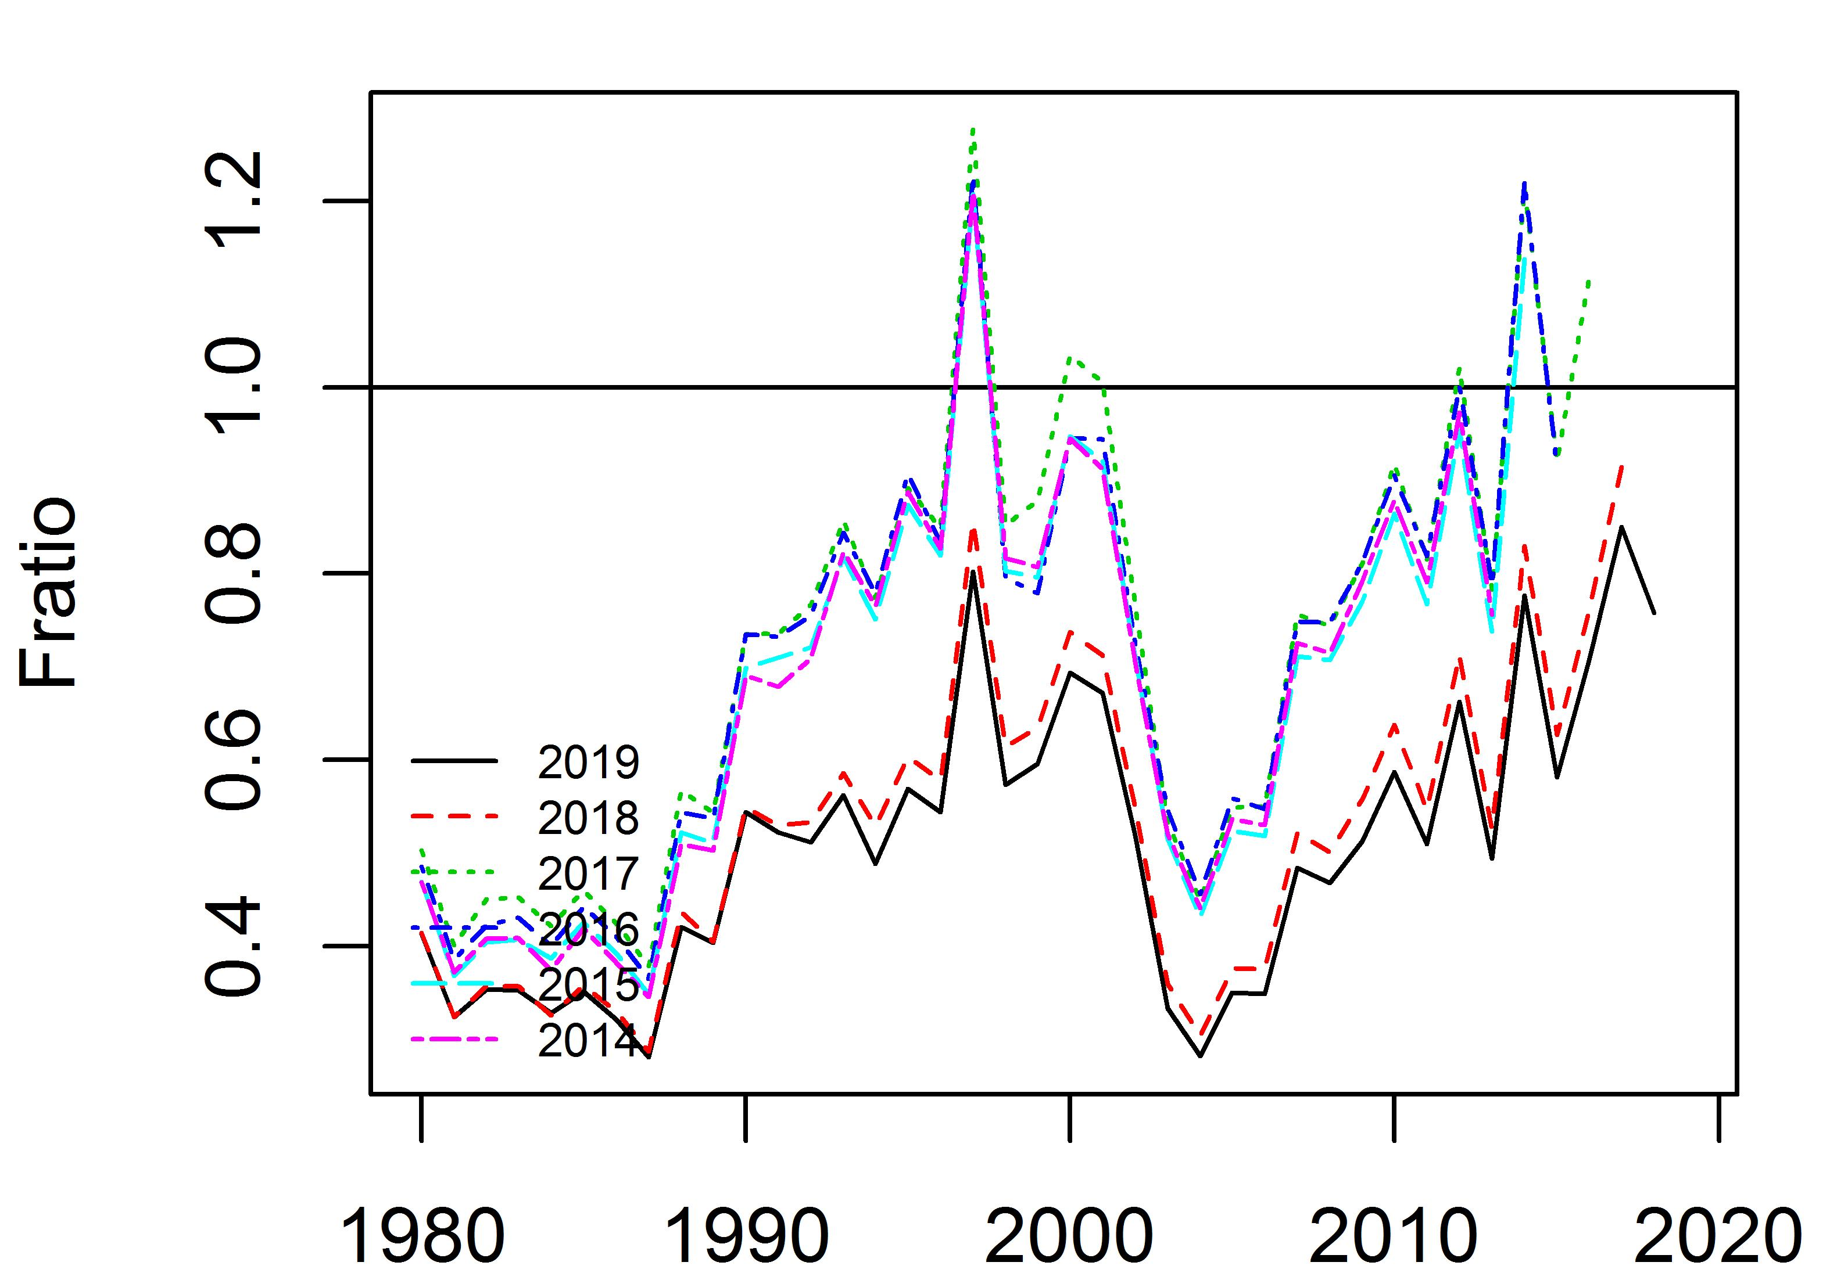
Appendix Figure 16. Time trajectories of fishing mortality and Fratio from retrospective analysis of sensitivity case scenario 2.

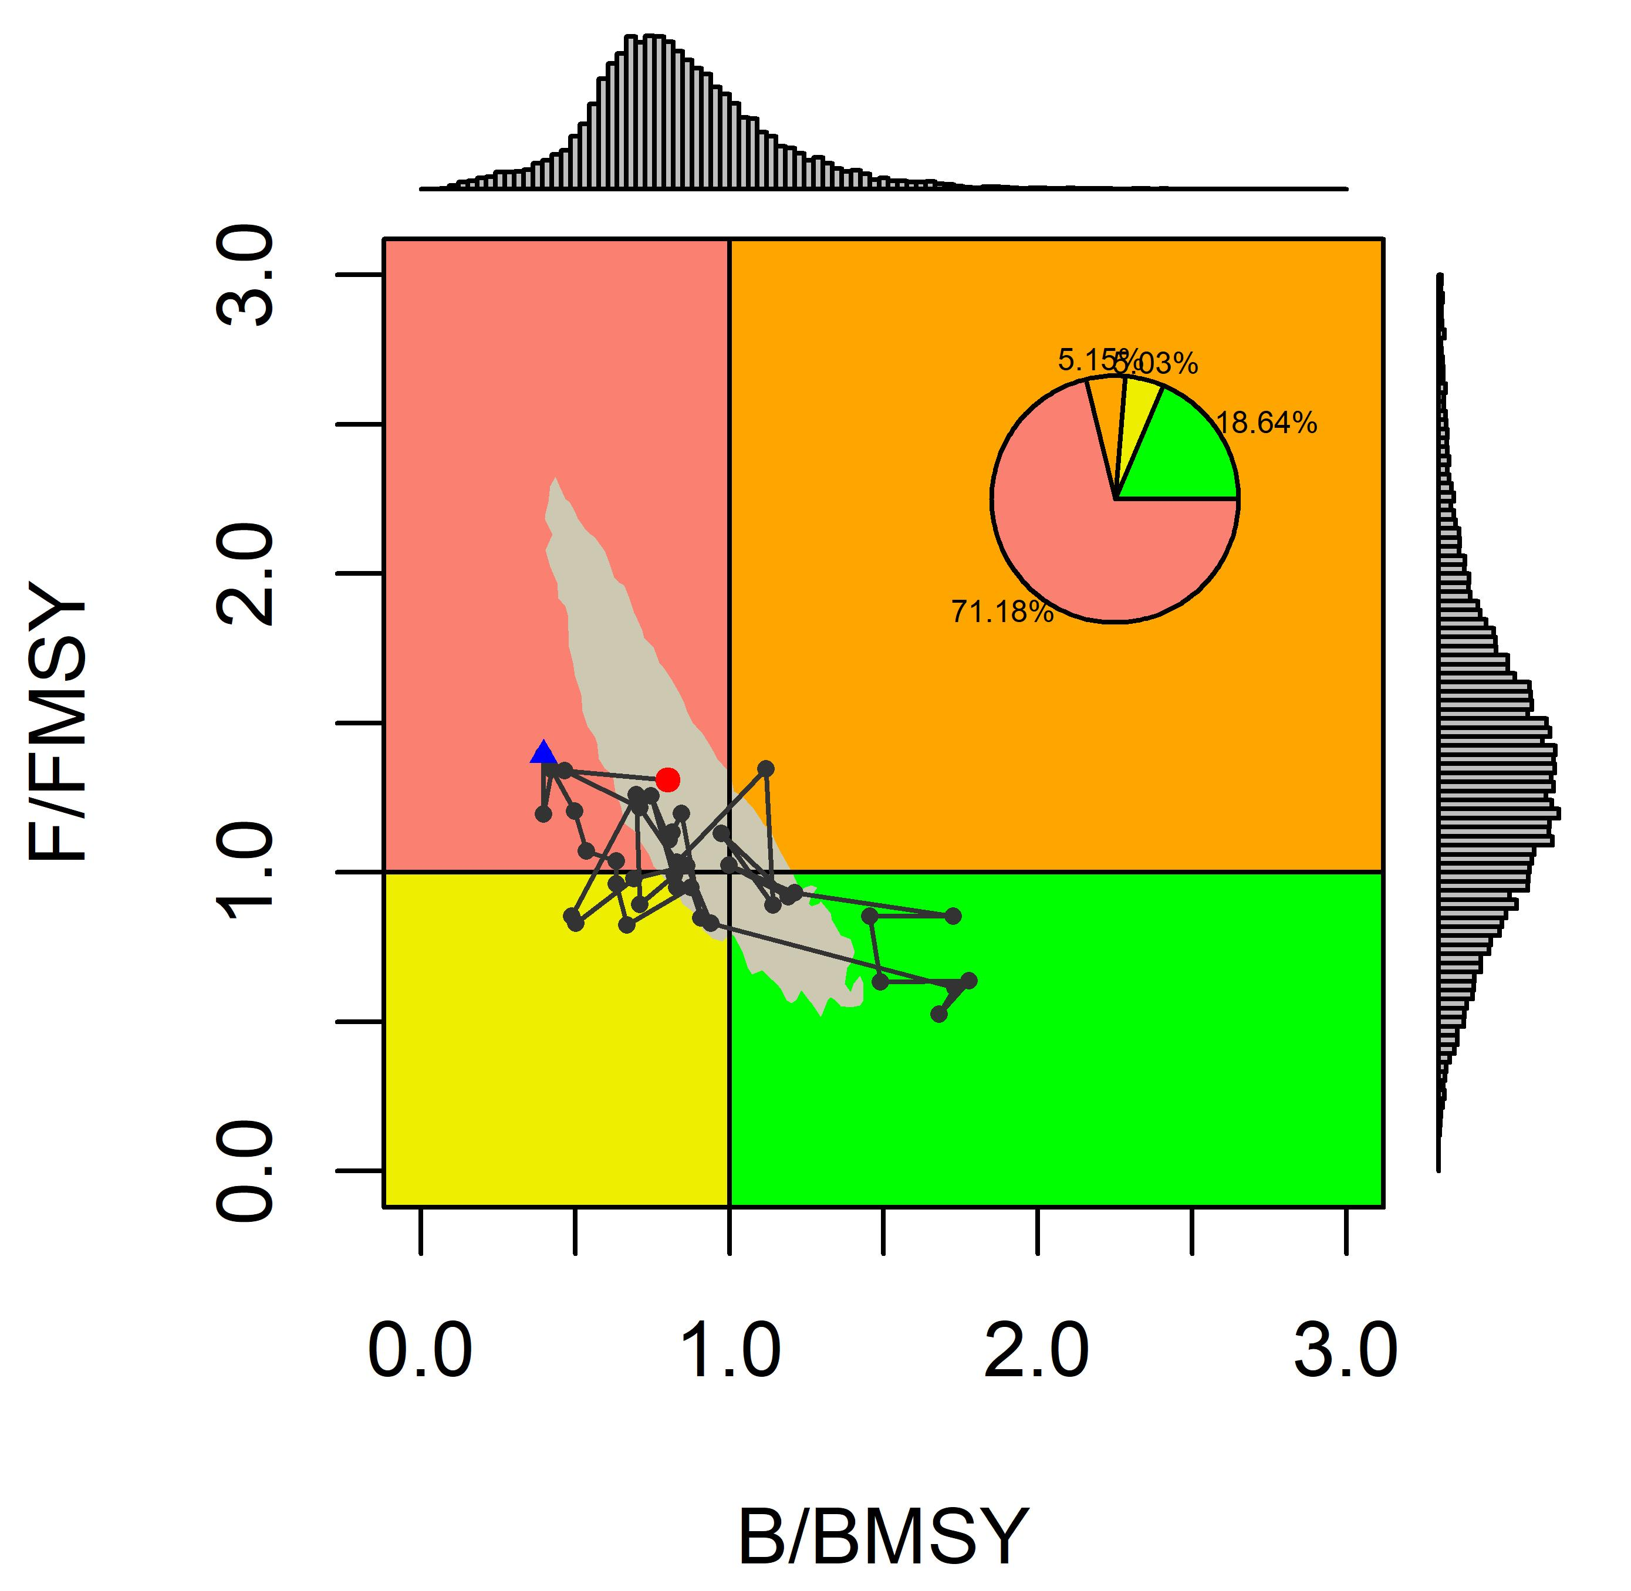
Appendix Figure 17. Kobe plot with time series median Fratio and Bratio from base case scenarios 1. The blue dot represents initial year 1980 and the red dot represents terminal year 2018.

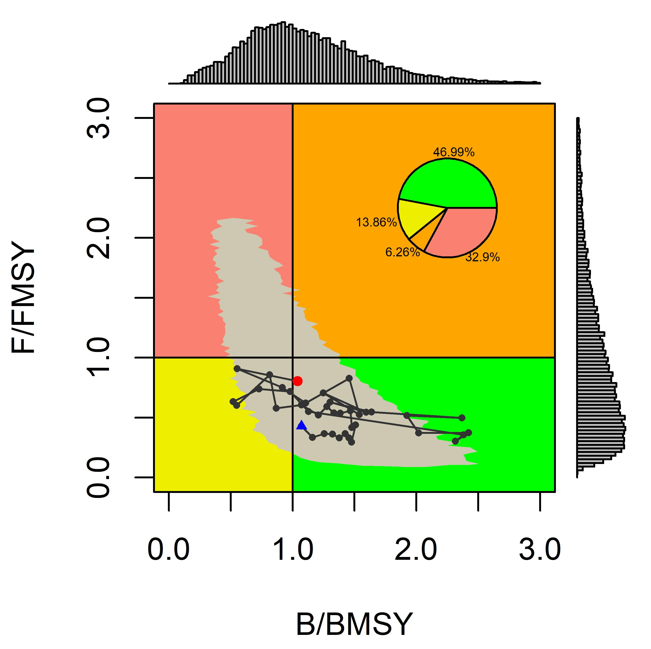
Appendix Figure 18. Kobe plot with time series median Fratio and Bratio from base case scenarios 2. The blue dot represents initial year 1980 and the red dot represents terminal year 2018.
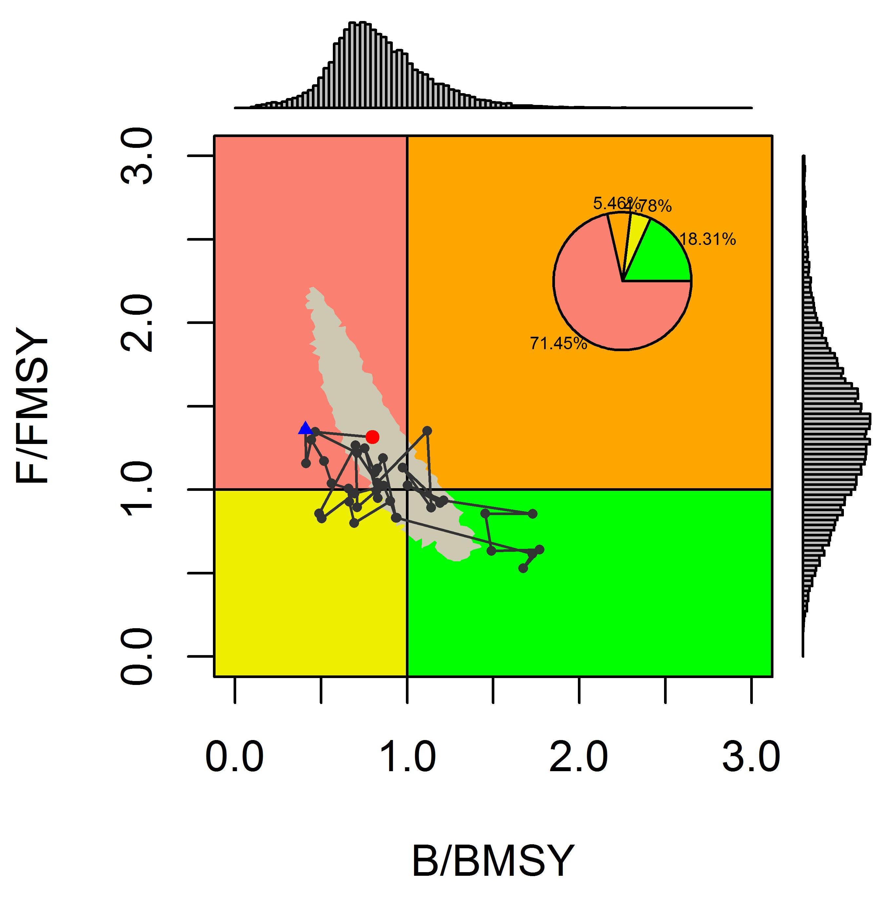
Appendix Figure 19. Kobe plot with time series median Fratio and Bratio from sensitivity case scenarios 1. The blue dot represents initial year 1980 and the red dot represents terminal year 2018.

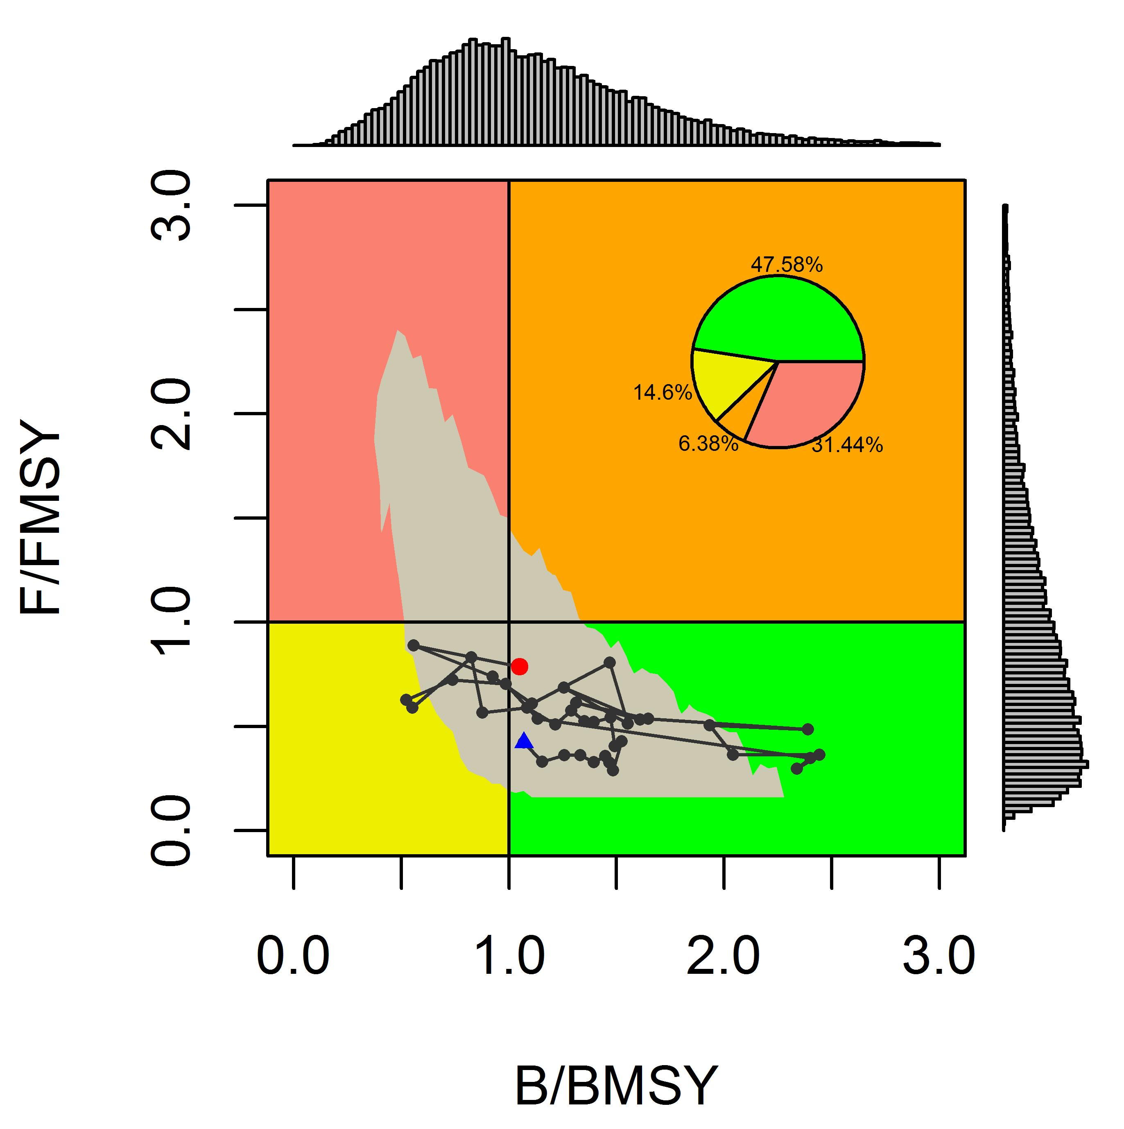
Appendix Figure 20. Kobe plot with time series median Fratio and Bratio from sensitivity case scenarios 2. The blue dot represents initial year 1980 and the red dot represents terminal year 2018.
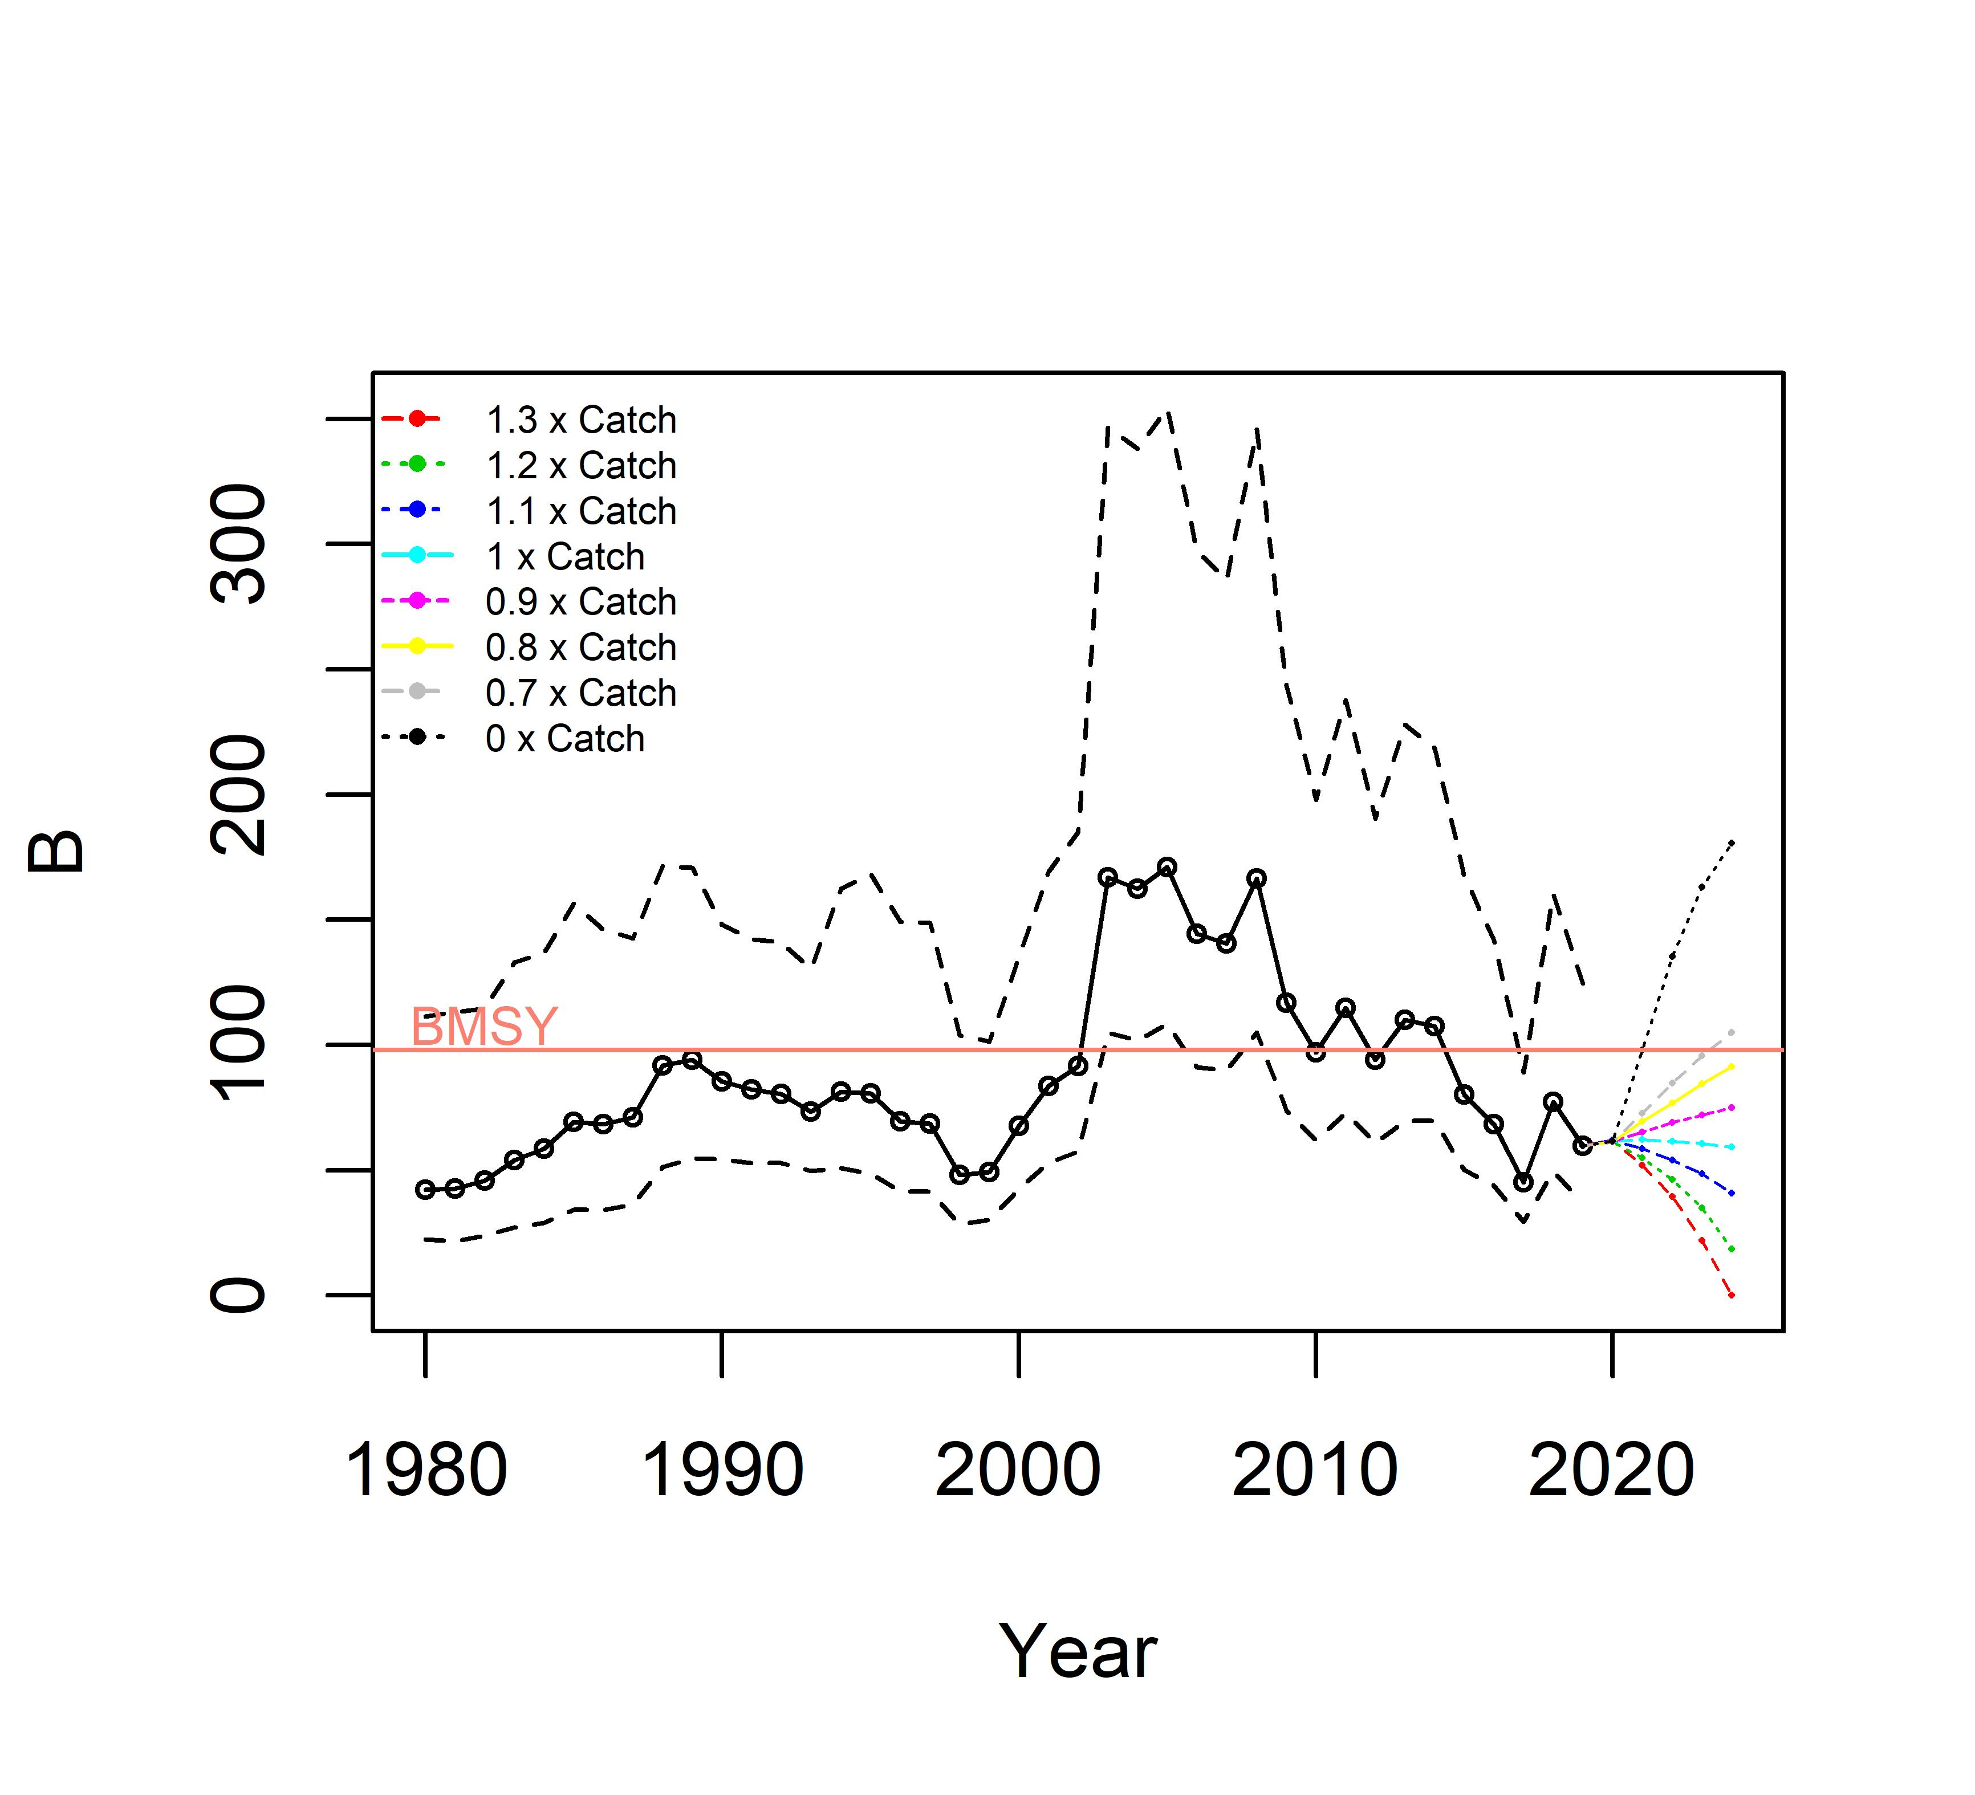
Appendix Figure 21. Biomass projection from base case scenario 1.
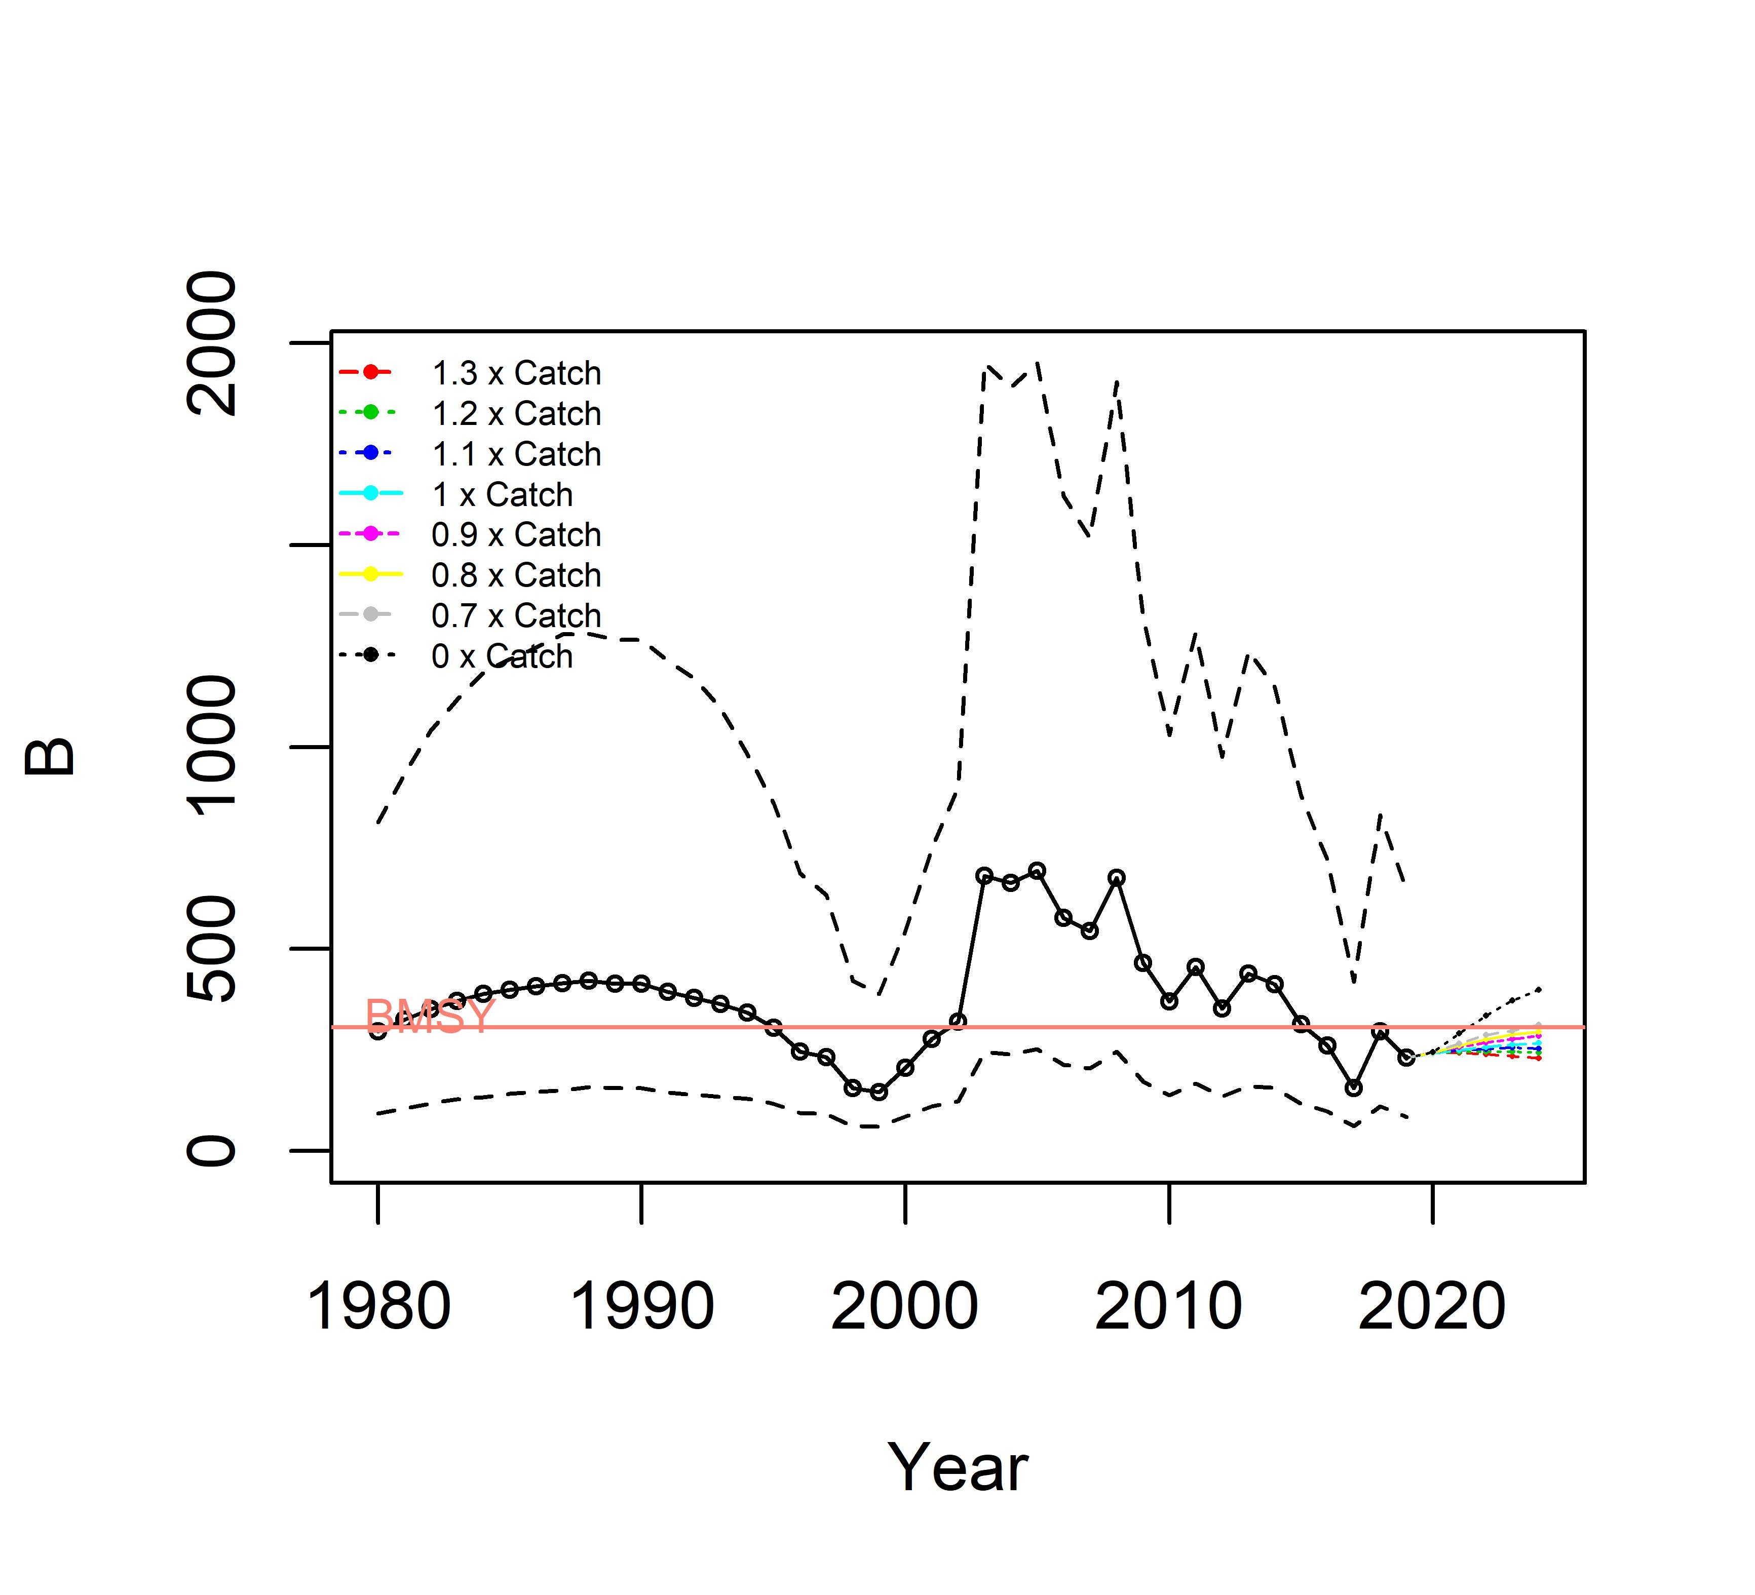
Appendix Figure 22. Biomass projection from base case scenario 2.
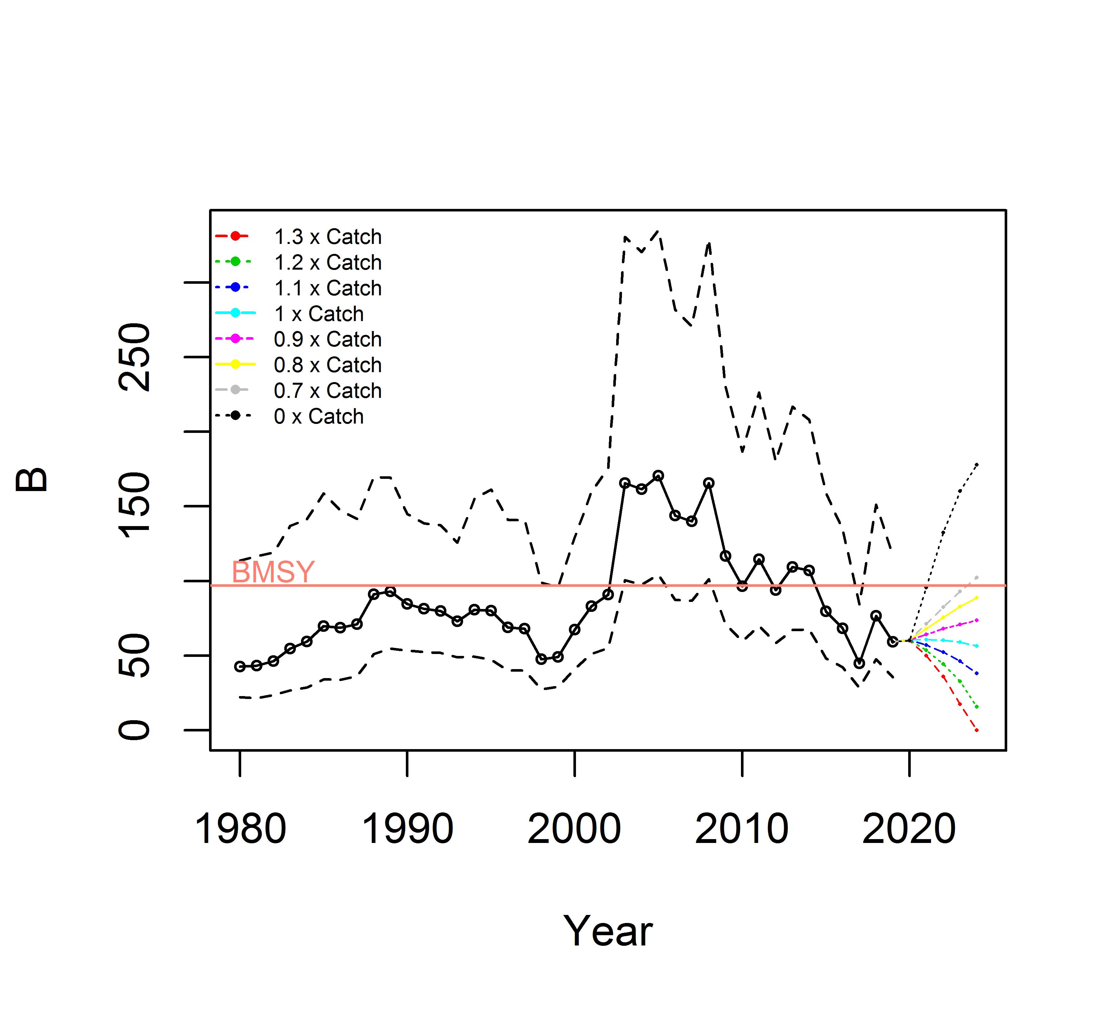
Appendix Figure 23. Biomass projection from sensitivity case scenario 1.
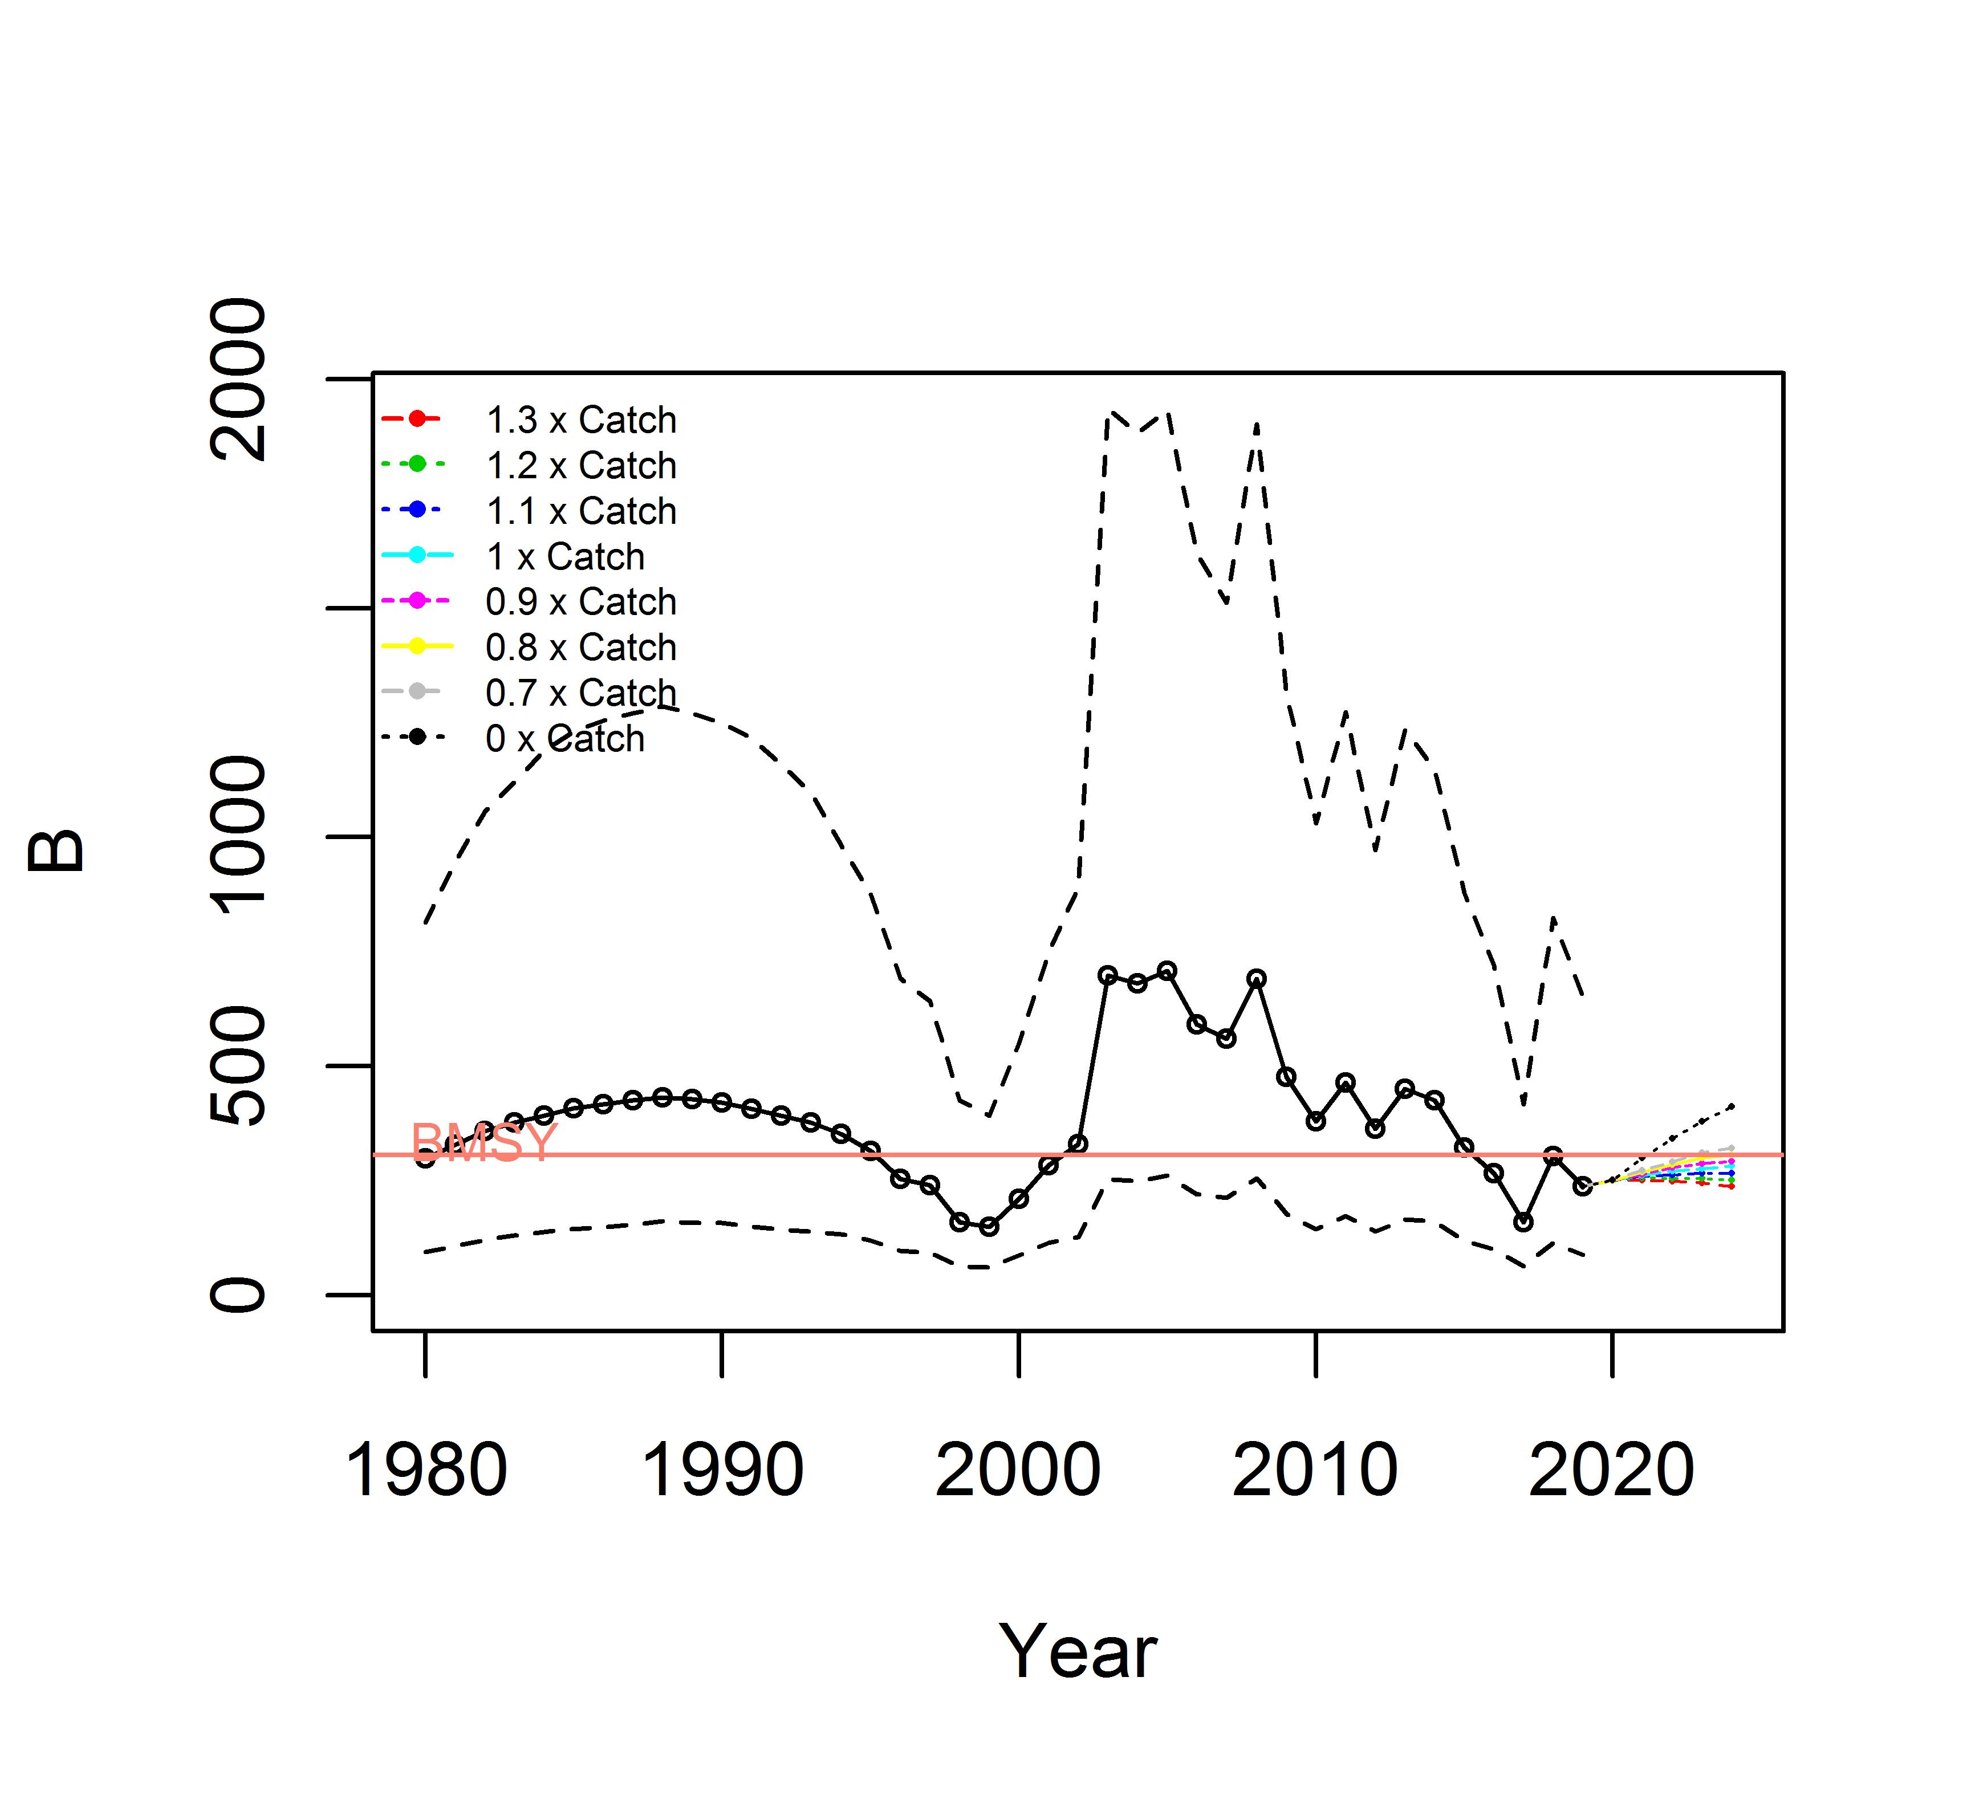
Appendix Figure 24. Biomass projection from sensitivity case scenario 2.

