NPFC-2020-SSC PS06-WP17
Stock assessment of Pacific saury (Cololabis saira) in the Western North Pacific Ocean
through 2019

Jhen Hsu¹, Yi-Jay Chang¹, Chih-hao Hsieh¹, Wen-Bin Huang², Tung-Hsieh Chiang³

1. Institute of Oceanography, National Taiwan University
2. Department of Natural Resources and Environmental Studies, National Dong Hwa University
3. Overseas Fisheries Development Council of Chinese Taipei

Abstract
This paper describes the stock assessment of the Pacific saury (Cololabis saira) in the Western North Pacific Ocean (WNPO) based on the guideline of the 2019 SSC PS05. The assessment consisted of applying the Bayesian state-space surplus production model for estimating the biomass from 1980 to 2019 with available catches from 1980 to 2018. Abundance indices available for WNPO saury consisted of standardized catch-per-unit-effort (CPUE) of stick-held dip net fisheries from Japan (1980 - 2018), Chinese Taipei (2001 - 2018), Russia (1994 - 2018), Korea (2001 - 2018) and China (2013 - 2018), and biomass survey from Japan (2003 - 2019). Two base case models were considered for the assessment outputs. The results of two base case models indicated that the estimated biomass trends before 2000 were sensitive to the early Japanese CPUE index (1980 - 1993). The ensemble time-series of biomass is estimated to have an increasing pattern since 2000 with the peaks in 2005 and 2008, after then dramatically decreased overtime and below B_{MSY} in 2015 - 2019. It should be noted that the models estimate an increase in biomass in 2018 (median B₂₀₁₈/B_{MSY} = 0.87, 80 percentile range 0.61 - 1.30) and following a slightly decrease in 2019 (median B₂₀₁₉/B_{MSY} = 0.70, 80 percentile range 0.48 - 1.05). A steady increase in fishing mortality is estimated to have occurred from 2004 to 2018 and the recent average fishing mortality is estimated to be above F_{MSY} (median F₂₀₁₆₋₂₀₁₈/F_{MSY} = 1.26, 80 percentile range 0.65 - 2.35). The ensemble MCMC results from the two base cases indicated that the 2018 stock status are likely within the red quadrant (Prob[B₂₀₁₈<B_{MSY} and F₂₀₁₈>F_{MSY}] = 61.35%) and the stock is likely overfished and is likely experiencing overfishing relative to MSY-based reference points.

1. INTRODUCTION
The Pacific saury (Cololabis saira), a migratory pelagic fish, is widely distributed throughout the middle latitudes of the North Pacific (Fukushima, 1979). The broad geographical distribution of saury in the North Pacific implies that this species can support important commercial fisheries in many countries and regions. In the Northwest Pacific Ocean, Pacific saury is a commercially important target species of offshore or distant water stick-held dip net fisheries for various countries, including Japan, Chinese Taipei, Russia, Korea, China, and Vanuatu. While Japanese and Russian fishing vessels operate mainly within their exclusive economic zones (EEZ), Chinese Taipei, Korean and Chinese fishing vessels operate mainly in the high sea east of Hokkaido and Kuril Islands of the Northwest Pacific. Genetic study suggested no genetic structuring in the Pacific saury population based on 141 individuals collected from five distant locales (East China Sea, Sea of Okhotsk, northwest Pacific, central North Pacific, and northeast Pacific) (Chow et al., 2009). However, it is important to note that regional differences may exist in the stock. Currently, the general consensus is that there is a single management stock in the Western North Pacific Ocean (NPFC-2017-TWG PSSA01-Final Report).
Here, we present a stock assessment of Pacific saury in the WNPO of the North Pacific Fisheries Commission (NPFC) convention area. The assessment consisted of applying the Bayesian state-space surplus production model with available catches of Pacific saury from Japan, Chinese Taipei, Korea, China, Russia and Vanuatu from 1980 to 2019. The Bayesian method provided the direct estimates of uncertainty of the model parameters and management quantities. The objectives of this study are to conduct a stock assessment for the Pacific saury in the WNPO through 2019, to examine the sensitivity of the results to changes in model structural uncertainty, to determine the ensemble stock condition from the developed base cases, and to conduct stochastic projection to evaluate the probable impacts of alternative catch scenarios on future levels of biomass.

2. MATERIALS AND METHODS
2.1 Fishery Data
2.1.1 Catch data
Fishery catch data from 1950-2019 for assessing WNPO saury were taken from the most recent summary of available fishery-dependent data (NPFC-2019-SSC PS05-Final Report). The commercial catch of Pacific saury caught by Japan, Chinese Taipei, Korea, China, Russia and other members in the WNPO area were collected from 1950 to 2019 (Table 1). Japan included coastal and offshore stick-held dip net and other coastal gears (gill nets, set-net and by-catch). Chinese Taipei included distant stick-held dip net and other gears (trawlers, drift net and by-catch before 1996). Korea and China included the distant water stick-held dip net fisheries. Russia included offshore and distant stick-held dip net fisheries.
2.1.2 Abundance indices
Estimates of standardized fishery-dependent catch-per-unit-effort (CPUE) of WNPO saury were available for Japanese offshore stick-held dip net fisheries, however, Japanese standardized CPUE data was separated into two time series, one before 1994 (1980-1993) (NPFC-TWG PSSA03-WP11) and one from 1994 to 2018 (NPFC-2019-SSC-PS05-WP06) to account for the potential change in catchability. Indices of Chinese Taipei and Korean distant-water stick-held dip net fisheries were available from 2001-2018 (NPFC-2019-SSC PS05-WP02 and NPFC-2019-SSC PS05-WP05). Russia provided the abundance index of offshore and distant stick-held dip net fisheries from 1994-2018 (NPFC-2019-SSC PS05-WP07). Index of Chinese distant-water stick-held dip net fisheries was also available from 2013-2018 (NPFC-2019-SSC PS05-WP01).Fishery-independent biomass index was available from Japanese scientific research surveys from 2003-2019 by using mid-water trawl (NPFC-2019-SSC PS05-WP08) (Table 2).
2.2 Bayesian production model
Pacific saury production models were formulated as Bayesian state-space models with explicit observation and process error terms (e.g., Meyer and Millar, 1999; Chang et al., 2015) from 1980 to 2019 following the recommendations of the SSC PS05 (NPFC-2019-SSC PS05-Final Report). We implemented the models in WinBUGS (version 1.4.3, Lunn et al. 2000) via the R2WinBUGS package (Sturtz et al., 2005) in the statistical programming environment R (R Development Core Team 2019). Under the Bayesian paradigm, prior distributions are employed to quantify existing knowledge, or the lack thereof, of the likely value of each model parameter.
2.3 Assumption of time-varying catchability
Base on the additional information regarding the changes in the Japanese stick-held dip net fishery for Pacific saury, especially from 1980 to 1993 (NPFC-2018-TWG PSSA03-WP11). For example, new fishing equipment (sonar, side thruster, fish pump, and auxiliary electrical generator) was installed on vessels in this fishery from 1980 to 1993. Therefore, further developments to the previous models have been undertaken to include potential catchability change of early Japanese CPUE (1980-1993). In this study, the catchability (q) of early Japanese CPUE was allowed to vary according to a random walk on the log scale (Wilberg et al., 2006; Nesslage and Wilberg, 2012).
;
where q_{t} is a catchability for early Japanese CPUE at time t (1980-1993); the ω_{t} is the annual deviation from a normal distribution with a mean of zero and a standard deviation of 0.1. For the reasonable assumption, the q of the Japanese late CPUE (1994-2017) is set to the same value in the terminal year (1993) of Japanese early CPUE.
2.4 Alternative relationships between CPUE and biomass
Commonly, fishery-dependent CPUE indices are assumed to be proportional to biomass, regardless of population size (i.e., constant q). In this paper, we assumed the catchability is a power function of CPUEs and biomass to allow catchability to change as population biomass changes (Davies and Jonsen, 2011).
where β is a shape parameter for index i; q is the catchability for index i; the B is the biomass for index i. When β < 1, implying the CPUE declines more slowly than population biomass, a condition known as hyper-stability. In this case, CPUE would overestimate the population biomass. Conversely, β > 1 describes the situation where the CPUE declines faster than population biomass as the hyper-depletion, and the CPUE would underestimate biomass.
2.5 Prior distributions
The Bayesian analysis requires prior probability distributions for each of the model parameters. These priors were summarized in Table 3. In this study, we provided less informative prior with the mean value of intrinsic growth rate (r) based on the demographic method of McAllister et al. (2001) and the estimated value of resilience from FishBase (Froese and Pauly, 2000). The prior distribution for r was a lognormal distribution with a mean of 1.4 and the coefficient of variation (CV) of 2, . The prior chosen for carrying capacity (K) was uninformative, as little is known about the carrying capacity of the WNPO saury population. We specified a vague prior for carrying capacity using a lognormal distribution with a mean of (10,000 mt) and CV of 1 to cover the reasonable range of predictions. This mean value was chosen to reflect the magnitude of biomass likely needed to support the observed fishery catches. The prior distribution for shape parameter (M) was a gamma distribution with scale and shape parameters equal with λ = k = 2. Therefore, the prior mean is equal to 1 and the CV is around 70%, implying that the production curve was centred on the symmetric Schaefer model as the default with adequate flexibility to estimate a non-symmetric production function if needed.
The prior distribution for the initial catchability (q_{JPN1}) of early Japanese CPUE was uninformative with a uniform from 1×10⁻⁷ to 2. The annual deviation of log(q) was assumed an informative normal distribution with a mean of zero and a standard deviation of 0.1 which allows the 90% quantile of the annual change ranged from 0.2 to 5 times relative to the previous catchability. Unfortunately, since little is known about the q on stick-held dip net gear for other CPUEs (i.e., JPN2, CT, RUS, KOR, and CHN), we were limited to use least-informative prior for q. The priors for the q were chosen to be a diffuse inverse-gamma distribution with scale parameter λ = 0.01 and shape parameter k = 0.01. The prior distribution of the Japanese biomass survey (q_{bio}) was a uniform distribution from zero to one (NPFC-2019-SSC PS05-Final Report). The prior distribution of hyper-stability of CPUEs (β) was a uniform distribution from 0 to 1 (NPFC-2019-SSC PS05-Final Report).
Following Meyer and Millar (1999), we used inverse gamma prior for the process and observation error variances. The parameters were set to λ = 4 and k = 0.1 for the process error variance (τ²) and λ = 2 and k = 0.45 for the observation error variance (σ²) priors. The observation error variance was set up to the common value among CPUEs. Given that all the CPUEs observed may not necessarily have a consistent trend because of the difference in spatial use of fishing and survey grounds. Therefore, we prioritized to fit the Japanese survey index, and its observation variation error was set to the 0.17 or 0.2 times of the common observation error variance.
The initial state of the stock was described as a proportion of carrying capacity (P₁=B₁₉₈₀/K). We specified an uninformative prior for P₁ using a lognormal distribution with a mean of 0.7 with a CV of 1 based on an assumption that the Pacific saury population was lightly exploited in 1980.
2.6 Convergence to the posterior distribution
A critical issue in using MCMC methods is how to determine when random draws have converged to the posterior distribution. Convergence of the MCMC samples to the posterior distribution was checked by monitoring the trace and diagnosing the autocorrelation plot. Gelman and Rubin (1992) and Heidelberger and Welch (1983) diagnostics as implemented in the R language (R Development Core Team, 2018) and the CODA package (Best et al., 1995) were also examined. In this study, three chains were used. The model was run for 333,333 iterations, sampled with a thinning rate of 25 with a burn-in period of 83,333 iterations, and 10,000 samples were collected for each chain. A total of 30,000 samples derived from three chains were used to generate the posterior distributions.
2.7 Diagnostics of model fitting
The predicted CPUE indices for each model were compared to the observed CPUE to determine model fit. The standardized log-residuals from the CPUE fit were visually examined for time trends. The retrospective analysis of each base case was conducted by removing data for years 2019-2014 successively to evaluate whether there were any substantial changes in the ratios of biomass to B_{MSY} and fishing mortality to F_{MSY} through time.
2.8 Base case models
Based on the SSC PS05 recommended base case scenarios (NPFC-2019-SSC PS05-Final Report), two models differed in the inclusion of the early Japanese CPUE and the observation error variance of the CPUEs were explored (Table 4).
2.9 Sensitivity analysis
We developed four sensitivity cases (Table 5) to evaluate the model outputs of the base cases following the recommendation of the SSC PS05 (NPFC-2019-SSC PS05-Final Report).
2.10 Projection analysis
Projections were applied to the base case models to evaluate the impact of various levels of harvest scenarios on the future biomass. Three years (2016-2018) average catches (354,469 mt) was set as the baseline in the future projection. The projections were run from 2020 to 2023 under eight different harvest scenarios following the recommendation of the SSC PS05 (NPFC-2019-SSC PS05-Final Report):
- +30% catch (460,809 mt);
- +20% catch (425,362 mt);
- +10% catch (389,916 mt);
- + 0% catch (354,469 mt);
- -10% catch (319,022 mt);
- -20% catch (283,575 mt);
- -30% catch (248,128 mt);
- No catch

3. RESULTS
3.1 Catch and abundance indices
Time-series of commercial catches by fisheries were shown in Figure 1. In the last decades, annual total catches of the saury increased from 176,364 mt in 1998 to 617,509 mt in 2008 and then continuously decreased to 264,784 mt in 2017 except for high catch in 2014 (629,576 mt). In 2018, the total catch (439,079 mt) increased over the average of the recent five years. Time-series of abundance indices and the biomass survey index overlapped were shown in Figure 2.
3.2 Convergence of base case model
The visual inspection of trace plots of the major parameters showed the good mixing of the three chains (i.e., moving around the parameter space), also indicative of convergence of the MCMC chains. The Gelman and Rubin statistic for all parameters, including all variance terms, equalled 1, which indicated convergence of the Markov chains. Similarly, the Heidelberger and Welch test could not reject the hypothesis that the MCMC chains were stationary at the 95% confidence level for any of the parameters. Overall, these diagnostics indicated that the posterior distributions of the model parameters were adequately sampled with the MCMC simulations.
3.3 Model fits to catch-per-unit-effort indices
The predicted indices for each model were compared to the observed indices to determine model fit. A summary table of the root-mean-square-error value (RMSE) from each index is provided in Table 6. Plots of residual diagnostics by fishery for the base case models were shown in Figures 3-4. Models fit to the Chinese Taipei index had a residual trend with negative residuals in 2002-2010 and positive residuals in 2011-2018. Overall, the model fits to the WNPO Pacific saury indices indicated that there was a lack of fit to the Chinese Taipei CPUE.
3.4 Posterior estimates of model parameters
Plots of posterior densities of the parameters r, K, M, σ², τ², β, and P₁ for each base case were shown in Figures 5-6, together with their respective prior densities. Similar to the log-normal priors, the marginal posteriors generally have a long right-hand tail in the density plot. Summaries of posterior medians of parameters of the base cases were provided in Tables 7-8. The results of time-varying catchability (q) in early Japanese CPUE (1980-1993) were shown in Figure 7 and Table 9.
3.5 Stock assessment results
3.5.1 Time-series of biomass
Time-series of biomass (B) and biomass depletion (B/K) and the ratio of biomass to B_{MSY} (B/B_{MSY}) within each base case were provided in Figures 8-9. Different trends in biomass during 1980-1987 were found between base case 1 and base case 2. However, the biomass trends after 2000 were consistent between two base cases.
The ensemble time-series of biomass is estimated to have an increasing pattern since 2000 with the peaks in 2005 and 2008, after then dramatically decreased overtime and below B_{MSY} in 2015 - 2019 (Figure 10). It should be noted that the models estimate an increase in biomass in 2018 (median B₂₀₁₈/B_{MSY} = 0.87, 80 percentile range 0.61 - 1.30) and following a slightly decrease in 2019 (median B₂₀₁₉/B_{MSY} = 0.70, 80 percentile range 0.48 - 1.05).
3.5.2 Time-series of fishing mortality
Time-series of fishing mortality (F) and the ratio of F to (F/F_{MSY}) within two base cases were provided in Figures 11-12. Differences in trends for F during 1980 - 1993 were found between base cases 1 and 2. Since 1994, there were similar trends among the two base case models. The ensemble time-series of fishing mortality trend from two base cases were shown in Figure 13. A steady increase in fishing mortality is estimated to have occurred from 2004 to 2018 and the recent average fishing mortality is estimated to be above F_{MSY} (median F₂₀₁₆₋₂₀₁₈/F_{MSY} = 1.26, 80 percentile range 0.65 - 2.35).
3.6 Stock status
The quantities of management interest reference points from two base cases were shown in Tables 10-12. Based on the MSY-based reference points, the Kobe plot showed that the 2018 stock status is within the red quadrant for both base case 1 (median B₂₀₁₈/B_{MSY} = 0.96 and F₂₀₁₈/F_{MSY} = 1.11) and 2 (median B₂₀₁₈/B_{MSY} = 0.79 and F₂₀₁₈/F_{MSY} = 1.55) (Figure 14). The average stock status in recent 3 years (B₂₀₁₇₋₂₀₁₉ and F₂₀₁₆₋₂₀₁₈) is also within the red quadrant for both base case 1 (median B₂₀₁₇₋₂₀₁₉/B_{MSY} = 0.78 and F₂₀₁₆₋₂₀₁₈/F_{MSY} = 1.04) and 2 (median B₂₀₁₇₋₂₀₁₉/B_{MSY} = 0.64 and F₂₀₁₆₋₂₀₁₈/F_{MSY} = 1.52) (Figure 15). Overall, the ensemble MCMC results from the two base cases indicated that the 2018 stock status are likely within the red quadrant (Prob[B₂₀₁₈<B_{MSY} and F₂₀₁₈>F_{MSY}] = 61.35%) and the stock is likely overfished and is likely experiencing overfishing relative to MSY-based reference points (Figure 16).
3.7 Retrospective analysis
Retrospective analyses show that the time-series of B/B_{MSY} and F/F_{MSY} estimated with the removal of the most 6 years of data (2014-2019) in successive model runs generally match well with the full-time series assessment (Figures 17-18). This suggested that there is no consistent pattern of bias in the estimates of B/B_{MSY} and F/F_{MSY}.
3.8 Sensitivity analyses
The estimated biomass and fishing mortality trends of the sensitivity cases 1 and 2 were shown in Figures S1-S4 . Higher uncertainty in the estimate of fishing mortality in 1997 was found for the sensitivity case 1 compared to the base case 1. Overall, the time-series of median B/B_{MSY} and F/F_{MSY} were almost the same between each of the paired base cases and sensitivity cases. This result suggested that the base case is not sensitive to the change of uniform prior distribution from U(0,1) to U(0,2) for the catchability parameter of the Japanese biomass survey. The results of sensitivity cases 3 and 4 were not shown in this paper, but will be discussed in the 6th SSC PS meeting.
3.9 Stock projections
The ensemble projection outputs from the MCMC samplings of all base cases were shown in Figure 17 and Table 13. When the current catch level (354,469 mt) was maintained, the biomass was projected to be slightly increased to 1,019,000 mt by 2024, which is below the biomass at MSY level (1,241,000 mt). When the current catch level was decreased 20% (283,575 mt) and 30% (248,128 mt), the biomass was projected to be increased to 1,397,000 mt and 1,562,000 mt by 2024, respectively, which was above B_{MSY}. If the current catch level was increased by 10% (389,916 mt) and 30% (460,809 mt), the projected biomass was estimated to gradually decrease to 787,700 mt and 208,300 mt by 2024, respectively, which was 63% and 17% of the biomass at MSY level.
4. CONCLUSION
- For the ensemble result from two base cases, estimates of biomass have been increased since 2000 with the peaks in 2005 and 2008, and then dramatically decreased until 2017. It should be noted that the models estimate an increase in biomass in 2018 and following a slight decrease in 2019.
- The key stock assessment results across all base cases of this assessment show the median depletion and the ratio of biomass to B_{MSY} in 2018 were estimated at 0.41 (80 percentile range 0.28 - 0.58) and 0.87 (80 percentile range 0.61 – 1.30), respectively, and in 2019 were estimated at 0.35 (80 percentile range 0.24 - 0.49) and 0.70 (80 percentile range 0.48 - 1.05). A steady increase in fishing mortality is estimated to have occurred from 2004 to 2018 and the recent average fishing mortality is estimated to be above F_{MSY} (median F₂₀₁₆₋₂₀₁₈/F_{MSY} = 1.26, 80 percentile range 0.65 - 2.35).
- The ensemble MCMC results from the two base cases indicated that the 2018 stock status are likely within the red quadrant (Prob[B₂₀₁₈<B_{MSY} and F₂₀₁₈>F_{MSY}] = 61.35%) and the stock is likely overfished and is likely experiencing overfishing relative to MSY-based reference points.
- When the current catch level (354,469 mt) was maintained, the biomass was projected to be slightly increased to 1,019,000 mt by 2024, which is below the biomass at MSY level (1,241,000 mt).

REFERENCE
Best, N.G., Cowles, M.K., Vines, S.K., 1995. CODA Manual Version 0.30. MRC, Biostatistics Unit, Cambridge, pp. 41.
Chang, Y.J., Brodziak, J., O’Malley, J., Lee, H., DiNardo, G., Sun, C. 2015. Model selection and multi-model inference for Bayesian surplus production models: a case study for Pacific blue and striped marlin. Fish. Res. 166:129-139.
Chow, S, Suzuki, N, Brodeur, R.D., Ueno, Y. 2009. Little population structuring and recent evolution of the Pacific saury (Cololabis saira) as indicated by mitochondrial and nuclear DNA sequence data. J. Exp. Mar. Biol. Ecol. 369:17-21.
Davies, T. D., and Jonsen, I. D. 2011. Identifying nonproportionality of fishery-independent survey data to estimate population trends and assess recovery potential for cusk (Brosme brosme). Can. J. Fish. Aquat. Sci. 68: 413-425.
Froese, R., Pauly, D. 2000. FishBase 2000: concepts, design and data sources. ICLARM, Los Baños, Laguna, Philippines. 344 p.
Fukushima, S. 1979. Synoptic analysis of migration and fishing conditions of saury in northwest Pacific Ocean. Bull. Tohoku Reg. Fish. Res. Lab. 41:1-70.
Gelman, A., Rubin, D.B., 1992. Inference from iterative simulation using multiple sequences. Stat. Sci. 7, 457-511.
Heidelberger, P., Welch, P.D., 1983. Simulation run length control in the presence of an initial transient. Oper. Res. 31, 1109-1144.
Hurtado-Ferro, F., Szuwalski, C.S., Valero, J.L., Anderson, S.C., Cunningham, C.J., Johnson, K.F., Licandeo, R., McGilliard, C.R., Monnahan, C.C., Muradian, M.L., Ono, K., Vert-Pre, K.A., Whitten, A.R., Punt, A.E. 2015. Looking in the rear-view mirror: bias and retrospective patterns in integrated, age structured stock assessment models. ICES J. Mar. Sci. 72(1): 99–110.
Lunn, D., Thomas, A., Best, N., Spiegelhalter, D., 2000. WinBUGS: a Bayesian modelling framework: concepts, structure, and extensibility. Stat. Comput. 10, 325-337.
McAllister, M.K., Pikitch, E.K., Babcock, E.A. 2001. Using demographic methods to construct Bayesian priors for the intrinsic rate of increase in the Schaefer model and implications for stock rebuilding. Can. J. Fish. Aquat. Sci. 58: 1871-1890.
Nesslage, G. M., and Wilberg, M. J. 2012. Performance of Surplus Production Models with Time‐Varying Parameters for Assessing Multispecies Assemblages. North American journal of fisheries management, 32(6), 1137-1145.
NPFC TWG-PSSA. 2019. Report of Meeting of the Technical Working Group on Pacific Saury Stock Assessment. NPFC-2017-TWG PSSA01-Final Report. 30 pp.
NPFC TWG-PSSA. 2018. CPUE standardization for the Pacific saury Russian catches in the Northwest Pacific Ocean. NPFC-2018-SSC PS03-WP08.
NPFC TWG-PSSA. 2018. Update of biomass estimate through Japanese fishery independent survey for Pacific saury in 2018. NPFC-2018-TWG PSSA03-WP09.
NPFC TWG-PSSA. 2018. Update of standardized CPUE of Pacific saury (Cololabis saira) caught by the Japanese stick-held dip net fishery during 1994 to 2017. NPFC-2018-TWG PSSA03-WP10.
NPFC TWG-PSSA. 2018. Additional information regarding changes in the Japanese stick-held dip net for Pacific saury, especially in 1980s. NPFC-2018-TWG PSSA03-WP11.
NPFC TWG-PSSA. 2018. CPUE standardization of Pacific saury (Cololabis saira) for the Taiwanese stick-held dip net fishery in the Northwestern Pacific Ocean from 2001-2017. NPFC-2018-TWG PSSA03-WP12.
NPFC TWG-PSSA. 2018. Pacific saury catches by all NPFC Members in 1950-2017. NPFC-2018-TWG PSSA03-WP15 (Rev. 2)
NPFC SSC PS03-WP07. 2018. CPUE standardization of the Pacific saury (Cololabis saira) for the Korean stick-held dip net fishery in the Northwest Pacific Ocean. NPFC-2018-SSC PS03-WP07.
NPFC SSC PS03-WP08. 2018. CPUE standardization for the Pacific saury Russian catches in the Northwest Pacific Ocean. NPFC-2018-SSC PS03-WP08.
NPFC SSC PS03-WP09. 2018. CPUE standardization for the Pacific saury international catches in the Russian EEZ in the Northwest Pacific Ocean. NPFC-2018-SSC PS03-WP09.
Meyer, R., Millar, R.B., 1999. BUGS in Bayesian stock assessments. Can. J. Fish. Aquat. Sci. 56, 1078-1087.
R Development Core Team. 2019. R: a language and environment for statistical computing. R Foundation for Statistical Computing, Vienna, Austria.
Spiegelhalter, D.J., Thomas, A., Best, N.G., Carlin, B.P., and vander Linde, A., 2002. Bayesian measures of model complexity and ﬁt. J. R. Stat. Soc. B 64, 583-640.
Sturtz, S., Ligges, U., and Gelman, A., 2005. R2WinBUGS: A package for running WinBUGS from R. J. Stat. Soft. 12.
Wilberg, M. J., and Bence, J. R. 2006. Performance of time-varying catchability estimators in statistical catch-at-age analysis. Can. J. Fish. Aquat. Sci. 63, 2275-2285.

Table 1. Time series of the Pacific saury catches (metric ton) in the Western North Pacific Ocean by fisheries during 1950-2019; “-” indicates less than 1 metric ton.

Year | China | Japan | Korea | Russia | Chinese Taipei | Vanuatu | Total
1950 | - | 200,000 | 3,500 | - | - | - | 203,500
1951 | - | 250,000 | 3,500 | - | - | - | 253,500
1952 | - | 250,000 | 3,800 | - | - | - | 253,800
1953 | - | 253,700 | 6,500 | - | - | - | 260,200
1954 | - | 292,700 | 8,200 | - | - | - | 300,900
1955 | - | 497,000 | 8,700 | - | - | - | 505,700
1956 | - | 327,800 | 14,700 | 200 | - | - | 342,700
1957 | - | 421,500 | 22,900 | 200 | - | - | 444,600
1958 | - | 575,100 | 20,700 | 300 | - | - | 596,100
1959 | - | 522,600 | 31,300 | 2,200 | - | - | 556,100
1960 | - | 287,100 | 14,900 | 12,900 | - | - | 314,900
1961 | - | 473,800 | 28,500 | 24,300 | - | - | 526,600
1962 | - | 483,200 | 38,900 | 44,800 | - | - | 566,900
1963 | - | 384,500 | 12,500 | 72,500 | - | - | 469,500
1964 | - | 210,700 | 25,400 | 26,700 | - | - | 262,800
1965 | - | 231,400 | 32,300 | 42,400 | - | - | 306,100
1966 | - | 241,800 | 39,400 | 44,600 | - | - | 325,800
1967 | - | 220,100 | 27,900 | 48,000 | - | - | 296,000
1968 | - | 140,200 | 29,900 | 51,000 | - | - | 221,100
1969 | - | 63,300 | 29,700 | 31,300 | - | - | 124,300
1970 | - | 93,100 | 25,000 | 44,800 | - | - | 162,900
1971 | - | 190,300 | 30,600 | 42,900 | - | - | 263,800
1972 | - | 196,600 | 38,500 | 46,500 | - | - | 281,600
1973 | - | 406,300 | 34,100 | 50,300 | - | - | 490,700
1974 | - | 135,462 | 31,723 | 50,900 | - | - | 218,085
1975 | - | 221,573 | 25,958 | 69,031 | - | - | 316,562
1976 | - | 105,419 | 42,121 | 40,005 | - | - | 187,545
1977 | - | 253,465 | 23,175 | 66,597 | 100 | - | 343,337
1978 | - | 360,213 | 21,744 | 77,965 | 200 | - | 460,122
1979 | - | 277,960 | 17,178 | 68,900 | 250 | - | 364,288
1980 | - | 187,155 | 12,395 | 38,600 | 360 | - | 238,510
1981 | - | 160,319 | 10,844 | 31,700 | 1,400 | - | 204,263
1982 | - | 206,958 | 7,449 | 26,293 | 4,000 | - | 244,700
1983 | - | 239,658 | 4,597 | 7,606 | 6,000 | - | 257,861
1984 | - | 209,974 | 1,923 | 30,447 | 4,700 | - | 247,044
1985 | - | 245,944 | 4,393 | 23,423 | 8,100 | - | 281,860
1986 | - | 217,229 | 8,924 | 24,902 | 9,400 | - | 260,455
Continues
1987 | - | 197,084 | 6,779 | 23,484 | 8,163 | - | 235,510
1988 | - | 291,575 | 4,495 | 50,927 | 9,992 | - | 356,989
1989 | - | 246,821 | 3,367 | 68,368 | 12,036 | - | 330,592
1990 | - | 308,271 | 23,103 | 72,618 | 31,877 | - | 435,869
1991 | - | 303,567 | 26,034 | 49,943 | 19,473 | - | 399,017
1992 | - | 265,884 | 33,708 | 50,172 | 34,235 | - | 383,999
1993 | - | 277,461 | 40,144 | 48,145 | 36,435 | - | 402,185
1994 | - | 261,587 | 31,987 | 26,385 | 12,550 | - | 332,509
1995 | - | 273,510 | 31,321 | 25,140 | 13,772 | - | 343,743
1996 | - | 229,227 | 18,681 | 10,280 | 8,236 | - | 266,424
1997 | - | 290,812 | 50,227 | 7,091 | 21,887 | - | 370,017
1998 | - | 144,983 | 13,922 | 4,665 | 12,794 | - | 176,364
1999 | - | 141,011 | 18,138 | 4,808 | 12,541 | - | 176,498
2000 | - | 216,471 | 24,457 | 17,390 | 27,868 | - | 286,186
2001 | - | 269,797 | 20,869 | 40,407 | 39,750 | - | 370,823
2002 | - | 205,282 | 20,088 | 51,709 | 51,283 | - | 328,362
2003 | 411 | 264,804 | 31,219 | 57,104 | 91,515 | - | 445,053
2004 | 276 | 204,371 | 22,625 | 81,572 | 60,832 | - | 369,676
2005 | 459 | 234,451 | 40,509 | 87,456 | 111,491 | - | 474,366
2006 | 747 | 244,586 | 12,009 | 76,920 | 60,578 | - | 394,840
2007 | - | 296,521 | 16,976 | 119,433 | 87,277 | - | 520,207
2008 | 308 | 354,727 | 29,591 | 93,677 | 139,514 | - | 617,817
2009 | 1,446 | 310,744 | 22,001 | 35,213 | 104,219 | - | 473,623
2010 | 1,369 | 207,488 | 21,360 | 35,268 | 165,692 | - | 431,177
2011 | 674 | 215,353 | 18,068 | 62,311 | 160,531 | - | 456,937
2012 | 2,014 | 221,470 | 13,961 | 61,585 | 161,514 | - | 460,544
2013 | 23,191 | 149,204 | 20,055 | 47,212 | 182,619 | 1,509 | 423,790
2014 | 76,129 | 227,520 | 23,431 | 70,644 | 229,937 | 1,915 | 629,576
2015 | 48,503 | 116,243 | 11,204 | 24,046 | 152,271 | 6,616 | 358,883
2016 | 63,016 | 113,828 | 16,828 | 14,660 | 146,025 | 7,331 | 361,688
2017 | 48,458 | 83,672 | 15,353 | 5,464 | 104,405 | 4,437 | 261,789
2018 | 90,365 | 128,531 | 23,702 | 7,784 | 180,466 | 8,231 | 439,079
2019 | 23,8510* | 294.7

Table 2. Time series of Pacific saury standardized catch-per-unit-effort (CPUE) in Western North Pacific Ocean stock by fisheries, 1980-2019. “-” indicates no effort or data not available “JPN_early” = early Japan (1980-1993), “JPN_late” = late Japan (1994-2018), “CT” = Chinese Taipei, “RUS” = Russia, “KOR” = Korea, “CHN” = China, “JPN_bio” = Japan biomass survey.

Year | JPN_early | JPN_late | CT | RUS | KOR | CHN | JPN_bio
1980 | 0.72 | - | - | - | - | - | -
1981 | 0.63 | - | - | - | - | - | -
1982 | 0.46 | - | - | - | - | - | -
1983 | 0.87 | - | - | - | - | - | -
1984 | 0.81 | - | - | - | - | - | -
1985 | 1.4 | - | - | - | - | - | -
1986 | 1.13 | - | - | - | - | - | -
1987 | 0.97 | - | - | - | - | - | -
1988 | 2.36 | - | - | - | - | - | -
1989 | 3.06 | - | - | - | - | - | -
1990 | 1.95 | - | - | - | - | - | -
1991 | 3.13 | - | - | - | - | - | -
1992 | 4.32 | - | - | - | - | - | -
1993 | 3.25 | - | - | - | - | - | -
1994 | - | 2.93 | - | 16.9 | - | - | -
1995 | - | 2.16 | - | 20.2 | - | - | -
1996 | - | 1.62 | - | 16.1 | - | - | -
1997 | - | 3.58 | - | 11.7 | - | - | -
1998 | - | 1.02 | - | 12.4 | - | - | -
1999 | - | 0.75 | - | 12.6 | - | - | -
2000 | - | 1.37 | - | 17.1 | - | - | -
2001 | - | 2.06 | 1.79 | 21.1 | 7.15 | - | -
2002 | - | 1.15 | 1.59 | 20 | 8.58 | - | -
2003 | - | 2.17 | 2.29 | 35.9 | 12.78 | - | 1068.6
2004 | - | 2.51 | 1.57 | 47.1 | 9.04 | - | 965.4
2005 | - | 4.38 | 1.93 | 49.6 | 14.16 | - | 905.9
2006 | - | 3.93 | 1.34 | 34.6 | 13.47 | - | 764
2007 | - | 4.05 | 2.12 | 43.2 | 12.39 | - | 647.1
2008 | - | 4.93 | 2.73 | 42.4 | 16.65 | - | 871.8
2009 | - | 3.58 | 1.46 | 21.3 | 8.69 | - | 651.7
2010 | - | 1.49 | 1.89 | 23.7 | 11.94 | - | 471
2011 | - | 2.36 | 2.35 | 28.5 | 8.97 | - | 648.6
2012 | - | 2.31 | 2.66 | 24.4 | 8.12 | - | 421.6
2013 | - | 1.43 | 3.05 | 22.2 | 8.84 | 14.01 | 654.1
2014 | - | 2.49 | 3.55 | 25.3 | 14.22 | 16.27 | 505.5
2015 | - | 1.34 | 3.29 | 16.5 | 6.35 | 17.78 | 422
Continuous
2016 | - | 1.5 | 2.77 | 17.9 | 9.2 | 9.36 | 357.5
2017 | - | 1.08 | 1.86 | 8.6 | 6.03 | 8.57 | 176.6
2018 | - | 1.4 | 3.26 | 26 | 7.67 | 15.96 | 420
2019 | - | - | - | - | - | - | 294.7

Table 3. Summary of the specified priors for the Bayesian state-space models. “JPN1” = early Japan (1980-1993), “JPN2” = late Japan (1994-2018), “CT” = Chinese Taipei, “RUS” = Russia, “KOR” = Korea, “CHN” = China, “JPN_bio” = Japan biomass survey.

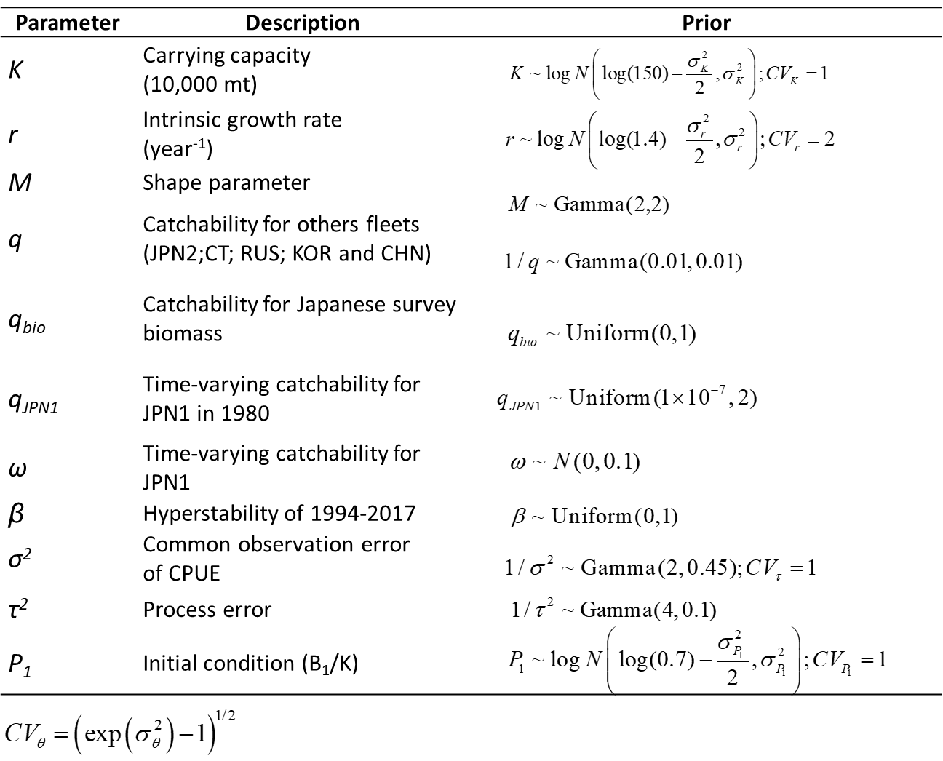

Table 4. Specifications of the 2 base case models. “JPN_early” = early Japan (1980-1993), “JPN_late” = late Japan (1994-2018), “CT” = Chinese Taipei, “RUS” = Russia, “KOR” = Korea, “CHN” = China, “JPN_bio” = Japan biomass survey. q1 = fishing efficiency of the Japanese mid-water trawl net; q = generic catchability of the Japanese biomass survey.

 | Base case 1 | Base case 2
Initial year | 1980
Biomass survey | B_obs = B_est*q1 ~ LN(log(q*B), σ²)  q~U(0, 1)
CPUE | CHN (2013-2018)  JPN_early (1980-1993; with time-varying q)  JPN_late (1994-2018)  KOR (2001-2018)  RUS (1994-2018)  CT (2001-2018) |  | CHN (2013-2018)  JPN_late (1994-2018)  KOR (2001-2018)  RUS (1994-2018)  CT (2001-2018)
Variance component | 6 times of biomass |  | 5 times of biomass
Hyper-depletion/ stability | β ~ U(0, 1) but [β_JPN_early=1] |  | β ~ U(0, 1)

Table 5. Specifications of the 4 sensitivity models. “JPN_early” = early Japan (1980-1993), “JPN_late” = late Japan (1994-2018), “CT” = Chinese Taipei, “RUS” = Russia, “KOR” = Korea, “CHN” = China, “JPN_bio” = Japan biomass survey. q = generic catchability of the Japanese biomass survey.

 | Sensitivity case 1 & 2 |  | Sensitivity case 3 & 4
Initial year | 1980 |  | 1980/2001
Biomass survey | q~U(0, 2) |  | q~U(0, 1)  2003-2019
CPUE | CHN (2013-2018)  JPN_early (1980-1993; with time-varying q)  JPN_late (1994-2018)  KOR (2001-2018)  RUS (1994-2018)  CT (2001-2018) | CHN (2013-2018)  JPN_late (1994-2018)  KOR (2001-2018)  RUS (1994-2018)  CT (2001-2018) | Joint CPUE (2001-2019) | JPN_early (1980-1993)  Joint CPUE (2001-2019)
Variance component | Same as base cases 1 and 2, respectively |  | Same weight between biomass and joint CPUE
Hyper-depletion/ stability | Same as base cases 1 and 2, respectively |  | b ~ U(0, 1)

Table 6. Diagnostics of model fittings of the two base case models. Root Mean Square Error (RMSE) is a measure of how to spread out the residuals. “JPN_early” = early Japan (1980-1993), “JPN_late” = late Japan (1994-2017), “CT” = Chinese Taipei, “RUS” = Russia, “KOR” = Korea, “CHN” = China, “JPN_bio” = Japan biomass survey.
Model | Base case1 | Base case2
Abundance index | RMSE ( Root Mean Square Error)
JPN_early | 0.56 | --
JPN_late | 0.87 | 0.88
CT | 1.05 | 1.04
KOR | 6.14 | 6.19
RUS | 2.37 | 2.36
CHN | 3.35 | 3.39
JPN_bio | 10.42 | 10.40

Table 7. Summary of parameter estimates of the base case 1.

 | Mean | Median | Lower 10th | Upper 10th
r | 1.130 | 0.928 | 0.474 | 1.976
K | 316.120 | 287.800 | 184.200 | 484.100
qCHN | 0.191 | 0.172 | 0.088 | 0.320
qJPN2 | 0.024 | 0.022 | 0.012 | 0.040
qKOR | 0.272 | 0.244 | 0.129 | 0.448
qRUS | 0.109 | 0.098 | 0.051 | 0.178
qCT | 0.025 | 0.022 | 0.012 | 0.040
qBio | 0.352 | 0.319 | 0.155 | 0.598
Shape parameter (M) | 0.684 | 0.582 | 0.233 | 1.260
observation error (σ_{com}) | 0.349 | 0.347 | 0.316 | 0.384
observation error (σ_{bio}) | 0.144 | 0.143 | 0.130 | 0.158
process error (τ) | 0.226 | 0.222 | 0.173 | 0.282
F_{MSY} | 0.437 | 0.403 | 0.235 | 0.682
B_{MSY} | 144.991 | 131.600 | 85.189 | 221.500
MSY | 44.641 | 43.040 | 35.970 | 55.380
b | 0.891 | 0.894 | 0.818 | 0.963
qJPN1_1980 | 0.015 | 0.014 | 0.007 | 0.024
qJPN1_1981 | 0.015 | 0.014 | 0.007 | 0.024
qJPN1_1982 | 0.015 | 0.014 | 0.007 | 0.024
qJPN1_1983 | 0.015 | 0.014 | 0.007 | 0.025
qJPN1_1984 | 0.016 | 0.014 | 0.008 | 0.025
qJPN1_1985 | 0.016 | 0.015 | 0.008 | 0.027
qJPN1_1986 | 0.017 | 0.015 | 0.008 | 0.027
qJPN1_1987 | 0.017 | 0.016 | 0.009 | 0.028
qJPN1_1988 | 0.019 | 0.017 | 0.009 | 0.030
qJPN1_1989 | 0.020 | 0.018 | 0.010 | 0.032
qJPN1_1990 | 0.021 | 0.019 | 0.010 | 0.033
qJPN1_1991 | 0.022 | 0.020 | 0.011 | 0.036
qJPN1_1992 | 0.023 | 0.021 | 0.011 | 0.038
qJPN1_1993 | 0.024 | 0.022 | 0.012 | 0.040

Table 8. Summary of parameter estimates of the base case 2.

 | Mean | Median | Lower 10th | Upper 10th
r | 1.159 | 0.956 | 0.433 | 2.068
K | 287.431 | 251.300 | 158.000 | 465.110
qCHN | 1.012 | 0.888 | 0.391 | 1.782
qJPN2 | 0.141 | 0.124 | 0.054 | 0.249
qKOR | 1.543 | 1.355 | 0.585 | 2.730
qRUS | 0.624 | 0.547 | 0.234 | 1.103
qCT | 0.140 | 0.123 | 0.053 | 0.250
qBio | 0.442 | 0.414 | 0.181 | 0.751
Shape parameter (M) | 0.739 | 0.633 | 0.251 | 1.363
Observation error (σ_{com}) | 0.344 | 0.342 | 0.309 | 0.381
observation error (σ_{bio}) | 0.153 | 0.153 | 0.138 | 0.170
Process error (τ) | 0.267 | 0.262 | 0.197 | 0.344
F_{MSY} | 0.501 | 0.446 | 0.210 | 0.863
B_{MSY} | 133.546 | 116.350 | 73.420 | 216.100
MSY | 42.457 | 41.560 | 33.310 | 52.500
b | 0.591 | 0.587 | 0.455 | 0.734

Table 9. Summary of joint estimates of model parameters of the base cases 1 and 2.

 | Mean | Median | Lower 10th | Upper 10th
r | 1.144 | 0.941 | 0.456 | 2.023
K | 301.776 | 270.200 | 168.590 | 474.900
qCHN | 0.602 | 0.347 | 0.111 | 1.422
qJPN2 | 0.083 | 0.045 | 0.014 | 0.199
qKOR | 0.907 | 0.501 | 0.160 | 2.178
qRUS | 0.366 | 0.200 | 0.064 | 0.878
qCT | 0.082 | 0.045 | 0.014 | 0.198
qBio | 0.397 | 0.362 | 0.166 | 0.686
Shape parameter (M) | 0.711 | 0.607 | 0.241 | 1.313
Observation error (σ_{com}) | 0.346 | 0.345 | 0.312 | 0.383
Observation error (σ_{bio}) | 0.149 | 0.148 | 0.133 | 0.166
Process error (τ) | 0.247 | 0.240 | 0.182 | 0.320
F_{MSY} | 0.469 | 0.421 | 0.223 | 0.775
B_{MSY} | 139.269 | 124.100 | 78.270 | 218.900
MSY | 43.549 | 42.320 | 34.590 | 54.000
b | 0.741 | 0.790 | 0.499 | 0.942

Table 10. Summary of reference points of the base case 1.

 | Mean | Median | Lower 10th | Upper 10th
C₂₀₁₈ | 43.91 | 43.91 | 43.91 | 43.91
AveC₂₀₁₆₋₂₀₁₈ | 35.45 | 35.45 | 35.45 | 35.45
AveF₂₀₁₆₋₂₀₁₈ | 0.543 | 0.404 | 0.177 | 0.975
F₂₀₁₈ | 0.612 | 0.430 | 0.186 | 1.078
F_{MSY} | 0.437 | 0.403 | 0.235 | 0.682
MSY | 44.641 | 43.040 | 35.970 | 55.380
F₂₀₁₈/F_{MSY} | 1.298 | 1.105 | 0.590 | 2.052
AveF_{2016-2018/}F_{MSY} | 1.168 | 1.038 | 0.575 | 1.814
K | 316.120 | 287.800 | 184.200 | 484.100
B₂₀₁₈ | 148.738 | 125.500 | 66.550 | 259.310
B₂₀₁₉ | 119.117 | 100.300 | 51.759 | 210.500
AveB₂₀₁₇₋₂₀₁₉ | 120.722 | 102.288 | 54.503 | 210.203
B_{MSY} | 144.991 | 131.600 | 85.189 | 221.500
B_{MSY}/K | 0.461 | 0.455 | 0.407 | 0.524
B₂₀₁₈/K | 0.455 | 0.443 | 0.310 | 0.608
B₂₀₁₉/K | 0.363 | 0.354 | 0.243 | 0.491
B₂₀₁₇₋₂₀₁₉/K | 0.369 | 0.362 | 0.258 | 0.484
B₂₀₁₇/B_{MSY} | 0.632 | 0.609 | 0.443 | 0.845
B₂₀₁₈/B_{MSY} | 0.996 | 0.958 | 0.662 | 1.371
B₂₀₁₉/B_{MSY} | 0.795 | 0.766 | 0.519 | 1.098
B₂₀₁₇₋₂₀₁₉/B_{MSY} | 0.807 | 0.781 | 0.551 | 1.090

Table 11. Summary of reference points of the base case 2.

 | Mean | Median | Lower 10th | Upper 10th
C₂₀₁₈ | 43.91 | 43.91 | 43.91 | 43.91
AveC₂₀₁₆₋₂₀₁₈ | 35.45 | 35.45 | 35.45 | 35.45
AveF₂₀₁₆₋₂₀₁₈ | 1.078 | 0.630 | 0.228 | 1.961
F₂₀₁₈ | 1.156 | 0.646 | 0.230 | 2.023
F_{MSY} | 0.501 | 0.446 | 0.210 | 0.863
MSY | 42.457 | 41.560 | 33.310 | 52.500
F₂₀₁₈/F_{MSY} | 1.971 | 1.554 | 0.791 | 3.051
AveF_{2016-2018/}F_{MSY} | 1.843 | 1.524 | 0.804 | 2.906
K | 287.431 | 251.300 | 158.000 | 465.110
B₂₀₁₈ | 118.625 | 92.245 | 50.600 | 214.010
B₂₀₁₉ | 95.583 | 74.190 | 39.550 | 174.200
AveB₂₀₁₇₋₂₀₁₉ | 94.623 | 74.073 | 40.676 | 169.967
B_{MSY} | 133.546 | 116.350 | 73.420 | 216.100
B_{MSY}/K | 0.467 | 0.461 | 0.410 | 0.532
B₂₀₁₈/K | 0.394 | 0.374 | 0.270 | 0.539
B₂₀₁₉/K | 0.317 | 0.301 | 0.210 | 0.436
B₂₀₁₇₋₂₀₁₉/K | 0.315 | 0.301 | 0.220 | 0.422
B₂₀₁₇/B_{MSY} | 0.504 | 0.475 | 0.352 | 0.685
B₂₀₁₈/B_{MSY} | 0.855 | 0.794 | 0.575 | 1.194
B₂₀₁₉/B_{MSY} | 0.686 | 0.640 | 0.450 | 0.964
B₂₀₁₇₋₂₀₁₉/B_{MSY} | 0.681 | 0.638 | 0.471 | 0.934

Table 12. Summary of joint estimates of reference points of the base cases 1 and 2.

 | Mean | Median | Lower 10th | Upper 10th
C₂₀₁₈ | 43.91 | 43.91 | 43.91 | 43.91
AveC₂₀₁₆₋₂₀₁₈ | 35.45 | 35.45 | 35.45 | 35.45
AveF₂₀₁₆₋₂₀₁₈ | 0.810 | 0.497 | 0.196 | 1.425
F₂₀₁₈ | 0.884 | 0.521 | 0.202 | 1.523
F_{MSY} | 0.469 | 0.421 | 0.223 | 0.775
MSY | 43.549 | 42.320 | 34.590 | 54.000
F₂₀₁₈/F_{MSY} | 1.635 | 1.308 | 0.656 | 2.562
AveF_{2016-2018/}F_{MSY} | 1.505 | 1.257 | 0.646 | 2.354
K | 301.776 | 270.200 | 168.590 | 474.900
B₂₀₁₈ | 133.681 | 108.100 | 56.149 | 239.600
B₂₀₁₉ | 107.350 | 86.960 | 43.720 | 194.300
AveB₂₀₁₇₋₂₀₁₉ | 107.672 | 87.565 | 45.387 | 192.903
B_{MSY} | 139.269 | 124.100 | 78.270 | 218.900
B_{MSY}/K | 0.506 | 0.456 | 0.285 | 0.756
B₂₀₁₈/K | 0.425 | 0.407 | 0.284 | 0.582
B₂₀₁₉/K | 0.362 | 0.353 | 0.242 | 0.491
B₂₀₁₇₋₂₀₁₉/K | 0.342 | 0.330 | 0.233 | 0.462
B₂₀₁₇/B_{MSY} | 0.568 | 0.538 | 0.379 | 0.788
B₂₀₁₈/B_{MSY} | 0.925 | 0.873 | 0.607 | 1.303
B₂₀₁₉/B_{MSY} | 0.740 | 0.700 | 0.475 | 1.046
B₂₀₁₇₋₂₀₁₉/B_{MSY} | 0.744 | 0.707 | 0.499 | 1.033

Table 13. Ensemble projected probabilities of stock phases of the Kobe plot in 2024 by eight harvest scenarios (differed in the catch fraction of average catch [354,469 mt] in 2016-2018) from the base cases 1 and 2. Q1 means the Prob [B>B_{MSY} and F<F_{MSY}]; Q2 means the Prob [B>B_{MSY} and F>F_{MSY}]; Q3 means the Prob [B<B_{MSY} and F<F_{MSY}] and Q4 means the Prob [B<B_{MSY} and F>F_{MSY}].

Catch fraction | Q1 | Q2 | Q3 | Q4
-30% | 0.81 | 0.00 | 0.06 | 0.12
-20% | 0.69 | 0.00 | 0.17 | 0.15
-10% | 0.53 | 0.00 | 0.33 | 0.14
1 | 0.39 | 0.01 | 0.51 | 0.10
10% | 0.28 | 0.01 | 0.65 | 0.06
20% | 0.20 | 0.01 | 0.76 | 0.04
30% | 0.14 | 0.01 | 0.83 | 0.02
No catch | 1.00 | 0.00 | 0.00 | 0.00

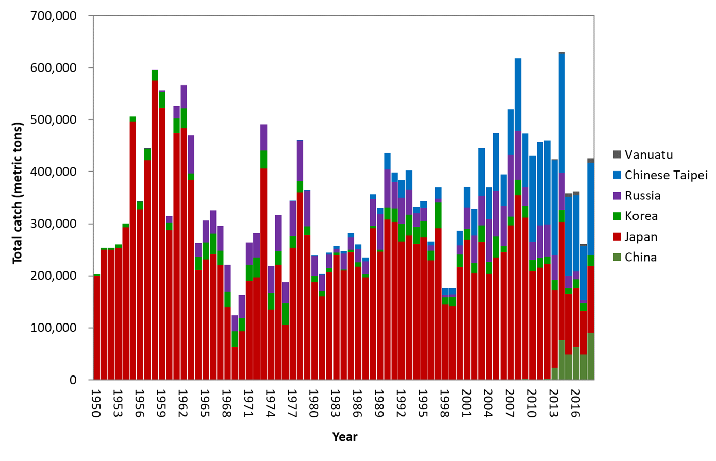
Figure 1. Time-series of catches (metric ton) of the Pacific saury in the Western North Pacific Ocean from 1950 to 2018 by members.
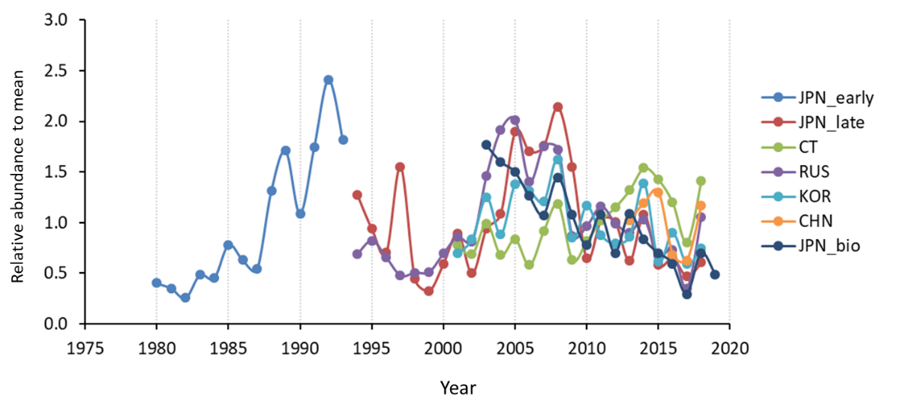
Figure 2. Pacific saury CPUE indices from early Japan (JPN_early), late Japan (JPN_late). Chinese Taipei (CT), Russia (RUS), Korea (KOR), and China (CHN) stick-held dip net fisheries, and biomass survey index of Japan (JPN_bio) during 1980-2019 in the Western North Pacific Ocean.
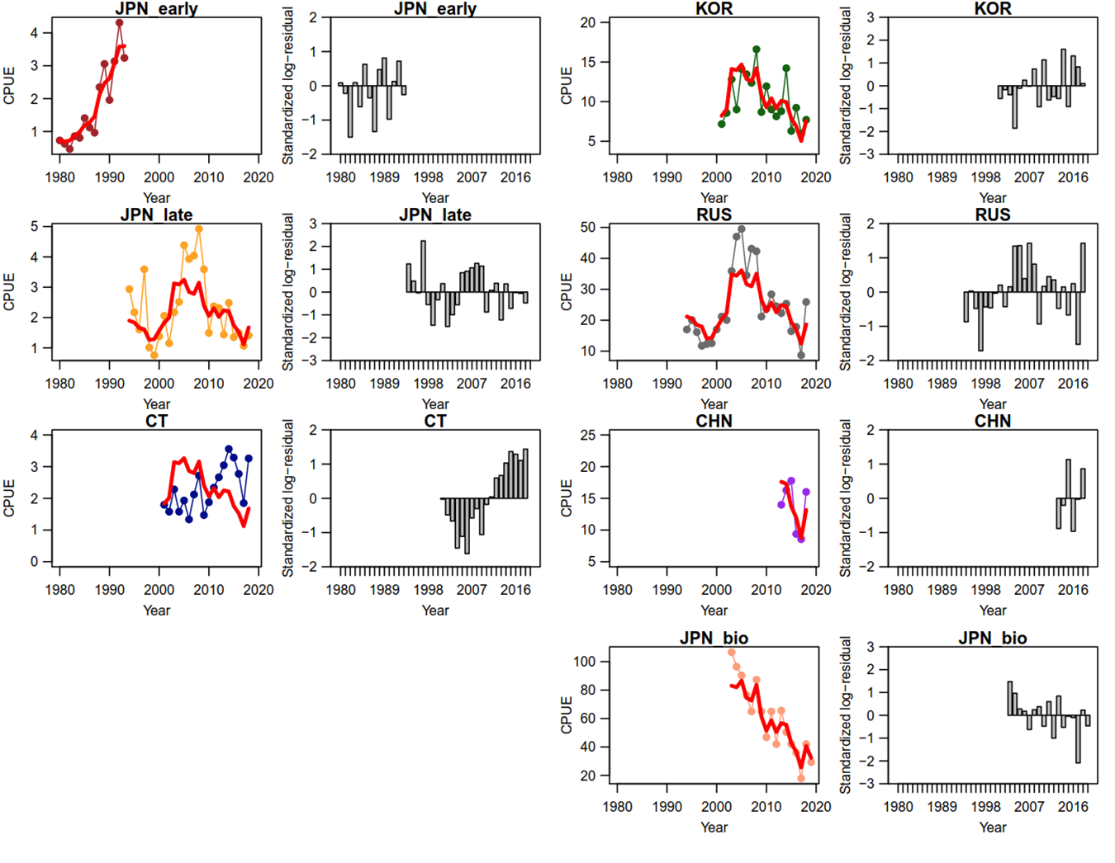
Figure 3. Time-series of observed (circle-line) and predicted (red solid line) catch per unit effort (CPUE) of Western North Pacific saury and standardized log-residuals for the base case 1 production model. “JPN_early” = early Japan (1980-1993), “JPN_late”=late Japan (1994-2018), “CT” = Chinese Taipei, “RUS” = Russia, “KOR”= Korea, “CHN”=China, “JPN_bio” = Japanese biomass survey.
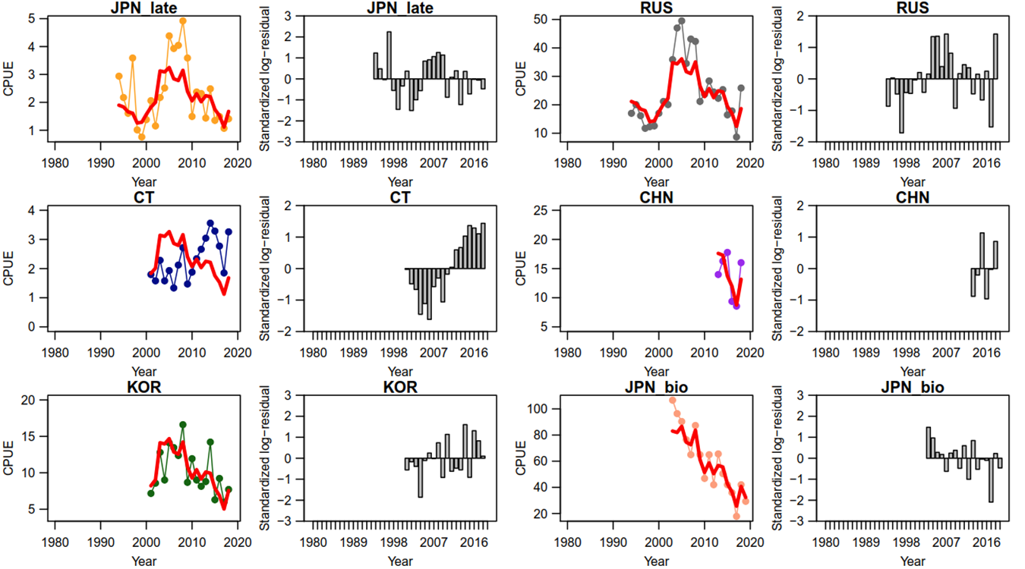

Figure 4. Time-series of observed (circle-line) and predicted (red solid line) catch per unit effort (CPUE) of Western North Pacific saury and standardized log-residuals for the base case 2 production model. “JPN_late”=late Japan (1994-2018), “CT” = Chinese Taipei, “RUS” = Russia, “KOR”= Korea, “CHN”=China, “JPN_bio” = Japanese biomass survey.

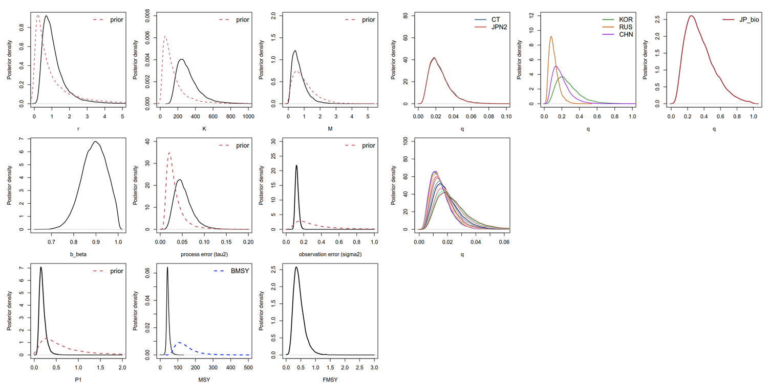
Figure 5. Kernel density estimates of the posterior distributions (solid lines) of various model parameters and management quantities for the base case 1 production model for the Pacific saury in the Western North Pacific Ocean. Proper prior densities are given by the dashed lines. “JPN2”=late Japan (1994-2018), “CT” = Chinese Taipei, “RUS” = Russia, “KOR”= Korea, “CHN”=China, “JP_bio” = Japanese biomass survey.
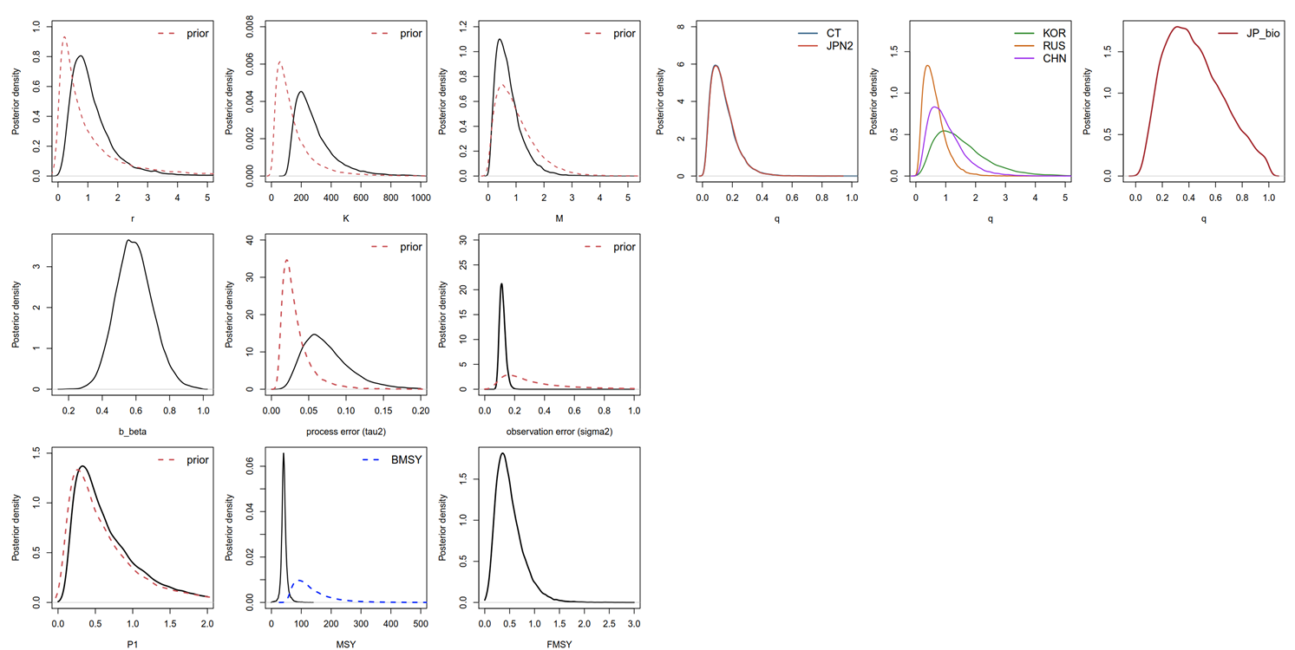
Figure 6. Kernel density estimates of the posterior distributions (solid lines) of various model parameters and management quantities for the base case 2 production model for the Pacific saury in the Western North Pacific Ocean. Proper prior densities are given by the dashed lines. “JPN2”=late Japan (1994-2018), “CT” = Chinese Taipei, “RUS” = Russia, “KOR”= Korea, “CHN”=China, “JP_bio” = Japanese biomass survey.

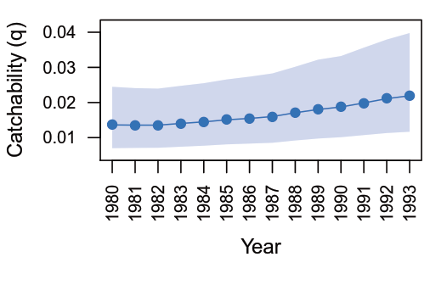
Figure 7. Time series estimates of annual catchabilities of the early Japanese CPUE from 1980 to 1993 for the base case 1.

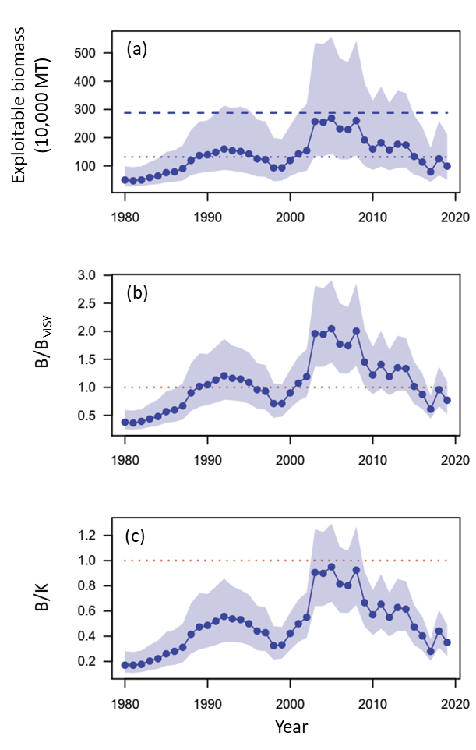
Figure 8. Time series of biomass (10,000 metric ton) (a), ratio of biomass to B_{MSY} (B/B_{MSY}) (b), and depletion ratio (B/K) of the Western North Pacific saury for the base case 1. In panel (a), the upper dashed and lower dotted horizontal line denotes the carrying capacity (K) and B_{MSY}, respectively. In panels (b) and (c), the dashed lines denote the reference levels of 1.

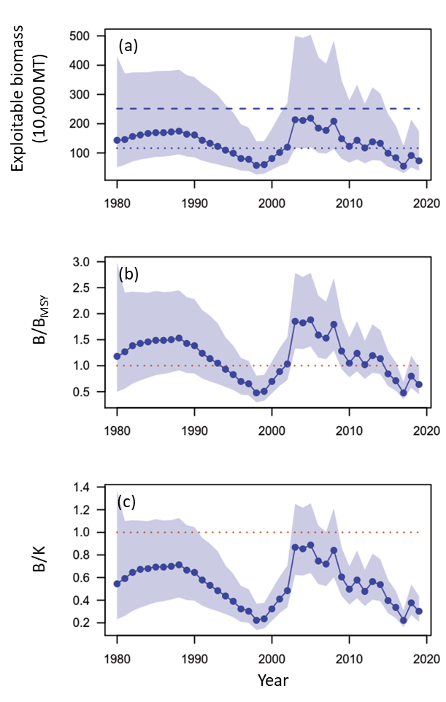
Figure 9. Time series of biomass (10,000 metric ton) (a), ratio of biomass to B_{MSY} (B/B_{MSY}) (b), and depletion ratio (B/K) of the Western North Pacific saury for the base case 2. In panel (a), the upper dashed and lower dotted horizontal line denotes the carrying capacity (K) and BMSY, respectively. In panels (b) and (c), the dashed lines denote the reference levels of 1.
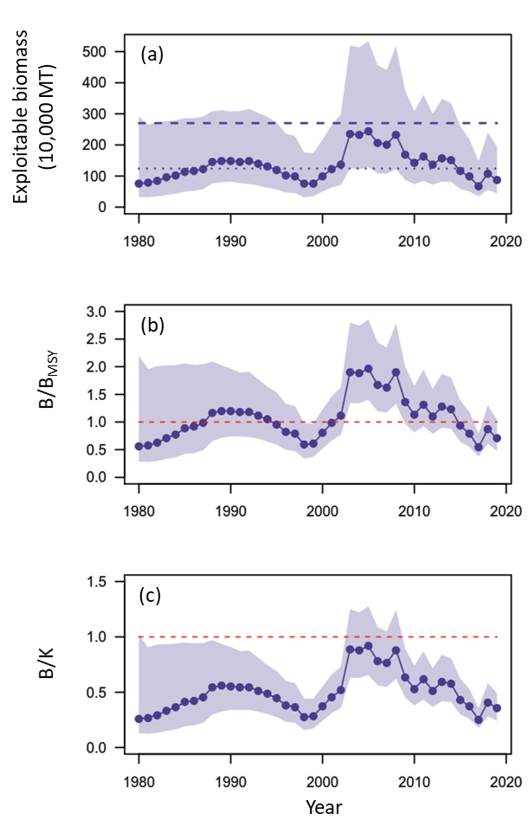
Figure 10. Time series of ensemble biomass (10,000 metric ton) (a), ratio of biomass to B_{MSY} (B/B_{MSY}) (b), and depletion ratio (B/K) of the Western North Pacific saury for the median estimates of MCMC results from base case 1 and 2. In panel (a), the upper dashed and lower dotted horizontal line denotes the carrying capacity (K) and B_{MSY}, respectively. In panels (b) and (c), the dashed lines denote the reference levels of 1.
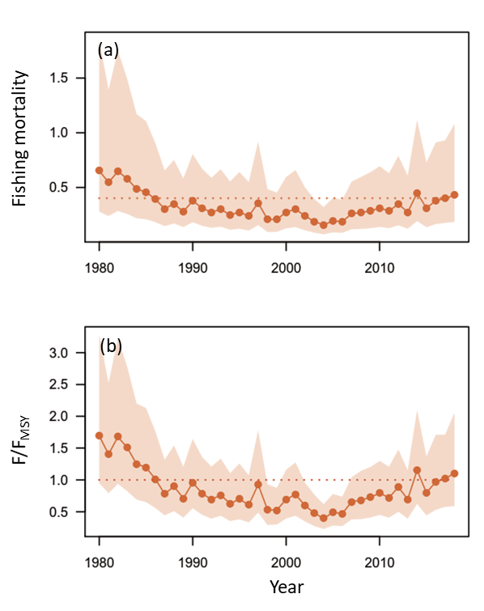
Figure. 11. Time series of fishing mortality (a) and ratio of fishing mortality to F_{MSY} (F/F_{MSY}) (b) of the Western North Pacific saury for the base case 1. In panel (a), the dashed line denotes the F_{MSY}. In panels (b), the dashed line denotes the reference levels of 1.

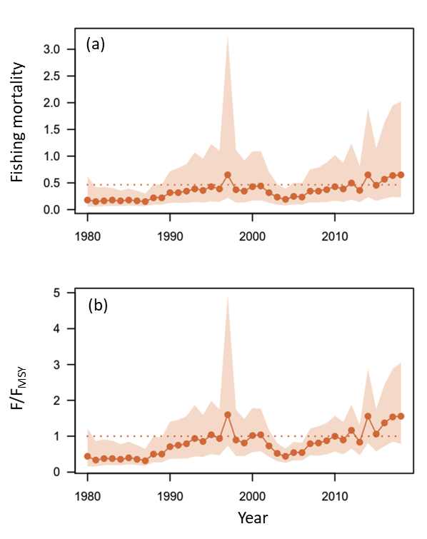
Figure. 12. Time series of fishing mortality (a) and ratio of fishing mortality to F_{MSY} (F/F_{MSY}) (b) of the Western North Pacific saury for the base case 2. In panel (a), the dashed line denotes the F_{MSY}. In panels (b), the dashed line denotes the reference levels of 1.

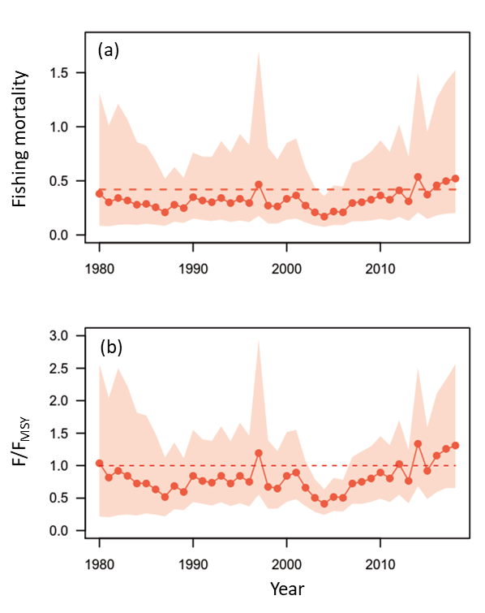
Figure 13. Time series of ensemble fishing mortality (a) and ratio of fishing mortality to F_{MSY} (F/F_{MSY}) (b) of the Western North Pacific saury for the median estimates of MCMC results from base case 1 and 2. In panel (a), the dashed line denotes the F_{MSY}. In panels (b), the dashed line denotes the reference levels of 1.

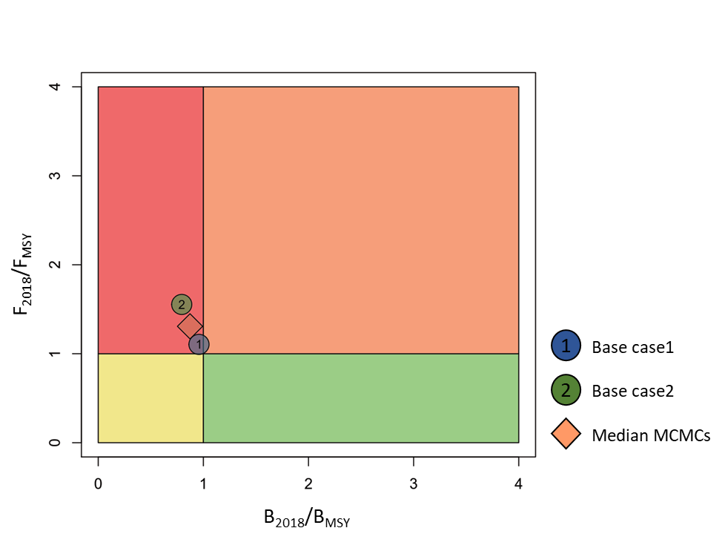
Figure 14. Kobe phase plot of stock status in 2018 of Pacific saury from the two base case models. The orange diamond is the median estimate of MCMC results from the two base case models.
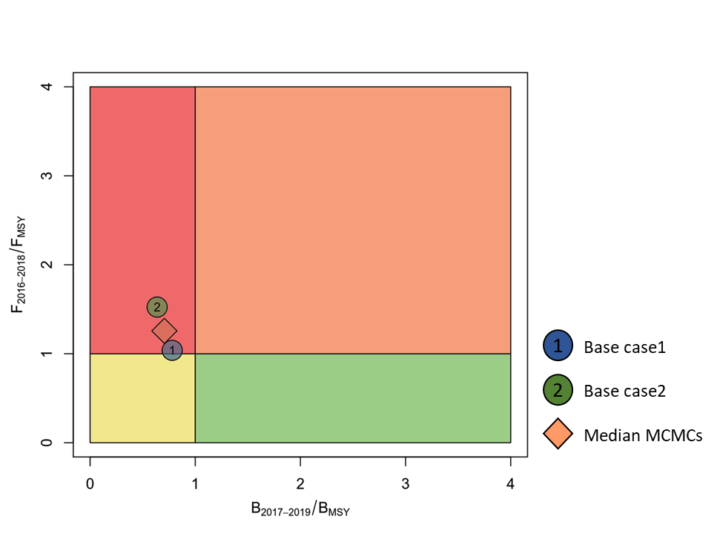
Figure 15. Kobe phase plot of average stock status (B₂₀₁₇₋₂₀₁₉/B_{MSY} and F₂₀₁₆₋₂₀₁₈/F_{MSY}) of Pacific saury from the two base case models. The orange diamond is the median estimate of MCMC results from the two base case models.
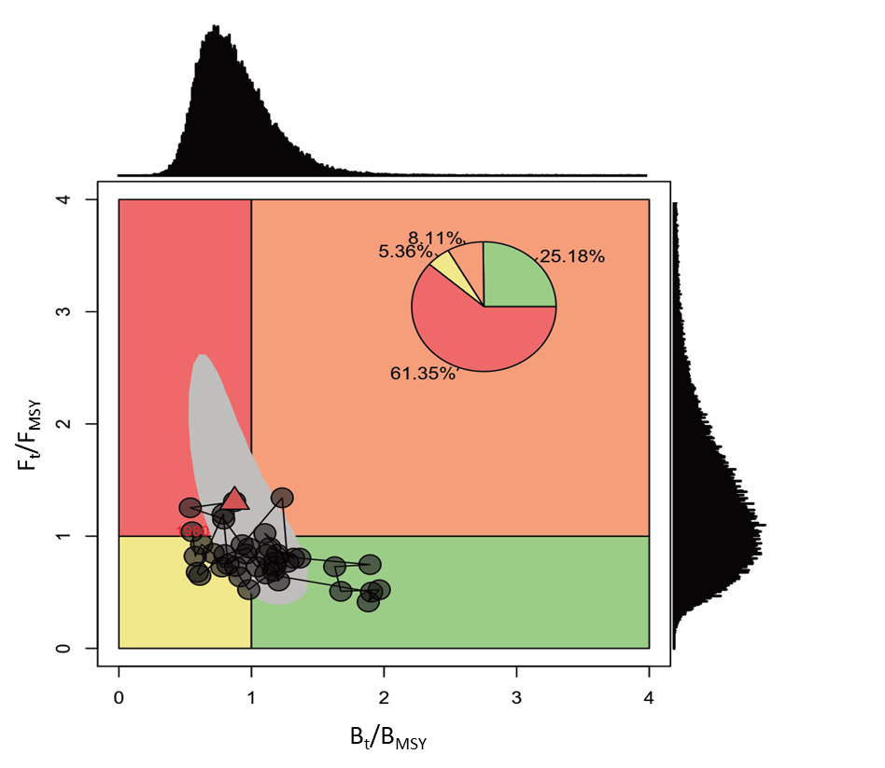
Figure 16. Ensemble Kobe phase plot of the stock trajectory of the Western North Pacific saury from 1980 to 2018 with uncertainty estimate in 2018 (80% credible intervals, grey polygon) from the two base case models.
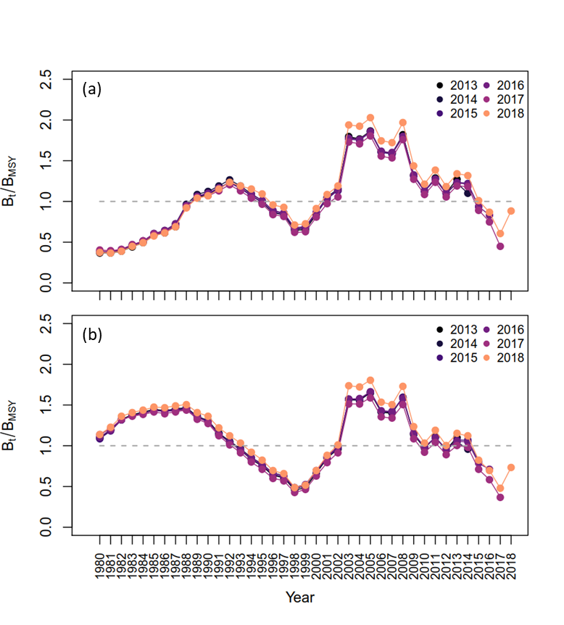
Figure 17. Six years within‒model retrospective plots of the change in biomass ratio to B_{MSY} of the Western North Pacific saury from the base case 1 (a) and 2 (b).

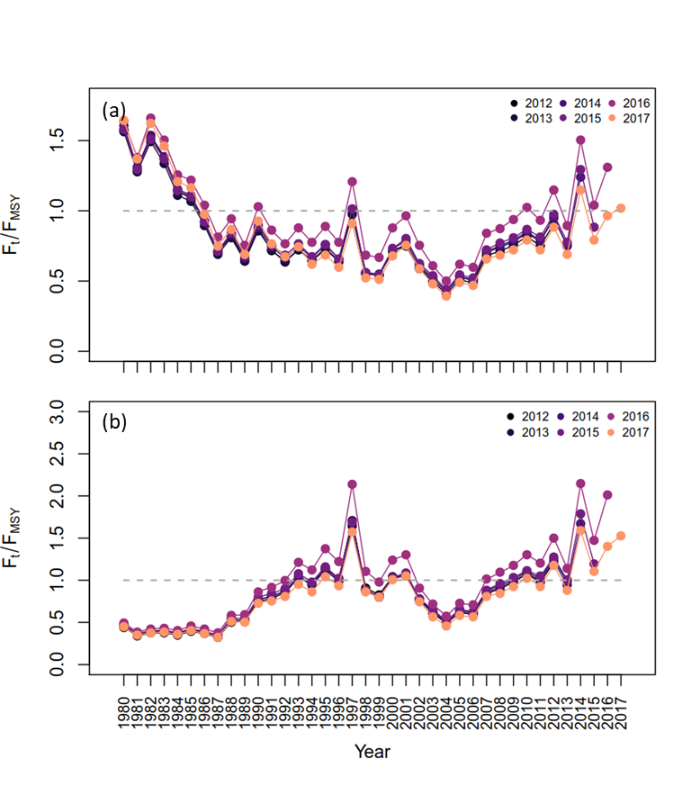
Figure 18. Six years within‒model retrospective plots of the change in fishing mortality to F_{MSY} of the Western North Pacific saury from the base case 1 (a) and 2 (b).

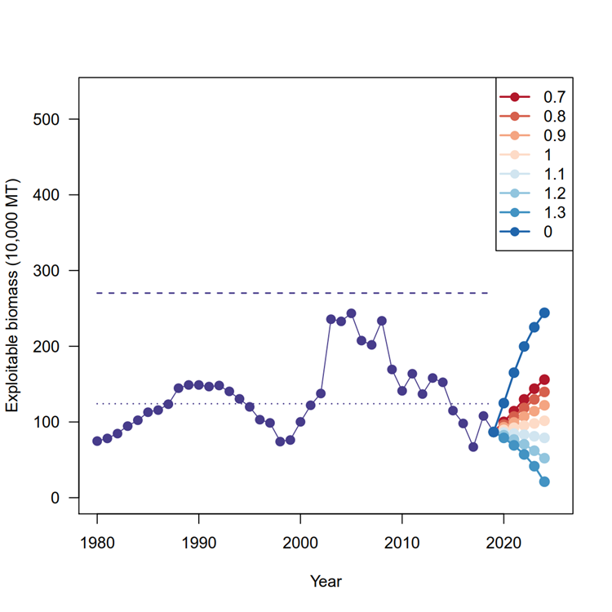
Figure 19. Ensemble estimates of historical and projected trajectories of biomass (in 10,000 mt) of the Western and Central North Pacific Ocean Pacific saury by eight harvest scenarios (differed in the catch fraction of average catch [354,469 mt] in 2016-2018) from the base cases 1 and 2. The upper dashed and lower dotted horizontal line denotes the carrying capacity (K) and B_{MSY}, respectively.

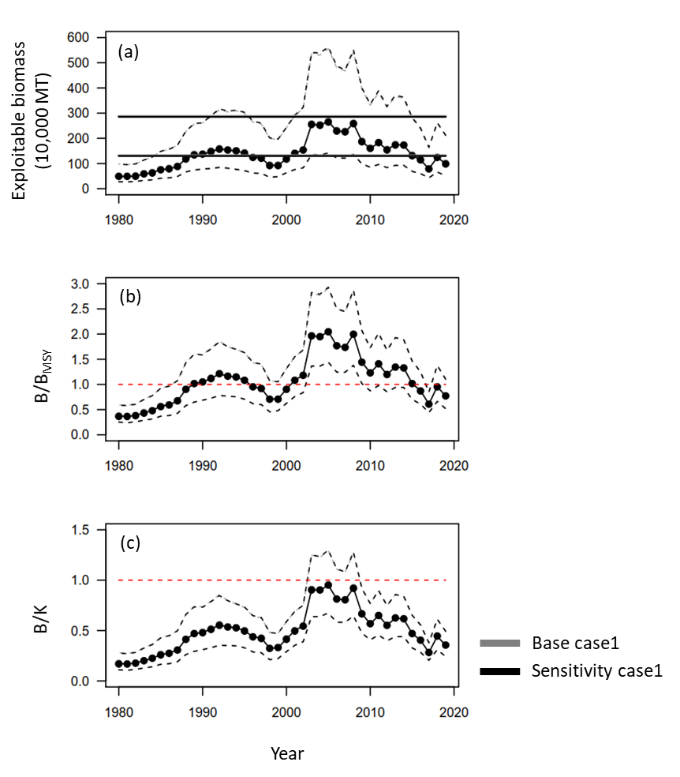
Figure S1. Time series of biomass (10,000 metric ton) (a), the ratio of biomass to B_{MSY} (B/B_{MSY}) (b), and depletion ratio (B/K) of the Western North Pacific saury for the base and sensitivity cases 1. In panel (a), the upper dashed and lower dotted horizontal line denotes the carrying capacity (K) and B_{MSY}, respectively. In panels (b) and (c), the dashed lines denote the reference levels of 1.

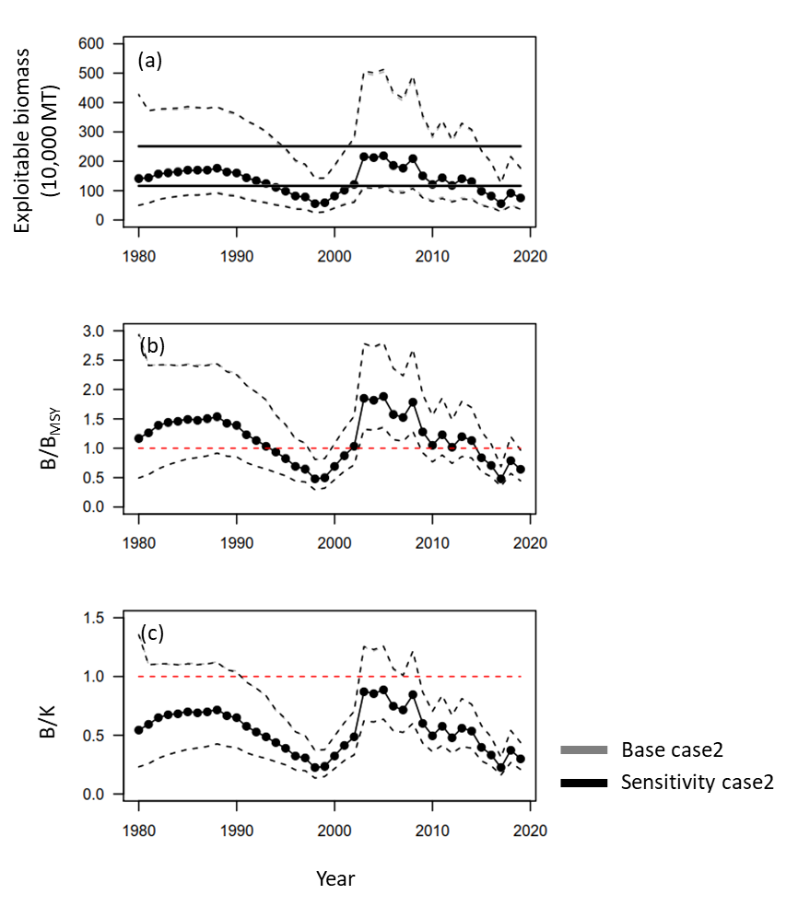
Figure S2. Time series of biomass (10,000 metric ton) (a), the ratio of biomass to B_{MSY} (B/B_{MSY}) (b), and depletion ratio (B/K) of the Western North Pacific saury for the base and sensitivity cases 1. In panel (a), the upper dashed and lower dotted horizontal line denotes the carrying capacity (K) and B_{MSY}, respectively. In panels (b) and (c), the dashed lines denote the reference levels of 1.
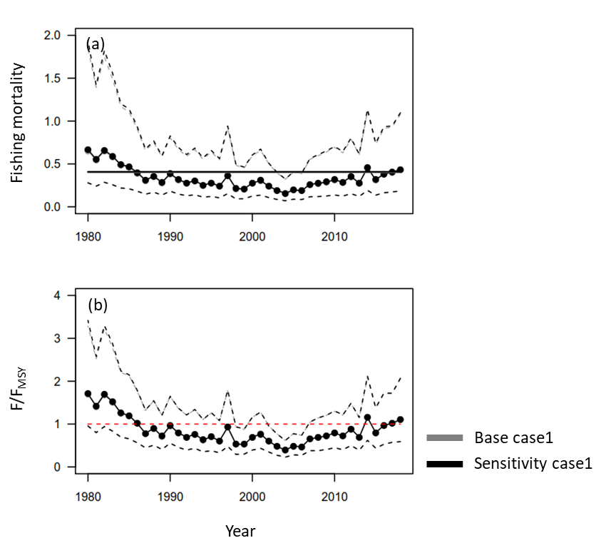
Figure S3. Time series of fishing mortality (a) and the ratio of fishing mortality to F_{MSY} (F/F_{MSY}) (b) of the Western North Pacific saury for the base and sensitivity cases 1. In panel (a), the dashed line denotes the FMSY. In panels (b), the dashed line denotes the reference levels of 1.
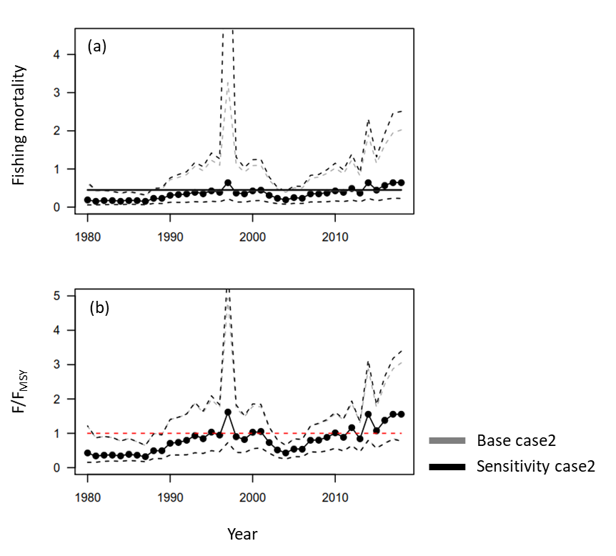
Figure S4. Time series of fishing mortality (a) and the ratio of fishing mortality to F_{MSY} (F/F_{MSY}) (b) of the Western North Pacific saury for the base and sensitivity cases 2. In panel (a), the dashed line denotes the FMSY. In panels (b), the dashed line denotes the reference levels of 1.

