NPFC-2020-SSC BFME01-WP16 (Rev. 1)
Elements of NPFC post-encounter measure

Based on the review of practices of other RFMOs (NPFC-2019-SSC VME04-WP01), five potential elements of post-encounter treatment, after encounter above the threshold, have been identified. They include supplementary information, reporting, temporary measure, SAI assessment and CMM (conservation and management measure). Comparing the existing VME process in NPFC with the process in other RFMOs, there are some missing parts that need to be considered (Figure 1).

Members expressed their views on the proposed options for the development of a post encounter measure for NPFC’s bottom fisheries. The Secretariat received feedback from Canada, Japan, Korea, Russia and the USA and compiled members’ views in the table below (Table 1).

The SSC BF-ME01 reviewed the table, made recommendations on the elements 1 and 2 and agreed on intersessional work to address the elements 3-6.
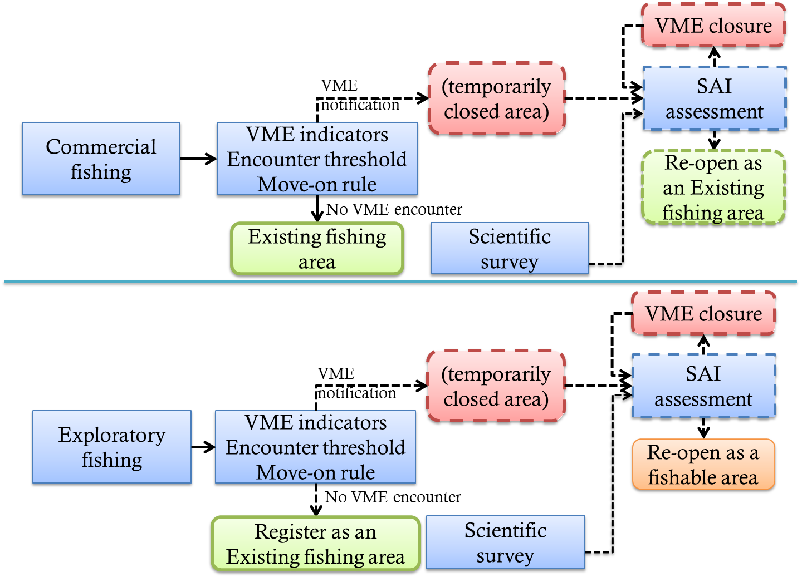
Figure 1. Existing and missing parts of the VME process in the NPFC. The solid lines represent existing parts and the dash lines represent missing parts.

Table 1. Potential elements of post-encounter treatment with explanatory notes.
Agreed at the SSC BF-ME01 meeting
To be discussed
# | Element of post-encounter treatment | Explanatory note of other RFMOs’ practices | Current NPFC situation | Proposed options for the development of a post encounter measure for NPFC
1 | Supplementary information | NEAFC and SEAFO Members shall carry out a sea bed mapping using eco-sounders and multi-beam sounder, if practicable, to assess accurate position and extent of the VME. | No requirements to collect supplementary information in the event of encounter.  *For data to be collected in association with VME, see CMM 2018-05, Annex 5, H, 2. | What (if any) post-encounter data should be collected?  a. Fishing data (collect data regarding the encounter)  CANADA: Yes, where (start and end latitudes and longitudes), how much (weight), what species of VME indicator, gear type, date, time –collected at time of encounter.  JAPAN: Yes, footprints.  KOREA: Yes.  RUSSIA: Yes  USA: Yes.  b. Science data (conduct a post-encounter scientific survey)  CANADA: Yes, seabed mapping (e.g. multibeam or other echosounder) with visual survey (e.g. drop-camera, AUV, or ROV) to confirm the presence of the VME and map the extent of the VME – collected some time after the encounter  JAPAN: Yes. ・Bottom topography mapped by eco-sounders (multi-beam bathymetric data) ・Seafloor images taken by drop camera and/or ROV ・Sampling of VME indicator species by a beam trawl and/or dredge.  KOREA: Yes  RUSSIA: Yes.  USA: Yes. Recommend that the area be marked for potential survey location for use in determining current or future survey sites by Members or others.
2 | Reporting | In all the RFMO/As, fishing vessels shall report encounters, however, the recipients and timelines differ.  Recipients: flag state, Secretariat or both.  Timelines: immediately/without delay (all RFMOs) or annually (SIOFA).  Also, one RFMO, CCAMLR, requires to immediately report some sub-threshold encounters. | Recipient: Secretariat, however, it is not clear who shall communicate to the Secretariat.  Timelines: Not specified.  Sub-threshold encounters: not reported to the Secretariat. | Who reports an encounter?  Fishing vessels → flag state →Secretariat→Member states  CANADA: Fishing vessel to both flag state and Secretariat.  JAPAN: Fishing vessels → flag state →Secretariat→Member states  KOREA: Fishing vessel to both flag state and Secretariat.  RUSSIA: Fishing vessels to flag state.  USA: Recommend that the fishing vessel reports to flag state, flag state passes along report to secretariat.  How quickly should be the report filed?  CANADA: Immediately (within 24 hours)  JAPAN: Immediately.  KOREA: Immediately.  RUSSIA: Within 1 day.  USA: Immediately. Will need to define ‘immediately’. Ideally within 24 hours.  Should sub-threshold encounters be reported?  No.  CANADA: No, this should be recorded as bycatch under the observer protocol (identified to smallest taxonomic grouping possible and weight).  JAPAN: No.  KOREA: No.  RUSSIA: No.  USA: Yes. Presence/absence data is important also. Thresholds need to be set sufficiently low as to be protective and precautionary.
3 | Temporary measure | NEAFC, CCAMLR, NAFO and SEAFO implement a temporary closure. For NEAFC and CCAMLR, it applies for both existing and new fishing areas. NAFO and SEAFO immediately implement a temporary closure only if the encounter happened outside existing fishing areas. Encounters within fishing footprint are assessed by SC of NAFO and SEAFO annually.  For sub-threshold encounters, a warning for Members shall be circulated by the Executive Secretary, indicating that VMEs may occur within the area. | No temporary measures. | Should a temporary closure be implemented when an encounter occurs?  CANADA: Yes.  JAPAN: Yes.  KOREA: Yes.  RUSSIA: No. It should be defined clearly what “temporary closure” means.  USA: Yes. Gear-specific encounter thresholds should be established that are sufficiently low that if the area is determined to be a VME, the closure that was triggered was both appropriate and precautionary.  What is the size of the closure?  CANADA: Trawl: 2 nautical mile wide band (polygon) on both sides of the "track" of the trawl haul; Other gears: 2 nautical mile radius around a reported VME encounter location (consult with TCC for enforceability issues regarding size of closure and mix of gear types on a single vessel).  JAPAN: ・The size of the closure and its base line/point should be considered taking into account rationales of NAFO, SEAFO, SIOFA and SPRFMO measures. For example, in NAFO and SIOFA, temporary closure size is 2 nm radius around encounter location, or 2 nm either side of the trawl track. Meanwhile, in SPRFMO, it is 1 nm either side of the trawl track extended by 1 nm at each end. Further, in SEAFO, a temporary closure for bottom trawling is implemented on the basis of the end point of the trawl haul instead of the trawl track.  ・The approach by NAFO and SEAFO that a temporary closure is implemented if the encounter happened outside existing fishing area should be considered.  KOREA: Trawl: 2 nautical mile wide band (polygon) on both sides of the "track" of the trawl haul; Other gears: 2 mile radius around a reported VME encounter location.  RUSSIA: 2 nautical mile radius around the center of the fishing operation.  USA: Trawl: 2 nautical mile wide band (polygon) on both sides of the "track" of the trawl haul; Other gears: 2 mile radius around a reported VME encounter location.  Who can implement the closure?  CANADA: Executive Secretary immediately informs HODs and designated representatives through a Circular. Members can choose to implement a closure for their own fleet if desired.  JAPAN: Matter to be dealt with by the commission.  KOREA: Executive Secretary immediately informs HODs and designated representatives through a Circular.  RUSSIA: Chair of the Commission informs HODs and designated representatives on a temporary closure through a Circular via the Secretariat (until an official decision by the Commission).  USA: Executive Secretary immediately informs HODs and designated representatives through a Circular. Members have duty to inform fleets and enforcement operations. A list of all closures should be maintained in an easily accessible format on the public portion of the NPFC website.  What are the timelines?  CANADA: The closure shall be implemented effective immediately upon communication of the encounter by the commission.  JAPAN: Matter to be dealt with by the commission.  KOREA: The temporary closure….  RUSSIA: The temporary closure shall be implemented following the receipt of information on encounter (exact timeline TBD).  USA: The closure shall be implemented on the day following the receipt of information on encounter.
4 | SAI assessment | Based on the information received from the fishing vessel(s) and other sources (e.g. research survey), Scientific Committee shall conclude if the area has a VME.  If yes, the temporary closure shall be maintained. Otherwise, the Executive Secretary shall inform the Members that they may reopen the area to their vessels. | In the event of encounter, the Secretariat “shall notify the other Members of the Commission so that appropriate measures can be adopted in respect of the relevant site”.  Neither timelines for such notification nor appropriate measures are specified.  Generally, paragraph 5 of CMM 2018-05 stipulates that “Members of the Commission shall submit to the SC their assessments of the impacts of fishing activity on marine species or any VMEs, including the proposed management measures to prevent such impact. Such submissions shall include all relevant data and information in support of any such assessment”. However, there is no specific guidance on how, by whom and when SAI assessment related to VME encounter shall be done. | How do we assess whether a VME exists in the area and has been impacted?  CANADA: Based on all the available data, including data on the VME encounter and distribution received from the fishing vessel(s), research survey data, model outputs or visual survey data, Scientific Committee shall conclude if the area has a VME. If yes, the temporary closure shall be made permanent with periodic review if new information or data become available. Otherwise, the Executive Secretary shall inform the Members that they may reopen the area to their vessels.  JAPAN: These questions are important topics at the SSC meeting. It would be very helpful for our discussion at the SSC if you and/or Kari could kindly review on how other RFMOs are assessing them.  KOREA: Based on the information received from the fishing vessel(s) and other sources (e.g. research survey), Scientific Committee shall conclude if the area has a VME. If yes, the temporary closure shall be maintained. Otherwise, the Executive Secretary shall inform the Members that they may reopen the area to their vessels.  RUSSIA: Based on the information received from the fishing vessel(s) and other sources (e.g. research survey), Scientific Committee shall conclude if the area has a VME. If yes, the temporary closure shall be maintained. Otherwise, the Executive Secretary shall inform the Members that they may reopen the area to their vessels.  USA: Based on the information received from the fishing vessel(s) and other sources (e.g. research survey), Scientific Committee shall conclude if the area has a VME. Temporary closures will remain in place until the SC reviews the fishing and relevant scientific information about the site and encounter. If the SC reviews all relevant information and determines that the area does not have a VME, the Commission may decide to remove/rescind the temporary closure.  How do determine if a VME exists: Consider an approach similar to CCAMLR (and possibly other RFMOs); VME area is where 10 or more VME indicator species were caught in a specified longline segment – but adapt concept to gears used in NPFC.  Require 100% observer coverage on bottom fishing vessels, which would help to ensure accuracy in reporting.  Question – on what time frame would the SC be reaching a conclusion about VME presence? Annually, intersessionally, or other?
5 | CMM | Scientific Committee shall provide advice to the Commission on whether a VME exists in the area and suggest appropriate measures. The Commission shall consider the advice and adopt conservation and management measures. | See the above. | CMM  CANADA: Scientific Committee shall provide advice to the Commission on whether a VME exists in the area and suggest appropriate measures. The Commission shall consider the advice and adopt conservation and management measures.  JAPAN: -/-  KOREA: Scientific Committee shall provide any relevant scientific advice on VME. The Commission shall consider the advice and adopt conservation and management measures.  RUSSIA: Scientific Committee shall provide advice to the Commission on whether a VME exists in the area and suggest appropriate measures. The Commission shall consider the advice and adopt particular changes and a revised conservation and management measure (CMM)s, or adopt new CMM(s).  USA: Scientific Committee shall provide advice to the Commission on whether a VME exists in the area and suggest appropriate precautionary measures. The Commission shall consider the advice and adopt conservation and management measures to protect VME areas.
6 | Other questions |  |  | ▪ Area of application: Shall it be a common encounter protocol, including post-encounter treatment, for all areas or shall it be different for “fished” and “unfished” areas?  CANADA: No, unfished areas should follow the exploratory fishing protocol.  JAPAN: According to CMM 2018-05, Annex 1 (Exploratory fishery protocol in the North Pacific Ocean). 6, exploratory fishery is required to adopt conservation and management measures to prevent SAIs on marine species or any VMEs as in the case of fishery. This suggests that the common encounter protocol with SAI assessments should be applied for all areas (i.e. both fished and unfished areas).  KOREA: For all areas.  RUSSIA: Common encounter protocol.  USA: Same for all areas.  ▪ Gear: Shall encounter threshold and post-encounter treatment be the same for all fishing gears or shall they be gear-specific?  CANADA: Consider a lower threshold for gillnet and pot gear (for example 10 kg per set) than for trawl gear (currently 50 kg per haul).  JAPAN: These questions are important topics at the SSC meeting. It would be very helpful for our discussion at the SSC if you and/or Kari could kindly review on how other RFMOs are assessing them.  KOREA: Treat by gear type.  RUSSIA: Gear-specific.  USA: Encounter thresholds should be based on gear, as gear types interact differently with the ocean floor and with VME species.  ▪ Vessels: Which vessels should be closed out of the area (all vessels using the same gear as involved in the encounter or all vessels)?  CANADA: All bottom fishing vessels should be closed out of the area.  JAPAN: These questions are important topics at the SSC meeting. It would be very helpful for our discussion at the SSC if you and/or Kari could kindly review on how other RFMOs are assessing them.  KOREA: All bottom fishing vessels.  RUSSIA: All vessels that use the same gear.  USA: All vessels using the same gear as involved in the encounter.

