NPFC-2021-SSC PS07-WP07

Standardized CPUE of Pacific saury (Cololabis saira) caught
by the Japanese stick-held dip net fishery up to 2020
Midori HASHIMOTO, Miyako NAYA, Satoshi SUYAMA, Shin-Ichiro NAKAYAMA,
Taiki FUJI, Hiroomi MIYAMOTO, Atsushi KAWABATA, and Shuya NAKATSUKA
Fisheries Resources Institute, Japan Fisheries Research and Education Agency
Summary
We updated the standardized catch-per-unit-effort (CPUE) of Pacific saury caught by the Japanese stick-held dip net fishery up to 2020 for the stock assessment conducted by NPFC. CPUE was standardized by a generalized linear model (GLM) incorporating explanatory variables such as year, month, fishing area, vessel size, and sea surface temperature. The standardized CPUE in 2020 decreased to the lowest since 1994.

Introduction
In the stock assessment on Pacific saury (Cololabis saira hereafter PS) under the framework of the North Pacific Fisheries Commission (NPFC), it was assessed that stock biomass fell to the lowest value since 1980 in 2017 and has been still at a historically low level in recent years (NPFC-2021-SCsm01-Final Report). Since the latest status of PS stock would be informative for next PS stock assessment, we updated the standardized CPUE of PS by the Japanese stick-held dip net (hereafter SHDN) fishery up to 2020.

Method
Standardization of CPUE for PS was conducted according to the standardization protocol (Annex E in NPFC-2019-SSC PS05-Final Report) updated in the 5th meeting of Small Scientific Committee on Pacific Saury (see Appendix I).
- Commercial fishery data sources
Previous standardizations (e.g., Hashimoto et al., 2020) have used data of the Japanese SHDN fishery for PS collected from the landing surveys deployed at six major landing ports (see Suyama et al. 2018 for detailed survey procedures). As the fishery data from the logbook since 2020 was prepared, in this year, the fishery data was obtained from two sources: the landing surveys during 1994 to 1999 and the logbook during 2000 to 2020. Annual data coverage (proportion of total catch of data in weight out of the Japanese total landing in weight) was increased from 33% (landing survey) to 77% (logbook) on average during 2000 to 2020. The fishery data includes information on date, fishing position (longitude and latitude), catch in weight (metric ton, mt), number of hauls, in situ sea surface temperature (SST) measured using an on-board thermometer, and size of the fishing vessels (gross register tonnage, GRT). CPUE was defined as catch in weight per number of hauls in a fishing operation.
In 2020, the data obtained from 3190 fishing operations carried out from August to December were used for the CPUE standardization. The data covered 98% of Japanese total landing of PS in weight. Records with zero catch were very few (8 records) and were eliminated from data, because fishing operations were basically conducted only when the fish schools were detected. Fishing ground of the Japanese SHDN fishery for PS was divided into five subareas based on oceanographic characteristics (Fig. 1). Features of each subarea are described in Suyama et al. (2018). Because fishing ground expanded eastward in 2020, total area of Area V increased compared with the previous year’s standardization (Hashimoto et al., 2020).
- Statistical method
- Model specification
A generalized linear model (GLM) was used to standardize CPUE. Factors of year, month, fishing area, size of fishing vessels and SST were incorporated as explanatory variables. CPUE varied annually and monthly with hitting its peak around October (Fig. 2). There observed differences in CPUE among categories for fishing area, vessel size and SST. The correlation matrix for these explanatory variables is shown in Fig. 3. Full model was given as:
ln(CPUE) = Intercept + Year + Month + Area + Grt + Sst + two-way interactions + ε,
where Year, Month and Area are categorical variables, composed of 27 years (1994–2020), 5 months (August–December) and 5 subareas (I–V), respectively (Table 1). Vessel size was divided into 10 (Grt1) or 5 (Grt2) categories at intervals of 20 or 40 mt, respectively. SST was divided into 12 (Sst1) or 5 (Sst2) categories at intervals of 1 or 3 °C, respectively. Parameter ε denotes an error term with ε ~ N(0, σ²).
In Japanese SHDN fisheries, no fishing operation in December was occurred in some years and spatial allocation of fishing efforts has varied across years (Fig.4). Re-stratification was therefore conducted for the explanatory variables other than year used in two-way interactions (Month.int, Area.int, Grt.int, and Sst.int) in order to avoid no observation in any stratum (Table 1). Order of interaction terms in full model was determined based on their interpretability in terms of habitat suitability and fishing strategy (Table 2). For example, interaction between Year and Grt is essential, because CPUE for large vessels equipped with larger nets increased along with increase in stock biomass, while CPUE for small vessels did not increase (Fig.5). Interactions with Grt were additionally incorporated because CPUE for small vessels did not increase even in the main fishing season and main fishing ground (Fig.5).
- Model selection and diagnostics
We employed a Bayesian information criterion (BIC) to measure the predictive ability and selected the best model. The optimal categorizations regarding vessel size and SST were determined through model selections. For model diagnostics, the percent deviation explained was calculated in addition to Q-Q plot and residual plots.
- Calculation of standardized CPUE
Time series of standardized CPUE was estimated using the best GLM. We first generated a data that was composed of all combinations of explanatory variables and then predicted annual values of ln(CPUE) for area a (ln(CPUE)_{y,a}). Finally annual standardized CPUE were calculated as the area-weighted mean of (CPUE)_{y,a}:
CPUE_{y} = Σ_{a}{ exp(ln(CPUE)_{y,a}) × (A_{a} / ΣA) },
where A_{a} indicates an area of area a. Coefficient of variation and 95% confidential intervals were calculated by bootstrap resampled residuals with 1000 replications. The standardized CPUE was compared with nominal CPUE (annual mean of CPUE).

Results and discussion
- Model selection
After conducting a backward step-wise model selection based on BIC (Table 3), following model was selected as the best model:
ln(CPUE) = Intercept + Year + Month + Grt1 + Sst1 + Year:Month.int + Year:Area.int + Year:Grt.int + Month.int:Area.int + Month.int:Sst.int + Area.int:Sst.int + Month.int:Grt.int + Area.int:Grt.int + ε.
BIC value and percent deviance explained of the selected model were 322269 and 42.3%, respectively. Analysis of deviance (Type III tests) indicated that all selected explanatory variables were significant at a significant level of <0.05 (Table 4). Q-Q plot and residuals distribution indicated residuals were distributed normally around 0, even though long tails were observed at the both ends (Fig. 6). Furthermore, there found no tendencies in residuals across years. It is concluded that CPUE were appropriately modeled using the selected explanatory variables.
- Year trend of standardized CPUE
The annual standardized CPUE derived from the best GLM showed a generally similar trend with nominal CPUE (Fig. 7), though there was a difference between 2005 and 2009. The CPUEs in 2019 and 2020 were the second lowest and the lowest since 1994, respectively.

Reference
Hashimoto M, Naya M, Nakayama S, Fuji T, Suyama S and Oshima K (2020) Standardized CPUE of Pacific saury (Cololabis saira) caught by the Japanese stick-held dip net fishery up to 2019. NPFC-2020-SSC PS06-WP12.
Scientific Committee (2021) 1st Special Meeting Report. NPFC-2021-SCsm01-Final Report. 47 pp. (Available at www.npfc.int)
Small Scientific Committee on Pacific Saury (2019) 5th Meeting Report. NPFC-2019-SSC PS05-Final Report. 44 pp. (Available at www.npfc.int)
Suyama S, Kidokoro H, Naya M, Hashimoto M and Vijai D (2018) Standardization of CPUE data of Pacific saury (Cololabis saira) caught by the Japanese stick-held dip net fishery during 1994 to 2017. NPFC-2018-SSC PS03-WP05.

Table and figures

Table 1 Summary of explanatory variables in GLM.
Variables | Cases | Number of categories | Detail | Note
Year | Year | 27 | 1994–2020
Month | Month | 5 | August–December
 | Month.int | 4 | Aug, Sep, Oct, Nov + Dec | for interaction terms
Area | Area | 5 | I–V | see Fig. 1
 | Area.int | 3 | I+V, II+IV, III | for interaction terms
Vessel tonnage | Grt1 | 10 | Grt＜20 tons, 20≦Grt＜40, …, 180≦Grt＜200 | at intervals of 20 tons
 | Grt2 | 5 | Grt＜40 tons, 40≦Grt＜80, …, 160≦Grt＜200 | at intervals of 40 tons
 | Grt.int | 3 | Grt＜80 tons, 80≦Grt＜160, 160≦Grt＜200 | for interaction terms
Sea surface temperature | Sst1 | 12 | Sst＜10°C, 10≦Sst＜11, …, 20≦Sst | at intervals of 1 °C
 | Sst2 | 5 | Sst＜10°C, 10≦Sst＜13, …, 19≦Sst | at intervals of 3 °C
 | Sst.int | 4 | Sst＜13°C, 13≦Sst＜16, …, 19≦Sst | for interaction terms

Table 2 Order based on interpretation of interaction terms.
Interaction terms | Order in the full model | Possible interpretation
Year:Month.int | 1 | Main fishing season differs among years
Year:Area.int | 2 | Main fish distribution (high density area) and/or main fishing ground (large effort) differs among years
Year:Grt.int | 3 | Annual catchability differs among vessel sizes
Year:Sst.int | - | Little difference in suitable water temperature among years
Month.int:Area.int | 4 | Main fish distribution/fishing ground differs among months
Month.int:Grt.int | 7 | Little difference in monthly catchability among vessel sizes
Month.int:Sst.int | 5 | Suitable water temperature differs among months
Area.int:Grt.int | 8 | Little difference in spatial catchability (e.g., accessibility to fishing ground) among vessel sizes
Area.int:Sst.int | 6 | Suitable water temperature differs among fishing areas
Grt.int:Sst.int | - | Little difference in suitable water temperature among vessel sizes

Table 3 Results of back-ward model selection.
No. | Models | BIC | ΔBIC
1 (Full/Best) | Year + Month + Area + Grt1 + Sst1 + Year:Month.int + Year:Area.int + Year:Grt.int + Month.int:Area.int + Month.int:Sst.int + Area.int:Sst.int + Month.int:Grt.int + Area.int:Grt.int | 322269 | 0
2 | Full model - Area.int:Grt.int | 322275 | 6
3 | Full model - Month.int:Grt.int | 322289 | 20
4 | Full model - Area.int:Sst.int | 322301 | 32
5 | Full model - Month.int:Sst.int | 322473 | 205
6 | Full model - Month.int:Area.int | 322498 | 229
7 | Full model - Year:Grt.int | 323915 | 1646
8 | Full model - Year:Area.int | 323299 | 1030
9 | Full model - Year:Month.int | 326036 | 3767
10 | Full model - Sst1 | 322347 | 78
11 | Full model - Grt1 | 323326 | 1057
12 | Full model - Area | 322293 | 25
13 | Full model - Month | 322614 | 345
14 (Null) | Year | 361309 | 39040

Table 4 Analysis of deviance table (Type III tests) for the best GLM with minimum BIC.
 | SS | Df | F | Pr(>F) | Signif. codes
Year | 3474 | 30 | 199.10 | < 2.2e-16 | ***
Month | 221 | 3 | 126.91 | < 2.2e-16 | ***
Area | 42 | 4 | 17.93 | 9.87e-15 | ***
Grt1 | 671 | 8 | 144.29 | < 2.2e-16 | ***
Sst1 | 100 | 8 | 21.57 | < 2.2e-16 | ***
Year:Month.int | 2783 | 80 | 59.82 | < 2.2e-16 | ***
Year:Area.int | 975 | 54 | 31.04 | < 2.2e-16 | ***
Year:Grt.int | 1330 | 51 | 43.16 | < 2.2e-16 | ***
Month.int:Area.int | 174 | 6 | 50.00 | < 2.2e-16 | ***
Month.int:Sst.int | 181 | 9 | 34.55 | < 2.2e-16 | ***
Area.int:Sst.int | 60 | 6 | 17.22 | < 2.2e-16 | ***
Month.int:Grt.int | 53 | 9 | 15.12 | < 2.2e-16 | ***
Area.int:Grt.int | 31 | 4 | 13.25 | 8.60e-11 | ***
Residuals | 80720 | 138807
Signif. codes: 0 ‘***’ 0.001 ‘**’ 0.01 ‘*’ 0.05 ‘.’ 0.1 ‘ ’ 1

Table 5 Nominal and standardized CPUE of Japanese stick-held dip net fishery for Pacific saury from 1994 to 2020.
Year | Nominal CPUE (metric ton/haul) | Standardized CPUE by GLM | CV (%) | Lower limit of 95% CI | Upper limit of 95% CI
1994 | 5.38 | 3.19 | 3.87 | 2.98 | 3.43
1995 | 4.41 | 2.03 | 8.68 | 1.70 | 2.39
1996 | 2.40 | 1.69 | 5.48 | 1.51 | 1.88
1997 | 4.77 | 3.31 | 18.28 | 2.24 | 4.65
1998 | 1.44 | 1.03 | 4.16 | 0.95 | 1.11
1999 | 1.45 | 0.78 | 4.15 | 0.72 | 0.85
2000 | 1.77 | 1.22 | 2.36 | 1.16 | 1.27
2001 | 2.46 | 1.46 | 2.60 | 1.38 | 1.54
2002 | 1.83 | 1.07 | 2.84 | 1.01 | 1.13
2003 | 2.79 | 2.00 | 2.60 | 1.91 | 2.10
2004 | 2.98 | 2.52 | 2.51 | 2.41 | 2.65
2005 | 4.75 | 3.96 | 2.66 | 3.78 | 4.19
2006 | 4.48 | 3.59 | 2.76 | 3.40 | 3.78
2007 | 5.33 | 3.77 | 2.85 | 3.57 | 4.00
2008 | 5.61 | 4.29 | 3.03 | 4.05 | 4.54
2009 | 4.00 | 4.00 | 3.05 | 3.76 | 4.25
2010 | 2.57 | 1.57 | 2.42 | 1.50 | 1.65
2011 | 3.14 | 2.21 | 2.48 | 2.11 | 2.32
2012 | 3.27 | 2.38 | 2.70 | 2.26 | 2.51
2013 | 3.02 | 1.66 | 2.64 | 1.57 | 1.74
2014 | 4.42 | 2.74 | 2.85 | 2.59 | 2.89
2015 | 2.69 | 1.66 | 3.12 | 1.56 | 1.74
2016 | 2.93 | 1.74 | 3.42 | 1.63 | 1.86
2017 | 1.62 | 1.11 | 3.11 | 1.04 | 1.18
2018 | 3.16 | 1.76 | 2.99 | 1.66 | 1.87
2019 | 1.58 | 0.64 | 3.70 | 0.60 | 0.69
2020 | 0.88 | 0.35 | 4.74 | 0.32 | 0.38

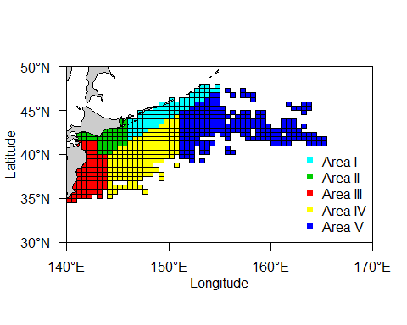
Fig.1 Area definition applied for CPUE standardization in this study.

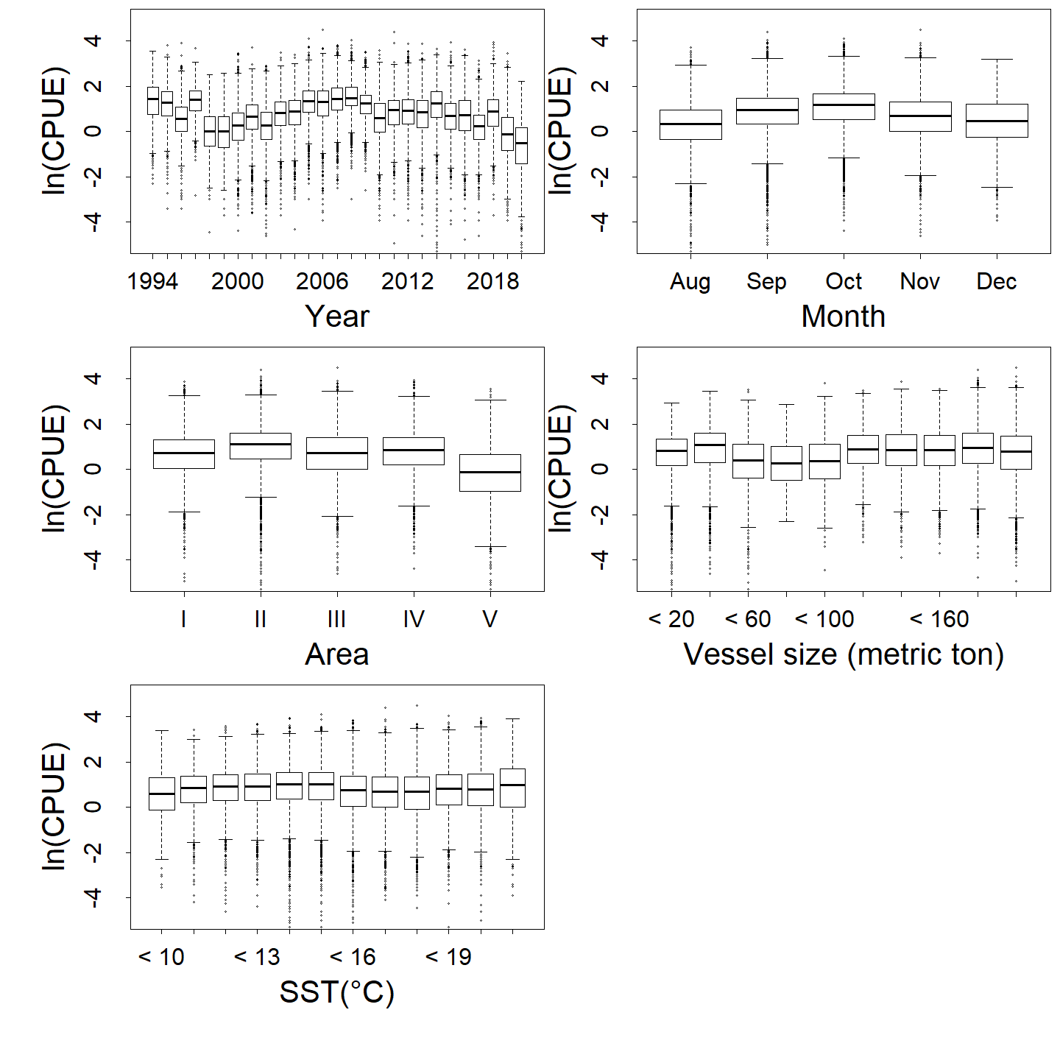
Fig.2 Relationship between CPUE and each factor (Year, Month, Area, vessel size and SST).
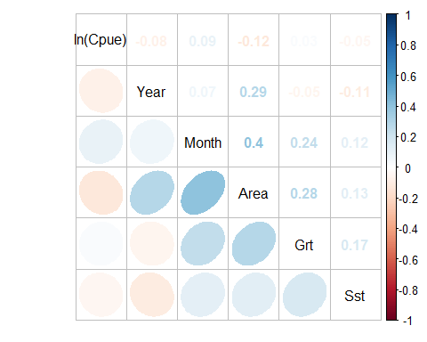
Fig.3 Correlation matrix of used explanatory variables.
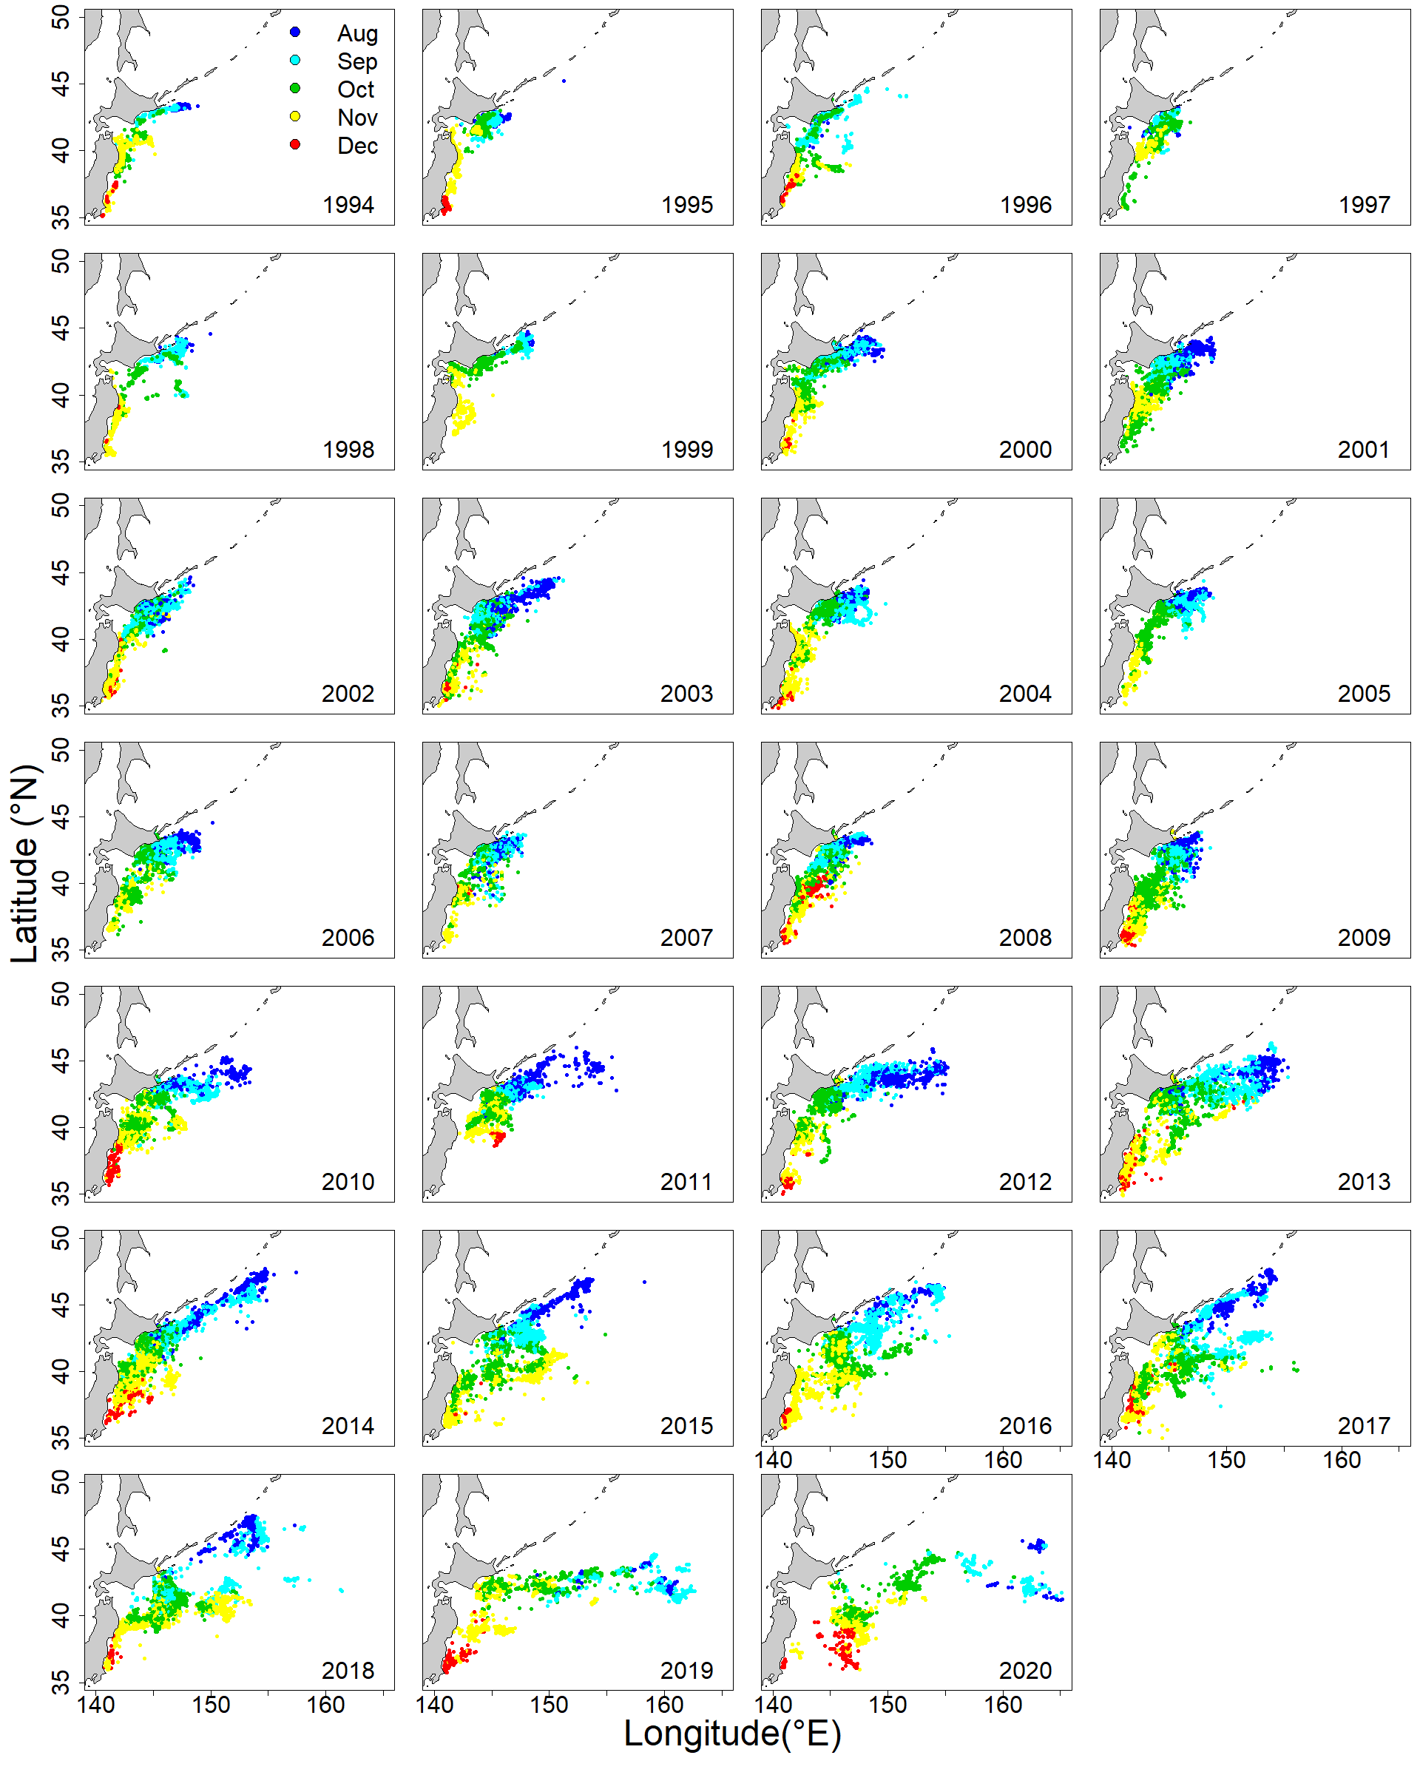
Fig.4 Annual changes in monthly fishing ground of Japanese stick-held dip net fishery for Pacific saury from 1994 to 2020.
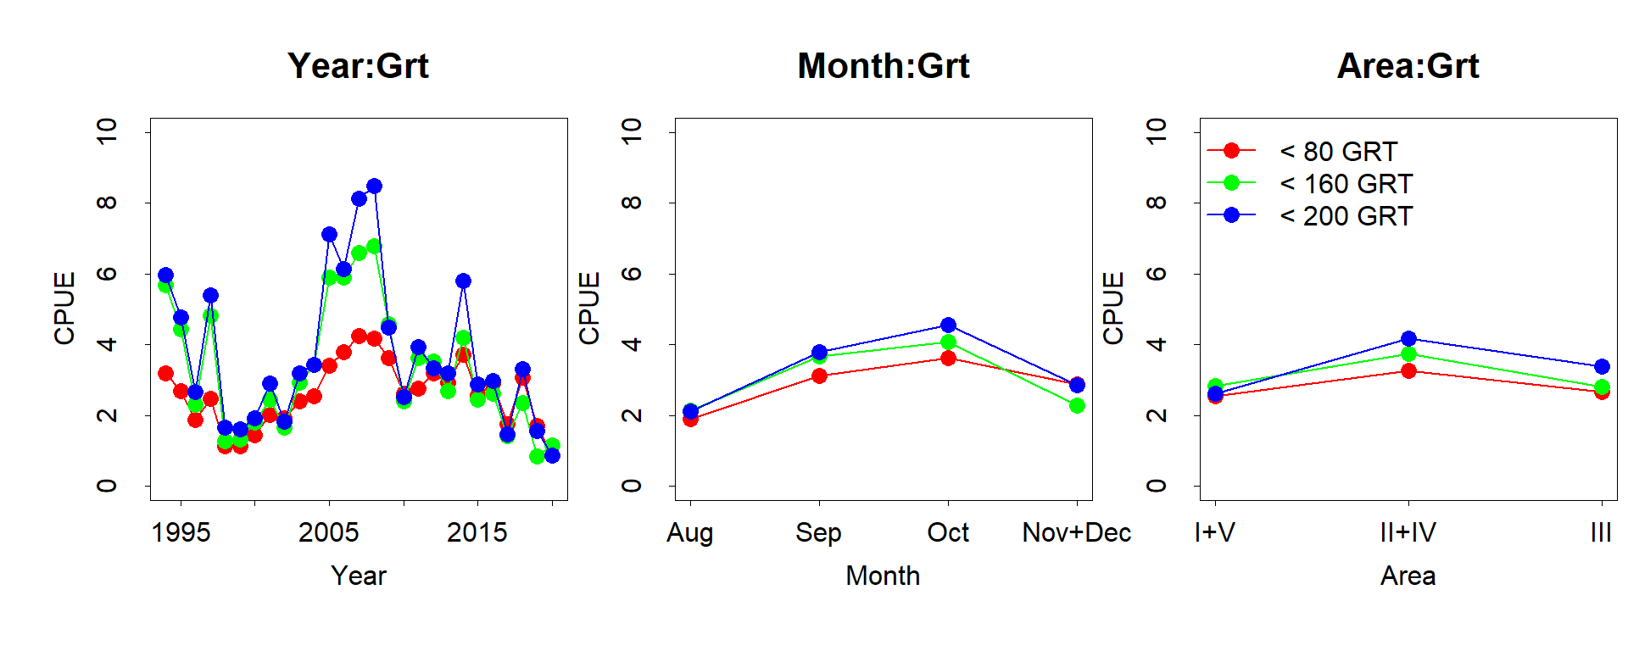
Fig.5 Relation to CPUE for variables in interaction terms.

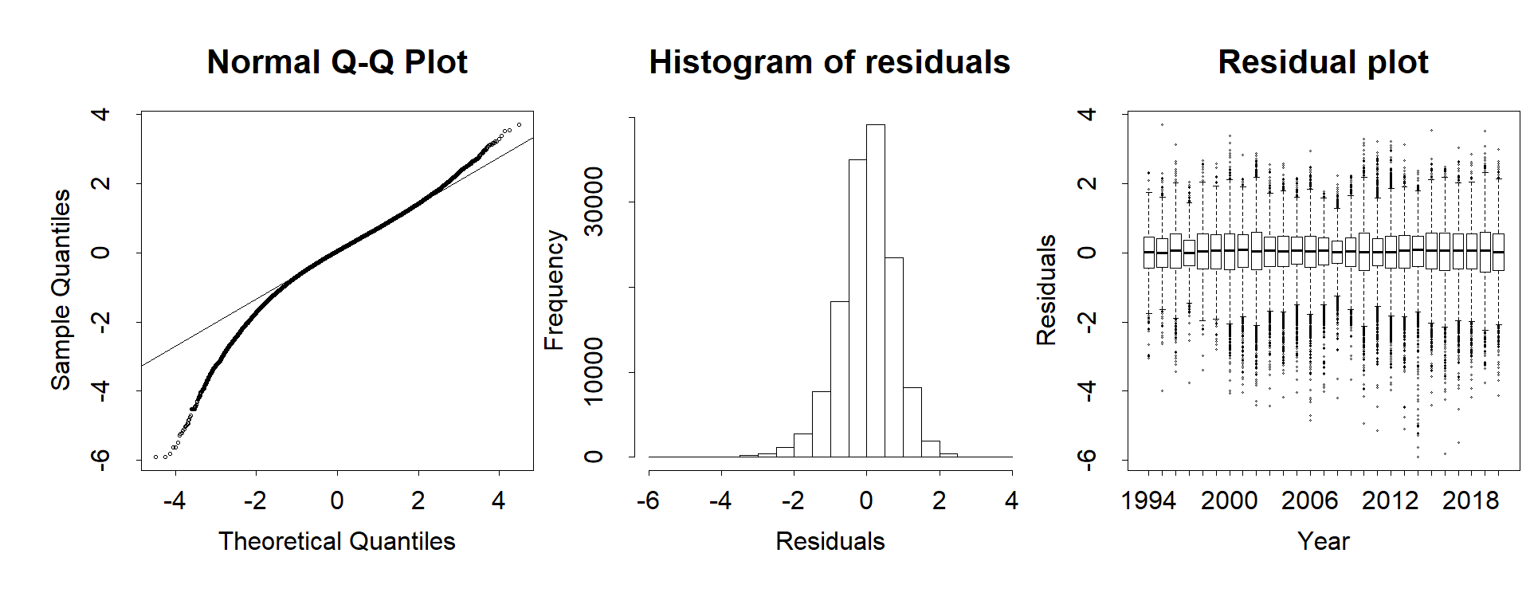
Fig.6 Q-Q plot, histogram of residuals and residual plots across years for the best GLM.
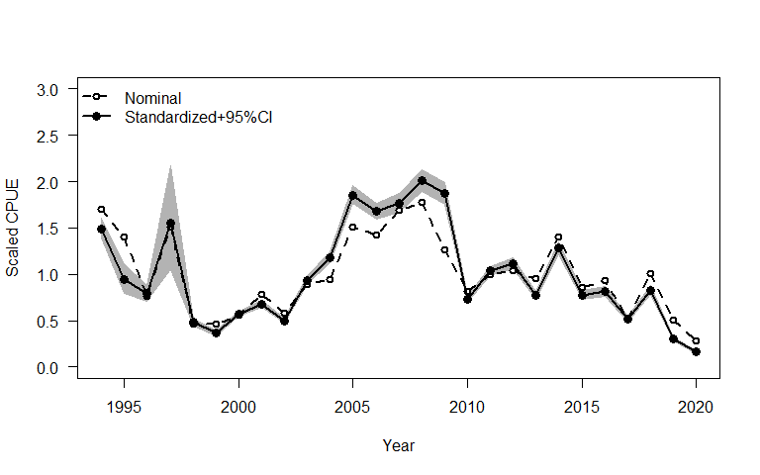
Fig.7 Scaled nominal CPUE and annual scaled standardized CPUE when using catch data up to 2020. Gray zone indicates 95% confidence intervals of standardized CPUE.

Appendix I Checklist for the CPUE standardization protocol.
(1) | Conduct a thorough literature review to identify key factors (i.e., spatial, temporal, environmental, and fisheries variables) that may influence CPUE values; | Yes (see Suyama et al. (2018))
(2) | Determine temporal and spatial scales for data grouping for CPUE standardization; | Yes (Table 1)
(3) | Plot spatio-temporal distributions of fishing efforts and catch to evaluate spatio-temporal patterns of fishing effort and catch; | Yes (Fig. 4)
(4) | Calculate correlation matrix to evaluate correlations between each pair of those variables; | Yes (Fig. 3)
(5) | Identify potential explanatory variables based on (1)-(4) as well as interaction terms to develop full model for the CPUE standardization; | Yes (Table 1)
(6) | Fit candidate statistical models to the data (e.g., GLM, GAM, Delta-lognormal GLM, Neural Networks, Regression Trees, Habitat based models, and Statistical habitat based models); | Yes (GLM)
(7) | Evaluate the models using methods such as likelihood ratio, AIC/BIC and cross validation; | Yes (BIC)
(8) | Evaluate if distributional assumptions are satisfied and if there is a significant spatial/temporal pattern of residuals in CPUE standardization modeling; | Yes (Fig. 6)
(9) | Extract yearly standardized CPUE and standard error by a method that is able to account for spatial heterogeneity of effort, such as least squares mean or expanded grid. If the model includes area and the size of spatial strata differs or the model includes interactions between time and area, then standardized CPUE should be calculated with area weighting for each time step. Model with interactions between area and season or month requires careful consideration on a case by case basis; | Yes (see Method section)
(10) | Recommend a time series of yearly standardized CPUE and associated uncertainty; | Yes (Table 4)
(11) | Plot nominal and standardized CPUEs over time; | Yes (Fig.7)

