NPFC-2021-SC06-WP02 (Rev. 1)
Five-Year Work Plan of the Scientific Committee and its subsidiary bodies

Small Scientific Committee on Pacific Saury (SSC PS)

Priority list:
- Conduct a stock assessment update based on BSSPM analyses
- Further investigate improvements to the BSSPM
- Develop an age/size-structured model
- Develop a list of plausible ranges for biological parameters
- Develop databases to support age/size-structured models
- Continue joint CPUE work to incorporate broader spatial and temporal coverage
- Update the biomass estimate using the existing method (swept area method)
- Develop spatio-temporal model for the biomass estimate
- Further refine the catchability coefficient of the Japanese survey and characterize its variance
- Develop a longer-term roadmap for work related to Pacific saury stock assessment
- Set biological reference points
- Develop a timeframe for MSE process

[H] and [M] indicate high and medium priorities. Cells with “TBD” depend on the progress of data preparation and analytical works.
ITEM | 2021 | 2022 | 2023 | 2024 | 2025
Regular update of inputs
Update & improvement of biomass survey index | Continue regular review [H] of  1) survey plan  2) analytical work  3) any related issues | Continue regular review [H] of  1) survey plan  2) analytical work  3) any related issues | Continue regular review [H] of  1) survey plan  2) analytical work  3) any related issues | Continue regular review [H] of  1) survey plan  2) analytical work  3) any related issues | Continue regular review [H] of  1) survey plan  2) analytical work  3) any related issues
Update & improvement of CPUE indices | Continue review of outcomes of regular update and analytical works [H] | Continue review of outcomes of regular update and analytical works [H] | Continue review of outcomes of regular update and analytical works [H] | Continue review of outcomes of regular update and analytical works [H] | Continue review of outcomes of regular update and analytical works [H]
Development of joint CPUE index | Continue review of outcomes of regular update and analytical works [H] | Continue review of outcomes of regular update and analytical works [H] | Continue review of outcomes of regular update and analytical works [H] | Continue review of outcomes of regular update and analytical works [H] | Continue review of outcomes of regular update and analytical works [H]
Regular update of the existing SA
Routine update BSSPM as a benchmark | Continue review of outcomes of regular BSSPM update [M] | Continue review of outcomes of regular BSSPM update [M] | TBD¹⁾ | TBD¹⁾ | TBD¹⁾
Improvement and further investigation of BSSPM | Review any outcomes of improvements (see Para 29 in TWG PSSA04 report)  [M] | Review any outcomes of improvements, inter alia in light of possible incorporation of environmental information  [H] | TBD¹⁾ | TBD¹⁾ | TBD¹⁾
Toward age/size-structured models (ASSMs)
Data inventory (CPUE and size/age in space and time) | Finalize data for 2021 stock assessment with ASSMs [H] | Continue update of data for stock assessment with ASSMs [H] | TBD²⁾ | TBD²⁾ | TBD²⁾
Summarizing available information on PS biology | Finalize assumption for 2021 stock assessment with ASSMs [H] | Continue update of data for stock assessment with ASSMs [H] | TBD²⁾ | TBD²⁾ | TBD²⁾
Development of models | Review results of analyses by an agreed initial set of ASSMs [H] | Finalize models and results of analyses by ASSMs [H] | TBD²⁾ | TBD²⁾ | TBD²⁾
Uncertainty in models (possible link with OM grid under MSE) | Start investigation [M] | Finalize the procedure of assessing model uncertainty [H] | TBD²⁾ | TBD²⁾ | TBD²⁾
Examination of estimation performance and finalization of models | Review initial simulation works [H] | Finalize simulation works [H] | TBD²⁾ | TBD²⁾ | TBD²⁾
Toward development of reference points
Set biological reference points (limit and target) | Continue discussion and adoption [H] | Continue discussion and amend if necessary [H] | TBD | TBD
Toward development of MSE (work formally starts in 2022)³⁾
Development of management objectives
Definition of performance measures
Construction of OMs
Development of candidate MPs
Simulation performance tests
Comparison of MPs and finalize advice
¹⁾ It depends on the progress of the age/size-structured models and discussion about how the BSSPM will be used for future assessment and management. As a backup method as well as an underlying assessment method used in a management procedure, it seems sensible to keep this as one of reference assessment models.
²⁾ These items might be re-structured depending on the progress of preparation of data and biological information as well as the development of models.
³⁾ More specific plans and timeline will be developed after the first WG MSE PS starts.

Technical Working Group on Chub Mackerel Stock Assessment (TWG CMSA)

Priority list:
- Data preparation and review of biological information
- Develop an operating model
- Test stock assessment models (VPA, ASAP, KAFKA, SAM, state-space production model)
- Conduct stock assessment of chub mackerel
- Set biological reference points
- Provide scientific advice on the management of chub mackerel stock to the Commission
- Regularly update and refine inputs
- Conduct MSE for chub mackerel

ITEM | 2021 summer | 2022 spring | 2022 | 2023 | 2024 | 2025
Regular update of inputs
Research survey indices | - Standardize survey data (intersessional)  - Review the data used for the stock assessment | Review the data used for the stock assessment | Finalize the data used for the stock assessment | Update | Update | Update
CPUE indices | - Standardize CPUE (intersessional)  - Review the data used for the stock assessment | Review standardized CPUE indices for stock assessment | Finalized CPUE standardization | Update | Update | Update
Catch data/catch composition | Review the data used for the stock assessment | Review the data used for the stock assessment | Finalize the data used for the stock assessment | Update | Update | Update
Biological parameters (maturity, M, weight) | Review biological parameters | - Review biological parameters  - Determine the range of assumption for preliminary stock assessment | Finalize assumptions for the stock assessment | Review biological parameters | Review biological parameters | Review biological parameters
Operating model (OM)
Development of operating model | - Agree on the rules for prioritization of the performance measures  - Generate pseudo data to be fitted to the stock assessment models (intersessional)
Testing stock assessment models | Members fit models to pseudo-data and send estimates to the Secretariat (intersessional) | - Consultant drafts a report about the performance of the candidate stock assessment models (intersessional)  - Choose the best SA model(s)
Stock assessment
Benchmark stock assessment |  | Discuss future projection methods | - Determine the method for future projection  - Conduct preliminary stock assessment | Complete stock assessment with the selected SA model(s) | Update SA model | Update SA model
Improvement and further investigation of the selected model |  |  |  |  | Review and improve, if needed, the SA model | Review and improve, if needed, the SA model
Toward development of reference points
Set biological reference points (limit and target) |  | - Review RPs report  - List candidate reference points | - Compare robustness of reference points  - Choose reference points |  | Review reference points
Toward development of MSE*
Development of management objectives |  | Liaise with the Commission and TCC to set management objectives | Finalize management objectives
Definition of performance measures |  | List of performance measures | Review performance measures | Select performance measure |  | Review performance measures
Construction of OMs | Continue | Discuss MSE approaches and frameworks for chub mackerel | Discuss ranges of uncertainties
Development of candidate MPs |  | Suggest preliminary list of MPs | Review the list of MPs |  |  | Review the performance of MP
Simulation performance tests |  |  | Conduct preliminary MSE | Conduct MSE
Comparison of MPs and finalize advice |  |  |  | Select MP and suggest HCR to SC | Review MP and HCR | Continue
* Work plan for the development of MSE will be reviewed and revised by the TWG CMSA in the future.

Flowchart for the development of operating models and testing stock assessment models
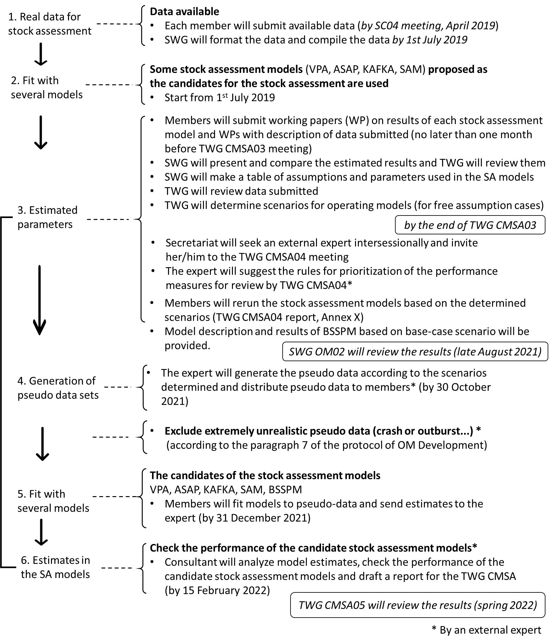
Small Scientific Committee on Bottom Fish and Marine Ecosystems (SSC BF-ME)

Priority list:
- NPA and SA: Develop catch and CPUE time series for commercial fisheries
- NPA: Review survey
- NPA: Conduct comprehensive stock assessment and provide management advice
- SA: Conduct comprehensive stock assessment and provide management advice
- NPA, SA and Sablefish: Develop and implement harvest control rule
- Sablefish: Evaluate historical harvest relative to trip limits and update trip limits if necessary
- Sablefish and VME: Conduct trade-off analysis between commercial fishing and VME protection
- VME: Collect and share fishing footprint data
- VME: Develop a process for establishing quantitative definitions of VMEs
- VME: Develop standardized approach to SAI determination

ITEM | SSC BFME02 (2021) | SSC BFME03 (2022) | SSC BFME04 (2023) | SSC BFME05 (2024) | SSC BFME06 (2025)
North Pacific Armorhead
Assess and monitor status of stock | Update catch data and CPUE index for NPA | Update catch data and CPUE index for NPA | Update catch data and CPUE index for NPA | Update catch data and CPUE index for NPA | Update catch data and CPUE index for NPA
 | Review results of NPA monitoring surveys | Review results of NPA monitoring surveys | Review results of NPA monitoring surveys | Review results of NPA monitoring surveys | Review results of NPA monitoring surveys
 | Integrate CPUE index and NPA surveys (acoustic and pre-fishery) into preliminary stock assessment or simulation approach using DLM tools | Life history based DLM approach | Update status of stock | Update status of stock | Update status of stock
 | Review acoustic survey and research | Review acoustic survey and research
 | Conduct analysis of historical patterns in NPA recruitment and oceanography; Identify and conduct additional research on NPA | Identify and conduct additional research on NPA | Identify and conduct additional research on NPA | Identify and conduct additional research on NPA | Identify and conduct additional research on NPA
 | Review fisheries observer program data collection for adequacy to produce data streams to support management advice | Review fisheries observer program data collection for adequacy to produce data streams to support management advice | Review fisheries observer program data collection for adequacy to produce data streams to support management advice | Review fisheries observer program data collection for adequacy to produce data streams to support management advice | Review fisheries observer program data collection for adequacy to produce data streams to support management advice
Conserve stock | Develop conservation objective(s) |  | Develop conservation objective(s)
 |  |  | Implement adaptive management
 |  | Refine harvest control rule if needed | Refine HCR and implement | Update data and implement HCR | Update data and implement HCR
Splendid alfonsino
Assess and monitor status of stock | Update catch data and CPUE index for SA | Update catch data and CPUE index for SA | Update catch data and CPUE index for SA | Update catch data and CPUE index for SA | Update catch data and CPUE index for SA
 | Develop monitoring plan for SA
 | Conduct comprehensive stock assessment or data limited approach | DLM approach life history | Update comprehensive stock assessment or data limited approach, and provide management advice | Update comprehensive stock assessment or data limited approach, and provide management advice | Update comprehensive stock assessment or data limited approach, and provide management advice
 | Review fisheries observer program data collection for adequacy to produce data streams to support management advice | Review fisheries observer program data collection for adequacy to produce data streams to support management advice | Review fisheries observer program data collection for adequacy to produce data streams to support management advice | Review fisheries observer program data collection for adequacy to produce data streams to support management advice | Review fisheries observer program data collection for adequacy to produce data streams to support management advice
Conserve stock |  |  | Develop conservation objective(s);  Define and implement harvest control rule | Update data and implement HCR | Update data and implement HCR
Sablefish
Assess and monitor status of stock | Update catch data and CPUE index | Update catch data and CPUE index | Update catch data and CPUE index | Update catch data and CPUE index | Update catch data and CPUE index
 | Provide an update on USA-Canada stock assessment models for Sablefish and joint research on Sablefish | Provide an update on USA-Canada stock assessment models for Sablefish and joint research on Sablefish | Provide an update on USA-Canada stock assessment models for Sablefish and joint research on Sablefish | Provide an update on USA-Canada stock assessment models for Sablefish and joint research on Sablefish | Provide an update on USA-Canada stock assessment models for Sablefish and joint research on Sablefish
 | Review fisheries observer program data collection for adequacy to produce data streams to support management advice | Review fisheries observer program data collection for adequacy to produce data streams to support management advice | Review fisheries observer program data collection for adequacy to produce data streams to support management advice | Review fisheries observer program data collection for adequacy to produce data streams to support management advice | Review fisheries observer program data collection for adequacy to produce data streams to support management advice
Conserve stock | Evaluate catch limits relative to stock status | Update catch limits relative to stock status
 | Summarize harvest control rules and stock status
Other research |  | Conduct analysis of sablefish associations with VME (intersessional)
 |  | Conduct trade-off analysis for Sablefish fishing and VME protection (intersessional)
Vulnerable marine ecosystems
Defining and Identifying VMEs | Map the distribution of VME indicator taxa (model, kernel density estimates, observation data); | Bring together VME indicator taxa observation data from various sources and map for NPFC area
 | Determine a quantitative definition of VMEs | Determine a quantitative definition of VMEs | Review and apply quantitative definition of VMEs
Identifying and defining SAI's | Determine data requirements and resolution for SAI assessment | Determine data requirements and resolution for SAI assessment | Conduct integrated SAI assessment | Conduct integrated SAI assessment | Conduct integrated SAI assessment
 | Apply the standardized approach for SAI assessments and conduct integrated SAI assessment | Apply the standardized approach for SAI assessments and conduct integrated SAI assessment
 |  | Discuss VME indicator taxa and whether species/taxa should be added/subtracted
Quantifying interactions between fisheries and VMEs | Update spatially explicit fishing effort data | Update spatially explicit fishing effort data | Update spatially explicit fishing effort data | Update spatially explicit fishing effort data | Update spatially explicit fishing effort data
 | Implement timely reporting and action protocol when VME sites or recovering sites are identified
 | Review fisheries observer program data collection for adequacy to produce data streams to support management advice | Review fisheries observer program data collection for adequacy to produce data streams to support management advice | Review fisheries observer program data collection for adequacy to produce data streams to support management advice | Review fisheries observer program data collection for adequacy to produce data streams to support management advice | Review fisheries observer program data collection for adequacy to produce data streams to support management advice
Conserving VMEs |  | Develop management objectives for recovering VME sites | Develop management objectives for recovering VME sites | Periodic review of VME management | Periodic review of VME management
 | Refine the exploratory fishing protocol and consider banning exploratory fishing in VME closed areas
 | Review and refine the encounter protocol if necessary
 |  | Literature review on impacts and impact rates by fishing gears
Other ecosystem components
 | Approval of fish ID guide for scientific observers in the NW Pacific Ocean | Publication of fish ID guide for scientific observers in the NW Pacific Ocean

Scientific Committee (SC)

Priority list
As stipulated in the Convention, Article 10, the Scientific Committee shall provide scientific advice and recommendations to the Commission which is considered the highest priority task of the SC. The following priority areas have been identified for SC:
- Priority species summaries and stock assessments for management advice
- Management Strategy Evaluation (MSE) for priority species
- Ecosystem approach to fisheries management: understand ecological interactions among species and impacts of fishing on fisheries resources and their ecosystem components
- Collaboration with other organizations
- Regular review of the research plan and work plan
- Data collection, management, and security

ITEM | 2021 | 2022 | 2023 | 2024 | 2025
Priority Species
Summaries of priority species | Develop summary template | Draft summary sheet | Update summary sheets as needed | Update summary sheets as needed | Update summary sheets as needed
Assessment of Spotted Mackerel and associated bycatch | Identify lead  Identify data sources, data gaps and strategies to fill gaps | Collate data  Develop data collection templates and share data  Determine spatial structure of stocks | Undertake baseline stock assessment and provide management advice including harvest control rules | Update baseline stock assessment as needed and provide management advice including harvest control rules  Collate data on associated bycatch species | Update baseline stock assessment as needed and provide management advice including harvest control rules  Develop baseline stock assessment of associated bycatch species
Assessment of Japanese Sardine and associated bycatch | Identify lead  Identify data sources, data gaps and strategies to fill gaps | Collate data  Develop data collection templates and share data  Determine spatial structure of stocks | Undertake baseline stock assessment and provide management advice including harvest control rules | Update baseline stock assessment as needed and provide management advice including harvest control rules  Collate data on associated bycatch species | Update baseline stock assessment as needed and provide management advice including harvest control rules  Develop baseline stock assessment of associated bycatch species
Assessment of Neon Flying Squid and associated bycatch | Identify lead  Identify data sources, data gaps and strategies to fill gaps | Collate data  Develop data collection templates  Determine spatial structure of stocks | Undertake baseline stock assessment and provide management advice including harvest control rules | Update baseline stock assessment as needed and provide management advice including harvest control rules  Collate data on associated bycatch species | Update baseline stock assessment as needed and provide management advice including harvest control rules  Develop baseline stock assessment of associated bycatch species
Assessment of Japanese Flying Squid and associated bycatch | Identify lead  Identify data sources, data gaps and strategies to fill gaps | Collate data  Develop data collection templates  Determine spatial structure of stocks | Undertake baseline stock assessment and provide management advice including harvest control rules | Update baseline stock assessment as needed and provide management advice including harvest control rules  Collate data on associated bycatch species | Update baseline stock assessment as needed and provide management advice including harvest control rules  Develop baseline stock assessment of associated bycatch species
Management Strategy Evaluation (MSE)
Pacific Saury | Support NPFC’s SWG MSE PS in achieving its goals | Support NPFC’s SWG MSE PS in achieving its goals | Support NPFC’s SWG MSE PS in achieving its goals | Support NPFC’s SWG MSE PS in achieving its goals | Support NPFC’s SWG MSE PS in achieving its goals
Ecosystem approach to fisheries management
Ecological Interactions | Understand ecological interactions among species in the North Pacific Ocean | Understand ecological interactions among species in the North Pacific Ocean | Understand ecological interactions among species in the North Pacific Ocean | Understand ecological interactions among species in the North Pacific Ocean | Understand ecological interactions among species in the North Pacific Ocean
Impacts of fishing on ecosystem component | Evaluate impacts of fishing on fisheries resources and their ecosystem components, including bycatch species and discards | Evaluate impacts of fishing on fisheries resources and their ecosystem components, including bycatch species and discards | Evaluate impacts of fishing on fisheries resources and their ecosystem components, including bycatch species and discards | Evaluate impacts of fishing on fisheries resources and their ecosystem components, including bycatch species and discards | Evaluate impacts of fishing on fisheries resources and their ecosystem components, including bycatch species and discards
Collaboration with other Organizations
PICES | Review implementation of NPFC-PICES Framework for Collaboration  Review ICES-PICES WGSPF activities  Review PICES WG37 activities | Review implementation of NPFC-PICES Framework for Collaboration  Review ICES-PICES WGSPF activities  Review PICES WG37 activities  Review NPFC-PICES workshop on VME indicator identification | Review implementation of NPFC-PICES Framework for Collaboration  Identify other opportunities for collaboration with PICES  Review PICES WG37 activities | Review implementation of NPFC-PICES Framework for Collaboration  Identify other opportunities for collaboration with PICES | Review implementation of NPFC-PICES Framework for Collaboration  Identify other opportunities for collaboration with PICES
FAO | Review partnership with FIRMS | Review NPFC’s involvement in the 2nd Phase of the GEF-FAO Common Oceans Programme
NPAFC | Discuss, review and revise the work plan to implement the NPFC/NPAFC Memorandum of Cooperation  Review NPAFC- NPFC multinational survey program | Review work plan to implement NPFC/NPAFC Memorandum of Cooperation  Review NPAFC- NPFC multinational survey program | Undertake scientific activities to achieve relevant deliverables of the work plan | Undertake scientific activities to achieve relevant deliverables of the work plan | Undertake scientific activities to achieve relevant deliverables of the work plan
Other organizations | Review collaborations with other organizations | Review collaborations with other organizations | Review collaborations with other organizations | Review collaborations with other organizations | Review collaborations with other organizations
Research and Work Plans
Terms of Reference | Review SC’s Terms of Reference | Review SC’s Terms of Reference, as needed | Review SC’s Terms of Reference, as needed | Review SC’s Terms of Reference, as needed | Review SC’s Terms of Reference, as needed
Research Plan | Update SC’s rolling 5-year research plan | Update SC’s rolling 5-year research plan | Update SC’s rolling 5-year research plan | Update SC’s rolling 5-year research plan | Update SC’s rolling 5-year research plan
Work Plan | Update SC’s rolling 5-year work plan | Update SC’s rolling 5-year work plan | Update SC’s rolling 5-year work plan | Update SC’s rolling 5-year work plan | Update SC’s rolling 5-year work plan
Projects | Review completed and ongoing projects  Identify and prioritize new projects and recommend sources of funding | Review completed and ongoing projects  Identify and prioritize new projects and recommend sources of funding | Review completed and ongoing projects  Identify and prioritize new projects and recommend sources of funding | Review completed and ongoing projects  Identify and prioritize new projects and recommend sources of funding | Review completed and ongoing projects  Identify and prioritize new projects and recommend sources of funding
Data Management
 | Discuss need of VMS data for scientific analyses  Review data management system (DMS) and Electronic Annual Report | Review data standards in relation to stock assessment of priority species  Discuss need for additional sources of data for scientific analyses and associated data management policy | Review data standards in relation to stock assessment of priority species  Discuss need for additional sources of data for scientific analyses and associated data management policy | Review data standards in relation to stock assessment of priority species  Discuss need for additional sources of data for scientific analyses and associated data management policy | Review data standards in relation to stock assessment of priority species  Discuss need for additional sources of data for scientific analyses and associated data management policy
Recommendations
Advice | Develop recommendations for the Commission, TCC, and FAC | Develop recommendations for the Commission, TCC, and FAC | Develop recommendations for the Commission, TCC, and FAC | Develop recommendations for the Commission, TCC, and FAC | Develop recommendations for the Commission, TCC, and FAC
Media Communication
Press Release | Prepare and publish a press release about SC activities during its meeting | Prepare and publish a press release about SC activities during its meeting | Prepare and publish a press release about SC activities during its meeting | Prepare and publish a press release about SC activities during its meeting | Prepare and publish a press release about SC activities during its meeting

