NPFC-2022-SSC PS09-WP02
1st Intersessional Meeting of the Small Scientific Committee on Pacific Saury
June 28, 2022 (9:00 a.m. – 12:00 noon Tokyo time)
WebEx

Summary

Agenda Item 1. Introductory items (incl. adoption of the agenda and drafting meeting summary)
The 1st intersessional meeting of the Small Scientific Committee on Pacific Saury (SSC PSint01) commenced at 9 AM on 28 June 2022, Tokyo time in the format of video conferencing via WebEx. The meeting was attended by Members from Canada, China, Japan, Korea, Russia, Chinese Taipei, US, Vanuatu, and Panama. The meeting was opened by Dr. Toshihide Kitakado (Japan) who served as the SSC PS Chair. The list of participants is attached (Annex).

Agenda Item 2. Overview of the outcomes of SWG MSE PS01 (incl. review of the SWG workplan)
The Chair updated members on the outcomes of the 1st Meeting of the Joint SC-TCC-COM Small Working Group on Management Strategy Evaluation for Pacific Saury (SWG MSE PS) in February 2022, and emphasized its main results, which is the continued discussion of management objectives, reference points and operating models at this meeting, as well as the recommendation for allocating funds to develop a simulation platform for HCR, the hiring of an external expert to support the group, and the timeframe of future meetings and tasks. The Chair also noted that the endorsement of the SWG meeting report is still pending due to the postponement of COM07 but expressed hope that this will be smoothly adopted once the Commission reconvenes.

Agenda Item 3. Discussion on reference points and management objectives
The Chair gave a presentation to address agenda items 3, 4 and 5. The presentation is available on the Collaboration website.
Based on the presentation delivered by the Chair, the participants further discussed potential values for the reference points for initial computational work, which is summarized below:
A preliminary list of reference points. The list is only for an initial computation purpose.
Reference point | Default value (if any) | Potential range
Btar = c*Bmsy | c = 1 | c=0.8
Blim = c*Bmsy | TBD | c = 0.3 – 0.5
Ftar = c*Fmsy | c = 1 | c = 0.8 – 1.2
Flim = c*Fmsy | TBD | c = 1.2 - 1.5

• Note that the depletion-based reference points might be computed in addition to MSY-based reference points for back-up use although the computation of both might be a cause of potential confusion for managers and stakeholders.
• Also note that equivalent values of “c” for the depletion-based reference points such as Btar = c*K can be calculated based on the model assumption.

Agenda Item 4. Discussion for developing and evaluating HCRs as a short-term task (conditioning of OMs and list up possible/candidate HCRs)
The Chair recalled the discussion during the SSC PS08 (NPFC-2021-SSC PS08-Final Report) about the relative importance of fishing and environmental factors on the population dynamics of PS and that there are no clear definition of overfishing and overfished for the HCR for PS. The Chair also reiterated the importance of Operating Models as discussed in SWG MSE PS01 (NPFC-2022-SWG MSE PS01-Final Report) as follows:
Development of Operating Models (OMs)
[Option A]
Use the current interim stock assessment model (BSSPM) with consideration of uncertainties in estimated parameters and process errors as the basis. The model can be extended through accounting for some changes in environmental conditions and/or auto-correlation in the process error terms or incorporating stochastic variation into key parameters (r and/or K).
[Option B]
Use an age-structured model with consideration of uncertainties in estimated and key input parameters (natural mortality and steepness) as well as recruitment process errors. The model can be further extended for consideration of environmental changes like in Option A.
[Option C]
Possible to consider further complicated models to account for migration patterns and difference in space and time in Member’s fishing operations. This is of course scientifically interesting, but considering the limited time, this may not be a good option for meeting the short-term objective.
Based on the presentation delivered by the Chair, the participants further discussed the specifications of OMs as follows:
Model parameters (conditioning)
Surplus-production models conditioned on the combined BSSPM assessment results (2 base models times 3 Members’ results) are used as the population dynamics at this moment (as in option A) with the following notes:
- Some combinations of fixed values (median + LB/UB of 80%CI) of r, K, shape parameter, initial depletion and process error cv will be used (#).
- Or alternatively, random samples from joint posterior distributions can be used (&).
- For considering unaccounted environmental effects, OMs with/without autocorrelation can be used. Some specific climate scenarios can be used for sensitivity/robustness tests.
- Estimation uncertainty will be added to the initial year of the management period for simulation.
Member scientists were encouraged to develop age-structured models and present the results at SSC09 in August for Option B).
Options for an HCR to use the most recent information (see also figure below)
- Currently, the stock assessment is conducted, say for year “y” (e.g. 2022), using Japanese fishery-independent index up to year “y” (2022) and fishery-dependent indices and catch up to year “y-1” (2021), to produce the estimate of biomass in year “y” and management related quantities. These pieces of information can then be used in setting a TAC in year “y+1” or later (2023 or later) once an HCR has been adopted (say TAC X).
- If some biomass-related information (like trend or level from Japanese fishery-independent index) is available timely before or at the beginning of fishing season in year “y+1” (2023), TAC X can be adjusted according to the most recent information (this mechanism should be speculated as a hybrid version of HCR.
- Or, TAC X in year “y+1” (2023) is set based on information available up to year “y+1” (2023)

Hybrid HCR (option 2) or no-lag approach (option 3) may work for this short-lived species for which the population size might be influenced by environmental condition and has been fluctuating.
The details of this implementation require further discussion with the members of the SWG MSE PS.

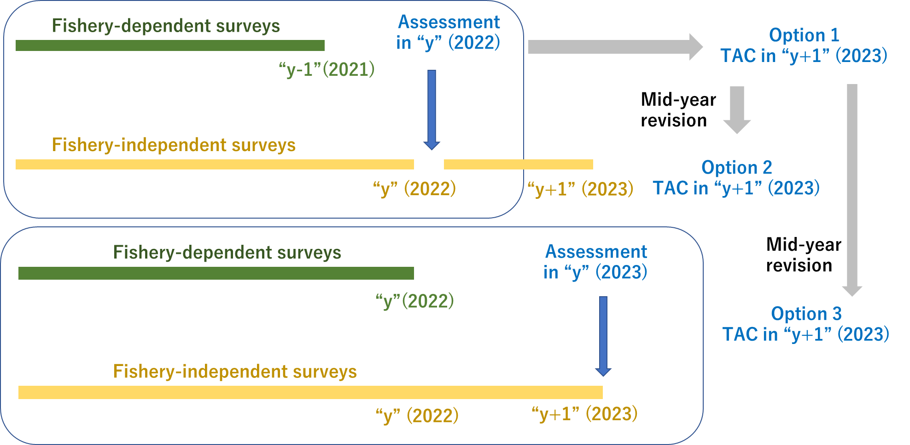
Illustrative figure for the three options of HCRs. The numbers for 2022, 2023, etc. in the figure are only for illustrative purposes to make the procedure easier to understand, and the rule is applied successively each year during a certain pre-determined management period.

Application of HCR in simulations
- If (#), estimates of Bmsy and Fmsy used in an HCR were assumed to be the true values consistent with the conditioned OMs (to see the best performance) and most optimistic and pessimistic combinations of LB/UB of their 80%Cis.
- If (&), estimates of Bmsy and Fmsy used in an HCR were simply random variables from the joint posterior distributions.
- In each time step, a biomass estimate is generated with an error distribution (log-normal) without imposing the internal assessment with the internal BSSPM assessment to reduce the computational load. This was justified since the main purpose of the simulation is to test the effectiveness of HCR (In the future application of a full MP, this should be more addressed).
- In that sense, there is no need to generate the CPUEs from OMs. On the other hand, a fishery-independent survey indicator is drawn every time step to use it in options 2 and 3 in the hybrid HCRs.
As an input estimate of B or Bratio for HCR, a single year or an average of multi-years estimates can be used for assessing the impact of the treatment in light of bias/variance for the input.

Agenda Item 5. Discussion on simulation platform
The Chair demonstrated the use of a simulation software for the evaluation of HCR used by IOTC where he concurrently leads as SC Chair. The platform can summarize and produce figures and tables and has an interactive function that can facilitate dialogue between managers and stakeholders.
The Chair offered to provide more materials about the software if participants wish to proceed with this suggestion reminding that SWG MSE PS01 recommended to allocate funds for the development of a simulation platform for the evaluation of HCR, although this has not yet been endorsed by the Commission. The Chair also welcomed suggestions from participants for any ideas to include in the simulation platform and responded affirmatively to a query about the possibility of sharing software codes in the future.

Agenda Item 6. Other matters
Japan updated participants about the Japanese biomass survey. Scientists from Japan were reported to be currently on-board research vessels and conducting the survey as scheduled.

Agenda Item 7. Timeline and future process
The Chair reminded the participants that the next step for the intersessional work is to review the progress, and then to start developing and evaluating HCRs as a short-term task.
The Chair also commented that the discussion at the SSC PSint01 would be very useful for further progress and for the discussions at the SSC PS09 but reminded the participants that there are only 10 days between SSC PS09 and SWG MSE PS02 noting that the latter will be joined by managers and other stakeholders and as such may require further work in between meetings. Intersessional technical work will continue until early 2023 as scheduled but further progress can be made before the SWG MSE PS03 in 2023.

Agenda Item 8. Close of the meeting
The meeting closed at 12:10 on 28 June 2022, Tokyo time.

Annex
Participants list

Chair
Toshihide KITAKADO
kitakado@kaiyodai.ac.jp

Canada
Janelle CURTIS
Janelle.Curtis@dfo-mpo.gc.ca

China
Libin DAI
644318716@qq.com

Japan
Kazuhiro OSHIMA
oshimaka@affrc.go.jp
Midori HASHIMOTO
mhashimoto@affrc.go.jp
Hiroshi KUBOTA
miles@affrc.go.jp
Shuya NAKATSUKA
snakatsuka@affrc.go.jp
Shin-Ichiro NAKAYAMA
shin.ichiro.nak@gmail.com

Korea
Kyumjoon PARK
mogas@korea.kr
Hae Won LEE
roundsea@korea.kr

Russia
Oleg KATUGIN
oleg.katugin@tinro-center.ru
Igor CHERNIENKO
chernienko.igor@gmail.com
Vladimir KULIK
vladimir.kulik@tinro-center.ru

Chinese Taipei
Yi-Jay CHANG
yjchang@ntu.edu.tw
Tung-hsieh CHIANG
chiangdon@ofdc.org.tw
Jhen HSU
jhenhsu@ntu.edu.tw
Wen-Bin HUANG
bruce@gms.ndhu.edu.tw
Ren-Fen WU
fan@ofdc.org.tw

USA
Felipe CARVALHO
felipe.carvalho@noaa.gov

Vanuatu
Mei-Chin JUAN
meichin.mdfc@gmail.com

Panama
Rudick KANT
rkant@arap.gob.pa
Vivian QUIROS
vquiros@arap.gob.pa
Yarkelia VERGARA

Invited expert
Larry JACOBSON
larryjacobson6@gmail.com

Secretariat
Alex ZAVOLOKIN
azavolokin@npfc.int
Sungkuk KANG
skang@npfc.int
Mervin OGAWA
mogawa@npfc.int

