NPFC-2022-SSC PS09-WP04
Standardized CPUE of Pacific saury (Cololabis saira) caught by the Chinese Taipei stick-held dip net fishery up to 2021

Wen-Bin Huang1, Yi-Jay Chang2 and Chih-hao Hsieh2

¹ Department of Natural Resources and Environmental Studies,
National Dong Hwa University, Hualien 974.
E-mail: bruce@gms.ndhu.edu.tw
² Institute of Oceanography, National Taiwan University, Taipei 106.

SUMMARY
Catch and effort data of Pacific saury for the Chinese Taipei saury fishery in the Northwestern Pacific Ocean were collected from 2001-2021. Two alternative approaches, generalized linear models (GLMs) and generalized additive models (GAMs), were used to standardize the catch per unit effort (CPUE) of Pacific saury. An updated version (incorporating 2021 data) of the previous year’s CPUE standardization data set derived from fishing logbooks was used in this study. Most of the main explanatory variables and interaction terms used in the modeling analyses were statistically significant in the GLMs and GAMs. We suggest using the standardized CPUE series of Pacific saury derived from the GAM as basic input data in stock assessments, because this approach had a lower Bayesian information criterion, explained more deviance, and demonstrated better performance in the cross-validation tests than the GLM approach. The standardized CPUE of Pacific saury for the Chinese Taipei saury fishing fleets showed a general oscillating trend with a slight increase observed from 2001-2010, followed by a sharp increase through to 2014, a sharp decline until 2017, a dramatic increase in 2018, and then an abrupt decrease to 2021.

KEYWORDS
Pacific saury, standardized CPUE, GLM, GAM, stick-held dip net

- Background of the Pacific saury fishery
Pacific saury (Cololabis saira Brevoort, 1856) is a commercially important fish in the Northwestern Pacific Ocean (NWPO) (Hubbs and Wisner, 1980). Most Pacific saury are caught by the stick-held dip net fishery and only a small proportion of catches are acquired through the use of other gear, such as gill nets and set-nets (TWG PSSA01, 2017). There are six harvesting fleets, originating from Japan, Chinese Taipei, Russia, Korea, China, and Vanuatu, all of which are the North Pacific Fisheries Commission (NPFC) members. Results of stock assessments in late 2021 indicated that the saury stock declined with an inter-annual variability from near carrying capacity in the mid-2000’s after a period of high productivity to current levels and exploitation rates were increasing slowly since 2005 except for 2019 (SC06, 2021). The results also indicated that stock biomass (B) was below B_{MSY} and fishing mortality (F) was above F_{MSY}. The results further indicated that stock biomass fell to the lowest value since 1980 in 2020 and has been still at a historically low level in recent years (2019-2021).

The Chinese Taipei saury fishery is a far-sea fishery, which commenced in 1967, with fishing grounds located mainly on the high-seas (Huang, 2007; 2010). Inter-annual variations of monthly fishing ground locations of the Chinese Taipei stick-held dip net fishery from 2001 to 2021 is shown in Fig. 1. The catch of the Chinese Taipei saury fishery increased dramatically from about 40,000 mt in 2001 to about 230,000 mt, the highest historical level, in 2014 (Huang et al., 2017). However, the current catch in 2021 was about 34,000 mt, which is about 15 % and 60 % of the catch from 2014 and the previous year (2020: ~57,000 mt), respectively.

The standardization of catch per unit effort (CPUE) of Pacific saury for various fleets operating in the NWPO was conducted for use as basic input data in stock assessments (TWG PSSA01, 2017). The stock assessments were based on the assumption of a single North Pacific-wide stock of Pacific saury, since there was no evidence of genetic structuring groups in this population (Chow et al., 2009). At the meeting of the SSC PS07 in NPFC, standardized CPUE of Pacific saury for the 2001-2020 Chinese Taipei stick-held dip net fishery showed a general oscillating trend with a slight increase observed from 2001-2010, followed by a sharp increase through to 2014, a sharp decline until 2017, a dramatic increase in 2018, and then an abrupt decrease to 2020 (Huang et al., 2021).

The objectives of this study were to use generalized linear models (GLMs) and generalized additive models (GAMs) to standardize the Pacific saury CPUE for the Chinese Taipei saury fishery in the NWPO using an updated dataset (2001-2021), and then to compare the results derived from these approaches.

- Materials and methods

2.1. Fishery data and water temperature
Data, collected from the Chinese Taipei saury fishery in the NWPO, included records of daily catch (weight of Pacific saury), fishing effort (number of hauls), and sea surface water temperature from 2001-2021. A thermometer equipped beneath the bottom of each vessel measured sea surface water temperature as fishing was underway. These data were obtained from the Overseas Fisheries Development Council (OFDC) which compiled data from logbooks. CPUE is expressed as the weight of fish in metric tons per haul (mt/haul). The data set used in this study contained 127,379 catch-effort records reported on a daily basis for each vessel. This data set is an updated version (includes 2021 data) of the data set used for the CPUE standardization in last year’s assessment.

  - Full model descriptions and model selection
Both GLMs and GAMs were used in this study to standardize the nominal CPUE for the Chinese Taipei saury fishery. Lognormal error distribution was assumed in the standardization. GLMs are the most commonly used approach for standardizing catch and effort data, assuming that the expected value of a transformed response variable is related to a linear combination of exploratory variables (Maunder and Punt, 2004). GAMs are a semi-parametric extension of GLMs with the underlying assumption that the response variable is related to smooth additive functions of the explanatory variables (Maunder and Punt, 2004).

Six items in four groups of possible explanatory variables were considered for CPUE standardization, including year and month for the temporal variable, latitude and longitude for the spatial variable, gross registered tonnage (Grt) for the fishing vessel size variable, and sea surface water temperature (Sst) for the environmental variable. Prior to fitting the GLMs/GAMs, Spearman correlation coefficient among explanatory variables were calculated. In addition, variance inflation factor (VIF) was used to measure the amount of multi-collinearity among the independent variables in models.

The full models of GLMs and GAMs including interactions were expressed as follows:
GLM: ln(CPUE) = Year +Month +Area +Sst-l +Grt-l +two-way IAs +IC +Ɛ
GAM: ln(CPUE) = Year +Month +Area +s(Sst-c) +s(Grt-c) +two-way IAs +IC +Ɛ
where Year is a categorical variable from 2001 - 2021 (21 years), Month is a categorical variable with 6 calendar months from June to November, Sst-l is a categorical variable with 12 levels from 8-19 ºC with an interval of 1 ºC, Sst-c is a continuous variable from 8-19 ºC, Grt-l is a categorical variable with 4 levels: 700 t, 800 t, 900 t, and > 1,000 t, Grt-c is a continuous variable from 700-1400 t, Area is a categorical variable with 4 regions based on bathymetric contours, two-way IAs are two-way interaction terms, IC is an intercept, and ε is an error term with ε~ N (0, σ²). s(X) denotes a spline smoother function of the variable X. Month data from May and December were incorporated into June and November, respectively, because the data from May and December were limited. Definition of the 4 Area regions was modified based on Huang et al. (2007), which examined the geographical distribution of Pacific saury in the NWPO. The 4 regions used in our analyses are the continental shelf and slope area (CSS), abyssal plain area 1 (AP1) and abyssal plain area 2 (AP2), and the abyssal mountain area (AM) (Fig. 2). A summary of used explanatory variables in the GLM and GAM analyses is shown in Table 1.

Model assumptions followed the assumptions for GLMs and GAMs. Lognormal error distribution was assumed in the standardization. A forward stepwise approach was employed for the model selection. The improvement of each model that adds an additional predictor was examined using the changes in deviance explained and the proportions of deviance explained relative to the total explained deviance. In addition, since the maximum likelihood was employed for the parameter estimation, the Bayesian information criterion (BIC) was used to conduct objective model selection. Various diagnostic plots, including the distribution of residuals and the quantile-quantile plots (Q-Q plots), were used to assess the assumption of error distribution in the models and model fits for standardizing the nominal CPUE of Pacific saury in the NWPO. Five-fold cross-validation tests with the Pearson’s correlation coefficients and mean squared errors (MSE) were conducted to compare prediction performances of the selected models in the GLM and GAM analyses.

  - Yearly trend extraction
The standardized CPUE and its standard deviation (SD) represent the estimates of the mean and SD of predictions from the suggested model, respectively. If the best model includes area and the size of spatial strata differs or the best model includes interactions between time and area, then standardized CPUE should be calculated with area weighting for each time step. The checklist for the CPUE standardization protocol is shown in Appendix I.

- Results and discussion
Chinese Taipei stick held dip-net fishery operated mainly in the high seas of the NWPO during 2001-2021 and high fishing efforts aggregated in the south eastern portion of the boundary between the exclusive economic zones and high seas (Fig. 3a). However, high CPUEs of Pacific saury appeared to be distributed mainly in the waters between 146-155 °E and 37-44 °N, and to a lesser degree between 160-164 °E and 36-40 °N (Fig. 3b).

All Spearman’s correlation coefficients between each pair of variables used in the model were significant (p < 0.001) (Fig. 4, Table 2). All variance inflation factors (VIFs) were less than 3, indicating that there was no serious multi-collinearity among the independent variables in models (Table 2).

Most of the main explanatory variables and interaction terms used in the modeling analyses were statistically significant in the GLMs and GAMs (Table 3). The BIC and deviance explained (%) in the best GLM and GAM are 278,033 and 38.1% (Table 3a), and 276,361 and 38.5% (Table 3b), respectively. Analysis of deviance for the best models of GLM and GAM is shown in Table 4. The Q-Q plot, histogram of residuals and residual plots across years for the best GLM and GAM indicated that the residual distributions from the GLM and GAM analyses appeared normal for both best models and confirmed the assumption of lognormal error distribution for both models used to standardize the CPUE (Fig. 5). Results of the 5-fold cross-validation tests indicated higher Pearson’s correlation coefficients and lower mean squared error in the GAM (r = 0.6206, MSE = 0.7081) than the GLM (r = 0.6173, MSE = 0.7105) (Table 5).

We suggest using the standardized CPUE series of Pacific saury derived from the GAM as basic input data in stock assessments (Table 6), because this approach had a lower BIC, explained more deviance, and demonstrated better performance in the cross-validation tests than the GLM approach. The standardized CPUE of Pacific saury for the Chinese Taipei saury fishing fleets showed a general oscillating trend with a slight increase observed from 2001-2010, followed by a sharp increase through to 2014, a sharp decline until 2017, a dramatic increase in 2018, and then an abrupt decrease to 2021 (Fig. 6).

- References
Chow S, Suzuki N, Brodeur RD, Ueno Y (2009) Little population structuring and recent evolution of the Pacific saury (Cololabis saira) as indicated by mitochondrial and nuclear DNA sequence data. J Exp Mar Biol Ecol 369:17-21.
Huang WB (2007) Body length, weight, and condition factor of Pacific saury (Cololabis saira) from the landed size-classes of Taiwanese catch in comparison with Japanese statistics. J Fish Soc Taiwan 34(4): 361-368.
Huang WB (2010) Comparisons of monthly and geographical variations in abundance and size composition of Pacific saury between the high-seas and coastal fishing grounds in the Northwestern Pacific. Fish Sci 76(1): 21-31.
Huang WB, Chang YJ, Hsieh CH (2017) Summary of CPUE standardization report from Chinese Taipei. NPFC-2017-TWG PSSA01-WP04. 4 pp.
Huang WB, Chang YJ, Hsieh CH (2021) Standardized CPUE of Pacific saury (Cololabis saira) caught by the Chinese Taipei stick-held dip net fishery up to 2020. NPFC-2021-SSC PS07-WP14. 16 pp.
Huang WB, Lo NCH, Chiu TS, Chen CS (2007) Geographical distribution and abundance of Pacific saury fishing stock in the Northwestern Pacific in relation to sea temperature. Zool Stud 46(6): 705-716
Hubbs CL, Wisner RL (1980) Revision of the sauries (Pisces, Scomberesocidae) with descriptions of two new genera and one new species. Fish Bull US 77:521–566.
Maunder MN, Punt AE (2004) Standardizing catch and effort data: A review of recent approaches. Fish Res 70: 141-159.
SC06 (2021) 6th Scientific Committee Meeting Report. NPFC-2021-SC06-Final Report. 231 pp. (Available at www.npfc.int)
TWG PSSA01 (1st Meeting of the Technical Working Group on Pacific Saury Stock Assessment) (2017) 1st Meeting Report. NPFC-2017-TWG PSSA01-Final Report. 120 pp. (Available at www.npfc.int)

Table 1. Summary of explanatory variables used in the GLM and GAM analyses for Pacific saury CPUE standardization.
Variables | Abbreviation |  | Number of categories | Detail | Note
Year |  | Year | 21 | 2001–2021
Month |  | Month | 6 | June–November
Fishing area |  | Area | 4 | CSS(I), AP1(II), AP2(III), AM(IV) | see Fig. 2
Vessel size |  | Grt-l | 4 | Grt < 800, 800≦Grt <900,  900≦Grt <1000, 1000≦Grt<1300
 |  | Grt-c | Continues  (spline)
Sea surface temperature |  | Sst-l | 12 | Sst(8)< 9°C, 9°≦ Sst(9) <10°C,…,  18°C≦ Sst(18)< 19°C, 19 ≦Sst(19) | at intervals of 1ºC
 |  | Sst-c | Continues  (spline)

Table 2. Spearman correlation coefficient and variance inflation factor (VIF) among explanatory variables.
 | Coefficient \ p value |  |  |  |  |  |  | VIF
 | Year | Month | Grt | Long. | Lat. | SST
Year |  | <0.001 | <0.001 | <0.001 | <0.001 | <0.001 |  | 1.69
Month | 0.08 |  | <0.001 | <0.001 | <0.001 | <0.001 |  | 2.20
Grt | 0.47 | 0.11 |  | <0.001 | <0.001 | <0.001 |  | 1.29
Long. | 0.23 | -0.69 | 0.10 |  | <0.001 | <0.001 |  | 3.00
Lat. | -0.18 | -0.45 | -0.08 | 0.56 |  | <0.001 |  | 1.72
SST | 0.28 | 0.20 | 0.15 | -0.12 | -0.25 |  |  | 1.15
Spearman correlation coefficients are under the slope line; p values are above the slope line.

Table 3. Results of model selection using an (a) GLM approach and (b) GAM approach for Pacific saury CPUE standardization.
- GLM
No. | GLM model | BIC | Explained deviance（%）
1 | ln(CPUE) ~ IC+ Year | 315647 | 14.6
2 | ln(CPUE) ~ IC+ Year + Month | 295191 | 27.3
3 | ln(CPUE) ~ IC+ Year + Month + Grt-l | 293081 | 28.5
4 | ln(CPUE) ~ IC+ Year + Month + Grt-l + Area | 291691 | 29.3
5 | ln(CPUE) ~ IC+ Year + Month + Grt-l + Area + Sst-l | 291323 | 29.6
6 | ln(CPUE) ~ IC+ Year + Month + Grt-l + Area + Sst-l + Year: Month | 280666 | 35.8
7 | ln(CPUE) ~ IC+ Year + Month + Grt-l + Area + Sst-l + Year: Month + Year:Area | 279161 | 36.9
8 | ln(CPUE) ~ IC+ Year + Month + Grt-l + Area + Sst-l + Year: Month + Year:Area + Year: Grt-l | 278276 | 37.6
9 | ln(CPUE) ~ IC+ Year + Month + Grt-l + Area + Sst-l + Year: Month + Year:Area + Year: Grt-l + Month: Sst-l | 278129 | 38.0
10 | ln(CPUE) ~ IC+ Year + Month + Grt-l + Area + Sst-l + Year: Month + Year:Area + Year: Grt-l + Month: Sst-l + Month:Area | 278033 | 38.1
IC: intercept
- GAM
No. | GAM model | BIC | Explained deviance（%）
1 | ln(CPUE) ~ IC+ Year | 315647 | 14.6
2 | ln(CPUE) ~ IC+ Year + Month | 295191 | 27.3
3 | ln(CPUE) ~ IC+ Year + Month + s(Grt-c) | 292072 | 29.1
4 | ln(CPUE) ~ IC+ Year + Month + s(Grt-c) + Area | 290584 | 30.0
5 | ln(CPUE) ~ IC+ Year + Month + s(Grt-c) + Area + s(Sst-c) | 290148 | 30.3
6 | ln(CPUE) ~ IC+ Year + Month + s(Grt-c) + Area + s(Sst-c) + Year:Month | 279212 | 36.6
7 | ln(CPUE) ~ IC+ Year + Month + s(Grt-c) + Area + s(Sst-c) + Year:Month + Year:Area | 277677 | 37.6
8 | ln(CPUE) ~ IC+ Year + Month + s(Grt-c) + Area + s(Sst-c) + Year:Month + Year:Area + s(Grt-c, Sst-c) | 276568 | 38.2
9 | ln(CPUE) ~ IC+ Year + Month + s(Grt-c) + Area + s(Sst-c) + Year:Month + Year:Area + s(Grt-c, Sst-c) + Month:Area | 276463 | 38.4
10 | ln(CPUE) ~ IC+ Year + Month + s(Grt-c) + Area + s(Sst-c) + Year:Month + Year:Area + s(Grt-c, Sst-c) + Month:Area + s(Sst-c:Month) | 276369 | 38.5
11 | ln(CPUE) ~ IC+ Year + Month + s(Grt-c) + Area + s(Sst-c) + Year:Month + Year:Area + s(Grt-c, Sst-c) + Month:Area + s(Sst-c:Month) + s(Grt-c:Area) | 276361 | 38.5

Table 4. Analysis of deviance table of the (a) GLM approach and (b) GAM approach for Pacific saury CPUE standardization.
- GLM: ln(CPUE) ~ IC + Year + Month + Grt-l+ Area + Sst-l+ Year:Month + Year:Area + Year:
Grt-l + Month: Sst-l +Month:Area + ε
Parametric terms:
 | SS | df | F | Pr(>F) | Signif. codes
Year | 15181 | 20 | 1500.16 | < 0.001 | ***
Month | 13195 | 5 | 5215.67 | < 0.001 | ***
Grt-l | 1261 | 3 | 830.73 | < 0.001 | ***
Area | 826 | 3 | 544.01 | < 0.001 | ***
Sst-l | 286 | 11 | 51.44 | < 0.001 | ***
Year:Month | 6488 | 97 | 132.20 | < 0.001 | ***
Year:Area | 1061 | 46 | 45.61 | < 0.001 | ***
Year:Grt-l | 748 | 49 | 30.16 | < 0.001 | ***
Month:Sst-l | 403 | 55 | 14.47 | < 0.001 | ***
Month:Area | 138 | 14 | 19.42 | < 0.001 | ***
***, < 0.001; **, < 0.01; *, < 0.05

- GAM: ln(CPUE) ~ IC + Year + Month + s(Grt-c) + Area + s(Sst-c) + Year:Month + Year:Area +
s(Grt-c, Sst-c) + Month:Area + s(Sst-c :Month) + s(Grt-c:Area) + ε
Parametric terms:
 | df | F | p-value | Signif. codes
Year | 20 | 48.75 | < 0.001 | ***
Month | 5 | 22.96 | < 0.001 | ***
Area | 3 | 4.15 | 0.006 | **
Year:Month | 100 | 88.43 | < 0.001 | ***
Year:Area | 55 | 48.04 | < 0.001 | ***
Month:Area | 15 | 30.18 | < 0.001 | ***
***, < 0.001; **, < 0.01; *, < 0.05

Approximate significance of smooth terms:
 | edf | Ref. df | F | p-value | Signif. codes
s(Grt-c) | 1.81 | 2.41 | 19.28 | < 0.001 | ***
s(Sst-c) | 7.65 | 8.12 | 17.56 | < 0.001 | ***
s(Grt-c, Sst-c) | 27.00 | 27.00 | 40.44 | < 0.001 | ***
s(Sst-c):Month | 8.50 | 9.01 | 19.91 | < 0.001 | ***
s(Grt-c):Area | 9.39 | 9.84 | 5.15 | < 0.001 | ***
***, < 0.001; **, < 0.01; *, < 0.05

Table 5. Five-fold cross-validation for the selected model in the GLM and GAM analyses.
 |  | GLM |  |  | GAM
Case |  | r | MSE |  | r | MSE
1 |  | 0.6158 | 0.7103 |  | 0.6244 | 0.7050
2 |  | 0.6128 | 0.7189 |  | 0.6157 | 0.7095
3 |  | 0.6184 | 0.7069 |  | 0.6138 | 0.7160
4 |  | 0.6154 | 0.7105 |  | 0.6154 | 0.7097
5 |  | 0.6102 | 0.7157 |  | 0.6224 | 0.7085
Average |  | 0.6173 | 0.7105 |  | 0.6206 | 0.7081
r, Pearson’s correlation coefficient
MSE, Mean squared error

Table 6. Nominal CPUE, standardized CPUE and summary statistics from the GAM approach for the Chinese Taipei saury fishing vessels in the Northwestern Pacific Ocean from 2001-2021.
Year | Nominal CPUE (mt/haul) | Standardized  CPUE by  GAM | SD  by  GAM | 95% CI by GAM
 |  |  |  | Lower | Upper
2001 | 2.38 | 1.57 | 0.03 | 1.53 | 1.62
2002 | 2.12 | 1.63 | 0.02 | 1.59 | 1.67
2003 | 2.62 | 2.67 | 0.06 | 2.57 | 2.78
2004 | 1.92 | 1.45 | 0.02 | 1.42 | 1.48
2005 | 2.27 | 2.38 | 0.05 | 2.31 | 2.47
2006 | 1.83 | 1.27 | 0.01 | 1.25 | 1.30
2007 | 2.65 | 2.37 | 0.04 | 2.30 | 2.45
2008 | 3.34 | 2.90 | 0.04 | 2.83 | 2.97
2009 | 1.90 | 1.57 | 0.02 | 1.53 | 1.61
2010 | 2.31 | 1.93 | 0.02 | 1.90 | 1.98
2011 | 2.90 | 2.50 | 0.03 | 2.45 | 2.57
2012 | 3.27 | 2.47 | 0.03 | 2.41 | 2.52
2013 | 3.69 | 2.80 | 0.03 | 2.74 | 2.86
2014 | 4.32 | 3.72 | 0.04 | 3.64 | 3.80
2015 | 4.08 | 2.33 | 0.05 | 2.26 | 2.42
2016 | 3.63 | 2.44 | 0.02 | 2.40 | 2.49
2017 | 2.37 | 1.79 | 0.02 | 1.75 | 1.83
2018 | 4.21 | 3.12 | 0.04 | 3.05 | 3.19
2019 | 2.09 | 1.41 | 0.01 | 1.38 | 1.44
2020 | 1.83 | 1.23 | 0.01 | 1.20 | 1.26
2021 | 1.05 | 0.81 | 0.01 | 0.79 | 0.83

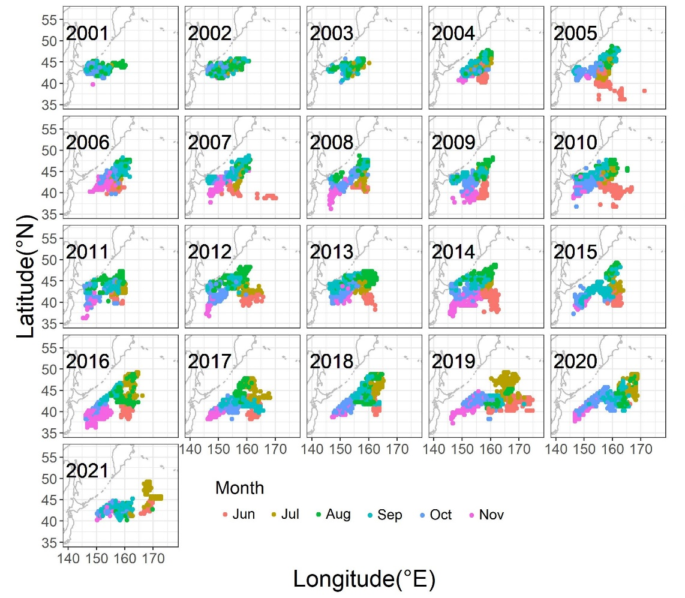
Fig. 1. Annual changes in monthly fishing grounds of Chinese Taipei stick-held dip net fishery for Pacific saury from 2001 to 2021.

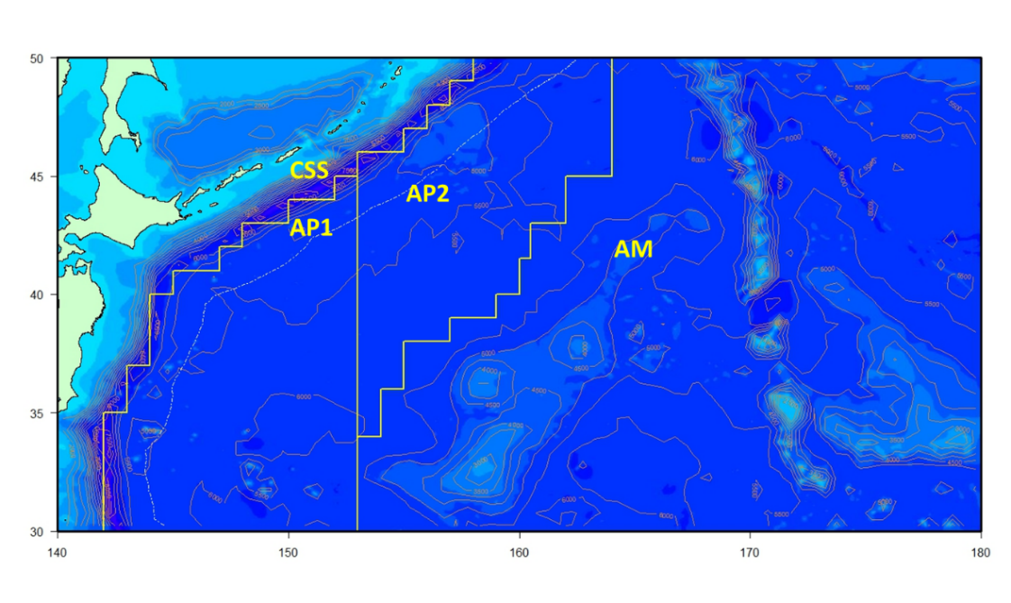
Fig. 2. Definition of four geographic regions based on bathymetric contours and Pacific saury aggregations (modified from Huang et al. (2007)). CSS, continental shelf and slop area; AP1, abyssal plain area 1; AP2, abyssal plain area 2; and AM, abyssal mountain area.
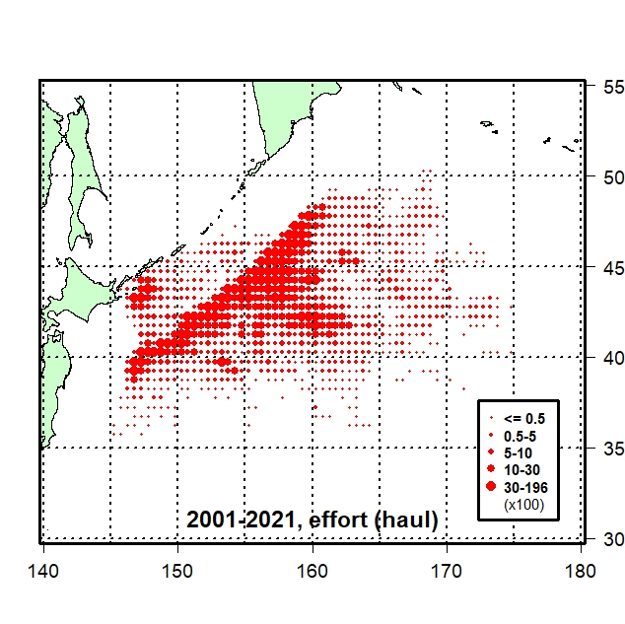  (a) | 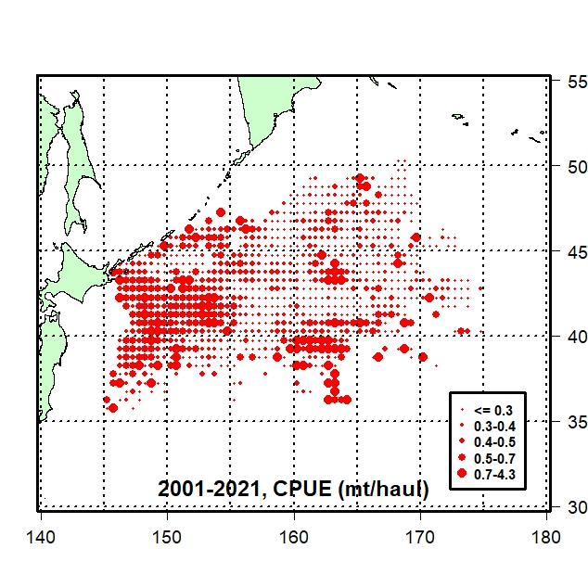  (b)
Fig. 3. Distribution of (a) fishing effort (10² hauls) and (b) nominal CPUE (mt/haul) for the Chinese Taipei saury fishing fleets in the Northwestern Pacific Ocean from 2001-2021.

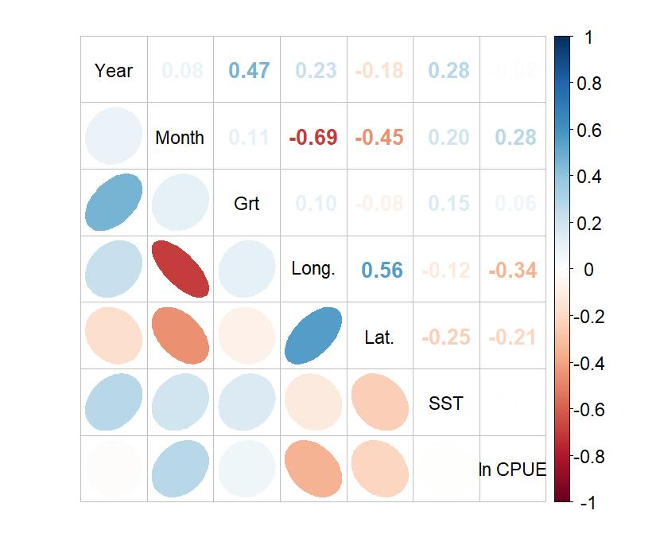
Fig. 4. Correlation matrix of explanatory variables used in the GLM and GAM analyses for Pacific saury CPUE standardization.

- GLM | - GAM
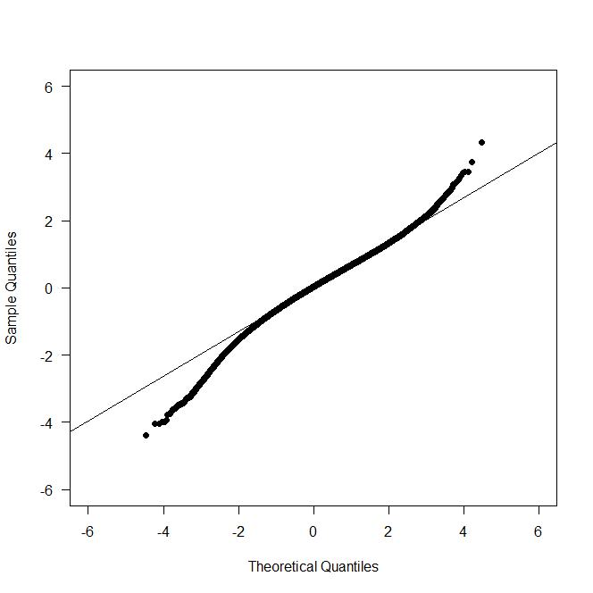 | 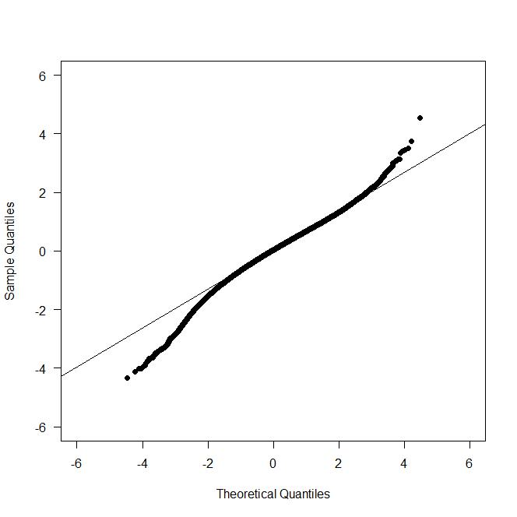
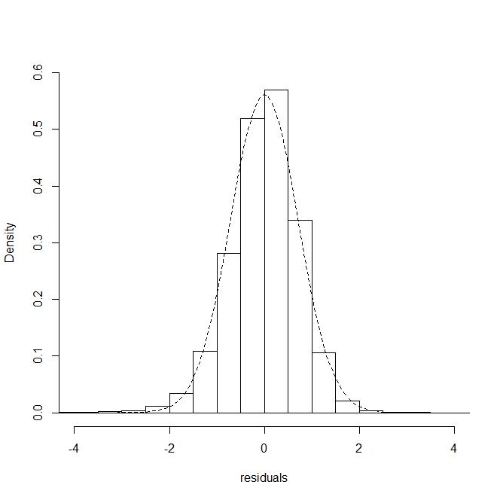 | 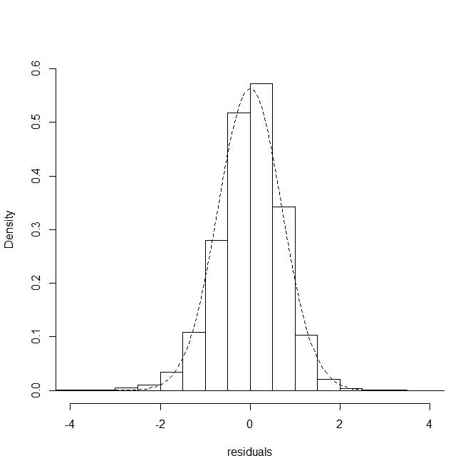
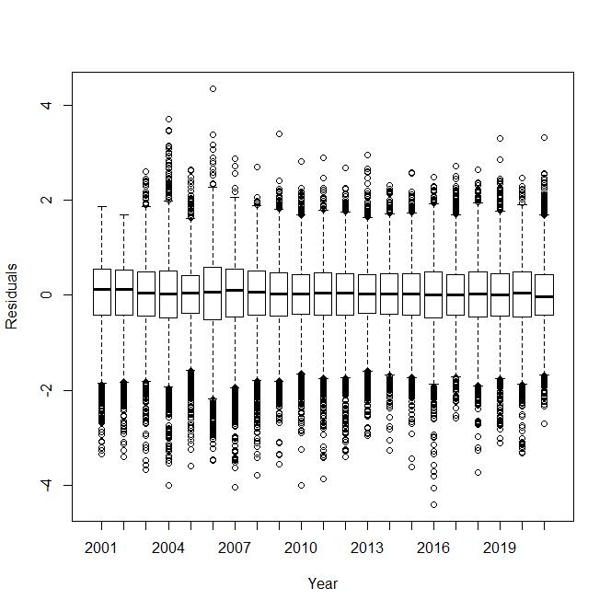 | 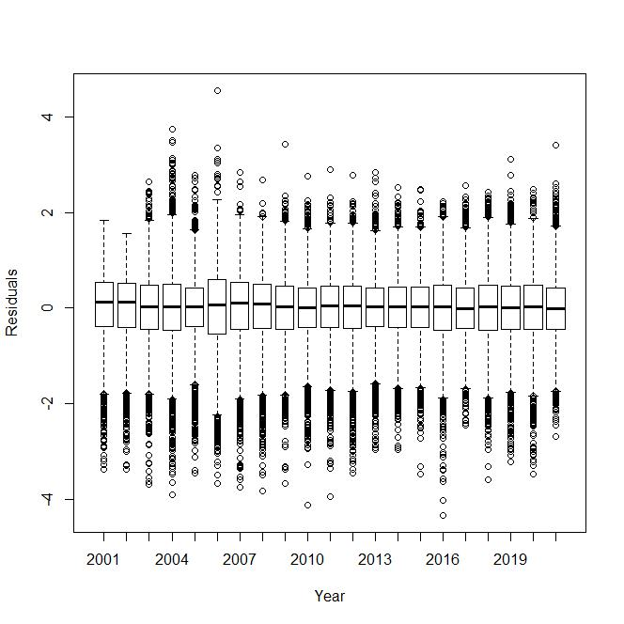
Fig. 5. Q-Q plots, histograms of residuals and residual plots across years for the best models from the (a) GLM and (b) GAM approaches.

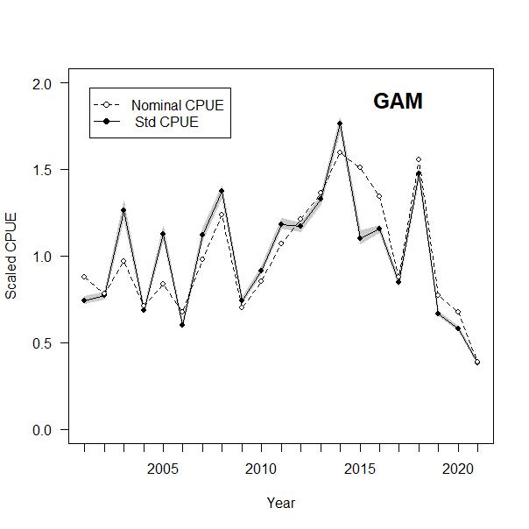
Fig. 6. A scaled nominal CPUE series (dashed line) and scaled standardized CPUE series (solid line) from the best models of the GAM approach from 2001 to 2021. Gray shading indicates the 95% confidence interval for the standardized CPUE.
AppendICES

Appendix I. Checklist for the CPUE standardization protocol
No. | Step-by-step protocols | yes/no | Note
1 | Conduct a thorough literature review to identify key factors (i.e., spatial, temporal, environmental, and fisheries variables) that may influence CPUE values; | yes | Tian et al. 2003, 2004  Huang et al. 2007, 2010  Tseng et al. 2011, 2013  TWG PSSA, 2018, 2019
2 | Determine temporal and spatial scales for data grouping for CPUE standardization; | yes | See 2.1 Fishery data and water temperature, p.3 & 2.2. Full model descriptions and model selection, 2nd last par., p.3 to 1st par., p.4
3 | Plot spatio-temporal distributions of fishing efforts and catch to evaluate spatio-temporal patterns of fishing effort and catch; | yes | See Fig.3, p.12
4 | Calculate correlation matrix to evaluate relationship between each pair of variables; | yes | See Fig.4, p.12
5 | Identify potential explanatory variables based on steps 1-4 as well as interaction terms to develop a full model for the CPUE standardization; | yes | See 2.2. Full model descriptions and model selection, 2nd last paragraph, p.3 to 1st par., p.4
6 | Fit candidate statistical models to the data (e.g., GLM, GAM, Delta-lognormal GLM, Neural Networks, Regression Trees, Habitat based models, and Statistical habitat based models); | yes | See Tables 3 & 4, p.8-9
7 | Evaluate the models using methods such as likelihood ratio, AIC/BIC and cross-validation; | yes | See 2.2. Full model descriptions and model selection, 2nd par., p.4
8 | Evaluate if distributional assumptions are satisfied and if there is a significant spatial/temporal pattern of residuals in CPUE standardization modeling; | yes | See Fig.5, p.13
9 | Extract yearly standardized CPUE and standard error by a method that is able to account for spatial heterogeneity of effort, such as least squares mean or expanded grid. If the model includes area and the size of spatial strata differs, or the model includes interactions between time and area, then standardized CPUE should be calculated with an area weighting for each time step. Models with interactions between area and season or month require careful consideration on a case by case basis; | yes | See 2.3. Yearly trend extraction, p.4
10 | Recommend a time series of yearly standardized CPUE and associated uncertainty; | yes | See Table 6, GAM, p.10
11 | Plot nominal and standardized CPUEs over time; | yes | See Fig.6, p.14

