NPFC-2022-TWG CMSA06-WP02

**Japanese fishery data based on a quarterly calendar**

Akihiro Manabe, Ryuji Yukami, Shota Nishijima, Shuya Nakatsuka and Momoko Ichinokawa

*Fisheries Resources Institute, Japan Fisheries Research and Education Agency*

**Summary**

The quarterly catch and weight at age of CM from 2010 to 2020 and quarterly maturity at age data from 2007 to 2020 are calculated and presented. The quarterly catch at age represents catch in Q4 and Q1 of the subsequent year is significant while catch in Q2 and Q3 is low. The catch of age 0 appears regularly in Q3 and Q4, representing the recruitment of age 0 fish to fishery appears after Q2. With the availability of Japanese catch at age data in quarterly basis and presence of age incrementation in the middle of the calendar year, it is advised to use fishing year to assess the stock of CM with rich temporal catch at age data.

**Introduction**

The TWG CMSA agreed that the Members will submit fishery data on a quarterly calendar which are expected to facilitate discussion to set fishing/calendar year to conduct stock assessment on chub mackerel (CM) (5th Meeting of TWG CMSA 2022). Japan provides those information based on the input data used for the Japanese domestic stock assessment on this species.

**Data**

Catch at age

The monthly length composition data were constructed for 2010 to 2020 using the length measurement data obtained from CM landings at major landing ports in Japan. Then using the length-weight relationship obtained annually at each prefecture and the monthly length composition data, monthly average weight per fish were calculated. Using the monthly average weight per fish and the monthly catch data obtained from each prefecture, monthly catch in number of fish were obtained. By multiplying the catch number by the length frequency data, monthly catch at length were obtained. Using the quarterly developed age-length-key, obtained by the biological measurement of fish performed by each prefecture every month, quarterly catch at age in number were calculated. For the development of age-length-key, the age of CM is incremented on July 1st since recruitment of age-0 fish begins in July. Due to the nature of recruitment and fishery, the catch at age data from Q3 to Q2 of the following year was used as the annual catch at age of the fishing year.

Weight at age

Likewise, monthly catch weight at length is estimated from monthly catch at length and length-weight relationship from each month. By combining monthly catch weight at length into quarterly basis and applying age-length-key, the quarterly catch at age in weight were obtained. Weight at age was thus calculated by dividing the catch at age in weight with catch at age in numbers. For the detailed method of preparation of catch and weight at age, see Manabe and Yukami (2020).

Maturity at age

Quarterly maturity rate by age was analyzed using the sample from the Pacific coast of Japan obtained between 2006 and 2019. Of the 17673 fishes collected, 6941 and 7985 fishes were male and females, respectively. The maturation status is analyzed using GSI criteria as described in Manabe et al. (2021).

**Results and discussion**

The quarterly catch annually hit a peak in Q1 or Q4 and decreased after Q4, touching bottom in Q2 or Q3 (Fig. 1, Table 1). The catch of age-0 fish appeared regularly in Q3 and Q4, representing the recruitment of age-0 fish to fishery appeared after Q2. These results support setting of a fishing year starting from July and end in June, which has been employed in the Japanese domestic stock assessment on CM.

The weight at age based on the quarterly calendar, which was provided through the catch in weight at age with the catch number at age, is shown in Table 2. The weight by year class grew across the quarter, showing different growth rates among cohorts (Fig. 2).

Quarterly GSI by age is shown in Fig. 3 and proportion of matured individuals by age for each quarter is shown in Fig 4. Based on Yukami et al. (2019), the criterion of maturation was set as GSI > 2.5. Matured individuals were dominated for age-2 and above in Q1 and Q2, however, scarce in all ages in Q3 and Q4 (Fig. 3). Likewise, the proportion of matured individuals by age per quarter exhibited the similar pattern in Q1 and Q2, showing the increasing trend of proportion of matured individuals from age-2 and above with greater proportion in higher ages (e.g. age-4 and above). The proportion of matured individuals were scarce in Q3 and Q4; resulting completely lack of matured individuals except for 2015 and 2016 in Q4 (Fig 4). The pattern of appearance of matured individual in each quarter is due to the spawning season which lies between Q1 and Q2. Since fishes were post-spawning in Q3 and Q4, the gonads were underdeveloped, hence, considered as immature based on the GSI criterion. The present analysis of proportion of maturated individuals at age properly shown the trend of maturation based on the seasonal gonadal development. Additionally, the result is convincing in terms of the maturity at age of the current domestic stock assessment of Japan, where the maturity-at-age is determined based on the Watanabe and Yatsu (2006) and Watanabe (2010) considering the stock level.

Because of the spawning season of CM from Q1 to Q2, age increment occurs in the middle of the calendar year. Based on this biological aspect of this species, an application of the calendar year will cause a significant problem that two year-classes could be included in an identical age class in the catch at age data in a single year. The periodicity of the variation in the quarterly catch which had a peak in Q1 or Q4 annually supported the application of the fishing year employed in the Japanese domestic stock assessment. It is concluded that the application of this fishing year can meet two requirements with respect to biology and fishery.

In this document, the quarterly catch, weight, and maturity at age data from 2010 was provided upon the request. Owing to the current data availability, catch and weight at age data prior to 2010 cannot be divided in quarterly basis.

The temporal length of data, hence the quantity of the data, is a fundamental part to yield a robust stock assessment (Chen et al. 2003). The domestic stock assessment of chub mackerel in Japan uses data from 1970, resulting in accumulating more than 50 years of catch at age and corresponding biological data. The data includes variety of phenomena such as the population dynamics in high and low stock levels and recent appearance of strong year class. Considering the catch at age data from Japanese fleet outnumbers the data from the other members, it is critical to include the data into stock assessment for NPFC. Therefore, it is important to consider the application of the fishing year to the stock assessment of CM in NPFC to fully maximize the quantity of the data to yield a robust stock assessment.

**References**

Chen, Y., Chen, L., Stergiou, K.I. (2003). Impacts of data quantity of fisheries stock assessment. Aquat. Sci. 65. 1-7.

5th Meeting of the Technical Working Group on Chub Mackerel Stock Assessment. 2022. 5th Meeting Report. NPFC-2022-TWG CMSA05-Final Report. 24 pp. (Available at [www.npfc.int](http://www.npfc.int))

Manabe, A. and Yukami, R. (2020). Catch, weight, and maturity at age of the chub mackerel of Japan. NPFC-2020-TWG_CMSA03-WP02, pp1-19.

Manabe, A., Kamimura, Y., Ichinokawa, M., and Oshima, K. (2021). Maturity at age of chub mackerels under different stock level in the northwestern Pacific Ocean. NPFC-2021-TWG_CMSA-WP07, pp1-17.

Watanabe, C., and Yatsu, A. (2006). Long-term changes in maturity at age of chub mackerel (Scomber japonicus) in relation to population declines in the waters off northeastern Japan. Fish. Res. 78:2-3, 323-332. (doi: 10.1016/j.fishres.2006.01.001)

Watanabe, C. (2010). Changes in the reproductive traits of the Pacific stock of chub mackerel Scomber japonicus and their effects on the population dynamics. Bull. Jpn. Soc. Fish. Oceanogr. 74. 46-50. (in Japanese with English abstract).

Table 1 Quarterly catch at age from 2010 to 2020.



Table 2 Quarterly weight at age from 2010 to 2020.



Fig. 1 Quarterly catch in number at age for 2010 to 2020. Y-axes are based on number and proportion in upper and lower panels.

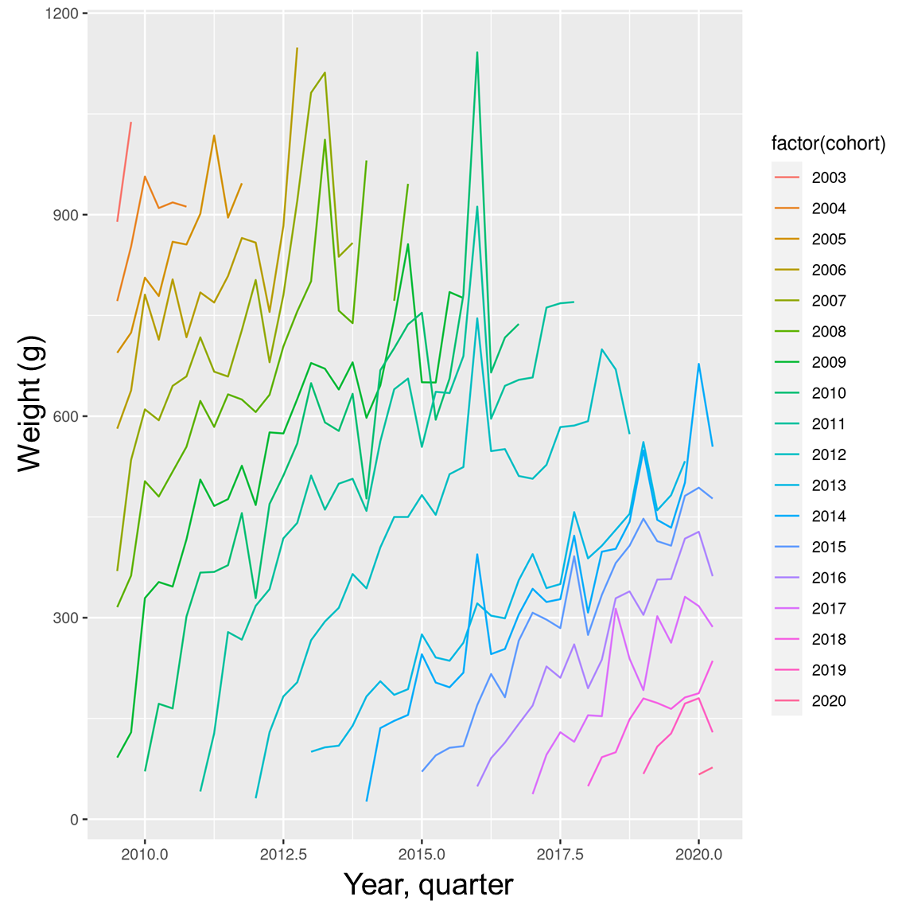

Fig. 2 Trajectories of weight at age by year class (cohort) from 2009 to 2020.

Fig 3. GSI by age by quarter. The horizontal orange line represents the criteria of maturation (GSI = 2.5). Q1 to Q4 represent quarters 1 to 4 and 1 and 2 on the leftmost boxes represent male and female, respectively.

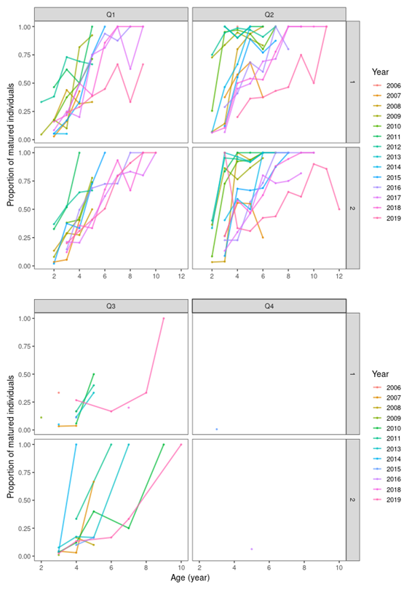

Fig 4. Proportion of matured individuals by age. Q1 to Q4 represent quarters 1 to 4 and 1 and 2 on the leftmost boxes represent male and female, respectively.