NPFC-2022-SSC PS09-WP05 (Rev. 1)
Joint CPUE standardization of the Pacific saury in the Northwest Pacific Ocean by using the spatio-temporal modelling approach

Jhen Hsu, Yi-Jay Chang, and Yun-Wei Chou
Institute of Oceanography, National Taiwan University

Abstract

Reliable indices of population abundance are an important type of data for stock assessment. We applied a Vector-Autoregressive Spatio-Temporal Model (VAST) to conduct index standardization by using the joint CPUE (catch-per-unit-effort) data of the Pacific saury in the Northwest Pacific Ocean during 1994 and 2021. The results indicated that the annual standardized CPUE trend had a fluctuated pattern over studied periods, and the annual standardized CPUE value was at the lowest level below average (1994 - 2020) in 2021. The analysis we presented is generally applicable and should be considered as a standard tool in the CPUE standardization.

1. Introduction

Standardization of commercial catch and effort data is important in fisheries where standardized abundance indices based on the fishery-dependent data are a fundamental input to stock assessments. The nominal CPUE (catch-per-unit-effort) index, derived from yearly means of the raw CPUE data, can be severely biased due to the fishing fleets in specific locales using gear that increases catchability, low fishing effort in areas which give inaccurate average CPUE, oceanography conditions that increase catchability by, for instance, making fish more vulnerable to fishing gear, or simply chance. The most commonly used standardization procedures entail the application of Generalized Linear Models (GLMs) or Generalized Additive Models (GAMs), which aim to isolate temporal abundance trends from the total variation in the CPUE data by adjusting for confounding effects on the estimated abundance trends (Guisan et al., 2002; Maunder and Punt, 2004). In addition, observations that occur closer in space are more likely to be similar (spatial autocorrelation), which makes it harder to distinguish the real signal of a spatial effect by an explanatory variable. Recent years have seen the emergence of spatiotemporal modelling methods for standardizing CPUE data (e.g., Walter et al., 2014; Thorson et al., 2015; Kai et al., 2017; Grüss et al., 2019), because they allow the spatial autocorrelation to be removed, which may yield more precise, biologically reasonable, and interpretable estimates of abundance than common methods such as GLMs (Shelton et al., 2014; Thorson et al. 2015).

Pacific saury (Cololabis saira), a migratory small pelagic fish, is widely distributed and migrate over extensive areas of the Northwestern Pacific Ocean. (Fukushima, 1979). This species is commercially important in the Northwestern Pacific Ocean, targeted by stick‐held dip net fisheries from several members of the North Pacific Fisheries Commission (NPFC) that the offshore fishing vessels by Japan and Russia operate mainly within the exclusive economic zones while the distant-water vessels of China, Korea, and Chinese Taipei operate mainly east of Hokkaido and the Kuril Islands in the Northwestern Pacific Ocean. In view of the fact that there is a conflict among the standardized CPUE indices derived by members, the 3rd Technical Working Group on the Pacific Saury Stock Assessment (TWG PSSA) aim to develop a single joint CPUE index (NPFC-2018-TWG PSSA03-Final Report) for the Pacific saury from the catch and effort data by all members (i.e., joint CPUE data).

In this study, we apply a Vector-Autoregressive Spatio-Temporal Model (i.e., VAST, Thorson, 2019) to conduct an index standardization by using the joint CPUE data of the Pacific saury in the Northwest Pacific Ocean. The objective is to update the joint CPUE index for the use in the Pacific saury stock assessment.

2. Methods

Joint CPUE dataset

The joint CPUE data of stick-held dip net fisheries was collected from each member including Japan, Chinese Taipei, China, Korea, Russia and Vanuatu in the North Pacific Fisheries Commission (NPFC) during 1994 - 2021. It also serves as a repository for the fisheries summary plots (including catch, operating day, and nominal CPUE; see Appendix figures 1 - 6). This dataset was aggregated by year and month with a spatial resolution of 1° × 1° and covered the Northwestern Pacific Ocean between 32 - 50 °N and 140 - 174 °E from 2001 to 2021. Data grooming was applied prior to the standardization to remove the monthly observation with less than 10 operation days. In total, 2% records have been removed. CPUE was defined as a catch of Pacific saury in metric ton per operating day fished. The joint data set included approximately 14,044 records with all members, and Figure 1 illustrates the distribution of fishing effort (i.e., 1° by 1° grid) through time by different members. The spatial and temporal pattern of the nominal joint CPUE data during 2001 and 2021 was shown in Figure 2.

Spatio-temporal modelling approach

The spatio-temporal modelling approach we used here is adapted from the R package VAST (https://github.com/James-Thorson-NOAA/VAST) developed by Thorson et al. (2015). VAST uses the Gaussian random fields to model the spatial autocorrelation with anisotropy (which means the relationship of spatial autocorrelation does not have to change at the same rate in all directions), and an interactive relationship between space and time (i.e., spatio-temporal autocorrelation). These Gaussian random ﬁelds are deﬁned with a Matérn covariance function (see Thorson, 2019). VAST requires the previous definition of knots s which are points where the correlation of spatial and spatio-temporal eﬀects are estimated. Each observation in the dataset then gets assigned to the knot which is the closest to them using the k-means. In this study, we specify 100 spatial knots (see Figure 3 for the configuration) to approximate the spatial and spatio-temporal autocorrelated variations. We confirmed that our results are qualitatively similar when using various numbers of spatial knots (100, 150, and 200 knots) in the explanatory runs.

We give a brief description of how the VAST is applied to the Pacific saury joint CPUE dataset below and refer the readers to the original reference for more technical details (see also Thorson, 2019). The logarithm prediction of Pacific saury density, p(s,t), in knot s and year-month t is described below:

(1)

where β(t) is the intercept for each year t as a fixed effect, ω(s) is a time-invariant spatial autocorrelated variation for knot s (100 knots), and ε(s,t) is a time-varying spatio-temporal autocorrelated variation for knot s and in year t (i.e., the interaction of spatial variation and time). γ_{j} represents the impact of covariate j (i.e., the linear impact of SST, n_{j} = 1) with value x_{j}(s,t) on density for knot s and year t. Q(k) are the fixed effects for fleet, month and SST effects (i.e., n_{k} = 3). The detail information of explanatory variables used in VAST was shown in Table 1. The correlation matrix for these explanatory variables of VAST is shown in Figure 4.

Additional model runs
In response to the suggestions of the SSC PS09, we conducted further analysis to investigate the potential non-linear relationship between observed CPUE and SST. Four SST treatments (i.e., quadratic functions of SST and log(SST), 12 categorical variables of SST, and the interaction of month and SST) were included in the additional model runs. For the best model, we further compared the standardized joint CPUE indices beginning in 1994 with that beginning in 2001. The spatial and temporal pattern of the nominal joint CPUE data during 1994 - 2000 was shown in Appendix Figure 7.

Model selection and diagnostics

We used the Akaike Information Criterion (AIC; Akaike, 1973) to identify which model had greater support given available data within the VAST. Histograms of the residuals were used to assess normality for the VAST, in addition, the quantile-quantile normal probability plots (Normal Q-Q plot) for both of them. For a better understanding of CPUE standardization of Pacific saury, the “step plots” (Bishop et al., 2008) were conducted to understand the effects of removing individual factors from the VAST with respect to the estimated CPUE indices.

Standardized CPUE trend

Predictions of standardized Pacific saury density for observation i then excludes the value for the covariates linked to catchability, here are the fleet and SST effects but otherwise retains the other predictors of density in space and time. Estimated values of fixed and random effects are used to predict the relative density p(s,t) except for the catchability variables (Thorson, 2019). The annual density, B(t), for VAST is described below (Thorson, 2019; Grüss et al., 2019):

(2)

where d(t,m) is the area re-weighted biomass density in year t and month m throughout the population domain, α(m) is the month effect; n is the number of knot s, and SA(s) is the area of knot s. The annual density of the Pacific saury, B(t), is derived from relative abundance estimates for each year t and month m as follows (Campbell, 2015):

(3)

where m is the number of the month (i.e., May - December). Standard errors of the annual standardized CPUEs estimated by the spatio-temporal model were computed using a generalization of the delta method (Thorson et al., 2015; Thorson and Barnett, 2017).

3. Results and discussion

Model selection and diagnostic

The convergence in optimization was confirmed for each model if the Hessian matrix was positive and the maximum gradient of each component was smaller than 0.0001. However, the model with quadratic functions of SST and log(SST) (V-7 and V-8) and the interaction of month and SST (V-10) did not converge (Table 2). The results indicated that joint CPUE data did not support the hypothesis of a smooth quadratic and monthly varying effects between SST and observed CPUEs. Furthermore, we found that using categorical SST effects (V-9) could improve the model fitting compared to the model using a continuous SST effect (V-6) based on the AIC values (Table 2). In addition, the value of deviance explained derived from V-9 (71%) was slightly higher than the V-6 model (70%). The spatial residuals at the level of the knot for the best model (i.e., V-9; smallest AIC), exhibited a normal distribution around zero, indicating an overall reasonable fit to the data (Fig. 5). However, a notable spatial pattern in residuals, such that the area of 145 ºE - 155ºE and 40 ºN - 45ºN exhibited residuals apparently below zero during 2005 - 2006. Moreover, the peripheral areas generally exhibited spatial residual below zero, this pattern suggested that the density estimates may be slightly underestimated in peripheral regions. Additionally, we noted that relatively small residuals were observed during 2019 - 2021 compared to previous years. It could be explained by the observed CPUEs of 2019 – 2021 had a larger spatial coverage compared to other years, therefore more information could be referred to estimate the CPUE values for the peripheral regions. The histogram and Q-Q plots of the model based on the lognormal distributions appear normal in VAST for all fleets (Fig. 6), which confirms the assumption of the error distribution is generally appropriate for the CPUE standardization.

Standardized CPUE index

Step plots indicated that the spatio-temporal variable has a major influence on standardized CPUE compared to the other effects in VAST (Fig. 7). Comparison of the estimated standardized CPUEs from the V-6 and V-9 models (differed with SST treatments) was shown in Figure 8. The annual relative standardized CPUE trends were similar and indicated there was a fluctuated pattern during 2001 - 2021 (Fig. 8). The annual relative density was at the lowest level below average (2001 - 2021) in 2021.
We also conducted a comparison between the standardized joint CPUE indices beginning in 1994 and that beginning in 2001. The two indices were found to be comparable and the estimated yearly trends of standardized CPUE are similar during the overlapped time period (Fig. 9). The summary of annual standardized CPUEs by considering the categorical SST effects during 1994 – 2021 (the best model) was shown in Figure 10 and Table 3. It is noted that the uncertainties of estimated yearly CPUE for 2019 -2020 are smaller than in previous years. It may be because the observed CPUE data of these two years had a wider coverage compared to data of 2001 - 2018 (Fig. 2), therefore more observed data could provide the model for estimation, especially for the periphery of the study area.
Previous study has also suggested that the spatio-temporal modeling platform VAST achieved the best performance among nine CPUE standardization methods by using the simulation testing, namely generally had one of the lowest biases, one of the lowest mean absolute errors, and the probability of the true index been included by the estimated 50% confidence interval is closest to 50% (Grüss et al., 2019). We also recommend using VAST from a practical standpoint that the regional weights, the year-quarter standardized indices, and the corresponding standard errors can be estimated directly as part of the modelling procedure, so no additional step is required to produce them (often not been reported).

References
Akaike, H. (1974). A new look at the statistical model identification. IEEE transactions on automatic control, 19(6), 716-723.
Bishop, J., Venables, W. N., Dichmont, C. M., and Sterling, D. J. (2008). Standardizing catch rates: is logbook information by itself enough?. ICES J. Mar. Sci., 65(2), 255-266.
Bentley, N., Kendrick, T. H., Starr, P. J., and Breen, P. A. (2012). Influence plots and metrics: tools for better understanding fisheries catch-per-unit-effort standardizations. ICES J. Mar. Sci., 69(1):84–88.
Campbell RA (2015) Constructing stock abundance indices from catch and effort data: Some nuts and bolts. Fish Res. 161: 109-130.
Fukushima, S. (1979) Synoptic analysis of migration and fishing conditions of saury in the northwest Pacific Ocean. Bull. Tohoku Reg. Fish. Res. Lab. 41: l-70. (In Japanese, English abstract.)
Guisan, A., Edwards Jr., T.C., Hastie, T. (2002). Generalized linear and generalized additive models in studies of species distributions: setting the scene. Ecol. Mod. 157, 89–100
Grüss, A., Walter III, J. F., Babcock, E. A., Forrestal, F. C., Thorson, J. T., Lauretta, M. V., and Schirripa, M. J. (2019). Evaluation of the impacts of different treatments of spatio-temporal variation in catch-per-unit-effort standardization models. Fish Res., 213, 75-93.
Kai, M., Thorson, J. T., Piner, K. R., and Maunder, M. N. (2017). Spatiotemporal variation in size-structured populations using fishery data: an application to shortfin mako (Isurus oxyrinchus) in the Pacific Ocean. Can. J. Fish Aquat. Sci., 74(11), 1765-1780.
Maunder, M. N., and Punt, A. E. (2004). Standardizing catch and eﬀort data: a review of recent approaches. Fish Res., 70(2-3):141–159.
NPFC TWG-PSSA. 2018. Report of 3rd Meeting of the Technical Working Group on Pacific Saury Stock Assessment. NPFC-2018-TWG PSSA03-Final Report. 29 pp.
R Development Core Team (2018). R: A language and environment for statistical computing. Vienna, Austria: R Foundation for Statistical Computing. ISBN 3-900051-07-0. Retrieved from http://www.R-project.org
Shelton, A. O., Thorson, J. T., Ward, E. J., and Feist, B.E. (2014).Spatial semiparametric models improve estimates of species abundance and distribution. Can. J. Fish Aquat. Sci. 71(11): 1655–1666.
Thorson, J. T., Shelton, A. O., Ward, E. J., and Skaug, H. (2015). Geostatistical delta-generalized linear mixed models improve precision for estimated abundance indices for West Coast groundfishes. ICES J. Mar. Sci., 72, 1297–1310.
Thorson, J. T., and Kristensen, K. (2016). Implementing a generic method for bias correction in statistical models using random effects, with spatial and population dynamics examples. Fish Res., 175, 66-74.
Thorson, J. T. (2019). Guidance for decisions using the Vector Autoregressive Spatio-Temporal (VAST) package in stock, ecosystem, habitat and climate assessments. Fish Res., 210:143–161.
Walter, J. F., Hoenig, J. M., and Christman, M. C. (2014). Reducing bias and filling in spatial gaps in fishery-dependent catch-per-unit-effort data by geostatistical prediction, I. Methodology and simulation. N. Am. J. Fish Manage., 34(6), 1095-1107

Table 1. Summary of explanatory variables used in VAST.
Variables |  | Number of categories | Detail | Note
Year | t | 21 | 2001 – 2021 / 1994 – 2021
Month | m | 8 | May - December
Spatial knot | s | 100 | 32 – 50 °N and 140 – 174 °E | See Figure 3
Sea surface temperature | SST | 1 | Continues variable (3 – 27 °C)
 |  | 12 | Categorical variable (3 – 27 °C, by 2 °C)
Fleet | Fleet | 7 | JP1: Japanese vessel less than 100 GRT;  JP2: Japanese vessel larger than 100 GRT;  CT: Chinese Taipei;  CN: China;  RS: Russia;  KR: Korea;  VU: Vanuatu

Table 2. Summary of the model selection information from VAST.
No. | Model structure | Number of parameters (fixed effect) | Deviance | AIC | Maximum  gradient
V-1 | Year | 21 | 52421 | 121178 | < 0.0001
V-2 | Year + Month | 28 | 51026 | 102099 | < 0.0001
V-3 | Year + Month + Spatial | 29 | 50328 | 100713 | < 0.0001
V-4 | Year + Month + Spatial + Spatio-temporal | 30 | 49790 | 99637 | < 0.0001
V-5 | Year + Month + Spatial + Spatio-temporal + Fleet | 36 | 49679 | 99416 | < 0.0001
V-6 | Year + Month + Spatial + Spatio-temporal + Fleet + SST | 37 | 49066 | 98247 | < 0.0001
V-7* | Year + Month + Spatial + Spatio-temporal + Fleet + SST + SST² | 39 | 48938 | 97990 | > 0.0001
V-8* | Year + Month + Spatial + Spatio-temporal + Fleet + log(SST) + log(SST²) | 39 | 49154 | 98308 | > 0.0001
V-9 | Year + Month + Spatial + Spatio-temporal + Fleet + 12 categories of SST | 49 | 48187 | 96374 | < 0.0001
V-10* | Year + Month + Spatial + Spatio-temporal + Fleet + Month × SST | 44 | 48992 | 97983 | < 0.0001
* represented that the model did not achieve convergence based on the maximum gradient was larger than 0.0001.
Table 3. Annual relative (relative to mean) nominal and standardized indices from VAST for Pacific saury during 1994 and 2021 in the Northwestern Pacific Ocean. SE = standard error, lower and upper = lower and upper limits of the 95% confidence intervals. CV = coefficient of variation.
Year | Standardized CPUE | SE | Upper | Lower | CV
1994 | 1.29 | 0.46 | 2.19 | 0.40 | 0.35
1995 | 1.60 | 0.58 | 2.74 | 0.47 | 0.36
1996 | 0.67 | 0.24 | 1.14 | 0.21 | 0.35
1997 | 1.34 | 0.48 | 2.29 | 0.40 | 0.36
1998 | 0.79 | 0.29 | 1.36 | 0.22 | 0.37
1999 | 0.50 | 0.19 | 0.88 | 0.12 | 0.39
2000 | 0.91 | 0.34 | 1.57 | 0.25 | 0.37
2001 | 0.90 | 0.26 | 1.41 | 0.39 | 0.29
2002 | 0.68 | 0.19 | 1.07 | 0.30 | 0.28
2003 | 1.18 | 0.33 | 1.82 | 0.54 | 0.28
2004 | 1.08 | 0.30 | 1.67 | 0.49 | 0.28
2005 | 1.63 | 0.44 | 2.49 | 0.78 | 0.27
2006 | 0.59 | 0.16 | 0.90 | 0.27 | 0.27
2007 | 1.05 | 0.29 | 1.61 | 0.49 | 0.27
2008 | 1.95 | 0.55 | 3.04 | 0.86 | 0.28
2009 | 1.03 | 0.29 | 1.59 | 0.47 | 0.28
2010 | 1.07 | 0.29 | 1.65 | 0.50 | 0.27
2011 | 1.26 | 0.36 | 1.97 | 0.55 | 0.29
2012 | 1.14 | 0.31 | 1.76 | 0.53 | 0.27
2013 | 1.02 | 0.28 | 1.57 | 0.48 | 0.27
2014 | 1.32 | 0.35 | 2.01 | 0.63 | 0.27
2015 | 0.99 | 0.28 | 1.54 | 0.45 | 0.28
2016 | 0.72 | 0.19 | 1.10 | 0.34 | 0.27
2017 | 0.79 | 0.21 | 1.21 | 0.37 | 0.27
2018 | 1.38 | 0.38 | 2.13 | 0.63 | 0.28
2019 | 0.54 | 0.15 | 0.83 | 0.25 | 0.27
2020 | 0.33 | 0.09 | 0.52 | 0.14 | 0.29
2021 | 0.22 | 0.06 | 0.34 | 0.10 | 0.28

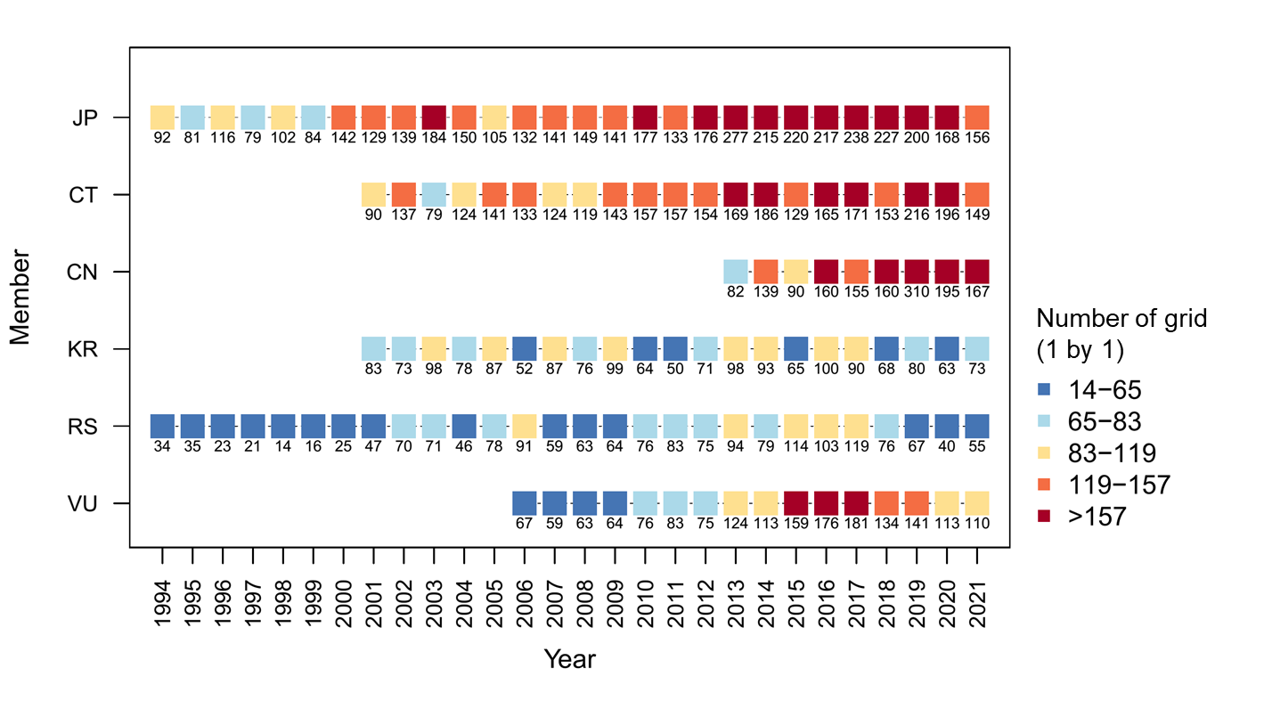
Figure 1. Distribution of fishing effort (i.e., 1° by 1° grid), by NPFC members (JP = Japan; CT = Chinese Taipei; CN = China; KR = Korea; RS = Russia; VU = Vanuatu) in the joint CPUE dataset of Pacific saury during 1994 - 2021.
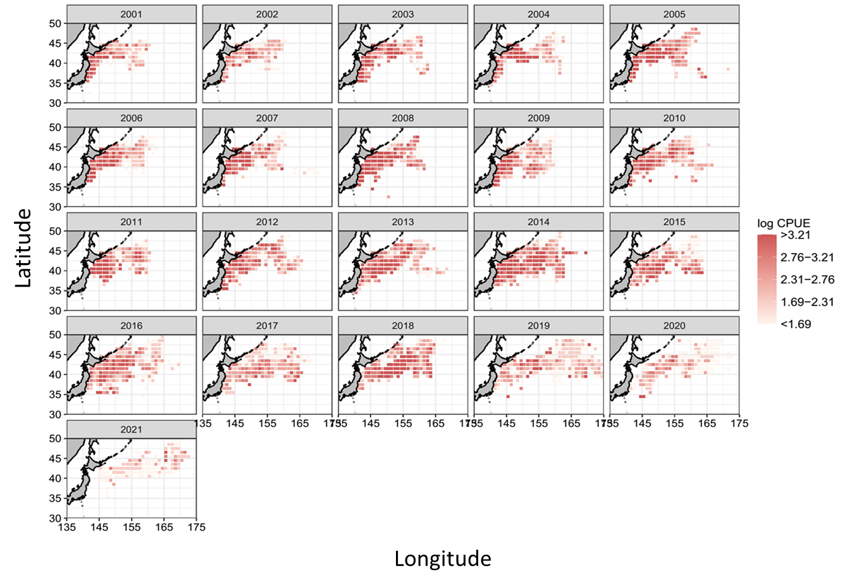
Figure 2. Spatial and temporal distribution of the logarithmic nominal CPUE (in metric ton per operating day fished) of Pacific saury during 2001 - 2021 in the Northwestern Pacific Ocean.

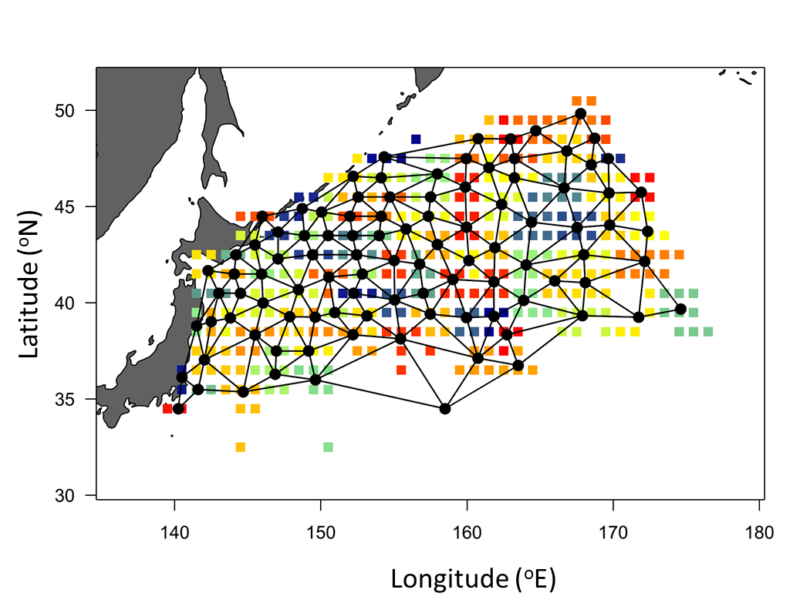
Figure 3. Mesh used to fit the Vector Autoregressive Spatio-Temporal (VAST) model. An eﬀect is estimated for each of the 100 spatial knots (black). The colored circles grouped by knots indicate the locations of spatial observations of the Pacific saury from 2001 to 2021 within the 1° × 1° grid.
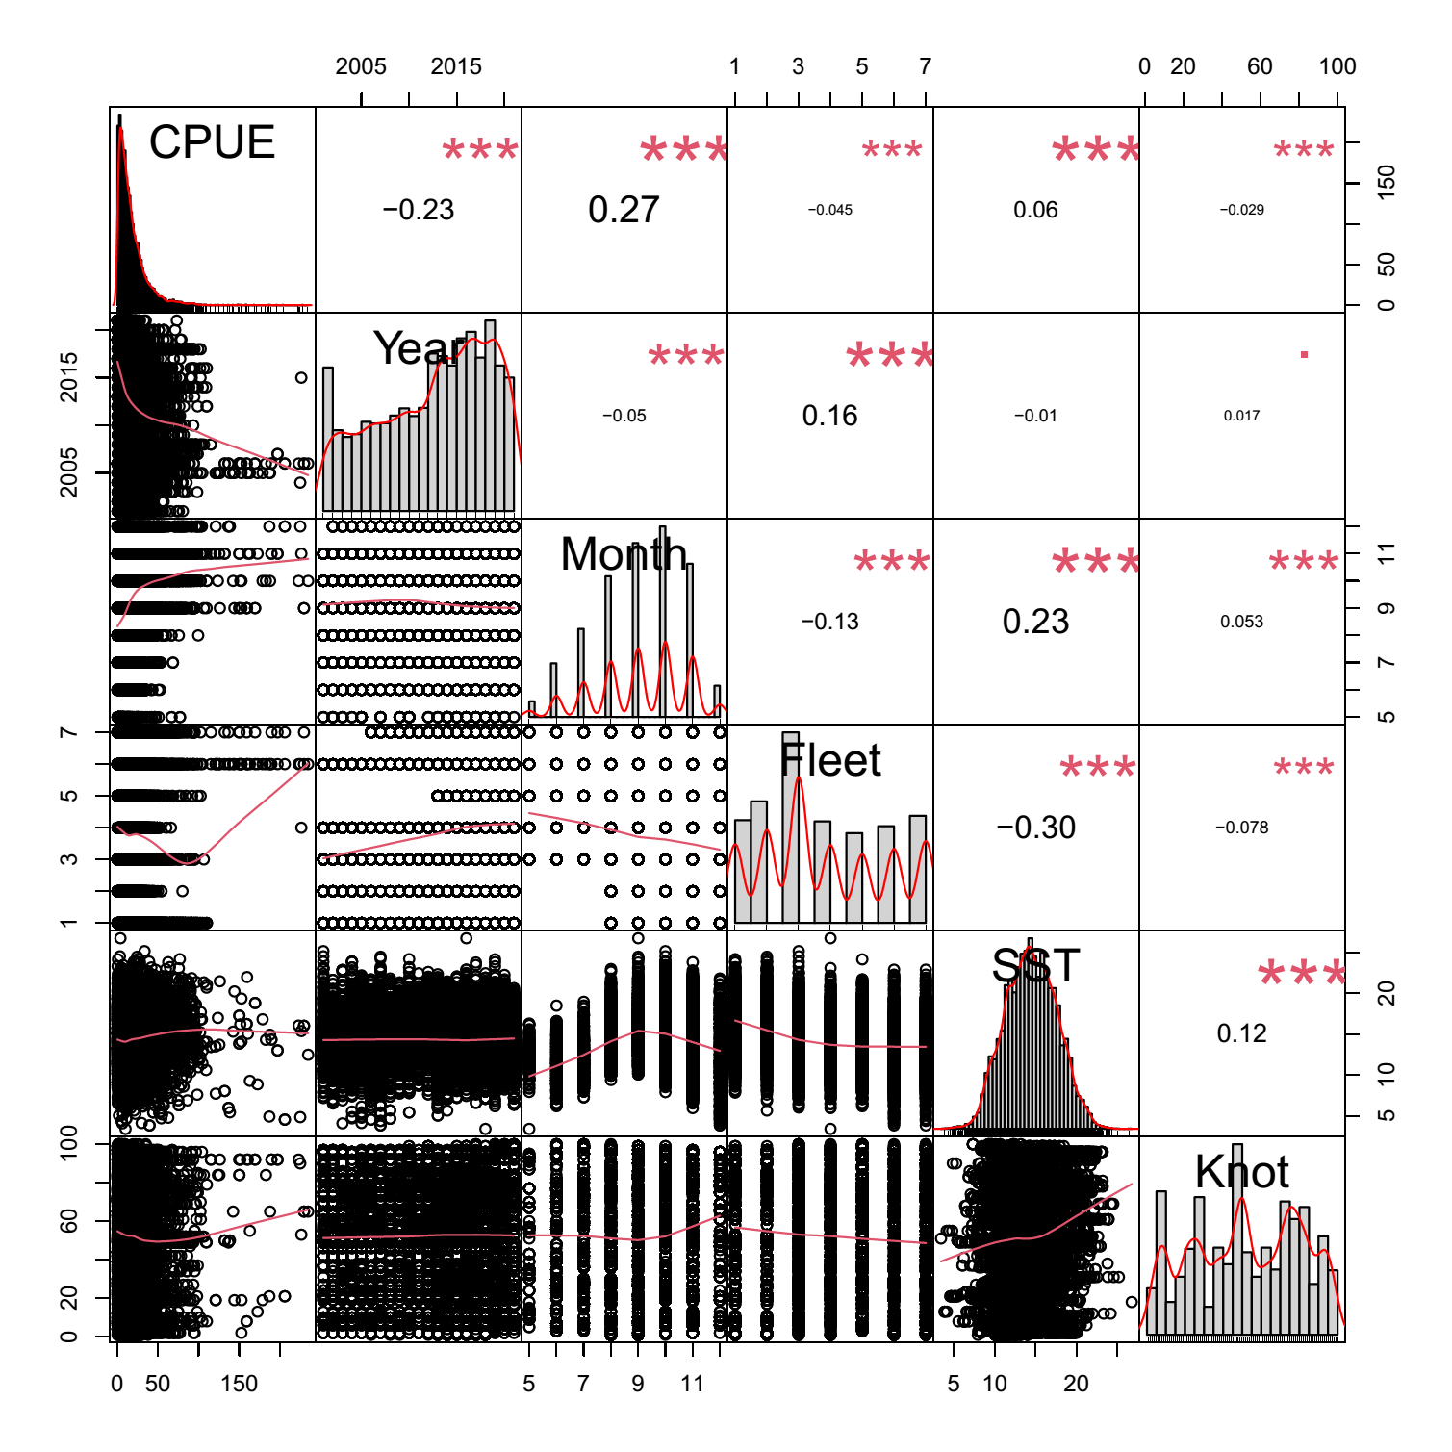
Figure 4. Correlation matrix of explanatory variables used in VAST analysis. The distribution of each variable is shown on the diagonal. On the bottom of the diagonal is the bivariate scatter plots with a fitted red line and on the top of the diagonal is the value of the correlation plus the significance level as stars. Each significance level is associated to a symbol: p-values (0***, 0.001**, 0.01*, 0.05., 0.1).

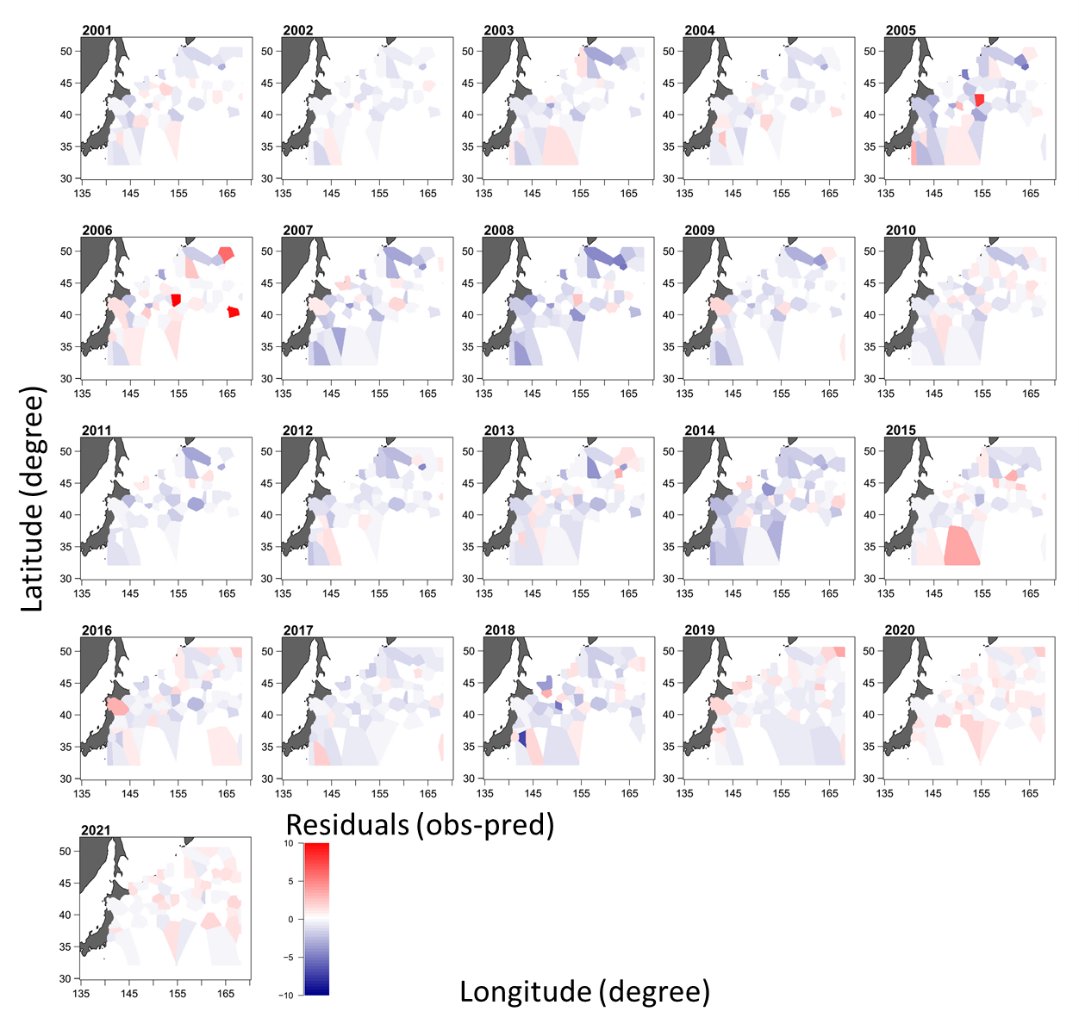
Figure 5. Spatial distribution of yearly aggregated residuals of Pacific saury derived from the V-9 model from 2001 to 2021.
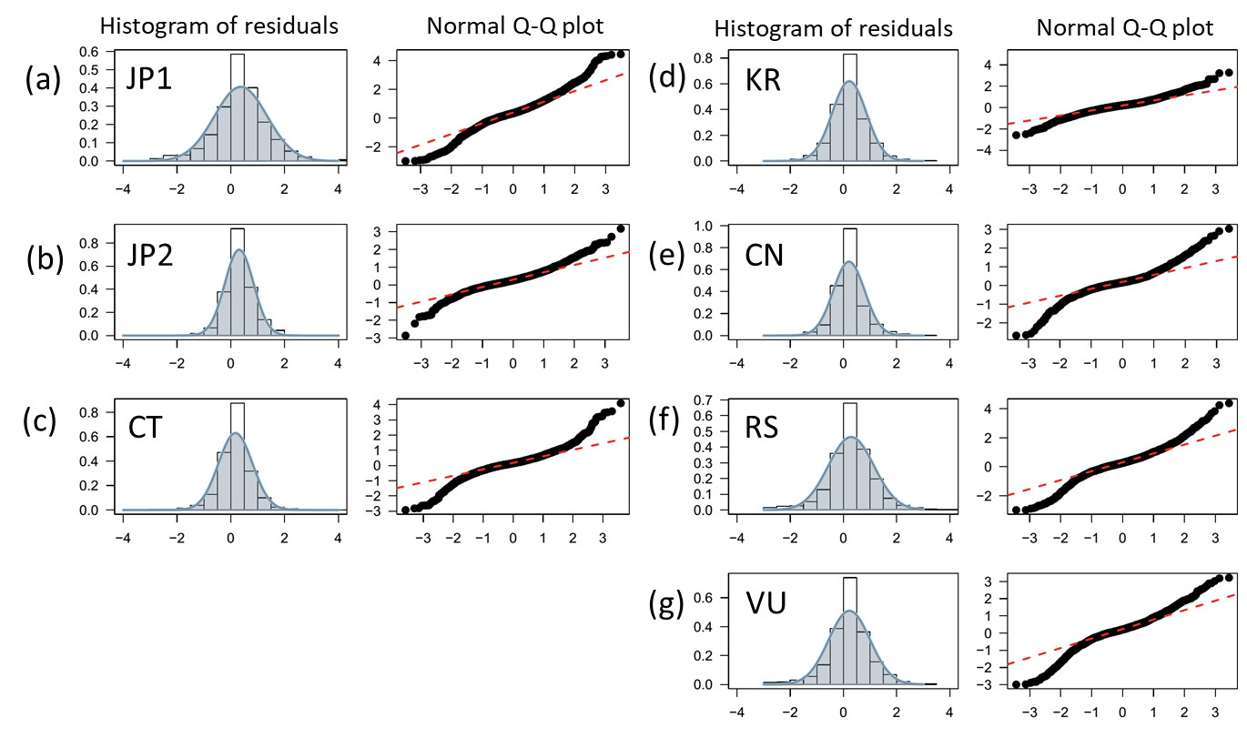
Figure 6. Diagnostic plots of the fitted V-9 model. The histogram of residuals (left) and Q-Q plot (right) from (a) Japanese fisheries by vessels of <100; (b) Japanese fisheries by vessels of >= 100; (c) Chinese Taipei; (d) Korea; (e) China; (f) Russia, and (g) Vanuatu fisheries.
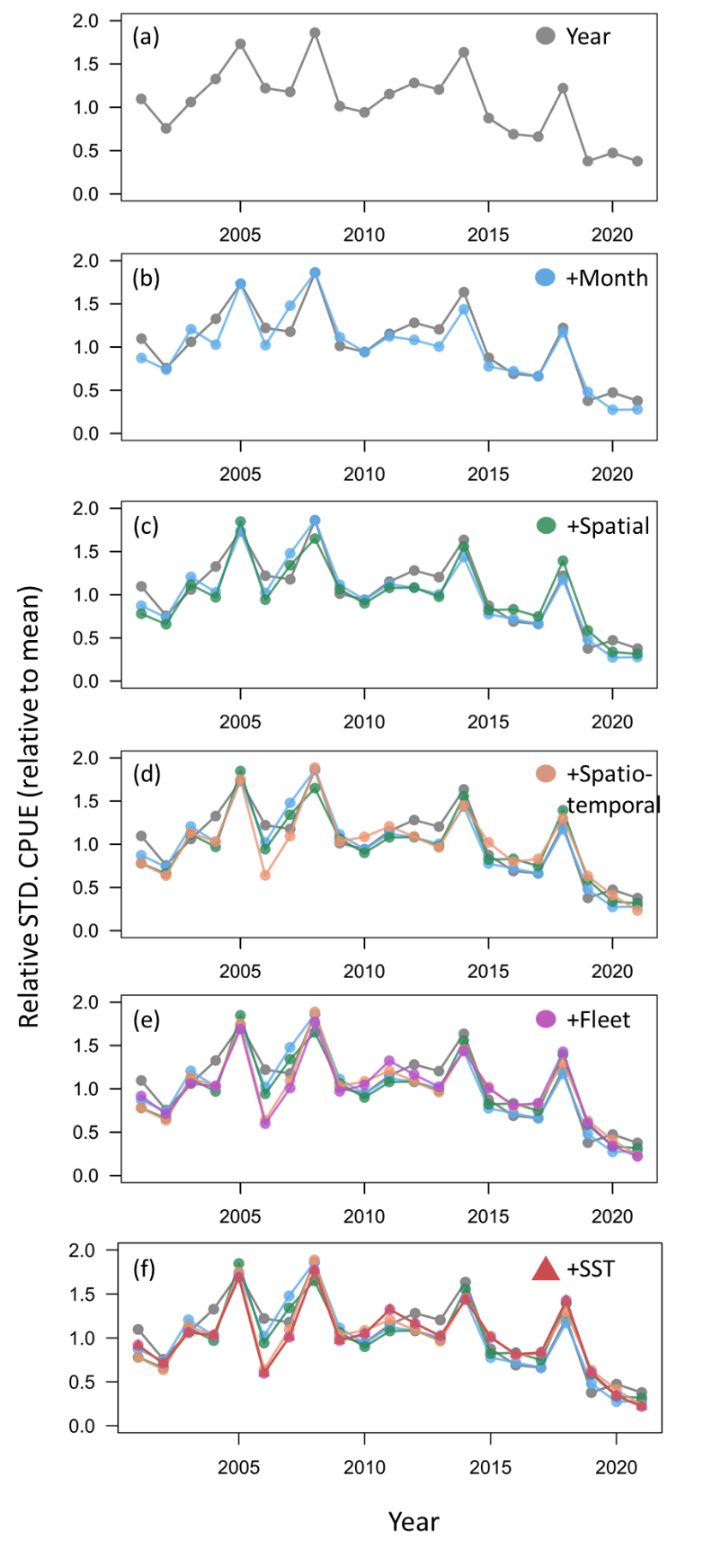
Figure 7. Step plots showing the eﬀects of adding individual factors from the V-9 model with respect to the estimated CPUE indices.

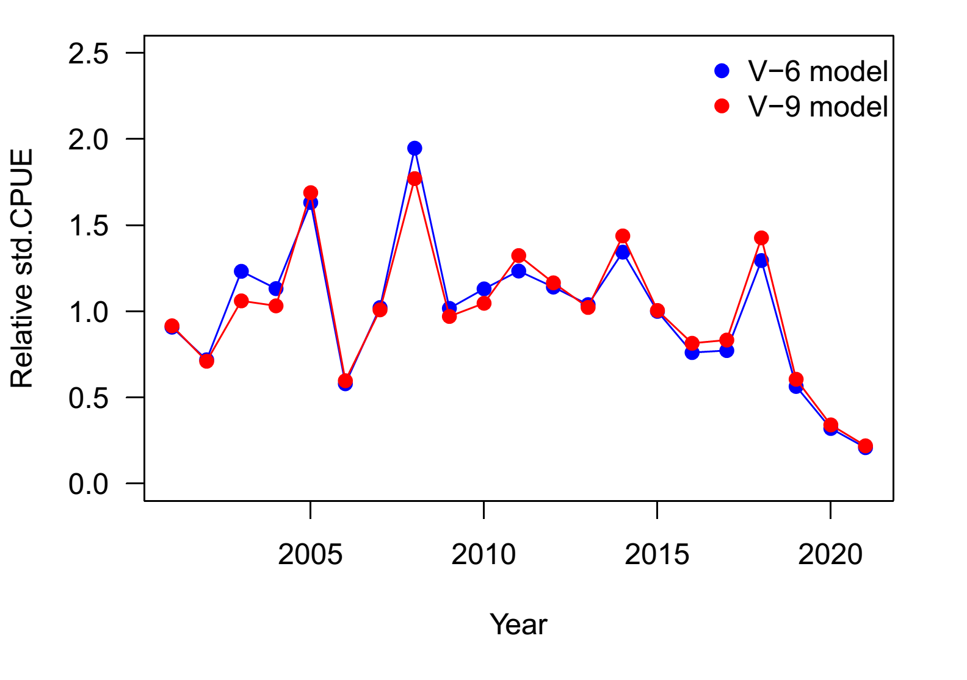
Figure 8. Time-series of yearly relative standardized indices (relative to mean) from the V-6 and V-9 models for the Pacific saury in Northwestern Pacific Ocean from 2001 to 2021.
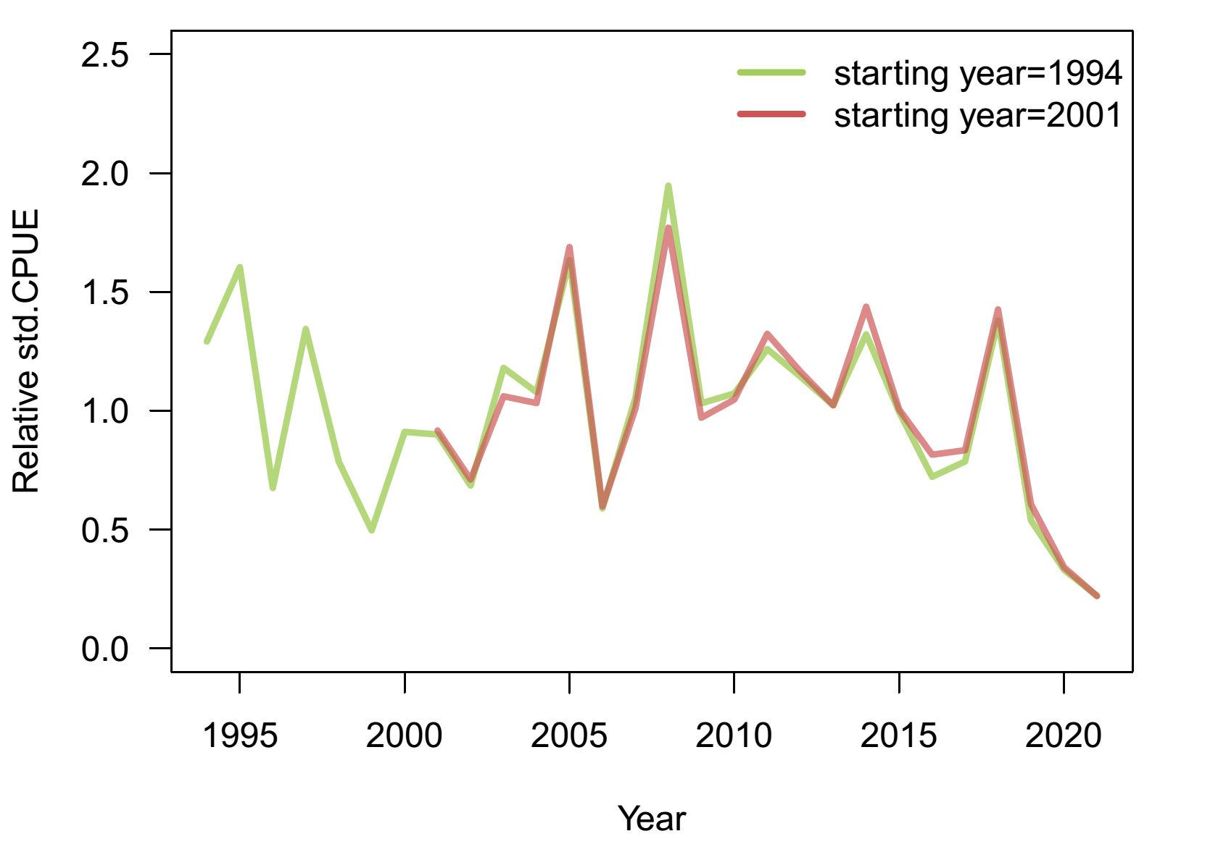
Figure 9. Time-series of yearly relative standardized indices (relative to mean) of the model starting from 1994 and 2001 for the Pacific saury in Northwestern Pacific Ocean.
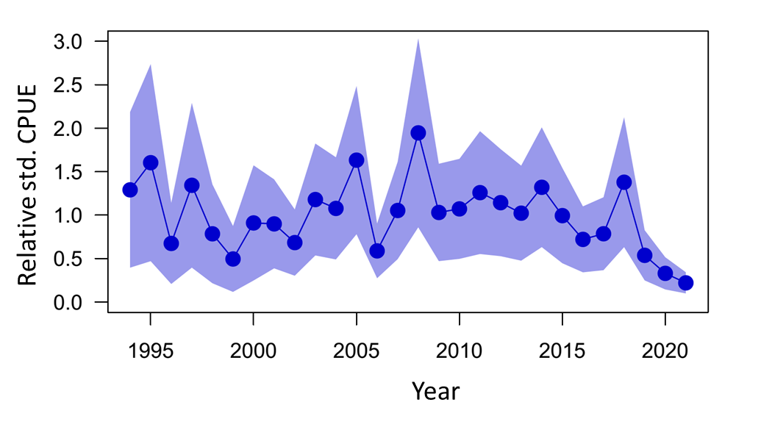
Figure 10. Time series of annual relative standardized indices (relative to mean) the Pacific saury in the Northwestern Pacific Ocean during 1994 - 2021. The shaded areas denote the 95% confidence intervals.

Appendix figures

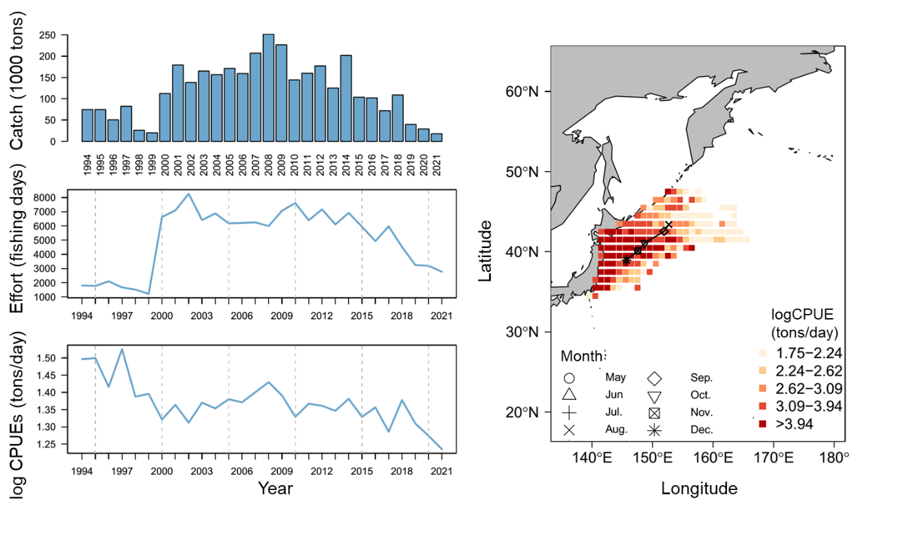
Figure A1. The summary plot of catch (in 1,000 tons), effort (in operating days), nominal CPUE (in tons/day), and the spatial distribution of CPUE from 1994 - 2021 for Pacific saury collected from Japan. The symbol of map represents the monthly centroid of gravity of nominal CPUE over years.

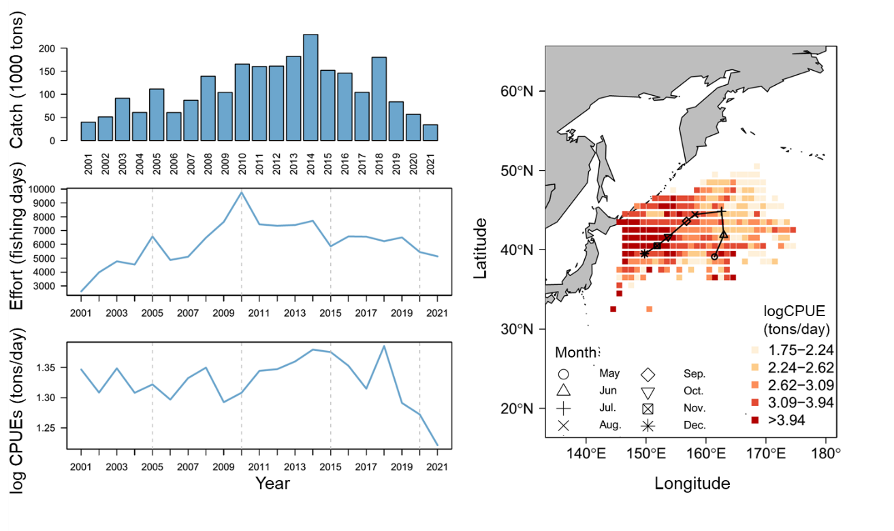
Figure A2. The summary plot of catch (in 1,000 tons), effort (in operating days), nominal CPUE (in tons/day), and the spatial distribution of CPUE from 2001 - 2021 for Pacific saury collected from Chinese Taipei. The symbol of map represents the monthly centroid of gravity of nominal CPUE over years.
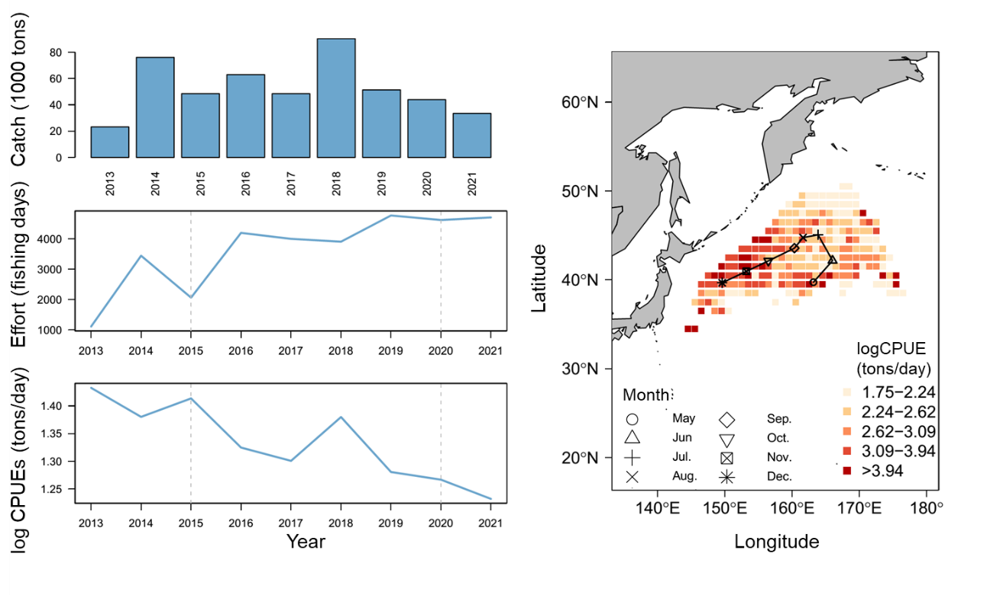
Figure A3. The summary plot of catch (in 1,000 tons), effort (in operating days), nominal CPUE (in tons/day), and the spatial distribution of CPUE from 2013 - 2021 for Pacific saury collected from China. The symbol of map represents the monthly centroid of gravity of nominal CPUE over years.

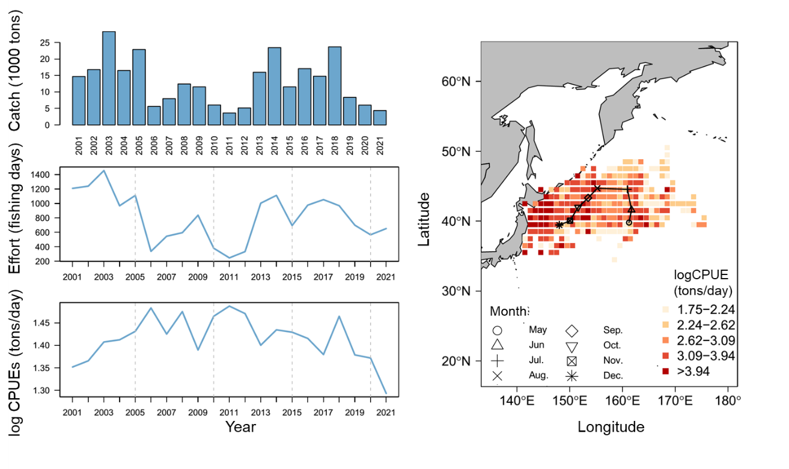

Figure A4. The summary plot of catch (in 1,000 tons), effort (in operating days), nominal CPUE (in tons/day), and the spatial distribution of CPUE from 2001 - 2020 for Pacific saury collected from Korea. The symbol of map represents the monthly centroid of gravity of nominal CPUE over years.
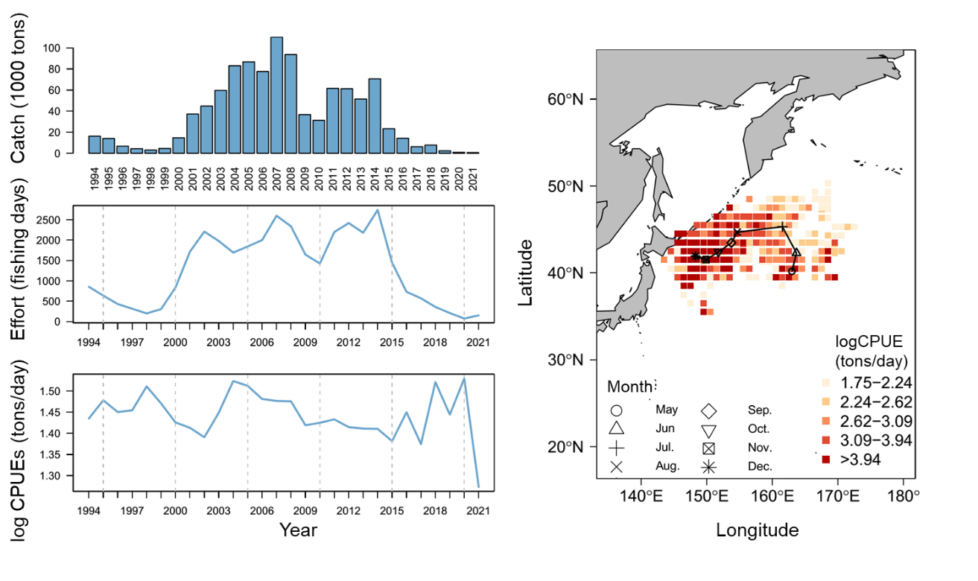

Figure A5. The summary plot of catch (in 1,000 tons), effort (in operating days), nominal CPUE (in tons/day), and the spatial distribution of CPUE from 1994 - 2021 for Pacific saury collected from Russia. The symbol of map represents the monthly centroid of gravity of nominal CPUE over years.
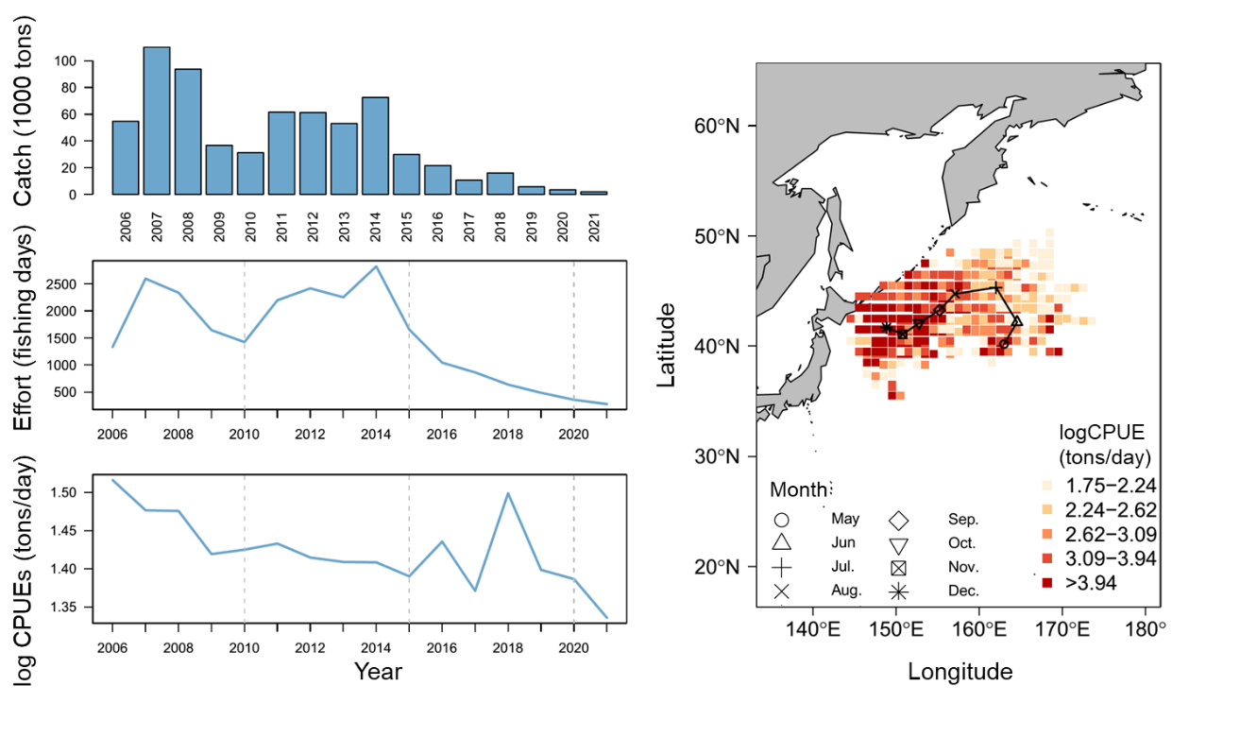
Figure A6. The summary plot of catch (in 1,000 tons), effort (in operating days), nominal CPUE (in tons/day), and the spatial distribution of CPUE from 2013 - 2021 for Pacific saury collected from Vanuatu. The symbol of map represents the monthly centroid of gravity of nominal CPUE over years.

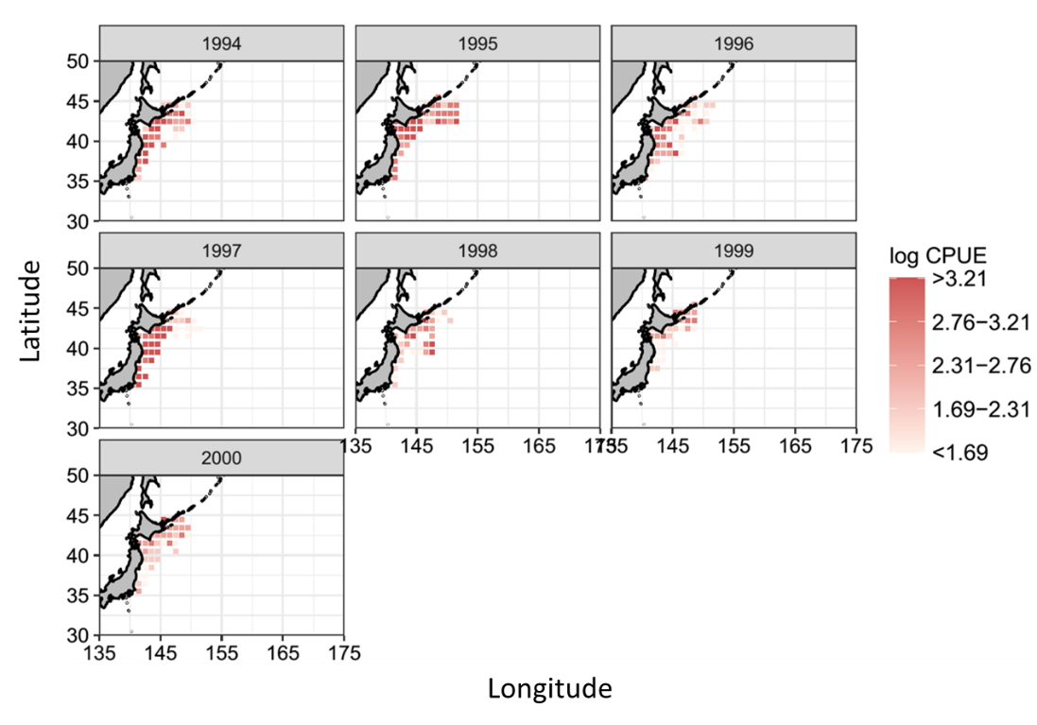

Figure A7. Spatial and temporal distribution of the logarithmic nominal CPUE (in metric ton per operating day fished) of Pacific saury during 1994 - 2000 in the Northwestern Pacific Ocean.

