NPFC-2022-SC07-WP09

Species summary for Japanese flying squid

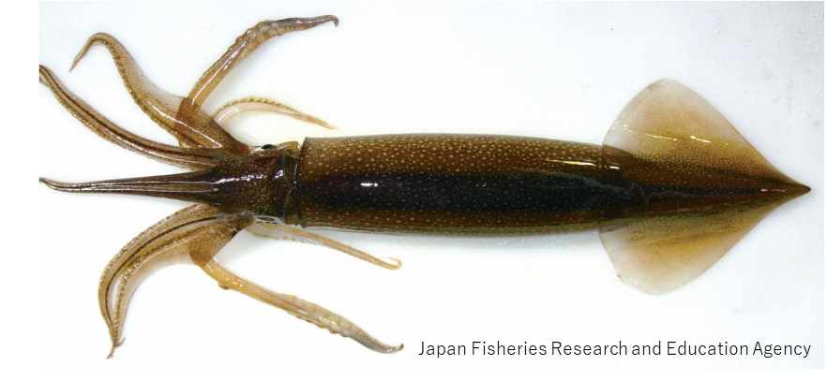

Japanese Flying Squid (Todarodes pacificus)

Common names:
太平洋褶柔鱼 [tai ping yang zhe rou yu] (Chinese); Japanese flying squid (English); スルメイカ [surume-ika] (Japanese); 살오징어 [sal-o-jing-eo] (Korean); тихоокеанский кальмар [tihookeanskiy Kalmar] (Russian); 日本魷 [ri-ben-you] (Chinese Taipei).
Other common names: Japanese common squid, Pacific flying squid.

Management
Active NPFC Management Measures
The following NPFC conservation and management measure pertains to this species:
CMM 2021-11 For Japanese Sardine, Neon Flying Squid and Japanese Flying Squid
Available from https://www.npfc.int/active-conservation-and-management-measures.

Management Summary
The current management measure for Japanese flying squid (JFS) does not specify catch or effort limits. The CMM states that Members and Cooperating non-Contracting Parties currently harvesting JFS should refrain from expansion of the number of fishing vessels authorized to fish JFS in the Convention Area. New harvest capacity should also be avoided until as stock assessment has been completed.
Japan has been conducted stock assessment annually for two stocks of JFS such as the Autumn- and Winter-spawning stocks since 1997. Japanese domestic total allowable catch (TAC) has been annually set for JFS based on acceptable biological catch (ABC) determined based on the stock assessment results.

Table 1. Management Summary
Convention/Management Principle | Status | Comment/Consideration
Biological reference point(s) |  | Not established.
Stock status |  | Status determination criteria not established.
Catch limit |  | Recommended catch, effort limits.
Harvest control rule |  | Not established.
Other |  | No expansion of fishing beyond established areas.

OK Intermediate Not accomplished Unknown

Stock Assessment
No stock assessment has been conducted by NPFC for the Convention Area.
Japan conducts annual stock assessments for JFS for the Autumn- and Winter-spawning stocks (Kaga et al. 2020, Kubota et al. 2020).

Data
Survey
JFS are encountered in several surveys conducted by Japan and Russia. Japanese surveys encounter multiple life history stages of one or more seasonal stocks, including larvae (winter survey), recruits (May-June), and adults. Russia conducts a survey of JFS during their feeding migration into Krill Islands waters, this results in number and biomass estimated by area swept method for Krill Islands waters (annual, for winter cohort only). While this survey captures only a portion of the stock so not fully representing stock biomass, it may help identify environmental impact on migration patterns, timing, etc.

Fishery
The winter-spawning stock of JFS is harvested in the NPFC Convention Area (see Biological Information).
JFS are caught by Members in both the Convention Area and National Waters. Catch tables are available at the NPFC website (https://www.npfc.int/system/files/2021-07/NPFC-2021-AR-Annual%20Summary%20Footprint%20-%20Squids%20%28Rev.%202%29.xlsx). Catches of JFS in the Convention Area are low, as the majority of catches comes from Japanese and Russian national waters (Figure 1). JFS are caught using a variety of gears, most commonly squid jigging and trawl, but purse seine and set net are also used. They are predominantly caught as a targeted species, not as bycatch in other fisheries. However, in some seasons, they can be caught as bycatch in the Japanese sardine fishery. Chinese fishing fleets do not target JFS but encounter them in low quantities as bycatch in other fisheries.
There is no fishery CPUE index developed for this species in the Convention Area. Japan has already developed fishery-dependent/independent abundance indices to use in the domestic stock assessment.
Age data are collected by port samplers from a subset of Japanese fishing ports and for several Japanese prefectural research bodies. The squid’s statolith is used for counting daily ages and estimating hatching dates.
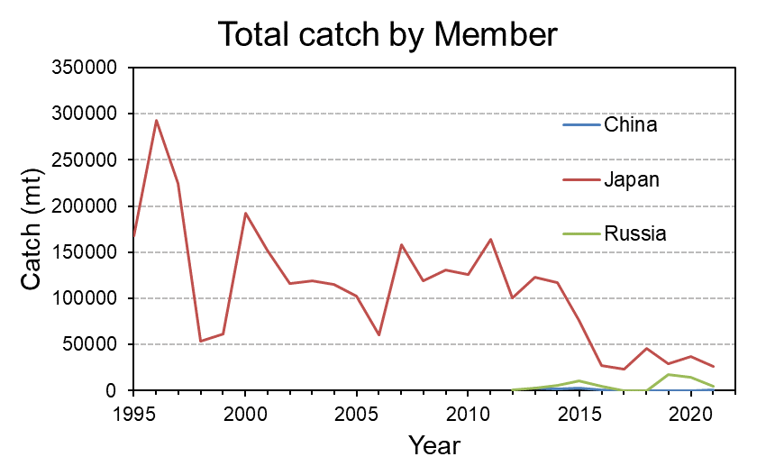
Figure 1. Total catch (mt) for each Member reporting Japanese flying squid catches during 1995-present.

Data table

Table 2. Data availability from Members regarding Japanese flying squid
Japanese flying squid: China*, Japan, Russia.
* No fishery targets Japanese flying squid. No relevant data.
Category and data sources | Description | Years with available data | Average sample size/ year or data coverage | Potential issues to be reviewed
JAPAN
Catch statistics
Coastal jigging fishery | Official statistics; Reports from fisheries associations and markets | 1979-2021 (only after 1995 at some ports) | Coverage = 100%
Offshore jigging fishery | Logbook | 1979-2021 | Coverage = 100%
Trawl fishery | Logbook | 1980-2021 | Coverage = 100%
Purse seine fishery | Official statistics; Reports from fisheries associations and markets (only at Hachinohe and Mie); | 1995-2021 | Coverage = 100%
Set net | Official statistics; Reports from fisheries association | 1995-2021 | Coverage = 100%
Size composition data
Length measurements | Port sampling by eight local fisheries research bodies at major ports on the Pacific side | 1979-2021 | 3000-15000 fish/year (about 50 individuals measured per a single size sampling) | Data coverage in the eastern Hokkaido (Nemuro Strait)
Aging | Port sampling by three local fisheries associations and nine fisheries research bodies | 2012-2021 | 700-1400 fish/year | Data coverage in the eastern Hokkaido (Nemuro Strait)
Abundance indices (survey)
Winter survey for larvae | BONGO net | 2001-2021 | 65-204 stations/year | Review survey protocol and conduct standardization
Survey for recruitment from May to June | Midwater trawl | 1996-2021 | 24-63 stations/year | Review survey protocol and conduct standardization
Survey for recruitment in June | Jigging | 1972-2021 | 25-83 stations/year | Review survey protocol and conduct standardization
Survey for recruitment from June to July | Midwater trawl mainly targeting saury | 2001-2021 | 33-136 stations/year | Review survey protocol and conduct standardization
Survey for recruitment in July | Midwater trawl | 2018-2021 | 28-39 stations/year | Short time series (three years)
Survey for recruitment in August | Jigging | 1979-2021 | 28-66 stations/year | Review survey protocol and conduct standardization
Abundance indices (commercial)
Coastal jigging fishery | Monthly catch and effort data reported by fisheries associations and markets in the seven major regions during fishing season from July to December; Standardized CPUE for domestic stock assessment | 1979-2021 | 25-37 observations/year

Category and data sources | Description | Years with available data | Average sample size/year or data coverage | Potential issues to be reviewed
RUSSIA
Catch statistics
Jigging fishery | Official statistics, reports from fisheries associations | Official statistics:  1964-1970, 2013-2020,  1971-2012 (no data available); publications: 1967-2018 | Coverage  1964-1970 ?%;  Coverage  2013-2020 =100% | Data coverage details to be reviewed
Midwater trawl fishery
Size composition data
Length measurements | Sampling from commercial fishing vessels.  Sampling during research surveys. | 1966-1975  1992-2020 | 500-3,000 squids /year (ca. 50 measurements per sampling) | Data coverage details to be reviewed
Aging | - | - | - | -
Catch at age  (CAA) | - | - | - | -
Abundance indices (survey)
Summer trawl and acoustic (echointegration) surveys to assess pelagic squids abundance | Mid-water upper epipelagic surveys | 1992-2020  (June-July)  1992-2020  (July-August) | 60-80 stations/year  60-80 stations/year | Changes in abundance and migration patterns; development survey protocol and conduct standardization

Biological Information
Distribution and migration
JFS are distributed mainly in the northwest Pacific (Figs 2 and 3) and their northward/southward shifts in distribution range occur in response to changes in water temperature (Sakurai et al. 2013). JFS extent their distribution up to 50° N in September. There are northmost (eastmost) and southmost occurrences recorded in Canada and Hong Kong, respectively (Cuttlefishes and Squids of the World, FAO.org).
The autumn- and winter-spawning stocks have spatially different nursery areas and migration patterns (Fig 3). Although the nursery area of the autumn-spawning stock is located in the Sea of Japan, the winter-spawning stock has the nursery area east of Hokkaido and Tohoku regions of Japan, of which a part overlaps the NPFC Convention Area. Both stocks conduct southward migration via the Sea of Japan towards each spawning grounds.

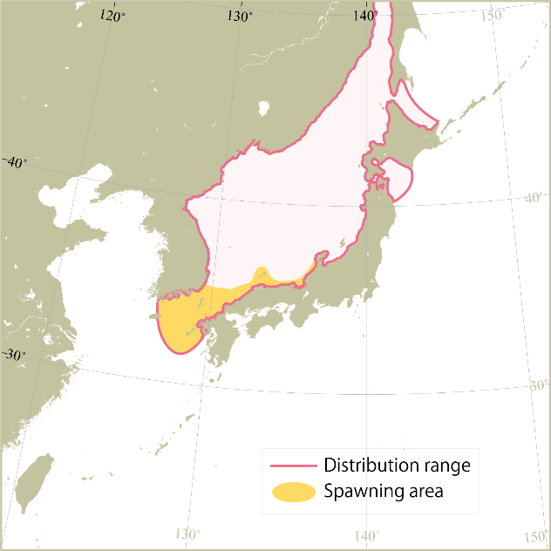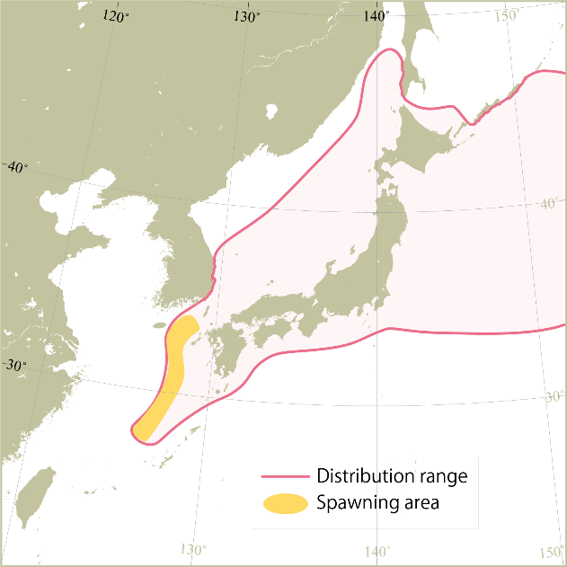
Autumn-spawning stock
Winter-spawning stock
Figure 2. Distribution ranges and spawning areas of autumn- and winter-spawning stocks. These figures were modified based on Kubota et al. (2020) and Kaga et al. (2020).
Autumn-spawning stock
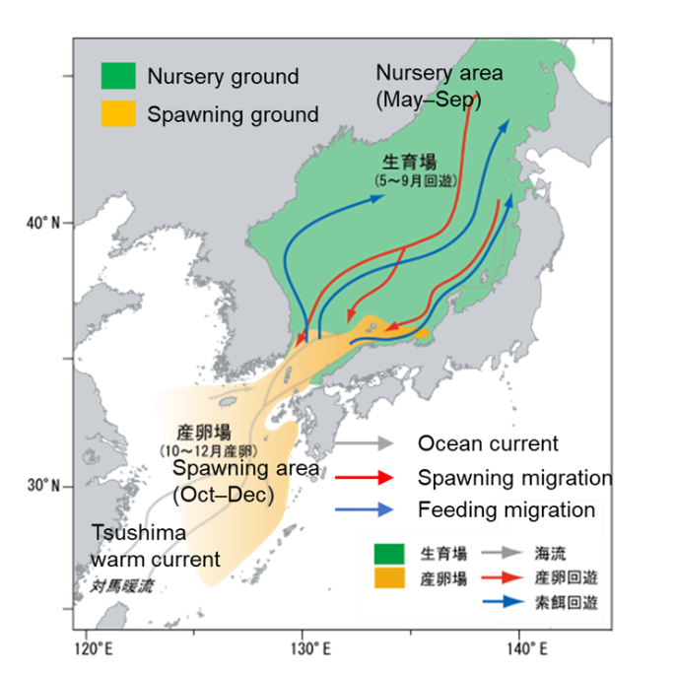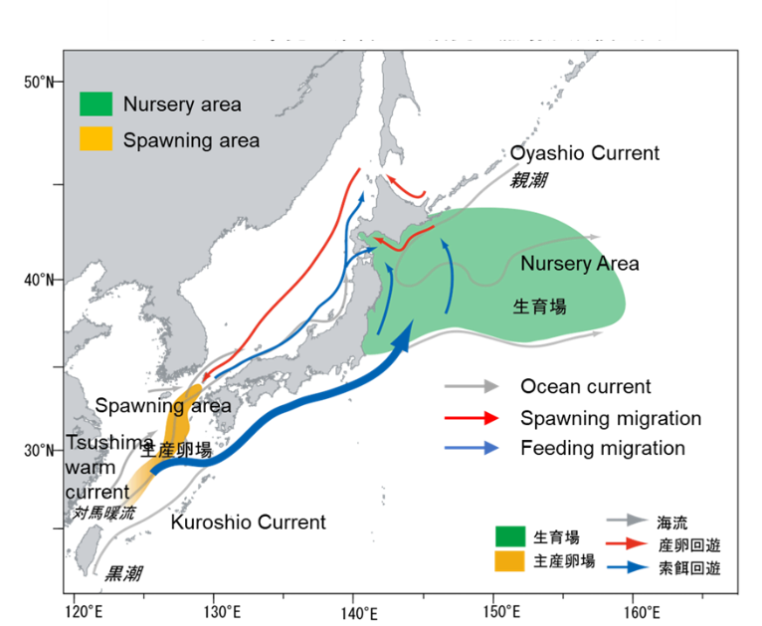
Winter-spawning stock
Figure 3. Seasonal migration of autumn- and winter-spawning stocks. These figures were modified based on Kubota et al. (2019) and Okamoto et al. (2021).

Stock Structure
There are distinct sub-populations (stocks) which spawn during different seasons (FAO.org, Sakurai et al. 2013). An autumn-spawning stock is most abundance, followed by a winter-spawning stock which is distributed in the waters off eastern Japan Oyashio region (Sakurai et al. 2013, Kaga et al. 2020, Kubota et al. 2020). There is, in addition, minor stock of spring/summer spawned squid.

Life history
Maximum size thought to be 50 cm (mantle length) for females, smaller for males. Females are thought to mature around 20-25 cm (mantle length). The JFS lifespan is approximately one year (FAO.org). According to FAO, JFS prey on myctophids, anchovies, crustaceans, gastropod larvae, and chaetognaths, and are preyed upon by rays and several marine mammals.

Literature Cited
Cuttlefishes and Squids of the World http://www.zen-ika.com/zukan/index-e.html
FAO.org http://www.fao.org/fishery/species/3567/en
Okamoto, S., Kaga, T., Kubota, H., Miyahara, H., Matsui, H., Abo, J., Nishijima, S. and Setou, S. (2021) Stock assessment and evaluation for winter-spawning stock of Japanese flying squid (fiscal year 2021). In Marine Fisheries Stock Assessment and Evaluation for Japanese Waters (fiscal year 2021/2022). Fisheries Agency and Fisheries Research and Education Agency of Japan. http://abchan.fra.go.jp/digests2021/details/202118.pdf (in Japanese)
Kubota, H., Miyahara, H., Matsukura, Okamoto S. and Nishijima, S. (2019) Stock assessment and evaluation for autumn-spawning stock of Japanese flying squid (fiscal year 2019). In Marine Fisheries Stock Assessment and Evaluation for Japanese Waters (fiscal year 2019/2020). Fisheries Agency and Fisheries Research and Education Agency of Japan. http://abchan.fra.go.jp/digests2019/details/201919.pdf (in Japanese)
Kubota, H., Miyahara, H., Kaga, T., Okamoto, S., Nishijima, S., Matsukura, R., Matsui, H., Abo, J., Takasaki, K., Saito, T and Inagake, D. (2021) Stock assessment and evaluation for autumn-spawning stock of Japanese flying squid (fiscal year 2021). In Marine Fisheries Stock Assessment and Evaluation for Japanese Waters (fiscal year 2021/2022). Fisheries Agency and Fisheries Research and Education Agency of Japan. http://abchan.fra.go.jp/digests2021/details/202119.pdf (in Japanese)
Sakurai, Y., Kidokoro, H., Yamashita, N., Yamamoto, J., Uchikawa, K., & Takahara, H. (2013). Todarodes pacificus, Japanese common squid. Advances in Squid Biology, Ecology and Fisheries. Part II Oegopsid Squids. Nova Biomedical, New York, 249-272.

