NPFC-2023-SSC BFME04-WP15
1st meeting of the Small Working Group on VME
June 8, 2023 (9 am – 1 pm Tokyo time)
WebEx

Summary

Agenda Item 1. Opening of the Meeting.
The 1st intersessional meeting of the Small Working Group on Vulnerable Marine Ecosystems (SWG VME) in the 2023 operational year commenced at 9am on 8 June 2023 Tokyo time in the format of video conferencing via WebEx. The meeting was attended by Members from Canada (Janelle Curtis, Chris Rooper, Devon Warawa), Japan (Kota Sawada, Yumiko Osawa, Mai Miyamoto, Moto-omi Yamaguchi), Korea (Jeonseong Park, Hye-won Moon, Haejin Song, Sanggyu Shin) and Russia (Tatiana Dautova, Vladimir Kulik) as well as the Secretariat (Robert Day, Alex Zavolokin). Amy Baco-Taylor attended the meeting as an observer. Bárbara Neves participated in the meeting as an invited expert. The meeting was opened by Janelle Curtis (Canada) who served as the SWG VME Lead.

Agenda Item 2. Adoption of Agenda.
There were no amendments to the agenda.

Agenda Item 3. Review of SWG VME Tasks for 2023.
The Lead informed participants that SSC BF-ME03 assigned six tasks to this group. Four tasks relate to VMEs and two relate to Significant Adverse Impacts (SAI) to VMEs and encounter thresholds. This meeting focused on three tasks related to VMEs and the next meeting will address the rest of the tasks and other outstanding issues resulting from this meeting.

Agenda Item 4. Discussion of VME-related tasks.
4.1. Review VME indicator taxa from corals relative to taxonomy revisions for Octocorallia and review the appropriateness of adding Pennatulacea to the list of VME indicator taxa.
The Lead reminded participants that last year the SWG VME had considered recommending that the NPFC’s list of VME indicator taxa be revised to Alcyonacea (which now includes the Gorgonacea), Antipatharia, and Scleractinia. However, recent revisions to coral taxonomy made these changes outdated. The Lead shared links and reference information on the current systematics of Octocorallia:
- McFadden, C.S.; van Ofwegen, L.P.; Quattrini, A.M. (2022). Revisionary systematics of Octocorallia (Cnidaria: Anthozoa) guided by phylogenomics. Bulletin of the Society of Systematic Biologists. 1(3), 8735, pp. 1-79., available online at https://ssbbulletin.org/index.php/bssb/article/view/8735
- World Register of Marine Species (WORMS): www.marinespecies.org

4.1.1 Presentation by an invited expert, Dr. Bárbara Neves (Canada), who will outline recent key taxonomic changes to soft corals and sea fans.
The invited expert gave a presentation on the recent changes in octocoral systematics which was based on the paper of McFadden et al (2022) (available on the Collaboration website under SWG VME). The presentation outlined previous/recent and the current classifications of octocorals, gave specific examples of recent changes and provided an update on the list of soft coral families considered by SWG VME as VME indicator taxa in 2022. The invited expert raised the following questions:
(1) Are there any higher taxonomic levels that could be used to group these families to keep the list of VME indicator taxa simpler?
(2) Are there functionally- or structurally-important coral taxa in the NE Pacific Ocean that would be missed by listing these families as VME indicator taxa in the NPFC’s Convention Area?
The invited expert presented a few examples from other RFMOs and Canada’s national programs in relation to the raised questions. She also pointed out the importance of pennatulaceans (sea pens) from the VME perspective and highlighted their functional role (ecosystem services), relatively high longevity, and high bycatch in some areas.

Participants appreciated Bárbara Neves’ overview of the taxonomic changes to soft corals and their implications for developing a practical list of coral VME indicator taxa. They discussed how to accommodate the recent taxonomic revisions in the NPFC’s list of VME indicator taxa and made the following points:
- Coral taxonomy will continue to change, therefore high level, broad definitions based on biological groups that also use common names (as opposed to scientific names) will work better for the formal list of VME indicator taxa in NPFC’s CMMs.
- The common taxa names of the VME indicator list are linked to the VME taxa identification guide which provides all necessary information about VME indicators, including at the species level.
- The group noted two objectives of the VME indicator taxa list: (1) to inform move-on rules based on the encounter thresholds, and (2) to identify a VME or area likely to be a VME.
- The group also recognized the value of listing simple and easy descriptive biological groups of soft corals that could be recognized by fishers and observers. Observers identify corals according to the NPFC VME taxa identification guide for the Western North Pacific Ocean.
- VME identification in research surveys is not limited by the list of VME indicator taxa and may be based on other taxa if they meet one or more of FAO’s criteria for VMEs.

SWG VME agreed to recommend keeping Antipatharia (black corals) and Scleractinia (stony corals) as two orders in the list of VME indicator taxa and recommend changing Alcyonacea to soft corals and Gorgonacea to gorgonians.

4.1.2 Presentations by members and recommendations on coral taxonomic groups to include in the list of NPFC’s VME indicator taxa given recent taxonomic revisions.
No presentations were made by Members.

4.1.3 Discussion on the merits of adding pennatulaceans to the list of NPFC’s VME indicator taxa.
Japan presented a report on the occurrence of pennatulaceans and other taxa in commercial fisheries bycatch and scientific surveys from 2009 to 2021 in the Emperor Seamounts region (available on the Collaboration website under SWG VME). No pennatulacean bycatch has been reported by Japanese fishery vessels and only 1 out of 3546 hauls included pennatulaceans (0.004kg) in scientific surveys since 2009. Japan concluded that, in the Northwestern part of the NPFC’s Convention Area (Emperor Seamounts), there is no need to add pennatulaceans to the VME indicator taxa list because of their rarity.

Participants noted that pennatulaceans are rare and that a bed of sea pens in the Emperor Seamounts would form a rare and unique habitat, which meets one of FAO’s criteria for identifying VMEs. They also noted that inclusion of pennatulaceans in the VME indicator taxa list will have relatively limited management implications in the Northwestern part of the NPFC’s Convention Area due to their low abundance.

The observer brought to members’ attention that NPFC is the only RFMO which does not list sea pens as VME indicator taxa and suggested that sea pens may be more abundant in the Northern part of the Emperor Seamount chain which is close to the Aleutian Islands.

Japan suggested to keep the list of VME indicator taxa as simple as possible or apply different lists for the Northeastern and Northwestern parts of the NPFC’s Convention Area.

Other Members agreed with listing pennatulaceans as VME indicator taxa in the Northeast and Northwest Pacific Ocean, although they recognized a different VME encounter threshold may be needed for this taxon.

The SWG VME did not come to a consensus on recommending the inclusion of pennatulaceans as VME indicator taxa. It agreed to re-visit this issue at the next SSC BF-ME meeting and encouraged Japan to hold internal discussion on this matter in the meantime.

4.2. Update and refine quantitative definition of VME.
4.2.1 Discuss the merits of including the methodology presented by Dr. Amy Baco-Taylor during SSC BF-ME03 that draws on images collected during visual surveys.
The observer presented a paper on a community consensus on designating VMEs from imagery which is a collaborative work of VME experts from 15 countries (the presentation and manuscript are available on the Collaboration website under SWG VME). The goal was to establish first pass consensus guidelines across geographic regions for designating VMEs from images. Four questions were addressed in the research: (1) Which taxa are considered VME indicator species? (2) Can a VME be identified from a single image? (3) What criteria can we use to designate a VME from a single image? and(4) What are the thresholds (density or diversity) that need to be met to make a single image a VME?
The observer proposed a flowchart for VME identification from a single image:
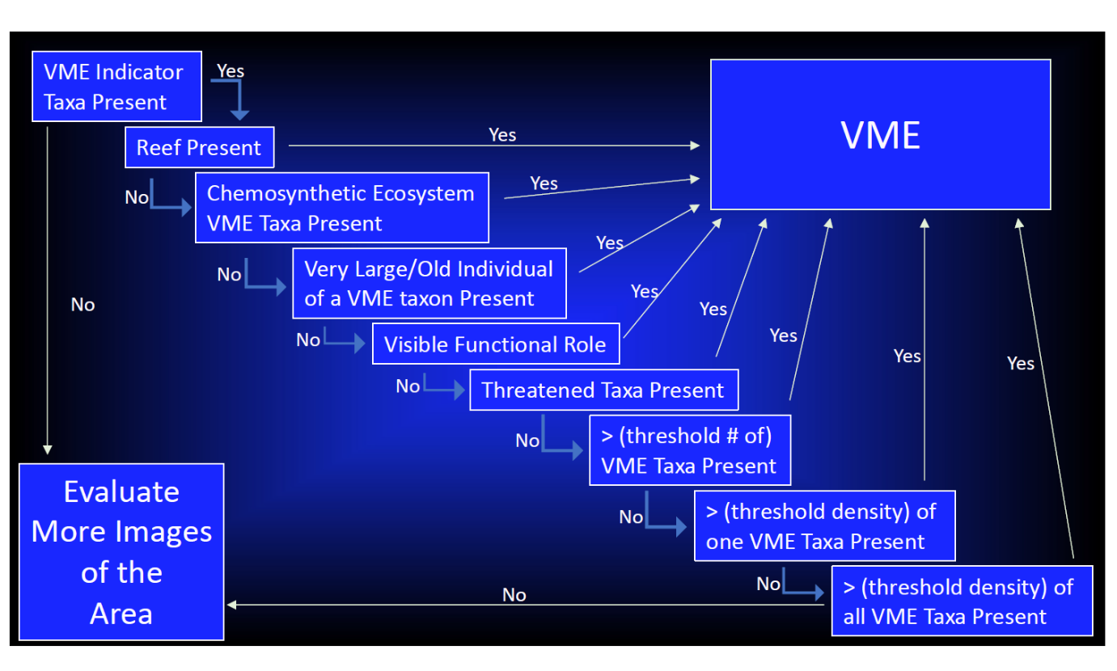
The Lead encouraged participants to read the paper in detail, contact the observer directly with any questions, and revisit the question of recommending that SSC BF-ME endorse including this approach as a part of NPFC’s toolkit for VME identification.

Japan will present the comparison of its approach with the presented one at the next SWG VME meeting.

The observer shared plans for further steps to set threshold density, develop standards for images and other work. The observer also invited all SWG VME participants to join discussions led by the Deep Ocean Stewardship Initiative (DOSI) on this topic.

4.3. Bring together observation data on VME from visual survey sources.
The Lead reminded that Members agreed to bring together observation data on VME from visual survey sources at the last SSC BF-ME meeting.
4.3.1. Summarize the VME data from visual surveys, identify additional sources of data, and discuss options to obtain such data.
The Lead presented a summary of the data shared by Canada, Japan and Russia (available on the Collaboration website under SWG VME). There are at last two thousand records and most are from taxa at high taxonomic levels (e.g. Hexactinellida, Octocorallia, gorgonian, etc…) although some data are available at species, genus, or family level. Japan clarified that it has also submitted point data in addition to its transect data. All of the submitted visual data were uploaded on the Collaboration website (https://collaboration.npfc.int/node/138).

Members gave a short summary of the data sets they provided. The observer informed participants that she will provide data from visual surveys conducted by US although in a format which is different from the agreed template.

Russia gave a presentation on the observation data on VME from visual surveys and also presented some results of species distribution modelling (SDM) using its data from visual surveys and data from GEBCO (https://www.gebco.net) and Bio-Oracle (https://www.bio-oracle.org). The presentation is available on the Collaboration website under SWG VME. Russia concluded that (1) data from one Member is not enough to fine tune SDMs, (2) accurate depth data are very important, and (3) the Forester package is very simple to use in R for tuning hyperparameters of different machine learning methods.

4.3.2. Discuss objectives for analyzing the data and identify people to undertake relevant analyses.
The SWG VME agreed to establish a correspondence group to discuss objectives for analyzing the observation data (Chris Rooper (Canada), Mai Miyamoto, Moto-omi Yamaguchi and Satoi Arai (Japan), Hyejin Song (Korea), Vladimir Kulik (Russia) and Amy Baco-Taylor (observer)). The correspondence group will communicate intersessionally and report back to the SWG VME at its next meeting. The correspondence group will request the Secretariat to establish a GitHub site, if needed.

4.4. Intersessional activities to address any outstanding VME-related tasks.
See agenda item 4.1-4.3 above.

Dr. Rooper informed participants about his plans to conduct analyses on bycatch of corals and sponges from US and Canada. This will support SWG VME’s work on gear-specific encounter thresholds. Dr. Rooper invited participants to join this project.

Agenda Item 5. Review of SAI-related tasks.
5.1. Develop management objectives for recovering VME site
5.2. Review the basis for gear specific and taxa specific encounter thresholds from other RFMOs
5.3. Synchronize and refine approaches to defining SAI so that one method can be applied to the eastern and western North Pacific Ocean
Participants noted the above tasks for the next SWG VME meeting.

Agenda Item 6. Intersessional activities to address SAI-related tasks.
6.1. Selection of a second SWG VME meeting date to discuss SAI-related tasks.
The next SWG VME meeting will be held via Webex on 16 August, 9am – 1pm Tokyo time.

Agenda Item 7. Summary of activities/analyses/discussion to report to SSC BF-ME.
The SWG VME will continue discussions and summarize them at the next meeting.

Agenda Item 8. Close of the Meeting
The meeting closed at 13:30pm on 8 June 2023, Tokyo time.

