NPFC-2023-SSC BFME04-WP16
2nd meeting of the Small Working Group on VME
August 16, 2023 (9 am – 1 pm Tokyo time)
WebEx

Summary

Agenda Item 1. Opening of the Meeting.
The 2nd intersessional meeting of the Small Working Group on Vulnerable Marine Ecosystems (SWG VME) in the 2023 operational year commenced at 9 am on 16 August 2023 Tokyo time in the format of video conferencing via WebEx. The meeting was attended by Members from Canada (Janelle Curtis, Chris Rooper, Devon Warawa), China (Libin Dai), Japan (Kota Sawada, Mai Miyamoto, Moto-omi Yamaguchi, Satoi Arai), Korea (Jeonseong Park, Hye-won Moon, Hyejin Song) and Russia (Vladimir Kulik) as well as the Secretariat (Robert Day, Alex Zavolokin). Amy Baco-Taylor attended the meeting as an observer. Keith Reid participated in the meeting as an invited expert. The meeting was opened by Janelle Curtis (Canada) who served as the SWG VME Lead.

Agenda Item 2. Adoption of Agenda.
There were no amendments to the agenda.

Agenda Item 3. Review of SWG VME Tasks for 2023.
The Lead reminded participants about the tasks assigned by SSC BF-ME03 to this group. These tasks relate to VMEs and to Significant Adverse Impacts (SAI) to VMEs and encounter thresholds. This meeting focused primarily on SAI-related tasks and addressed some VME tasks as specified in the agenda.

Agenda Item 4. Discussion of SAI-related tasks.
4.1. Review the basis for gear-specific and taxa-specific encounter thresholds from other RFMOs.
4.1.1 Presentation by an invited expert, Dr. Keith Reid (Australia), who will review the basis by which other RFMOs’ VME encounter thresholds were determined by taxa and gear-type.
The invited expert, Dr. Keith Reid presented a summary of VME encounter thresholds from other RFMOs (NAFO, NEAFC, SEAFO, SIOFA, SPRFMO) and CCAMLR and how they were determined by taxa and gear-type. The presentation is available on the Collaboration website under SWG VME.

The invited expert pointed out the need to determine objectives for management actions when setting encounter thresholds. They may be set (i) to determine when a VME might have been encountered in order to implement a temporary closure until the existence of a VME can be established, or (ii) to indicate a level of catch of VMEs that is greater than expected based on the spatial modelling of VME distribution and may cause SAI at the overall scale of the distribution of VMEs. The data requirements and the management actions arising from (i) and (ii) are very different.

The invited expert noted that data availability leads to different approaches. He identified two approaches taken by other RFMOs: survey led (data rich, NAFO) and modelling led (data limited, SPRFMO). The NEAFC, SEAFO and SIOFA generally adopted NAFO’s encounter thresholds.

Japan suggested to clearly define methodological aspects of setting encounter thresholds, inter alia what types of survey and what types of modelling were used to set thresholds by NAFO and by SPRFMO.

The invited expert also discussed the value of reporting bycatch of VME indicator taxa even in the case that an encounter threshold is not exceeded; bycatch amounts that are close to but do not exceed the threshold(s) may suggest the occurrence of a VME.

In addition, the invited expert raised the following global issues:
- Need to consider encounter thresholds as part of an overall management framework including area closures, gear restrictions, etc
- Need clarity on the management objective for the threshold: identify a potential VME or avoid SAI
- Need to follow a science process to identify thresholds
- Need a policy decision to determine the level of risk of SAI that is acceptable
- Regulatory Diffusion
  - Occurs when an agency adopts a substantially similar rule to that of another agency
  - Delivers efficiencies in relation to the negotiation, drafting, and implementation of a measure
  - Can act to retain outdated solutions at the expense of scientific innovation

Canada suggested to include in the invited expert’s report the rationale behind the setting of thresholds by other RFMOs and highlight the need to establish objectives for setting encounter thresholds.

The invited expert will revise the draft report following comments and suggestions from Members and submit it to SSC BF-ME04. SWG VME participants were encouraged to provide further questions or feedback to the invited expert by email (keith.reid@rossanalytics.com.au). The draft report will be finalized in October and circulated to participants for review.

4.1.2 Presentation by Canada about the use of VME indicator bycatch and visual surveys to inform discussions on setting encounter thresholds that are specific to gear type and taxa.
Canada shared preliminary results of its analysis on gear- and taxon-specific VME encounter thresholds based on the data from the west coast of Canada and the USA. The objective was to use available data to develop a method for determining gear-specific and taxon-specific encounter thresholds for VME indicator taxa. Four methods were investigated, including three bycatch data only methods (Youden method, Minimum distance method and Segmented regression as in Geange et al. (2020) Frontiers | A Data-Informed Approach for Identifying Move-on Encounter Thresholds for Vulnerable Marine Ecosystem Indicator Taxa (frontiersin.org)) and the combination of bycatch data and visual data from research surveys (percentile regression with catch and observations). Based on these methods, the potential gear- and taxon-specific thresholds were calculated as follows:
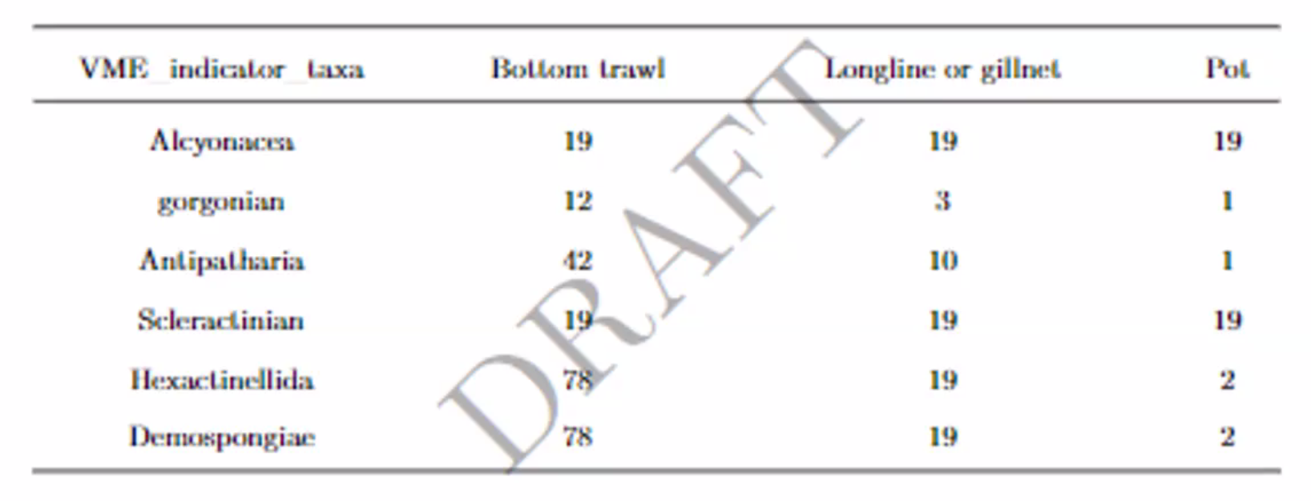

Canada noted that the code developed for these analyses is available on GitHub. If other participants wish to apply it to their data or have any questions, they should send a request to Dr. Chris Rooper (Chris.Rooper@dfo-mpo.gc.ca).

In response to the question from the Lead on the biodiversity indicators approach, Canada will consider applying this approach in its future analyses.

4.1.3 Presentation by other SWG VME participants, if available.
No presentations from other Members were made.

4.2. Synchronization of approaches to assessing the risk of SAI so that one method can be applied to the eastern and western North Pacific Ocean.
The Lead recalled three working papers on approaches to assessing the risk of SAI submitted by Canada and Japan in the past and noted that Canada had started to work with Japan to identify methods of assessing the risk of SAI for the eastern and western parts of the NPFC Convention Area.

4.2.1 Presentation by Canada on a proposed flow chart for assessing the risk of SAI in the eastern and western parts of the NPFC Convention Area.
The Lead proposed a flow chart for assessing and managing the risk of SAI in the eastern and western parts of the NPFC Convention Area. This involves five steps:
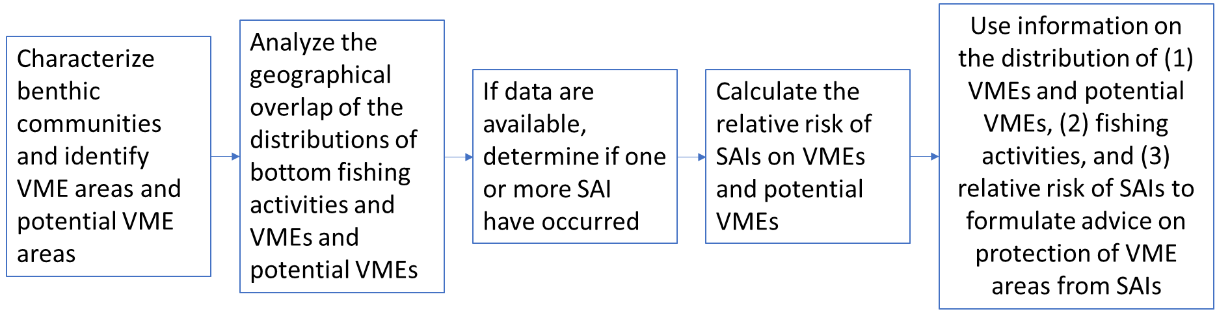

Canada pointed out the need to decide the spatial scale (a spot versus wider distribution area). This will affect the types of data and methods to be used for assessing the risk of SAI.

Participants agreed to further discuss the proposed flow chart at SSC BF-ME04 in December.

4.3. Develop management objectives for recovering VME sites.
Participants re-affirmed that this task is a lower priority for the SWG VME. But they also recalled that the importance of managing recovering VMEs was discussed during the 2018 NPFC/FAO Workshop on Protection of Vulnerable Marine Ecosystems in the North Pacific Fisheries Commission Area: applying global experiences to regional assessments.

The observer raised a question about what the components of recovery would be and the timeframe. Participants recalled a previous discussion in April 2022 when they identified size, density, diversity, and/or species richness as potential characteristics to monitor the health of recovering VMEs.

Canada suggested that one of the objectives could be to survey the VME sites identified by the observer in 2014 that were damaged and monitor their recovery. For doing this, the SWG VME has to set up a framework including identifying the lead, contributors and the source of funding.

Participants agreed to further discuss this task at SSC BF-ME04 in December.

4.4. Intersessional activities to address any outstanding SAI-related tasks.
No activities were identified.

Agenda Item 5. Discussion of VME-related tasks.
5.1. Update and refine a quantitative definition of VME.
5.1.1 Presentation by Japan of a comparison of its approach with the method proposed by Dr. Amy Baco-Taylor during SSC BF-ME03 that draws on images collected during visual surveys.
The Lead reminded participants about Dr. Baco-Taylor’s presentation made at the previous SWG VME meeting in June 2023. At that meeting, Dr. Baco-Taylor presented a paper on a community consensus on designating VMEs from imagery which is a collaborative work of VME experts from 15 countries (the presentation and manuscript are available on the Collaboration website under SWG VME). Dr. Baco-Taylor updated participants that the paper was recently accepted for publication.

Japan presented its 4-step approach to define VME sites using sea-floor images which was submitted to SSC VME04 in 2019 (NPFC-2019-SSC VME04-WP02).

Participants expressed their views about the criteria listed in the FAO Deep Sea Fisheries Guidelines for the identification of a VME. They agreed that meeting only one criterion (for example, the presence of one fragile organism) may not constitute a VME, and a comprehensive analysis is needed to understand the spatial extent of the potential VME and analyze other criteria. Members also agreed that a site does not need to meet all criteria to be a VME.

5.1.2 Discuss the merits of recommending inclusion of Dr. Baco-Taylor’s methodology as one means of identifying VMEs in the NPFC Convention Area.
Participants agreed to scrutinize the paper presented by Dr. Baco-Taylor at the previous meeting and discuss at SSC BF-ME04 the inclusion of Dr. Baco-Taylor’s methodology as one means of identifying VMEs in the NPFC Convention Area.

5.2. VME data from visual survey sources.
5.2.1. Discuss objectives for analyzing the data and identify people to undertake relevant analyses.
The SSC BF-ME Chair, Dr. Chris Rooper, presented the proposed objectives for using the shared VME data. This incorporated the comments received from Members intersessionally.

Members discussed the proposal and agreed on the following objectives:

Objective 1. Use the data to learn where VME indicator taxa are known to be present and absent.
- Map the known distribution of VME indicator taxa in the Emperor Seamounts and Cobb-Eickelberg Seamount Chain (this would essentially involve taking all of the presence observations and putting them on a map).
- If possible, map the absence observations for VME indicator taxa in the Emperor Seamounts and Cobb-Eickelberg Seamount Chain.

Objective 2. Use the data to determine where there are elevated densities (hotspots) of VME indicator taxa.
- Map the densities (where they can be calculated with some accuracy, recognizing that for some surveys/data sets this may be difficult)
- Use the data and tools like kernel density estimation to try to estimate where high density areas might be located.
- Use the new data to validate existing models.

Objective 3. Use the data to update or develop models that predict the presence or absence or density of VME indicator taxa for further visual survey planning.
- Use the data and other sources of data (such as environmental variables, bathymetry, etc.) to update existing species distribution models with the new data or to develop new species distribution models for presence or absence or density of VME indicator taxa.
- Use the models, as appropriate, to prioritize further visual surveys or sample collection as shown in the flow chart on Annex 2.3 of CMM 2023-05 and CMM 2023-06 for scientific purposes.

Agenda Item 6. Intersessional activities to address VME and SAI-related tasks.
6.1. Selection of a third SWG VME meeting date to discuss tasks, if needed.
Members agreed to continue working through the Collaboration website and email correspondence, if needed, and decided not to have another intersessional meeting before SC08.

Agenda Item 7. Summary of activities/analyses/discussion to report to SSC BF-ME.
See above summaries and agreements.

Agenda Item 8. Close of the Meeting
The meeting closed at 12:30pm on 16 August 2023, Tokyo time.

