NPFC-2023-SC08-WP06 (Rev. 1)
Species Summary
NPFC Japanese Sardine Small Working Group
2023-11-06

Japanese sardine (Sardinops melanostictus)
Common names:
拟沙丁鱼, Ni Sha Ding Yu (China)
マイワシ, Maiwashi (Japan)
정어리, Jeong-eoli (Korea)
Дальневосточная сардина (Russia)
遠東擬沙丁魚, Yuan-Dong-Ni-Sha-Ding-Yu (Chinese Taipei)
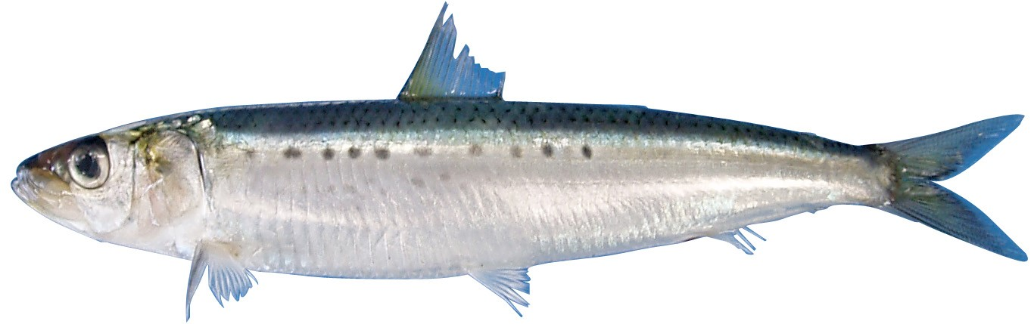
Figure 1. Japanese Sardine (Sardinops melanostictus).

Management

Active NPFC Management Measures
The following NPFC conservation and mangement measure (CMM) pertains to this species:
- CMM 2023-11 For Japanese Sardine, Neon Flying Squid and Japanese Flying Squid
Available from https://www.npfc.int/active-conservation-and-management-measures

Management Summary
The current management measure for Japanese Sardine does not specify catch or effort limits. The CMM states that Members and Cooperating non-Contracting Parties currently harvesting Japanese Sardine should refrain from expansion of the number of fishing vessels authorized to fish Japanese Sardine in the Convention Area. New harvest capacity should also be avoided until as stock assessment has been completed.
A stock assessment for Japanese Sardine is conducted by Japan within their EEZ and used for management of the domestic fishery.
Table 1. Current status of NPFC management measures
Convention or Managment Principle | Status | Comment or Consideration
Biological reference point(s) | Not accomplished | Not established for NPFC CA (Established in Japan EEZ)
Stock status | Unknown | Status determination criteria not established for NPFC CA (Established in Japan EEZ)
Catch limit | Intermediate | Recommended catch, effort limits
Harvest control rule | Not accomplished | Not established for NPFC CA (Established in Japan EEZ)
Other

Assessment
There is currently no stock assessment for Japanese Sardine conducted by NPFC for the Convention Area.
Japan conducts stock assessments for the Pacific stock of Japanese sardine using tuned virtual population analysis (VPA) and MSY-based reference points (Furuichi et al. in press). Only the Pacific stock is distributed into the NPFC Convention Area. The most recent stock assessment in Japan included foreign catches from China and Russia, with some assumptions about age composition of these catches. Information on the size, weight and age of the catch from the NPFC CA would be useful if it were made available for Japan’s stock assessment.
Estimated recruitment, biomass, and spawning stock biomass (SSB) have gradually increased since 2010 (Figure 2a). Japan uses a hockey-stick stock-recruitment relationship with regime shifts between a standard-recruitment state and a high-recruitment state and considers the current state to be the standard-recruitment state (Figure 2b). In the last five years (2018-2022), SSB was estimated to be higher than SSBmsy but F has been gradually increasing at higher levels than Fmsy (Figure 2c).
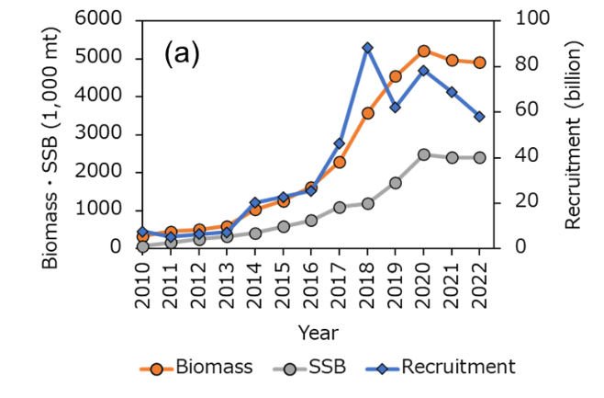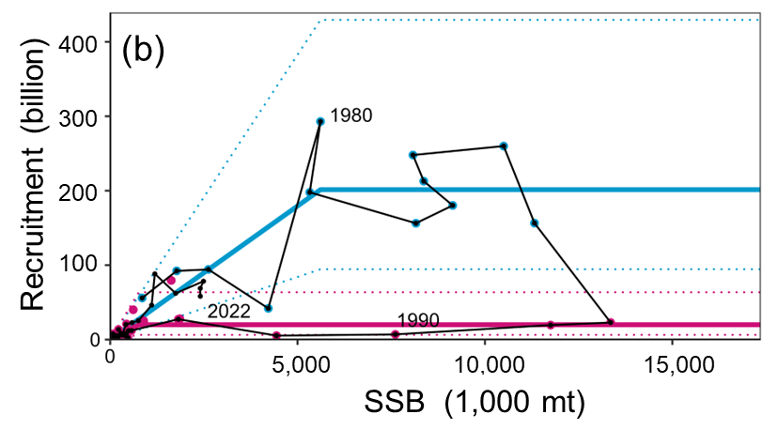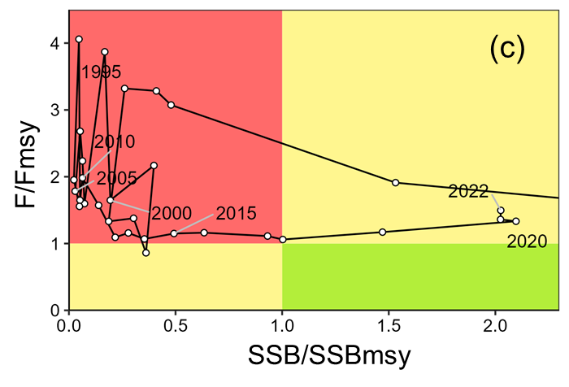
Figure 2. Time series of spawning stock biomass, total biomass and recruitment from the domestic Japanese Sardine stock assessment (panel a) and stock recruit relationship (panel b). Kobe plot indicating historical and current status of Japanese sardine in relation to MSY-based reference points reprinted from Japan’s domestic stock assessment of Japanese Sardine (Furuichi et al. in press; panel c).

Data

Surveys
Japan conducts three surveys that estimate recruitment for a number of pelagic species, including Japanese Sardine (Table 2). The surveys target pre-recruits and juveniles to determine an index of recruitment. Japan also conducts a monthly egg and larval survey that is used to estimate spawning stock biomass. Surveys are conducted in spring (1995-2020), summer (2001-2020) and fall (2005-2020) at 30-80 stations per year. The survey protocol can be found at (Oozeki et al. 2007). Russia has conducted a summertime acoustic-trawl survey since 2010 that examines mid-water and upper epipelagic species including Japanese Sardine.

Fishery
China, Japan and Russia catch Japanese sardine. China does not target the species, but it is captured as bycatch in other fisheries (e.g. chub mackerel). Catches are primarily by purse seine, with a smaller component of the catch taken by pelagic trawl. China’s catch of Japanese Sardine is taken exclusively from the Convention Area from April to December. China’s existing catch records are from 2016 to 2020 and show increasing catches during that time period as the stock may have been increasing. The historical catches (prior to 2016) are unknown, thought to be low and likely need to be confirmed.
Japan’s fishery for Japanese Sardine occurs inside their EEZ and is mostly conducted by large purse seine vessels (>90% of the catch). Additional components of the fishery include set nets, dip nets and other gears. The fishery experienced very high catches in the 1980’s and early 1990’s, a decline to very low catches from 1995 to ~2010 and has been recovering since then. The fishery is conducted year round, but mainly during the summer season.
The Russian fishery occurs inside their EEZ and is prosecuted primarily by pelagic trawling (>90% of the catch), with a smaller component of the catch coming from purse seines. The success of Russian fishery depends on the migration patterns and overall abundance of Japanese Sardine, as the sardine move into Russian waters when their abundance is high. For this reason, there was no catch from 1994-2011 when the stock abundance was low, but in recent years (since 2016) as the stock has recovered and water temperatures have been warm there have been increasing catches in Russia. The Russian fishery occurs primarily from June to November.
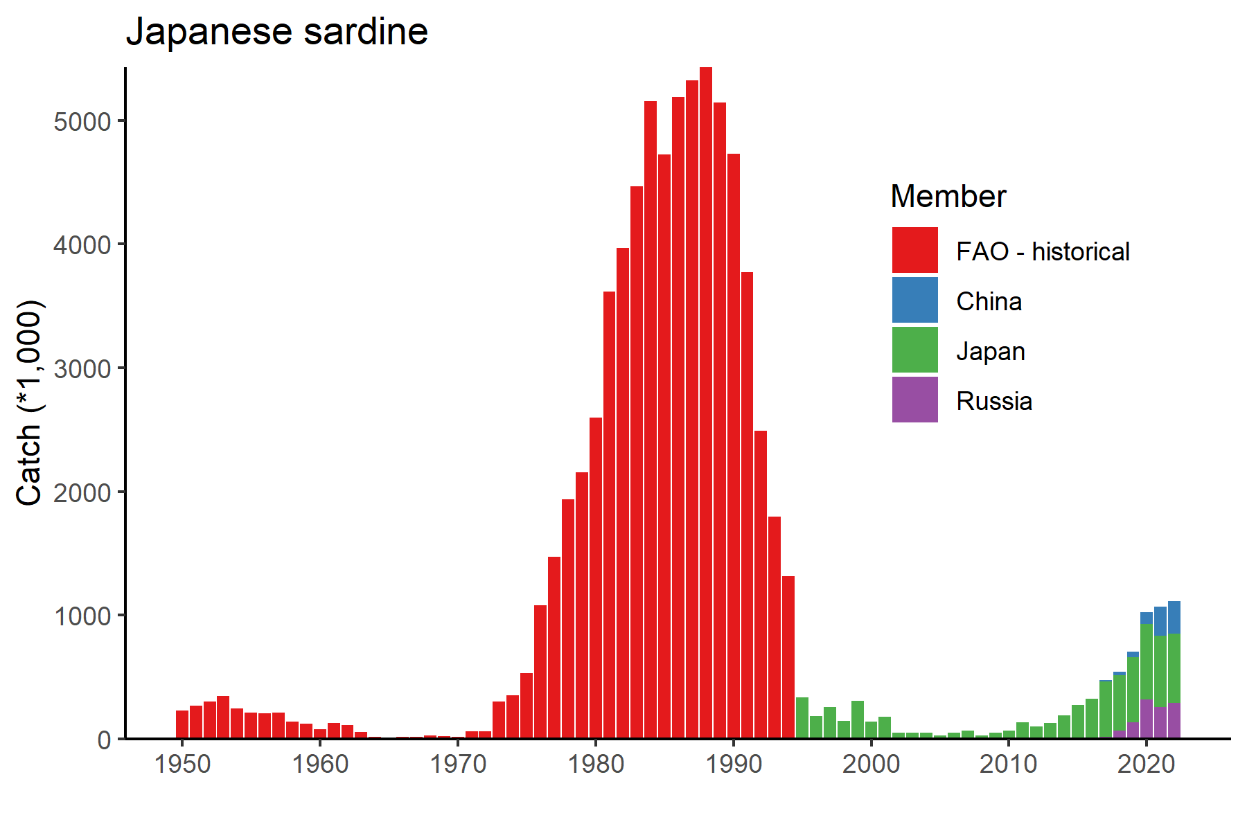
Figure 3. Historical catch of Japanese Sardine.
Other NPFC Members (Canada, Korea, Chinese Taipei, USA and Vanuatu) do not target Japanese Sardine. Chinese Taipei has some historical records of Japanese Sardine bycatch in the Pacific Saury fishery (~100 mt) and Korea has a small amount of historical bycatch data from the bottom trawl fishery. Vanuatu, USA and Canada have no record of Japanese Sardine catches.
Fishery catch data is available for Members from the NPFC website (https://www.npfc.int/system/files/2022-03/NPFC-2023-AR-Annual%20Summary%20Footprint%20-%20Japanese%20Sardine.xlsx) since 2001. Prior years fishery catch data was downloaded from FAO data collections at https://www.openfisheries.org using rfisheries package (Karthik Ram, Carl Boettiger, and Dyck 2013).
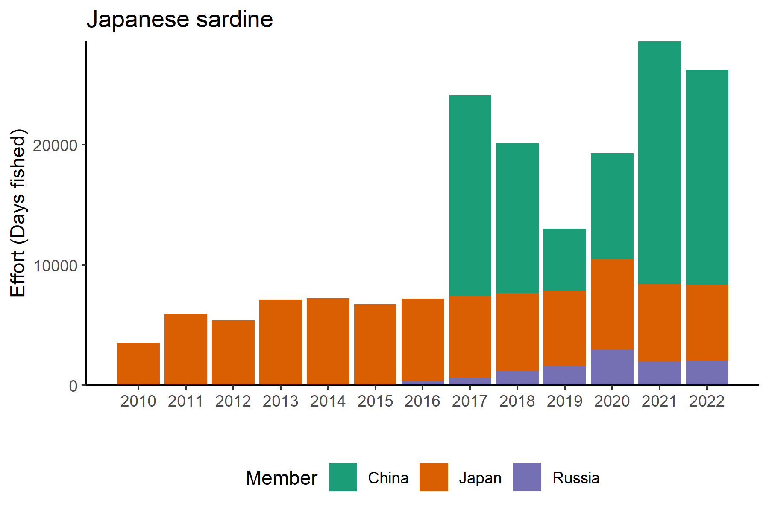
Figure 4. Historical fishing effort for Japanese Sardine.

Biological collections
China has collected biological data from fishery catches of Japanese Sardine since 2020. These collections included length data as well as maturity and age structures.
Russia collects length and weight data, age structures (scales) and maturity data from both commercial catches and surveys.
Japan also collects length, weight, maturity and age data from the survey and fishery to support their stock assessment.
Data availability from Members regarding Japanese sardine
Data | Source | Years | Comment
Catch | China | 2016-present | Catches from convention area
 | Japan | 1995-present | Historical catch data from 1968 available, catches in national waters
 | Korea |  | Minor bycatch in bottom trawl fishery
 | Russia | 2016-present | Catches primarily in national waters, not convention area
 | Chinese Taipei |  | Minor bycatch in Pacific saury fishery
CPUE |  |  | not developed
Survey | Japan |  | Pre-recruit survey
 | Japan |  | Juvenile survey
 | Japan |  | Monthly egg and larval survey
 | Russia | 2010-present | Acoustic-trawl survey
Age data | China | 2020-present | Commercial catch
 | Japan |  | Commercial and survey catches
 | Russia |  | Commercial and survey catches
Length data | China | 2020-present | Commercial catch
 | Japan |  | Commercial and survey catches
 | Russia |  | Commercial and survey catches
Maturity/fecundity | China | 2020-present | Commercial catch
 | Japan |  | Commercial and survey catches
 | Russia |  | Commercial and survey catches

Special Comments
None

Biological Information

Distribution
Japanese sardine (Sardinops melanostichtus; Figure 1) are a pelagic species that occurs in large migratory schools in the coastal waters of China, Chinese Taipei, Japan, Korea and Russia (Figure 5, (Kaschner et al. 2019)). They generally migrate from the south to the north during summer, returning to inshore areas in the south to spawn in the winter. Japanese sardine feed mainly on zooplankton and phytoplankton.

Life history
Japanese sardine are short-lived and fast growing, maturing early at 2-years old. Their maximum length is ~24 cm and their maximum reported age is 25 years (Whitehead 1985). Their growth rates and spawning patterns are highly influenced by the environment (Niino et al. 2021)
Taxonomically, the Japanese sardine are closely related to other species around the globe including Sardinops from southern Africa, Australia, South America and California.
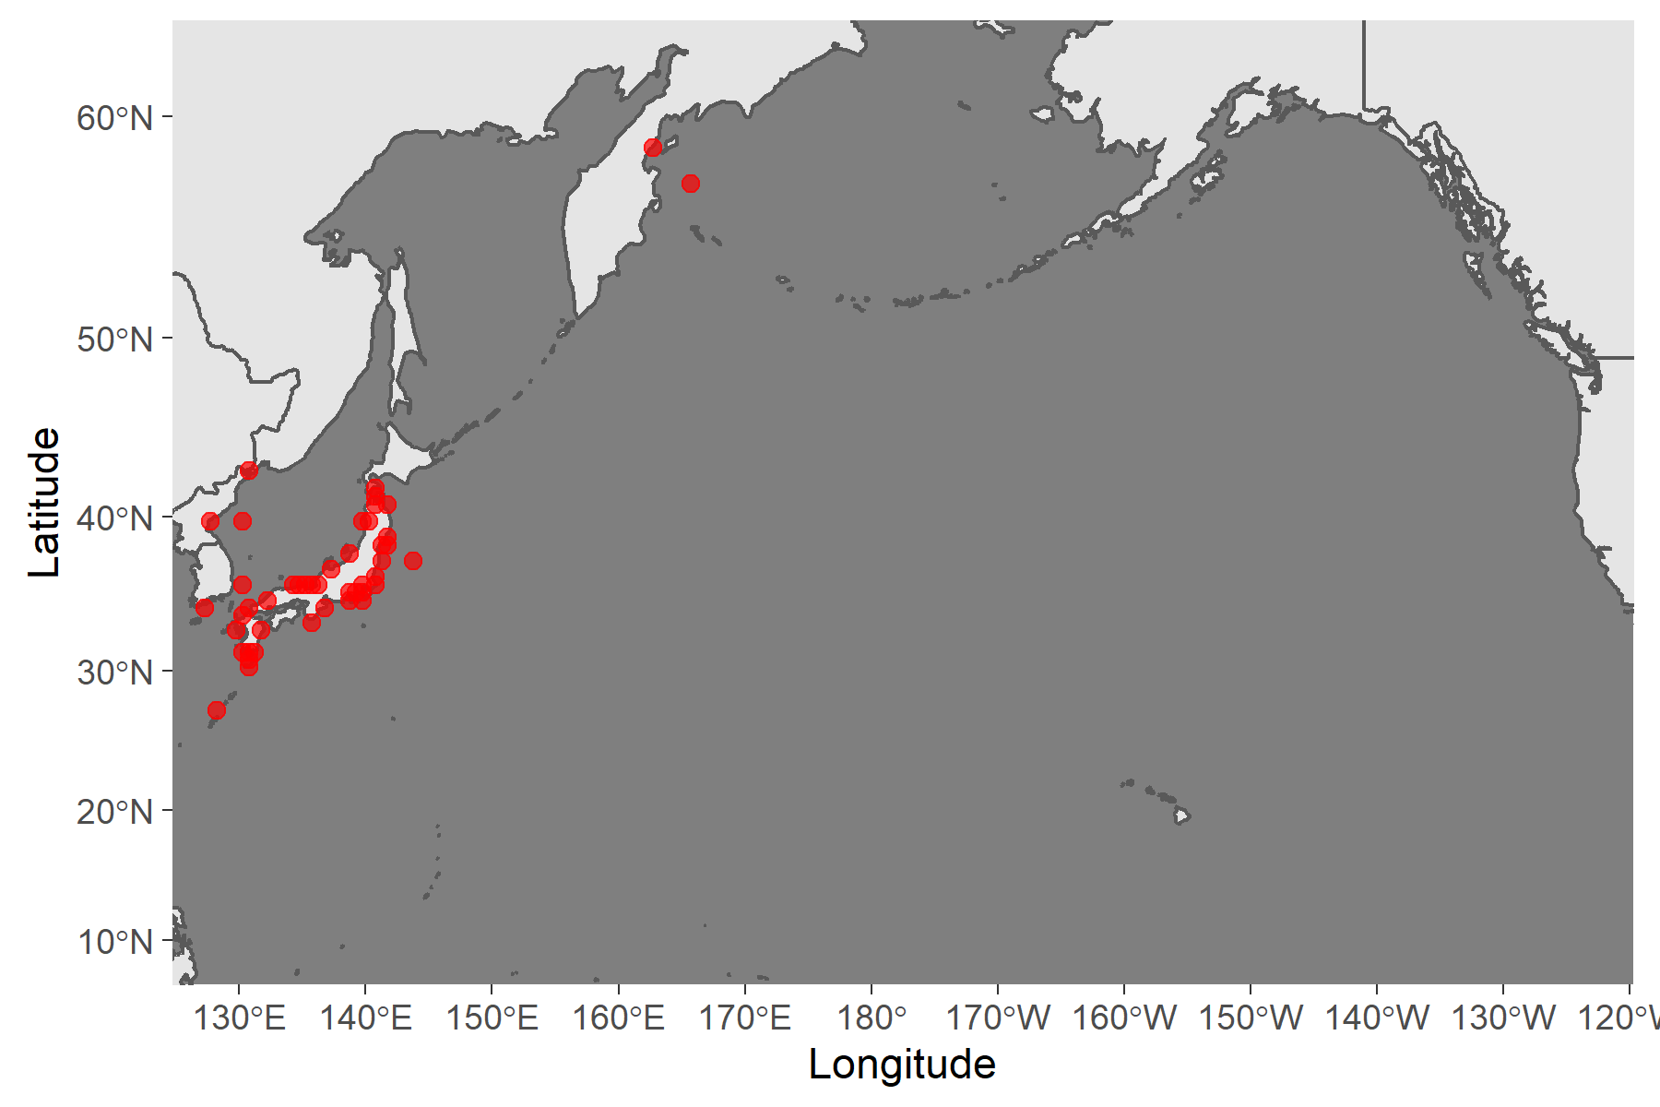
Figure 5. Map of distribution of Sardine species in the North Pacific.

Literature cited
Furuichi, S., Yukami. R., Kamimura, Y., Nishijima, S., Watanabe, R., Isu, S., & Higashiguchi, K. (in press) Stock assessment and evaluation for Japanese Sardine Pacific stock (fiscal year 2023). In Marine Fisheries Stock Assessment and Evaluation for Japanese Waters (fiscal year 2023/2024). Japan Fisheries Agency and Fisheries Research and Education Agency of Japan. Tokyo, 51pp. (will be published at https://abchan.fra.go.jp/hyouka/doc2023/)
Karthik Ram, Carl Boettiger, and Andrew Dyck. 2013. “Rfisheries: R Interface for Fisheries Data. R Package Version 0.1.” 2013. http://CRAN.R-project.org/package=rfisheries.
Kaschner, K., Kesner-Reyes K., Garilao C., Segschneider J., J. Rius-Barile, Rees T., and R. Froese. 2019. “AquaMaps: Predicted Range Maps for Aquatic Species. Data Retrieved from Https://Www.aquamaps.org.”
Niino, Yohei, Sho Furuichi, Yasuhiro Kamimura, and Ryuji Yukami. 2021. “Spatiotemporal spawning patterns and early growth of Japanese sardine in the western North Pacific during the recent stock increase.” Fisheries Oceanography, no. April: 1–10. https://doi.org/10.1111/fog.12542.
Oozeki, Yoshioki, Akinori Takasuka, Hiroshi Kubota, and Manuel Barange. 2007. “Characterizing Spawning Habitats of Japanese Sardine (Sardinops Melanostictus), Japanese Anchovy (Engraulis Japonicus), and Pacific Round Herring (Etrumeus Teres) in the Northwestern Pacific.” CalCOFI Rep. 48 (December).
Whitehead, Peter J. P. 1985. “FAO Species Catalogue. Vol. 7. Clupeoid Fishes of the World (Suborder Clupeoidei). An Annotated and Illustrated Catalogue of the Herrings, Sardines, Pilchards, Sprats, Shads, Anchovies and Wolf-Herrings.” FAO Fish. Synop. 125(7/1): 1–303.

Appendix: Sardine and the environment
Studies examining the relationship between Japanese sardine and the environment
Reference | Year | Type | Country | Ocean | Region | Species | Life stage | Parameter | Environmental variables | Effect | Method
Kodama, T, Wagawa T, Ohshimo S, Morimoto H, Iguchi N, Fukudome KI, Goto T, Takahashi T, Yasuda T. 2018. Improvement in Recruitment of Japanese Sardine with Delays of the Spring Phytoplankton Bloom in the Sea of Japan. Fisheries Oceanography 27 (4): 289–301. https://doi.org/10.1111/fog.12252. | 2018 | journal paper | Japan | Pacific | Sea of Japan | Japanese sardine | Larvae | Recruitment | Sea surface chlorophyl a | delay in start and end dates of spring bloom were positively correlated with recruitment | Correlation, empirical orthoganal function
Yasuda, Tohya, Satoshi Kitajima, Akira Hayashi, Motomitsu Takahashi, and Masa aki Fukuwaka. 2021. “Cold Offshore Area Provides a Favorable Feeding Ground with Lipid-Rich Foods for Juvenile Japanese Sardine.” Fisheries Oceanography, no. January: 1–16. https://doi.org/10.1111/fog.12530. | 2021 | journal paper | Japan | Pacific | Sea of Japan | Japanese sardine | juvenile | Body condition | Prey species and temperature | higher condition in offshore distributed fish due to lower temperature and higher lipid content prey | correlation
Nishikawa, Haruka. 2019. “Relationship between Recruitment of Japanese Sardine (Sardinops Melanostictus) and Environment of Larval Habitat in the Low-Stock Period (1995–2010).” Fisheries Oceanography 28 (2): 131–42. https://doi.org/10.1111/fog.12397. | 2019 | journal paper | Japan | Pacific | Kuoshio current | Japanese sardine | Larvae | Recruitment | water temperature and larval drift | warmer temperature related to lower recruitment | correlation
Niino, Yohei, Sho Furuichi, Yasuhiro Kamimura, and Ryuji Yukami. 2021. “Spatiotemporal Spawning Patterns and Early Growth of Japanese Sardine in the Western North Pacific during the Recent Stock Increase.” Fisheries Oceanography, no. April: 1–10. https://doi.org/10.1111/fog.12542. | 2021 | journal paper | Japan | Pacific | Kuoshio current | Japanese sardine | Larvae | growth | spawning distribution and timing (temperature) | early spawning in eastern area contributed to higher recruitment during time of increasing sardine biomass | correlation
Muko, Soyoka, Seiji Ohshimo, Hiroyuki Kurota, Tohya Yasuda, and Masa Aki Fukuwaka. 2018. “Long-Term Change in the Distribution of Japanese Sardine in the Sea of Japan during Population Fluctuations.” Marine Ecology Progress Series 593: 141–54. https://doi.org/10.3354/meps12491. | 2018 | journal paper | Japan | Pacific | Sea of Japan | Japanese sardine | Adult | Distribution (SDM) | sea surface temperature | dome shaped relationship between sea surface temperature and the probability of presence, with peak between 10-20 C | generalized additive models
Sogawa, Sayaka, Kiyotaka Hidaka, Yasuhiro Kamimura, Masanori Takahashi, Hiroaki Saito, Yuji Okazaki, Yugo Shimizu, and Takashi Setou. 2019. “Environmental Characteristics of Spawning and Nursery Grounds of Japanese Sardine and Mackerels in the Kuroshio and Kuroshio Extension Area.” Fisheries Oceanography 28 (4): 454–67. https://doi.org/10.1111/fog.12423. | 2019 | journal paper | Japan | Pacific | Kuoshio current | Japanese sardine | Egg | Distribution | water temperature, larval drift, zooplankton | little variability in environment where eggs were found, copepod community structure was important | correlation
Kuroda, Hiroshi, Toshihiko Saito, Toshiki Kaga, Akinori Takasuka, Yasuhiro Kamimura, Sho Furuichi, and Takuya Nakanowatari. 2020. “Unconventional Sea Surface Temperature Regime Around Japan in the 2000s–2010s: Potential Influences on Major Fisheries Resources.” Frontiers in Marine Science 7 (October): 1–21. https://doi.org/10.3389/fmars.2020.574904. | 2020 | journal paper | Japan | Pacific | Pacific | Japanese sardine | Adult | Recruitment | PDO, SST | spawning was earlier during SST increases | correlation
Ma, Shuyang, Yongjun Tian, Caihong Fu, Haiqing Yu, Jianchao Li, Yang Liu, Jiahua Cheng, Rong Wan, and Yoshiro Watanabe. 2021. “Climate-Induced Nonlinearity in Pelagic Communities and Non-Stationary Relationships with Physical Drivers in the Kuroshio Ecosystem.” Fish and Fisheries 22 (1): 1–17. https://doi.org/10.1111/faf.12502. | 2020 | journal paper | China | Pacific | Kuoshio current | Japanese sardine | Adult | Abundance/Catch | Basin scale climate (ALPI, SST, Current patterns) | Climate variability introduced nonlinearity and nonstationarity to pelagic fish | time series analyses
Kurota, Hiroyuki, Cody S. Szuwalski, and Momoko Ichinokawa. 2020. “Drivers of Recruitment Dynamics in Japanese Major Fisheries Resources: Effects of Environmental Conditions and Spawner Abundance.” Fisheries Research 221 (September 2019): 105353. https://doi.org/10.1016/j.fishres.2019.105353. | 2020 | journal paper | Japan | Pacific | Pacific | Japanese sardine | Adult | Recruitment | "Environment" other than SSB | Regime shifts were detected in pelagic species | time series analyses, change point analysis
Furuichi, Sho, Tohya Yasuda, Hiroyuki Kurota, Mari Yoda, Kei Suzuki, Motomitsu Takahashi, and Masa Aki Fukuwaka. 2020. “Disentangling the Effects of Climate and Density-Dependent Factors on Spatiotemporal Dynamics of Japanese Sardine Spawning.” Marine Ecology Progress Series 633: 157–68. https://doi.org/10.3354/meps13169. | 2020 | journal paper | Japan | Pacific | Sea of Japan | Japanese sardine | Egg | Abundance and distribution | SST | Cold water led to decreased egg abundance over larger area, warm temperatures led to earlier spawning | correlation
Okazaki, Yuji, Kazuaki Tadokoro, Hiroshi Kubota, Yasuhiro Kamimura, and Kiyotaka Hidaka. 2019. “Dietary Overlap and Optimal Prey Environments of Larval and Juvenile Sardine and Anchovy in the Mixed Water Region of the Western North Pacific.” Marine Ecology Progress Series 630: 149–60. https://doi.org/10.3354/meps13124. | 2019 | journal paper | Japan | Pacific | Kuoshio current |  | larvae and juvenile | prey habits | SST | Temperature influences abundance of prey with effect on recruitment | correlation

