NPFC-2023-SC08-WP07 (Rev.1)

Species Summary

Blue mackerel

NPFC Small Working Group on Blue mackerel

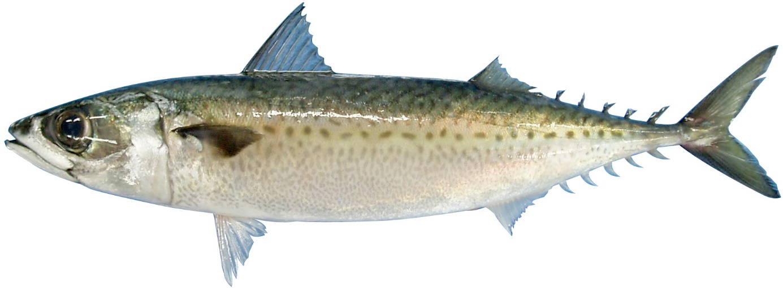

Blue mackerel (Scomber australasicus)
澳洲鲐 [ao-zhou-tai] (Chinese), ゴマサバ [gomasaba] (Japanese), 망치고등어 [Mang-chi-go-deung-eo] (Korean), пятнистая скумбрия [pyatnistaya skumbriya] (Russian), 花腹鯖 [Hua-Fu-Ching] (Chinese Taipei)
Other common names: Spotted mackerel

Management

Active NPFC Management Measures
None

Management Summary
- Conservation and Management Measure has not been set for blue mackerel in the NPFC.
- In Japan, total allowable catch (TAC) has been introduced to management of mackerels (blue mackerel and chub mackerel) since 1997.
Convention/Management Principle | Status | Comment/Consideration
Biological reference point(s) |  | Not established for NPFC CA (Established in Japan EEZ).
Stock status |  | Status determination criteria not established for NPFC CA (Established in Japan EEZ).
Catch limit |  | Not established for NPFC CA (Established in Japan EEZ).
Harvest control rule |  | Not established for NPFC CA (Established in Japan EEZ).
Other

OK Intermediate Not accomplished Unknown

Stock Assessment
No stock assessment has been conducted by NPFC.
Japan conducts stock assessments for the Pacific stock and the East China Sea stock of blue mackerel (BM) using tuned virtual population analysis (VPA) and MSY-based reference points (Yukami et al. 2019a, Hayashi et al. 2019). Only the Pacific stock is distributed as far as the NPFC Convention Area. The most recent stock assessment in Japan included foreign catches from China and Russia, with some assumptions on species composition and age composition of mackerel (Fig. 1a). Estimated recruitment, biomass, and spawning stock biomass (SSB) have declined dramatically since the 2010s (Fig. 1b). Japan uses a Ricker stock-recruitment relationship. In the last two years (2020-2021), SSB was estimated to be lower than SSBmsy and F was higher than Fmsy (Fig. 1d).
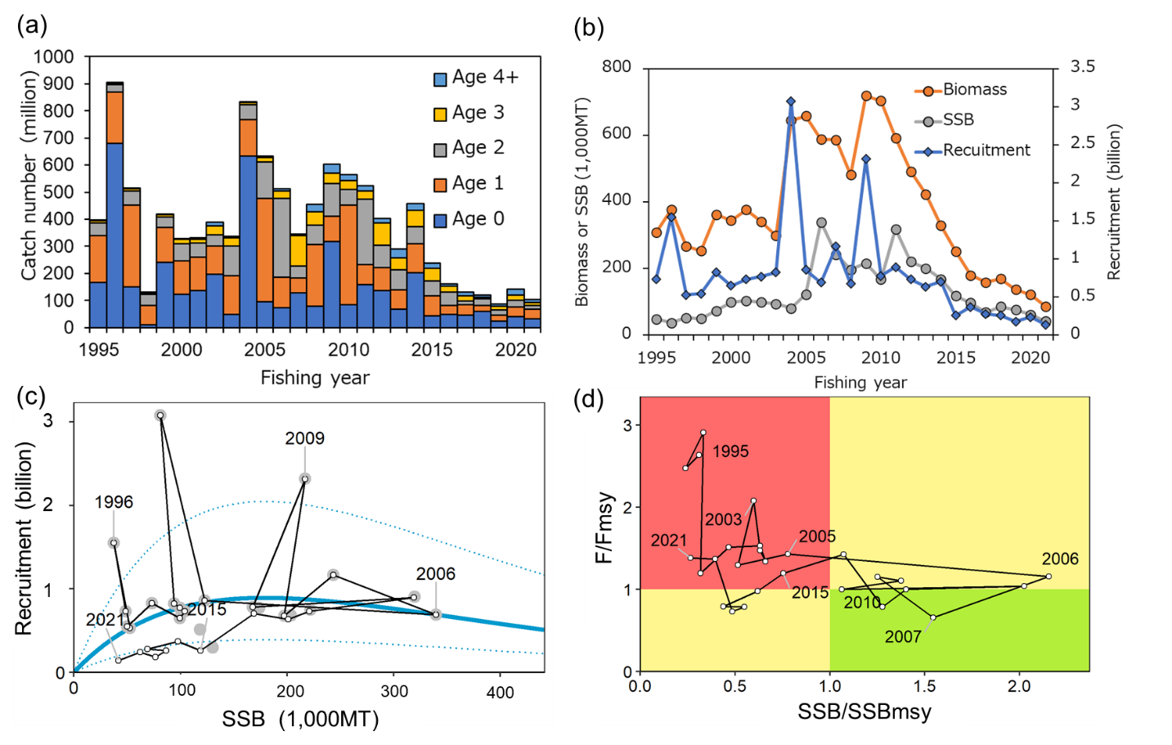
Figure 1: Summary of the stock assessment for the Pacific BM stock by Japan (Yukami et al. 2023). (a) Time series of catch number by age. (b) Estimated biomass, SSB, and recruitment. (c) Stock-recruitment relationship. (d) Kobe plot.

Data

Survey
Japan conducts three surveys: (1) egg and larval distribution survey (every month), (2) juvenile survey (May-Jul since 2001), and (3) pre-recruit fish survey (Aug-Oct since 2001). The egg survey has been used as an abundance index for SSB in Japan’s domestic stock assessment (Figs. 2, 3). Other members do not conduct surveys for BM.

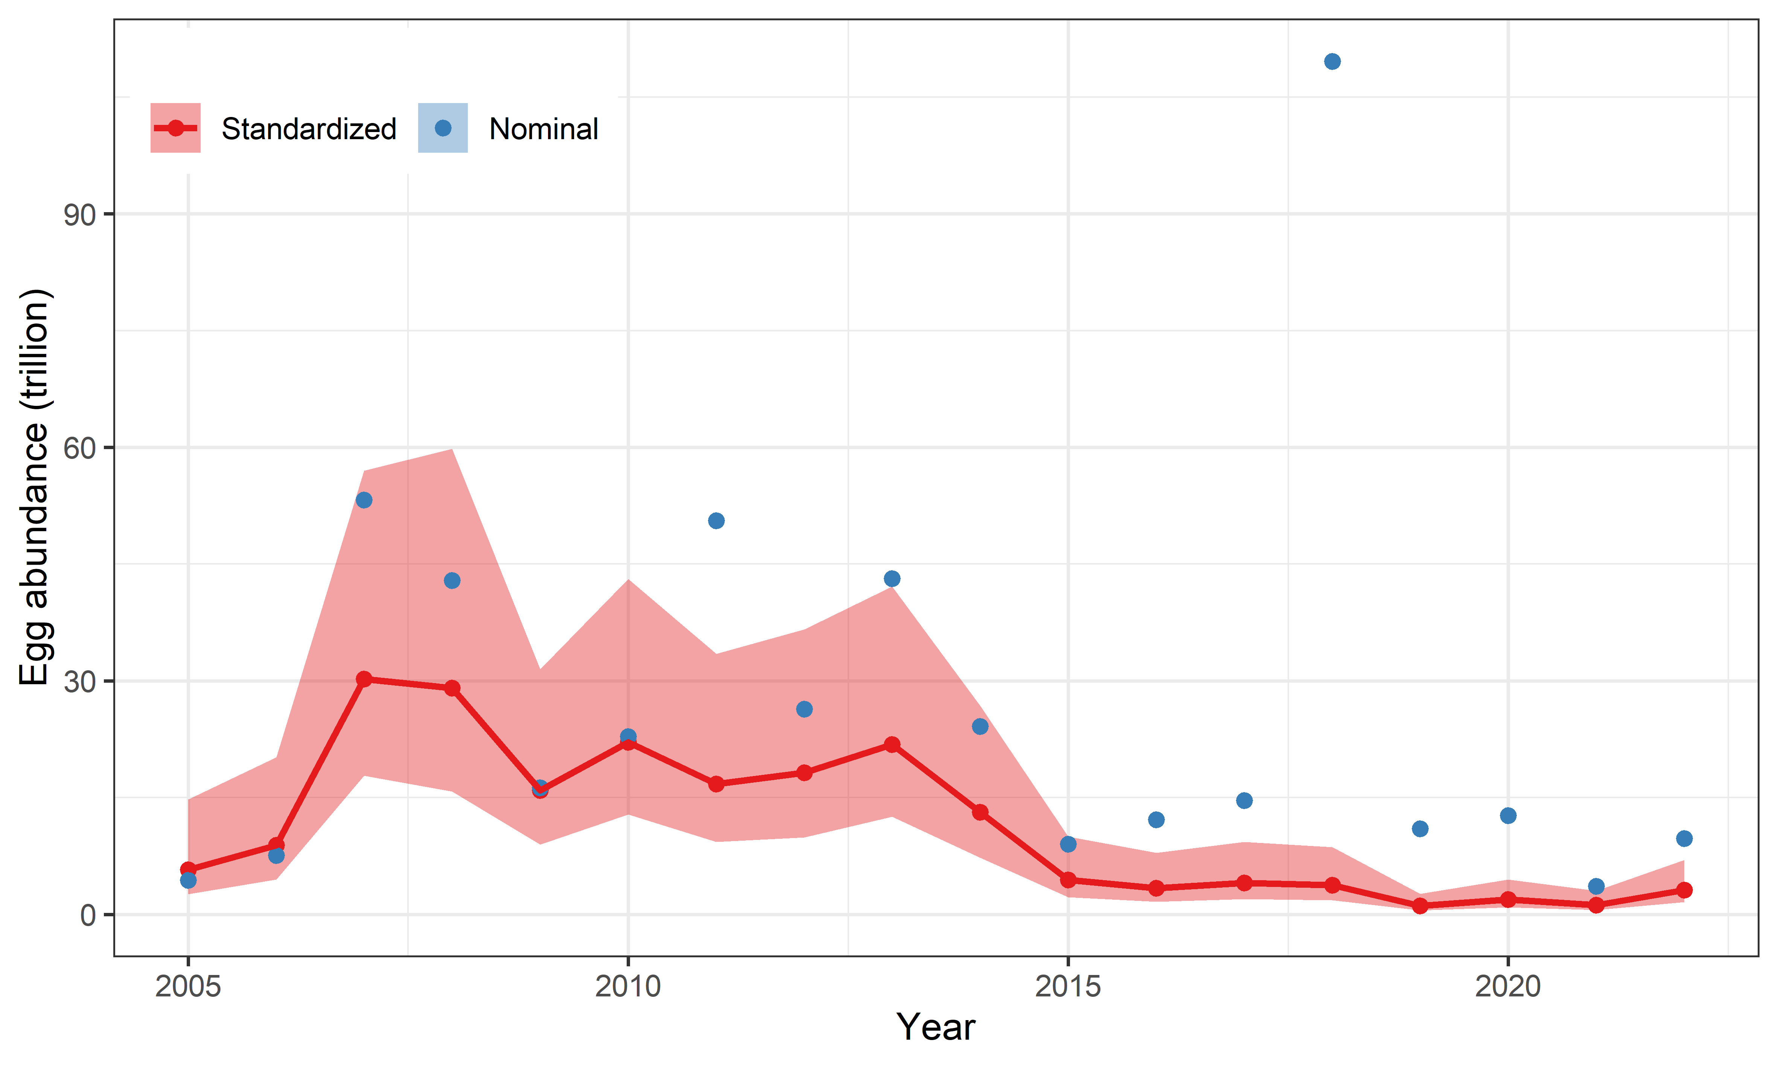
Figure 2: Time series of egg abundance indices. Nominal standardized indices are shown. This standardization incorporates the effect of species misidentification of chub mackerel as blue mackerel, which is a reason why standardized values are lower than nominal values in most years typically 2018. See Kanamori et al. (2021) for details.

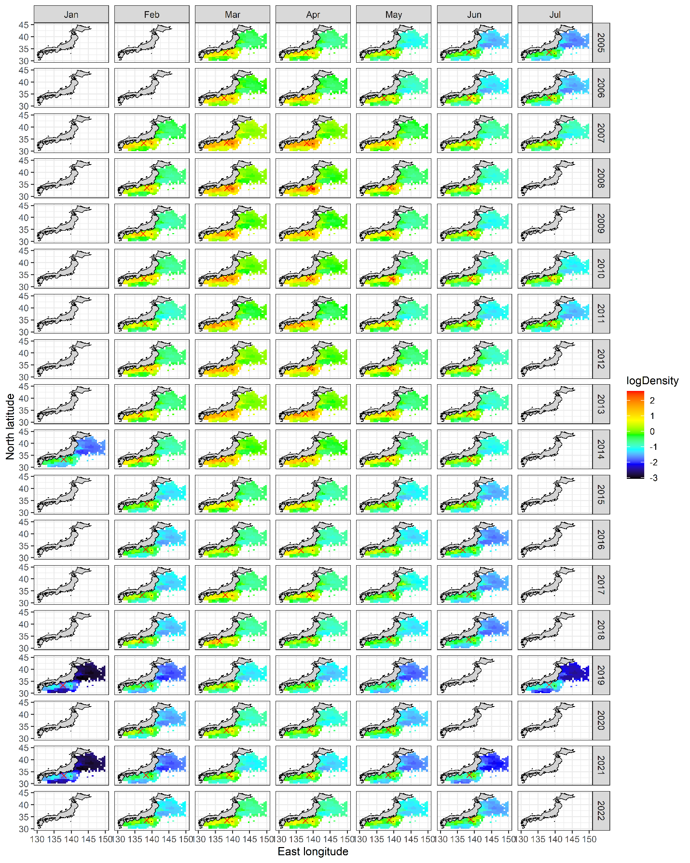
Figure 3: Spatial distributions of BM eggs on the Pacific coast of Japan by month (column) by year (row), estimated from the seasonal VAST model (Thorson et al. 2020) with the egg survey data. The sign of X in red represents the centroid of abundance distributions.

Fishery
The fishing grounds of Japanese fisheries are located in the waters on the continental shelves and slopes, around the waters of islands within Japan’s EEZ. The main fishing gears of Japan are purse seine (large vessels >40 GRT and small vessels <40 GRT), set net and dip net. In the 1980s, BM were mainly caught by dip net. From the 1990s, the large and small-scale purse seine fisheries dominated the catch. BM catch has decreased since the 2010s (Fig. 4). Chub and blue mackerels are caught together by the fisheries and summed up as “mackerel” in Japan’s fishery statistics of Japan. The catch of BM was estimated from the mixing ratio survey of landings. Japan conducts the identification of each species by external shape; BM has distinct black spots on both sides of the body, and the interval between the splines of the first dorsal fin of BM is narrower than that of chub mackerel. The proportion of BM catch in the total mackerel catch was about 10% from 2016 to 2022.
China conducts a BM fishery only in the NPFC Convention Area, in the same fishing grounds as for chub mackerel. China takes samples to determine the composition of mackerel species in the catch and collects biological information. The proportion of blue mackerel is about 10% of the mackerel catch from 2014 to 2021, but increases to 25% in 2022. Thus, it is estimated that the catch weight of China (27.7 thousand MT) exceeded that of Japan (24.7 thousand MT) in 2022 (Fig. 4).
In Russia, there are no accurate catch statistics on the proportion of blue and chub mackerels. However, the portion of BM is very small and probably comprises less than 1% of the total mackerel catch by Russia.

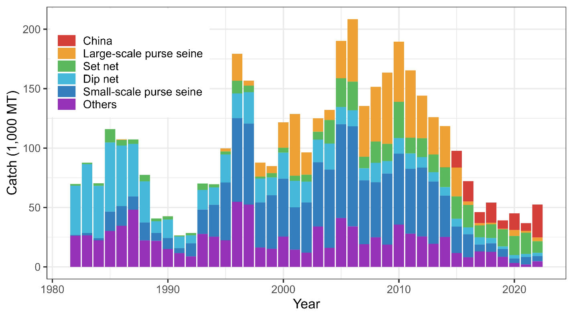
Figure 4: Time series of catch weight from 1982 to 2022 for the Pacific BM stock. Colors represent different fisheries in Japan, and purse seine and pelagic trawl fisheries in China are aggregated as red. Russia is assumed not to have fished for BM.

Data table
Data availability tables which include information about catch, abundance indices and biological data from China and Japan are respectively shown below (Tables 1, 2). For Russia, no relevant data are available.

Table 1: Data availability table from China.
Category and data sources | Description | Years with available data | Average sample size/ year or data coverage | Potential issues to be reviewed
CHINA
Catch statistics
Purse seine fishery  Trawl fishery | Official statistics, reports from annual report | Official statistics:  2015-2022 | Coverage=100% | The blue mackerel and Japanese sardine catches are from the fishing catch provided by the fishery company
Size composition data
Length measurements | Port sampling by Institute and technology group. | 2018-2022 | 550-800 fish/year | Details to be reviewed
Aging | Sampling during research surveys and from commercial fishing vessels | 2020-2022 | 30-180 fish/year | Details to be reviewed
Catch at age  (CAA) | Estimate CAA from the above data | 2020-2022 | Age-length keys are to be developed | Evaluate uncertainty of catch at age, especially on changes of growth depending on recruitment abundance
…
Abundance indices (survey)
Abundance indices (commercial)
Purse seine fishery | Purse seine logbook | 2015-2022 | 10-60/year | Should separate blue mackerel and chub mackerel  Will conduct standardization

Table 2: Data availability table from Japan.
Category and data sources | Description | Years with available data | Average sample size/ year or data coverage | Potential issues to be reviewed
JAPAN
Catch statistics
Purse seine fishery | Official statistics; reports from fisheries associations and markets | Official statistics: 1950-2022, other reports: 1982-2022 | Coverage=100% | The spotted mackerel catches are estimated from chub and spotted mackerel catches based on port sampling data
Dip net fishery
Set net
Size composition data
Length measurements | Port sampling by 17 local fishery institutes in 17 prefectures | 1995-2022 | 4,000-40,000 (average 10,000) fish/year (ca. 100 measurements per sampling) | Data coverage review
Aging | Port sampling by 17 local fishery institutes in 17 prefectures | 1995-2022 | 500-1000 fish/year | Data coverage review
Catch at age  (CAA) | CAA is estimated with length measurement and aging data | 1995-2022 | Age-length keys are created approximately by quarter and local regions | Evaluation of uncertainty in catch at age, especially on changes in growth depending on recruitment abundance
Abundance indices (survey)
Year-round for egg density | Almost all local fisheries research bodies join this survey program. NORPAC net is sampling gear. This survey is conducted for small pelagic species. | 2005-2022 | ca. 6000 stations in total, 1000-4000 stations with spotted mackerel eggs/year | Review survey protocol and conduct standardization
Abundance indices (commercial)
Dip net fishery | Logbook data are collected from fishermen in Shizuoka prefecture since 1995 | 1995-2022 | 100-500/year | Standardization

Special Comments
Although the Small Working Group (SWG) previously used ‘spotted mackerel’ as the common name of this species, the SWG recommended to SC to change the common name to ‘blue mackerel’ for consistency with the FAO database of fish species.
Catch statistics specific to blue mackerel in the NPFC Convention Area are not available because combined catch of chub and blue mackerels have been reported to NPFC (https://www.npfc.int/summary-footprint-chub-mackerel-fisheries). China and Japan began to share data on the proportion of BM in the mackerel fishery and data on the size composition of the BM catch to allow for accurate stock assessment of BM.

Biological Information
The below descriptions are mostly extracted from Yukami et al. (2019b).

Distribution and migration
Blue mackerel is distributed from Japan to Australia and New Zealand in the Indo-West Pacific (Frose and Pauly 2022). Blue mackerel around Japan is divided into two stocks by spatial distributions in Japanese stock assessments: Pacific stock and East China Sea stock (Hayashi et al. 2019, Yukami et al. 2019; Fig. 5). Below we describe biological information based on the Pacific stock of blue mackerel.
Blue mackerel tends to distribute in warm offshore waters. The main distribution area for adults is around water of the Kuroshio current. The larvae hatch around the Kuroshio current and are distributed from the coastal water of southern Honsyu to the transition water between Kuroshio and Oyashio currents located 165 to 170 East longitude, the same as the chub mackerel larvae. The juveniles sized at 5 to 15cm fork length (FL) transferred to transition water, migrate to north as they grow, feed at the area from coastal water of eastern Hokkaido and Kurill Islands to the subarctic water around 165 degree East longitude where the surface temperature around 13°C in summer to fall. They reach 20 to 25cm FL in fall to winter, and migrate south to the coastal waters of Joban and Boso to offshore water around Kuroshio current for wintering. A wintering ground in the water near Emperor Seamounts was observed for 2004 year class which had high recruitment. Age 1 fish did not appear in the water north of Sanriku district after wintering until 1980, but they have migrated to the water from Tohoku to Hokkaido with the increase of surface temperature since 2001. They return south for wintering and migrate to the Izu Islands water for spawning in spring. Many schools distribute near Kuroshio current at the coastal water of southern Honshu all the year and are targeted by many fisheries. These are different from the schools that largely migrate from near the Kuroshio current at the Izu Island to Tohoku and Hokkaido waters. It is suggested that many fish above age 3 do not migrate north of Sanriku district and stay at the western water near the cape Ashizuri with small migrations or stay near the spawning grounds. Furthermore, it is considered that the observation of schools mainly consisting of age 8 fish at the Emperor seamounts area in 2008 to 2015 were due to the dominant recruitment spawned at the water south of Hachijo Island.

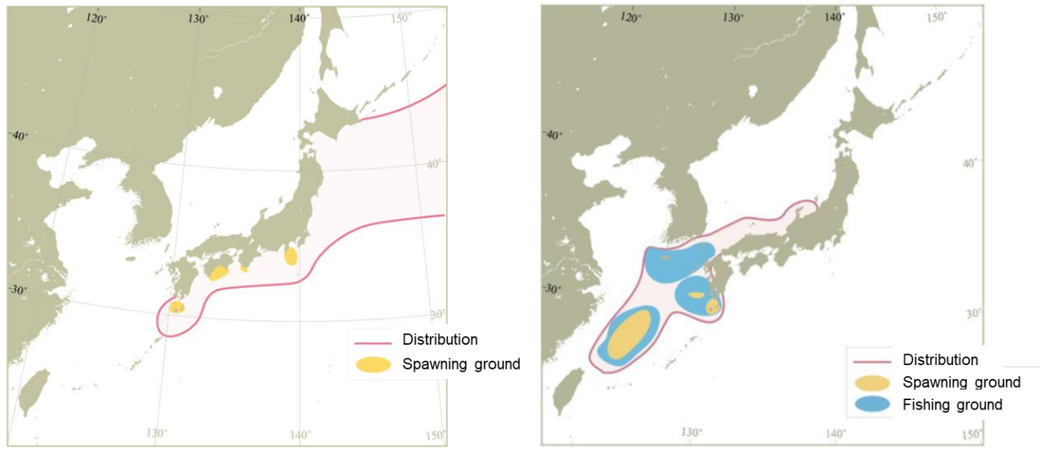
Figure 5: Distribution and spawning ground of the Pacific stock (left) and the East China Sea stock (right) of blue mackerel.

Age and growth
The larvae grow 1mm per day until 5cm FL after hatching observed by otolith reading, then it grows 15cm after 80days, and over 20cm of 120 days after hatching. The scale annuli reading is practical for the fish after subadult stage, it is used for the survey. Otolith annuli and daily ring readings are also effective for age determination. It is suggested that fish becoming 20-25cm FL at age 0 in fall, 28-31cm at age 1 in summer, 30-34cm at age 2, 33-36cm at age 3, around 37cm at age 4, and 45cm at the maximum. The longevity was estimated around age 6 from size composition of catch, but the oldest age 11 was reported. The growth at younger ages is different by area, and in the western area of offshore Kumano there is a tendency for faster growth than fish occur in the water north of Izu Islands. The average length (FL), weight (the averages in caught fish in 2017 to 2021) by age are shown in Fig. 6.
The length-weight (LW) relationships in Japan and China are shown in Fig. 7 (see also Furuichi et al. 2021). Although the estimated parameters from the Chinese samples in 2021 and 2022 were different from the others probably due to the small sample sizes and narrow sampling ranges of length (Table 3), their shapes are almost identical. This suggests that the degree of obesity for BM was little different between Chinese and Japanese fishing grounds.

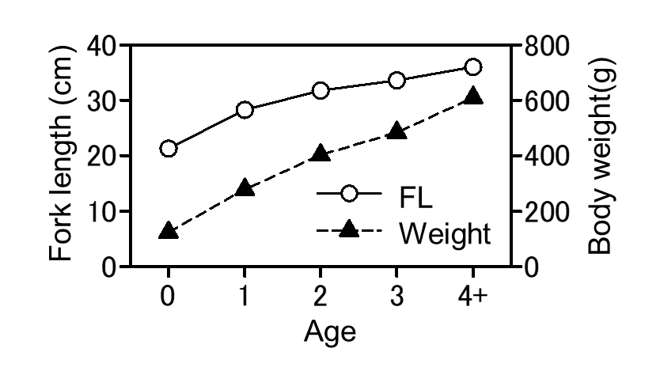
Figure 6: Relationship between age and fork length and relationship between age and body weight of BM (the averages of caught fish for the latest five years 2017-2021).

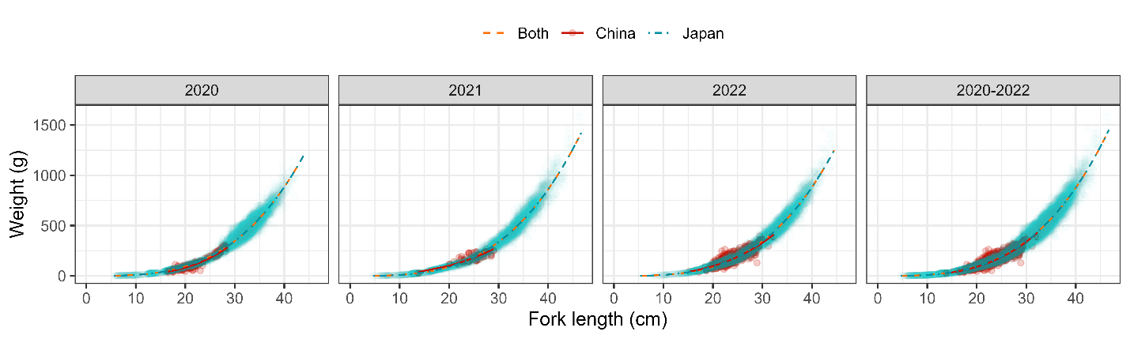
Figure 7: Relationships between fork length and weight from 2020 to 2022 of BM in Japan.

Table 3: Parameters of the relationship between fork length (cm) and weight (g) by Member from 2020 to 2022. The parameters are estimated by the least square method from the equation $W=aL^{b}$. ‘Both’ in the ‘Member’ column represents China + Japan and N represents sample size.
Year | Member | a | b | N
2020 | Both | 0.0054 | 3.25 | 9818
2020 | China | 0.0024 | 3.49 | 218
2020 | Japan | 0.0056 | 3.25 | 9600
2021 | Both | 0.0053 | 3.25 | 7711
2021 | China | 0.0398 | 2.62 | 56
2021 | Japan | 0.0052 | 3.26 | 7655
2022 | Both | 0.0051 | 3.27 | 12405
2022 | China | 0.0117 | 3.01 | 632
2022 | Japan | 0.0051 | 3.27 | 11773
2020-2022 | Both | 0.0053 | 3.26 | 29934
2020-2022 | China | 0.0049 | 3.28 | 906
2020-2022 | Japan | 0.0053 | 3.26 | 29028

Reproduction
The blue mackerel mature and spawn above 30cm FL from the observation of ovary tissue. The mature age was considered age 2 and above and it is assumed that all the fish age 2 and above are mature and spawn (Figs. 6. 8). The spawning grounds are found from the waters southern Kyusyu and cape Ashizuri to the Kuroshio current water near Izu Islands (Fig5). The recruitments hatched at the larger spawning ground in the East China sea supposed to migrate into the Pacific water. A spawning season are from December to June next year at the western waters of cape Ashizuri, January to March in the East China sea, and February to March near the water of cape Ashizur. The spawning season of main spawning ground of blue mackerel near Izu Island are March to June, but it considered that it is not suitable as spawning grounds by the short spawning season from the ovary tissue observation and small amount of spawning eggs sampled. However, it is supposed that larvae and juvenile occurring in the north of transition area consist of the fish hatched at the Izu Island spawning grounds in March to June, same as chub mackerel.

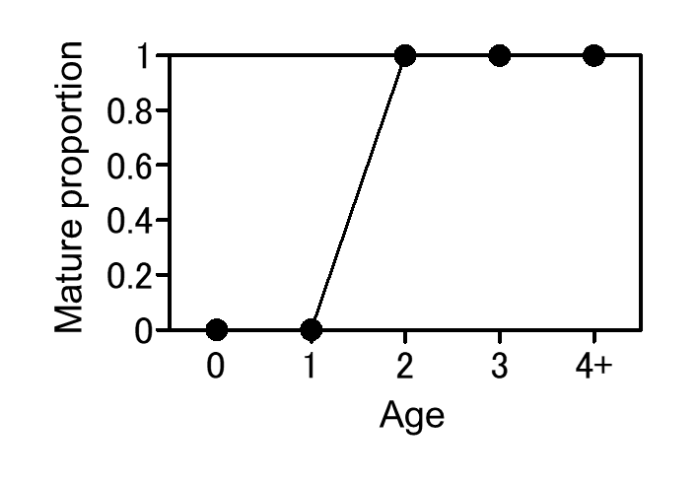
Figure 8: Mature proportion by age.

Predator-prey relationship
Larvae feed on planktonic crustaceans and larvae of anchovy or sardines. Juveniles feed on small teleost and cephalopods with preys mentioned above. It preys on fishes including anchovy, benttooth and lantern fishes, crustaceans like krill and cephalopods at the Kumano Nada fishing ground, horned krill and anchovy at Sanriku fishing ground and copepod, krill, anchovy, lantern fishes, cephalopod like Enoploteuthidae and salpa in the transition area between Kuroshio and Oyashio where located offshore of Joban and Sanriku. Predation on blue mackerel by whales is observed during periods of high abundance.

Literature Cited
Froese, R. & D. Pauly. Editors. (2022) FishBase. World Wide Web electronic publication. www.fishbase.org, (08/2022).
Furuichi, S., Kamimura, Y., & Yukami, R. (2021) Length–length and length–weight relationships for four dominant small pelagic fishes in the Kuroshio–Oyashio current system. Thalassas: An International Journal of Marine Sciences, 37: 651-657.
Hayashi, A., Yasuda, T., Kurota, H., & Yukami R. (2019). Stock assessment and evaluation for Blue Mackerel Pacific stock (fiscal year 2019). In Marine Fisheries Stock Assessment and Evaluation for Japanese Waters (fiscal year 2019/2020). Fisheries Agency and Fisheries Research and Education Agency of Japan. http://www.fra.affrc.go.jp/shigen_hyoka/peer_review/2020/index.html
Kanamori, Y., Nishijima, S., Okamura, H., Yukami, R., Watai, M., & Takasuka, A. (2021). Spatio-temporal model reduces species misidentification bias of spawning eggs in stock assessment of spotted mackerel in the western North Pacific. Fisheries Research, 236: 105825. https://doi.org/10.1016/j.fishres.2020.105825
Thorson, JT., CF. Adams, EN. Brooks, LB. Eisner, DG Kimmel, CM. Legault, LA., Rogers, EM. Yasumiishi. (2020) Seasonal and interannual variation in spatio-temporal models for index standardization and phenology studies. ICES J. Mar. Sci., 77: 1879-1892.
Yukami, R., Isu, S., Kamimura, Y., & Furuichi, S. (2019a). Research Institute Meeting Report on (Biological) Reference Points for the Pacific Stock of Blue Mackerel (Scomber Australasicus) in FY2019. http://www.fra.affrc.go.jp/shigen_hyoka/peer_review/2020/index.html
Yukami, R., Isu, S., Kamimura, Y., Furuichi, S., Watanabe, R., & Kanamori, Y. (2019b). Stock assessment and evaluation for Blue Mackerel Pacific stock (fiscal year 2019). In Marine Fisheries Stock Assessment and Evaluation for Japanese Waters (fiscal year 2019/2020). Fisheries Agency and Fisheries Research and Education Agency of Japan. http://www.fra.affrc.go.jp/shigen_hyoka/peer_review/2020/index.html
Yukami, R., Nishijima, S., Kamimura, Y., Furuichi, S., Watanabe, R. (2023). Stock assessment and evaluation for Blue Mackerel Pacific stock (fiscal year 2022). In Marine Fisheries Stock Assessment and Evaluation for Japanese Waters (fiscal year 2022/2023). Japan Fisheries Agency and Fisheries Research and Education Agency of Japan. Tokyo, 57pp. https://abchan.fra.go.jp/wpt/wp-content/uploads/2023/07/details_2022_07.pdf

