NPFC-2023-SC08-WP08 (Rev.1)

Species Summary

Japanese flying squid
NPFC Small Working Group on Japanese flying squid

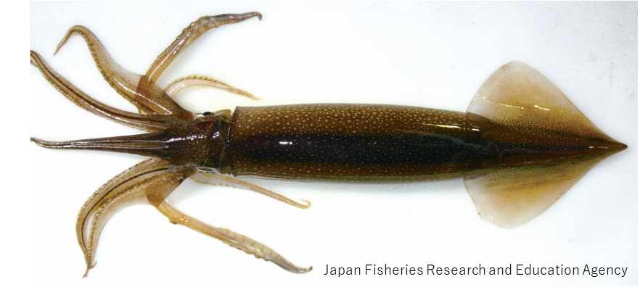

Japanese Flying Squid (Todarodes pacificus)

Common names:
太平洋褶柔鱼 [tai ping yang zhe rou yu] (Chinese); Japanese flying squid (English); スルメイカ [surume-ika] (Japanese); 살오징어 [sal-o-jing-eo] (Korean); тихоокеанский кальмар [tihookeanskiy Kalmar] (Russian); 日本魷 [ri-ben-you] (Chinese Taipei).
Other common names: Japanese common squid, Pacific flying squid.

Management
Active NPFC Management Measures
The following NPFC conservation and management measure pertains to this species:
CMM 2021-11 For Japanese Sardine, Neon Flying Squid and Japanese Flying Squid
Available from https://www.npfc.int/active-conservation-and-management-measures.

Management Summary
The current management measure for Japanese flying squid (JFS) does not specify catch or effort limits. The CMM states that Members and Cooperating non-Contracting Parties currently harvesting JFS should refrain from expansion of the number of fishing vessels authorized to fish JFS in the Convention Area. New harvest capacity should also be avoided until as stock assessment has been completed.
Japan has been conducted stock assessment annually for two stocks of JFS such as the autumn- and winter-spawning stocks since 1997. Japanese domestic total allowable catch (TAC) has been annually set for JFS based on acceptable biological catch (ABC) determined based on the stock assessment results.

Table 1. Management Summary
Convention/Management Principle | Status | Comment/Consideration
Biological reference point(s) |  | Not established for NPFC CA (Established in Japan EEZ).
Stock status |  | Status determination criteria not established for NPFC CA (Established in Japan EEZ).
Catch limit |  | Not established for NPFC CA (Established in Japan EEZ).
Harvest control rule |  | Not established for NPFC CA (Established in Japan EEZ).
Other

OK Intermediate Not accomplished Unknown

Stock Assessment
No stock assessment has been conducted by NPFC for the Convention Area.
Japan conducts annual stock assessments for the autumn-spawning stock and winter-spawning stock of JFS (Figure 1, Miyahara et al. 2023, Okamoto et al. 2023). The latest stock assessment for the winter-spawning stock in Japan included overseas catch from Russia, China and Korea (Fig. 1a). Estimated biomass and spawning stock biomass (SSB) have decreased drastically since 2015 (Fig. 1b). Japan uses a Beverton–Holt stock-recruitment relationship (Fig. 1c). In 2021, SSB was estimated lower than SSBmsy and F was lower than Fmsy (Fig. 1d).

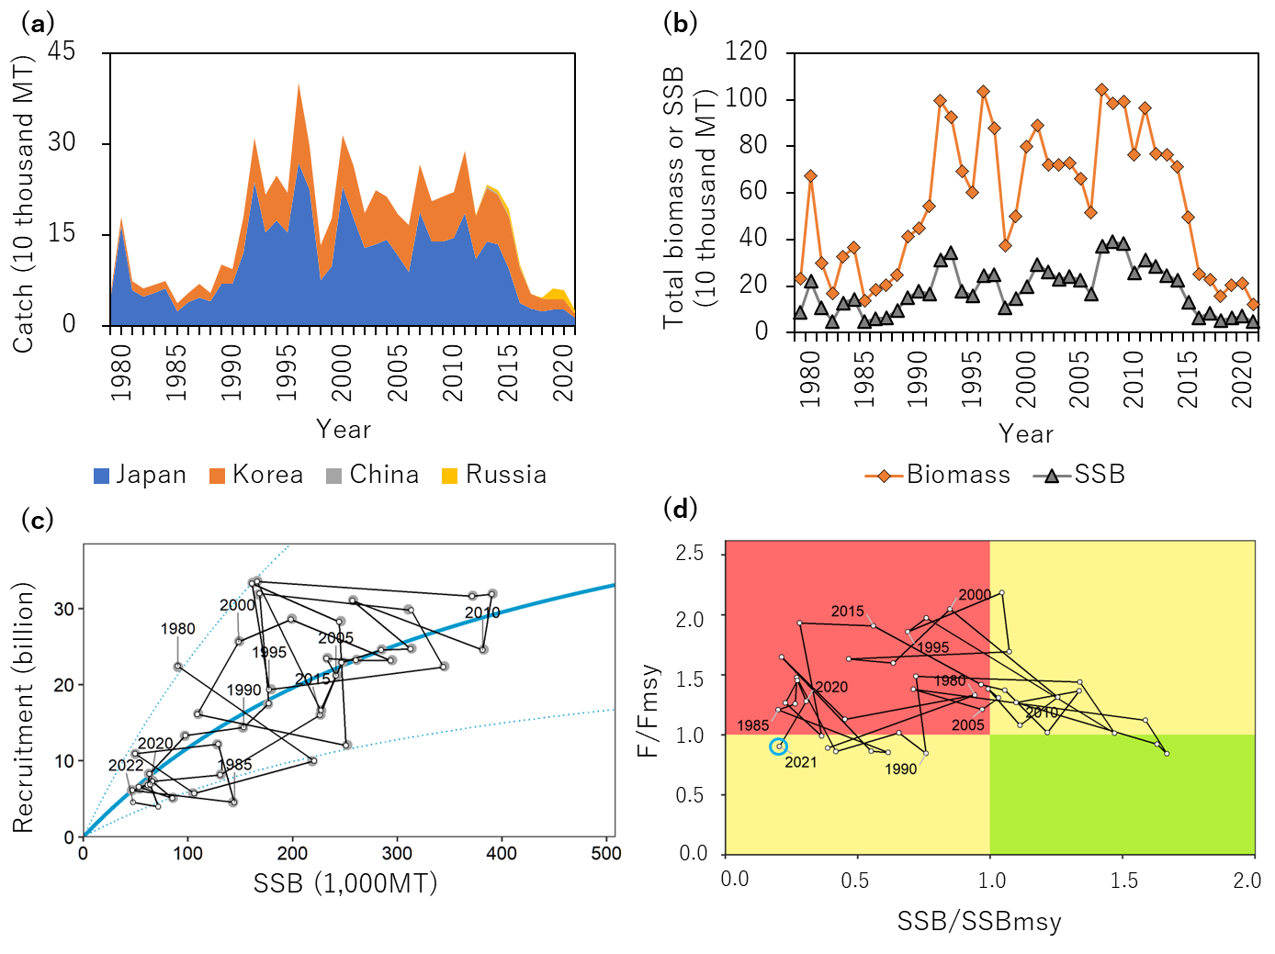
Figure 1. Summary of the stock assessment for the winter-spawning stock Japanese flying squid by Japan (Okamoto et al. 2023). (a) Time series of catch of each Member from fishing year 1979 to 2021. (b)Estimated biomass and SSB. (c) Stock-recruitment relationship. (d) Kobe plot.

Data
Survey
JFS are encountered in several surveys conducted by Japan and Russia. Japanese surveys encounter multiple life history stages of one or more seasonal stocks, including larvae (winter survey), recruits (May-June), and adults (July-September). Russia conducts a survey of JFS during their feeding migration into Krill Islands waters, this results in number and biomass estimated by area swept method for Krill Islands waters (annual, for winter stock only). While this survey captures only a portion of the stock so not fully representing stock biomass, it may help identify environmental impact on migration patterns, timing, etc.

Fishery
The winter-spawning stock of JFS is harvested in the NPFC Convention Area (see Biological Information).
JFS are caught by Members in both the Convention Area and National Waters. Catch tables are available at the NPFC website (https://www.npfc.int/system/files/2023-04/NPFC-2023-AR-Annual%20Summary%20Footprint%20-%20Squids%20%28Rev.%201%29_0.xlsx). Catches of JFS in the Convention Area are low, as the majority of catches comes from Japanese and Russian national waters (Figure 2). JFS are caught using a variety of gears, most commonly squid jigging and trawl, but purse seine and set net are also used. They are predominantly caught as a targeted species, not as bycatch in other fisheries. However, in some seasons, they can be caught as bycatch in the Japanese sardine fishery. Chinese fishing fleets do not target JFS but encounter them in low quantities as bycatch in other fisheries.
There is no fishery CPUE index developed for this species in the Convention Area. Japan has already developed fishery-dependent/independent abundance indices to use in the domestic stock assessment.
Age data are collected by port samplers from a subset of Japanese fishing ports and for several Japanese prefectural research bodies. The squid’s statolith is used for counting daily ages and estimating hatching dates (Nakamura and Sakurai 1991).
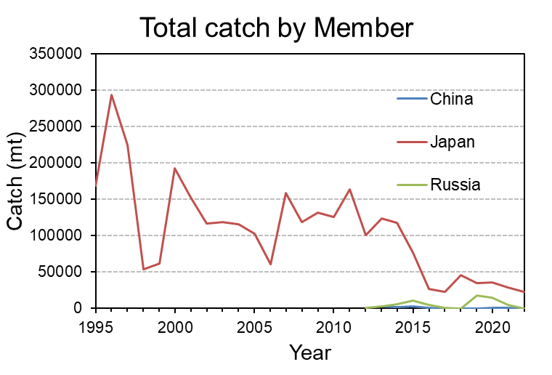
Figure 2. Total catch (mt) for each Member reporting Japanese flying squid catches during 1995-present.

Data table

Table 2. Data availability from Members regarding Japanese flying squid
Japanese flying squid: China*, Japan, Russia.
* No fishery targets Japanese flying squid. No relevant data.
Category and data sources | Description | Years with available data | Average sample size/ year or data coverage | Potential issues to be reviewed
JAPAN
Catch statistics
Coastal jigging fishery | Official statistics; Reports from fisheries associations and markets | 1979-2022 (only after 1995 at some ports) | Coverage = 100%
Offshore jigging fishery | Logbook | 1979-2022 | Coverage = 100%
Trawl fishery | Logbook | 1980-2022 | Coverage = 100%
Purse seine fishery | Official statistics; Reports from fisheries associations and markets (only at Hachinohe and Mie); | 1995-2022 | Coverage = 100%
Set net | Official statistics; Reports from fisheries association | 1995-2022 | Coverage = 100%
Size composition data
Length measurements | Port sampling by eight local fisheries research bodies at major ports on the Pacific side | 1979-2022 | 3000-15000 fish/year (about 50 individuals measured per a single size sampling) | Data coverage in the eastern Hokkaido (Nemuro Strait)
Aging | Port sampling by three local fisheries associations and nine fisheries research bodies | 2012-2022 | 500-1200 fish/year | Data coverage in the eastern Hokkaido (Nemuro Strait)
Abundance indices (survey)
Winter survey for larvae | BONGO net | 2001-2022 | 65-204 stations/year | Review survey protocol and conduct standardization
Survey for recruitment from May to June | Midwater trawl | 1996-2022 | 24-63 stations/year | Review survey protocol and conduct standardization
Survey for recruitment in June | Jigging | 1972-2022 | 25-83 stations/year | Review survey protocol and conduct standardization
Survey for recruitment from June to July | Midwater trawl mainly targeting saury | 2001-2022 | 33-136 stations/year | Review survey protocol and conduct standardization
Survey for recruitment in July | Midwater trawl | 2019-2022 | 20-40 stations/year | Short time series (four years)
Survey for recruitment in August | Jigging | 1979-2022 | 28-66 stations/year | Review survey protocol and conduct standardization
Abundance indices (commercial)
Coastal jigging fishery | Monthly catch and effort data reported by fisheries associations and markets in the seven major regions during fishing season from July to December; Standardized CPUE for domestic stock assessment | 1979-2022 | 25-37 observations/year

Category and data sources | Description | Years with available data | Average sample size/year or data coverage | Potential issues to be reviewed
RUSSIA
Catch statistics
Jigging fishery | Official statistics, reports from fisheries associations | Official statistics:  1964-1970, 2013-2022,  1971-2012 (no data available); publications: 1967-2018 | Coverage  1964-1970 ?%;  Coverage  2013-2022 =100% | Data coverage details to be reviewed
Midwater trawl fishery
Size composition data
Length measurements | Sampling from commercial fishing vessels.  Sampling during research surveys. | 1966-1975  1992-2022 | 500-3,000 squids /year (ca. 50 measurements per sampling) | Data coverage details to be reviewed
Aging | - | - | - | -
Abundance indices (survey)
Summer trawl and acoustic (echo integration) surveys to assess pelagic squids abundance | Mid-water upper epipelagic surveys | 1992-2022  (June-July)  1992-2022  (July-August) | 60-80 stations/year  60-80 stations/year | Changes in abundance and migration patterns; development survey protocol and conduct standardization
Biological Information
Distribution and migration
JFS are distributed mainly in the northwest Pacific (Figs 3 and 4) and their northward/southward shifts in distribution range occur in response to changes in water temperature (Murata 1990, Sakurai et al. 2013). JFS extent their distribution up to 50° N in September. There are northmost (eastmost) and southmost occurrences recorded in Canada and Hong Kong, respectively (Jereb and Roper 2010, Okutani 2015).
The autumn- and winter-spawning stocks have spatially different nursery areas and migration patterns (Fig 4). Although the nursery area of the autumn-spawning stock is located in the Sea of Japan, the winter-spawning stock has the nursery area east of Hokkaido and Tohoku regions of Japan, of which a part overlaps the NPFC Convention Area. Both stocks conduct southward migration via the Sea of Japan towards each spawning grounds. The main spawning grounds of the autumn-spawning stock are in the Tsushima Strait and in the Sea of Japan off southern Honshu Island (Goto 2002, Yamamoto et al. 2002), while those of the winter-spawning stock are in the East China Sea (Okutani and Watanabe 1983, Bower et al. 1999).

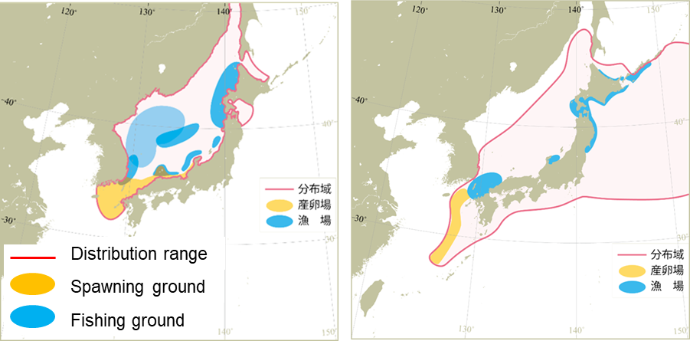
Autumn-spawning stock
Winter-spawning stock
Figure 3. Distribution ranges, spawning grounds, and fishing grounds of the autumn- and winter-spawning stocks. These figures were modified based on Miyahara et al. (2023) and Okamoto et al. (2023).

Autumn-spawning stock
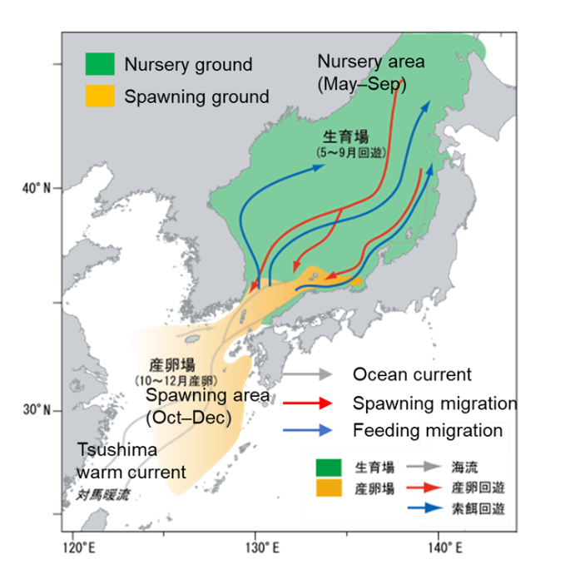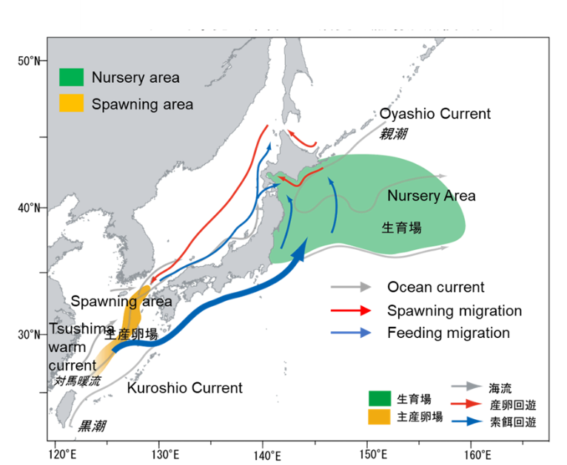
Winter-spawning stock
Figure 4. Seasonal migration of the autumn- and winter-spawning stocks. These figures were modified based on Miyahara et al. (2023) and Okamoto et al. (2023).

Stock Structure
There are distinct sub-populations (stocks) which spawn during different seasons (Murata 1990, Sakurai et al. 2013). The autumn-spawning stock is most abundance, followed by the winter-spawning stock which is distributed in the waters off eastern Japan Oyashio region (Sakurai et al. 2013, Miyahara et al. 2023, Okamoto et al. 2023). There is, in addition, minor stock of spring/summer spawned squid.

Life history
Maximum size thought to be 50 cm (mantle length) for females, smaller for males (Jereb and Roper 2010). Females are thought to mature around 20-25 cm (mantle length). The JFS lifespan is approximately one year (Murata 1990). JFS prey on myctophids, anchovies, crustaceans, gastropod larvae, and chaetognaths, and are preyed upon by rays and several marine mammals (Jereb and Roper 2010, Uchikawa and Kidokoro 2013).

Literature Cited
Bower, J. R., Nakamura, Y., Mori, K., Yamamoto, J., Isoda, Y., Sakurai, Y. (1999). Distribution of Todarodes pacificus (Cephalopoda: Ommastrephidae) paralarvae near the Kuroshio off southern Kyushu, Japan. Marine Biology, 135: 99–106.
Goto, T. (2002). Paralarval distribution of the ommastrephid squid Todarodes pacificus during fall in the southern Sea of Japan, and its implication for locating spawning grounds. Bulletin of Marine Science, 71: 299–312.
Jereb, P. and Roper, C. F. E. (2010) Cephalopods of the world. An annotated and illustrated catalogue of cephalopod species known to date. Volume 2. Myopsid and Oegopsid Squids.FAO Species Catalogue for Fishery Purposes. No. 4, Vol. 2. Rome, FAO. 328–332, https://www.fao.org/3/i1920e/i1920e.pdf
Miyahara, H., Okamoto, S., Nishijima, S., Matsukura, R., Matsui, H., Moriyama, T., Takasaki, K., Saito, T. and Inagake, D. (2023) Stock assessment and evaluation for autumn-spawning stock of Japanese flying squid (fiscal year 2022). Marine fisheries stock assessment and evaluation for Japanese waters. Japan Fisheries Agency and Japan Fisheries Research and Education Agency. Tokyo, 97pp, https://abchan.fra.go.jp/wpt/wp-content/uploads/2023/06/details_2022_19-Surume-A.pdf (in Japanese)
Murata, M. (1990) Oceanic resources of squids. Marine and Freshwater Behaviour and Physiology 18: 19–71
Nakamura, Y., Sakurai, Y. (1991) Validation of daily growth increments in statoliths of Japanese common squid Todarodes pacificus. Nippon Suisan Gakkaishi 57: 2007–2011
Okamoto, S., Miyahara, H., Matsui, H., Moriyama, T., Kurashima, A., Abo, J., Nishijima, S. and Setou, S. (2023) Stock assessment and evaluation for winter-spawning stock of Japanese flying squid (fiscal year 2022). Marine fisheries stock assessment and evaluation for Japanese waters. Japan Fisheries Agency and Japan Fisheries Research and Education Agency. Tokyo, 49pp, https://abchan.fra.go.jp/wpt/wp-content/uploads/2022/details_2022_18-Surume-W.pdf (in Japanese)
Okutani, T., and Watanabe, T. (1983). Stock assessment by larval surveys of the winter population of Todarodes pacificus Steenstrup (Cephalopoda: Ommastrephidae), with a review of early works. Biological Oceanography 2: 401–431.
Okutani, T. (2015). Cuttlefishes and Squids of the World, new edition. National Cooperative Association of Squid Processors. Tokyo, http://www.zen-ika.com/zukan/index-e.html
Sakurai, Y., Kidokoro, H., Yamashita, N., Yamamoto, J., Uchikawa, K., and Takahara, H. (2013). Todarodes pacificus, Japanese common squid. In: Rui, R, Ron, O. D, and Graham, P (eds) Advances in Squid Biology, Ecology and Fisheries. Part II Oegopsid Squids. Nova Biomedical, New York, 249–272.
Uchikawa, K., and Kidokoro, H. (2013). Feeding habits of juvenile Japanese common squid Todarodes pacificus: Relationship between dietary shift and allometric growth. Fisheries Research, 152: 29–36.
Yamamoto, J., Masuda, S., Miyashita, K., Uji, R., and Sakurai, Y. (2002). Investigation on the early stages of the Ommastrephid squid Todarodes pacificus near Oki Islands (Sea of Japan). Bulletin of Marine Science, 71: 897–992.

