NPFC-2024-TWG CMSA08-WP06 (Rev. 1)
Standardized abundance index for recruitment of chub mackerel from Northwest Pacific summer surveys up to 2023

Shota Nishijima, Yasuhiro Kamimura, Momoko Ichinokawa, and Ryuji Yukami
Fisheries Resources Institute, Japan Fisheries Research and Education Agency

Summary
We conducted CPUE standardization of surface trawl surveys in summer for Pacific chub mackerel using the Vector Autoregressive Spatio-Temporal (VAST) model. We estimated local densities of young-of-the-year fish in the Northwest Pacific from 2002 to 2023 with consideration for environmental factors of sea surface temperature (SST) and 50m-depth temperature as well as spatial autocorrelation. The analysis showed high levels of recruitment index have frequently occurred since 2013. Model diagnostics found no serious problems in residual patterns. We propose this standardized recruitment index to be used as the abundance index of age 0 fish in the Technical Working Group for the Chub Mackerel Stock Assessment (TWG CMSA).

1. BACKGROUND
Chub mackerel (Scomber japonicus) is a small pelagic species having high recruitment variability. Understanding the strength of recruitment is important to estimate the current and near-future stock abundance of chub mackerel. Japan Fisheries Research and Education Agency (FRA) has conducted a sea surface trawl net survey in a broad range of Northwestern Pacific Ocean (Fig. 1) from June to July annually to collect biological and abundance information on small pelagic fish including chub mackerel (here called summer survey). The survey area largely covers spatial distributions of young-of-the-year (YOY) fish of chub mackerel and, therefore, the catch rate or catch-per-unit effort (CPUE) can be used as a recruitment (i.e., age 0) index for CMSA.
Here, we updated the standardized CPUE values of the summer survey up to 2023. From the previous working paper (Nishijima et al. 2022), where we used the 'delta-GLM-tree' (Hashimoto et al. 2019) for CPUE standardization, we changed the analyzed model to the Vector Autoregressive Spatio-Temporal (VAST) model (Thorson 2019) in this paper because VAST was found to outperform the delta-GLM-tree in terms of Akaike Information Criterion (AIC) (Yukami et al. 2023). In the previous working paper (Nishijima et al. 2022), we used in-situ sea surface temperature (SST) and 50m-depth temperature (T50) as covariates, which were highly correlated. In this analysis, we instead used principal components (PC) calculated from principal component analysis (PCA) for SST and T50 as orthogonal covariates.

2. METHOD

2.1 The data
The sea surface trawl net surveys have been conducted by FRA in a broad range of the Northwestern Pacific in summer (June and July) annually (Fig. 1). This summer surveys have been conducted annually in the area approximately from 141.5º E to 170.0º W and from 32.0º to 45.0º N. We conducted CPUE standardization from 2002 to 2023. This survey began in 2001, but we removed the samples of 2001 from analyzed data because the number of stations and covered range in the beginning year were small (Tables 1 and 2, Fig. 1). The sweeping times per towing of sea surface trawl net, which was used as effort, is generally one hour (Table 1, Fig. 1A). The CPUEs (Fig. 1B, C) were calculated as the number of fish per hour of towing. The proportions of positive catch were low with a large interannual fluctuation (2−42%). We removed samples with no information on SST or T50 from the analyzed data (Table 2). The final sample size was 2,916.

2.2 Associations between independent variables and between dependent and independent variables
SST and T50 were highly correlated with r = 0.69 of Pearson’s correlation coefficient (Fig. 2, left). Such collinearity in multiple regression models could destabilize parameter estimates and prediction to new data, suggesting that it might be problematic in the interpretation of results and model predictions in CPUE standardization. Therefore, we conducted the PCA and used PC1 and PC2 calculated from the analysis as orthogonal covariates (Fig. 2, right). PC1 was negatively correlated with SST and T50, indicating a common component of SST and T50. By contrast, PC2 was positively correlated with SST but negatively with T50, reflecting a difference between SST and T50. The proportion of variance of PC1 and PC2 were 84.3% and 15.7%, respectively (Fig. 2).
We found that SST, T50, PC1, and PC2 did not show any systematic patterns over the years (Fig. 3). SST and T50 tended to be higher in the south than in the north (Fig. 4A, B). PC1, which was negatively correlated with SST and T50, was thus higher in the north (Fig. 4C). PC2 tended to be higher off the Pacific coast of Japan (Fig. 4D). Accordingly, PC1 and PC2 represented the north-south and east-west gradients, respectively.

2.3 Full model description and model selection
We used the VAST model for the CPUE standardization of age 0 fish in the summer survey. In simulations, VAST demonstrated superior overall performance in CPUE standardization compared to generalized linear models or generalized additive models (Grüss et al. 2019). In VAST, the survey CPUE is represented using two linear predictors for each sample i: the encounter probability (p₁(i)) and the density (or CPUE) when encountered (p₂(i)).
$$p_{1}\left(i\right)=β_{1}\left(t_{i}\right)+ω_{1}\left(s_{i}\right)+ε_{1}\left(s_{i},t_{i}\right)+\sum_{k_{1}}^{n_{k1}}{λ_{1}\left(k_{1}\right)Q_{i}\left(i,k_{1}\right) }$$ | (1)
$$p_{2}\left(i\right)=β_{2}\left(t_{i}\right)+ω_{2}\left(s_{i}\right)+ε_{2}\left(s_{i},t_{i}\right)+\sum_{k_{2}}^{n_{k2}}{λ_{2}(k_{2})Q_{i}(i,k_{2})}$$ | (2)
The first term on the right-hand side, $β\left(t_{i}\right)$, represents the coefficient indicating the effect of survey year t. The second term, $ω\left(s_{i}\right)$, signifies the spatial random effect for survey year t, while the third term, $ε\left(s_{i},t_{i}\right)$, denotes the spatiotemporal random effect for survey year t and location s. The fourth term represents the covariate Q influencing catchability, with its corresponding coefficient λ. In the VAST model, initially, spatial distribution is approximated by determining knots through a form of clustering called k-means from spatial information. The spatiotemporal variation in relative density at these knots is then modeled. Previous studies recommend using 100 or more knots (Thorson 2019), and following this guidance, we selected 100 knots for this study. The probability density function for spatial effects is modeled using a multivariate normal distribution (MVN):
$$ω_{1}\left(∙,f\right)\sim MVN\left(0,R_{1}\right), ω_{2}\left(∙,f\right)\sim MVN\left(0,R_{2}\right) ,$$ | (3)
where R₁ and R₂ is the Matérn correlation function:
$$R_{1}\left(s_{n},s_{m}\right)=\frac{1}{2^{φ-1}Γ(φ)}×{\left(κ_{1}\left|d\left(s_{n},s_{m}\right)H\right|\right)}^{φ}×K_{υ}\left(κ_{1}\left|d\left(s_{n},s_{m}\right)H\right|\right) ,$$ | (4)
$$R_{2}\left(s_{n},s_{m}\right)=\frac{1}{2^{φ-1}Γ(φ)}×{\left(κ_{2}\left|d\left(s_{n},s_{m}\right)H\right|\right)}^{φ}×K_{υ}\left(κ_{2}\left|d\left(s_{n},s_{m}\right)H\right|\right) .$$ | (5)
In VAST, the parameter $φ$ is not estimated, but rather fixed at $φ=1$. Here, $Γ$ represents the gamma function, K_{ν} is the modified Bessel function of the second kind, $κ_{1}$ and $κ_{2}$ are decorrelation rate to be estimated, $d\left(s_{n},s_{m}\right)$ is the distance between knots, and H is the matrix representing geographical anisotropy (variation in correlation depending on the direction). However, geographical anisotropy was not assumed ($H=I$) due to challenges in estimation. Similarly, the probability density function for spatiotemporal effects is given as follows:
$$ε_{1}\left(∙,f,t\right)\sim \left\{\begin{matrix}MVN(0,R_{1}) & if t=1 \\ MVN(ρ_{ε1}ε_{1}\left(∙,f,t-1\right),R_{1}) & if t>1\end{matrix}\right. ,$$ | (6)
$$ε_{2}\left(∙,f,t\right)\sim \left\{\begin{matrix}MVN(0,R_{2}) & if t=1 \\ MVN(ρ_{ε2}ε_{2}\left(∙,f,t-1\right),R_{2}) & if t>1\end{matrix}\right. .$$ | (7)
As part of the default settings in VAST, the effects for each year (β) were estimated as fixed effects, and the spatiotemporal effects were assumed to be independent ($ρ_{ε1}=ρ_{ε2}=0$).
In the analysis, a delta-type model employing the binomial distribution and gamma distribution was utilized. The predicted encounter rate (r₁(i)) and predicted CPUE when encountered (r₂(i)) were expressed using the following equations (Thorson 2017):
$$r_{1}\left(i\right)={logit}^{-1}p_{1}\left(i\right) ,$$ | (8)
$$r_{2}\left(i\right)=a_{i}×\log^{-1}p_{2}\left(i\right) .$$ | (9)
Although the term a_{i} represents the offset variable, it was set to 1 with CPUE as the dependent variable. The probability of observing CPUE is expressed as follows, and the parameters that maximize the marginal likelihood were estimated.
$$\operatorname{Pr}\left(b_{i}=B\right)=\left\{\begin{matrix}1-r_{1}\left(i\right) & if B=0 \\ r_{1}\left(i\right)×g\{\left.B|r_{2}\left(i\right),σ_{m}^{2}\}\right. & if B>0\end{matrix}\right.$$ |  | (10)
The parameters of the aforementioned model are estimated using the maximum likelihood method. In this document, we used the ‘VAST’ package distributed by GitHub (https://github.com/James-Thorson-NOAA/VAST, Thorson 2019), where complex computations involving integrals due to the involvement of numerous random effects are efficiently analyzed using a software called Template Model Builder (Kristensen et al. 2016).
The covariate Q, influencing catchability, includes PC1, PC2, the square terms of PC1 and PC2, and interaction terms between PC1 and PC2 (Table 3). Model selection was conducted using exhaustive search based on Akaike Information Criterion with correction (AICc).

2.4 Yearly trend extraction
The abundance index was calculated by employing the model with minimum AICc. In VAST, the density for each year (t) and each knot (s) is computed as $d\left(s,t\right)=r_{1}^{*}(s,t)×r_{2}^{*}(s,t)$, where r* is obtained using equations 8 and 9 from equations 1 and 2, excluding the fourth term regarding catchability. The abundance is then determined by summing the product of the area ($a\left(s\right)$) and the density for each knot. Since the density is represented by CPUE (individuals/hour) in this analysis, the standardized CPUE (individuals/hour) was calculated by dividing the sum by the total area.
$$I\left(t\right)=\frac{\sum_{s=1}^{n_{s}}{\left(a(s)×d\left(s,t\right)\right)}}{\sum_{s=1}^{n_{S}}{a(s)}}$$ | (11)
The total sum of the areas for each knot remains constant across years; therefore, this procedure does not alter the relative trends of the standardized index values.

3. RESULT and DISCUSSION
As a result of model selection, for the best model, all variables were chosen in the binomial distribution part, whereas in the gamma distribution, only the linear effects of PC1 and PC2 were selected (Table 4). The maximum likelihood estimates and standard errors of fixed-effect parameters did not exhibit extreme values, and the gradients were all close to zero (Table 5). The percent deviance explained was 57.5%.
We generated scaled residuals using the R package ‘DHARMa’ (Hartig 2022) for model diagnostics. This package enables to simulate the scaled residuals which should theoretically follow the uniform distribution from zero to one. As a result, the QQ plot and the Kolmogorov-Smirnov test showed that the scaled residuals were not significantly deviated from the theoretical prediction of the uniform distribution (Fig. 6). Moreover, the scaled residuals were almost constant in response to varying predicted CPUE and dependent variables (PC1, PC2 and year) (Fig. 6). It also seemed that there were no systematic spatial patterns in the scaled residuals (Fig. 7).
Estimated densities of YOY fish were low until 2012, but increased thereafter (Fig. 8). The centroid of fish distributions was relatively constant over the years, averaging 157.4º E and 39.2º N. The partial dependence plot showed that the probability of positive catch exhibited concave-down responses to PC1 and PC2 (Fig. 9). Regarding CPUE when encountered, a negative response was observed for PC1, while a positive response was observed for PC2. Assuming that the original variables SST and T50 change “independently,” the responses to changes in each variable were examined through partial dependence plots. As a result, it was indicated that SST had a greater influence than T50 (Fig. 9). The probability of positive catch peaked around 17.5°C for SST, while CPUE when encountered during fishing showed a positive response to SST. Therefore, the combined prediction suggested that the expected CPUE is highest at temperatures exceeding 20°C.
Standardized CPUE remained low until 2012, but high values were frequently observed since 2013 (Fig. 10). Especially in 2013, 2018, and 2021, the values were the highest, but compared to those, the values for the past two years (2022-2023) are not as elevated. This yearly trend of the standardized CPUE was not greatly different from that of the nominal CPUE. The coefficient of variation (CV) of the standardized CPUE was in the range of 0.24−0.49 for all years except 2006, when the standardized CPUE was the lowest with an exceptionally high CV (0.62) (Table 6).
The standardized index obtained from this analysis cover a long time series from periods of poor chub mackerel recruitment in the Pacific to times of high recruitment. This provides highly valuable information for CMSA. In addition to covering a broad survey area, the use of the cutting-edge VAST model and favorable results from model diagnostics make these standardized index particularly useful. Therefore, we propose utilizing the standardized index from the summer survey as an index of recruitment for the chub mackerel stock assessment in TWG CMSA.

4. REFERENCES
Grüss, A., J. F. Walter III, E. A. Babcock, F. C. Forrestal, J. T. Thorson, M. V. Lauretta and M. J. Schirripac (2019) Evaluation of the impacts of different treatments of spatio-temporal variation in catch-per-unit-effort standardization models. Fish. Res., 213, 75–93.
Hartig, F. (2022) DHARMa: Residual Diagnostics for Hierarchical (Multi-Level/Mixed) Regression Models. R package version 0.4.5. https://CRAN.R-project.org/package=DHARMa.
Hashimoto, M., S. Nishijima, R. Yukami, C. Watanabe, Y. Kamimura, S. Furuichi, M. Ichinokawa, and H. Okamura. 2019. Spatiotemporal dynamics of the Pacific chub mackerel revealed by standardized abundance indices. Fisheries Research 219:105315.
Kristensen, K., A. Nielsen, C. E. Berg, H. Skaug and B. M. Bell (2016) TMB: automatic differentiation and Laplace approximation. J. Stat. Softw., 70, 1–21.
Thorson, J. T. (2017) Three problems with the conventional delta-model for biomass sampling data, and a computationally efficient alternative. Can. J. Fish. Aquat. Sci., 75, 1369-1382.
Thorson, J. T. (2019) Guidance for decisions using the Vector Autoregressive Spatio-Temporal (VAST) package in stock, ecosystem, habitat and climate assessments. Fish. Res., 210, 143-161.
Yukami R., Nishijima S., Kamimura Y., Furuichi S., Watanabe R. (2023) Stock assessment and evaluation for the Pacific stock of chub mackerel (fiscal year 2022). Marine fisheries stock assessment and evaluation for Japanese waters. Japan Fisheries Agency and Japan Fisheries Research and Education Agency, Tokyo, 79pp, https://abchan.fra.go.jp/wpt/wp-content/uploads/2023/04/details_2022_05.pdf
Nishijima, S., Kisara Y., Ichinokawa M., Yukami R., Kamimura Y., Manabe A. (2022) Standardizing abundance index for recruitment of chub mackerel in the Northwet Pacific. NPFC-2022-TWG CMSA06-WP11 (Rev. 1).

Table 1
Catch and effort information by SURVEY FLEET.
Year | Number of observations (stations) | Total sweeping time (h) | Total swept area (km²) | Total catch (ind) | Number of observations with positive catch | Percentage of positive catch (%)
2001 | 58 | 59.00 | 12.02 | 113.5 | 9 | 15.52
2002 | 93 | 93.00 | 18.26 | 259.0 | 17 | 18.28
2003 | 157 | 155.37 | 30.55 | 4063.8 | 15 | 9.55
2004 | 179 | 178.50 | 36.35 | 21262.5 | 24 | 13.41
2005 | 164 | 162.95 | 31.12 | 2389.0 | 16 | 9.76
2006 | 163 | 162.63 | 30.19 | 39.0 | 3 | 1.84
2007 | 155 | 154.50 | 29.58 | 36441.0 | 24 | 15.48
2008 | 169 | 169.00 | 33.08 | 6024.0 | 16 | 9.47
2009 | 168 | 168.02 | 39.43 | 5568.0 | 25 | 14.88
2010 | 126 | 126.18 | 24.88 | 2504.0 | 18 | 14.29
2011 | 97 | 97.00 | 17.48 | 363.5 | 12 | 12.37
2012 | 135 | 134.85 | 25.12 | 4745.5 | 20 | 14.81
2013 | 125 | 122.48 | 26.27 | 183151.5 | 17 | 13.60
2014 | 122 | 108.95 | 20.29 | 884.8 | 5 | 4.10
2015 | 121 | 121.00 | 22.99 | 4358.6 | 19 | 15.70
2016 | 122 | 121.47 | 22.73 | 81005.6 | 32 | 26.23
2017 | 129 | 128.65 | 24.18 | 68441.9 | 18 | 13.95
2018 | 104 | 97.93 | 18.74 | 192845.9 | 23 | 22.12
2019 | 134 | 134.00 | 28.27 | 9998.5 | 26 | 19.40
2020 | 67 | 66.20 | 11.53 | 29231.4 | 28 | 41.79
2021 | 143 | 136.45 | 32.21 | 250694.6 | 60 | 41.96
2022 | 156 | 154.61 | 30.76 | 100144.9 | 55 | 35.26
2023 | 143 | 142.77 | 28.44 | 41228.2 | 53 | 35.33

Table 2
Filtering "rules" used on data for CPUE standardization and the effect on the overall sample size.
Filter Applied | Number of Records Remaining | Number Removed | Number of Records with Chub Mackerel Catch >0
Initial Data set | 3,030 | - | 535
Remove data in 2001 | 2,972 | 58 | 526
Remove data with no SST | 2,970 | 2 | 526
Remove data with no 50m-depth temperature | 2,916 | 54 | 524

Table 3
Summary of explanatory variables used in VAST.
Variable | Symbol¹ | Number of categories | Detail | Note
Year | $$β\left(t\right)$$ | 22 | 2002-2023 | Categorical variable with fixed effect
Spatial | $$ω\left(s\right)$$ | - | Average over years | Estimated as random effects by SPDE approximation
Spatio-temporal | $$ε\left(s,t\right)$$ | - | Assume independence of each year | Estimated as random effects by SPDE approximation
PC1 | $$λ(k)Q_{i}(i,k))$$ | - | Negative correlation for SST and T50 | Continuous variable as a catchability covariate
PC1 squared | $$λ(k)Q_{i}(i,k))$$ | - | Squared PC1 | Continuous variable as a catchability covariate
PC2 | $$λ(k)Q_{i}(i,k))$$ | - | Positive correlation for SST and negative correlation for T50 | Continuous variable as a catchability covariate
PC2 squared | $$λ(k)Q_{i}(i,k))$$ | - | Squared PC1 | Continuous variable as a catchability covariate
PC1 X PC2 | $$λ(k)Q_{i}(i,k))$$ | - | Interaction between the two PC axes | Continuous variable as a catchability covariate
1: See equations 1-2.

Table 4
Top 20 models from the lowest AICc. B: selected by the binomial-distribution model. G: selected by the Gamma-distribution model.
Rank | PC1 | PC1 squared | PC2 | PC2 squared | PC1×PC2 | Df | logLik | AICc | ΔAICc
1 | B,G | B | B,G | B | B | 58 | -4245.74 | 8609.88 | 0.00
2 | B,G | B | B,G | B,G | B | 59 | -4244.84 | 8610.17 | 0.28
3 | B,G | B,G | B,G | B | B | 59 | -4245.13 | 8610.73 | 0.85
4 | B,G | B,G | B,G | B,G | B | 60 | -4244.28 | 8611.13 | 1.24
5 | B,G | B | B,G |  | B | 57 | -4247.43 | 8611.17 | 1.29
6 | B,G | B | B,G | G | B | 58 | -4246.53 | 8611.45 | 1.57
7 | B,G | B | B,G | B,G | B,G | 60 | -4244.62 | 8611.80 | 1.92
8 | B,G | B | B,G | B | B,G | 59 | -4245.74 | 8611.96 | 2.08
9 | B,G | B,G | B,G |  | B | 58 | -4246.81 | 8612.02 | 2.13
10 | B,G | B,G | B,G | G | B | 59 | -4245.97 | 8612.41 | 2.53
11 | B,G | B,G | B,G | B | B,G | 60 | -4244.96 | 8612.49 | 2.61
12 | B,G | B | B,G | G | B,G | 59 | -4246.30 | 8613.09 | 3.20
13 | B,G | B,G | B,G | B,G | B,G | 61 | -4244.27 | 8613.19 | 3.30
14 | B,G | B | B,G |  | B,G | 58 | -4247.43 | 8613.25 | 3.36
15 | B,G | B,G | B,G |  | B,G | 59 | -4246.65 | 8613.77 | 3.89
16 | B,G | B,G | B,G | G | B,G | 60 | -4245.95 | 8614.47 | 4.59
17 | B,G | B | B | B | B | 57 | -4251.96 | 8620.24 | 10.36
18 | B,G | B,G | B | B | B | 58 | -4251.46 | 8621.31 | 11.43
19 | B,G | B | B |  | B | 56 | -4253.65 | 8621.53 | 11.64
20 | B | B | B,G | B | B | 57 | -4252.66 | 8621.64 | 11.76

Table 5
Maximum likelihood estimates (MLE), standard errors (SE), and final gradients of parameters.
Parameter | MLE | SE | final gradient
beta1_ft | -2.8571 | 0.9579 | -6.33E-14
beta1_ft | -4.2039 | 0.9793 | -5.21E-14
beta1_ft | -3.0712 | 0.9290 | 1.24E-13
beta1_ft | -3.7521 | 0.9557 | -1.71E-13
beta1_ft | -6.2573 | 1.1449 | -4.33E-15
beta1_ft | -3.6719 | 0.9475 | 8.20E-14
beta1_ft | -4.5966 | 1.0348 | -2.54E-13
beta1_ft | -3.8237 | 0.9597 | 6.44E-14
beta1_ft | -3.1805 | 0.9538 | 1.45E-13
beta1_ft | -4.1161 | 1.0008 | -3.65E-14
beta1_ft | -3.0843 | 0.9551 | -9.30E-14
beta1_ft | -3.4173 | 0.9637 | -6.01E-14
beta1_ft | -4.9910 | 1.0696 | -6.74E-14
beta1_ft | -2.3064 | 0.9161 | -1.36E-13
beta1_ft | -2.1048 | 0.9329 | -4.23E-14
beta1_ft | -3.0155 | 0.9749 | -3.60E-14
beta1_ft | -1.9863 | 0.9655 | -3.36E-14
beta1_ft | -2.4807 | 0.9276 | 5.92E-13
beta1_ft | -1.1856 | 1.0018 | 1.19E-13
beta1_ft | -0.6474 | 0.9005 | 1.31E-14
beta1_ft | -1.2255 | 0.8967 | -1.02E-13
beta1_ft | -1.5886 | 0.9225 | 3.85E-14
lambda1_k | -1.3860 | 0.1446 | 2.53E-14
lambda1_k | -0.5164 | 0.0572 | 1.75E-12
lambda1_k | 1.0851 | 0.2749 | 2.03E-13
lambda1_k | -0.2895 | 0.1580 | -1.79E-13
lambda1_k | 0.6729 | 0.1428 | -1.42E-13
L_omega1_z | 1.3090 | 0.2095 | -3.25E-12
L_epsilon1_z | 0.8462 | 0.2275 | -1.19E-11
logkappa1 | -6.0160 | 0.2457 | 5.52E-12
beta2_ft | 2.4779 | 0.8127 | -1.89E-14
beta2_ft | 2.3787 | 0.9195 | -3.71E-14
beta2_ft | 3.4005 | 0.7891 | 4.13E-14
beta2_ft | 2.8643 | 0.8893 | -7.39E-14
beta2_ft | 1.2898 | 1.3771 | -2.86E-14
beta2_ft | 4.3055 | 0.8267 | 6.66E-14
beta2_ft | 3.1118 | 1.0187 | -3.42E-14
beta2_ft | 2.3441 | 0.8153 | 9.77E-15
beta2_ft | 2.4023 | 0.8207 | -2.93E-14
beta2_ft | 1.4446 | 0.9135 | 1.18E-14
beta2_ft | 3.1280 | 0.8382 | -6.62E-14
beta2_ft | 6.9496 | 0.9578 | 4.15E-14
beta2_ft | 2.9244 | 1.1768 | 1.59E-14
beta2_ft | 4.6525 | 0.7885 | -1.85E-13
beta2_ft | 5.7202 | 0.7667 | 3.69E-14
beta2_ft | 5.5932 | 0.9290 | 2.38E-14
beta2_ft | 7.1439 | 0.7954 | 3.33E-14
beta2_ft | 4.2283 | 0.7390 | 3.15E-14
beta2_ft | 5.5646 | 0.8107 | -9.77E-14
beta2_ft | 6.4028 | 0.6756 | 5.77E-14
beta2_ft | 5.2075 | 0.6484 | 2.40E-14
beta2_ft | 4.2823 | 0.7125 | 7.37E-14
lambda2_k | -0.5695 | 0.1507 | 1.71E-13
lambda2_k | 0.7920 | 0.2250 | -1.05E-13
L_omega2_z | 1.6169 | 0.3353 | 4.92E-12
L_epsilon2_z | 1.4044 | 0.3259 | -7.39E-12
logkappa2 | -4.9461 | 0.3311 | 1.03E-11
logSigmaM | 0.4450 | 0.0350 | -2.67E-11

Table 6
Nominal and standardized CPUE with CV and 95% CI from 2002 to 2023.
Year | Nominal (ind/h) | Standardized (ind/h) | CV | Lower 95%CI | Upper 95%CI
2002 | 2.94 | 9.75 | 0.39 | 1.83 | 51.94
2003 | 26.22 | 5.88 | 0.35 | 1.59 | 21.72
2004 | 132.07 | 49.22 | 0.33 | 15.34 | 157.98
2005 | 15.31 | 8.85 | 0.37 | 2.01 | 39.00
2006 | 0.24 | 0.25 | 0.62 | 0.01 | 4.26
2007 | 236.63 | 45.35 | 0.34 | 11.81 | 174.17
2008 | 37.65 | 6.20 | 0.40 | 1.22 | 31.43
2009 | 33.33 | 9.85 | 0.28 | 3.75 | 25.90
2010 | 19.97 | 11.46 | 0.36 | 2.78 | 47.30
2011 | 3.75 | 2.12 | 0.36 | 0.50 | 8.90
2012 | 35.95 | 23.76 | 0.32 | 6.93 | 81.49
2013 | 1443.45 | 974.09 | 0.43 | 177.92 | 5333.00
2014 | 14.03 | 5.89 | 0.49 | 0.73 | 47.43
2015 | 36.02 | 104.11 | 0.38 | 21.78 | 497.80
2016 | 663.42 | 499.73 | 0.30 | 160.72 | 1553.78
2017 | 543.68 | 492.72 | 0.31 | 168.96 | 1436.87
2018 | 2382.26 | 2665.93 | 0.32 | 848.68 | 8374.38
2019 | 74.62 | 96.33 | 0.32 | 29.20 | 317.73
2020 | 443.27 | 456.79 | 0.36 | 106.64 | 1956.65
2021 | 2077.32 | 1898.33 | 0.25 | 777.15 | 4637.02
2022 | 642.11 | 250.71 | 0.24 | 104.26 | 602.90
2023 | 288.17 | 153.54 | 0.35 | 42.70 | 552.14

Figure 1A
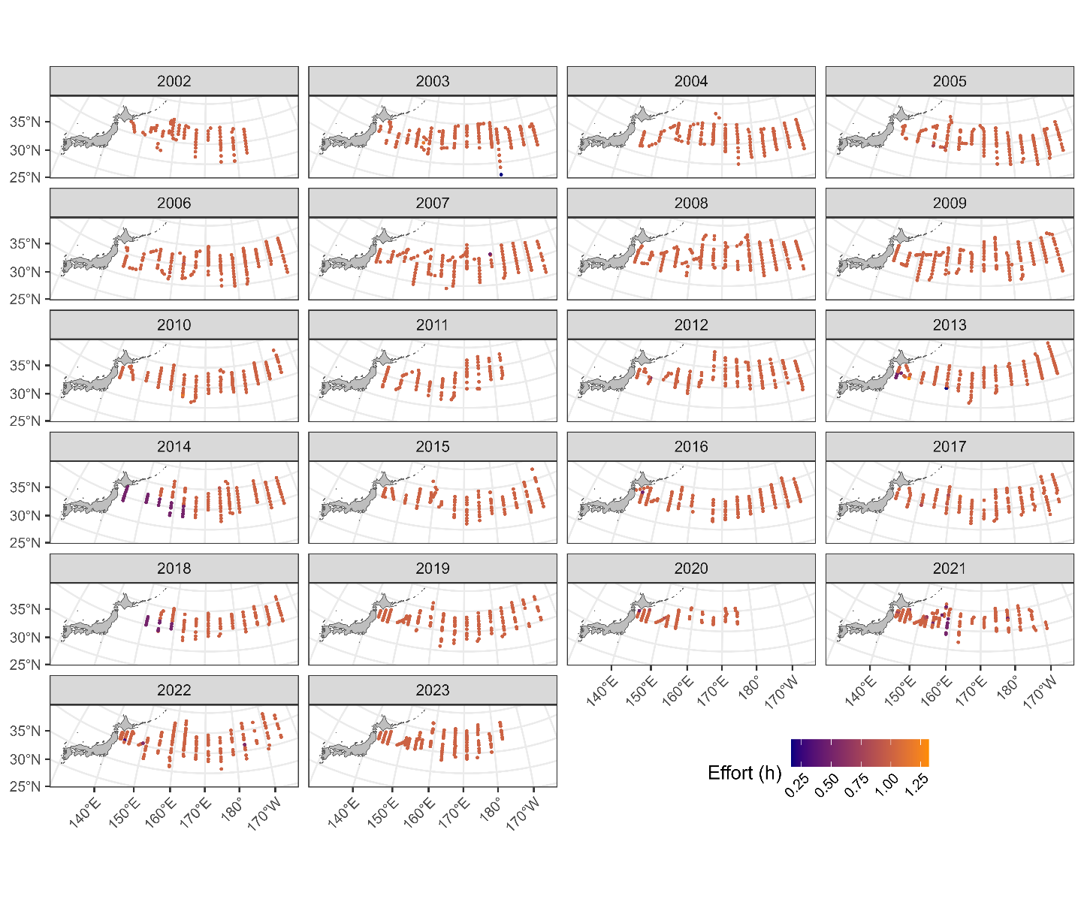
Map of summer survey stations from 2002 to 2023. Colors indicate sweeping time.

Figure 1B
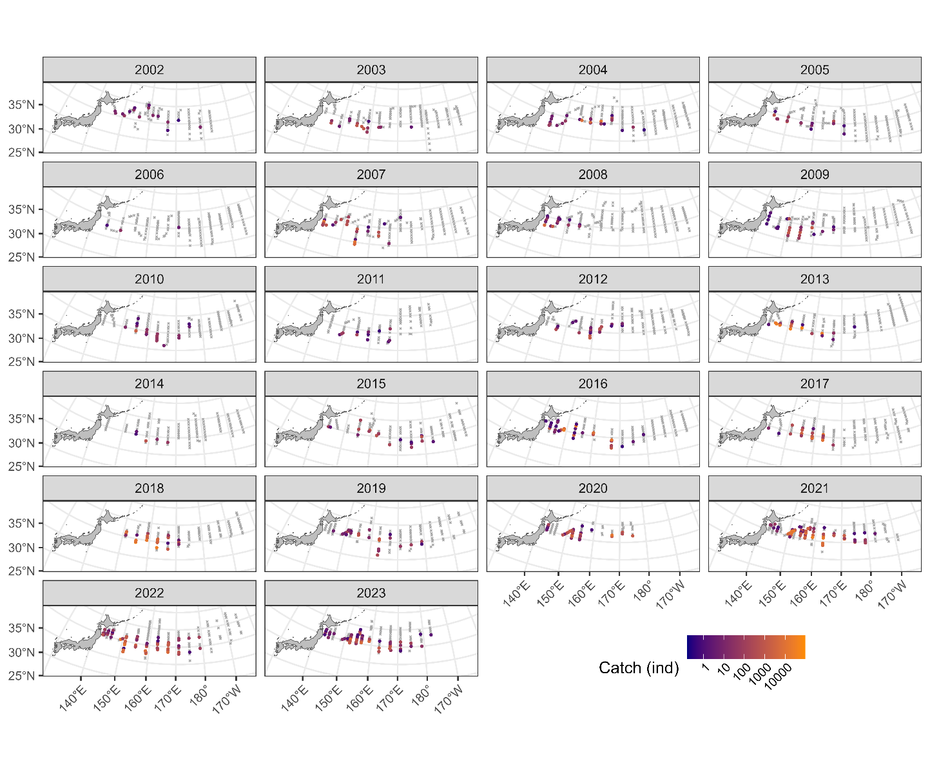 Map of catch amounts from 2002 to 2023 in the summer survey. The gray X indicates zero catch while the colors of circles indicate the amount of positive catch.

Figure 1C
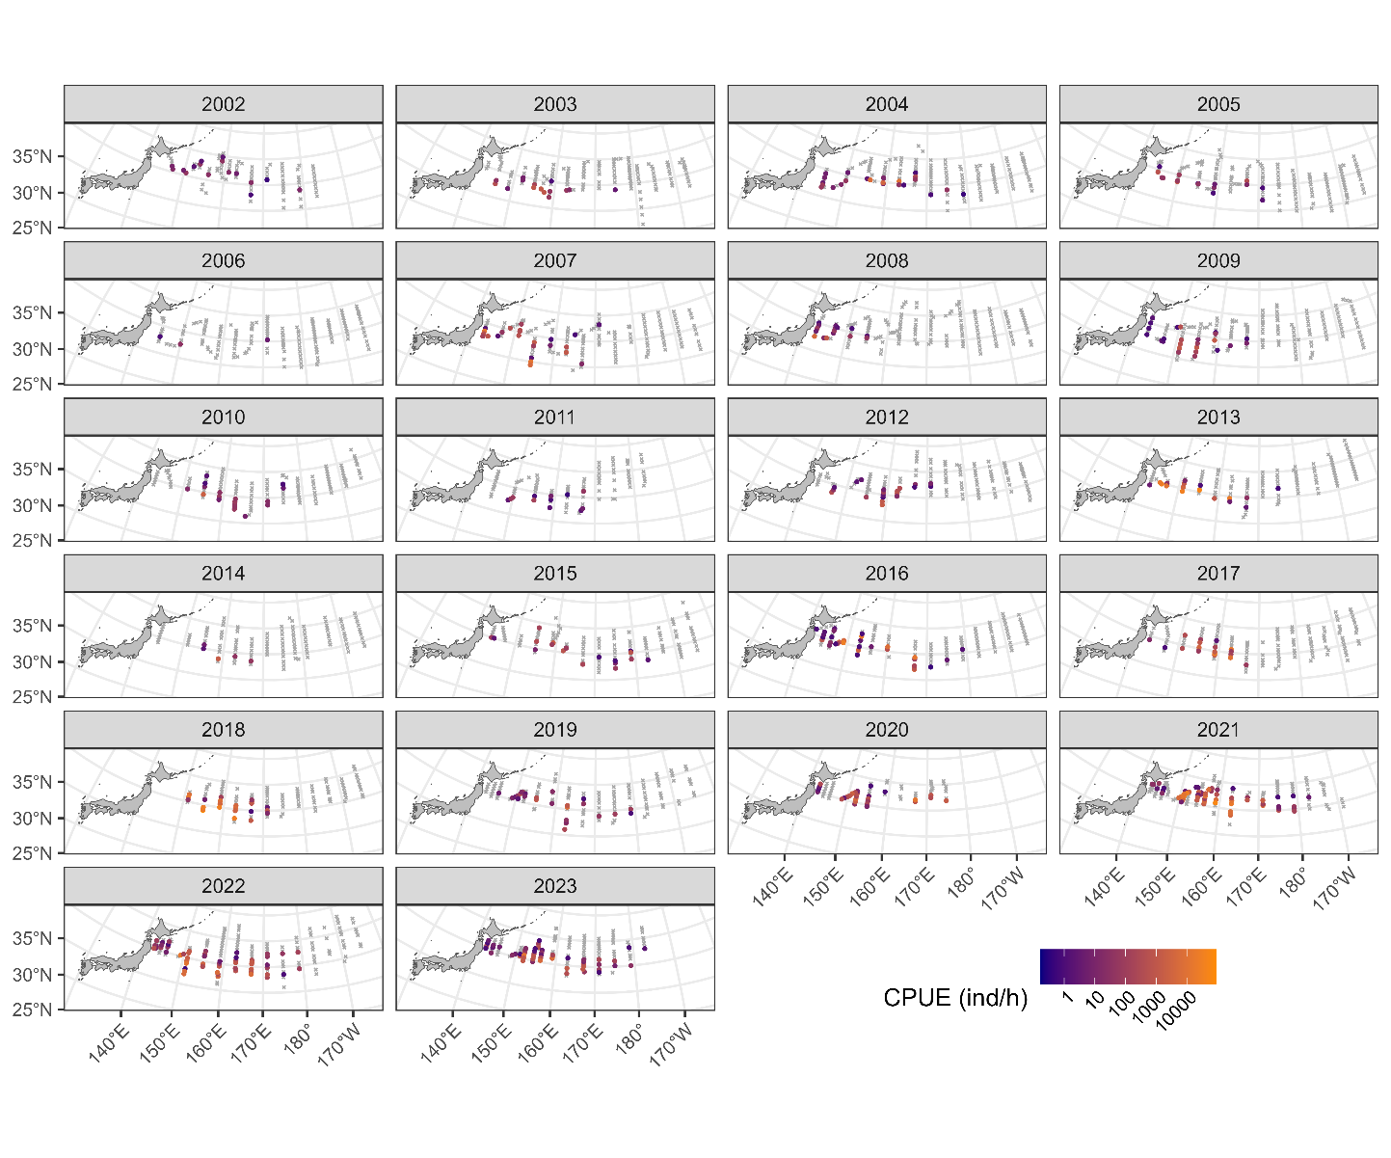
Map of CPUE from 2002 to 2023 in the summer survey. The gray X indicates zero catch while the colors of circles indicate the amount of positive catch.

Figure 2
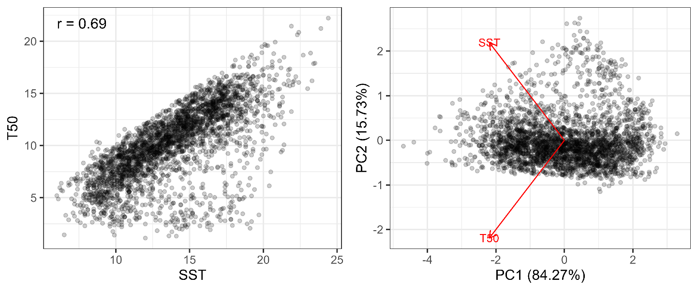
(left) Relationship between SST and T50. The Pearson’s correlation coefficient is shown at the upper-left corner. (right) Relationship between PC1 and PC2 along with the directions of SST and T50. The proportions of variance in each component are shown in the axis labels.

Figure 3
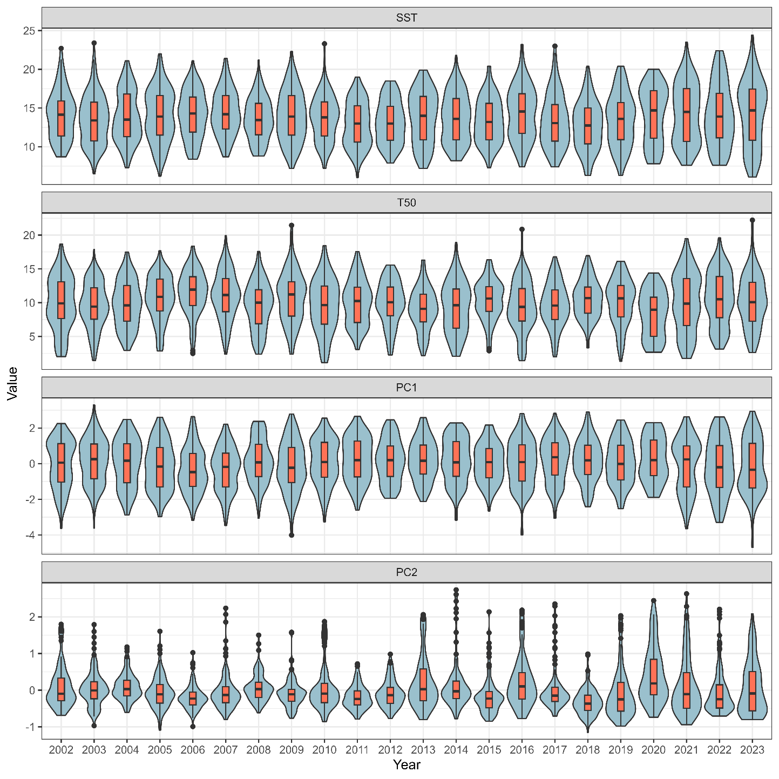
Relationships between year and each of SST, T50, PC1, and PC2 (see Fig. 2).

Figure 4A
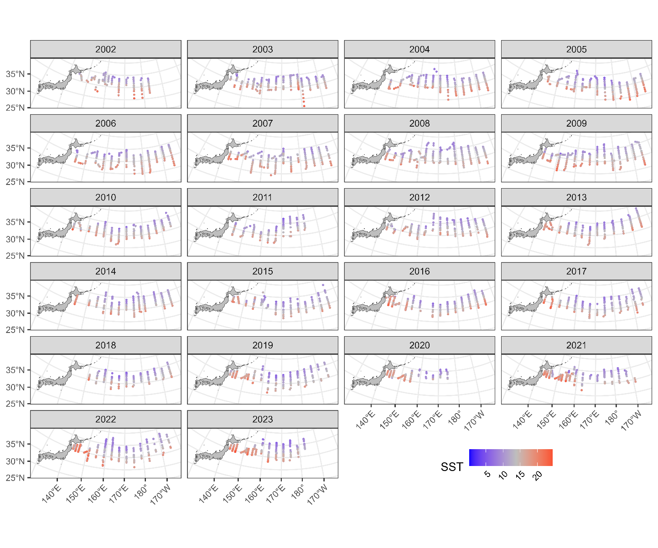
Map of SST from 2002 to 2023.

Figure 4B
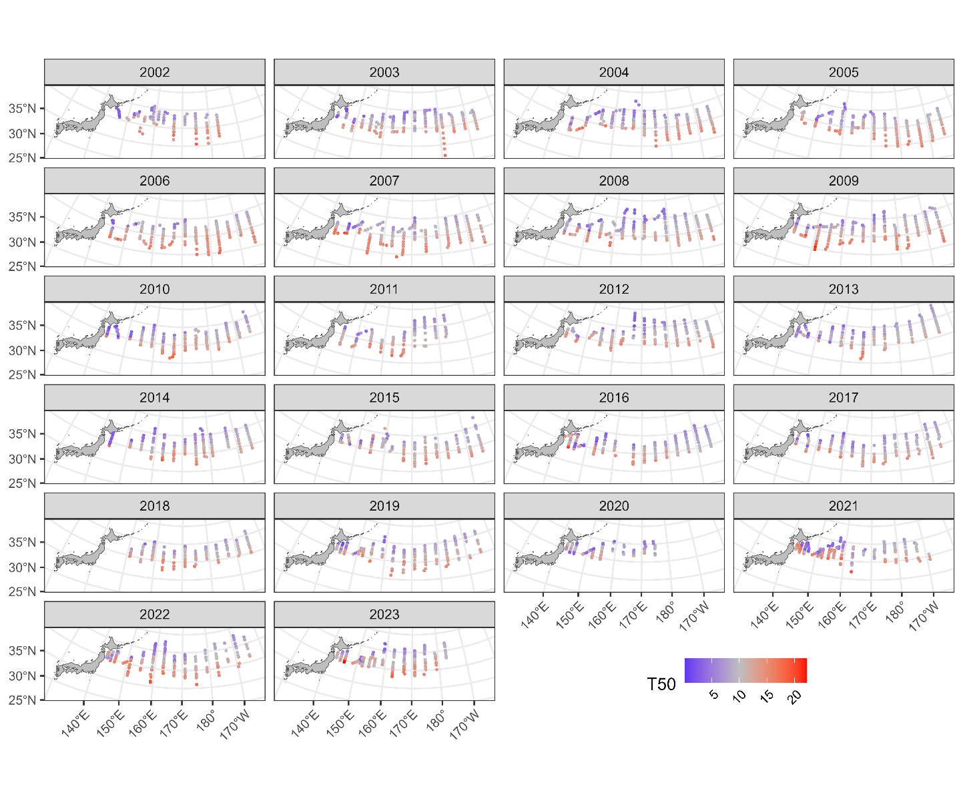
Map of T50 (50m depth temperature) from 2002 to 2023.

Figure 4C
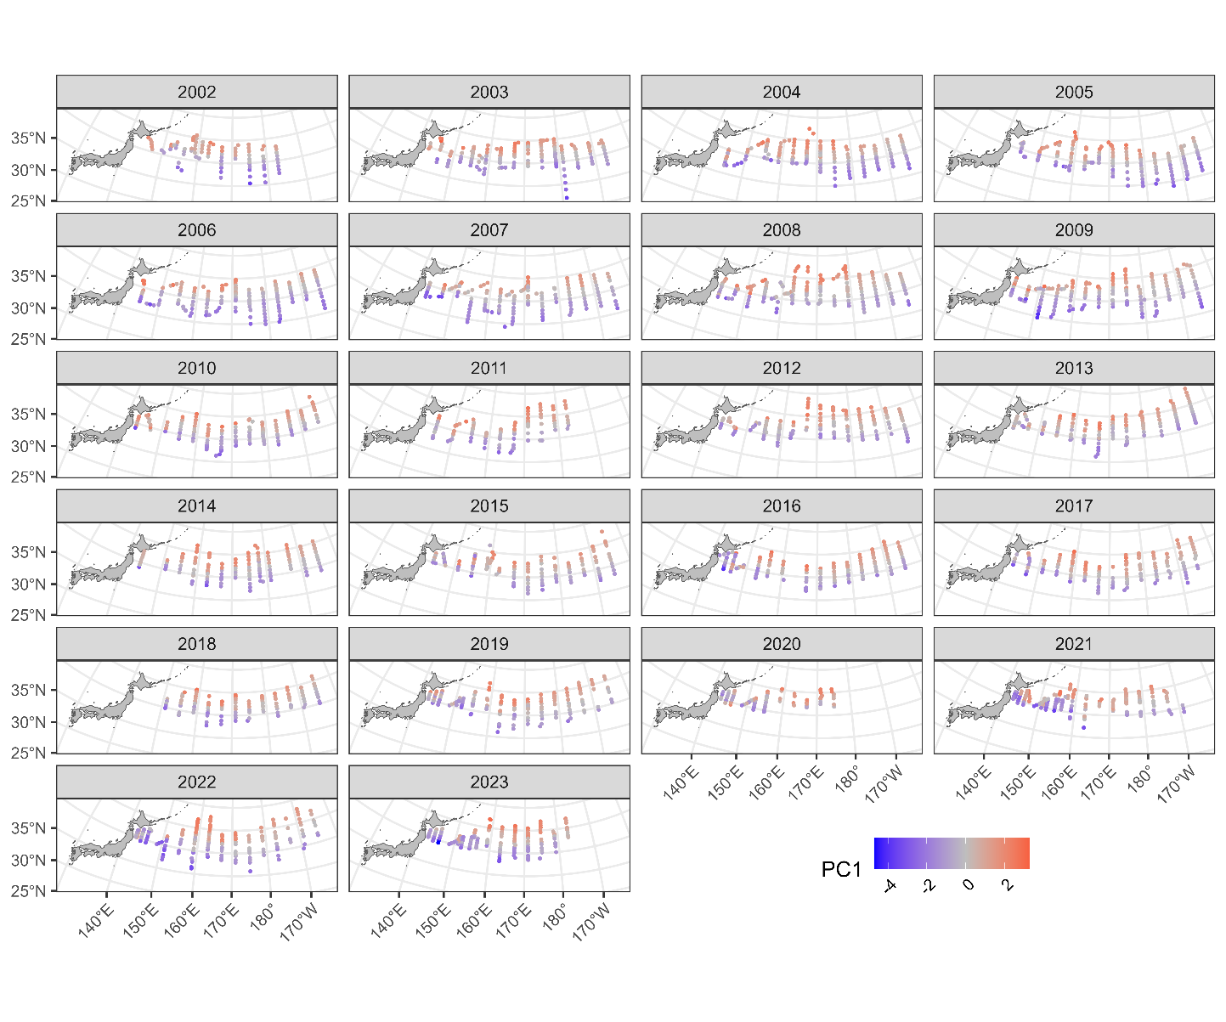
Map of PC1 (see Fig. 2) from 2002 to 2023.

Figure 4D
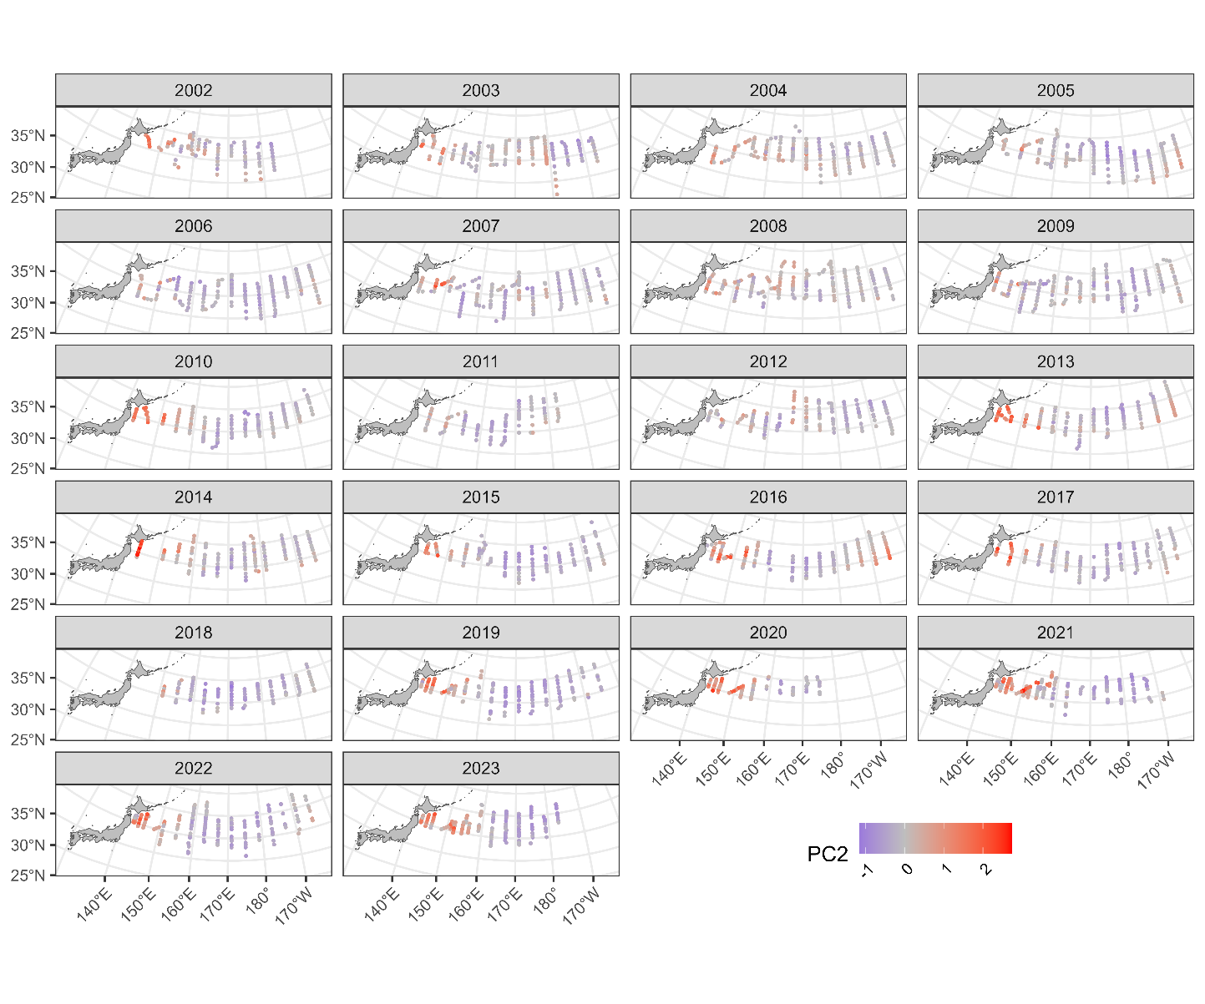
Map of PC2 (see Fig. 2) from 2002 to 2023.

Figure 5
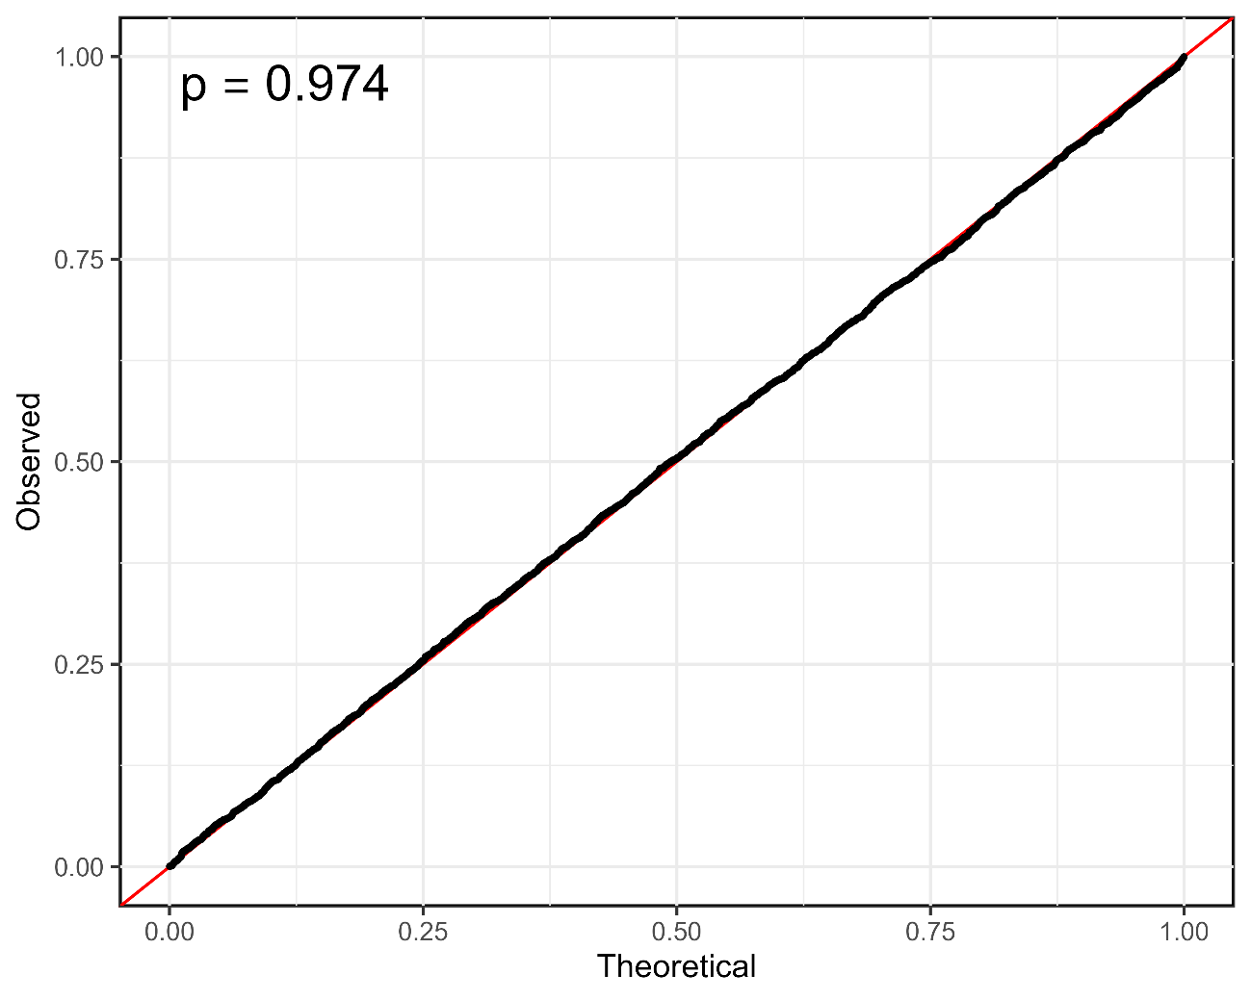
QQ plot along with p value in the Kolmogorov-Smirnov test at the upper-left corner.

Figure 6
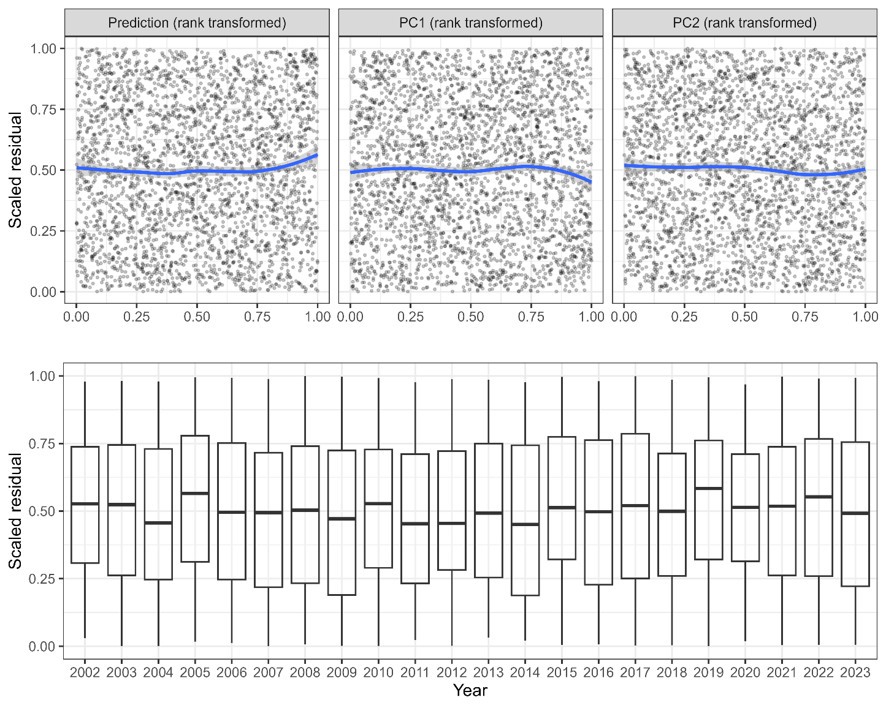
Relationships between scaled residuals and the selected variables or predicted CPUE. Continuous variables are all rank-transformed. Smooth curves in blue for the upper panels are described by LOESS.

Figure 7
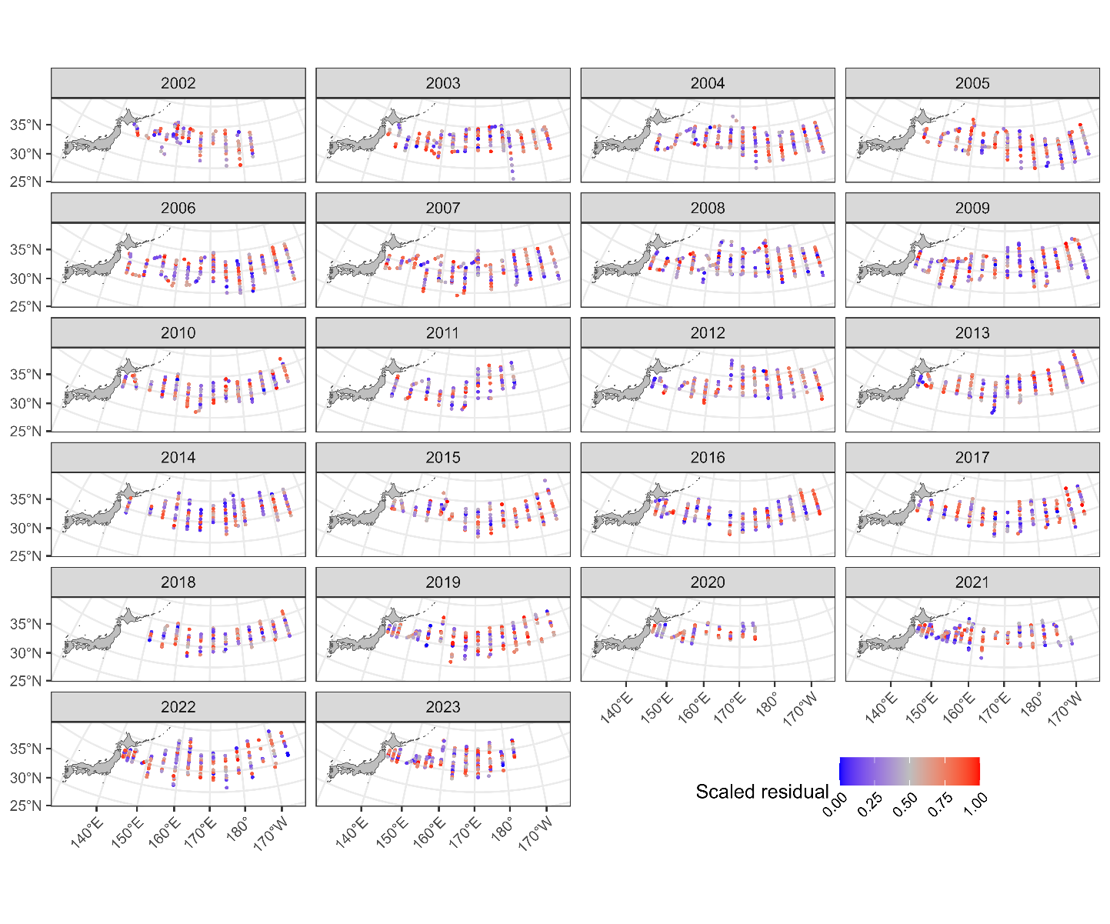
Maps of the scaled residuals from 2002 to 2023.

Figure 8
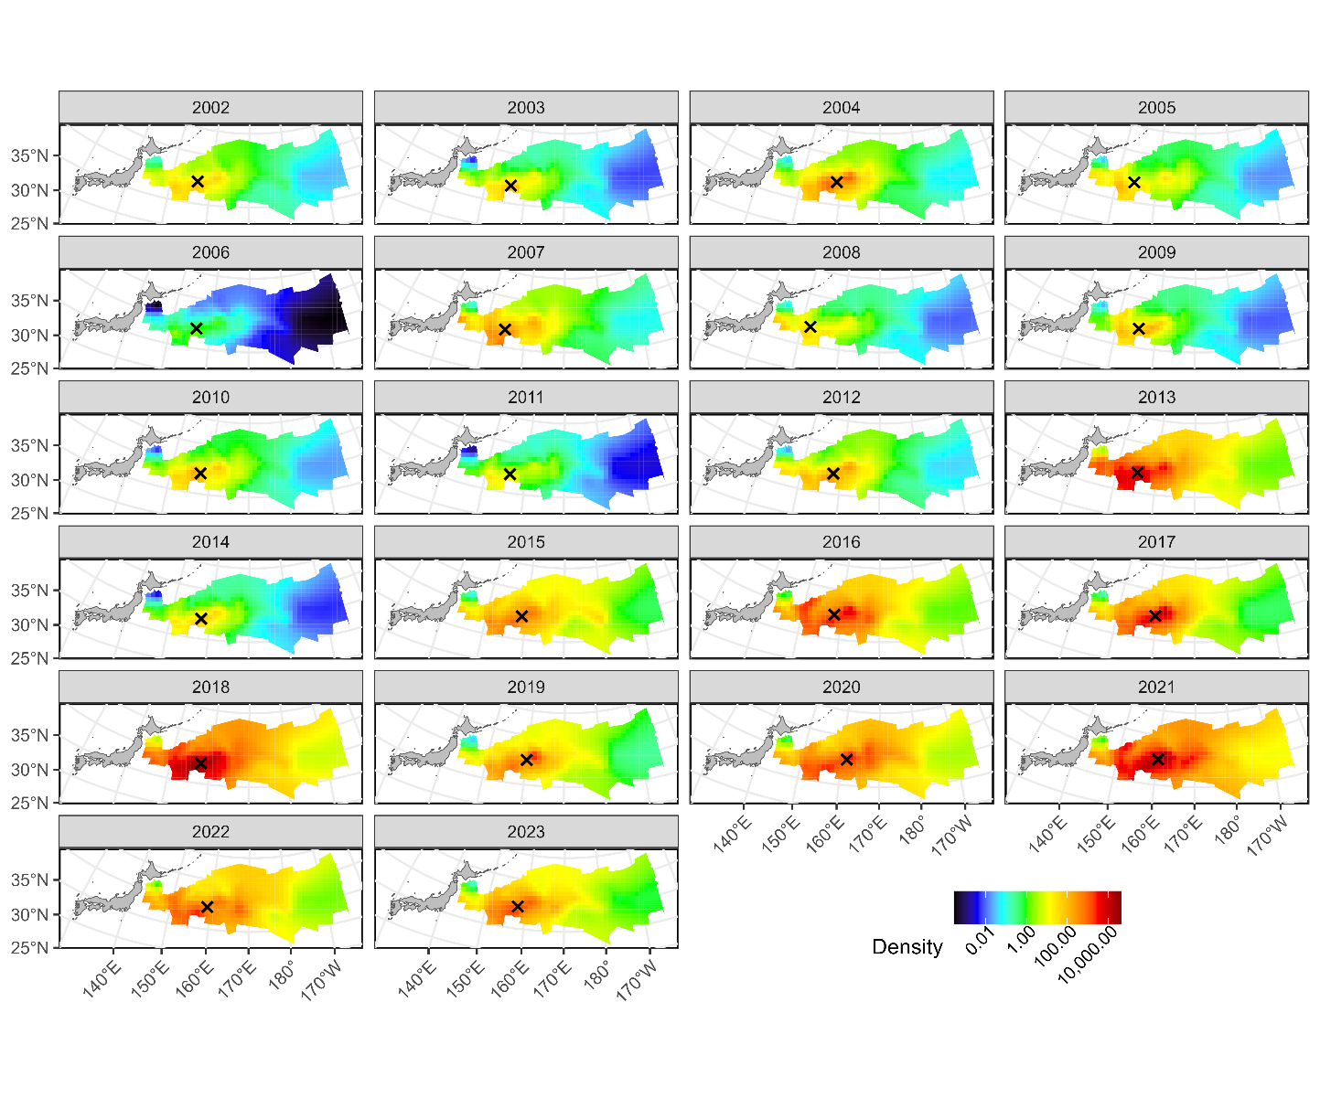
Estimated densities from 2002 to 2023. The signs of X indicate the centroid of spatial distributions.

Figure 9
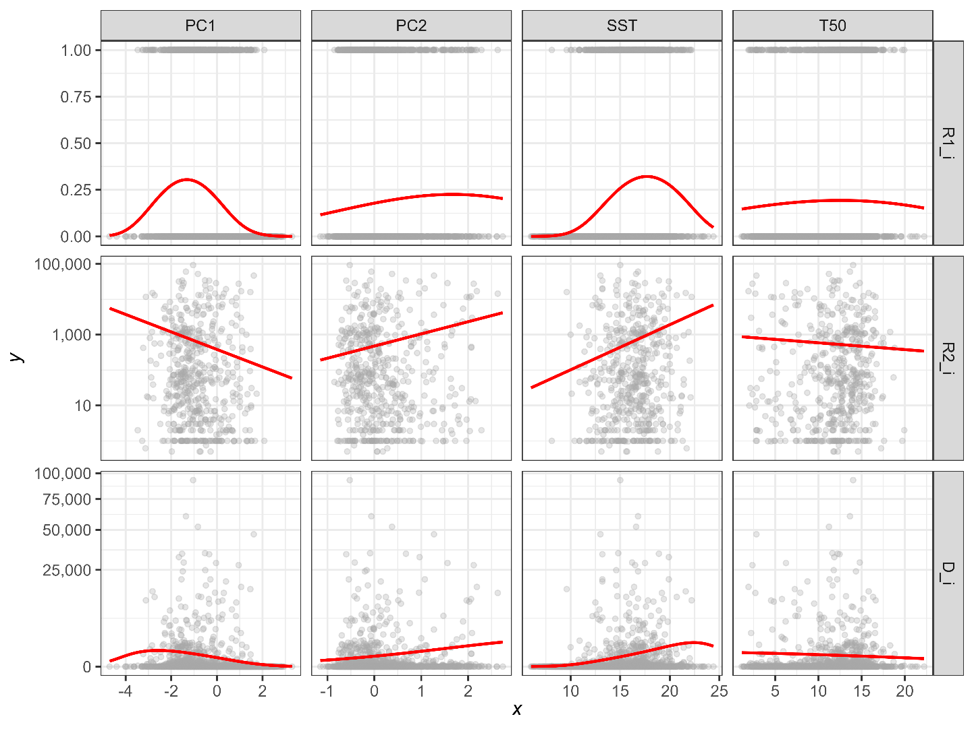
Estimated relationships between environmental variables (PC1, PC2, SST, and T50) and expected CPUE (upper: probability of positive catch, middle: positive catch rate, lower: catch rate). The expected CPUE versus SST and T50 was calculated with the assumption that the original variables SST and T50 change independently.

Figure 10
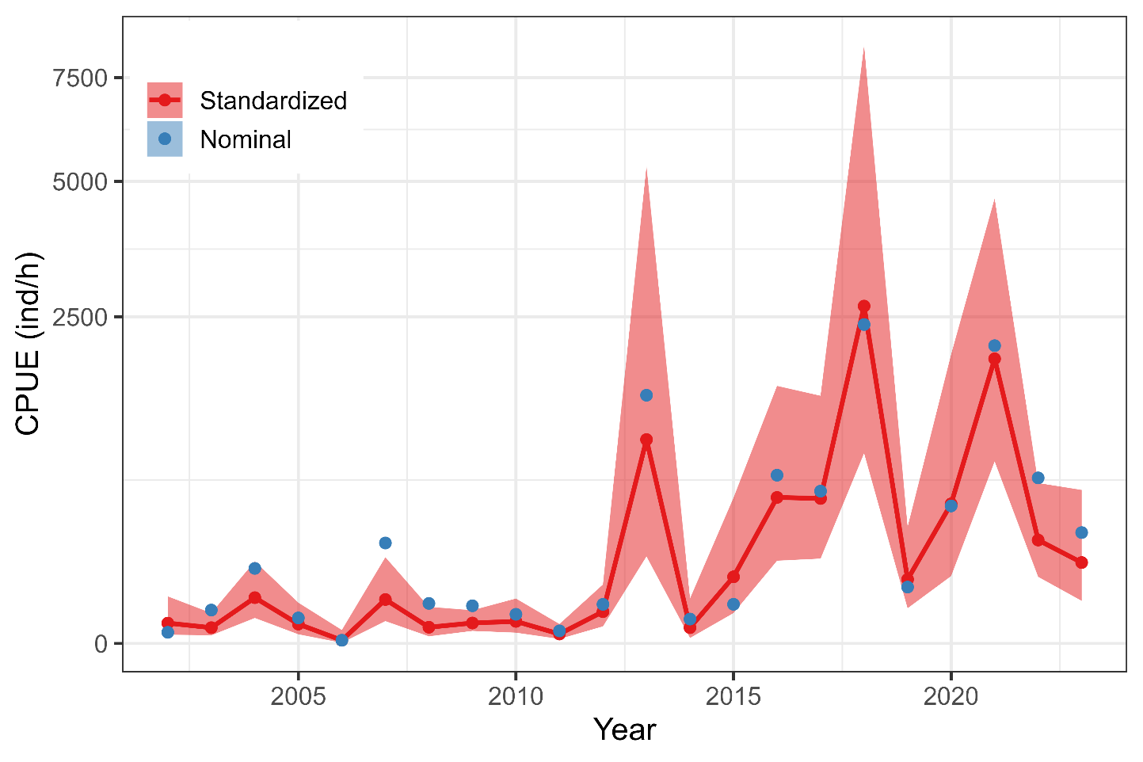
Time series of nominal and standardized CPUE from 2002 to 2023. The shadow area represents 95% confidence intervals of standardized CPUE.

AppendIX
Checklist for the CPUE standardization protocol
No. | Step-by-step protocols | yes/no | Note
1 | Provide a description of the type of data (logbook, observer, survey, etc. ), and the "resolution" of the data (aggregated, set-by-set etc..). This description should also include the representativeness of the data in two tables: (1st table) Number of observations, % Coverage of CPUE fleet (catch), % Coverage of CPUE fleet (effort), Total Catch CPUE fleet (mt), Total Effort CPUE fleet, Percentage of overall catch by member (across all fleets/gears); and (2nd table) Number of records remaining, Number removed, Number of records with chub mackerel catch >0; | Yes | Section 2.1 (pages 1-2) and Tables 1 (page 7) and 2 (page 8)
2 | Conduct a thorough literature review to identify key factors (i.e., spatial, temporal, environmental, and fisheries variables) that may influence CPUE values; | Yes | Section 1. Background (page 1)
3 | Plot annual/monthly spatial distributions of fishing efforts, catch and nominal CPUE to determine temporal and spatial resolution for CPUE standardization | Yes | Fig. 1, (pages 13-15)
4 | Make scatter plots (for continuous variables) and/or box plots (for categorical variables) and present correlation matrix if possible to evaluate correlations between each pair of those variables; | Yes | Figs. 2-4 (pages 14-21]
5 | Describe selected explanatory variables based on (2)-(4) to develop full model for the CPUE standardization; | Yes | Section 2.3. (pages 2-4) and Table 3 (page 9)
6 | Specify model type and software (packages) and fit the data to the assumed statistical models (i.e., GLM, GAM, Delta-lognormal GLM, Neural Networks, Regression Trees, Habitat based models, and Statistical habitat based models); | Yes | Section 2.3. (pages 2-4)
7 | Evaluate and select the best model(s) using methods such as likelihood ratio test, information criterions, cross validation etc.; | Yes | Table 4 (page 9)
8 | Provide diagnostic plots to support the chosen model is appropriate and assumption are met (QQ plot and residual plots along with predicted values and important explanatory variables, etc.); | Yes | Figs. 5-6 (page 22-24)
9 | Present estimated values of parameters and uncertainty in the parameters in table; | Yes | Table 5 (pages 10-11)
10 | Present the relationship between the response variable and the explanatory variables. Check if it is interpretable. | Yes | Figs. 8-9 (pages 25-26)
11 | Extract yearly standardized CPUE and standard error by a method that is able to account for spatial heterogeneity of effort, such as least squares mean or expanded grid. If the model includes area and the size of spatial strata differs or the model includes interactions between time and area, then standardized CPUE should be calculated with area weighting for each time step. Model with interactions between area and season or month requires careful consideration on a case by case basis. Provide details on how the CPUE index was extracted. | Yes | Section 2.4. (page 4)
12 | Calculate uncertainty (SD, CV, CI) for standardized CPUE for each year. Provide detailed explanation on how the uncertainty was calculated; | Yes | Table 6 (page 12) and Fig. 10 (page 27)
13 | Provide a table and a plot of nominal and standardized CPUEs over time. When the trends between nominal and standardized CPUE are largely different, explain the reasons (e.g. spatial shift of fishing efforts), whenever possible. | Yes

