NPFC-2024-TWG CMSA08-WP09
Chub mackerel abundance indices in the North-Western Pacific Ocean based on the results of stocks surveys carried out by Russian research vessels in 2014-2023
Antonenko D. V.
Pacific Branch of VNIRO (TINRO)

The Russian research vessels have been conducting multipurpose trawl surveys of the upper epipelagic zone of the Northwestern Pacific Ocean annually for more than 20 years. Surveys are carried out according to the standard scheme of trawl stations which covers a large area to the east of the Kuril Islands but the number of stations in each survey varies from year to year. The main purpose of these surveys is to conduct stock assessment of Pacific salmon during the marine period of its life, but based on the results of scientific research, the stock and number of all inhabitants of the epipelagic zone is estimated. According to survey data before 2014 mackerel was found sporadically and in small quantities. Large schools of mackerel migrated in Kuril waters and adjacent open water areas since 2014. The results of assessment for mackerel biomass from 2014 to 2023 are presented in the table.
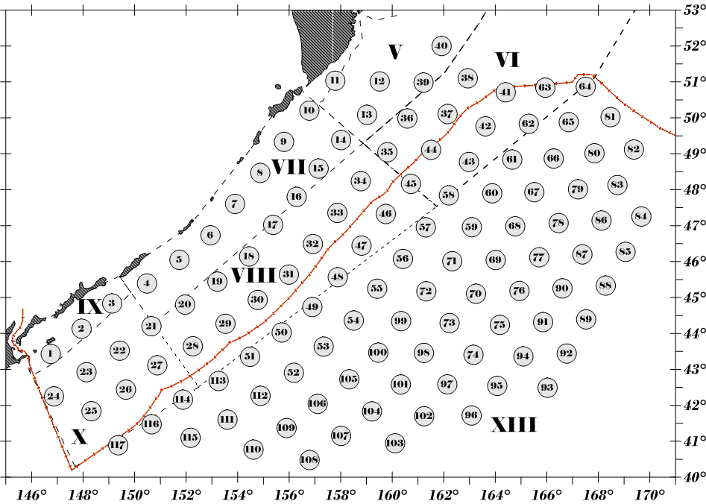
Fig. - Standard scheme of trawl stations for the stock survey of the epipelagic zone of the northwestern Pacific Ocean. Roman numerals are the numbers of biostatistical areas. Lines indicate the borders of biostatistical areas (dashed) and the border of the Russian EEZ (the number of trawl stations can vary in each particular year).

Table – Estimations of mackerel biomass (thousand tons) by stock surveys in the Northwestern Pacific Ocean in 2014-2023.
Years | Dates | Acoustic survey,  thousand tons | Trawl survey,  thousand tons
2014 | June-July | 690.3 | 902.4
2014 | September | 1209.0 | 719.3
2015 | June-July | 3319.4 | 2838.4
2015 | July-August | 6087.7 | 4740.8
2016 | June-July | 1597.6 | 958.8
2016 | July-August | 3617.2 | 2591.9
2017 | June-July | 2727.3 | 1432.9
2017 | August-September | 6043.2 | 1826.0
2018 | June-July | 2755.1 | 1931.0
2019 | June-July | 779.1 | 406.2
2020 | June-July | 400.5 | 262.7
2020 | August-october | 2661.0 | 1654.4
2021 | June-July | 1635.9 | 1004.9
2021 | August-September | 1471.2 | 1160.0
2022 | May-July | 955.9 | 29.3
2022 | August-September | 1433.9 | 984.0
2023 | June-July | 439.4 | 116.8

