NPFC-2024-TWG CMSA09-WP01

**The data description for the base case stock assessment of chub mackerel *Scomber japonicus* in the northwestern Pacific Ocean**

Akihiro Manabe, Kazunari Higashiguchi, Ryuji Yukami, and Kazuhiro Oshima

*Fisheries Resources Institute, Japan Fisheries Research and Education Agency*

**Summary**

The details of fundamental data used for the stock assessment of chub mackerel in the northwestern Pacific Ocean is described. The data consists of catch-at-age, weight-at-age, and maturity-at-age since 1970 with different length of temporal data from three members: China, Japan, and Russia. This working paper describes the details on each data and its derivation and the data itself.

**Introduction**

The data used for the stock assessment is a fundamental component that affect the evaluation of the stock status. The TWG CMSA conducts stock assessment on chub mackerel (CM) is being conducted using State-space Assessment Model (SAM) with fishing year (FY, i.e., the 3rd quarter (Q3) of the calendar year (CY) to the 2nd quarter). The input data were provided by each member: China, Japan, and Russia. The data preparation was conducted at the TWG CMSA08 meeting, which the preparatory method of catch-at-age, weight-at-age, maturity-at-age, and natural mortalities were discussed and finalized for the base case (Manabe et al., 2024a, b, c; Nishijima et al., 2024). In the present document, the finalized catch-at-age, weight-at-age, and maturity-at-age for the base-case stock assessment is described.

**Catch-at-age**

Catch-at-age is one of fundamental data sets that characterizes the population dynamics and status. In the TWG CMSA, three members: China, Japan, and Russia harvest CM in both national waters and the Conventional Area. Quarterly catch-at-length, age-length-key (ALK), and catch-at-age data were submitted and the TWG CMSA had discussed the methodology to convert catch-at-length to catch-at-age using ALK on fishing-year-basis at its 8th meeting (Manabe et al., 2024c).

The data collection for catch-at-length and development of ALK are conducted by each member, however, considering the spatial difference, Japanese data are separated into the eastern and western Japan at Shizuoka-Mie prefectural border (Manabe et al., 2024a). For Chinese data collection and development of ALK and Russian method of data collection method, the details are described in Chernienko and Chernienko (2021) and NPFC (2022).

Quarterly catch-at-length data from each member are converted into catch-at-age data by applying ALK of the equivalent region, quarter, and year. The details and preparation of ALKs are described in NPFC-2024-TWG CMS-WP15. Since the age incrementation of CM is defined differently across members which China and Russia set the date as January 1st (i.e., beginning of CY) and Japan as July 1st (i.e., beginning of FY), the Chinese age are converted to FY-based data by subtracting age by 1 year on the data between January 1st to July 30th (the 1st quarter to 2nd quarter). For the Russian aging on catch-at-age, the ALK from Eastern Japan is applied with the fishing-year based age incrementation. The catch of YOY fish during the 1st and 2nd quarter, the age is treated as 0 and included in the catch in the 3rd quarter. Additionally, the age conversion process creates the appearance of age-7 fish occurs only on the 3rd and 4th quarter; to avoid misinterpretation of the population dynamics, age-7 fish are aggregated with age-6 fish to create a plus group (i.e., age-6+). Quarterly catch-at-age data is aggregated from the 3rd quarter to the 2nd of the following year to calculate the fishing yearly catch-at-age.

The development of catch-at-age based on catch-at-length data and ALKs are conducted since FY2014 up to FY2022 fishing year. For the data since FY1970 to FY2013, the catch-at-age is sourced from the Japanese domestic stock assessment report of the Pacific stock of chub mackerel (Yukami et al., 2024). For FY1967 to FY1988, the catch-at-age contains catch conducted by Russia, however due to its difficulty to separate the catch-at-age into two members; Japan and Russia, the catch-at-age from FY1967 to FY1988 are considered as the catch obtained by Japan.

Table 1 lists the quarter/year that contains unavailable data to develop catch-at-age. The solutions to supplement the unavailable data to develop catch-at-age for FY2014-2017 were discussed at the TWG CMSA08 meeting and following solutions listed in the Table 1 were agreed and adopted as the base case (NPFC, 2024).

For Chinese catch-at-age in CY2015 and Russian catch-at-age in CY2014-2016, the averaged of CY2016-2018 is assumed to be the age composition for CY2014-2015. The averaged catch-at-length is estimated as follows:

$$P_{m,t}=\frac{1}{2}\left(\frac{C_{m,2016}+C_{m,2017}+C_{m,2018}}{3}+C_{m,t}\right)$$

where $P_{m,t}$ is a proportion of catch *C* of member *m* at year *t*. The number of catch *N* at length bin *l* for member *m* at quarter *q* of year *t* is derived as follows:

$$N_{l, m, q,t}=P_{m,t}\left(\frac{N_{l,m,q,2016}+N_{l,m,q,2017}+N_{l,m,q,2018}}{3}\right)$$

The calculated quarterly catch-at-length is multiplied by the Eastern Japanese ALK of the equivalent year and quarter to develop the catch-at-age.

Figure 1 and Table 2 show the finalized quarterly catch-at-age of CM from each member from FY2014-2022 and Figure 3 shows the total quarterly catch-at-age from FY2014-2022. In combination with the historical data from the Japanese domestic stock assessment, Figure 3 and Table 3 show the finalized annual catch-at-age of CM in FY1970-2022 for each member and Figure 4 shows the total annual catch-at-age in FY1970-2022.

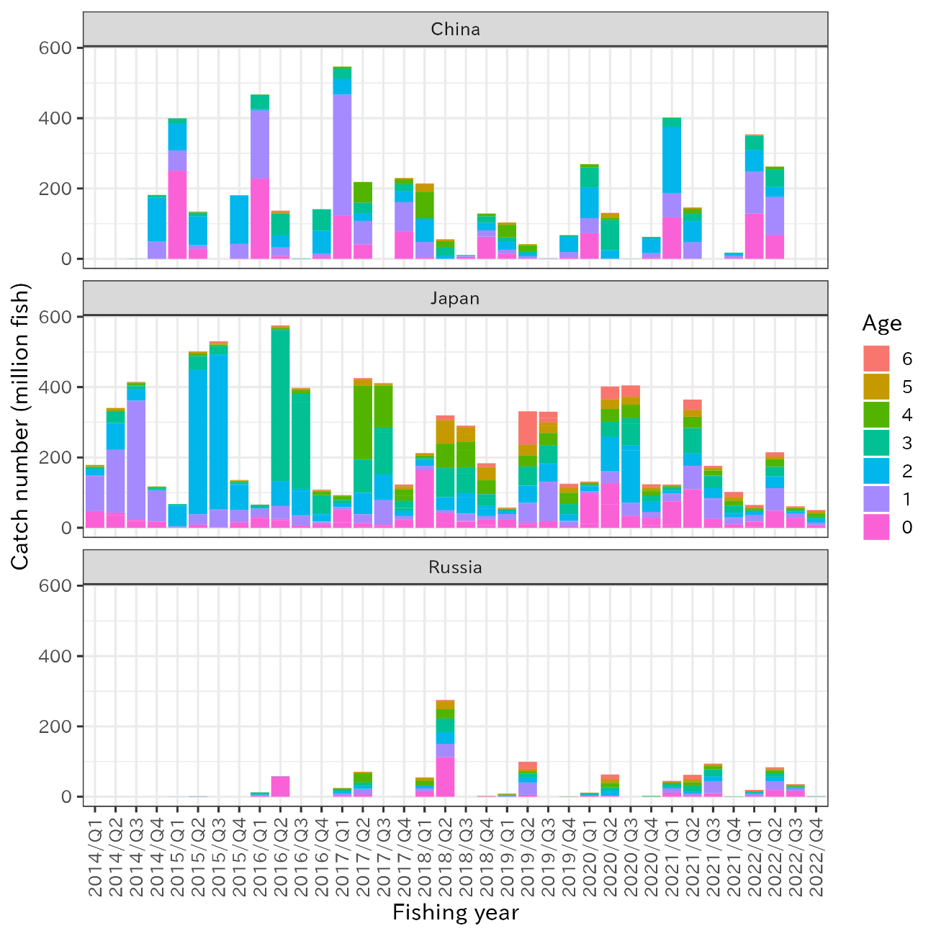

Figure 1. Quarterly catch-at-age from each member in FY2014-2022.

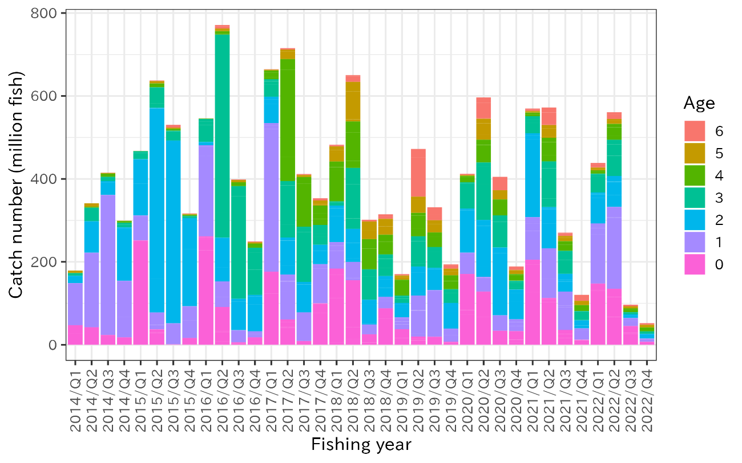

Figure 2. Quarterly catch-at-age of CM from the northwestern Pacific in FY2014-2022.

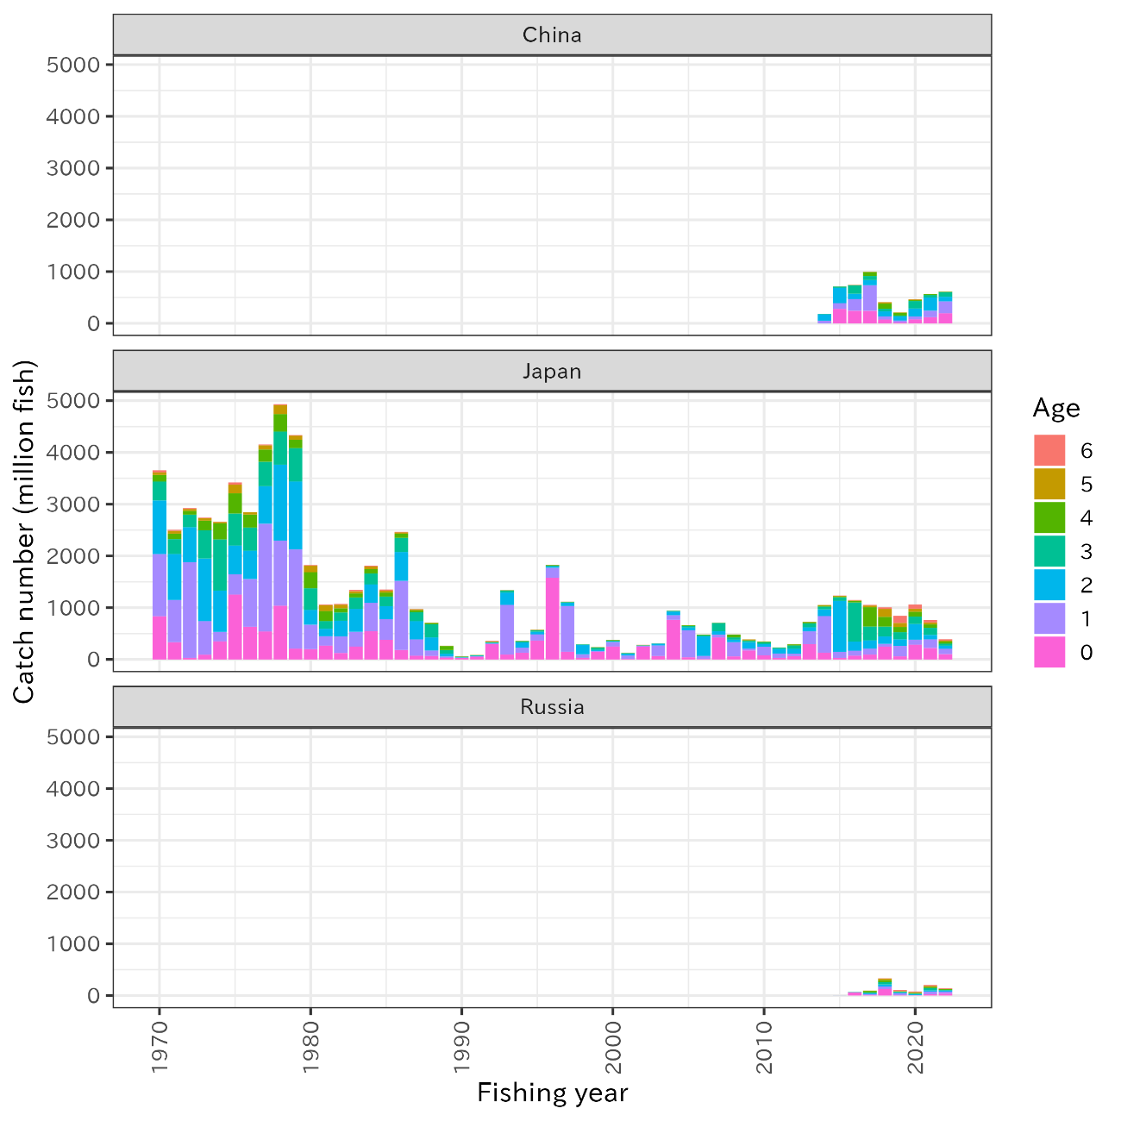

Figure 3. Annual catch-at-age from each member in FY1970-2022.

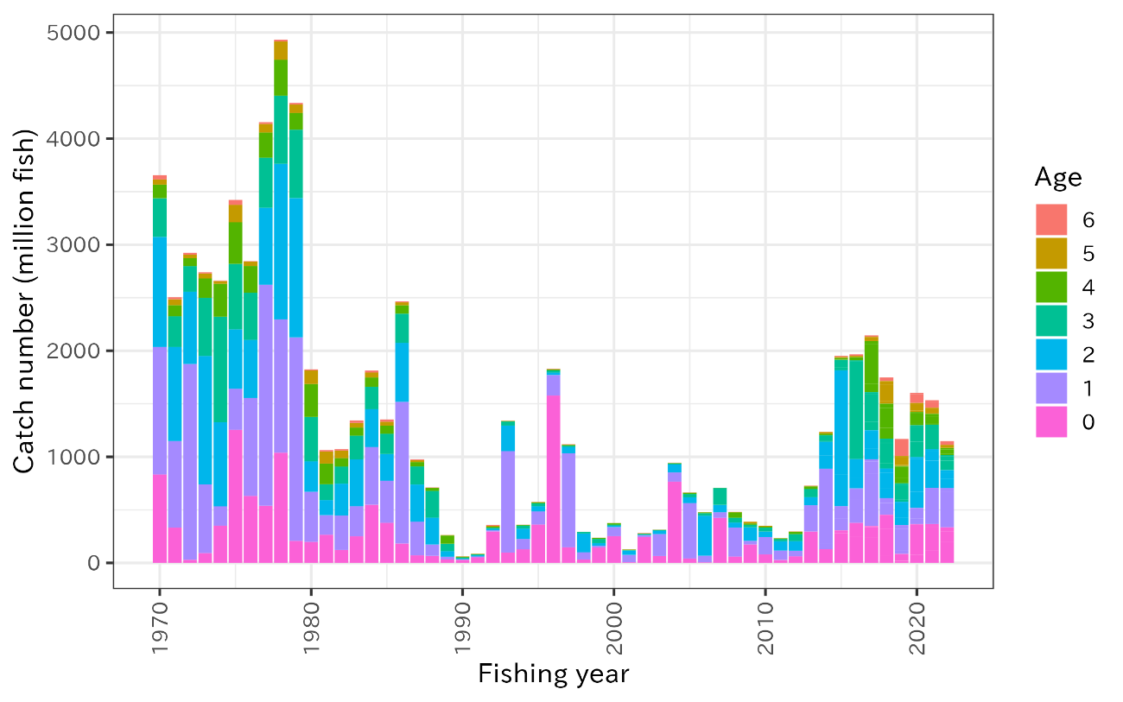

Figure 4. Annual catch-at-age of CM from the northwestern Pacific in FY1970-2022.

Table 1. List of year/quarter/member with unavailable data and solution.

|  |  |  |  |  |
| --- | --- | --- | --- | --- |
| Year (calendar) | Quarter | Member | Unavailable data | Solution |
| 2015 | Q2-Q4 | China | Catch-at-length  ALK | Use mean catch-at-length of China CY2016-2018  Use Eastern Japanese ALK of the equivalent quarter/year |
| 2016-2017 | Q2-Q4 | China | ALK | Use Eastern Japanese ALK of the equivalent quarter/year |
| 2014-2015 | Q2-Q4 | Russia | Catch-at-length  ALK | Use mean catch-at-length of Russia CY2016-2018  Use Eastern Japanese ALK of the equivalent quarter/year |
| 2022-2023 | Q1-Q4 | Russia | Catch-at-length  ALK | Use mean catch-at-length and ALK from Eastern Japan of the equivalent quarter/year |

Table 2. Quarterly catch-at-age of CM in the northwestern Pacific from each member.

|  |  |  |  |  |  |  |  |  |  |
| --- | --- | --- | --- | --- | --- | --- | --- | --- | --- |
| Fishing year | Quarter | Member | Age_0 | Age_1 | Age_2 | Age_3 | Age_4 | Age_5 | Age_6+ |
| 2014 | 3 | China | 0 | 0 | 0 | 0 | 0 | 0 | 0 |
| 2014 | 3 | Japan | 47237213.81 | 101497275 | 17776698.23 | 6430248.264 | 686087.0644 | 5257345.05 | 20903.54039 |
| 2014 | 3 | Russia | 6462.902762 | 8966.017898 | 8318.119137 | 1227.235286 | 28.7212582 | 362.6213941 | 3.612960752 |
| 2014 | 4 | China | 0 | 0 | 0 | 0 | 0 | 0 | 0 |
| 2014 | 4 | Japan | 42347670.85 | 179706344.7 | 75918907.02 | 32709460.25 | 2270808.36 | 7906203.208 | 184.4855752 |
| 2014 | 4 | Russia | 57391.29451 | 19112.95521 | 29234.96315 | 4779.025046 | 222.4899799 | 605.7661214 | 9.52528268 |
| 2014 | 1 | China | 0 | 29829.99518 | 303015.7948 | 2730.560785 | 0 | 0 | 0 |
| 2014 | 1 | Japan | 23601326.97 | 337791185 | 32765644.82 | 10633493.1 | 7676084.356 | 1789543.134 | 586577.5498 |
| 2014 | 1 | Russia | 0 | 0 | 0 | 0 | 0 | 0 | 0 |
| 2014 | 2 | China | 0 | 48835438.92 | 125504042.2 | 6568535.168 | 855936.8196 | 89932.43012 | 0 |
| 2014 | 2 | Japan | 18016589.68 | 87681107.12 | 3375130.493 | 4026065.532 | 3548927.969 | 766616.4038 | 48460.77064 |
| 2014 | 2 | Russia | 0.751676726 | 91.8479817 | 147.4675281 | 226.0357738 | 17.59778951 | 4.209439957 | 0.777601882 |
| 2015 | 3 | China | 250634295.8 | 57523869.15 | 76363924.88 | 14760489.79 | 374415.9064 | 0 | 120085.8996 |
| 2015 | 3 | Japan | 1312813.191 | 2338676.828 | 59306474.17 | 4346851.355 | 201954.4656 | 3727.090805 | 56673.72761 |
| 2015 | 3 | Russia | 72652.73797 | 34108.73104 | 130309.4269 | 26758.77404 | 829.597106 | 44.53370078 | 763.5790777 |
| 2015 | 4 | China | 28544531.93 | 10464909.45 | 81893436.84 | 10392615.98 | 1709283.857 | 884628.6003 | 494801.8664 |
| 2015 | 4 | Japan | 8420525.453 | 29965958.7 | 411046068.1 | 39146021.71 | 7533294.347 | 4693208.402 | 1023539.844 |
| 2015 | 4 | Russia | 565380.2663 | 71485.20362 | 365657.7665 | 147143.2113 | 8221.835179 | 6032.723593 | 1157.341679 |
| 2015 | 1 | China | 0 | 0 | 0 | 0 | 0 | 0 | 0 |
| 2015 | 1 | Japan | 1122037.865 | 50792897.01 | 440588253.4 | 23771819.16 | 4760691.855 | 2923305.082 | 6562401.919 |
| 2015 | 1 | Russia | 0 | 0 | 0 | 0 | 0 | 0 | 0 |
| 2015 | 2 | China | 868436.3381 | 41949503.78 | 137799352.5 | 0 | 0 | 0 | 0 |
| 2015 | 2 | Japan | 15600874.75 | 34772007.78 | 74424371.63 | 5187042.453 | 3084580.897 | 1793477.624 | 1145139.456 |
| 2015 | 2 | Russia | 49.5 | 1813.073014 | 7400.998415 | 276.8452381 | 53.83333333 | 6.25 | 12.5 |

Table 2. Continued.

|  |  |  |  |  |  |  |  |  |  |
| --- | --- | --- | --- | --- | --- | --- | --- | --- | --- |
| Fishing year | Quarter | Member | Age_0 | Age_1 | Age_2 | Age_3 | Age_4 | Age_5 | Age_6+ |
| 2016 | 3 | China | 228199505.6 | 193748266.1 | 3973300.921 | 40794985.51 | 618533.3865 | 48383.12264 | 0 |
| 2016 | 3 | Japan | 31346763.15 | 22801023.58 | 3353126.081 | 7760657.426 | 498366.288 | 174562.0198 | 193372.9971 |
| 2016 | 3 | Russia | 1922401.537 | 3394154.987 | 788302.1245 | 6266948.233 | 96606.93724 | 28544.44451 | 9076.736842 |
| 2016 | 4 | China | 8077138.414 | 24271397.73 | 34672443.12 | 60153416.91 | 1884665.63 | 2860719.858 | 5048344.847 |
| 2016 | 4 | Japan | 25199174.1 | 37119266.58 | 71023241.66 | 429130503.7 | 6414004.857 | 3507521.99 | 3365267.147 |
| 2016 | 4 | Russia | 58024976 | 22934.78261 | 45869.56522 | 458695.6522 | 0 | 0 | 0 |
| 2016 | 1 | China | 0 | 97696.69918 | 272812.2144 | 615302.4025 | 0 | 0 | 0 |
| 2016 | 1 | Japan | 5929279.241 | 29298962.77 | 75485367.7 | 271043631 | 9466497.326 | 5275137.395 | 1475767.264 |
| 2016 | 1 | Russia | 0 | 0 | 0 | 0 | 0 | 0 | 0 |
| 2016 | 2 | China | 6781282.178 | 8291954.888 | 65147293.73 | 60843133.56 | 0 | 0 | 0 |
| 2016 | 2 | Japan | 11214378.93 | 6404033.386 | 22424940.64 | 52777830.79 | 10285284.45 | 3134210.045 | 2142348.061 |
| 2016 | 2 | Russia | 33 | 491.9774597 | 5483.899526 | 17160.29367 | 2467.103521 | 350.4685691 | 198.2572581 |
| 2017 | 3 | China | 123026816.5 | 344227876.3 | 45833881.21 | 28600367.66 | 4808651.533 | 272779.6842 | 0 |
| 2017 | 3 | Japan | 51067823.48 | 7555217.386 | 11355460.5 | 9182874.664 | 11579713.12 | 1549971.816 | 665235.5098 |
| 2017 | 3 | Russia | 2296409 | 6250129.5 | 6704342.177 | 4321216.191 | 4539855.525 | 432715.7398 | 255456.8667 |
| 2017 | 4 | China | 41227586.69 | 66928147.3 | 21087254.96 | 30398506.96 | 58688025.51 | 295911.8674 | 0 |
| 2017 | 4 | Japan | 13205713.94 | 25702205.77 | 60735367.55 | 94821064.49 | 209604509.4 | 18279440.18 | 3511832.979 |
| 2017 | 4 | Russia | 6640274 | 15828071.62 | 7685161.483 | 10340486.03 | 26065264.14 | 4118750.852 | 334296.875 |
| 2017 | 1 | China | 5333.015337 | 15702.33373 | 10776.80438 | 7658.860498 | 1877.278801 | 0 | 0 |
| 2017 | 1 | Japan | 9066561.552 | 69175256.32 | 73578370.31 | 133217126.1 | 119457375.2 | 5381369.042 | 2000741.297 |
| 2017 | 1 | Russia | 0 | 0 | 0 | 0 | 0 | 0 | 0 |
| 2017 | 2 | China | 77316060.36 | 83465293.9 | 32397145.56 | 18650364.25 | 14716346.46 | 3403710.11 | 0 |
| 2017 | 2 | Japan | 22702909.9 | 10949878.92 | 14443110.71 | 28828099.47 | 32228838.31 | 9141503.598 | 5121030.086 |
| 2017 | 2 | Russia | 27545.91667 | 16946.83544 | 19670.11893 | 21897.24502 | 36713.61961 | 8474.588781 | 1690.408889 |

Table 2. Continued.

|  |  |  |  |  |  |  |  |  |  |
| --- | --- | --- | --- | --- | --- | --- | --- | --- | --- |
| Fishing year | Quarter | Member | Age_0 | Age_1 | Age_2 | Age_3 | Age_4 | Age_5 | Age_6+ |
| 2018 | 3 | China | 5003405.652 | 42626215.67 | 62991671.74 | 5285568.811 | 74768779.44 | 21626829.89 | 2218055.768 |
| 2018 | 3 | Japan | 163305267.9 | 13199749.14 | 18677714.4 | 2890971.645 | 7687663.54 | 5686061.677 | 1539322.867 |
| 2018 | 3 | Russia | 15539472.27 | 8084888.2 | 6239688.6 | 2015152.4 | 13571931.1 | 9298835.2 | 121394.5 |
| 2018 | 4 | China | 0 | 0 | 8369661.996 | 25410764.74 | 16523960.65 | 5209742.265 | 226514.3039 |
| 2018 | 4 | Japan | 42929074.13 | 6991957.552 | 37695269.76 | 82412236.45 | 69286086.82 | 66924138.12 | 13595741.61 |
| 2018 | 4 | Russia | 112625855 | 37178455 | 33717982.98 | 39310240.3 | 26201673.28 | 23342477.7 | 2659548.743 |
| 2018 | 1 | China | 5627804.664 | 2443688.179 | 1799773.877 | 690161.8481 | 566136.9851 | 0 | 0 |
| 2018 | 1 | Japan | 19635530.19 | 21386676.45 | 57685895.16 | 72591689.9 | 72393185.98 | 42589378.82 | 4184809.874 |
| 2018 | 1 | Russia | 0 | 0 | 0 | 0 | 0 | 0 | 0 |
| 2018 | 2 | China | 63172355.15 | 17624019.98 | 21498109.74 | 18798712.12 | 7526800.424 | 181322.7943 | 0 |
| 2018 | 2 | Japan | 23911159.25 | 9746834.996 | 28406818.76 | 33176283.62 | 39771206.36 | 37584856.59 | 10861004.92 |
| 2018 | 2 | Russia | 899983 | 274762.5693 | 336941.9537 | 286508.4511 | 279144.3423 | 267448.2043 | 35869.47934 |
| 2019 | 3 | China | 14174279.06 | 11593096.58 | 24760907.59 | 10396582.37 | 36007062.99 | 6608551.001 | 0 |
| 2019 | 3 | Japan | 23706659.75 | 15105785.78 | 8033354.538 | 5540360.261 | 1410623.526 | 1980382.77 | 1883604.257 |
| 2019 | 3 | Russia | 24453.86667 | 1630499.826 | 1925470.019 | 1749834.437 | 938301.5715 | 1539701.02 | 1326864.26 |
| 2019 | 4 | China | 793862.0968 | 6746786.805 | 6265893.708 | 7653063.224 | 17647983.63 | 2492516.971 | 0 |
| 2019 | 4 | Japan | 13778075.36 | 56811547.75 | 49968987.58 | 53579440.15 | 32200458.26 | 29973200.94 | 94915643.96 |
| 2019 | 4 | Russia | 5540892.121 | 35056118.21 | 13829083.2 | 11545912.53 | 6719226.517 | 6538827.368 | 20209606.05 |
| 2019 | 1 | China | 334001.6743 | 587211.5758 | 423581.7401 | 0 | 0 | 0 | 0 |
| 2019 | 1 | Japan | 19141117.82 | 111986510.8 | 53153380.69 | 50294500.54 | 34911410.15 | 29494398.07 | 31022591.23 |
| 2019 | 1 | Russia | 0 | 0 | 0 | 0 | 0 | 0 | 0 |
| 2019 | 2 | China | 3616791.438 | 15787548.63 | 42712242.23 | 4051073.212 | 1285561.608 | 0 | 0 |
| 2019 | 2 | Japan | 3761782.398 | 15829349.32 | 19026865.57 | 28880292.76 | 31999630.25 | 15860628.99 | 10282596.05 |
| 2019 | 2 | Russia | 1482.434211 | 77192.36621 | 119248.1369 | 267046.3202 | 212882.6158 | 132636.7376 | 114975.3891 |

Table 2. Continued.

|  |  |  |  |  |  |  |  |  |  |
| --- | --- | --- | --- | --- | --- | --- | --- | --- | --- |
| Fishing year | Quarter | Member | Age_0 | Age_1 | Age_2 | Age_3 | Age_4 | Age_5 | Age_6+ |
| 2020 | 3 | China | 72899094.14 | 42415901.69 | 87474865.78 | 57057152.07 | 9121568.176 | 0 | 0 |
| 2020 | 3 | Japan | 96249230.78 | 7769995.271 | 15258287.99 | 4168797.27 | 4136333.294 | 1608076.044 | 2206899.174 |
| 2020 | 3 | Russia | 1988681.24 | 868615.2819 | 3546284.783 | 2419322.616 | 1912833.606 | 523568.8599 | 576035.6136 |
| 2020 | 4 | China | 0 | 298900.3695 | 24600993.96 | 85963742.76 | 6103006.499 | 12548331.71 | 1345062.726 |
| 2020 | 4 | Japan | 126868194.9 | 33454452.81 | 98397715.49 | 43158647.22 | 36360840.11 | 27145856.94 | 36632521.99 |
| 2020 | 4 | Russia | 1233513.132 | 1858302.047 | 14426788.39 | 9424311.537 | 12427370.16 | 10923704.68 | 13088557.06 |
| 2020 | 1 | China | 6062.04278 | 31070.53543 | 167276.683 | 27867.80602 | 1513.270717 | 0 | 0 |
| 2020 | 1 | Japan | 33810546.64 | 37278812.07 | 163449770 | 77187266.63 | 38493855.13 | 22473207.89 | 32222394.82 |
| 2020 | 1 | Russia | 0 | 0 | 0 | 0 | 0 | 0 | 0 |
| 2020 | 2 | China | 4708016.755 | 11788694.88 | 41975975.79 | 3226035.898 | 852099.5516 | 0 | 0 |
| 2020 | 2 | Japan | 28251152.12 | 16537372.51 | 29383996.9 | 17004482.2 | 15019927.44 | 9621379.383 | 7976294.788 |
| 2020 | 2 | Russia | 58489.03846 | 183268.7167 | 568843.8563 | 537535.8602 | 676238.058 | 507809.0076 | 319268.4628 |
| 2021 | 3 | China | 118366895.3 | 68868325.94 | 188462254.2 | 24861652.98 | 1243138.267 | 0 | 0 |
| 2021 | 3 | Japan | 75317394.49 | 21772574.7 | 9683172.747 | 8631869.929 | 3036319.084 | 1593832.593 | 2989960.436 |
| 2021 | 3 | Russia | 11616071.9 | 11888803.48 | 3959685.721 | 8079990.443 | 4201012.022 | 2309649.279 | 2868283.162 |
| 2021 | 4 | China | 451757.3478 | 46534021.9 | 60076092.58 | 21006882.04 | 14231125.25 | 2436113.556 | 1139916.658 |
| 2021 | 4 | Japan | 109612091.7 | 66871707.96 | 34779416.12 | 72213612.65 | 32152950.94 | 19505346.61 | 29194411.92 |
| 2021 | 4 | Russia | 2812827.318 | 6582891.026 | 4474580.5 | 16900202.73 | 10711328.94 | 8573526.399 | 11979368.08 |
| 2021 | 1 | China | 0 | 0 | 0 | 0 | 0 | 0 | 0 |
| 2021 | 1 | Japan | 25578328.18 | 59059351.35 | 28629392.97 | 35132973.87 | 14708660.12 | 7979163.456 | 5044338.249 |
| 2021 | 1 | Russia | 10153268.35 | 33300512.02 | 14589509.42 | 20152117.53 | 8495077.738 | 4689156.313 | 2918920.174 |
| 2021 | 2 | China | 2017130.84 | 7136674.622 | 6650552.266 | 1572555.637 | 240123.9629 | 43658.98585 | 0 |
| 2021 | 2 | Japan | 10135913.49 | 20182203.26 | 12609786.52 | 20644707.5 | 13872870.46 | 10293793.12 | 14202650.92 |
| 2021 | 2 | Russia | 97304.67559 | 162333.5621 | 98097.93708 | 221045.5974 | 149795.8125 | 112592.7569 | 155416.2525 |

Table 2. Continued.

|  |  |  |  |  |  |  |  |  |  |
| --- | --- | --- | --- | --- | --- | --- | --- | --- | --- |
| Fishing year | Quarter | Member | Age_0 | Age_1 | Age_2 | Age_3 | Age_4 | Age_5 | Age_6+ |
| 2022 | 3 | China | 128569974.8 | 119244031.4 | 62126100.89 | 39866051.04 | 903068.7752 | 1812422.615 | 1388223.511 |
| 2022 | 3 | Japan | 17555629.76 | 19310286.41 | 8892300.026 | 3792214.434 | 5052099.3 | 3389871.704 | 6793977.342 |
| 2022 | 3 | Russia | 1490503.28 | 6442397.206 | 3585279.608 | 1593714.793 | 2132653.466 | 1461149.639 | 2942229.215 |
| 2022 | 4 | China | 67247764.7 | 108921842.4 | 28266439.42 | 48817194.64 | 8795871.607 | 615471.7441 | 0 |
| 2022 | 4 | Japan | 48876420.79 | 63477697.27 | 33640907.43 | 27682244.54 | 21120058.76 | 8109608.266 | 11530929.52 |
| 2022 | 4 | Russia | 19097196.8 | 24836409.59 | 12794049.19 | 10802546.77 | 8290597.426 | 3223017.951 | 4612649.413 |
| 2022 | 1 | China | 0 | 0 | 0 | 0 | 0 | 0 | 0 |
| 2022 | 1 | Japan | 28834994.94 | 12168466.63 | 5718935.393 | 3182063.953 | 5709268.226 | 3103354.792 | 2296692.072 |
| 2022 | 1 | Russia | 16361131.3 | 7119007.436 | 3451459.03 | 1948399.272 | 3496221.025 | 1904479.05 | 1400388.037 |
| 2022 | 2 | China | 0 | 0 | 0 | 0 | 0 | 0 | 0 |
| 2022 | 2 | Japan | 7260335.031 | 7523900.95 | 11019862.05 | 5676432.347 | 9151346.283 | 6222501.345 | 3689104.549 |
| 2022 | 2 | Russia | 234118.2377 | 212168.1166 | 357409.7546 | 189015.662 | 306551.9065 | 208128.2716 | 123665.0894 |

Table 3. Catch-at-age of CM in the northwestern Pacific in FY1970-2022.

|  |  |  |  |  |  |  |  |  |
| --- | --- | --- | --- | --- | --- | --- | --- | --- |
| Fishing year | Member | Age_0 | Age_1 | Age_2 | Age_3 | Age_4 | Age_5 | Age_6+ |
| 1970 | Japan | 834153496.6 | 1201530100 | 1037301944 | 364874940.2 | 127479242.9 | 48870917.71 | 41361518.24 |
| 1971 | Japan | 334039692.2 | 814569531.2 | 888012239.1 | 288473458.4 | 103696881.1 | 56448914.05 | 18749683.38 |
| 1972 | Japan | 29022334.85 | 1846505570 | 680729020.7 | 241928130.2 | 73069935.44 | 35267621.02 | 17576606.85 |
| 1973 | Japan | 93175249.47 | 647123444.3 | 1210643871 | 547598229 | 183066072.9 | 46073495.15 | 12208770.22 |
| 1974 | Japan | 351124869.1 | 181956601.2 | 794061426.6 | 993752710.6 | 310059762.4 | 26350882.34 | 4372553.999 |
| 1975 | Japan | 1254231238 | 387855571.2 | 560121368.5 | 617525649 | 391233910 | 164578951.6 | 45867016.68 |
| 1976 | Japan | 631539246.4 | 923332728.1 | 547761974.2 | 445772190 | 251283049.5 | 41562414.46 | 3567383.274 |
| 1977 | Japan | 538985850.9 | 2083021197 | 726803278.3 | 471869021 | 236281244.2 | 81765283.23 | 15636377.15 |
| 1978 | Japan | 1039101579 | 1255785576 | 1468448951 | 640791035.4 | 338065987.2 | 172995580.5 | 16552963.17 |
| 1979 | Japan | 208231521.9 | 1918541758 | 1312222178 | 644674853.8 | 158389673.6 | 80206800.72 | 12837642.6 |
| 1980 | Japan | 198991657.4 | 472101028.7 | 286294537.8 | 419204041.7 | 309771086.9 | 126460996.9 | 11277505.13 |
| 1981 | Japan | 266173323.7 | 184459118.6 | 142036670 | 148722615.1 | 193911349 | 114759342.5 | 13402163.32 |
| 1982 | Japan | 123081551.4 | 323540250.1 | 301357210.6 | 159717361.8 | 80676186.95 | 70494102.86 | 12833282.92 |
| 1983 | Japan | 250359805 | 284122749.9 | 440153170.9 | 225430649.5 | 76212818.26 | 43563923.48 | 23247521.49 |
| 1984 | Japan | 548511344.7 | 544011504.4 | 358272089.9 | 208060588.5 | 89812337.77 | 45848979.69 | 17695953.92 |
| 1985 | Japan | 377730993.3 | 397592535.6 | 252510932.4 | 189871975.3 | 74546377.69 | 38311888.41 | 21369367.57 |
| 1986 | Japan | 182740814 | 1336026723 | 554794376.7 | 275872393.4 | 78946195.64 | 27700665.21 | 9116754.595 |
| 1987 | Japan | 72284437.16 | 315572655.7 | 351624752.7 | 170371515.3 | 41173087.46 | 19155761.28 | 6063893.97 |
| 1988 | Japan | 66882204.85 | 106468063.5 | 252813392.3 | 253117663.9 | 26354855.28 | 4128172.511 | 1728040.695 |
| 1989 | Japan | 33836048.69 | 23892453.22 | 52950482.13 | 70542150.47 | 77178781.16 | 3990339.668 | 630576.0173 |
| 1990 | Japan | 28736252.37 | 5964878.164 | 5997831.045 | 10645710.5 | 6324489.547 | 4230907 | 834779.9009 |
| 1991 | Japan | 52516265.75 | 8069326.6 | 10700439.41 | 8123560.597 | 4722320.668 | 2126594.594 | 303106.282 |
| 1992 | Japan | 296726169.9 | 10682932.89 | 13136721.94 | 11963048.53 | 6526453.273 | 10342490.03 | 7960334.707 |
| 1993 | Japan | 96467309.07 | 957212888.3 | 239669059.5 | 39138895.57 | 5191708.57 | 1706955.102 | 1594969.076 |

Table 3. Continued.

|  |  |  |  |  |  |  |  |  |
| --- | --- | --- | --- | --- | --- | --- | --- | --- |
| Fishing year | Member | Age_0 | Age_1 | Age_2 | Age_3 | Age_4 | Age_5 | Age_6+ |
| 1994 | Japan | 127952732 | 98101182.58 | 97999618.71 | 28365431.08 | 4837596.847 | 1658262.716 | 1926381.229 |
| 1995 | Japan | 362077875.9 | 123330943.7 | 48660792.05 | 27646448.45 | 8871464.602 | 3450333.624 | 1651254.524 |
| 1996 | Japan | 1578156279 | 192976851.1 | 22748912.15 | 19666171.2 | 9740970.612 | 4475685.527 | 2708251.736 |
| 1997 | Japan | 147180180.4 | 884610285.1 | 60935921.8 | 13296018.24 | 6337105.031 | 3768655.103 | 2278785.438 |
| 1998 | Japan | 31587926.46 | 68642255.08 | 177414645.2 | 13184041.21 | 1067886.156 | 344767.1957 | 61264.11701 |
| 1999 | Japan | 144587018.1 | 17202574.5 | 24129316.63 | 40583177.32 | 10051029.64 | 1268127.412 | 449628.2174 |
| 2000 | Japan | 251842271.8 | 85522163.8 | 13314977.5 | 10764169.93 | 13602948.74 | 757053.1167 | 274595.9834 |
| 2001 | Japan | 7109794.966 | 68817151.33 | 40115946.1 | 5344320.652 | 3800043.166 | 2952296.589 | 2366378.966 |
| 2002 | Japan | 243788587.2 | 16557875.09 | 5877361.313 | 6481324.575 | 3614606.892 | 3240117.534 | 1912662.764 |
| 2003 | Japan | 65721525.64 | 205574627.4 | 32326746.3 | 6511313.102 | 2014698.833 | 1050708.578 | 955564.38 |
| 2004 | Japan | 767105074.4 | 86693621.87 | 71950921.83 | 11429534.8 | 4295027.15 | 1390499.578 | 1286317.12 |
| 2005 | Japan | 41515849.2 | 522895013.7 | 52726452.95 | 31965651.15 | 13154396.2 | 918572.8361 | 1059198.305 |
| 2006 | Japan | 6296243.25 | 61539292.71 | 376307034.6 | 24875600.37 | 7515206.446 | 1770320.442 | 481786.0045 |
| 2007 | Japan | 424936952.2 | 53165114.2 | 69503492.76 | 157128058.4 | 3684360.332 | 821495.1528 | 184879.4375 |
| 2008 | Japan | 59640311.64 | 274928168.1 | 46727735.2 | 44430957.8 | 51131380.28 | 3059030.233 | 1284798.498 |
| 2009 | Japan | 173813152.9 | 34660496.58 | 127110968.6 | 23502100.93 | 13098767.58 | 14953296.96 | 1308572.427 |
| 2010 | Japan | 79666431.75 | 162861244 | 53958139.57 | 37253510.04 | 9222520.577 | 5689821.038 | 553464.7642 |
| 2011 | Japan | 28037835.42 | 88153900.89 | 87304583.05 | 21348327.11 | 6648373.047 | 2106940.343 | 132091.2031 |
| 2012 | Japan | 62725113.69 | 51894046.2 | 90270961.4 | 66422761.64 | 20938459.94 | 4028704.029 | 589836.3061 |
| 2013 | Japan | 296564420.5 | 247763518.1 | 75483294.35 | 76526558.23 | 25140554.61 | 4972793.642 | 2338312.094 |
| 2014 | China | 0 | 48865268.92 | 125807058 | 6571265.729 | 855936.8196 | 89932.43012 | 0 |
| 2014 | Japan | 131202801.3 | 706675911.8 | 129836380.6 | 53799267.15 | 14181907.75 | 15719707.8 | 656126.3465 |
| 2014 | Russia | 63854.94895 | 28170.82109 | 37700.54981 | 6232.296106 | 268.8090276 | 972.5969555 | 13.91584531 |

Table 3. Continued.

|  |  |  |  |  |  |  |  |  |
| --- | --- | --- | --- | --- | --- | --- | --- | --- |
| Fishing year | Member | Age_0 | Age_1 | Age_2 | Age_3 | Age_4 | Age_5 | Age_6+ |
| 2015 | China | 280047264 | 109938282.4 | 296056714.2 | 25153105.77 | 2083699.763 | 884628.6003 | 614887.766 |
| 2015 | Japan | 26456251.26 | 117869540.3 | 985365167.2 | 72451734.68 | 15580521.56 | 9413718.197 | 8787754.947 |
| 2015 | Russia | 638082.5042 | 107407.0077 | 503368.1918 | 174178.8305 | 9105.265618 | 6083.507294 | 1933.420757 |
| 2016 | China | 243057926.2 | 226409315.4 | 104065850 | 162406838.4 | 2503199.016 | 2909102.98 | 5048344.847 |
| 2016 | Japan | 73689595.41 | 95623286.3 | 172286676.1 | 760712622.9 | 26664152.92 | 12091431.45 | 7176755.468 |
| 2016 | Russia | 59947410.54 | 3417581.747 | 839655.5892 | 6742804.179 | 99074.04076 | 28894.91308 | 9274.9941 |
| 2017 | China | 241575796.5 | 494637019.9 | 99329058.54 | 77656897.73 | 78214900.79 | 3972401.661 | 0 |
| 2017 | Japan | 96043008.87 | 113382558.4 | 160112309.1 | 266049164.8 | 372870436.1 | 34352284.63 | 11298839.87 |
| 2017 | Russia | 8964228.917 | 22095147.96 | 14409173.78 | 14683599.47 | 30641833.28 | 4559941.181 | 591444.1506 |
| 2018 | China | 73803565.46 | 62693923.82 | 94659217.36 | 50185207.53 | 99385677.5 | 27017894.95 | 2444570.071 |
| 2018 | Japan | 249781031.5 | 51325218.13 | 142465698.1 | 191071181.6 | 189138142.7 | 152784435.2 | 30180879.27 |
| 2018 | Russia | 129065310.3 | 45538105.77 | 40294613.53 | 41611901.15 | 40052748.72 | 32908761.1 | 2816812.722 |
| 2019 | China | 18918934.27 | 34714643.6 | 74162625.27 | 22100718.81 | 54940608.22 | 9101067.972 | 0 |
| 2019 | Japan | 60387635.33 | 199733193.7 | 130182588.4 | 138294593.7 | 100522122.2 | 77308610.76 | 138104435.5 |
| 2019 | Russia | 5566828.421 | 36763810.4 | 15873801.36 | 13562793.29 | 7870410.705 | 8211165.126 | 21651445.7 |
| 2020 | China | 77613172.94 | 54534567.48 | 154219112.2 | 146274798.5 | 16078187.5 | 12548331.71 | 1345062.726 |
| 2020 | Japan | 285179124.4 | 95040632.67 | 306489770.4 | 141519193.3 | 94010955.98 | 60848520.26 | 79038110.77 |
| 2020 | Russia | 3280683.41 | 2910186.045 | 18541917.03 | 12381170.01 | 15016441.83 | 11955082.54 | 13983861.14 |
| 2021 | China | 120835783.5 | 122539022.5 | 255188899 | 47441090.65 | 15714387.48 | 2479772.542 | 1139916.658 |
| 2021 | Japan | 220643727.8 | 167885837.3 | 85701768.34 | 136623163.9 | 63770800.6 | 39372135.78 | 51431361.53 |
| 2021 | Russia | 24679472.24 | 51934540.08 | 23121873.58 | 45353356.3 | 23557214.51 | 15684924.75 | 17921987.67 |
| 2022 | China | 195817739.5 | 228165873.8 | 90392540.32 | 88683245.68 | 9698940.382 | 2427894.359 | 1388223.511 |
| 2022 | Japan | 102527380.5 | 102480351.3 | 59272004.89 | 40332955.28 | 41032772.56 | 20825336.11 | 24310703.49 |
| 2022 | Russia | 37182949.62 | 38609982.35 | 20188197.59 | 14533676.5 | 14226023.82 | 6796774.911 | 9078931.755 |

**Weight-at-age**

Weight-at-age plays an important role in calculating catch, biomass, and spawning stock biomass. Considering the frequent change in growth pattern (Kamimura et al. 2019), weight-at-age is calculated on the annual fishing-year basis to calculate the dynamics of the CM in the northwestern Pacific. In this section, the derivation of annual weight at age is explained.

Quarterly weight-at-age data is collected from China, Eastern and Western Japan, and Russia since CY2018, CY2014, and CY2016, respectively. Since the quarterly weight-at-age from each member exhibited different patterns, The TWG CMSA has agreed to calculate a single weight value for each age to convert stock number into biomass (NPFC, 2024).

To properly aggregate the information collected by the three members with four regions, weighted-mean of body weight for each age is calculated as follows.

First, the proportion of catch number for each quarter is calculated for four regions: China, Eastern Japan, Western Japan, and Russia, using the following equation, where *P* is proportion of catch number, *Na,t,r* represents the catch number of age *a* at year *t*, and region *r*.

$$P_{a,t, r}=\frac{N_{a,t,r}}{\sum{N_{a,t,r}}}$$

The yearly catch number ratio for each region is then averaged between FY2014-2022 to calculate the constant ratio of catch number across the members.

$$P_{a,r}=\frac{\sum_{t= 2014}^{2022}{P_{a,t,r}}}{9}$$

The weighted mean of weight *W* at age *a* at quarter *q* of year *t* is then calculated as:

$$W_{a,q,t}=\frac{P_{china}W_{a,q,t,china}+P_{japan}W_{a,q,t,japan}+P_{russia}W_{a,q,t,russia}}{3}$$

The quarterly weight-at-age within a single fishing year is taken an arithmetic mean to calculate the annual weight-at-age, which is used for the stock assessment.

$$W_{a,t}=\frac{\sum{W_{a,q,t}}}{4}$$

Figure 5 shows the calculated weighted weight-at-age in FY2014-2022. The weighted weight-at-age detects the decrease in body weight at each age after the introduction of a strong 2013 year-class as such phenomena in growth rate was reported in Kamimura et al. (2021).

Since the weight-at-age prior to FY2014 was not reported by other members, the weight-at-age of CM in FY1970-2013 is sourced from the Japanese domestic stock assessment of the Pacific stock of chub mackerel. In combination with the Japanese data from FY1970-2013 and weighted weight-at-age from all members, the finalized weight-at-age is presented in Figure 6 and Table 4.

Figure 5. Weighted weight-at-age of CM in FY2014-2022.

Figure 6. Weight-at-age of CM in the northwestern Pacific in FY1970-2022.

Table 4. Weight-at-age (g) of CM in the northwestern Pacific in FY1970 to FY2022.

|  |  |  |  |  |  |  |  |
| --- | --- | --- | --- | --- | --- | --- | --- |
| Fishing year | Age_0 | Age_1 | Age_2 | Age_3 | Age_4 | Age_5 | Age_6+ |
| 1970 | 75.6 | 188.3 | 288.2 | 403.7 | 531.6 | 654.7 | 731.0 |
| 1971 | 64.1 | 203.1 | 384.8 | 551.2 | 811.2 | 1065.8 | 1241.7 |
| 1972 | 77.8 | 225.9 | 338.7 | 459.4 | 591.8 | 736.9 | 843.2 |
| 1973 | 100.6 | 235.3 | 285.6 | 353.8 | 443.4 | 610.6 | 908.0 |
| 1974 | 70.7 | 236.0 | 330.0 | 389.5 | 483.7 | 698.5 | 946.5 |
| 1975 | 45.5 | 182.8 | 332.2 | 428.5 | 484.1 | 567.1 | 768.1 |
| 1976 | 75.9 | 153.6 | 289.7 | 452.7 | 529.7 | 682.5 | 917.4 |
| 1977 | 89.8 | 186.1 | 304.9 | 450.4 | 562.6 | 667.8 | 846.8 |
| 1978 | 96.8 | 260.9 | 307.9 | 397.5 | 514.9 | 600.5 | 893.4 |
| 1979 | 70.3 | 218.9 | 317.4 | 430.7 | 535.8 | 647.8 | 738.1 |
| 1980 | 61.8 | 163.6 | 332.0 | 447.8 | 544.3 | 674.8 | 953.9 |
| 1981 | 106.7 | 211.3 | 321.6 | 439.4 | 627.5 | 732.1 | 1067.3 |
| 1982 | 112.8 | 232.9 | 276.0 | 438.6 | 582.7 | 681.4 | 757.6 |
| 1983 | 77.2 | 199.9 | 307.0 | 401.7 | 475.1 | 576.4 | 645.5 |
| 1984 | 120.1 | 223.3 | 362.2 | 547.1 | 655.8 | 767.8 | 992.9 |
| 1985 | 81.5 | 241.1 | 375.9 | 488.5 | 740.8 | 854.7 | 942.9 |
| 1986 | 98.0 | 199.3 | 280.9 | 406.8 | 572.1 | 755.3 | 947.3 |
| 1987 | 85.8 | 243.7 | 335.8 | 446.4 | 643.7 | 837.5 | 1112.1 |
| 1988 | 168.4 | 254.6 | 341.2 | 439.6 | 653.7 | 885.6 | 1065.5 |
| 1989 | 207.3 | 325.2 | 425.5 | 536.9 | 598.6 | 813.8 | 1033.7 |
| 1990 | 169.6 | 365.2 | 581.6 | 660.9 | 827.6 | 954.4 | 1100.5 |
| 1991 | 169.3 | 305.2 | 488.1 | 584.6 | 654.1 | 789.9 | 956.9 |
| 1992 | 143.3 | 288.3 | 424.0 | 529.0 | 749.5 | 990.4 | 1114.4 |
| 1993 | 143.2 | 284.3 | 367.7 | 429.5 | 705.4 | 943.0 | 1115.2 |
| 1994 | 145.5 | 293.9 | 476.2 | 577.7 | 661.3 | 895.7 | 1116.0 |
| 1995 | 105.5 | 406.1 | 474.0 | 625.7 | 809.1 | 908.2 | 973.0 |
| 1996 | 118.0 | 260.3 | 450.9 | 544.9 | 632.9 | 742.8 | 818.5 |
| 1997 | 152.0 | 287.4 | 428.3 | 535.2 | 642.0 | 699.2 | 840.2 |
| 1998 | 165.4 | 324.5 | 446.4 | 523.0 | 787.3 | 879.3 | 969.5 |
| 1999 | 168.9 | 307.9 | 514.9 | 606.2 | 802.7 | 949.6 | 1098.8 |

Table 4. Continued.

|  |  |  |  |  |  |  |  |
| --- | --- | --- | --- | --- | --- | --- | --- |
| Fishing year | Age_0 | Age_1 | Age_2 | Age_3 | Age_4 | Age_5 | Age_6+ |
| 2000 | 157.8 | 365.6 | 420.9 | 517.1 | 592.8 | 894.6 | 1030.5 |
| 2001 | 136.9 | 350.1 | 440.4 | 599.1 | 625.5 | 688.5 | 1078.0 |
| 2002 | 112.7 | 354.0 | 454.6 | 576.3 | 643.3 | 779.7 | 1125.5 |
| 2003 | 123.9 | 235.9 | 374.2 | 529.7 | 755.9 | 787.6 | 1078.0 |
| 2004 | 131.8 | 280.2 | 568.6 | 742.1 | 835.4 | 1010.7 | 1086.7 |
| 2005 | 117.6 | 316.1 | 477.3 | 578.0 | 786.6 | 1002.2 | 1088.7 |
| 2006 | 135.9 | 361.5 | 527.5 | 630.7 | 726.2 | 1012.7 | 1121.8 |
| 2007 | 120.9 | 314.4 | 469.2 | 537.0 | 683.1 | 744.6 | 920.9 |
| 2008 | 138.5 | 312.2 | 384.9 | 589.4 | 671.8 | 805.8 | 995.2 |
| 2009 | 120.0 | 376.7 | 502.7 | 557.2 | 599.0 | 694.1 | 837.6 |
| 2010 | 125.6 | 350.6 | 490.1 | 605.8 | 728.7 | 795.6 | 939.8 |
| 2011 | 180.9 | 392.9 | 488.4 | 614.1 | 701.3 | 842.2 | 909.4 |
| 2012 | 155.6 | 373.2 | 479.6 | 550.3 | 627.5 | 750.9 | 868.4 |
| 2013 | 123.2 | 313.8 | 488.7 | 611.9 | 672.3 | 747.3 | 885.8 |
| 2014 | 129.9 | 200.5 | 410.7 | 592.4 | 664.0 | 718.5 | 886.2 |
| 2015 | 111.6 | 218.9 | 264.2 | 490.9 | 622.6 | 692.2 | 723.2 |
| 2016 | 109.8 | 194.8 | 301.7 | 331.7 | 572.7 | 685.4 | 880.4 |
| 2017 | 88.8 | 186.5 | 292.2 | 347.0 | 396.4 | 550.0 | 802.5 |
| 2018 | 76.7 | 179.5 | 250.5 | 335.0 | 391.5 | 431.7 | 732.9 |
| 2019 | 95.3 | 140.6 | 237.4 | 335.9 | 421.0 | 476.0 | 586.6 |
| 2020 | 90.5 | 161.5 | 240.0 | 327.2 | 430.8 | 505.9 | 608.5 |
| 2021 | 99.9 | 149.3 | 241.4 | 341.1 | 440.0 | 514.5 | 632.5 |
| 2022 | 109.9 | 155.3 | 225.4 | 337.0 | 453.0 | 535.4 | 663.5 |

**Maturity-at-age**

Maturity-at-age affect the amount of spawning stock biomass; hence it is an influential value that affect multiple outputs of stock assessment. Since the value affects the dynamics of spawning stock biomass, continuity of the value is critical to equally value the spawning stock biomass for each year. The TWG CMSA has agreed to use the annual maturity-at-age data from Japanese domestic stock assessment (NPFC, 2024). The maturity-at-age data is derived from the observation of catch from the spawning area, and based on previous studies (Watanabe and Yatsu, 2006; Watanabe, 2010). Chinese maturity-at-age data submitted on a quarterly basis were not included in the base-case maturity-at-age however the alternative maturity-at-age data are prepared for the sensitivity analysis, which the data preparation and data are described in NPFC-2024-TWG CMSA9-WP02. Figure 7 and Table 5 show the maturity-at-age of CM in the northwestern Pacific since FY1970-2022.

グラフ

Fig 7. Maturity-at-age of CM in the northwestern Pacific in FY1970-2022. Since the maturity-at-age of age 4 and above are equally 1, the figure plots the maturity-at-age of age-0 to age-4+ to improve the readability.

Table 5. Maturity-at-age of CM in northwestern Pacific. The amount 1 represents 100% of the fish of the age is matured while 0 represents 0% of fish of the age is matured.

|  |  |  |  |  |  |  |  |
| --- | --- | --- | --- | --- | --- | --- | --- |
| Fishing year | Age_0 | Age_1 | Age_2 | Age_3 | Age_4 | Age_5 | Age_6+ |
| 1970 | 0 | 0 | 0.2 | 0.8 | 1 | 1 | 1 |
| 1971 | 0 | 0 | 0.2 | 0.8 | 1 | 1 | 1 |
| 1972 | 0 | 0 | 0.2 | 0.8 | 1 | 1 | 1 |
| 1973 | 0 | 0 | 0.2 | 0.8 | 1 | 1 | 1 |
| 1974 | 0 | 0 | 0.2 | 0.8 | 1 | 1 | 1 |
| 1975 | 0 | 0 | 0.2 | 0.8 | 1 | 1 | 1 |
| 1976 | 0 | 0 | 0.3 | 0.9 | 1 | 1 | 1 |
| 1977 | 0 | 0 | 0.3 | 0.9 | 1 | 1 | 1 |
| 1978 | 0 | 0 | 0.3 | 0.9 | 1 | 1 | 1 |
| 1979 | 0 | 0 | 0.3 | 0.9 | 1 | 1 | 1 |
| 1980 | 0 | 0 | 0.3 | 0.9 | 1 | 1 | 1 |
| 1981 | 0 | 0 | 0.3 | 0.9 | 1 | 1 | 1 |
| 1982 | 0 | 0 | 0.3 | 0.9 | 1 | 1 | 1 |
| 1983 | 0 | 0 | 0.3 | 0.9 | 1 | 1 | 1 |
| 1984 | 0 | 0 | 0.3 | 0.9 | 1 | 1 | 1 |
| 1985 | 0 | 0 | 0.3 | 0.9 | 1 | 1 | 1 |
| 1986 | 0 | 0 | 0.3 | 0.9 | 1 | 1 | 1 |
| 1987 | 0 | 0 | 0.4 | 1 | 1 | 1 | 1 |
| 1988 | 0 | 0 | 0.4 | 1 | 1 | 1 | 1 |
| 1989 | 0 | 0 | 0.4 | 1 | 1 | 1 | 1 |
| 1990 | 0 | 0 | 0.4 | 1 | 1 | 1 | 1 |
| 1991 | 0 | 0 | 0.4 | 1 | 1 | 1 | 1 |
| 1992 | 0 | 0 | 0.4 | 1 | 1 | 1 | 1 |
| 1993 | 0 | 0 | 0.4 | 1 | 1 | 1 | 1 |
| 1994 | 0 | 0 | 0.4 | 1 | 1 | 1 | 1 |
| 1995 | 0 | 0 | 0.4 | 1 | 1 | 1 | 1 |
| 1996 | 0 | 0 | 0.4 | 1 | 1 | 1 | 1 |
| 1997 | 0 | 0 | 0.4 | 1 | 1 | 1 | 1 |
| 1998 | 0 | 0 | 0.4 | 1 | 1 | 1 | 1 |
| 1999 | 0 | 0 | 0.4 | 1 | 1 | 1 | 1 |

Table 5. Continued.

|  |  |  |  |  |  |  |  |
| --- | --- | --- | --- | --- | --- | --- | --- |
| Fishing year | Age_0 | Age_1 | Age_2 | Age_3 | Age_4 | Age_5 | Age_6+ |
| 2000 | 0 | 0.05 | 0.8 | 1 | 1 | 1 | 1 |
| 2001 | 0 | 0.05 | 0.8 | 1 | 1 | 1 | 1 |
| 2002 | 0 | 0.05 | 0.8 | 1 | 1 | 1 | 1 |
| 2003 | 0 | 0.05 | 0.8 | 1 | 1 | 1 | 1 |
| 2004 | 0 | 0.05 | 0.8 | 1 | 1 | 1 | 1 |
| 2005 | 0 | 0 | 0.5 | 1 | 1 | 1 | 1 |
| 2006 | 0 | 0 | 0.5 | 1 | 1 | 1 | 1 |
| 2007 | 0 | 0 | 0.5 | 1 | 1 | 1 | 1 |
| 2008 | 0 | 0 | 0.5 | 1 | 1 | 1 | 1 |
| 2009 | 0 | 0 | 0.5 | 1 | 1 | 1 | 1 |
| 2010 | 0 | 0 | 0.5 | 1 | 1 | 1 | 1 |
| 2011 | 0 | 0 | 0.5 | 1 | 1 | 1 | 1 |
| 2012 | 0 | 0 | 0.5 | 1 | 1 | 1 | 1 |
| 2013 | 0 | 0 | 0.5 | 1 | 1 | 1 | 1 |
| 2014 | 0 | 0 | 0.5 | 1 | 1 | 1 | 1 |
| 2015 | 0 | 0 | 0 | 1 | 1 | 1 | 1 |
| 2016 | 0 | 0 | 0 | 0.3 | 1 | 1 | 1 |
| 2017 | 0 | 0 | 0 | 0.3 | 1 | 1 | 1 |
| 2018 | 0 | 0 | 0 | 0.3 | 1 | 1 | 1 |
| 2019 | 0 | 0 | 0 | 0.3 | 1 | 1 | 1 |
| 2020 | 0 | 0 | 0 | 0.3 | 1 | 1 | 1 |
| 2021 | 0 | 0 | 0 | 0.3 | 1 | 1 | 1 |
| 2022 | 0 | 0 | 0 | 0.3 | 1 | 1 | 1 |

**Reference**

Chernienko, E., Chernienko, I. (2021). Catch and weight at age of chub mackerel in Russia. NPFC-2021-TWG CMSA04-WP11. pp1-7.

Kamimura, Y., Taga, M., Yukami, R., Watanabe, C., and Furuichi, S. (2021). Intra- and inter-specific density dependence of body condition, growth, and habitat temperature in chub mackerel (*Scomber japonicus*). ICES J. Mar. Sci. 78:9, pp3254-3264. https://doi.org/10.1093/icesjms/fsab191

Manabe, A., Yukami, R., Ichinokawa, M., Zheng, H., Chernienko, E., and Chernienko, I. (2024). Length-weight relationship and weight at age of chub mackerel *Scomber japonicus* caught in the northwestern Pacific Ocean by China, Japan, and Russia. NPFC-2024-TWG CMSA-WP13.

Manabe, A., Yukami, R., Ichinokawa, M., and Zheng, H. (2024). Maturity at age of chub mackerel *Scomber japonicus* caught in the northwestern Pacific Ocean by China and Japan. NPFC-2024-TWG CMSA-WP14.

Manabe, A., Yukami, R., Ichinokawa, M., Zheng, H., Chernienko, E., and Chernienko, I. (2024) Catch at length, age length key, and catch at age of chub mackerels *Scomber japonicus* caught in the northwestern Pacific Ocean by China, Japan, and Russia. NPFC-2024-TWG CMSA-WP15.

Nishijima, S., Kamimura, Y., Yukami, R., Manabe, A., Oshima, K., and Ichinokawa, M. (2024). Update on natural mortality estimator for chub mackerel in the Northwest Pacific Ocean. NPFC-2024-TWG CMSA08-IP06.

NPFC (2022). Content of the document for data description in China. NPFC-2022-TWG CMSA 05-IP4. pp1-10.

NPFC (2024). North Pacific Fisheries Commission 8th Meeting of the Technical Working Group on Chub mackerel Stock Assessment. NPFC-2024-TWG CMSA08-Final Report. pp32.

Yukami, R., Nishijima, S., Kamimura, Y., Isu, S., Furuichi, S., Watanabe, R. et al. (2024). Stock assessment and evaluation for　the Pacific stock of chub mackerel (Fiscal year 2023). Marine fisheries stock assessment and evaluation for Japanese waters. Japan Fisheries Agency and Japan Fisheries Research and Education Agency, Tokyo, pp72. FRA-SA2024-AC005. https://abchan.fra.go.jp/wpt/wp-content/uploads/2024/03/details_2023_05.pdf (in Japanese).

Watanabe C. and Yatsu, A. (2006). Long-term changes in maturity at age of chub mackerel (*Scomber japonicus*) in relation to population declines in the waters off northeastern Japan. Fisheries Research, 78:2-3, pp323-332. https://doi.org/10.1016/j.fishres.2006.01.001

Watanabe C. (2010). Changes in the reproductive traits of the Pacific stock of chub mackerel *Scomber japonicus* and their effects on the population dynamics. Bulletin of the Japanese Society of Fisheries Oceanography, 74, pp46–50.