NPFC-2024-TWG CMSA09-WP03 (Rev.1)

**Base case stock assessment for chub mackerel in Northwest Pacific Ocean in 2024**

Shota Nishijima1, Momoko Ichinokawa1, Akihiro Manabe1, Kazuhiro Oshima1, and Joel Rice2

1: Fisheries Resources Institute, Japan Fisheries Research and Education Agency (FRA)

2: NPFC consultant

(Corresponding author: Shota Nishijima, nishijima_shota02@fra.go.jp)

Red colored texts indicate the minor revision in Rev. 1.

SUMMARY

A state-space age-structured (assessment) model (SAM) was used to conduct a stock assessment of the chub mackerel stock in the Northwestern Pacific. This working paper shows the model selection methodology, parameter estimates and model diagnostic results for two base case scenarios (with different settings of M for natural mortality coefficient) in detail. Estimated total biomass and spawning stock biomass (SSB) declined from high levels in the 1970s to low levels in the 1980s, remained at low levels in the 1990s and early 2000s, and increased in the late 2000s; a 2013 strong year-class led to a significant increase in total biomass and SSB, which peaked in 2017 and declined slightly up to the latest year (2022), with recent abundance levels estimated to be lower than those of the 1970s. Model diagnostic showed that a few parameters had strong correlations and large uncertainties with other parameters, and the retrospective analysis showed a moderately large positive bias in total biomass, and there is room for further improvement on these issues.

Introduction

Chub mackerel is a commercially important small pelagic fish, and its stock assessment is important for providing scientific management advice. Through the simulation testing for stock assessment model selection, it has been agreed that the state-space stock assessment model (SAM) be used in the Technical Working Group for Chub Mackerel Stock Assessment (TWG CMSA) in NPFC (TWG CMSA 2023). The TWG CMSA has also determined the data to be used and base case scenarios to be analyzed (NPFC-2024-TWG CMSA09-WP01). In this working paper, we show the detailed model configurations, results, model diagnostics under the base case scenarios. Results of sensitivity cases (NPFC-2024-TWG CMSA09-WP02) are shown in another working paper (NPFC-2024-TWG CMSA09-WP04).

Brief description of the data used

SAM uses age-specific data on catch numbers, stock weight, and maturity in each fishing years. We have prepared these data from the 1970 fishing year (FY1970) to FY2022 by aggregating data from Members (China, Japan and Russia) (Fig. 1a-c). In the base case run, there are six abundance indices from Japan and China (Fig. 1d). Details of the input data are shown in NPFC-2024-TWG CMSA09-WP01.

Model description

SAM is a statistical catch-at-age model that accounts for observation errors in catch at age, which was originally developed by Nielsen and Berg (2014). We slightly modified several model configurations from the original version to consider the biological and data characteristics of chub mackerel (see a previous working paper for details; Nishijima and Ichinokawa, 2023). SAM consists of two subparts: population dynamics model and observation model.

Population dynamics model

The population dynamics of chub mackerel in SAM basically follows an age-structured model:

|  |  |  |
| --- | --- | --- |
| $$\log\left(N_{0,y}\right)=\log\left[f\left({SSB}_{y}\right)\right]+η_{0,y},$$ | a = 0 | (1) |
| $$\log\left(N_{a,y}\right)=\log\left(N_{a-1,y-1}\right)-F_{a-1,y-1}-M_{a-1,y-1}+η_{a,y},$$ | 1 ≤ *a* ≤ 5 | (2) |
| $$\log\left(N_{6+,y}\right)=\log\left(N_{5,y-1}e^{-F_{5,y-1}-M_{5,y-1}}+N_{6+,y-1}e^{-F_{6+,y-1}-M_{6+,y-1}}\right)+η_{6+,y} ,$$ | *a* = 6+ | (3) |

where *ηa,y* is the process error at age *a* in year *y* following $η_{a,y}\sim N(0,ω_{a}^{2})$. The recruitment of chub mackerel occurs at age 0, described by a function of SSB and process errors (Eqn. 1). We use a Beverton-Holt stock-recruitment relationship (Beverton & Holt 1957):

|  |  |
| --- | --- |
| $$f\left({SSB}_{y}\right)=\frac{α×{SSB}_{y}}{1+β×{SSB}_{y}} ,$$ | (4) |

where $SSB_{y}$ is the sum-product of number (*N*), weight (*w*), and maturity (*g*) at age:

|  |  |
| --- | --- |
| $${SSB}_{y}=\sum_{a=0}^{6+}{g_{a,y}w_{a,y}N_{a,y}} .$$ | (5) |

For fish older than age 0, the number of each cohort decreases by fishing mortality coefficient (*Fa,y*) and natural mortality coefficient (*Ma,y*) from the previous year and also be affected by process errors $η_{a,y}$ (Eqn. 2). For the plus-age group (6+), the number is described as the sum of surviving numbers of age 5 and age 6+ from the previous year (Eqn. 3). For simplicity, we assume that process errors for age 1 and older were fixed at a small value: $ω_{1-6+}=0.01$. We analyzed a sensitivity run in which this process error assumption was relaxed and show its results in a separate working paper (NPFC-2024-TWG CMSA09-WP04).

In SAM, fishing mortality coefficients are assumed to follow a multivariate random walk:

|  |  |
| --- | --- |
| $$log⁡(F_{y})=log⁡{(F}_{y-1})+ξ_{y} ,$$ | (6) |

where $F_{y}={(F_{1,y},…,F_{A+,y})}^{T}$, $ξ_{y}\sim MVN\left(0,Σ\right)$, and $Σ$ is the variance-covariance matrix of multivariate normal distribution (MVN). The diagonal elements of matrix $Σ$ were $σ_{a}^{2}$, while off-diagonal elements represent covariance of *F* process errors between age classes. This assumption of *F* random walk allows us to estimate time-varying selectivity (Nielsen and Berg 2014). For the covariance of MVN, we assume that the correlation coefficient of *F* between ages *a* and *a’* decreases along with their age differences: $ρ^{|a-a^{'}|}σ_{a}σ_{a'}$ (*a* *≠* *a’*).

Observation model

SAM is fitted to the data of catch-at-age and abundance indices. SAM uses the Baranov equation for estimates in catch-at-age:

|  |  |
| --- | --- |
| $${\hat{C}}_{a,y}=\frac{F_{a,y}}{F_{a,y}+M_{a,y}}\left(1-\exp\left(-F_{a,y}-M_{a,y}\right)\right)N_{a,y} .$$ | (7) |

In this equation, *Fa,y* and *Na,y* are estimated parameters by random effects, while *Ma,y* is the natural mortality coefficient. That is, the predicted catch at age in number (${\hat{C}}_{a,y}$) is a derived parameter. SAM then fit to observed catch-at-age in a lognormal assumption:

|  |  |
| --- | --- |
| $$\log\left(C_{a,y}\right)=log\left({\hat{C}}_{a,y}\right)+ε_{a,y} ,$$ | (8) |

where $ε_{a,y}\sim N\left(0,τ_{a}^{2}\right)$.

We have agreed to use six abundance indices (Fig. 1d) which represent, respectively,

1. Relative number of age 0 fish from the summer survey by Japan,
2. Relative number of age 0 fish from the autumn survey by Japan,
3. Relative number of age 1 fish from the autumn survey by Japan,
4. Relative spawning stock biomass (SSB) from the egg survey by Japan,
5. Relative SSB from the dip-net fishery by Japan, and
6. Relative vulnerable stock biomass to Chinese fleet from the light purse-seine fishery by China.

The predicted values of these abundance indices can be expressed in the following general equation:

|  |  |
| --- | --- |
| $${\hat{I}}_{k,y}=q_{k} {\left[\sum_{a=0}^{6+}{\left(χ_{a,y,k}N_{a,y}\right)}\right]}^{b_{k}}.$$ | (9) |

The subscripts *k, y, a* represent index, year, and age, respectively. *qk* and *bk* are the proportionality constant and the nonlinear coefficient, respectively, for index *k*. Note that this equation does not mean that all the abundance indices are all nonlinear against abundance but includes a linear case (*bk* =1). The parameter $χ_{a,y,k}$ is a multiplier on the number of fish in age *a* and year *y ${(N}_{a,y})$* for index *k*. For the abundance indices for age 0 fish number (*k*=1,2),

|  |  |
| --- | --- |
| $$χ_{a,y,k}=\left\{\begin{aligned}1, &a=0 \\ 0, &otherwise\end{aligned} \right..$$ | (10) |

For the abundance index for age 1 fish number (*k*=3),

|  |  |
| --- | --- |
| $$χ_{a,y,k}=\left\{\begin{aligned}1, &a=1 \\ 0, &otherwise\end{aligned}\right. .$$ | (11) |

For the abundance indices for SSB (*k*=4,5),

|  |  |
| --- | --- |
| $χ_{a,y,k}= g_{a,y}w_{a,y}$. | (12) |

The abundance indices for vulnerable stock biomass to Chinese fleet (*k*=6) would represent a part of the stock for each fleet or each member’s fishery. For the abundance indices for vulnerable stock biomass (*k*=6), therefore,

|  |  |
| --- | --- |
| $$χ_{a,y,k}= {\hat{s}}_{a,y,k}w_{a,y,k} ,$$ | (13) |

where ${\hat{s}}_{a,y,k}$ is the estimated fishery selectivity in age *a* and year *y* for index (or fleet) *k*. We cannot estimate fleet-specific *F* in the current setting of SAM or, therefore, derive fleet-specific predicted catch at age (see Eqn. 1). Since the fleet-specific catch-at-age data is available (Fig. 2), however, we can approximate the fleet-specific *F* as follows:

|  |  |
| --- | --- |
| $$F_{a,y,k}≒ \frac{C_{a,y,k}}{\sum_{f}{C_{a,y,f}}}F_{a,y} ,$$ | (14) |

where *Ca,y,k* are the observed catch number in age *a* and year *y* for fleet *k*. This approximation assumes that the fleet-specific *F* is proportional to fleet-specific “observed” catch at age in number. We then obtain the fleet-specific selectivity:

|  |  |
| --- | --- |
| $${\hat{s}}_{a,y,k}= \frac{F_{a,y,k}}{\max\left[F_{y,k}\right]} ,$$ | (15) |

where $F_{y,k}={(F_{0,y,k},F_{1,y,k},…,F_{6+,y,k})}^{T}$. It is important to note that *χk,a,y* for *k*=6 include the estimated parameters ($F_{a,y,k}$), whereas *χk,a,y* for *k*=1-5 are provided from input data. We used the ratios of catch numbers of China to the total catch numbers as input data to fit the CPUE of Chinese light purse seine fishery. In calculating the vulnerable biomass, fleet- and age- specific weight (*wa,y,k* in Eqn. 12) is needed. However, it is difficult to obtain accurate and precise data because there are no agreed data of fleet- and age- specific weights in fishing year by Chinese fishery. We therefore took a simpler approach to using the stock weights for biomass calculation: *wa,y,k* = *wa,y* (Fig. 1b).

The list of fixed-effect and random-effect parameters is shown in Table 1. The parameters are estimated to maximize the marginal likelihood of summing process-error components and observation error components. The marginal likelihood is computed by the numerical integration using the Laplace approximation via Template Model Builder (TMB: Kristensen et al., 2016). We applied a generic bias-correction estimator for derived quantities calculated as a nonlinear function of random effects (e.g., *Na,y* is a derived quantity calculated from the random effect of log(*Na,y*)), which is implemented in TMB (Thorson and Kristensen, 2016). Estimation uncertainties including standard errors (SEs) and confidence intervals were computed from the delta method in TMB. In this stock of chub mackerel, the period from July to the following June is treated as a fishing year (NPFC-2024-TWG CMSA09-WP01), and the estimated abundance is that at the beginning of the fishing year (i.e., July).

Base case scenarios and model selection

*Natural mortality*

We have set two cases of natural mortality (TWG CMSA 2024). One is M = 0.5 for all age classes while the other is age-specific M (0.80 for age 0, 0.60 for age 1, 0.51 for age 2, 0.46 for age 3,0.43 for age 4, 0.41 for age 5, and 0.40 for age 6+) (Fig. 3). These natural mortality coefficients have been determined according to different natural mortality estimators with biological parameters from various samples (Ma et al. 2024; Nishijima et al., 2021). It is assumed that the natural mortalities are time-invariant throughout all years. We call these two base case scenarios ‘B1-Mcom’ and ‘B2-Mage’, respectively.

Model selection for base case analysis

SAM estimates multiple fixed-effect parameters of process and observation errors (Table 1). Estimating these parameters by age may cause the failure to converge or over-parameterization. Furthermore, CPUE does not always respond linearly to the stock abundance, and the presence of these indices can lead to overestimation or underestimation of resources (Nishijima et al., 2019; Rose and Kulka, 1999). One way to solve this problem is to estimate nonlinearity parameters, which may improve model performance such as the fit to the abundance index and retrospective analysis (Hashimoto et al., 2018). We therefore conduct model selection to obtain parsimonious model by using AICc according the procedure below. We incorporate the nonlinear relationship (Eqn. 9), and conduct model selection among the models with (*bk* is estimated) and without (*bk* =1) nonlinear relationship.

We took the following two steps in searching for base case models. We started the simplest model in which the SDs of measurement error in catch at age were common among all age classes, the SDs of F process error were common among all age classes, and all abundance indices are linear ($b_{k}=1$). We assume that the six abundance indices have different SDs of measurement errors even in the simplest model because each abundance index is derived from different sources and/or age classes. In the first, we chose which between-age to change the magnitude of catch-at-age observation errors and F process error based on AIC by a stepwise approach. From the initial model, the model in which the SDs measurement errors in catch at age were separately estimated between ages 0-2 and 3-6+ yielded the minimum AIC from the initial model under both scenarios of B1-Mcom and B2-Mage (stage 1 in Table 2) and this process was replicated until AIC was not lowered (Table 2). In the best model with the minimum AIC in the first step, for both scenarios, the SDs of measurement error in catch at age were different among all age classes except for ages 4 and 5, while the SDs of F process error were only different between ages 0-1 and 2-6+ (Table 3).

In the second step, we consider which nonlinear coefficients of abundance indices should be estimated. We classified six abundance indices into four categories:

1. Trawl surveys by Japan (summer for age 0 and autumn for ages 0 and 1)
2. Egg survey for SSB by Japan
3. Dipnet fishery CPUE for SSB by Japan
4. Light purse-seine fishery CPUE by China

We analyzed 16 (= 24) cases of all combinations in which the nonlinear coefficients of abundance index (indices) in each category were either estimated or fixed at 1. We filtered out models without convergence, models that did not output SE due to non-positive definite of Hessian matrix, or models having very large SE of any of the fixed-effect parameters (>10). Among models meeting these criteria, the simplest model with ΔAIC < 2.0 was selected as the base case model for each scenario.

Model diagnostics

For the selected base case models, we applied several model diagnostics to check the reliability from a statistical view. Firstly, we performed a jitter analysis in which the initial values of the parameters were varied and re-estimated to confirm that the estimated parameters reach the global optimum. We checked whether the final gradients of the fixed effect parameters are close to zero, which is a necessary condition for model convergence.

We then plotted residuals in the catch number by age and in abundance indices to examine whether the residuals have temporal patterns. We also examined residuals in process errors for numbers by age ( $η_{a,y}$ in Eqns. 1-3) and F by age (diagonal components of $ξ_{y}$ in Eqn. 6). to show the stock abundance historically changed by these process errors.

A five-year retrospective analysis was performed to examine if the estimates had systematic bias for the removal (updating) of data. Mohn’s rho was calculated for total biomass, SSB, recruitment, and mean F. We also performed a retrospective forecasting, which excludes the stock index values and catch number by age from the latest year and compares the results of a one-year-ahead forecasting from the terminal year of those data (in which age-specific weight and maturity rates were used) with estimates from the model using all data.

The leave-one-out (LOO) index analysis was next conducted by excluding the six abundance indices one by one and comparing the estimates with the results obtained when all indices were used This analysis allows us to examine the impact of each index on abundance estimates and check their robustness.

To evaluate whether the parameters converged to the maximum likelihood estimate (MLE) and the uncertainty of the estimate, we lastly examined the log-likelihood when the parameters were varied around the estimate. The parameters profiled are those related to the stock-recruitment relationship and proportionality constants for the abundance indices. For the indices for which nonlinear coefficients were estimated, the likelihood profile was obtained by fixing the nonlinear coefficients to the estimated values, because it was shown that the likelihood did not change much if the value of the proportionality constant was changed, and it was unclear whether the index had sufficient information on stock abundance. We also change the value of natural mortality coefficient (M), given as input data, and its effects on the likelihood and abundance estimates.

Results

Model selection

Models that estimated the nonlinear coefficient of the China’s light purse seine CPUE were all excluded by these criteria (indicating that $b_{k}=1$ should be assumed for the Chinese CPUE), while models that fixed the nonlinear coefficients of Japan’s trawl survey indices at 1 yielded larger AIC values than the models in which *b* is estimated, signifying that it is better to estimate $b_{k}$ for the Japanese trawl survey indices (Table 2). The model with the smallest AIC for the two scenarios was a model that estimated $b_{k}$ of the Japanese trawl and spawning egg survey indices and fixed the others at 1. The second model from the AIC minimum, however, had a much small AIC difference from the first model (ΔAIC=0.42 for B1-Mcom and ΔAIC=0.01 for B2-Mage) and was a simpler model that fixed the nonlinear coefficients of the spawning egg survey index to 1 (Table 4). The spawning egg survey index estimated by the model with the smallest AIC had *b* = 0.73 with 95% confidence interval (CI) of 0.48-1.11 for B1-Mcom and 0.75 with 95% CI of 0.50-1.15 for B2-Mage, which were not significantly deviated from 1. A simpler model was preferred in the range where the difference in AIC was small, so the model with nonlinear coefficients estimated only for the trawl survey indices was selected as the base case models for both scenarios. The model estimating nonlinear coefficients for the spawning egg survey index, which had the lowest AIC, was treated as one scenario of the sensitivity analysis and the results are presented in a separate working paper (NPFC-2024-TWG CMSA09-WP04). The selected model for the B1-Mcom scenario had slightly lower AIC than that for the B2-Mage scenario (ΔAIC = 1.69, Table 4).

Parameter estimates

The estimated fixed effects parameters are shown in Tables 5 (Scenario B1-Mcom) and 6 (Scenario B2-Mage). For both parameters, the final gradient values were very close to 0 and the SE values were less than 4. We found no problems in jitter analysis (results not shown). Correlation coefficients from the covariance matrices of the fixed effects parameters showed that *qk* and *bk* for age-0 and age-1 fish in the Japanese trawl surveys were highly negatively correlated (Fig .4). In addition, the parameters *α* and *β* of the Beverton-Holt stock-recruitment relationship were highly positively correlated, however since *β* is a of *α* this is to be expected (Beverton & Holt 1957). These strong correlations are explained by the scales of abundance and SSB (see Discussion for details), and there were no problems with model convergence, as indicated by the absolute values of the final gradients approaching zero and sufficiently small SEs for these parameters (Tables 5 and 6). The nonlinear coefficients in the Japanese trawl survey indices were estimated in the range of 1.6-2.4 (Tables 5 and 6), suggesting that they have a tendency toward hyperdepletion (Figs 5 and 6).

Time-series estimates for abundances and fishing impacts

Since 1970, total biomass, SSB, and recruitment of chub mackerel have fluctuated widely from high to low to high (Tables 7 and 8, Fig. 7). Specifically, stock levels were high in the 1970s, but declined in the 1980s, and stock levels were maintained at fairly low levels from the 1990s to the early 2000s; stock levels gradually recovered in the late 2000s and increased rapidly after the occurrence of the strong year class in 2013. However, total biomass and SSB during the most recent 10-year period (2013-2022) did not reach the same high level as in the 1970s. In SAM, the estimated catch (sum product of estimated age-specific catch and age-specific weight) and the observed catch (sum product of observed age-specific catch and age-specific weight) do not match because of the assumption of observational error in the age-specific catch numbers, but the difference between these values was small, except in some years (Fig. 7). Exploitation rate (estimated catch biomass / total biomass) and mean F remained constant, with some fluctuations, until the 2000s, but decreased thereafter (Fig. 8). Comparing the two scenarios with different M settings, SSB was higher in the constant-M scenario (B1-Mcom), recruitment was higher in the different-M scenario (B2-Bage), and total biomass was estimated to be similar. In recent years, SSB had been increasing since the beginning of the 2010s, but after peaking in 2017 (897,400 MT for B1-Mcom and 774,500 MT for B2-Mage), it declined slightly and has remained almost constant since 2018 (676,500 MT for B1-Mcom and 590,600 MT for B2-Mage) (Fig. 8).

Stock-recruitment relationship

The estimated Beverton-Holt stock-recruitment relationship is shown in Fig. 9. In both scenarios, recruitment tended to increase in proportion to the increase in SSB, suggesting that the density-dependent effect in the stock-recruitment relationship is little found in the historical range of estimated SSB for chub mackerel. SD of recruitment variability was 0.74 for B1-Mcom and 0.75 for B2-Mage (Tables 5 and 6).

Residual plots

Observation errors were largest for young and old age groups and smallest for intermediate age group 3 fish (Figs 10-13, see also Tables 5-6). The time-series trend of the residuals was weak.

For abundance index values, observation error was largest for the Japanese trawl survey indices and smallest for the spawning egg index (Figs 14-17). The summer and autumn age-0 indices tended to have positive residuals in recent years (Fig. 15, 17).

The process errors in log(*N*) for age-0 fish (deviation from the stock-recruitment relationship) greatly fluctuated, whereas those for the other ages were almost zero because of the restriction that the SD of the process errors was fixed at 0.01 (Fig. 18, top). After a large positive recruitment residual in 2013, the residual was positive in all years except 2019. In addition, the first seven years from 1971 had positive recruitment residuals (except 1974), but for the next 13 years through 1990, the residuals were negative in all years except 1985.

Process errors for log(*F*) (deviation from random walk) were larger in ages 0 and 1 than in the other ages (Fig. 18, bottom). The pattern of random walks for each age was very similar, as evidenced by the very high correlation coefficient of 0.96 between the closely adjacent ages (Tables 5 and 6).

Retrospective analysis

In the retrospective analysis, recruitment (especially for the 2018 and 2020 classes) tended to be overbiased, and as a result, total biomass also tended to be overbiased (i.e., revised downward as the data were updated) (Figs. 19 and 20). Mohn's rho values for SSB were close to zero, but tended to have positive biases for the last three years; the mean F in 2017 tended to be higher.

In the retrospective forecasting, the retrospective bias for recruitment was reduced due to the loss of positive bias for the 2018 and 2020 year-classes (since they are predicted from the stock-recruitment relationship and therefore no longer takes extreme values), but retrospective patterns for other state variables were similar to those when no future forecasting was done (Figs 21-22).

Leave-one-out index analysis

The LOO index analysis showed that the abundance and exploitation rate did not change much regardless of which index was removed, indicating that the stock estimates are very robust (Figs 23-24). A closer look shows that the SSB estimates increased slightly in recent years when the dipnet fishery CPUE and spawning egg indices were excluded, and the SSB estimates decreased slightly when the age-0 and age-1 fish indices were excluded. This may be because the age-0 and age-1 fish indices have had high values in many years since 2013 and have a role in increasing SSB, whereas the two SSB indices have tended to decrease slowly in recent years and thus decrease SSB (Figs 14 and 16). Although there were conflicting trends in the indices for age 0-1 fish and the indices for SSB, the effect of a single index was small because there were multiple indices for young and old fish, respectively. The influence of the Chinese purse seine CPUE was small.

Likelihood profiling

To evaluate whether the parameters converged to the maximum likelihood estimate (MLE) and the uncertainty of the estimate, we examined the log-likelihood when the parameters were varied around the estimate. First, when the parameters related to the stock-recruitment relationship were varied, the objective function (negative log-likelihood) was found to have a convex shape with the MLE as the smallest, indicating convergence to the optimal value (Fig. 25). This result also indicates that the parameter *β* has a smaller range of change in the objective function than *α* and the SD of recruitment variability, suggesting that there is greater uncertainty in the density-dependent parameter.

We also investigated likelihood profiles for proportionality constants for the six abundance indices. Although they all showed convergence to optimal values, the change in log-likelihood for the Japanese trawl survey indices for age-0 and age-1 fish was smaller than for the other indices (Fig. 26). As mentioned earlier, nonlinear coefficients were estimated for these indices. As a result, the correlation between the proportionality constants and the nonlinear coefficients was strong (Fig. 6), suggesting that the identifiability of these parameters was low, and the estimation uncertainty of the proportionality constant was large.

Finally, the effect of the natural mortality coefficient (M), given as input data, was examined: the change in log likelihood was examined by adding values of -0.3 to 0.5 simultaneously from the values of M in the two base case scenarios. The results revealed that the negative log-likelihood monotonically decreases (i.e., the likelihood increases) as M is decreased. This suggests that it is difficult to estimate M from these data. Higher values of M resulted in higher values of total biomass, SSB, and recruitment and lower exploitation rates (Figs. 27-28). Although the relative trends did not change significantly, higher values of total biomass, SSB, and recruitment in recent years relative to the 1970s were estimated higher as M increased; when 0.3 was added (i.e., M = 0.5 in B1-Mcom was changed to M = 0.8), the recent estimates were much higher than in the 1970s. In other words, the value of M affects recent estimates of stock abundances relative to the past.

Discussion

In this working paper, a stock assessment of Northwestern Pacific chub mackerel was conducted using SAM with existing agreed data. Two scenarios with different natural mortality coefficients M were prepared as base case scenarios, but there were no significant differences. SSB gradually decreased from the high period in the 1970s to the 1980s, and SSB remained at a low level from the 1990s to the early 2000s; the beginning of the decreasing trend in SSB in the 1980s can be explained by a reversal from the positive recruitment residuals that often appeared until 1977 to negative residuals that often appeared thereafter, shown in the plot for process errors (Fig. 18). High fishing mortalities were found since 1986 thorough the 1990s, causing the extremely low levels of SSB for this time period. In the late 2000s, SSB gradually recovered as fishing pressure slowly decreased, and after the occurrence of the strong year class in 2013. Although SSB recovered in the 2010s, it was still lower than in the late 1970s.

In SAM, it is possible to account for process errors for age-specific stock numbers, but we assumed that process errors after recruitment (for age-1 fish and older) would be much smaller. This is due to the difficulty of interpreting process errors for age-1 and older fish and the complexity of population dynamics, which makes it difficult to predict the future. The results of relaxing this assumption are presented in a separate working paper (NPFC-2024-TWG CMSA09-WP04).

SAM requires estimating the process error in age-specific F and the observation error in age-specific catch number. Since attempting to calculate these standard deviations (SDs) by age may lead to the failure of model convergence and overfitting, model selection based on AIC was performed. As a result, the observation errors in age-specific catch numbers were common for age-5 fish in the selected model, showing high SD for young and old age groups and low SD for intermediate age groups (minimum for 3-year-old fish). On the other hand, the process error for F was estimated to be larger for 0-1 year old fish than for older fish, suggesting that the change in fishing pressure is greater for younger age groups.

Because it is known that estimating nonlinearities in stock abundance index in an age-structured model improves model performance, such as reducing retrospective bias (Hashimoto et al. 2018), we examined whether to estimate nonlinear coefficients. We showed that AICs were significantly reduced in models with nonlinear coefficients estimated for age-0 and age-1 fish indices from the Japanese trawl surveys. AIC was only slightly reduced in the model with estimated nonlinear coefficients for the spawning egg index, but since the estimation of nonlinear coefficients can make the model estimation unstable, a simpler model assuming linearity for spawning egg was chosen here as the model for the base case scenarios. Nonlinear coefficients were estimated larger than 1 for the Japanese trawl survey indices and had a tendency toward hyperdepletion. The reason for this is not clear, but it may be because the survey was conducted at a particular time of year, and thus the variation in the index values is larger than the actual variation in recruitment. In addition, there was a strong negative correlation between this nonlinear coefficient and the proportionality constant, which can be explained by the relationship between the intercept and slope in the simple regression. The relationship between the index value and the number of stock tails is expressed as $\log\left(I_{k,y}\right)=\log\left(q_{k}\right)+b_{k}\log{(N_{a,y})}+ε_{k,y}$. In this equation $\log\left(q_{k}\right)$ and $b_{k}$ correspond to the intercept and slope, respectively, in the linear regression model having $\log\left(I_{k,y}\right)$ as the response variable and $\log{(N_{a,y})}$ as the explanatory variable. In the current specification, *Na,y* has very large values (in millions) and is far from zero in the range of $\log{(N_{a,y})}$. Therefore, a small difference in slope *bk* can greatly change the value of intercept $\log\left(q_{k}\right)$, resulting in a high correlation between these parameters, and relatively large estimation errors and confidence intervals for $\log\left(q_{k}\right)$. As a test, when the unit of *Na,y* was made larger (1 billion fish) and $\log{(N_{a,y})}$ was made closer to zero, the correlation became weaker and the estimation error smaller, but the estimated parameters remained the same except for $\log\left(q_{k}\right)$. Thus, the high correlation between the nonlinear coefficients and the proportionality constant and the relatively larger SE of the proportionality constant are considered to be a matter of abundance scale and not a threat to estimability or identifiability for these parameters.

Retrospective analysis revealed a positive bias in recruitment and total biomass. This is because recent high recruitment (especially for the 2018 and 2020 classes), elevated by high recruitment index values, has been revised downward by low catch numbers and low SSB index values. In other words, there is a conflict between the age-0 and age-1 fish indices, which have been high since 2013, and the SSB indices, which have been declining in recent years. The LOO index analysis showed that the effect of excluding one index was small, suggesting that the age-0 and age-1 fish indices have similar information to each other and the two SSB have similar information to each other. In a nutshell, this situation means that the high recruitment expected in the survey has disappeared, never showing up as catch or SSB. Unfortunately, the reason for this curious phenomenon is unknown at this moment.

In this stock, the choice of the stock-recruitment relationship is a difficult issue. In this case, we used the Beverton-Holt model, which is the simplest model and fits well with chub mackerel, but recruitment shows almost proportional relationship with SSB and the density-dependent effect is very small. Therefore, the uncertainty of the parameters related to the density dependence was large. Such low density-dependent effects and large uncertainties greatly affect the calculation of biological reference points and future projections (NPFC-2024-TWG CMSA09-WP05). Estimating stock recruitment relationships in an assessment model is inherently challenging due to the complex interplay of biological and environmental factors that influence fish population dynamics. Variability in recruitment can result from factors such as fluctuating environmental conditions, changes in predator-prey interactions, and genetic diversity within the stock (Myers, 1998). Additionally, data limitations, such as insufficient time series data, measurement errors, and biases in sampling methods, further complicate the estimation process (Maunder & Deriso, 2013). These difficulties are exacerbated by the non-linear and often unpredictable nature of recruitment, making it hard to develop reliable models that accurately capture the true dynamics of fish populations (Hilborn & Walters, 1992). Another possible stock-recruitment relationship is the use of the hockey-stick model, but it cannot be applied as is in SAM using TMB, where optimization is performed by automatic differentiation. From the viewpoint of stock assessment and management for chub mackerel, it will be necessary to consider how the stock-recruitment relationship should be characterized in the future.

This is the first chub mackerel stock assessment in NPFC since the TWG CMSA was established in 2017. Although it has taken a very long time to select the stock assessment model by simulation, the data and model to be used this time have been determined with the agreement of all Members. The stock of chub mackerel was increasing in the 2010s, but the situation has changed since the beginning of the 2020s, and at least the period of increase is considered to have passed. Furthermore, the abundance indices for SSB in 2023 for Japan, which was not used in the base case analysis, is significantly reduced (Fig. 1), and a sensitivity analysis using these indices would reduce SSB more recently than in the base case (NPFC-2024-TWG CMSA09-WO04), so this SSB in this working paper may also be an overestimate. Although there are still issues to be resolved, such as retrospective bias and highly uncertain parameters, it is hoped that the results of the stock assessment in the base case scenario while taking into account the results of sensitivity analysis will provide effective scientific advice for the sustainable use of chub mackerel in the Northwestern Pacific Ocean.

References

Beverton, R. J. H., & Holt, S. J. (1957). On the dynamics of exploited fish populations. Chapman and Hall, London, Fish and Fisheries Series No. 11, fascimile reprint 1993.

Hashimoto, M., Okamura, H., Ichinokawa, M., Hiramatsu, K., and Yamakawa, T. (2018). Impacts of the nonlinear relationship between abundance and its index in a tuned virtual population analysis. *Fisheries Science*, *84*(2), 335–347. <https://doi.org/10.1007/s12562-017-1159-0>

Hilborn, R., & Walters, C. J. (1992). Quantitative Fisheries Stock Assessment: Choice, Dynamics, and Uncertainty. Springer.

Ichinokawa M., Nishijima S., Oshima K., and Rice J. (2024) Biological reference points and future projections with the results of stock assessment for the Pacific chub mackerel. *NPFC-2024-TWG CMSA09-WP05.*

Kristensen, K., Nielsen, A., Berg, C. W., Skaug, H., and Bell, B. M. (2016). TMB: Automatic differentiation and laplace approximation. *Journal of Statistical Software*, *70*(5), 1–21. <https://doi.org/10.18637/jss.v070.i05>

Ma Q., Liu Z., Zhang H., and Tian S. (2024) Growth and mortality estimation for chub mackerel based on Chinese data in the Convention Area of NPFC. *NPFC-2024-TWG CMSA08-WP12*.

Maunder, M. N., & Deriso, R. B. (2013). A stock–recruitment model for highly fecund species based on temporal and spatial extent of spawning. Fisheries Research, 146, 96-101.

Myers, R. A. (1998). When do environment-recruitment correlations work? *Reviews in Fish Biology and Fisheries*, 8(3), 285-305.

Nielsen, A., and Berg, C. W. (2014). Estimation of time-varying selectivity in stock assessments using state-space models. *Fisheries Research*, *158*, 96–101. <https://doi.org/10.1016/j.fishres.2014.01.014>

Nishijima, S., and Ichinokawa, M. (2023). On the description and flexibility of state-space assessment model. *NPFC-2023-TWG CMSA07-WP07.*

Nishijima, S., Kamimura, Y., Yukami, R., Manabe, A., Oshima, K., and Ichinokawa, M. (2021). Update on natural mortality estimators for chub mackerel in the Northwest Pacific Ocean. *NPFC-2021-TWG CMSA04-WP05*.

Nishijima, S., Suzuki, S., Ichinokawa, M., and Okamura, H. (2019). Integrated multi-timescale modeling untangles anthropogenic, environmental, and biological effects on catchability. *Canadian Journal of Fisheries and Aquatic Sciences*, *76*(11), 2045–2056. <https://doi.org/https://doi.org/10.1139/cjfas-2018-0114>

Rose, G., and Kulka, D. (1999). Hyperaggregation of fish and fisheries: how catch-per-unit-effort increased as the northern cod (*Gadus morhua*) declined. *Canadian Journal of Fisheries and Aquatic Sciences*, *56*(S1), 118–127. <https://doi.org/10.1139/cjfas-56-S1-118>

Thorson, J. T., and Kristensen, K. (2016). Implementing a generic method for bias correction in statistical models using random effects, with spatial and population dynamics examples. *Fisheries Research*, *175*, 66–74. <https://doi.org/10.1016/j.fishres.2015.11.016>

Technical Working Group on Chub Mackerel Stock Assessment (2023) 7th Meeting Report. *NPFC-2023-TWG CMSA07-Final Report.* 53 pp. (Available at [www.npfc.int](http://www.npfc.int))

Technical Working Group on Chub Mackerel Stock Assessment. (2024) 8th Meeting Report. *NPFC-2023-TWG CMSA08-Final Report.* 32 pp. (Available at www.npfc.int)

Tables and Figures

Table 1  
The list of mathematical notations for SAM, including the symbol used, its type (Index, Data, random effects: RE, fixed effects: FE, and derived quantities: DQ, and its description).

|  |  |  |
| --- | --- | --- |
| Symbol | Type | Description |
| *a* | Index | Age class (from 0 to 6+) |
| *y* | Index | Fishing year (from 1970 to 2022) |
| *k* | Index | Fleet ID for abundance index (from 1 to 6) |
| $$C_{a,y}$$ | Data | Observed catch number at age *a* in a year *y* |
| $$w_{a,y}$$ | Data | Stock weight at age *a* in a year *y* (also used as catch weight for simplicity) |
| $$g_{a,y}$$ | Data | Maturity at age *a* in a year *y* |
| $$M_{a,y}$$ | Data | Natural mortality coefficient at age *a* in a year *y* |
| $$N_{a,y}$$ | RE | Number at age *a* in a year *y* |
| $$F_{a,y}$$ | RE | Fishing mortality coefficient at age *a* in a year *y* |
| $$ω_{a}$$ | FE | SD for the process error in number at age *a* |
| $$σ_{a}$$ | FE | SD for the process error in F at age *a* |
| $$ρ$$ | FE | Correlation coefficient in MVN of F random walk between adjacent age classes |
| $$τ_{a}$$ | FE | SD for the measurement error in catch at age *a* |
| $$q_{k}$$ | FE | Catchability coefficient for abundance index *k* |
| $$ν_{k}$$ | FE | SD for the measurement error in abundance index *k* |
| $$b_{k}$$ | FE | Nonlinear coefficient for abundance index *k* |
| *α* | FE | Slope of stock-recruitment relationship at the origin |
| *β* | FE | Strength of density dependence in stock-recruitment relationship |
| $${\hat{C}}_{a,y}$$ | DQ | Predicted catch number at age *a* in a year *y* |
| $${\hat{s}}_{a,y}$$ | DQ | Selectivity at age *a* in a year *y* |

Table 2  
Model selection results for measurement errors of catch at age (Variable: C) and process errors of F (Variable: F). Boundary of 2 for Stage 1 means that the AIC minimum was to divide the error into different sizes for ages 1 and below and ages 2 and above. The bold rows indicate the AIC minimum.

|  |  |  |  |
| --- | --- | --- | --- |
| **Stage** | **AIC** | **Variable** | **Boundary** |
| Scenario B1-Mcom | |  |  |
| 0 | 1226.14 | - | - |
| 1 | 1213.25 | C | 2 |
| 2 | 1193.76 | C | 6 |
| 3 | 1190.75 | C | 4 |
| 4 | 1181.09 | C | 3 |
| 5 | 1179.48 | F | 2 |
| 6 | 1179.37 | C | 1 |
| 7 | 1180.02 | C | 5 |
| Scenario B2-Mage | |  |  |
| 0 | 1226.89 | - | - |
| 1 | 1213.07 | C | 2 |
| 2 | 1195.4 | C | 6 |
| 3 | 1192.65 | C | 4 |
| 4 | 1183.27 | C | 3 |
| 5 | 1180.99 | F | 2 |
| 6 | 1180.87 | C | 1 |
| 7 | 1181.59 | C | 5 |

Table 3  
Patterns of measurement errors of catch-at-age (column C) and process errors of F (row F) in the best model. Different figures indicate different SDs. Both base case scenarios yielded the same pattern (see Table 2). The process error for age 6+ are not subject to model selection because F6+, y = F5, y is assumed.

|  |  |  |  |  |  |  |  |
| --- | --- | --- | --- | --- | --- | --- | --- |
| **Age** | **0** | **1** | **2** | **3** | **4** | **5** | **6+** |
| **C** | 0 | 1 | 2 | 3 | 4 | 4 | 5 |
| **F** | 0 | 0 | 1 | 1 | 1 | 1 | - |

Table 4  
Model selection results for nonlinear coefficients of four index categories (trawl survey by Japan: Trawl_jpn, spawning egg survey by Japan: EggSurv_jpn, Dipnet fishery by Japan: Dipnet_jpn, purse seine fishery by China: PS_chn). ‘e’ and ‘f’ indicate ‘estimated’ and ‘fixed at 1’, respectively. Rank indicates the ranking within each scenario while ΔAIC was calculated across both scenarios. The bold rows indicate the selected base case models in each scenario. The column”pdHess” indicates whether the positive definite value of the Hesse matrix has been obtained or not, and ‘maxSE’ indicates the maximum value of SE for the parameters. Models for which the positive definite value of the Hesse matrix has not been obtained and the maximum value of SE exceeds 10 are considered to have estimation problems, and the Rank and AIC columns are marked "-". If the positive definite value of the Hesse matrix cannot be obtained, the SE of the parameter cannot be obtained, so it is set to NA.

|  |  |  |  |  |  |  |  |  |
| --- | --- | --- | --- | --- | --- | --- | --- | --- |
| **Rank** | **Trawl_jpn** | **EggSurv_jpn** | **Dipnet_jpn** | **PS_chin** | **AIC** | **ΔAIC** | **pdHess** | **maxSE** |
| B1-Mcom scenario | |  |  |  |  |  |  |  |
| 1 | e | e | f | f | 1158.91 | 0 | O | 5.60 |
| **2** | **e** | **f** | **f** | **f** | **1159.33** | **0.42** | **O** | **3.72** |
| 3 | e | f | e | f | 1161.32 | 2.41 | O | 3.79 |
| 4 | f | e | f | f | 1177.36 | 18.45 | O | 5.32 |
| 5 | f | f | f | f | 1179.37 | 20.46 | O | 3.03 |
| 6 | f | f | e | f | 1181.15 | 22.24 | O | 3.26 |
| - | e | e | f | e | - | - | O | 3648.75 |
| - | e | e | e | e | - | - | X | NA |
| - | e | f | f | e | - | - | O | 4637.85 |
| - | e | f | e | e | - | - | O | 4053.55 |
| - | e | e | e | f | - | - | O | 12.97 |
| - | f | e | e | e | - | - | X | NA |
| - | f | e | e | f | - | - | O | 3596.46 |
| - | f | e | f | e | - | - | O | 463535.05 |
| - | f | f | f | e | - | - | O | 4183.15 |
| - | f | f | e | e | - | - | O | 5255.55 |
| B2-Mage scenario | |  |  |  |  |  |  |  |
| 1 | e | e | f | f | 1160.6 | 1.69 | O | 5.10 |
| **2** | **e** | **f** | **f** | **f** | **1160.61** | **1.7** | **O** | **3.69** |
| 3 | e | e | e | f | 1161.89 | 2.98 | O | 7.90 |
| 4 | e | f | e | f | 1162.61 | 3.7 | O | 3.72 |
| 5 | f | e | f | f | 1179.56 | 20.65 | O | 4.49 |
| 6 | f | f | f | f | 1180.87 | 21.96 | O | 3.01 |
| 7 | f | f | e | f | 1182.73 | 23.82 | O | 3.15 |
| - | e | e | f | e | - | - | O | 5619.98 |
| - | e | f | f | e | - | - | O | 3987.07 |
| - | e | e | e | e | - | - | O | 187.78 |
| - | e | f | e | e | - | - | O | 4762.66 |
| - | f | e | e | e | - | - | X | NA |
| - | f | e | f | e | - | - | O | 3787.61 |
| - | f | e | e | f | - | - | O | 4432.04 |
| - | f | f | f | e | - | - | O | 4319.90 |
| - | f | f | e | e | - | - | O | 4334.45 |

Table 5  
Fixed-effect parameters (FE), their maximum likelihood estimates (MLE), their standard errors (SE), their final gradients, symbols including the information on age class and index fleet, and unlinked value (inverse link function of MLE) in the selected model (see Table 4) under Scenario B1-Mcom.

|  |  |  |  |  |  |
| --- | --- | --- | --- | --- | --- |
| **FE** | **MLE** | **SE** | **Final Gradient** | **Symbol** | **Unlinked value** |
| logQ | -11.591 | 2.457 | -1.15E-05 | *q*1 | 9.25.E-06 |
| logQ | -14.492 | 2.465 | 8.98E-06 | *q*2 | 5.09.E-07 |
| logQ | -9.697 | 1.712 | 6.45E-06 | *q*3 | 6.14.E-05 |
| logQ | -0.366 | 0.165 | -7.85E-06 | *q*4 | 0.694 |
| logQ | -2.62 | 0.174 | 1.47E-05 | *q*5 | 0.073 |
| logQ | -5.031 | 0.253 | -7.44E-06 | *q*6 | 6.53.E-03 |
| logB | 0.638 | 0.159 | -1.72E-04 | *b*1 | 1.893 |
| logB | 0.847 | 0.127 | 1.85E-04 | *b*2 | 2.333 |
| logB | 0.495 | 0.135 | 8.53E-05 | *b*3 | 1.640 |
| logSdLogFsta | -0.782 | 0.178 | -1.37E-05 | *σ*0-1 | 0.457 |
| logSdLogFsta | -1.167 | 0.147 | -1.18E-05 | *σ*2-6+ | 0.311 |
| logSdLogN | -0.3 | 0.112 | -1.26E-05 | *σ*0 | 0.741 |
| logSdLogObs | -0.185 | 0.119 | 8.98E-06 | *τ*0 | 0.831 |
| logSdLogObs | -0.43 | 0.134 | 1.38E-05 | *τ*1 | 0.650 |
| logSdLogObs | -0.861 | 0.139 | -5.48E-06 | τ2 | 0.423 |
| logSdLogObs | -1.633 | 0.343 | 9.24E-07 | *τ*3 | 0.195 |
| logSdLogObs | -0.701 | 0.099 | 9.27E-06 | *τ*4-5 | 0.496 |
| logSdLogObs | -0.137 | 0.13 | 1.11E-05 | *τ*6+ | 0.872 |
| logSdLogObs | 0.296 | 0.167 | -5.34E-06 | *ν*1 | 1.345 |
| logSdLogObs | 0.101 | 0.195 | -9.97E-06 | *ν*2 | 1.106 |
| logSdLogObs | -0.158 | 0.184 | -5.04E-06 | *ν*3 | 0.854 |
| logSdLogObs | -0.91 | 0.181 | -2.82E-06 | *ν*4 | 0.403 |
| logSdLogObs | -0.606 | 0.177 | 1.83E-05 | *ν*5 | 0.545 |
| logSdLogObs | -0.464 | 0.253 | -8.75E-06 | *ν*6+ | 0.629 |
| rec_loga | -4.726 | 0.172 | 1.00E-05 | *α* | 8.86.E-03 |
| rec_logb | -9.515 | 3.719 | -2.09E-07 | *β* | 7.37.E-05 |
| logit_rho | 3.126 | 0.655 | -2.44E-06 | *ρ* | 0.958 |

Table 6  
Same as Table 5 except that it is Scenario B2-Mage.

|  |  |  |  |  |  |
| --- | --- | --- | --- | --- | --- |
| FE | MLE | SE | Final Gradient | Symbol | Unlinked value |
| logQ | -12.269 | 2.547 | 1.19E-06 | *q*1 | 4.70.E-06 |
| logQ | -15.216 | 2.538 | -1.91E-06 | *q*2 | 2.47.E-07 |
| logQ | -9.752 | 1.724 | -8.69E-06 | *q*3 | 5.82.E-05 |
| logQ | -0.23 | 0.142 | 1.37E-05 | *q*4 | 0.794 |
| logQ | -2.492 | 0.16 | 2.24E-06 | *q*5 | 0.083 |
| logQ | -4.912 | 0.248 | 1.63E-05 | *q*6 | 7.36.E-03 |
| logB | 0.646 | 0.158 | -7.50E-06 | *b*1 | 1.908 |
| logB | 0.85 | 0.127 | -2.28E-05 | *b*2 | 2.340 |
| logB | 0.499 | 0.136 | -1.07E-04 | *b*3 | 1.648 |
| logSdLogFsta | -0.779 | 0.178 | -9.13E-06 | *σ*0-1 | 0.459 |
| logSdLogFsta | -1.195 | 0.148 | 4.28E-06 | *σ*2-6+ | 0.303 |
| logSdLogN | -0.288 | 0.111 | 4.23E-05 | *σ*0 | 0.749 |
| logSdLogObs | -0.183 | 0.119 | -9.81E-06 | *τ*0 | 0.833 |
| logSdLogObs | -0.427 | 0.133 | 4.41E-05 | *τ*1 | 0.653 |
| logSdLogObs | -0.856 | 0.138 | 4.47E-07 | τ2 | 0.425 |
| logSdLogObs | -1.587 | 0.314 | 2.02E-06 | *τ*3 | 0.205 |
| logSdLogObs | -0.705 | 0.098 | -2.64E-05 | *τ*4-5 | 0.494 |
| logSdLogObs | -0.162 | 0.13 | -2.01E-05 | *τ*6+ | 0.850 |
| logSdLogObs | 0.292 | 0.168 | -1.54E-05 | *ν*1 | 1.339 |
| logSdLogObs | 0.097 | 0.195 | 3.53E-06 | *ν*2 | 1.102 |
| logSdLogObs | -0.153 | 0.184 | 9.81E-06 | *ν*3 | 0.858 |
| logSdLogObs | -0.935 | 0.181 | -1.11E-05 | *ν*4 | 0.393 |
| logSdLogObs | -0.572 | 0.174 | -1.42E-05 | *ν*5 | 0.564 |
| logSdLogObs | -0.445 | 0.251 | -1.31E-05 | *ν*6+ | 0.641 |
| rec_loga | -4.323 | 0.169 | 3.58E-05 | *α* | 1.33.E-02 |
| rec_logb | -9.426 | 3.673 | 4.39E-07 | *β* | 8.06.E-05 |
| logit_rho | 3.133 | 0.633 | -2.44E-06 | *ρ* | 0.958 |

Table 7  
Time series of estimates of total biomass, spawning stock biomass, recruitment, catch, and exploitation rate (catch/biomass) and their standard error (SE) under Scenario B1-Mcom. The SEs were derived using the delta method.

|  |  |  |  |  |  |  |  |  |  |  |
| --- | --- | --- | --- | --- | --- | --- | --- | --- | --- | --- |
| **Fishing** | **Biomass (1000 MT)** | | **SSB (1000 MT)** | | **Recruitment (billion)** | | **Catch (1000 MT)** | | **Exploitation rate** | |
| **year** | **Estimate** | **SE** | **MLE** | **SE** | **MLE** | **SE** | **MLE** | **SE** | **MLE** | **SE** |
| **1970** | 3267.8 | 290.5 | 761.6 | 97.0 | 13.343 | 2.124 | 745.6 | 128.6 | 0.228 | 0.032 |
| **1971** | 4371.7 | 364.4 | 891.9 | 104.7 | 17.737 | 2.891 | 814.2 | 127.4 | 0.186 | 0.025 |
| **1972** | 5146.0 | 463.7 | 835.5 | 94.1 | 10.912 | 1.674 | 699.3 | 116.2 | 0.136 | 0.021 |
| **1973** | 4969.3 | 420.2 | 1046.5 | 113.2 | 9.990 | 1.608 | 807.8 | 120.4 | 0.163 | 0.022 |
| **1974** | 4651.2 | 385.3 | 1405.8 | 169.6 | 10.654 | 1.662 | 913.4 | 128.8 | 0.196 | 0.023 |
| **1975** | 3964.4 | 318.1 | 1278.5 | 148.8 | 12.851 | 1.947 | 968.6 | 140.5 | 0.244 | 0.028 |
| **1976** | 4311.0 | 336.7 | 1237.7 | 137.8 | 16.313 | 2.542 | 760.8 | 106.9 | 0.177 | 0.022 |
| **1977** | 5130.1 | 424.7 | 1324.9 | 138.9 | 12.979 | 2.132 | 981.5 | 146.6 | 0.191 | 0.024 |
| **1978** | 4991.9 | 448.7 | 1392.4 | 142.2 | 6.053 | 1.053 | 1320.7 | 213.2 | 0.264 | 0.031 |
| **1979** | 3257.8 | 275.1 | 1386.9 | 151.0 | 4.560 | 0.739 | 959.2 | 137.1 | 0.294 | 0.032 |
| **1980** | 2225.4 | 186.1 | 1101.2 | 132.7 | 4.960 | 0.763 | 594.9 | 78.7 | 0.267 | 0.029 |
| **1981** | 2201.7 | 177.3 | 814.0 | 105.2 | 4.682 | 0.731 | 404.3 | 59.3 | 0.184 | 0.024 |
| **1982** | 2046.7 | 162.0 | 639.7 | 76.3 | 4.213 | 0.664 | 367.4 | 52.7 | 0.180 | 0.023 |
| **1983** | 1687.8 | 130.4 | 556.6 | 60.2 | 4.219 | 0.692 | 370.9 | 52.7 | 0.220 | 0.026 |
| **1984** | 2010.3 | 160.8 | 654.1 | 71.2 | 4.153 | 0.692 | 494.9 | 70.7 | 0.246 | 0.028 |
| **1985** | 1923.6 | 179.2 | 540.0 | 57.6 | 6.463 | 1.222 | 489.7 | 74.1 | 0.254 | 0.030 |
| **1986** | 1520.0 | 176.2 | 364.0 | 39.9 | 2.518 | 0.486 | 567.5 | 103.5 | 0.372 | 0.039 |
| **1987** | 999.8 | 106.6 | 373.5 | 40.1 | 0.914 | 0.190 | 404.8 | 66.1 | 0.403 | 0.037 |
| **1988** | 540.4 | 52.3 | 272.3 | 33.2 | 0.384 | 0.073 | 236.9 | 34.9 | 0.437 | 0.036 |
| **1989** | 308.8 | 27.2 | 146.7 | 17.3 | 0.306 | 0.050 | 104.6 | 15.3 | 0.338 | 0.037 |
| **1990** | 266.6 | 23.8 | 98.6 | 13.9 | 0.501 | 0.084 | 34.9 | 5.4 | 0.131 | 0.022 |
| **1991** | 325.8 | 30.2 | 71.3 | 9.8 | 0.838 | 0.141 | 30.1 | 5.2 | 0.093 | 0.016 |
| **1992** | 438.9 | 47.6 | 81.8 | 9.9 | 1.240 | 0.248 | 62.7 | 12.2 | 0.143 | 0.025 |
| **1993** | 446.1 | 55.7 | 91.7 | 10.0 | 0.751 | 0.155 | 153.4 | 36.4 | 0.341 | 0.050 |
| **1994** | 355.1 | 35.6 | 108.1 | 11.6 | 0.578 | 0.118 | 112.0 | 20.3 | 0.314 | 0.037 |
| **1995** | 364.3 | 42.5 | 98.1 | 10.8 | 1.173 | 0.256 | 119.8 | 23.3 | 0.327 | 0.041 |
| **1996** | 564.8 | 97.2 | 58.4 | 6.1 | 2.946 | 0.703 | 189.2 | 48.0 | 0.333 | 0.048 |
| **1997** | 526.9 | 87.4 | 50.1 | 5.6 | 0.631 | 0.128 | 235.8 | 63.4 | 0.441 | 0.056 |
| **1998** | 285.4 | 29.5 | 80.8 | 9.5 | 0.281 | 0.055 | 83.9 | 16.3 | 0.292 | 0.038 |
| **1999** | 238.4 | 23.1 | 98.0 | 11.7 | 0.417 | 0.087 | 72.6 | 11.6 | 0.304 | 0.036 |
| **2000** | 177.0 | 20.1 | 62.2 | 7.1 | 0.277 | 0.054 | 51.5 | 11.3 | 0.289 | 0.043 |
| **2001** | 155.9 | 15.2 | 54.9 | 6.4 | 0.375 | 0.065 | 38.8 | 7.8 | 0.248 | 0.038 |
| **2002** | 213.0 | 21.0 | 49.9 | 5.4 | 0.849 | 0.143 | 37.1 | 7.5 | 0.174 | 0.029 |
| **2003** | 251.6 | 26.0 | 55.2 | 5.6 | 0.721 | 0.122 | 50.6 | 10.9 | 0.200 | 0.033 |
| **2004** | 792.4 | 95.4 | 131.8 | 14.7 | 4.080 | 0.661 | 133.9 | 28.6 | 0.168 | 0.029 |
| **2005** | 934.5 | 116.1 | 93.3 | 9.7 | 1.101 | 0.178 | 220.5 | 52.8 | 0.234 | 0.040 |
| **2006** | 832.0 | 88.1 | 296.6 | 38.3 | 0.625 | 0.104 | 210.0 | 39.1 | 0.251 | 0.033 |
| **2007** | 635.5 | 62.0 | 269.5 | 33.0 | 1.616 | 0.282 | 150.9 | 21.4 | 0.237 | 0.030 |
| **2008** | 619.8 | 73.8 | 173.9 | 24.4 | 1.005 | 0.177 | 152.6 | 27.1 | 0.246 | 0.037 |
| **2009** | 750.9 | 92.8 | 172.9 | 27.3 | 2.290 | 0.372 | 143.8 | 25.7 | 0.191 | 0.035 |
| **2010** | 942.8 | 124.1 | 184.4 | 36.1 | 2.022 | 0.335 | 126.0 | 23.7 | 0.134 | 0.029 |
| **2011** | 1187.8 | 159.6 | 282.0 | 53.3 | 1.614 | 0.276 | 105.5 | 18.1 | 0.089 | 0.019 |
| **2012** | 1467.5 | 186.2 | 391.5 | 69.5 | 3.644 | 0.591 | 129.6 | 19.0 | 0.089 | 0.016 |
| **2013** | 3963.1 | 511.6 | 454.7 | 82.1 | 21.979 | 3.490 | 235.7 | 42.8 | 0.060 | 0.012 |
| **2014** | 4404.8 | 553.8 | 551.0 | 92.7 | 7.946 | 1.377 | 326.2 | 65.9 | 0.074 | 0.015 |
| **2015** | 4272.8 | 496.7 | 432.3 | 82.3 | 8.301 | 1.291 | 392.5 | 64.7 | 0.092 | 0.015 |
| **2016** | 4009.0 | 436.3 | 600.0 | 102.0 | 7.382 | 1.220 | 497.4 | 74.3 | 0.124 | 0.019 |
| **2017** | 3527.4 | 394.0 | 897.4 | 164.5 | 8.063 | 1.375 | 493.6 | 73.5 | 0.140 | 0.021 |
| **2018** | 3193.8 | 385.5 | 720.3 | 131.8 | 9.691 | 1.868 | 413.7 | 57.2 | 0.130 | 0.021 |
| **2019** | 2880.0 | 393.7 | 673.5 | 128.4 | 5.660 | 1.210 | 336.9 | 49.3 | 0.118 | 0.022 |
| **2020** | 2906.0 | 457.1 | 644.6 | 127.3 | 7.498 | 1.968 | 415.9 | 57.6 | 0.144 | 0.028 |
| **2021** | 3194.2 | 613.3 | 654.9 | 146.4 | 10.999 | 3.260 | 342.6 | 49.1 | 0.109 | 0.026 |
| **2022** | 3433.1 | 749.5 | 675.5 | 174.9 | 9.217 | 3.222 | 278.8 | 44.2 | 0.083 | 0.022 |

Table 8  
Same as Table 7 except that it is Scenario B2_Mage.

|  |  |  |  |  |  |  |  |  |  |  |
| --- | --- | --- | --- | --- | --- | --- | --- | --- | --- | --- |
| **Fishing** | **Biomass (1000 MT)** | | **SSB (1000 MT)** | | **Recruitment (billion)** | | **Catch (1000 MT)** | | **Exploitation rate** | |
| **year** | **MLE** | **SE** | **MLE** | **SE** | **MLE** | **SE** | **MLE** | **SE** | **MLE** | **SE** |
| **1970** | 3645.1 | 335.3 | 710.8 | 90.2 | 18.711 | 3.006 | 743.7 | 128.8 | 0.204 | 0.030 |
| **1971** | 4803.2 | 410.0 | 827.1 | 95.0 | 24.843 | 4.095 | 815.5 | 128.0 | 0.170 | 0.024 |
| **1972** | 5485.5 | 494.6 | 775.2 | 85.4 | 15.421 | 2.398 | 704.2 | 117.1 | 0.128 | 0.020 |
| **1973** | 5308.0 | 451.6 | 970.4 | 103.9 | 14.104 | 2.296 | 808.3 | 120.6 | 0.152 | 0.020 |
| **1974** | 4867.2 | 403.0 | 1296.0 | 155.4 | 15.081 | 2.383 | 906.3 | 127.7 | 0.186 | 0.022 |
| **1975** | 4129.6 | 329.4 | 1183.5 | 136.4 | 18.212 | 2.798 | 966.3 | 140.4 | 0.234 | 0.027 |
| **1976** | 4768.9 | 392.7 | 1144.8 | 125.4 | 23.090 | 3.639 | 759.1 | 106.9 | 0.159 | 0.021 |
| **1977** | 5576.0 | 477.1 | 1237.5 | 128.8 | 18.171 | 3.006 | 977.9 | 146.5 | 0.175 | 0.023 |
| **1978** | 5190.8 | 470.4 | 1310.1 | 133.8 | 8.402 | 1.467 | 1313.9 | 212.7 | 0.252 | 0.030 |
| **1979** | 3287.4 | 272.5 | 1296.3 | 140.1 | 6.321 | 1.030 | 958.9 | 137.5 | 0.291 | 0.031 |
| **1980** | 2261.9 | 181.3 | 1017.3 | 120.2 | 6.952 | 1.080 | 596.6 | 79.5 | 0.264 | 0.028 |
| **1981** | 2362.8 | 190.0 | 748.3 | 94.1 | 6.668 | 1.052 | 408.5 | 59.9 | 0.173 | 0.023 |
| **1982** | 2228.9 | 181.2 | 591.9 | 68.9 | 6.016 | 0.959 | 368.7 | 52.9 | 0.166 | 0.021 |
| **1983** | 1812.9 | 143.5 | 521.3 | 55.8 | 6.004 | 0.996 | 371.2 | 53.0 | 0.205 | 0.024 |
| **1984** | 2215.9 | 187.5 | 618.2 | 67.0 | 5.921 | 0.994 | 496.7 | 71.2 | 0.224 | 0.027 |
| **1985** | 2142.8 | 213.4 | 514.0 | 55.1 | 9.025 | 1.711 | 491.5 | 74.5 | 0.229 | 0.029 |
| **1986** | 1631.9 | 192.0 | 348.5 | 38.7 | 3.427 | 0.657 | 563.3 | 103.1 | 0.344 | 0.037 |
| **1987** | 1023.2 | 110.1 | 359.5 | 39.7 | 1.231 | 0.254 | 404.6 | 66.2 | 0.394 | 0.036 |
| **1988** | 546.6 | 53.1 | 256.4 | 31.8 | 0.508 | 0.096 | 234.2 | 34.7 | 0.427 | 0.035 |
| **1989** | 318.8 | 27.5 | 134.5 | 15.6 | 0.416 | 0.068 | 104.0 | 15.3 | 0.326 | 0.035 |
| **1990** | 290.3 | 26.3 | 87.7 | 11.7 | 0.705 | 0.120 | 35.3 | 5.5 | 0.122 | 0.020 |
| **1991** | 381.6 | 38.7 | 64.3 | 8.5 | 1.192 | 0.203 | 30.2 | 5.3 | 0.079 | 0.014 |
| **1992** | 511.4 | 60.7 | 75.8 | 9.0 | 1.739 | 0.348 | 63.0 | 12.2 | 0.123 | 0.022 |
| **1993** | 488.6 | 61.4 | 86.4 | 9.5 | 1.016 | 0.202 | 152.1 | 36.2 | 0.309 | 0.046 |
| **1994** | 385.9 | 40.4 | 102.5 | 11.1 | 0.795 | 0.160 | 112.5 | 20.4 | 0.290 | 0.035 |
| **1995** | 411.2 | 51.5 | 92.7 | 10.2 | 1.601 | 0.346 | 121.3 | 23.8 | 0.294 | 0.039 |
| **1996** | 690.0 | 124.3 | 55.1 | 5.8 | 3.958 | 0.934 | 192.4 | 49.1 | 0.278 | 0.043 |
| **1997** | 576.6 | 95.3 | 47.4 | 5.4 | 0.836 | 0.165 | 242.0 | 65.8 | 0.413 | 0.055 |
| **1998** | 297.5 | 30.7 | 75.7 | 9.0 | 0.381 | 0.074 | 84.1 | 16.3 | 0.281 | 0.036 |
| **1999** | 255.1 | 26.1 | 90.0 | 10.5 | 0.559 | 0.115 | 72.3 | 11.6 | 0.283 | 0.034 |
| **2000** | 190.1 | 21.9 | 57.3 | 6.3 | 0.374 | 0.071 | 51.2 | 11.2 | 0.268 | 0.040 |
| **2001** | 173.1 | 17.4 | 51.0 | 5.8 | 0.516 | 0.089 | 38.8 | 7.8 | 0.223 | 0.034 |
| **2002** | 249.5 | 26.2 | 46.6 | 4.9 | 1.172 | 0.197 | 37.5 | 7.6 | 0.150 | 0.026 |
| **2003** | 286.7 | 30.5 | 52.2 | 5.2 | 0.992 | 0.166 | 50.4 | 10.9 | 0.175 | 0.030 |
| **2004** | 975.7 | 122.7 | 124.8 | 14.0 | 5.497 | 0.878 | 132.7 | 28.2 | 0.136 | 0.024 |
| **2005** | 990.2 | 118.5 | 86.6 | 8.8 | 1.503 | 0.235 | 215.5 | 51.4 | 0.216 | 0.037 |
| **2006** | 831.5 | 81.6 | 274.7 | 34.9 | 0.846 | 0.135 | 206.7 | 38.0 | 0.248 | 0.031 |
| **2007** | 674.2 | 60.8 | 243.2 | 27.4 | 2.166 | 0.364 | 148.6 | 21.1 | 0.220 | 0.027 |
| **2008** | 644.8 | 67.7 | 153.9 | 17.9 | 1.325 | 0.221 | 149.8 | 26.4 | 0.232 | 0.032 |
| **2009** | 808.2 | 84.2 | 152.9 | 19.0 | 3.015 | 0.458 | 144.9 | 25.8 | 0.179 | 0.028 |
| **2010** | 982.0 | 102.3 | 156.3 | 22.8 | 2.662 | 0.408 | 129.9 | 24.5 | 0.132 | 0.025 |
| **2011** | 1208.9 | 127.9 | 238.0 | 34.6 | 2.131 | 0.341 | 107.7 | 18.5 | 0.089 | 0.017 |
| **2012** | 1570.2 | 166.4 | 330.9 | 46.1 | 4.855 | 0.742 | 131.1 | 19.4 | 0.084 | 0.014 |
| **2013** | 4756.1 | 590.0 | 383.0 | 55.8 | 29.171 | 4.455 | 236.8 | 43.4 | 0.050 | 0.010 |
| **2014** | 4617.0 | 531.6 | 471.7 | 65.9 | 10.630 | 1.811 | 319.6 | 64.3 | 0.069 | 0.013 |
| **2015** | 4306.6 | 442.7 | 365.7 | 60.5 | 11.051 | 1.673 | 393.9 | 65.3 | 0.092 | 0.015 |
| **2016** | 3983.9 | 372.4 | 513.7 | 77.3 | 9.810 | 1.570 | 485.2 | 72.8 | 0.122 | 0.018 |
| **2017** | 3505.5 | 340.6 | 774.5 | 128.9 | 10.628 | 1.725 | 475.6 | 70.7 | 0.136 | 0.019 |
| **2018** | 3255.9 | 351.9 | 633.9 | 103.8 | 13.019 | 2.421 | 412.0 | 56.6 | 0.127 | 0.019 |
| **2019** | 2881.7 | 355.0 | 596.6 | 102.2 | 7.490 | 1.552 | 345.0 | 50.1 | 0.120 | 0.021 |
| **2020** | 2936.8 | 438.1 | 571.5 | 103.2 | 9.960 | 2.569 | 425.8 | 59.3 | 0.146 | 0.028 |
| **2021** | 3385.4 | 648.3 | 573.0 | 120.5 | 14.760 | 4.314 | 349.6 | 50.0 | 0.105 | 0.025 |
| **2022** | 3591.4 | 782.8 | 590.6 | 149.3 | 12.234 | 4.226 | 282.1 | 44.8 | 0.081 | 0.021 |

Figure 1  
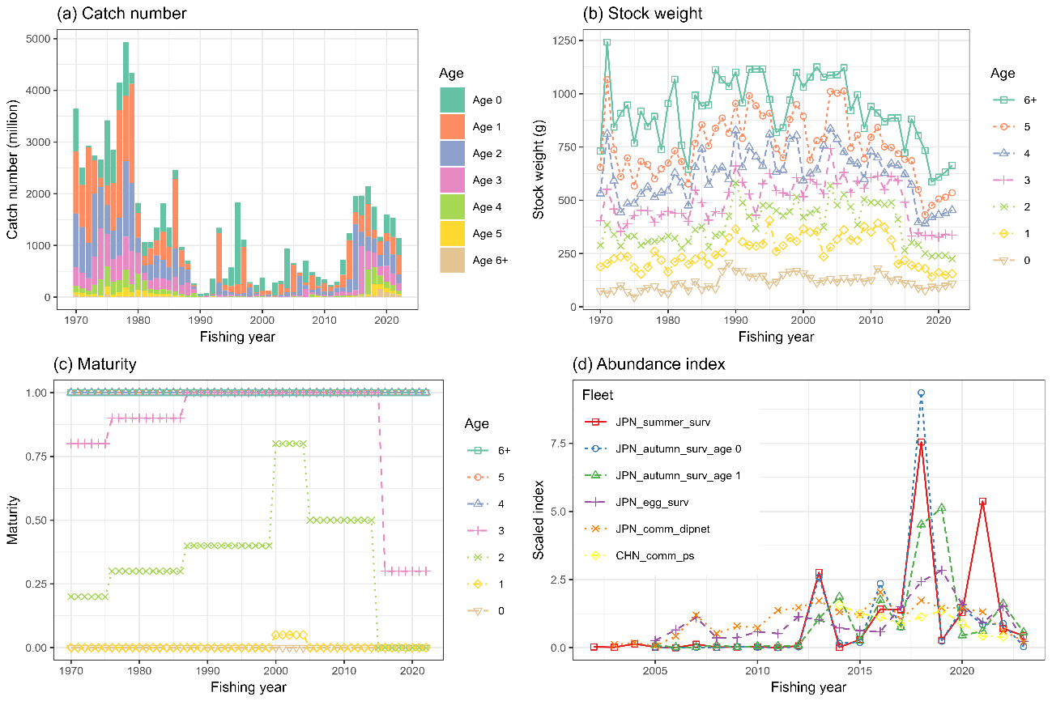  
The time series data used for the base case scenario. (a) catch number by age, (b) weight by age, (c) maturity by age, (d) abundance index. Each abundance index is scaled by its mean value for visualization. Note that the five Japanese abundance indices are included through FY2023, but are not used in the base case analysis.

Figure 2  
Catch number by member by age by year.

Figure 3  
Natural mortality (M) values under the two base case scenarios.

Figure 4  
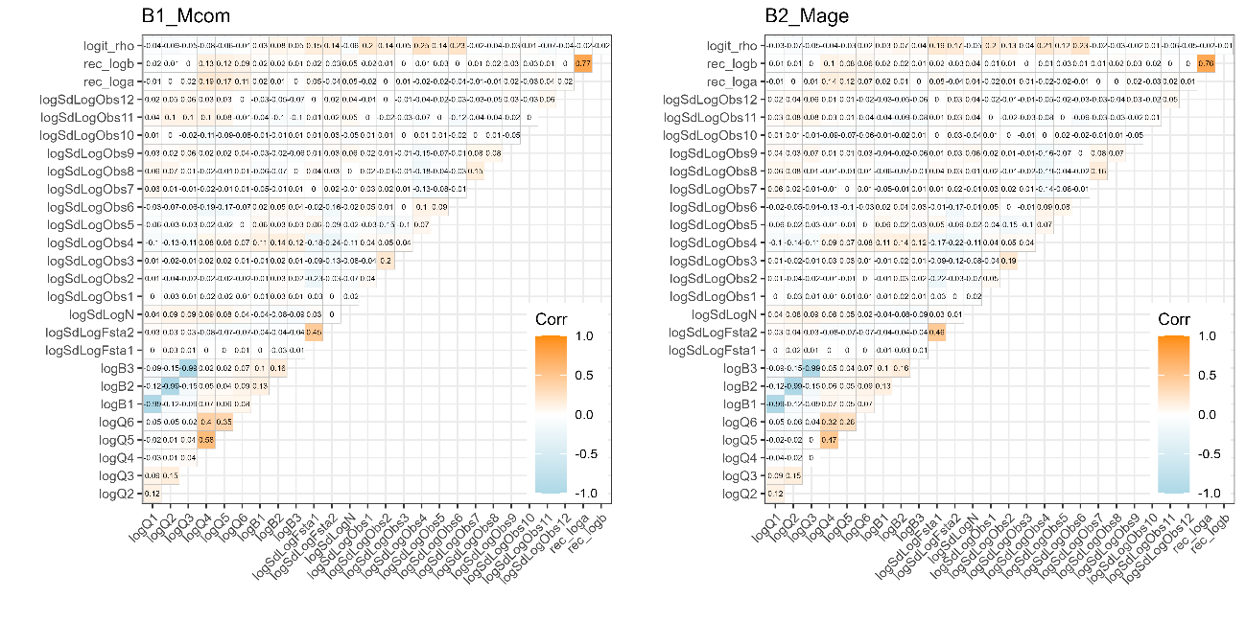  
Plot of the correlation matrix obtained from the covariance matrix of the fixed effects parameter estimates. (left) Scenario B1-Mcom, and (right) Scenario B2-Mage. Orange colors indicate positive correlation, while light blue indicates negative correlation.

Figure 5  
Relationship between six abundance index and their corresponding abundance estimates under Scenario B1-Mcom. The blue lines indicate the precited relationships.

Figure 6  
Same as Fig. 5 except that it is Scenario B2-Mage.

Figure 7  
Time series of estimates of total biomass (1,000 MT), SSB (1,000 MT), recruitment (billion), catch (1,000 MT), mean F, and exploitation rate (catch divided by total biomass) under the two base case scenarios. Shaded areas indicate 95% confidence intervals. Black dots in catch indicate observed values which were calculated from the sum products of catch at age and stock weight at age.

Figure 8  
Time series of estimates of total biomass, SSB, recruitment, catch, mean F, and exploitation rate in recent years under the two baseline scenarios. Shaded areas indicate 95% confidence intervals. Black dots in catch indicate observed values.

Figure 9  
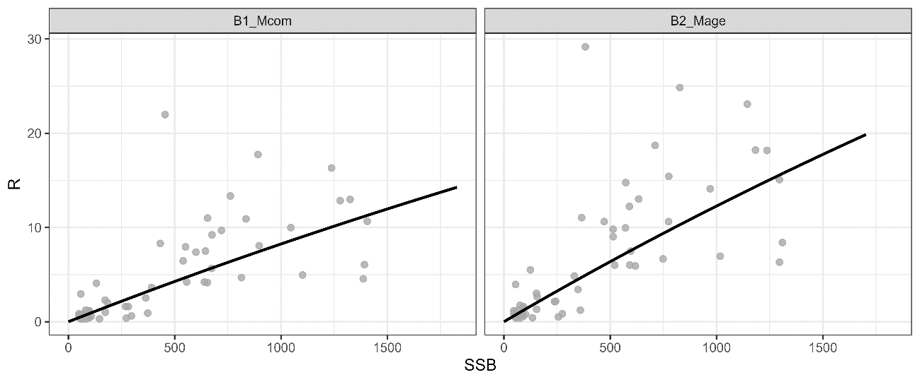  
Beverton-Holt stock recruitment relationship under the two base case scenarios. The unit of SSB on the x-axis is 1000 MT and the unit of subscription on the y-axis is billions.

Figure 10  
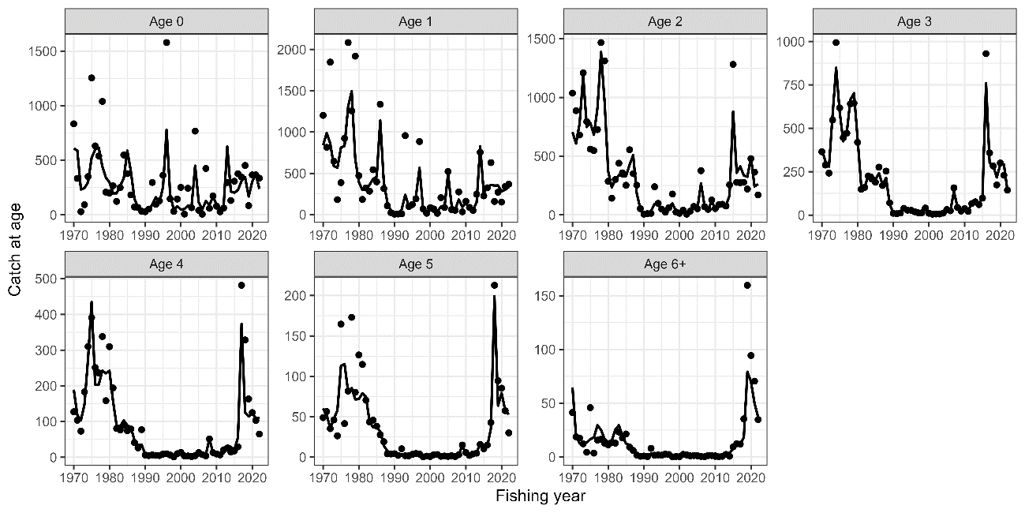  
Observed catch numbers by age (dots) and their predicted values (lines) under Scenario B1-Mcom.

Figure 11  
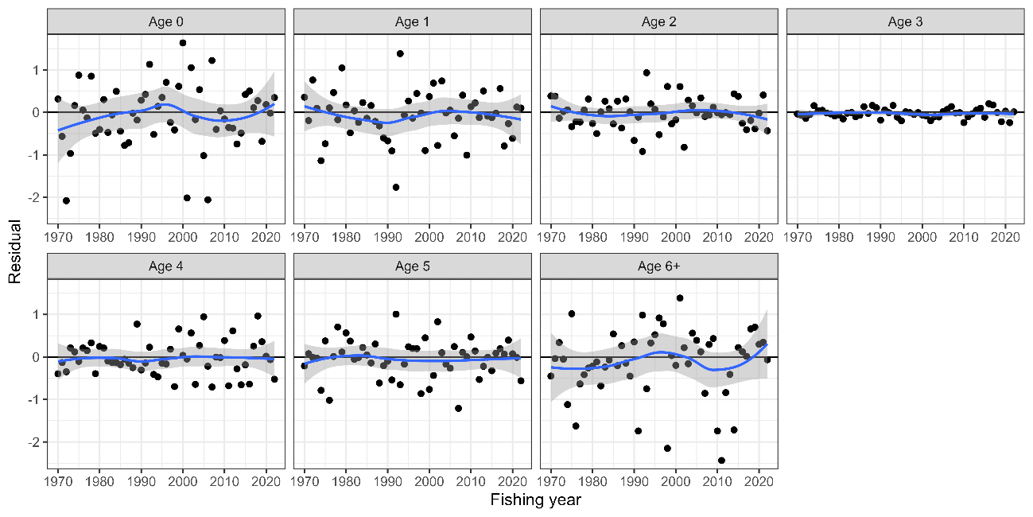  
Residual plot for catch numbers by age under Scenario B1-Mcom. Blue curves and shaded areas indicate smoothed curves estimated by LOESS and their 95% confidence intervals.

Figure 12  
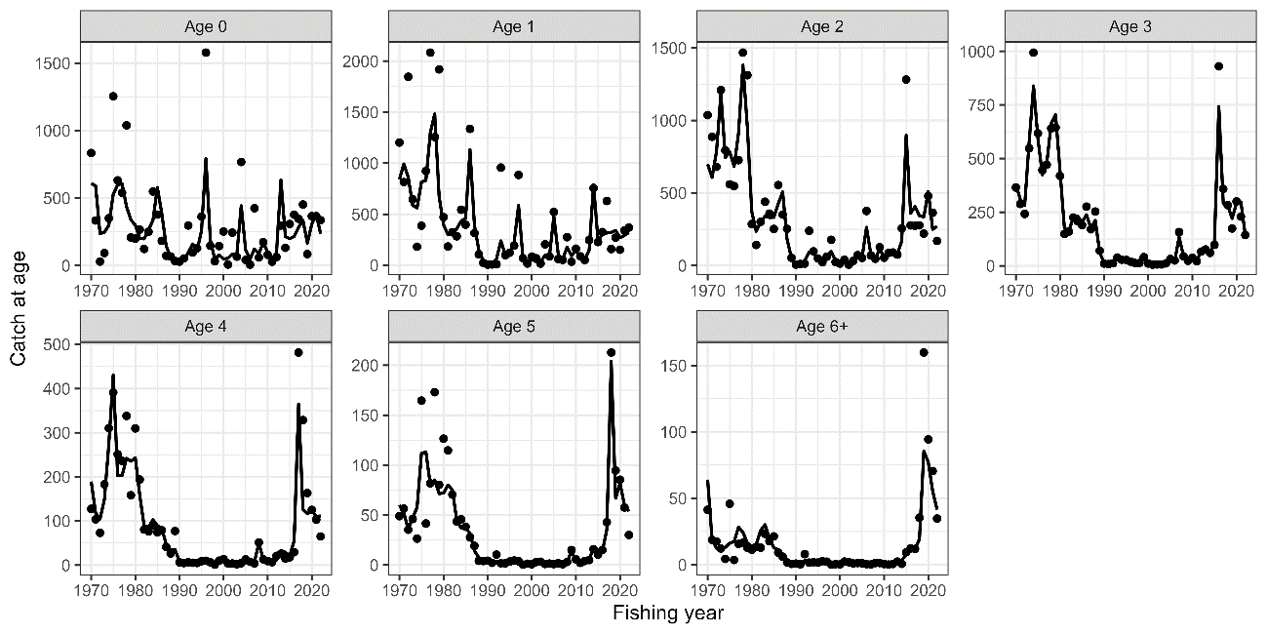  
Same as Fig. 10 except that it is Scenario B2-Mage.

Figure 13  
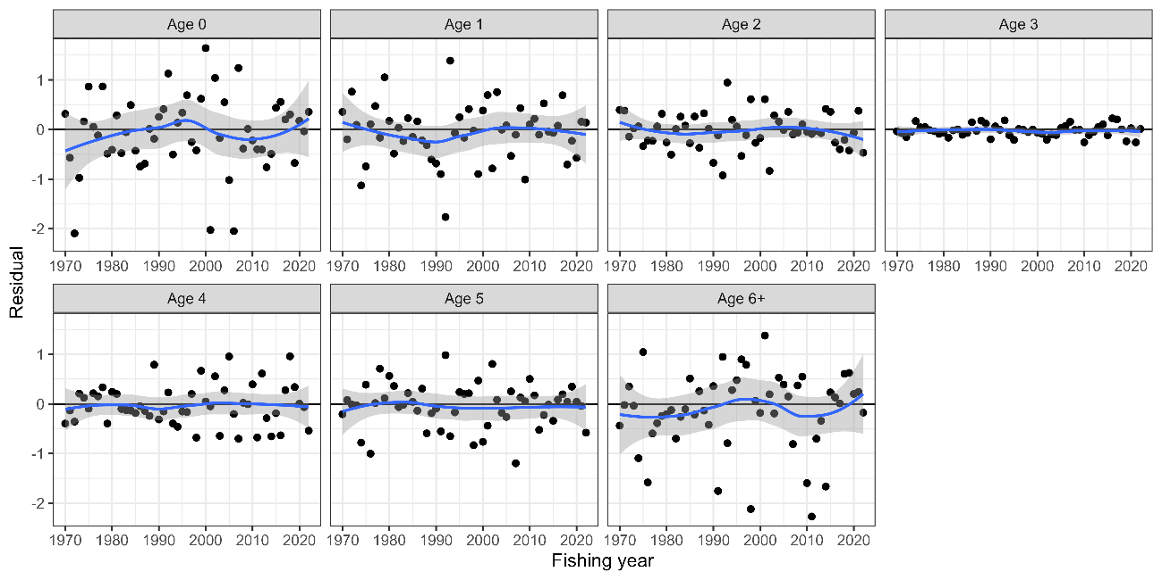  
Same as Fig. 11 except that it is Scenario B2-Mage.

Figure 14  
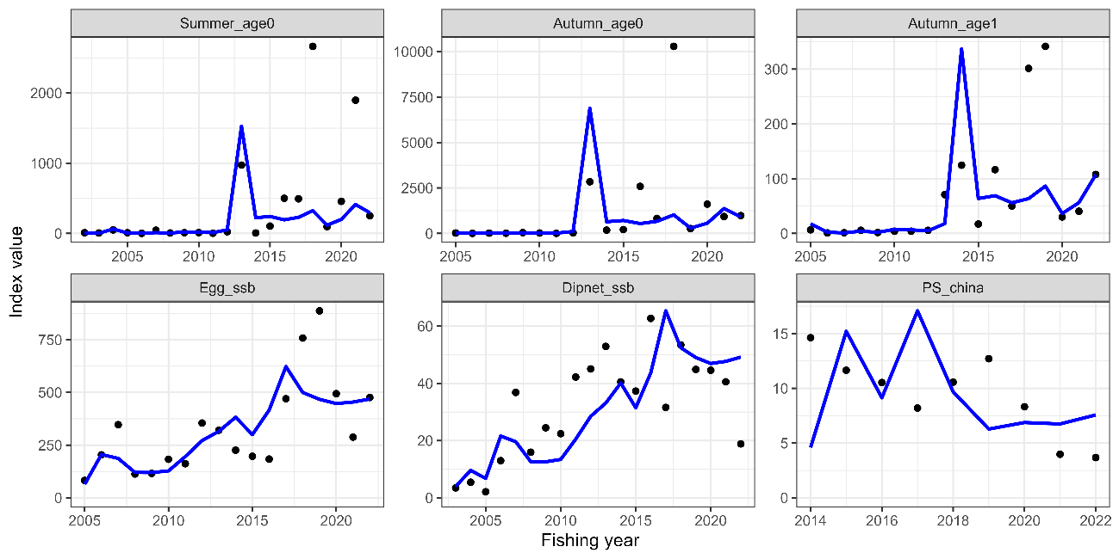  
Trends of abundance indices used (dots) and their predicted values (lines) under Scenario B1-Mcom.

Figure 15  
Residual plot for abundance indices under the B1-Mcom scenario. Blue curves and shaded areas indicate smoothed curves estimated by LOESS and their 95% confidence intervals.

Figure 16  
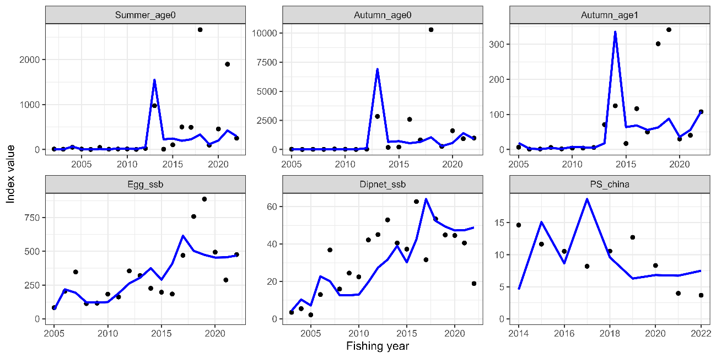  
Same as Fig. 14 except that it is Scenario B2-Mage.

Figure 17  
Same as Fig. 15 except that it is Scenario B2-Mage.

Figure 18  
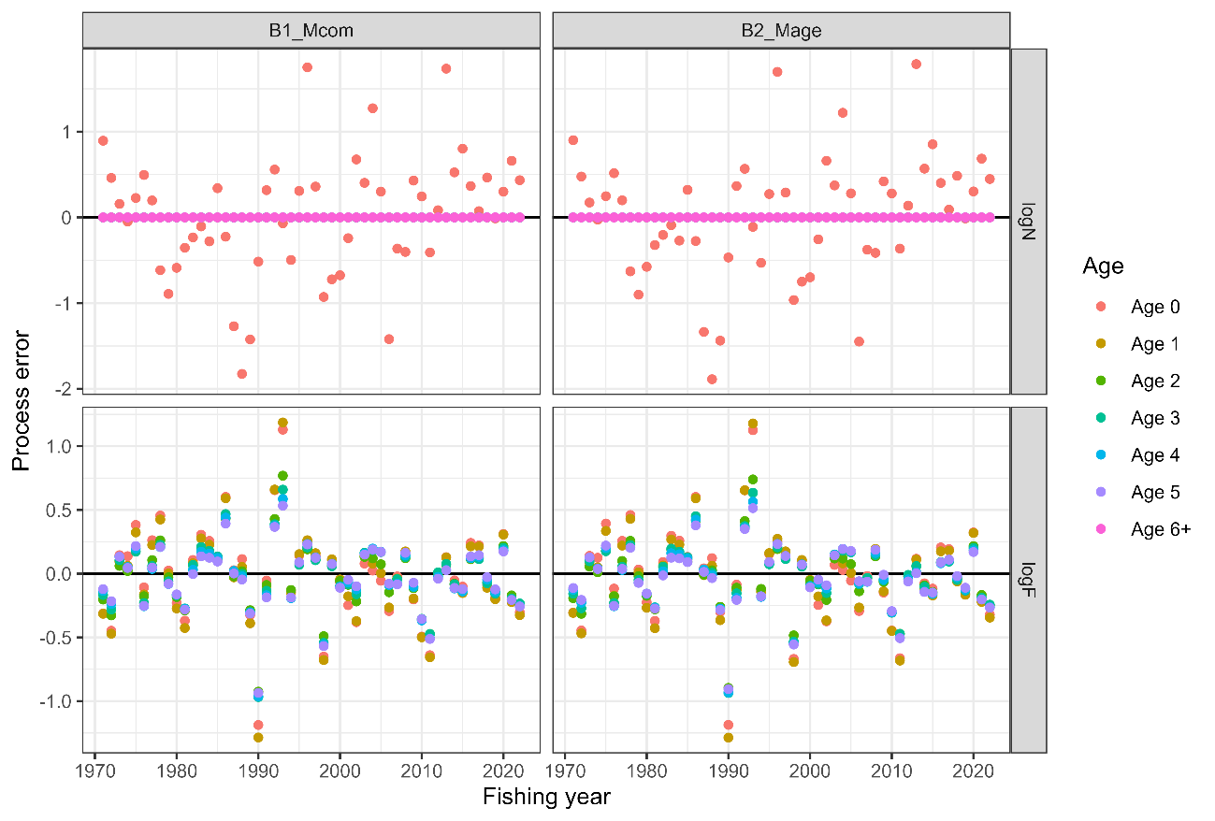Process errors log(N) (top) and log(F) (bottom) under B1-Mcom (left) and B2-Mage (right) scenarios. Note that the process error in the number of individuals is almost zero, since the number of fish above one year of age is fixed to a small value, and the residuals of zero-year-old recruitment are shown as scattered up and down.

Figure 19  
Retrospective patterns for total biomass (top left), SSB (top right), recruitment (bottom left), and mean F (bottom right). Black Lines represent models with all data, and colored lines represent models with the most recent data trimmed. Mohn's rho is shown in the upper left corner. The dots indicate the terminal year for the calculation of Mohn’s rho.

Figure 20  
Same as Fig. 17 except that it is Scenario B2-Mage.

Figure 21  
Patterns of retrospective forecasting for total biomass (top left), SSB (top right), recruitment (bottom left), and mean F (bottom right) for Scenario B1-Mcom. Black Lines represent models with all data, and colored lines represent models with the most recent data trimmed. Mohn's rho is shown in the upper left corner. The dots indicate the year of one-year-ahead forecasting, used for the calculation of Mohn’s rho.

Figure 22  
Same as Fig. 19 except that it is Scenario B2-Mage.

Figure 23  
Comparison of the results of the estimates when all index values are used and when each indicator is excluded for Scenario B1-Mcom. The IDs of the index are as follows: (1) relative stock number of age 0 from the summer survey by Japan, (2) relative stock number of age 0 from the autumn survey by Japan, (3) relative stock number of age 1 from the autumn survey by Japan, (4) relative SSB from the egg survey by Japan, (5) relative SSB from the dip-net fishery by Japan, and (6) relative vulnerable stock biomass from the light purse-seine fishery by China.

Figure 24  
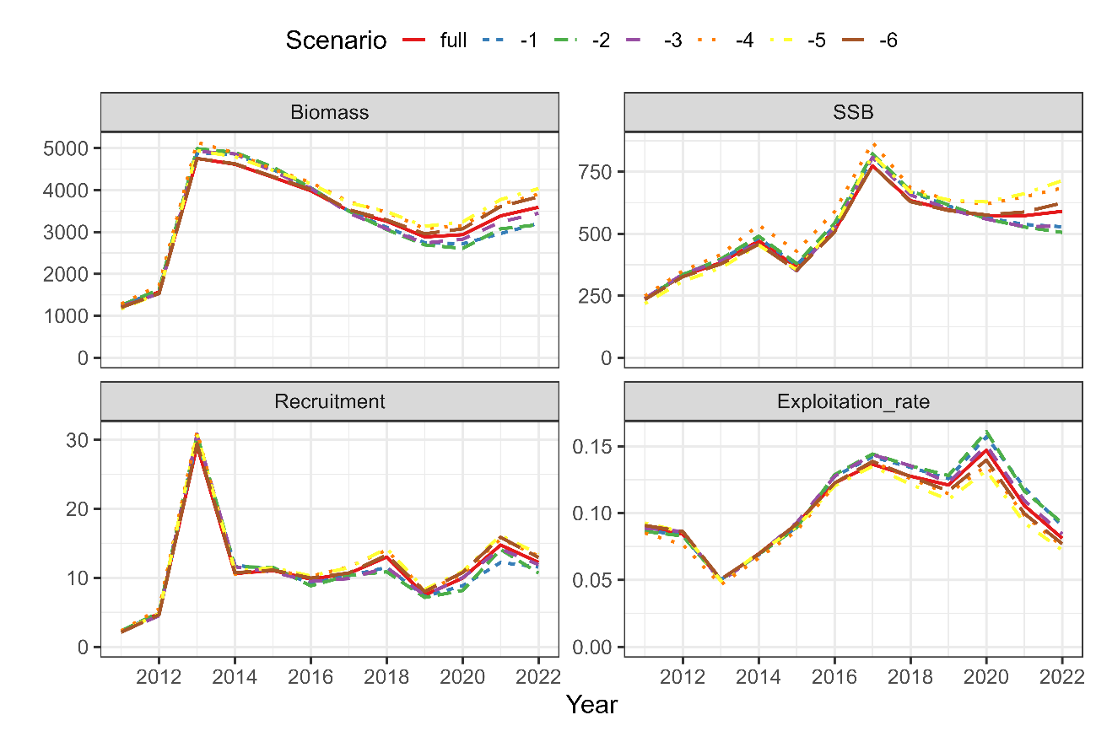  
Same as Fig. 23 except that it is Scenario B2-Mage.

Figure 25  
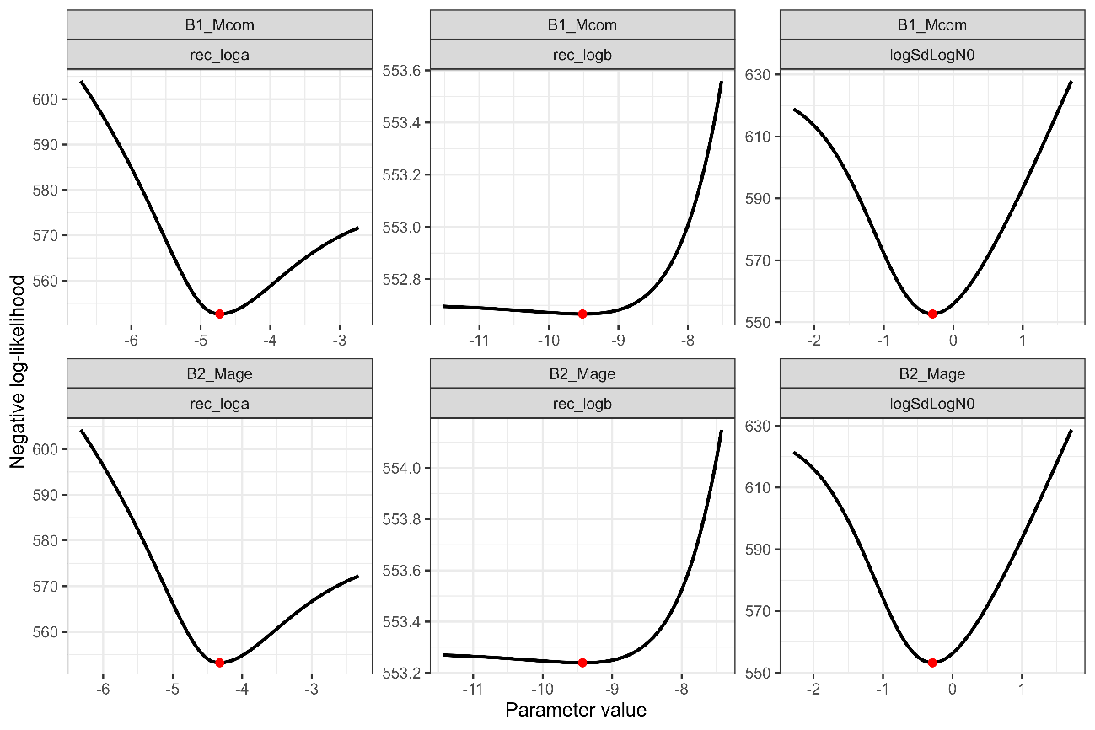  
Changes in negative log-likelihoods by varying parameters related to the stock-recruitment relationship (α, β, ω0 in log space). (This figure has been replaced by the corrected one because the profile likelihood for logSdLogN0 was wrong)

Figure 26  
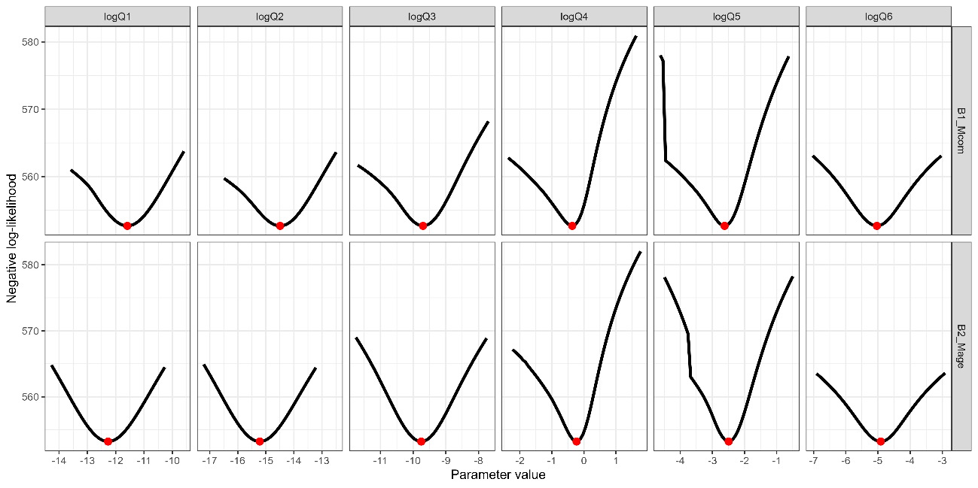  
Changes in negative log-likelihoods by varying parameters of proportionality constants for abundance indices (qk in log space). The red dotes indicate the input values for the base case scenarios.

Figure 27  
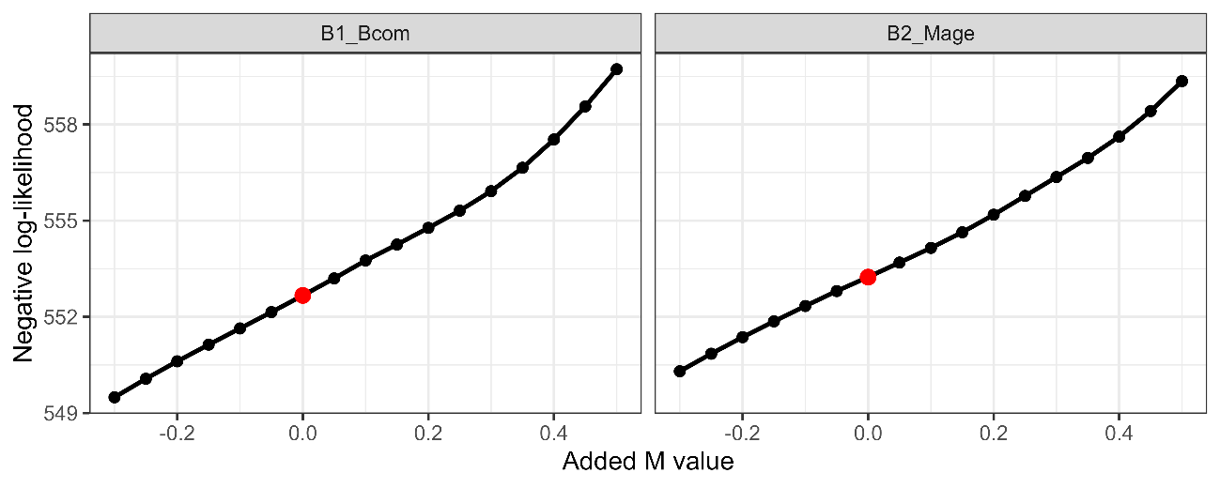  
Changes in negative log-likelihood ay adding different M values. The red dotes indicate the input values for the base case scenarios.

Figure 28  
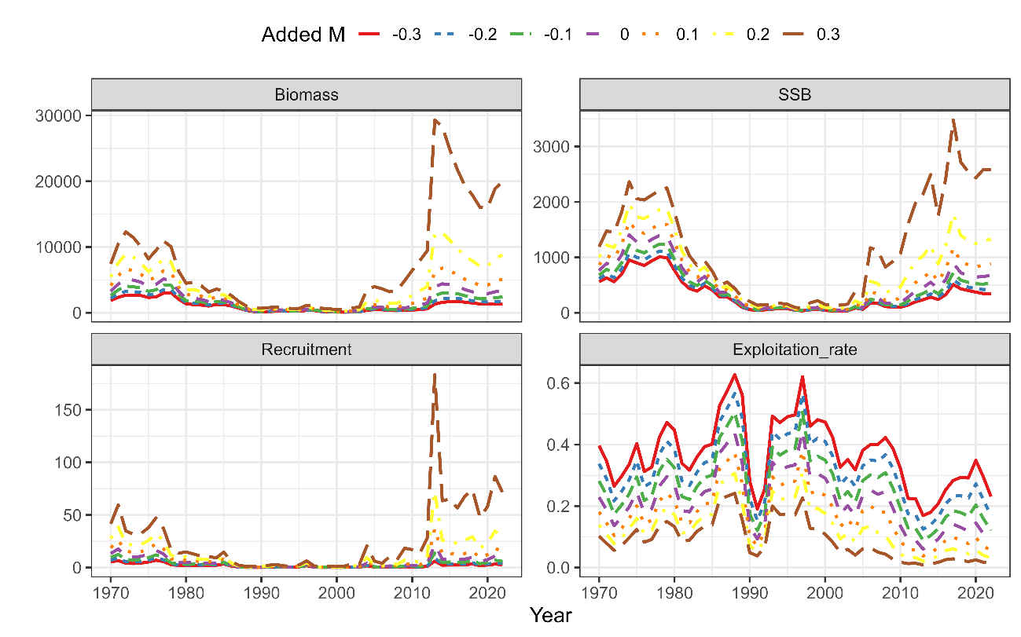Effects of varying M values on the estimates total biomass, SSB, recruitment, and exploitation rate under Scenario B1-Mcom.

Figure 29  
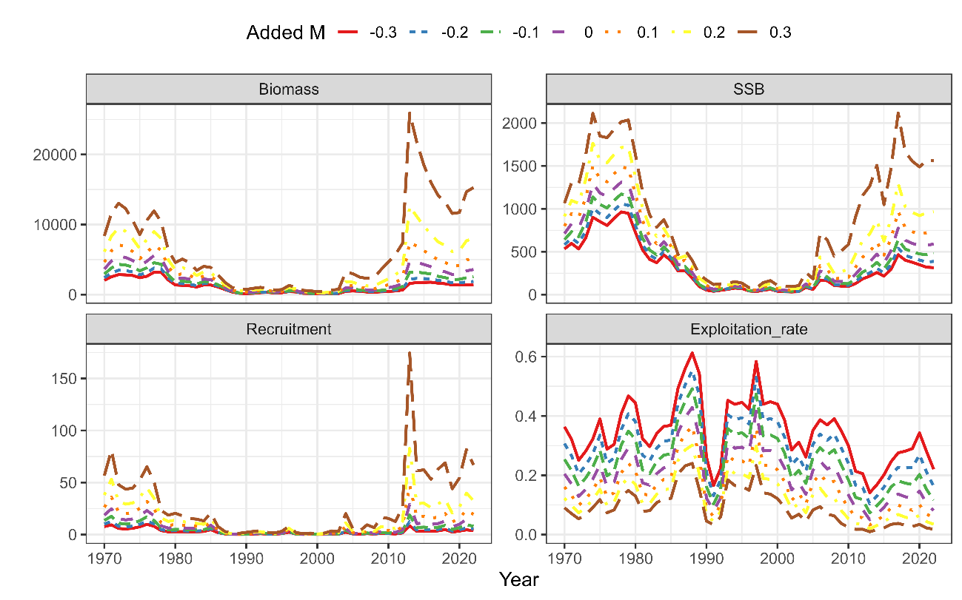  
Same as Fig. 28 except that it is Scenario B2 Mage.

Appendix: Age-specific estimates of F, stock numbers and catch numbers

Table A1  
Estimated F at age since FY1970 to2022 under Scenario B1-Mcom.

|  |  |  |  |  |  |  |  |
| --- | --- | --- | --- | --- | --- | --- | --- |
| **FY** | **Age 0** | **Age 1** | **Age 2** | **Age 3** | **Age 4** | **Age 5** | **Age 6+** |
| **1970** | 0.06 | 0.25 | 0.50 | 0.74 | 0.94 | 1.35 | 1.35 |
| **1971** | 0.04 | 0.18 | 0.40 | 0.63 | 0.81 | 1.18 | 1.18 |
| **1972** | 0.03 | 0.11 | 0.29 | 0.47 | 0.64 | 0.95 | 0.95 |
| **1973** | 0.03 | 0.12 | 0.31 | 0.52 | 0.73 | 1.08 | 1.08 |
| **1974** | 0.04 | 0.13 | 0.32 | 0.55 | 0.77 | 1.13 | 1.13 |
| **1975** | 0.05 | 0.18 | 0.38 | 0.65 | 0.94 | 1.40 | 1.40 |
| **1976** | 0.05 | 0.15 | 0.32 | 0.52 | 0.73 | 1.09 | 1.09 |
| **1977** | 0.06 | 0.19 | 0.35 | 0.56 | 0.76 | 1.15 | 1.15 |
| **1978** | 0.10 | 0.29 | 0.46 | 0.69 | 0.93 | 1.41 | 1.41 |
| **1979** | 0.10 | 0.29 | 0.44 | 0.65 | 0.86 | 1.31 | 1.31 |
| **1980** | 0.08 | 0.22 | 0.37 | 0.55 | 0.73 | 1.11 | 1.11 |
| **1981** | 0.05 | 0.15 | 0.28 | 0.42 | 0.56 | 0.84 | 0.84 |
| **1982** | 0.06 | 0.16 | 0.30 | 0.45 | 0.57 | 0.84 | 0.84 |
| **1983** | 0.08 | 0.21 | 0.36 | 0.56 | 0.68 | 0.97 | 0.97 |
| **1984** | 0.11 | 0.26 | 0.43 | 0.67 | 0.80 | 1.10 | 1.10 |
| **1985** | 0.12 | 0.29 | 0.47 | 0.77 | 0.91 | 1.21 | 1.21 |
| **1986** | 0.22 | 0.53 | 0.72 | 1.22 | 1.40 | 1.78 | 1.78 |
| **1987** | 0.23 | 0.51 | 0.71 | 1.22 | 1.42 | 1.78 | 1.78 |
| **1988** | 0.25 | 0.53 | 0.72 | 1.21 | 1.38 | 1.69 | 1.69 |
| **1989** | 0.18 | 0.36 | 0.54 | 0.89 | 1.02 | 1.23 | 1.23 |
| **1990** | 0.06 | 0.10 | 0.21 | 0.34 | 0.39 | 0.49 | 0.49 |
| **1991** | 0.05 | 0.09 | 0.20 | 0.30 | 0.33 | 0.40 | 0.40 |
| **1992** | 0.10 | 0.18 | 0.30 | 0.44 | 0.48 | 0.58 | 0.58 |
| **1993** | 0.32 | 0.58 | 0.65 | 0.85 | 0.86 | 0.99 | 0.99 |
| **1994** | 0.28 | 0.50 | 0.57 | 0.70 | 0.71 | 0.82 | 0.82 |
| **1995** | 0.32 | 0.58 | 0.62 | 0.75 | 0.78 | 0.90 | 0.90 |
| **1996** | 0.40 | 0.75 | 0.75 | 0.92 | 0.98 | 1.12 | 1.12 |
| **1997** | 0.46 | 0.87 | 0.84 | 1.02 | 1.10 | 1.27 | 1.27 |
| **1998** | 0.24 | 0.45 | 0.52 | 0.59 | 0.63 | 0.72 | 0.72 |
| **1999** | 0.27 | 0.50 | 0.55 | 0.63 | 0.69 | 0.78 | 0.78 |
| **2000** | 0.25 | 0.48 | 0.52 | 0.57 | 0.62 | 0.70 | 0.70 |
| **2001** | 0.20 | 0.40 | 0.48 | 0.53 | 0.58 | 0.67 | 0.67 |
| **2002** | 0.14 | 0.28 | 0.38 | 0.45 | 0.51 | 0.60 | 0.60 |
| **2003** | 0.15 | 0.32 | 0.44 | 0.53 | 0.60 | 0.70 | 0.70 |
| **2004** | 0.15 | 0.35 | 0.49 | 0.64 | 0.73 | 0.85 | 0.85 |
| **2005** | 0.14 | 0.35 | 0.53 | 0.75 | 0.86 | 1.00 | 1.00 |
| **2006** | 0.11 | 0.26 | 0.46 | 0.69 | 0.79 | 0.93 | 0.93 |
| **2007** | 0.10 | 0.26 | 0.44 | 0.66 | 0.73 | 0.86 | 0.86 |
| **2008** | 0.12 | 0.30 | 0.49 | 0.75 | 0.84 | 1.01 | 1.01 |
| **2009** | 0.10 | 0.25 | 0.44 | 0.68 | 0.77 | 0.96 | 0.96 |
| **2010** | 0.06 | 0.15 | 0.31 | 0.48 | 0.54 | 0.69 | 0.69 |
| **2011** | 0.03 | 0.08 | 0.20 | 0.30 | 0.33 | 0.42 | 0.42 |
| **2012** | 0.03 | 0.08 | 0.20 | 0.31 | 0.32 | 0.40 | 0.40 |
| **2013** | 0.04 | 0.09 | 0.21 | 0.33 | 0.33 | 0.42 | 0.42 |
| **2014** | 0.03 | 0.09 | 0.19 | 0.31 | 0.30 | 0.37 | 0.37 |
| **2015** | 0.03 | 0.07 | 0.17 | 0.27 | 0.26 | 0.33 | 0.33 |
| **2016** | 0.04 | 0.09 | 0.19 | 0.30 | 0.29 | 0.37 | 0.37 |
| **2017** | 0.05 | 0.11 | 0.21 | 0.34 | 0.33 | 0.43 | 0.43 |
| **2018** | 0.05 | 0.10 | 0.20 | 0.31 | 0.32 | 0.42 | 0.42 |
| **2019** | 0.04 | 0.08 | 0.18 | 0.27 | 0.28 | 0.38 | 0.38 |
| **2020** | 0.05 | 0.11 | 0.22 | 0.33 | 0.34 | 0.45 | 0.45 |
| **2021** | 0.04 | 0.09 | 0.19 | 0.28 | 0.28 | 0.37 | 0.37 |
| **2022** | 0.03 | 0.07 | 0.15 | 0.22 | 0.22 | 0.29 | 0.29 |

Table A2  
Same as Table A1 except it is Scenario B2-Mage.

|  |  |  |  |  |  |  |  |
| --- | --- | --- | --- | --- | --- | --- | --- |
| **FY** | **Age 0** | **Age 1** | **Age 2** | **Age 3** | **Age 4** | **Age 5** | **Age 6+** |
| **1970** | 0.05 | 0.25 | 0.52 | 0.80 | 1.01 | 1.46 | 1.46 |
| **1971** | 0.04 | 0.18 | 0.43 | 0.68 | 0.89 | 1.29 | 1.29 |
| **1972** | 0.02 | 0.11 | 0.31 | 0.52 | 0.71 | 1.05 | 1.05 |
| **1973** | 0.03 | 0.12 | 0.33 | 0.57 | 0.80 | 1.19 | 1.19 |
| **1974** | 0.03 | 0.13 | 0.34 | 0.59 | 0.83 | 1.23 | 1.23 |
| **1975** | 0.04 | 0.18 | 0.40 | 0.71 | 1.02 | 1.53 | 1.53 |
| **1976** | 0.04 | 0.15 | 0.34 | 0.56 | 0.79 | 1.19 | 1.19 |
| **1977** | 0.05 | 0.19 | 0.37 | 0.60 | 0.82 | 1.24 | 1.24 |
| **1978** | 0.08 | 0.29 | 0.48 | 0.75 | 1.00 | 1.52 | 1.52 |
| **1979** | 0.08 | 0.29 | 0.47 | 0.71 | 0.93 | 1.41 | 1.41 |
| **1980** | 0.06 | 0.22 | 0.40 | 0.60 | 0.80 | 1.21 | 1.21 |
| **1981** | 0.04 | 0.15 | 0.30 | 0.46 | 0.61 | 0.93 | 0.93 |
| **1982** | 0.05 | 0.16 | 0.32 | 0.49 | 0.63 | 0.91 | 0.91 |
| **1983** | 0.07 | 0.20 | 0.38 | 0.60 | 0.73 | 1.04 | 1.04 |
| **1984** | 0.09 | 0.26 | 0.45 | 0.71 | 0.86 | 1.17 | 1.17 |
| **1985** | 0.10 | 0.29 | 0.49 | 0.81 | 0.96 | 1.28 | 1.28 |
| **1986** | 0.18 | 0.51 | 0.74 | 1.27 | 1.47 | 1.87 | 1.87 |
| **1987** | 0.18 | 0.50 | 0.73 | 1.29 | 1.51 | 1.89 | 1.89 |
| **1988** | 0.21 | 0.53 | 0.75 | 1.29 | 1.49 | 1.82 | 1.82 |
| **1989** | 0.15 | 0.37 | 0.58 | 0.98 | 1.13 | 1.36 | 1.36 |
| **1990** | 0.05 | 0.10 | 0.24 | 0.39 | 0.45 | 0.56 | 0.56 |
| **1991** | 0.04 | 0.09 | 0.21 | 0.33 | 0.37 | 0.45 | 0.45 |
| **1992** | 0.08 | 0.17 | 0.32 | 0.48 | 0.53 | 0.64 | 0.64 |
| **1993** | 0.25 | 0.56 | 0.67 | 0.91 | 0.93 | 1.07 | 1.07 |
| **1994** | 0.22 | 0.49 | 0.60 | 0.76 | 0.78 | 0.90 | 0.90 |
| **1995** | 0.26 | 0.57 | 0.65 | 0.82 | 0.85 | 0.98 | 0.98 |
| **1996** | 0.33 | 0.75 | 0.79 | 1.00 | 1.07 | 1.23 | 1.23 |
| **1997** | 0.39 | 0.89 | 0.89 | 1.12 | 1.22 | 1.41 | 1.41 |
| **1998** | 0.20 | 0.45 | 0.55 | 0.66 | 0.71 | 0.81 | 0.81 |
| **1999** | 0.22 | 0.50 | 0.58 | 0.69 | 0.76 | 0.87 | 0.87 |
| **2000** | 0.21 | 0.47 | 0.55 | 0.63 | 0.69 | 0.78 | 0.78 |
| **2001** | 0.16 | 0.40 | 0.51 | 0.58 | 0.64 | 0.75 | 0.75 |
| **2002** | 0.11 | 0.28 | 0.41 | 0.50 | 0.57 | 0.68 | 0.68 |
| **2003** | 0.12 | 0.31 | 0.47 | 0.58 | 0.67 | 0.79 | 0.79 |
| **2004** | 0.12 | 0.34 | 0.52 | 0.70 | 0.81 | 0.95 | 0.95 |
| **2005** | 0.12 | 0.34 | 0.56 | 0.83 | 0.96 | 1.14 | 1.14 |
| **2006** | 0.09 | 0.26 | 0.49 | 0.76 | 0.89 | 1.07 | 1.07 |
| **2007** | 0.09 | 0.25 | 0.47 | 0.73 | 0.83 | 1.01 | 1.01 |
| **2008** | 0.10 | 0.30 | 0.54 | 0.84 | 0.97 | 1.21 | 1.21 |
| **2009** | 0.09 | 0.26 | 0.51 | 0.80 | 0.93 | 1.20 | 1.20 |
| **2010** | 0.06 | 0.17 | 0.37 | 0.60 | 0.69 | 0.91 | 0.91 |
| **2011** | 0.03 | 0.09 | 0.24 | 0.38 | 0.42 | 0.56 | 0.56 |
| **2012** | 0.03 | 0.09 | 0.23 | 0.37 | 0.41 | 0.53 | 0.53 |
| **2013** | 0.03 | 0.10 | 0.25 | 0.40 | 0.42 | 0.54 | 0.54 |
| **2014** | 0.03 | 0.09 | 0.23 | 0.36 | 0.36 | 0.46 | 0.46 |
| **2015** | 0.03 | 0.07 | 0.20 | 0.31 | 0.31 | 0.40 | 0.40 |
| **2016** | 0.03 | 0.09 | 0.21 | 0.34 | 0.34 | 0.44 | 0.44 |
| **2017** | 0.04 | 0.10 | 0.24 | 0.37 | 0.37 | 0.49 | 0.49 |
| **2018** | 0.04 | 0.10 | 0.23 | 0.36 | 0.36 | 0.48 | 0.48 |
| **2019** | 0.03 | 0.08 | 0.21 | 0.32 | 0.32 | 0.43 | 0.43 |
| **2020** | 0.05 | 0.12 | 0.26 | 0.39 | 0.39 | 0.52 | 0.52 |
| **2021** | 0.04 | 0.10 | 0.22 | 0.33 | 0.33 | 0.43 | 0.43 |
| **2022** | 0.03 | 0.07 | 0.18 | 0.26 | 0.25 | 0.33 | 0.33 |

Table A3  
Estimated stock number at age (million) since FY1970 to2022 under Scenario B1-Mcom.

|  |  |  |  |  |  |  |  |
| --- | --- | --- | --- | --- | --- | --- | --- |
| **FY** | **Age 0** | **Age 1** | **Age 2** | **Age 3** | **Age 4** | **Age 5** | **Age 6+** |
| **1970** | 13343.5 | 4828.4 | 2241.8 | 892.1 | 381.3 | 98.3 | 105.6 |
| **1971** | 17737.5 | 7625.0 | 2283.3 | 825.8 | 261.5 | 91.5 | 34.1 |
| **1972** | 10912.4 | 10308.9 | 3866.6 | 924.1 | 271.1 | 71.1 | 25.0 |
| **1973** | 9989.9 | 6442.4 | 5592.1 | 1752.3 | 352.4 | 87.3 | 23.7 |
| **1974** | 10653.8 | 5871.6 | 3457.9 | 2488.3 | 634.2 | 103.9 | 24.1 |
| **1975** | 12850.7 | 6231.6 | 3127.1 | 1528.5 | 876.3 | 180.2 | 26.5 |
| **1976** | 16313.1 | 7391.7 | 3157.3 | 1302.8 | 486.5 | 211.3 | 33.3 |
| **1977** | 12978.7 | 9435.1 | 3845.7 | 1396.9 | 473.0 | 144.1 | 52.5 |
| **1978** | 6053.4 | 7399.1 | 4720.9 | 1639.9 | 490.3 | 135.9 | 39.9 |
| **1979** | 4559.7 | 3329.6 | 3346.0 | 1813.0 | 501.1 | 118.4 | 27.6 |
| **1980** | 4959.6 | 2502.9 | 1504.8 | 1302.7 | 577.5 | 130.1 | 25.4 |
| **1981** | 4682.2 | 2778.9 | 1214.1 | 631.0 | 458.8 | 170.5 | 32.5 |
| **1982** | 4212.5 | 2687.9 | 1456.6 | 558.5 | 253.0 | 160.9 | 54.8 |
| **1983** | 4218.5 | 2403.3 | 1390.8 | 657.0 | 217.2 | 87.1 | 58.2 |
| **1984** | 4152.6 | 2354.4 | 1182.1 | 586.2 | 230.0 | 67.1 | 34.8 |
| **1985** | 6463.0 | 2261.6 | 1097.2 | 467.6 | 184.0 | 63.2 | 21.5 |
| **1986** | 2518.3 | 3468.9 | 1022.5 | 415.2 | 133.3 | 45.5 | 16.0 |
| **1987** | 913.9 | 1222.7 | 1240.1 | 300.1 | 75.6 | 20.2 | 6.6 |
| **1988** | 383.9 | 441.2 | 444.9 | 370.8 | 54.5 | 11.2 | 2.9 |
| **1989** | 306.2 | 180.5 | 156.6 | 131.7 | 68.0 | 8.4 | 1.7 |
| **1990** | 501.4 | 154.6 | 76.2 | 55.7 | 33.2 | 15.1 | 1.9 |
| **1991** | 838.3 | 287.5 | 84.8 | 37.4 | 24.2 | 13.7 | 6.5 |
| **1992** | 1240.1 | 482.0 | 159.0 | 42.3 | 16.9 | 10.6 | 8.3 |
| **1993** | 750.8 | 678.5 | 244.7 | 71.4 | 16.6 | 6.4 | 6.6 |
| **1994** | 578.4 | 331.3 | 229.2 | 77.5 | 18.7 | 4.3 | 3.0 |
| **1995** | 1172.5 | 265.8 | 121.5 | 78.4 | 23.5 | 5.6 | 2.0 |
| **1996** | 2945.7 | 516.8 | 89.6 | 39.4 | 22.6 | 6.6 | 1.9 |
| **1997** | 631.4 | 1193.8 | 146.8 | 25.6 | 9.6 | 5.2 | 1.8 |
| **1998** | 280.6 | 241.0 | 298.6 | 38.4 | 5.7 | 2.0 | 1.3 |
| **1999** | 417.1 | 133.5 | 93.2 | 108.2 | 13.0 | 1.8 | 1.0 |
| **2000** | 276.8 | 192.9 | 48.9 | 32.7 | 35.3 | 4.0 | 0.8 |
| **2001** | 375.0 | 130.1 | 72.0 | 17.7 | 11.3 | 11.6 | 1.5 |
| **2002** | 848.7 | 186.5 | 52.5 | 27.1 | 6.4 | 3.9 | 4.2 |
| **2003** | 721.2 | 449.2 | 85.5 | 21.7 | 10.6 | 2.3 | 2.8 |
| **2004** | 4080.4 | 377.6 | 197.4 | 33.5 | 7.8 | 3.5 | 1.6 |
| **2005** | 1101.1 | 2129.2 | 161.9 | 73.1 | 10.9 | 2.3 | 1.4 |
| **2006** | 625.2 | 579.5 | 913.4 | 57.9 | 21.1 | 2.8 | 0.9 |
| **2007** | 1616.0 | 341.4 | 269.9 | 351.5 | 17.8 | 5.9 | 0.9 |
| **2008** | 1004.9 | 883.4 | 160.5 | 105.7 | 111.1 | 5.3 | 1.8 |
| **2009** | 2290.1 | 541.0 | 395.5 | 59.6 | 30.7 | 29.5 | 1.7 |
| **2010** | 2021.5 | 1260.4 | 255.9 | 154.6 | 18.7 | 8.9 | 7.9 |
| **2011** | 1613.7 | 1154.7 | 655.7 | 114.0 | 58.6 | 6.7 | 5.5 |
| **2012** | 3644.4 | 948.4 | 646.4 | 327.7 | 51.5 | 25.9 | 5.2 |
| **2013** | 21979.1 | 2141.1 | 530.6 | 322.9 | 147.1 | 22.8 | 13.0 |
| **2014** | 7945.9 | 12858.2 | 1183.8 | 261.3 | 141.3 | 64.4 | 14.8 |
| **2015** | 8301.4 | 4658.5 | 7169.8 | 591.7 | 117.4 | 64.0 | 33.8 |
| **2016** | 7381.6 | 4881.6 | 2630.3 | 3677.8 | 275.9 | 55.2 | 43.3 |
| **2017** | 8063.3 | 4300.1 | 2706.5 | 1323.7 | 1657.5 | 125.5 | 41.7 |
| **2018** | 9690.6 | 4651.8 | 2331.6 | 1328.1 | 576.4 | 723.5 | 66.6 |
| **2019** | 5659.7 | 5610.4 | 2551.1 | 1158.4 | 591.9 | 255.1 | 317.1 |
| **2020** | 7498.4 | 3304.6 | 3129.9 | 1299.9 | 539.3 | 272.8 | 241.0 |
| **2021** | 10998.9 | 4315.7 | 1791.3 | 1526.4 | 569.3 | 234.8 | 201.4 |
| **2022** | 9217.1 | 6391.7 | 2390.8 | 904.4 | 707.2 | 263.0 | 185.1 |

Table A4  
Same as Table A3 except that it is Scenario B2-Mage.

|  |  |  |  |  |  |  |  |
| --- | --- | --- | --- | --- | --- | --- | --- |
| **FY** | **Age 0** | **Age 1** | **Age 2** | **Age 3** | **Age 4** | **Age 5** | **Age 6+** |
| **1970** | 18711.5 | 5088.0 | 2147.9 | 832.5 | 353.3 | 91.1 | 96.7 |
| **1971** | 24843.3 | 8011.7 | 2182.3 | 764.1 | 239.7 | 83.9 | 30.8 |
| **1972** | 15420.9 | 10781.6 | 3677.6 | 852.8 | 246.9 | 64.7 | 22.3 |
| **1973** | 14104.4 | 6778.3 | 5292.0 | 1614.6 | 322.9 | 79.7 | 21.3 |
| **1974** | 15080.8 | 6178.0 | 3294.2 | 2282.4 | 579.9 | 95.1 | 21.5 |
| **1975** | 18211.8 | 6581.9 | 2984.3 | 1415.3 | 801.3 | 165.4 | 23.8 |
| **1976** | 23089.7 | 7838.8 | 3021.2 | 1202.6 | 444.5 | 190.5 | 29.1 |
| **1977** | 18171.3 | 9986.7 | 3699.5 | 1298.2 | 435.5 | 132.4 | 46.5 |
| **1978** | 8402.2 | 7770.9 | 4540.2 | 1532.7 | 455.0 | 126.4 | 36.1 |
| **1979** | 6321.4 | 3490.5 | 3195.0 | 1687.5 | 463.5 | 109.9 | 25.1 |
| **1980** | 6951.8 | 2620.1 | 1430.2 | 1199.8 | 529.7 | 120.0 | 23.0 |
| **1981** | 6667.7 | 2928.8 | 1150.6 | 578.9 | 417.7 | 156.7 | 29.6 |
| **1982** | 6016.4 | 2865.3 | 1390.0 | 512.9 | 231.3 | 148.4 | 50.7 |
| **1983** | 6004.3 | 2574.5 | 1346.1 | 609.3 | 199.5 | 81.2 | 54.9 |
| **1984** | 5921.0 | 2526.0 | 1153.2 | 551.9 | 213.1 | 62.8 | 33.4 |
| **1985** | 9024.9 | 2442.8 | 1073.5 | 443.3 | 172.5 | 59.4 | 20.7 |
| **1986** | 3426.7 | 3680.1 | 1007.9 | 394.7 | 125.7 | 43.2 | 15.3 |
| **1987** | 1230.8 | 1290.4 | 1208.8 | 287.5 | 71.1 | 19.1 | 6.3 |
| **1988** | 508.4 | 460.1 | 427.4 | 347.8 | 50.7 | 10.3 | 2.7 |
| **1989** | 415.8 | 185.7 | 147.9 | 120.9 | 61.3 | 7.5 | 1.5 |
| **1990** | 704.6 | 160.3 | 70.4 | 49.9 | 29.1 | 13.1 | 1.6 |
| **1991** | 1192.3 | 302.1 | 79.4 | 33.4 | 21.6 | 12.2 | 5.8 |
| **1992** | 1739.4 | 513.1 | 151.4 | 38.6 | 15.2 | 9.8 | 7.8 |
| **1993** | 1016.2 | 719.2 | 236.6 | 66.0 | 15.2 | 5.9 | 6.3 |
| **1994** | 795.1 | 353.6 | 223.5 | 72.5 | 17.0 | 3.9 | 2.9 |
| **1995** | 1601.1 | 285.3 | 118.6 | 73.8 | 21.6 | 5.1 | 1.9 |
| **1996** | 3957.7 | 553.7 | 87.8 | 37.0 | 20.8 | 6.1 | 1.8 |
| **1997** | 836.1 | 1271.9 | 142.6 | 23.9 | 8.7 | 4.7 | 1.6 |
| **1998** | 380.6 | 254.3 | 284.8 | 35.1 | 5.0 | 1.7 | 1.1 |
| **1999** | 559.4 | 139.9 | 89.1 | 98.7 | 11.6 | 1.6 | 0.9 |
| **2000** | 374.1 | 201.0 | 46.5 | 29.9 | 31.4 | 3.6 | 0.7 |
| **2001** | 516.2 | 136.4 | 68.4 | 16.1 | 10.1 | 10.4 | 1.3 |
| **2002** | 1172.1 | 197.0 | 50.1 | 24.7 | 5.7 | 3.5 | 3.8 |
| **2003** | 992.2 | 470.5 | 81.9 | 19.9 | 9.5 | 2.1 | 2.5 |
| **2004** | 5497.2 | 395.2 | 188.3 | 30.9 | 7.1 | 3.2 | 1.5 |
| **2005** | 1503.3 | 2182.5 | 154.2 | 66.9 | 9.8 | 2.1 | 1.2 |
| **2006** | 845.5 | 600.9 | 851.6 | 52.7 | 18.7 | 2.5 | 0.7 |
| **2007** | 2166.0 | 348.4 | 254.2 | 313.5 | 15.7 | 5.1 | 0.8 |
| **2008** | 1325.3 | 892.9 | 148.6 | 95.0 | 95.7 | 4.5 | 1.5 |
| **2009** | 3014.7 | 538.5 | 361.0 | 52.0 | 26.0 | 23.8 | 1.3 |
| **2010** | 2661.7 | 1243.1 | 227.2 | 130.9 | 15.0 | 6.8 | 5.4 |
| **2011** | 2131.0 | 1131.6 | 575.9 | 94.0 | 45.9 | 5.0 | 3.6 |
| **2012** | 4855.3 | 930.7 | 569.6 | 273.7 | 41.1 | 19.8 | 3.5 |
| **2013** | 29171.2 | 2121.3 | 469.2 | 271.5 | 119.6 | 18.0 | 9.5 |
| **2014** | 10629.6 | 12702.0 | 1057.7 | 220.4 | 115.7 | 51.9 | 11.2 |
| **2015** | 11050.5 | 4640.2 | 6403.4 | 507.0 | 97.5 | 52.8 | 27.1 |
| **2016** | 9810.1 | 4837.9 | 2372.1 | 3165.3 | 235.2 | 46.8 | 36.3 |
| **2017** | 10628.3 | 4265.5 | 2437.1 | 1152.6 | 1424.9 | 109.8 | 36.4 |
| **2018** | 13019.5 | 4590.9 | 2110.8 | 1155.2 | 502.6 | 640.7 | 60.6 |
| **2019** | 7489.5 | 5629.1 | 2285.0 | 1008.0 | 512.3 | 228.1 | 291.1 |
| **2020** | 9959.6 | 3257.8 | 2840.2 | 1117.8 | 466.4 | 242.0 | 227.4 |
| **2021** | 14760.4 | 4276.9 | 1594.4 | 1320.0 | 481.5 | 206.2 | 189.7 |
| **2022** | 12233.9 | 6391.2 | 2139.4 | 770.9 | 606.2 | 227.7 | 175.0 |

Table A5  
Predicted catch number at age (million) since FY1970 to2022 under Scenario B1-Mcom.

|  |  |  |  |  |  |  |  |
| --- | --- | --- | --- | --- | --- | --- | --- |
| **FY** | **Age 0** | **Age 1** | **Age 2** | **Age 3** | **Age 4** | **Age 5** | **Age 6+** |
| **1970** | 608.7 | 841.3 | 705.7 | 379.0 | 189.5 | 60.4 | 64.9 |
| **1971** | 588.1 | 988.9 | 607.7 | 309.7 | 118.4 | 52.3 | 19.5 |
| **1972** | 232.5 | 861.4 | 779.8 | 279.0 | 103.6 | 35.6 | 12.5 |
| **1973** | 245.2 | 587.8 | 1188.8 | 575.0 | 148.1 | 47.4 | 12.9 |
| **1974** | 299.2 | 568.0 | 748.8 | 848.6 | 275.9 | 57.9 | 13.4 |
| **1975** | 522.7 | 812.6 | 783.9 | 592.9 | 434.9 | 112.9 | 16.6 |
| **1976** | 598.3 | 830.9 | 682.2 | 425.2 | 203.5 | 115.3 | 18.1 |
| **1977** | 615.5 | 1307.7 | 912.2 | 478.7 | 203.4 | 80.9 | 29.5 |
| **1978** | 443.8 | 1494.1 | 1388.1 | 664.6 | 242.6 | 85.5 | 25.1 |
| **1979** | 341.3 | 672.5 | 960.4 | 702.4 | 235.0 | 71.5 | 16.7 |
| **1980** | 298.0 | 397.0 | 371.4 | 444.5 | 242.2 | 71.8 | 14.0 |
| **1981** | 197.2 | 298.6 | 234.1 | 173.6 | 157.3 | 79.0 | 15.0 |
| **1982** | 197.4 | 312.2 | 298.0 | 162.8 | 89.0 | 74.6 | 25.4 |
| **1983** | 265.6 | 360.0 | 338.9 | 226.1 | 86.9 | 44.1 | 29.5 |
| **1984** | 334.6 | 432.5 | 329.4 | 231.0 | 102.9 | 36.7 | 19.1 |
| **1985** | 588.4 | 457.5 | 330.9 | 203.1 | 89.4 | 36.6 | 12.4 |
| **1986** | 397.9 | 1139.1 | 426.9 | 241.5 | 83.5 | 31.9 | 11.2 |
| **1987** | 147.5 | 391.0 | 508.5 | 174.7 | 47.8 | 14.1 | 4.7 |
| **1988** | 68.2 | 146.3 | 184.2 | 214.7 | 33.9 | 7.6 | 2.0 |
| **1989** | 40.5 | 43.6 | 52.2 | 63.3 | 35.6 | 4.9 | 1.0 |
| **1990** | 21.6 | 11.7 | 11.6 | 12.8 | 8.6 | 4.7 | 0.6 |
| **1991** | 34.5 | 20.0 | 12.0 | 7.7 | 5.4 | 3.7 | 1.7 |
| **1992** | 95.9 | 62.3 | 33.0 | 12.1 | 5.2 | 3.8 | 3.0 |
| **1993** | 162.2 | 240.3 | 94.3 | 33.3 | 7.8 | 3.3 | 3.4 |
| **1994** | 111.2 | 104.6 | 80.4 | 31.7 | 7.7 | 2.0 | 1.4 |
| **1995** | 254.9 | 94.5 | 45.5 | 33.7 | 10.3 | 2.7 | 1.0 |
| **1996** | 779.3 | 221.5 | 38.4 | 19.4 | 11.5 | 3.7 | 1.1 |
| **1997** | 186.3 | 567.2 | 67.8 | 13.4 | 5.3 | 3.1 | 1.0 |
| **1998** | 47.8 | 69.7 | 96.6 | 13.9 | 2.1 | 0.8 | 0.5 |
| **1999** | 78.4 | 42.3 | 31.7 | 40.8 | 5.2 | 0.8 | 0.4 |
| **2000** | 49.1 | 59.0 | 15.9 | 11.4 | 13.1 | 1.6 | 0.3 |
| **2001** | 53.3 | 34.6 | 21.9 | 5.8 | 4.0 | 4.6 | 0.6 |
| **2002** | 85.2 | 36.1 | 13.4 | 7.9 | 2.1 | 1.4 | 1.5 |
| **2003** | 77.9 | 98.1 | 24.3 | 7.2 | 3.8 | 1.0 | 1.1 |
| **2004** | 450.0 | 88.0 | 61.6 | 12.8 | 3.3 | 1.6 | 0.7 |
| **2005** | 115.0 | 495.7 | 53.4 | 31.4 | 5.1 | 1.2 | 0.7 |
| **2006** | 49.4 | 107.0 | 267.9 | 23.3 | 9.4 | 1.4 | 0.4 |
| **2007** | 125.4 | 61.1 | 76.6 | 137.1 | 7.5 | 2.8 | 0.4 |
| **2008** | 89.1 | 183.6 | 50.1 | 45.1 | 51.4 | 2.7 | 1.0 |
| **2009** | 167.6 | 94.9 | 112.9 | 23.7 | 13.3 | 14.9 | 0.8 |
| **2010** | 93.2 | 142.5 | 54.6 | 47.4 | 6.3 | 3.6 | 3.2 |
| **2011** | 40.1 | 70.7 | 92.3 | 23.7 | 13.1 | 1.8 | 1.5 |
| **2012** | 91.1 | 58.6 | 90.9 | 68.9 | 11.3 | 6.9 | 1.4 |
| **2013** | 624.6 | 149.7 | 79.7 | 72.7 | 33.3 | 6.2 | 3.5 |
| **2014** | 214.0 | 826.8 | 165.4 | 54.8 | 29.0 | 15.9 | 3.7 |
| **2015** | 202.1 | 258.4 | 881.0 | 109.8 | 21.3 | 14.3 | 7.5 |
| **2016** | 227.9 | 332.5 | 358.1 | 758.9 | 55.5 | 13.8 | 10.8 |
| **2017** | 310.1 | 359.6 | 412.3 | 301.3 | 373.7 | 35.3 | 11.7 |
| **2018** | 343.6 | 352.1 | 335.3 | 283.9 | 125.3 | 199.1 | 18.3 |
| **2019** | 168.1 | 353.5 | 324.7 | 216.9 | 114.1 | 63.7 | 79.2 |
| **2020** | 305.1 | 281.4 | 489.0 | 292.1 | 123.0 | 79.3 | 70.0 |
| **2021** | 372.5 | 302.2 | 242.0 | 292.3 | 109.8 | 58.1 | 49.9 |
| **2022** | 237.0 | 333.8 | 262.0 | 141.9 | 109.9 | 52.7 | 37.1 |

Table A6  
Same as Table A5 except that it is Scenario B2-Mage.

|  |  |  |  |  |  |  |  |
| --- | --- | --- | --- | --- | --- | --- | --- |
| **FY** | **Age 0** | **Age 1** | **Age 2** | **Age 3** | **Age 4** | **Age 5** | **Age 6+** |
| **1970** | 608.6 | 841.7 | 699.6 | 378.7 | 189.6 | 60.1 | 64.1 |
| **1971** | 590.3 | 992.4 | 607.6 | 310.1 | 118.4 | 52.1 | 19.2 |
| **1972** | 235.5 | 861.9 | 786.0 | 282.4 | 104.4 | 35.7 | 12.4 |
| **1973** | 246.8 | 588.5 | 1185.7 | 576.2 | 148.8 | 47.3 | 12.7 |
| **1974** | 298.3 | 562.0 | 745.6 | 838.3 | 274.4 | 57.5 | 13.1 |
| **1975** | 528.3 | 816.4 | 783.1 | 590.6 | 431.0 | 111.8 | 16.1 |
| **1976** | 598.0 | 830.3 | 683.7 | 424.0 | 202.9 | 113.3 | 17.4 |
| **1977** | 606.3 | 1298.7 | 913.0 | 477.9 | 203.0 | 80.4 | 28.4 |
| **1978** | 437.0 | 1481.8 | 1382.1 | 663.4 | 241.9 | 85.1 | 24.4 |
| **1979** | 338.6 | 671.3 | 956.0 | 704.2 | 235.6 | 71.5 | 16.4 |
| **1980** | 299.4 | 397.0 | 371.5 | 445.6 | 243.1 | 72.0 | 13.8 |
| **1981** | 200.4 | 300.0 | 235.8 | 175.4 | 158.7 | 80.0 | 15.2 |
| **1982** | 198.1 | 312.1 | 298.4 | 162.5 | 89.3 | 75.2 | 25.8 |
| **1983** | 264.4 | 359.0 | 339.9 | 225.0 | 86.5 | 44.5 | 30.2 |
| **1984** | 335.1 | 432.8 | 331.3 | 231.5 | 102.7 | 36.9 | 19.7 |
| **1985** | 579.1 | 461.4 | 332.7 | 203.5 | 89.7 | 36.7 | 12.8 |
| **1986** | 385.9 | 1133.5 | 426.8 | 238.3 | 82.6 | 31.8 | 11.3 |
| **1987** | 143.7 | 392.4 | 507.9 | 174.9 | 47.4 | 14.1 | 4.7 |
| **1988** | 66.0 | 146.2 | 182.3 | 211.6 | 33.6 | 7.5 | 2.0 |
| **1989** | 40.8 | 43.8 | 52.0 | 62.7 | 35.0 | 4.8 | 1.0 |
| **1990** | 22.3 | 11.8 | 11.7 | 13.0 | 8.7 | 4.7 | 0.6 |
| **1991** | 34.8 | 19.8 | 12.0 | 7.6 | 5.5 | 3.7 | 1.8 |
| **1992** | 96.0 | 62.3 | 33.1 | 12.0 | 5.2 | 3.9 | 3.1 |
| **1993** | 159.7 | 239.3 | 93.2 | 32.6 | 7.7 | 3.3 | 3.5 |
| **1994** | 111.6 | 105.3 | 80.7 | 31.8 | 7.7 | 2.0 | 1.5 |
| **1995** | 257.9 | 96.4 | 45.8 | 34.0 | 10.3 | 2.7 | 1.0 |
| **1996** | 791.5 | 227.7 | 38.8 | 19.5 | 11.5 | 3.7 | 1.1 |
| **1997** | 189.5 | 586.1 | 68.2 | 13.4 | 5.2 | 3.0 | 1.0 |
| **1998** | 48.1 | 70.3 | 96.4 | 13.9 | 2.1 | 0.8 | 0.5 |
| **1999** | 77.8 | 42.2 | 31.6 | 40.6 | 5.2 | 0.8 | 0.4 |
| **2000** | 48.9 | 58.4 | 15.8 | 11.5 | 13.0 | 1.6 | 0.3 |
| **2001** | 53.9 | 34.4 | 21.8 | 5.8 | 4.0 | 4.6 | 0.6 |
| **2002** | 86.3 | 36.3 | 13.5 | 8.0 | 2.1 | 1.4 | 1.6 |
| **2003** | 78.0 | 96.8 | 24.4 | 7.2 | 3.8 | 1.0 | 1.2 |
| **2004** | 443.4 | 87.0 | 61.5 | 12.8 | 3.3 | 1.7 | 0.8 |
| **2005** | 115.0 | 480.8 | 53.3 | 31.1 | 5.1 | 1.2 | 0.7 |
| **2006** | 48.8 | 104.8 | 263.6 | 23.1 | 9.2 | 1.4 | 0.4 |
| **2007** | 123.1 | 59.1 | 76.7 | 134.3 | 7.4 | 2.7 | 0.4 |
| **2008** | 87.6 | 178.7 | 49.7 | 44.8 | 50.0 | 2.7 | 0.9 |
| **2009** | 171.7 | 94.9 | 114.4 | 23.6 | 13.2 | 14.2 | 0.8 |
| **2010** | 99.2 | 147.2 | 56.4 | 48.3 | 6.2 | 3.4 | 2.7 |
| **2011** | 41.8 | 71.1 | 95.5 | 23.9 | 13.1 | 1.8 | 1.3 |
| **2012** | 93.9 | 57.6 | 93.2 | 69.5 | 11.4 | 6.8 | 1.2 |
| **2013** | 634.6 | 146.6 | 81.2 | 72.8 | 33.5 | 6.2 | 3.3 |
| **2014** | 214.6 | 788.1 | 168.8 | 54.3 | 28.9 | 16.0 | 3.5 |
| **2015** | 198.7 | 244.1 | 897.9 | 110.1 | 21.3 | 14.5 | 7.5 |
| **2016** | 216.0 | 301.1 | 360.3 | 742.5 | 55.2 | 13.8 | 10.8 |
| **2017** | 283.0 | 316.0 | 407.8 | 292.7 | 365.1 | 35.4 | 11.8 |
| **2018** | 334.4 | 322.6 | 342.3 | 282.0 | 126.1 | 203.8 | 19.3 |
| **2019** | 166.5 | 340.7 | 335.9 | 220.7 | 116.3 | 66.8 | 85.6 |
| **2020** | 307.4 | 270.1 | 510.6 | 292.4 | 124.6 | 81.8 | 77.2 |
| **2021** | 379.9 | 292.7 | 249.6 | 297.4 | 110.0 | 60.0 | 55.4 |
| **2022** | 235.1 | 321.0 | 271.1 | 142.0 | 111.4 | 53.7 | 41.4 |