NPFC-2024-TWG CMSA09-WP04

**Sensitivity of the chub mackerel stock assessment in 2024 to observation and model uncertainty in the Northwest Pacific Ocean**

Shota Nishijima1, Momoko Ichinokawa1, Akihiro Manabe1, Kazuhiro Oshima1,

and Joel Rice2

1: Fisheries Resources Institute, Japan Fisheries Research and Education Agency (FRA)

2: NPFC consultant

(Corresponding author: Shota Nishijima, nishijima_shota02@fra.go.jp)

SUMMARY

In this working paper, we conducted sensitivity analyses to examine the impacts of observation uncertainty and model uncertainty, which are crucial for the stock assessment and management of chub mackerel in the Northwest Pacific. The sensitivity analysis scenarios with the data up to 2022 or model settings without considering additional process errors showed results that were not significantly different from the base case, indicating that estimates by the base case are relatively robust to these uncertainties. However, scenarios using Japan's indices up to the latest available year, 2023, yielded results that differed significantly from the base case, representing the most pessimistic scenario with recent SSB being low and fishing pressure being high. This was primarily due to the low values of Japan's indices in 2023. Comparative analysis of predictive skill between the base case and this sensitivity scenario demonstrated higher accuracy in short-term forecasting for the sensitivity scenario. Therefore, it is crucial to consider the results of the sensitivity scenario using the latest information from the Japan’s index thoroughly when assessing recent stock status, conducting risk assessments from future projections, and making scientific management recommendations.

Introduction

The stock assessment of chub mackerel in the Northwestern Pacific is conducted by aggregating data from the TWG CMSA Members and using the state-space assessment model (SAM, Nielsen and Berg 2014). The fundamental data have been agreed upon, and the model settings were decided through discussions among members and methods using information criteria, leading to the analysis of the base case (NPFC-2024-TWG CMSA09-WP03). However, stock assessment and management involve many uncertainties, making it important to manage fisheries resources while considering these uncertainties.

The uncertainties related to fisheries resource management can be divided into five categories: (1) observation uncertainty, (2) process uncertainty, (3) model uncertainty, (4) estimation uncertainty, and (5) implementation uncertainty (Rosenberg and Restrepo 1994; Holland and Herrera 2009). Among these, implementation uncertainty refers to errors in management implementation, also known as management uncertainty, and it is sometimes considered separately from the other four (which are commonly called scientific uncertainty) (Privitera-Johnson and Punt 2020). Process uncertainty refers to the inherent variability in the natural biological processes affecting fish populations, such as growth rates, natural mortality, recruitment, and environmental influences. This type of uncertainty arises from the stochastic nature of these processes, which are not perfectly predictable. The CM stock assessment includes variations in recruitment, which are estimated as process errors in SAM for chub mackerel. Moreover, variations in recruitment are considered when conducting simulations and risk assessments for future projections (NPFC-2024-TWG CMSA09-WP05). Estimation uncertainty (the statistical uncertainty in the estimated parameters within a given model) and observation uncertainties in catch at age and abundance indices are also evaluated in the base case document (NPFC-2024-TWG CMSA09-WP03).

In this working paper, we conduct sensitivity analyses to evaluate further uncertainty that was not covered in the base case document: uncertainty in input data (observation uncertainty) and model settings (model uncertainty). To analyze the level of observation uncertainty (i.e. the errors and inaccuracies in the data) we prepare several scenarios changing input data or model settings from the base case (to assess the uncertainty due to the choice of the model structure and assumptions used in the assessment). These alternative scenarios are compared by using performance measures employed during the operating model development (NPFC-2022-TWG CMSA05-WP01), including recent spawning stock biomass (SSB), F reference points relative to current F, depletion statistics of SSB and other state variables.

Scenarios and Methods

Scenarios for observation uncertainty

SAM is a statistical catch-at-age model that considers not only the observation errors of abundance indices but also the observation errors of catch-at-age. However, it is unclear how robust the estimates are to changes in these data and biological parameters within. In particular, during the context of model development and data preparation for the 2024 stock assessment, the TWG CMSA made assumptions about some of the unknowns, but different assumptions could have led to different datasets. The potential alternative input data in this document were agreed to be used as the input data of sensitivity analysis in the TWG CMSA08 and subsequent intersessional meetings.

Here, for observation uncertainty, we prepared scenarios where we replaced the input data of catch-at-age, maturity-at-age, and abundance indices with the alternative data agreed to be used for sensitivity analysis (Table 1). For catch-at-age, since the data for China's calendar year (CY) 2015 and Russia's CY2014-2015 are not available, the base case estimated catch-at-age using the age-length key for East Japan in the same quarter. To consider the uncertainty of this assumption, we prepared the following scenarios: (1) a scenario excluding China's CY2015 catch (S1- and S2-CN15estCAA1), (2) a scenario where China's CY2015 catch-at-age was calculated from China’s CY2016 catch-at-length (S3- and S4-CN15estCAA2), and (3) a scenario where China's CY2015 catch-at-age was calculated from Eastern Japan's CY2015 catch-at-length (S3- and S4-CN15estCAA3). Note that each scenario has two versions because there are two types of natural mortality (M) in the base case scenarios: one where M is constant across ages and another where M varies by age. Odd-numbered scenarios use the former, while even-numbered scenarios use the latter.

These sensitivity scenarios affect the catch at age for the fishing years (FY) 2014 and 2015 (Fig. 1). In the CaaCNest1 scenario, the exclusion of Chinese catches leads to a reduction in the number of catches, particularly for 1-year-old and 2-year-old fish. The CaaCNest2 scenario is quite similar to the base case. In the CaaCNest3 scenario, compared to the base case, the number of 3-year-old fish catches in FY2014 decreases while the number of 2-year-old fish catches increases. In FY2015, the number of 0-year-old fish catches decreases while the number of 2-year-old fish catches slightly increases.

Along with changes to the catch-at-age data, the data on the proportion of Chinese fleet catches used to fit the Chinese purse seine CPUE was also adjusted. Specifically, as in the base case scenario (see NPFC-2024-TWG CMSA09-WP03), the recalculated proportion of Chinese catch numbers relative to the total catch numbers of all members for each year and age was used. However, in the CaaCNest1 scenario, it was assumed that there were no Chinese catches in FY2014, so the CPUE value for that fishing year was not used.

For maturity at age, we agreed on the values provided by Japan as the base case, but China also provided values for FY2017 and beyond. The sensitivity scenarios for maturity were calculated by taking the average of the Chinese and Japanese values, and the Chinese maturity was calculated in two ways. The first is the average of the maturity percentages given for each quarter as they are (S11- and S12-MaaYmean), and the second is the average of the first and second quarters of the spawning season (S13- and S14-MaaSmean). For ages 1 to 3, the maturation rate of these sensitivity scenarios was higher than in the base case, with MaaSmean being the highest (Fig. 2).

For the abundance index, we prepared two scenarios. The first scenario uses the FY2023 values of the five Japanese indices. The 2023 index values represent the abundance levels at the beginning of that fishing year. Therefore, although there is no catch-at-age data for the 2023 fishing year, it is treated as missing data, allowing us to estimate the stock abundance up to FY2023. This means that we can use the latest information by advancing the population dynamics calculations by one year compared to the base case. For the spawning egg index and dipnet fishery CPUE, since the maturity rate and weight for the 2023 fishing year are required, we used the average from FY2020 to FY2022, same as the future projection (NPFC-2024-TWG CMSA09-WP05). The 2023 values have significantly decreased for all Japanese abundance indices (Fig. 3), and it is crucial to examine the impact of this information on the stock status.

As the second scenario for the abundance index, we used Russian commercial trawl CPUE (Fig. 2). This Russian CPUE covers multiple age groups and, therefore, we used the same method as the Chinese purse seine fishery CPUE to fit the Russian CPUE. In other words, we calculated the proportion of Russian catch numbers to the total catch numbers and multiplied that proportion by the overall F at age to obtain the selectivity for the Russian fishery, which was then used. Note that value up to FY2023 was obtained for the Russian CPUE, but since the time span of this sensitivity run is up to FY2022, the same as in the base case, Russian CPUE values up to FY2022 were used. Further descriptions and details are written in NPFC-2024-TWG CMSA09-WP02.

Scenarios for model uncertainty

To examine the sensitivity to model structure, we prepared five scenarios (Table 1). The first two scenarios relate to the nonlinear coefficients for abundance indices. In the base case, nonlinear coefficients were estimated for the three indices of 0-1 year-old fish from Japanese trawl surveys (NPFC-2024-TWG CMSA09-WP03), but we analyzed scenarios where these were fixed at 1 (S15- and S16-bFix1). In the base case, the nonlinear coefficient for the spawning egg index was fixed at 1, but estimating it resulted in a slightly lower AIC (NPFC-2024-TWG CMSA09-WP03). Therefore, we also analyzed scenarios where the nonlinear coefficient for the spawning egg index was estimated (S17- and S18-bEstEgg).

Next, we established a scenario where the process error for fish aged 1 and older was estimated. In the base case, while the process error size (SD) for 0-year-old fish (recruits) was estimated, the SD for fish aged 1 and older was fixed at a small value such that SD = 0.01. However, since SAM can estimate process errors for ages beyond recruitment, we also analyzed a model where the SD for process errors of 1-6+ year-old fish were assumed to be the same and estimated (S19- and S20-N+ProcEst).

The fourth and fifth scenarios relate to the process error of F and the observation error of catch-at-age. When determining the base case model, the size of the process error for F was divided between 0-1 year-old fish and fish aged 2 and older, but we created a scenario where it was the same for all age groups (S21- and S22-FProcCom). For the observation error of catch-at-age, it was divided into finer age groups, but we also analyzed a scenario where it was common for all age groups (S23- and S24-CaaObsCom).

Model diagnostics and performance measures

For all the scenarios mentioned above, we performed a complete set of model diagnostics similar to what was done in the base case (NPFC-2024-TWG CMSA09-WP03). For example, we checked for model convergence and calculated the AIC. However, for scenarios where either the catch-at-age or the abundance index data changed, AIC cannot be compared. It is not practical to include all diagnostic results for all scenarios in this document, so we introduce the results selectively for scenarios that showed high sensitivity compared to the base case. However, retrospective analysis is an important diagnostic, and therefore, we summarized the Mohn’s rho values in a table.

To compare scenarios, we used the performance measures employed during OM development (Table 2). These performance measures include state variables such as recent total biomass, SSB, recruitment, and exploitation rate, as well as current SPR and depletion statistics like the ratio of the average SSB of 2020-2022 to the historical median SSB (NPFC-2024-TWG CMSA09-WP05). Additionally, several F reference points relative to current F were calculated, such as Fmed, F0.1, and F%SPR. Quantities related to the stock-recruitment relationship and MSY reference points were also estimated. These biological reference points were calculated using the average biological parameters of 2020-2022 and the estimated average F at age. Detailed calculation methods are shown in Annex D of NPFC-2022-TWG CMSA05-WP01.

Hindcast cross validation

AIC comparisons cannot be made when catch-at-age or abundance index data change. Additionally, retrospective analysis serves only as a method to assess the consistency of the model, not to evaluate prediction skill. For comparing predictive abilities when using different data and model structures, hindcast cross-validation (CV) is sometimes utilized (Kell et al. 2016; Carvalho et al. 2021). This method evaluates model performance by assessing predictive power on observed values rather than unobserved, estimated values. In this sensitivity analysis, the scenario using Japan's 2023 indices (S7- and S8-JP23indics) showed the greatest deviation from the base case, hence hindcast CV was employed to evaluate its predictive performance against the base case.

The spawning egg abundance index is used for evaluating predictive performance because it correlates well with SSB (NPFC-2024-TWG CMSA09-WP03) and is a crucial indicator of population reproductive potential. To execute hindcast CV, the timeframes of the base case (B1-2) and scenario S7-8 need to align. While the base case shares the same final year for catch-at-age and index values, scenario S7-8 benefits from Japan's indices available one year ahead of catch-at-age data. Therefore, while B1-2 uses catch-at-age and index values up to 2021 to predict the 2023 spawning egg index value (effectively the first year of retrospective analysis), S7-8 uses catch-at-age data up to 2021 but Japan's indices up to 2022 to predict the 2023 spawning egg index value (also the first year of retrospective analysis). In other words, in terms of lagged spawning egg index values, B1-2 forecasts two years into the future, whereas S7-8 forecasts only one year into the future. Catch-at-age data from 2022 onwards are treated as missing data, but SAM assumes F at age to follow a random walk, allowing it to predict SSB in FY2023 under this assumption, with the predicted spawning egg value obtained by multiplying the predicted SSB by the estimated proportionality constant. This process is repeated in the manner of retrospective analysis to obtain predictions of parent fish quantities for eight years (FY2016-2023) across each scenario.

Predictive performance evaluation utilizes a robust statistical measure known as the mean absolute scaled error (MASE) (Hyndman and Koehler 2006; Carvalho et al. 2021):

|  |  |
| --- | --- |
|  | (1) |

where *n* is the total number of peels (i.e., 8 years), *h* is the time horizon of forecasting (2 years) , $I_{1,y}$ is the observed value of the spawning egg index in year *y*, and ${\hat{I}}_{1,y|y-h}$ is the predicted value of the spawning egg index in year *y* obtained by *h*-year-ahead forecasting. MASE is the mean absolute error (MAE) of forecasts scaled (divided) by MAE of naïve prediction by a random walk assumption ($I_{1,y}=I_{1,y-h}$). That is, MASE > 1 indicated that model forecasts are worse than the random walk prediction, while MASE = 0.5 indicates that the model forecasts twice as accurate as the naïve benchmark prediction (Carvalho et al. 2021; Kell et al. 2021). We set the hindcasting horizon to *h* = 2 because the catch-at-age data was available up to 2 years. This means that the denominator of eqn. (1) is the same in the base case and S7-8 and indicates the naïve prediction of a random walk of the spawning egg index two year ahead.

Results

Model diagnostics and performance measures

In all 24 scenarios for the sensitivity analysis, the parameters converged, and the positive definite values of the Hessian matrix required to calculate the estimation error were obtained (Table 3). The final gradient values were also close to zero. These indicates no problems in parameter estimation for all the sensitivity scenarios.

Looking first at the scenarios for data uncertainty, the scenarios using the 2023 index values for Japan (S7- and S8-JP23indics) differed the most from the base cases (Tables 3-4, Figs. 4-5): total biomass and SSB in 2022 by S7- and S8-JP23indics were estimated to be the lowest, approximately 2/3 of the estimates by the other models, and F and exploitation rates were the highest accordingly. Current SPR was lower than the estimates in the other scenarios and the ratios of F reference points to current F were lower across the broad because of the higher current F in S7- and S8-JP23indics. Relatively low values were estimated for the S7-JP23indics and S8-JP23indics scenarios, but for any scenarios, SB0, Bmsy, and SBmsy were estimated much higher than historical estimates (e.g. SBmsy/SBmax were 1.93 and 2.72 in S7- and S8-JP23indics while the estimates ranged 3.2-5.8 in the other models). The importance of using Japan's most recent information is also demonstrated in the subsection on hindcast CV at the end of the results.

Although abundance estimates were relatively robust to other changes in the data, the scenarios with the highest total biomass and SSB in recent years were S5- and S6-CaaCN15est3 (Tables 3-4, Figs. 4-5). This is because the catch numbers of the year class 2013, which was the strongest cohort, were the largest for this scenario (Fig. 1). Interestingly, the scenarios that assumed higher maturity proportions in recent years (S11-14) had a slightly lower SSB in 2022 than the base case estimates (Tables 3-4). These scenarios using higher maturity percentages estimate lower recent-year recruitments than the base case (Tables 3-4). This is because recent recruitment estimates were lower under the S11-14 than the base case scenarios and the SSB estimates are more strongly controlled by the SSB index values than by the maturity rates. AIC can be compared for differences in maturity rates, but the AIC was slightly higher in S11-14 than in the base cases (Table 1).

　　　Looking at the sensitivity scenarios for model configurations, the recent trends for the scenarios with estimated process errors for age-1 fish and older differ significantly from the others (Figs. 6-7): the recruitment in 2013 was estimated smaller, resulting in a lower total biomass estimate for 2013-2015, and the recruitment in 2018 was estimated higher. However, the trend of SSB was not significantly different from the base case, but the most recent (2022) SSB estimate was lower than the base case. The current SPR and the ratios of F reference points to current F are not much different from the base case and other scenarios (Tables 6-7). The trend in recruitment fitted well with the pattern of index values in the summer and autumn surveys (Figs. 8-9), with large positive process errors at ages 1-2 in the 2013 cohort, while large negative process errors at ages 1-3 in the 2018 cohort (Figs. 10-11). In other words, in the base case, where the process error for age-1 fish and older was fixed to be a very small value, a conflict was detected between the high values of the recruitment index values in recent years and the declining SSB index (NPFC-2024-TWG CMSA09-WP03), but this conflict was eliminated for this sensitivity scenario; the 2013 class population increased post-recruitment and the 2018 and beyond population decreased post-recruitment. The SD of log(*N*) for age-1+ fish was estimated to be 0.28, indicating a large post-recruitment process error. This improved the fit to the recruitment index values (Figs 8-9), and AIC decreased significantly from the base case (Table 3).

The scenarios with catch-at-age errors common across ages (S23- and S24-CaaObsCom) also estimated a lower total biomass for 2013-15 (Figs 6-7). This would be associated with the fact that the observation error in the 2-5 age group was estimated to be larger than in the base case (Figs. 12-13), resulting the lowest catch estimates in 2013-2017 and the highest in 2019-2022 (Figs. 6-7). The most recent (2022) total biomass and SSB values were not much different from the base case (Tables 6-7).

The scenarios with estimated nonlinear coefficients of the spawning egg index (S17- and S18-bEstEgg) showed higher estimated total biomass and SSB in recent years (Figs. 6-7). The magnitude of the estimated nonlinear coefficients ranged from 0.73-0.75, indicating a trend toward hyperstability (Figs. 14-15). The reason for the high SSB estimates may be that when the nonlinear coefficient is estimated to be less than 1, the variation in abundance estimates is amplified more than the variation in the index values. As noted in the base case working paper (NPFC-2024-TWG CMSA09-WP03), AIC for these scenarios were slightly below the base case (Table 3), but a temporal pattern was detected in residuals of the dipnet fishery CPUE, which has been declining in recent years, with negative residuals for six consecutive years since 2017 (Figs. 16-17).

Retrospective analysis

Mohn's rho values were similar to the base case values in many scenarios (Table 8). While the bias was not as large in SSB, a positive bias was detected in total biomass and recruitment. A similar trend was observed in the retrospective forecasting, which forecasted one year ahead, but the Mohn's rho value of recruitment was smaller than in the non-forecasting retrospective analysis (Table 9).

The scenario in which the retrospective bias was larger than in the base case was the S7- and S8-JP23indics using index values through 2023 in Japan, with larger overbiases for total biomass and recruitment (Figs. 18-19). This was due to a large downward adjustment of the abundance estimates due to the low value of the 2023 SSB indices. In S15- and S16-bFix1, where the nonlinear coefficients for all indicator values were fixed at 1, the biases for total biomass and recruitment exceeded 1 (Figs. 20-21). This is because the recruitment estimates after 2017 are estimated higher due to the higher index values in age-0 and age-1 fish in most recent years and then revised downward due to the impact of the SSB indices as the data is updated.

Conversely, the scenario with reduced retrospective bias was S19- and S20-N+ProcEst, which estimated process errors for age-1 and older fish, with little biomass and recruitment bias detected (Figs. 22-23). The retrospective bias also disappeared, probably resulting in a consistent abundance estimate, because the conflict between the index values for age-0-1 fish and SSB was resolved by estimating process errors for age-1 and older fish. S23- and S24-CaaObsCom, in which the catch-at-age error was assumed equal across ages, also showed reduced retrospective bias compared to the base case (Figs 24-25).

Hindcast cross validation: comparison with and without index values in 2023

In the base case, which matched the periods of catch and index value data, the predicted values of the spawning egg index (using index values up to two years before) were underestimated for 2017-2019 and overestimated for 2021-23, with a MASE of 1.5 (Fig. 26, upper panels). On the other hand, in the scenarios using Japanese index values one year ahead of the catch (S7- and S8-JP23indics), the predicted values of the spawning egg index (using Japanese index values up to one year before) showed a similar trend of bias, but the MASE value became lower at 1.2 (Fig. 26, bottom panels). This indicates that using index values one year ahead of catch data and reflecting more recent information certainly improves the accuracy of short-term future projections of spawning egg abundance.

Discussion

In this working paper, we conducted sensitivity analysis using several scenarios to capture the uncertainties in observations and model structures. Regarding the observation uncertainty, performance measures considered important for management recommendations, such as estimated SSB, depletion statistics relative to the SSB median, current SPR, and the ratios of F reference points to current F, were robust against changes in catch-at-age, maturity-at-age, and the addition of Russian trawl CPUE as an index. This robustness is because the estimates of SSB and F heavily depend on the SSB indices such as spawning egg and dipnet fishery CPUE. The estimates thus remain robust as long as these indices do not change. The estimated current (average from 2020-2022) %SPR was around 30-40%, which is below F0.1 but above Fmed, F50%SPR, and Fmsy levels. Given the very low steepness of around 0.35, Bmsy and SBmsy are significantly higher than historical estimates of total biomass and SSB, making it unrealistic to use MSY-base reference points as biological reference points used. However, the biological reference points (BRPs) are significantly influenced by the settings of biological parameters such as maturity rates and weights (NPFC-2024-TWG CMSA09-WP05). Although the SAM estimates related to stock status were relatively robust against slight changes in maturity rates, how to consider age-specific maturity and weights is crucial for the assessment and management of this chub mackerel stock, especially in BRPs and future projections directly related to scientific management recommendations.

Changes in the indices of SSB have a relatively large impact. The scenarios estimating a nonlinear coefficient for the spawning egg index (S17- and S18-bEstEgg) correspond to taking the original index raised to the power of 1/b as the new index. In these scenarios, the recent estimates of total biomass and SSB were higher than in other scenarios, making current F lower, which suggests a more optimistic stock status. Whether to estimate the nonlinear coefficient of the spawning egg index influences the stock status, but given the small AIC difference with the model assuming *b*=1 and the 95% confidence interval of *b* crossing 1, the simpler model assuming *b*=1 was adopted as the base case.

The scenario that had a larger impact was the one using Japanese index values up to 2023 (S7- and S8-JP23indics). Although the catch for the 2023 fishing year is not available, abundance index values representing relative population numbers and relative biomass at the beginning of the fishing year are available. Although provisional assumptions regarding the 2023 weights and maturity rates are necessary (for this, we assumed the average of 2020-22), using the latest information is considered to have great value for the stock assessment. Importantly, the 2023 index values were uniformly low: the spawning egg abundance was the lowest since data became available in 2005, and the dipnet fishery CPUE was the lowest since 2006. Consequently, in scenarios using these indices, total biomass and SSB averaged over the period 2020-2022 were estimated to be only 1.2 times higher than the historical median SSB, while the corresponding estimates were 1.6-1.7 times in the base case. In the scenario using Japanese index values ahead of time, retrospective bias increased, but this was mainly due to the significant downward revision of abundance estimates when using full data. In the hindcast CV, the prediction skill of spawning egg abundance, a crucial and reliable index, improved in this scenario compared to the base case scenario. This result suggests that the scenarios S7- and S8-JP23indics have higher prediction skill and, hence, more plausible than the base case scenario. In general, it is considered that the inclusion of more recent data will improve the accuracy of stock status estimations and short-term future projections, and a similar study has been conducted (Nishijima et al. 2023). Management recommendations considering only the base case might be overly optimistic. We propose that the TWG CMSA considers risk assessments and scientific recommendations taking into account the results of these sensitivity scenarios, which we believe are plausible and important from a precautionary principle (NPFC-2024-TWG CMSA09-WP05).

The scenarios where temporal trends in total biomass and recruitment significantly differed were those estimating process errors for the stock numbers of age-1 and older fish (S19- and S20-N+ProcEst). In these scenarios, the recruitment in 2013 was lower and the recruitment in 2018 was higher compared to other scenarios, resulting in different patterns of total biomass trends. Since 2018, negative process errors for age 1 and older fish have continued to occur, resolving the discrepancy between the 0-1 year old fish indices, which have maintained high values, and the two SSB indices, which have been decreasing in recent years. Consequently, AIC was lower than that of the base case scenario, and the retrospective bias was much smaller. However, it is difficult to use the scenario with this model specification as a base case for chub mackerel stock assessment at this time. First, although the process errors for age-1+ could be due to migration or random variations in natural mortality, interpreting these process errors is challenging. Addressing the issue of cohorts that were abundantly caught in recruitment surveys but not reflected in the SSB indices or catches as unexplained process errors does not provide a fundamental solution. Second, the process error for age 1+ fish changes population dynamics, making it challenging to consider them in future projections. Therefore, further examination and development are needed to use this scenario.

Additionally, in scenarios where observation errors for catch-at-age were assumed to be common across all ages (S23- and S24-CaaObsCom), the retrospective bias slightly decreased, but the estimated catches significantly differed from those in other scenarios. This indicates that observation errors for catch biomass are substantial, and the validity of this scenario should be further verified.

Overall, the estimates from the SAM model can be considered robust against the uncertainties within the ranges of the scenarios considered in this document. This robustness is likely due to the adjustment of observation and process errors to fit the trends of the SSB indices. Therefore, improving the accuracy of the SSB indices is a crucial endeavor. The significant change in estimates with the addition of the 2023 indices is because the SSB index values in 2023 have greatly decreased to 16% and 38% of the values in 2022 for the spawning egg abundance and dipnet fishery CPUE, respectively. The results of this scenario are the most pessimistic among the sensitivity scenarios, with the lowest SSB, depletion statistics, and current SPR, and the highest ratio of current F to F reference points. For instance, in the scenario using age-specific M (S8-JP23indcs), the current SPR decreases to 20%, slightly above the historical median of SSB. In this scenario, SSB has been continuously declining since 2017, which differed from the base case, suggesting that the chub mackerel stock is transitioning into a period of decline. The hindcast CV shows that the prediction skill of the spawning egg indices in this scenario is higher than in the base case, indicating that using the latest information is effective in improving the short-term future prediction of the stock assessment model. Even if catch data for the most recent year is not available, we suggest that if abundance indices are available for that year, they should be added to the input data and used in the stock assessment of chub mackerel. We believe that while the results of this scenario are pessimistic, they are more representative of the stock status of this stock. When considering biological reference points and conducting future projections, it is essential to undertake risk assessments and scientific management recommendations based on these findings.

References

Carvalho, F., Winker, H., Courtney, D., Kapur, M., Kell, L., Cardinale, M., Schirripa, M., Kitakado, T., Yemane, D., Piner, K.R., Maunder, M.N., Taylor, I., Wetzel, C.R., Doering, K., Johnson, K.F., and Methot, R.D. 2021. A cookbook for using model diagnostics in integrated stock assessments. Fish Res **240**: 105959. Elsevier. doi:10.1016/J.FISHRES.2021.105959.

Holland, D.S., and Herrera, G.E. 2009. Uncertainty in the Management of Fisheries: Contradictory Implications and a New Approach. https://doi.org/10.1086/mre.24.3.42629656 **24**(3): 289–299. MRE Foundation, Inc. . doi:10.1086/MRE.24.3.42629656.

Hyndman, R.J., and Koehler, A.B. 2006. Another look at measures of forecast accuracy. Int J Forecast **22**(4): 679–688. Elsevier. doi:10.1016/J.IJFORECAST.2006.03.001.

Kell, L.T., Kimoto, A., and Kitakado, T. 2016. Evaluation of the prediction skill of stock assessment using hindcasting. Fish Res **183**: 119–127. Elsevier. doi:10.1016/J.FISHRES.2016.05.017.

Kell, L.T., Sharma, R., Kitakado, T., Winker, H., Mosqueira, I., Cardinale, M., and Fu, D. 2021. Validation of stock assessment methods: is it me or my model talking? ICES Journal of Marine Science **78**(6): 2244–2255. Oxford Academic. doi:10.1093/ICESJMS/FSAB104.

Nielsen, A., and Berg, C. W. (2014). Estimation of time-varying selectivity in stock assessments using state-space models. Fisheries Research, 158, 96–101. https://doi.org/10.1016/j.fishres.2014.01.014

Nishijima, S., Suzuki, S., Fukuta, R., and Okada, M. 2023. Modeling pulse dynamics of juvenile fish enables the short-term forecasting of population dynamics in Japanese pufferfish: a latent variable approach and hindcasting. Canadian Journal of Fisheries and Aquatic Sciences **80**(6): 1017–1031. Canadian Science Publishing 1840 Woodward Drive, Suite 1, Ottawa, ON K2C 0P7.

Privitera-Johnson, K.M., and Punt, A.E. 2020. A review of approaches to quantifying uncertainty in fisheries stock assessments. Fish Res **226**: 105503. Elsevier. doi:10.1016/J.FISHRES.2020.105503.

Rosenberg, A.A., and Restrepo, V.R. 1994. Uncertainty and risk evaluation in stock assessment advice for U.S. marine fisheries. https://doi.org/10.1139/f94-271 **51**(12): 2715–2720. NRC Research Press Ottawa, Canada . doi:10.1139/F94-271.

Tables and Figures

Table 1  
The list of base-case and sensitivity scenarios, including ID, short name, and description. Odd IDs use age-common M and even IDs use age-specific M.

|  |  |  |
| --- | --- | --- |
| ID | Short name | Description |
| Base case (see NPFC-2024-TWG CMSA09-WP01 and WP03) | | |
| B1 | Mcom | Base case scenario with age-common M |
| B2 | Mage | Base case scenario with age-specific M |
| Sensitivity case to observation uncertainty (see NPFC-TWG CMSA09-WP02) | | |
| S1, S2 | CaaCN15est1 | Same as the base case except replacing catch-at-age by CAA1, in which Chinese catch for CY2015 is removed |
| S3, S4 | CaaCN15est2 | Same as the base case except replacing catch-at-age by CAA2, in which Chinese catch-at-age for CY2015 is calculated using Chinese catch-at-length for CY2016 |
| S5, S6 | CaaCN15est3 | Same as the base case except replacing catch-at-age by CAA2, in which Chinese catch-at-age for CY2015 is calculated using catch-at-length from Eastern Japan for CY2015 |
| S7, S8 | JP23indics | Same as the base case except using Japanese index values in FY2023 |
| S9, S10 | RUcpue | Same as the base case except adding the Russian CPUE |
| S11, S12 | MaaYmean | Same as the base case except replacing maturity-at-age calculated by the mean of Japanese and annual mean of Chinese maturity at age |
| S13, 14 | MaaSmean | Same as the base case except replacing maturity-at-age calculated by the mean of Japanese and seasonal of Chinese maturity at age |
| Sensitivity case to structural uncertainty | | |
| S15, S16 | bFix1 | Same as the base case except assuming all abundance indices to be linear |
| S17, S18 | bEstEgg | Same as the base case except estimating the nonlinear coefficient of spawning egg index |
| S19, S20 | N+ProcEst | Same as the base case except estimating process errors of numbers for age 1 and older fish |
| S21, S22 | FProcCom | Same as the base case except assuming the SD of F process errors to be common among age groups |
| S23, S24 | CaaObsCom | Same as the base case except assuming the SD of catch-at-age observation errors to be common among age groups |

Table 2  
Descriptions of performance measures (PM). The most recent three-year averages (FY2020-2022) of F-at-age and the biological parameters (maturity at age and weight at age) are used for PMs related to current F, F reference points, stock-recruitment relationship, and MSY.

|  |  |
| --- | --- |
| PM | Description |
| TBy2022 | Total stock biomass in FY2022 (1,000 MT) |
| Sby2022 | Spawning stock biomass in FY2022 (1,000 MT) |
| Ry2018 | The number of recruits in FY2018 (million) |
| Ry2019 | The number of recruits in FY2019 (million) |
| Ry2020 | The number of recruits in FY2020 (million) |
| Ry2021 | The number of recruits in FY2021 (million) |
| Ry2022 | The number of recruits in FY2022 (million) |
| AFy2018 | Weighted average of F-at-age by estimated catch-at-age in FY2018 |
| AFy2019 | Weighted average of F-at-age by estimated catch-at-age in FY2019 |
| AFy2020 | Weighted average of F-at-age by estimated catch-at-age in FY2020 |
| AFy2021 | Weighted average of F-at-age by estimated catch-at-age in FY2021 |
| AFy2022 | Weighted average of F-at-age by estimated catch-at-age in FY2022 |
| Ey2018 | Exploitation rate (estimated catch divided by stock biomass) in FY2018 |
| Ey2019 | Exploitation rate in FY2019 |
| Ey2020 | Exploitation rate in FY2020 |
| Ey2021 | Exploitation rate in FY2021 |
| Ey2022 | Exploitation rate in FY2022 |
| currentSPR | Spawners per recruit (SPR) in the average of FY2020-2022 (%) |
| deple_median_last3 | Ratio of the average of spawning biomass in FY2020-2022 to its historical median |
| Fmed/Fcur | Ratio of F median to current F (average F in FY2020-2022) |
| F0.1/Fcur | Ratio of F0.1 to current F (average F in FY2020-2022) |
| FpSPR.30.SPR/Fcur | Ratio of F30%SPR to current F (average F in FY2020-2022) |
| FpSPR.40.SPR/Fcur | Ratio of F40%SPR to current F (average F in FY2020-2022) |
| FpSPR.50.SPR/Fcur | Ratio of F50%SPR to current F (average F in FY2020-2022) |
| FpSPR.60.SPR/Fcur | Ratio of F60%SPR to current F (average F in FY2020-2022) |
| FpSPR.70.SPR/Fcur | Ratio of F70%SPR to current F (average F in FY2020-2022) |
| Fmsy/Fcur | Ratio of FMSY to current F (average F in FY2020-2022) |
| Bmsy | Deterministic MSY reference point for total biomass (1,000 MT) |
| SBmsy | Deterministic MSY reference point for spawning biomass (1,000 MT) |
| h | Steepness |
| SB0 | Virgin spawning stock biomass (1,000 MT) |
| SBmsy/SB0 | Ratio of SBMSY to SB0 |
| FmsySPR | %SPR for FMSY |
| B/Bmsy | Ratio of total biomass in FY2022 to BMSY |
| SB/SBmsy | Ratio of spawning biomass in FY2022 to SBMSY |
| SBmsy/SBmax | Ratio of SBMSY to the historical maximum of spawning biomass |

*Table 3*  
Model diagnostics of all scenarios on convergence, positive definite of Hessian matrix (pdHess), the maximum of absolute final gradient (maxGrad), and AIC. Note that AIC with asterisk* cannot be compared with AIC for the base case scenarios. “ü” means successful convergence for the column of “convergence” or positive definite can be obtained for the column of “pdHess”.

|  |  |  |  |  |  |
| --- | --- | --- | --- | --- | --- |
| ID | Scenario | convergence | pdHess | maxGrad | AIC |
| 1 | B1-Mcom | ✓ | ✓ | 0.0001845 | 1159.33 |
| 2 | B2-Mage | ✓ | ✓ | 0.000107 | 1160.48 |
| 3 | S1-CaaCN15est1 | ✓ | ✓ | 0.0017407 | 1155.32* |
| 4 | S2-CaaCN15est1 | ✓ | ✓ | 0.0012032 | 1156.5* |
| 5 | S3-CaaCN15est2 | ✓ | ✓ | 0.0017363 | 1162.91* |
| 6 | S4-CaaCN15est2 | ✓ | ✓ | 0.0011526 | 1163.85* |
| 7 | S5-CaaCN15est3 | ✓ | ✓ | 0.0002411 | 1157.98* |
| 8 | S6-CaaCN15est3 | ✓ | ✓ | 0.0009083 | 1159.71* |
| 9 | S7-JP23indics | ✓ | ✓ | 0.0017211 | 1187.2* |
| 10 | S8-JP23indics | ✓ | ✓ | 0.0023446 | 1188.19* |
| 11 | S9-RUcpue | ✓ | ✓ | 0.0001715 | 1170.43* |
| 12 | S10-RUcpue | ✓ | ✓ | 0.0004419 | 1172.71* |
| 13 | S11-MaaYmean | ✓ | ✓ | 0.0004305 | 1160.35 |
| 14 | S12-MaaYmean | ✓ | ✓ | 0.0002955 | 1161.4 |
| 15 | S13-MaaSmean | ✓ | ✓ | 0.0006888 | 1160.51 |
| 16 | S14-MaaSmean | ✓ | ✓ | 0.0006171 | 1161.52 |
| 17 | S15-bFix1 | ✓ | ✓ | 0.0003409 | 1179.37 |
| 18 | S16-bFix1 | ✓ | ✓ | 0.0002663 | 1180.75 |
| 19 | S17-bEstEgg | ✓ | ✓ | 0.0004947 | 1158.91 |
| 20 | S18-bEstEgg | ✓ | ✓ | 0.000262 | 1160.52 |
| 21 | S19-N+ProcEst | ✓ | ✓ | 0.0003371 | 1132.63 |
| 22 | S20-N+ProcEst | ✓ | ✓ | 0.0001922 | 1134.22 |
| 23 | S21-FProcCom | ✓ | ✓ | 0.0001002 | 1161.94 |
| 24 | S22-FProcCom | ✓ | ✓ | 0.0003581 | 1163.81 |
| 25 | S23-CaaObsCom | ✓ | ✓ | 0.000509 | 1199.14 |
| 26 | S24-CaaObsCom | ✓ | ✓ | 0.0006707 | 1198.25 |

Table 4  
Performance measures for scenarios of base case and sensitivity against data uncertainty with common M.

|  |  |  |  |  |  |  |  |  |
| --- | --- | --- | --- | --- | --- | --- | --- | --- |
|  | B1-Mcom | S1-CaaCN15est1 | S3-CaaCN15est2 | S5-CaaCN15est3 | S7-JP23indics | S9-RUcpue | S11-MaaYmean | S13-MaaSmean |
| TBy2022 | 3,433 | 3,441 | 3,407 | 3,651 | 2,276 | 3,278 | 3,295 | 3,016 |
| Sby2022 | 675 | 699 | 666 | 747 | 399 | 634 | 669 | 640 |
| Ry2018 | 9,691 | 9,958 | 9,788 | 9,959 | 7,623 | 9,280 | 9,567 | 8,851 |
| Ry2019 | 5,660 | 5,710 | 5,601 | 6,008 | 4,086 | 5,494 | 5,438 | 5,019 |
| Ry2020 | 7,498 | 7,470 | 7,502 | 7,818 | 5,106 | 7,240 | 7,294 | 6,877 |
| Ry2021 | 10,999 | 10,854 | 10,958 | 11,434 | 8,259 | 10,598 | 10,678 | 10,152 |
| Ry2022 | 9,217 | 9,191 | 9,138 | 9,740 | 6,313 | 8,824 | 8,902 | 8,360 |
| AFy2018 | 0.267 | 0.259 | 0.273 | 0.245 | 0.306 | 0.267 | 0.281 | 0.308 |
| AFy2019 | 0.235 | 0.226 | 0.242 | 0.210 | 0.291 | 0.239 | 0.247 | 0.277 |
| AFy2020 | 0.282 | 0.274 | 0.288 | 0.257 | 0.388 | 0.290 | 0.296 | 0.335 |
| AFy2021 | 0.229 | 0.224 | 0.236 | 0.206 | 0.365 | 0.242 | 0.243 | 0.277 |
| AFy2022 | 0.174 | 0.169 | 0.179 | 0.155 | 0.302 | 0.183 | 0.185 | 0.210 |
| Ey2018 | 0.131 | 0.129 | 0.132 | 0.126 | 0.152 | 0.133 | 0.135 | 0.146 |
| Ey2019 | 0.118 | 0.117 | 0.121 | 0.111 | 0.149 | 0.121 | 0.123 | 0.135 |
| Ey2020 | 0.145 | 0.145 | 0.147 | 0.137 | 0.199 | 0.149 | 0.150 | 0.165 |
| Ey2021 | 0.110 | 0.109 | 0.112 | 0.102 | 0.168 | 0.115 | 0.114 | 0.125 |
| Ey2022 | 0.084 | 0.083 | 0.085 | 0.078 | 0.142 | 0.087 | 0.087 | 0.096 |
| currentSPR | 0.403 | 0.408 | 0.397 | 0.430 | 0.261 | 0.390 | 0.405 | 0.408 |
| deple_median_last3 | 1.681 | 1.680 | 1.665 | 1.584 | 1.239 | 1.572 | 1.736 | 1.874 |
| Fmed/Fcur | 0.706 | 0.722 | 0.694 | 0.783 | 0.457 | 0.677 | 0.756 | 0.903 |
| F0.1/Fcur | 1.986 | 2.057 | 1.930 | 2.236 | 1.273 | 1.908 | 1.860 | 1.603 |
| FpSPR.30.SPR/Fcur | 1.400 | 1.418 | 1.376 | 1.514 | 0.874 | 1.342 | 1.423 | 1.468 |
| FpSPR.40.SPR/Fcur | 1.011 | 1.027 | 0.992 | 1.099 | 0.632 | 0.969 | 1.017 | 1.030 |
| FpSPR.50.SPR/Fcur | 0.732 | 0.746 | 0.717 | 0.800 | 0.458 | 0.702 | 0.731 | 0.729 |
| FpSPR.60.SPR/Fcur | 0.520 | 0.531 | 0.509 | 0.570 | 0.325 | 0.499 | 0.516 | 0.508 |
| FpSPR.70.SPR/Fcur | 0.351 | 0.359 | 0.343 | 0.387 | 0.220 | 0.337 | 0.347 | 0.338 |
| Fmsy/Fcur | 0.286 | 0.289 | 0.282 | 0.296 | 0.186 | 0.273 | 0.304 | 0.351 |
| Bmsy | 14,930 | 15,434 | 14,384 | 23,340 | 8,469 | 14,234 | 13,350 | 12,965 |
| SBmsy | 4,779 | 4,956 | 4,598 | 7,557 | 2,698 | 4,561 | 4,449 | 4,811 |
| h | 0.312 | 0.310 | 0.313 | 0.305 | 0.316 | 0.311 | 0.322 | 0.347 |
| SB0 | 11,070 | 11,458 | 10,659 | 17,359 | 6,285 | 10,558 | 10,402 | 11,508 |
| SBmsy/SB0 | 0.432 | 0.433 | 0.431 | 0.435 | 0.429 | 0.432 | 0.428 | 0.418 |
| FmsySPR | 0.745 | 0.748 | 0.743 | 0.758 | 0.738 | 0.746 | 0.729 | 0.691 |
| B/Bmsy | 0.230 | 0.223 | 0.237 | 0.156 | 0.269 | 0.230 | 0.247 | 0.233 |
| SB/SBmsy | 0.141 | 0.141 | 0.145 | 0.099 | 0.148 | 0.139 | 0.150 | 0.133 |
| SBmsy/SBmax | 3.400 | 3.529 | 3.293 | 5.323 | 1.931 | 3.236 | 3.172 | 3.425 |

Table 5  
Performance measures for scenarios of base case and sensitivity against data uncertainty with age-specific M.

|  |  |  |  |  |  |  |  |  |
| --- | --- | --- | --- | --- | --- | --- | --- | --- |
|  | B2-Mage | S2-CaaCN15est1 | S4-CaaCN15est2 | S6-CaaCN15est3 | S8-JP23indics | S10-RUcpue | S12-MaaYmean | S14-MaaSmean |
| TBy2022 | 3,591 | 3,564 | 3,567 | 3,716 | 2,405 | 3,494 | 3,460 | 3,201 |
| Sby2022 | 591 | 603 | 583 | 626 | 344 | 574 | 585 | 560 |
| Ry2018 | 13,019 | 13,325 | 13,154 | 13,132 | 10,428 | 12,686 | 12,897 | 12,024 |
| Ry2019 | 7,490 | 7,503 | 7,429 | 7,760 | 5,518 | 7,379 | 7,219 | 6,713 |
| Ry2020 | 9,960 | 9,875 | 9,973 | 10,193 | 6,870 | 9,746 | 9,717 | 9,219 |
| Ry2021 | 14,760 | 14,477 | 14,698 | 15,069 | 11,048 | 14,457 | 14,368 | 13,749 |
| Ry2022 | 12,234 | 12,094 | 12,142 | 12,626 | 8,449 | 11,865 | 11,849 | 11,192 |
| AFy2018 | 0.306 | 0.299 | 0.311 | 0.291 | 0.341 | 0.295 | 0.319 | 0.347 |
| AFy2019 | 0.274 | 0.268 | 0.281 | 0.256 | 0.330 | 0.269 | 0.288 | 0.319 |
| AFy2020 | 0.329 | 0.324 | 0.334 | 0.311 | 0.441 | 0.325 | 0.344 | 0.385 |
| AFy2021 | 0.268 | 0.266 | 0.275 | 0.252 | 0.421 | 0.272 | 0.284 | 0.320 |
| AFy2022 | 0.202 | 0.199 | 0.207 | 0.188 | 0.351 | 0.204 | 0.214 | 0.243 |
| Ey2018 | 0.128 | 0.127 | 0.128 | 0.126 | 0.148 | 0.128 | 0.130 | 0.139 |
| Ey2019 | 0.121 | 0.121 | 0.123 | 0.117 | 0.151 | 0.122 | 0.125 | 0.136 |
| Ey2020 | 0.147 | 0.148 | 0.148 | 0.143 | 0.199 | 0.148 | 0.151 | 0.164 |
| Ey2021 | 0.106 | 0.106 | 0.107 | 0.101 | 0.160 | 0.109 | 0.109 | 0.118 |
| Ey2022 | 0.081 | 0.081 | 0.082 | 0.077 | 0.137 | 0.083 | 0.084 | 0.091 |
| currentSPR | 0.328 | 0.329 | 0.323 | 0.342 | 0.200 | 0.323 | 0.331 | 0.338 |
| deple_median_last3 | 1.609 | 1.699 | 1.596 | 1.673 | 1.176 | 1.590 | 1.653 | 1.812 |
| Fmed/Fcur | 0.755 | 0.754 | 0.734 | 0.792 | 0.474 | 0.736 | 0.797 | 0.912 |
| F0.1/Fcur | 1.516 | 1.556 | 1.475 | 1.649 | 0.989 | 1.536 | 1.416 | 1.220 |
| FpSPR.30.SPR/Fcur | 1.099 | 1.103 | 1.082 | 1.153 | 0.690 | 1.082 | 1.115 | 1.155 |
| FpSPR.40.SPR/Fcur | 0.785 | 0.791 | 0.772 | 0.828 | 0.493 | 0.776 | 0.788 | 0.798 |
| FpSPR.50.SPR/Fcur | 0.564 | 0.570 | 0.554 | 0.597 | 0.354 | 0.559 | 0.561 | 0.558 |
| FpSPR.60.SPR/Fcur | 0.398 | 0.403 | 0.390 | 0.423 | 0.250 | 0.395 | 0.393 | 0.386 |
| FpSPR.70.SPR/Fcur | 0.267 | 0.271 | 0.262 | 0.285 | 0.168 | 0.266 | 0.263 | 0.255 |
| Fmsy/Fcur | 0.292 | 0.294 | 0.287 | 0.303 | 0.188 | 0.287 | 0.301 | 0.329 |
| Bmsy | 19,936 | 20,030 | 19,589 | 24,915 | 11,794 | 20,706 | 18,121 | 17,386 |
| SBmsy | 6,071 | 6,114 | 5,961 | 7,642 | 3,576 | 6,326 | 5,715 | 6,017 |
| h | 0.354 | 0.353 | 0.355 | 0.349 | 0.358 | 0.352 | 0.362 | 0.384 |
| SB0 | 14,815 | 14,901 | 14,550 | 18,556 | 8,773 | 15,411 | 14,047 | 15,058 |
| SBmsy/SB0 | 0.410 | 0.410 | 0.410 | 0.412 | 0.408 | 0.410 | 0.407 | 0.400 |
| FmsySPR | 0.679 | 0.681 | 0.678 | 0.686 | 0.673 | 0.682 | 0.668 | 0.640 |
| B/Bmsy | 0.180 | 0.178 | 0.182 | 0.149 | 0.204 | 0.169 | 0.191 | 0.184 |
| SB/SBmsy | 0.097 | 0.099 | 0.098 | 0.082 | 0.096 | 0.091 | 0.102 | 0.093 |
| SBmsy/SBmax | 4.634 | 4.662 | 4.538 | 5.836 | 2.721 | 4.831 | 4.362 | 4.591 |

Table 6  
Performance measures for scenarios of base case and sensitivity against structural uncertainty with common M.

|  |  |  |  |  |  |  |
| --- | --- | --- | --- | --- | --- | --- |
|  | B1-Mcom | S15-bFix1 | S17-bEstEgg | S19-N+ProcEst | S21-FProcCom | S23-CaaObsCom |
| TBy2022 | 3,433 | 3,570 | 3,956 | 2,721 | 3,464 | 3,248 |
| Sby2022 | 675 | 611 | 833 | 507 | 693 | 657 |
| Ry2018 | 9,691 | 7,971 | 10,642 | 16,126 | 9,846 | 12,033 |
| Ry2019 | 5,660 | 5,844 | 6,344 | 4,495 | 5,865 | 4,622 |
| Ry2020 | 7,498 | 6,901 | 8,322 | 8,085 | 7,680 | 7,650 |
| Ry2021 | 10,999 | 12,238 | 12,341 | 9,047 | 10,860 | 10,282 |
| Ry2022 | 9,217 | 10,455 | 10,405 | 7,229 | 9,213 | 8,792 |
| AFy2018 | 0.267 | 0.265 | 0.241 | 0.267 | 0.271 | 0.267 |
| AFy2019 | 0.235 | 0.235 | 0.205 | 0.236 | 0.234 | 0.274 |
| AFy2020 | 0.282 | 0.297 | 0.243 | 0.305 | 0.287 | 0.324 |
| AFy2021 | 0.229 | 0.238 | 0.192 | 0.275 | 0.224 | 0.306 |
| AFy2022 | 0.174 | 0.174 | 0.145 | 0.209 | 0.163 | 0.211 |
| Ey2018 | 0.131 | 0.135 | 0.120 | 0.121 | 0.131 | 0.122 |
| Ey2019 | 0.118 | 0.120 | 0.106 | 0.119 | 0.118 | 0.133 |
| Ey2020 | 0.145 | 0.153 | 0.129 | 0.154 | 0.144 | 0.160 |
| Ey2021 | 0.110 | 0.112 | 0.095 | 0.129 | 0.108 | 0.139 |
| Ey2022 | 0.084 | 0.083 | 0.073 | 0.099 | 0.082 | 0.099 |
| currentSPR | 0.403 | 0.387 | 0.455 | 0.362 | 0.410 | 0.349 |
| deple_median_last3 | 1.681 | 1.612 | 1.925 | 1.594 | 1.690 | 1.767 |
| Fmed/Fcur | 0.706 | 0.663 | 0.843 | 0.480 | 0.717 | 0.608 |
| F0.1/Fcur | 1.986 | 1.912 | 2.387 | 1.761 | 2.017 | 1.608 |
| FpSPR.30.SPR/Fcur | 1.400 | 1.325 | 1.646 | 1.226 | 1.430 | 1.180 |
| FpSPR.40.SPR/Fcur | 1.011 | 0.958 | 1.192 | 0.887 | 1.031 | 0.847 |
| FpSPR.50.SPR/Fcur | 0.732 | 0.695 | 0.865 | 0.643 | 0.747 | 0.611 |
| FpSPR.60.SPR/Fcur | 0.520 | 0.495 | 0.616 | 0.457 | 0.530 | 0.432 |
| FpSPR.70.SPR/Fcur | 0.351 | 0.335 | 0.417 | 0.310 | 0.358 | 0.291 |
| Fmsy/Fcur | 0.286 | 0.274 | 0.329 | 0.239 | 0.276 | 0.226 |
| Bmsy | 14,930 | 11,615 | 22,688 | 7,171 | 21,494 | 31,117 |
| SBmsy | 4,779 | 3,719 | 7,306 | 2,316 | 6,946 | 10,027 |
| h | 0.312 | 0.312 | 0.308 | 0.306 | 0.306 | 0.307 |
| SB0 | 11,070 | 8,620 | 16,854 | 5,324 | 15,954 | 23,045 |
| SBmsy/SB0 | 0.432 | 0.431 | 0.434 | 0.435 | 0.435 | 0.435 |
| FmsySPR | 0.745 | 0.744 | 0.751 | 0.756 | 0.756 | 0.754 |
| B/Bmsy | 0.230 | 0.307 | 0.174 | 0.379 | 0.161 | 0.104 |
| SB/SBmsy | 0.141 | 0.164 | 0.114 | 0.219 | 0.100 | 0.066 |
| SBmsy/SBmax | 3.400 | 2.560 | 5.184 | 1.484 | 4.937 | 7.008 |

Table 7  
Performance measures for scenarios of base case and sensitivity against structural uncertainty with age-specific M.

|  |  |  |  |  |  |  |
| --- | --- | --- | --- | --- | --- | --- |
|  | B2-Mage | S16-bFix1 | S18-bEstEgg | S20-N+ProcEst | S22-FProcCom | S24-CaaObsCom |
| TBy2022 | 3,591 | 3,824 | 4,058 | 2,921 | 3,628 | 3,457 |
| Sby2022 | 591 | 535 | 718 | 451 | 609 | 586 |
| Ry2018 | 13,019 | 10,701 | 14,057 | 22,058 | 13,280 | 16,521 |
| Ry2019 | 7,490 | 7,750 | 8,252 | 6,115 | 7,780 | 6,277 |
| Ry2020 | 9,960 | 9,159 | 10,893 | 11,022 | 10,250 | 10,355 |
| Ry2021 | 14,760 | 16,731 | 16,306 | 12,369 | 14,603 | 13,968 |
| Ry2022 | 12,234 | 14,012 | 13,587 | 9,849 | 12,246 | 11,832 |
| AFy2018 | 0.306 | 0.307 | 0.280 | 0.302 | 0.310 | 0.295 |
| AFy2019 | 0.274 | 0.275 | 0.244 | 0.271 | 0.272 | 0.309 |
| AFy2020 | 0.329 | 0.345 | 0.288 | 0.348 | 0.333 | 0.368 |
| AFy2021 | 0.268 | 0.276 | 0.229 | 0.312 | 0.260 | 0.345 |
| AFy2022 | 0.202 | 0.201 | 0.171 | 0.238 | 0.187 | 0.240 |
| Ey2018 | 0.128 | 0.135 | 0.120 | 0.113 | 0.128 | 0.115 |
| Ey2019 | 0.121 | 0.123 | 0.111 | 0.120 | 0.120 | 0.134 |
| Ey2020 | 0.147 | 0.154 | 0.133 | 0.151 | 0.146 | 0.161 |
| Ey2021 | 0.106 | 0.105 | 0.094 | 0.121 | 0.104 | 0.131 |
| Ey2022 | 0.081 | 0.079 | 0.072 | 0.094 | 0.079 | 0.095 |
| currentSPR | 0.328 | 0.314 | 0.372 | 0.297 | 0.335 | 0.282 |
| deple_median_last3 | 1.609 | 1.531 | 1.908 | 1.490 | 1.635 | 1.796 |
| Fmed/Fcur | 0.755 | 0.714 | 0.880 | 0.550 | 0.769 | 0.641 |
| F0.1/Fcur | 1.516 | 1.475 | 1.807 | 1.380 | 1.548 | 1.255 |
| FpSPR.30.SPR/Fcur | 1.099 | 1.049 | 1.274 | 0.990 | 1.129 | 0.938 |
| FpSPR.40.SPR/Fcur | 0.785 | 0.751 | 0.913 | 0.708 | 0.806 | 0.668 |
| FpSPR.50.SPR/Fcur | 0.564 | 0.541 | 0.658 | 0.509 | 0.579 | 0.478 |
| FpSPR.60.SPR/Fcur | 0.398 | 0.382 | 0.465 | 0.360 | 0.408 | 0.336 |
| FpSPR.70.SPR/Fcur | 0.267 | 0.257 | 0.313 | 0.242 | 0.274 | 0.225 |
| Fmsy/Fcur | 0.292 | 0.282 | 0.335 | 0.253 | 0.287 | 0.237 |
| Bmsy | 19,936 | 15,564 | 27,802 | 10,822 | 27,559 | 48,424 |
| SBmsy | 6,071 | 4,738 | 8,513 | 3,329 | 8,473 | 14,874 |
| h | 0.354 | 0.355 | 0.350 | 0.347 | 0.347 | 0.347 |
| SB0 | 14,815 | 11,579 | 20,698 | 8,053 | 20,500 | 35,966 |
| SBmsy/SB0 | 0.410 | 0.409 | 0.411 | 0.413 | 0.413 | 0.414 |
| FmsySPR | 0.679 | 0.678 | 0.684 | 0.690 | 0.689 | 0.689 |
| B/Bmsy | 0.180 | 0.246 | 0.146 | 0.270 | 0.132 | 0.071 |
| SB/SBmsy | 0.097 | 0.113 | 0.084 | 0.135 | 0.072 | 0.039 |
| SBmsy/SBmax | 4.634 | 3.527 | 6.509 | 2.306 | 6.392 | 11.064 |

Table 8  
Mohn’s rho in the five-year retrospective analysis for all scenarios (N: total number, B: total biomass, SSB: spawning stock biomass, R: recruitment, F: mean F).

|  |  |  |  |  |  |  |
| --- | --- | --- | --- | --- | --- | --- |
| ID | Scenario | N | B | SSB | R | F |
| 1 | B1-Mcom | 0.5 | 0.36 | -0.04 | 0.54 | 0.17 |
| 2 | B2-Mage | 0.55 | 0.42 | 0 | 0.57 | 0.14 |
| 3 | S1-CaaCN15est1 | 0.47 | 0.34 | 0 | 0.53 | 0.09 |
| 4 | S2-CaaCN15est1 | 0.51 | 0.4 | 0 | 0.53 | 0.11 |
| 5 | S3-CaaCN15est2 | 0.48 | 0.35 | -0.03 | 0.52 | 0.18 |
| 6 | S4-CaaCN15est2 | 0.53 | 0.41 | 0 | 0.55 | 0.14 |
| 7 | S5-CaaCN15est3 | 0.53 | 0.38 | -0.01 | 0.61 | 0.13 |
| 8 | S6-CaaCN15est3 | 0.54 | 0.41 | -0.03 | 0.58 | 0.15 |
| 9 | S7-JP23indics | 0.81 | 0.62 | 0.14 | 0.91 | -0.17 |
| 10 | S8-JP23indics | 0.84 | 0.66 | 0.15 | 0.91 | -0.17 |
| 11 | S9-RUcpue | 0.52 | 0.37 | 0 | 0.59 | 0.1 |
| 12 | S10-RUcpue | 0.55 | 0.42 | 0 | 0.59 | 0.11 |
| 13 | S11-MaaYmean | 0.47 | 0.34 | -0.04 | 0.52 | 0.21 |
| 14 | S12-MaaYmean | 0.52 | 0.4 | 0 | 0.54 | 0.17 |
| 15 | S13-MaaSmean | 0.51 | 0.37 | 0 | 0.56 | 0.18 |
| 16 | S14-MaaSmean | 0.55 | 0.42 | 0.04 | 0.59 | 0.14 |
| 17 | S15-bFix1 | 1.44 | 1.03 | 0.13 | 1.8 | -0.05 |
| 18 | S16-bFix1 | 1.65 | 1.22 | 0.17 | 1.95 | -0.09 |
| 19 | S17-bEstEgg | 0.5 | 0.36 | -0.04 | 0.55 | 0.15 |
| 20 | S18-bEstEgg | 0.55 | 0.42 | 0 | 0.58 | 0.11 |
| 21 | S19-N+ProcEst | 0.12 | 0.07 | -0.11 | 0.1 | 0.23 |
| 22 | S20-N+ProcEst | 0.14 | 0.11 | -0.09 | 0.11 | 0.2 |
| 23 | S21-FProcCom | 0.49 | 0.36 | -0.04 | 0.52 | 0.22 |
| 24 | S22-FProcCom | 0.52 | 0.4 | -0.01 | 0.54 | 0.19 |
| 25 | S23-CaaObsCom | 0.36 | 0.27 | 0 | 0.39 | 0.17 |
| 26 | S24-CaaObsCom | 0.39 | 0.32 | 0.04 | 0.41 | 0.12 |

Table 9  
Mohn’s rho in the five-year retrospective-forecasting analysis for all scenarios (N: total number, B: total biomass, SSB: spawning stock biomass, R: recruitment, F: mean F).

|  |  |  |  |  |  |  |
| --- | --- | --- | --- | --- | --- | --- |
| ID | Model | N | B | SSB | R | F |
| 1 | B1-Mcom | 0.28 | 0.33 | 0.1 | -0.03 | 0.35 |
| 2 | B2-Mage | 0.27 | 0.34 | 0.15 | 0 | 0.29 |
| 3 | S1-CaaCN15est1 | 0.28 | 0.32 | 0.12 | 0 | 0.26 |
| 4 | S2-CaaCN15est1 | 0.26 | 0.33 | 0.14 | 0.02 | 0.25 |
| 5 | S3-CaaCN15est2 | 0.26 | 0.32 | 0.1 | -0.04 | 0.35 |
| 6 | S4-CaaCN15est2 | 0.25 | 0.33 | 0.15 | -0.01 | 0.29 |
| 7 | S5-CaaCN15est3 | 0.33 | 0.37 | 0.12 | 0.03 | 0.31 |
| 8 | S6-CaaCN15est3 | 0.27 | 0.33 | 0.12 | 0 | 0.31 |
| 9 | S7-JP23indics | 0.97 | 0.85 | 0.41 | 0.98 | -0.13 |
| 10 | S8-JP23indics | 0.99 | 0.87 | 0.44 | 0.98 | -0.15 |
| 11 | S9-RUcpue | 0.3 | 0.35 | 0.14 | 0 | 0.26 |
| 12 | S10-RUcpue | 0.28 | 0.35 | 0.15 | 0.02 | 0.25 |
| 13 | S11-MaaYmean | 0.29 | 0.33 | 0.12 | 0.02 | 0.39 |
| 14 | S12-MaaYmean | 0.28 | 0.34 | 0.17 | 0.06 | 0.33 |
| 15 | S13-MaaSmean | 0.41 | 0.41 | 0.21 | 0.23 | 0.33 |
| 16 | S14-MaaSmean | 0.41 | 0.43 | 0.25 | 0.27 | 0.27 |
| 17 | S15-bFix1 | 1.02 | 1.07 | 0.42 | 0.35 | 0.09 |
| 18 | S16-bFix1 | 1.01 | 1.11 | 0.49 | 0.41 | 0.04 |
| 19 | S17-bEstEgg | 0.31 | 0.35 | 0.09 | 0.03 | 0.35 |
| 20 | S18-bEstEgg | 0.3 | 0.36 | 0.14 | 0.06 | 0.29 |
| 21 | S19-N+ProcEst | 0.05 | 0.1 | -0.04 | -0.13 | 0.43 |
| 22 | S20-N+ProcEst | 0.04 | 0.11 | -0.01 | -0.11 | 0.38 |
| 23 | S21-FProcCom | 0.27 | 0.33 | 0.11 | -0.03 | 0.41 |
| 24 | S22-FProcCom | 0.25 | 0.33 | 0.15 | -0.01 | 0.36 |
| 25 | S23-CaaObsCom | 0.2 | 0.25 | 0.13 | 0 | 0.26 |
| 26 | S24-CaaObsCom | 0.21 | 0.26 | 0.18 | 0.05 | 0.2 |

Figure 1: 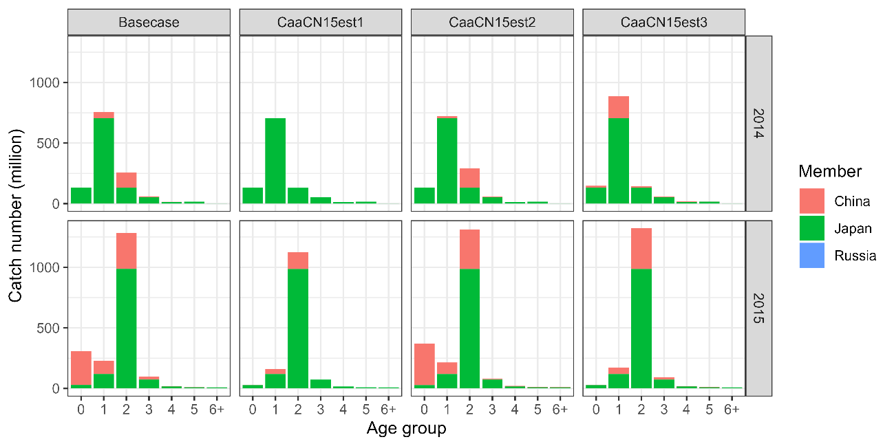  
Catch number by age by member for FY2014 and FY2015 under scenarios of Base case, CaaCN15est1, CaaCN15est2, and CaaCN15est3.

Figure 2   
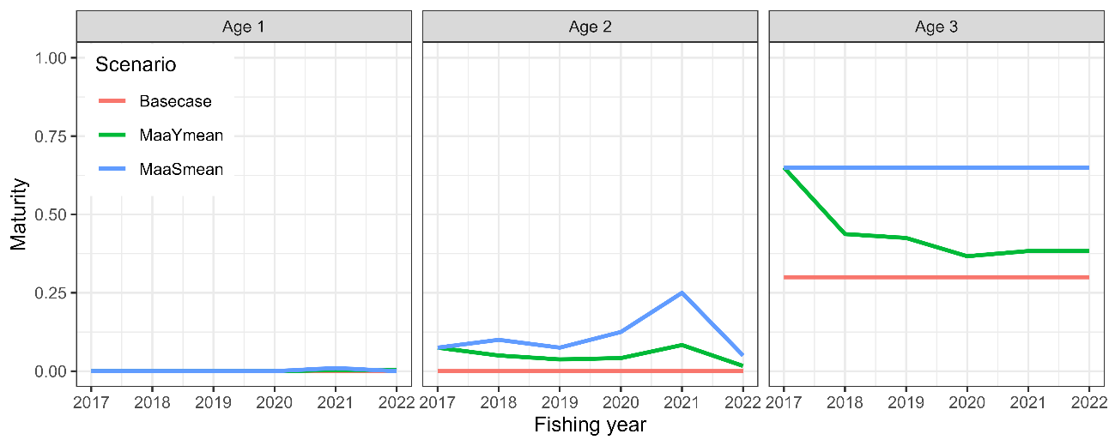  
Maturity by age under scenarios of Base case, MaaYmean, and MaaSmean.

Figure 3   
地図と文字のコラージュ

Seven abundance indices used in the sensitivity analysis. The six abundance indices up to FY2022 are used for the base case. The Japanese index values for FY2023 (shown in red circles) are used for the S7- and S8-JP23indcs scenarios. The Russian commercial trawl CPUEs up to FY2022 are used for the S9- and S10-RUcpue scenarios. Shadow areas are 95% confidence intervals calculated from provided CV values under the assumption of lognormal distributions.

Figure 4  
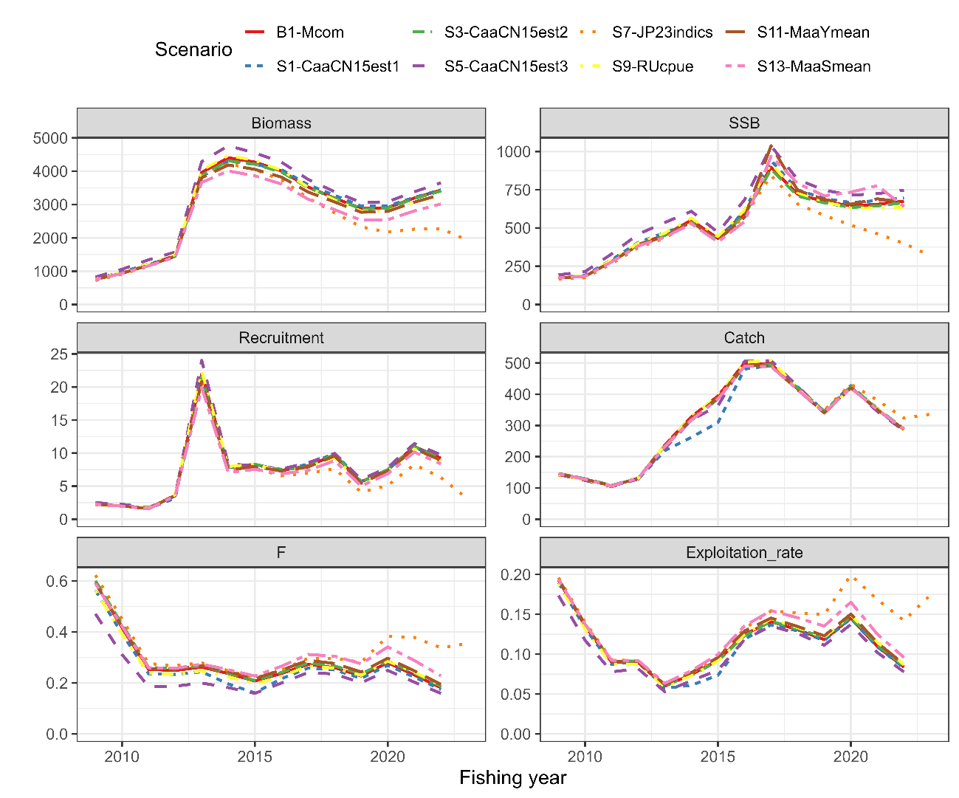  
Recent estimates of total biomass (1,000 MT), SSB (1,000 MT), recruitment (billion), catch (1,000 MT), mean F, and exploitation rate (catch divided by total biomass) under the scenarios for base case and sensitivity to data uncertainty with common M.

Figure 5  
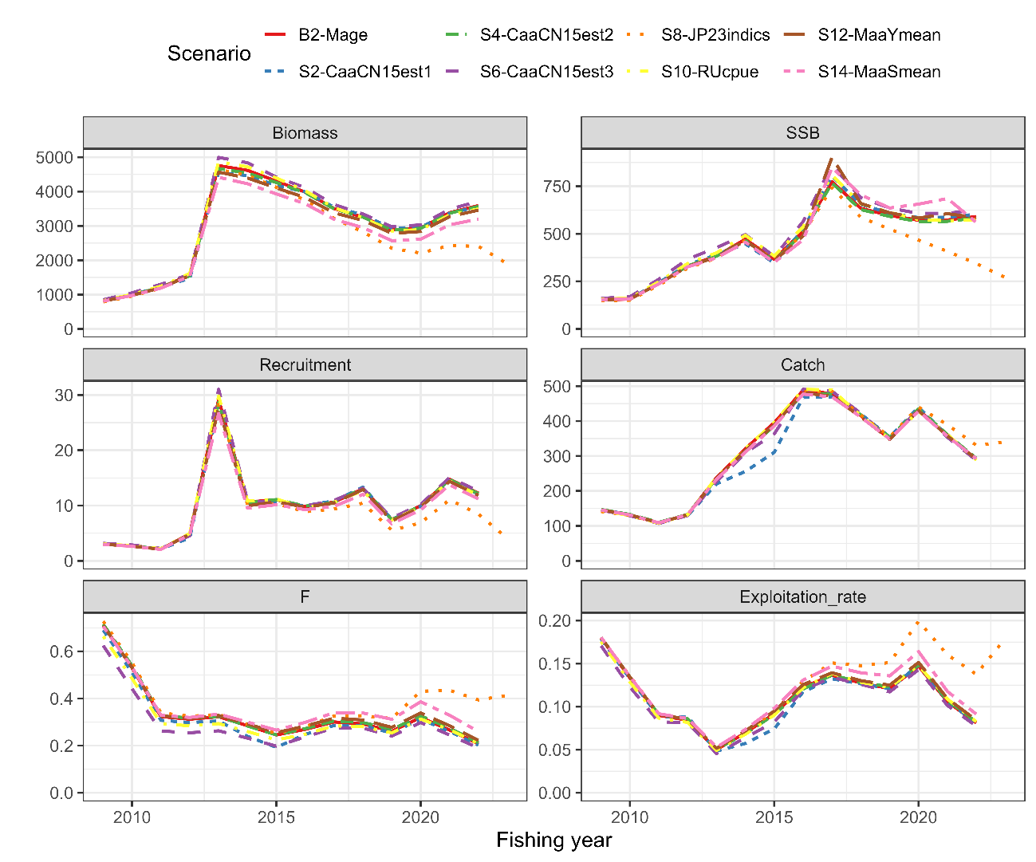  
Recent estimates of total biomass (1,000 MT), SSB (1,000 MT), recruitment (billion), catch (1,000 MT), mean F, and exploitation rate (catch divided by total biomass) under the scenarios for base case and sensitivity to data uncertainty with age-specific M.

Figure 6  
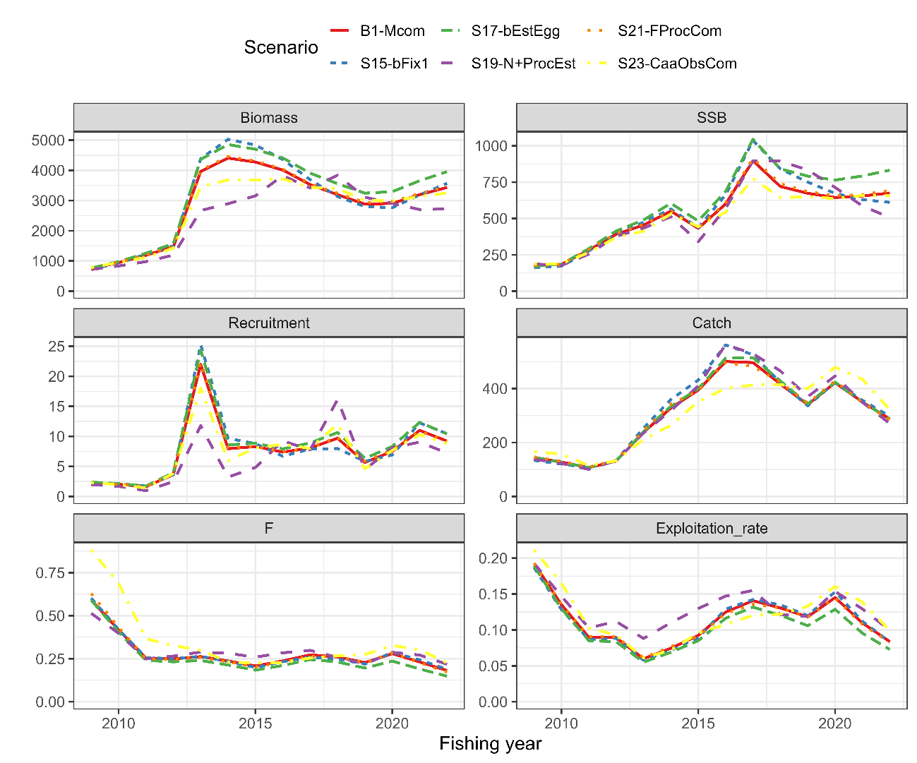  
Recent estimates of total biomass (1,000 MT), SSB (1,000 MT), recruitment (billion), catch (1,000 MT), mean F, and exploitation rate (catch divided by total biomass) under the scenarios for base case and sensitivity to structural uncertainty with common M.

Figure 7  
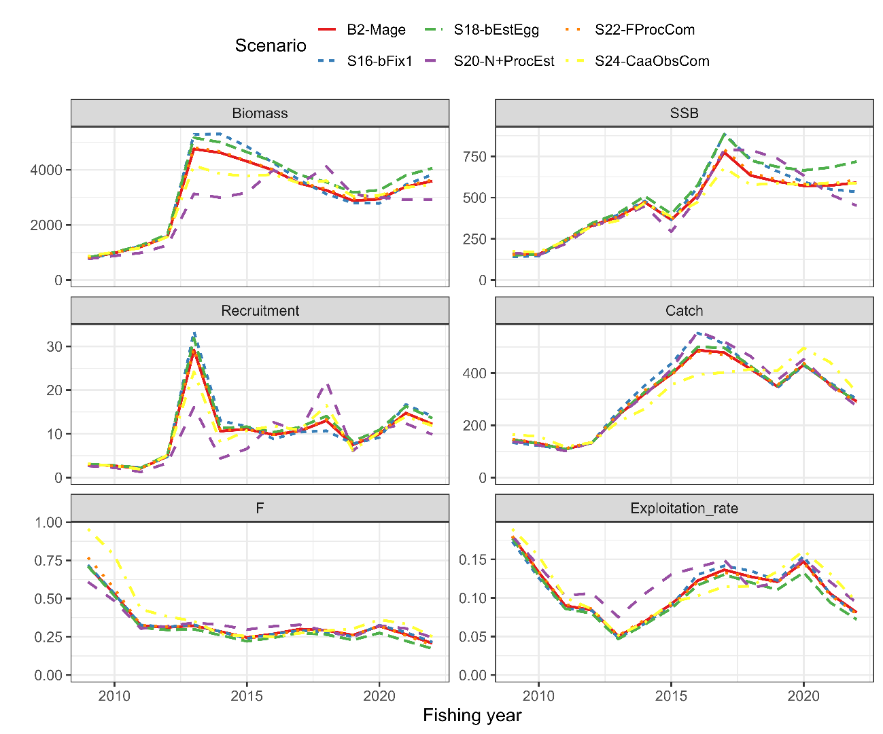  
Recent estimates of total biomass (1,000 MT), SSB (1,000 MT), recruitment (billion), catch (1,000 MT), mean F, and exploitation rate (catch divided by total biomass) under the scenarios for base case and sensitivity to structural uncertainty with age-specific M.

Figure 8  
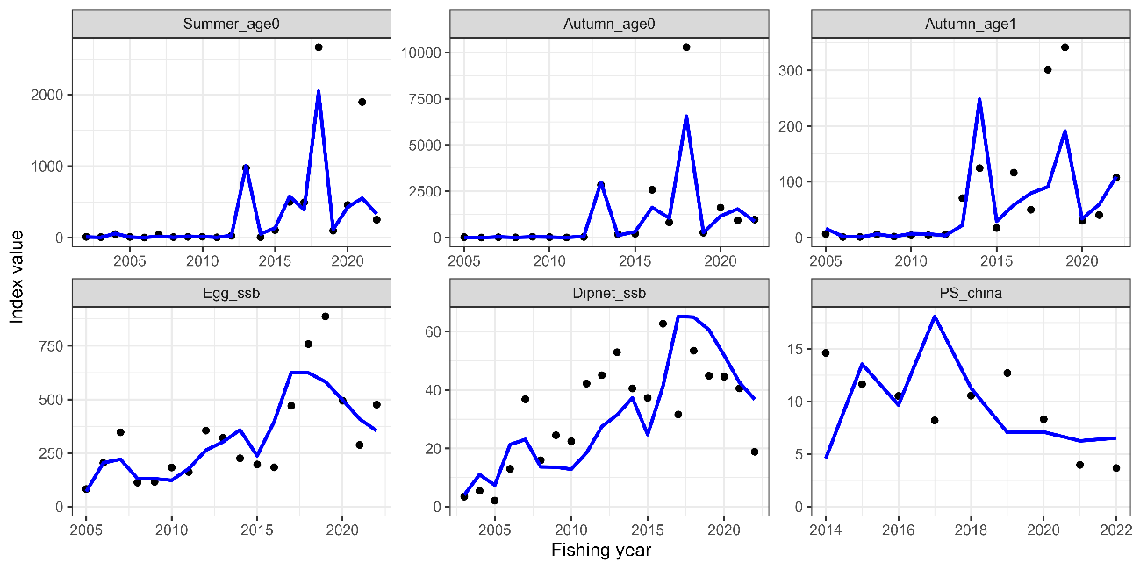  
Temporal trends of abundance indices used (dots) and their predicted values (lines) under Scenario S19-N+ProcEst.

Figure 9  
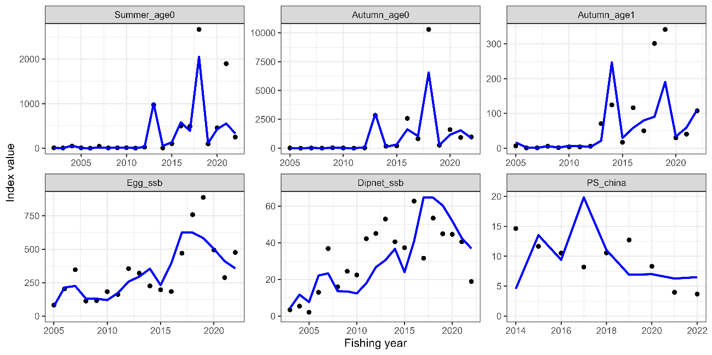  
Same as Fig. 8 except that it is Scenario S20-N+ProcEst.

Figure 10  
Process errors for log(N) (left) and log(F) (right) under S19-N+ProcEst scenarios.

## Figure 11 グラフ, 散布図 自動的に生成された説明 Same as Fig. 14 except that it is S20-N+ProcEst scenario.

Figure 12   
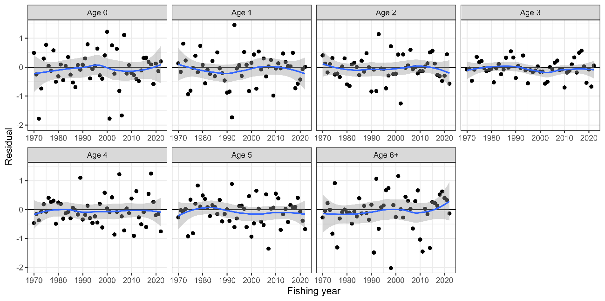  
Residual plot for catch numbers by age under Scenario S23-CaaObsCom. Blue curves and shaded areas indicate smoothed curves estimated by LOESS and their 95% confidence intervals.

Figure 13   
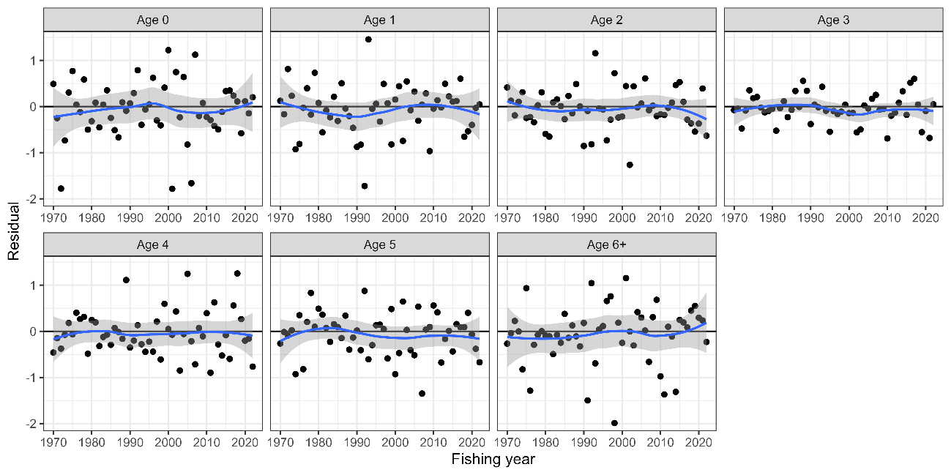  
Same as Fig. 12 except that it is Scenario S24-CaaObsCom.

Figure 14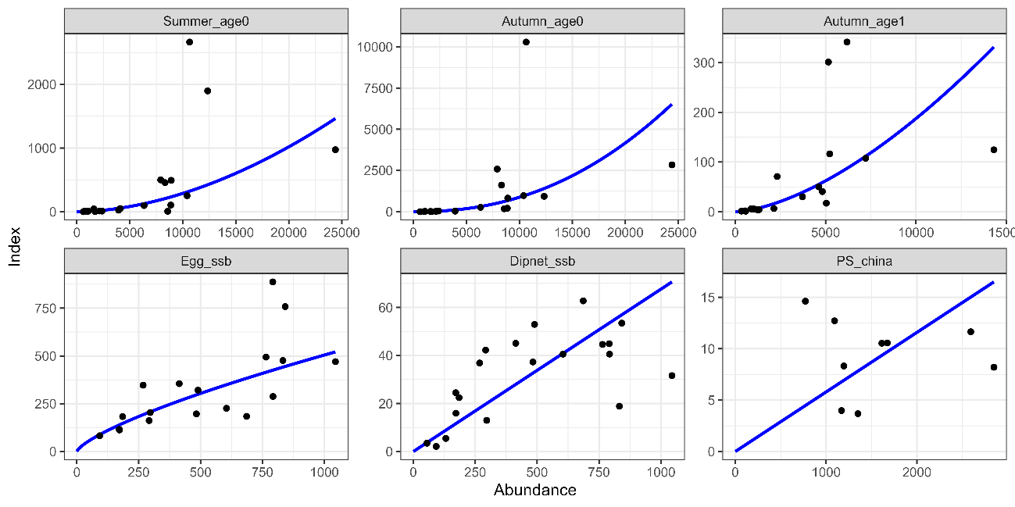   
Relationship between six abundance index and their corresponding abundance estimates under Scenario S17-bEstEgg. The blue lines indicate the precited relationships.

*Figure 15*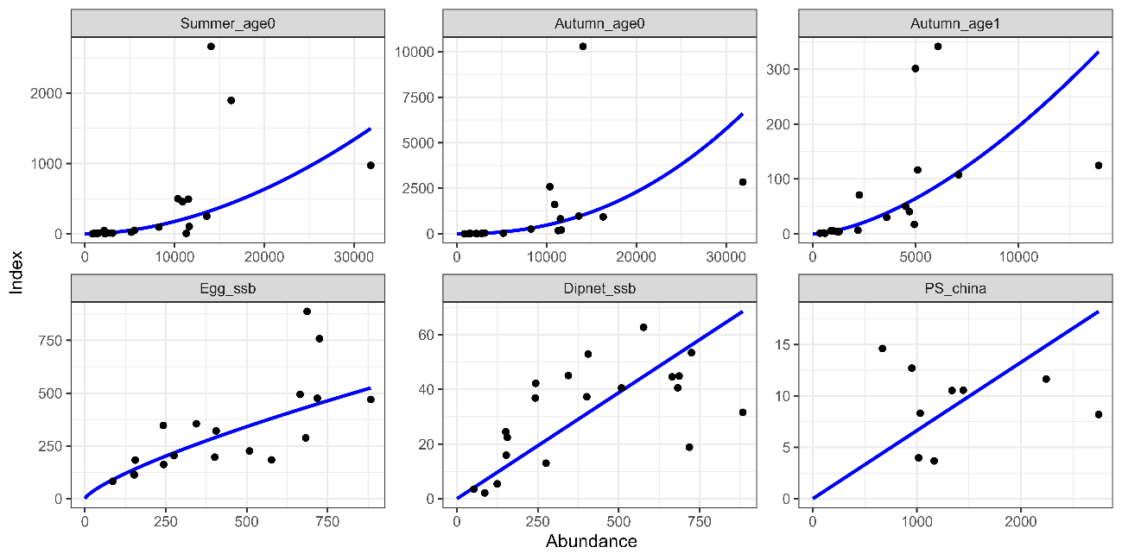   
Same as Fig. 14 except that it is Scenario S18-bEstEgg.

Figure 16  
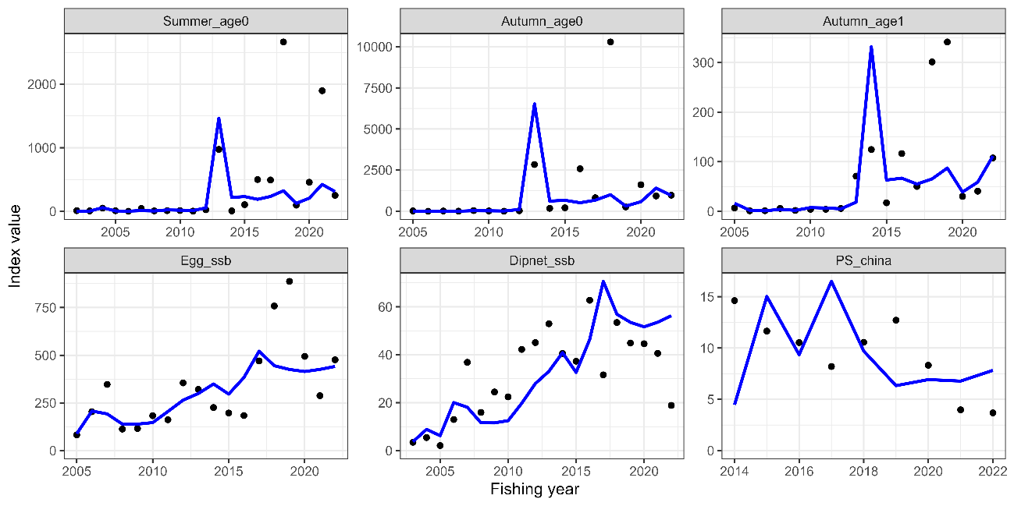  
Temporal trends of abundance indices used (dots) and their predicted values (lines) under Scenario S17-bEstEgg.

Figure 17  
Same as Fig. 16 except that it is Scenario S18-bEstEgg.

Figure 18  
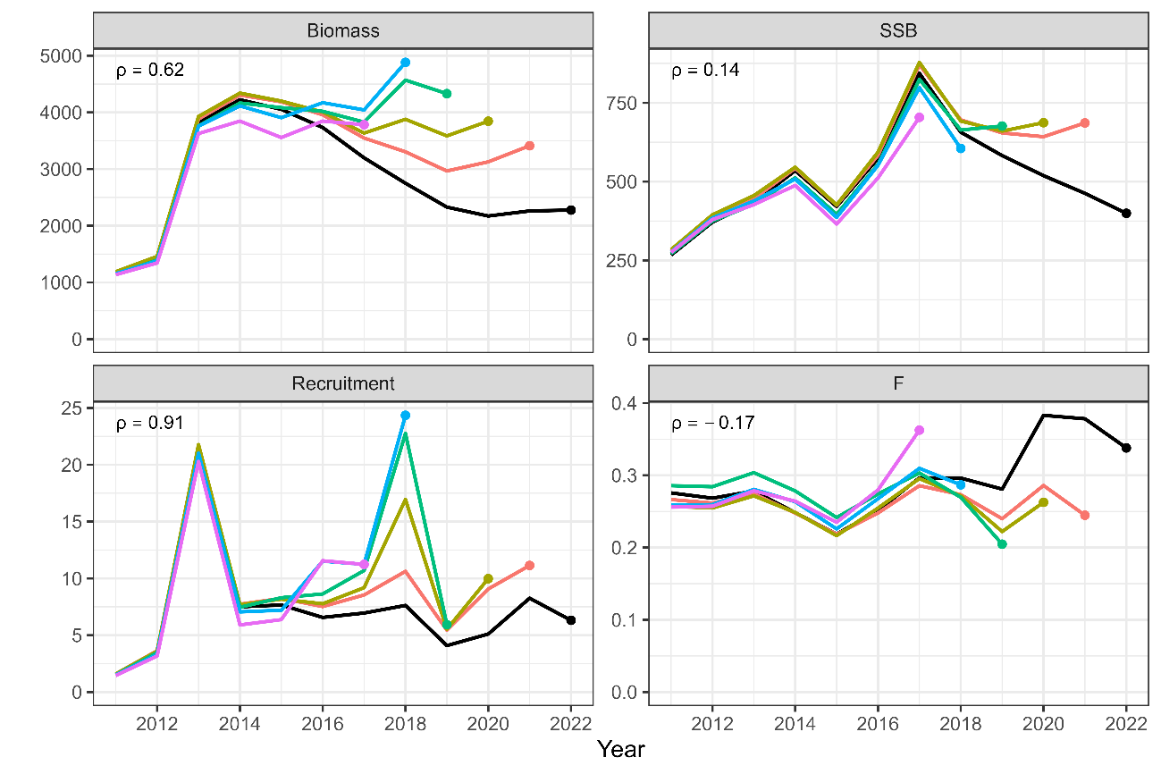  
Retrospective patterns for total biomass (top left), SSB (top right), recruitment (bottom left), and mean F (bottom right) for Scenario S7-JP23indics. Black Lines represent models with all data, and colored lines represent models with the most recent data trimmed. Mohn's rho is shown in the upper left corner. The dots indicate the terminal year for the calculation of Mohn’s rho.

Figure 19  
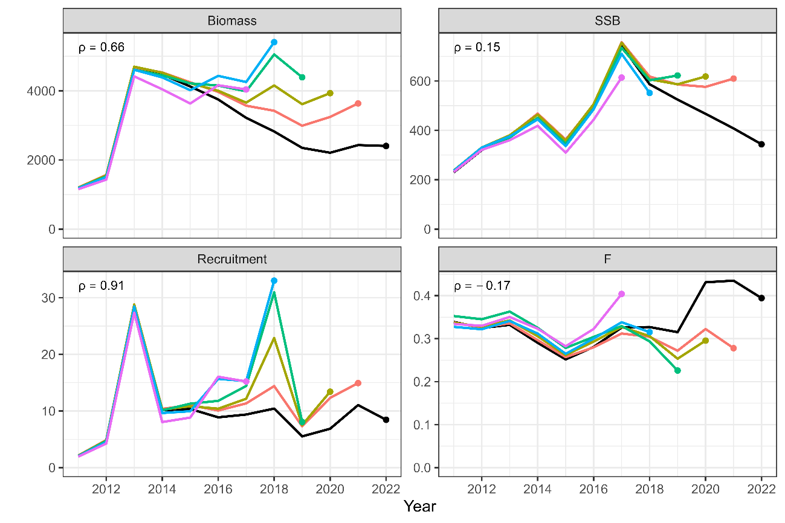  
Same as Fig. 8 except that is Scenario S8-JP23indics.

Figure 20  
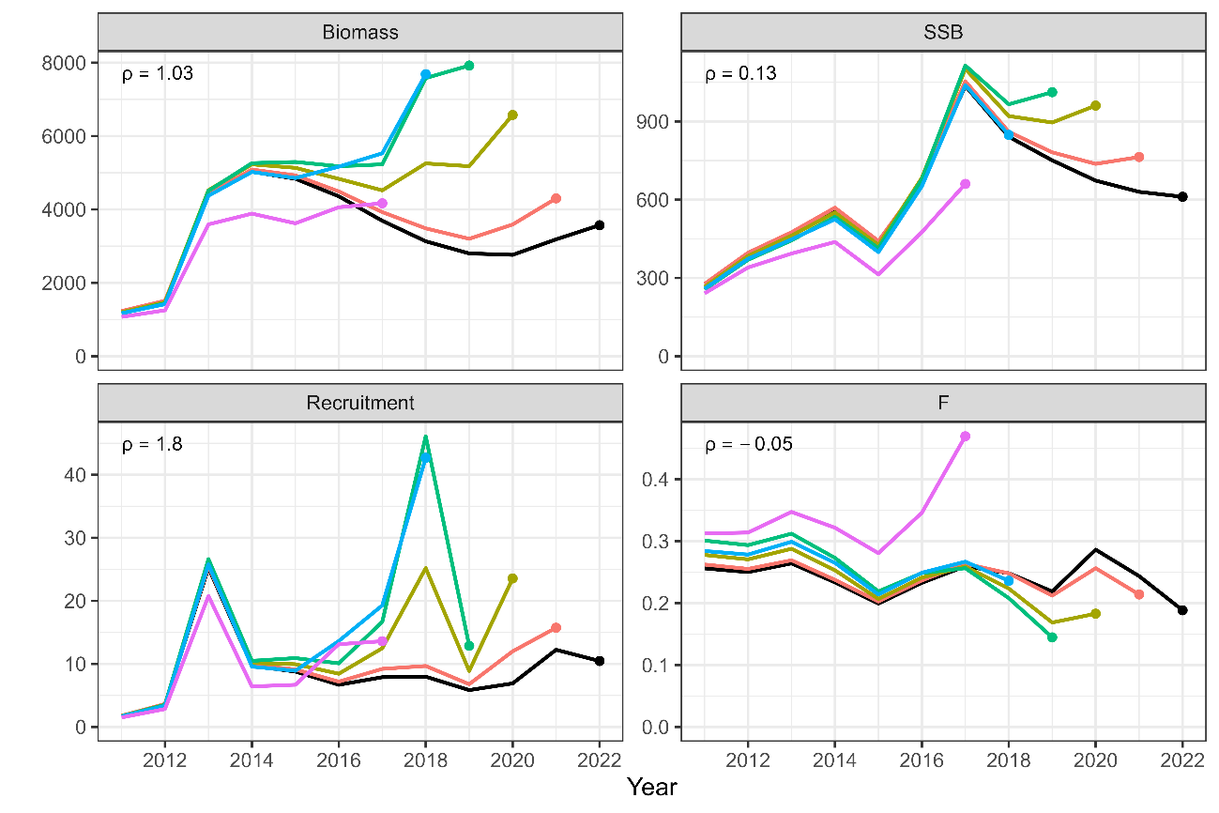  
Same as Fig. 8 except that is Scenario S15-bFix1.

Figure 21  
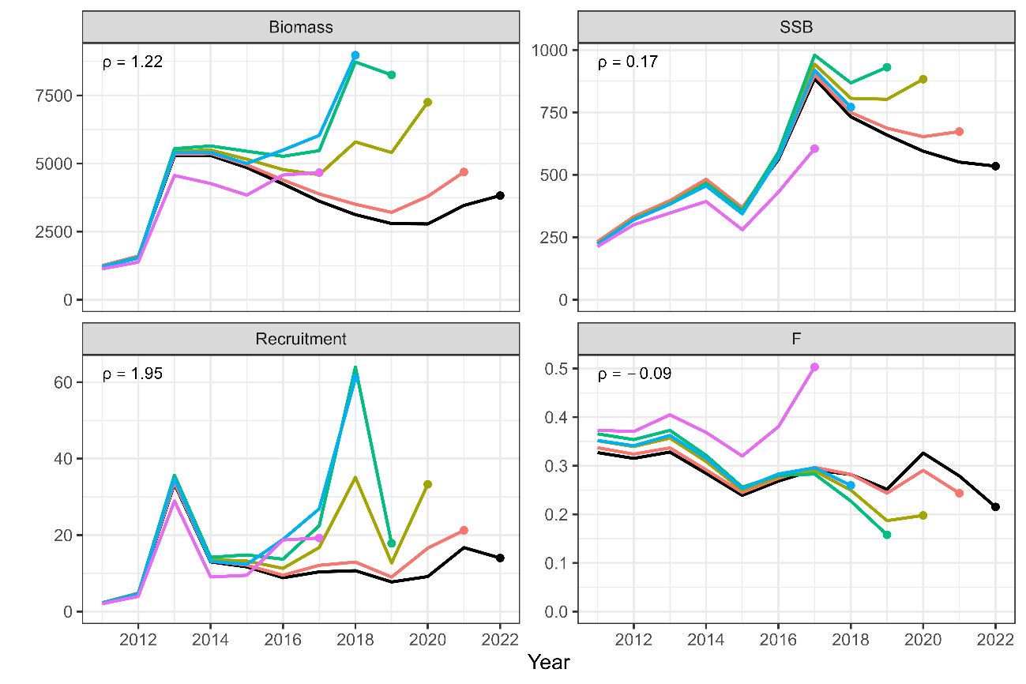  
Same as Fig. 8 except that is Scenario S16-bFix1.

Figure 22  
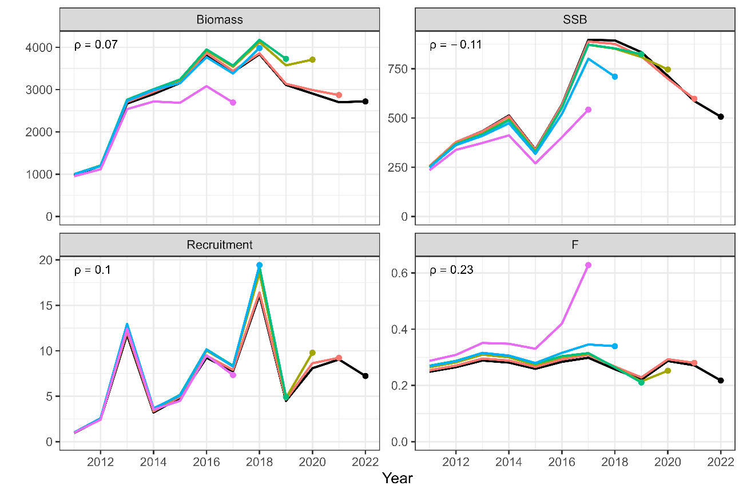  
Same as Fig. 8 except that is Scenario S19-N+ProcEst.

Figure 23  
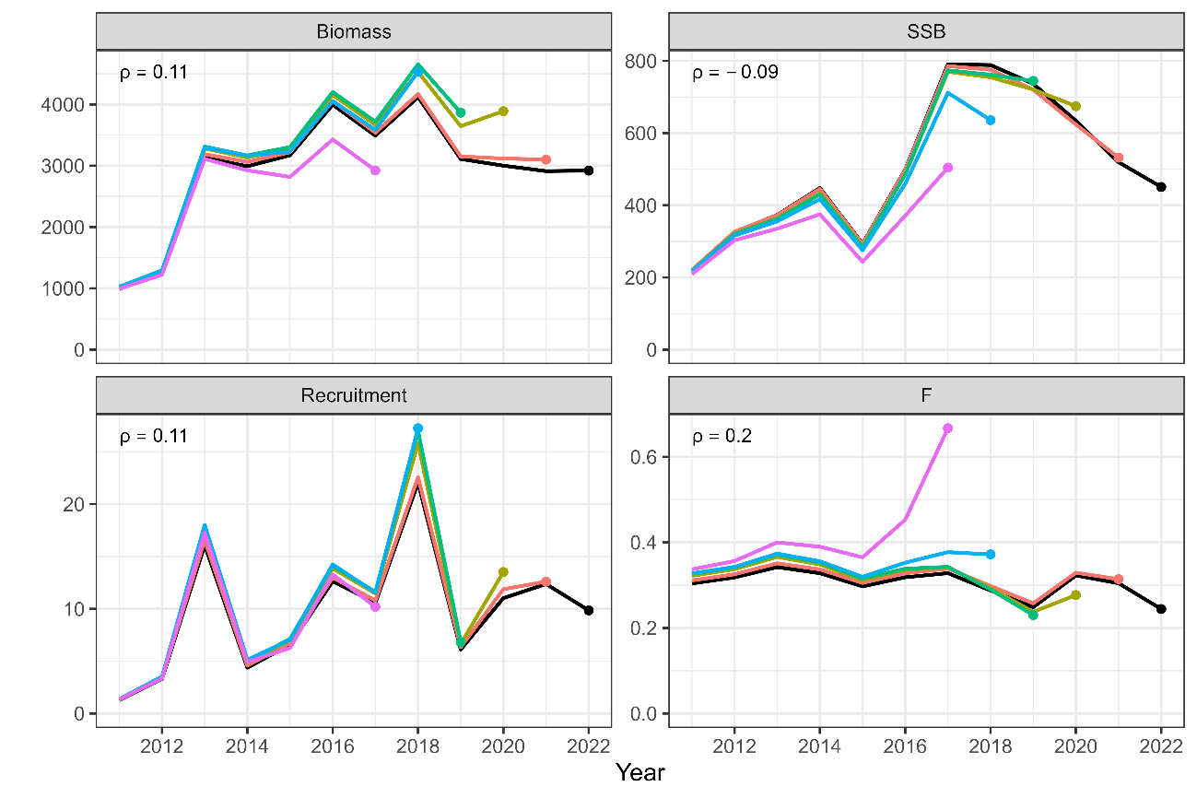  
Same as Fig. 8 except that is Scenario S20-N+ProcEst.

Figure 24  
Same as Fig. 8 except that it is Scenario S23-CaaObsCom.

Figure 25  
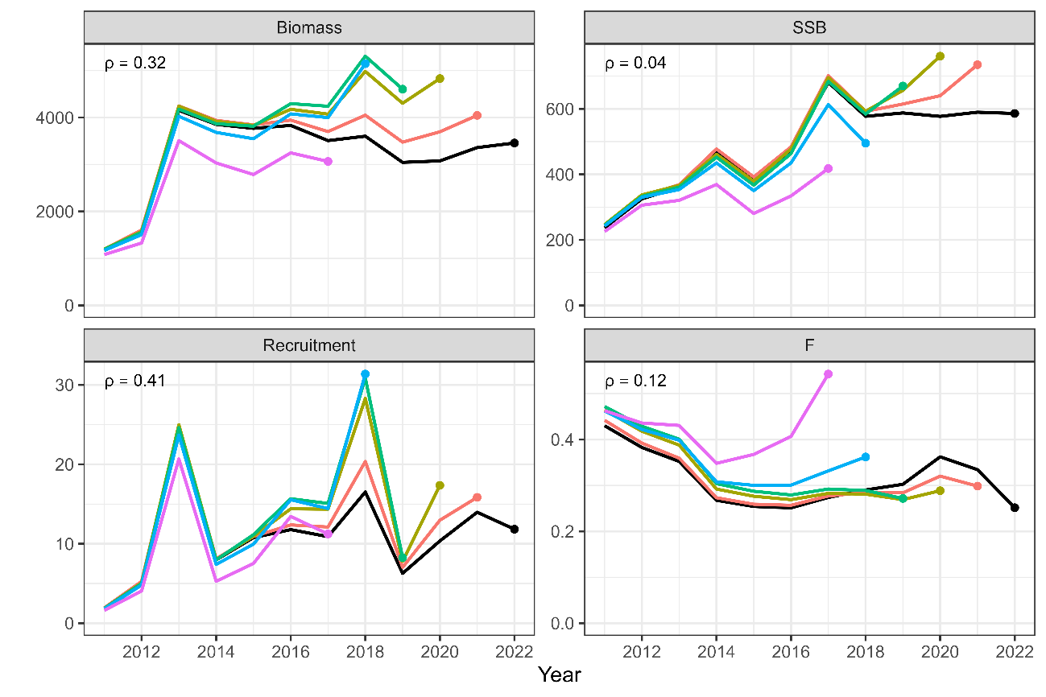  
Same as Fig. 8 except that it is Scenario S24-CaaObsCom.

Figure 26  
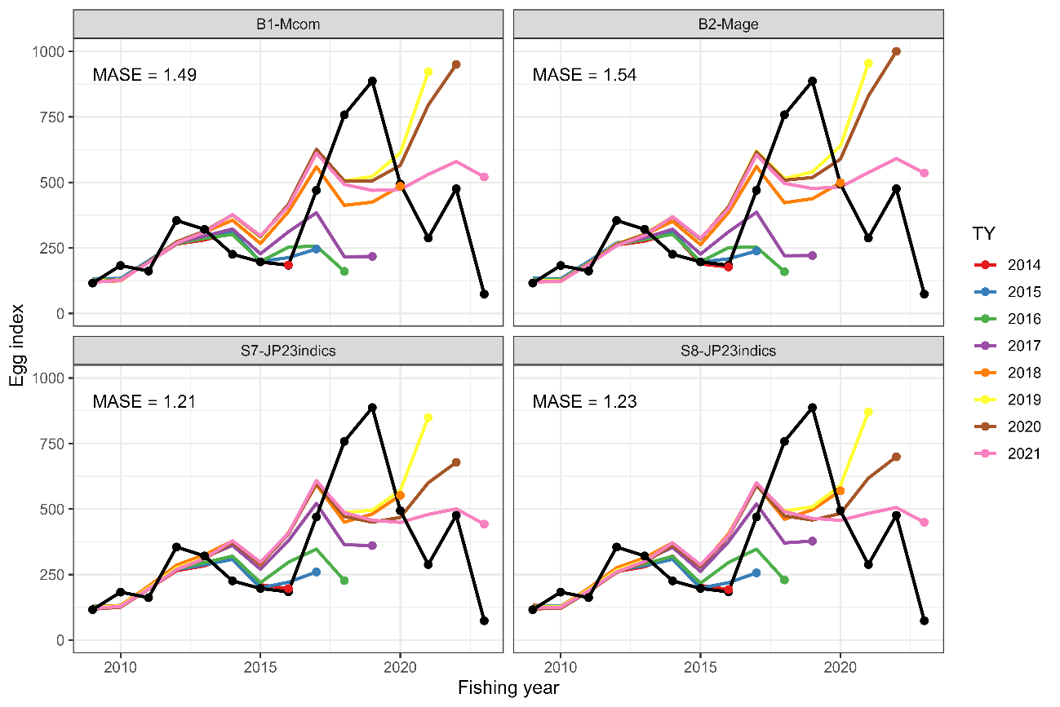  
Results of hindcast CV to compare the prediction skill against the spawning egg index for B1-Mcom (upper left), B2-Mage (upper right), S7-JP23indics (bottom left), and S8-JP23indics (bottom right) scenarios. The terminal years (TY) for catch-at-age data are shown on the right. MASE scores are shown in the upper right corners of each panel.

Appendix: Full results of parameter estimates and model diagnostics for the sensitivity scenarios S7- and S8-JP23indics

In the sensitivity analysis, we found that the sensitivity scenarios with Japan’s index up to 2023 yielded significantly different estimates from the base case. Since we consider that while the results of this sensitivity scenario are pessimistic, they are more representative of the stock status of this stock, in Appendix, we provide all results of parameter estimates and model diagnostics for the scenario S7- and S8-JPindics that are not shown in the main text.

Table A1:

|  |  |  |  |  |  |
| --- | --- | --- | --- | --- | --- |
| FE | MLE | SE | Final Gradient | Symbol | Unlinked value |
| logQ | -11.611 | 2.755 | 1.03E-05 | *q*1 | 9.07.E-06 |
| logQ | -14.746 | 2.826 | 1.36E-04 | *q*2 | 3.94.E-07 |
| logQ | -9.899 | 1.83 | -3.76E-05 | *q*3 | 5.02.E-05 |
| logQ | -0.322 | 0.166 | 2.89E-04 | *q*4 | 0.725 |
| logQ | -2.583 | 0.169 | -6.45E-05 | *q*5 | 0.076 |
| logQ | -4.866 | 0.227 | 3.56E-05 | *q*6 | 7.70.E-03 |
| logB | 0.657 | 0.176 | 8.23E-04 | *b*1 | 1.929 |
| logB | 0.874 | 0.144 | 1.72E-03 | *b*2 | 2.396 |
| logB | 0.524 | 0.142 | -1.10E-03 | *b*3 | 1.689 |
| logSdLogFsta | -0.785 | 0.179 | -3.23E-04 | *σ*0-1 | 0.456 |
| logSdLogFsta | -1.181 | 0.147 | -1.07E-04 | *σ*2-6+ | 0.307 |
| logSdLogN | -0.315 | 0.112 | -1.07E-04 | *σ*0 | 0.730 |
| logSdLogObs | -0.186 | 0.119 | -7.18E-05 | *τ*0 | 0.830 |
| logSdLogObs | -0.426 | 0.134 | 7.49E-05 | *τ*1 | 0.653 |
| logSdLogObs | -0.852 | 0.139 | -2.66E-04 | τ2 | 0.427 |
| logSdLogObs | -1.582 | 0.326 | -6.45E-05 | *τ*3 | 0.206 |
| logSdLogObs | -0.704 | 0.099 | -4.58E-04 | *τ*4-5 | 0.494 |
| logSdLogObs | -0.151 | 0.128 | 1.21E-04 | *τ*6+ | 0.860 |
| logSdLogObs | 0.366 | 0.166 | 2.03E-04 | *ν*1 | 1.442 |
| logSdLogObs | 0.217 | 0.19 | -3.65E-05 | *ν*2 | 1.242 |
| logSdLogObs | -0.119 | 0.183 | -2.56E-04 | *ν*3 | 0.888 |
| logSdLogObs | -0.712 | 0.177 | -1.01E-04 | *ν*4 | 0.491 |
| logSdLogObs | -0.557 | 0.176 | -1.55E-04 | *ν*5 | 0.573 |
| logSdLogObs | -0.555 | 0.252 | -1.31E-04 | *ν*6+ | 0.574 |
| rec_loga | -4.707 | 0.168 | -1.99E-04 | α | 9.03.E-03 |
| rec_logb | -8.906 | 2.167 | -3.05E-05 | β | 1.36.E-04 |
| logit_rho | 3.128 | 0.656 | 4.16E-05 | ρ | 0.958 |

Table A2:

|  |  |  |  |  |  |
| --- | --- | --- | --- | --- | --- |
| FE | MLE | SE | Final Gradient | Symbol | Unlinked value |
| logQ | -12.276 | 2.859 | -2.27E-05 | *q*1 | 4.66.E-06 |
| logQ | -15.5 | 2.903 | -1.06E-04 | *q*2 | 1.86.E-07 |
| logQ | -9.974 | 1.838 | 1.16E-04 | *q*3 | 4.66.E-05 |
| logQ | -0.198 | 0.151 | 2.81E-04 | *q*4 | 0.820 |
| logQ | -2.466 | 0.159 | 1.23E-04 | *q*5 | 0.085 |
| logQ | -4.772 | 0.225 | -1.05E-04 | *q*6 | 8.46.E-03 |
| logB | 0.662 | 0.176 | 4.84E-04 | *b*1 | 1.939 |
| logB | 0.876 | 0.142 | -2.34E-03 | *b*2 | 2.401 |
| logB | 0.529 | 0.142 | 8.42E-04 | *b*3 | 1.697 |
| logSdLogFsta | -0.781 | 0.181 | 2.00E-05 | *σ*0-1 | 0.458 |
| logSdLogFsta | -1.204 | 0.148 | 1.09E-04 | *σ*2-6+ | 0.300 |
| logSdLogN | -0.302 | 0.111 | -4.38E-05 | *σ*0 | 0.739 |
| logSdLogObs | -0.187 | 0.119 | 5.05E-05 | *τ*0 | 0.830 |
| logSdLogObs | -0.425 | 0.135 | 1.78E-04 | *τ*1 | 0.654 |
| logSdLogObs | -0.848 | 0.138 | -3.80E-05 | τ2 | 0.428 |
| logSdLogObs | -1.554 | 0.308 | -5.63E-05 | *τ*3 | 0.211 |
| logSdLogObs | -0.709 | 0.099 | 1.22E-04 | *τ*4-5 | 0.492 |
| logSdLogObs | -0.173 | 0.129 | 1.07E-04 | *τ*6+ | 0.841 |
| logSdLogObs | 0.363 | 0.166 | 8.55E-05 | *ν*1 | 1.438 |
| logSdLogObs | 0.21 | 0.19 | -1.29E-05 | *ν*2 | 1.234 |
| logSdLogObs | -0.118 | 0.183 | -5.50E-06 | *ν*3 | 0.889 |
| logSdLogObs | -0.734 | 0.178 | 2.37E-05 | *ν*4 | 0.480 |
| logSdLogObs | -0.541 | 0.174 | -1.42E-04 | *ν*5 | 0.582 |
| logSdLogObs | -0.522 | 0.251 | 5.65E-06 | *ν*6+ | 0.593 |
| rec_loga | -4.306 | 0.167 | -1.83E-04 | α | 1.35.E-02 |
| rec_logb | -8.872 | 2.249 | 1.50E-05 | β | 1.40.E-04 |
| logit_rho | 3.096 | 0.631 | -1.23E-05 | ρ | 0.957 |

Table A3：

|  |  |  |  |  |  |  |  |  |  |  |
| --- | --- | --- | --- | --- | --- | --- | --- | --- | --- | --- |
| **Fishing** | **Biomass (1000 MT)** | | **SSB (1000 MT)** | | **Recruitment (billion)** | | **Catch (1000 MT)** | | **Exploitation rate** | |
| **year** | **MLE** | **SE** | **MLE** | **SE** | **MLE** | **SE** | **MLE** | **SE** | **MLE** | **SE** |
| **1970** | 3273.1 | 293.1 | 761.4 | 97.3 | 13.374 | 2.162 | 743.9 | 129.1 | 0.227 | 0.032 |
| **1971** | 4370.1 | 368.0 | 894.3 | 105.3 | 17.560 | 2.909 | 814.8 | 128.1 | 0.186 | 0.025 |
| **1972** | 5127.2 | 467.1 | 839.0 | 95.1 | 10.877 | 1.698 | 700.9 | 116.8 | 0.137 | 0.021 |
| **1973** | 4947.6 | 423.2 | 1044.9 | 114.1 | 9.966 | 1.626 | 805.2 | 120.7 | 0.163 | 0.022 |
| **1974** | 4634.4 | 387.8 | 1397.5 | 169.8 | 10.653 | 1.688 | 906.2 | 129.0 | 0.196 | 0.024 |
| **1975** | 3959.1 | 321.1 | 1274.0 | 148.9 | 12.868 | 1.982 | 964.4 | 141.1 | 0.243 | 0.029 |
| **1976** | 4314.4 | 341.4 | 1236.6 | 138.5 | 16.349 | 2.584 | 758.6 | 107.4 | 0.176 | 0.023 |
| **1977** | 5136.0 | 429.9 | 1326.5 | 140.3 | 12.955 | 2.150 | 979.7 | 147.2 | 0.191 | 0.024 |
| **1978** | 4999.3 | 453.0 | 1397.0 | 144.3 | 6.068 | 1.064 | 1317.3 | 213.5 | 0.263 | 0.031 |
| **1979** | 3268.0 | 278.5 | 1393.8 | 153.3 | 4.558 | 0.748 | 960.2 | 138.3 | 0.293 | 0.033 |
| **1980** | 2232.7 | 188.0 | 1106.7 | 133.8 | 4.955 | 0.774 | 597.4 | 79.9 | 0.268 | 0.030 |
| **1981** | 2206.7 | 178.9 | 817.3 | 105.4 | 4.697 | 0.744 | 407.2 | 59.9 | 0.185 | 0.024 |
| **1982** | 2049.1 | 164.0 | 639.9 | 76.3 | 4.217 | 0.674 | 367.4 | 52.9 | 0.179 | 0.023 |
| **1983** | 1687.6 | 132.5 | 556.8 | 60.7 | 4.190 | 0.698 | 370.5 | 53.1 | 0.219 | 0.026 |
| **1984** | 2009.2 | 163.2 | 655.7 | 71.9 | 4.150 | 0.700 | 496.0 | 71.4 | 0.247 | 0.029 |
| **1985** | 1916.5 | 180.7 | 539.7 | 58.2 | 6.410 | 1.224 | 490.8 | 74.7 | 0.256 | 0.031 |
| **1986** | 1510.0 | 176.8 | 362.0 | 40.3 | 2.510 | 0.490 | 563.6 | 103.3 | 0.371 | 0.039 |
| **1987** | 994.8 | 107.6 | 371.6 | 40.8 | 0.924 | 0.194 | 404.4 | 66.4 | 0.405 | 0.037 |
| **1988** | 537.3 | 52.7 | 269.3 | 33.6 | 0.384 | 0.074 | 235.3 | 35.3 | 0.437 | 0.036 |
| **1989** | 307.8 | 27.2 | 145.5 | 17.3 | 0.307 | 0.051 | 104.2 | 15.4 | 0.338 | 0.038 |
| **1990** | 265.8 | 23.7 | 98.1 | 13.7 | 0.500 | 0.085 | 35.2 | 5.5 | 0.133 | 0.022 |
| **1991** | 324.9 | 30.4 | 70.8 | 9.7 | 0.838 | 0.143 | 30.1 | 5.3 | 0.093 | 0.016 |
| **1992** | 438.1 | 47.8 | 81.3 | 9.9 | 1.240 | 0.249 | 62.9 | 12.3 | 0.144 | 0.026 |
| **1993** | 445.0 | 55.6 | 91.2 | 10.1 | 0.748 | 0.155 | 151.8 | 36.1 | 0.338 | 0.050 |
| **1994** | 356.3 | 36.1 | 108.6 | 11.8 | 0.581 | 0.119 | 112.4 | 20.4 | 0.314 | 0.037 |
| **1995** | 365.7 | 43.0 | 98.5 | 11.0 | 1.177 | 0.258 | 120.9 | 23.6 | 0.329 | 0.041 |
| **1996** | 562.9 | 97.1 | 58.4 | 6.2 | 2.929 | 0.703 | 189.4 | 48.0 | 0.334 | 0.048 |
| **1997** | 523.9 | 87.2 | 50.0 | 5.7 | 0.631 | 0.129 | 234.6 | 63.2 | 0.441 | 0.056 |
| **1998** | 284.2 | 29.7 | 80.3 | 9.6 | 0.282 | 0.055 | 83.5 | 16.2 | 0.292 | 0.038 |
| **1999** | 238.0 | 23.2 | 97.4 | 11.7 | 0.418 | 0.088 | 72.7 | 11.7 | 0.305 | 0.036 |
| **2000** | 176.8 | 20.1 | 61.9 | 7.0 | 0.277 | 0.054 | 51.5 | 11.3 | 0.290 | 0.043 |
| **2001** | 155.8 | 15.2 | 54.8 | 6.4 | 0.375 | 0.065 | 38.7 | 7.7 | 0.247 | 0.038 |
| **2002** | 211.3 | 20.8 | 49.8 | 5.4 | 0.833 | 0.141 | 37.1 | 7.5 | 0.175 | 0.029 |
| **2003** | 247.5 | 25.6 | 54.9 | 5.6 | 0.705 | 0.120 | 49.7 | 10.7 | 0.200 | 0.033 |
| **2004** | 765.4 | 92.1 | 130.1 | 14.7 | 3.908 | 0.640 | 130.4 | 27.6 | 0.170 | 0.029 |
| **2005** | 898.5 | 111.7 | 91.6 | 9.5 | 1.059 | 0.169 | 212.1 | 50.4 | 0.234 | 0.039 |
| **2006** | 801.4 | 83.8 | 285.3 | 37.1 | 0.615 | 0.101 | 203.3 | 38.0 | 0.253 | 0.033 |
| **2007** | 612.1 | 55.6 | 257.9 | 30.8 | 1.553 | 0.268 | 146.4 | 21.3 | 0.239 | 0.030 |
| **2008** | 595.2 | 65.7 | 166.2 | 21.0 | 0.965 | 0.166 | 148.3 | 26.2 | 0.249 | 0.036 |
| **2009** | 721.6 | 81.0 | 165.1 | 22.9 | 2.213 | 0.353 | 140.5 | 25.0 | 0.195 | 0.032 |
| **2010** | 906.4 | 107.1 | 174.5 | 29.3 | 1.955 | 0.318 | 125.6 | 23.4 | 0.139 | 0.028 |
| **2011** | 1146.3 | 138.1 | 266.8 | 44.0 | 1.592 | 0.266 | 105.5 | 18.1 | 0.092 | 0.018 |
| **2012** | 1433.4 | 164.0 | 371.4 | 58.4 | 3.626 | 0.576 | 129.3 | 19.2 | 0.091 | 0.016 |
| **2013** | 3825.4 | 477.9 | 433.8 | 69.8 | 21.079 | 3.400 | 232.5 | 42.5 | 0.061 | 0.012 |
| **2014** | 4222.8 | 516.3 | 535.0 | 80.4 | 7.503 | 1.300 | 318.7 | 64.4 | 0.076 | 0.015 |
| **2015** | 4053.8 | 452.2 | 421.0 | 73.1 | 7.661 | 1.173 | 387.9 | 64.7 | 0.096 | 0.016 |
| **2016** | 3733.0 | 375.7 | 574.0 | 90.8 | 6.567 | 1.046 | 489.8 | 74.2 | 0.131 | 0.019 |
| **2017** | 3198.3 | 312.8 | 843.8 | 148.8 | 6.952 | 1.103 | 490.1 | 73.7 | 0.153 | 0.022 |
| **2018** | 2749.6 | 278.2 | 656.7 | 113.8 | 7.623 | 1.404 | 414.1 | 57.8 | 0.151 | 0.022 |
| **2019** | 2328.8 | 265.0 | 582.5 | 102.8 | 4.086 | 0.791 | 344.6 | 51.0 | 0.148 | 0.024 |
| **2020** | 2171.6 | 291.5 | 518.9 | 92.8 | 5.106 | 1.276 | 427.1 | 60.5 | 0.198 | 0.034 |
| **2021** | 2261.1 | 410.6 | 462.7 | 96.1 | 8.259 | 2.439 | 372.9 | 57.0 | 0.167 | 0.038 |
| **2022** | 2276.1 | 481.9 | 399.3 | 108.4 | 6.313 | 1.942 | 312.4 | 54.0 | 0.140 | 0.038 |
| **2023** | 1928.8 | 462.6 | 318.3 | 108.6 | 3.095 | 1.182 | 321.5 | 98.0 | 0.171 | 0.061 |

Table A4：

|  |  |  |  |  |  |  |  |  |  |  |
| --- | --- | --- | --- | --- | --- | --- | --- | --- | --- | --- |
| **Fishing** | **Biomass (1000 MT)** | | **SSB (1000 MT)** | | **Recruitment (billion)** | | **Catch (1000 MT)** | | **Exploitation rate** | |
| **year** | **MLE** | **SE** | **MLE** | **SE** | **MLE** | **SE** | **MLE** | **SE** | **MLE** | **SE** |
| **1970** | 3651.3 | 338.2 | 710.5 | 90.3 | 18.754 | 3.046 | 742.9 | 129.4 | 0.203 | 0.030 |
| **1971** | 4799.9 | 413.0 | 828.6 | 95.4 | 24.660 | 4.116 | 816.4 | 128.6 | 0.170 | 0.024 |
| **1972** | 5470.0 | 497.7 | 777.5 | 86.1 | 15.373 | 2.418 | 705.4 | 117.6 | 0.129 | 0.020 |
| **1973** | 5291.6 | 454.2 | 969.3 | 104.6 | 14.081 | 2.313 | 805.9 | 120.7 | 0.152 | 0.020 |
| **1974** | 4856.1 | 405.3 | 1290.4 | 155.7 | 15.082 | 2.408 | 901.2 | 127.6 | 0.186 | 0.022 |
| **1975** | 4127.2 | 332.0 | 1180.2 | 136.5 | 18.234 | 2.833 | 963.6 | 140.6 | 0.233 | 0.027 |
| **1976** | 4774.1 | 396.9 | 1144.0 | 125.7 | 23.137 | 3.683 | 757.3 | 107.2 | 0.159 | 0.021 |
| **1977** | 5582.7 | 481.5 | 1239.2 | 129.8 | 18.159 | 3.028 | 977.0 | 147.0 | 0.175 | 0.023 |
| **1978** | 5199.8 | 474.1 | 1314.2 | 135.3 | 8.430 | 1.482 | 1312.5 | 213.3 | 0.252 | 0.030 |
| **1979** | 3297.1 | 275.1 | 1302.2 | 141.8 | 6.327 | 1.040 | 960.1 | 138.6 | 0.291 | 0.031 |
| **1980** | 2268.5 | 182.9 | 1022.1 | 121.2 | 6.948 | 1.091 | 599.0 | 80.3 | 0.264 | 0.028 |
| **1981** | 2367.6 | 191.7 | 751.3 | 94.3 | 6.681 | 1.065 | 411.0 | 60.4 | 0.174 | 0.023 |
| **1982** | 2230.9 | 183.0 | 592.4 | 69.0 | 6.020 | 0.970 | 368.9 | 53.1 | 0.166 | 0.021 |
| **1983** | 1812.1 | 145.1 | 521.6 | 56.0 | 5.977 | 1.002 | 370.9 | 53.2 | 0.205 | 0.025 |
| **1984** | 2214.3 | 189.3 | 619.3 | 67.5 | 5.915 | 1.002 | 497.5 | 71.6 | 0.225 | 0.027 |
| **1985** | 2135.0 | 214.2 | 513.8 | 55.4 | 8.959 | 1.710 | 492.0 | 74.9 | 0.230 | 0.029 |
| **1986** | 1622.3 | 192.1 | 347.1 | 38.9 | 3.408 | 0.658 | 559.6 | 102.8 | 0.343 | 0.037 |
| **1987** | 1018.7 | 110.6 | 358.1 | 40.1 | 1.237 | 0.256 | 403.5 | 66.2 | 0.395 | 0.036 |
| **1988** | 544.4 | 53.3 | 254.4 | 32.1 | 0.509 | 0.097 | 232.9 | 34.9 | 0.426 | 0.035 |
| **1989** | 318.3 | 27.6 | 133.8 | 15.6 | 0.416 | 0.068 | 103.7 | 15.4 | 0.325 | 0.035 |
| **1990** | 289.9 | 26.3 | 87.5 | 11.6 | 0.703 | 0.120 | 35.5 | 5.6 | 0.123 | 0.020 |
| **1991** | 380.9 | 39.0 | 64.0 | 8.4 | 1.191 | 0.205 | 30.2 | 5.3 | 0.080 | 0.014 |
| **1992** | 511.2 | 61.0 | 75.5 | 8.9 | 1.742 | 0.349 | 63.1 | 12.3 | 0.124 | 0.023 |
| **1993** | 488.2 | 61.5 | 86.0 | 9.5 | 1.016 | 0.203 | 151.3 | 36.2 | 0.307 | 0.047 |
| **1994** | 387.4 | 40.8 | 102.8 | 11.2 | 0.800 | 0.162 | 113.0 | 20.6 | 0.290 | 0.035 |
| **1995** | 413.0 | 52.0 | 93.0 | 10.4 | 1.609 | 0.349 | 122.4 | 24.1 | 0.295 | 0.039 |
| **1996** | 688.8 | 124.3 | 55.1 | 5.9 | 3.944 | 0.935 | 192.9 | 49.2 | 0.279 | 0.043 |
| **1997** | 574.8 | 95.3 | 47.3 | 5.5 | 0.837 | 0.166 | 241.3 | 65.8 | 0.414 | 0.055 |
| **1998** | 297.0 | 30.9 | 75.4 | 9.0 | 0.383 | 0.075 | 83.8 | 16.3 | 0.280 | 0.037 |
| **1999** | 255.5 | 26.3 | 89.7 | 10.6 | 0.562 | 0.116 | 72.5 | 11.7 | 0.283 | 0.034 |
| **2000** | 190.8 | 22.1 | 57.3 | 6.2 | 0.377 | 0.072 | 51.5 | 11.3 | 0.268 | 0.040 |
| **2001** | 173.4 | 17.6 | 51.0 | 5.8 | 0.517 | 0.089 | 38.9 | 7.8 | 0.223 | 0.035 |
| **2002** | 247.8 | 26.1 | 46.7 | 4.9 | 1.155 | 0.196 | 37.6 | 7.6 | 0.152 | 0.026 |
| **2003** | 282.8 | 30.3 | 52.0 | 5.2 | 0.974 | 0.165 | 49.8 | 10.7 | 0.175 | 0.030 |
| **2004** | 947.4 | 120.6 | 123.4 | 14.0 | 5.310 | 0.863 | 129.4 | 27.3 | 0.136 | 0.024 |
| **2005** | 959.4 | 116.6 | 85.4 | 8.8 | 1.453 | 0.227 | 209.0 | 49.7 | 0.216 | 0.037 |
| **2006** | 807.8 | 80.6 | 266.5 | 34.7 | 0.838 | 0.133 | 200.3 | 37.1 | 0.247 | 0.031 |
| **2007** | 655.3 | 58.0 | 235.5 | 27.2 | 2.097 | 0.353 | 144.4 | 20.9 | 0.220 | 0.027 |
| **2008** | 625.9 | 64.3 | 149.5 | 17.0 | 1.284 | 0.214 | 146.2 | 25.7 | 0.233 | 0.032 |
| **2009** | 785.8 | 79.9 | 148.2 | 17.7 | 2.943 | 0.449 | 140.9 | 25.0 | 0.179 | 0.028 |
| **2010** | 957.0 | 96.6 | 151.1 | 20.7 | 2.597 | 0.401 | 128.9 | 24.1 | 0.135 | 0.025 |
| **2011** | 1184.9 | 121.0 | 229.9 | 31.4 | 2.125 | 0.340 | 107.1 | 18.4 | 0.091 | 0.017 |
| **2012** | 1556.0 | 159.2 | 319.8 | 42.2 | 4.866 | 0.744 | 130.1 | 19.4 | 0.084 | 0.014 |
| **2013** | 4642.2 | 580.7 | 372.6 | 51.2 | 28.325 | 4.454 | 233.9 | 43.0 | 0.051 | 0.010 |
| **2014** | 4472.3 | 517.2 | 465.3 | 61.2 | 10.132 | 1.735 | 317.5 | 64.4 | 0.071 | 0.014 |
| **2015** | 4125.2 | 419.1 | 362.6 | 57.1 | 10.360 | 1.563 | 386.8 | 64.8 | 0.094 | 0.015 |
| **2016** | 3749.6 | 331.9 | 500.7 | 72.7 | 8.883 | 1.386 | 482.2 | 73.3 | 0.129 | 0.018 |
| **2017** | 3218.2 | 277.9 | 742.0 | 122.3 | 9.379 | 1.438 | 482.5 | 72.6 | 0.150 | 0.021 |
| **2018** | 2823.9 | 259.3 | 586.7 | 94.2 | 10.428 | 1.872 | 413.7 | 57.6 | 0.147 | 0.020 |
| **2019** | 2349.3 | 238.8 | 524.5 | 85.4 | 5.518 | 1.025 | 351.7 | 51.8 | 0.150 | 0.022 |
| **2020** | 2209.2 | 276.4 | 467.0 | 76.7 | 6.870 | 1.674 | 435.1 | 61.7 | 0.198 | 0.032 |
| **2021** | 2430.0 | 440.2 | 407.9 | 77.4 | 11.048 | 3.210 | 381.3 | 58.3 | 0.160 | 0.036 |
| **2022** | 2404.8 | 493.3 | 343.6 | 88.3 | 8.449 | 2.564 | 319.0 | 55.6 | 0.136 | 0.036 |
| **2023** | 1898.2 | 435.3 | 270.5 | 91.3 | 4.110 | 1.555 | 324.2 | 96.3 | 0.175 | 0.060 |

Table A5:  
Estimated F at age since FY1970 to2023 under Scenario S7-JP23indics.

|  |  |  |  |  |  |  |  |
| --- | --- | --- | --- | --- | --- | --- | --- |
| FY | Age 0 | Age 1 | Age 2 | Age 3 | Age 4 | Age 5 | Age 6+ |
| 1970 | 0.06 | 0.25 | 0.49 | 0.74 | 0.94 | 1.35 | 1.35 |
| 1971 | 0.04 | 0.18 | 0.40 | 0.62 | 0.81 | 1.18 | 1.18 |
| 1972 | 0.03 | 0.11 | 0.29 | 0.47 | 0.64 | 0.95 | 0.95 |
| 1973 | 0.03 | 0.12 | 0.31 | 0.53 | 0.73 | 1.08 | 1.08 |
| 1974 | 0.04 | 0.13 | 0.32 | 0.55 | 0.76 | 1.12 | 1.12 |
| 1975 | 0.05 | 0.18 | 0.38 | 0.65 | 0.93 | 1.39 | 1.39 |
| 1976 | 0.05 | 0.15 | 0.32 | 0.52 | 0.72 | 1.09 | 1.09 |
| 1977 | 0.06 | 0.19 | 0.35 | 0.55 | 0.75 | 1.14 | 1.14 |
| 1978 | 0.10 | 0.29 | 0.45 | 0.69 | 0.93 | 1.41 | 1.41 |
| 1979 | 0.10 | 0.29 | 0.44 | 0.65 | 0.86 | 1.30 | 1.30 |
| 1980 | 0.08 | 0.22 | 0.37 | 0.55 | 0.73 | 1.11 | 1.11 |
| 1981 | 0.05 | 0.15 | 0.28 | 0.42 | 0.56 | 0.85 | 0.85 |
| 1982 | 0.06 | 0.16 | 0.30 | 0.45 | 0.57 | 0.84 | 0.84 |
| 1983 | 0.08 | 0.21 | 0.36 | 0.56 | 0.68 | 0.96 | 0.96 |
| 1984 | 0.11 | 0.26 | 0.43 | 0.67 | 0.80 | 1.10 | 1.10 |
| 1985 | 0.12 | 0.30 | 0.47 | 0.77 | 0.91 | 1.21 | 1.21 |
| 1986 | 0.22 | 0.53 | 0.72 | 1.21 | 1.39 | 1.77 | 1.77 |
| 1987 | 0.23 | 0.51 | 0.71 | 1.22 | 1.42 | 1.78 | 1.78 |
| 1988 | 0.26 | 0.54 | 0.72 | 1.20 | 1.38 | 1.69 | 1.69 |
| 1989 | 0.18 | 0.36 | 0.54 | 0.89 | 1.02 | 1.23 | 1.23 |
| 1990 | 0.06 | 0.10 | 0.22 | 0.34 | 0.40 | 0.49 | 0.49 |
| 1991 | 0.05 | 0.09 | 0.20 | 0.30 | 0.33 | 0.41 | 0.41 |
| 1992 | 0.10 | 0.18 | 0.30 | 0.44 | 0.48 | 0.59 | 0.59 |
| 1993 | 0.31 | 0.57 | 0.64 | 0.84 | 0.86 | 0.99 | 0.99 |
| 1994 | 0.28 | 0.50 | 0.57 | 0.70 | 0.71 | 0.83 | 0.83 |
| 1995 | 0.32 | 0.59 | 0.63 | 0.76 | 0.78 | 0.91 | 0.91 |
| 1996 | 0.40 | 0.75 | 0.75 | 0.93 | 0.98 | 1.13 | 1.13 |
| 1997 | 0.46 | 0.88 | 0.84 | 1.02 | 1.10 | 1.28 | 1.28 |
| 1998 | 0.24 | 0.45 | 0.51 | 0.60 | 0.64 | 0.73 | 0.73 |
| 1999 | 0.27 | 0.50 | 0.55 | 0.63 | 0.69 | 0.79 | 0.79 |
| 2000 | 0.25 | 0.48 | 0.52 | 0.58 | 0.62 | 0.71 | 0.71 |
| 2001 | 0.20 | 0.40 | 0.48 | 0.53 | 0.58 | 0.68 | 0.68 |
| 2002 | 0.14 | 0.28 | 0.39 | 0.46 | 0.52 | 0.62 | 0.62 |
| 2003 | 0.15 | 0.32 | 0.44 | 0.54 | 0.60 | 0.71 | 0.71 |
| 2004 | 0.15 | 0.34 | 0.49 | 0.64 | 0.74 | 0.87 | 0.87 |
| 2005 | 0.14 | 0.34 | 0.53 | 0.76 | 0.87 | 1.03 | 1.03 |
| 2006 | 0.11 | 0.26 | 0.46 | 0.70 | 0.80 | 0.96 | 0.96 |
| 2007 | 0.10 | 0.25 | 0.44 | 0.67 | 0.75 | 0.90 | 0.90 |
| 2008 | 0.12 | 0.30 | 0.50 | 0.77 | 0.87 | 1.07 | 1.07 |
| 2009 | 0.10 | 0.25 | 0.45 | 0.70 | 0.80 | 1.03 | 1.03 |
| 2010 | 0.06 | 0.16 | 0.33 | 0.51 | 0.58 | 0.76 | 0.76 |
| 2011 | 0.03 | 0.08 | 0.21 | 0.32 | 0.36 | 0.46 | 0.46 |
| 2012 | 0.03 | 0.08 | 0.20 | 0.32 | 0.35 | 0.44 | 0.44 |
| 2013 | 0.04 | 0.09 | 0.22 | 0.34 | 0.35 | 0.45 | 0.45 |
| 2014 | 0.04 | 0.09 | 0.20 | 0.31 | 0.31 | 0.40 | 0.40 |
| 2015 | 0.03 | 0.07 | 0.17 | 0.27 | 0.27 | 0.35 | 0.35 |
| 2016 | 0.04 | 0.10 | 0.20 | 0.31 | 0.31 | 0.40 | 0.40 |
| 2017 | 0.06 | 0.12 | 0.23 | 0.36 | 0.36 | 0.47 | 0.47 |
| 2018 | 0.05 | 0.12 | 0.23 | 0.35 | 0.36 | 0.48 | 0.48 |
| 2019 | 0.05 | 0.11 | 0.22 | 0.33 | 0.34 | 0.46 | 0.46 |
| 2020 | 0.08 | 0.17 | 0.30 | 0.45 | 0.46 | 0.61 | 0.61 |
| 2021 | 0.08 | 0.17 | 0.30 | 0.44 | 0.45 | 0.60 | 0.60 |
| 2022 | 0.06 | 0.14 | 0.27 | 0.40 | 0.41 | 0.54 | 0.54 |
| 2023 | 0.07 | 0.16 | 0.28 | 0.42 | 0.42 | 0.57 | 0.57 |

Table A6:

Same as Table A5 except it is Scenario S8-JP23indics.

|  |  |  |  |  |  |  |  |
| --- | --- | --- | --- | --- | --- | --- | --- |
| FY | Age 0 | Age 1 | Age 2 | Age 3 | Age 4 | Age 5 | Age 6+ |
| 1970 | 0.05 | 0.24 | 0.52 | 0.80 | 1.01 | 1.46 | 1.46 |
| 1971 | 0.03 | 0.18 | 0.43 | 0.68 | 0.89 | 1.29 | 1.29 |
| 1972 | 0.02 | 0.11 | 0.31 | 0.52 | 0.71 | 1.06 | 1.06 |
| 1973 | 0.03 | 0.12 | 0.33 | 0.57 | 0.80 | 1.20 | 1.20 |
| 1974 | 0.03 | 0.13 | 0.33 | 0.59 | 0.83 | 1.23 | 1.23 |
| 1975 | 0.04 | 0.18 | 0.40 | 0.71 | 1.02 | 1.54 | 1.54 |
| 1976 | 0.04 | 0.15 | 0.33 | 0.56 | 0.79 | 1.20 | 1.20 |
| 1977 | 0.05 | 0.19 | 0.37 | 0.59 | 0.81 | 1.24 | 1.24 |
| 1978 | 0.08 | 0.29 | 0.48 | 0.74 | 1.00 | 1.52 | 1.52 |
| 1979 | 0.08 | 0.29 | 0.47 | 0.70 | 0.93 | 1.41 | 1.41 |
| 1980 | 0.06 | 0.22 | 0.39 | 0.60 | 0.80 | 1.21 | 1.21 |
| 1981 | 0.04 | 0.15 | 0.30 | 0.47 | 0.61 | 0.93 | 0.93 |
| 1982 | 0.05 | 0.15 | 0.32 | 0.49 | 0.62 | 0.92 | 0.92 |
| 1983 | 0.07 | 0.20 | 0.38 | 0.60 | 0.73 | 1.04 | 1.04 |
| 1984 | 0.09 | 0.26 | 0.45 | 0.71 | 0.86 | 1.17 | 1.17 |
| 1985 | 0.10 | 0.29 | 0.49 | 0.81 | 0.97 | 1.29 | 1.29 |
| 1986 | 0.18 | 0.51 | 0.74 | 1.27 | 1.46 | 1.86 | 1.86 |
| 1987 | 0.18 | 0.50 | 0.74 | 1.29 | 1.52 | 1.89 | 1.89 |
| 1988 | 0.21 | 0.53 | 0.75 | 1.29 | 1.48 | 1.81 | 1.81 |
| 1989 | 0.15 | 0.37 | 0.58 | 0.98 | 1.13 | 1.36 | 1.36 |
| 1990 | 0.05 | 0.10 | 0.24 | 0.39 | 0.45 | 0.56 | 0.56 |
| 1991 | 0.04 | 0.09 | 0.21 | 0.33 | 0.37 | 0.45 | 0.45 |
| 1992 | 0.08 | 0.18 | 0.32 | 0.48 | 0.53 | 0.64 | 0.64 |
| 1993 | 0.25 | 0.56 | 0.67 | 0.90 | 0.92 | 1.06 | 1.06 |
| 1994 | 0.23 | 0.49 | 0.60 | 0.76 | 0.77 | 0.89 | 0.89 |
| 1995 | 0.26 | 0.58 | 0.65 | 0.82 | 0.85 | 0.98 | 0.98 |
| 1996 | 0.34 | 0.75 | 0.79 | 1.00 | 1.07 | 1.23 | 1.23 |
| 1997 | 0.39 | 0.89 | 0.88 | 1.12 | 1.22 | 1.41 | 1.41 |
| 1998 | 0.20 | 0.45 | 0.55 | 0.66 | 0.71 | 0.81 | 0.81 |
| 1999 | 0.22 | 0.50 | 0.58 | 0.70 | 0.76 | 0.87 | 0.87 |
| 2000 | 0.21 | 0.48 | 0.55 | 0.63 | 0.69 | 0.78 | 0.78 |
| 2001 | 0.16 | 0.40 | 0.51 | 0.58 | 0.64 | 0.75 | 0.75 |
| 2002 | 0.11 | 0.28 | 0.41 | 0.51 | 0.58 | 0.69 | 0.69 |
| 2003 | 0.12 | 0.31 | 0.46 | 0.59 | 0.67 | 0.79 | 0.79 |
| 2004 | 0.12 | 0.34 | 0.52 | 0.70 | 0.81 | 0.96 | 0.96 |
| 2005 | 0.12 | 0.34 | 0.56 | 0.83 | 0.96 | 1.15 | 1.15 |
| 2006 | 0.09 | 0.26 | 0.49 | 0.77 | 0.90 | 1.09 | 1.09 |
| 2007 | 0.08 | 0.25 | 0.47 | 0.74 | 0.84 | 1.02 | 1.02 |
| 2008 | 0.10 | 0.31 | 0.54 | 0.85 | 0.99 | 1.24 | 1.24 |
| 2009 | 0.08 | 0.27 | 0.50 | 0.81 | 0.95 | 1.24 | 1.24 |
| 2010 | 0.06 | 0.18 | 0.38 | 0.62 | 0.72 | 0.96 | 0.96 |
| 2011 | 0.03 | 0.09 | 0.24 | 0.39 | 0.44 | 0.59 | 0.59 |
| 2012 | 0.03 | 0.09 | 0.23 | 0.38 | 0.42 | 0.56 | 0.56 |
| 2013 | 0.03 | 0.10 | 0.25 | 0.41 | 0.43 | 0.56 | 0.56 |
| 2014 | 0.03 | 0.09 | 0.22 | 0.36 | 0.37 | 0.48 | 0.48 |
| 2015 | 0.03 | 0.08 | 0.20 | 0.32 | 0.32 | 0.42 | 0.42 |
| 2016 | 0.03 | 0.10 | 0.22 | 0.35 | 0.35 | 0.46 | 0.46 |
| 2017 | 0.05 | 0.13 | 0.25 | 0.40 | 0.40 | 0.53 | 0.53 |
| 2018 | 0.04 | 0.12 | 0.25 | 0.39 | 0.40 | 0.53 | 0.53 |
| 2019 | 0.04 | 0.11 | 0.25 | 0.38 | 0.39 | 0.52 | 0.52 |
| 2020 | 0.06 | 0.18 | 0.34 | 0.52 | 0.53 | 0.70 | 0.70 |
| 2021 | 0.07 | 0.18 | 0.34 | 0.52 | 0.53 | 0.70 | 0.70 |
| 2022 | 0.06 | 0.16 | 0.31 | 0.48 | 0.48 | 0.64 | 0.64 |
| 2023 | 0.06 | 0.17 | 0.32 | 0.50 | 0.50 | 0.67 | 0.67 |

Table A7:

Estimated stock number at age (million) since FY1970 to2023 under Scenario S7-JP23indics.

|  |  |  |  |  |  |  |  |
| --- | --- | --- | --- | --- | --- | --- | --- |
| FY | Age 0 | Age 1 | Age 2 | Age 3 | Age 4 | Age 5 | Age 6+ |
| 1970 | 13374.3 | 4846.3 | 2240.3 | 893.6 | 381.3 | 98.3 | 104.9 |
| 1971 | 17560.3 | 7642.8 | 2294.7 | 828.3 | 262.2 | 91.5 | 34.0 |
| 1972 | 10876.7 | 10205.6 | 3878.4 | 930.3 | 271.8 | 71.2 | 24.9 |
| 1973 | 9965.6 | 6420.5 | 5536.0 | 1756.2 | 353.8 | 87.3 | 23.6 |
| 1974 | 10653.1 | 5856.9 | 3446.6 | 2462.5 | 635.0 | 104.2 | 24.0 |
| 1975 | 12868.5 | 6231.9 | 3122.0 | 1525.0 | 869.1 | 180.9 | 26.6 |
| 1976 | 16348.7 | 7401.8 | 3159.2 | 1301.4 | 486.2 | 210.1 | 33.5 |
| 1977 | 12955.1 | 9457.9 | 3855.8 | 1398.6 | 473.0 | 144.2 | 52.4 |
| 1978 | 6067.9 | 7388.0 | 4740.1 | 1646.0 | 491.3 | 136.0 | 40.0 |
| 1979 | 4558.0 | 3339.3 | 3349.5 | 1825.1 | 503.9 | 118.9 | 27.8 |
| 1980 | 4954.9 | 2503.2 | 1513.0 | 1306.8 | 581.6 | 130.9 | 25.5 |
| 1981 | 4697.2 | 2776.9 | 1215.9 | 634.7 | 459.7 | 171.5 | 32.7 |
| 1982 | 4216.7 | 2696.2 | 1455.7 | 558.4 | 253.6 | 160.7 | 55.0 |
| 1983 | 4189.9 | 2406.2 | 1396.6 | 656.4 | 216.9 | 87.2 | 58.2 |
| 1984 | 4150.4 | 2339.2 | 1185.1 | 589.0 | 229.8 | 67.1 | 34.9 |
| 1985 | 6410.1 | 2259.5 | 1089.6 | 468.3 | 184.6 | 63.1 | 21.4 |
| 1986 | 2510.2 | 3436.6 | 1019.2 | 411.3 | 133.1 | 45.5 | 15.8 |
| 1987 | 923.6 | 1217.6 | 1226.9 | 299.8 | 75.4 | 20.3 | 6.7 |
| 1988 | 384.4 | 444.5 | 440.2 | 365.7 | 54.4 | 11.1 | 2.9 |
| 1989 | 306.6 | 180.2 | 157.1 | 130.3 | 67.3 | 8.4 | 1.7 |
| 1990 | 499.8 | 154.6 | 75.9 | 55.7 | 32.9 | 15.0 | 1.9 |
| 1991 | 838.0 | 286.3 | 84.7 | 37.1 | 24.1 | 13.5 | 6.4 |
| 1992 | 1240.2 | 481.7 | 158.4 | 42.2 | 16.8 | 10.5 | 8.2 |
| 1993 | 747.6 | 678.1 | 244.4 | 70.9 | 16.5 | 6.3 | 6.4 |
| 1994 | 581.1 | 330.8 | 230.6 | 78.0 | 18.8 | 4.3 | 3.0 |
| 1995 | 1176.8 | 267.0 | 121.4 | 79.0 | 23.6 | 5.6 | 2.0 |
| 1996 | 2928.9 | 517.3 | 89.7 | 39.3 | 22.6 | 6.6 | 1.9 |
| 1997 | 631.5 | 1184.3 | 146.5 | 25.6 | 9.5 | 5.2 | 1.7 |
| 1998 | 281.5 | 240.6 | 295.9 | 38.4 | 5.7 | 1.9 | 1.2 |
| 1999 | 417.8 | 134.0 | 93.1 | 107.2 | 12.9 | 1.8 | 1.0 |
| 2000 | 277.4 | 192.9 | 49.0 | 32.6 | 34.7 | 4.0 | 0.8 |
| 2001 | 374.8 | 130.4 | 72.1 | 17.7 | 11.2 | 11.4 | 1.5 |
| 2002 | 833.2 | 186.5 | 52.8 | 27.2 | 6.4 | 3.8 | 4.1 |
| 2003 | 705.1 | 440.7 | 85.5 | 21.8 | 10.5 | 2.3 | 2.7 |
| 2004 | 3907.8 | 369.4 | 194.3 | 33.5 | 7.8 | 3.5 | 1.5 |
| 2005 | 1059.3 | 2038.7 | 158.5 | 71.9 | 10.8 | 2.3 | 1.3 |
| 2006 | 614.7 | 557.5 | 875.8 | 56.6 | 20.5 | 2.8 | 0.8 |
| 2007 | 1553.3 | 335.5 | 259.6 | 335.7 | 17.2 | 5.6 | 0.9 |
| 2008 | 964.6 | 849.1 | 157.9 | 101.3 | 104.8 | 5.0 | 1.7 |
| 2009 | 2213.4 | 518.9 | 379.7 | 58.2 | 28.8 | 27.0 | 1.5 |
| 2010 | 1955.1 | 1216.5 | 244.6 | 146.9 | 17.7 | 8.0 | 6.7 |
| 2011 | 1592.0 | 1114.2 | 629.3 | 107.4 | 54.0 | 6.1 | 4.5 |
| 2012 | 3625.6 | 934.5 | 621.9 | 311.3 | 47.5 | 23.2 | 4.3 |
| 2013 | 21079.1 | 2128.5 | 521.9 | 308.2 | 137.6 | 20.6 | 11.1 |
| 2014 | 7502.9 | 12326.1 | 1175.7 | 255.4 | 133.3 | 59.2 | 12.7 |
| 2015 | 7661.2 | 4397.3 | 6870.6 | 584.9 | 113.9 | 59.7 | 29.9 |
| 2016 | 6566.9 | 4501.7 | 2478.7 | 3502.2 | 270.6 | 52.9 | 38.8 |
| 2017 | 6952.1 | 3817.7 | 2483.7 | 1233.8 | 1559.6 | 121.2 | 37.8 |
| 2018 | 7622.7 | 3989.8 | 2044.7 | 1194.0 | 524.8 | 663.7 | 61.0 |
| 2019 | 4086.2 | 4377.5 | 2146.5 | 984.7 | 512.0 | 223.2 | 275.2 |
| 2020 | 5106.2 | 2358.1 | 2376.3 | 1045.4 | 432.0 | 222.0 | 193.6 |
| 2021 | 8258.9 | 2869.3 | 1206.5 | 1064.8 | 407.8 | 166.9 | 139.8 |
| 2022 | 6312.8 | 4652.9 | 1474.5 | 543.5 | 418.9 | 158.9 | 104.8 |
| 2023 | 3094.9 | 3596.7 | 2462.7 | 689.6 | 224.3 | 171.6 | 96.1 |

Table A8:

Same as Table A7 except that it is Scenario S8-JP23indics.

|  |  |  |  |  |  |  |  |
| --- | --- | --- | --- | --- | --- | --- | --- |
| FY | Age 0 | Age 1 | Age 2 | Age 3 | Age 4 | Age 5 | Age 6+ |
| 1970 | 605.7 | 843.858 | 698.1 | 378.637 | 189.2 | 60.0509 | 63.6 |
| 1971 | 581.4 | 993.502 | 609.4 | 310.477 | 118.7 | 52.2015 | 19.2 |
| 1972 | 233.4 | 855.772 | 790.0 | 284.352 | 104.9 | 35.9136 | 12.4 |
| 1973 | 244.6 | 585.174 | 1177.6 | 578.074 | 149.4 | 47.3049 | 12.6 |
| 1974 | 295.5 | 557.359 | 741.8 | 831.091 | 274.8 | 57.5088 | 13.0 |
| 1975 | 526.3 | 813.826 | 781.0 | 589.14 | 428.8 | 112.001 | 16.1 |
| 1976 | 596.1 | 827.726 | 682.6 | 423.497 | 202.8 | 112.479 | 17.3 |
| 1977 | 603.6 | 1297.03 | 912.3 | 477.895 | 203.3 | 80.3417 | 28.1 |
| 1978 | 437.0 | 1476.79 | 1380.6 | 663.819 | 242.5 | 85.2231 | 24.3 |
| 1979 | 338.0 | 672.484 | 953.3 | 706.331 | 236.8 | 71.8561 | 16.4 |
| 1980 | 298.9 | 397.176 | 372.5 | 446.461 | 245.1 | 72.6466 | 13.9 |
| 1981 | 201.5 | 300.571 | 236.7 | 176.717 | 159.8 | 80.8839 | 15.3 |
| 1982 | 198.1 | 312.101 | 298.0 | 162.598 | 89.6 | 75.2816 | 25.9 |
| 1983 | 262.8 | 358.547 | 340.2 | 224.539 | 86.5 | 44.5879 | 30.1 |
| 1984 | 335.9 | 432.016 | 332.0 | 232.348 | 102.7 | 37.0084 | 19.7 |
| 1985 | 578.1 | 463.067 | 331.8 | 204.06 | 90.0 | 36.7861 | 12.8 |
| 1986 | 383.7 | 1124.55 | 424.7 | 236.363 | 82.3 | 31.7189 | 11.3 |
| 1987 | 145.3 | 392.226 | 504.5 | 174.982 | 47.3 | 14.1434 | 4.7 |
| 1988 | 66.4 | 147.099 | 180.5 | 209.585 | 33.4 | 7.42836 | 2.0 |
| 1989 | 41.0 | 43.8571 | 52.2 | 62.1997 | 34.8 | 4.80578 | 1.0 |
| 1990 | 22.5 | 11.9243 | 11.8 | 13.096 | 8.7 | 4.66519 | 0.6 |
| 1991 | 35.0 | 19.7555 | 12.1 | 7.64364 | 5.5 | 3.66878 | 1.7 |
| 1992 | 96.9 | 62.4067 | 33.1 | 12.0479 | 5.2 | 3.87722 | 3.1 |
| 1993 | 159.2 | 238.451 | 92.4 | 32.2863 | 7.6 | 3.23653 | 3.5 |
| 1994 | 112.8 | 105.584 | 80.9 | 31.9014 | 7.7 | 1.97468 | 1.5 |
| 1995 | 261.3 | 97.5558 | 45.8 | 34.309 | 10.4 | 2.73946 | 1.0 |
| 1996 | 792.2 | 229.325 | 38.8 | 19.459 | 11.5 | 3.6842 | 1.1 |
| 1997 | 189.9 | 584.046 | 67.9 | 13.4116 | 5.2 | 3.05062 | 1.0 |
| 1998 | 48.4 | 70.4528 | 95.5 | 13.9235 | 2.1 | 0.79012 | 0.5 |
| 1999 | 78.5 | 42.6524 | 31.6 | 40.4605 | 5.2 | 0.79614 | 0.4 |
| 2000 | 49.4 | 59.0428 | 15.8 | 11.5077 | 12.9 | 1.6301 | 0.3 |
| 2001 | 53.8 | 34.7104 | 21.7 | 5.8663 | 4.0 | 4.55603 | 0.6 |
| 2002 | 85.3 | 36.6683 | 13.6 | 8.04774 | 2.1 | 1.46079 | 1.6 |
| 2003 | 76.1 | 95.5037 | 24.2 | 7.25736 | 3.8 | 0.97187 | 1.2 |
| 2004 | 425.5 | 85.7561 | 60.3 | 12.8512 | 3.3 | 1.6697 | 0.8 |
| 2005 | 109.7 | 465.01 | 52.0 | 30.7871 | 5.1 | 1.20082 | 0.7 |
| 2006 | 47.8 | 101.877 | 254.1 | 22.9234 | 9.1 | 1.38226 | 0.4 |
| 2007 | 117.5 | 58.6899 | 73.7 | 130.761 | 7.3 | 2.67517 | 0.4 |
| 2008 | 83.9 | 174.484 | 49.1 | 43.8439 | 48.6 | 2.64881 | 0.9 |
| 2009 | 165.5 | 92.8875 | 110.2 | 23.7177 | 12.8 | 13.7493 | 0.7 |
| 2010 | 97.2 | 148.09 | 55.0 | 47.8783 | 6.3 | 3.35109 | 2.6 |
| 2011 | 42.1 | 72.0777 | 94.0 | 23.7805 | 12.9 | 1.7752 | 1.2 |
| 2012 | 94.2 | 59.4007 | 91.1 | 68.88 | 11.1 | 6.60839 | 1.1 |
| 2013 | 614.1 | 151.522 | 80.5 | 71.5678 | 32.8 | 6.0225 | 3.1 |
| 2014 | 204.0 | 792.027 | 167.5 | 54.2832 | 28.3 | 15.6447 | 3.2 |
| 2015 | 189.8 | 246.965 | 871.4 | 111.422 | 21.6 | 14.3266 | 7.1 |
| 2016 | 207.8 | 313.626 | 349.8 | 736.229 | 56.7 | 14.1386 | 10.5 |
| 2017 | 285.5 | 343.115 | 402.7 | 291.945 | 371.3 | 37.0417 | 11.8 |
| 2018 | 313.2 | 349.624 | 332.1 | 279.547 | 126.5 | 206.934 | 19.8 |
| 2019 | 155.5 | 366.21 | 338.4 | 221.323 | 119.2 | 68.2793 | 87.7 |
| 2020 | 298.4 | 297.11 | 503.0 | 302.404 | 128.2 | 83.9311 | 78.4 |
| 2021 | 483.1 | 366.059 | 253.1 | 310.027 | 119.0 | 62.007 | 55.9 |
| 2022 | 318.7 | 507.045 | 281.5 | 144.032 | 112.8 | 53.3983 | 38.0 |
| 2023 | 169.2 | 425.905 | 484.3 | 188.616 | 61.1 | 59.1137 | 34.7 |

Table A9:

Predicted catch number at age (million) since FY1970 to2023 under Scenario S7-JP23indics.

|  |  |  |  |  |  |  |  |
| --- | --- | --- | --- | --- | --- | --- | --- |
| FY | Age 0 | Age 1 | Age 2 | Age 3 | Age 4 | Age 5 | Age 6+ |
| 1970 | 610.0 | 840.635 | 701.2 | 379.145 | 189.4 | 60.3197 | 64.4 |
| 1971 | 582.8 | 987.791 | 608.6 | 310.617 | 118.8 | 52.3102 | 19.4 |
| 1972 | 232.9 | 853.188 | 784.2 | 281.99 | 104.3 | 35.8026 | 12.5 |
| 1973 | 245.4 | 585.251 | 1178.2 | 576.871 | 148.8 | 47.4162 | 12.8 |
| 1974 | 298.4 | 563.137 | 744.6 | 836.894 | 275.5 | 57.8894 | 13.3 |
| 1975 | 523.8 | 810.588 | 781.7 | 590.083 | 430.4 | 113.124 | 16.7 |
| 1976 | 597.0 | 825.914 | 681.4 | 423.879 | 203.1 | 114.458 | 18.3 |
| 1977 | 611.5 | 1300.95 | 912.4 | 478.638 | 203.3 | 80.8894 | 29.4 |
| 1978 | 442.7 | 1480.89 | 1387.5 | 665.482 | 242.6 | 85.3981 | 25.1 |
| 1979 | 339.6 | 669.614 | 957.7 | 706.387 | 236.2 | 71.7035 | 16.7 |
| 1980 | 296.9 | 394.956 | 373.0 | 446.457 | 244.2 | 72.2181 | 14.1 |
| 1981 | 198.3 | 298.275 | 235.7 | 175.679 | 158.4 | 79.7086 | 15.2 |
| 1982 | 196.9 | 311.312 | 298.1 | 162.965 | 89.3 | 74.4104 | 25.5 |
| 1983 | 262.9 | 358.431 | 339.9 | 225.764 | 86.7 | 44.1502 | 29.4 |
| 1984 | 335.7 | 430.418 | 330.9 | 232.456 | 103.0 | 36.746 | 19.1 |
| 1985 | 588.8 | 460.119 | 330.1 | 203.876 | 90.0 | 36.5829 | 12.4 |
| 1986 | 398.3 | 1131.01 | 424.7 | 238.402 | 83.1 | 31.8358 | 11.1 |
| 1987 | 150.9 | 393.345 | 504.7 | 174.56 | 47.7 | 14.2284 | 4.7 |
| 1988 | 68.9 | 148.306 | 182.3 | 211.347 | 33.8 | 7.60867 | 2.0 |
| 1989 | 40.9 | 43.7381 | 52.5 | 62.5354 | 35.2 | 4.91741 | 1.0 |
| 1990 | 21.8 | 11.8256 | 11.8 | 12.9665 | 8.6 | 4.69567 | 0.6 |
| 1991 | 34.5 | 19.9081 | 12.1 | 7.6737 | 5.5 | 3.62978 | 1.7 |
| 1992 | 96.4 | 62.5262 | 33.1 | 12.0917 | 5.2 | 3.78265 | 2.9 |
| 1993 | 160.3 | 238.134 | 93.5 | 32.8213 | 7.7 | 3.23785 | 3.3 |
| 1994 | 111.8 | 104.362 | 80.8 | 31.9378 | 7.8 | 1.97397 | 1.4 |
| 1995 | 257.7 | 95.4221 | 45.6 | 34.1321 | 10.4 | 2.73469 | 1.0 |
| 1996 | 778.7 | 222.368 | 38.5 | 19.4053 | 11.5 | 3.68006 | 1.1 |
| 1997 | 186.9 | 563.078 | 67.6 | 13.4068 | 5.2 | 3.10604 | 1.0 |
| 1998 | 48.0 | 69.3903 | 95.7 | 13.9244 | 2.1 | 0.81795 | 0.5 |
| 1999 | 78.8 | 42.4448 | 31.7 | 40.6671 | 5.2 | 0.81284 | 0.4 |
| 2000 | 49.3 | 58.9476 | 15.9 | 11.5102 | 13.0 | 1.63391 | 0.3 |
| 2001 | 53.2 | 34.4471 | 21.9 | 5.87234 | 4.0 | 4.53345 | 0.6 |
| 2002 | 84.0 | 36.1582 | 13.5 | 8.01164 | 2.1 | 1.42682 | 1.5 |
| 2003 | 75.9 | 95.5366 | 24.3 | 7.25264 | 3.8 | 0.95664 | 1.1 |
| 2004 | 431.7 | 85.8214 | 60.8 | 12.8617 | 3.3 | 1.6589 | 0.7 |
| 2005 | 110.7 | 473.207 | 52.5 | 31.0737 | 5.1 | 1.20369 | 0.7 |
| 2006 | 48.8 | 102.904 | 258.7 | 23.023 | 9.2 | 1.39542 | 0.4 |
| 2007 | 120.7 | 59.8236 | 74.2 | 132.683 | 7.3 | 2.72291 | 0.4 |
| 2008 | 86.2 | 177.089 | 49.8 | 44.0874 | 49.5 | 2.69975 | 0.9 |
| 2009 | 164.3 | 91.9942 | 110.4 | 23.7391 | 12.9 | 14.2502 | 0.8 |
| 2010 | 93.5 | 142.32 | 54.3 | 47.2903 | 6.3 | 3.45266 | 2.9 |
| 2011 | 41.0 | 70.5469 | 92.8 | 23.5996 | 12.9 | 1.82847 | 1.3 |
| 2012 | 92.7 | 58.9589 | 90.8 | 68.5025 | 11.1 | 6.67889 | 1.2 |
| 2013 | 607.1 | 150.356 | 80.5 | 71.585 | 32.6 | 6.01564 | 3.2 |
| 2014 | 203.8 | 796.561 | 168.0 | 54.6534 | 28.3 | 15.5502 | 3.3 |
| 2015 | 190.9 | 249.201 | 874.0 | 111.542 | 21.5 | 14.137 | 7.1 |
| 2016 | 213.1 | 322.385 | 355.4 | 748.157 | 57.0 | 14.0324 | 10.3 |
| 2017 | 294.5 | 352.517 | 411.1 | 297.503 | 374.7 | 36.6257 | 11.4 |
| 2018 | 316.5 | 356.095 | 335.3 | 282.398 | 126.4 | 202.747 | 18.6 |
| 2019 | 156.7 | 361.388 | 336.9 | 219.699 | 117.5 | 65.9104 | 81.3 |
| 2020 | 298.3 | 294.291 | 495.7 | 302.426 | 127.2 | 81.9871 | 71.5 |
| 2021 | 475.8 | 354.758 | 250.4 | 304.906 | 118.8 | 60.9911 | 51.1 |
| 2022 | 310.9 | 489.353 | 276.1 | 143.261 | 111.9 | 53.4905 | 35.3 |
| 2023 | 166.2 | 411.539 | 479.4 | 188.458 | 62.1 | 59.7131 | 33.4 |

Table A10:

Same as Table A9 except that it is Scenario S8-JP23indics.

|  |  |  |  |  |  |  |  |
| --- | --- | --- | --- | --- | --- | --- | --- |
| FY | Age 0 | Age 1 | Age 2 | Age 3 | Age 4 | Age 5 | Age 6+ |
| 1970 | 605.7 | 843.858 | 698.1 | 378.637 | 189.2 | 60.0509 | 63.6 |
| 1971 | 581.4 | 993.502 | 609.4 | 310.477 | 118.7 | 52.2015 | 19.2 |
| 1972 | 233.4 | 855.772 | 790.0 | 284.352 | 104.9 | 35.9136 | 12.4 |
| 1973 | 244.6 | 585.174 | 1177.6 | 578.074 | 149.4 | 47.3049 | 12.6 |
| 1974 | 295.5 | 557.359 | 741.8 | 831.091 | 274.8 | 57.5088 | 13.0 |
| 1975 | 526.3 | 813.826 | 781.0 | 589.14 | 428.8 | 112.001 | 16.1 |
| 1976 | 596.1 | 827.726 | 682.6 | 423.497 | 202.8 | 112.479 | 17.3 |
| 1977 | 603.6 | 1297.03 | 912.3 | 477.895 | 203.3 | 80.3417 | 28.1 |
| 1978 | 437.0 | 1476.79 | 1380.6 | 663.819 | 242.5 | 85.2231 | 24.3 |
| 1979 | 338.0 | 672.484 | 953.3 | 706.331 | 236.8 | 71.8561 | 16.4 |
| 1980 | 298.9 | 397.176 | 372.5 | 446.461 | 245.1 | 72.6466 | 13.9 |
| 1981 | 201.5 | 300.571 | 236.7 | 176.717 | 159.8 | 80.8839 | 15.3 |
| 1982 | 198.1 | 312.101 | 298.0 | 162.598 | 89.6 | 75.2816 | 25.9 |
| 1983 | 262.8 | 358.547 | 340.2 | 224.539 | 86.5 | 44.5879 | 30.1 |
| 1984 | 335.9 | 432.016 | 332.0 | 232.348 | 102.7 | 37.0084 | 19.7 |
| 1985 | 578.1 | 463.067 | 331.8 | 204.06 | 90.0 | 36.7861 | 12.8 |
| 1986 | 383.7 | 1124.55 | 424.7 | 236.363 | 82.3 | 31.7189 | 11.3 |
| 1987 | 145.3 | 392.226 | 504.5 | 174.982 | 47.3 | 14.1434 | 4.7 |
| 1988 | 66.4 | 147.099 | 180.5 | 209.585 | 33.4 | 7.42836 | 2.0 |
| 1989 | 41.0 | 43.8571 | 52.2 | 62.1997 | 34.8 | 4.80578 | 1.0 |
| 1990 | 22.5 | 11.9243 | 11.8 | 13.096 | 8.7 | 4.66519 | 0.6 |
| 1991 | 35.0 | 19.7555 | 12.1 | 7.64364 | 5.5 | 3.66878 | 1.7 |
| 1992 | 96.9 | 62.4067 | 33.1 | 12.0479 | 5.2 | 3.87722 | 3.1 |
| 1993 | 159.2 | 238.451 | 92.4 | 32.2863 | 7.6 | 3.23653 | 3.5 |
| 1994 | 112.8 | 105.584 | 80.9 | 31.9014 | 7.7 | 1.97468 | 1.5 |
| 1995 | 261.3 | 97.5558 | 45.8 | 34.309 | 10.4 | 2.73946 | 1.0 |
| 1996 | 792.2 | 229.325 | 38.8 | 19.459 | 11.5 | 3.6842 | 1.1 |
| 1997 | 189.9 | 584.046 | 67.9 | 13.4116 | 5.2 | 3.05062 | 1.0 |
| 1998 | 48.4 | 70.4528 | 95.5 | 13.9235 | 2.1 | 0.79012 | 0.5 |
| 1999 | 78.5 | 42.6524 | 31.6 | 40.4605 | 5.2 | 0.79614 | 0.4 |
| 2000 | 49.4 | 59.0428 | 15.8 | 11.5077 | 12.9 | 1.6301 | 0.3 |
| 2001 | 53.8 | 34.7104 | 21.7 | 5.8663 | 4.0 | 4.55603 | 0.6 |
| 2002 | 85.3 | 36.6683 | 13.6 | 8.04774 | 2.1 | 1.46079 | 1.6 |
| 2003 | 76.1 | 95.5037 | 24.2 | 7.25736 | 3.8 | 0.97187 | 1.2 |
| 2004 | 425.5 | 85.7561 | 60.3 | 12.8512 | 3.3 | 1.6697 | 0.8 |
| 2005 | 109.7 | 465.01 | 52.0 | 30.7871 | 5.1 | 1.20082 | 0.7 |
| 2006 | 47.8 | 101.877 | 254.1 | 22.9234 | 9.1 | 1.38226 | 0.4 |
| 2007 | 117.5 | 58.6899 | 73.7 | 130.761 | 7.3 | 2.67517 | 0.4 |
| 2008 | 83.9 | 174.484 | 49.1 | 43.8439 | 48.6 | 2.64881 | 0.9 |
| 2009 | 165.5 | 92.8875 | 110.2 | 23.7177 | 12.8 | 13.7493 | 0.7 |
| 2010 | 97.2 | 148.09 | 55.0 | 47.8783 | 6.3 | 3.35109 | 2.6 |
| 2011 | 42.1 | 72.0777 | 94.0 | 23.7805 | 12.9 | 1.7752 | 1.2 |
| 2012 | 94.2 | 59.4007 | 91.1 | 68.88 | 11.1 | 6.60839 | 1.1 |
| 2013 | 614.1 | 151.522 | 80.5 | 71.5678 | 32.8 | 6.0225 | 3.1 |
| 2014 | 204.0 | 792.027 | 167.5 | 54.2832 | 28.3 | 15.6447 | 3.2 |
| 2015 | 189.8 | 246.965 | 871.4 | 111.422 | 21.6 | 14.3266 | 7.1 |
| 2016 | 207.8 | 313.626 | 349.8 | 736.229 | 56.7 | 14.1386 | 10.5 |
| 2017 | 285.5 | 343.115 | 402.7 | 291.945 | 371.3 | 37.0417 | 11.8 |
| 2018 | 313.2 | 349.624 | 332.1 | 279.547 | 126.5 | 206.934 | 19.8 |
| 2019 | 155.5 | 366.21 | 338.4 | 221.323 | 119.2 | 68.2793 | 87.7 |
| 2020 | 298.4 | 297.11 | 503.0 | 302.404 | 128.2 | 83.9311 | 78.4 |
| 2021 | 483.1 | 366.059 | 253.1 | 310.027 | 119.0 | 62.007 | 55.9 |
| 2022 | 318.7 | 507.045 | 281.5 | 144.032 | 112.8 | 53.3983 | 38.0 |
| 2023 | 169.2 | 425.905 | 484.3 | 188.616 | 61.1 | 59.1137 | 34.7 |

Figure A1:  
Comparison of historical estimates of total biomass, SSB, recruitment, catch, mean F, and exploitation rate in recent years between the two base case scenarios (B1-Mcom and B2-Mage) and the sensitivity scenarios with Japan’s indices up to 2023 (S7- and S8-JP23indics).

Figure A2:  
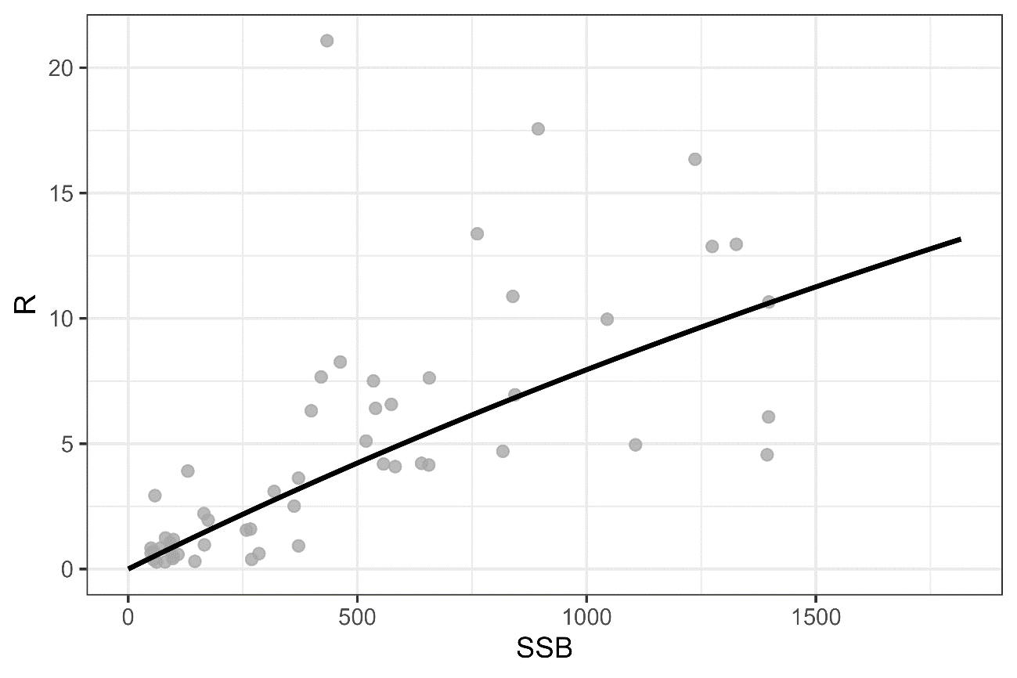  
Beverton-Holt stock recruitment relationship under Scenario S7-JP23indics. The unit of SSB on the x-axis is 1000 MT and the unit of subscription on the y-axis is billions.

Figure A3  
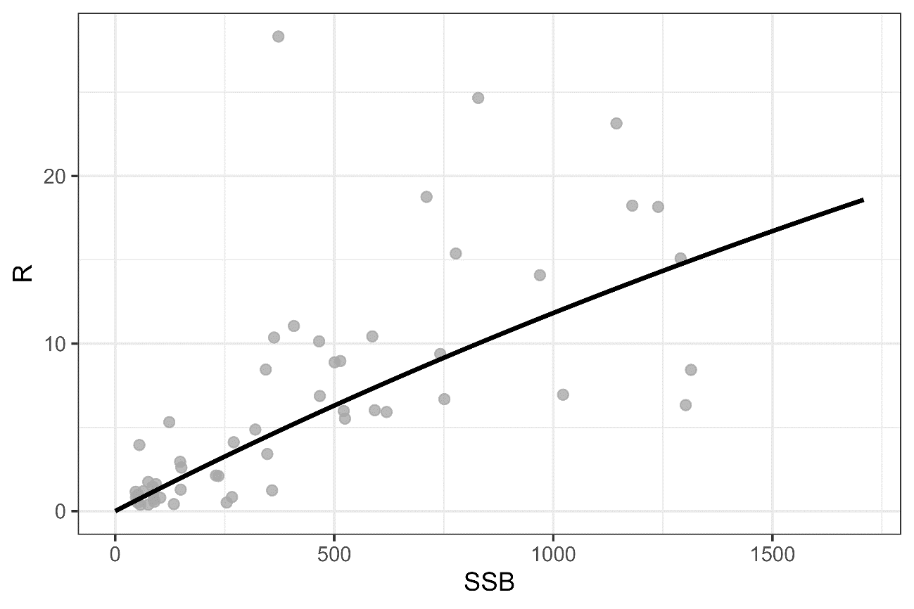

Same as Fig. A2 except that it is Scenario S8-JP23indics.

Figure A4:  
Plot of the correlation matrix obtained from the covariance matrix of the fixed effects parameter estimates for Scenario S7-JPindics. Orange colors indicate positive correlation, while light blue indicates negative correlation.

Figure A5:  
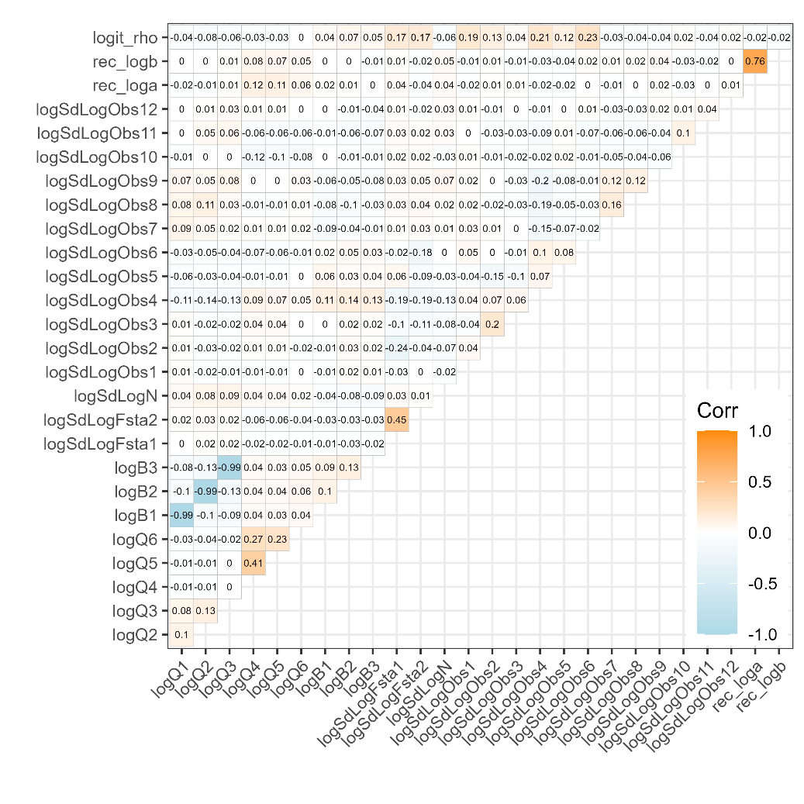  
Same as Fig. A4 except that it is Scenario S8-JP23indics.

Figure A6:  
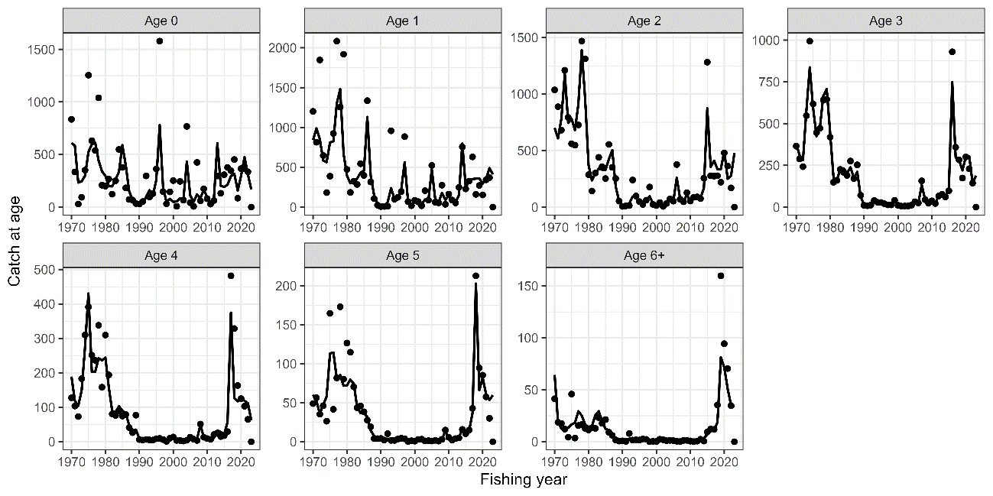  
Observed catch numbers by age (dots) and their predicted values (lines) under Scenario S7-JP23indcs.

Figure A7:  
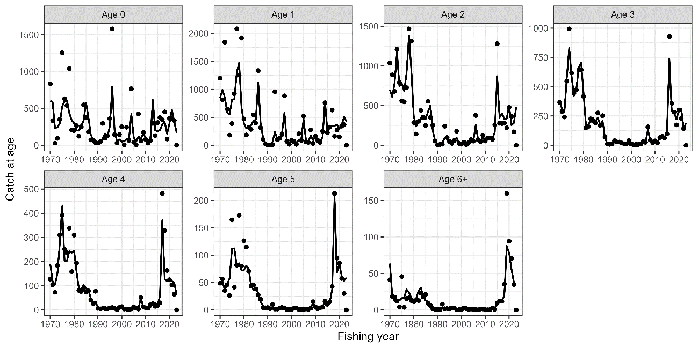  
Same as Fig. A6 except that it is Scenario S8-JP23indics.

Figure A8:  
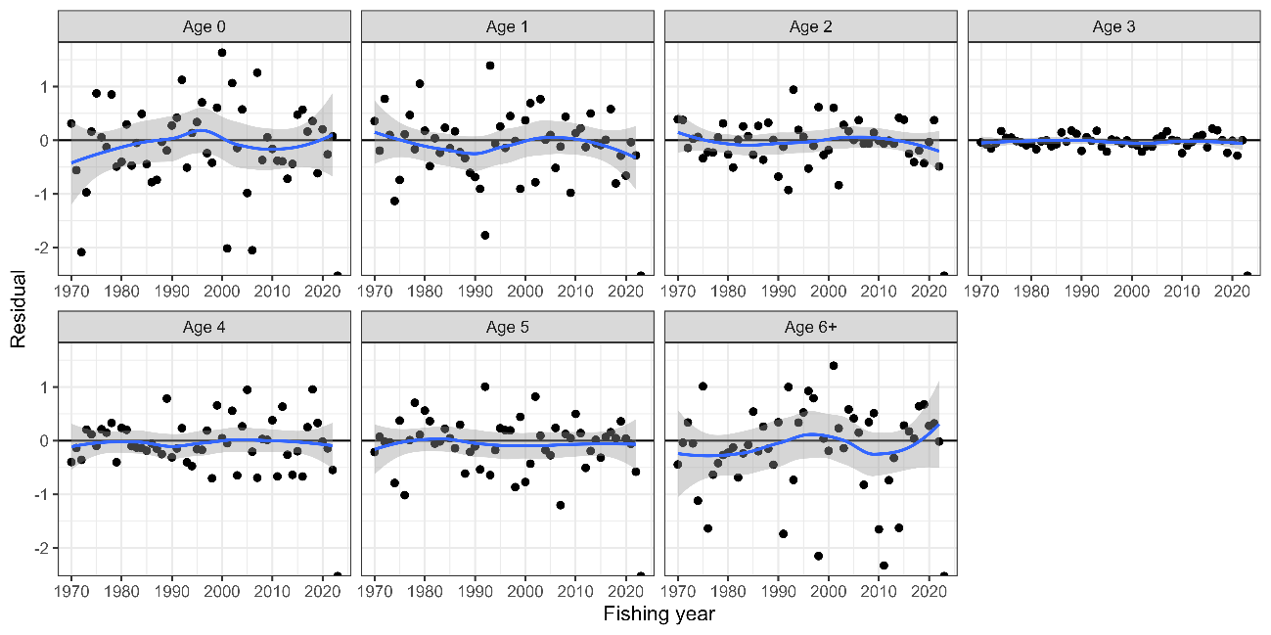

Residual plot for catch numbers by age under Scenario S7-JP23indics. Blue curves and shaded areas indicate smoothed curves estimated by LOESS and their 95% confidence intervals.

Figure A9:  
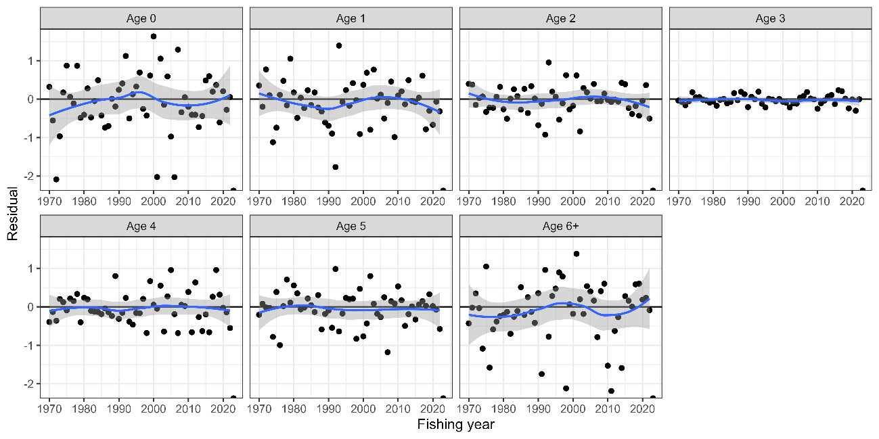  
Same as Fig. A8 except that it is Scenario S8-JP23indics.

Figure A10:  
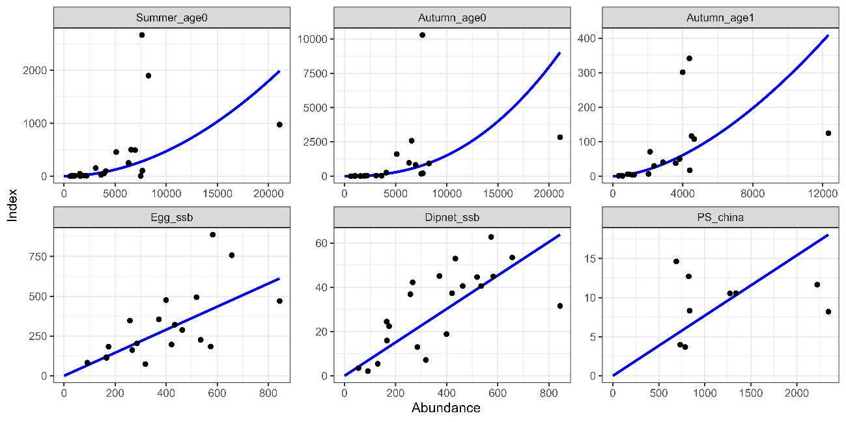

Relationship between six abundance index and their corresponding abundance estimates under Scenario S7-JP23indics. The blue lines indicate the precited relationships.

Figure A11:  
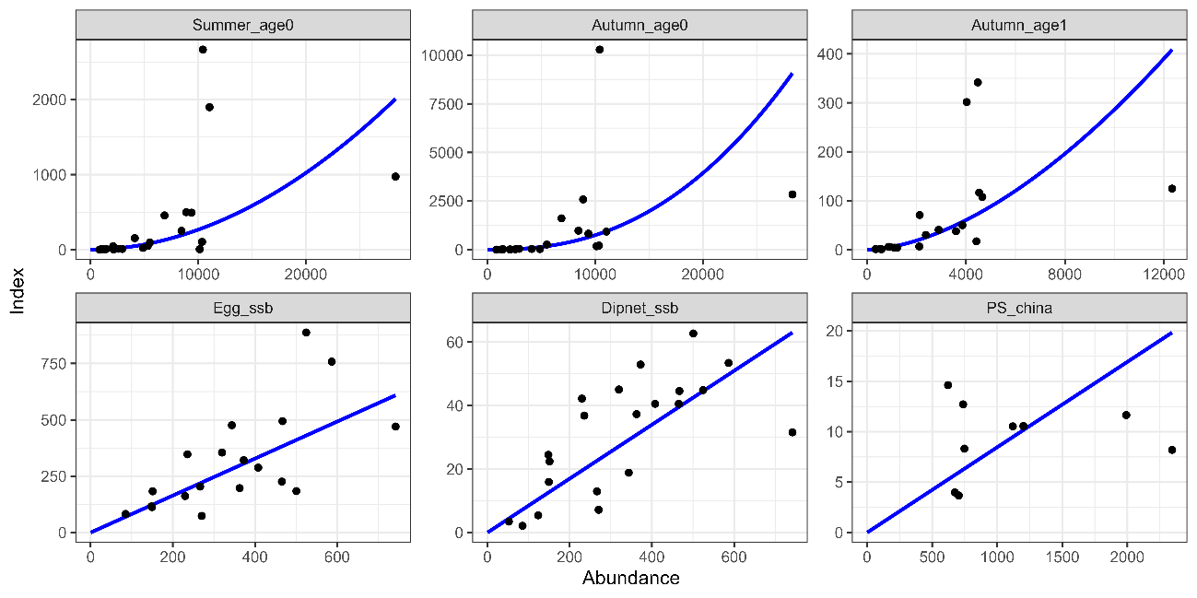  
Same as Fig. A10 except that it is Scenario S8-JP23indics.

Figure A12:  
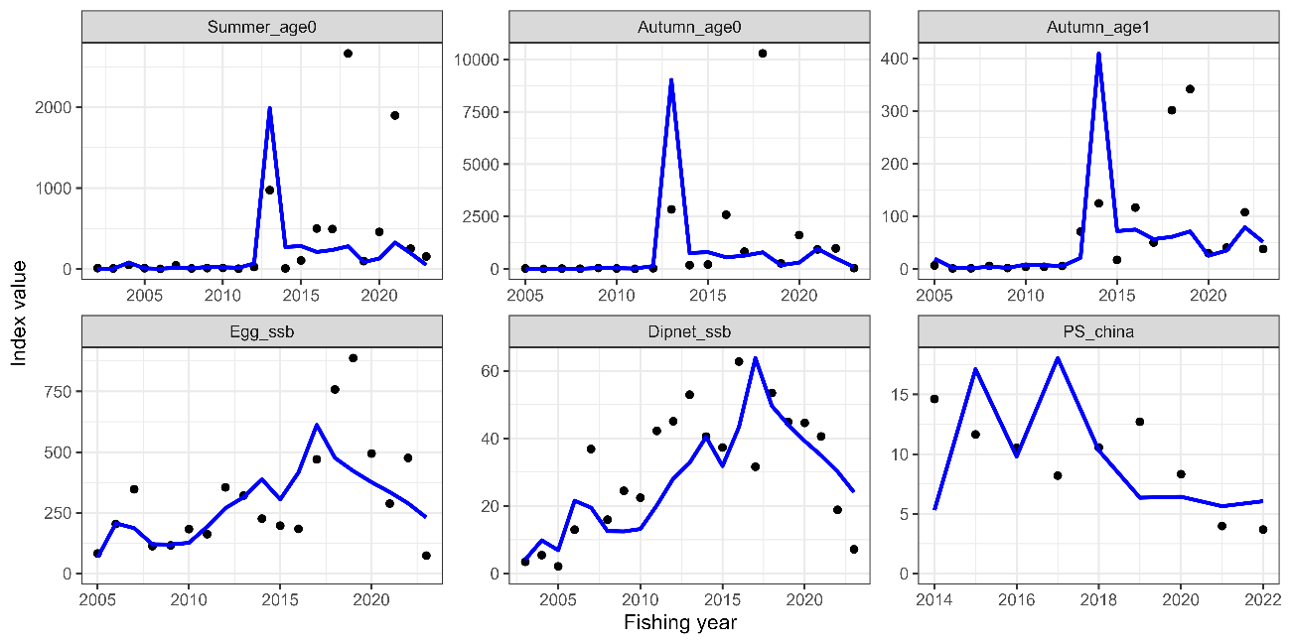

Trends of abundance indices used (dots) and their predicted values (lines) under Scenario S7-JP23indics.

Figure A13:  
Same as Fig. A12 except that it is Scenario S8-JP23indics.

Figure A14:  
Residual plot for abundance indices under the S7-JP23indics scenario. Blue curves and shaded areas indicate smoothed curves estimated by LOESS and their 95% confidence intervals.

Figure A15:  
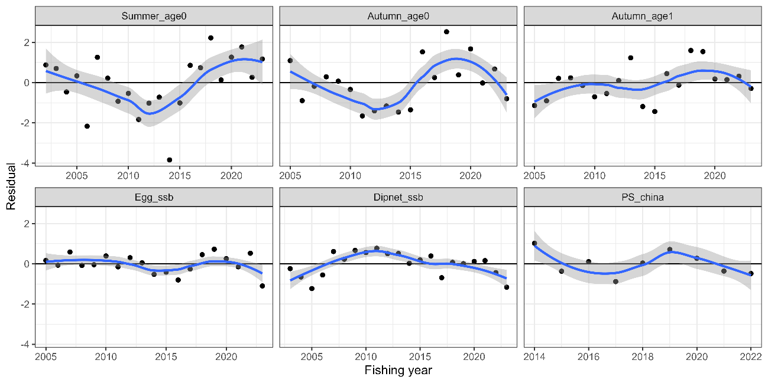  
Same as Fig. A14 except that it is Scenario S8-JP23indics.

Figure A16:  
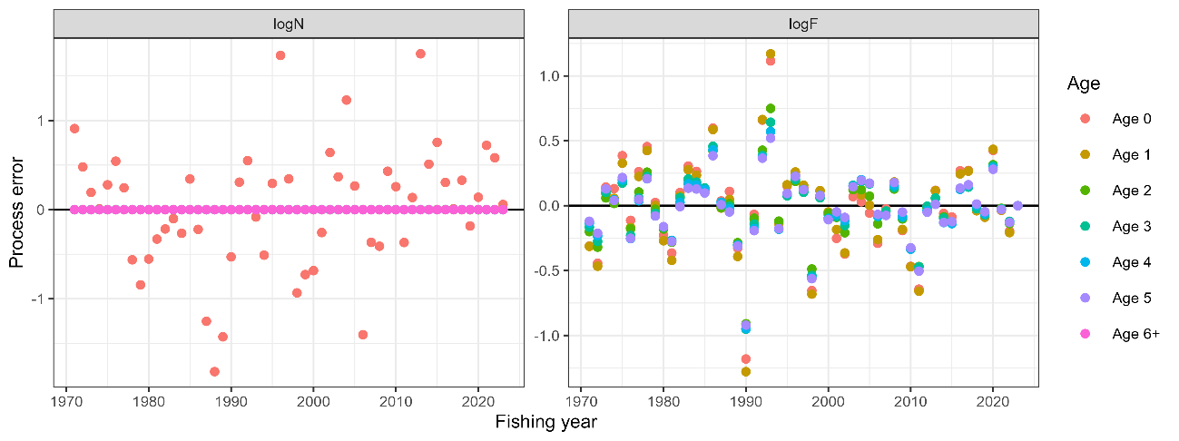  
Process errors log(*N*) (left) and log(*F*) (right) under Scenario S7-JP23indcs. Note that the process error in the number of individuals is almost zero, since the number of fish above one year of age is fixed to a small value, and the residuals of zero-year-old recruitment are shown as scattered up and down

Figure A17  
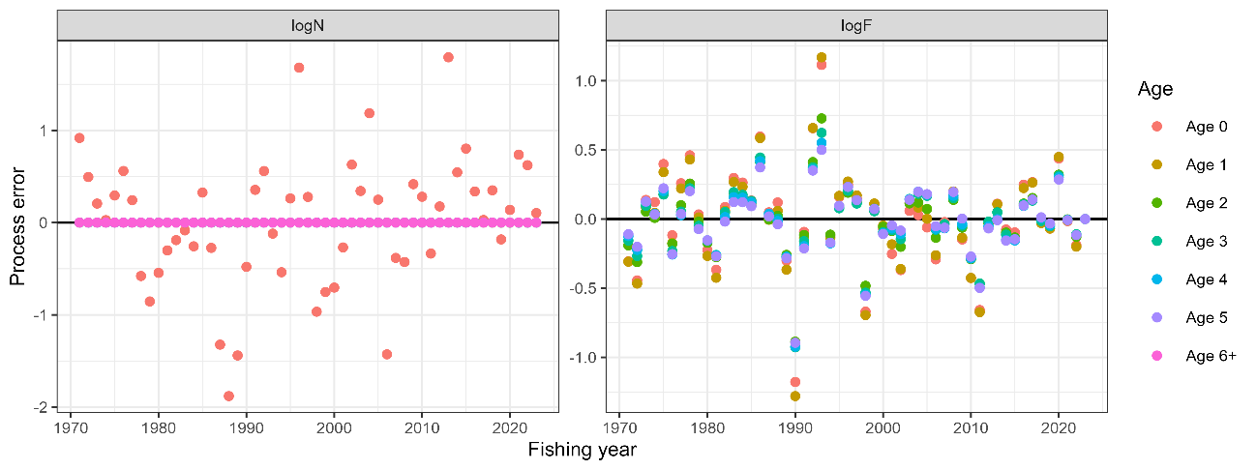  
Same as Fig. A16 except that it is Scenario S8-JP23indics.

Figure A18:  
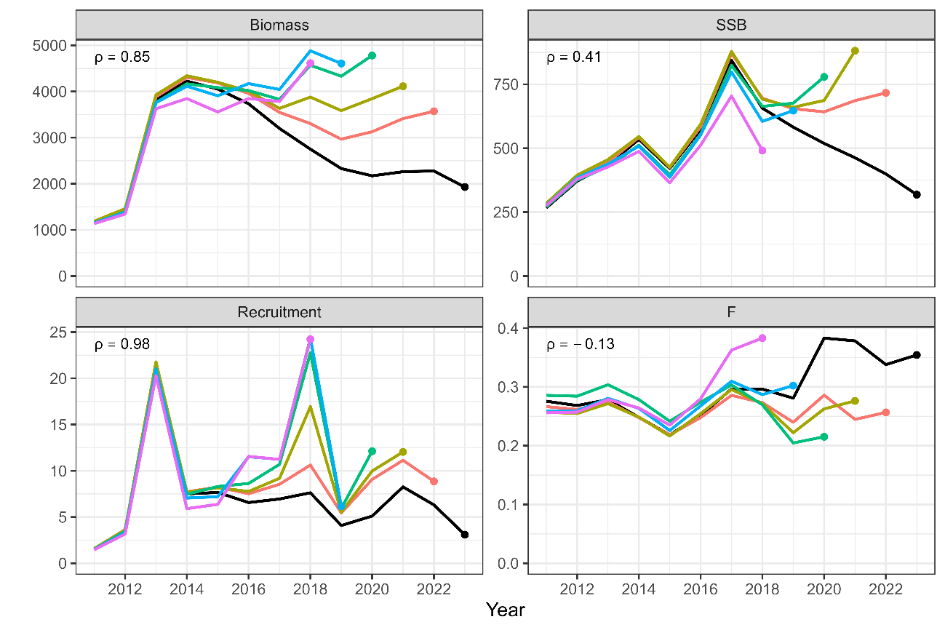  
Patterns of retrospective forecasting for total biomass (top left), SSB (top right), recruitment (bottom left), and mean F (bottom right). Black Lines represent models with all data, and colored lines represent models with the most recent data trimmed. Mohn's rho is shown in the upper left corner. The dots indicate the year of one-year-ahead forecasting, used for the calculation of Mohn’s rho.

Figure A19:  
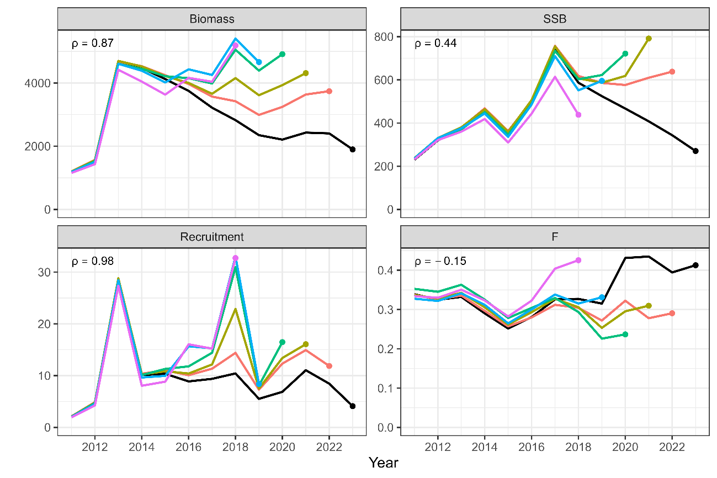  
Same as Fig. A18 except that it is Scenario S8-JP23indics.

Figure A20:  
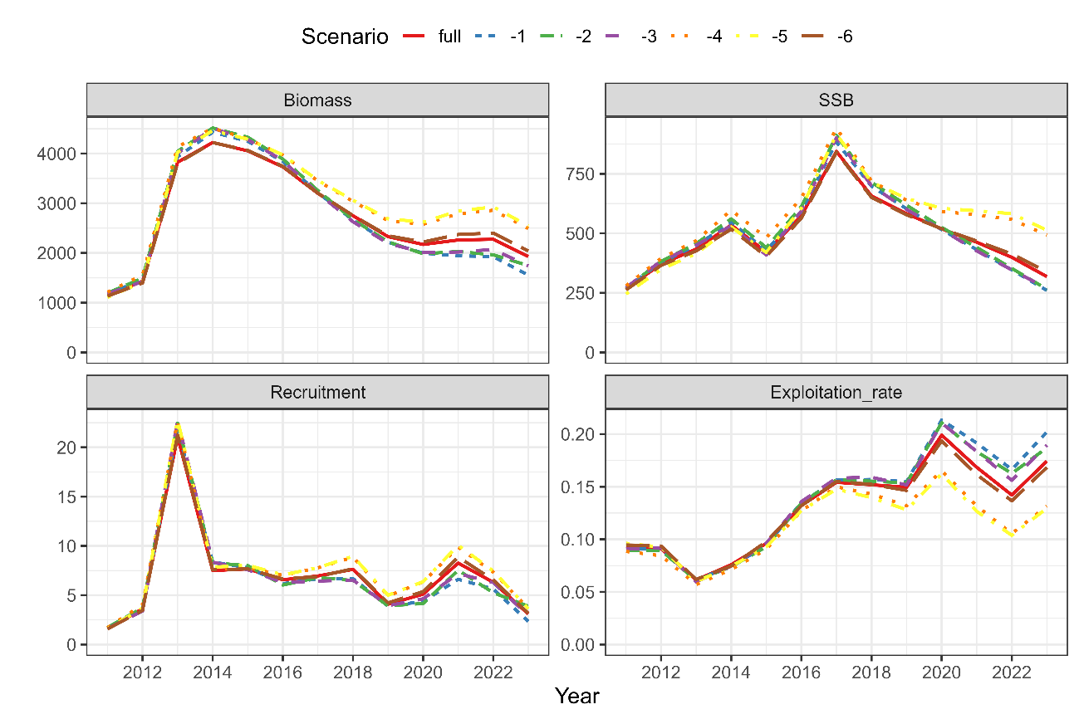  
Comparison of the results of the estimates when all index values are used and when each indicator is excluded for Scenario S7-JP23indics. The IDs of the index are as follows: (1) relative stock number of age 0 from the summer survey by Japan, (2) relative stock number of age 0 from the autumn survey by Japan, (3) relative stock number of age 1 from the autumn survey by Japan, (4) relative SSB from the egg survey by Japan, (5) relative SSB from the dip-net fishery by Japan, and (6) relative vulnerable stock biomass from the light purse-seine fishery by China.

Figure A21:  
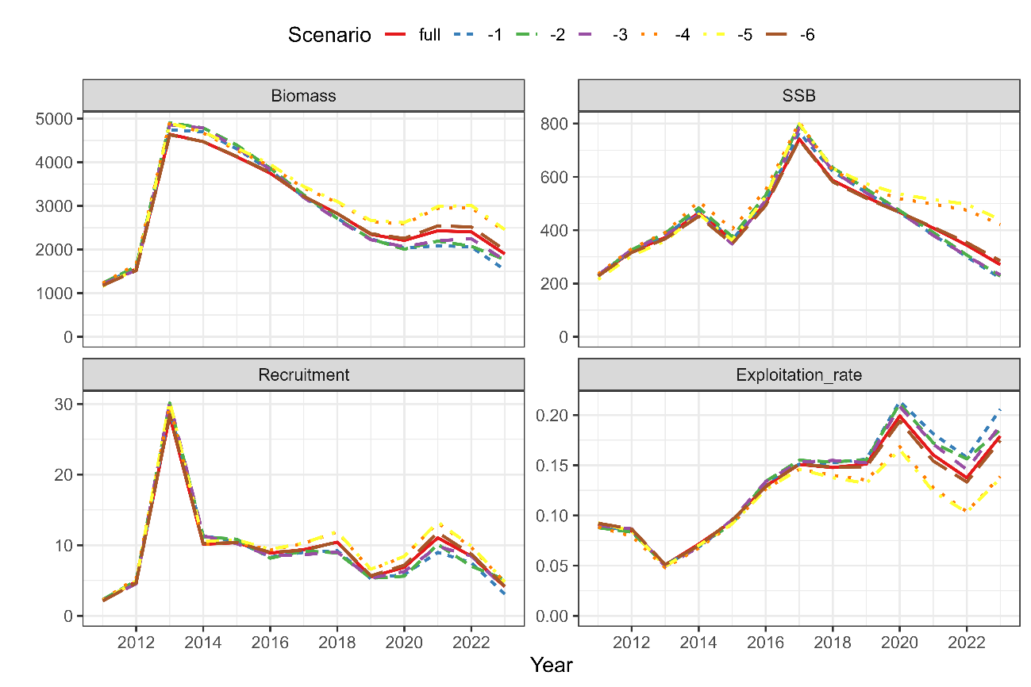  
Same as Fig. A20 except that it is Scenario S8-JP23indics.

Figure A22:  
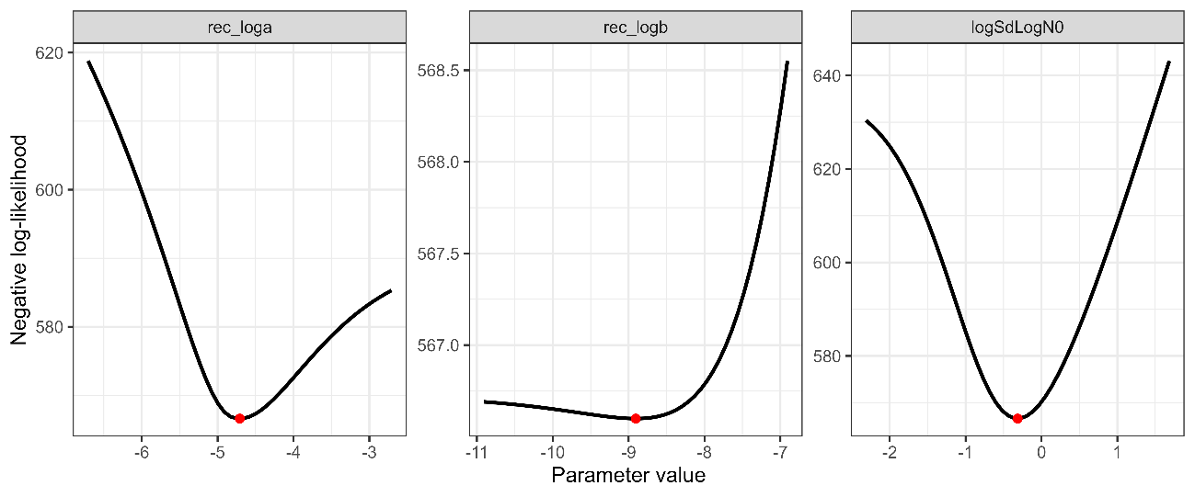  
Changes in negative log-likelihoods by varying parameters related to the stock-recruitment relationship (*α, β, ω*0 in log space) for Scenario S7-JP23indics.

Figure A23:  
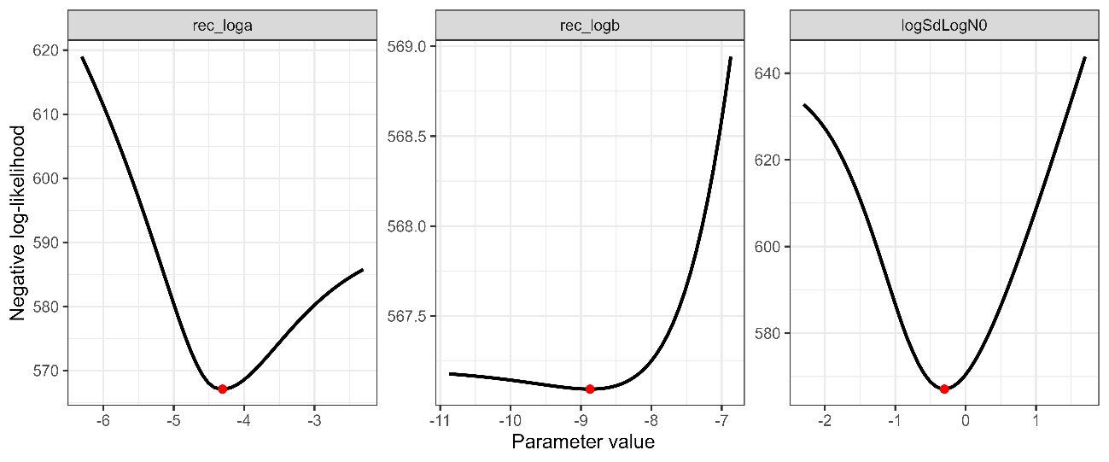  
Same as Fig. A22 except that it is Scenario S8-JP23indics.

Figure A24:  
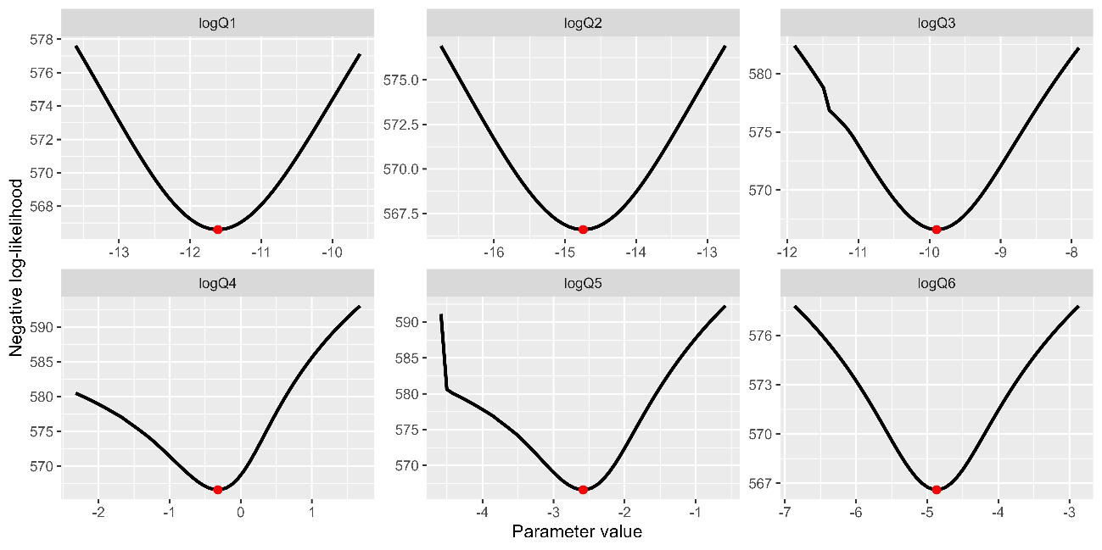  
Changes in negative log-likelihoods by varying parameters of proportionality constants for abundance indices (*qk* in log space) for Scenario S7-JP23indics. The red dotes indicate the input values for the base case scenarios.

Figure A25:

Same as Fig. A24 except that it is Scenario S8-JP23indics.

Figure A26  
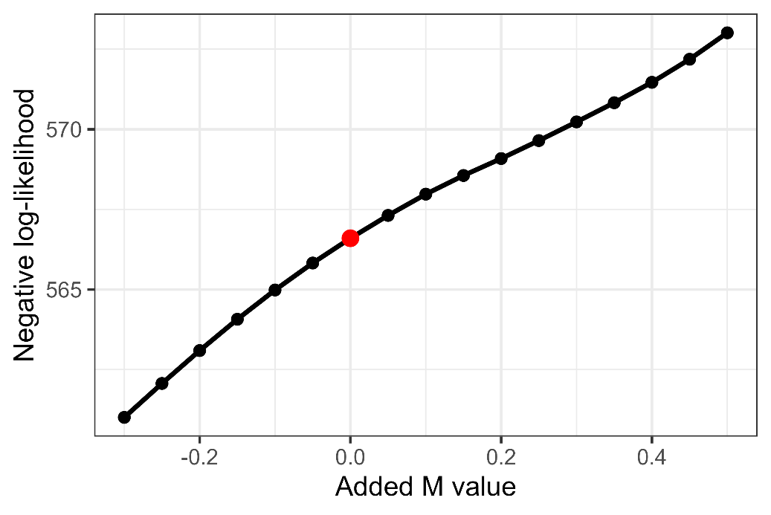  
Changes in negative log-likelihood ay adding different M values for Scenario S7-JP23indics. The red dotes indicate the input values for the base case scenarios.

Figure A27:

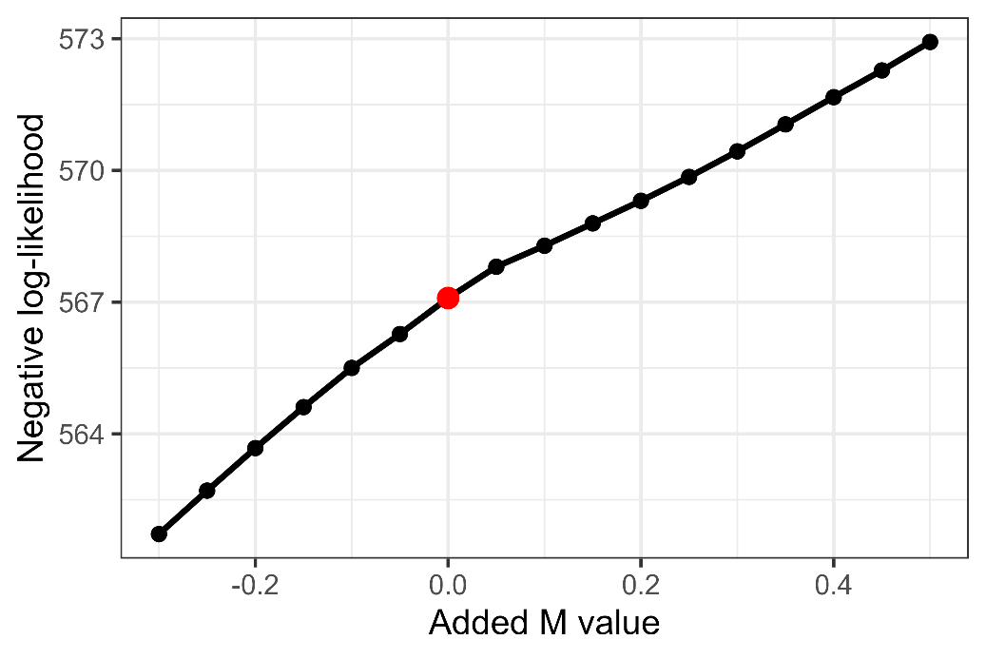  
Same as Fig. A26 except that it is Scenario S8-JP23indics.

Figure A28:  
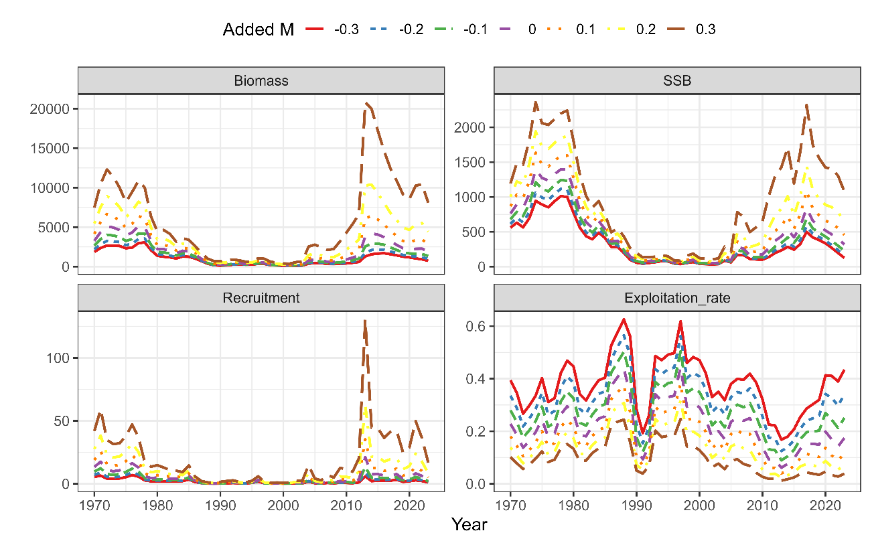  
Effects of varying M values on the estimates total biomass, SSB, recruitment, and exploitation rate under Scenario S7-JP23indics.

Figure A29:  
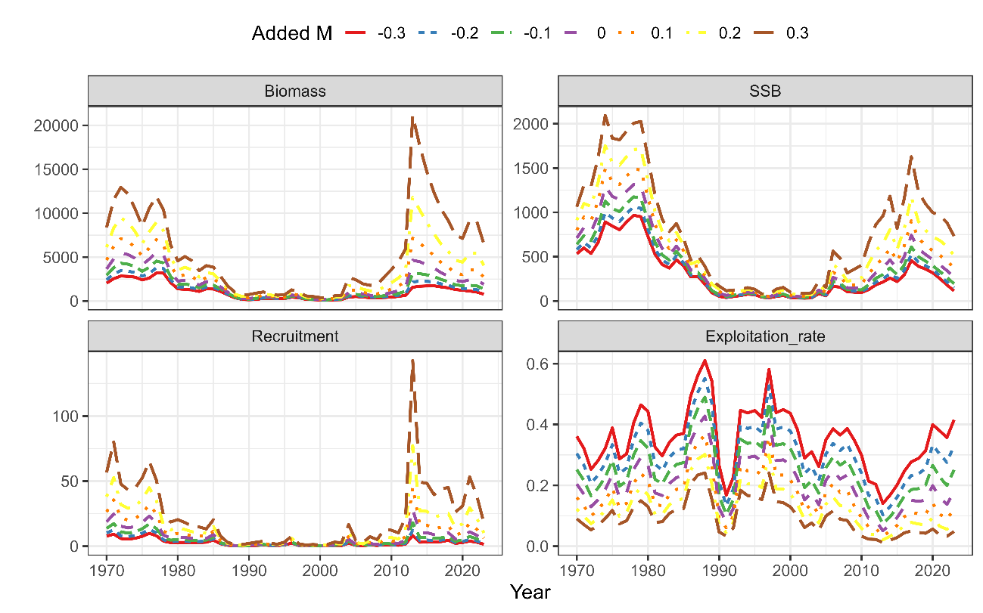  
Same as Fig. A28 except that it is Scenario S8-JP23indics.