NPFC-2024-TWG CMSA09-WP11

**Standardized CPUE of Chub mackerel (*Scomber japonicus*) caught by the Russia’s trawls fishery up to 2023**

Chernienko Igor, Chernienko Emilya

*Pacific branch of the Federal State Budget Scientific Institution “Russian Federal Research Institute of Fisheries and oceanography”, Vladivostok, Russia, 69009*

**Summary**

Catch per effort is often used in fish stock assessments as an indicator related to abundance. However, CPUE can be influenced by factors other than abundance. Standardization is performed to remove their influence. CPUE Standardization was completed using generalized additive models. Four groups of variables were used: spatial (latitude, longitude), temporal (day of the year), fishery (vessel length and engine power), environmental (sea surface temperature - SST). Models based on different combination of factors were tested using information criteria (AIC, BIC). The final model includes tensor product of latitude and longitude, harmonic representation of the day of the year, vessel length, engine power and SST.

1. BACKGROUND

Russian mackerel fishery in the Far East began in the early 1960s and lasted until the late 1980s, when its stocks in areas accessible to the domestic fleet were completely depleted (Baryshko, 2009). In 26 years of mackerel fishery for 13 years it was harvested more than 50 thousand tonnes per year, including 9 years when the catch was more than 100 thousand tonnes. Commercial fishing of mackerel in the North-West Pacific Ocean by vessels under the Russian (Soviet) flag began in 1968. Since the second half of the 1980s, due to a sharp decline in mackerel abundance, its commercial aggregations in the Russian EEZ have not been formed. Until recently, no targeted mackerel fishery was conducted by Russia in the EEZ.

In all habitats, the Japanese mackerel is characterised by long migrations, which allow each population to cover an extensive range in different seasons of the year, using favorable habitats (primarily feeding areas) (Belyaev, 1979; Pozdnyakov , Vasilenko, 1994).

The annual biological cycle of NWP mackerel can be divided into the following main stages. Spawning begins after the end of the wintering period in areas where SST exceed 15°C. Mackerel mature earlier and start spawning earlier in the southern part of their range due to higher temperatures during wintering and spawning in the south. The wintering period is longer in the north than in the south, and the spawning period in the south, lasts longer than in the north. The final maturation of producers occurs directly in the wintering and spawning areas, but they arrive there at a certain stage of readiness for spawning, after they have finished feeding and reached a high degree of fatness. A significant proportion of immature juveniles winter in the open ocean (Vasilenko, 1990). Thus, temperature is the most important factor affecting CPUE. Individual catches are also dependent on production factors such as vessel type, fishery period , etc. (Chernienko, Chernienko, 2022).

Mackerel begins feeding migrations as surface waters warm up, thus water temperature is the most important factor affecting its catches. It is also apparent that catches are affected by vessel type, size and engine power.

2. METHOD

2.1 The data

Catch and effort logbook from the Russian EEZ for 2016-2023 were used. Catch and effort data are summarized in Fig. 1 A,B. Catch patterns and fishing effort are grouped in a 30′ grid for better visualization. All catches were made with pelagic trawls. Data with missing coordinates is not included in the analyses.

Description of the used variables is given in Table 3. Year as a categorical variable, year percentage, cyclical components of year percentage (eq 1), latitude and longitude, mackerel and squid ratio in the catch, and SST as continuous variables were used. The use of mackerel ratio as a variable rather than a data filtering criterion is due to the fact that catches with a mackerel ratio less than 50% are quite numerous. At the same time, the absolute values of catches are quite significant and it is not reasonable to exclude them from the analysis.

Cyclic components were used because the mackerel migration activity is cyclic in nature

$$\begin{aligned}d_{sin}=sin2π\frac{D}{D_{Y}} \\ d_{cos}=cos2π\frac{D}{D_{Y}}\end{aligned}$$

where *D* is the ordinal number of the day of the year, *DY* is the number of days in the year (365 or 366). The SST data was obtained from the Japanese Meteorological Agency. Fig. 2 shows the distributions of the values of the explanatory re-sensors, Fig 3 shows the correlation matrix. It can be seen that vessel length and engine power are quite strongly correlated. Nevertheless, the engine power was used for standardization because, firstly, the relationship is non-linear, and secondly, this relationship is different for different types of ships.

2.2 Full model description and model selection

Standardization was performed using generalized additive models. Candidate models were constructed by combining various factors described in Table 3. The error ε was assumed to correspond to the Tweedie distribution.

The simplest model №1 was considered as a baseline.

$$1.lnCPUE=β_{Year}+ε$$

$$2.lnCPUE=s\left(sst\right)+β_{Year}+ε$$

$$3.lnCPUE=te\left(lon,lat\right)+s\left(sst\right)+β_{Year}+ε$$

$$4.lnCPUE=te\left(lon,lat\right)+s\left(p_{Y}\right)+s\left(L\right)+s\left(E\right)+s\left(sst\right)+β_{Year}+ε$$

$$5.lnCPUE=te\left(lon,lat\right)+s\left(d_{sin}\right)+s\left(d_{cos}\right)+s\left(L\right)+s\left(E\right)+s\left(sst\right)+β_{Year}+ε$$

The decision on model selection was based on the value of the Bayesian information criterion (BIC). The Akaike Information Criterion (AIC) value and explained variance were also taken into account. Model No. 5 (Table 4) showed the best performance. The value of explained variance in the best model is 10 times higher than in the control model. The contributions of the influencing variables to the CPUE value are shown in fig 5.

2.3 Yearly trend extraction

The time series of standardized CPUEs was obtained using the model that showed the highest performance. In the model we substituted the values accepted as standard values. Modal values were used for coordinates, vessel length and engine power and SST (see table 5).  
 95% confidence intervals were obtained from the Tweedie distribution.

3. RESULT and DISCUSSION

The estimation results of the best model are presented in Table 4. Figure 5 shows the contributions of the variables to the CPUE value. Figure 6 and Table 8 show the values of the standardized and nominal index values. The observed difference can be explained by the fact that both the composition of the fishing fleet and the coverage of the fished area changed during the fishing period.

Table 1

Catch and effort information by CPUE FLEET.

|  |  |  |  |  |  |  |
| --- | --- | --- | --- | --- | --- | --- |
| Year | Number of observations | % Coverage of CPUE fleet(catch) | % Coverage of CPUE fleet(effort) | Total Catch CPUE fleet (mt) | Total Effort CPUE fleet | Percentage of overall catch by member (across all fleets/gears) |
| 2016 | 1527 | 87.8% | 99.3% | 7.86 | 1527 | 87.8% |
| 2017 | 1454 | 97.8% | 99.7% | 26.94 | 1454 | 97.8% |
| 2018 | 2395 | 98.2% | 91.8% | 65.90 | 2395 | 98.2% |
| 2019 | 2105 | 95.2% | 99.7% | 35.13 | 2105 | 95.2% |
| 2020 | 2427 | 95.5% | 95.6% | 29.88 | 2427 | 95.5% |
| 2021 | 1871 | 96.3% | 97.1% | 38.81 | 1871 | 96.3% |
| 2022 | 1361 | 92.8% | 94.1% | 10.42 | 1361 | 92.8% |
| 2023 | 1393 | 91.1% | 93.7% | 6.94 | 1393 | 91.1% |

Table 2

|  |  |  |  |
| --- | --- | --- | --- |
| Filter Applied | Number of records Remaining | Number Removed | Number of records with Chub Mackerel Catch>0 |
| Initial Data set | 14533 | - | 14489 |
| Removed records without coordinates | 13984 | 549 | 13970 |
| Final Data set | 13984 | 549 | 13928 |

Table 3

Summary of explanatory variables used in GAM.

|  |  |  |  |  |
| --- | --- | --- | --- | --- |
|  | Variable | Categories or Units | Detail | Note |
| Year | *Y* | 8 | 8 years from 2016 to 2023 |  |
| Longitude | *Lon* | continuous | decimal degree |  |
| Latitude | *Lat* | continuous | decimal degree |  |
| Proportion of year | *pY* | continuous | Day of year derived on number of days in year (365 or 366) |  |
| Harmonic Proportion of year 1 | *dsin* | continuous | see eq 1 |  |
| Harmonic Proportion of year 2 | *dcos* | continuous | see eq1 |  |
| Length of vessel | *L* | continuous | Vessels length in meters |  |
| Engine power | *E* | continuous | Engine power in kWt |  |
| Sea surface temperature | *SST* | continuous | Sea surface temperature in the daily vessel position |  |

Table 4

Model selection.

|  |  |  |  |
| --- | --- | --- | --- |
| Model number | AIC | BIC | Explained deviance |
| 1 | 72525.69 | 72601.26 | 6.0% |
| 2 | 70670.85 | 70768.87 | 10.0% |
| 3 | 68658.70 | 68933.44 | 19.0% |
| 4 | 58359.65 | 58723.07 | 56.0% |
| **5** | **58279.13** | **58680.90** | **56.2%** |

**Table 5**

“Standard” explanatory variables values

|  |  |  |  |  |  |  |  |
| --- | --- | --- | --- | --- | --- | --- | --- |
| Y | Lon | Lat | dsin | dcos | L | E | SST |
| 2016 | 147.20 | 43.42 | -0.9243 | 0.0043 | 57.06 | 2250 | 13.83 |
| 2017 | 147.20 | 43.42 | -0.9243 | 0.0043 | 57.06 | 2250 | 13.83 |
| 2018 | 147.20 | 43.42 | -0.9243 | 0.0043 | 57.06 | 2250 | 13.83 |
| 2019 | 147.20 | 43.42 | -0.9243 | 0.0043 | 57.06 | 2250 | 13.83 |
| 2020 | 147.20 | 43.42 | -0.9243 | 0.0043 | 57.06 | 2250 | 13.83 |
| 2021 | 147.20 | 43.42 | -0.9243 | 0.0043 | 57.06 | 2250 | 13.83 |
| 2022 | 147.20 | 43.42 | -0.9243 | 0.0043 | 57.06 | 2250 | 13.83 |
| 2023 | 147.20 | 43.42 | -0.9243 | 0.0043 | 57.06 | 2250 | 13.83 |

**Table 6**

Anova test for best GAM model

Parametric terms::

|  |  |  |  |  |
| --- | --- | --- | --- | --- |
|  | df | F | p |  |
| Year | 7 | 38,47 | <2˟10-16 | *** |

Approximate significance of smooth terms:

|  |  |  |  |  |  |
| --- | --- | --- | --- | --- | --- |
|  | edf | Ref.df | F | p-value |  |
| te(Lon,Lat) | 17.09 | 18.52 | 36.73 | <2˟10-16 | *** |
| s(dsin) | 7.79 | 8.22 | 12.93 | 2.35˟10-3 | ** |
| s(dcos) | 7.13 | 7.44 | 97.94 | <2˟10-16 | *** |
| s(L) | 3.00 | 3.00 | 2080.95 | <2˟10-16 | *** |
| s(E) | 2.97 | 3.00 | 296.21 | <2˟10-16 | *** |
| s(SST) | 2.83 | 2.98 | 24.79 | <2˟10-16 | *** |

**Table 7**

The estimated coefficients in the best GAM models for CPUE standardization

|  |  |  |
| --- | --- | --- |
| Explanatory variable | Coefficient | SE |
| Intercept | 0.875 | 0.047 |
| 2017 | 0.147 | 0.055 |
| 2018 | 0.381 | 0.054 |
| 2019 | 0.031 | 0.059 |
| 2020 | 0.000 | 0.061 |
| 2021 | 0.354 | 0.062 |
| 2022 | 0.277 | 0.072 |
| 2023 | -0.323 | 0.076 |

**Table 8**

Nominal and standardized CPUEs of CPUE FLEET from 2016 to 2023

|  |  |  |  |  |
| --- | --- | --- | --- | --- |
| Year | Nominal CPUE | Standardized CPUE | SE | 95% CI by GAM |
| 2016 | 4.29 | *21.4* | 0.58 | [6.79 67.46] |
| 2017 | 16.86 | 24.81 | 0.57 | [7.88 78.14] |
| 2018 | 29.45 | 23.66 | 0.57 | [7.52 74.39] |
| 2019 | 14.72 | 10.81 | 0.57 | [3.43 34] |
| 2020 | 12.30 | 7.16 | 0.57 | [2.27 22.51] |
| 2021 | 20.59 | 19.27 | 0.57 | [6.12 60.68] |
| 2022 | 7.55 | 7.29 | 0.58 | [2.31 23] |
| 2023 | 5.83 | 2.47 | 0.58 | [0.78 7.79] |

Figure 1A

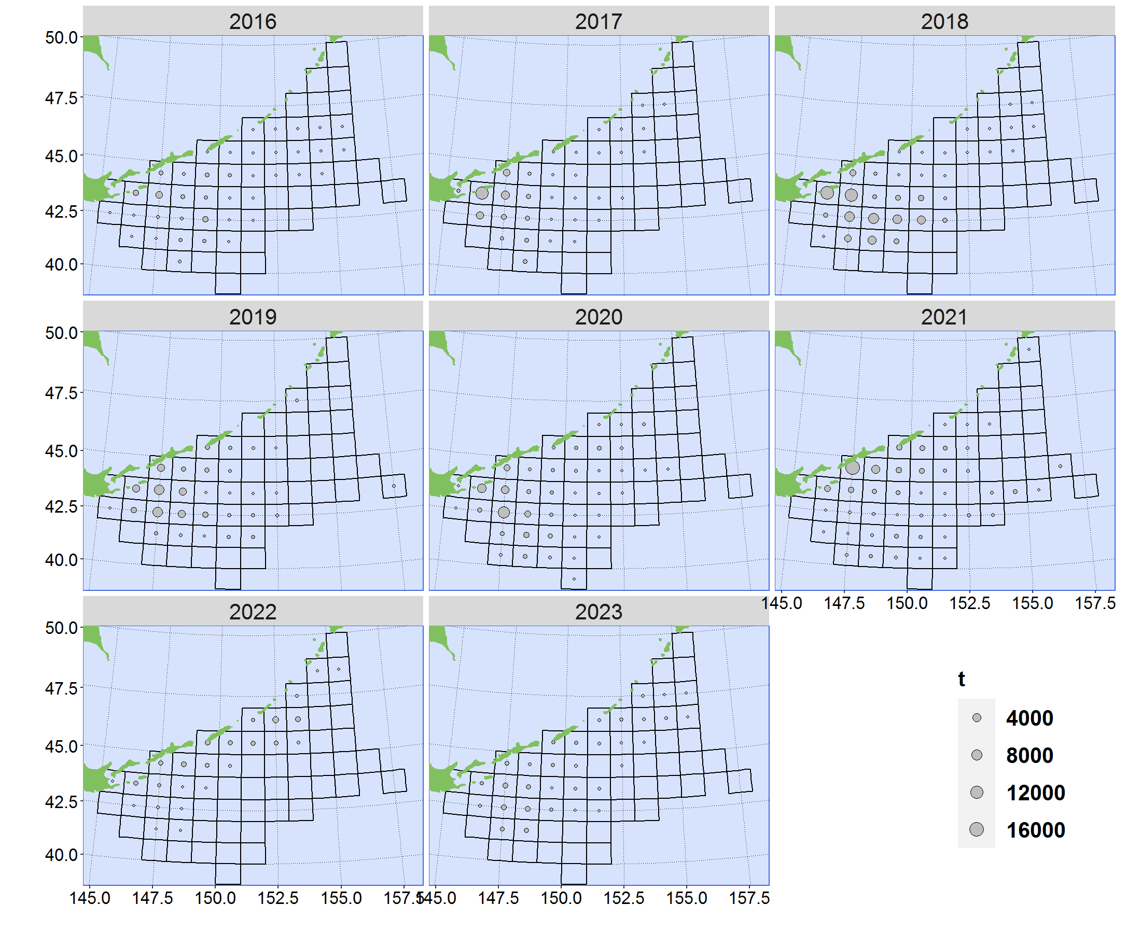

Map of annual catches (in tonnes) from 2016 to 2023 in EEZ of Russian Federation, grouped by 30′

Figure 1B

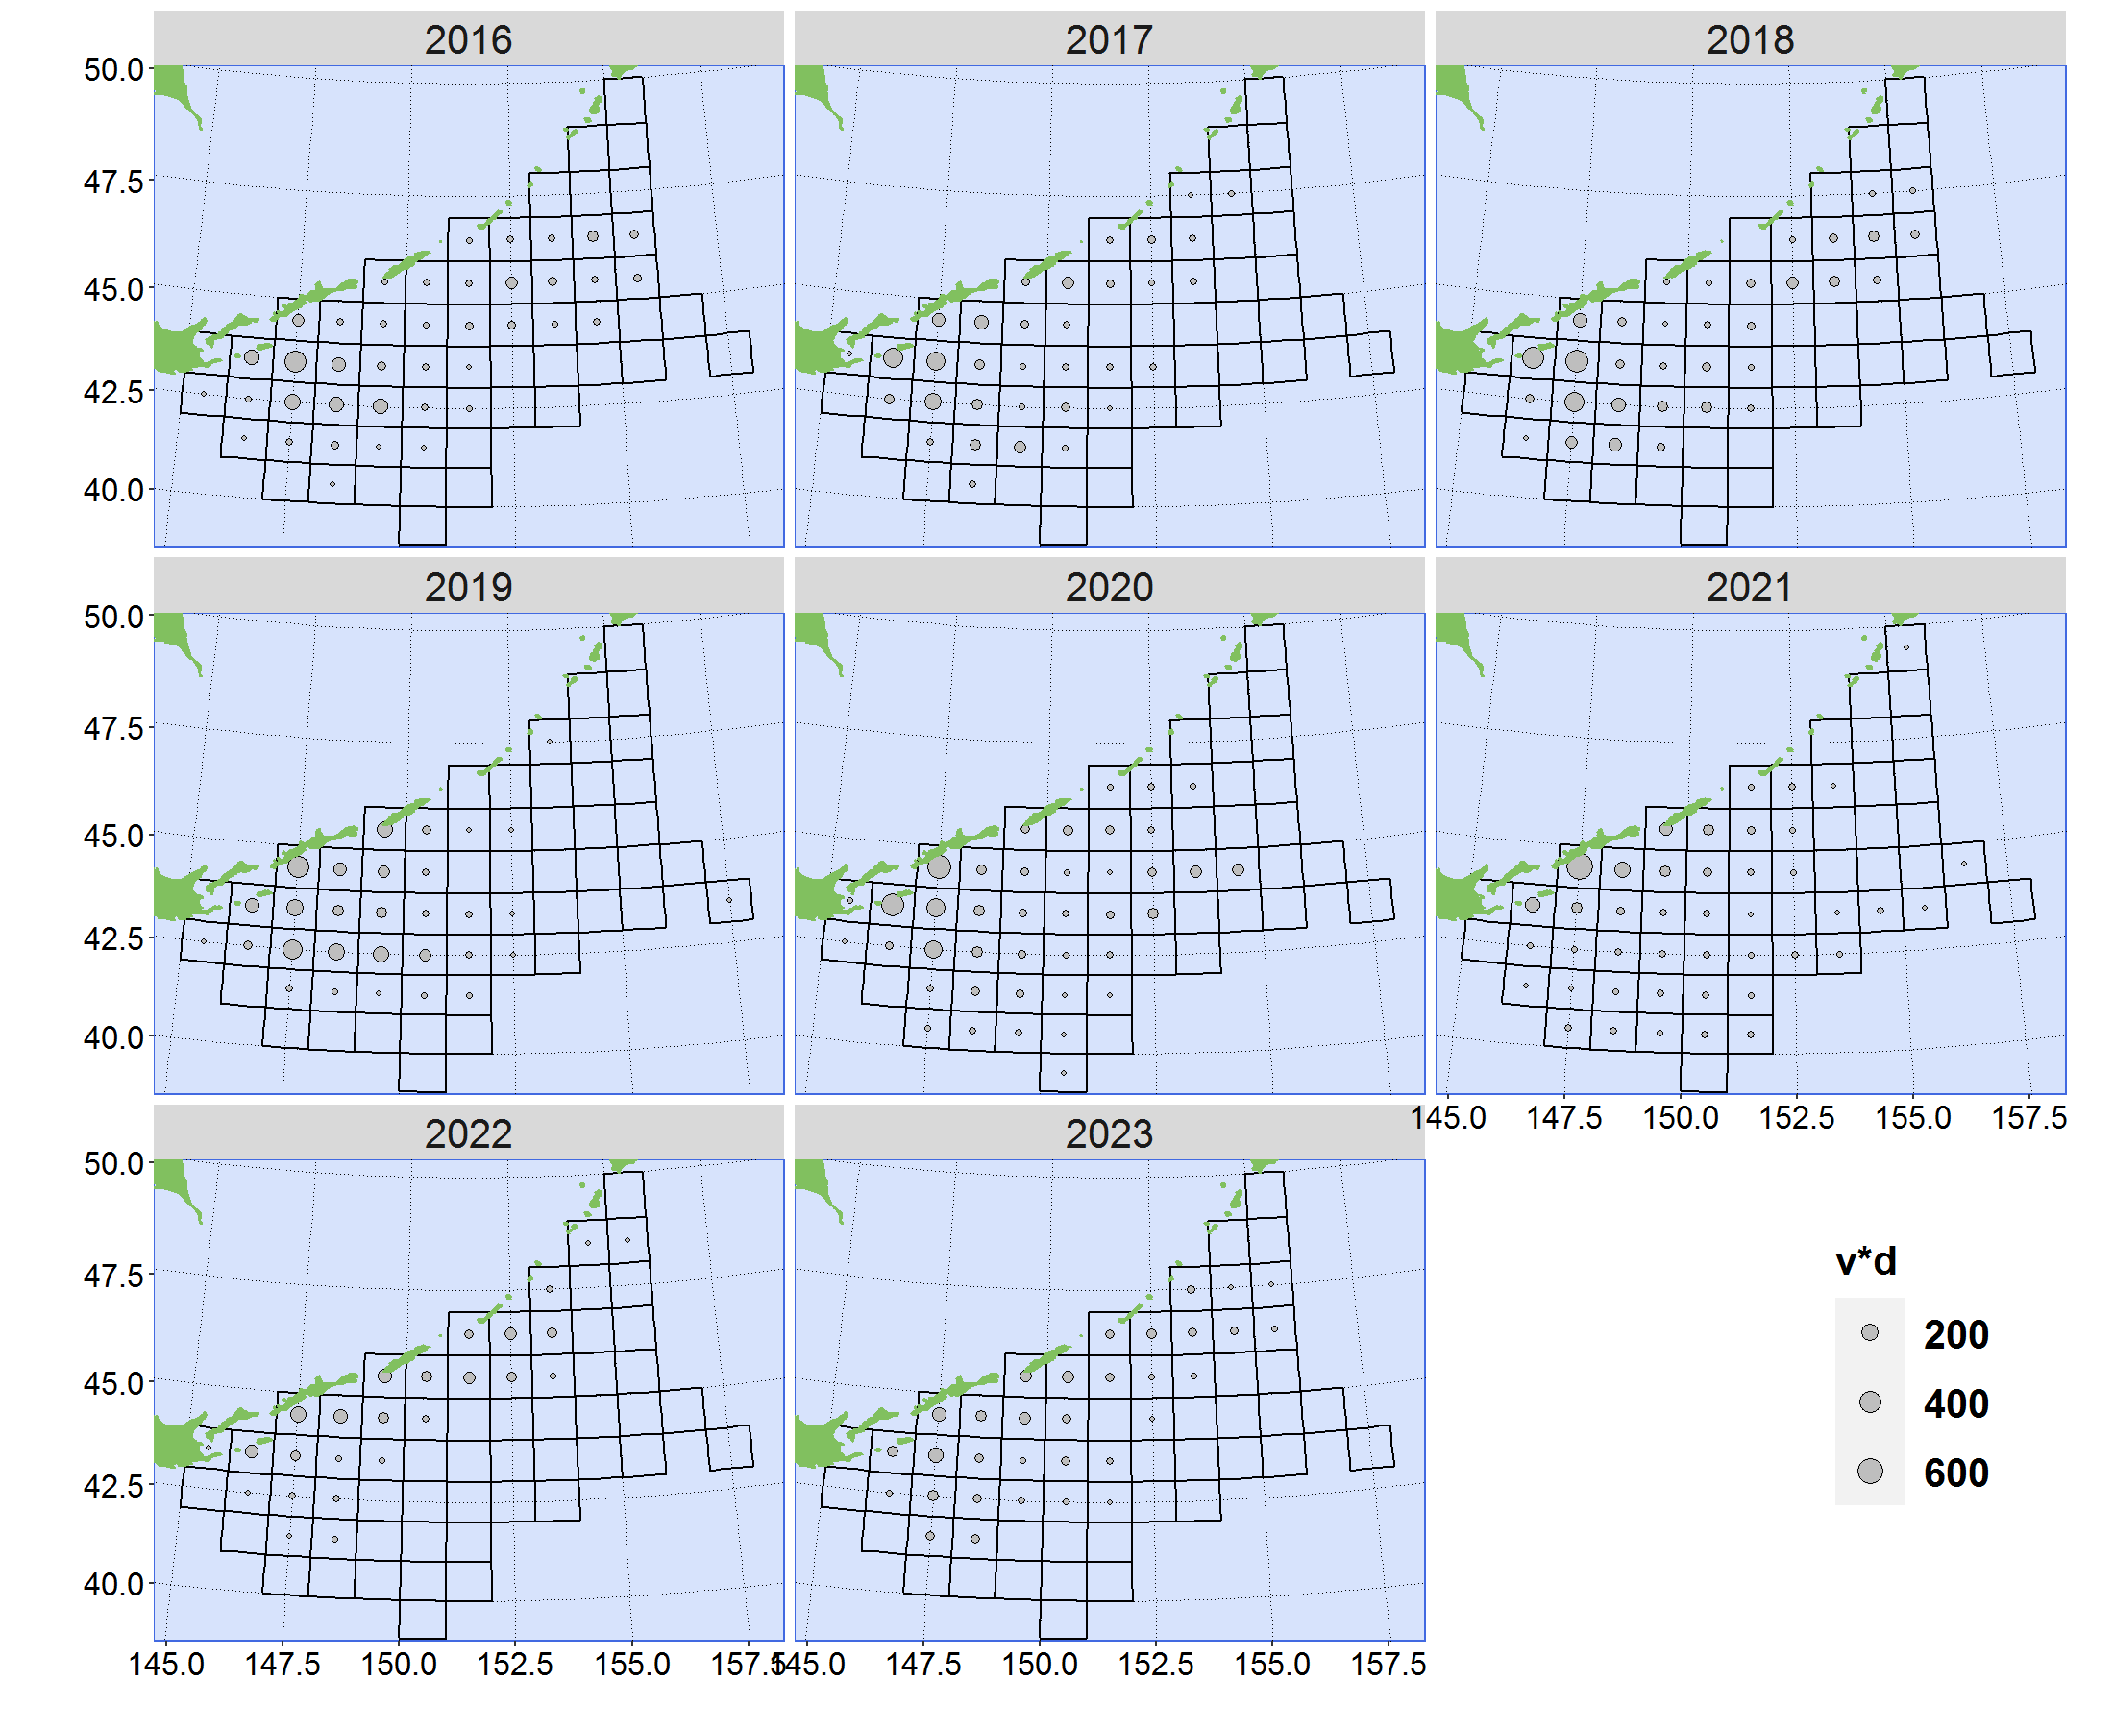

Map of annual effort (vessel-day) from 2016 to 2023 in EEZ of Russian Federation grouped by 30´.

Figure 2

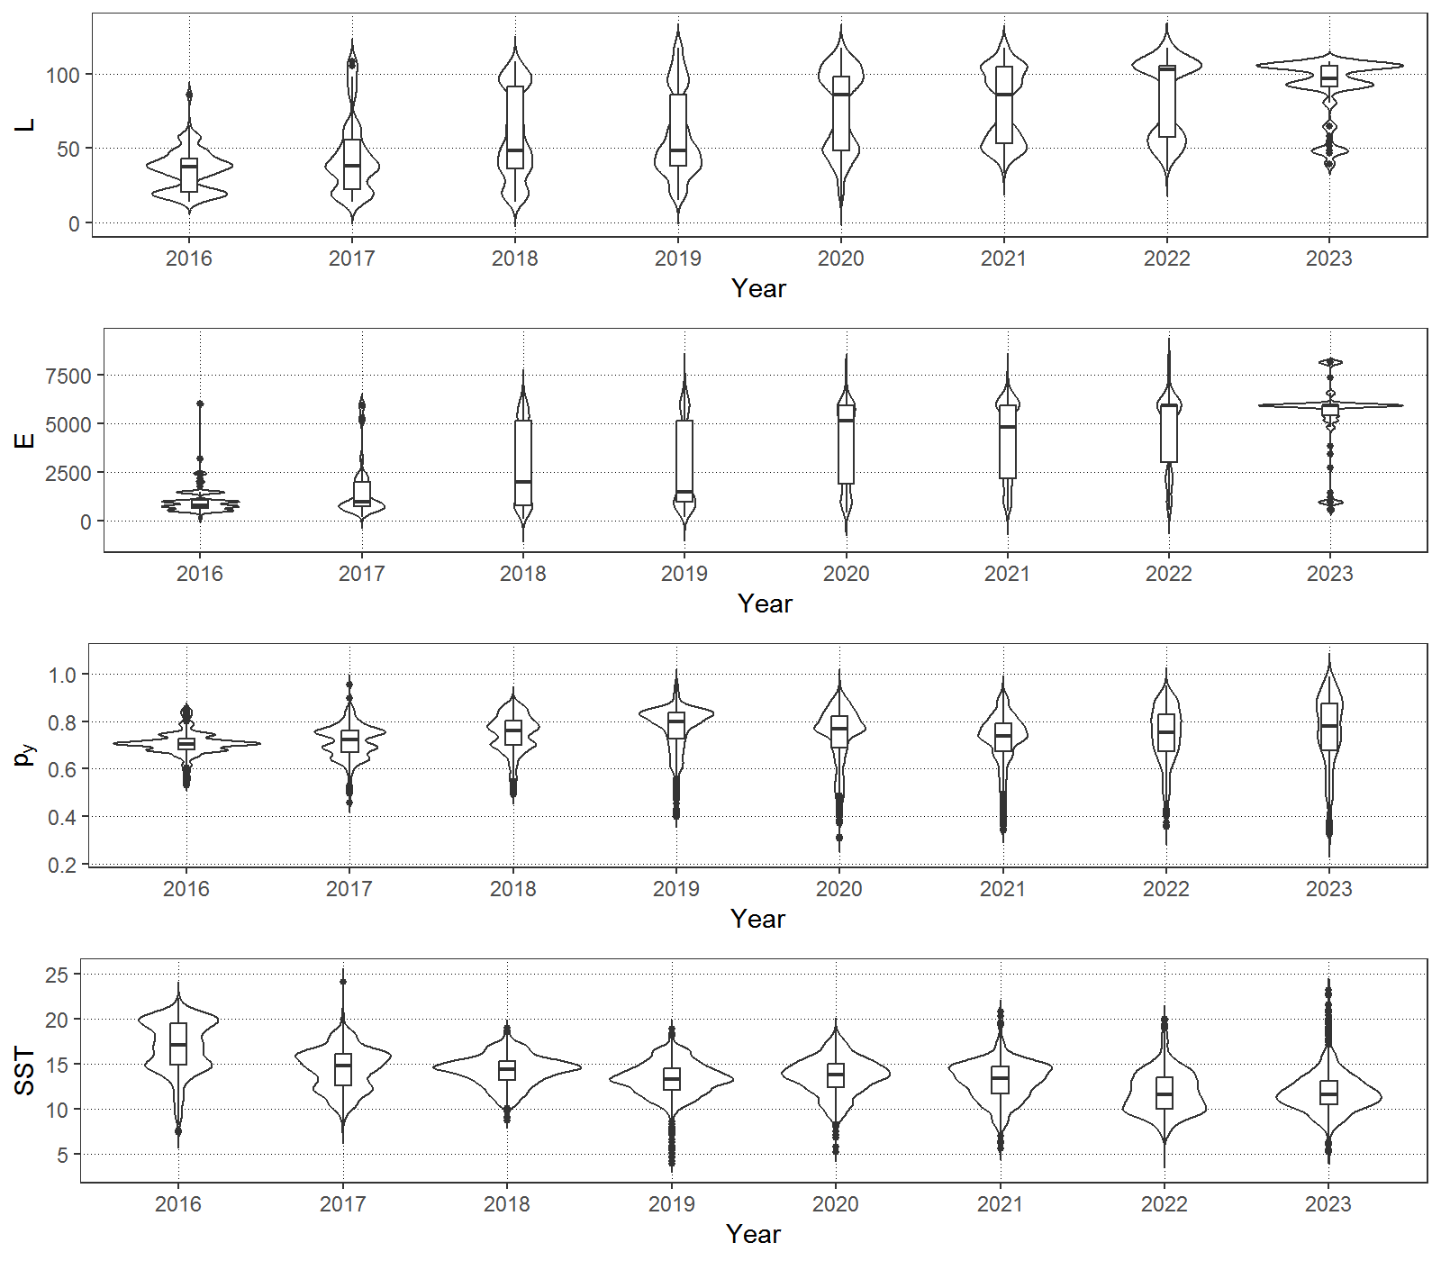

Plots of explanatory variables by year

**Figure 3**

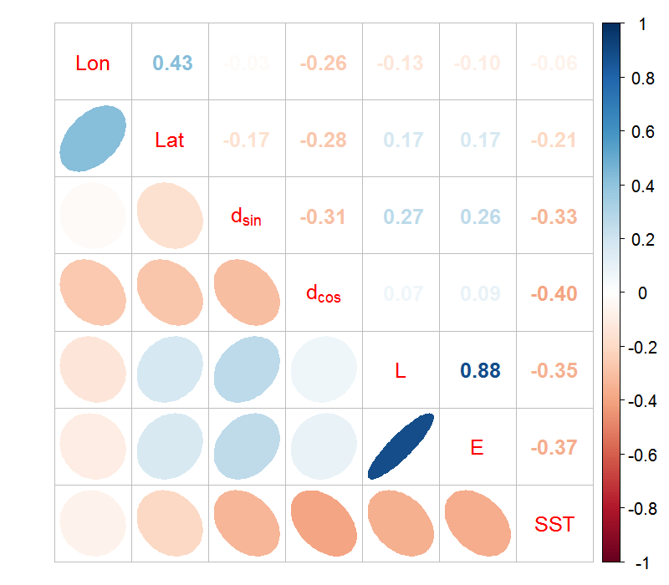

Correlation matrix of explanatory variables

**Figure 4**

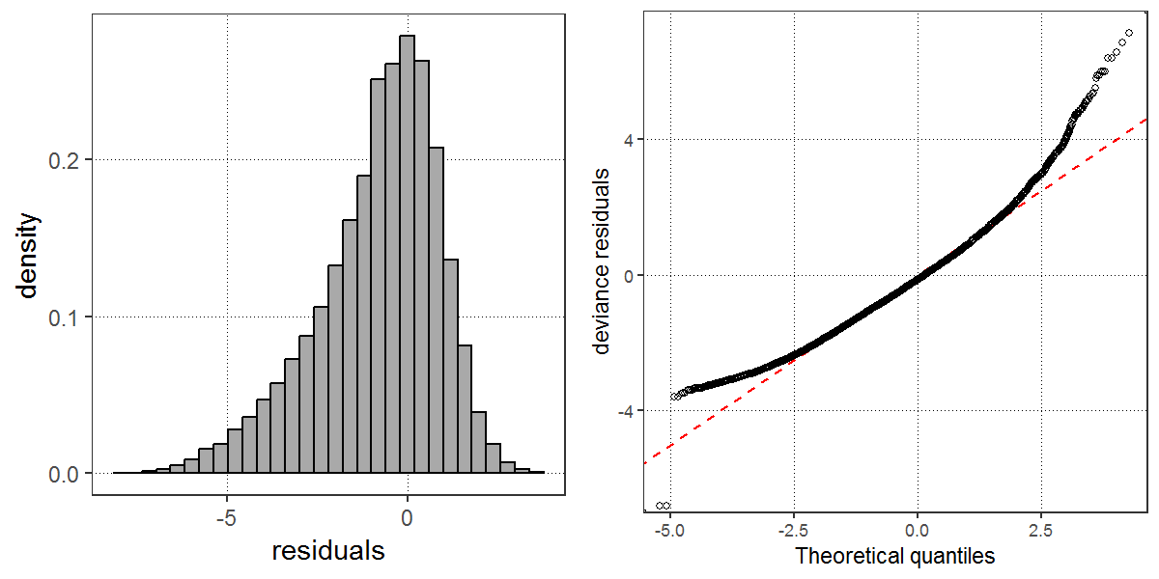

Q-Q plot, histogram of residuals for the best GAM

Figure 5

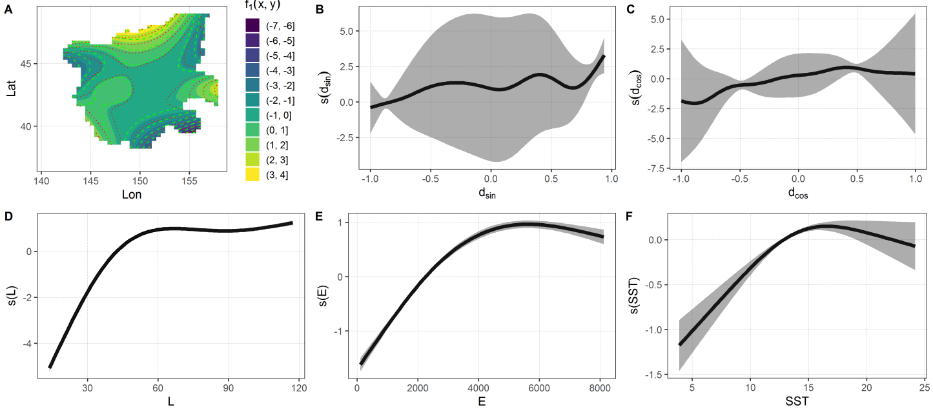

Impact of explanatory variables on the CPUE value

Figure 6

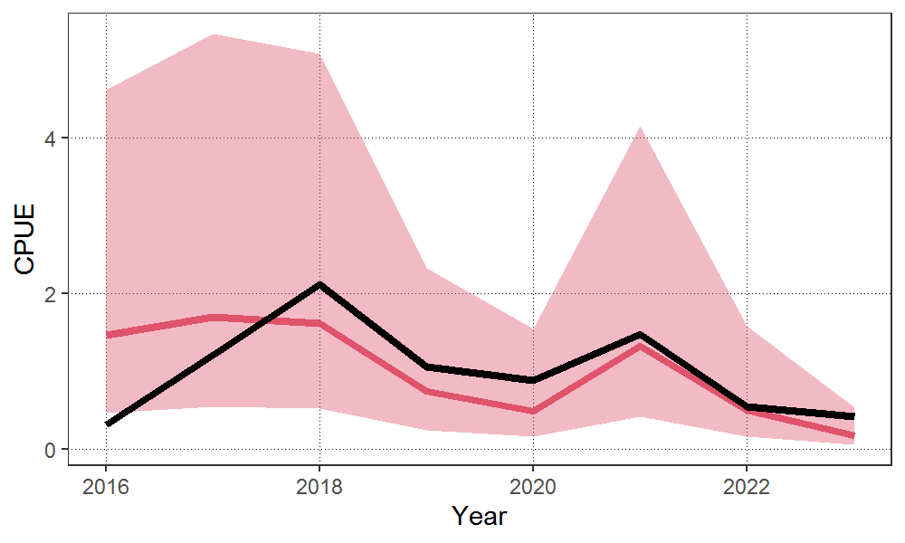

Time series of scaled nominal and standardized CPUE from 2016 to 2023. The shadow area represents 95% confidence intervals of standardized CPUE.

AppendIX

Checklist for the CPUE standardization protocol

|  |  |  |  |
| --- | --- | --- | --- |
| No. | Step-by-step protocols | yes/no | Note |
| 1 | Provide a description of the type of data (logbook, observer, survey, etc. ), and the "resolution" of the data (aggregated, set-by-set etc..). This description should also include the representativeness of the data in two tables: (1st table) Number of observations, % Coverage of CPUE fleet (catch), % Coverage of CPUE fleet (effort), Total Catch CPUE fleet (mt), Total Effort CPUE fleet, Percentage of overall catch by member (across all fleets/gears); and (2nd table) Number of records remaining, Number removed, Number of records with chub mackerel catch >0; | Yes | Section 2.1 (pages2-3) and Tables 1 and 2 (page 5) |
| 2 | Conduct a thorough literature review to identify key factors (i.e., spatial, temporal, environmental, and fisheries variables) that may influence CPUE values; | Yes | Section 1. Background (page 1-2) |
| 3 | Plot annual/monthly spatial distributions of fishing efforts, catch and nominal CPUE to determine temporal and spatial resolution for CPUE standardization | Yes | Fig. 1, (pages 9-10) |
| 4 | Make scatter plots (for continuous variables) and/or box plots (for categorical variables) and present correlation matrix if possible to evaluate correlations between each pair of those variables; | Yes | Figs. 2-3 (pages 11-12] |
| 5 | Describe selected explanatory variables based on (2)-(4) to develop full model for the CPUE standardization; | Yes | Section 2.2*.* (page 3) and Table 3 (page 5) |
| 6 | Specify model type and software (packages) and fit the data to the assumed statistical models (i.e., GLM, GAM, Delta-lognormal GLM, Neural Networks, Regression Trees, Habitat based models, and Statistical habitat based models); | Yes | Section 2.2*.* (page 2) |
| 7 | Evaluate and select the best model(s) using methods such as likelihood ratio test, information criterions, cross validation etc.; | Yes | Section 2.2*.* (page 2) and  Table 3 (page 6) |
| 8 | Provide diagnostic plots to support the chosen model is appropriate and assumption are met (QQ plot and residual plots along with predicted values and important explanatory variables, etc.); | Yes | Figs. 5-6 (page 22-24) |
| 9 | Present estimated values of parameters and uncertainty in the parameters in table; | Yes | Table 6-7 (page 7) |
| 10 | Present the relationship between the response variable and the explanatory variables. Check if it is interpretable. | Yes | Fig. 5 (page 12) |
| 11 | Extract yearly standardized CPUE and standard error by a method that is able to account for spatial heterogeneity of effort, such as least squares mean or expanded grid. If the model includes area and the size of spatial strata differs or the model includes interactions between time and area, then standardized CPUE should be calculated with area weighting for each time step. Model with interactions between area and season or month requires careful consideration on a case by case basis. Provide details on how the CPUE index was extracted. | Yes | See sections 2.2. and 2.3 (page 3) |
| 12 | Calculate uncertainty (SD, CV, CI) for standardized CPUE for each year. Provide detailed explanation on how the uncertainty was calculated; | Yes | Table 8 (page 8) Fig. 6 (page 15), Section 3 (page 4) |
| 13 | Provide a table and a plot of nominal and standardized CPUEs over time. When the trends between nominal and standardized CPUE are largely different, explain the reasons (e.g. spatial shift of fishing efforts), whenever possible. | Yes |