NPFC-2024-TWG CMSA09-WP12 (Rev. 1)

Stock assessment based on age-structured assessment program for Chub mackerel in the North Pacific Ocean 2024

Zhiwei Liu; Qiuyun Ma; Siquan Tian; Yufei Zhou

College of Marine Living Resource Sciences and Management, Shanghai Ocean University, China

(Corresponding author: Qiuyun Ma, qyma@shou.edu.cn)

**Summary**

Based on the latest aggregated dataset and the agreed scenarios for Chub mackerel *Scomber Japonicus* in the North Pacific Ocean, this document conducted stock assessment used the Age-Structured Assessment Program (ASAP). Total 12 scenarios were run in ASAP, including two base cases of different natural mortality and other 10 sensitivity cases considering various CPUE, maturity and catch-at-age data. The results indicated that there is no significant difference of biomass, SSB and fishing mortality estimates among all scenarios. The trend of SSB was similar with results from SAM, which was high before 1980, decreased to much low value between 1980 and 2020, recovered and kept at high values in the recent decade. No significant retrospective pattern present for the two base cases, with Mohn’s *ρ* values of *B*, SSB and *F* in the range of -0.16~0.19. Preliminary projections were also conducted, providing estimates of biomass, catch and SSB in next ten years under different *F* and TAC. Even ASAP was not selected as the benchmark stock assessment model, results of which could also provide some valuable information to scientists and mangers for comparison and reference.

ASAP is a fisheries toolbox model developed by NOAA, which has been used as an assessment tool for many fisheries, such as Pacific sardine and Pacific mackerel by SWFSC, Greenland halibut by ICES, etc. ASAP is an age-structured model that uses forward computations assuming separability of fishing mortality into year and age components to estimate population sizes given observed catches, catch-at-age, and indices of abundance. The TWG CMSA completed operating model for Chub mackerel in September 2023, and planned to conduct formal stock assessment at TWG CMSA09, in July 2024. As one of five stock assessment model candidates (ASAP, SAM, VPA, BSSPM and KAFKA) in the operating model, ASAP does not perform best and could not serve as the benchmark stock assessment model for Chub mackerel in the NPFC. However, multiple models could provide more information under different model structure and assumptions for comparison and references. This document provides some stock assessment results of ASAP for Chub mackerel, based on the agreed dataset and scenarios in TWG CMSAint02 in April 22-23.

**Materials and Methods**

The dataset used in this study, was still the data that China, Japan and Russia submitted and complied by Dr. Akihiro Manabe. This dataset includes catch-at-age, maturity-at-age, weight-at-age, natural mortality *M* and abundance index in both conventional area and national waters of Japan and Russia from fishing year 1970 to 2022, i.e. from 1970 July 1st to 2023 June 30th.

Given the capacity of ASAP and limited time, not all the scenarios for Chub mackerel stock assessment were conducted in ASAP. The scenarios in ASAP focused on data and its uncertainties, including two base cases and ten sensitivity cases of natural mortality, missing data of catch-at-age, abundance index and maturity-at-age (Table 1). The two base cases consider age constant *M* (0.50, the mean value of Japan EEZ and conventional area) and age specific M (age 0 ~ 6+: 0.80, 0.60, 0.51, 0.46, 0.43, 0.41, 0.40). The other basic settings of ASAP are same as the previous version in the operating model for Chub mackerel in the document NPFC-2022-TWG CMSA05-WP04.

Retrospective analysis was conducted for two base cases for 7 years, and Mohn’s *ρ* were calculated for biomass (*B*), spawning stock biomass (SSB), and fishing mortality (*F*) of Chub mackerel. Ten-years Projection for Chub mackerel was conducted in the two base cases, considering 8 harvest control rules (HCR). Five HCRs controlled the fishing mortality *F*, i.e. current *F*, *F*MSY, *F*20%SPR, *F*30%SPR, and *F*40%SPR, and other 3 HCRs set Total Allowable Catch TAC, i.e. the current TAC from COM08, its 75% level and 50% level. The TAC for convention area in 2024 and 2025 was set as the 20% decrease from the average catch in 2015-2022 and additional 6,000 tons for EU. Therefore, TAC in this research for national waters was set as the same rules, leading to totally 401,083 tons.

**Results and Discussions**

The overall trends of biomass, spawning stock biomass, and fishing mortality were much similar among these 12 scenarios. The biomass of Chub mackerel has kept at high level before 1980, then declined to low value. It recovered since 2010 and fluctuated around the high values in the recent decade. The results based on age-specific natural mortality are slightly higher than those based on *M* at common. Spawning stock biomass followed a similar trend with biomass, and the recent estimates were lower than SSB in 1970s but still at high level of 750,000 tons (Figures 1), while SSB trend estimated from ASAP is also similar with the preliminary estimates from SAM. Different scenarios based on age-specific *M* result in slightly larger SSB compared to age common *M*, and the SSB obtained from S11-MaaSmean and S12-MaaSmean is higher than that from the other scenarios. Consistent with the trend of *B* and SSB, the fishing mortality for Chub mackerel was high during 1985~2004, and low in the early and recent period (Figures 2). From 2013 to 2016, *F* in S1 and S2 is slightly larger, followed by *F* estimated in S3 and S4, which four scenarios (S1-S4) included Chinese CAA in 2015.

There is no significant difference of biomass, SSB and fishing mortality estimates among all scenarios. Generally, the assumption of age-specific natural mortality would lead to slightly higher biomass and lower fishing mortality, compared with age common *M*. Since the different settings of sensitivity cases are only related recent years, stock assessment results in the early period are much close.

The maximum sustainable yield (MSY) for Chub mackerel was estimated to be 1.55×105 and 1.54×105 metric tons from B1-Mcom and B2-Mage, respectively (Table 2). The fishing mortality and SSB of base cases in the MSY level were about 0.36~0.39 and 1.53~1.72×105 metric tons, respectively. The current *F*2022 was lower than the *F* related reference points.

Retrospective analysis was conducted for two base cases (Figures 4 and 5). Mohn’s *ρ* values of *B* were 0.19 and 0.16 for B1-Mcom and B2-Mage, respectively. Mohn’s *ρ* values of fishing mortality were all 0.19, and Mohn’s *ρ* of SSB were -0.16 and -0.14. The Base case 2 of age-specific natural mortality would lead to smaller Mohn’s *ρ*, compared with the Base case 1 of age common *M.*

Biomass, Catch and SSB from 2023 to 2032 were estimated based on 8 HCRs in the projection of two base cases, which provided similar results (Figures 6 and 7). Biomass estimates show a decreasing trend in HCRs, with the HCRs of TAC decreasing even faster. Catch estimate in the HCRs of *F*MSY, *F*20%SPR, *F*30%SPR, and *F*40%SPR are higher during 2023-2026 and decline to lower values than those in HCRs of TAC. The current F would lead to the much lower catch in most years, in which HCR, SSB would decrease dramatically. SSB estimated in all other projections would increase to the highest value and decrease to the stable level (e.g. SSBMSY).

**Acknowledgement**

This document is supported by the National Natural Science Foundation of China (32202934), and the Program on the Survey, Monitoring and Assessment of Global Fishery Resources (Comprehensive scientific survey of fisheries resources at the high seas) sponsored by the Ministry of Agriculture and Rural Affairs.

**References:**

Akihiro Manabe, Kazunari Higashiguchi, Ryuji Yukami, and Kazuhiro Oshima. 2024. The data description for the base case stock assessment of chub mackerel *Scomber japonicus* in the northwestern Pacific Ocean. NPFC-2024-TWG CMSA09-WP01

Akihiro Manabe, Kazunari Higashiguchi, Ryuji Yukami, and Kazuhiro Oshima. 2024. The data description of input data used for the sensitivity analyses of the stock assessment of chub mackerel *Scomber japonicus* in the northwestern Pacific Ocean. NPFC-2024-TWG CMSA09-WP02

Hurtado-Ferro, F., Szuwalski, C. S., Valero, J. L., Anderson, S. C., Cunningham, C. J., Johnson, K. F., Licandeo, R. et al. 2015. Looking in the rear-view mirror: bias and retrospective patterns in integrated, age-structured stock assessment models. ICES Journal of Marine Science, 72: 99–110

NPFC. 2023. 7th Meeting of the Technical Working Group on Chub Mackerel Stock Assessment. 2023. 7th Meeting Report. NPFC-2023-TWG CMSA07-Final Report

NPFC. 2024. 8th Meeting of the Technical Working Group on Chub Mackerel Stock Assessment. 2024. 8th Meeting Report. NPFC-2024-TWG CMSA08-Final Report

NPFC. 2024. Summary of the 1st Intersessional Meeting of the Technical Working Group on Chub Mackerel Stock Assessment. NPFC-2024-TWG CMSA09-RP01.

NPFC. 2024. Summary of the 2nd Intersessional Meeting of the Technical Working Group on Chub Mackerel Stock Assessment. NPFC-2024-TWG CMSA09-RP02.

Qiuyun MA, Zhiwei LIU, Heng ZHANG, Siquan TIAN. 2024. Growth and Mortality Estimation for Chub Mackerel based on Chinese data in the Convention Area of NPFC. NPFC-2024-TWG CMSA08-WP12

Qiuyun Ma; Kai Cai; Siquan Tian; Libin Dai; Yufei Zhou. 2022. Update stock assessment based on ASAP (age-structured assessment program) for Chub mackerel in the North Pacific Ocean 2022. NPFC-2022-TWG CMSA05-WP04

Shota Nishijima, Yasuhiro Kamimura, Ryuji Yukami, Akihiro Manabe, Kazuhiro Oshima, and Momoko Ichinokawa. 2024. Update on natural mortality estimators for chub mackerel in the Northwest Pacific Ocean. NPFC-2024-TWG CMSA08-IP06.

Shota Nishijima, Momoko Ichinokawa, Akihiro Manabe, Kazuhiro Oshima, and Joel Rice. 2024. Base case stock assessment for chub mackerel in Northwest Pacific Ocean in 2024. NPFC-2024-TWG CMSA09-WP03.

**Tables**

Table 1 Scenarios considered in the ASAP for Chub mackerel in the North Pacific Ocean

|  |  |  |  |  |  |
| --- | --- | --- | --- | --- | --- |
|  | **Scenarios** | **Natural mortality M** | **Maturity-at-age** | **Catch-at-age** | **Abundance Index** |
| Base cases | B1-Mcom | 0.50 | Japanese MAA | no CHN 2015 CAA data | No RUS CPUE |
| B2-Mage | M at age | Japanese MAA | no CHN 2015 CAA data | No RUS CPUE |
| Sensitivity cases | S1-CaaCN15est1 | 0.50 | Japanese MAA | CHN 2015 estimated_Cal2016 | No RUS CPUE |
| S2-CaaCN15est1 | M at age | Japanese MAA | CHN 2015 estimated_Cal2016 | No RUS CPUE |
| S3-CaaCN15est2 | 0.50 | Japanese MAA | CHN 2015 estimated_JPNCal | No RUS CPUE |
| S4-CaaCN15est2 | M at age | Japanese MAA | CHN 2015 estimated_JPNCal | No RUS CPUE |
| S7-RUcpue | 0.50 | Japanese MAA | no CHN 2015 CAA data | with RUS CPUE |
| S8-RUcpue | M at age | Japanese MAA | no CHN 2015 CAA data | with RUS CPUE |
| S9-MaaYmean | 0.50 | mean of CHN (annual) and JPN 2018 onward | no CHN 2015 CAA data | No RUS CPUE |
| S10-MaaYmean | M at age | mean of CHN (annual) and JPN 2018 onward | no CHN 2015 CAA data | No RUS CPUE |
| S11-MaaSmean | 0.50 | mean of CHN (seasonal) and JPN 2018 onward | no CHN 2015 CAA data | No RUS CPUE |
| S12-MaaSmean | M at age | mean of CHN (seasonal) and JPN 2018 onward | no CHN 2015 CAA data | No RUS CPUE |

Table 2 Estimates of biological reference points for Chub mackerel by all ASAP scenarios

|  |  |  |  |  |  |  |  |
| --- | --- | --- | --- | --- | --- | --- | --- |
| **Scenarios** | ***F*0.1** | ***F*30%SPR** | ***F*40%FPR** | ***F*MSY** | ***F*2022** | **SSBMSY (t)** | **MSY (t)** |
| B**1**-Mcom | 0.52 | 0.34 | 0.24 | 0.39 | 0.13 | 152,576 | 155,413 |
| B**2**-**Mage** | 0.49 | 0.30 | 0.22 | 0.36 | 0.13 | 171,906 | 154,184 |
| **S1-CaaCN15est1** | 0.52 | 0.34 | 0.24 | 0.39 | 0.13 | 154,253 | 157,121 |
| **S**2**-CaaCN15est1** | 0.49 | 0.30 | 0.22 | 0.36 | 0.12 | 174,115 | 156,165 |
| **S3-CaaCN15est2** | 0.52 | 0.34 | 0.24 | 0.39 | 0.13 | 153,408 | 156,260 |
| **S**4**-CaaCN15est2** | 0.49 | 0.30 | 0.22 | 0.36 | 0.13 | 172,892 | 155,069 |
| **S7-RUcpue** | 0.52 | 0.34 | 0.24 | 0.39 | 0.14 | 151,401 | 154,216 |
| **S8-RUcpue** | 0.49 | 0.30 | 0.22 | 0.36 | 0.14 | 170,351 | 152,790 |
| **S9-MaaYmean** | 0.52 | 0.35 | 0.26 | 0.41 | 0.13 | 160,880 | 159,378 |
| **S10-MaaYmean** | 0.49 | 0.32 | 0.23 | 0.37 | 0.13 | 179,318 | 157,784 |
| **S11-MaaSmean** | 0.52 | 0.39 | 0.28 | 0.45 | 0.13 | 186,025 | 169,219 |
| **S12-MaaSmean** | 0.49 | 0.35 | 0.25 | 0.41 | 0.13 | 201,623 | 166,843 |

**Figures**





Figure 1. The *B* and SSB estimates from ASAP for Chub mackerel



Figure 2. The fishing mortality *F* estimates from ASAP for Chub mackerel.

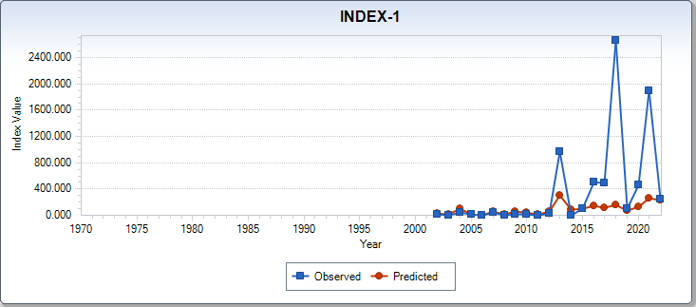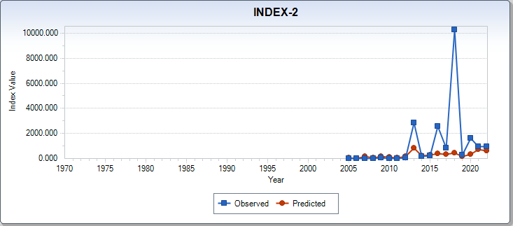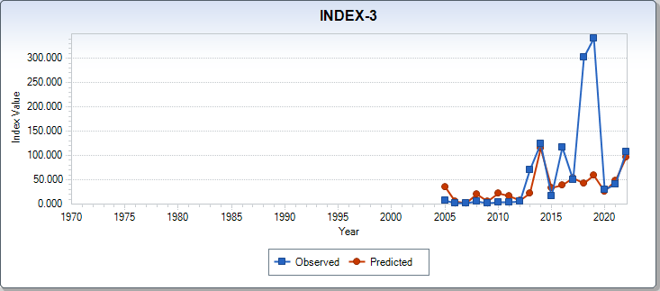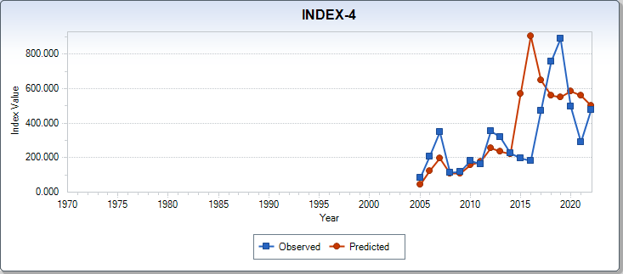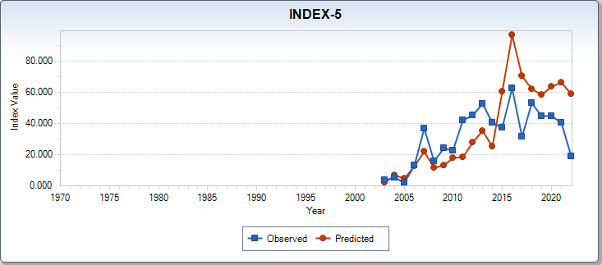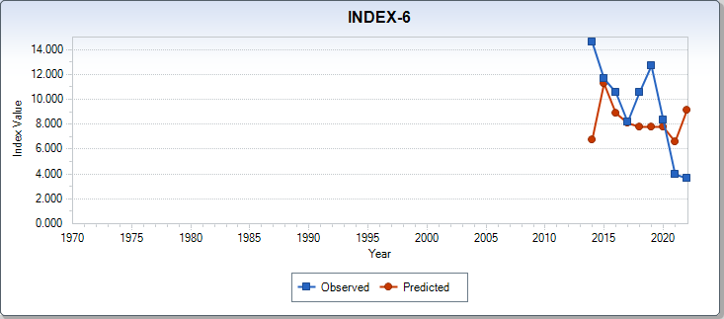

Figure 3(a). Index fitting in the ASAP B1-Mcom for Chub mackerel.

INDEX-1 represents index from the Japanese Recruitment survey in summer.

INDEX-2 represents index from the Japanese Recruitment survey in autumn(age0).

INDEX-3 represents index from the Japanese Recruitment survey in autumn(age1)

INDEX-4 represents index from the Japanese egg survey.

INDEX-5 represents index from the Japanese die-net fishery.

INDEX-6 represents the Standardized CPUE from Chinese fishery.

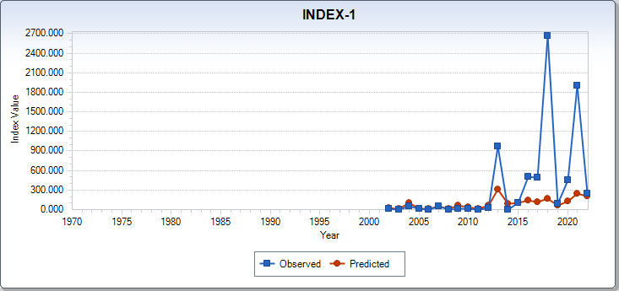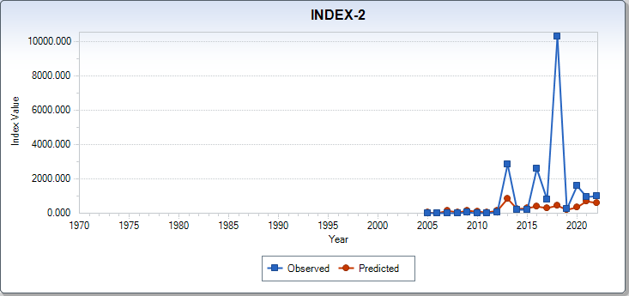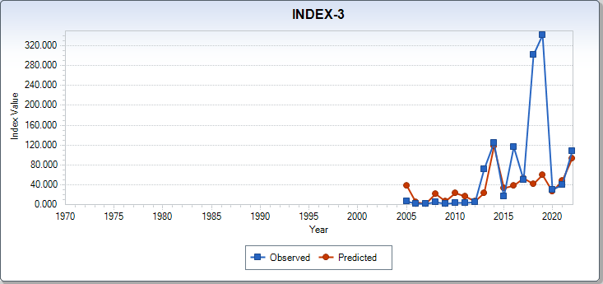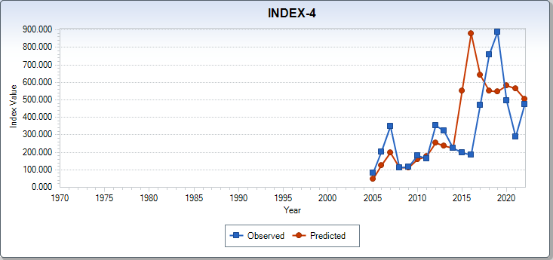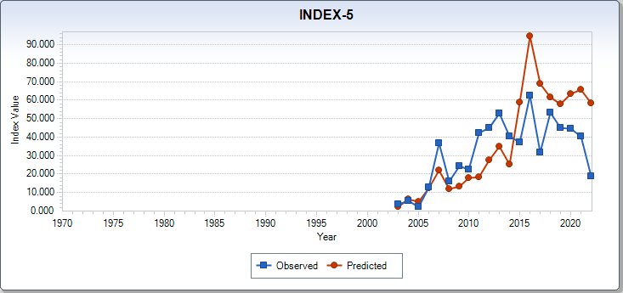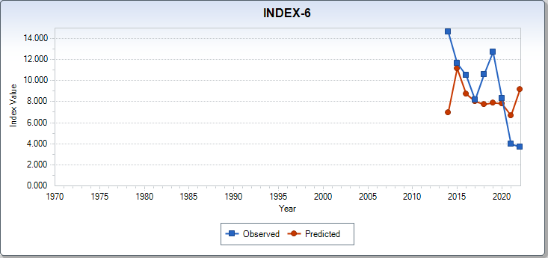

Figure 3(b). Index fitting in the ASAP B2-Mage for Chub mackerel.

INDEX-1 represents index from the Japanese Recruitment survey in summer.

INDEX-2 represents index from the Japanese Recruitment survey in autumn(age0).

INDEX-3 represents index from the Japanese Recruitment survey in autumn(age1)

INDEX-4 represents index from the Japanese egg survey.

INDEX-5 represents index from the Japanese die-net fishery.

INDEX-6 represents the Standardized CPUE from Chinese fishery.

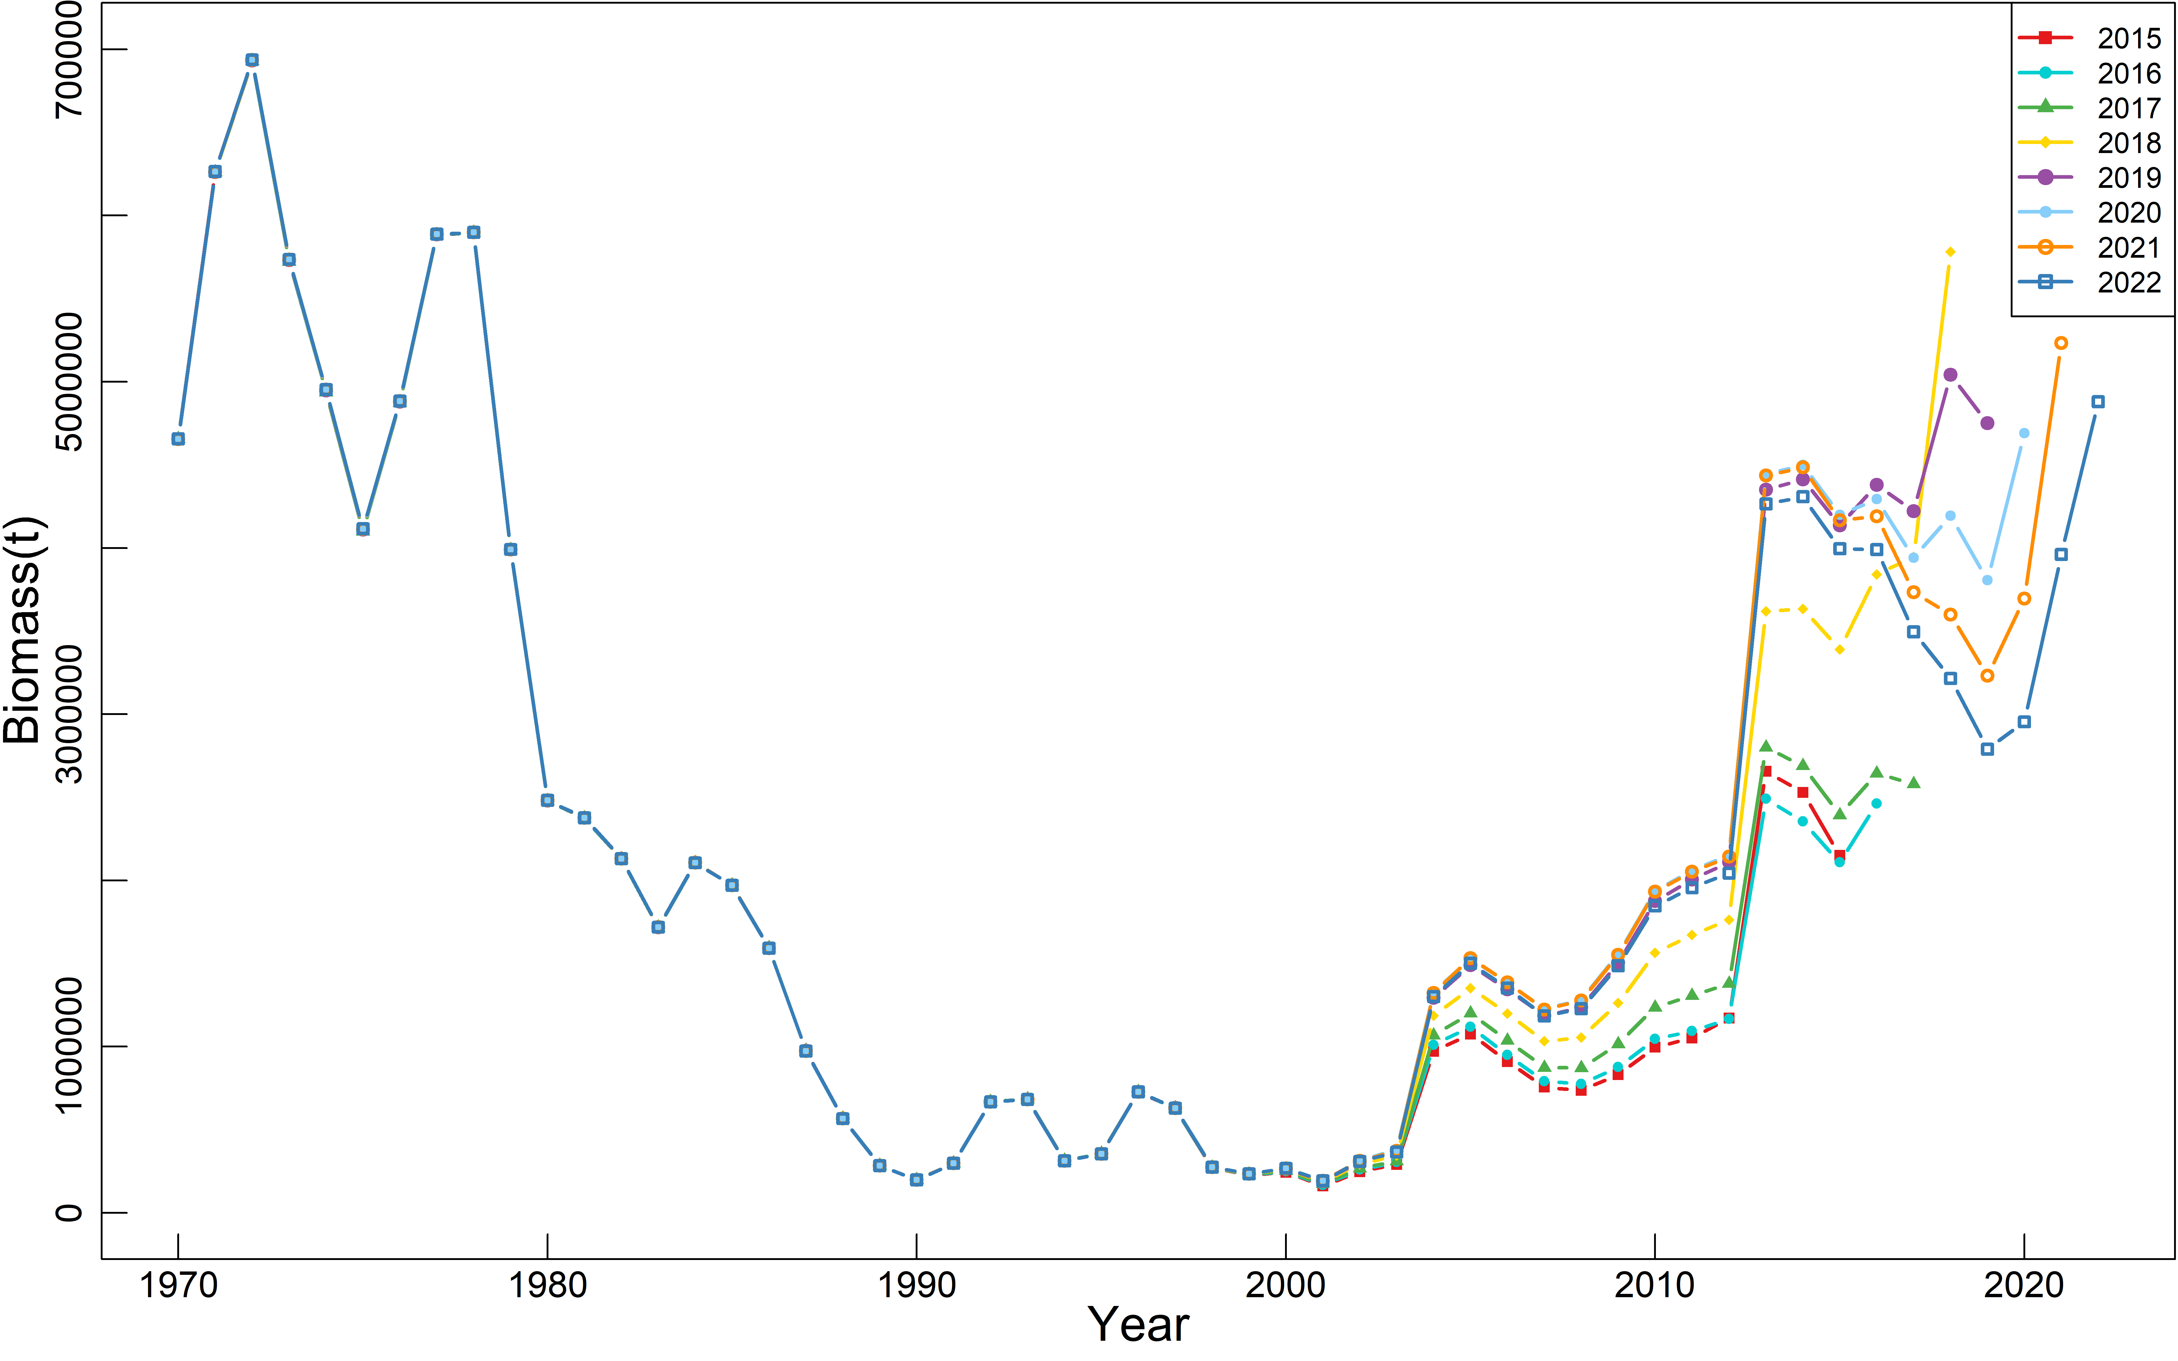

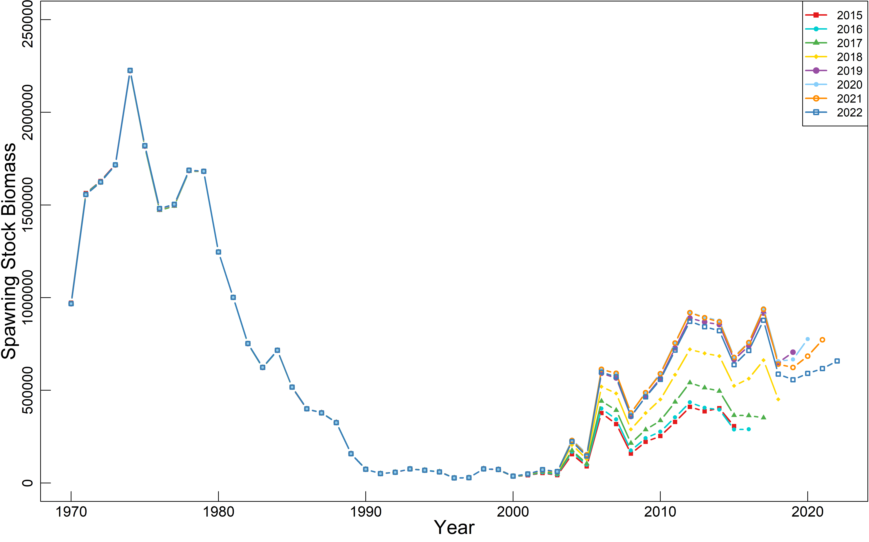

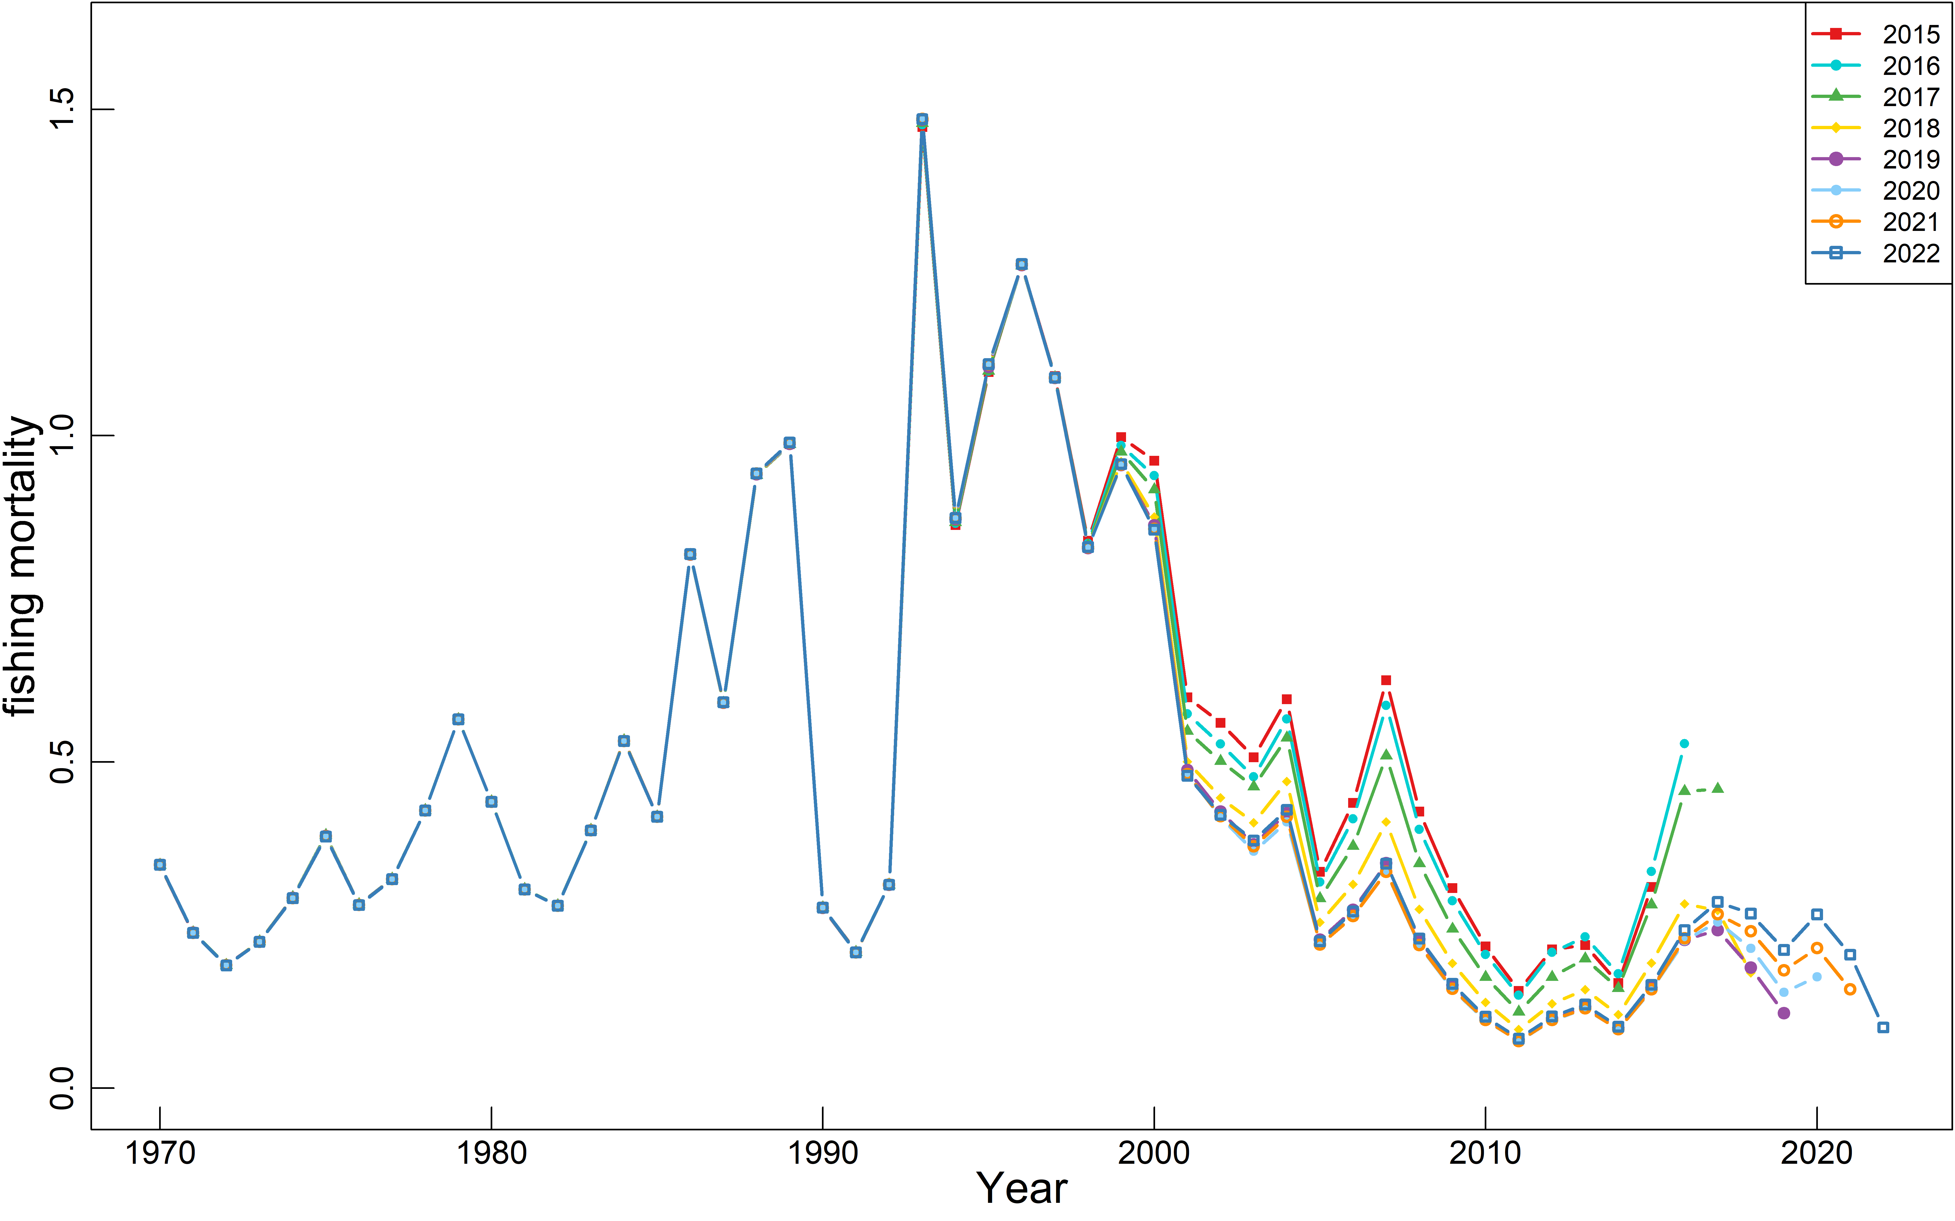

Figure 4. Retrospective analysis of biomass, spawning stock biomass and fishing mortality of base case 1 (B1-Mcom)

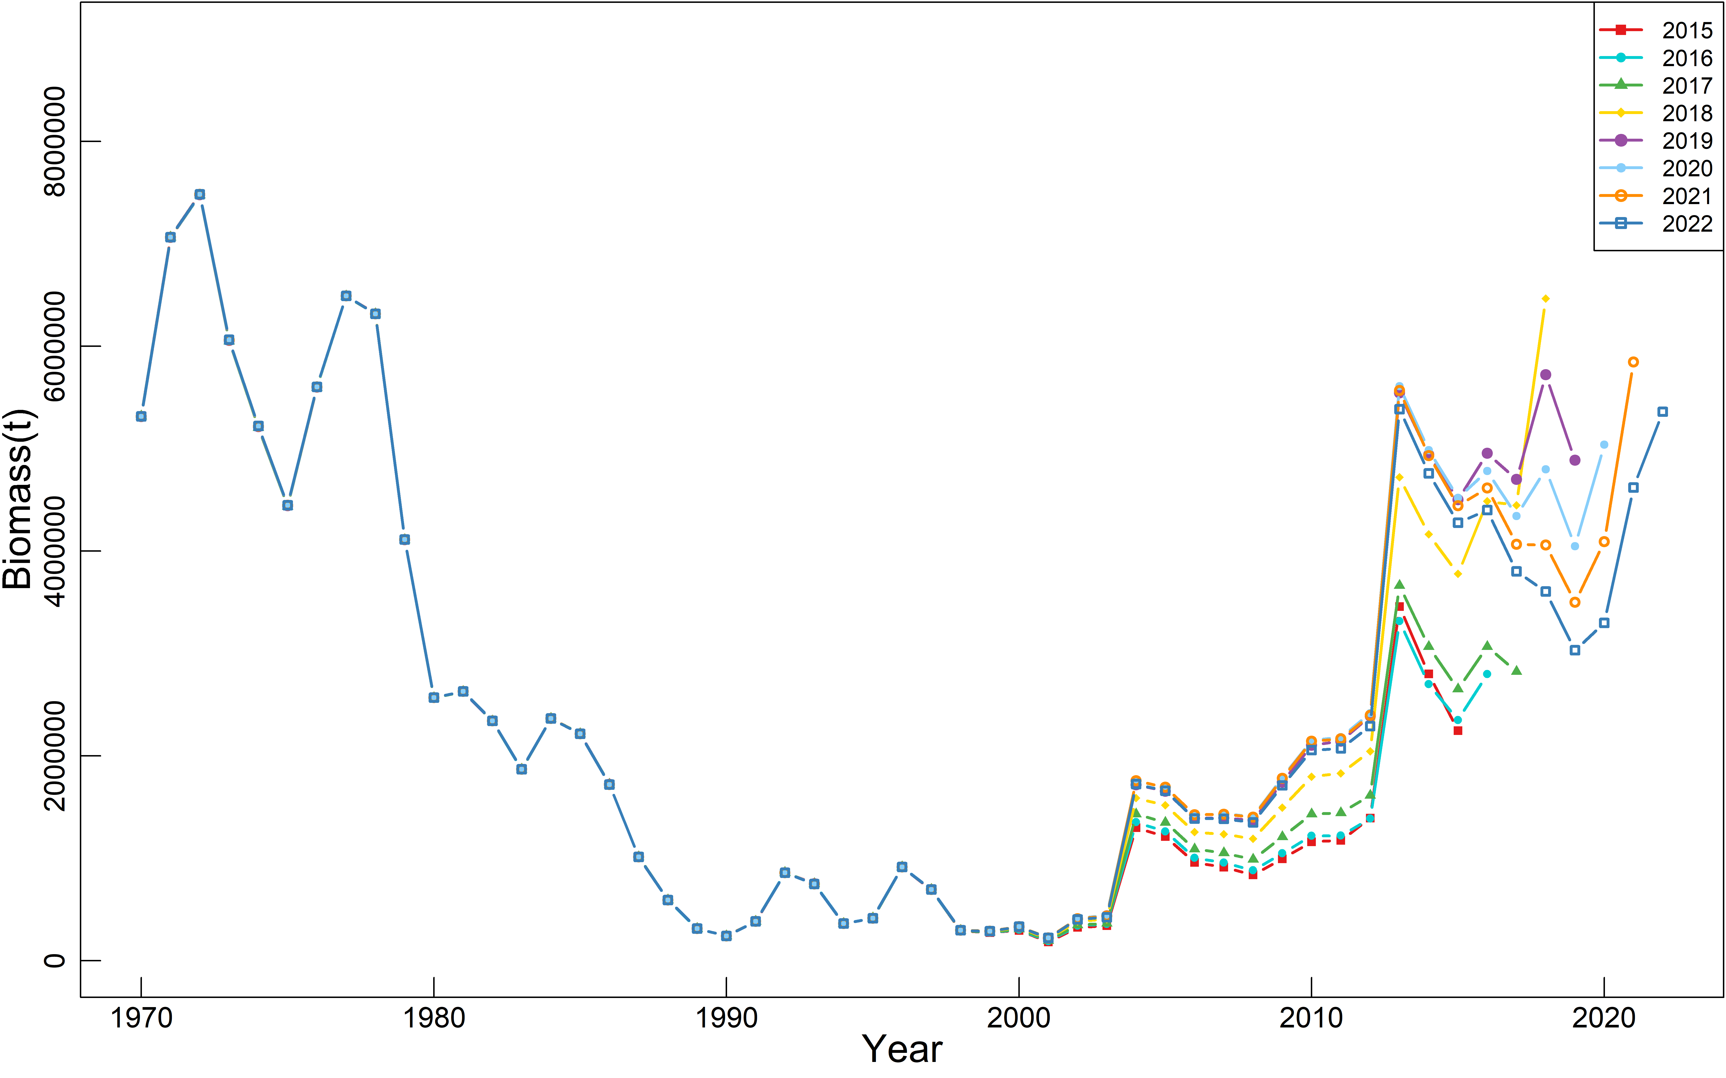

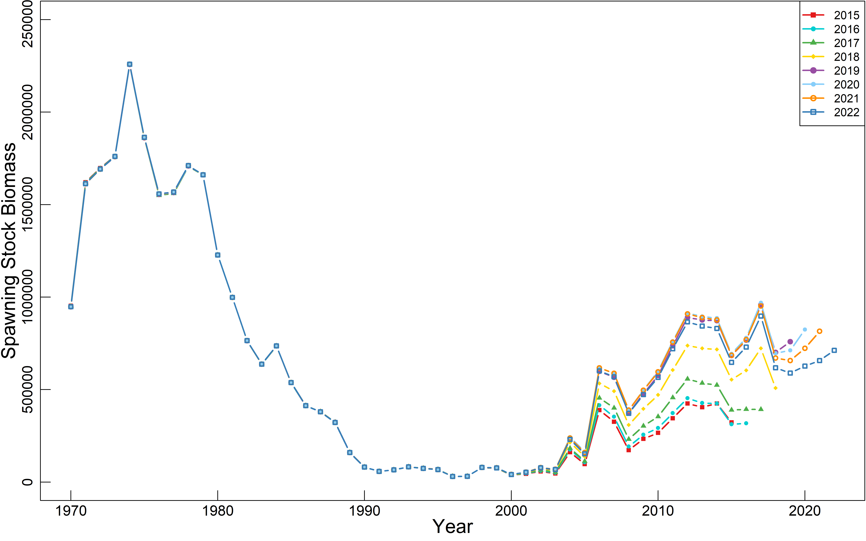

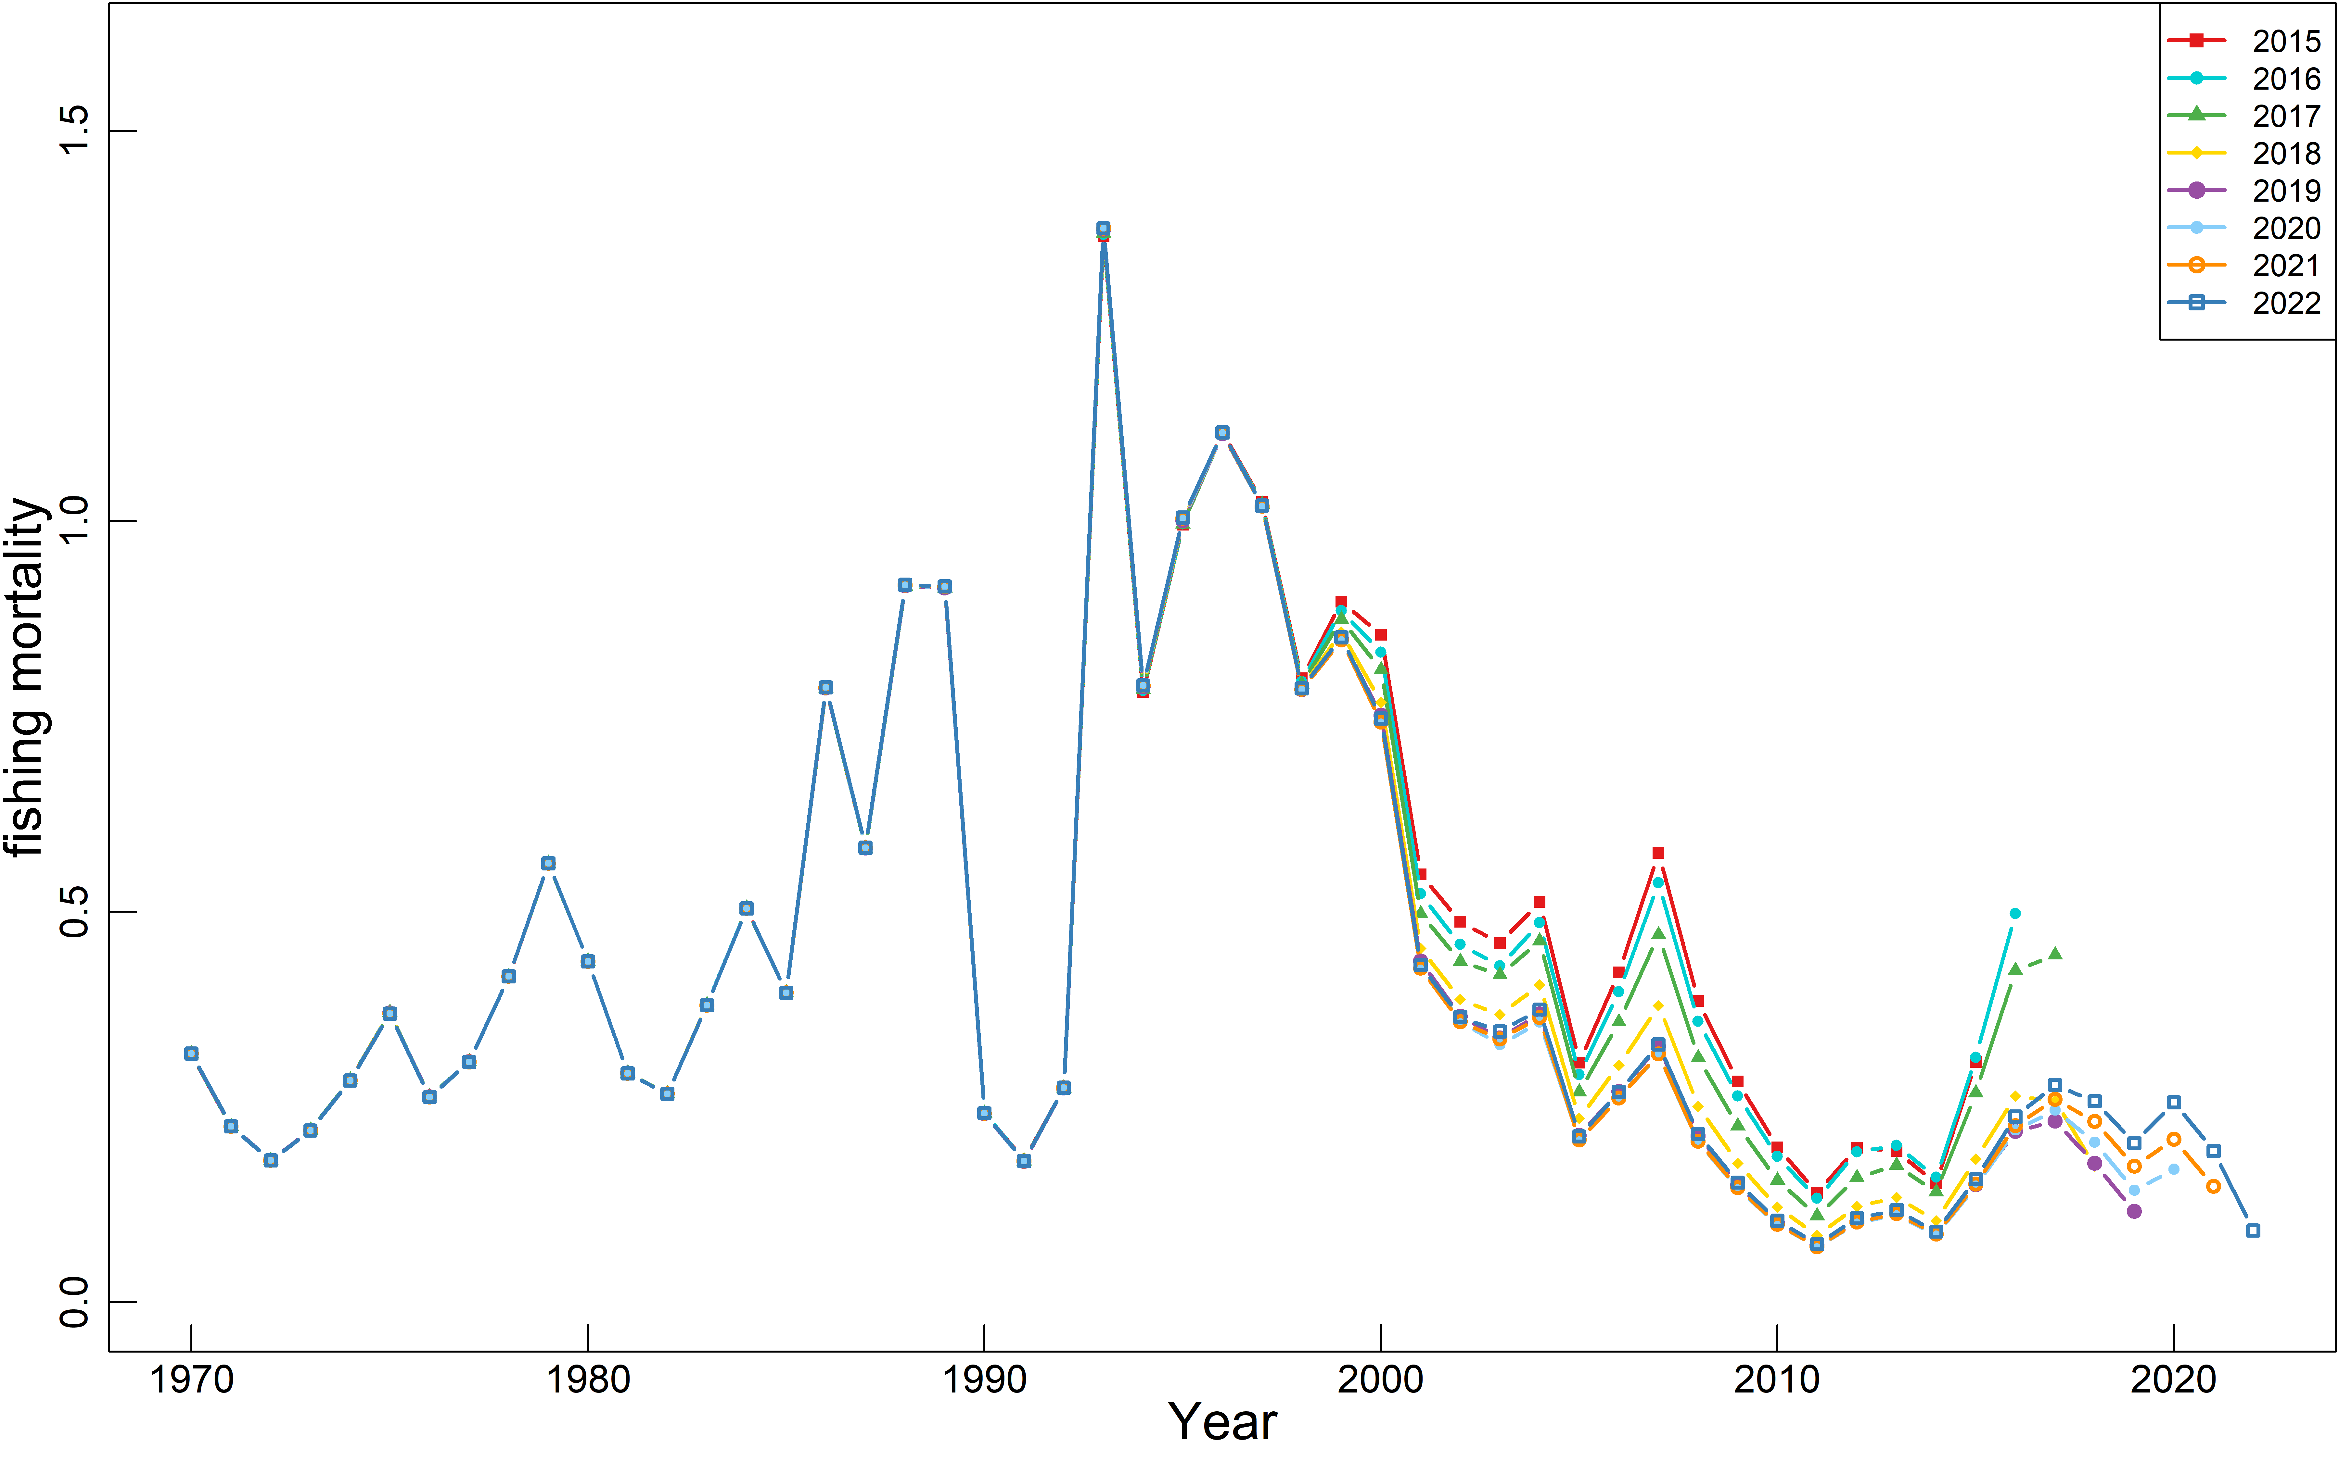

Figure 5. Retrospective analysis of biomass, spawning stock biomass and fishing mortality of Base case 2 (B2-Mage)





Figure 6. The catch, biomass and SSB estimates under the projection of 8 HCRs from base case 1 (B1-Mcom)







Figure 7. The catch, biomass and SSB estimates under the projection of 8 HCRs from base case 2 (B2-Mage)