NPFC-2024-TWG CMSA09-WP13 (Rev. 1)

**Standardized CPUE of Chub mackerel (*****Scomber japonicus*) caught by the China’s lighting purse seine fishery up to 2022**

Yongchuang Shi, Heng Zhang, Haibin Han

East China Sea Fisheries Research Institute, Chinese Academy of Fishery Science. Shanghai 200090, China

**Summary**

Catch per unit fishing effort (CPUE) standardization is an important approach to obtaining accurate indices of resource abundance by removing the influence of external factors. Chub mackerel (*Scomber japonicus*) is an economically important small pelagic fish inhabiting the Northwest Pacific Ocean. Most of the Chub mackerel catch is harvested by the lighting purse seine fishery in China. In this paper, we standardized CPUE of Chub mackerel using generalized linear model (GLM) and generalized additive model (GAM). Four groups of independent variables were considered in the CPUE standardization: spatial variables (latitude and longitude), temporal variables (year and month), fishery variables (vessel length) and environmental variables (SST and Chla). The model selections of GLM and GAM were based on the Bayesian information criterion (BIC). From the results, Higher Spearman’s correlation and lower mean squared error (MSE) were observed by GAM. Therefore, we prefer to choose the best GAM model to estimate standardized CPUE of Chub mackerel fishery.

**1. Background of the Chub mackerel fishery**

Chub mackerel (*Scomber japonicus*) is a highly migratory fish, widely distributed in the high seas of the Northwest Pacific Ocean (Yatsu et al., 2005). The annual catches of Chub mackerel recorded in 2022 were about 81,181 tons in China, which accounted for about 30% of the global production. Now, about 100 Chub mackerel vessels from China operate in the Northwest Pacific Ocean. The distribution of Chub mackerel fishing grounds shows large variation during the fishing period (April–November) each year (Yatsu et al., 2002), therefore, temporal variables (year and month), spatial variables (longitude and latitude) were included in the analysis. The fishing ground of the Chub mackerel is tightly associated with the marine environment (Zhang et al., 2009). Thus, Sea surface temperature (SST) and Chlorophyll-a concentration (Chla) were included in the analysis. In addition, the vessel length may affect the quantity of the catch, which were also included in this study.

**2. Method**

**2.1. The Data**

Full-commercial fishery data (logbook) were from 2014 to 2022, which were derived from Technical Group for Chub mackerel Fishery, Distant-water Fishery Society of China. The catch and effort of CPUE Fleet were aggregated by monthly at 1°×1° grid, with good representativeness of the whole fishery (Table 1). The Table 2 represents the filter "rules" used on data for CPUE standardization and the effect on the overall sample size. Annual spatial distribution patterns of catch, effort and nominal CPUE were presented in the Figure 1.

Summary of explanatory variables used for CPUE standardization were listed in the Table 3. *Year* is a categorical variable of 9 years (2014—2022). *Month* is a categorical variable including the 10 calendar months from March to December. *Longitude* and *latitude* are categorical variables, which divided at intervals of 1°. We attempted two cases (categorical and splined variable) for *SST* and investigated splined variable for *Chla*. *Vessellength* is a categorical variable of 44—61 m, which will affect the catchability(Table 3).

SST and Chla data were derived from the Copernicus Marine Service products (<http://marine.copernicus.eu>). The spatial-temporal resolution of the SST and Chla data are monthly at 0.25°×0.25° grid. The environmental data was matched with the fishery data for the further analysis. The environmental factors such as SST, Chla have been recognized as important drivers of chub mackerel distribution (Torrejon-Magallanes et al., 2021). SST influences fish physiology, metabolism, production rates, and migration patterns, and Chla reflects primary productivity (Lee et al., 2018; Okunishi et al., 2020). These factors play crucial roles in shaping the distribution and abundance of fishery resources. Therefore, they should be considered in CPUE standardization.

The scatter plots/ box plots of explanatory variables were presented in Figure 2, and the correlation matrix of explanatory variables used in the analysis was shown in Figure 3.

**2.2 Full model description and model selection**

Both generalized linear model (GLM) and generalized additive model (GAM) were used to estimate standardized CPUE.

The full GLM model was:

*log(CPUE*+1*) =Year + Month + Longitude + Latitude + Sst + Chla +Vessellength + interaction+ε*

The full GAM model was:

*log(CPUE*+1*)=Year+ Month+ Longitude+ Latitude + s(Sst) + s(Chla) + s(Vessellength) + interaction+ε*

where $ε$ is the residual, which is assumed to have a normal distribution. *interaction* is an interaction term representing the interactive effect of spatial and temporal factors for the Chub mackerel. Full model interaction includes all the possible combination of Year, Month, Longitude and Latitude.

The optimal model was selected using the Bayesian information criterion (BIC) based on forward selection. Spearman’s correlation and mean squared errors (MSE) between the predicted and observed CPUEs were calculated by 5 fold cross-validation with repeated 5 times to select well-performance model between two optimal models. All the model construction and data analysis were used the R(4.0.3) software (packages mgcv and nlme).

**2.3 Yearly trend extraction**

Time series of standardized CPUE was estimated using the well-performance model. Expanded grid function in R was used to generate a series of spatial homogeneous explanatory variables and the area of each 1°×1° grid cell was considered the same. Then, annual values of ln(*CPUE*) for each area (1°×1°) were predicted. Finally annual standardized CPUE were calculated as the mean of CPUE*y*:

where, ${\overline{CPUE}}_{y}$ is CPUE indices in *y*th year, $n_{y}$ is the spatial homogeneous explanatory variables number in *y*th year, ${CPUE}_{k}^{fitted}$ is the *k*th fitted CPUE data in *y*th year.

The fitted CPUE and 95% confidence intervals of optimal model were calculated by bootstrap resampled residuals with 1000 replications.

**3 Result and Discussion**

In this study, we used two models to standardize the CPUEs. The result of the best GLM and GAM model selections were shown in Table 4 and Table 5, respectively. Comparing the results of cross validation tests in GLM and GAM analyses (Table 6), higher Spearman’s correlation and lower MSE between observed and predicted of test data were observed by GAM, so we prefer to choose the best GAM model to estimate standardized CPUE of Chub mackerel. The summary of fitting a GAM for the optimal model is shown in Table 7. All explanatory variables are highly significant (*p*<0.01) except for SST and Chla. Residuals from the best GAM model showed an approximately normal distribution around 0, which indicated that the model assumptions were satisfied (Figure 4). The estimated relationship between response and explanatory variables were shown in the Figure 5, and the estimated values of main parameters and uncertainty in the parameters were presented in Table 8.

Table 9 and Figure 6 shows the annual changes of nominal CPUE and standardized CPUE by the optimal GAM model. There is similar trend between nominal CPUE and standardized CPUE by GAM. In conclusion, we prefer to choose the best GAM model to estimate standardized CPUE of Chub mackerel fishery.

We standardized CPUE in accordance with the standardization protocol. The checklist is shown in Appendix 1.

**References**

Lee, D., Son, S., Kim, W., Park, J.M., Joo, H., Lee, S.H., 2018. Spatio-temporal variability of the habitat suitability index for chub mackerel (Scomber japonicus) in the east/Japan sea and the south sea of South Korea. Remote Sens. 10 (6), 938.

Okunishi, T., Yokouchi, K., Hasegawa, D., Tanaka, T., Setou, T., Yukami, R., Takasuka, A., 2020. Relationship between sea temperature variation and fishing ground formations of chub mackerel in the Pacific Ocean off Tohoku. Jpn. Soc. Fish. Oceanogr. 84 (4), 271–284.

Torrejon-Magallanes, J., Angeles-Gonzalez, L.E., Csirke, J., Bouchon, M., Morales- Bojorquez, E., Arreguin-Sanchez, F., 2021. Modeling the Pacific chub mackerel (Scomber japonicus) ecological niche and future scenarios in the northern Peruvian current system. Prog. Oceanogr. 197, 10.

Yatsu A, Mitani T, Watanabc C, *et al*., 2002. Current stock status and management of Chub mackerel *Scomber japonicus* along the Pacific coast of Japan. Fisheries science, 68(supl):93-96.

Yatsu, A. Watanabe, T. Ishida, M. Sugisaki, H. Jacobson, L.D., 2005. Environmental effects on recruitment and productivity of Japanese sardine Sardinops melanostictus and Chub mackerel Scomber japonicus with recommendations for management. Fish. Oceanogr. 14, 263–278.

Zhang G W, Chen X J, Li G, 2009. Bio-economic model and its application of Chub mackerel in the East China Sea and Yellow Sea. Journal of Shanghai Ocean University, 18(4):447-452.

**Tables**:

**Table 1.** Catch and effort information by CPUE FLEET

|  |  |  |  |  |  |  |
| --- | --- | --- | --- | --- | --- | --- |
| Year | Number of observations | % Coverage of CPUE FLEET(catch ) | % Coverage of CPUE FLEET(effort ) | Total Catch of CPUE FLEET (MT) | Total Effort for CPUE FLEET and unit | Percentage of overall catch by member (across all fleets/gears) |
| 2014 | 1477 | 80% | 75% | 30030 | 1477 vessel days | 71% |
| 2015 | 5605 | 74% | 85% | 93884 | 5605 vessel days | 67% |
| 2016 | 6644 | 82% | 89% | 98132 | 6644 vessel days | 69% |
| 2017 | 9578 | 92% | 95% | 133632 | 9578 vessel days | 86% |
| 2018 | 6617 | 81% | 90% | 98142 | 6617 vessel days | 75% |
| 2019 | 2504 | 81% | 90% | 43364 | 2504 vessel days | 67% |
| 2020 | 5158 | 82% | 94% | 69543 | 5158 vessel days | 75% |
| 2021 | 14239 | 93% | 96% | 88550 | 14239 vessel days | 82% |
| 2022 | 13723 | 70% | 90% | 75341 | 13723 vessel days | 68% |

**Table 2.** Filter "Rules" used on data for CPUE standardization and the effect on the overall sample size.

|  |  |  |  |
| --- | --- | --- | --- |
| Filter Applied | Number of Records Remaining | Number Removed | Number of Records with Chub Mackerel Catch >0 |
| Initial Data set | 67518 | - | 63481 |
| Remove records <2°C & >26°C | 65545 | 1973 | 63228 |
| Final Data Set | 65545 | 1973 | 63228 |

**Table 3.** Summary of explanatory variables used for GLM and GAM analysis.

|  |  |  |  |  |
| --- | --- | --- | --- | --- |
| Variables | | Categorical or continuous | Details | Note |
| Year | *Year* | 9 categories | 9 years from 2014 to2022 |  |
| Month | *Month* | 10 categories | 10 months from March to December |  |
| Longitude | *Longitude* | 20 categories | 145°≤Longitude＜146° ; 146°≤Longitude＜147°; 147°≤Longitude＜148°;…, 164°≤Longitude＜165° | at intervals of 1° |
| Latitude | *Latitude* | 11 categories | 35°≤Latitude＜36°; 36°≤Latitude＜37°; …, 45°≤Latitude＜46° | at intervals of 1° |
| Sea surface temperature | *SST*  *SST_c* | spline  20 categories | 3℃≤SST＜4℃;4℃≤SST＜5℃; 5℃≤SST＜6℃; …, 25℃≤SST＜26℃ | at intervals of 1℃ |
| Chlorophyll-a concentration | *Chla* | continues |  |  |
| Vessel length | *Vessellength_c* | 10 categories | 45m≤Vessellength＜47m; 47m≤Vessellength＜49m …, 61m≤Vessellength＜63m | at intervals of 2m |

**Table 4.** Result of GLM model selection

|  |  |  |  |  |
| --- | --- | --- | --- | --- |
| No | GLM model | R2 | BIC | Explained deviance |
| 1 | *Ln*(CPUE+1)~*Intercept+Year+Month+Longitude+Latitude+Sst_c +Chla+Vl_c* | 0.3600 | 23483.6 | 35.46% |
| 2 | *Ln*(CPUE+1)~*Intercept+Year+Month+Longitude+Latitude+Sst_c +Chla+Vl_c +Year:Month* | **0.4249** | **23052.4** | **41.61%** |
| 3 | *Ln*(CPUE+1)~*Intercept+Year+Month+Longitude+Latitude+Sst_c +Chla+Vl_c +Year:Month +Year:Longitude* | 0.4434 | 23621.5 | 42.90% |
| 4 | *Ln*(CPUE+1)~*Intercept+Year+Month+Longitude+Latitude+Sst_c +Chla+Vl_c + Year:Month +Year:Latitude* | 0.4364 | 23484.2 | 42.35% |
| 5 | *Ln*(CPUE+1)~*Intercept+Year+Month+Longitude +Latitude+Sst_c +Chla+Vl_c +Year:Month+Year: Longitude* + *Year: Latitude* + *Month: Longitude* + *Month: Latitude* + *Longitude: Latitude* | 0.4767 | 25639.74 | 44.60% |

**Table 5.** Result of GAM model selection

|  |  |  |  |  |  |
| --- | --- | --- | --- | --- | --- |
| No | | GAM model | R2 | BIC | Explained deviance |
| 1 | *Ln*(CPUE+1)~*Intercept+Year+Month+Longitude+Latitude+Sst+Chla+Vl_c* | | 0.3618 | 23307.3 | 36.64% |
| 2 | *Ln*(CPUE+1)~*Intercept+Year+Month+Longitude+Latitude+Sst+Chla+Vl_c* +*Year:Month* | | **0.4155** | **22945.1** | **42.33%** |
| 3 | *Ln*(CPUE+1)~*Intercept+Year+Month+Longitude+Latitude+Sst+Chla+Vl_c* +*Year:Month+Year:Longitude* | | 0.4278 | 23494.9 | 44.10% |
| 4 | *Ln*(CPUE+1)~*Intercept+Year+Month+Longitude+Latitude+Sst+Chla+Vl_c +Year:Month* +*Year:Latitude* | | 0.4229 | 23341.8 | 43.46% |
| 5 | *Ln*(CPUE+1)~*Intercept+Year+Month+Longitude +Latitude+Sst+Chla +Vl_c* +*Year:Month+ Year: Longitude* + *Year: Latitude* + *Month: Longitude* + *Month: Latitude* + *Longitude: Latitude* | | 0.4457 | 25486.5 | 47.51% |

**Table 6.** The Five-fold cross validation for the best GLM

|  |  |  |  |  |
| --- | --- | --- | --- | --- |
| case | cor_GLM_test | MSE_GLM_test | cor_GAM_test | MSE_GAM_test |
| 1 | 0.5974 | 1.1629 | 0.6268 | 1.0578 |
| 2 | 0.5932 | 1.1834 | 0.6219 | 1.0421 |
| 3 | 0.5919 | 1.1175 | 0.6142 | 1.0289 |
| 4 | 0.5895 | 1.1129 | 0.6208 | 1.0375 |
| 5 | 0.5867 | 1.1537 | 0.6225 | 1.0497 |

The spearman’s correlation coefficient is showed in the table.

**Table 7.** Anova test for best GAM model

Parametric Terms:

|  |  |  |  |  |
| --- | --- | --- | --- | --- |
|  | df | *F* | P-value |  |
| factor(Year) | 8 | 122.68 | < 2.2E-16 | *** |
| factor(Month) | 9 | 8.29 | 2.11E-12 | *** |
| factor(Longitude) | 19 | 3.33 | 1.20E-6 | *** |
| factor(Latitude) | 10 | 3.34 | 0.00023 | *** |
| factor(Vl_c) | 9 | 35.01 | < 2.2E-16 | *** |
| factor(Year):factor(Month) | 69 | 41.04 | < 2.2E-16 | *** |

Approximate significance of smooth terms:

|  |  |  |  |  |  |
| --- | --- | --- | --- | --- | --- |
|  | Edf | Ref.df | *F* | P-value |  |
| s(SST) | 3.19 | 4.11 | 3.02 | 0.0016 | ** |
| s(Chla) | 5.28 | 6.54 | 1.92 | 0.0451 | * |

Significant code: *** 0.001, **0.01, *0.05

**Table 8.** The estimated coefficients in the best GAM models for CPUE standardization

|  |  |  |  |  |  |
| --- | --- | --- | --- | --- | --- |
| Explanatory variable | Coefficient | SE | Explanatory variable | Coefficient | SE |
| Year2015 | -0.197 | 0.055 | year2022:month4 | -0.761 | 0.125 |
| Year2016 | -0.232 | 0.049 | year2015:month5 | -0.611 | 0.142 |
| Year2017 | -1.870 | 0.479 | year2016:month5 | 0.104 | 0.136 |
| Year2018 | -0.033 | 0.657 | year2017:month5 | 0.931 | 0.492 |
| Year2019 | 0.698 | 0.196 | year2018:month5 | -0.457 | 0.67 |
| Year2020 | -0.725 | 0.222 | year2019:month5 | -0.803 | 0.239 |
| Year2021 | -0.673 | 0.279 | year2020:month5 | 0.148 | 0.276 |
| Year2022 | -1.33 | 0.055 | year2021:month5 | -1.063 | 0.321 |
| Month4 | 0.198 | 0.175 | year2022:month5 | -1.123 | 0.134 |
| Month5 | 0.706 | 0.209 | year2015:month6 | 0.188 | 0.115 |
| Month6 | 0.402 | 0.198 | year2016:month6 | 0.293 | 0.112 |
| Month7 | 0.397 | 0.214 | year2017:month6 | 1.399 | 0.489 |
| Month8 | 0.314 | 0.237 | year2018:month6 | -0.107 | 0.668 |
| Month9 | 1.095 | 0.237 | year2019:month6 | -0.682 | 0.229 |
| Month10 | 0.793 | 0.208 | year2020:month6 | -0.125 | 0.254 |
| Month11 | 0.624 | 0.226 | year2021:month6 | -0.861 | 0.301 |
| Month12 | 0.264 | 0.144 | year2022:month6 | -0.67 | 0.113 |
| factor(lon)146 | 0.31 | 0.212 | year2015:month7 | -0.01 | 0.12 |
| factor(lon)147 | 0.349 | 0.219 | year2016:month7 | -0.054 | 0.119 |
| factor(lon)148 | 0.191 | 0.221 | year2017:month7 | 1.605 | 0.49 |
| factor(lon)149 | 0.18 | 0.222 | year2018:month7 | -0.304 | 0.669 |
| factor(lon)150 | 0.181 | 0.223 | year2019:month7 | -0.655 | 0.236 |
| factor(lon)151 | 0.171 | 0.224 | year2020:month7 | -0.238 | 0.259 |
| factor(lon)152 | 0.134 | 0.225 | year2021:month7 | -0.746 | 0.307 |
| factor(lon)153 | 0.124 | 0.226 | year2022:month7 | -0.608 | 0.128 |
| factor(lon)154 | 0.12 | 0.227 | year2015:month8 | 0.17 | 0.138 |
| factor(lon)155 | 0.224 | 0.23 | year2016:month8 | -0.025 | 0.133 |
| factor(lon)156 | 0.032 | 0.235 | year2017:month8 | 1.689 | 0.494 |
| factor(lon)157 | -0.254 | 0.245 | year2018:month8 | -0.057 | 0.676 |
| factor(lon)158 | 0.098 | 0.268 | year2019:month8 | -0.566 | 0.24 |
| factor(lon)159 | -0.343 | 0.304 | year2020:month8 | 0.59 | 0.269 |
| factor(lon)160 | -0.006 | 0.281 | year2021:month8 | -0.067 | 0.314 |
| factor(lon)161 | 0.215 | 0.326 | year2022:month8 | 0.263 | 0.147 |
| factor(lon)162 | 0.003 | 0.372 | year2015:month9 | -0.442 | 0.147 |
| factor(lon)163 | -0.626 | 0.45 | year2016:month9 | -0.813 | 0.144 |
| factor(lon)164 | -0.537 | 0.504 | year2017:month9 | 0.779 | 0.497 |
| factor(lat)36 | 0.156 | 0.192 | year2018:month9 | -0.982 | 0.677 |
| factor(lat)37 | 0.154 | 0.185 | year2019:month9 | -1.225 | 0.257 |
| factor(lat)38 | 0.175 | 0.188 | year2020:month9 | -0.101 | 0.267 |
| factor(lat)39 | 0.311 | 0.192 | year2021:month9 | -0.744 | 0.317 |
| factor(lat)40 | 0.444 | 0.196 | year2022:month9 | 0.094 | 0.155 |
| factor(lat)41 | 0.543 | 0.201 | year2015:month10 | 0.209 | 0.128 |
| factor(lat)42 | 0.641 | 0.206 | year2016:month10 | -0.283 | 0.111 |
| factor(lat)43 | 0.64 | 0.212 | year2017:month10 | 1.491 | 0.489 |
| factor(lat)44 | 0.681 | 0.221 | year2018:month10 | -0.164 | 0.674 |
| factor(lat)45 | 0.591 | 0.271 | year2019:month10 | -1.014 | 0.251 |
| factor(vl_c)50 | -0.51 | 0.099 | year2020:month10 | 0.695 | 0.27 |
| factor(vl_c)51 | -0.122 | 0.029 | year2021:month10 | -0.191 | 0.307 |
| factor(vl_c)52 | 0.038 | 0.028 | year2022:month10 | 0.839 | 0.124 |
| factor(vl_c)53 | -0.792 | 0.084 | year2015:month11 | 0.68 | 0.176 |
| factor(vl_c)54 | -0.724 | 0.075 | year2016:month11 | 0.334 | 0.155 |
| factor(vl_c)55 | -0.183 | 0.045 | year2017:month11 | 1.605 | 0.501 |
| factor(vl_c)57 | 0.141 | 0.038 | year2018:month11 | 0.355 | 0.688 |
| factor(vl_c)59 | 0.036 | 0.026 | year2019:month11 | -0.985 | 0.258 |
| factor(vl_c)61 | 0.089 | 0.047 | year2020:month11 | 0.65 | 0.28 |
| year2015:month4 | -0.381 | 0.155 | year2021:month11 | -0.412 | 0.321 |
| year2016:month4 | 0.211 | 0.1 | year2022:month11 | 0.497 | 0.16 |
| year2017:month4 | 1.317 | 0.49 | year2017:month12 | 1.087 | 0.459 |
| year2018:month4 | 0.319 | 0.662 | year2019:month12 | -0.305 | 0.204 |
| year2019:month4 | -0.204 | 0.209 | year2020:month12 | 0.421 | 0.22 |
| year2020:month4 | -0.083 | 0.256 | year2021:month12 | -1.074 | 0.289 |
| year2021:month4 | -0.22 | 0.292 | year2022:month12 | 0.134 | 0.155 |

**Table 9.** Nominal and standardized CPUEs of CPUE FLEET from 2014 to 2022

|  |  |  |  |  |  |
| --- | --- | --- | --- | --- | --- |
| Year | Nominal CPUE | Standardized CPUE by GAM | CV (%) | 95% CI by GAM | |
| 2014 | 22.33 | 14.62 | 2.02 | [14.31 | 14.85] |
| 2015 | 16.75 | 11.65 | 0.73 | [11.42 | 11.86] |
| 2016 | 14.77 | 10.53 | 1.24 | [10.37 | 10.69] |
| 2017 | 13.92 | 8.2 | 1.72 | [7.98 | 8.45] |
| 2018 | 14.83 | 10.56 | 1.37 | [10.32 | 10.81] |
| 2019 | 17.32 | 12.71 | 1.51 | [12.49 | 12.95] |
| 2020 | 13.48 | 8.32 | 1.07 | [8.11 | 8.54] |
| 2021 | 6.22 | 3.98 | 1.15 | [3.79 | 4.21] |
| 2022 | 5.49 | 3.68 | 1.28 | [3.35 | 3.97] |

**Figures**:

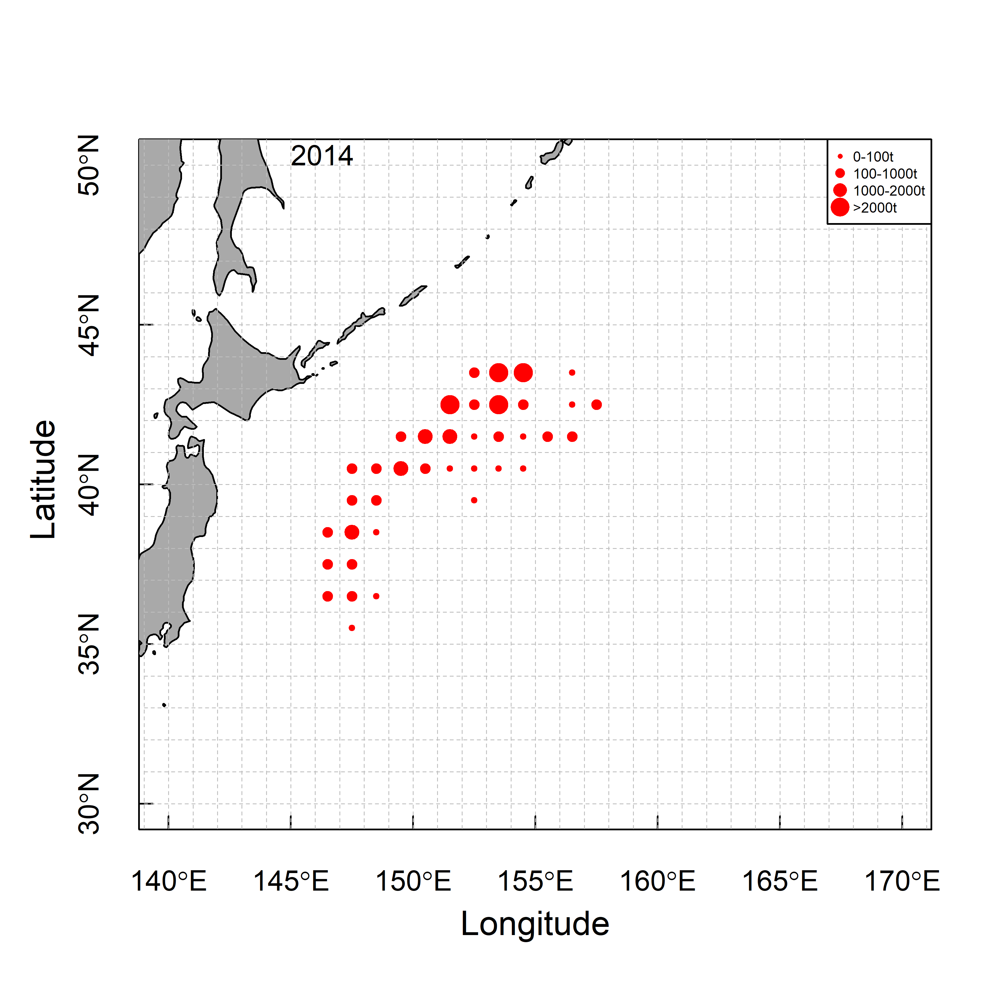 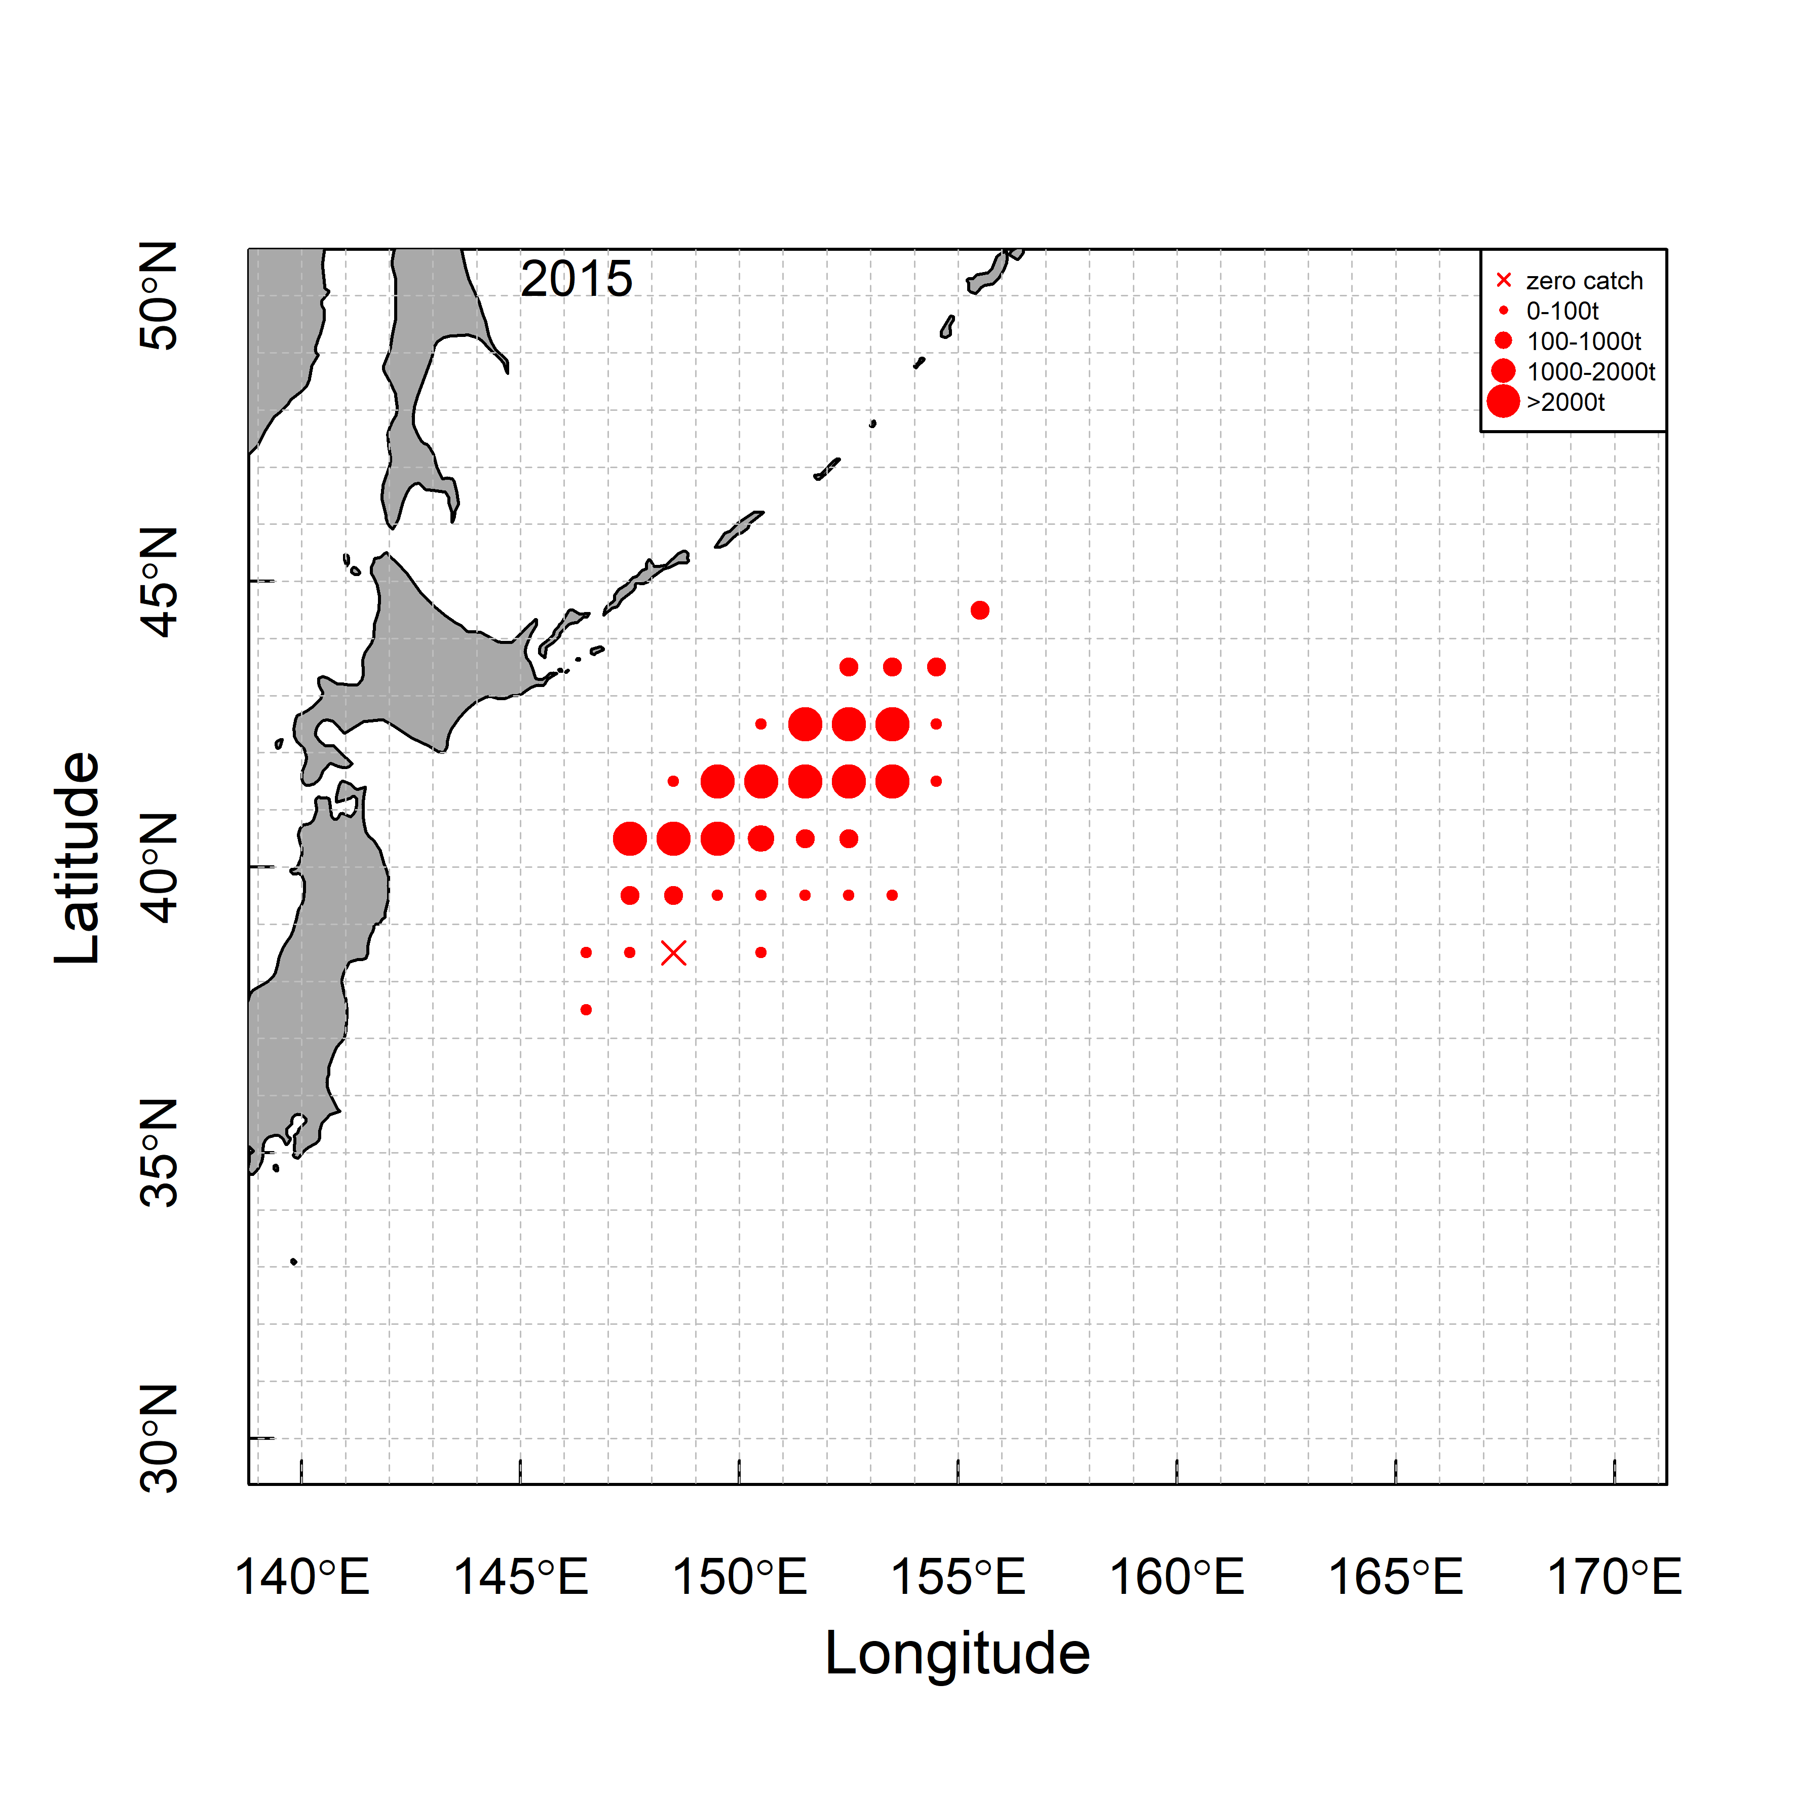 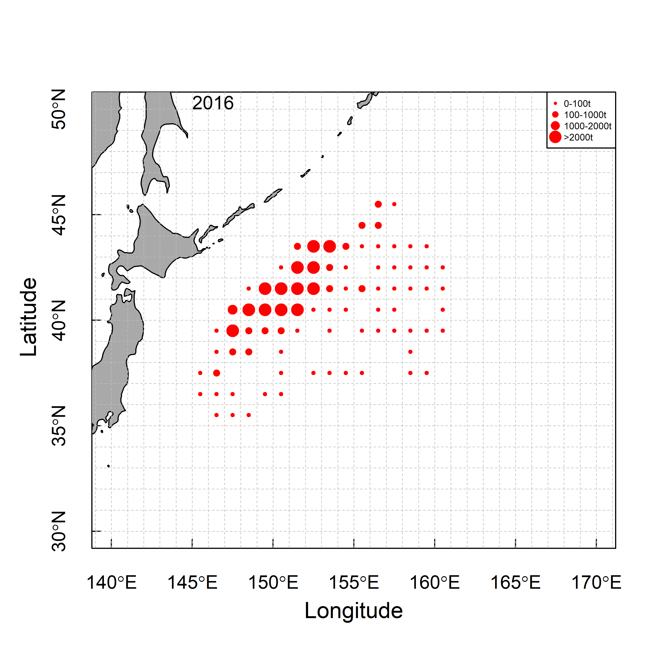

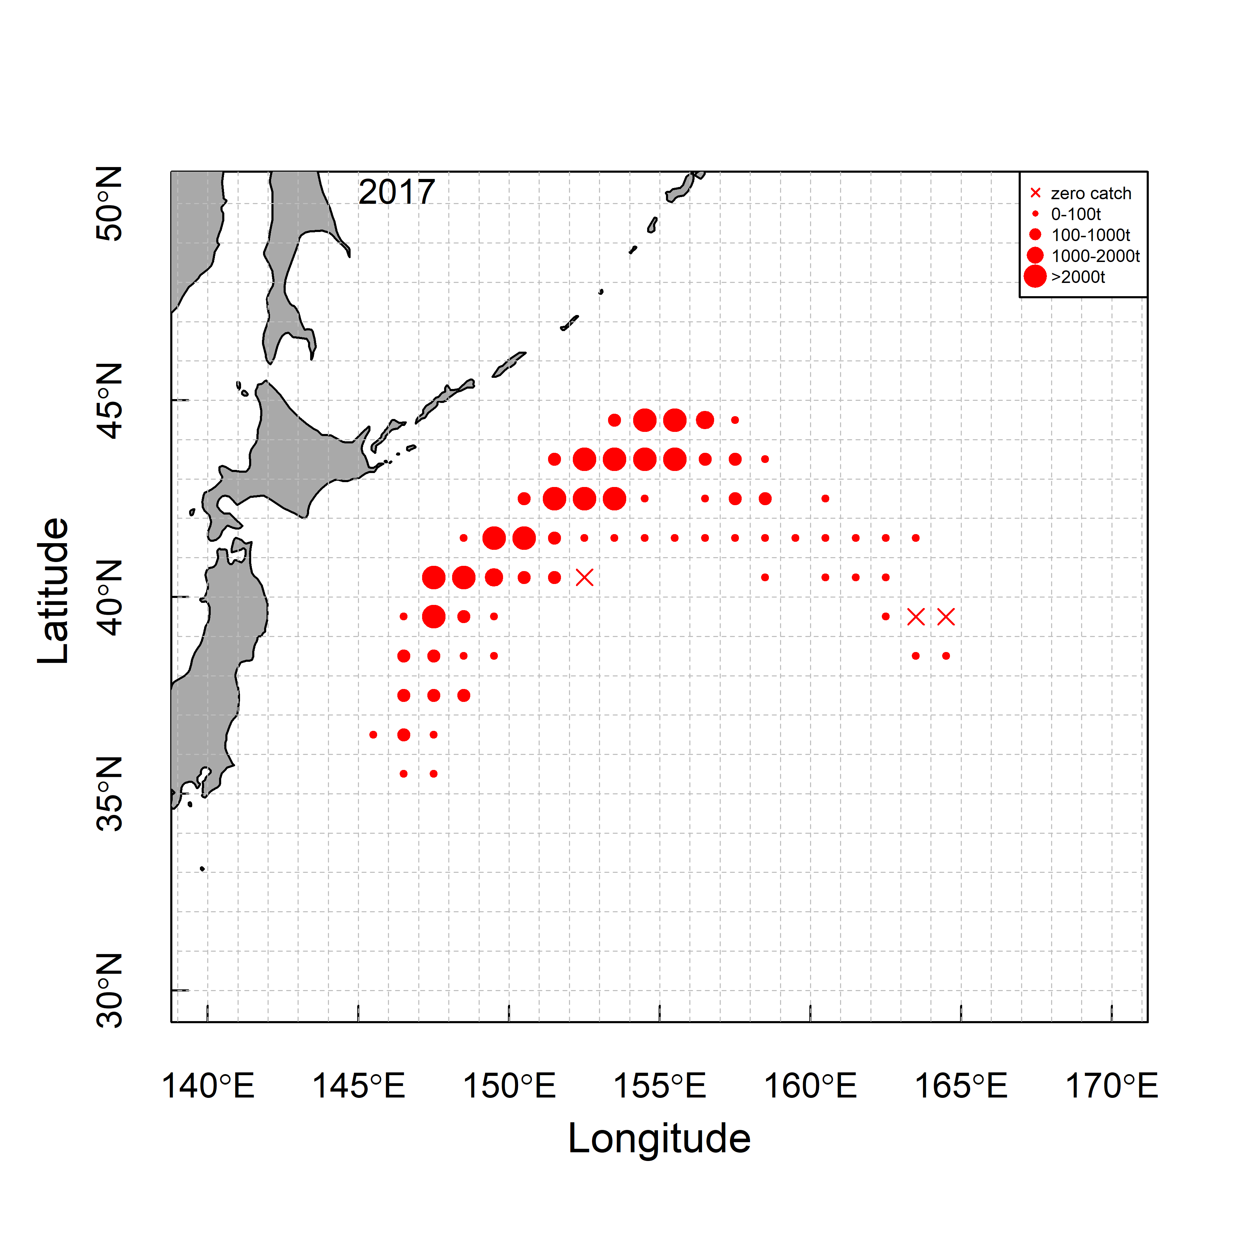 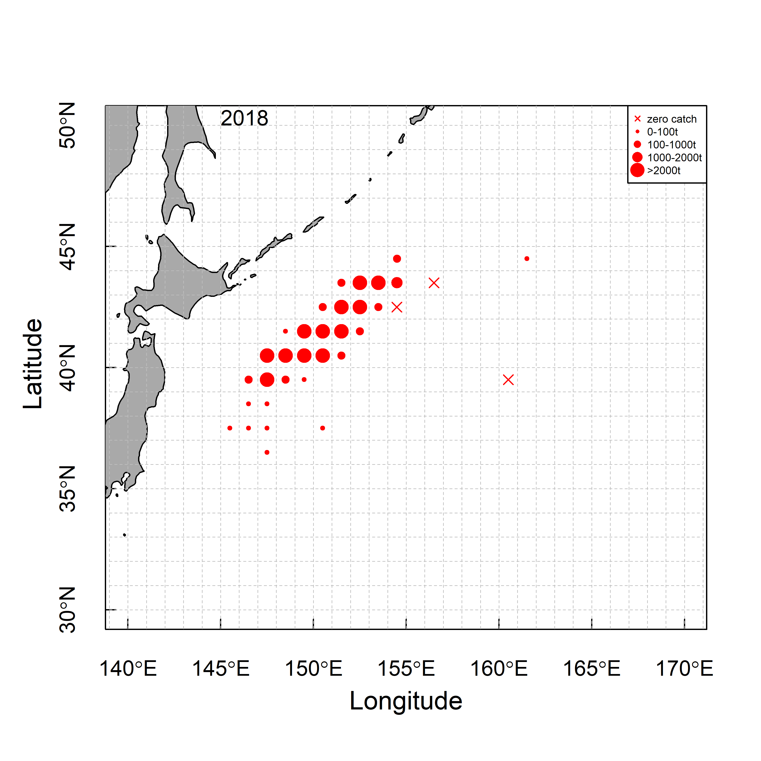 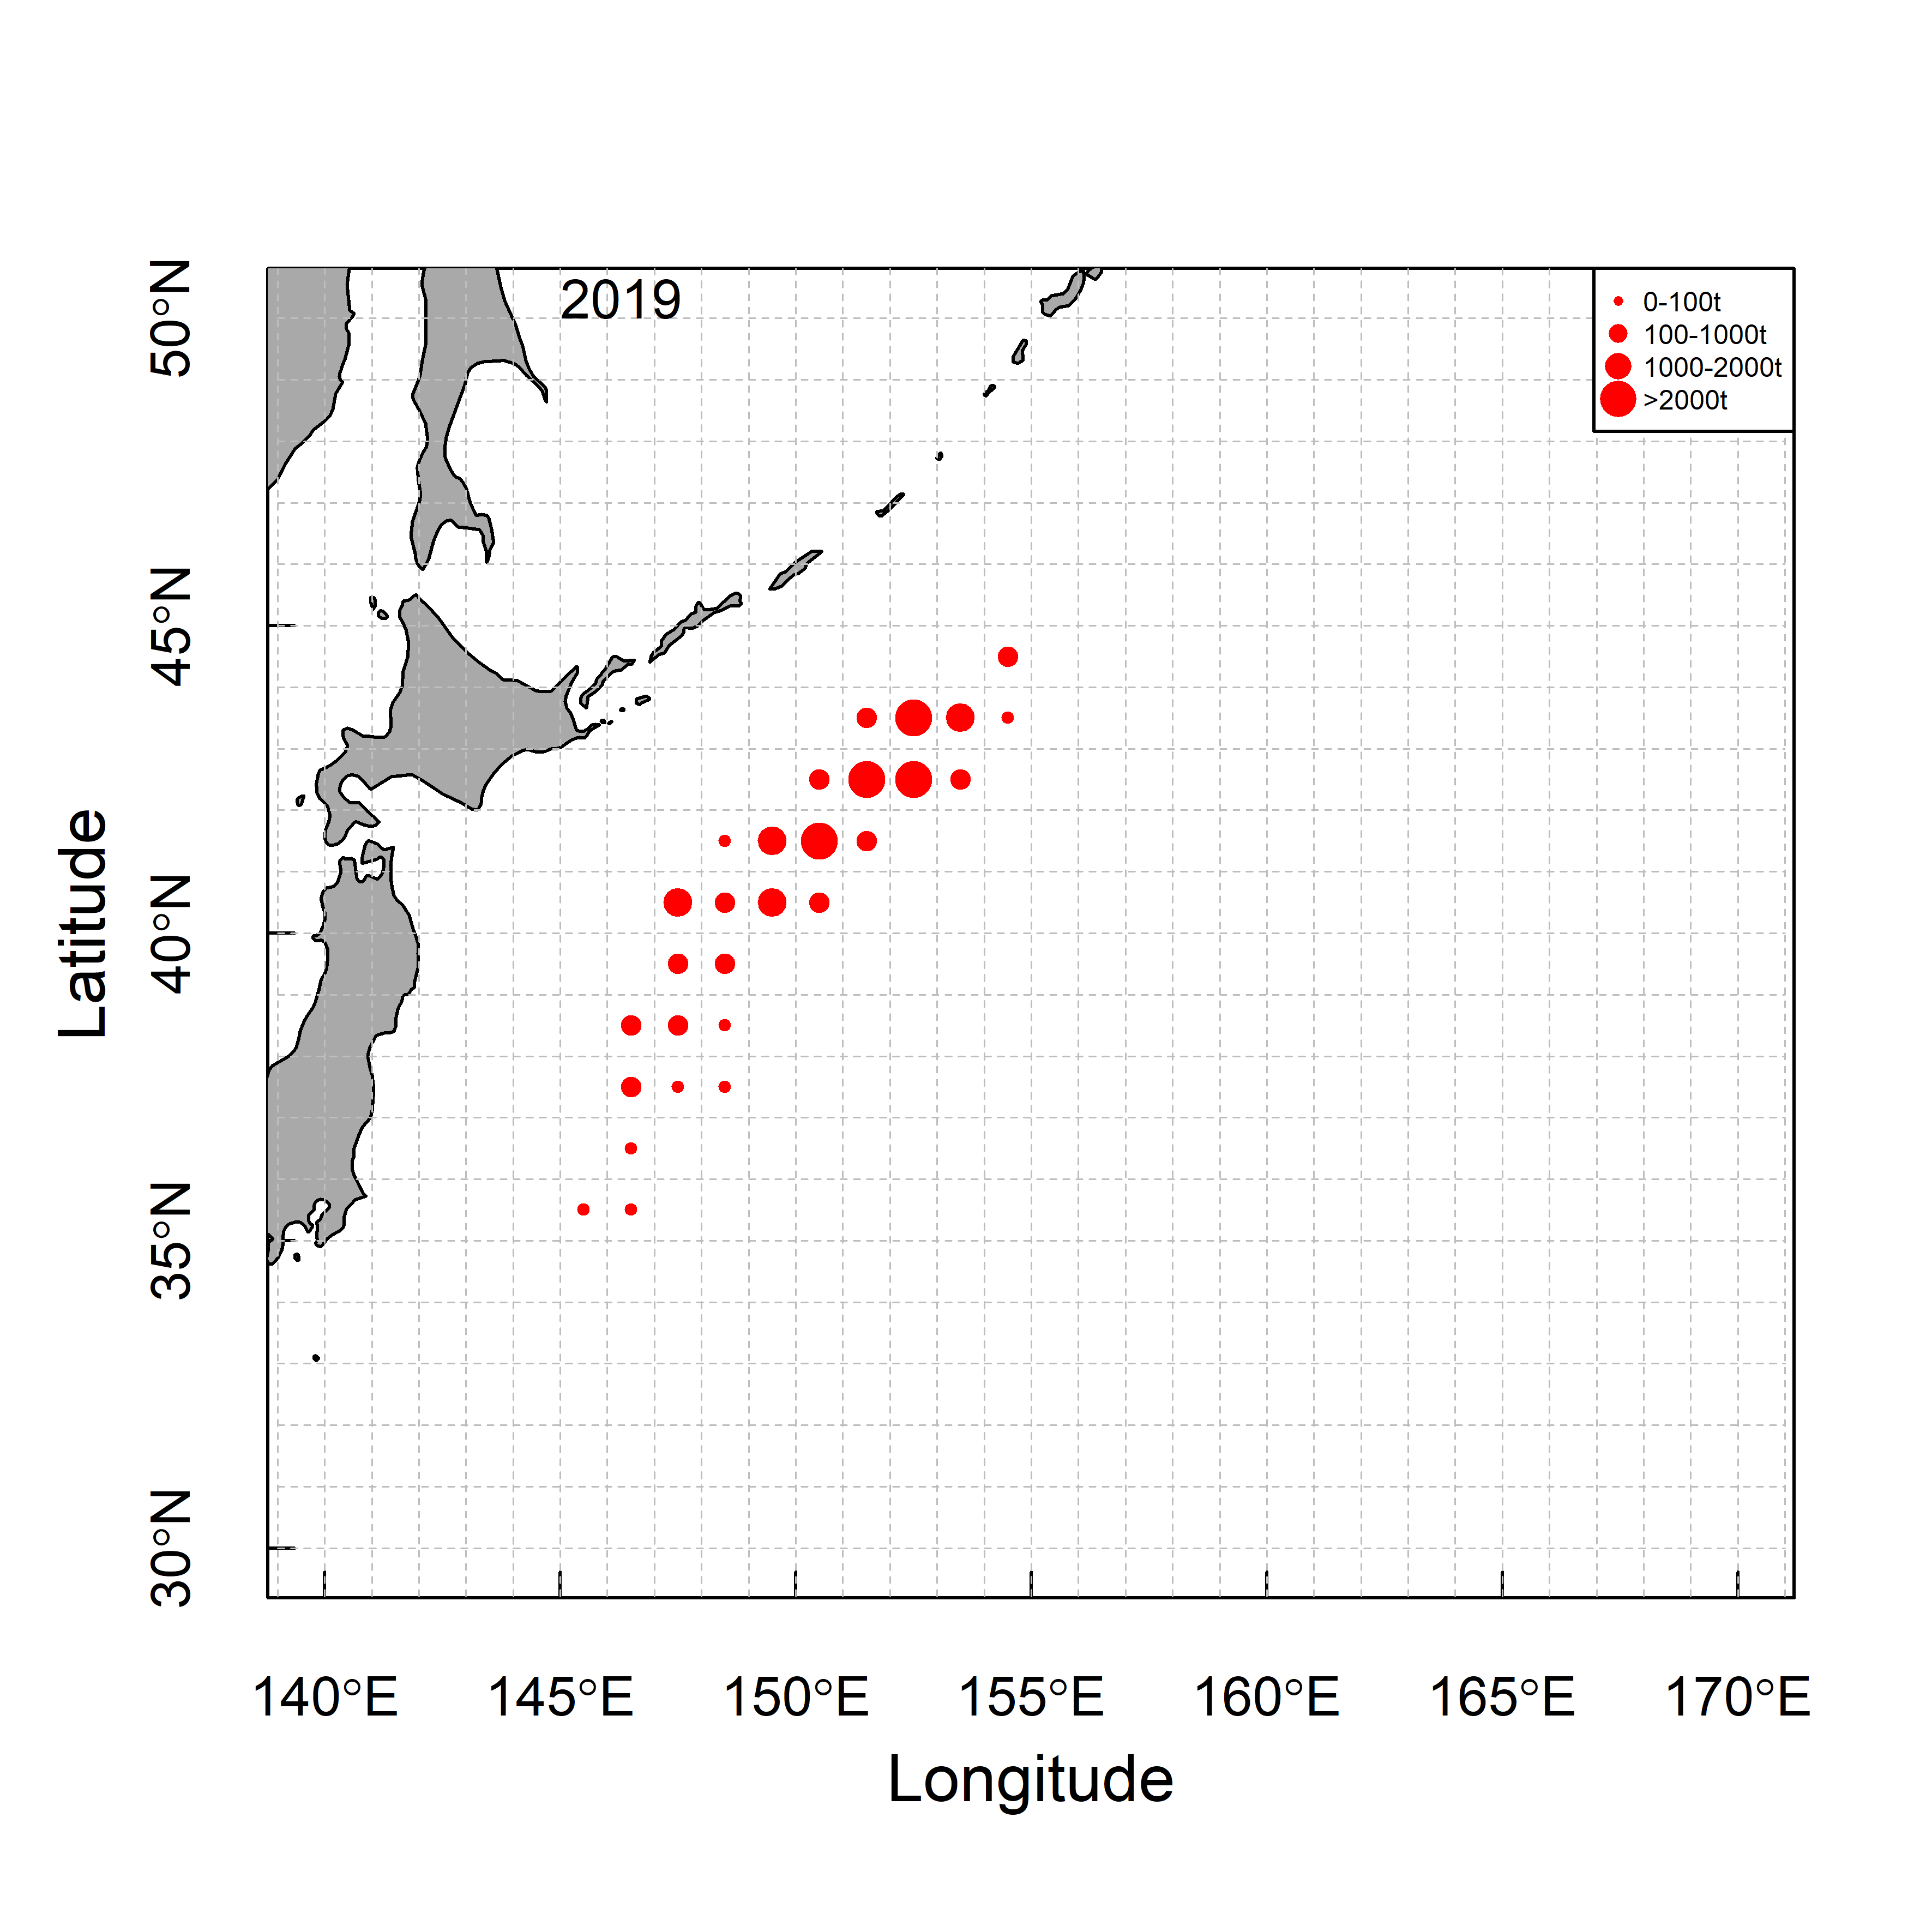

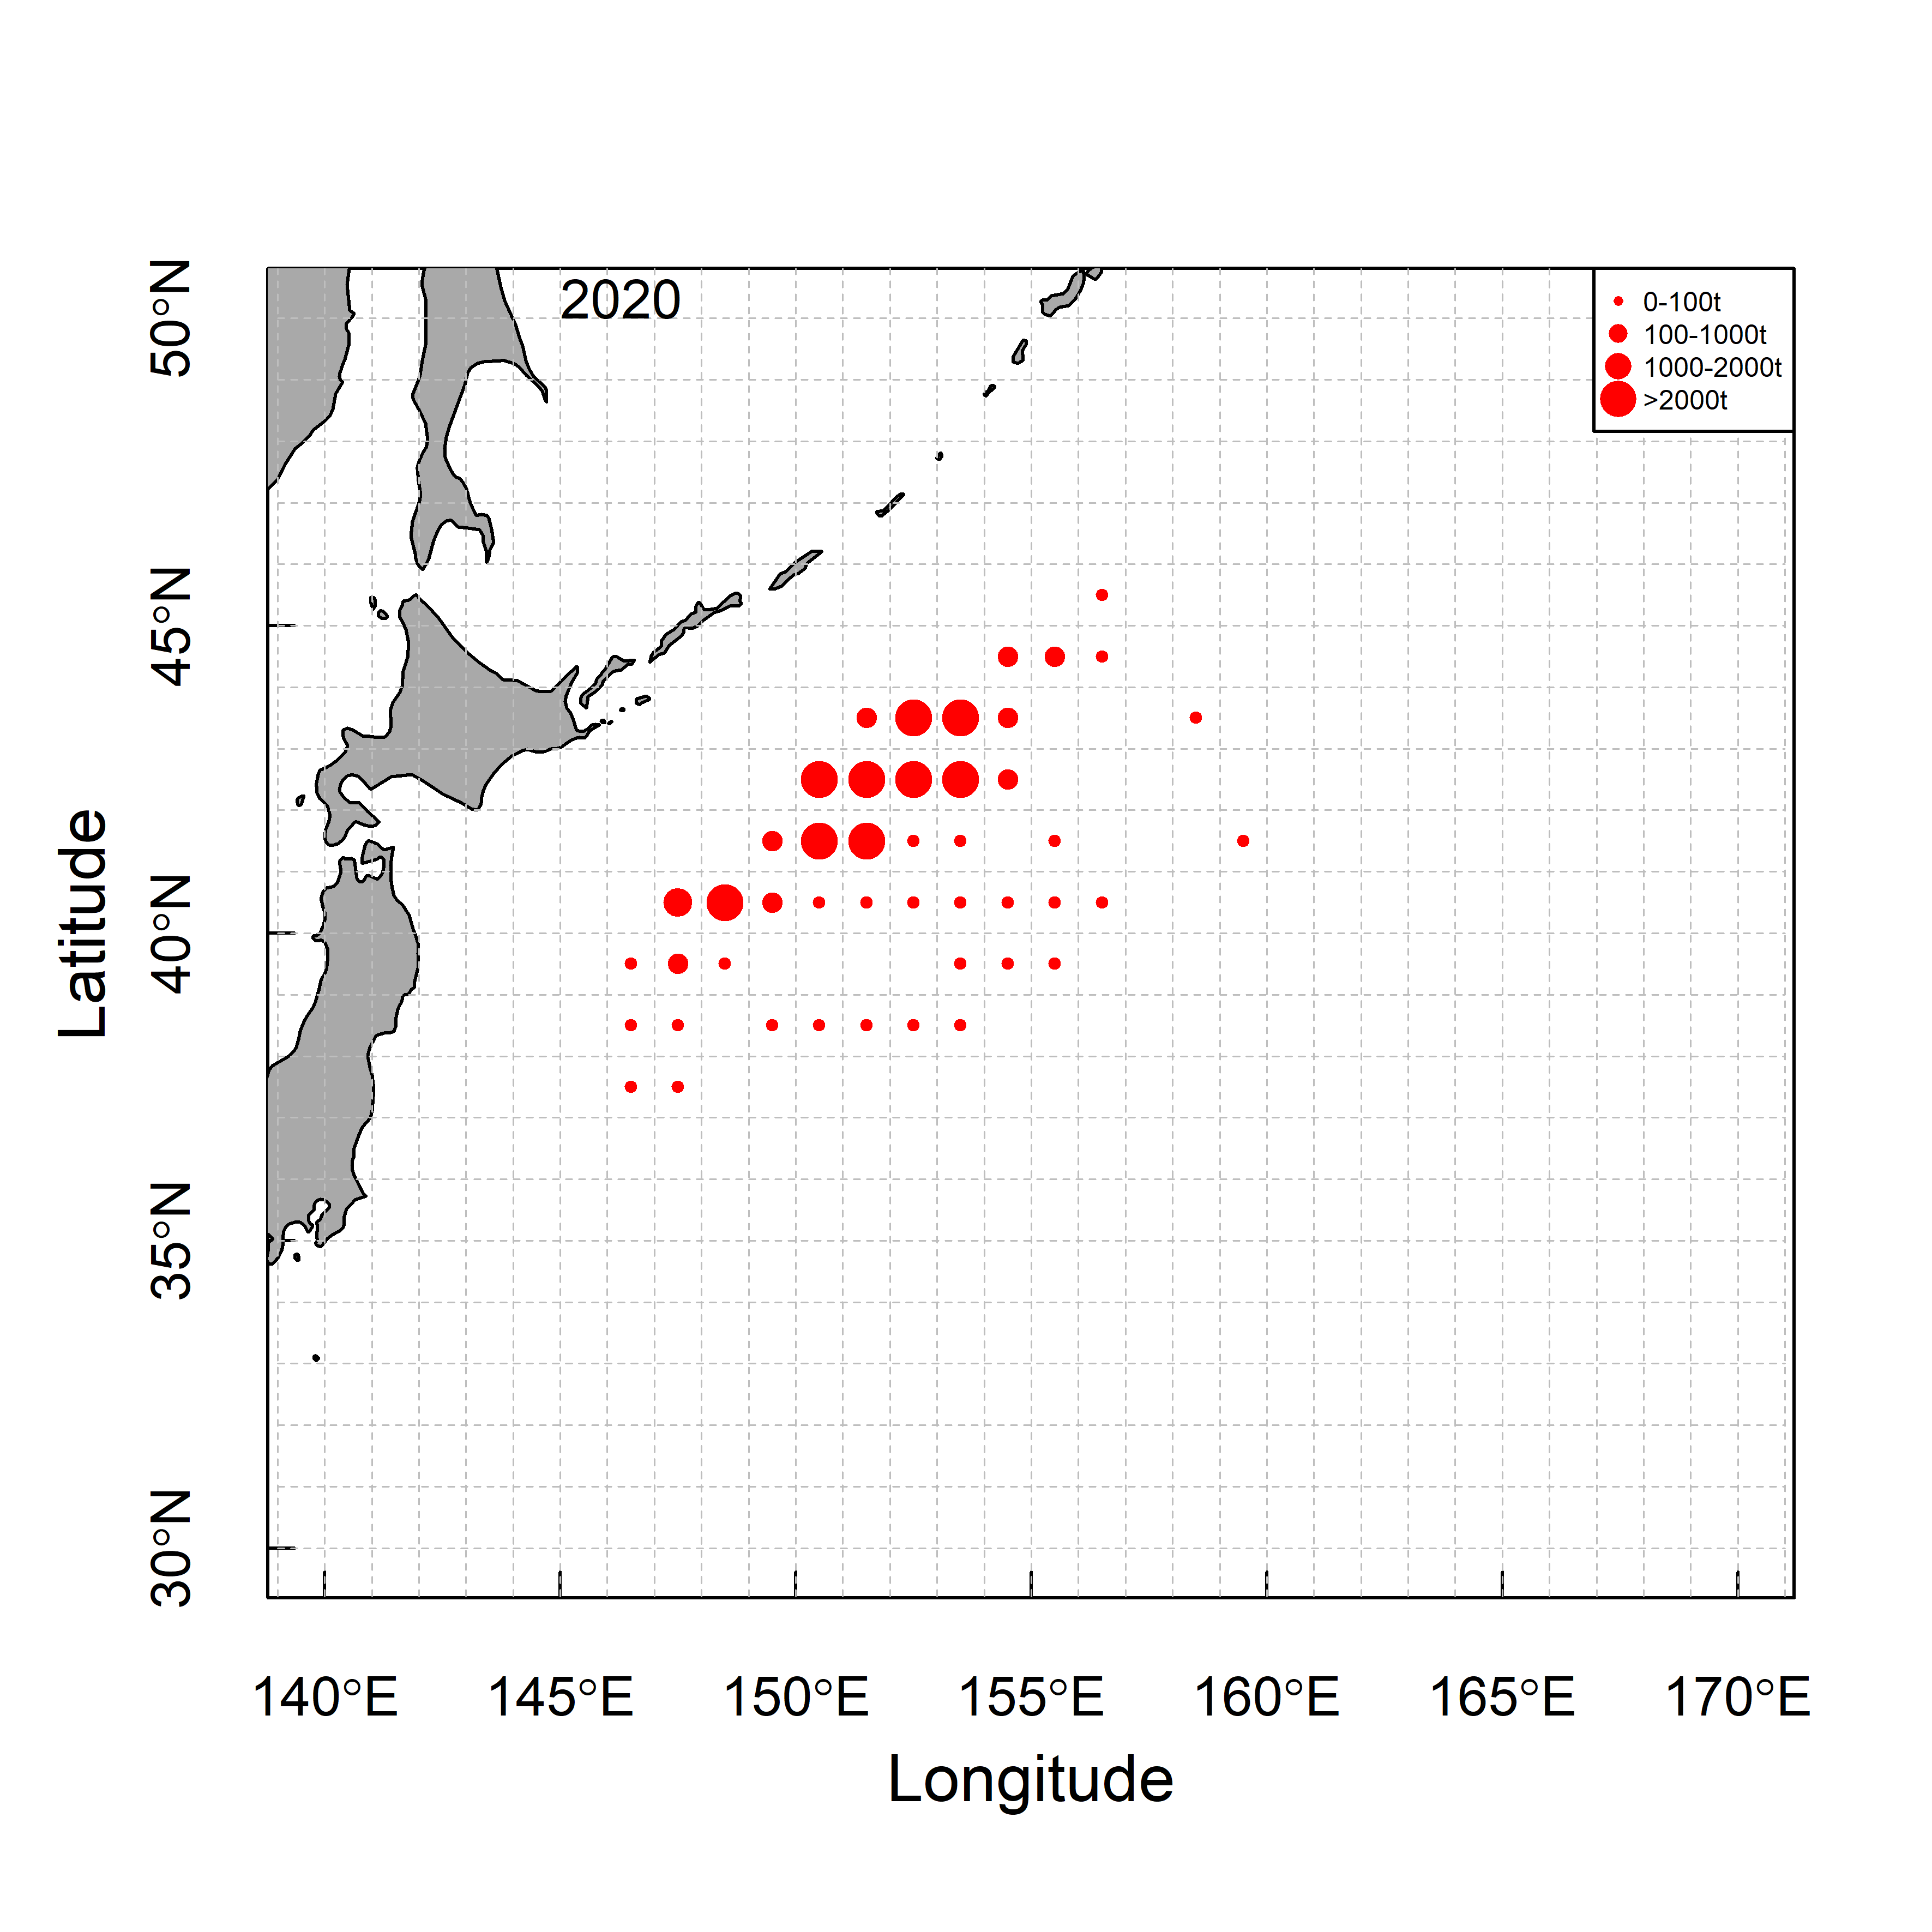 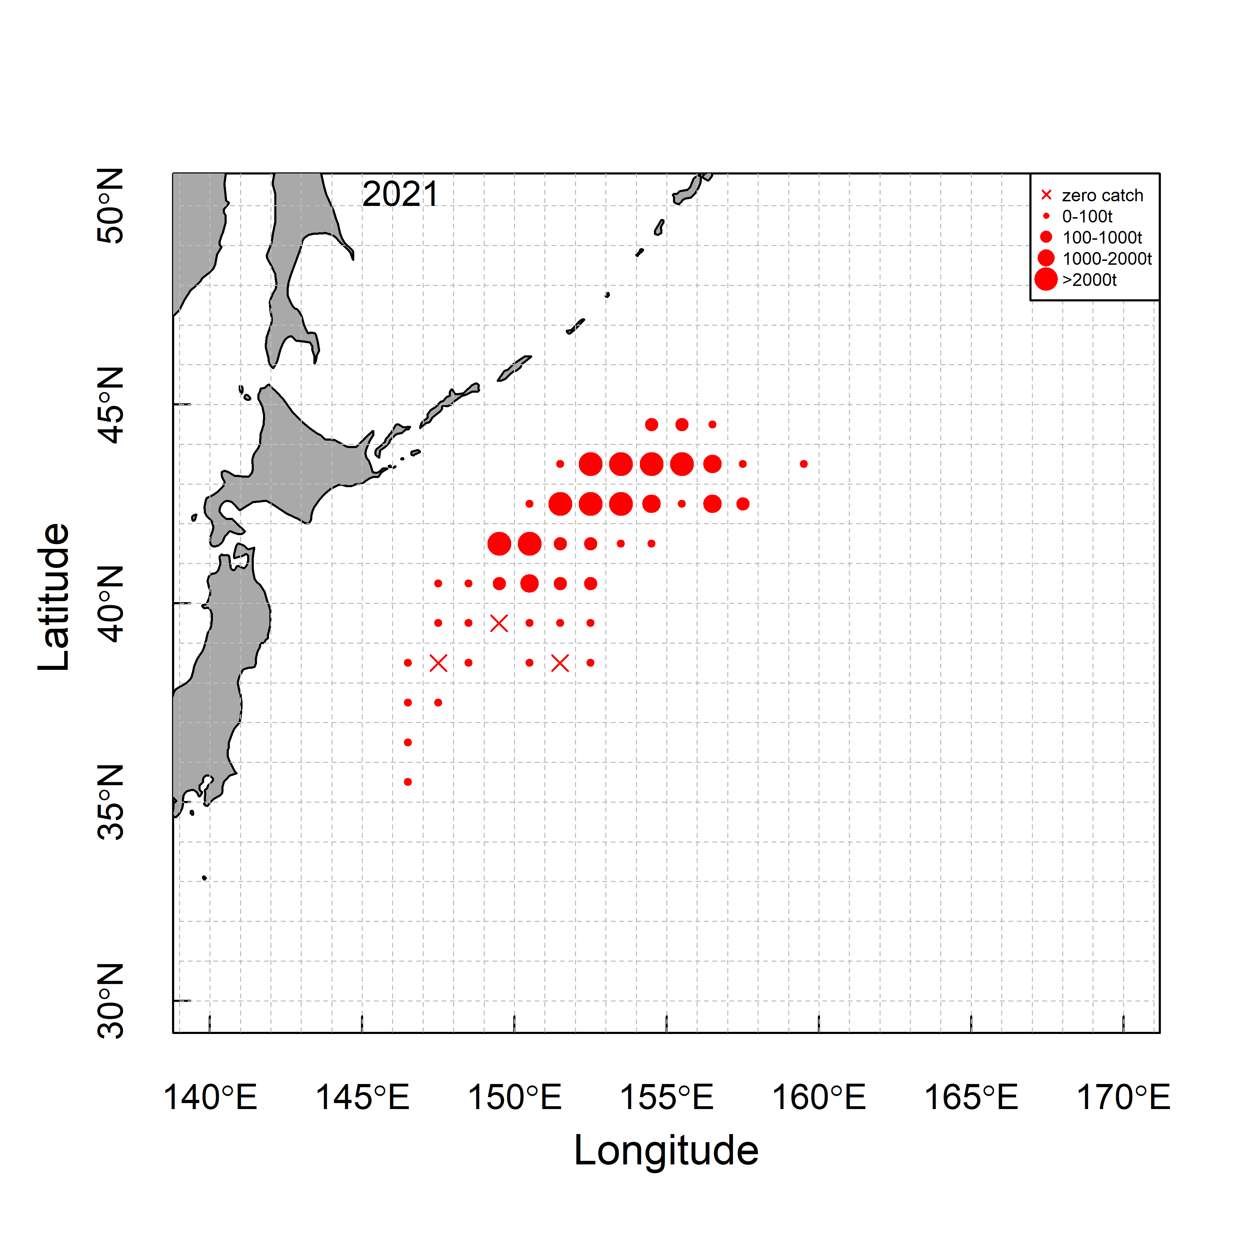 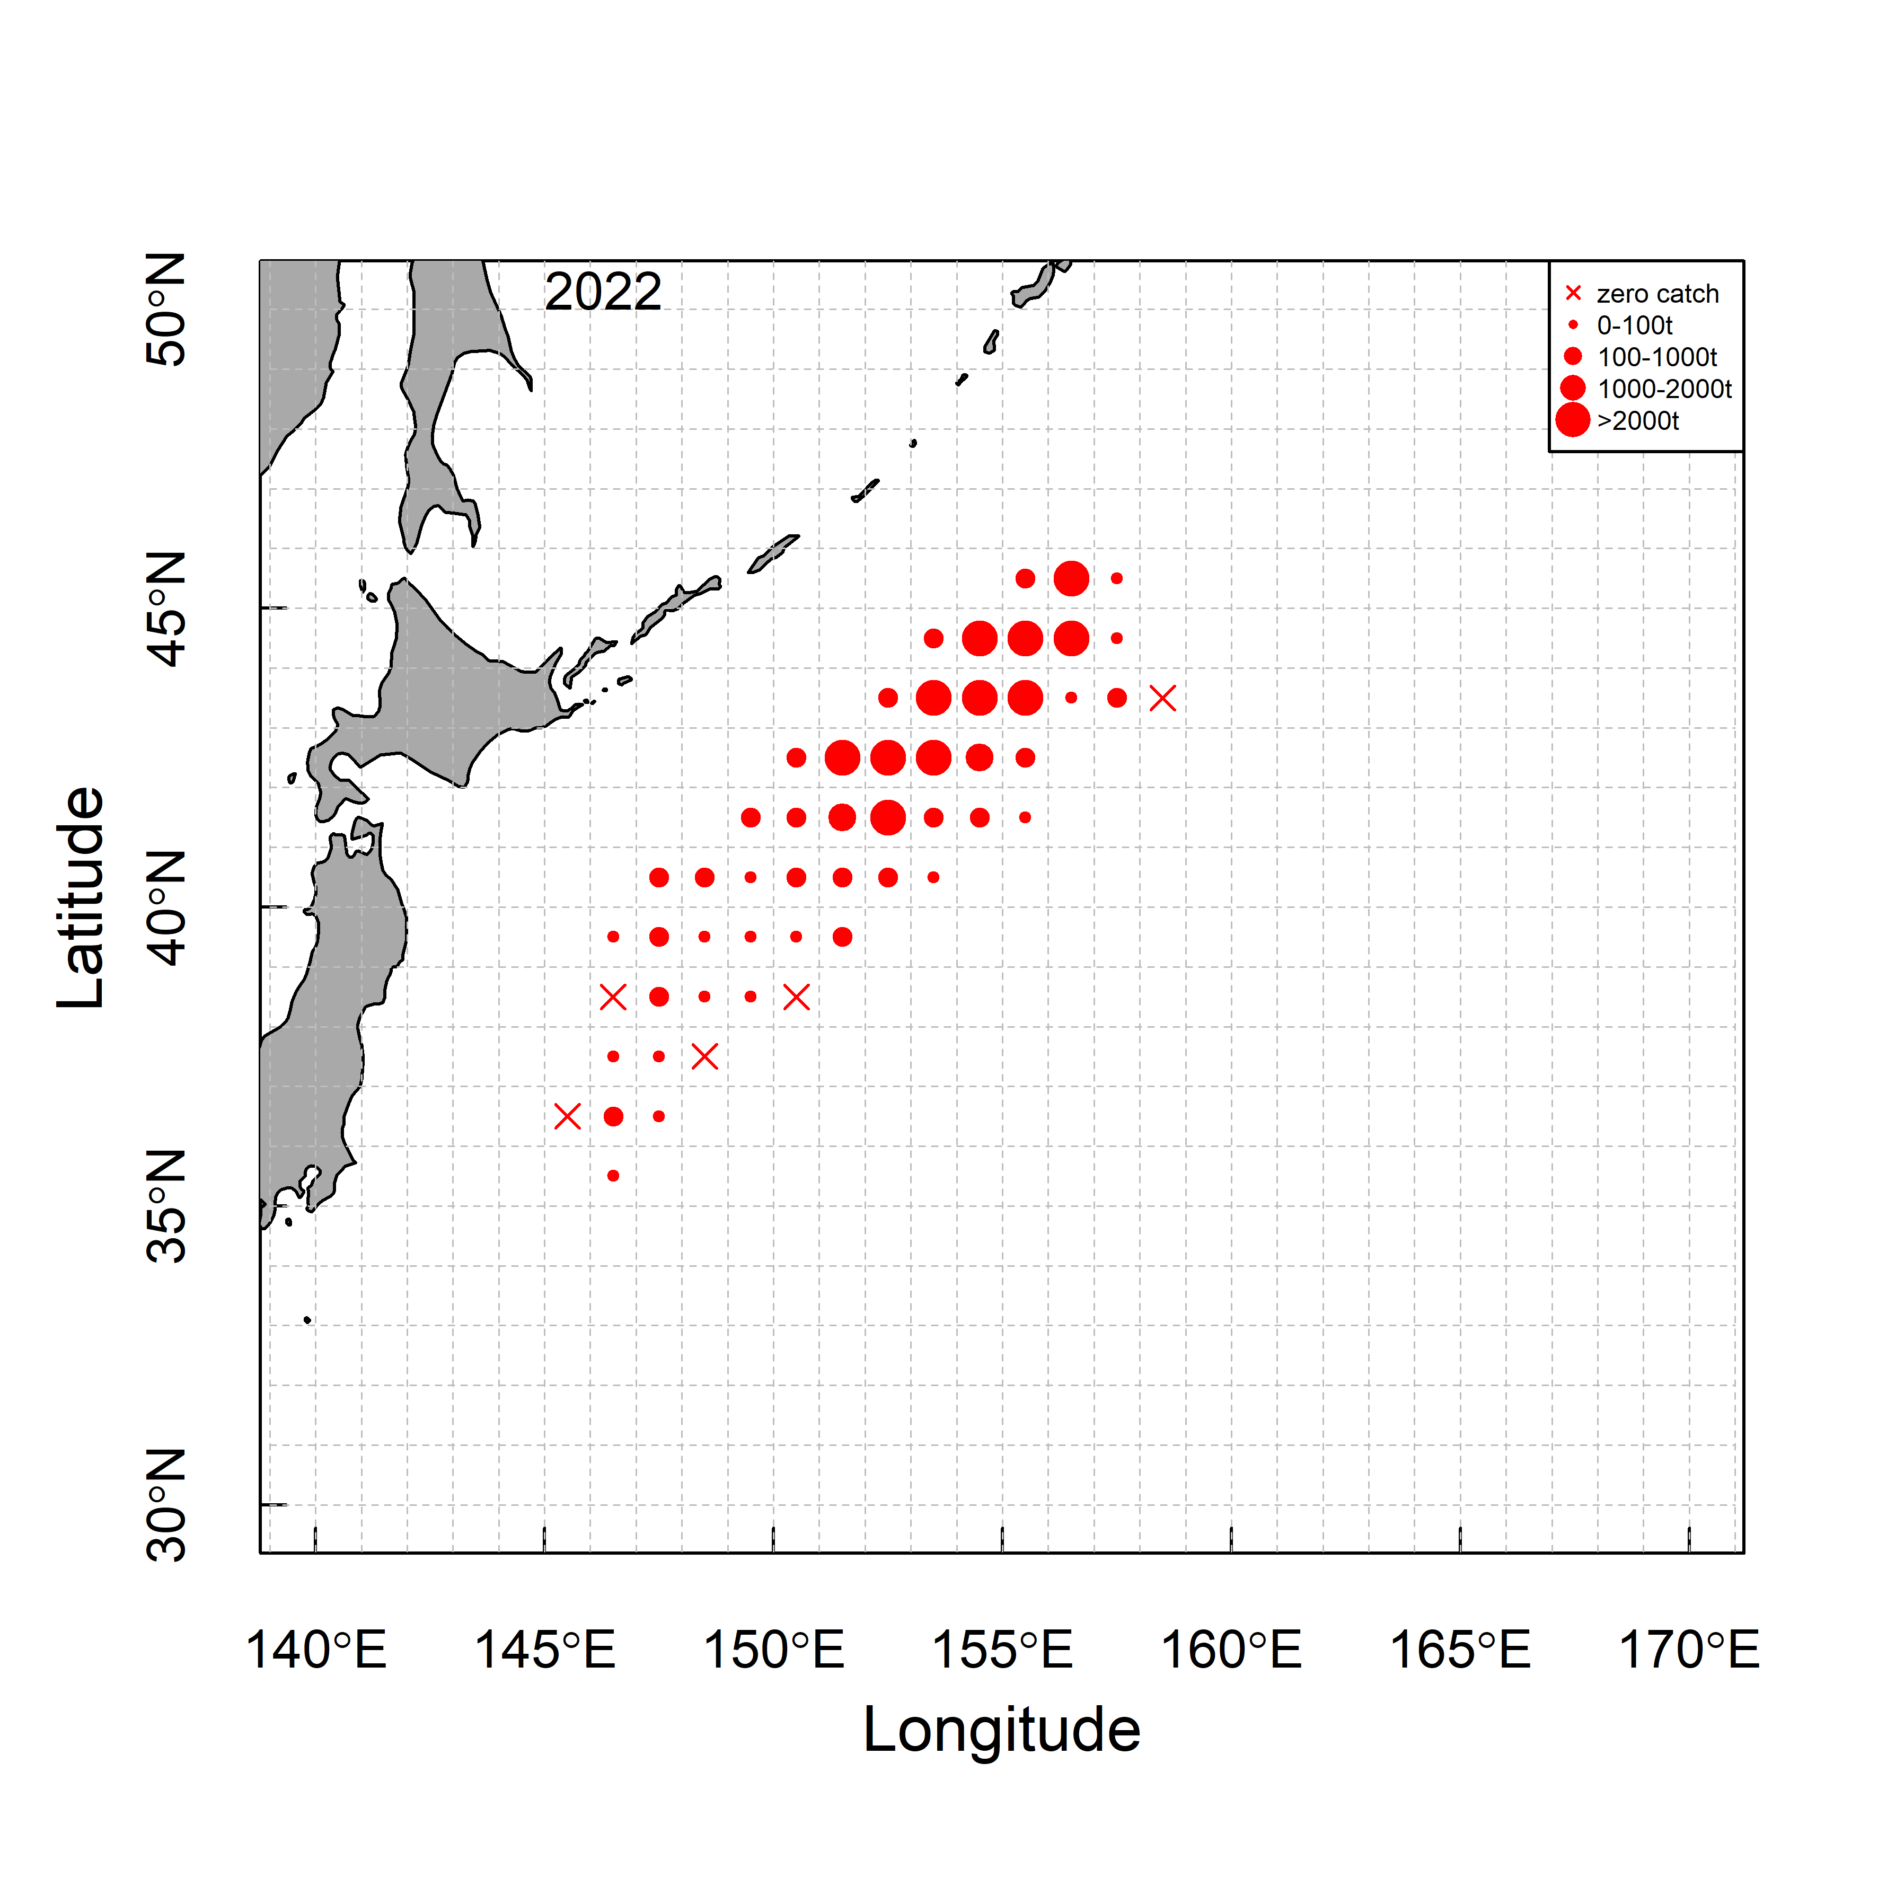

**Fig. 1a.** Spatio-temporal distribution of the total catch of CPUE fleet (metric tons).

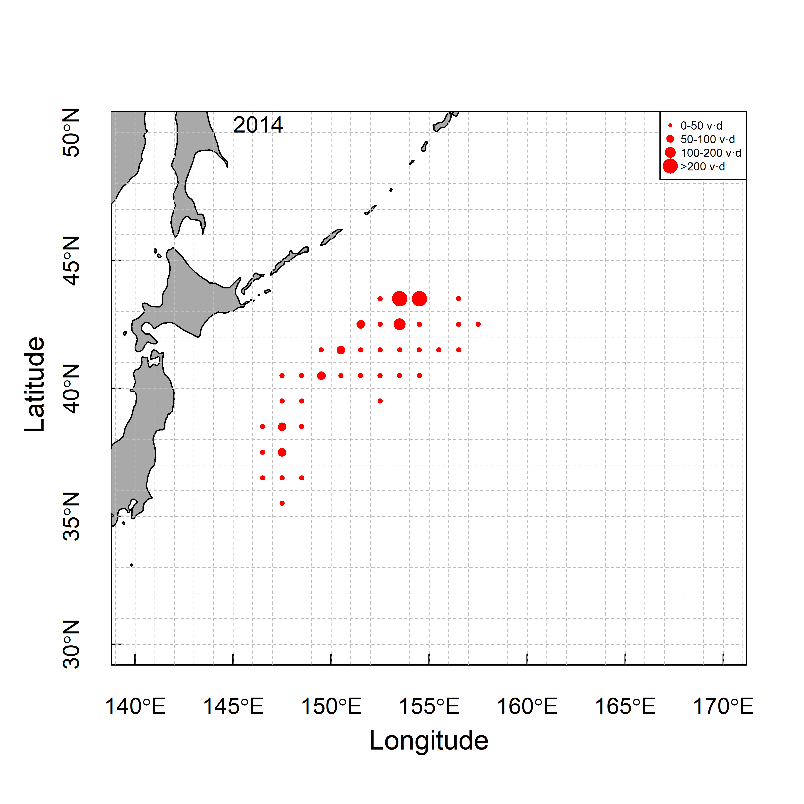 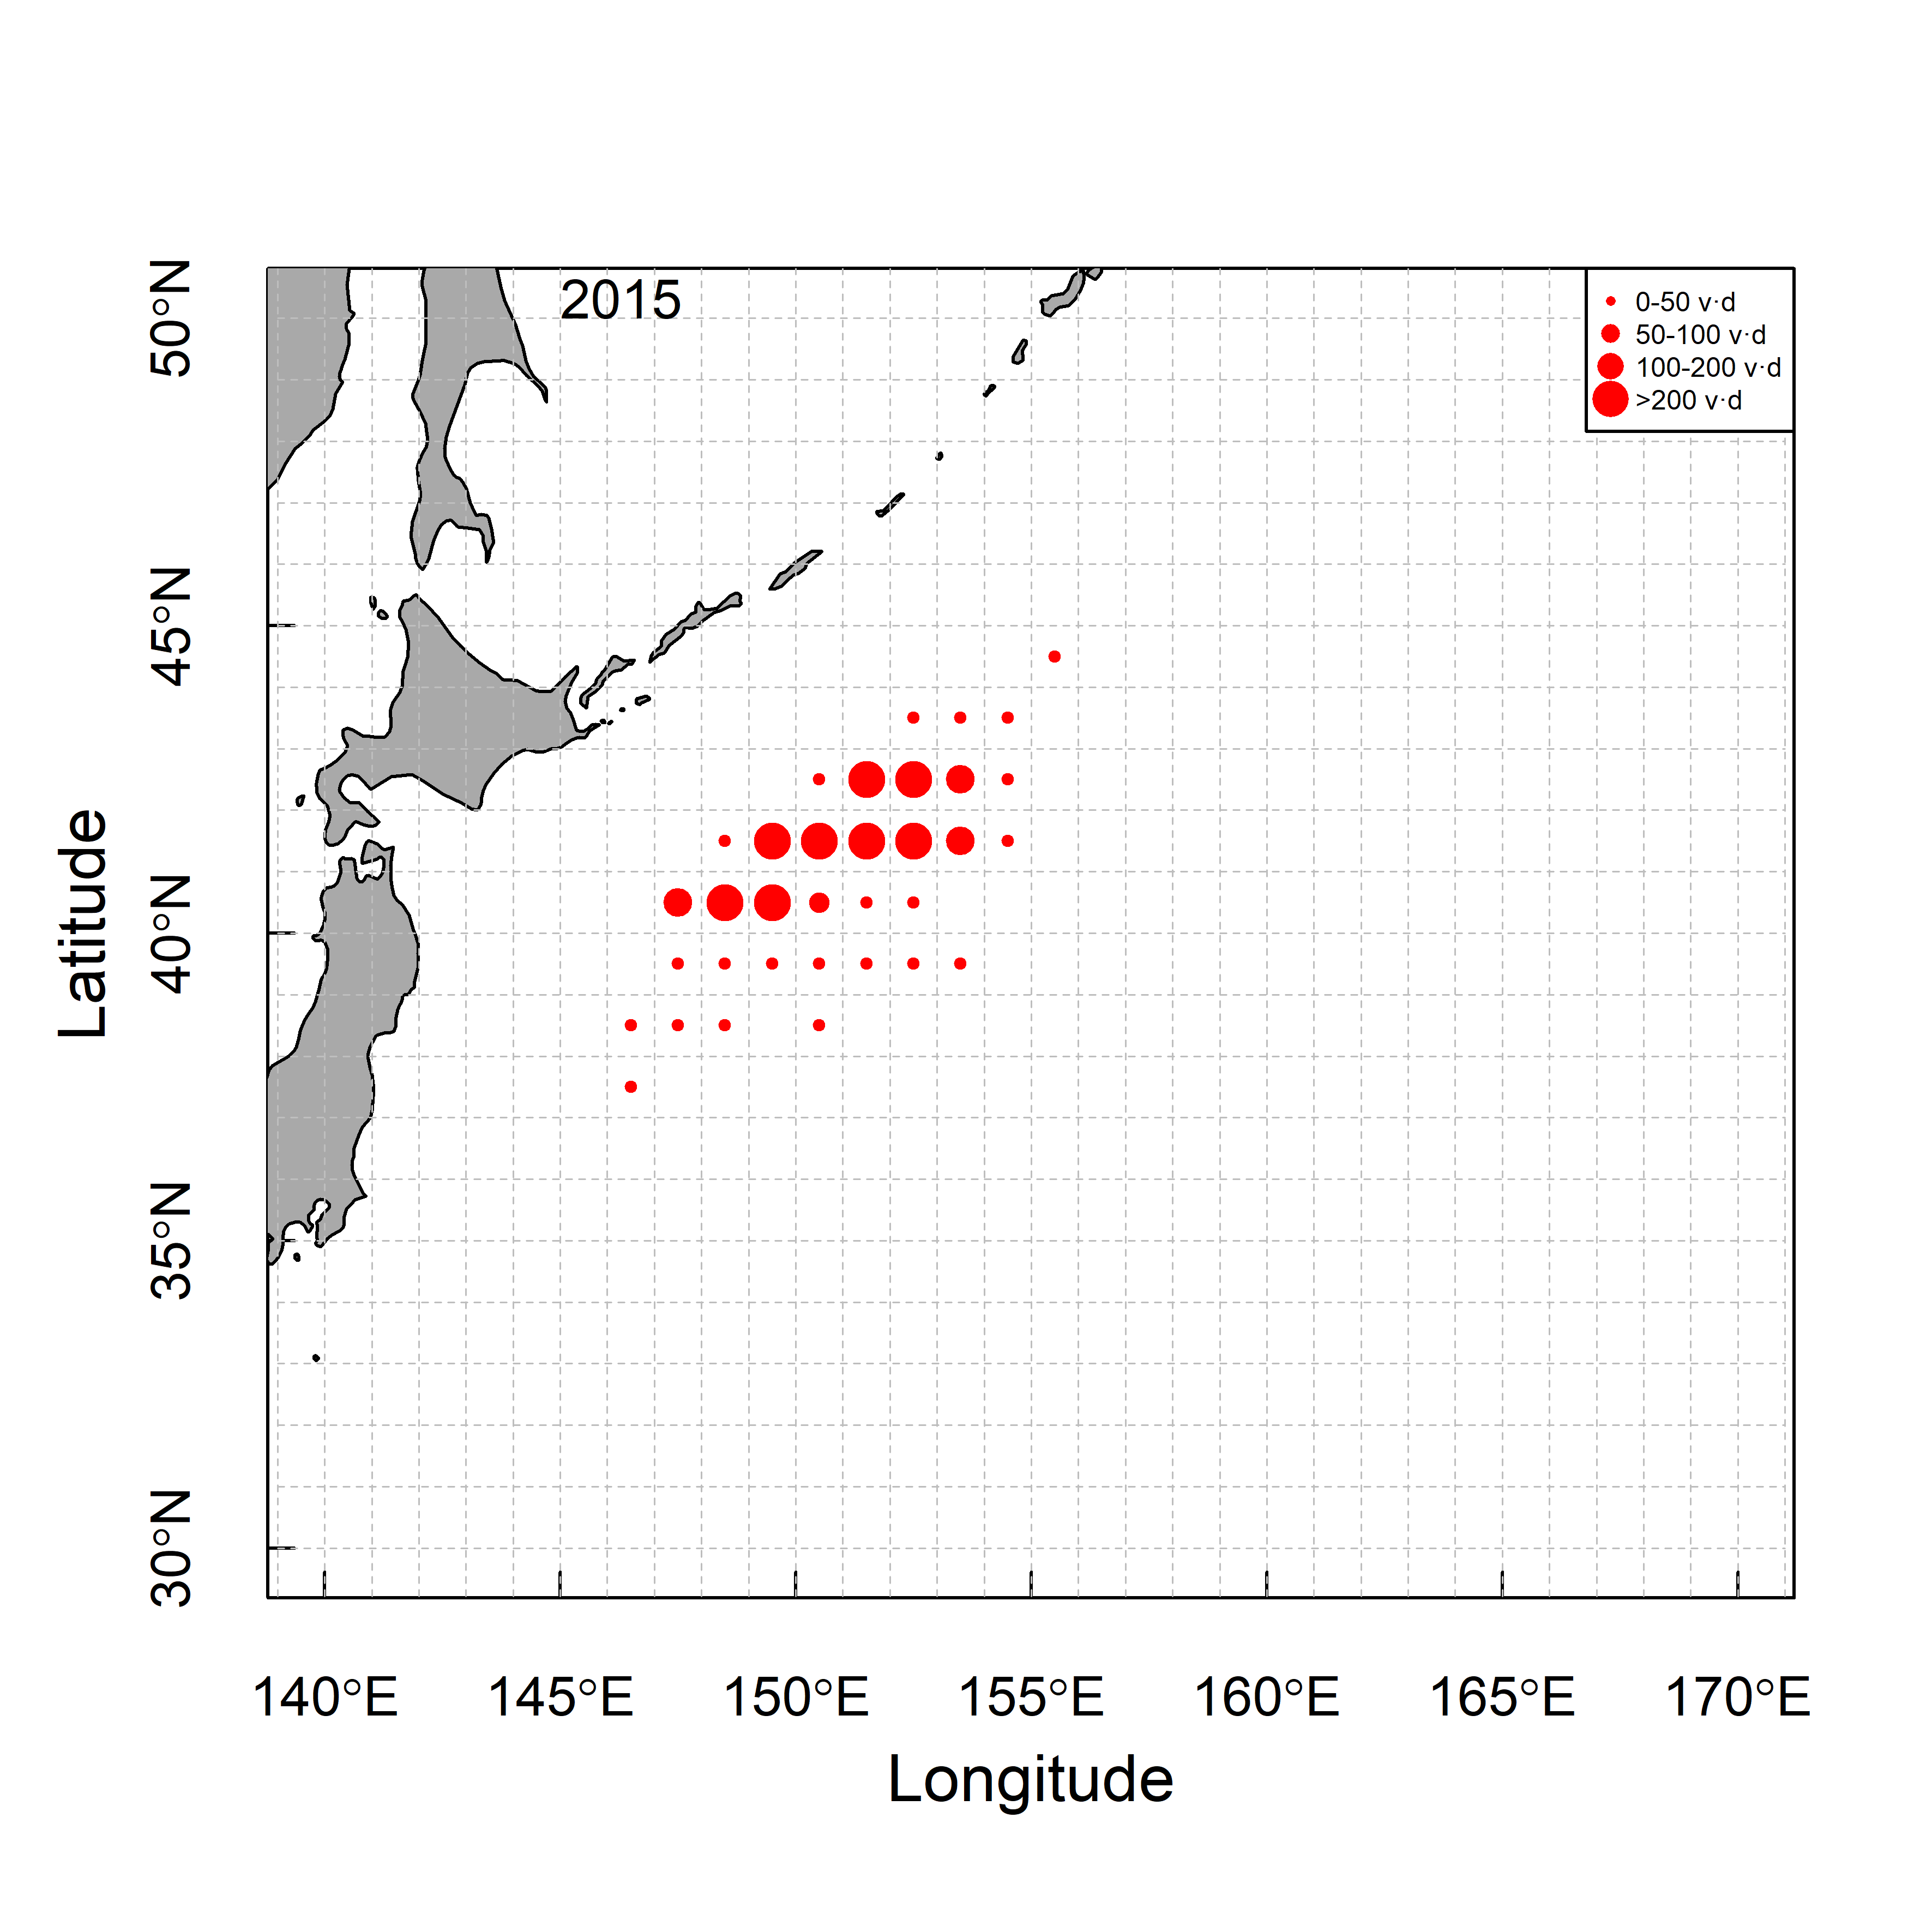 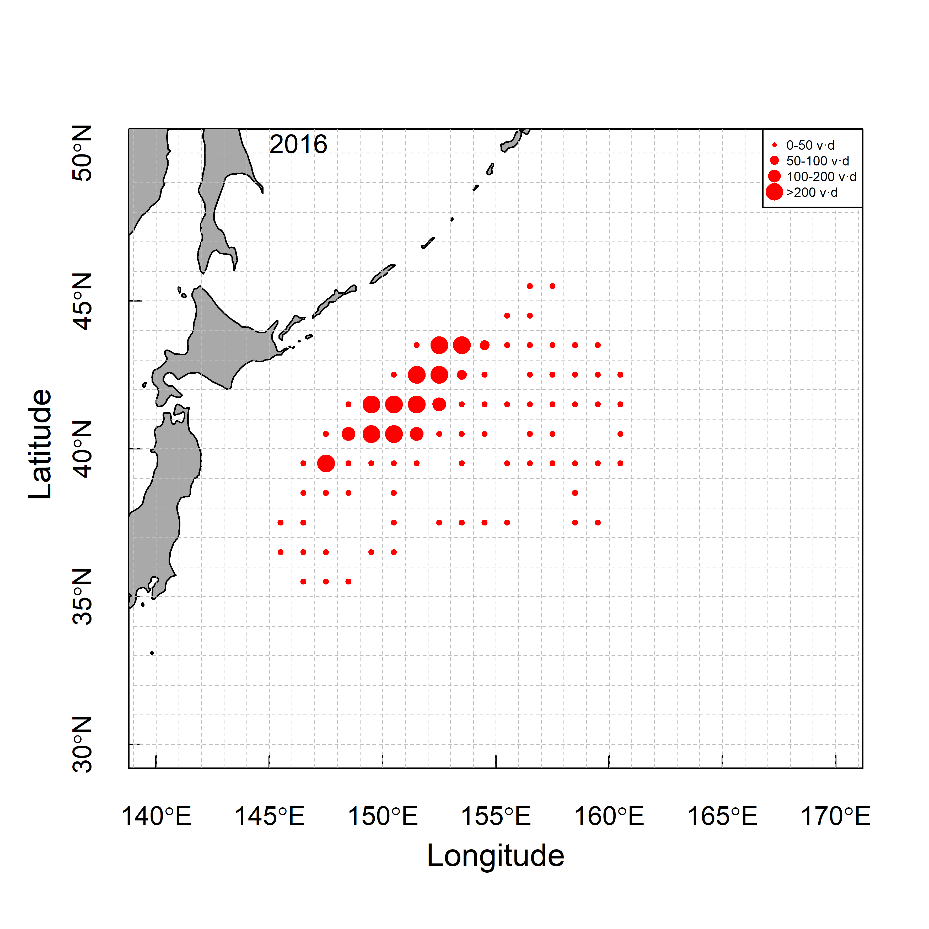

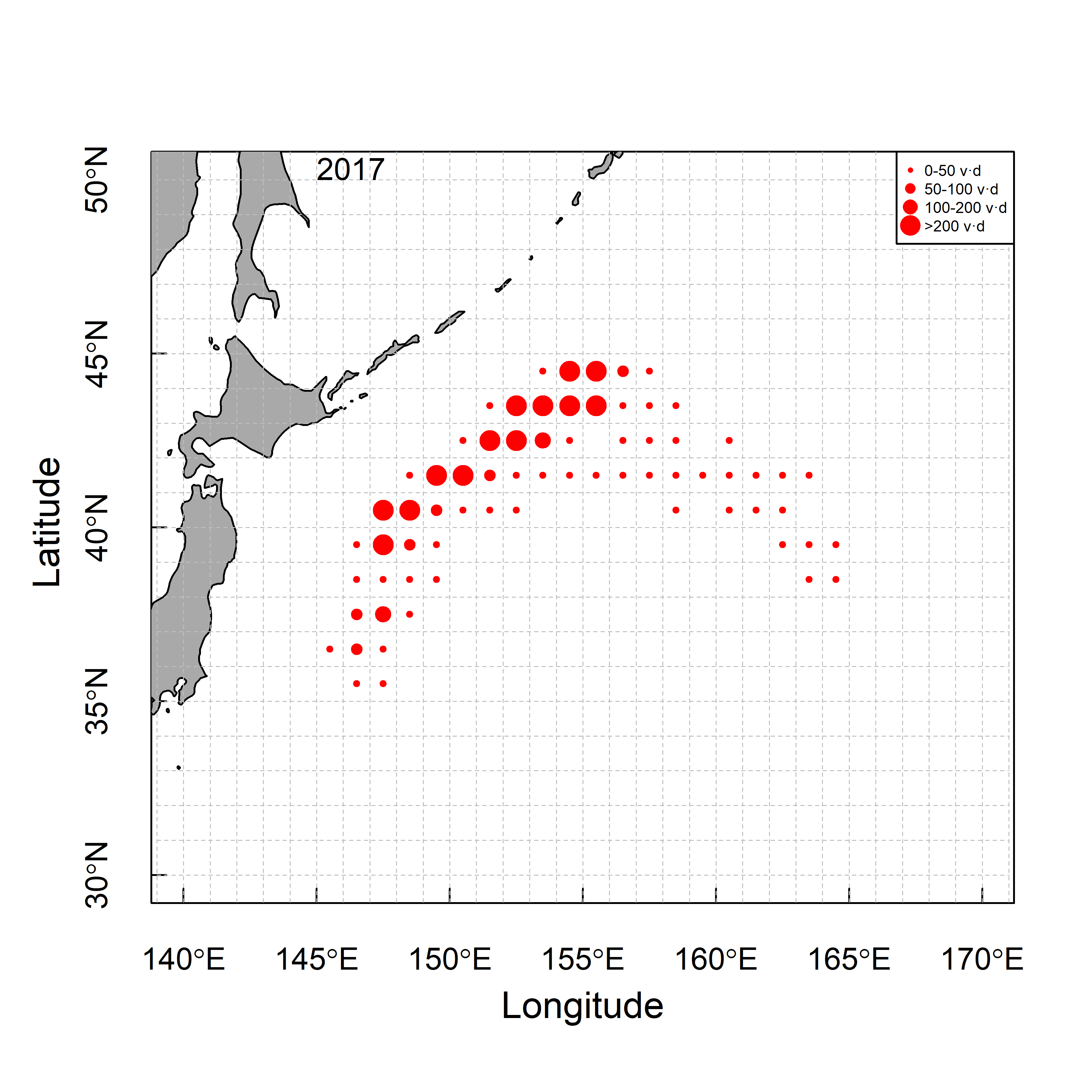 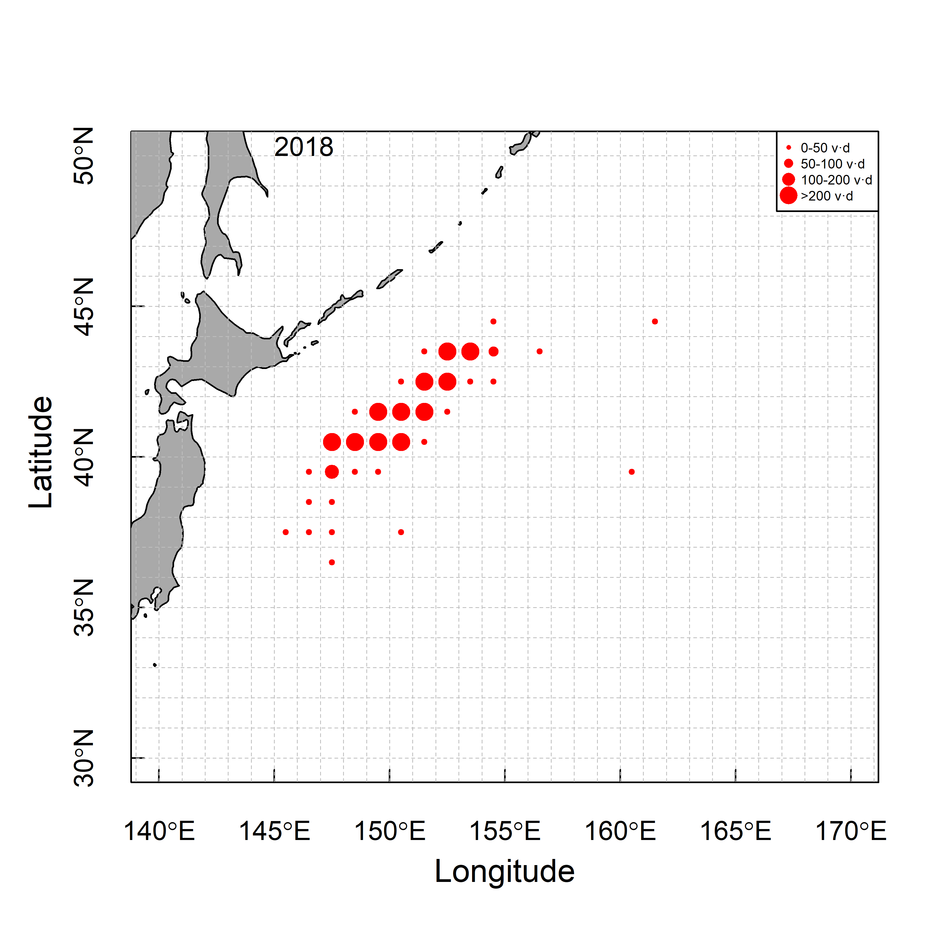 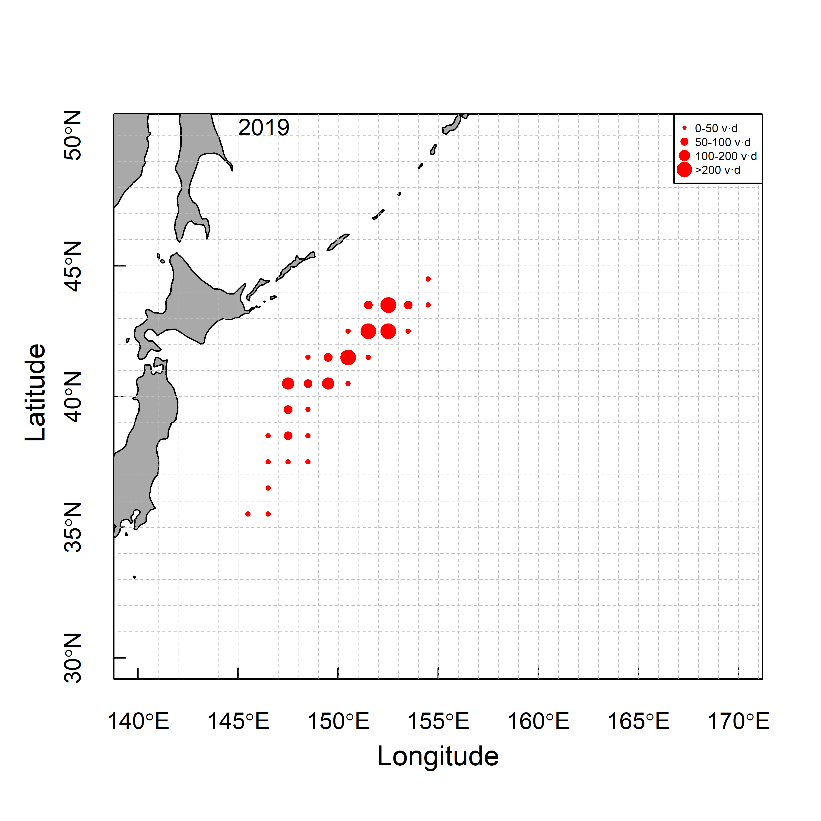

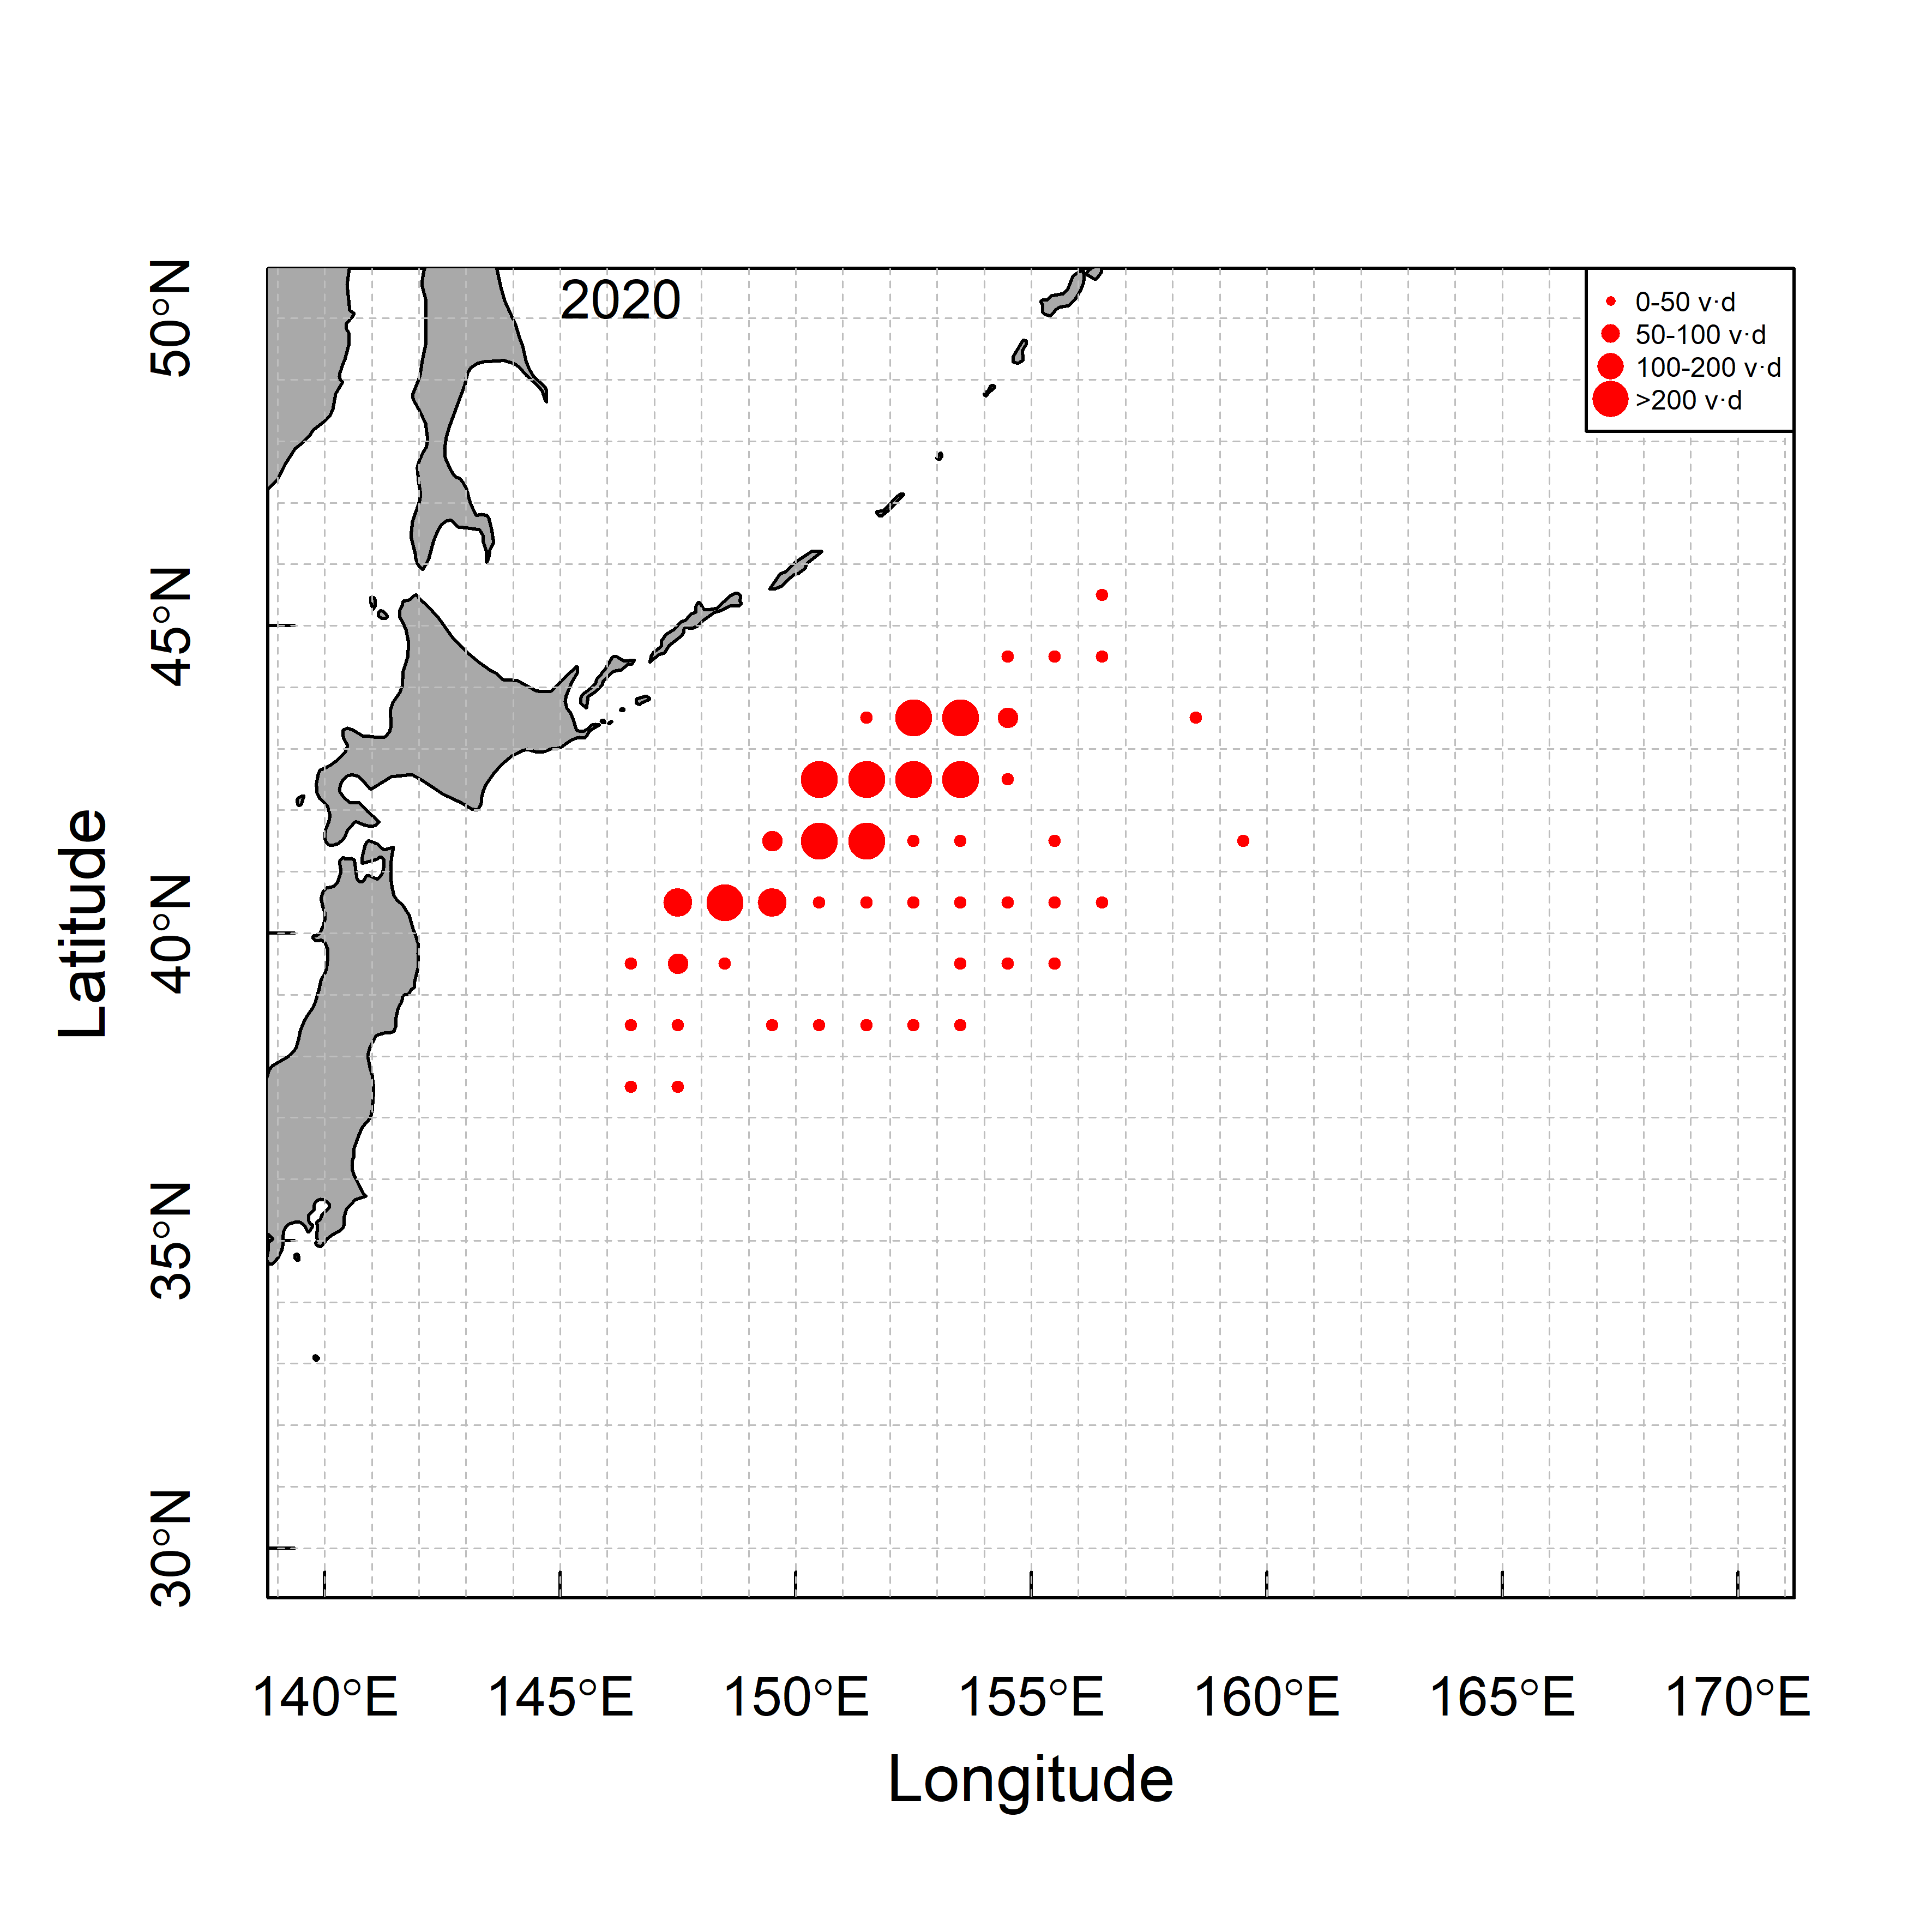 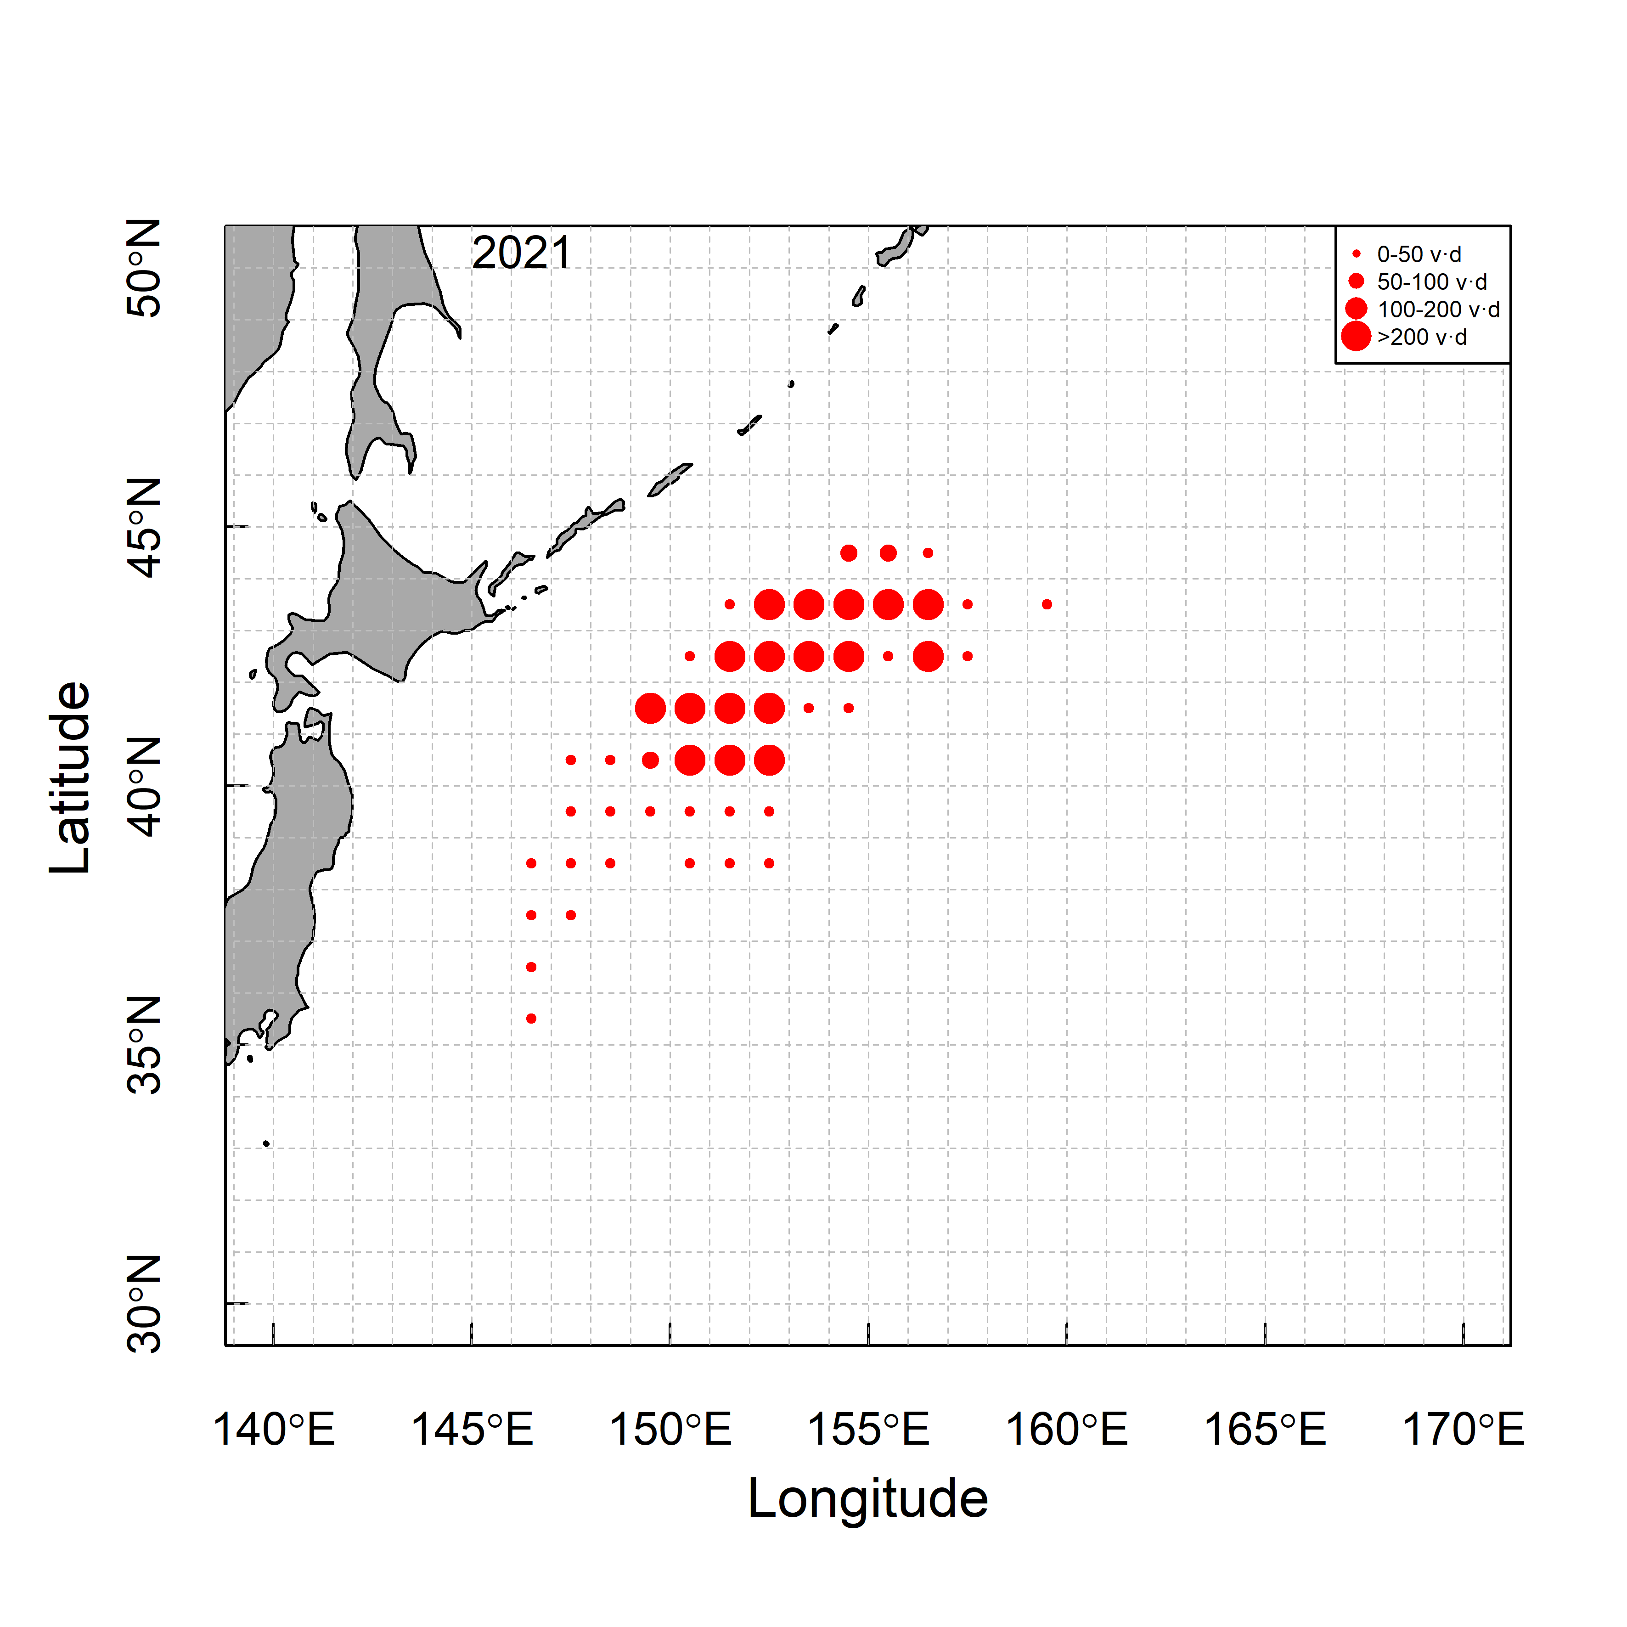 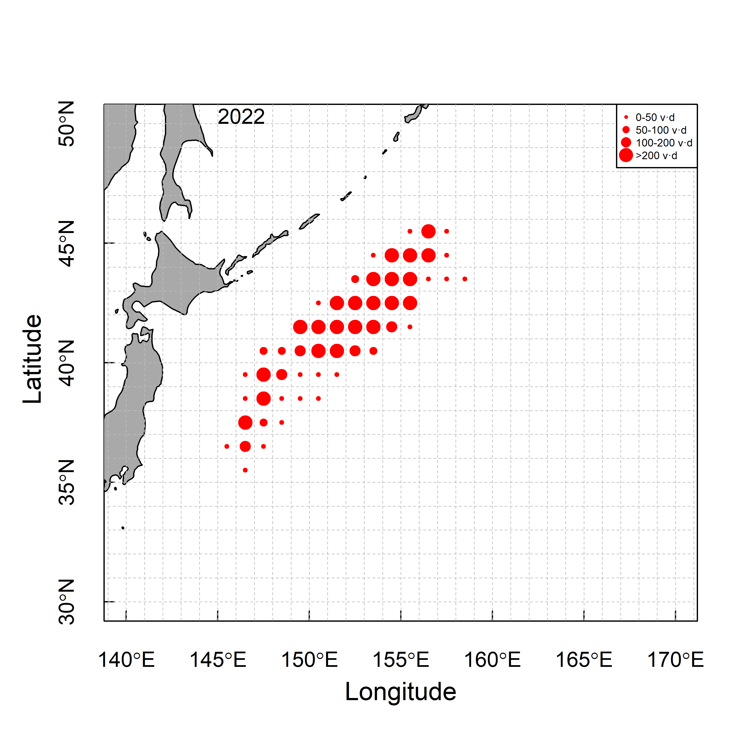

**Fig. 1b.** Spatio-temporal distribution of efforts by CPUE FLEET (vessel·day).

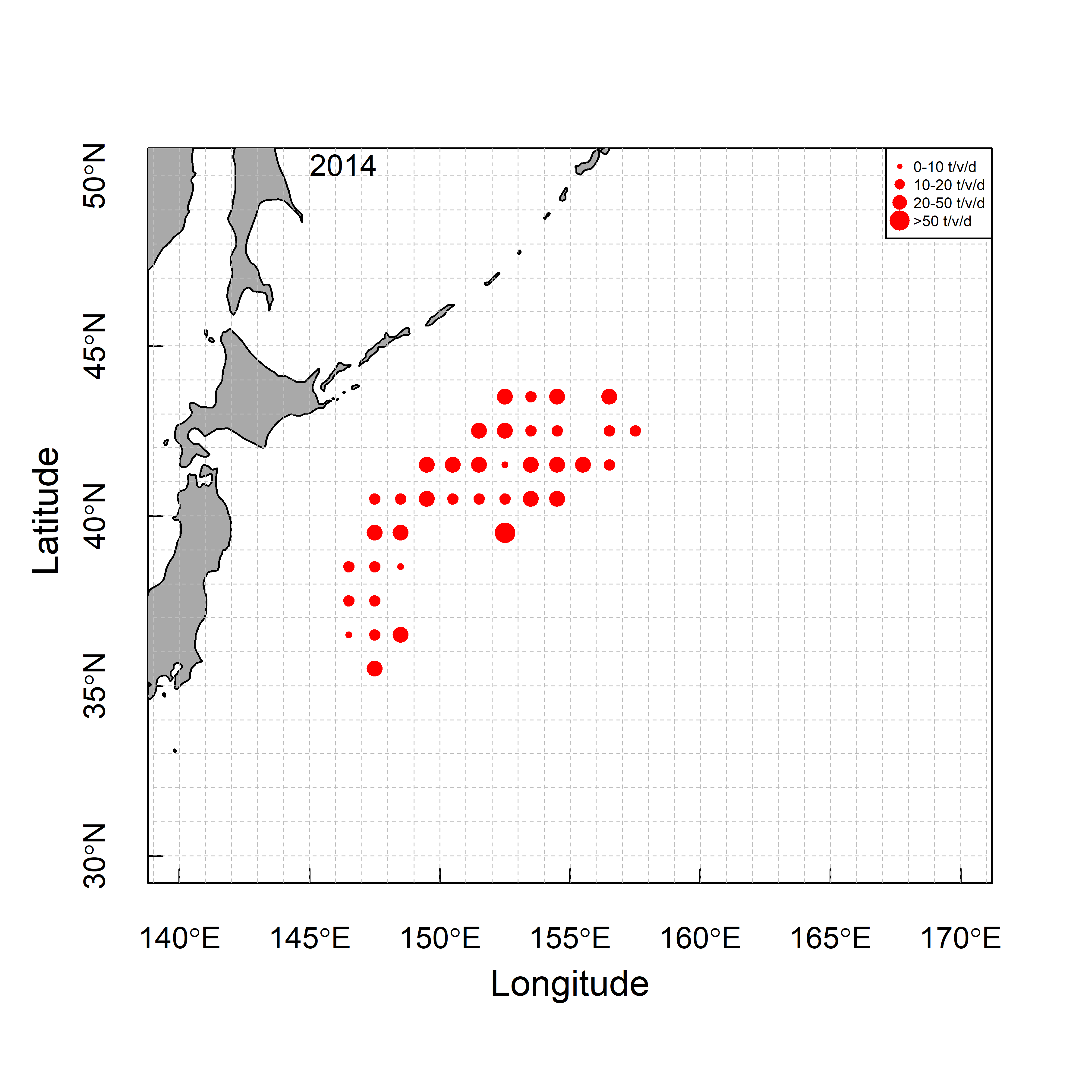 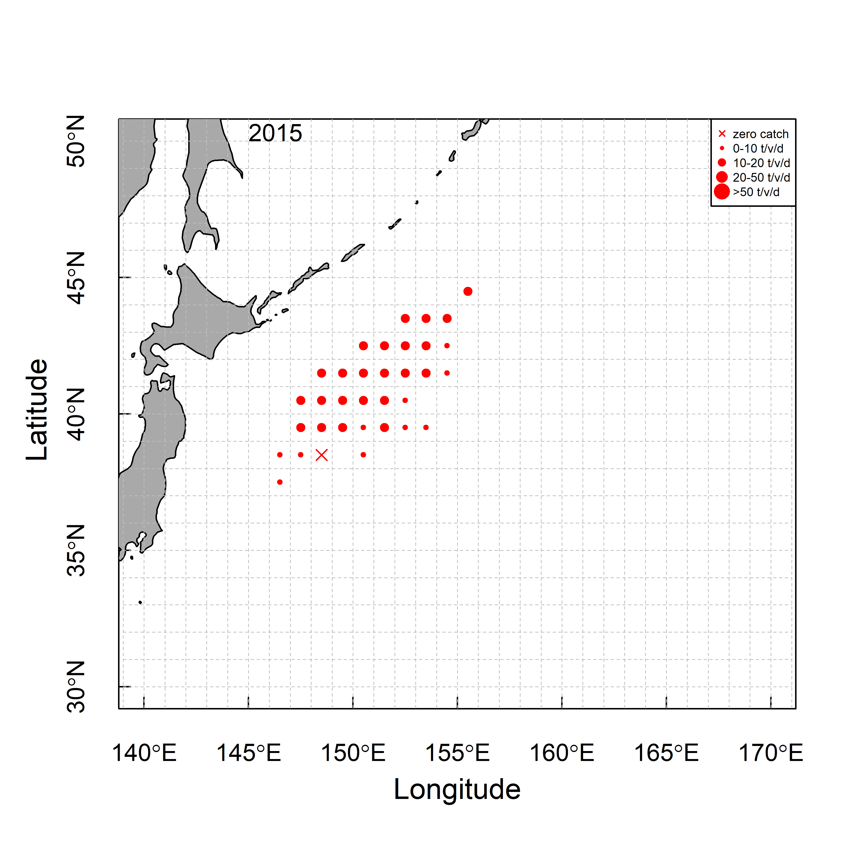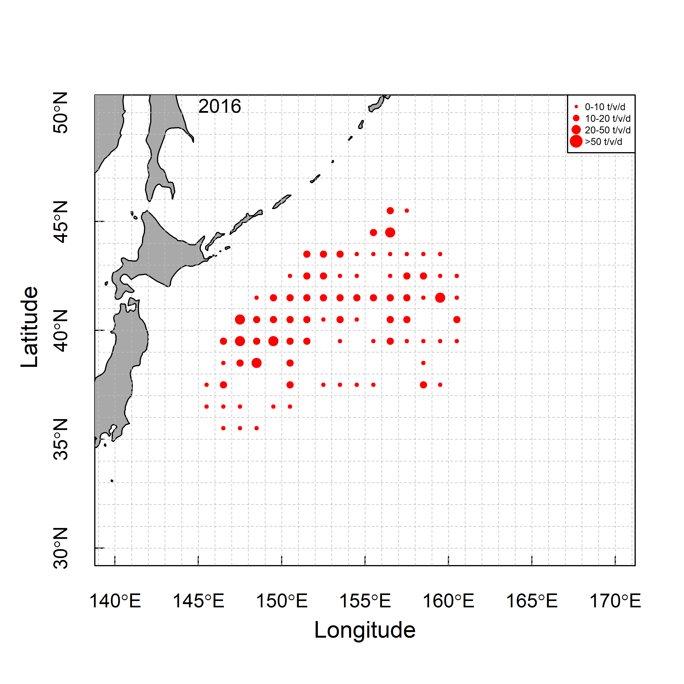

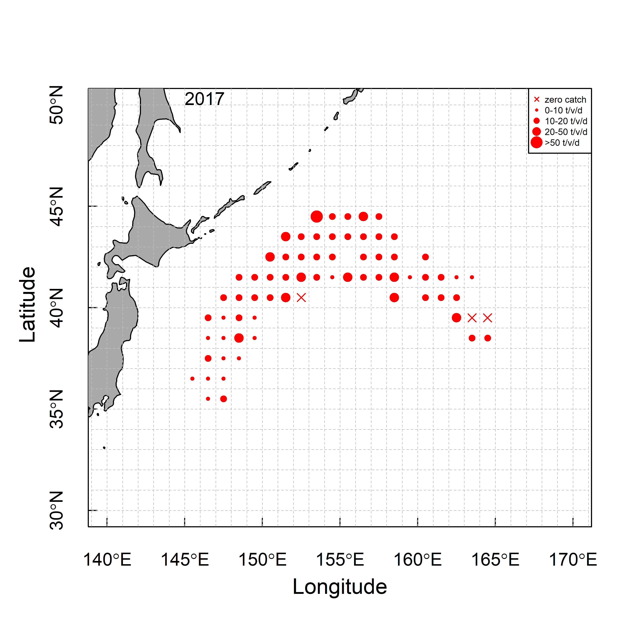 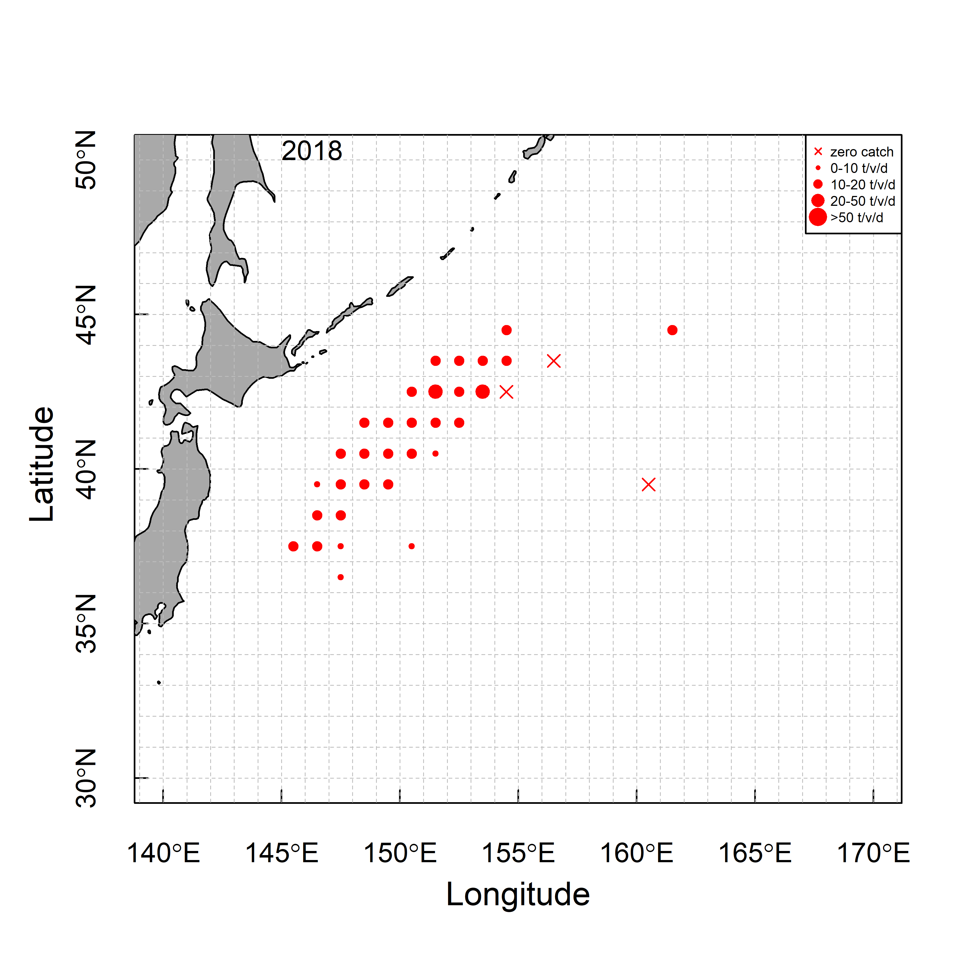 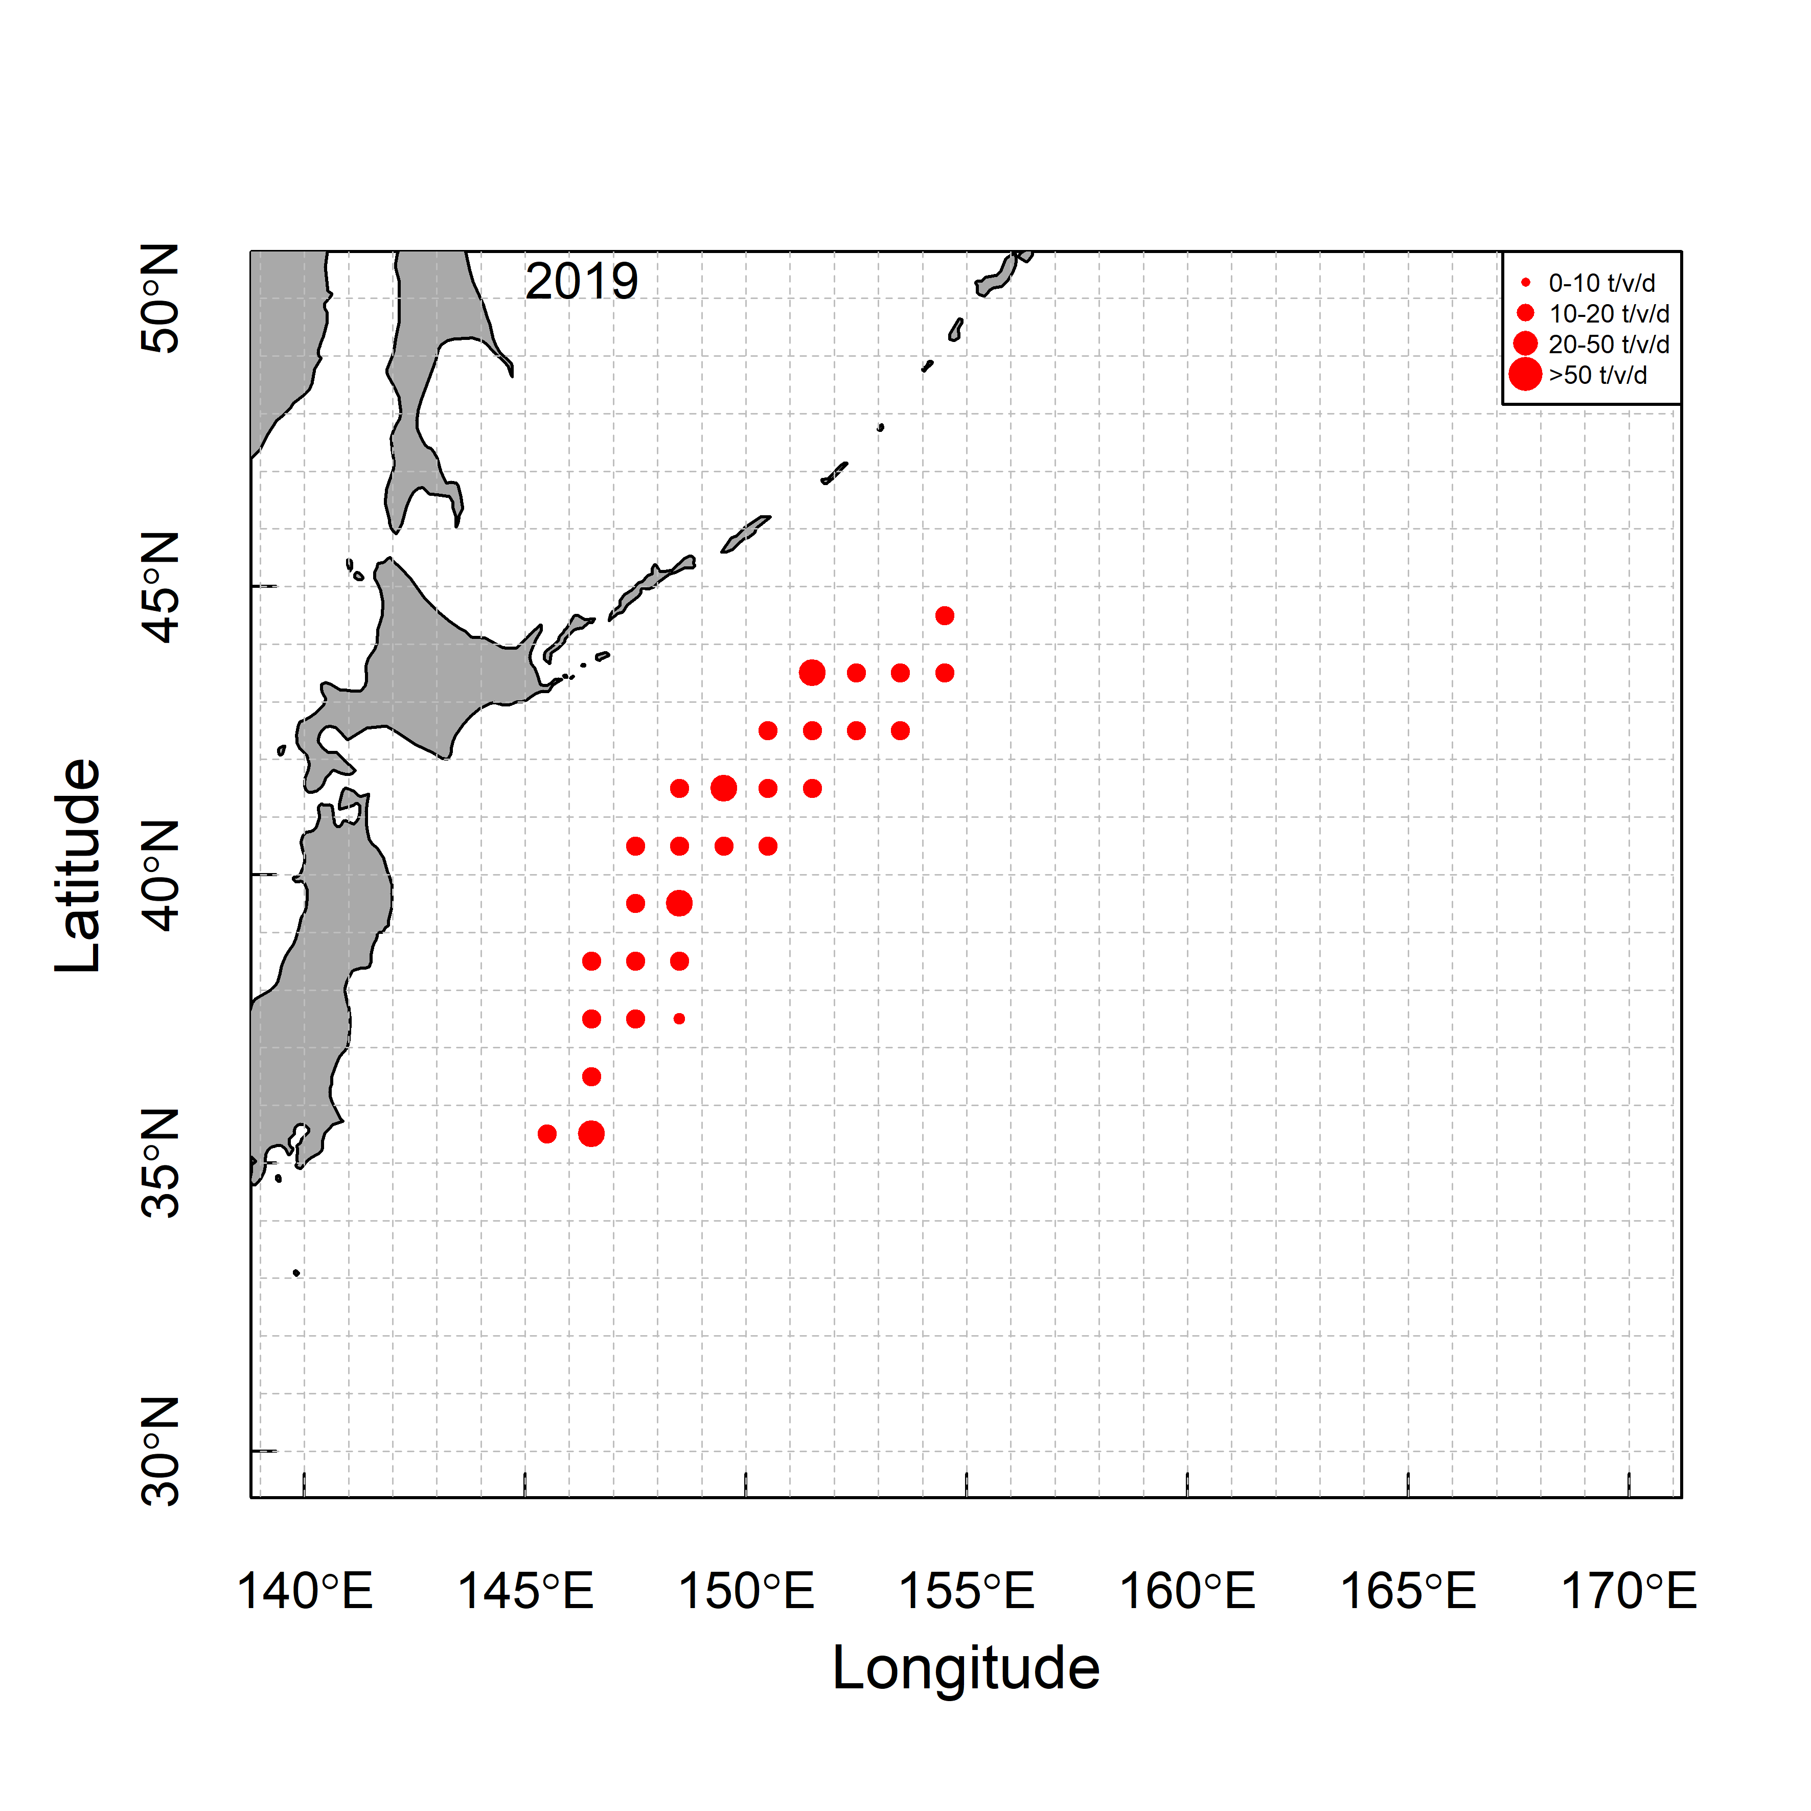

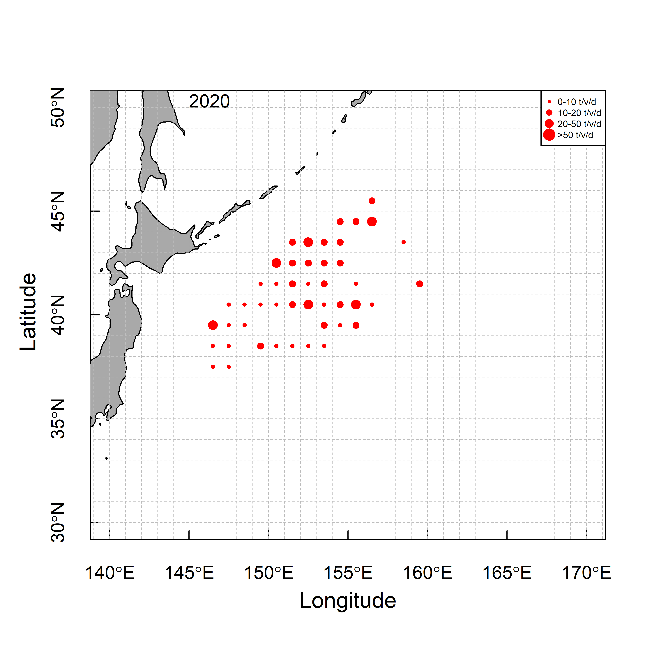 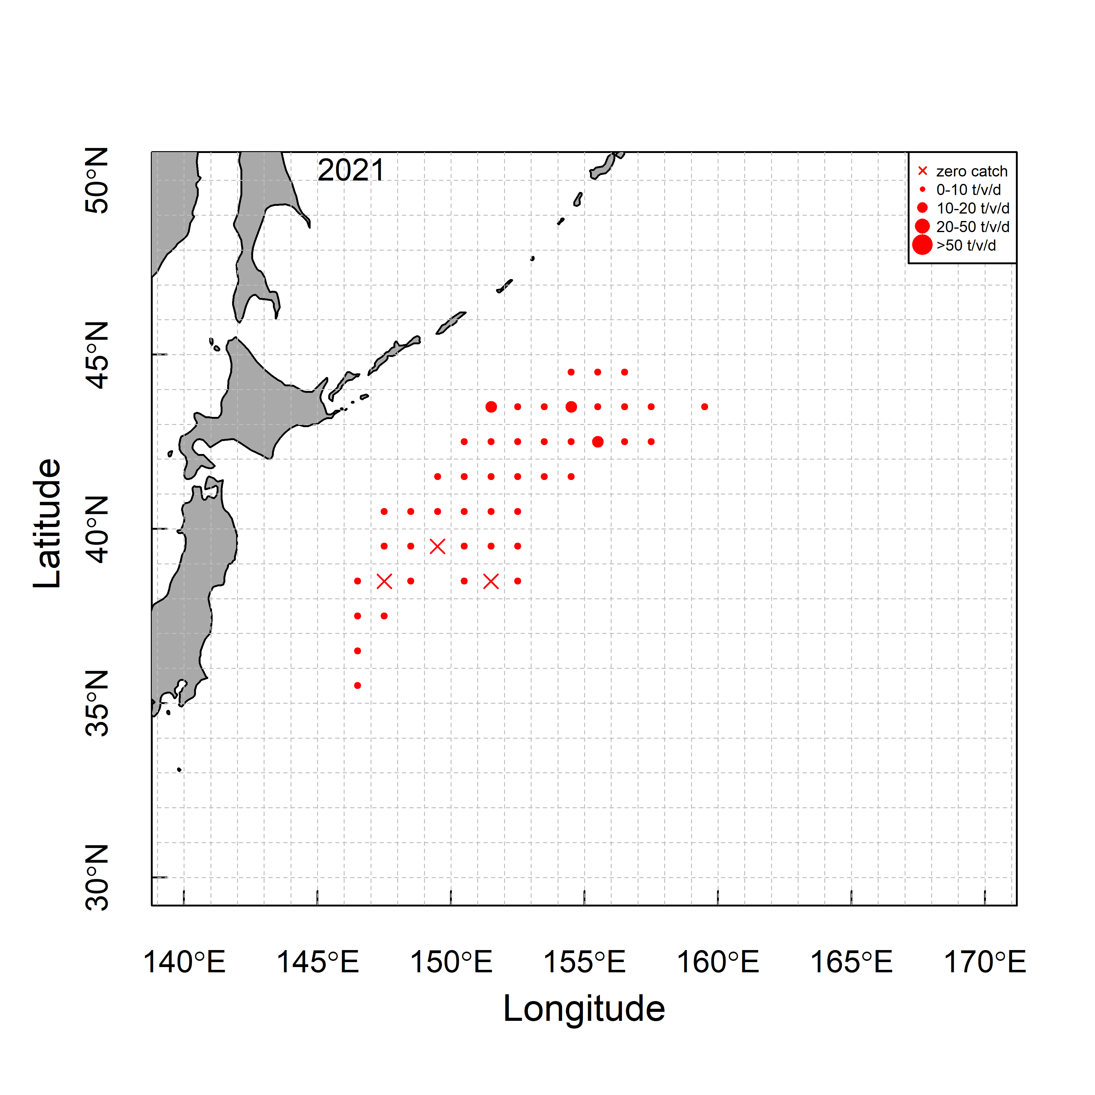 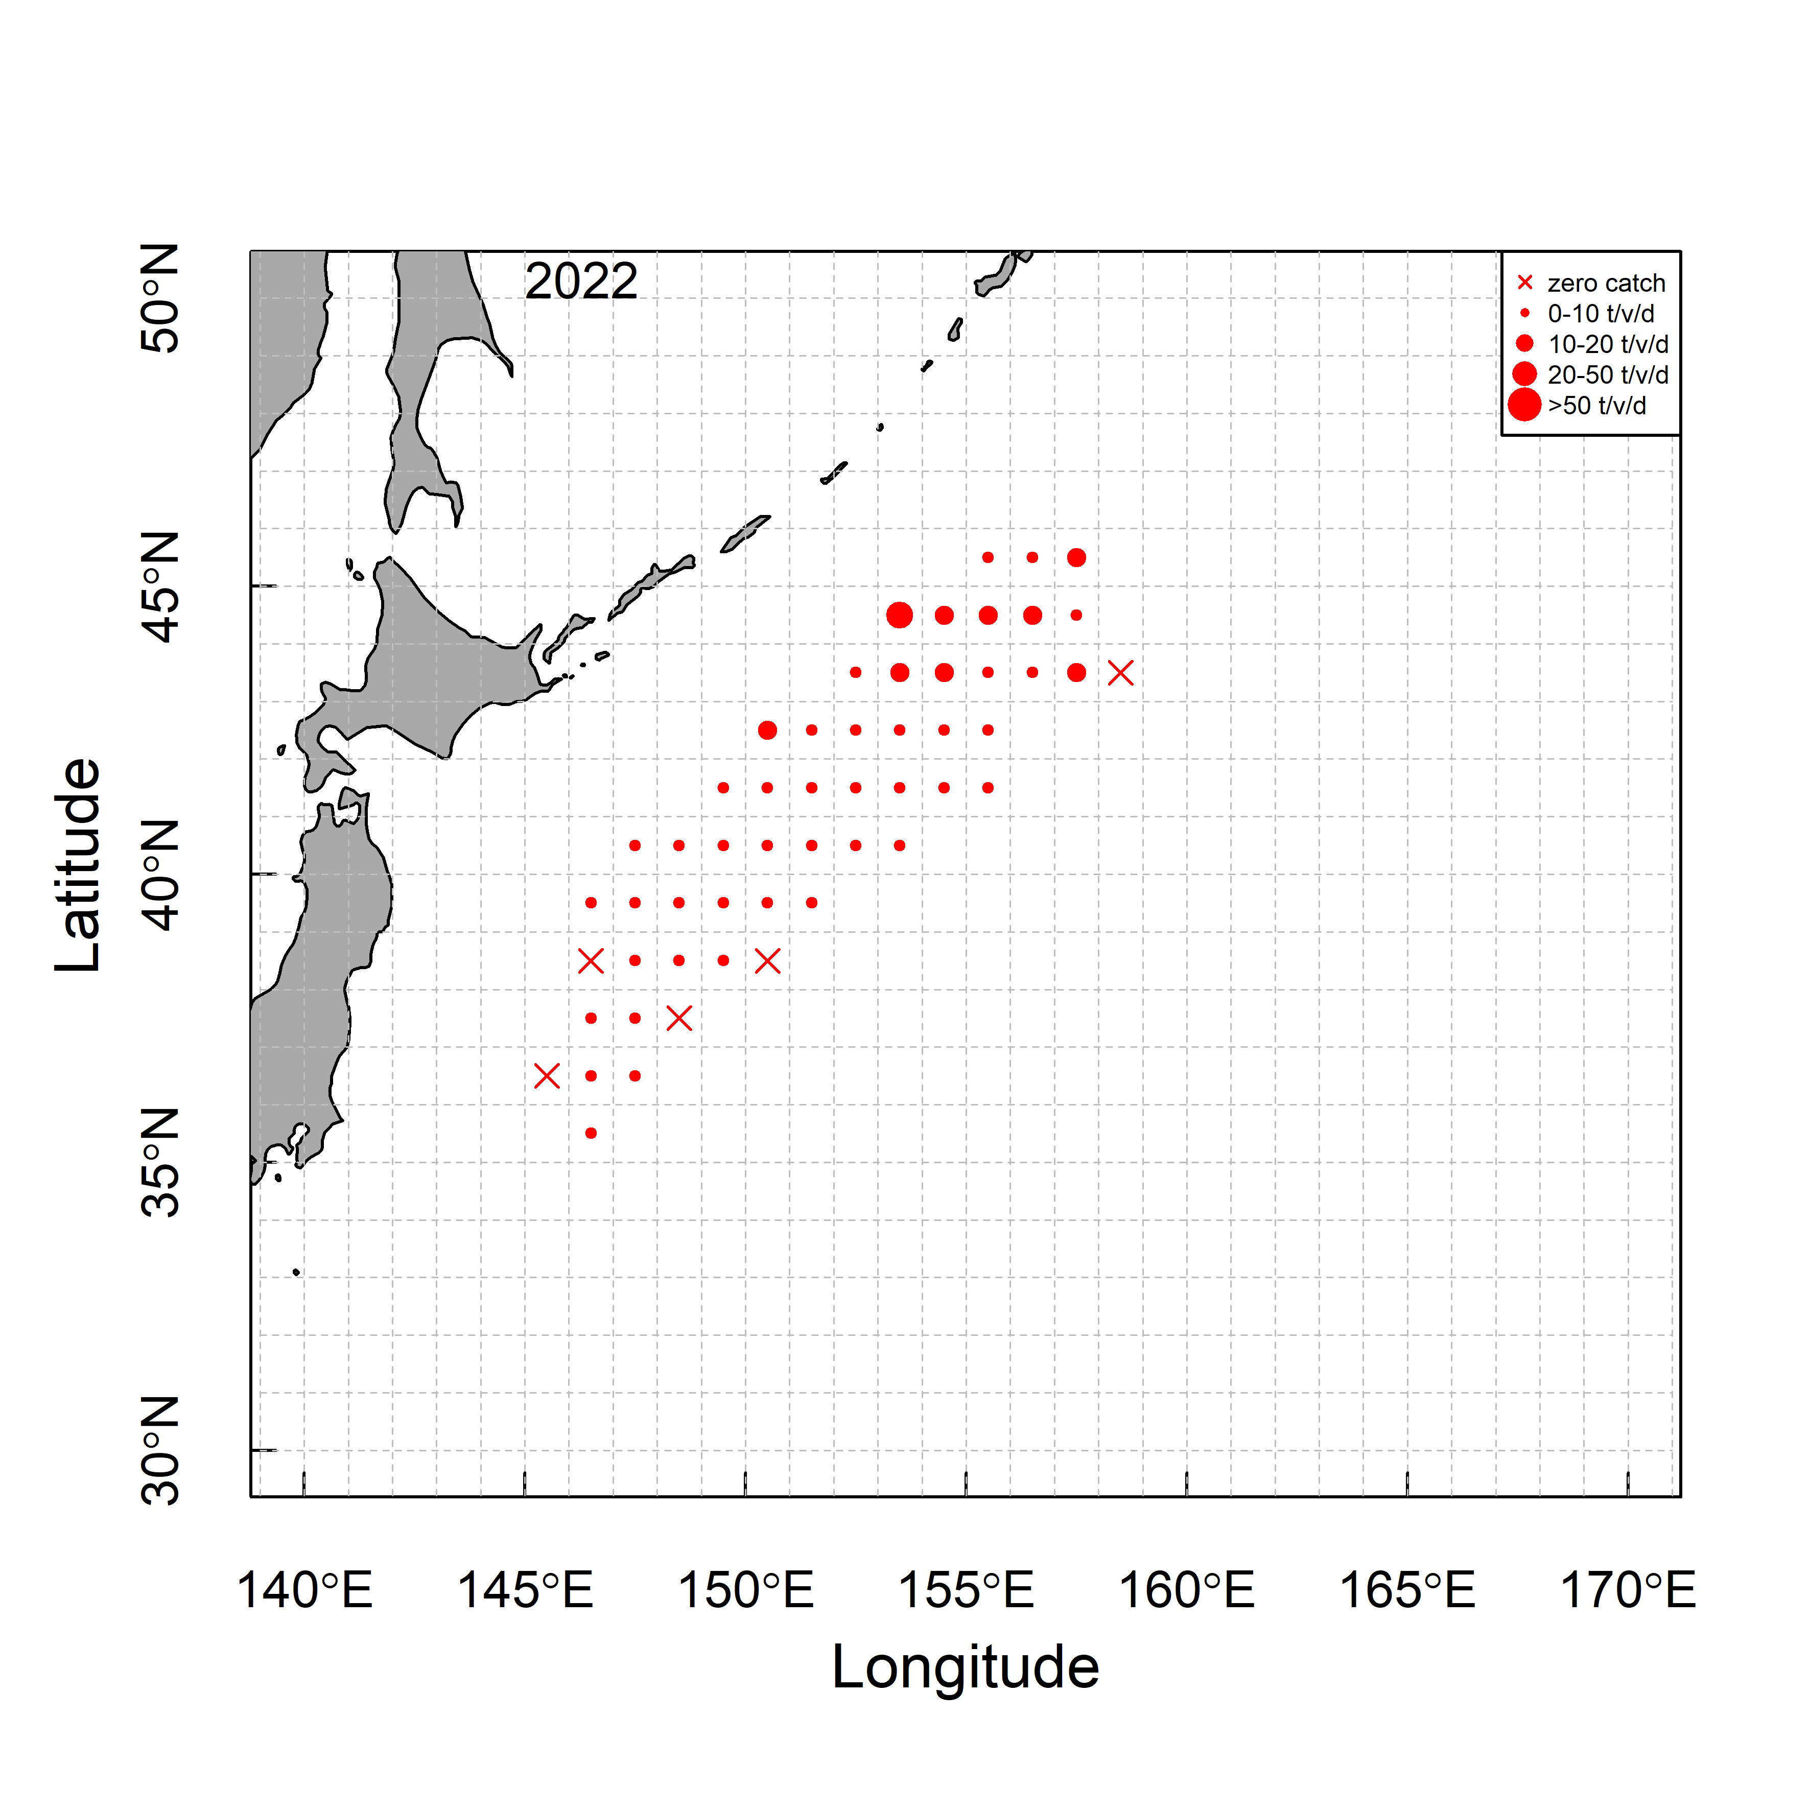

**Fig. 1c.** Spatio-temporal distribution of nominal CPUE of CPUE Fleet (t/v/d).

(a)

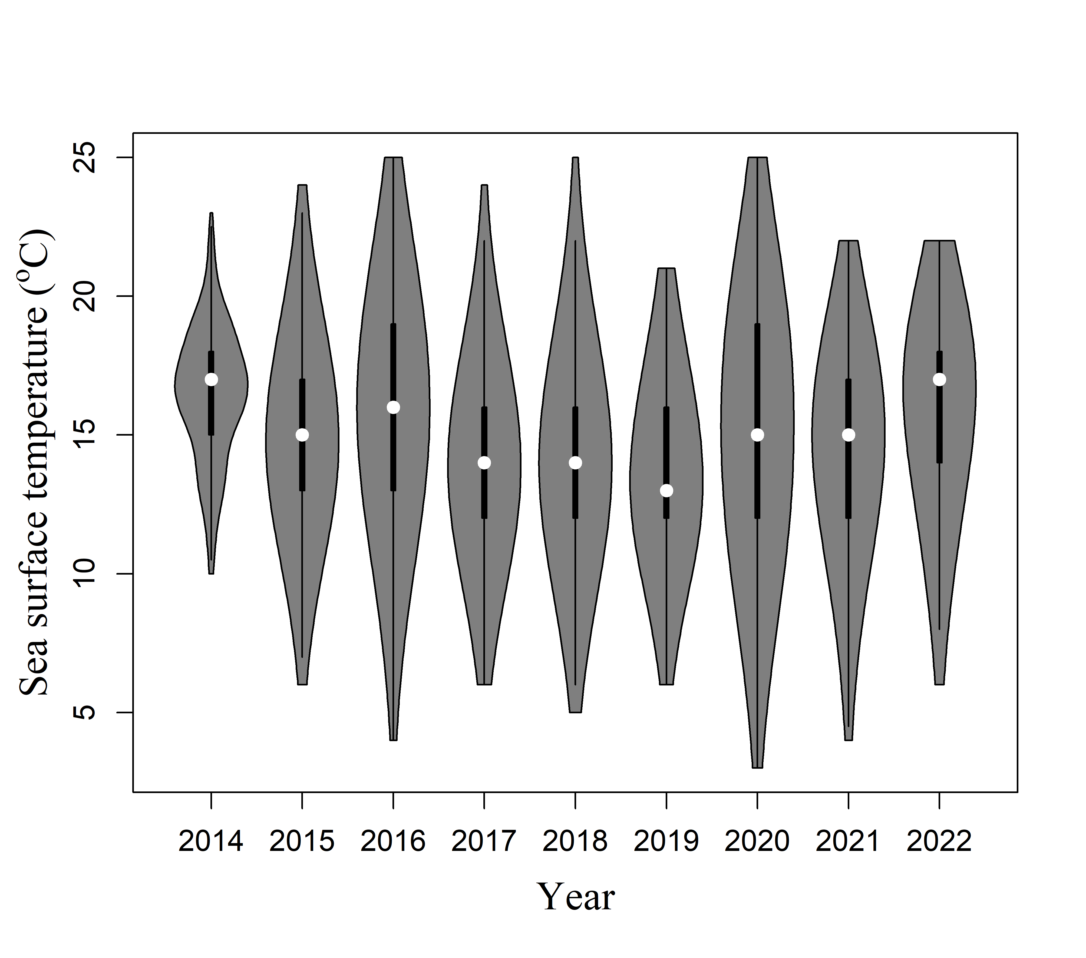 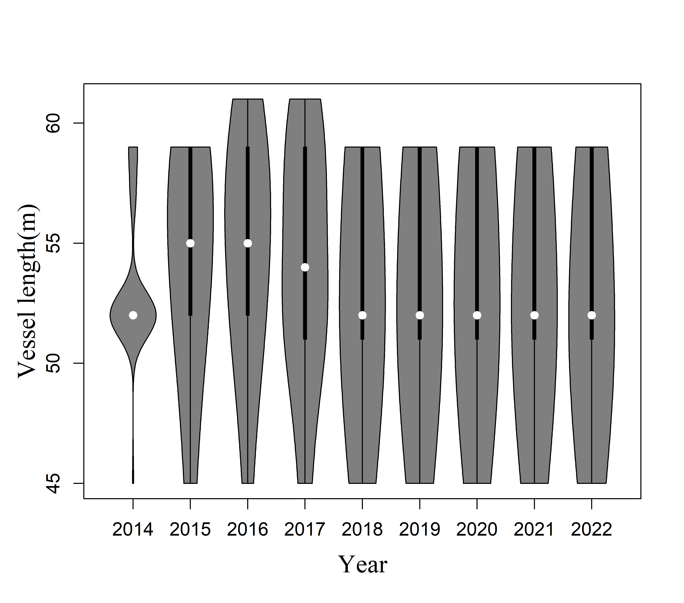

(b)

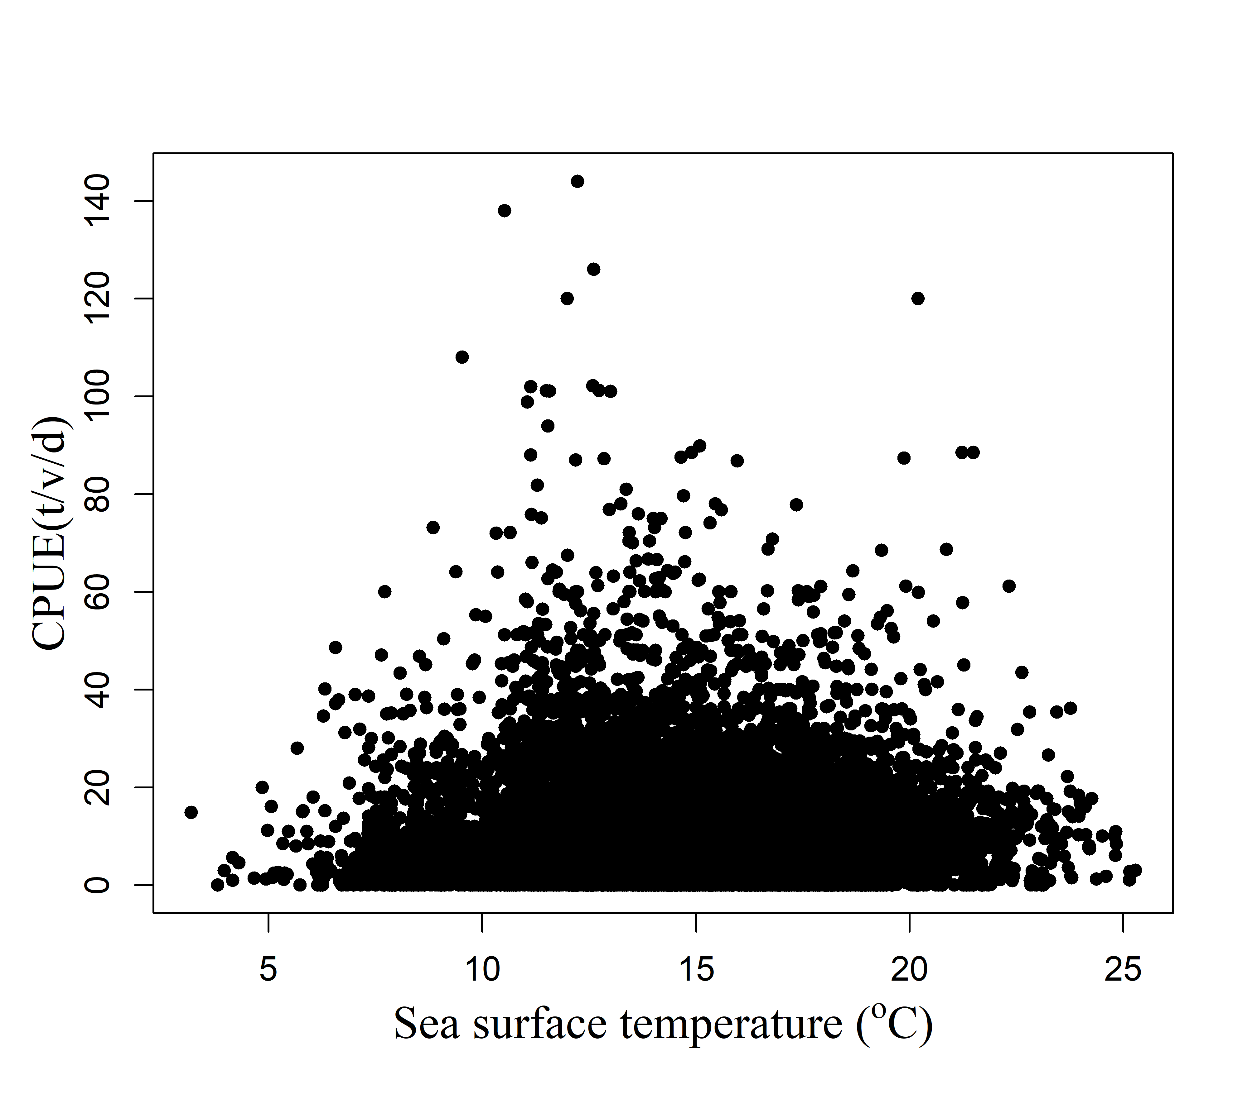 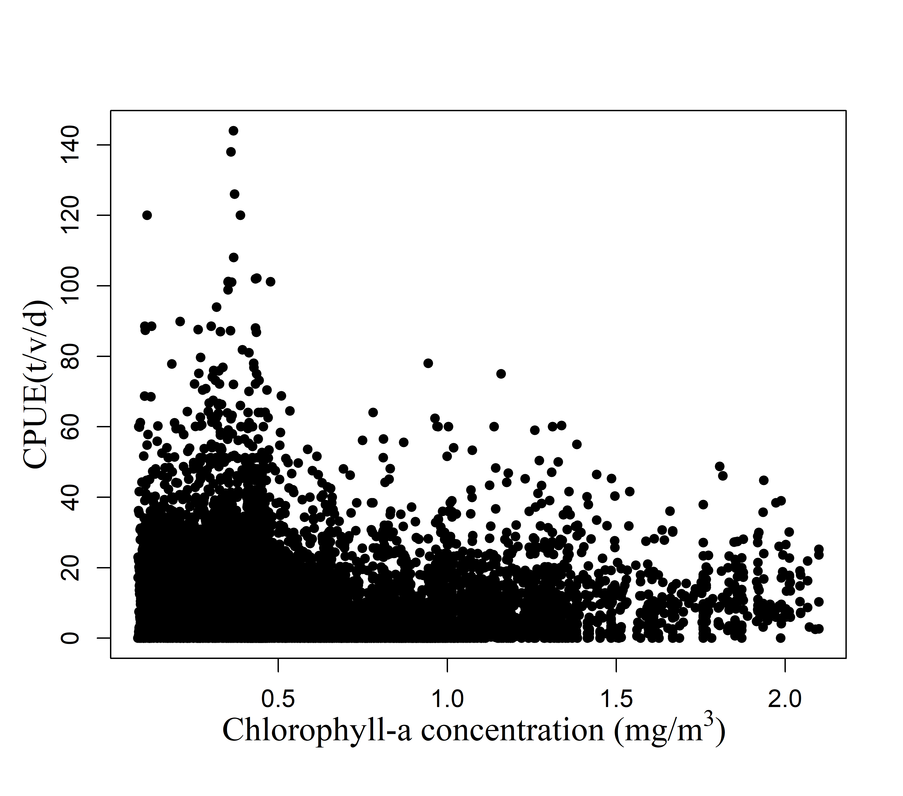

**Fig. 2.** Plots of explanatory variables of sea surface temperature (SST) and Vessel length by year (a) and scatter plots between CPUE and SST, Chla (b).

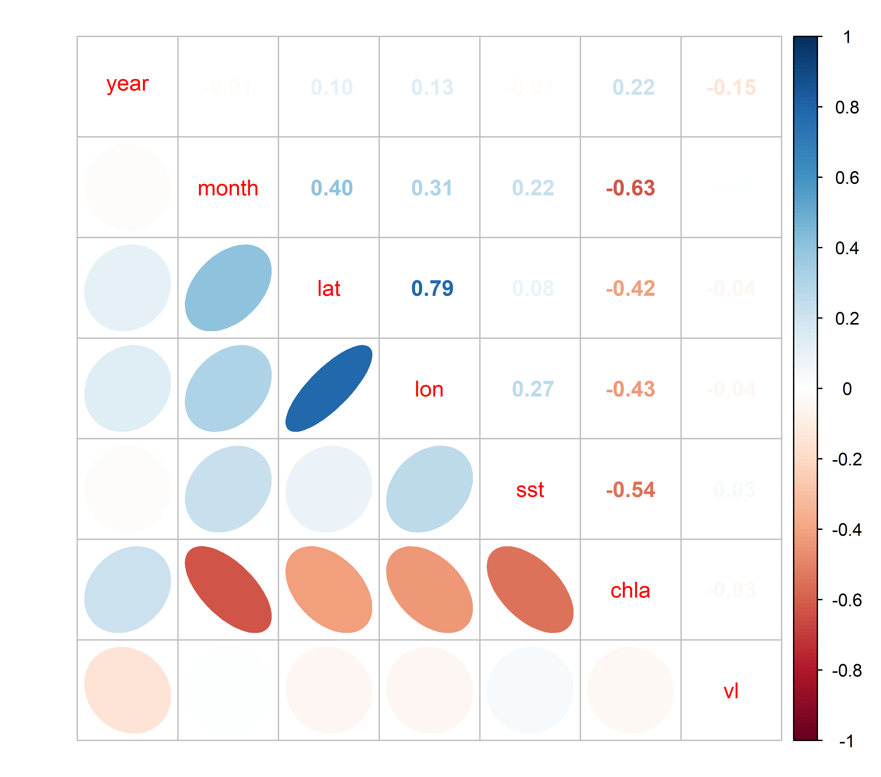

**Fig. 3.** Correlation matrix of explanatory variables used in the analysis

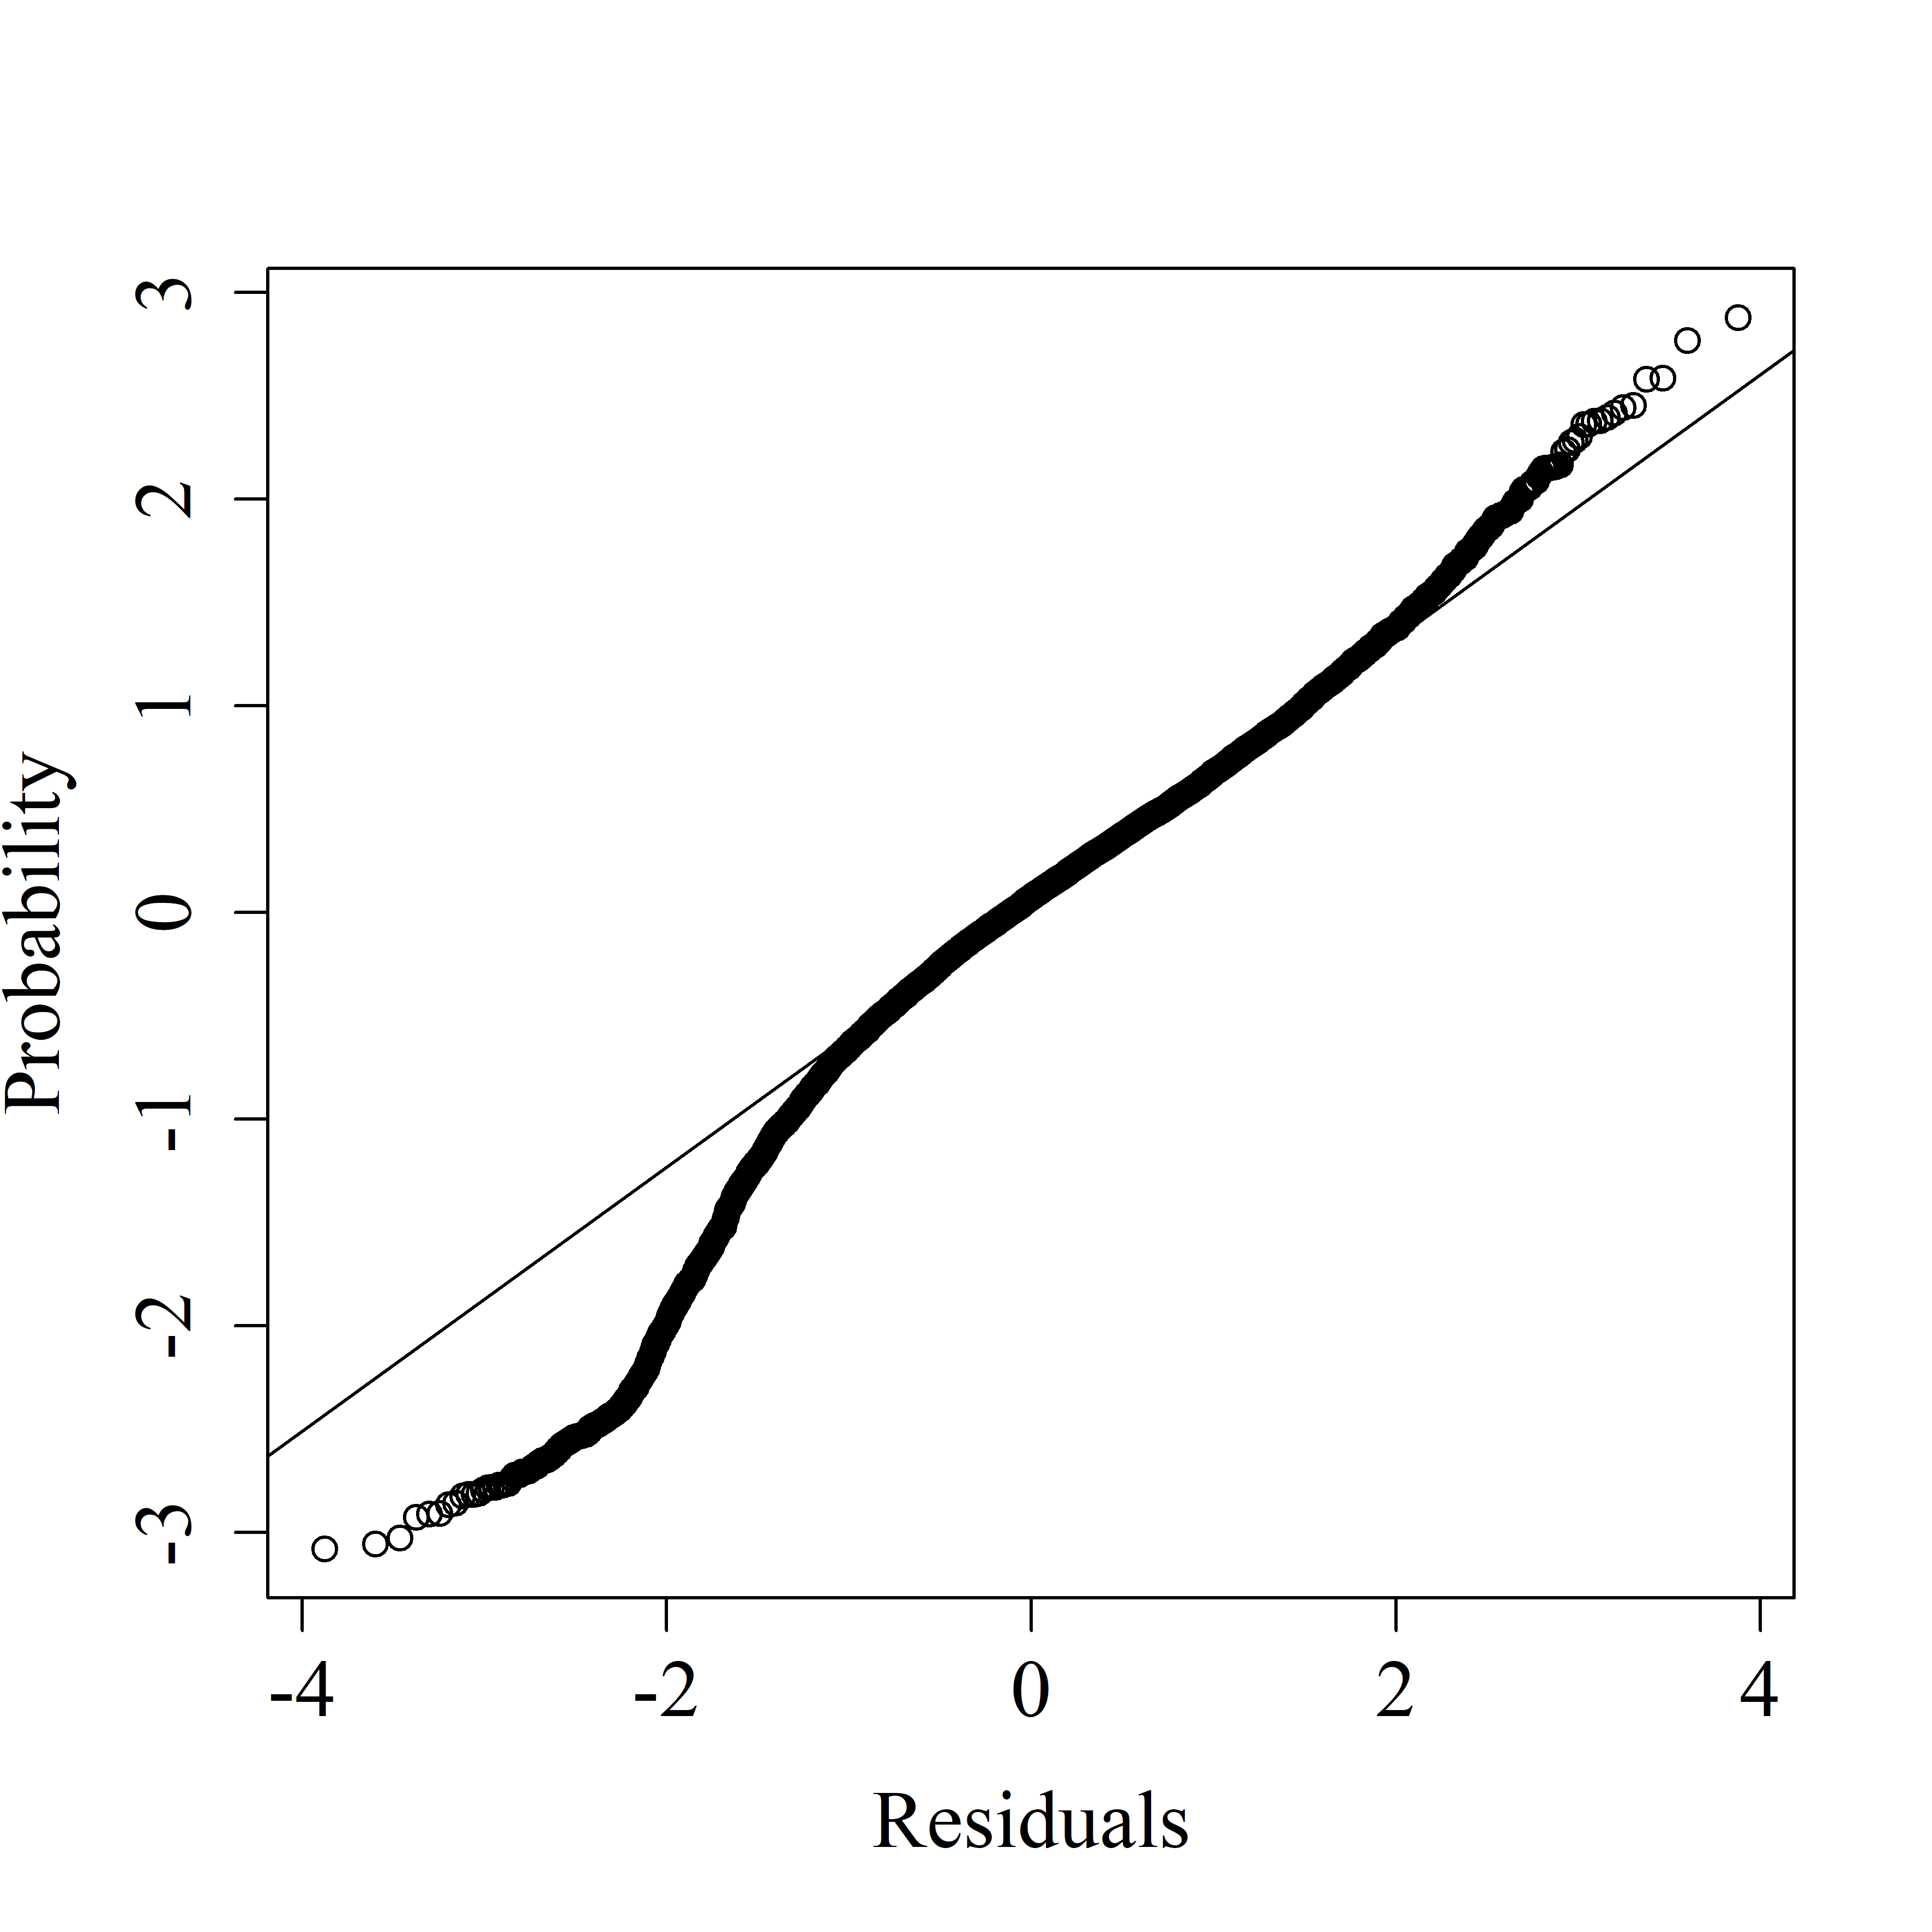 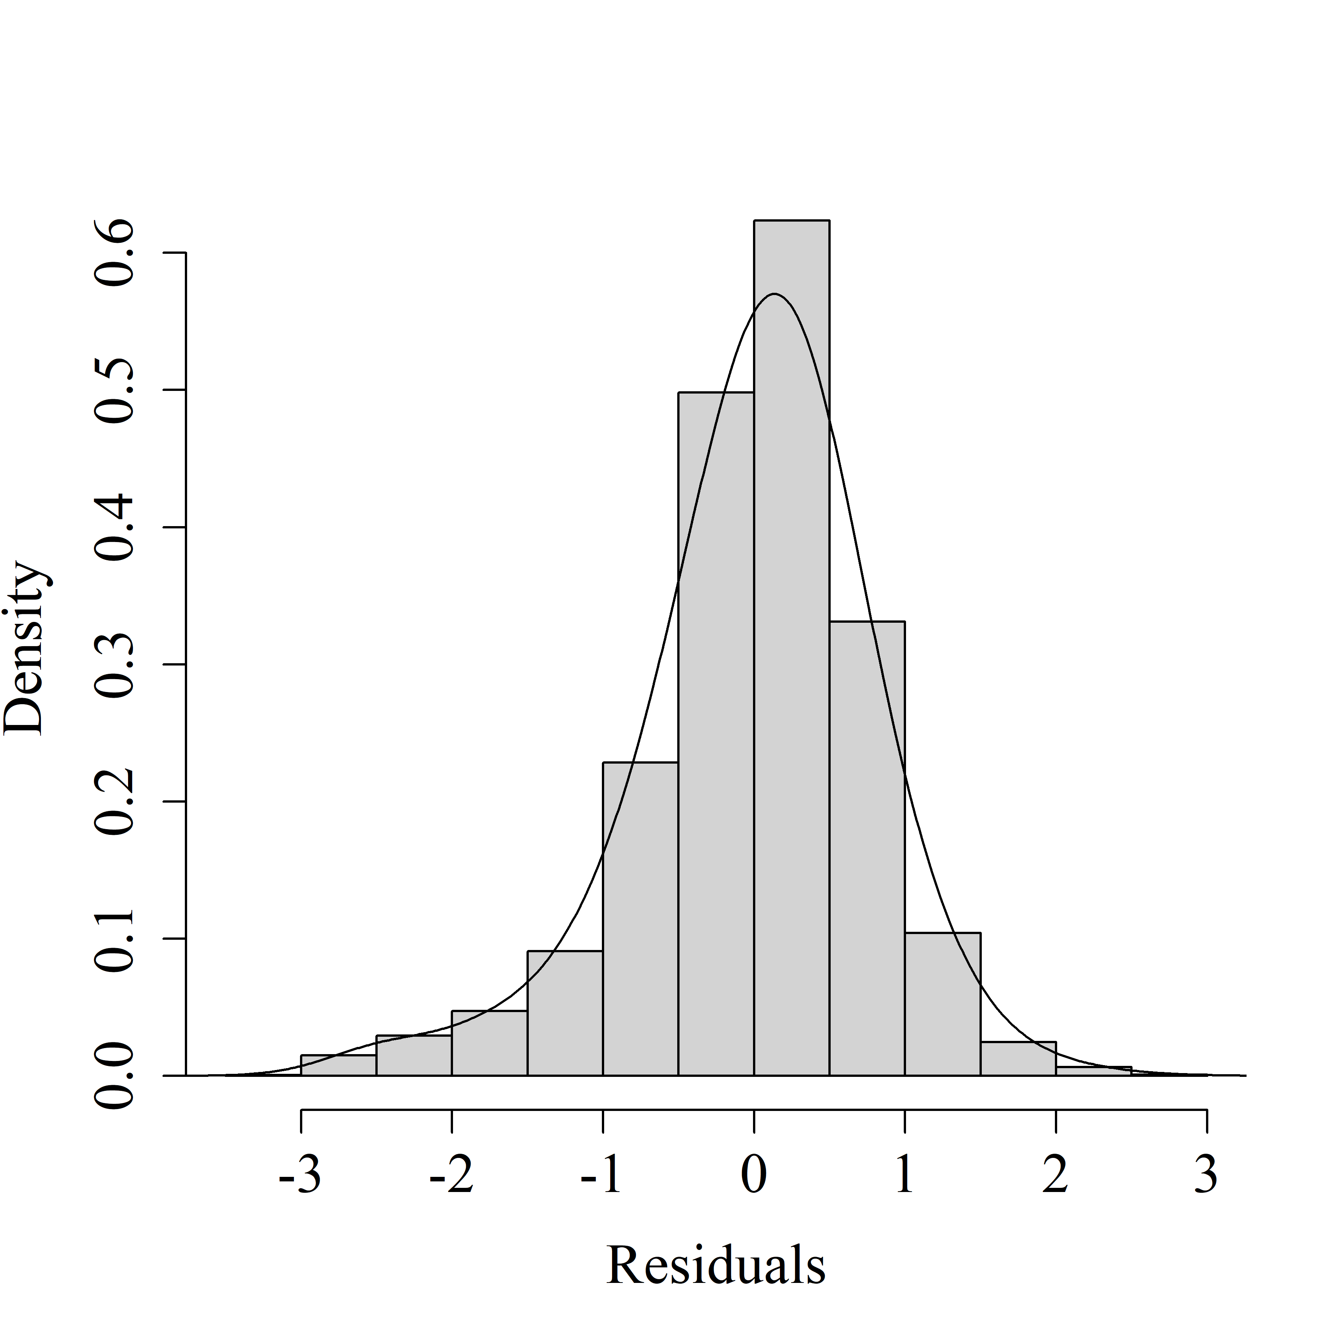 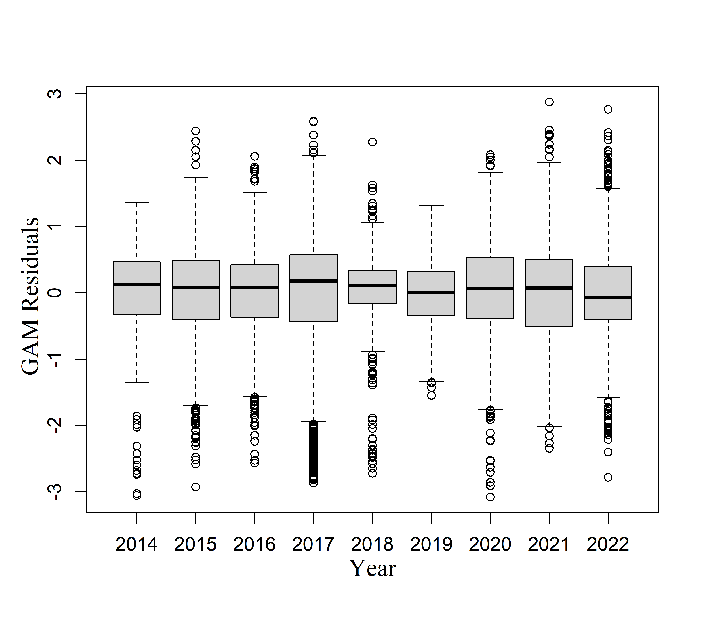

**Fig. 4.** Q-Q plot, histogram of residuals and residual plots across years for the best GAM.

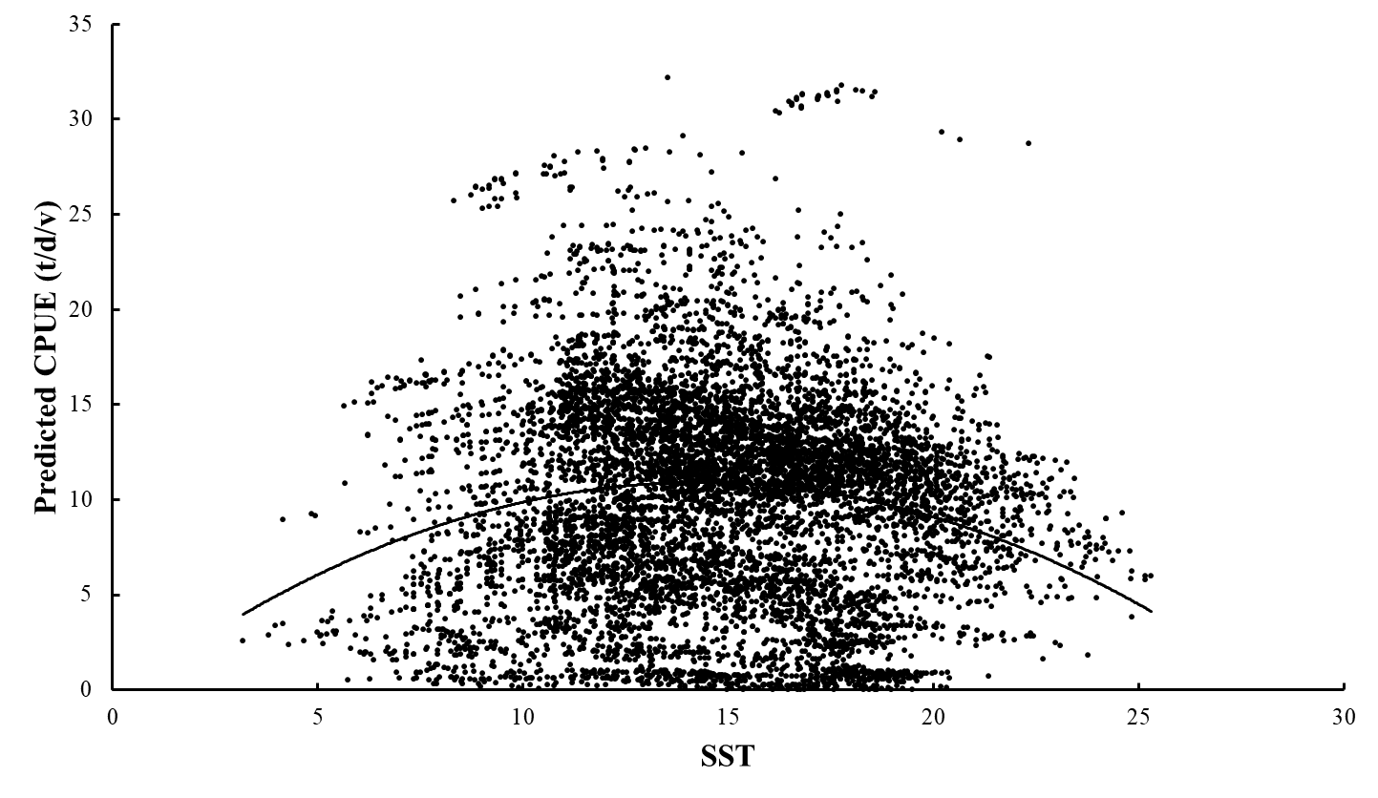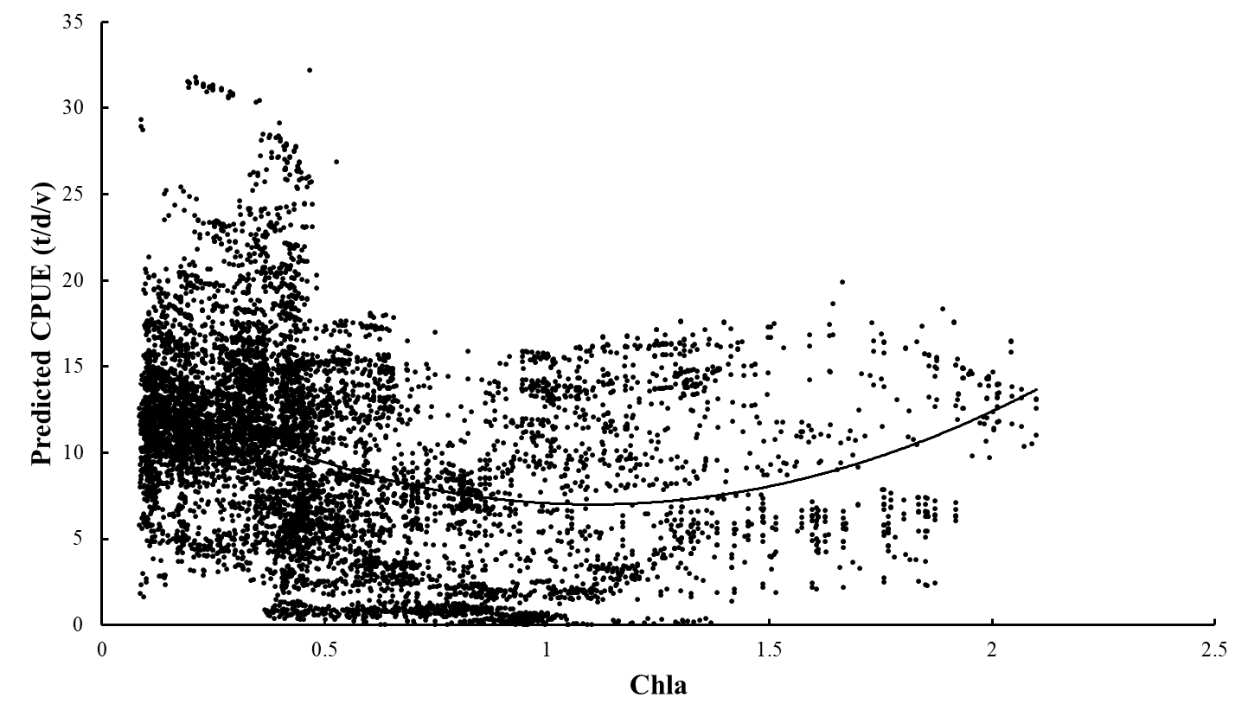

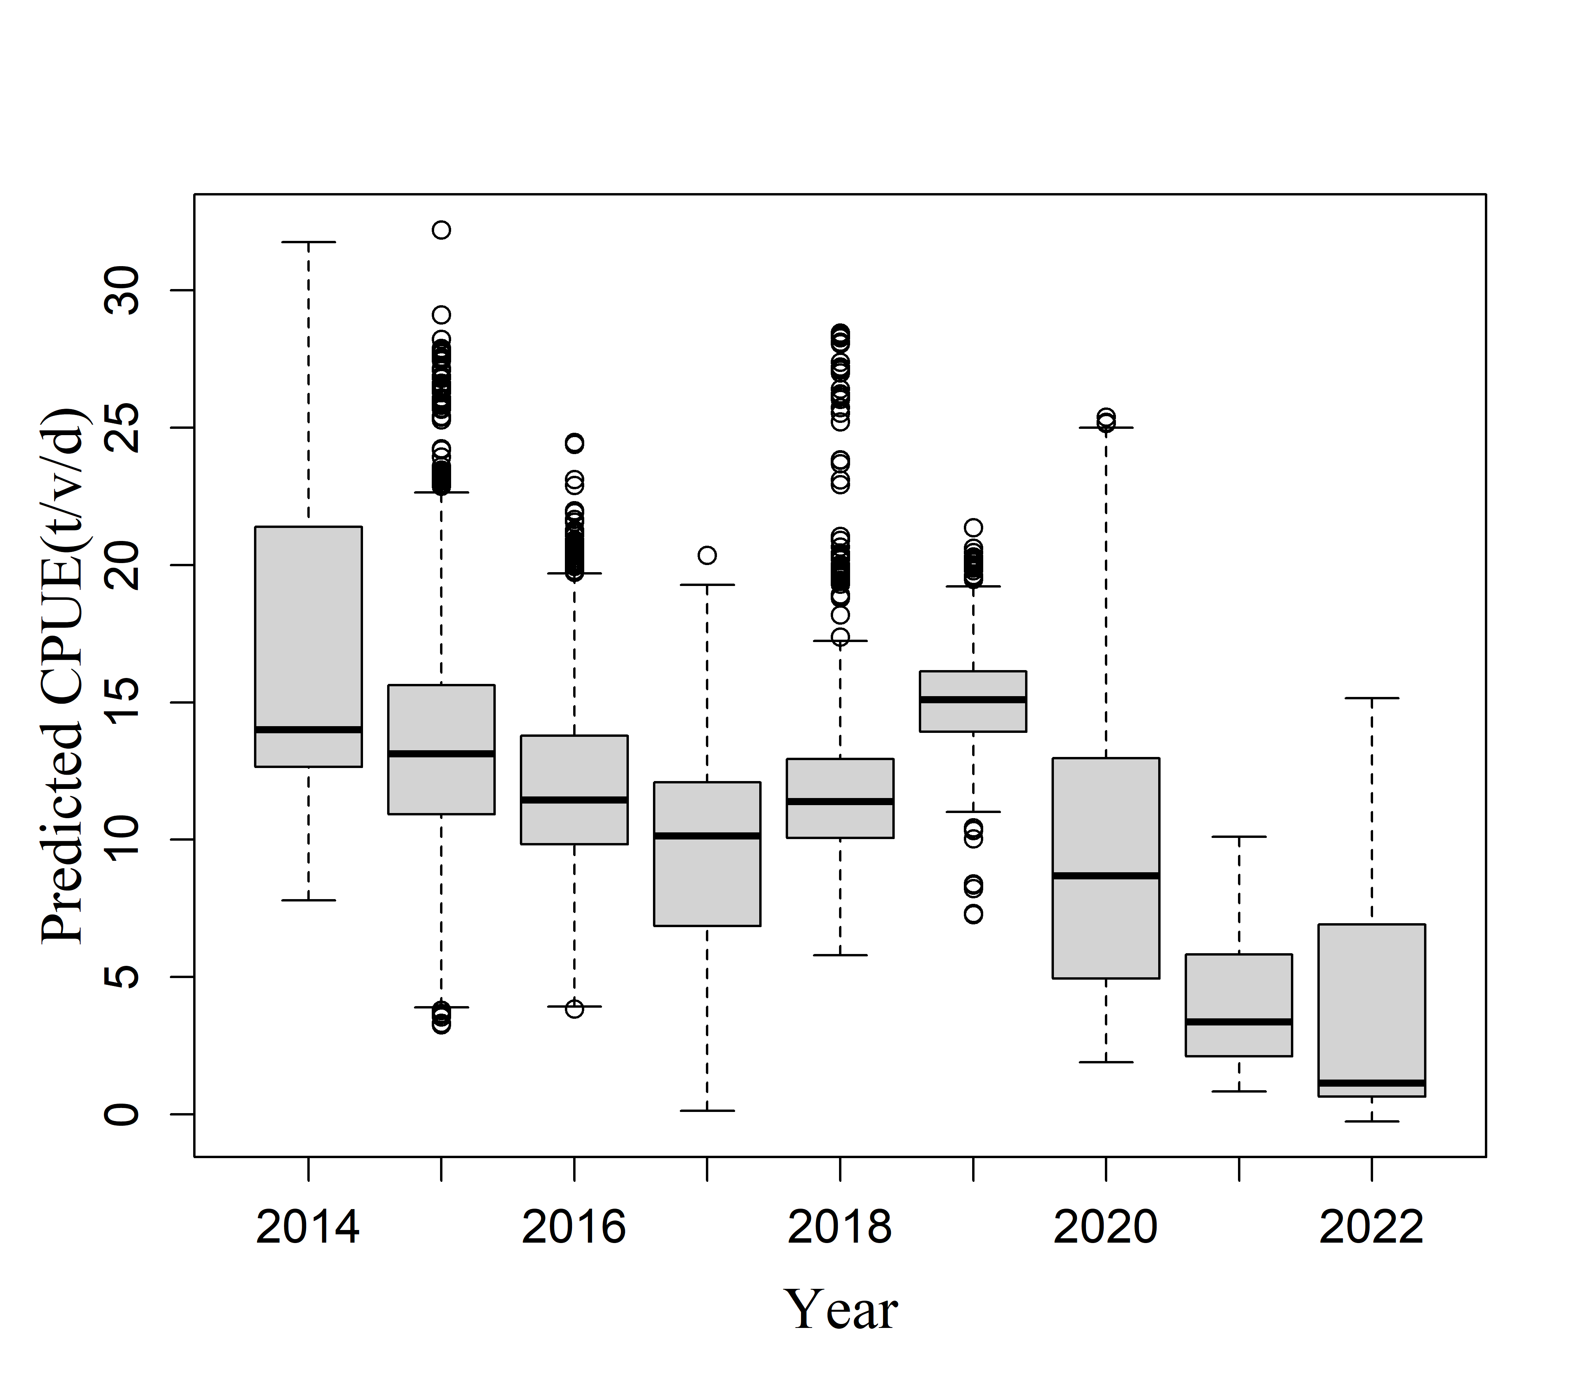 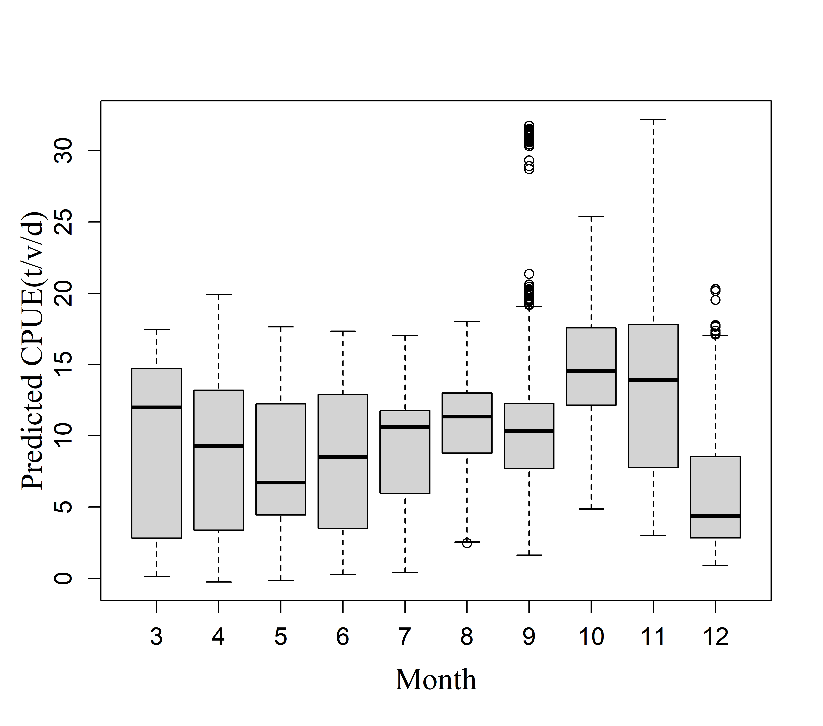

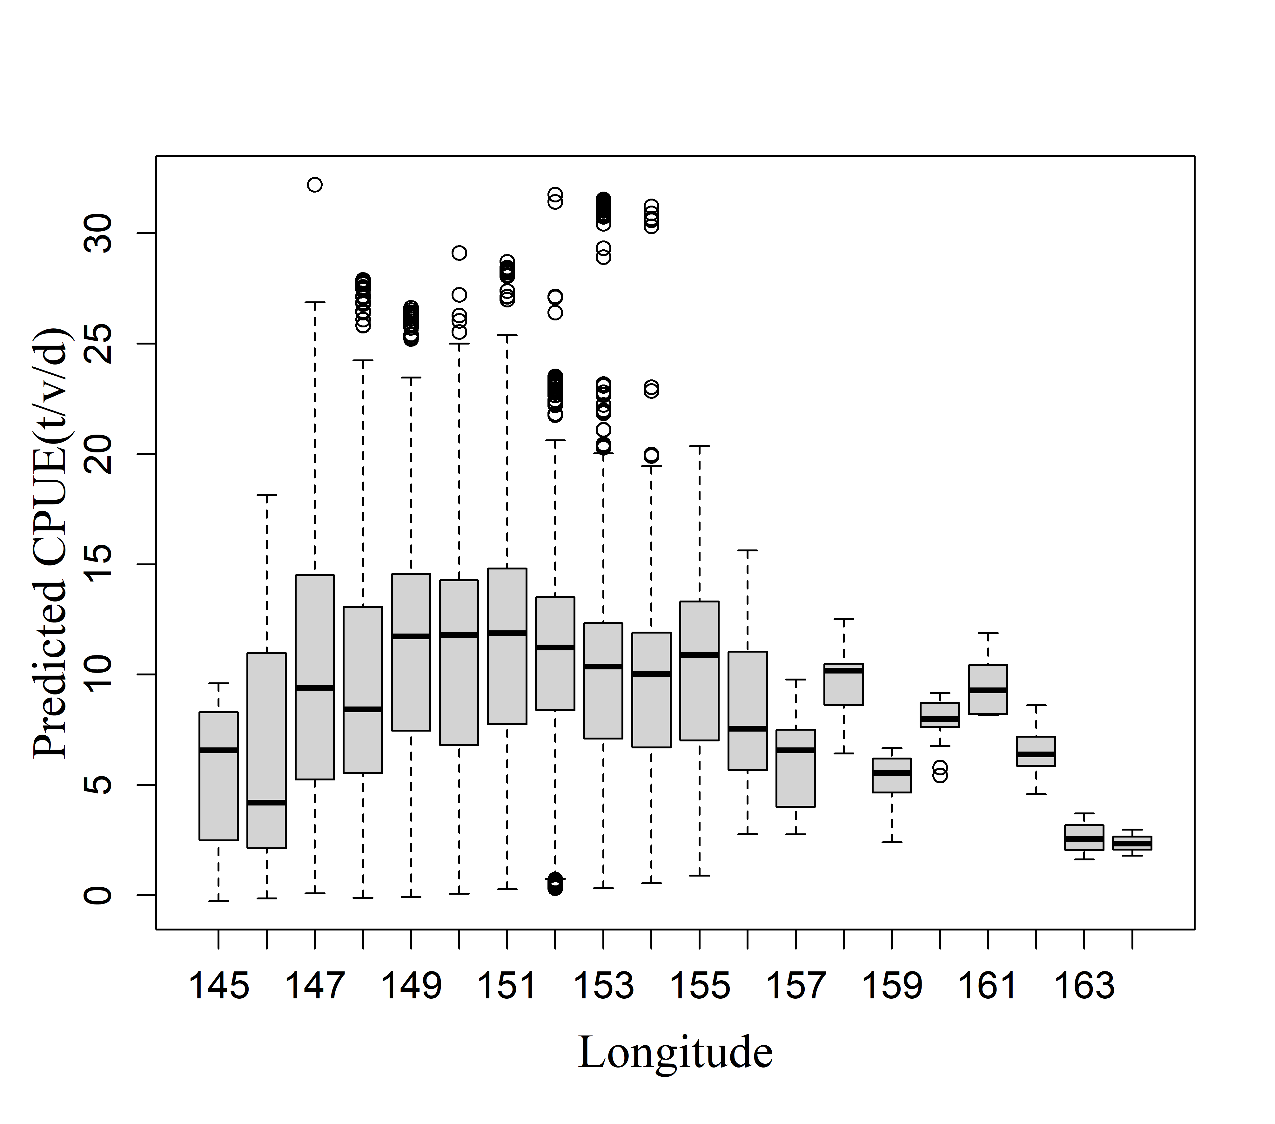 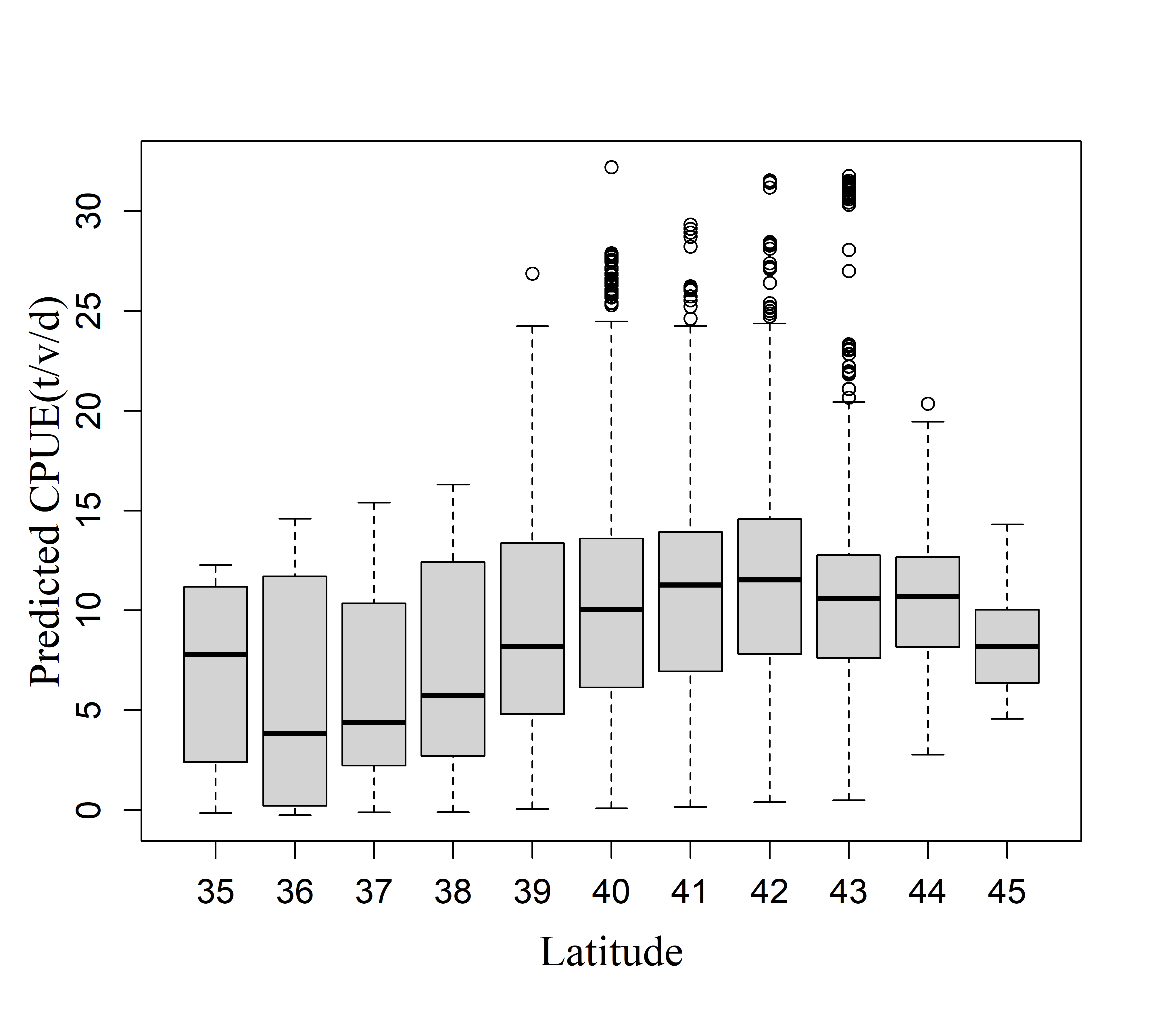

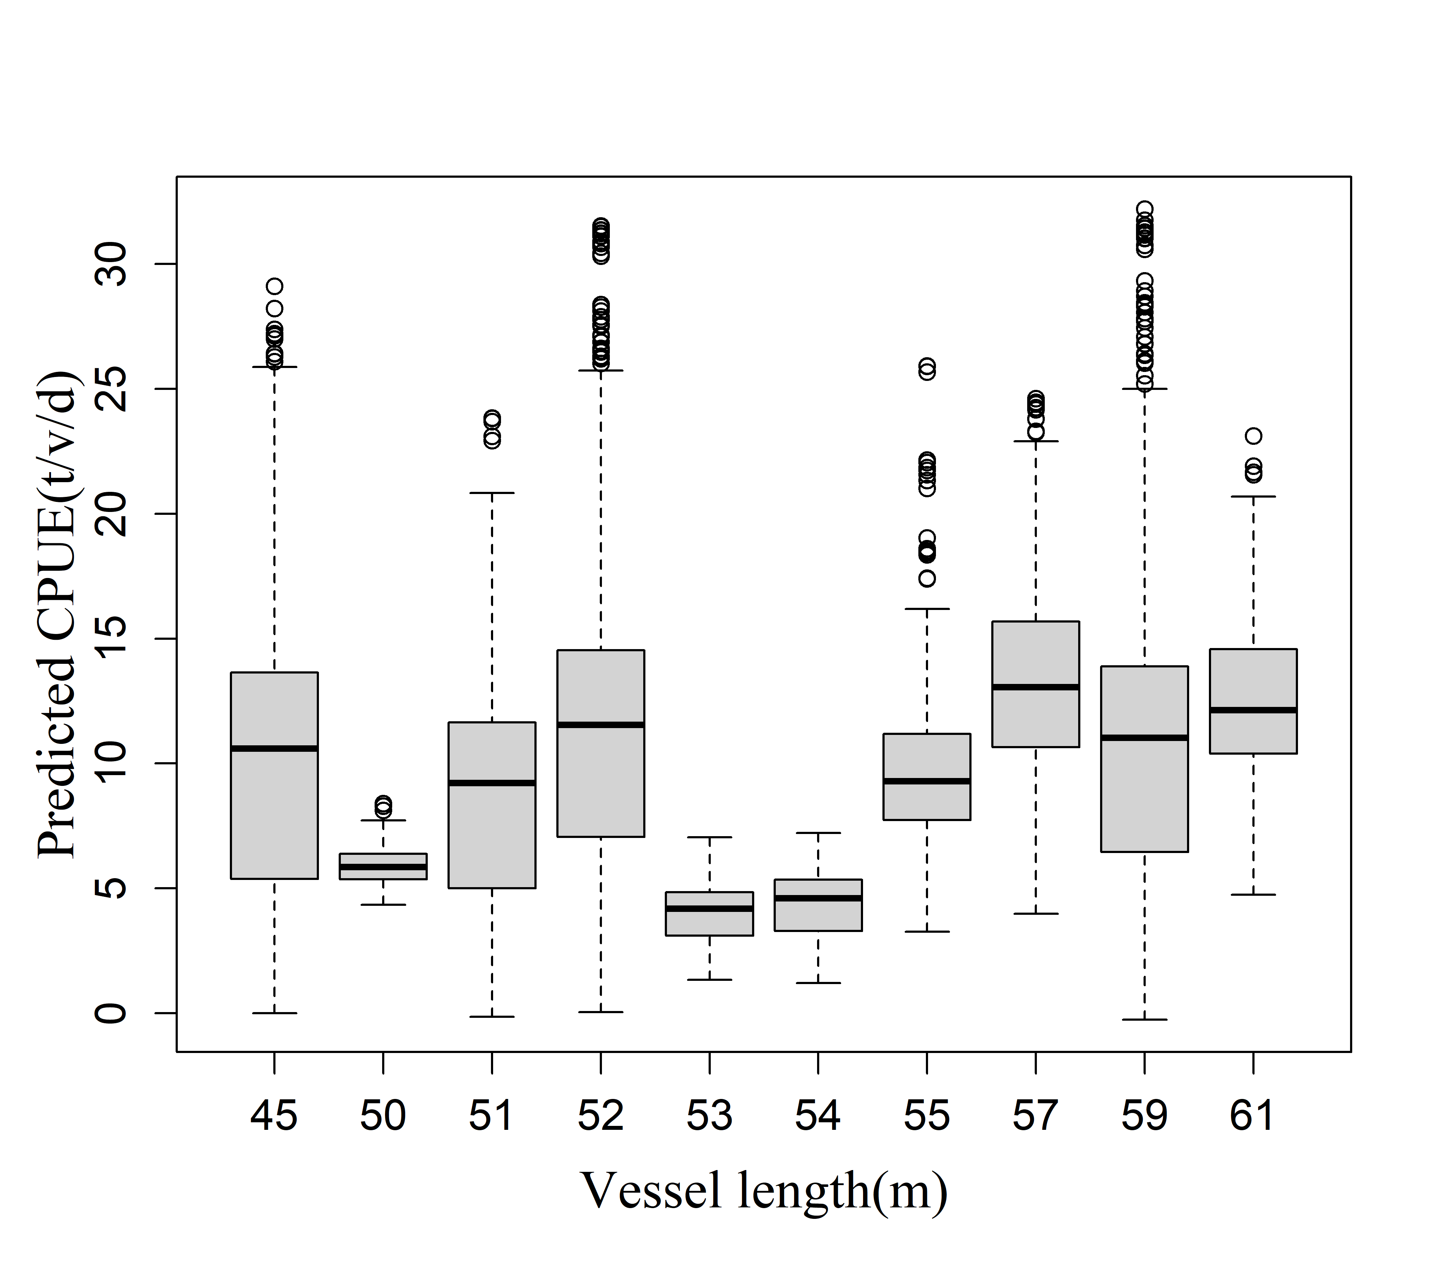

**Fig. 5.** Estimated relationships between response and explanatory variables.

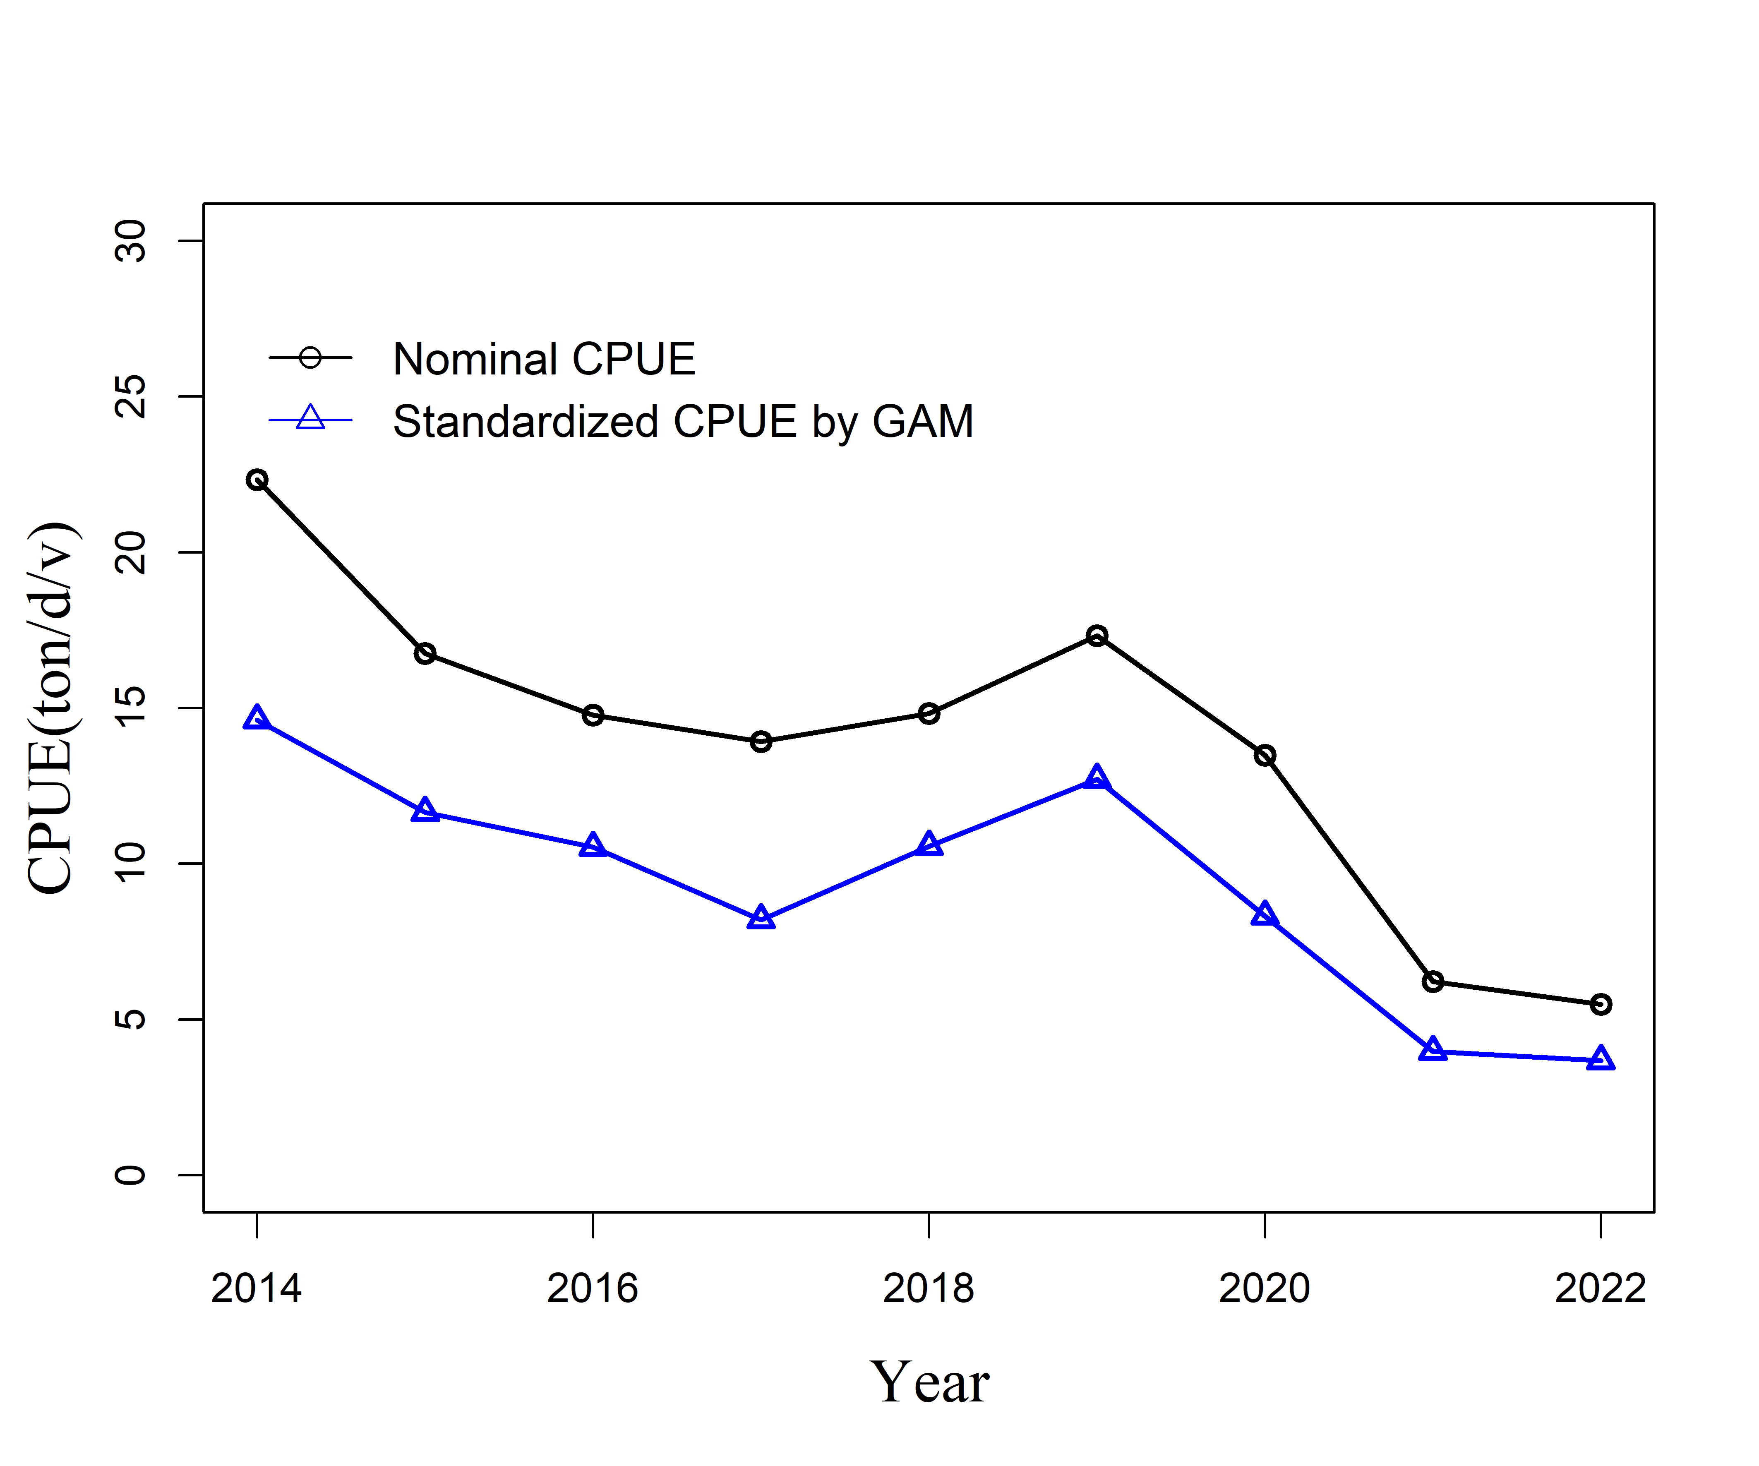

**Fig.6.** The nominal CPUE and standardized CPUE of Chub mackerel by best GAM up to 2022.

**APPENDICES**

Appendix1. Checklist for the CPUE standardization protocol

|  |  |  |  |
| --- | --- | --- | --- |
| No. | Step-by-step protocols | yes/no | Note |
| 1 | Provide a description of the type of data (logbook, observer, survey, etc. ), and the "resolution" of the data (aggregated, set-by-set etc..). This description should also include the representativeness of the data in two tables: (1st table) Number of observations, % Coverage of CPUE fleet (catch), % Coverage of CPUE fleet (effort), Total Catch CPUE fleet (mt), Total Effort CPUE fleet, Percentage of overall catch by member (across all fleets/gears); and (2nd table) Number of records remaining, Number removed, Number of records with chub mackerel catch >0; | Yes | See section *2.1* ([page 2-3]) and Tables 1, [page 6] and 2, [page 6] |
| 2 | Conduct a thorough literature review to identify potential explanatory variables (i.e., spatial, temporal, environmental, and fisheries variables) that may influence CPUE values; | Yes | See sections 1 and 2.1 ([page 2-3]) |
| 3 | Plot annual/monthly spatial catch, effort and nominal CPUE distributions and determine temporal and spatial resolution for CPUE standardization | Yes | See Fig. 1, [page 12-14] |
| 4 | Make scatter plots (for continuous variables) and/or box plots (for categorical variables) and present correlation matrix if possible to evaluate correlations between each pair of those variables; | Yes | See Figs 2, [page 15] and 3 [16] |
| 5 | Describe selected explanatory variables based on (2)-(4) to develop full model for the CPUE standardization; | Yes | See section *2.2.* ([page 3]) and Table 3, [page 7] |
| 6 | Specify model type and software (packages) and fit the data to the assumed statistical models (i.e., GLM, GAM, Delta-lognormal GLM, Neural Networks, Regression Trees, Habitat based models, and Statistical habitat based models); | Yes | See section *2.2.* ([page 3]) |
| 7 | Evaluate and select the best model(s) using methods such as likelihood ratio test, information criterions, cross validation etc.; | Yes | See Table 4, [page 8] and Table 5, [page 8] and section 3 |
| 8 | Provide diagnostic plots to support the chosen model is appropriate and assumption are met (QQ plot and residual plots along with predicted values and important explanatory variables, etc.); | Yes | See Table 7, [page 9] and Fig. 4, [page 16] |
| 9 | Present estimated values of parameters and uncertainty in the parameters in table; | yes | See Table 8, [page 10-11] |
| 10 | Present the relationship between dependent variable and independent variables. Check whether it is interpretable. | Yes | See Fig. 5, [page 17-18] |
| 11 | Extract yearly standardized CPUE and standard error by a method that is able to account for spatial heterogeneity of effort, such as least squares mean or expanded grid. If the model includes area and the size of spatial strata differs or the model includes interactions between time and area, then standardized CPUE should be calculated with area weighting for each time step. Model with interactions between area and season or month requires careful consideration on a case by case basis. Provide details on how the CPUE index was extracted. | Yes | See section 2.3. ([page 3-4]) |
| 12 | Calculate uncertainty (SD, CV, CI) for standardized CPUE for each year. Provide detailed explanation on how the uncertainty was calculated; | Yes | See section 2.3 (page 3-4), Table 9, [page 11] and Fig. 6, [page 18] |
| 13 | Provide a table and a plot of nominal and standardized CPUEs over time. When the trends between nominal and standardized CPUE are largely different, explain the reasons (e.g. spatial shift of fishing efforts), whenever possible. | Yes |