NPFC-2024-SC09-OP01

Pathways for the incorporation of climate change into the work of the North Pacific Fisheries Commission

A report for the Deep-Sea Fisheries under the Ecosystem Approach Project within the North Pacific Fisheries Commission Area

Joel Rice, FAO Consultant (ricemarineanalytics@gmail.com)

# Executive Summary

Incorporating climate change considerations into the North Pacific Fisheries Commission's (NPFC) management framework is essential to address the pressing impacts on key species in the convention area. Climate change is expected to introduce complex environmental shifts—including ocean warming, acidification, and changes in dissolved oxygen and salinity—that will likely affect the distribution, growth, and reproductive success of key NPFC species. The current NPFC resolution on climate change identifies the impact that climate change is likely to have and the need to develop a comprehensive approach to understanding and addressing the impacts of climate change in the convention area. This report provides and overview of the literature and data available to evaluate and address climate change related impacts on managed stocks, the IPCC ocean climate change predictions, and potential strategies for the NPFC to integrate climate change into its fisheries management. Addressing the effects of climate change on a basin wide scale should include the following steps;

* Collaboration between the NPFC, other regional organizations (i.e. UN or PICES and the BECI project) and NPFC members management agencies.
* Enhance monitoring fish of stocks and bycatch species through an increase in fisheries independent surveys, because commercial catch and effort is often affected by market, economic, regulatory and other drivers which are often disconnected from the ecological shifts driven by climate change.
* Development of a regional observer program.
* Expansion of fisheries-independent surveys to older individuals for the NPFC priority species surveyed only in the pre-recruit to juvenile stage.
* Adopt an iterative program of work that begins with a literature review, prioritization of research and the creation of a workplan that includes
  + Characterization and projection of climate driven changes in a the NPFC region,
  + Estimation of the effects environmental factors on demographic parameters and processes (i.e. recruitment, growth, survival, etc.) via laboratory and simulation studies
  + Development of population dynamics model(s) adapted to include environmental data to estimate the effects of environmental change, link this to a stock assessment model,
  + Project and assess the implications of climate change under current and alternative fishing and climate change scenarios.
  + Provide climate-informed (climate ready) management advice in the form of reference points along with an understanding of how they may change over time, and the risks associated with alternative future climate scenarios.
  + Communicate potential socio-economic implications of climate change (on the distribution, productivity etc.) to fishery dependent communities and other stakeholders

The insights gained from a comprehensive system of study will be critical for developing adaptive management strategies that ensure the sustainability of both target and non-target species under changing ocean conditions. By integrating climate considerations into its monitoring, research, and management processes, the NPFC can better anticipate climate-related changes and ensure sustainable fisheries in a rapidly changing ocean environment.

Contents

Executive Summary 1

Introduction 4

Methods 4

Summary of literature and data available to address potential climate change impacts 4

Available data and gaps related to determining climate change-related distributional shifts 8

IPCC Ocean Climate Change Predictions and Likely Impacts 10

Integrating Climate-Related Monitoring Data into Stock Assessments and Management for Climate Resilience 12

New Data Requirements for Climate-Related Monitoring 12

Incorporating Climate Change into Stock Assessments and Management 13

Results 14

Conclusions and recommendations 14

References 18

Tables 25

Figures 27

# Introduction

As climate change accelerates, its effects on marine ecosystems and fisheries become increasingly evident (IPCC 2023a). Rising sea temperatures, ocean acidification, and extreme weather events are altering the distribution, abundance, and health of fish stocks worldwide. Deep-sea fisheries (DSF), in particular, face unique challenges due to their remote locations, specialized habitats, and slow-growing species. As these ecosystems are highly sensitive to environmental changes, the need for climate-resilient fisheries management has never been more urgent.

This report focuses on increasing knowledge and awareness of climate change impacts on fisheries and their associated ecosystems. It provides guidance on how fisheries can adapt to these changes while mitigating further damage. Through the lens of the Areas Beyond National Jurisdiction (ABNJ) DSF project, this report outlines actionable steps for improving governance, strengthening management frameworks, and enhancing cross-sectoral cooperation to build climate-resilient fisheries.

The DSF project, in collaboration with the North Pacific Fisheries Commission (NPFC), emphasizes the importance of incorporating climate considerations into every aspect of fisheries management. By aligning with the project’s key areas—governance, management, cross-sectoral interactions, and knowledge-sharing—this report offers targeted recommendations to help fisheries respond to climate-driven disruptions. These efforts will not only sustain fish stocks but also ensure the long-term viability of the ecosystems that support them.

# Methods

## Summary of literature and data available to address potential climate change impacts

The literature on climate change impacts on fisheries emphasizes rising ocean temperatures, shifting ocean currents, and increased frequency of extreme events. These are the effects most readily measured and therefore modeled but importantly are also variables that can affect the abundance, distribution, and productivity of both managed fish stocks and non-target species. For example, species such as sablefish, Pacific saury, and rockfishes are expected to face habitat shifts as they seek cooler, deeper waters due to warming sea surface temperatures. Studies also highlight the vulnerability of non-target species (bycatch), which may experience more acute impacts due to their lack of specific management attention.

Ecosystem-level effects include alterations to the marine food web, where temperature-driven shifts in plankton productivity can ripple through the food chain, affecting the entire system. Ocean acidification, another consequence of climate change, weakens the resilience of coral reefs and other benthic ecosystems, threatening species that rely on these habitats. As marine ecosystems become more stressed, species interactions and predator-prey dynamics may be disrupted, further challenging fisheries management.

Literature on how to address potential climate change impacts on managed stocks, non-target species and associated ecosystem is wide ranging. Several analyses (some model-based, others not) have been undertaken to understand the direct (e.g., on survival and growth) consequences of changes in pH over time from ocean acidification on the stocks and fisheries of the North Pacific and other regions within the USA (e.g., Kaplan et al. 2010; Cooley et al. 2015; Punt et al. 2014; 2016; 2020), Most of these efforts include interdisciplinary efforts to

1) Characterize and project climate driven changes in a region,

2) Estimate the effects of environmental factors on demographic parameters and processes (i.e. recruitment, growth, survival, etc.),

3) Develop population dynamics model(s) adapted to include environmental data to estimate the effects of environmental change, link this to a stock assessment model, project under multiple scenarios, and

4) Develop climate-informed (climate ready) management advice in the form of reference points along with an understanding how they may change over time, and the risks associated with alternative future climate scenarios.

Iterative approaches to this process that incorporate realistic adaptation or management options along with regular improvement in methods (climate models, biological or population models, prediction methods) and management strategy evaluation (MSE) have been developed in and advanced as modeling frameworks and guides for multidisciplinary integrated climate impact and adaptation estimation and decision-making tools (Figure 2, Punt et al. 2021, Hollowed et al. 2020).

Climate change is expected to significantly impact managed fisheries stocks in the North Pacific, including many of the NPFC priority species[1]. The ability of any modeling or management action will depend on the data availability by species, which is:

**Blackspotted and rougheye rockfishes** are widely distributed throughout the Pacific Ocean from California to the Gulf of Alaska, westward to the Aleutian islands and seamounts (Figure 3). Although no stock assessment is conducted for blackspotted and rougheye rockfishes in the NPFC convention area, data from the Canadian and USA domestic fisheries and surveys have been used for domestic stock assessment. Both countries catch these rockfish as bycatch in the sablefish fishery and have trawl fisheries that target blackspotted and rougheye rockfish within their EEZ’s. While there is evidence of population structure in the Northeastern Pacific (i.e. genetics and population trends, Shotwell et al. 2014, Gharrett et al. 2007, DFO 2020), it is unclear whether the seamounts in the Northwest Pacific are connected to the populations on the northeastern continental shelf (NPFC 2023). While there is no survey conducted in the convention area outside the EEZ’s, these species are regularly assessed by CPCs in the Northeastern Pacific. They are generally considered vulnerable to overfishing due to their long life-span (>200 years), late age at maturity (approximately 20 years old) and being caught as bycatch and in directed fisheries.

**Blue mackerel** are distributed from Japan to Australia and New Zealand in the Indo-West Pacific (Figure 4). Although no stock assessment has been conducted by the NPFC, Japan conducts two stock assessments for blue mackerel, based on a Pacific stock and an East China Sea stock (Hayashi et al. 2019, Yukami et al. 2023; Figure 4). Only the Pacific stock is thought to extend into the NPFC convention area. Recent assessments of the Pacific stock indicate declining biomass, SSB and recruitment. This is one of the more data rich stocks, that has both commercial and survey indices of abundance, catch at length information, age-length information and a relatively long time period of catch statistics, although the historical catch composition is for some fisheries is based on recent ratios of chub to blue mackerel. While Japan conducts three surveys that catch blue mackerel they all survey younger life stages from egg and larval (which is used as a proxy for spawning stock biomass) to pre-recruit and juvenile fishes.

**Chub mackerel.** The chub mackerel stock in the North Pacific isthought to spawn mainly off of the Izu islands and be distributed to the northeast of Japan (Figure 5). There exist commercial and survey indices of abundance, along with data on age at length, weight at age, and a relatively long, complete catch history. The recent (NPFC 2024b) stock assessments note that the chub mackerel stock in the northwest Pacific has experienced large changes in biological parameters over the time period of the model. The main temporal changes are a recent decrease in maturity at age, along with a recent decrease in the weight at age, both of which were observed to change over the model time period (1970-2022) to cause temporal changes of biological reference points. MSY-based reference points are highly variable over the time series of the assessment because the weight- and maturity- at age of chub mackerel has varied which impacts the productivity of the stock. In addition, as there is little recruitment compensation in the stock-recruitment relationship within the range of historically observed SSB and recruitment.

**Japanese Flying Squid (JFS)**. No stock assessment has been conducted by NPFC for the convention area, however Japan conducts annual stock assessments for the autumn-spawning stock and winter-spawning stock of Japanese flying squid (Figure 6, Miyahara et al. 2023, Okamoto et al. 2023). JFS are distributed mainly in the northwest Pacific and their northward/southward shifts in distribution range occur in response to changes in water temperature (Murata 1990, Sakurai et al. 2013). The latest stock assessment for the winter-spawning stock in Japan included overseas catch from Russia, China and Korea. Estimated biomass and spawning stock biomass (SSB) have decreased drastically since 2015 and SSB was estimated lower than SSBmsy and F was lower than Fmsy. The data available for the assessment include total catch, catch at length, several indices of abundance. JFS are encountered in surveys conducted by Japan and Russia. This is one of the NPFC species where surveys encounter multiple life history stages of one or more seasonal stocks, the Japanese surveys encounter larvae recruits, and adults during the winter, spring/summer and summer/fall surveys, respectively. Russia conducts a survey of JFS during their feeding migration into Krill Islands waters, annually for the winter stock. Although this survey captures only a portion of the stock, it may help identify shifts in migration patterns and timing due to climate change related effects.

**Japanese sardine.** The primary distribution of Japanese sardine is inside the Japanese EEZ (Figure 7), with a Sea of Japan and Pacific stock, only the Pacific stock is distributed into the NPFC convention Area. Although there is no stock assessment for the NPFC convention Area, Japan conducts stock assessments for the Pacific stock of Japanese sardine (Furuichi et al. in press). The most recent stock assessment in Japan included foreign catches from China and Russia, with some assumptions about age composition of these catches. Estimated recruitment, biomass, and SSB have gradually increased since 2010. Japanese sardine generally migrate from the south to the north during summer, returning to inshore areas in the south to spawn in the winter. Surveys (Japanese) target pre-recruits and juveniles to determine an index of recruitment. Japan also conducts a monthly egg and larval survey that is used to estimate spawning stock biomass. Russia has conducted a summertime acoustic-trawl survey since 2010 that examines midwater and upper epipelagic species including Japanese Sardine. Together this data may be helpful in identifying shifts in migration patterns due to climate change.

**Neon flying squid (NFS)**. Official catch statistics, size composition data, abundance indices (commercial and survey) and age composition data exist for neon flying squid, which is an oceanic squid distributed in temperate and subtropical waters of the Pacific, Indian and Atlantic Oceans. The north Pacific population occurs mainly in the temperate waters between 20° and 50°N (Figure 8). This species makes an annual round-trip migration between its subtropical spawning grounds and its northern feeding grounds near the Subarctic Boundary. Survey data include a Japanese drift net survey (in summer from 1999-2020) and a jigging survey in winter from 2018-2020. Russia conducted upper epipelagic surveys from 1984-1992 and from 1999-2019 given the significant migration of this species, this survey data along with commercial catch records may inform any potential climate change impacts on distribution of NFS.

**North Pacific Armorhead (NPA).** Historical catches of North Pacific armorhead were greater than 150 000 tons in the late 1960s and early 1970s, recent catches have been extremely low, with recommended catch levels of 700 and 12 000 tons in low and high recruitment years as determined by annual monitoring. There is no stock assessment for NPA and data on this species is very limited. The life history of NPA is unique, they have a pelagic larva phase and a demersal adult stage on the seamounts (Figure 9, Kiyota et al. 2016). The logbook data may be helpful for determining the climate change impacts on this stock, however it appears highly depleted, isolating the effects of climate change from overfishing and adverse impacts due to fishing on vulnerable marine ecosystems (seamounts) may not be feasible.

**Pacific saury.** Stock assessments for Pacific saury carried outannually by the NPFC, the assessment is supported by a wealth of data, including a biomass survey (by Japan) in a wide area of the NPFC convention area. Additionally, a joint CPUE calculated using members commercial data is available along with catch at length data, and age (length) at maturity. Pacific saury are a fast growing short lived fish that spawn between September and the following June over a wide range from coastal Japan to the central-North Pacific (Baitaliuk et al. 2013). They are highly migratory and migrate between northern feeding grounds and spawning areas off of southern Japan in the winter (Figure 10, Suyama et al. 2012a). In addition to the survey data, NPFC members collect some size, maturity and age information from fishery catches of Pacific saury. This is important because there is variation in growth rate depending on the hatching month (Kurita et al. 2004) and geographical differences (Suyama et al. 2012b). In addition to the survey and commercial CPUE records, the information on growth may be helpful to determine the effects of climate change on this species and its distribution, however as a species that exists over a wide spatial area, Pacific saury may be more robust to environmental changes than other species.

**Sablefish.** Based on genetic and other evidence there exists a single stock of sablefish in the North Pacific (Figure 11), though for management purposes three assessment care carried out in Alaska, British Colombia, and the US West Coast. As for other species in that are primarily found in the members’ EEZs there is no assessment conducted for the sablefish population found in the NPFC convention area. Data that support the assessments include longline survey data in Canada and Alaska, bottom trawl survey data in Alaska and the US West Coast. In both Canadian and US fisheries, biological data collection occurs including length, weight and sex are routinely collected, along with otoliths for age estimation by scientific surveys, by observers and dockside samplers from the commercial fisheries. Sablefish are widely distributed throughout the Pacific Ocean (Wolotira et al. 1993), and thought to be one stock based on recent genetic work by Jasonowicz et al. (2017) which suggested that observed differences in growth and maturation rates may be due to phenotypic plasticity or are environmentally driven. The survey data, commercial catch records and biological data collected have a significant potential to investigate climate change impacts on sablefish.

**Splendid alfonsino.** The distribution of splendid alfonsino in the north Pacific ranges from equatorial waters to approximately 45° N (Figure 12), with historical catch records from the Emperor Seamount suggesting the main distribution occurring between the Nintoku (45° N) to Hancock (30° N). Historical catch records as well as commercial CPUE data, age, length and maturity data are collected by NPFC members and this may be helpful in estimating or addressing the climate change impacts on this species.

### Available data and gaps related to determining climate change-related distributional shifts

Available data on the location and relative abundance of NPFC priority species largely originates with fisheries-independent surveys and commercial catch records. There is no substitute for direct observation and measurement of associated variables (date, time, temperature, pH, O2, depth), because without at least an initial dataset, constructing and parameterizing a model would be impossible. Additionally, because species movement and behavior often change based on life stage, it is important to sample across the spectrum, from larvae and pre-recruits to adults and across the entire distribution to avoid biased estimates.

Because of this, fisheries independent surveys are often designed with a comprehensive regional grid of sampling stations or stratified randomized sampling locations in order to ensure that the obtained biomass indices are unbiased. Unfortunately, for species whose preferred habitat is only partially sampled survey estimates may be biased. This may occur when the distributional pattern of the species does not overlap with the survey area and/or life stages do not coincide during the survey period, the gear used does not select for a particular life stage or the stock has responded to a change in environmental factors (i.e. temperature) or availability of resources. In any of these cases, the species inherent spatial variation and or age/size spatial segregation is not adequately sampled, and the assumptions regarding the distribution and biomass of the species are not adequately captured. (Maunder et al. 2020).

An understanding of the inherent spatiotemporal distribution of a target species and its relationship with the related marine environmental variables is essential for effective fisheries (and ecosystem based) management. By identifying changes in population processes due to environmental influences scientists can provide better science based enable climate-ready management advice.

It is expected that pelagic species will be affected by oceanographic changes, particularly shifts in currents and nutrient availability. Rising sea temperatures and changes in the availability of prey species can alter the migration patterns of these fish, leading to challenges in stock management and catch predictability. Noting that the north Pacific is large, making it difficult to fully monitor, there are some notable data gaps.

**Bottomfish (rockfish, sablefish, armorhead, splendid alfonsino)**, which inhabit deep waters, are also thought to be particularly vulnerable to changes in ocean temperatures, stratification and oxygen levels. Rising temperatures may push these species to seek deeper, cooler habitats, impacting their distribution and availability to fisheries. Changes in oxygen minimum zones (OMZs) can further reduce the habitable range for these species, impacting their reproduction and survival. The type of data that can help fisheries scientists understand migration patterns and establish new baselines for managing shared resources is collected by NPFC members, However, data gaps remain for many species. Support for research and surveys that would lead to a better understanding of the life history of north Pacific armorhead and splendid alfonsino.

**Mackerels (blue and chub mackerel)**. These species are highly migratory and depend on specific temperature ranges for spawning and feeding. The blue mackerel, for example, relies on warm waters like those in the Kuroshio Current. As ocean temperatures rise, their distribution is shifting northward, impacting traditional fishing areas. For example, blue mackerel age 1 fish did not appear in the water north of Sanriku district after wintering until 1980, but they have migrated to the water from Tohoku to Hokkaido with the increase of surface temperature since 2001 (NPFC 2024). Chub mackerel have a similar breading area near the Izu islands and main distribution area for adults is around water of the Kuroshio current. Both blue and chub mackerel juveniles and pre-recruits are adequately sampled by surveys, however an additional survey that samples the adults in the Kuroshio current area would help provide additional data on an important life stage.

**Japanese sardine.** Historically a dominant fishery species, Japanese sardine populations are sensitive to environmental changes like sea surface temperature and food availability. As a pelagic species, Japanese sardine in vulnerable to climate change, which by altering ocean productivity, could cause significant fluctuations in sardine populations. This has implications for both the fishing industry and the broader marine ecosystem, given the sardine’s role as prey for other species. Continued studies on the recruitment and distribution, including monitoring, are important as climate change may affect migration. Recent studies have emphasized the uncertainty in the population structure (i.e. East China Sea and Pacific stocks) assumed in current stock assessment models for Japanese sardine (Sakamoto, et al. 2024). This is further supported by the fact that recently Japanese sardine have been found in surveys off of the US west coast (Longo et al. 2024). As climate change induced range shifts become more pervasive it is important to monitor the frequency and intensity of warm water anomalies and marine heatwaves which lead to shifts in species ranges and species assemblages.

**Squids (Japanese flying and neon flying squids).** Squid populations, including Japanese flying squid, are similarly affected by changes in sea temperature. These species rely on specific thermal conditions for spawning, and as these temperatures shift, their spawning grounds are likely to move. Additionally, squid are short-lived and respond rapidly to environmental changes, making them a key indicator of ocean health (NPFC, 2024), and because shifts in distribution range occur in response to changes in water temperature the fishery needs to be continued to be monitored (Murata 1990, Sakurai et al. 2013). Specifically, as recommended by the NPFC scientific committee there should be continued research on the spatial structure of the squid life history and stock relative to the historical fishing footprint and a system of long-term research on the influence of environmental variables on the life history and biology of squid. Recent research links the El Niño-Southern Oscillation (ENSO) events to the distribution and the relative abundance of neon flying squids (NPFC 2023). ENSO and related environmental factors could be incorporated in future stock assessment models based on the assumption that climate change may shift the biomass from traditional fishing grounds, increasing the difficulty of fishing in the future

**Vulnerable marine ecosystems.** Predictive modeling to identify VMEs and how they (and their distribution) may change with climate change should be further developed along with a single framework for identifying VMEs. This issue should be addressed collaboratively with other organizations (e.g. PICES or NPAFC) to prioritize and collect new data that would help with stock assessments for bottom fisheries and outstanding issues such as VME recovery.

## IPCC Ocean Climate Change Predictions and Likely Impacts

The Intergovernmental Panel on Climate Change (IPCC) predicts significant changes in ocean conditions over the next several decades (Sixth Assessment Report (AR6), IPCC 2023). The AR6 uses multiple models and scenarios to capture historical uncertainty as well as variations in future scenarios ranging from a “low greenhouse gas emissions, high mitigation future (scenario RCP2.6)” to a “high greenhouse gas emissions scenario absent of policies to combat climate change (RCP8.5 scenario). In the near term (2031-2050) the RCP2.6 and RCP8.5 are similar in mean predicted surface temperature change relative to 1850-1900, both reporting an average increase of 1.6°C, however by the end of the century (2081-2111) RCP8.5 predicts more than double the increase in temperature (4.3°C) than does RCP2.6 (2.0°C), in the next ten years the RCP2.6 predicts a change in sea surface temperature of 0.58°C while the RCP8.5 predicts an increase of 0.77°C (Table 1, Figure 13).

In the next 10 – 15 years, the North Pacific Ocean is expected to experience continued warming, with a projected rise of global temperatures at 1.5°C above pre-industrial levels. Short-term extreme events, such as marine heatwaves, will likely become more frequent and intense, posing immediate risks to temperature-sensitive species (IPCC 2023a, Longo et al. 2024). The IPCC predicts (IPCC 2023) that over the next 50 years, a rise in sea surface temperatures by 2–4°C, coupled with ocean acidification and deoxygenation, which will fundamentally alter marine ecosystems. These long-term changes could result in substantial shifts in species distribution, with species like sardines, squid, and sablefish potentially moving into new territories, creating challenges for fisheries that rely on traditional stock areas (IPCC 2023a). The IPCC's Special Report on the Ocean and Cryosphere in a Changing Climate (Bindoff et al. 2019) along with the AR6, highlights the following predicted effects of climate change on oceans in general and the also on the North Pacific Ocean:

**Warming oceans**: The report emphasizes the continuous increase in ocean temperatures. Specifically, for the North Pacific, rising ocean temperatures are expected to exacerbate changes in marine ecosystems and fishery stocks. Warming has the potential to cause poleward shifts in marine species, which may affect fisheries and biodiversity in the region. The rate of warming in the first 700 meters (0-700m) of the ocean has likely doubled since 1993 (IPCC 2019). This has resulted in increases in marine heatwaves, in some cases doubled, with longer duration and more intense/extensive duration. The warming of the ocean has increased the density stratification in the upper 200m, which has the effect of creating density contrast between shallower and deeper layers. Increased stratification reduces the vertical exchange of heat, salinity, oxygen, carbon, and nutrients (IPHC 2019).

**Sea-level rise**: Sea levels are projected to rise due to the melting of glaciers and thermal expansion of the ocean. This rise poses risks to coastal ecosystems, mainly on temperate/tropical habitats like marshes, mangroves, and coral reefs which are particularly vulnerable. However, there may be decreases in salinity associated with the loss of glaciers and sea ice, this freshening along with regional stratification can affect the timing, distribution and production of primary producers (Moore et al. 2018

**Ocean acidification:** Ocean acidification caused by the ocean uptake of CO2 emissions has very likely caused a decrease in open ocean surface pH (IPCC 2019). The AR6 notes that it is virtually certain that surface ocean pH will decline, by 0.036–0.042 or 0.287–0.29 pH units by 2081–2100, relative to 2006–2015, for the RCP2.6 or RCP8.5 scenarios, respectively. These pH changes are very likely to cause some oceans including the North Pacific to become corrosive for the major mineral forms of calcium carbonate under RCP8.5, but not under the RCP2.6 scenario. There is increasing evidence of an increase in the seasonal exposure to acidified conditions in the future, especially at high latitudes (IPCC 2019).

**Oxygen loss:** The AR6 indicates that there is medium confidence that the oxygen content of the upper 1000 m has declined with a very likely loss of 0.5–3.3% between 1970–2010. Alongside this oxygen minimum zones (OMZ) are expanding in volume, by a very likely range of 3.0–8.3%. The North Pacific (among other oceans) is one of the areas in which the largest regional changes have occurred (IPCC 2023, 2019).

**Fisheries and climate change**: Over the last five to six decades multiple marine species across various taxa have undergone shifts in geographical range as well as the timing of seasonal activities in response to climate change effects on the marine environment (i.e. ocean warming, sea ice change, ecosystem productivity, IPCC 2019). Shifts in species composition and changes in habitat and environmental productivity have also interacted with fisheries exploitation. In the Northeast Pacific warming induced species range expansions are thought to have led to altered ecosystem structure and functioning (IPCC 2019, Harvey et al. 2013). Arctic net primary production has increased in ice free waters in recent decades, leading to earlier spring phytoplankton blooms in response to nutrient availability and sea ice change. Climate change effects of ocean acidification and decrease in oxygen level in the California Current upwelling system are thought to have altered ecosystem structure, with direct negative impacts on biomass production and species composition (Alin et al. 2012; Bednaršek et al. 2014; Breitburg et al. 2018).

Overall, the AR6 provides key insights into climate-related effects on the ocean and marine environment, and highlights some potential drivers of shifts in species distribution. The report highlights that rising ocean temperatures and changes in other environmental conditions, such as acidification and oxygen levels, are driving significant shifts in the distribution of marine species. This is particularly noticeable in the North Pacific where many species are migrating toward cooler waters, generally poleward or into deeper depths.

These shifts can have profound implications for fisheries, as fish stocks move across traditional boundaries, sometimes entering the jurisdictions of different nations or moving out of managed fishing zones altogether. Such redistribution can disrupt established fisheries, potentially leading to conflicts over resources and requiring new international agreements to manage shared or transboundary stocks. Additionally, the report mentions that ocean ecosystems are increasingly affected by both gradual changes (such as the rise in average temperatures) and more extreme weather events, which together could further exacerbate shifts in species distribution. This not only affects targeted fish species but also can have cascading effects on ecosystems, including changes in predator-prey relationships and impacts on non-target species.

This evolving distribution pattern underlines the need for adaptive management strategies that incorporate climate-resilient approaches to fisheries, ensuring both sustainability and equitable resource sharing in the future. For example, in the USA, the North Pacific Fisheries Management Council (NPFMC) has adopted a strategy of adaptive governance, biodiversity conservation, scenario planning and the precautionary approach, development of coordinated monitoring programs, data sharing and decision support tools that alert managers to climate change impacts on species and ecosystems (NPFMC 2018). The NPFMC Fishery Ecosystem Plan, utilizes future ecological scenarios to develop strategies for mitigating the future risks and impacts of climate change (NPFMC 2018). The NPFMC Fishery Ecosystem Plan is supported by a suite of models that include multiple climate change scenarios adaptive management controls to inform management (Punt et al. 2016; Holsman et al. 2017; Zador et al. 2017; Holsman et al. 2019).

## Integrating Climate-Related Monitoring Data into Stock Assessments and Management for Climate Resilience

### New Data Requirements for Climate-Related Monitoring

Adaptive management strategies and Ecosystem Based Fisheries Management (EBFM) rely on a wide array of variables, and model output to provide an understanding of how the ecosystem responds to various drivers including removals from fisheries and environmental effects due to climate change (Pikitch et al. 2004). Especially in areas such as the North Pacific with diverse ecology that experience seasonal shifts in key variables that drive primary production, species distribution and have diverse fisheries, it is important to understand the effects of climate change. Implementation of EBFM generally includes an evaluation of environmental effects in the region to characterize how species respond to changes in the environment. Ideally this would consist of a comprehensive ocean observing system that would incorporate long-term monitoring stations to track temperature, pH, salinity and oxygen throughout the water column in the North Pacific, focusing on critical and vulnerable marine habitats. This data on the environment could then be incorporated with species specific data on distribution, condition and abundance of target (and bycatch) species.

While information on the environmental variables is generally available through satellite technology, model output or remote sensing, monitoring fish stocks and bycatch species in a changing climate will require an increase in surveillance. Further development of fisheries-independent surveys is needed because many of the NPFC key species are surveyed only in the juvenile or pre-recruit stage, leaving the spawning stock monitored only through commercial catch and effort. This could be offset coordinated observer programs (including electronic monitoring) coupled with advancements in satellite technology and real-time data collection through remote sensing. Commercial (logbook) data can be highly useful; however, fishing fleets typically respond to economic drivers such as market demand, fish prices, fuel costs, and regulatory measures, which influence their operational decisions, but these factors are often disconnected from the ecological shifts driven by climate change. For instance, high market demand for certain species can lead fleets to intensify efforts in traditional fishing grounds, even if climate-induced changes in ocean conditions have caused those species to shift their distribution (Hilborn et al. 2003).

Additionally, the price of fuel strongly affects the range and frequency of fishing trips; when fuel prices are high, fleets may avoid long-distance travel, thus limiting their ability to follow species that have moved to different regions or depths (Sumaila et al. 2008). Because these economic incentives do not inherently align with environmental signals, fishing fleet behavior is not a reliable indicator of real-time shifts in target species distribution. Climate change can cause fish to migrate to favorable habitats, often outside traditional fishing zones (Pinsky & Fogarty 2012). This misalignment between fleet behavior and species movement underscores the importance of incorporating survey data (tagging studies), to monitor and adapt to species shifts effectively. Improved biological sampling, including genetic studies, could provide insights into population structure, distribution and the effects of climate change.

### Incorporating Climate Change into Stock Assessments and Management

The productivity of fish stocks is heavily influenced by variability in the ecosystem and environment. Resource availability or lack thereof is a major driver of population dynamics, and accounting for environmental and ecosystem drivers is important for understanding population dynamics and providing management advice. For some species, especially short-lived fast-growing species, identifying drivers of recruitment variability can improve the precision of estimates of recruitment in a stock assessment (Ward et al. 2024). This is particularly important with respect to providing management advice over short time periods based on the terminal years of a stock assessment model where there is typically less data to inform recruitment estimations. Other species may be more impacted by factors that influence other aspects of their life history directly (i.e. growth, juvenile survival, Punt et al. 2014) either directly or indirectly (e.g. limiting primary productivity). By identifying and incorporating environmental drivers into population dynamics models the predictions (and associated management advice) could be improved by predicting and incorporating the impacts of climate change on a risk analysis or management strategy evaluation. This could help better communication of science and inform climate-ready fishery management advice.

To incorporate climate change into stock assessment and management an environmental index needs to be developed based on observed fisheries and environmental data. Studies that link the environment with population dynamics have mostly focused on the link between environmental indicators and recruitment, either directly or as deviations from a stock recruitment index (Gross et al. 2022; Haltuch & Punt 2011; Tolimieri & Haltuch 2023). However, other studies have linked warmer sea surface temperatures with declines in certain forage fish populations due to disruptions in nutrient upwelling, which reduces chlorophyll-a and resultant food availability (Chavez et al. 2003).

A wide array of potential oceanographic drivers exist that could be developed and incorporated into stock assessments (Haltuch et al. 2020; Chavez et al. 2003; Tolimieri & Haltuch, 2023). To effectively incorporate the long-term effects of climate change and be able to respond to shorter term a combination of laboratory experiments and simulation studies can inform understanding of how changing environmental conditions affect key life stages of species. Conducting controlled laboratory experiments across species’ life stages to assess their physiological tolerances and adaptability to various climate scenarios would enhance predictive models and refine management responses. Additional studies could investigate the temperature and oxygen thresholds that affect spawning, growth, and survival in NPFC species. This has been carried out for sablefish (Krieger et al. 2019, 2020), and other species (Punt et al. 2014, Szuwalski et al. 2019) in the North Pacific.

# Results

Incorporating climate change considerations into the North Pacific Fisheries Commission's (NPFC) management framework is essential to address the pressing impacts on marine species and fisheries. Climate change introduces complex environmental shifts—including ocean warming, acidification, and changes in dissolved oxygen and salinity—that affect the distribution, growth, and reproductive success of key NPFC species. The potential strategies for the NPFC to integrate climate change into its fisheries management include improved monitoring, laboratory research, ecosystem-based modeling, and adaptive management approaches.

The NPFC, through its members is actively monitoring environmental variables that impact key species. These efforts are foundational for tracking habitat changes and species responses over time; however they mainly target the pre-recruit to juvenile life stage, and often assume that egg abundance is representative of spawning stock biomass. A potential improvement is to expand the geographic scope of these surveys, and implement a regional observer program to enhance data from commercial fisheries and collect important environmental variables. Environmental data linked with high quality fisheries data would be beneficial to informing controlled laboratory experiments across species’ life stages to assess their physiological tolerances and adaptability to various climate change effects. This would enhance predictive models and refine management responses to climate change effects in NPFC species.

By integrating climate considerations into its monitoring, research, and management processes, the NPFC can better anticipate climate-related changes and ensure sustainable fisheries in a rapidly changing ocean environment. Enhanced predictive models, targeted research, and adaptive management structures will enable the NPFC to meet the challenges posed by climate change, fostering resilient fisheries and ecosystems in the North Pacific region.

# Conclusions and recommendations

Based in part on the NPFCs resolution on climate change, there has been considerable work done on linking the priority species and climate signals for the NPFC and coastal waters. For example, studies on chub mackerel and Pacific saury stocks and their relationship to the environment both in terms of recruitment, catch and to an extent distribution (e.g. Kim et al. 2024). However, some work remains with respect to developing direct inputs with the current stock assessment processes.

To be prepared for future changes in the distribution for NPFC priority species, additional work on the extent to which climate change related factors will be affecting the population dynamics (especially recruitment and pre-recruit survival) and distribution in the future. Establishing a link between the effects of a specific aspect of climate change on a particular life stage survival and development (e.g. ocean acidification on north pacific crab Szuwalski et al. 2021) has been successful, however how a species may respond to one, or more forcing factors (i.e. temperature increase, ocean acidification, change in dissolved oxygen, changes in productivity etc.) in a dynamic ecosystem needs a comprehensive system of study. For example, laboratory experiments to evaluate the effect of temperature (or PH) on the development of larvae, population models to incorporate population dynamics, associated impacts of fishing impacts and potential species interactions and simulation studies related to future climate predictions.

Recent work in the Gulf of Alaska by the United States NOAA Fisheries (Dorn et al. 2023) outlines a group of strategies to address climate impacts on the marine resources and fisheries in the Gulf of Alaska (GOA) through a series of initiatives aimed at ensuring resilient and sustainable ecosystems. Key focus areas that would translate to DSF project goals in the NPFC area include enhancing long-term ecosystem monitoring, conducting process-oriented research, advancing modeling and management-oriented synthesis. Other activities in the Gulf of Alaska regional action plan may be more appropriate a national level, for example assessing impacts on marine mammals, and understanding socio-economic impacts on fishing communities.

The approach outlined in Dorn et al. (2023) is a mix of approach that includes expanding long-term monitoring and then conducting some process-oriented research to try to get at specifics. This is similar to work done on individual species in the region (e.g. Szuwalski et al. 2021, Punt et al. 2014, Kroeker et al. 2013). Designing laboratory experiments and field sampling to parameterize distribution models for predicting habitat shifts due to ocean warming would involve a multi-step approach to understand species-specific responses to temperature changes, as well as ecosystem interactions that affect distribution. Ideally laboratory experiments t critical environmental variables and species responses would be carried out for the NPFC key species, with the objectives of identifying which variables (e.g., temperature, oxygen, pH) that most influence species distributions and physiological limits. Some of this work has been conducted, for example Krieger et al. (2020) found that young of the year sablefish growth and development may be dramatically influenced by relatively small shifts in water temperatures. These findings, whether they be on growth rate, reproductive output, threshold levels for oxygen or PH could then be used to parameterize a population dynamics model that could help develop insight about how a species may respond to future climate change scenarios.

To maintain and enhance understandings of current species distributions and document shifts over time, additional field sampling and survey would be very helpful. Ideally a multi-pronged approach would be used, that would combine seasonal surveys, remote sensing, tagging, environmental monitoring. This would help inform the understanding of species abundance, distribution and relationship to key environmental variables (i.e. temperature at depth, salinity, dissolved oxygen, pH). This could be done through the incorporation and expansion of current fisheries independent sampling in the region (i.e. Japanese larval and egg surveys, sablefish survey in Alaska), and an ocean observing system that integrates surveys and remote sensing technologies.

Remote sensing, using satellites to monitor oceanographic variables such as sea surface temperature (SST), chlorophyll concentration, and ocean color, provides real-time, large-scale data on environmental conditions that influence fish habitats and distribution patterns (Edwards et al. 2010). These parameters are critical because fish are highly responsive to temperature gradients, primary productivity, and ocean currents, which are all influenced by climate change (Perry et al., 2005). For instance, warmer SSTs can lead to poleward shifts of species in search of optimal conditions, a trend observable through remote sensing data, which can then be corroborated by in-situ surveys that assess species abundance and distribution in different regions.

Acoustic and trawl surveys, as part of an ocean observing system, complement remote sensing by providing specific information on fish abundance, biomass, and species composition at various depths. Repeated surveys over time allow scientists to detect temporal changes in species distribution, particularly as they move across historical boundaries (Pinsky et al. 2020). By combining these two approaches, researchers can build predictive models that forecast species distribution under various climate scenarios, supporting more effective fisheries management and adaptation strategies. Additionally, data from ocean observing systems contribute to Species Distribution Models (SDMs), which are critical for simulating how fish populations may respond to future changes in ocean conditions. This integrated system ultimately aids in managing fisheries sustainably by anticipating distributional shifts that could disrupt ecosystems and affect the economic viability of fisheries dependent on certain species (Hollowed et al. 2013).

In conjunction with the IPCC forecasts, future distributions under alternative climate scenarios can be forecasted by incorporating climate change scenarios to predict future temperatures, oxygen levels, and pH changes in the ocean within population or species distribution models to forecast habitat suitability and potential distribution shifts. This would help generate predictive maps showing potential habitat ranges and identify areas of potential species gain or loss. This integrated approach leverages both experimental and observational data to parameterize models, providing robust predictions on how ocean warming could shift species distributions.

An integrated approach to addressing the effects of climate change on a basin wide scale should start with collaboration between the NPFC and members management agencies. A program of work that begins with a literature review and adoption of a workplan that leads to the synthesis of environmental impacts on each priority species, and the incorporation of these variables in stock assessment and management advice. Collaboration with a wider community of researchers, including oceanographers, climate change experts and laboratory specialists is likely necessary.

There are hurdles to any large-scale collaborative research project, and most organizations are operating at full capacity. For the NPFC to implement the Resolution on Climate Change, a program of work should be prioritized by the Commission, with funding and a commitment of collaboration with members and other organizations (i.e. UN or PICES). This could begin with a more detailed synthesis on the topics outlined in this report, including prioritization of research and, and include the following steps;

* Collaboration between the NPFC, other regional organizations (i.e. UN or PICES and the BECI project) and NPFC members management agencies.
* Enhance monitoring fish of stocks and bycatch species through an increase in fisheries independent surveys, because commercial catch and effort is often affected by market, economic, regulatory and other drivers which are often disconnected from the ecological shifts driven by climate change.
* Development of a regional observer program.
* Expansion of fisheries-independent surveys to older individuals for the NPFC priority species surveyed only in the pre-recruit to juvenile stage.
* Adopt an iterative program of work that begins with a literature review, prioritization of research and the creation of a workplan that includes
  + Characterization and projection of climate driven changes in a the NPFC region,
  + Estimation of the effects environmental factors on demographic parameters and processes (i.e. recruitment, growth, survival, etc.) via laboratory and simulation studies
  + Development of population dynamics model(s) adapted to include environmental data to estimate the effects of environmental change, link this to a stock assessment model,
  + Project and assess the implications of climate change under current and alternative fishing and climate change scenarios.
  + Provide climate-informed (climate ready) management advice in the form of reference points along with an understanding of how they may change over time, and the risks associated with alternative future climate scenarios.
  + Communicate potential socio-economic implications of climate change (on the distribution, productivity etc.) to fishery dependent communities and other stakeholders

The insights gained from a comprehensive system of study will be critical for developing adaptive management strategies that ensure the sustainability of both target and non-target species under changing ocean conditions. By integrating climate considerations into its monitoring, research, and management processes, the NPFC can better anticipate climate-related changes and ensure sustainable fisheries in a rapidly changing ocean environment. The insights gained from a comprehensive system of study will be critical for developing adaptive management strategies that ensure the sustainability of both target and non-target species under changing ocean conditions.

# References

Alin, S.R. et al. 2012: Robust empirical relationships for estimating the carbonate system in the southern California Current System and application to CalCOFI hydrographic cruise data (2005–2011). J. Geophys. Res-Oceans, 117(C5), doi:10.1029/2011JC007511.

Bahri, T., Vasconcellos, M., Welch, D.J., Johnson, J., Perry, R.I., Ma, X. & Sharma, R., eds. 2021. Adaptive management of fisheries in response to climate change. FAO Fisheries and Aquaculture Technical Paper No. 667.Rome, FAO. https://doi.org/10.4060/cb3095en

Barange, M., Bahri, T., Beveridge, M.C.M., Cochrane, K.L., Funge-Smith, S. & Poulain, F., eds. 2018. Impacts of climate change on fisheries and aquaculture: synthesis of current knowledge, adaptation and mitigation options. FAO Fisheries and Aquaculture Technical Paper No. 627. Rome, FAO. 628 pp. https://www.fao.org/3/i9705en/I9705EN.pdf

Baitaliuk A.A., Orlov, A.M., & Ermakov, Y.K. 2013. Characteristic features of ecology of the Pacific saury Cololabis saira (Scomberesocidae, Beloniformes) in open waters and in the northeast Pacific Ocean. Journal of Ichthyology 53(11): 899-913.

Bednaršek, N., R.A. Feely, J.C.P. Reum, B. Peterson, J. Menkel, S.R. Alin, and B. Hales. (2014*). Limacina helicina* shell dissolution as an indicator of declining habitat suitability owing to ocean acidification in the California Current Ecosystem. Proceedings of the Royal Society B: Biological Sciences 281, no. 1785 20140123.

Bindoff, N.L., W.W.L. Cheung, J.G. Kairo, J. Arístegui, V.A. Guinder, R. Hallberg, N. Hilmi, N. Jiao, M.S. Karim, L. Levin, S. O’Donoghue, S.R. Purca Cuicapusa, B. Rinkevich, T. Suga, A. Tagliabue, and P. Williamson, 2019: Changing Ocean, Marine Ecosystems, and Dependent Communities. In: IPCC Special Report on the Ocean and Cryosphere in a Changing Climate [H.-O. Pörtner, D.C. Roberts, V. Masson-Delmotte, P. Zhai, M. Tignor, E. Poloczanska, K. Mintenbeck, A. Alegría, M. Nicolai, A. Okem, J. Petzold, B. Rama, N.M. Weyer (eds.)]. Cambridge University Press, Cambridge, UK and New York, NY, USA, pp. 447–587. https://doi.org/10.1017/9781009157964.007.

Boehlert, G. W., and T. Sasaki. (1988). Pelagic biogeography of the armorhead, *Pseudopentaceros wheeleri*, and recruitment to isolated seamounts in the North Pacific Ocean. Fish. Bull. 86:453– 465.

Bower; J.R., Ichii, T. (2005). The red flying squid (*Ommastrephes bartramii*): A review of recent research and the fishery in Japan. Fisheries Research.

Colt, S.G., Knapp, G.P., 2016. Economic effects of an ocean acidification catastrophe. Am. Econ. Rev. 106, 615–619.

Breitburg, D. et al. 2018: Declining oxygen in the global ocean and coastal waters. Science, 359(6371).

Chavez, F. P., Ryan, J., Lluch-Cota, S. E., & Ñiquen, M. (2003). *From anchovies to sardines and back: Multidecadal change in the Pacific Ocean*. Science, 299(5604), 217-221.

Cooley, S.R., Rheuban, J.E., Hart, D.R., Luu, V., Hare, J.A., Doney, S.C., 2015. An integrated assessment model for helping the United States sea scallop (Placopecten magellanicus) fishery plan ahead for ocean acidification and warming. PloS One 10, e0124145. https://doi.org/10.1371/journal.pone.0124145.

DFO. 2020. Rougheye/Blackspotted Rockfish (Sebastes aleutianus/melanostictus) Stock Assessment for British Columbia in 2020. DFO Can. Sci. Advis. Sec. Sci. Advis. Rep. 2020/047.

Edwards, M., Beaugrand, G., Helaouet, P., Alheit, J., & Coombs, S. (2010). Marine ecosystem response to the Atlantic Multidecadal Oscillation. PLoS One, 5(5), e10766.

FAO. 2019. *Deep-ocean climate change impacts on habitat, fish and fisheries*, by Lisa Levin, Maria Baker, and Anthony Thompson (eds). FAO Fisheries and Aquaculture Technical Paper No. 638. Rome, FAO. 186 pp. https://openknowledge.fao.org/bitstreams/7c0d3ebe-2554-4d0c-86c8-f23b9a4bd603/download

Furuichi, S., Yukami. R., Kamimura, Y., Nishijima, S., Watanabe, R., Isu, S., & Higashiguchi, K. (in press) Stock assessment and evaluation for Japanese Sardine Pacific stock (fiscal year 2023). 9 In Marine Fisheries Stock Assessment and Evaluation for Japanese Waters (fiscal year 2023/2024). Japan Fisheries Agency and Fisheries Research and Education Agency of Japan. Tokyo, 51pp. (will be published at https://abchan.fra.go.jp/hyouka/doc2023/)

Gharrett, A.J., A.P. Matala, E.L. Peterson, A.K. Gray, Z. Li, and J. Heifetz. 2007. Distribution and population genetic structure of sibling rougheye rockfish species. Pages 121-140 In J. Heifetz, J. DiCosimo, A.J.

Gharrett, M.S. Love, V.M. O’Connell, and R.D. Stanley (eds.) 2007. Biology, assessment, and management of North Pacific rockfishes. Alaska Sea Grant College Publication AK-SG-07-01, University of Alaska Fairbanks.

Gross, J. M., Sadler, P., & Hoenig, J. M. (2022). Evaluating a possible new paradigm for recruitment dynamics: Predicting poor recruitment for striped bass (Morone saxatilis) from an environmental variable. Fisheries Research, 252, 106329.

Haltuch, M. A., & Punt, A. E. (2011). The promises and pitfalls of including decadal-scale climate forcing of recruitment in groundfish stock assessment. Canadian Journal of Fisheries and Aquatic Sciences, 68, 912–926.

Haltuch, M. A., Tolimieri, N., Lee, Q., & Jacox, M. G. (2020). Oceanographic drivers of petrale sole recruitment in the California current ecosystem. Fisheries Oceanography, 29, 122–136.

Hayashi, A., Yasuda, T., Kurota, H., & Yukami R. (2019). Stock assessment and evaluation for Blue Mackerel Pacific stock (fiscal year 2019). In Marine Fisheries Stock Assessment and Evaluation for Japanese Waters (fiscal year 2019/2020). Fisheries Agency and Fisheries Research and Education Agency of Japan. http://www.fra.affrc.go.jp/shigen_hyoka/peer_review/2020/index.html

Hilborn, R., Punt, A. E., & Orensanz, J. (2003). Beyond band-aids in fisheries management: Fixing world fisheries. Bulletin of Marine Science, 74(3), 493-507.

Hiroshi, & Nishida (2005). Stock Assessment and ABC Calculation for Japanese Sardine (*Sardinops Melanostictus*) in the Northwestern Pacific under Japanese TAC System.

Hollowed AB, Holsman KK, Haynie AC, Hermann AJ, Punt AE, Aydin K, Ianelli JN, Kasperski S, Cheng W, Faig A, Kearney KA, Reum JCP, Spencer P, Spies I, Stockhausen W, Szuwalski CS, Whitehouse GA and Wilderbuer TK (2020) Integrated Modeling to Evaluate Climate Change Impacts on Coupled Social-Ecological Systems in Alaska. Front. Mar. Sci. 6:775. doi: 10.3389/fmars.2019.00775

Hollowed, A. B., et al. (2013). Projected impacts of climate change on marine fish and fisheries. ICES Journal of Marine Science, 70(5), 1023-1037.

Holsman, K. et al. 2017: An ecosystem-based approach to marine risk assessment. Ecosystem Health and Sustainability, 3 (1), e01256, doi:10.1002/ehs2.1256.

Holsman, K. et al. 2019: Towards climate resiliency in fisheries management. ICES Journal of Marine Science, 76 (5), 1368-1378, doi:10.1093/icesjms/fsz031.

Harvey, B.P., D. Gwynn-Jones and P.J. Moore, 2013: Meta-analysis reveals complex marine biological responses to the interactive effects of ocean acidification and warming. Ecol. Evol., 3(4), 1016–1030, doi:10.1002/ece3.516.

Ianelli, J., K. K. Holsman, A. E. Punt and K. Aydin, 2016: Multi-model inference for incorporating trophic and climate uncertainty into stock assessments. Deep Sea Research Part II: Topical Studies in Oceanography, 134 (Supplement C), 379-389, doi:10.1016/j.dsr2.2015.04.002.

IPCC, 2019: Summary for Policymakers. In: IPCC Special Report on the Ocean and Cryosphere in a Changing Climate [H.-O. Pörtner, D.C. Roberts, V. Masson-Delmotte, P. Zhai, M. Tignor, E. Poloczanska, K. Mintenbeck, A. Alegría, M. Nicolai, A. Okem, J. Petzold, B. Rama, N.M. Weyer (eds.)]. Cambridge University Press, Cambridge, UK and New York, NY, USA, pp. 3–35. https://doi.org/10.1017/9781009157964.001.

IPCC, 2023a: Sections. In: Climate Change 2023: Synthesis Report. Contribution of Working Groups I, II and III to the Sixth Assessment Report of the Intergovernmental Panel on Climate Change [Core Writing Team, H. Lee and J. Romero (eds.)]. IPCC, Geneva, Switzerland, pp. 35-115, doi: 10.59327/IPCC/AR6-9789291691647

IPCC, 2023b: Summary for Policymakers. In: Climate Change 2023: Synthesis Report. Contribution of Working Groups I, II and III to the Sixth Assessment Report of the Intergovernmental Panel on Climate Change [Core Writing Team, H. Lee and J. Romero (eds.)]. IPCC, Geneva, Switzerland, pp. 1-34, doi: 10.59327/IPCC/AR6-9789291691647.001

IPCC, 2019: Technical Summary [H.-O. Pörtner, D.C. Roberts, V. Masson-Delmotte, P. Zhai, E. Poloczanska, K. Mintenbeck, M. Tignor, A. Alegría, M. Nicolai, A. Okem, J. Petzold, B. Rama, N.M. Weyer (eds.)]. In: IPCC Special Report on the Ocean and Cryosphere in a Changing Climate [H.- O. Pörtner, D.C. Roberts, V. Masson-Delmotte, P. Zhai, M. Tignor, E. Poloczanska, K. Mintenbeck, A. Alegría, M. Nicolai, A. Okem, J. Petzold, B. Rama, N.M. Weyer (eds.)]. Cambridge University Press, Cambridge, UK and New York, NY, USA, pp. 39–69. https://doi.org/10.1017/9781009157964.002

Intergovernmental Panel on Climate Change (IPCC). Sixth Assessment Report: Climate Change 2021 - Impacts, Adaptation and Vulnerability . Cambridge University Press. Available online: https://www.ipcc.ch/report/ar6/wg2/

Jasonowicz, A. J., F. W. Goetz, G. W. Goetz, and K. M. Nichols. 2017. Love the one you’re with: genomic evidence of panmixia in the sablefish (*Anoplopoma fimbria*). Can. J. Fish. Aquat. Sci. 74:377-387.

Kaplan, I.C., Levin, P.S., Burden, M., Fulton, E.A., 2010. Fishing catch shares in the face of global change: a framework for integrating cumulative impacts and single species management. Can. J. Fish. Aquat. Sci. 67, 1968–1982.

Kim, J., Rooper, C., Nishijima, S., Oshima, K., Day, R., Zavolokin, A., 2024 Effects of Kuroshio Current Variability and Pacific Decadal Oscillation on Recent Decline in Chub Mackerel (*Scomber japonicus*) Catch in the Northwestern Pacific in the 2020s NPFC-2024-TWG CMSA09-IP01

Kiyota M., Nishida K., Murakami C. and Yonezaki S. (2016). History, biology, and conservation of Pacific endemics 2. The North Pacific armorhead, *Pentaceros wheeleri* (Hardy, 1983) (Perciformes, Pentacerotidae). Pacific Science 70(1): 1-20

Krieger, J. R., Sreenivasan, A., & Heintz, R. (2019). Temperature-dependent growth and consumption of young-of-the-year sablefish *Anoplopoma fimbria*: Too hot, too cold or just right? *Fisheries Research, 209*, 32-39. https://doi.org/10.1016/j.fishres.2018.09.005

Krieger, J. R., Beaudreau, A. H., Heintz, R. A., & Callahan, M. W. (2020). Growth of young-of-year sablefish (*Anoplopoma fimbria*) in response to temperature and prey quality: Insights from a life stage specific bioenergetics model. Journal of Experimental Marine Biology and Ecology, 526, 151340. https://doi.org/10.1016/j.jembe.2020.151340

Kroeker, K.J., Kordas, R.L., Crim, R.N., Hendriks, I.E., Ramajo, L., Singh, G.S., Duarte, C.M., and Gattuso, J.P. (2013). Impacts of ocean acidification on marine organisms: Quantifying sensitivities and interaction with warming. Global Change Biology, 19(6), 1884-1896. doi:10.1111/gcb.12179

Kurita Y., Nemoto Y., Oozeki Y., Hayashizaki K., Ida H. 2004. Variations in patterns of daily changes in otolith increment widths of 0+ Pacific saury, *Cololabis saira*, off Japan by hatch date in relation to the northward feeding migration during spring and summer. Fish Oceanogr 13(Suppl. 1): 54–62.

Longo, G., Minich, J., Allsing, N., James, K., Adams-Herrmann, E., Larson, W., Hartwick, N., Duong, T., Muhling, B., Michael, T. and Craig, M. (2024), Crossing the Pacific: Genomics Reveals the Presence of Japanese Sardine (*Sardinops melanosticta*) in the California Current Large Marine Ecosystem. Mol Ecol e17561. https://doi.org/10.1111/mec.17561

Love, M.S., M. Yoklavich, and L. Thorsteinson. 2002.The Rockfishes of the North Pacific. University of California Press, Berkeley, California. 405 p.

Maunder, M. N., Thorson,J. T., Xu, H., Oliveros-Ramos, R., Hoyle, S. D., Tremblay-Boyer, L., Lee, H. H. et al. 2020. The need for spatiotemporal modeling to determine catch-per-unit effort-based indices of abundance and associated composition data for inclusion in stock assessment models. Fisheries Research, 229: 105594

Miyahara, H., Okamoto, S., Nishijima, S., Matsukura, R., Matsui, H., Moriyama, T., Takasaki, K.,Saito, T. and Inagake, D. (2023) Stock assessment and evaluation for autumn-spawning stock of Japanese flying squid (fiscal year 2022). Marine fisheries stock assessment and evaluation for Japanese waters. Japan Fisheries Agency and Japan Fisheries Research and Education Agency. Tokyo, 97pp, https://abchan.fra.go.jp/wpt/wpcontent/uploads/2023/06/details_2022_19-Surume-A.pdf (in Japanese)

Moore, S. E., P. J. Stabeno, J. M. Grebmeier and S. R. Okkonen, 2018: The Arctic Marine Pulses Model: linking annual oceanographic processes to contiguous ecological domains in the Pacific Arctic. Deep Sea Research Part II: Topical Studies in Oceanography, 152, 8-21, doi:10.1016/j.dsr2.2016.10.011.

Murata, M. (1990) Oceanic resources of squids. Marine and Freshwater Behaviour and Physiology 18: 19–71

NPFC, (2024a). Compendium of NPFC conservation and management measures 2024. https://www.npfc.int/compendium-npfc-conservation-and-management-measure-handbook-2024

NPFC (2023). Species Summaries for NPFC target species (adopted by SC08, Dec 2023). https://www.npfc.int/species-summaries

NPFC, 2024 Technical Working Group on Chub Mackerel Stock Assessment. (2024) 9th Meeting Report. NPFC-2024-TWG CMSA09-Final Report. (Available at www.npfc.int)

NPFMC, (2018). Draft Bering Sea Fishery Ecosystem Plan. North Pacific Fishery Management Council, 605 West 4th, Site 306, Anchorage, Alaska.

Okamoto, S., Miyahara, H., Matsui, H., Moriyama, T., Kurashima, A., Abo, J., Nishijima, S. and Setou, S. (2023) Stock assessment and evaluation for winter-spawning stock of Japanese flying squid (fiscal year 2022). Marine fisheries stock assessment and evaluation for Japanese waters. Japan Fisheries Agency and Japan Fisheries Research and Education Agency. Tokyo, 49pp, https://abchan.fra.go.jp/wpt/wp-content/uploads/2022/details_2022_18-Surume-W.pdf (in Japanese)

Orr, J.W. and S. Hawkins. 2008. Species of the rougheye rockfish complex: resurrection of *Sebastes melanostictus* (Matsubara, 1934) and a redescription of *Sebastes aleutianus* (Jordan and Evermann, 1898) (Teleostei: Scorpaeniformes). Fish. Bull. 106(2):111-134

Perry, A. L., Low, P. J., Ellis, J. R., & Reynolds, J. D. (2005). Climate change and distribution shifts in marine fishes. Science, 308(5730), 1912-1915.

Pikitch, E. K., Santora, C., Babcock, E. A., Bakun, A., Bonfil, R., Conover, D. O., Dayton, P., Doukakis, P., Fluharty, D., Heneman, B., Houde, E. D., Link, J., Livingston, P. A., Mangel, M., McAllister, M. K., Pope, J., & Sainsbury, K. J. (2004). *Ecosystem-Based Fishery Management*. Science, 305(5682), 346-347. doi:10.1126/science.1098222.

Pinsky, M. L., & Fogarty, M. (2012). Lagged social-ecological responses to climate and range shifts in fisheries. Climatic Change, 115(3-4), 883-891.

Pinsky, M. L., Selden, R. L., & Kitchel, Z. J. (2020). Climate-driven shifts in marine species ranges: scaling from organisms to communities. Annual Review of Marine Science, 12, 153-179.

Punt, A.E., A’mar, T., Bond, N.A., Butterworth, D.S., de Moor, C.L., De Oliveira, J.A.A., Haltuch, M.A., Hollowed, A.B., and Szuwalski, C.S. (2015). Modeling climate change effects on fisheries and marine ecosystems. Fisheries Research, 164, 185-201. doi:10.1016/j.fishres.2014.09.007

Punt, A. E., Poljak, D., Dalton, M. G., & Foy, R. J. (2014). Evaluating the impact of ocean acidification on fishery yields and profits: The example of red king crab in Bristol Bay. Ecological Modelling, 285, 39-53. https://doi.org/10.1016/j.ecolmodel.2014.04.017

Punt, A.E., Dalton, M.G., Foy, R.J., 2020. Multispecies yield and profit when exploitation rates vary spatially including the impact on mortality of ocean acidification on North Pacific crab stocks. Fish. Res. 225, 105481.

Punt, A.E., Foy, R.J., Dalton, M.G., Long, W.C., Swiney, K.M., 2016. Effects of long-term exposure to ocean acidification conditions on future southern Tanner crab (*Chionoecetes bairdi*) fisheries management. ICES J. Mar. Sci. 73, 849–864.

Sakamoto, T., Takahashi, M., Shirai, K. *et al.* Fisheries shocks provide an opportunity to reveal multiple recruitment sources of sardine in the Sea of Japan. *Sci Rep* 14, 21722 (2024). https://doi.org/10.1038/s41598-024-72925-8

Sakurai, Y., Kidokoro, H., Yamashita, N., Yamamoto, J., Uchikawa, K., and Takahara, H. (2013). *Todarodes pacificus*, Japanese common squid. In: Rui, R, Ron, O. D, and Graham, P (eds) Advances in Squid Biology, Ecology and Fisheries. Part II Oegopsid Squids. Nova Biomedical, New York, 249–272

Shotwell, S.K., D.H Hanselman, P.J.F. Hulson, and J. Heifetz. 2014. Assessment of rougheye and blackspotted rockfish stock in the Gulf of Alaska. In Stock assessment and fishery evaluation report for the groundfish fisheries of the Gulf of Alaska. p.655-750. North Pacific Fishery Management Council, 605 W. 4th. Avenue, Suite 306, Anchorage, AK 9950-2252.

Sumaila, U. R., Marsden, A. D., Watson, R., & Pauly, D. (2008). A global ex-vessel fish price database: Construction and applications. Journal of Bioeconomics, 10(1), 1-24.

Suyama S., Nakagami M., Naya M., Ueno Y. 2012a. Migration route of Pacific saury *Cololabis saira* inferred from the otolith hyaline zone. Fisheries Science 78(6): 1179-1186.

Suyama S., Nakagami M., Naya M., Ueno Y. 2012b. Comparison of the growth of age-1 Pacific saury *Cololabis saira* in the Western and the Central North Pacific. Fisheries science 78(2): 277- 285

Swiney, K.M., Long, W.C., Foy, R.J., 2016. Effects of high pCO2 on Tanner crab reproduction and early life history, Part I: long-term exposure reduces hatching success and female calcification, and alters embryonic development. ICES J. Mar. Sci. 73, 825–835.

Szuwalski, C., Cheng, W., Foy, R., Hermann, A. J., Hollowed, A., Holsman, K., Lee, J., Stockhausen, W., and Zheng, J. (2021). Climate change and the future productivity and distribution of crab in the Bering Sea. – ICES Journal of Marine Science 78(2), 502 515.

Tolimieri, N., & Haltuch, M. A. (2023). Sea-level index of recruitment variability improves assessment model performance for sablefish *Anoplopoma fimbria*. Canadian Journal of Fisheries and Aquatic

Sciences, 80, 1006–1016

Ward, E. J., Hunsicker, M. E., Marshall, K. N., Oken, K. L., Semmens, B. X., Field, J. C., Haltuch, M. A., Johnson, K. F., Taylor, I. G., Thompson, A. R., & Tolimieri, N. (2024). Leveraging ecological indicators to improve short term forecasts of fish recruitment. *Fish and Fisheries*, 25, 895–909. https://doi.org/10.1111/faf.12850

Wolotira, R. J. J., T. M. Sample, S. F. Noel, and C. R. Iten. 1993. Geographic and bathymetric distributions for many commercially important fishes and shellfishes off the west coast of North America, based on research survey and commercial catch data, 1912-1984. NOAA Tech. Memo. NMFS-AFSC-6. 184 pp.

Yukami, R., Nishijima, S., Kamimura, Y., Furuichi, S., Watanabe, R. (2023). Stock assessment and evaluation for Blue Mackerel Pacific stock (fiscal year 2022). In Marine Fisheries Stock Assessment and Evaluation for Japanese Waters (fiscal year 2022/2023). Japan Fisheries Agency and Fisheries Research and Education Agency of Japan. Tokyo, 57pp. https://abchan.fra.go.jp/wpt/wp-content/uploads/2023/07/details_2022_07.pdf

Zador, S. G. et al. 2017: Ecosystem considerations in Alaska: the value of qualitative assessments. ICES Journal of Marine Science, 74 (1), 421-430, doi:10.1093/icesjms/fsw144.

# Tables

|  |  |  |
| --- | --- | --- |
| **Table 1. Future projections of key ocean variables under two IPCC scenarios.**    **Table 2. Potential actions related to key species in the Northwest Pacific (NPFC key species):** | | |
| **Species** |  | **Actions** |
| Blackspotted and Rougheye Rockfishes |  | - Develop climate-driven species distribution models to predict habitat shifts due to warming. |
|  |  | - Study recruitment dynamics and investigate thermal tolerance to assess vulnerability. |
|  |  |  |
| Blue Mackerel and Chub Mackerel |  | - Enhance monitoring to document shifts in spatial distribution and seasonal abundance. |
|  |  | - Use modeling tools to simulate future population dynamics under varying climate conditions. |
|  |  |  |
| Japanese Flying Squid and Neon Flying Squid |  | - Conduct oceanographic research to assess how changing water temperatures impact migration and breeding cycles. |
|  |  | - Collaborate with international partners on multi-species modeling to improve regional population estimates. |
|  |  |  |
| Japanese Sardine |  | - Track spawning timing changes and larval growth to understand phenology shifts caused by climate. |
|  |  | - Utilize survey data to estimate population productivity under warmer conditions. |
|  |  |  |
| North Pacific Armorhead |  | - Monitor population abundance and biomass through improved ecosystem sampling. |
|  |  | - Evaluate the potential for habitat shifts in response to reduced oxygen levels at depth. |
|  |  |  |
| Pacific Saury |  | - Increase focus on foraging ecology to understand the food web dynamics influencing saury abundance. |
|  |  | - Develop predictive models for distribution changes to support adaptive management. |
|  |  |  |
| Sablefish |  | - Focus on recruitment studies to better understand survival rates in early life stages affected by climate factors. |
|  |  | - Investigate how ocean acidification and temperature changes influence growth and reproduction. |
|  |  |  |
| Splendid Alfonsino |  | - Conduct research on habitat preferences under changing temperature and oxygen conditions. |
|  |  | - Improve data collection on spawning behaviors to support sustainable harvest strategies. |

# Figures

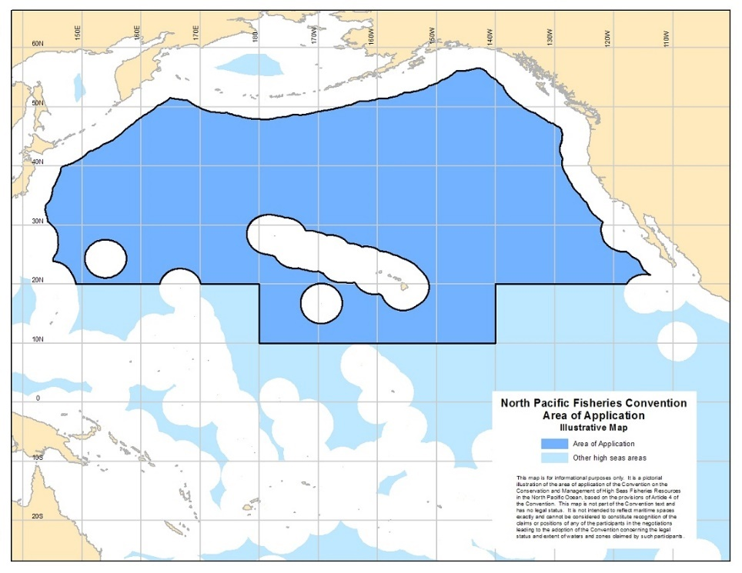

Figure 1. NPFC convention area.

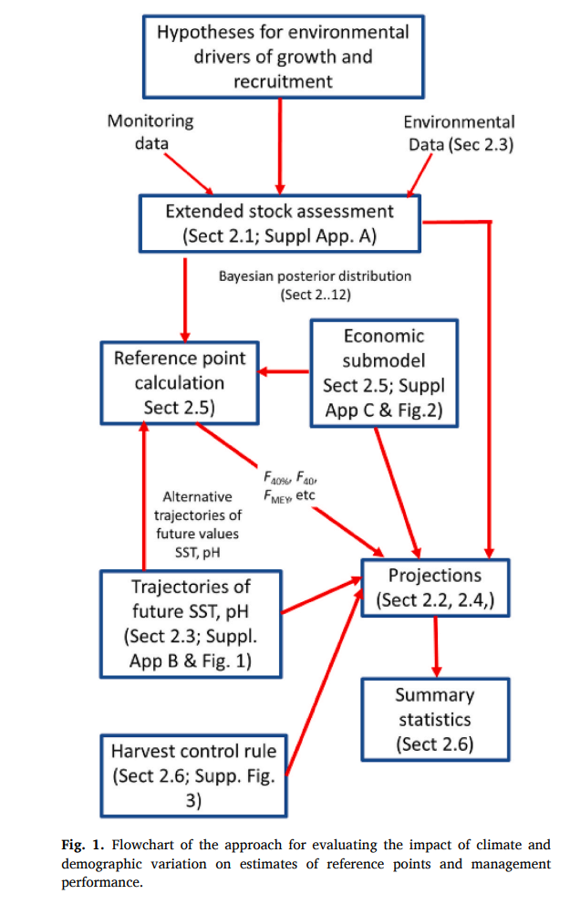

Figure 2. From *Punt et al. 2021 Fig. 1.* Flowchart of the approach for evaluating the impact of climate and demographic variation on estimates of reference points and management performance.

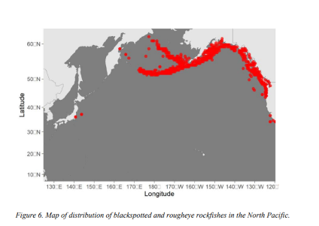

Figure 3. Map of the distribution of Blackspotted and rougheye rockfishes in the North Pacific (NPFC 2023).

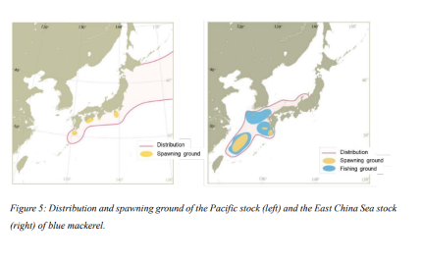

Figure 4. Blue mackerel distribution and spawning ground of the Pacific stock (left) and East China Sea stock (right) of blue mackerel, From NPFC 2024.

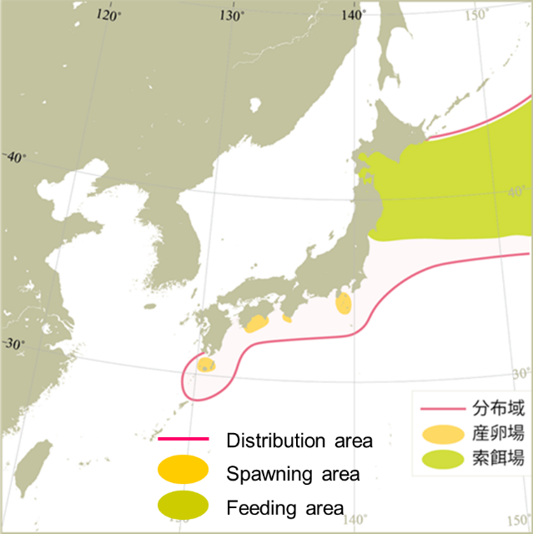

Figure 5. Map of distribution of Chub mackerel in the North Pacific (Yukami et al. 2023)

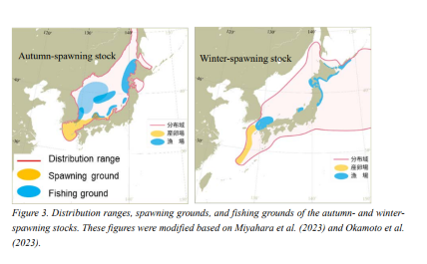

Figure 6. Distribution ranges, spawning grounds, and fishing grounds of the autumn- and winter spawning stocks of Japanese flying squid. These figures were modified based on Miyahara et al. (2023) and Okamoto et al. (2023)

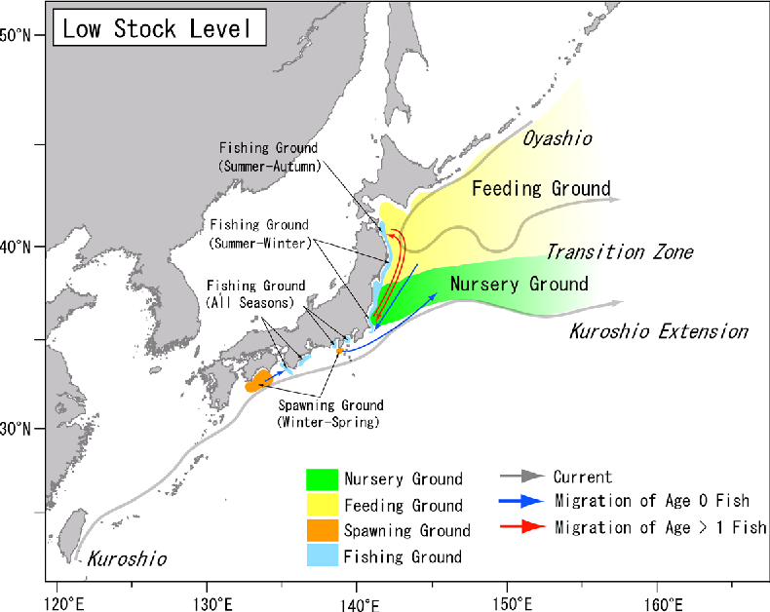

Figure 7. Distribution and migration of the Pacific stock of the Japanese sardine. The spawning area of the Pacific stock of the Japanese sardine covers a wide stretch of the waters off Honshu and Shikoku islands. Juveniles are broadly distributed in the Kuroshio/Oyashio Transition Zone during spring. The distribution of adult sardines extends to the central Pacific and to the southern areas of the Okhotsk Sea and Western Subarctic Gyre.(Hiroshi & Nishida 2005)

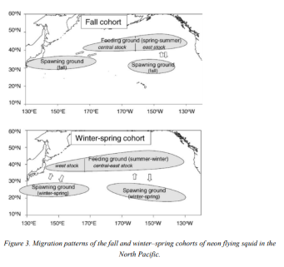

Figure 8. Migration patterns of the fall and winter spring cohorts of neon flying squid in the North Pacific.

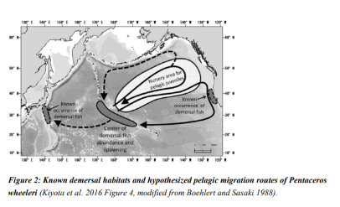

Figure 9. Known habitat possible migration routes of North Pacific armorhead *Pentaceros wheeleri (*Kiyota et al. 2016, Figure 4)

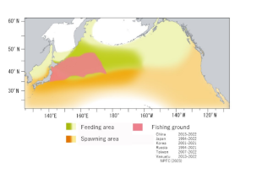

Figure 10. Map of the Feeding grounds, spawning areas and main fishing areas for Pacific Saury.

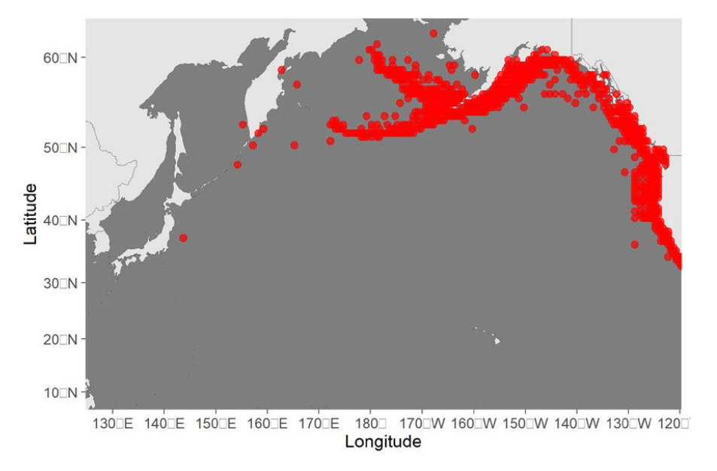

Figure 11. Map of the distribution of sable fish in the North Pacific.

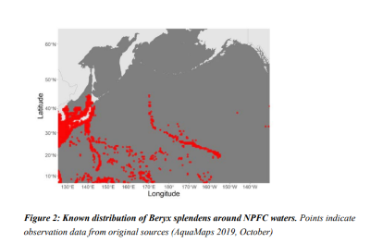

Figure 12. Map of the distribution of splendid alfonsino in the North Pacific (NPFC 2023).

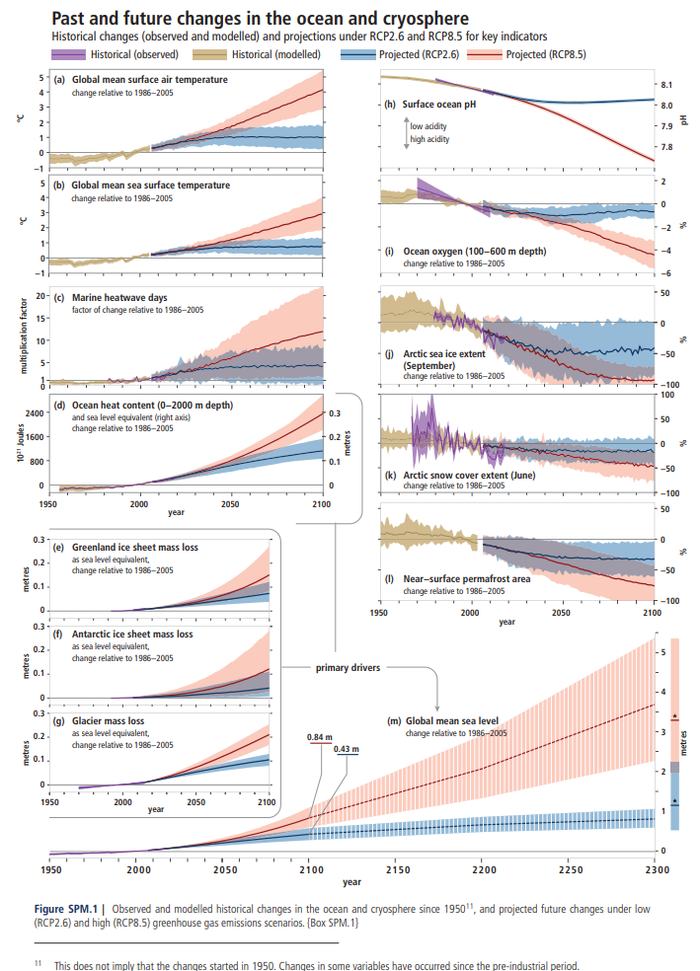

Figure 13. Observed and modelled historical changes in the ocean and cryosphere since 1950, projected future changes under low (RCP2.6) and high (RCP8.5) greenhouse gas emission scenarios. From IPCC 2019, Figure SPM.1.

1. Priority species in the NPFC are: North Pacific armorhead *Pentaceros wheeleri*, Splendid alfonsino *Beryx splendens*, Pacific saury *Cololabis saira*, Neon flying squid *Ommastrephes bartramii*, Japanese flying squid *Todarodes pacificus*, Chub mackerel *Scomber japonicus*, Blue (spotted) mackerel *Scomber australasicus*,

   Japanese sardine *Sardinops melanostictus*, and sablefish(black cod) *Anoplopoma fimbria*.