NPFC-2024-SC09-WP08

**SWG Milestones Report**

**Background and objectives**

The North Pacific Fisheries Commission (NPFC) is responsible for managing fisheries for fish and invertebrate species (not including tuna, tuna-like species and Pacific salmon) in international waters of the North Pacific. The NPFC has identified 10 priority species that are harvested in the Convention Area (CA) using a variety of gears. Four species of pelagic fish; Pacific saury, chub mackerel, blue mackerel and Japanese sardine, four species of bottom fish species; North Pacific armorhead, splendid alfonsino, skilfish, and sablefish and two species of squid; neon flying squid and Japanese flying squid constitute the priority species.

For each of these species the Scientific Committee (SC) of the NPFC is charged with determining the status of the stock and providing this information to the Commission. This will enable the Commission to make informed decisions on sustainable levels of harvest for each stock and/or implement harvest controls that meet other management or conservation objectives for each stock.

The Small Working Group on Milestones (SWG Milestones) was tasked by the Scientific Committee at SC08 to develop a set of common milestones for determining stock status for NPFC priority species. Additionally, the SWG Milestones was asked to develop a plan and timeline to achieve the assessment of stock status. One of the requested tasks was to develop and implement a common set of data sharing templates that would enable the NPFC to more efficiently manage and distribute data on each of the stocks. Finally, the SWG Milestones was asked to present the outcomes of their work at SC09 in December 2024.

**General framework for assessment milestones**

Most modern single species stock assessments utilize three main data streams to determine the status of a fish stock. The catch and effort data from commercial fisheries is the most basic data collected on a stock. Biological data on the species, including length, weight, age and maturity data from the catch and other sources is the second piece of important data. Finally, an index of abundance generated from a non-fishery source (e.g. a fishery independent survey) is sometimes available and always useful in stock assessments. The available data is then integrated into a data-appropriate model that describes the dynamics of the population and from which reference points on the status of the stock can be generated. It is important to note that in some cases the data may limit the type of assessment model that can be used.

In general, once a stock assessment model has been developed, it can be simulation tested to determine its robustness to the data. A stock assessment model (or other model that describes the population dynamics) can also be used as an operating model in a management strategy evaluation (MSE) to determine the performance of different harvest strategies against management and conservation objectives.

Depending on the data available, a more complex (full MSE based on age structured operating model) or a more simple (catch and effort data depicted over time) may be preferred or attainable for NPFC priority species. There is also a different pathway (at least currently) for NPFC priority species that are assessed domestically by Japan and Canada, in that these species are lower priorities for the NPFC SC to develop full stock assessments and MSE processes. A general diagram depicting this pathway from the most simple to most complex scenarios is shown in Figure 1 with NPFC priority species current location along that pathway.

**Pathways for priority species**

A depiction of the planned pathways for assessment within the NPFC are shown in the flow chart in Figures 2 and 3. Which priority stock is chosen for assessment can be determined by direct request of the Commission, or roughly determined by a set of indicators ranked by importance (e.g., stock nearing collapse based on auxiliary information like indices or domestic stock assessments, ecological importance, existing high harvest levels, effective managements with technical measures already in place etc.). In previous years, the stocks chosen for assessment were Pacific saury and chub mackerel and the choice was made by the Commission. At SC08 the Scientific Committee recommended that neon flying squid would be the next species to be assessed based on its importance and the absence of information on its status. The current logistics are that the SC establish a small scientific committee (or technical working group) with representatives from each Member to undertake assessment of a species.

The data available to the NPFC for each stock determines which model or method can be used to assess the stock (Figures 2 and 3). One way to divide the stocks are those that are data rich, data moderate and data poor. For data rich stocks there are two where the fishery occurs predominantly or extensively in the CA (Pacific saury and chub mackerel). There are also data rich stocks where the primary stock distribution is inside domestic waters and a domestic stock assessment is available (Japanese sardine, blue mackerel, Japanese flying squid, sablefish). The data moderate stocks in the NPFC priority species list are splendid alfonsino and neon flying squid, while the data limited stocks are skilfish and North Pacific armorhead.

A proposed set of pathways for assessment within the NPFC are shown in the flow chart in Figure 2. Requests from the Commission, in particular the request for an interim HCR for Pacific saury have led to a different pathway than is proposed in Figure 2 (for Pacific saury an HCR was simulation tested and adopted as an interim measure). The pathway in Figure 2 shows the more accepted practice of conducting MSE on management procedures prior to implementation (rather than implementing an HCR prior to full MSE). Figure 3 shows the proposed pathway for NPFC priority species that currently have a domestic assessment by a Member. We would propose the pathways in Figures 2 and 3 be adopted for future work by the NPFC.

**Data rich stocks (Pacific saury, chub mackerel)**

Data available for Pacific saury include catch and effort data from multiple fishery components (different Members), a juvenile fishery independent survey conducted annually by Japan, and biological data from some fishery catch and the survey data. More complete biological data from the catch of most fishery sectors would be useful for this species. Pacific saury is currently assessed using a Bayesian state-space surplus production model. The model has been simulation tested against the data, reference points have been calculated and a harvest control rule has been implemented by the Commission based on the simulation output. The next steps for the Pacific saury are to implement an age-structured stock assessment model and use this as the operating model in a full MSE for the species.

The status of the Pacific saury stock is currently communicated to the Commission at its annual meeting.

Table 1. Pacific saury milestones, timeline and deliverables

|  |  |  |
| --- | --- | --- |
| Deliverable | Anticipated timeline | Responsible group |
| Age structured assessment/operating model | SC10 (2025)? | SSC PS |
| Full MSE | SC10 (2025)? | SWG MSE, SSC PS |
| Assessment update | Annually | SSC PS |
| MSE update | 3-5 year cycle | SWG MSE, SSC PS |

Data available for chub mackerel include catch and effort data from multiple fishery components (both different gear types and different Members), two juvenile fishery independent surveys (summer and autumn) and egg survey conducted annually by Japan, and biological data from some fishery catch and the survey data. Additionally, recent data from fishery independent surveys conducted by China and Japan are potentially available. More complete biological data from the catch of most fishery sectors would be useful for this species. The chub mackerel stock assessment using a state-space assessment is currently being parameterized and estimated. The model has been tested and evaluated against simulated data. The next steps for the chub mackerel stock are to implement an age-structured stock assessment model, estimate reference points and report status of the stock.

The status of the chub mackerel stock is not currently communicated to the SC and the Commission.

Table 2. Chub mackerel milestones, timeline and deliverables

|  |  |  |
| --- | --- | --- |
| Deliverable | Anticipated timeline | Responsible group |
| Age structured assessment | SC09 (2024) | TWG CMSA |
| Reference points estimated | SC09 (2024) | TWG CMSA |
| Stock status communicated to the SC and Commission | SC09 (2024)? | TWG CMSA, SC |
| Assessment update | Annually | TWG CMSA |

**Data rich stocks with domestic assessments (Japanese sardine, Japanese flying squid, blue mackerel, Sablefish)**

Data available for Japanese sardine include catch and effort data from fishery components (both domestic and in the CA by all Members), fishery independent surveys conducted annually by Japan and biological data from some fishery catch and the survey data. More complete biological data from the catch of the CA fishery sectors would be useful for this species. A domestic assessment of the population is conducted annually by Japan using a virtual population analysis and includes annual catch amount from the CA components of the fishery. The next steps for the Japanese sardine assessment would be to collect and incorporate catch-at-age and biological data from the CA fishery components and report status of the stock to the Commission for the CA fishery based on the Japanese domestic stock assessment.

The status of the Japanese sardine stock is not currently communicated to the Commission.

Table 3. Japanese sardine milestones, timeline and deliverables

|  |  |  |
| --- | --- | --- |
| Deliverable | Anticipated timeline | Responsible group |
| Collect and share biological data from CA catch of Japanese sardine | SC09 (2024) | SWG JS |
| Stock status based on domestic assessment communicated to the SC and Commission | SC09 (2024) | SWG JS, SC |

Data available for Japanese flying squid include catch and effort data from fishery components (both domestic and in the CA by all Members), fishery independent surveys conducted annually by Japan (winter and spring) and historically by Russia, and biological data from some fishery catch and the survey data. More complete biological data from the catch of the CA fishery sectors would be useful for this species. A domestic assessment of the population is conducted annually by Japan based on abundance indices. The next steps for the Japanese flying squid assessment would be to collect and incorporate biological data from the CA fishery components and report status of the stock to the Commission for the CA fishery based on the Japanese domestic stock assessment.

The status of the Japanese flying squid stock is not currently communicated to the Commission.

Table 4. Japanese flying squid milestones, timeline and deliverables

|  |  |  |
| --- | --- | --- |
| Deliverable | Anticipated timeline | Responsible group |
| Collect and share biological data from CA catch of Japanese flying squid | SC09 (2024) | SWG JFS |
| Stock status based on domestic assessment communicated to the SC and Commission | SC09 (2024) | SWG JFS, SC |

Data available for blue mackerel include catch and effort data from fishery components (both domestic and in the CA by all Members), fishery independent surveys conducted annually by Japan and biological data from some fishery catch and the survey data. More complete biological data from the catch of the CA fishery sectors would be useful for this species. A domestic assessment of the population is conducted annually by Japan using a virtual population analysis and includes catch and effort data from the CA components of the fishery. The next steps for the blue assessment would be to collect and incorporate catch-at-age and biological data from the CA fishery components and report status of the stock to the Commission for the CA fishery based on the Japanese domestic stock assessment.

The status of the blue mackerel stock is not currently communicated to the Commission.

Table 5. Blue mackerel milestones, timeline and deliverables

|  |  |  |
| --- | --- | --- |
| Deliverable | Anticipated timeline | Responsible group |
| Collect and share biological data from CA catch of blue mackerel | SC09 (2024) | SWG BM |
| Stock status based on domestic assessment communicated to the SC and Commission | SC09 (2024) | SWG BM, SC |

Data available for sablefish include catch and effort data from fishery components (both domestic and in the CA), fishery independent surveys conducted annually by the USA and Canada and biological data from fishery catch and the survey data. A domestic assessment of the population is conducted annually by the USA for Alaska, and on a 3-5 year cycle for the USA West Coast using an age structured model. A full MSE is conducted on the Canadian portion of the stock on a 3-5 year cycle and a coastwide MSE was conducted in 2023 for sablefish. The next steps for the sablefish would be to report status of the stock to the Commission based on the Canadian MSE and USA stock assessments.

The status of the sablefish stock is not currently communicated to the Commission.

Table 6. Sablefish milestones, timeline and deliverables

|  |  |  |
| --- | --- | --- |
| Deliverable | Anticipated timeline | Responsible group |
| Stock status based on Canadian MSE assessment communicated to the SC and Commission | SC09 (2024) | SSC BFME, SC |

**Data moderate stocks (splendid alfonsino, neon flying squid)**

Data available for splendid alfonsino are more limited. They include catch data from the bottom trawl fishery (Japan and Korea) and the bottom gillnet fishery (Japan) and biological data from the fisheries catch including length, weight, age and maturity. Importantly, there is no fishery independent survey conducted for this species and effort data is not split from effort for the North Pacific armorhead, which makes calculating CPUE problematic. Due to these issues with the data, a data limited-life history based approach to determining stock status is being undertaken. This analysis will focus on calculating yield per recruit and spawner per recruit indices of the stock and attempting to use length data to estimate selectivity by age. The next steps for the splendid alfonsino stock are to conduct the life-history based analyses, develop reference points and report the status of the stock to the SC and the Commission.

The status of the splendid alfonsino stock is not currently communicated to the Commission.

Table 7. Splendid alfonsino milestones, timeline and deliverables

|  |  |  |
| --- | --- | --- |
| Deliverable | Anticipated timeline | Responsible group |
| Develop indicators of stock status using life-history based methods | SC09 (2024) | SSC BFME |
| Develop reference points and HCRs or suitable alternatives | SC10 (2025) | SSC BFME |
| Stock status reported to SC and Commission | SC09 (2024) | SSC BFME, SC |

Data available for neon flying squid include catch and effort data from fishery components (different Members), fishery independent surveys conducted annually by Japan (winter and spring) and historically by Russia, and biological data from some fishery catch and the survey data. Although neon flying squid has the potential to be considered as a data rich species, at the moment, only data on catch and effort has been shared among members, so we consider it data moderate at this time. More complete biological data from the catch of most fishery sectors would be useful for this species. The SSC NFS was recently formed by the Commission and has begun its work this year (2024). The next steps for the SSC NFS are to share Member data, select and assess a suitable population dynamics model, conduct the analytical stock assessment, estimate reference points and report status of the stock.

The status of the neon flying squid stock is not currently communicated to the SC and the Commission.

Table 8. Neon flying squid milestones, timeline and deliverables [**this table will be updated with agreed upon timelines at the conclusion of the 1st SSC NFS in August**]

|  |  |  |
| --- | --- | --- |
| Deliverable | Anticipated timeline | Responsible group |
| Share all neon flying squid data | SC09 (2024) | SSC NFS |
| Test/evaluate? and choose appropriate assessment model | SC10 (2025) | SSC NFS |
| Conduct stock assessment | SC11 (2026) | SSC NFS |
| Reference points estimated | SC11 (2026) | SSC NFS |
| Stock status communicated to the SC and Commission | SC11 (2026)? | SSC NFS, SC |

**Data limited stocks (north pacific armorhead, skilfish)**

Data available for North Pacific armorhead are also limited. They include catch data from the bottom trawl fishery (Japan and Korea) and the bottom gillnet fishery (Japan) and limited biological data from the fisheries catch including length, weight, and fatness index. There is no regular fishery independent survey conducted for this species, although there is a monitoring survey conducted since 2019 and consisting of a single tow conducted per month from March to June at a predesignated block. As with splendid alfonsino, the effort data is not easily resolved, which makes calculating CPUE problematic. Due to these issues with the data, a data limited approach is needed to assess the status of this stock. Two methods have been proposed, using a depletion method to determine an annual and historical biomass and an individual based modeling approach to attempt to indicate future recruitment. The next steps for the North Pacific armorhead stock are to explore the depletion estimate and individual based model to determine if one of these methods is sufficient to develop reference points. It may be that these methods will not prove suitable and robust, so the current species summary approach that documents the annual catch trends is the only information that is reported to the SC and the Commission.

The status of the North Pacific Armorhead stock is not currently communicated to the Commission.

Table 9. North Pacific armorhead milestones, timeline and deliverables

|  |  |  |
| --- | --- | --- |
| Deliverable | Anticipated timeline | Responsible group |
| Trends in catch reported to SC and Commission | SC09 (2024) | SSC BFME, SC |
| Develop indicators of historical and current biomass based on depletion method | SC10 (2025) | SSC BFME |
| Develop indicators of recruitment from individual based model | SC10 (2025) | SSC BFME |
| Stock status and/or trends in catch reported to SC and Commission | SC10 (2025) | SSC BFME, SC |

Table 10. Rougheye and blackspotted rockfish milestones, timeline and deliverables

|  |  |  |
| --- | --- | --- |
| Deliverable | Anticipated timeline | Responsible group |
| Continue to report trends in catch and effort to SC and begin reporting to the Commission | SC09 (2024) | SSC BFME, SC |

There is very little data available for the longline fishery conducted by Russia for skilfish. The fishery is intermittent in occurrence, but there are catch and effort data reported. There is some biological data (length and weight) recorded by observers on the catch. There is no fishery independent survey conducted for this species or other biological data collected. Due to the lack of data, a data limited approach is needed to assess the status of this stock. Currently there is no plan to conduct an assessment for this species, so the next steps are to develop a species summary that documents the annual catch and effort trends is reported to the SC and the Commission.

The status of the skilfish stock is not currently communicated to the SC or the Commission.

Table 11. Skilfish milestones, timeline and deliverables

|  |  |  |
| --- | --- | --- |
| Deliverable | Anticipated timeline | Responsible group |
| Develop species summary document for skilfish | SC09 (2024) | SSC BFME |
| Report trends in catch and effort to SC and Commission | SC09 (2024) | SSC BFME, SC |

**Data and data sharing templates**

Data from fisheries and research surveys are the backbone of stock assessment. Currently, the scientific data workflow in the NPFC involves the steps outlined in Figure 4. Data is collected by Members, cleaned and processed and then shared with SC’s expert groups in accordance with the agreed data sharing templates. Data is stored on the Collaboration site managed by the Secretariat. Expert groups review data, compile/process them and use for stock assessment and other analyses.

Efficient data workflow from data collection to management advice requires clearly defined responsibilities and agreed regulations for data collection, sharing and use. Table 12 summarizes the status of this process and identifies missing elements and potential steps forward. Other RFMOs and international management bodies have standing working groups to deal with data and provide guidance on data related issues as they arise. It would be useful to establish a Small Working Group within NPFC to fill this gap in resolving data and data issues. A draft Terms of Reference for such a group are attached as Annex 1.

Table 12. Scientific data workflow status and potential future tasks

|  |  |  |  |
| --- | --- | --- | --- |
| Data workflow step | Responsibility | Regulations | Note |
| Collection | Members | Data requirements  Data collection templates | Status: data requirements for BF (CMMs 05 and 06),  Data Information Template for PS ([link](https://www.npfc.int/data-information-template-pacific-saury)).  [Future tasks: Data requirements and Data collection templates for other species.] |
| Cleaning | Members | Data collection quality control  Data cleaning requirements | Status: conducted by M individually.  [Future tasks: Data collection quality control and Data cleaning requirements guidelines] |
| Submission | Members | Data sharing regulations  Data provision templates  Data provision deadlines | Status: Data sharing regulations in place ([link](https://www.npfc.int/policies-commission)).  Expert group-specific data provision templates.  [Future tasks: Common/standardized data submission templates and data submission process.  Data for domestic stock assessment.  Data provision deadlines on website.] |
| Storage | Secretariat / Members | Database management system | Status: data is stored in different locations and different formats.  [Future tasks: Relational database.  Online data submission tools] |
| Inventory | Secretariat | Data inventory policy | Status: Data inventory policy and template in preparation.  [Future tasks: final draft, review by SC] |
| Quality review and compilation | Expert groups | Agreed process for data quality check | Status: Data quality review at meetings.  [Future tasks: Data quality review for domestic stock assessments] |
| Analysis/modelling | Expert groups | CPUE Standardization Protocol  Stock Assessment Protocol | Status: CPUE Standardization Protocols and Stock Assessment Protocols for PS and CM are in place.  [Future tasks: Regular review/update for PS and CM.  Protocols for other priority species.] |
| Scientific advice | Expert groups/SC | Scientific Advice Format | Status: Stock Assessment Report incl. Executive Summary for PS.  In preparation for CM.  [Future tasks: Common Scientific Advice Format] |
| Workflow review | SWG Data/SC | Part of SWG Data TOR | [Future tasks: regular review] |

**Recommendations to the SC**

The following recommendations are made with regards to milestones for achieving stock assessment and status updates for NPFC priority species:

* Prioritize development of stock assessment activity for stocks without domestic assessments
* Use domestic assessments to monitor those species for which these exist
* Streamline reporting to Commission from the SC
  + Statements of status for each species (e.g. saury text, NPA text)
  + Time series of catch, effort for all species (with pictures)
  + CPUE standardized or biomass (if model) where available
* Review scientific data workflow (Table 12) and prioritize future tasks
* Establish [SWG] Data with the attached terms of reference (Annex 1)
* Share data using standardized data sharing templates to streamline process for Secretariat to compile and store data
* Implement a 5-10 year stock assessment review cycle for species assessed by the NPFC
* Share existing biological data from the fisheries catch in the CA and the adjacent EEZs with those conducting domestic stock assessments
* Consider collecting additional biological data from new surveys and the catch in the CA for species with a stock assessment (both domestic and NPFC)
* Consider assessing the impacts of climate change on the ecosystem as well as stocks and fisheries in the species summary for each species

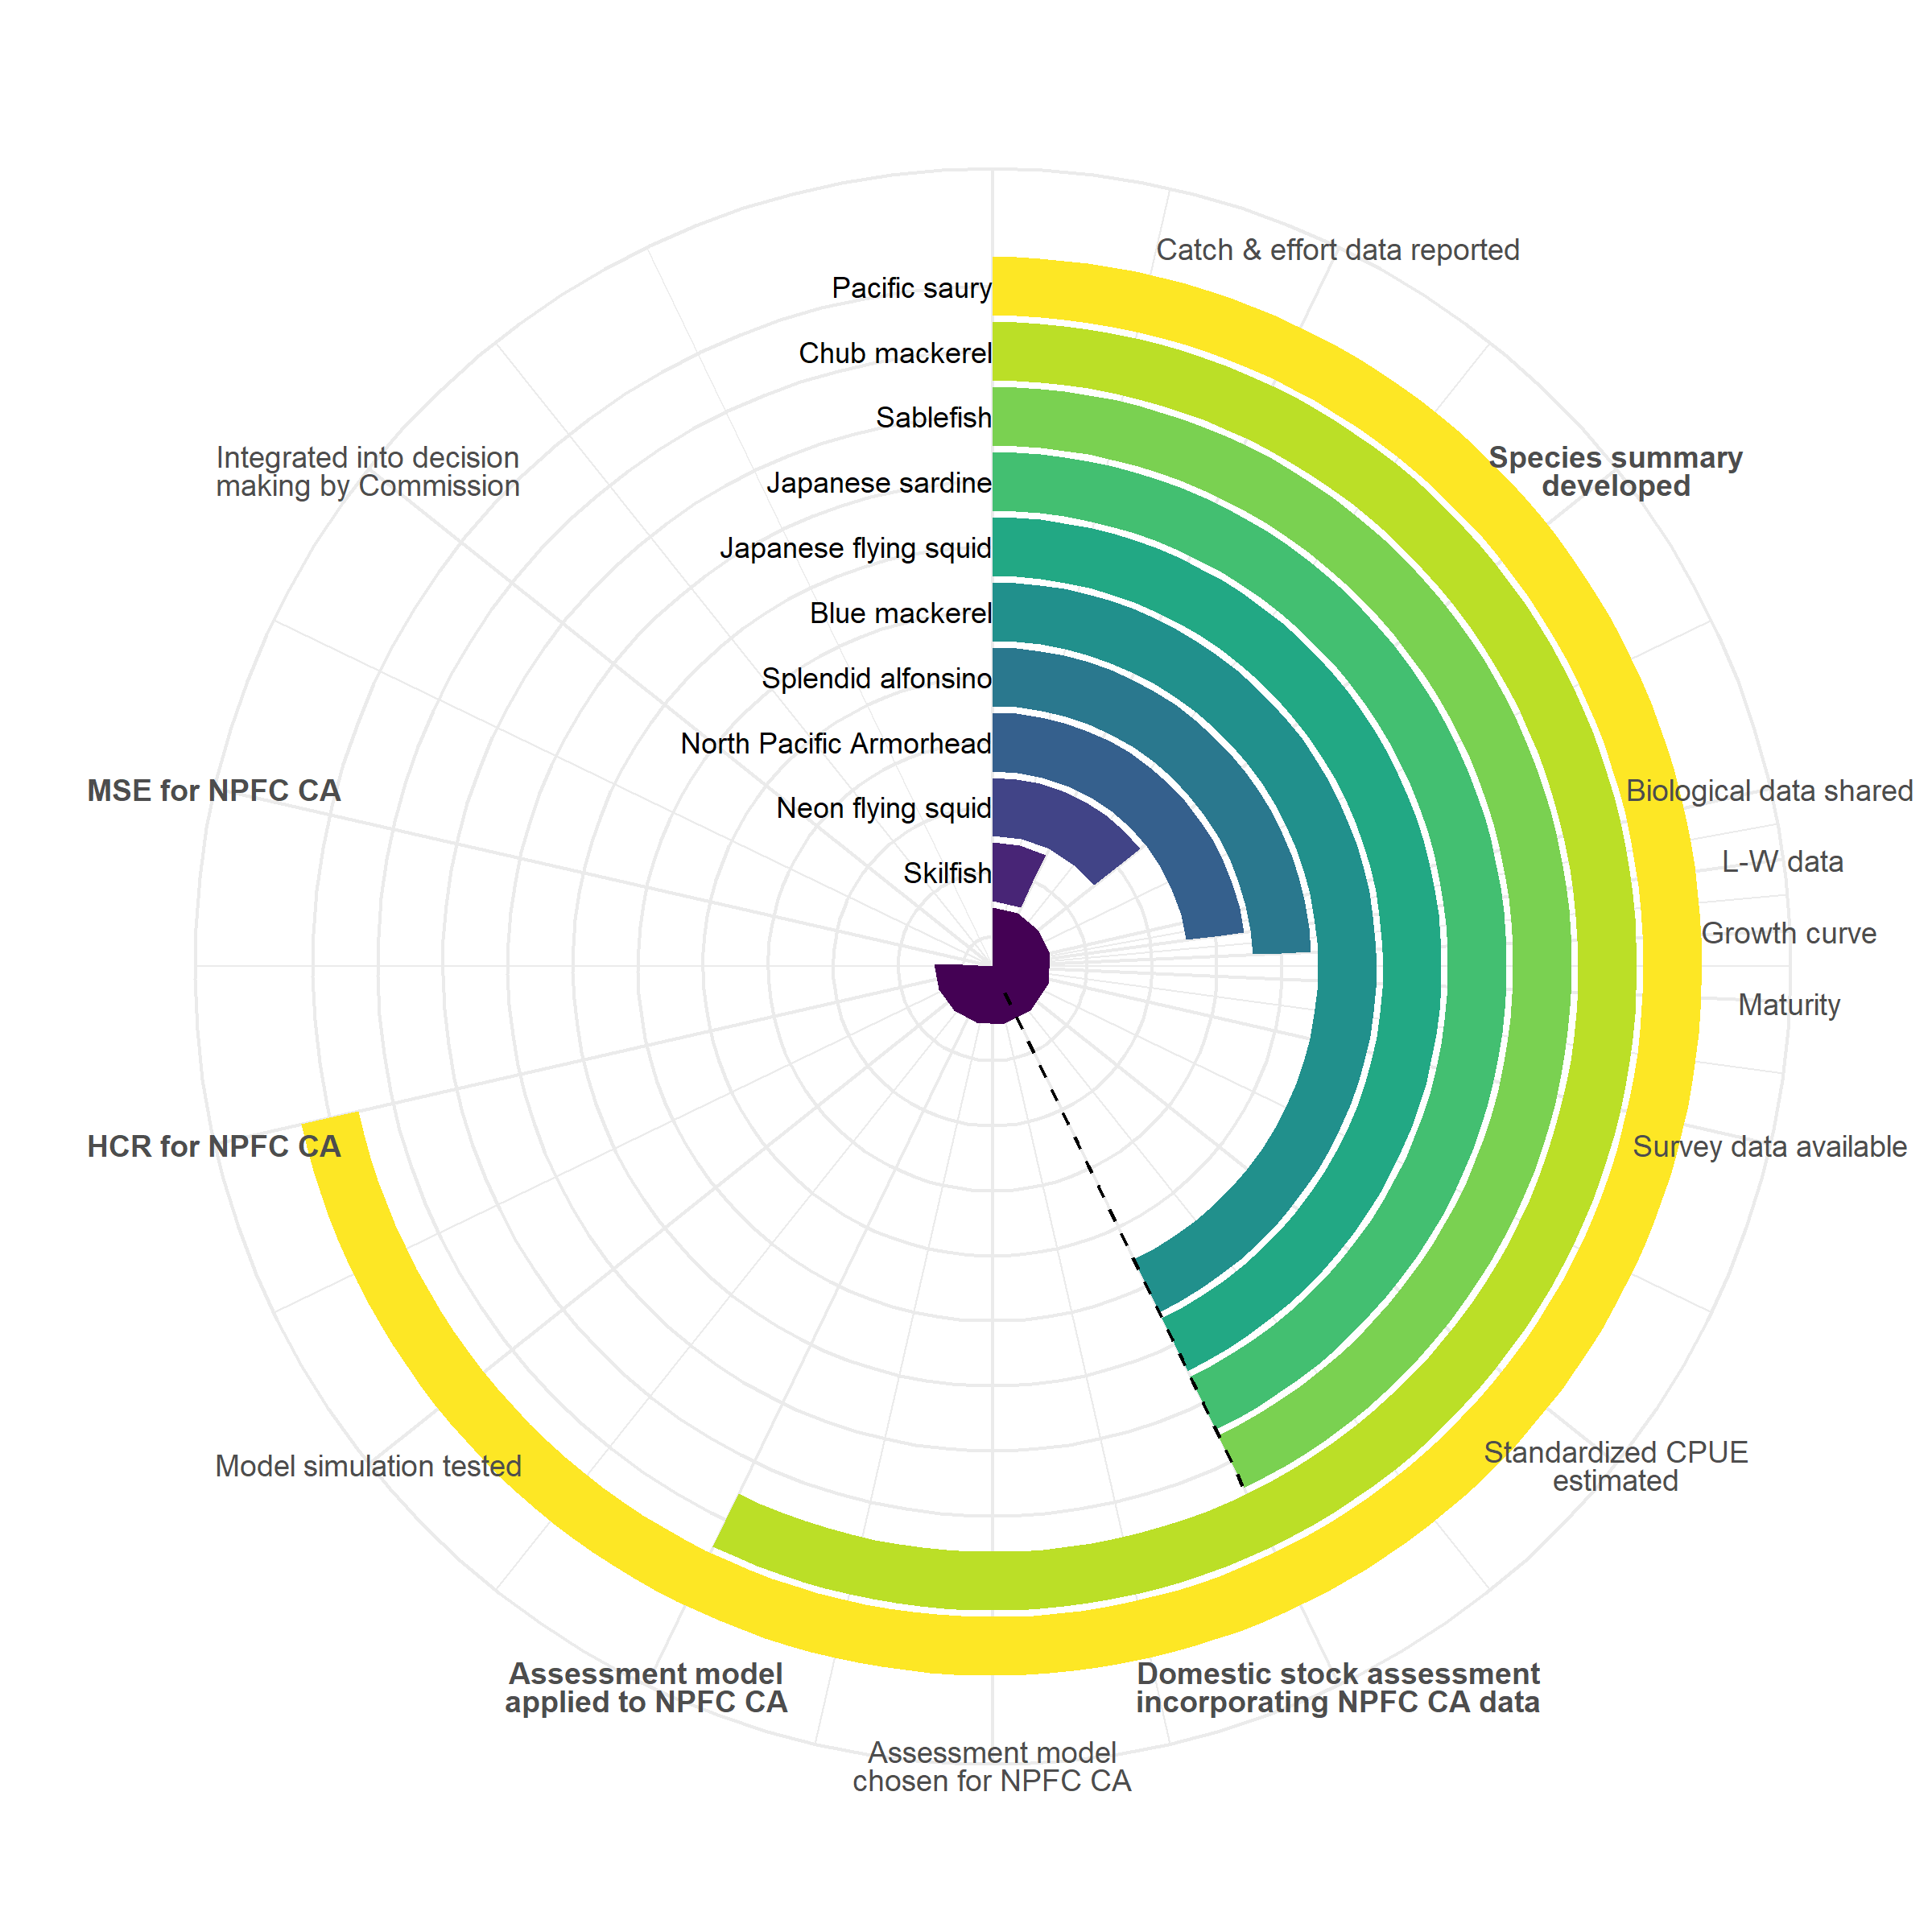

Figure 1. General schematic of current status of the assessment process for priority fish stocks that are currently targeted in the NPFC Convention Area. Milestones in bold demarcate products that can be provided to the Commission to inform about stock status. The dashed line indicates a domestic stock assessment is in place for the species that incorporates NPFC CA data and moving forward with a separate NPFC assessment may not be a priority.

Figure 2. Flow chart of proposed pathways for stock assessment and provision of advice to the Commission on priority species for the NPFC.

Figure 3. Flow chart of proposed pathway for reviewing domestic stock assessment on NPFC priority species without an NPFC stock assessment completed.

Figure 4. Flowchart of current and proposed pathways for data processing, submission and compilation for NPFC stocks.

**Annex 1. Terms of reference for new small working group on data management ([SWG] Data)**

1. Compile an inventory of Members’ data collection programs
   1. Review existing observer programs of Members and other RFMOs
   2. Update the inventory when needed to reflect changes in Members’ sampling schemes.
2. Assist the SC’s subsidiary groups in collecting information on data needs
   1. Develop a template for the subsidiary groups to quickly report the required information
   2. Assist the subsidiary groups in filling data gaps where they exist
3. Assist the secretariat in creating a data management system, including data collection, verification, reporting, storing, and dissemination
   1. Discuss the creation of a relational database for data storage and what the necessary steps would be
   2. Continue developing data provision templates, incorporating feedback from the SC’s subsidiary bodies.