NPFC-2024-SSC BFME05-IP02

**Joint Canada-USA International Seamount Survey - 2024**

Chris Rooper1, Christina Conrath2, Pam Goddard2 (1 Pacific Biological Station, Fisheries and Oceans Canada and 2 AFSC-RACE)

**Background and Objectives:**

The second Joint Canada-USA International Seamount Survey (JCUISS) was designed to study deep-sea coral and sponge communities on seamounts in international waters. Deep sea coral and sponge distributions outside of US and Canada EEZ’s are relatively under explored, with the exception of a handful of studies conducted at the Cobb Seamount complex off of southern British Columbia. Historically (1970’s – 1990’s) many of these offshore seamounts were fished by both domestic (Canadian and USA) and foreign (Russia, Korea and Japan) fishing fleets. Currently, there is limited fishing by the Canadian Sablefish longline trap fleet at seamounts in international waters. The intersection between deep-sea coral and sponge distribution and fisheries is an ongoing concern of the North Pacific Fisheries Commission, the Regional Fisheries Management Organization for international waters of the North Pacific Ocean (www.npfc.int). The NPFC manages fisheries and vulnerable marine ecosystems (VME’s) to monitor potential significant and adverse impacts on deep sea corals and sponges.

In 2022 a two-week survey using an underwater stereo camera was undertaken at 5 seamounts in the Cobb Seamount Chain. Data were collected at 77 transects. Preliminary analyses of these data have shown that deep-sea corals are widespread at relatively low densities across all the seamounts examined and especially at depths below 400 m where the majority of the sampling occurred. Preliminary species distribution models have been developed for coral and sponge taxonomic groups based on these data, but data from these international seamounts are limited.

The objective of this study was to both validate these existing coral and sponge models using an independent data set collected via underwater stereo camera systems and generate new spatially explicit data that can be utilized in constructing improved presence-absence and abundance models for coral and sponge distribution.

**Approach:**

In 2022 an extensive analysis was carried out to examine sample allocation methods using eight different methods, depth stratified random sampling was chosen as the best method. Thus, in the allocation for 2024 fieldwork, stratified random sampling was again be used for station allocation, this time with four depth strata (0-200, 200-400, 400-600, and 600-800 m). In 2022 there was an additional depth strata included from 800-1100 m, but could not be sampled due to depth limitations of the camera. In 2024 the same number of transects (n = 15) were randomly chosen within the shallower strata (0-200 m), with 20 transects chosen in the remaining strata. This is predominantly to focus more sampling effort on the deeper strata, as models and data from 2022 indicate that these strata had a higher probability of coral and sponge presence. There were six stations from the 2022 station allocation that were not sampled due to time constraints, so these stations were added to the total allocated stations, giving 86 potential stations to be sampled during 2024.

The main tool used in this work was the underwater stereo camera system developed during the Alaska Coral and Sponge Initiative in 2012-2015. The stereo-camera survey followed a standard protocol outlined in Rooper et al. (2016), with a target of 15 minutes of on-bottom time for each transect. Images will be processed to determine substrate type, density and size of structure forming invertebrates and density and size of fish species using Sebastes software (Williams et al. 2015). The visual survey was designed in a robust statistically sound method so that inferences about the deep-sea coral and sponge communities on seamounts can be made. In addition distribution models for deep-sea coral and sponge taxa were developed to aid in the selection of depth strata. An estimate of the total abundance of deep-sea coral and sponge (and associated fishes) will be generated using the sampling for each of the seamounts and the seamount chain. Further species distribution modeling will also be conducted to predict hotspots of abundance and diversity in the seamounts that may warrant protection as vulnerable marine ecosystems (FAO 2009).

In addition to the visual survey, we also collected temperature data. We also collected water samples with adjoining images that can contribute to ongoing eDNA studies and taxonomic studies. Acoustic data from scientific echosounders was also collected during nighttime benthic mapping. A series of benthic grabs were collected to document the sediment at selected locations on Cobb seamount.

**Significant Results to Date:** In total only 58 of the 86 stations were occupied on Brown Bear and Cobb Seamounts (Figure 1). The stereo camera system was lost due to a vicious hang on the seafloor on day six of the survey and could not be recovered.

Preliminary image analysis showed that gorgonian corals were present at 71% of the transects occupied. Most of the corals occurred at depths below 400 m and corals were present at most transects on all seamounts below this depth (Figure 2). Coral taxa appeared to consist of Primnoidae, Isididae and other Octocorallians and Antipatharians at deeper depths. Hexactinellid sponges had a similar distribution to the corals, although they occurred in only 46% of the transects. Hydrocorals were common at shallow depths on Cobb and Corn seamount, while sea whips and sea pens were not common, but found at most depths. Reef building scleractinians were observed at 8 transects across both years. Figure 3 shows the density for VME indicator taxa and Figure 4 shows the height of VME indicator taxa measured with the stereo camera system.

Discarded longline gear was observed at ~10% of transects and a single furrow believed to be indicative of bottom trawl gear was observed. Most of the fishing gear occurred on Cobb Seamount.

It should be noted that these data are the result of a cursory look at the transect data and will change when detailed image analysis is completed.

**Additional Collaborators in 2024:**

Steve Schut, Fisheries and Oceans Canada ([Steven.Schut@dfo-mpo.gc.ca](mailto:Steven.Schut@dfo-mpo.gc.ca))

**Figures:**

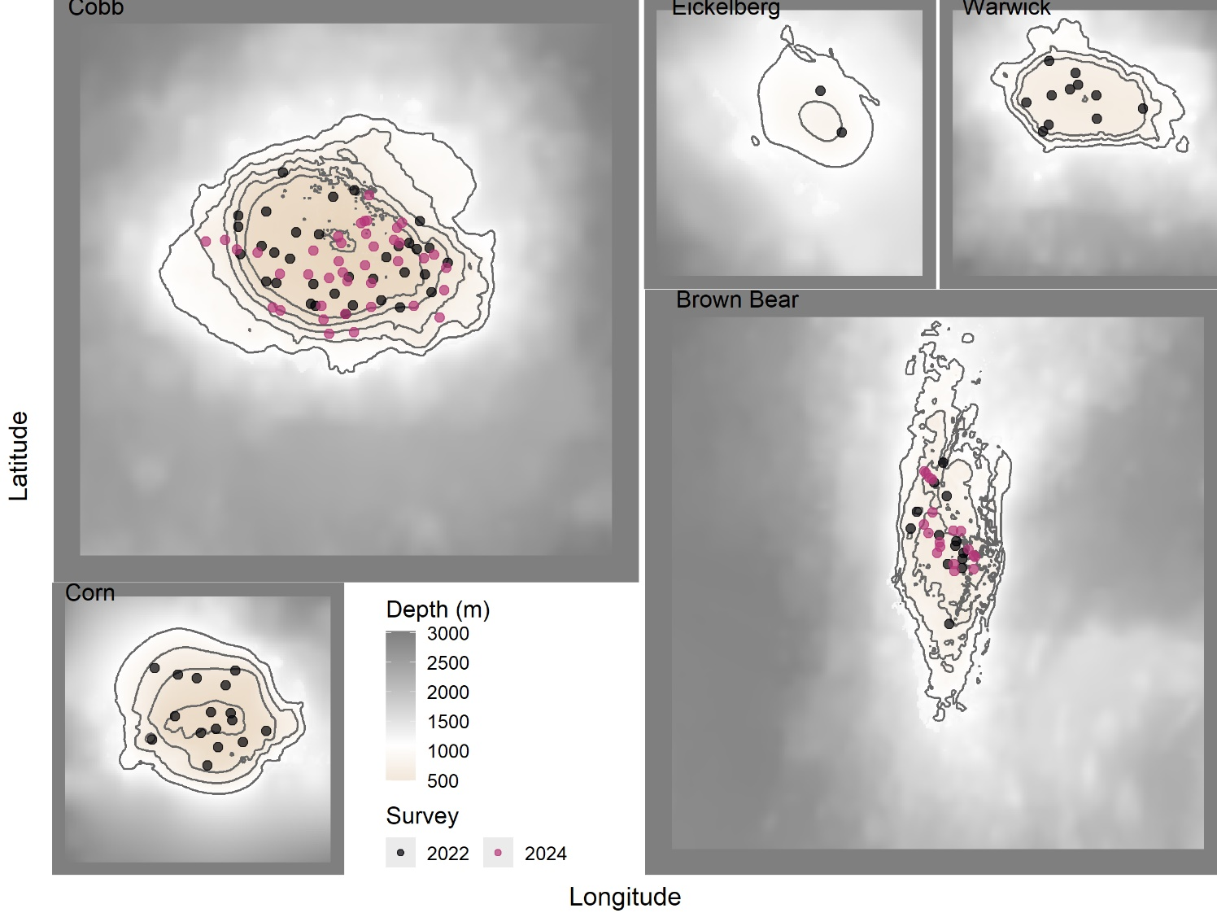

*Figure 1. Map showing distribution of randomly sampled transects in 2022 and 2024 at the five seamounts surveyed on the cruise in bold text (Cobb, Corn, Warwick, Eickelberg and Brown Bear).*

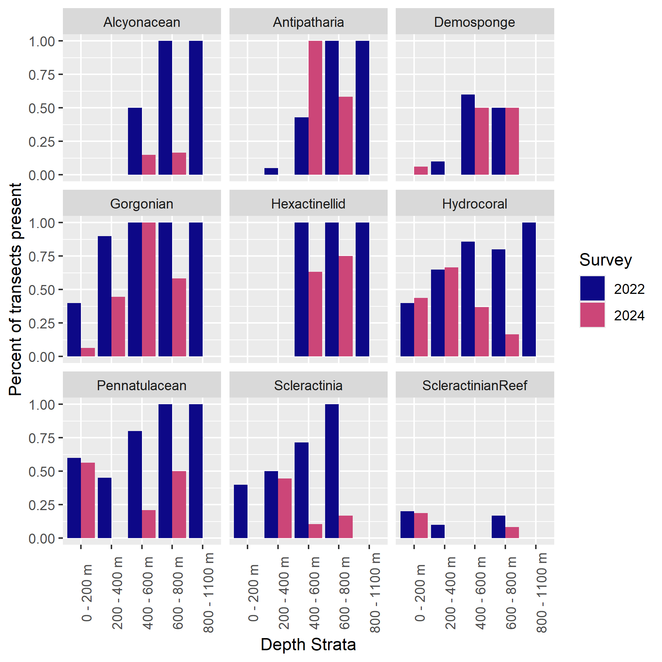

*Figure 2. Percentages present for the most common structure forming invertebrates at the five seamounts surveyed during the Joint Canada USA International Seamounts cruise.*

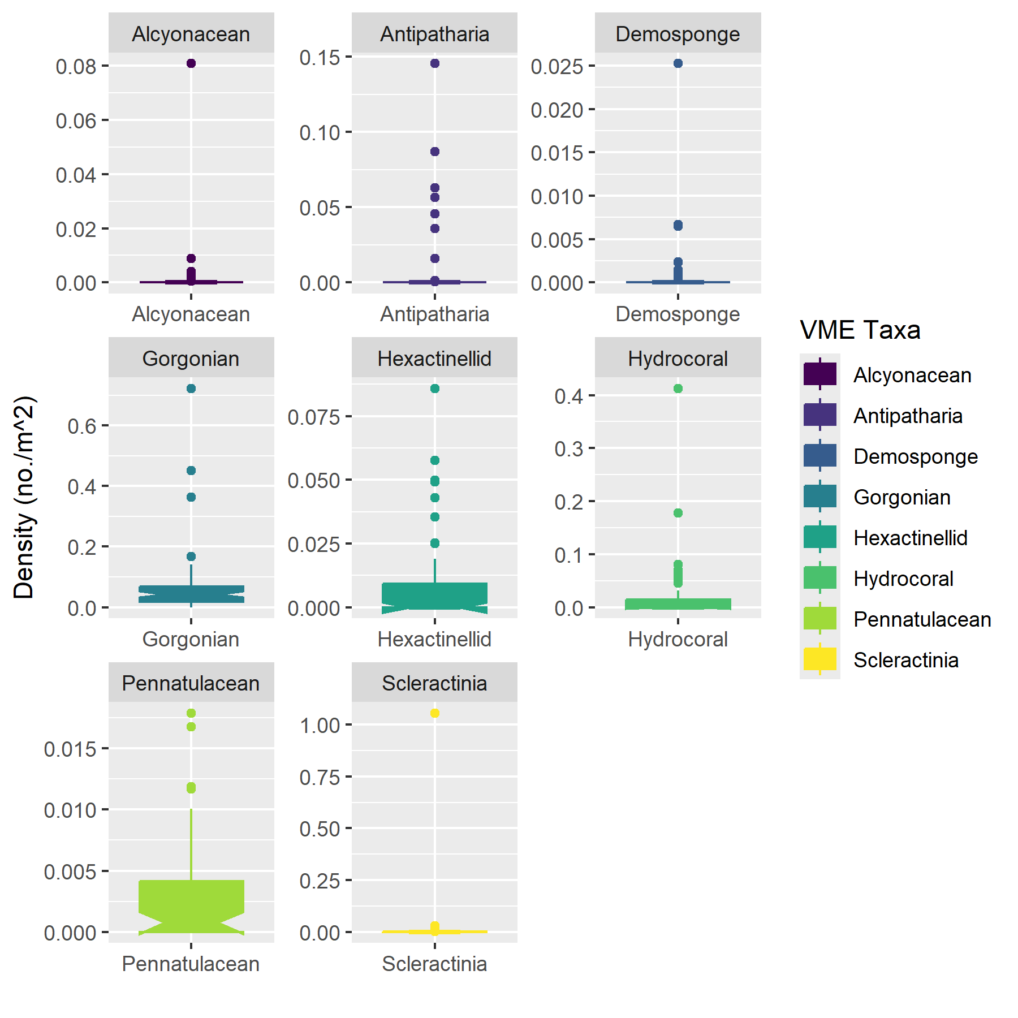

*Figure 3. Densities of the most common structure forming invertebrates occurring at the five seamounts surveyed during the Joint Canada USA International Seamounts cruise.*

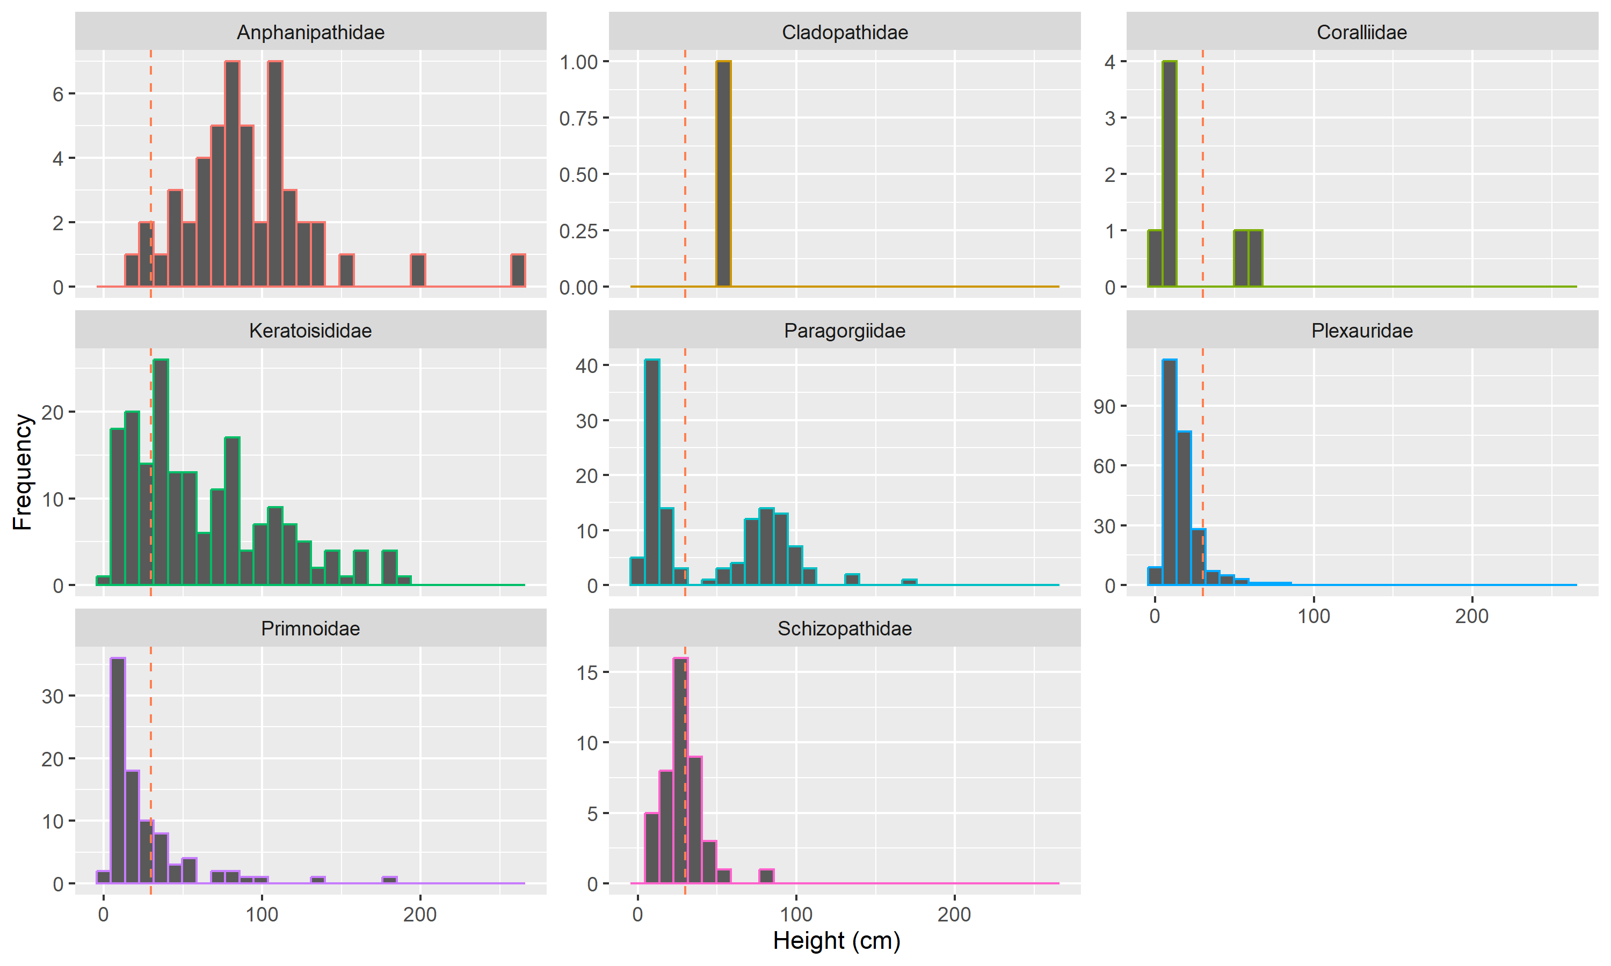

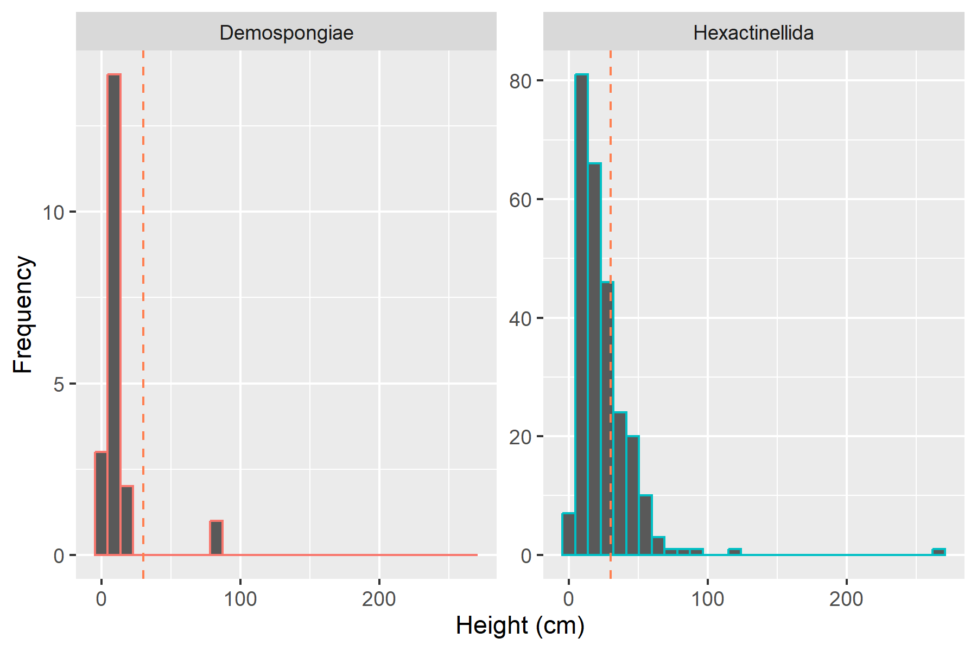

*Figure 4. Height distributions of common families of corals and classes of sponges observed at seamounts in international waters.*