NPFC-2024-SSC BFME05-WP02

North Pacific Armorhead

Species Summary

*NPFC SWG-NPA-SA*

*2024-10-24*

# North Pacific armorhead (*Pentaceros wheeleri*)

**Common names:** Pelagic armorhead, Slender armorhead (English); 五棘鲷 (Chinese); クサカリツボダイ (Japanese); 북방돗돔 (Korean); кабан-рыба (Russian)

## Biological Information

North Pacific armorhead has a unique life history consisting of a pelagic larva phase and a demersal adult stage on the seamounts (Kiyota et al. 2016). Distribution of the larva includes Gulf of Alaska to North Pacific Ocean off central California and south of Japan, with center of abundance at the Emperor Seamounts. Following their settlements in the seamounts, adults make morphological changes from the “fat” type to the “lean” type concurrent with their dietary shifts. Vertical distribution of the adults ranges from 300-500 m. Juveniles at the epipelagic stage mainly feeds on copepods, shifting the targets towards fish and large crustaceans with growth.

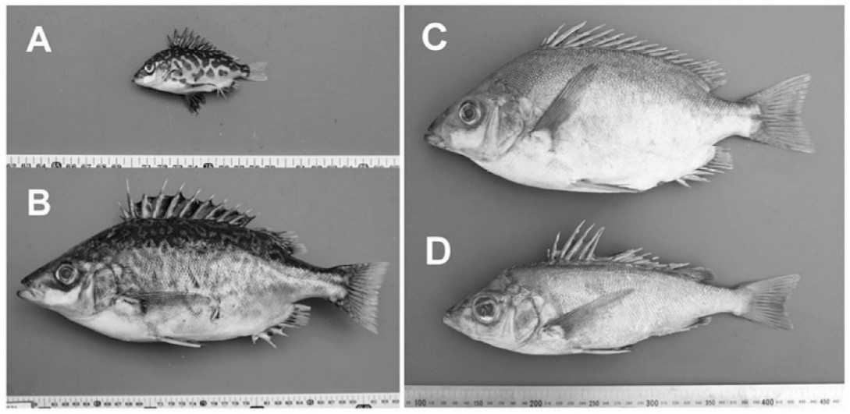

**Figure 1: Photographs of Pentaceros wheeleri.** A) Pelagic juvenile, B) pelagic subadult, C) demersal adult (fat type), D) demersal adult (lean type) (from Kiyota et al. 2016)

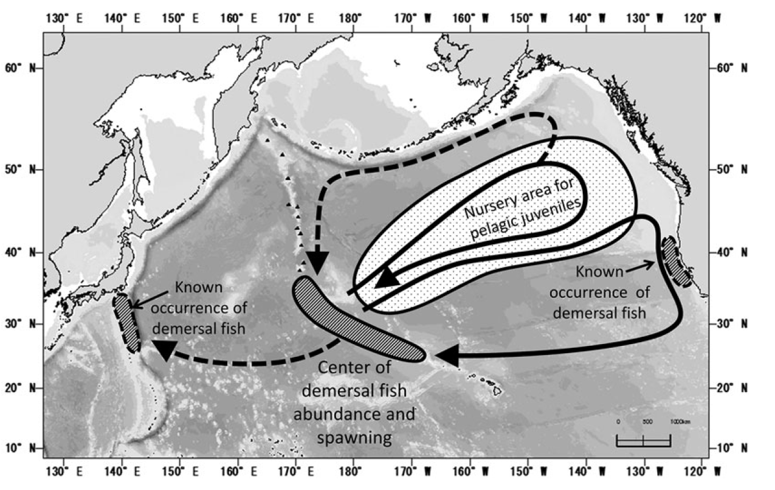

**Figure 2: Known demersal habitats and hypothesized pelagic migration routes of Pentaceros wheeleri** (Kiyota et al. 2016 Figure 4, modified from Boehlert and Sasaki 1988).

## Fishery

Historical catches by Russia and Japan from the combined Emperor Seamounts were high and reached 100 thousand tons in 1970s, followed by a crash (Figure 3). Currently North Pacific armorhead is caught by Japan and Korea on the Emperor Seamounts using bottom trawls and gillnets. This fishery is a potential source of significant adverse impacts on vulnerable marine ecosystems due to bottom contact gear.

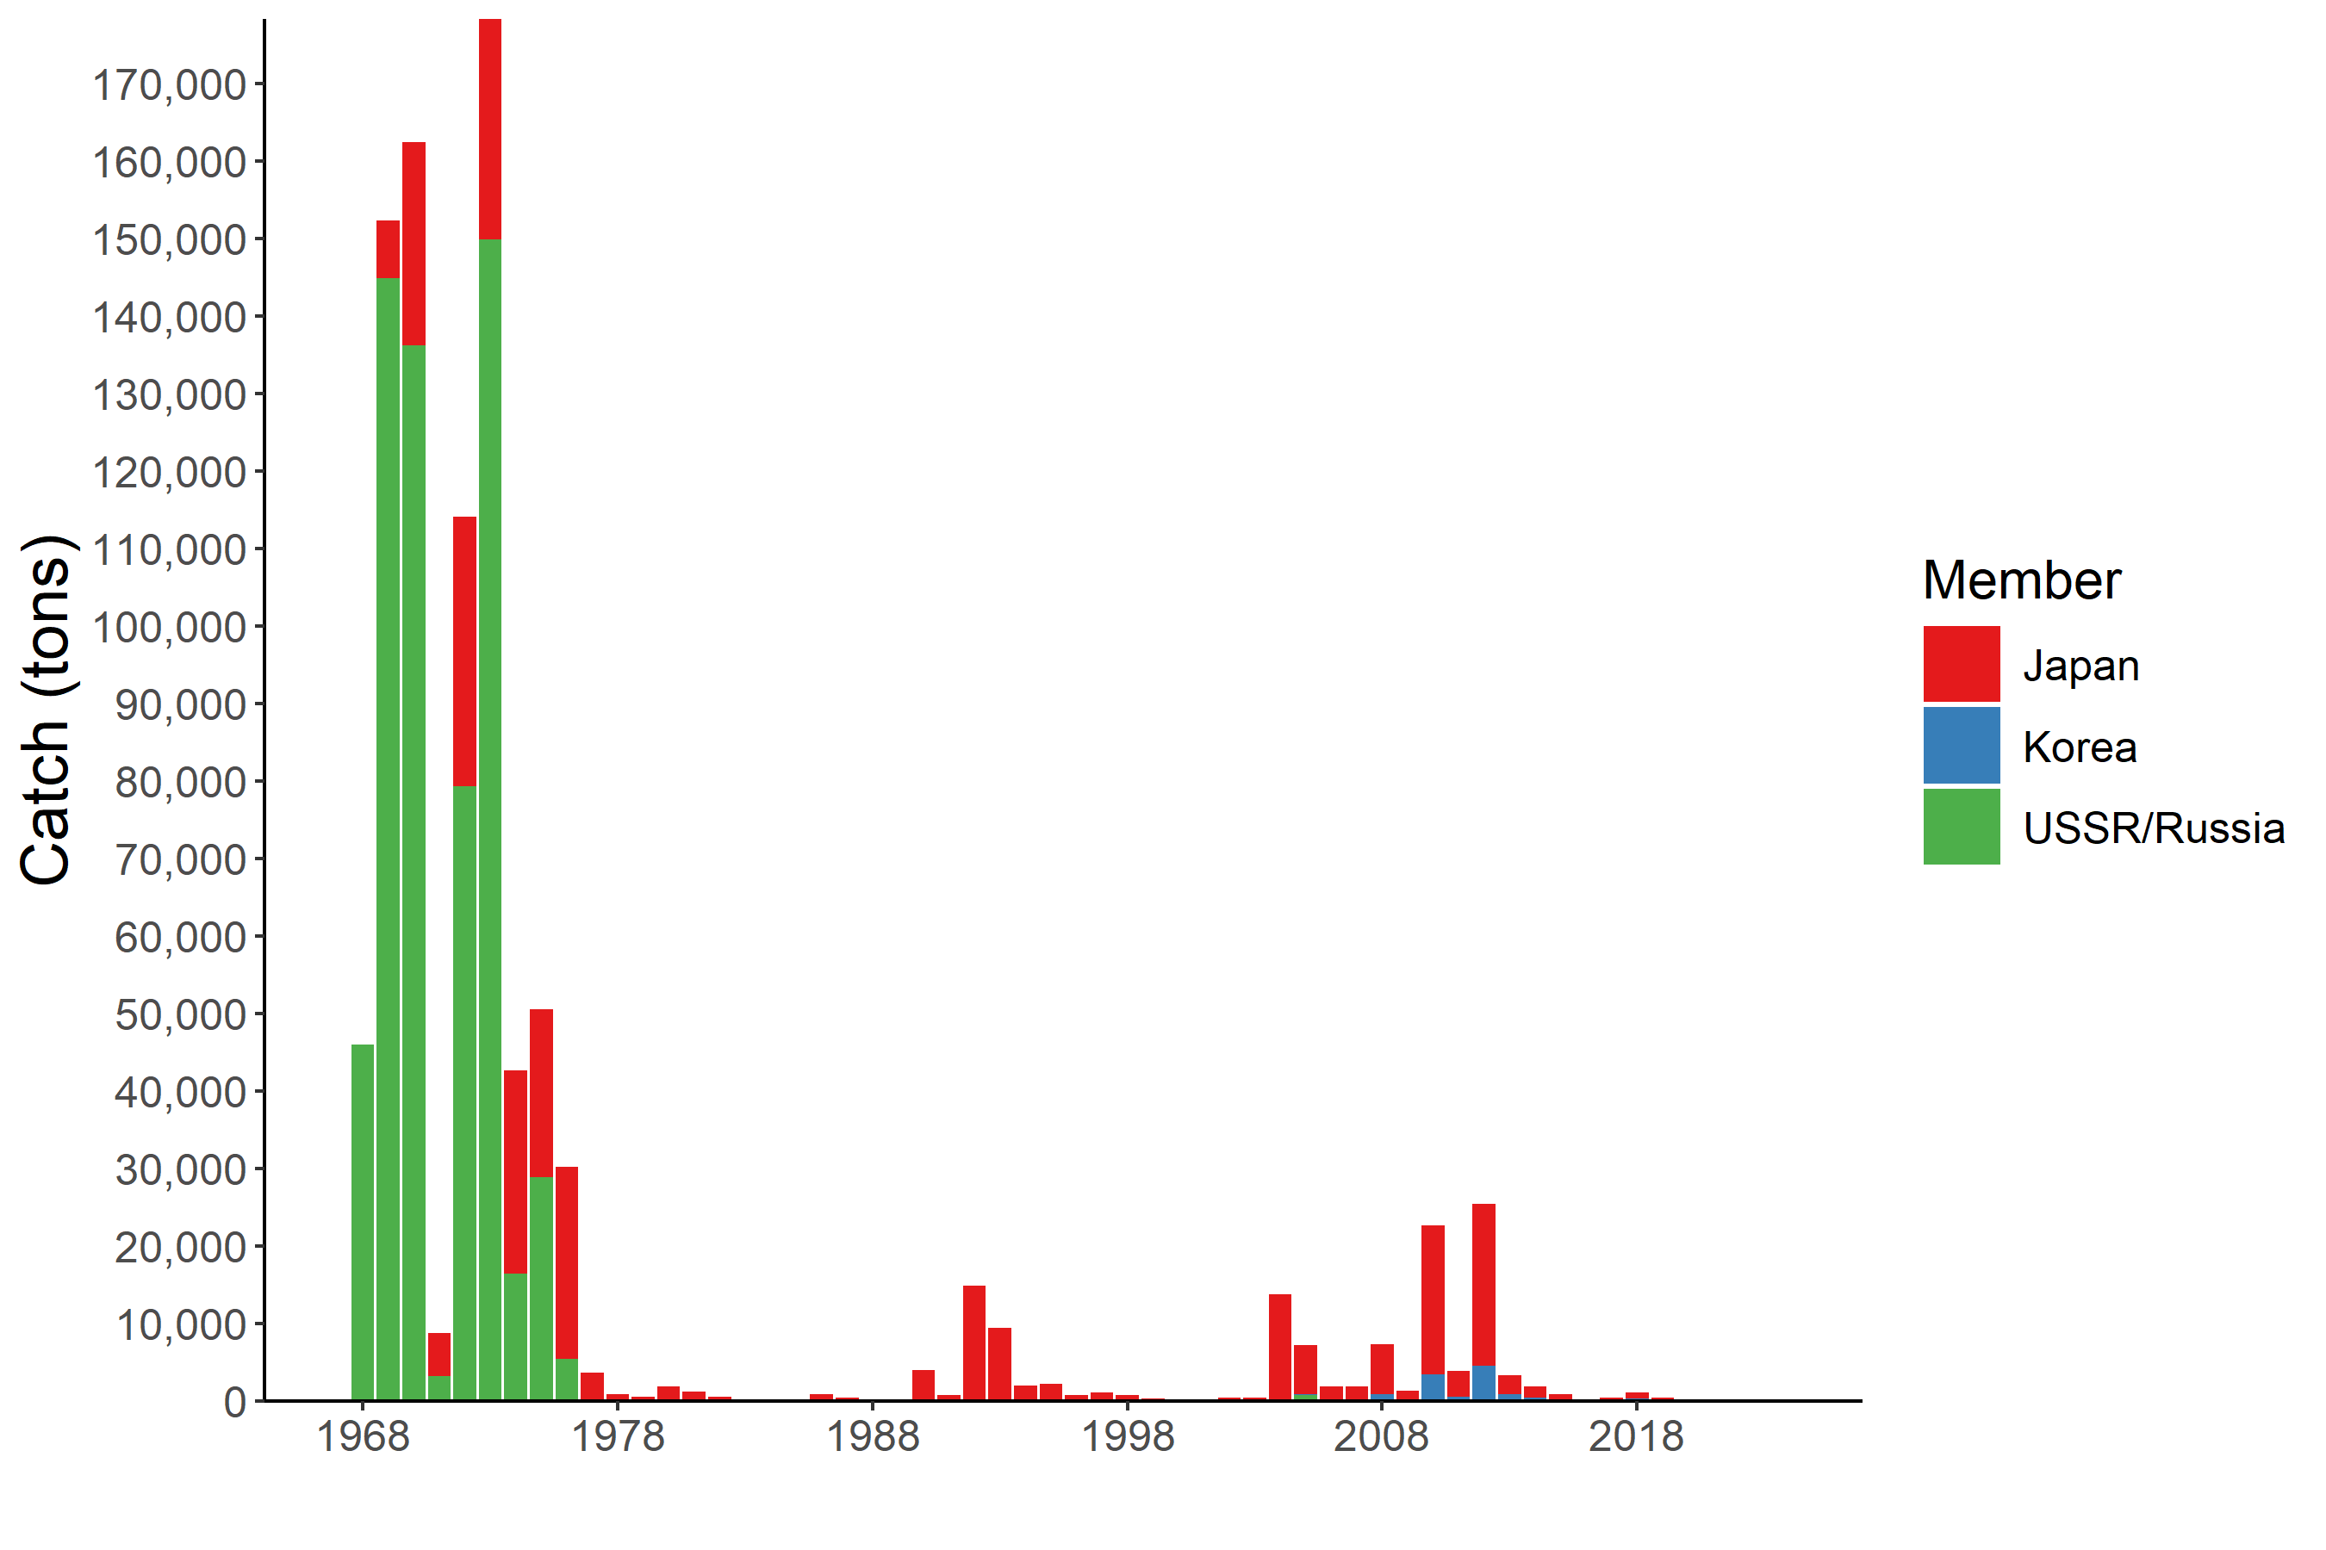

**Figure 3: Historical trends of North Pacific armorhead catches in NPFC waters.** The annual amounts of catch by each Member and gear are shown by the bar plot.

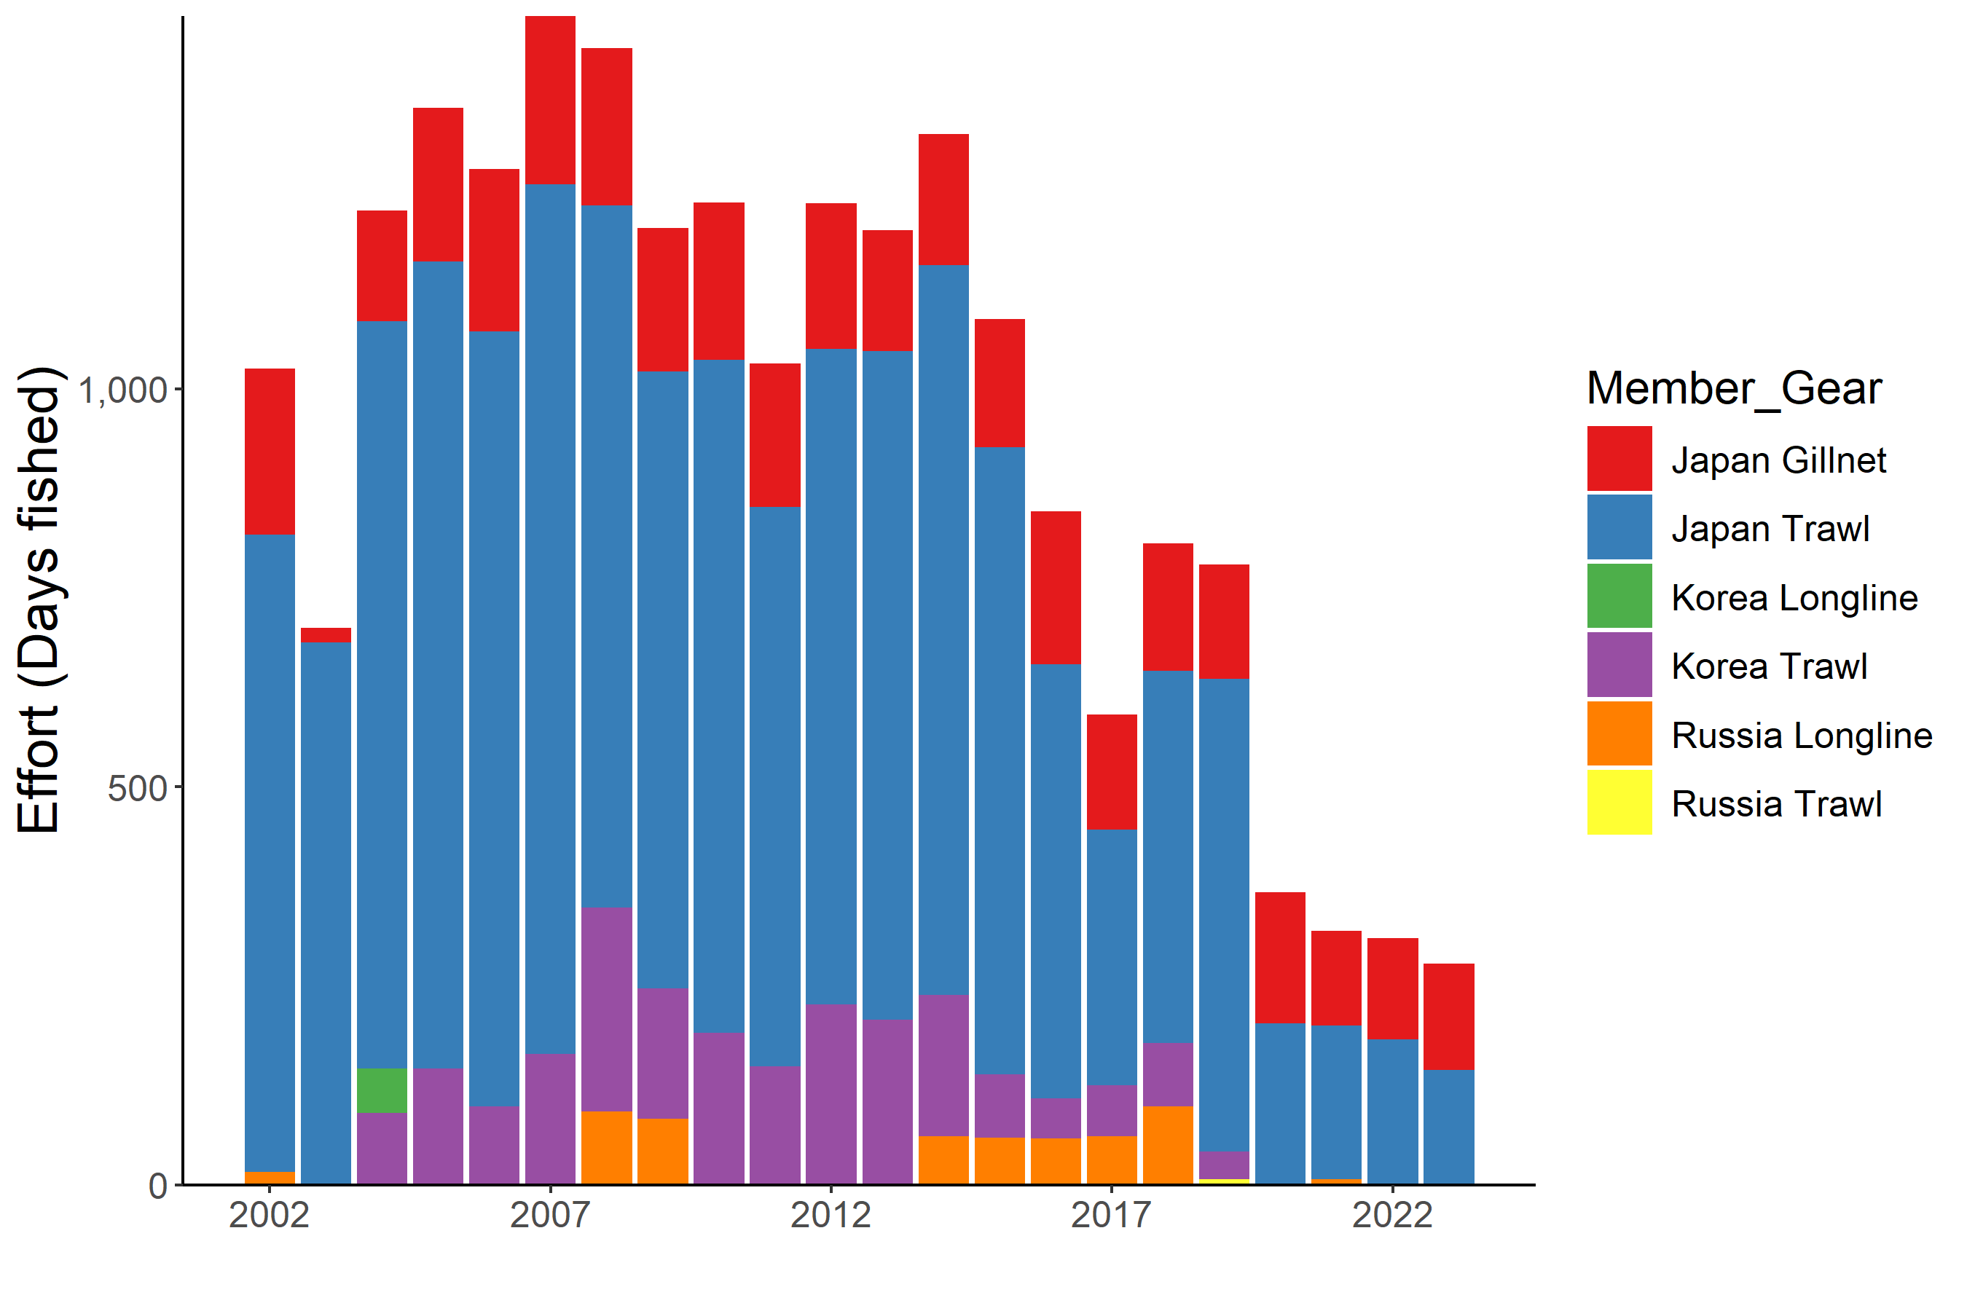

**Figure 4. Historical fishing effort for North Pacific armorhead.** The annual fishing efforts by each country are shown by barplot. The efforts are calculated by the total fishing days operated during the year

## Assessment

There is no current or accepted assessment for North Pacific armorhead.

There are no biomass estimates available for this species in NPFC waters. An age- or length-structured stock assessment is unlikely to be feasible given the life history of North Pacific armorhead. Data limited approaches may be examined in the future.

## Management

**Active Management Measures**

The following NPFC conservation and management measures pertain to this species:

* CMM 2021-05 For Bottom Fisheries and Protection of VMEs in the NW Pacific Ocean

Available from <https://www.npfc.int/active-conservation-and-management-measures>

Table 1: Current status of management measures

| Item | Status | Description |
| --- | --- | --- |
| Biological reference point | Not accomplished | Not established |
| Stock status | Unknown | Status determination criteria not established |
| Catch limit | Intermediate | Upper limit: 15,000 tons (only for Japan), No operation from November to December, Restriction of trawl mesh size |
| Harvest control rule | Not accomplished | Catch limit depending on the recruitment strength |
| Other | Intermediate | No expansion of fishing beyond established areas, No operation in the designated areas, No more increase in the fishing vessels |

In 2019, an adaptive management plan was implemented for North Pacific armorhead (NPFC-2019-SSC BF02-WP05, CMM 2019-05). This plan specifies data collection via an annual monitoring survey to be conducted in March-June each year on Koko, Yuryaki, Kammu and/or Colahan Seamounts. If the survey finds evidence of strong recruitment (see CMM 2021-05 and NPFC-2019-SSC BF02-IP01 for details) some areas in the Emperor Seamounts are closed and a 12,000 ton catch limit is encouraged. In low recruitment years, a 700 ton catch limit is encouraged.

## Data Availability

Table 2: Catch data

| Data | Member | Fishery | Year | Comments |
| --- | --- | --- | --- | --- |
| Annual catch | Japan | Trawl | 1969-present |  |
|  |  | Gillnet | 1990-present |  |
|  | Korea | Trawl | 2004-2019 |  |
|  | Russia | Trawl | 1970-1987; 1997; 2001-2002; 2005-2006; 2011; 2013 |  |
| CPUE | Japan | Trawl | 1970-present | Logbook data availabe |
|  |  | Gillnet | 2008-present | Logbook data available |
|  | Korea | Trawl | 2013-2019 | Logbook data available |
|  | Russia | Trawl | 2001-2002; 2005-2006; 2011; 2013 |  |

Table 3: Biological data

| Data | Member | Year | Comments |
| --- | --- | --- | --- |
| Age | Japan |  | A preliminary daily ring analysis for ca. 300 fish |
|  | Korea | 2013-2019 |  |
|  | Russia |  |  |
| Length | Japan | 2009-present | Protocol revised (see NPFC-2018-SSC BF01-WP03) |
|  | Korea | 2013-2019 |  |
|  | Russia |  |  |
| Maturity | Japan | 2013-present |  |
|  | Korea | 2013-2019 |  |
|  | Russia | 1970-1987; 1997; 2011; 2013 |  |

## References

Boehlert, G. W., and T. Sasaki. 1988. Pelagic biogeography of the armorhead, *Pseudopentaceros wheeleri*, and recruitment to isolated seamounts in the North Pacific Ocean. Fish. Bull. 86:453–465.

Kiyota M., Nishida K., Murakami C. and Yonezaki S. 2016. History, biology, and conservation of Pacific endemics 2. The North Pacific armorhead, *Pentaceros wheeleri* (Hardy, 1983) (Perciformes, Pentacerotidae). Pacific Science 70(1): 1-20.