NPFC-2024-SSC BFME05-WP06

**A brief update of Sablefish status in the eastern North Pacific including the NPFC Convention Area - 2024**

Chris Rooper (Canada), Kendra Holt (Canada), Kelli Johnson (USA)

Chantel Wetzel (USA), Dan Goethel (USA)

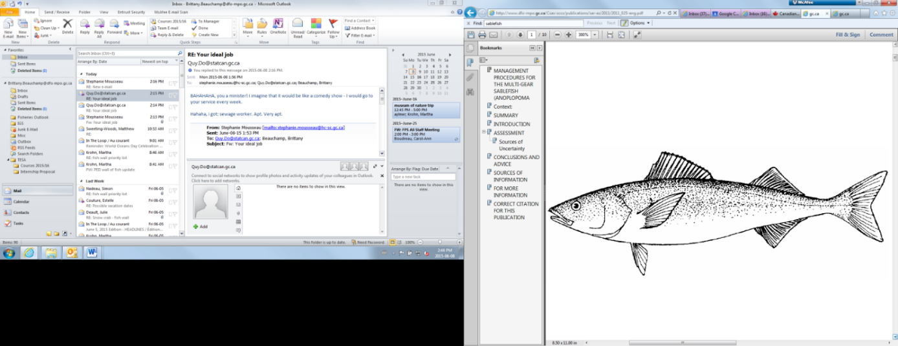

**Introduction**

Sablefish (*Anoplopoma fimbria*) are a highly valuable commercially harvested groundfish species in the North Pacific Ocean. They are the main target species in the eastern region of the North Pacific Fisheries Commission (NPFC) Convention Area. The goal of this document is to summarize the current landings, assessment and management of sablefish populations in Canada, the USA and the NPFC.

**Sablefish fisheries**

*Canada domestic*

Canada has a commercial longline trap fishery inside its EEZ. The fishery is carried out by ~30 longline vessels and occurs throughout the year. Vessels targeting sablefish tend to be small (< 20 m in length). A small amount of sablefish is also captured by the bottom trawl sector as bycatch. Historically, sablefish fisheries on the coast of Canada have been conducted by Canadian and foreign vessels (including USA, Japanese, Russian and Korean vessels) from 1961-1981. The earliest Canadian recorded landings were in 1913. Annual landings have averaged ~4000 mt since 1980 (Figure 1).

*USA domestic*

The Alaska sablefish fishery has been prosecuted since about 1920. The initial stages of fishery development were by US and Canadian fishers (as in other areas of the coast of North America), with other foreign vessels (primarily Japan, Korea and Russia) fishing along the coast from ~1960-1980 prior to the expansion of EEZ’s. Since ~1988 all sablefish landings in Alaska have been in the domestic fishery. Landings since ~2015 have increased from 10,000 to greater than 21,000 kt (Figure 1). In Alaska, the sablefish fishery has traditionally utilized longline hook gear. However, since the legalization of pot gear in the Gulf of Alaska in 2017, fishers have moved to alternative gears such as hard and, more recently, collapsible “slinky” pots, which help eliminate whale depredation on catches. Sablefish are also incidentally captured in various bottom trawl fisheries in Alaska. The vessels fishing sablefish in Alaska are mostly small in size (< 20 m length), but there are a handful (< 10) of larger (~40-50 m) longline catcher-processor vessels that also fish for sablefish in Alaska.

On the US West Coast sablefish have been commercially captured since ~1890, with appreciable landings beginning in 1916-1919. In the 1960’s and 70’s foreign vessels (primarily Japan, Korea and Russia) and an increasing domestic fleet were responsible for increasing harvests. Since ~2000 annual landings have been about 10,000 mt (Figure 1). Sablefish landings have traditionally been harvested by hook and line or pot gear. However, there is also targeted catch from bottom trawl gear. Small vessels (< 20 m length) participate in the US West Coast domestic sablefish fishery.

*NPFC CA*

In the NPFC Convention Area, sablefish are targeted only by Canadian fishers. The fishery uses longline trap gear at 1-4 seamounts in the Convention Area (CA). Since 2014, a maximum of 3 vessels per year have been allowed to fish in the CA and these have been chosen by lottery. Historically, there were significant and mostly unknown catches of sablefish and other groundfish landed in the NPFC CA by trawl and longline fishers from Canada, Japan, Korea, Russia and the USA. Since 1996 landings of sablefish in the NPFC CA have been around 10-20 mt, with some years (1996, 1998, 2017 and 2018 in particular) having larger catches (Figure 1). No fishing has occurred in the NPFC CA since 2020.

**Sablefish data**

Fisheries Independent Surveys

*Canada domestic*

Canada has conducted two longline trap surveys in British Columbia waters. From 1990-2009 a standardized trap survey was conducted at set stations annually. From 2003 to the present DFO conducts a stratified random trap survey along the outer shelf and slope of the BC coast. Both of these surveys generated a fishery independent CPUE as well as biological data that is used in the assessment. The time series of sablefish CPUE from the current stratified random trap survey is shown in Figure 2.

*USA domestic*

In Alaska, three survey indices are available for use in assessing the status of the sablefish population (Figure 2). There is an annual longline survey index of abundance conducted at standard survey stations since 1978 (cooperatively with Japan from 1978-1994) that samples depths from 200-1000 m. Bottom trawl surveys are conducted annually or biennially in the three main ecosystems in Alaska since 1982. These are either systematic surveys (eastern Bering Sea) or random-stratified surveys (Gulf of Alaska and Aleutian Islands). Because of limitations associated with catching sablefish with trawl gear and short survey time series in some regions (e.g., Bering Sea since 1997), only data from the Gulf of Alaska portion of the trawl survey is utilized for the Alaska stock assessment. Data from the International Pacific Halibut Commission standardized longline survey is also available, although this survey is conducted at the shallowest portion of the sablefish distribution (depths to 500 m) so it is not incorporated into the assessment. An additional longline survey conducted in the inside waters of Southeast Alaska by Alaska Department of Fish and Game is not used in the federal stock assessment because the state of Alaska assesses and manages sablefish in state waters independently from federal management.

The primary fishery independent survey index of abundance for U.S. West Coast sablefish is from the west coast groundfish bottom trawl survey, conducted from 2003-2024, over depths of 55 to ~1300 m (Figure 2). This annual bottom trawl survey follows a random-stratified survey design with four vessels (in most years). The trawl survey data is analyzed with the VAST model (Thorson 2019) to produce the index of abundance for sablefish. Historically other US West Coast bottom trawl surveys have had variable survey designs, although model based indices of abundance from these surveys (using the same VAST methods) are also included in the assessment. In the past a longline pot survey was conducted, but is not included in the stock assessment due to its limited spatial scope.

*NPFC CA*

There is currently no survey conducted in the eastern NPFC Convention Area that captures or monitors sablefish populations.

**Sablefish stock assessment**

*Canada domestic*

Canada uses a management strategy evaluation (MSE) process to generate recommended harvest. Underlying the MSE is a statistical catch-at-age structured operating model (stock assessment model) that gets updated on a 3 – 5 year cycle, at which time estimates of stock status are updated. Details of the operating model, as well as recent estimates of stock status relative to reference points, can be found in DFO 2020, DFO 2023, and DFO 2024.

*USA domestic*

The USA conducts two stock assessments (Alaska and the US West Coast) using age-structured models (Figure 3). The current Alaska assessment (Goethel et al. in press) and most recent USA West Coast assessments are a 2019 benchmark (Haltuch et al. 2019) and 2023 update assessment (Johnson et al. 2023) are available online (<https://www.fisheries.noaa.gov/alaska/population-assessments/north-pacific-groundfish-stock-assessments-and-fishery-evaluation>; https://www.pcouncil.org/stock-assessments-star-reports-stat-reports-rebuilding-analyses-terms-of-reference/groundfish-stock-assessment-documents/).

*NPFC CA*

No stock assessment is conducted for the portion of the sablefish population found in the NPFC Convention area*.*

**Sablefish management**

*NPFC CA*

The sablefish fishery in the NPFC area is managed under a Conservation and Management Measure agreed to by NPFC Members (currently CMM 2019-10 and CMM 2023-06) and the rules regulating the fishery are implemented through the conditions of licensing by DFO Fisheries Management. The allowable catch of sablefish in the eastern portion of the Convention Area is based on a long-term mean of historical catches from seamounts by Canada and assumed to be sustainable at that level (given the connection and sustainability of the coast wide population). It allows for 34 mt to be landed each month for the 6 months of the fishing season. The fishery is also managed through input controls by only allowing a single vessel to fish in each month. The 1-3 Canadian vessels licensed to fish in the NPFC Convention Area are submitted to the NPFC Secretariat annually.

**Status Update**

The most recent domestic stock assessments conducted by the USA and Canada all indicate that the sablefish stock is healthy and not subject to overfishing. Figure 3 shows that for all three regions the stock is well above the upper stock reference point. In the NPFC CA there has been no fishery catch or effort since 2020.

**References**

DFO. 2020. Evaluating the robustness of candidate management procedures in the BC Sablefsh (Anoplopoma fbria) fshery for 2019-2020. DFO Can. Sci. Advis. Sec. Sci. Resp. 2020/025.

DFO. 2023. A Revised Operating Model for Sablefish in British Columbia in 2022. Can. Sci. Advis. Sec. Sci. Advis. Rep. 2023/010.

DFO. 2024. Application of the British Columbia Sablefsh (Anoplopoma fimbria) Management Procedure for the 2024-25 Fishing Year. DFO Can. Sci. Advis. Sec. Sci. Resp. 2024/013.

Goethel, D.R., Hanselman, D.H., Rodgveller, C.J., Fenske, K.H., Shotwell, S.K., Echave, K.B., Malecha, P.W., Siwicke, K.A., and Lunsford, C.R. In press. Assessment of the sablefish stock in Alaska. *In* “Stock Assessment and Fishery Evaluation Report for the Groundfish Resources of the GOA and BS/AI.” Anchorage, AK: North Pacific Fishery Management Council.

Haltuch, M.A., Johnson, K.F., Tolimieri, N., Kapur, M.S., and Castillo-Jordán, C.A. 2019. Status of the sablefish stock in U.S. waters in 2019. Pacific Fisheries Management Council, 7700 Ambassador Place NE, Suite 200, Portland, OR. 398 p.

Johnson, K.F., Wetzel, C.R. and Tolimieri, N. 2023. Status of sablefish (Anaplopoma fimbria) along the US West Coast in 2023. Pacific Fisheries Management Council, Portland, Oregon, 169 p.

Thorson, J. 2019. Guidance for decisions using the Vector Autoregressive Spatio-Temporal (VAST) package in stock, ecosystem, habitat and climate assessments. Fisheries Research 210: 143–161. doi:10.1016/j.fishres.2018.10.013.

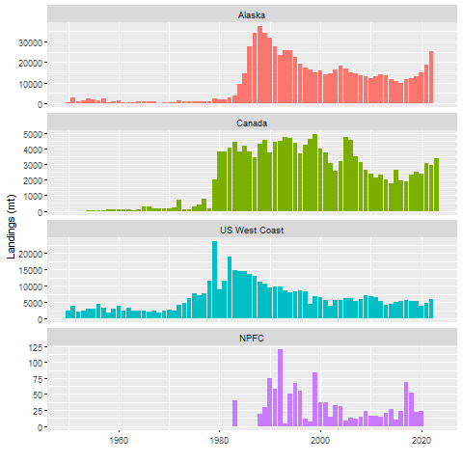

Figure 1. Historical landings of sablefish on the West Coast of North America and in the NPFC Convention Area.

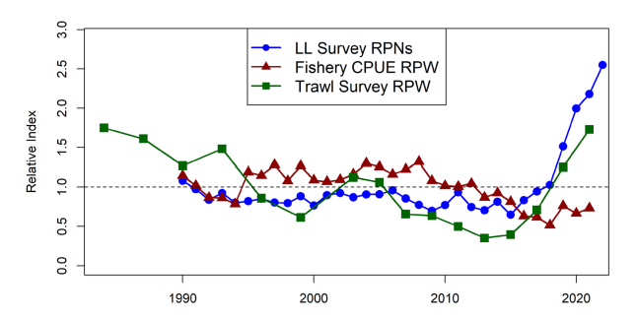

Alaska

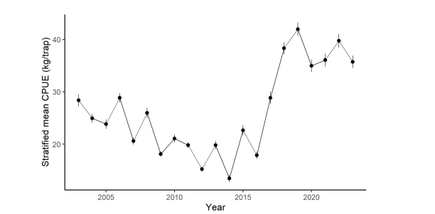

Canada

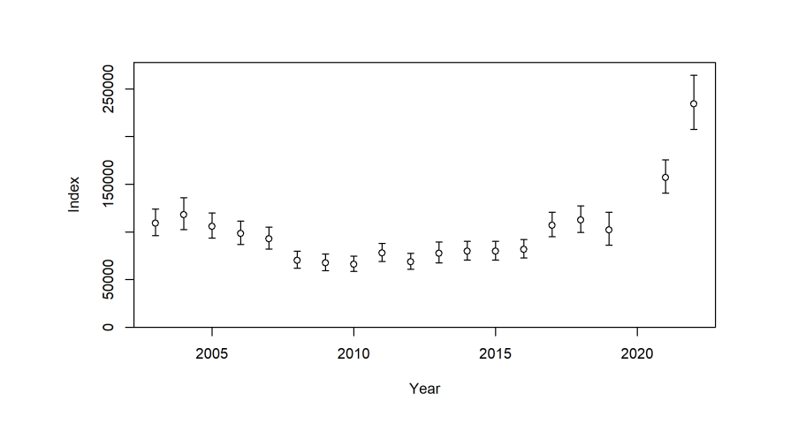Figure 2. Survey indices of sablefish on the coast of North America (from Alaska to California).

U.S. West Coast

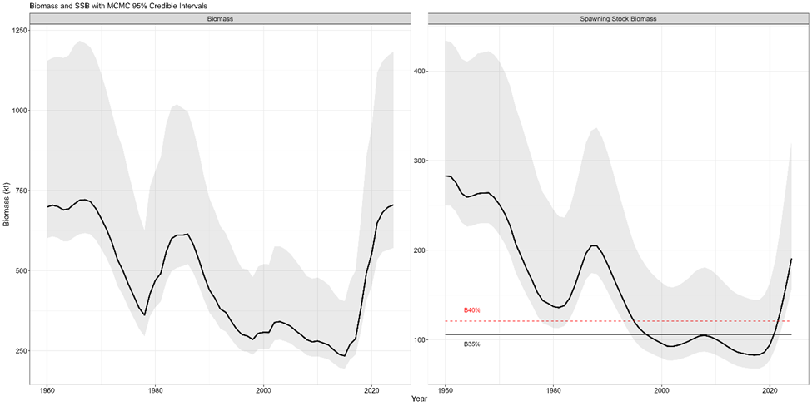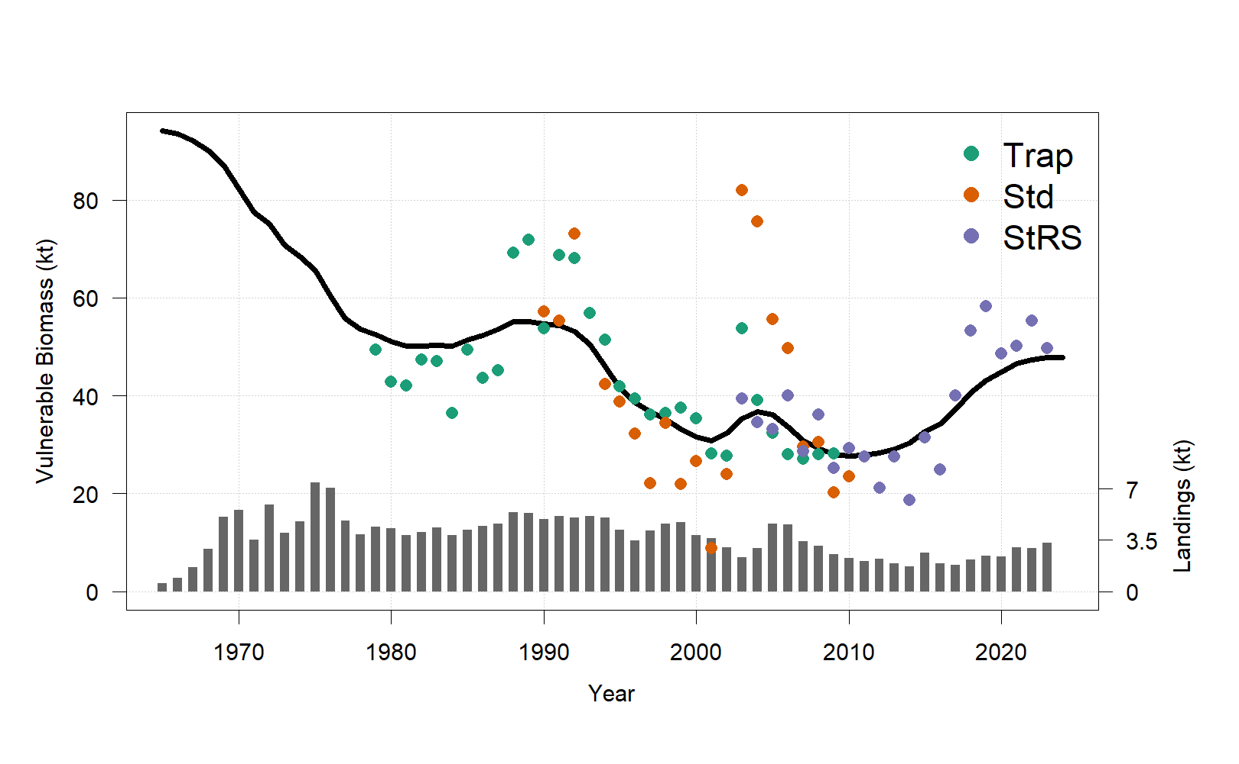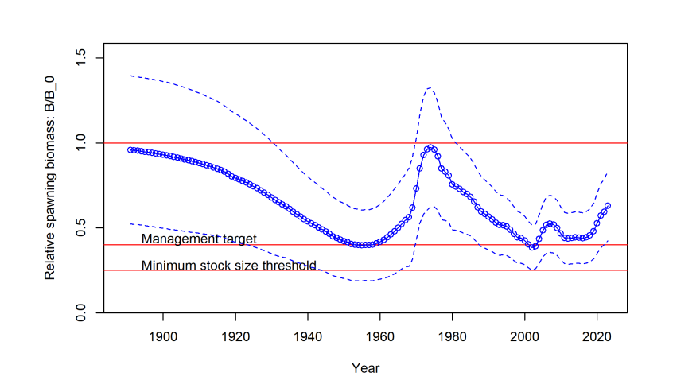

Figure 3. Time series of spawning stock biomass for Alaska (top), Canada (middle) and U.S. West Coast (bottom) sablefish. Horizontal lines represent upper and lower stock reference points.