NPFC-2024-SSC BFME05-WP13

Application of a data-based method to Japanese bycatch data

by Yumiko Osawa* and Kota Sawada*

*Oceanic Ecosystem Group, National Research Institute of Far Seas Fisheries,
Japan Fisheries Research and Education Agency, Japan

This paper may be cited in the following manner:
Osawa, Y., & Sawada, K. 2024. Application of data-based method to the Japanese bycatch data. NPFC-2024-SSC BFME05-WP13. 9 pp.

Application of a data-based method to Japanese bycatch data

Yumiko Osawa* and Kota Sawada*

*Oceanic Ecosystem Group, National Research Institute of Far Seas Fisheries,
Japan Fisheries Research and Education Agency, Japan

Abstract
For the sake of refining encounter bycatch thresholds of VME indicator taxa in the NW Pacific, a new potential quantitative evaluation method (“data-based method”) was applied to the Japanese bycatch data and we evaluated its fitness. Recalculated bycatch values were largely overestimated among taxa and fishing gears. Differences in data distribution between fishery and survey data may be the major problem behind the lower model performance. In conclusion, we would not recommend refining current encounter bycatch thresholds in the NW Pacific using the current data-based method, and we believe that further considerations/developments may be required for this task.

Background
In accordance with the adoption of conservation management measures by the United Nations General Assembly in 2005 (United Nations General Assembly, 2005), many regional fisheries management organizations (RFMOs) are adopting “move-on rules” triggered by encounter bycatch thresholds as one of the precautional approaches to protect vulnerable marine ecosystems (VMEs) from significant adverse anthropogenic impacts (Geange et al., 2020). Ideally, encounter bycatch thresholds should be area-, gear type- and taxon-specific. However, in reality, its feasibility varies greatly among RFMOs based on their data-availability, and is dependent on their objective settings (Reid, 2023). Consequently, the calculation methods and/or the threshold levels are greatly varied among areas/organizations based on their own needs and the best available scientific and technical information (Reid, 2023).
The encounter bycatch thresholds of fishing vessels operating in the Northwest Pacific have tentatively been set for all fishing gears as 50kg for cold-water corals and 500kg for sponges since the establishment of the NPFC (NPFC CMM 2024-05). The appropriateness of these values has been continually debated among members, and a science-based assessment of the thresholds has been sought to this day. In 2023, Canada proposed a new quantitative method to estimate gear and taxa specific thresholds (called the “data-based method”). By using this method, last year a new encounter threshold value for sponges was reduced to 350kg. Moreover, the SSC BF-ME agreed to apply this method to Japanese and Korean bycatch data (Small Scientific Committee on Bottom Fish and Marine Ecosystems, 2023). The objective of this working paper is to apply this data-based method to Japanese bycatch data and evaluate its fitness for refining encounter bycatch thresholds in the NW Pacific.

Methods
Fishery data
Gillnets and trawls are the two fishing gears currently utilized in the Emperor Seamounts. All bycatch data and related information used in this study were collected by onboard science observers from 2009 – 2023 (no. of operations with bycatches by gillnet and trawl were 489 and 722, respectively). Bycatch specimens were reidentified and weighed to the nearest 0.001kg on land by experts.

Survey data
Underwater visual survey data used in this study was collected via R/V Kaiyo-Maru from 2009 – 2023. We decided to focus on point data (n = 1,726) in this study since we still have some difficulty in handling the transect data properly (such as locations or density). For the sake of calculating gear specific bycatch thresholds, we selected the data collected from four seamounts where both fishing gears have operated (Colahan, Kammu, Koko including North Koko, and Yuryaku, Fig. 1). All density data (which was originally collected based on the visual area, 7.5 m²) used in this study was unified into m² in subsequent calculations.
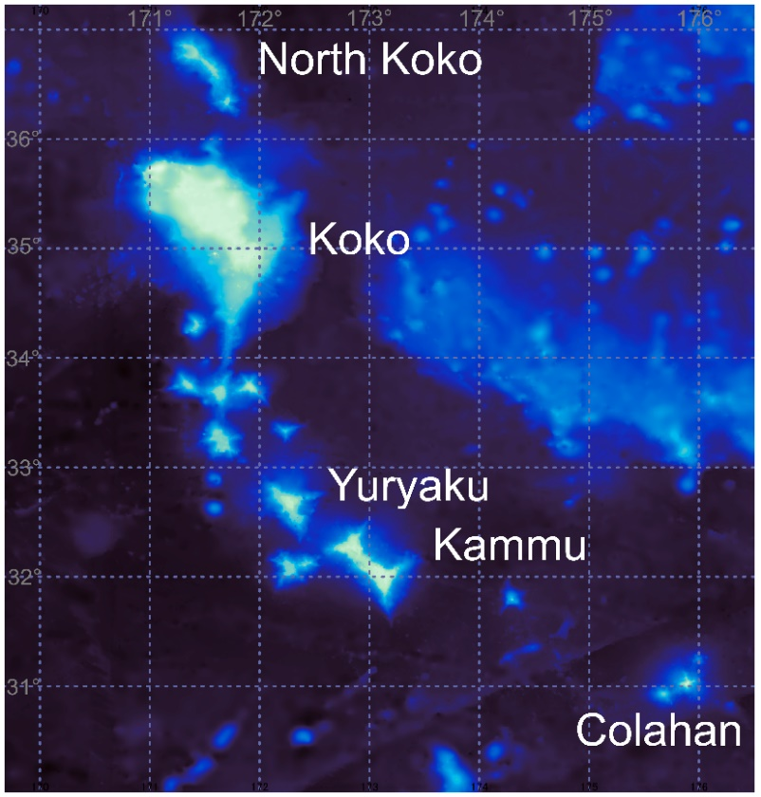
Fig. 1. Map of the seamounts where survey data used in this study were collected.

VME indicator taxa
Our analysis focused on five taxonomic groups (soft corals, Antipatharia, Gorgonians, Scleractinia, Porifera) out of six “VME indicator taxa” in the convention text of the NPFC (CMM 2024-05). Calculation of the potential bycatch threshold of Pennatulacean, an octocorallian taxon recently included in the list of VME indicator taxa of the NPFC since 2023, was impracticable, since there is no bycatch record in the NW Pacific. We followed the translation table (Yamaguchi et al., 2024) to categorize the bycatch of cold-water corals into four groups (Antipatharia, Scleractinia, Gorgonians, and soft corals).

VME threshold calculations
Based on Warawa et al., 2023, the following parts were modified to estimate VME thresholds for each VME indicator taxa.

Step 1: GAM model selection
- counting brittle stars and snails in the species richness
- excluding corals and sponges from the counts of species richness for the sake of clearly distinguishing between VME indicator taxa and surrounding associated organisms
- since our model is only applying point data, we removed “transect random effect” from the basic full model

The final selected model is shown below:
$$Species richness \sim s\left(VME density\right)+s(depth)$$

Step2: Calculating VME thresholds from GAM hypothetical curves
- the point of intersection of linear regressions using the initial and final 5% of data
- the point of intersection between a linear regression using the initial 5% of data and the maximum cumulative species richness value
- the point on the curve that is closest to the top right corner (“(0,1) distance”)
- the point on the curve that maximizes the distance between the curve and the line between extreme points (“Youden Index”)

Among the above four calculation methods used in Warawa et al., 2023, (A) and (B) were not applicable in our data, as none of the intersection points appeared. Instead, we conducted the “third-segmented point method” using the segmented package in R (Muggeo, 2008; R Core Team, 2024), by fitting 3-parameter segmented regression to the percentiles of the hypothetical curves of selected GAM model and the final breakpoint of the segmented regression was selected for the VME threshold. Thus, the following three calculations were conducted, and the averaged values were applied as the final VME threshold of each VME indicator taxa in the end.

- Third-segmented point method
- (0,1) distance
- Youden Index

Estimation of potential VME encounter thresholds and Model assessment
We followed Rooper et al., 2023 to estimate discrete potential VME encounter thresholds for each VME indicator taxa and fishing gear by (1) fitting a linear regression to the ordered log-transformed percentiles of bycatch weights and underwater survey density data, and (2) defining the potential encounter threshold using calculated VME thresholds. The best linear regression model was selected from the following full model (incorporating one numerical and three categorical explanatory variables) using the MuMIn package in R (Bartoń, 2024) and selecting the model with the smallest AIC value:

$$log\left(bycatch weight (kg)\right) \sim lm(log(VME density))*coral_taxa*gears*seamounts)$$

The performance of the selected linear regression was visually assessed using Q-Q residuals plots.

Results & Discussion
Estimated bycatch encounter thresholds using our data-based method were mostly overestimated (Table 1). Like in soft corals, Antipatharia caught by gillnet, Porifera caught by trawlers, and Scleractinia caught by gillnet, the estimated bycatch thresholds were over 1,000kg. Moreover, the Antipatharia caught by trawls and Gorgonians caught by gillnets, estimated bycatch thresholds were higher than 50kg, exceeding the current bycatch threshold.
Porifera caught by gillnet, Gorgonian and Scleractinia caught by trawls were the only three subgroups whose estimated thresholds were below the current thresholds. However, the interpretation of these values still needs some caution, because the model performance is unreliable at the current stage. When we checked the residual plots of the selected model, there were large deviations from normality, especially in both tails of the data (Fig. 2). These deviations seem to be larger in the VME indicator taxa with limited data (e.g. soft corals, Fig. 2d). These results imply the limited performance of the model.

Table 1. Summary table of the calculated taxa and gear specific bycatch thresholds by applying data-based method and the respective number of data used for the calculations.
 | soft corals |  | Antipatharia |  | gorgonians |  | Porifera |  | Scleractinia
 | Gillnet | Trawl | Gillnet | Trawl | Gillnet | Trawl | Gillnet | Trawl | Gillnet | Trawl
No. operations with bycatch (N) | 5 | 9 | 78 | 458 | 866 | 1239 | 15 | 136 | 54 | 14
calculated bycatch thresholds (kg) | >1,000 | >1,000 | >1,000 | 70.783 | 51.947 | 7.807 | 105.478 | >1,000 | >1,000 | 1.223

Fig. 2. Residual plots of (a) selected linear regression model and with selected variables ((b) fishing gears, (c) seamounts and (d) VME indicator taxa).

One of the possible reasons of overestimation might be the differences in data distribution. Fishermen deliberately avoid fishing bycatch areas, as hooking fishing nets on corals can risk damaging their gear. Thus, fishing data are supposed to be concentrated at the areas with relatively no/lower proportional occurrence of VME indicator taxa and the data are heavily skewed toward zero/small values. On the other hand, survey data are supposed to be collected within a concentrated area that potentially possesses higher densities of VME indicator taxa. Therefore, its data range would be more widely distributed than the fishery’s data in the end. Because of the discrepancies in the data distribution ranges, the amount of changes to the values within different percentiles is different between the data (Fig. 3). If so, appropriate evaluation might be difficult by just directly combining the survey/bycatch data, further consideration might be required to practically apply this method (e.g. considering geographical trends to bind two data, etc.).
Fig. 3 Cumulative proportional occurrence curves of Gorgonians in the fishery bycatch weight data and the individual density from underwater survey data. Dot-arrows represent 50th and 90th percentiles of the bycatch weights and the density in red and blue, respectively.

Conclusion
- Application of this data-based method might be problematic in both model quality and the discrepancy of data distributions between survey/fishery data.
- Due to the data limitations of most taxa, applying discrete bycatch thresholds for each VME indicator taxa with a data-based method is not recommended at this stage.
- Further considerations (e.g. trying other calculation methods or improving the data-based method) are encouraged for refining the current bycatch thresholds in the NW Pacific.

Acknowledgements
This work is conducted as a part of the project to evaluate the status of international fishery resources by the Fisheries Agency of Japan. We wish to express our gratitude to the staff of Fishery Agency of Japan and Fisheries Research Agency, the captain and crew of the R/V Kaiyo-Maru and on-board science observers of Japan.

References
- Bartoń, K. 2024. _MuMIn: Multi-Model Inference_. R package version 1.48.4, <https://CRAN.R-project.org/package=MuMIn>.
- Geange, S.W., Rowden, A.A., Nicol, S., Bock, T., & Cryer, M. 2020. A data-informed approach for identifying move-on encounter thresholds for vulnerable marine ecosystem indicator taxa. Frontier in Marine Science 7: 155, 1 – 12.
- Muggeo, V.M.R. 2008. segmented: an R Package to Fit Regression Models with Broken-Line Relationships. R News, 8/1, 20-25. <https://cran.r-project.org/doc/Rnews/>.
- NPFC CMM 2024-05. For Bottom Fisheries and Protection of VMEs in the NW Pacific Ocean (Entered into force 1 January 2025).
- R Core Team, 2024. _R: A Language and Environment for Statistical Computing_. R Foundation for Statistical Computing, Vienna, Austria. <https://www.R-project.org/>.
- Reid, K. 2023. A review of the basis by which RFMOs have determined VME encounter thresholds by taxa and gear-types. NPFC-2023-SSC BFME04-WP06. 20pp.
- Rooper, C., Goddard, P., Tuttle, V., Campbell, G. & Somers, K. 2023. Estimating quantitative gear and taxa specific thresholds for bycatch of vulnerable marine ecosystem indicator taxa in the NPFC Convention Area. NPFC-2023-SSC BFME04-WP04. 45pp.
- Small Scientific Committee on Bottom Fish and Marine Ecosystems. 2023. 4th Meeting Report. NPFC-2023-SSC BF-ME04-Final Report. 135 pp. (Available at www.npfc.int)
- United Nations General Assembly [UNGA]. 2005. Resolution 59/25: Sustainable fisheries, including through the 1995 Agreement for the Implementation of the Provisions of the United Nations Convention on the Law of the Sea of 10 December 1982 relating to the Conservation and Management of Straddling Fish Stocks and Highly Migratory Fish Stocks, and related instruments, UNGA A/RES/59/25, United Nations General Assembly. New York, NY: UNGA.
- Warawa, D.R., Rooper, C.N., Nephin, J., Chi, J.W.F., Dudas, S., Knudby, A., Georgian, S., & Curtis, J.M.R. 2023. Identifying VMEs on Cobb Seamount using visual data. NPFC-2023-SSC BFME04-WP13. 8pp.
- Yamaguchi, M., Osawa, Y., Miyamoto, M., & Rooper, C. 2024. Translation table of VME indicator corals between common and scientific names. NPFC-2024-SSC BFME05-WPXX. 5pp.

