NPFC-2024-SSC BFME05-WP15

Impact of mesh size change on catch size composition of splendid alfonsino *Beryx splendens* in the Emperor Seamounts

by

Christopher G. Ayer and Kota Sawada

Oceanic Resources Group, Fisheries Resources Institute,

Japan Fisheries Research and Education Agency, Japan

December 2024

**This paper may be cited in the following manner:**

Ayer, C.G. and Sawada, K. 2024. Impact of mesh size change on catch size composition of splendid alfonsino *Beryx splendens* in the Emperor Seamounts. NPFC-2024-SSC BFME05-WP15. 10 pp. Available at https://www.npfc.int/

Impact of mesh size change on catch size composition of splendid alfonsino *Beryx splendens* in the Emperor Seamounts

Christopher G. Ayer and Kota Sawada

Oceanic Resources Group, Fisheries Resources Institute,

Japan Fisheries Research and Education Agency

Abstract

In 2019 the NPFC made changes to the regulations of trawl net codend mesh sizes used for fishing splendid alfonsino *Beryx splendens* in the Emperor Seamounts. Intended to reduce the fishing pressure on immature individuals, initial evaluation of size composition data found no change following the implementation of the new regulations. Here we reevaluate the impact of the implemented mesh changes on alfonsino using a more robust size composition dataset spanning from 2013 to 2023, while also comparing the effects of different seamounts, fishing vessels, and seasons. Our analysis found a weakly positive relationship between the mesh changes and an increase in mean alfonsino FL over time, but there are several unusual length frequencies related to fishing vessel or year. While there is some evidence to support the mesh size regulations and reduced fishing pressure are having a positive effect, continued monitoring to determine the validity of the current trend is necessary.

Introduction

Splendid alfonsino *Beryx splendens* Lowe 1834 is a demersal fish with a global distribution that inhabits the tops and upper slopes of seamounts and is usually caught at depths of 200 to 800 meters (Nishizawa and Sawada 2022). While occasionally a target species for fisheries, it is regionally significant and often taken as a supplemental stock when the densities of primary deepwater stock, such as North Pacific armorhead *Pentaceros wheeleri* Hardy 1983 or orange roughy *Hoplostethus atlanticus* Collett 1889, are low (Laverly et al 2020; Shotton 2016). Due to the depth these fish inhabit, alfonsino and similar demersal species have relatively little information on their population sizes, health, and life history from which management policies can be based. This is an issue for sustainable fishing practices, since these species tend to be slow growing and late maturing, factors which increase the time required for recovery and the likelihood of stock overexploitation (Laverly et al 2020).

Starting in 2019, the North Pacific Fisheries Commission (NPFC) put in place regulations on the size of trawl codend mesh used for the fishing of alfonsino in the Emperor Seamounts as part of a management proposal from the Fisheries Agency of Japan (2018), requiring a minimum mesh size of 130 mm (Sawada and Ichii 2020). This change was put in place over concerns that the alfonsino population in this area may be overexploited, so increasing the mesh size would improve the number of individuals that survived to their first spawning (Sawada and Ichii 2020). Preliminary comparison between the pre and post 2019 catch data was performed in 2020 but did not reveal any consistent differences (Sawada and Ichii 2020). As a slow growing species, the time lag between implementation of the change and initial analysis was likely too short to observe any trends.

Here we revisit the impact of the 2019 mesh regulations by conducting a quantitative analysis of the stock to determine if significant changes in the length frequency data have occurred. Along with the mentioned mesh changes, there have also been changes in fishing pressure for alfonsino with two of three vessels ceasing activity after 2019, which leads us to expect signs of recovery for the populations in this area.

Materials and Methods

The splendid alfonsino length frequency was collected by Japanese scientific observers on trawlers between 2013 and 2023 from the Emperor Seamounts Colahan, Kinmei, Koko, North Koko, and Milwaukee, incorporating 198,612 individual samples from 2013 to 2018 and 102,273 from 2019 to 2023 (300,885 total). Data from gillnetters is not included in this analysis, as the mesh size change is only relevant to trawlers. Data is limited to Japanese catch during this time period due to no length frequency data collected for alfonsino by other NPFC members since 2019. The observers are instructed to measure 100 individuals (or all individuals if catch per tow is less than 100) per tow for each fishing day with an alfonsino catch greater than zero. Between 2013 and 2019 three trawlers were working in the convention area, and from 2020 onward this was reduced to a single vessel. Size composition data was collected at sea by on-board scientific observers, and fork length (FL) was measured using a punch card method which rounded down to the nearest 5 mm (Sawada et al 2018 Appendix). Before analysis, we added random values drawn from a uniform distribution range of 0 to 5 for all FL measurements.

For statistical analysis, a comparison of length frequency over time was conducted by generalized mixed models (GLMM) with a gaussian error structure performed in R (R Core Team 2023) using the R package glmmTMB (Brooks et al 2017). We used log FL as the response variable, seamount as the explanatory variable, and month, year, and fishing vessel ID and measurement (haul) ID as random effects to account for variations in size composition (measurement ID is nested within vessel ID). Violin plots were constructed with the ggplot2 package (Wickham 2016) to visualize the relationship of log FL between years. A likelihood ratio test with a 95% confidence interval was then performed to test the significance of each factor. An analysis of variance (ANOVA) testing the relationship of log FL between years was performed with a follow-up Tukey test used for post hoc analysis, while quantile-quantile (QQ) plots were then constructed to visualize the data distribution of log FL values and determine if it deviates from normality.

Results and Discussion

Fishing data by year and vessel ID for sample size and mean (see tables 1 and 2, respectively) found considerable discrepancies, with vessel ID 1 measuring a much greater number of individuals and recording fish of a much larger mean FL than the other two vessels. This resulted in FL values prior to the regulation appearing larger than those following the regulation (fig. 1), and when only comparing data after enacting the regulation we do see an increase in mean FL (fig. 2), with the exception of 2020 which had an unusually low mean FL. 2019 was the last year for two of three fishing vessels in Emperor Seamounts, with only a single ship continuing to fish following the mesh changes, thus along with the mesh changes the fishing pressure in this area has been considerably reduced as well. Prior to the regulation, no year had a take of less than 28,000 individual samples when combining all three vessels, with the highest take being 2019 (n = 42,449), from 2020 onwards with only a single vessel no year exceeded a catch of 16,000 individual samples.

Our GLMM results and the follow-up likelihood ratio test likewise found significant variation among years (x2(10) = 413.75, 0.01), seamounts (x2(4) = 180.72, 0.01), and months (x2(9) = 49.84, 0.01). Our ANOVA found considerable variation of log FL between years ( $F\left(1/{300883}\right)=1333,$ $p≤$ 0.001), with our post hoc Tukey test indicating significant variation ( $p≤$ 0.01) between all year combinations except 2015-2022 (TukeyHSD, $p=$ 0.92), 2017-2022 (TukeyHSD, $p=$ 0.22), and 2017-2023 (TukeyHSD, $p=$ 0.39). The high variability over time and between locations, even among years comprising the pre regulation or post regulation periods, indicates that factors outside of the mesh regulation or sample size are affecting the FL. Though our Tukey test appears to show a positive trend in FL for the years 2022 and 2023 compared to 2020 and 2021, it requires additional post regulation data to determine if this trend is related to the mesh changes. The QQ plot indicated a deviation from normality below theoretical quantile values of -3 (fig. 3), however, this is expected as fishing does not randomly sample a population, since smaller individuals are more likely to be underrepresented in the data as they are not selected by the fishery.

Alfonsino are a slow maturing species and so we expect a longer time lag following changes in fishing practices than what would be expected of shallow water species. Due to the large annual variation, estimating the effect directly from temporal trends is difficult. While we found some increase in the most recent years, more year-on-year data will be necessary to determine if the observed increase in FL is a sign of recovery.

Acknowledgements

This work is conducted as part of the research and assessment program for fisheries resources, the Fisheries Agency of Japan, and submitted under the approval of the Agency. We thank the participants of the SWG NPA-SA for their helpful comments and constructive discussions. We would also like to thank the fisheries personnel and observers through whose effort fish data could be collected.

References

Brooks ME, Kristensen K, van Benthem KJ, Magnusson A, Berg CW, Nielsen A, Skaug HJ, Maechler M, Bolker BM (2017). “glmmTMB balances speed and flexibility among packages for zero-inflated generalized linear mixed modeling.” R J., 9(2), 378­400

Lavery, M., Rooper, C., and Fenske, K. 2020. Literature review and data availability for Splendid Alfonsino stock assessment. NPFC-2020-SSC BFME01-WP11 (Rev. 1), 50 pp.

Nishizawa, B. and Sawada, K. 2022. Sexual maturity of Splendid alfonsino (Beryx splendens) in the Emperor seamounts. NPFC-2022-SSC BFME03-WP06. 8 pp. Available at https://www.npfc.int/

R Core Team (2023). R: A language and environment for statistical computing. R Foundation for Statistical Computing, Vienna, Austria. URL https://www.R-project.org/.

Sawada, K. and Ichii, T. 2020. Catch size composition of splendid alfonsino in the Emperor Seamounts area before and after the implementation of the mesh size regulation. NPFC-2020-SSC BFME01-WP05 (Rev. 1), 3 pp.

Sawada, K., Nishida, K., Yonezaki, S., and Kiyota, M. 2018. Review of biology and fisheries of splendid alfonsino *Beryx splendens*, especially in the Emperor seamounts area. NPFC-2018-SSC BF01-WP03, 26 pp.

Shotton, R. 2016. Global review of Alfonsino (Beryx spp.), their fisheries, biology and management. FAO, Rome Iss. C1084: I,IV,VIII,1­142,150­153.

Wickham H (2016). ggplot2: Elegant Graphics for Data Analysis. Springer-Verlag New York. ISBN 978-3-319-24277-4, https://ggplot2.tidyverse.org.

Table 1 – Alfonsino sampling data (n) by vessel between 2013 and 2023.

Table 2 – Mean FL (mm) of alfonsino by vessel between 2013 and 2023.

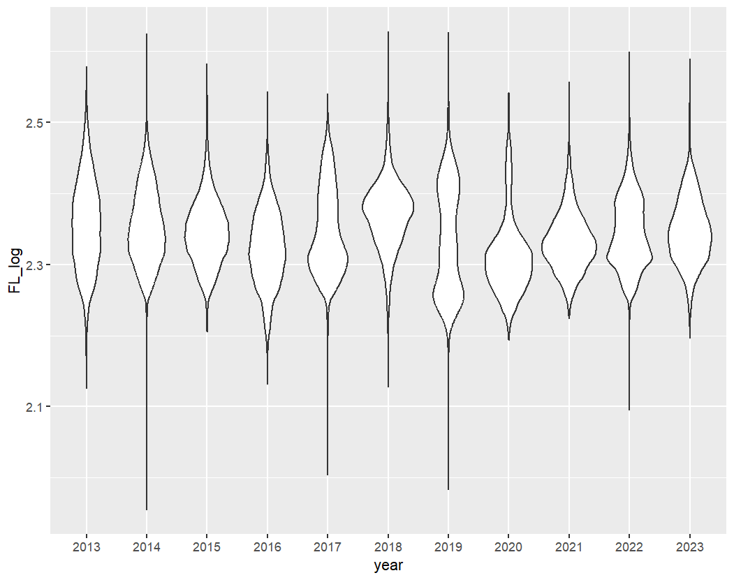

Log FL

Year

Figure 1 – Alfonsino log FL by year, from 2013-2023.

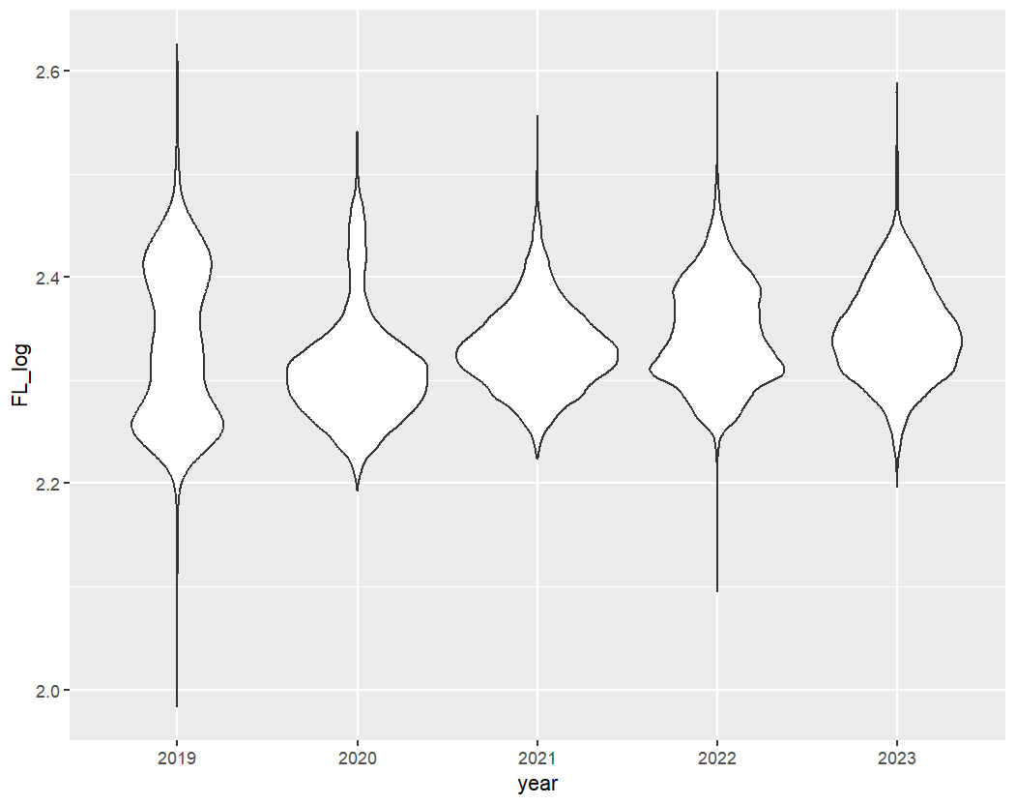

Log FL

Year

Figure 2 – Alfonsino log FL by year following the mesh regulations.

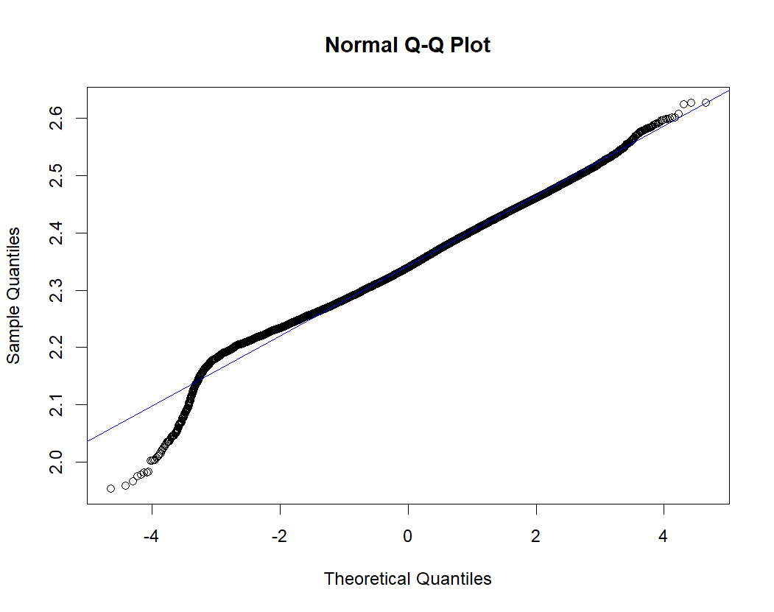

Figure 3 – QQ plot for alfonsino log FL data.

Theoretical Quantiles

Sampling Quantiles