NPFC-2024-SSC BFME05-WP17

Small Working Group on NPA and SA - Summary for 2024

by

Kota Sawada (Lead of the SWG NPA-SA)

Oceanic Resources Group, Fisheries Resources Institute,

Japan Fisheries Research and Education Agency, Japan

December 2024

**This paper may be cited in the following manner:**

Sawada, K. 2024. Working Group on NPA and SA - Summary for 2024. NPFC-2024-SSC BFME05-WP17. 4 pp. Available at https://www.npfc.int/

Working Group on NPA and SA - Summary for 2024

Kota Sawada (Lead of the SWG NPA-SA)

Oceanic Resources Group, Fisheries Resources Institute,

Japan Fisheries Research and Education Agency, Japan

Abstract

This document summarizes the progress achieved by the Small Working Group on North Pacific Armorhead and Splendid Alfonsino in 2024.

Introduction

The Small Working Group on North Pacific Armorhead and Splendid Alfonsino (SWG NPA-SA) held three online meetings in 2024 (May 24th, Aug 20th and October 16th). By SSC BF-ME04 (Small Scientific Committee on Bottom Fish and Marine Ecosystems 2023), the group was tasked with six items as follows:

1. Deliver science advice on the status of SA to SC09 using the life history based approach
2. Analyze the impact of mesh size change on SA catch size composition
3. Work towards completing approaches using depletion or IBM for NPA
4. Evaluate trend in directed effort relative to NPA catch
5. Update species summaries (SA and NPA)
6. Standardize CPUE (lower priority)

Progress on those tasks is summarized below.

**1. Deliver science advice on the status of SA to SC09 using the life history-based approach**

In 2023, the SWG NPA-SA shared biological data of SA collected by Members and worked to estimate life-history parameters (Ayer et al. 2023; Sawada 2023). In 2024, the SWG NPA-SA improved the estimation (Amoroso et al. 2024). The estimated parameters were used for life history-based analyses (Pons et al. 2024) on the stock status of SA. The uncertainty of parameter estimates is also considered by running sensitivity analyses.

The SWG recommended the SSC BF-ME05 deliver the following science advice to SC09, after reviewing the report of those analyses (Pons et al. 2024).

* Based on YPR analysis, growth overfishing of the SA stock is occurring in trawl fisheries
* Based on LBSPR analysis for all gears combined, recruitment overfishing of the SA stock is likely to be occurring. This result may be biased towards overfishing due to the dome shaped selectivity of the trawl gear which is the main fishery contributing to the SA total catch

For future work next year, SWG NPA-SA agreed to consider integrated modelling (e.g. Stock Synthesis, Methot and Wetzel 2013) with multiple fleets to assess the SA stock.

**2. Analyze the impact of mesh size change on SA catch size composition**

In 2023, the SWG agreed to evaluate the effectiveness of the current mesh size regulation as one of the approaches to monitor the effectiveness of current management measures of NPFC.

The SWG noted that the catch size composition data for SA is not only useful for this task, but also helps analyses for other tasks, especially Task 1. The SWG developed and agreed upon the Term of References for data sharing. The SWG reviewed the data shared by Members.

The SWG reviewed the preliminary analyses by Japan on the impact of trawl’s mesh size change on SA catch size composition introduced from 2019. Korean data were not used due to zero SA record since 2019. The analysis showed that, contrary to expectations, individuals caught since 2019 were smaller than ones before 2019. However, there was a large deviation from normality, and therefore further refinement is needed. Japan will present the updated analysis to the SSC BF-ME05 (Ayer and Sawada 2024)

**3. Work towards completing approaches using depletion or IBM for NPA**

In 2023, the SWG agreed to conduct individual-based bioenergetic modeling (see Gibson et al. 2019) and depletion analysis (Kiyota et al. 2014) as possible approaches for NPA, and drafted the Terms of Reference and data template for depletion analysis. The SSC BF-ME04 endorsed them.

The SWG reviewed the data for depletion analysis shared by Members (Japan and Korea) and update on IBM presented by Canada (very little progress was made on this item).

**4. Evaluate trend in directed effort relative to NPA catch**

In 2023, the SWG agreed to evaluate encouraged catch by testing the hypothesis that the setting of encouraged catch in 2019 (which will become catch limit since 2025, NPFC Commission 2024) reduced directed fishing effort and fishing pressure on NPA, even though recent annual catch is smaller than the encouraged level (Sawada 2023).

The SWG requested Japan to conduct the analysis to monitor the trend of directed effort using its data, rather than conducting a joint analysis. The SWG reviewed a preliminary work by Japan, which demonstrated that the reduction of fishing efforts recorded as targeting NPA by scientific observers, and recommended further analyses, especially approaches using catch composition to estimate targeting. Japan will present the updated analysis to the SSC BF-ME05 (Sawada 2024).

See Task 3 for the progress on depletion analysis, which will also help evaluate the change of harvest rate that may have been caused by the encouraged catch limit.

**5. Update species summaries (SA and NPA)**

The SWG reviewed the updated species summaries, and revised Fig.4 for both to show fishing efforts separately by gears, in addition to by Members. The revised Fig.4 (identical for both species) is shown below.

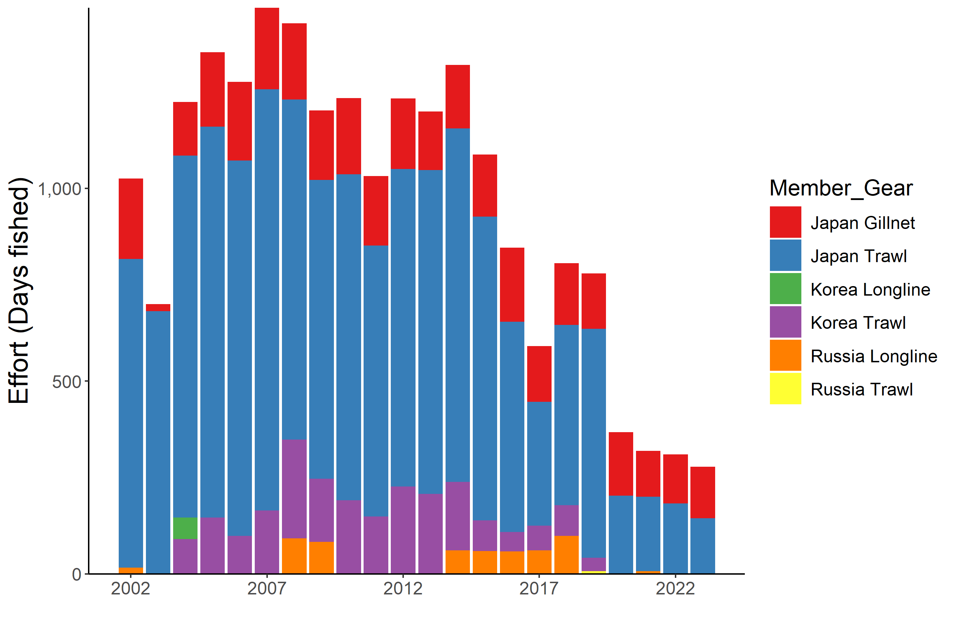

**6. Standardize CPUE**

The SWG had no progress on this task this year, as its priority is lower. However, participants noted that applying integrated model will require an index of abundance. Thus, the SWG recommended keeping it in the task list as a higher priority, if the integrative modeling of SA becomes the future task for the group (see Task 1).

Japan pointed out possible caveats to interpret CPUE as an index of abundance, that is, target shift (Sawada et al. 2017) and misreporting (Technical and Compliance Committee 2018).

Acknowledgements

I thank all the participants, including External Experts Drs. Maite Pons and Ricardo Amoroso, and the Secretariat for their contributions to the Small Working Group on North Pacific Armorhead and Splendid Alfonsino, and helpful comments on the manuscript.

References

Amoroso R, Pons M, Arai S, Ayer C., Song, H., Sawada K (2024) Life history parameters for Splendid Alfonsino (*Beryx splendens*) in the North Pacific. NPFC-2024-SSC BFME05-WP08. 21 pp.

Ayer CG, Arai S, Sawada K (2023) Size at maturity of splendid alfonsino (*Beryx splendens*) from the Emperor seamounts. NPFC-2023-BFME04-WP10. 9 pp.

Ayer, CG, Sawada, K (2024) Impact of mesh size change on catch size composition of splendid alfonsino *Beryx splendens* in the Emperor Seamounts. NPFC-2024-SSC BFME05-WP15. 10 pp.

Gibson GA, Stockhausen WT, Coyle KO, Hinckley S, Parada C, Hermann AJ, Doyle M, Ladd C (2019) An individual-based model for sablefish: Exploring the connectivity between potential spawning and nursery grounds in the Gulf of Alaska. Deep Sea Res 2. 165:89–112.

Kiyota M, Okuda T, Yonezaki S (2014) Depletion model analysis on recent recruitment and exploitation levels of North Pacific armorhead in the Southern Emperor–Northern Hawaiian Ridge seamounts. Document SWG12/WP3/J NPFC.

Methot RD Jr, Wetzel CR (2013) Stock synthesis: A biological and statistical framework for fish stock assessment and fishery management. Fish. Res. 142:86–99.

NPFC Commission (2024) Meeting Report. NPFC-2024-COM08-Final Report. 734 pp.

Pons M, Amoroso R, Sawada K (2024) Yield per recruit and spawning biomass per recruit analyses for Splendid Alfonsino (*Beryx splendens*) in the North Pacific. NPFC-2024-SSC BFME05-WP09. 22 pp.

Sawada K (2023) Small Working Group on NPA and SA - Summary for 2023. NPFC-2023-SSC BFME04-WP09. 4 pp.

Sawada K (2024) Reduced fishing effort directed to North Pacific armorhead by Japanese vessels operating in the Emperor Seamount area. NPFC-2024-SSC BFME05-WP16. 11 pp.

Sawada K, Nishida K, Yonezaki S, Kiyota M (2017) Application of the directed CPUE method to the multispecies bottom fisheries in the Emperor Seamounts region, for the monitoring of stock status and fishing activity. NPFC-2017-SSC NPA02-WP02 (Rev 1). 14 pp.

Small Scientific Committee on Bottom Fish and Marine Ecosystems (2023) 4th Meeting Report. NPFC-2023-SSC BF-ME04-Final Report.135 pp.

Technical and Compliance Committee (2018) 3rd Meeting Report. NPFC-2018-TCC03-Final Report. 83 pp.