NPFC-2024-SSC PS14-WP04

**Bycatch information from the Japanese fisheries**

Midori Hashimoto, Satoshi Suyama, Taiki Fuji, Hiroomi Miyamoto and Shin-Ichiro Nakayama

*Fisheries Resources Institute, Japan Fisheries Research and Education Agency*

**Summary**

Pacific saury has been historically caught primarily by the stick-held dip nets in Japan and the catch is quite small in other fisheries. In the Japanese stick-held dip net fisheries targeting Pacific saury, several kinds of pelagic fish have been bycaught, but their bycatch recorded in the logbooks is very rare.

**Introduction**

In the previous meeting, the SSC PS noted reviewing bycatch data of Pacific saury (hereafter, PS) from other fisheries would ensure more reliable catch information and improve the PS stock assessment (NPFC-2023-SSC PS12-Final Report). It was also noted that the bycatch data of other species from the PS fisheries may be useful for their stock assessment. The corresponding information from the Japanese fisheries was summarized in this working paper.

**1. Pacific saury catch from the fisheries other than the stick-held dip net fishery**

Pacific saury has been historically caught primarily by the stick-held dip nets in Japan and the PS catch is quite small in other fishing activities using set nets, drift nets, and purse seines (**Fig. 1**). The average annual proportions of PS catch from 1994 to 2022 were 98%, 1.4%, 0.4%, and 0.05% for stick-held dip nets, set nets, drift nets, and purse seines, respectively. The catch amount from the fisheries other than the stick-held dip net fishery by the Japanese fishing vessels is shared in the Annual Report from Japan (NPFC-2024-AR-Annual Summary Footprint – Pacific saury).

**2. Bycatch in the Japanese stick-held dip net fisheries**

In the Japanese stick-held dip net fisheries targeting PS, several kinds of pelagic fish have been bycaught, although the historical bycatch statistics are not available. Because mackerels, Japanese sardine, Japanese anchovy and Japanese flying squid were recorded separately in the logbooks since 2021, species-specific catch proportion are summarized in **Table 1**, indicating that the bycatch is very rare in this fishery.

**References**

Small Scientific Committee on Pacific Saury (2023) 12th Meeting Report. NPFC-2023-SSC PS12-Final Report. 61 pp. (Available at www.npfc.int)

NPFC (2024) Annual Report Summary Table – Pacific saury. NPFC-2024-AR-Annual Summary Footprint - Pacific saury. (Available at www.npfc.int/summary-footprint-pacific-saury-fisheries).

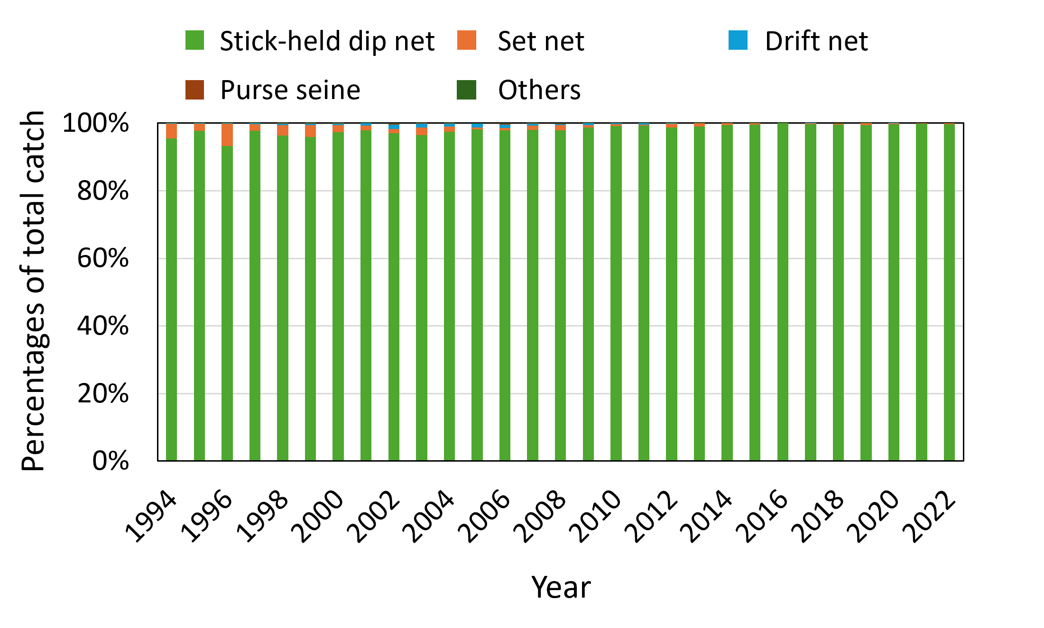

**Figure 1** Historical proportion of Pacific saury catch from the different fisheries in Japan.

**Table 1** Annual catch proportion (%) by species recorded in the logbooks of the Japanese stick-held dip net fishery.

|  |  |  |  |
| --- | --- | --- | --- |
|  | 2021 | 2022 | 2023 |
| Pacific saury | 99.7 | 99.9 | 99.9 |
| Mackerels  (chub mackerel and blue mackerel) | 0.1 | 0.08 | 0.06 |
| Japanese sardine | 0.2 | 0.02 | 0.01 |
| Japanese anchovy | 0.02 | 0.007 | 0.003 |
| Japanese flying squid | 0.004 | 0.003 | 0.002 |