NPFC-2024-SC09-WP21

**An overview of 2024 Chinese survey by fishery research vessel "Song Hang" in the NPFC convention area**

Yufei Zhou, Qiuyun Ma, Bilin Liu, Siquan Tian, Libin Dai, Congcong Wang

College of Marine Living Resource Sciences and Management, Shanghai Ocean University, China

(Corresponding author: Qiuyun Ma, qyma@shou.edu.cn)

**Summary**

In 2024, the Chinese fishery research vessel Song Hang embarked on its fourth year of scientific surveys by Shanghai Ocean University in the Northwest Pacific Ocean. This document provides an overview of the 2024 survey and presents some key findings based on data collected from 2021 to 2023. The improved survey program in 2024 continues to cover fisheries resources, larval and juvenile stages of marine species, plankton, and environmental surveys, consistent with previous years. Some case studies, i.e. distribution by acoustic, biodiversity by environment-DNA, feeding ecology, ecosystem modelling, and plastic analysis, were provided for references. The data collected will continue to contribute to a deeper understanding of the marine ecosystem within the NPFC convention area.

**Introduction**

Shanghai Ocean University of China has been conducting a scientific survey program using its fishery research vessel "Song Hang" of in the NPFC convention area since 2021. This comprehensive program includes fisheries resources, larval-juvenile, plankton, and environmental surveys, with the tasks as below:

a) Investigating population structure and spatial distribution of pelagic species.

b) Evaluating the relative abundance of NPFC species based on the trawl and acoustic data.

c) Collecting fishery-independent data, including length-frequency, length-weight data, and biological sampling of the main species in this ecosystem.

d) Collecting environment data and biology diversity for ecosystem modeling.

Through this project, we look forward to providing essential information to supplement the current scientific database of the SC and its subsidiary bodies to improve our understanding of the marine ecosystem in NPFC convention area.

**Materials and Methods**

Given the capacity and schedule of the “Song Hang” research vessel (3166 tons, 85-meters-length), we surveyed about two months from mid-June to early-August. In 2024, the program conducted from 11 June to 2 August, with 53 surveying days. This survey covered the area from 148°E to 164°E and from 35°N to 45°N on the high sea (Figure 1). This survey includes the fishery resources mid-trawling, squid jigging, egg-larva-juvenile trawling, zooplankton and phytoplankton vertical trawling, environmental factors monitoring, acoustic survey, and environment-DNA research.

Totally there are about 76 stations in 2024, with trawling for only 46 stations and squid-jigging for 27 stations (Figure 1). At each station, the mid-trawling covers about 2~3 hours, with 4~5kn speed and the squid jigging for 5 hours. The catch was identified to species level, weighted, counted, and some important specimens will be measured for the biological information (growth, sex, maturity, feeding etc.)

For environment factors, we collect data on temperature, salinity, transparency, dissolved oxygen, pH, nitrogen, etc. Conductivity Temperature Depth (CTD 9-11Plus, Sea-Bird) and its MOUNTED SBE43 probe was used to collect 0-300m vertical hydrological data of the above information at each station. Water samples were collected in layers of 25m, 50m, 75m, 100m, 200m, and 300m, and 12 bottles *250ml/ bottle per station, used for multiple purposes, e.g. environment-DNA analysis.

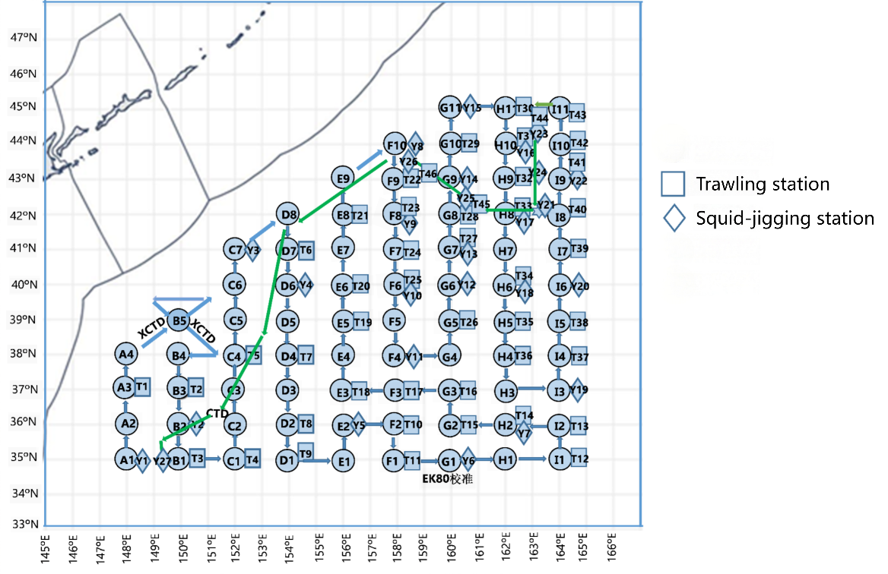

Figure 1 Survey stations of RV Song Hang in the northwest Pacific Ocean in2024.

**Results**

**Preliminary results of 2024 survey**

The trawling and squid jigging surveys collected many species, which are mainly fishes and cephalopoda (Tables 1-2). The dominate fishery species in trawling survey are Chub mackerel *Scomber japonicus*, Blue mackerel *Scomber australasicus*, Japanese sardine *Sardinops melanostictus*, and Pacific pomfret *Brama japonica* (Figure 2), while the dominant species in squid jigging survey are Neon flying squid *Ommastrephes bartrami* and Boreopacific gonate squid *Gonatopsis borealis* (Figure 3).

The catch spatial distribution of mackerels and Japanese sardine were shown in the figures 4, while the length distribution of 2024 specimens were exhibited in the figure 5. Using the swept-area method to calculate the relative density of three economic fish species in the Northwest Pacific, the results are as follows: the relative densities of Chub mackerel, Blue mackerel, and Japanese sardine are 116.55, 163.80, and 109.47 kg/km2.Through the acoustic analysis, the density of Chub mackerel was estimated to be 47.01 t/nmi2, while Blue mackerel’s density was 20.83 t/nmi2, and the Japanese sardine was 74.23 t/nmi2.

Table 1 The fishes collected in the four years fishery resources survey by RV Song Hang in the northwest Pacific.

| **Family** | **Species** | **2021** | **2022** | **2023** | **2024** |
| --- | --- | --- | --- | --- | --- |
| BATHYLAGIDAE | *Dolicholagus longirostris* |  |  | √ |  |
| *Lipolagus ochotensis* |  |  | √ | √ |
| BRAMIDAE | *Brama brama* |  |  | √ | √ |
| *Brama japonica* |  | √ | √ | √ |
| *Brama myersi* | √ | √ | √ | √ |
| *Taractes rubescens* |  | √ |  |  |
| BOTHIDAE | *Bothidae* |  |  |  | √ |
| CARANGIDAE | *Trachurus japonicus* |  |  |  | √ |
| *Decapterus lajang* |  |  |  | √ |
| *Naucrates ductor* |  |  |  | √ |
| CARCHARHINIDAE | *Prionace glauca* | √ | √ | √ | √ |
| CENTROLOPHIDAE | *Hyperoglyphe japonica* |  |  | √ | √ |
| *Lcichthys lockingtoni* |  |  |  | √ |
| CLUPEIDAE | *Sardinops melanostictus* | √ | √ | √ | √ |
| DALATIIDAE | *Squaliformes* |  |  |  | √ |
| DASYATIDAE | *Pteroplatytrygon violacea* | √ |  |  |  |
| EMMELICHTHYIDAE | *Erythrocles schlegelii* |  |  |  | √ |
| ENGRAULIDAE | *Engraulis japonicus* | √ | √ | √ | √ |
| EXOCOETIDAE | *Cypselurus oligolepis* |  |  | √ |  |
| GONOSTOMATIDAE | *Diplophos taenia* |  |  |  | √ |
| ICOSTEIDAE | *Icosteus aenigmaticus* |  |  | √ |  |
| LAMNIDAE | *Lamna nasus* |  |  | √ | √ |
| LAMPRIDIDA | *Lampris guttatus* |  |  | √ |  |
| LOPHIIDAE | *Lophius litulon* |  |  |  | √ |
| MOLIDAE | *Mola mola* |  | √ | √ |  |
| MONACANTHIDAE | *Thamnaconus septentrionalis* |  |  |  | √ |
| MYCTOPHIDAE | *Ceratoscopelus townsendi* |  |  | √ | √ |
| *Diaphus garmani* | √ |  |  |  |
| *Diaphus gigas* |  |  | √ | √ |
| *Diaphus perspicillatus* |  |  | √ | √ |
| *Diaphus suborbitalis* |  |  | √ |  |
| *Hygophum reinhardtii* |  |  |  | √ |
| *Lampanyctus tenuiformis* |  |  | √ |  |
| *Myctophidae* |  | √ |  | √ |
| *Myctophum asperum* | √ | √ | √ | √ |
| *Myctophum nitidulum* | √ |  | √ | √ |
| *Nannobrachium nigrum* |  |  | √ |  |
| *Notoscopelus caudispinosus* |  |  | √ | √ |
| *Notoscopelus japonicus* |  |  | √ | √ |
| *Notoscopelus resplendens* | √ |  | √ | √ |
| *Poropanchax normani* |  |  | √ |  |
| *Symbolophorus californiensis* | √ |  | √ | √ |
| *Symbolophorus evermanni* |  |  |  | √ |
| *Tarletonbeania taylori* |  |  | √ | √ |
| NEMICHTHYIDAE | *Nemichthys scolopaceus* |  |  |  | √ |
| NEOCERATIAS | *Ceratias holboelli* |  |  |  | √ |
| NOMEIDAE | *Cubiceps whiteleggii* |  | √ | √ |  |
| *Cubiceps pauciradiatus* |  |  |  | √ |
| *Psenes arafurensis* |  |  | √ | √ |
| *Psenes pellucidus* |  | √ | √ |  |
| *Psenes cyanophrys* |  |  |  | √ |
| NOTOSUDIDAE | *Scopelosaurus hoedti* | √ |  | √ | √ |
| OSTRACIONTIDAE | *Lactoria diaphana* |  |  | √ |  |
| PARALEPIDIDAE | *Lestidiops jayakari* |  |  | √ |  |
| *Lestrolepis intermedia* |  |  | √ |  |
| *Magnisudis indica* | √ |  |  |  |
| *Stemonosudis* |  |  |  | √ |
| PHOSICHTHYIDAE | *Vinciguerria nimbaria* |  |  |  | √ |
| REGALECIDAE | *Regalecus russllii* |  | √ |  |  |
| SALMONIDAE | *Oncorhynchus gorbuscha* |  |  | √ |  |
| SCOMBERESOCIDAE | *Cololabis saira* | √ |  |  | √ |
| SCOMBRIDAE | *Diplospinus multistriatus* |  |  | √ | √ |
| *Nealotus tripes* | √ | √ | √ | √ |
| *Scomber australasicus* | √ |  | √ | √ |
| *Scomber japonicus* | √ | √ | √ | √ |
| *Thyrsitoides marleyi* |  |  | √ | √ |
| STOMIAS AFFINIS | *Astronesthes fedorovi* |  |  |  | √ |
| *Astronesthes quasiindicus* |  |  | √ |  |
| TETRAGONURIDAE | *Tetragonuridae* |  |  |  | √ |
| *Tetragonurus cuvieri* |  | √ | √ | √ |
| TETRAODONTIDAE | *Arothron stellatus* |  |  |  | √ |
| *Lagocephalus lagocephalus* |  |  |  | √ |
| TRACHIPTERIDAE | *Trachipteridae* |  |  |  | √ |
| *Tradhypterus ishikawae* |  | √ | √ | √ |
| TRICHIURIDAE | *Assurger anzac* | √ |  |  |  |
| THUNNIDAE | *Auxis thazard thazard* |  |  |  | √ |
| XIPHIIDAE | *Xiphias gladius* |  |  | √ |  |
| ZEIDAE | *Zenopsis nebulosa* | √ | √ | √ | √ |

Table 2 The cephalopoda collected in the four years fishery resources survey by RV Song Hang in the northwest Pacific.

|  |  |  |  |  |  |
| --- | --- | --- | --- | --- | --- |
| **Family** | **Species** | **2021** | **2022** | **2023** | **2024** |
| ALLOPOSIDAE | *Haliphron atlanticus* |  | √ |  |  |
| AMPHITRETIDAE | *Amphitretus pelagicus* | √ | √ |  |  |
| ARGONAUTIDAE | *Argonauta argo* |  |  |  | √ |
| BOLITAEMIDAE | *Japetella diaphana* | √ | √ |  | √ |
| CRANCHIIDAE | *Cranchia scabra* |  |  | √ |  |
| *Galiteuthis sp.* |  | √ |  |  |
| *Leachia pacifica* |  |  | √ |  |
| *Liocranchia reinhardti* |  | √ | √ |  |
| *Taonius pavo* |  |  | √ |  |
| ENOPLOTEUTHIDAE | *Enoploteuthis chunii* |  |  | √ | √ |
| *Watasenia scintillans* | √ | √ | √ | √ |
| GONATIDAE | *Gonatopsis borealis* | √ | √ | √ | √ |
| *Gonatopsis octopedatus* | √ | √ |  |  |
| OCTOPOTEUTHIDAE | *Octopoteuthis sicula* |  |  | √ |  |
| OMMASTREPHIDAE | *Eucleoteuthis luminosa* | √ | √ | √ | √ |
| *Ornithoteuthis volatilis* |  |  |  | √ |
| *Ommastrephes bartrami* |  | √ |  | √ |
| *Sthenoteuthis oualaniensis* | √ |  |  |  |
| *Todarodes pacificus* | √ | √ | √ |  |
| ONYCHOTEUTHIDAE | *Moroteuthis* |  |  | √ | √ |
| *Moroteuthis robusta* | √ | √ |  |  |
| *Onychoteuthis borealijaponicus* | √ | √ |  | √ |
| *Onychoteuthis compacta* | √ | √ | √ | √ |

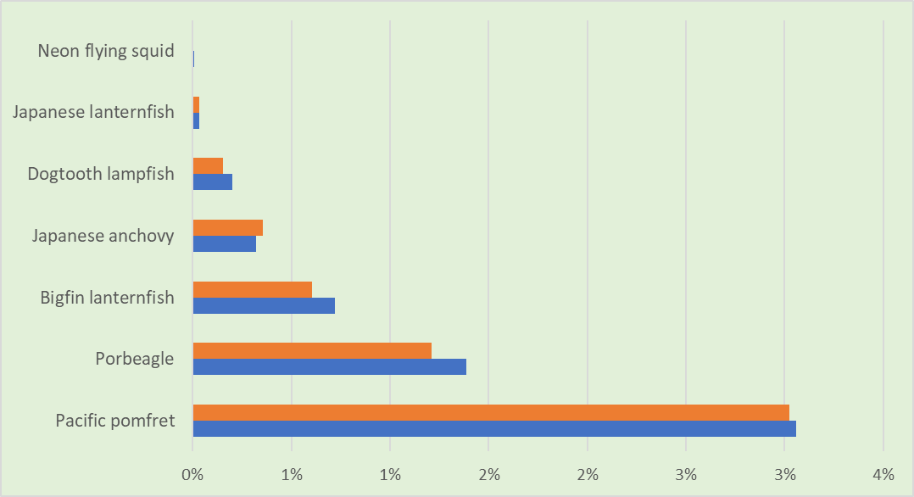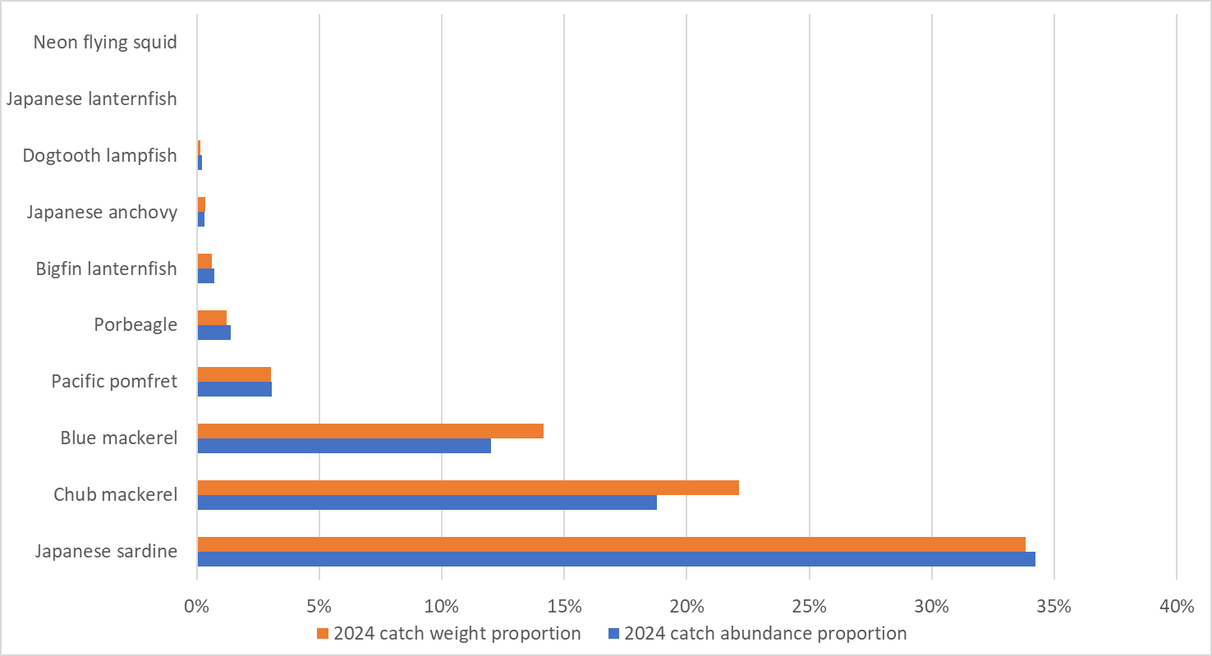

Figure 2 The catch weight and abundance proportions of main species in the 2024 trawling survey

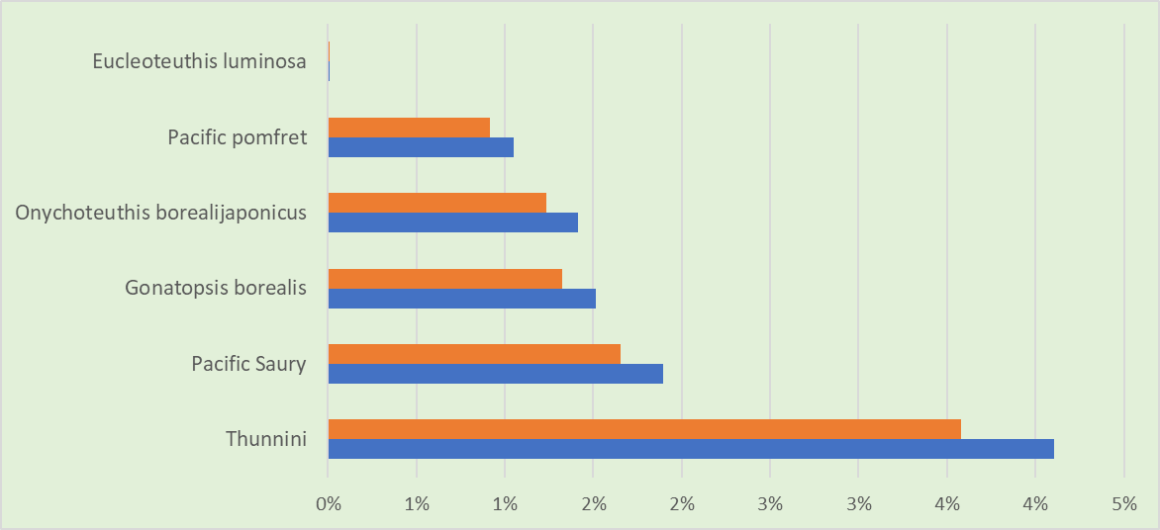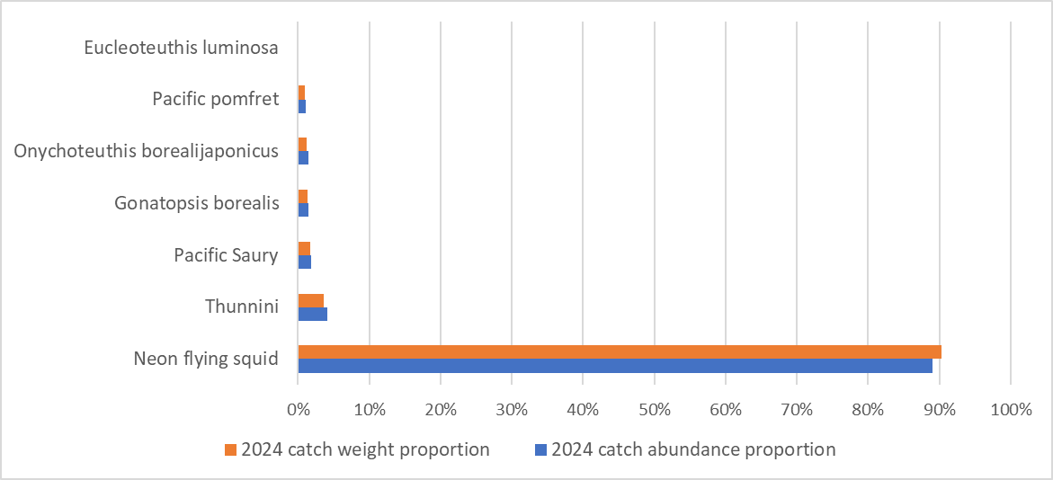

Figure 3 The catch weight and abundance proportions of main species in the 2024 squid jigging survey

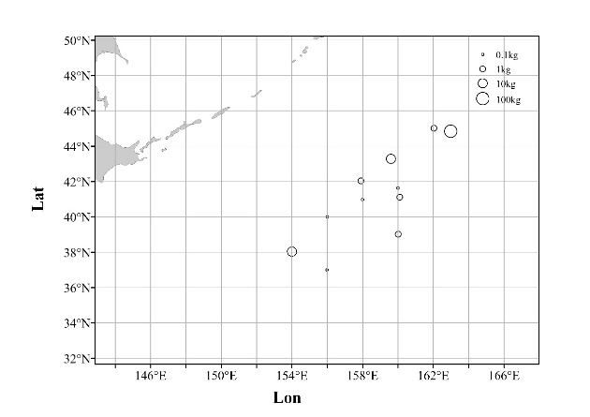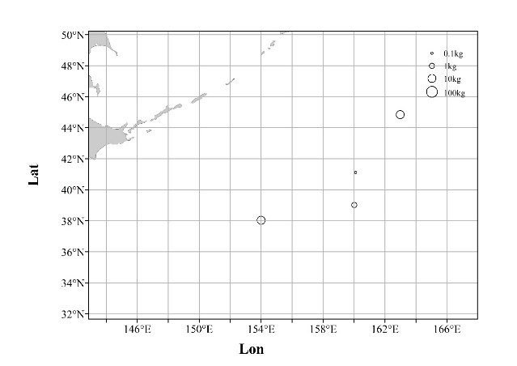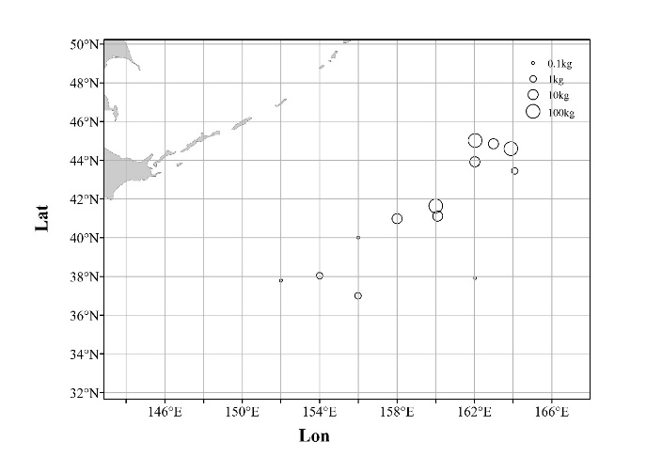

Japanese Sardine

2024

Chub Mackerel

2024

Blue Mackerel

2024

Figure 4 The catch distribution of mackerels and Japanese sardine in 2024 survey by RV Song Hang in the northwest Pacific.



Japanese Sardine

2024

Chub Mackerel

2024

澳洲鲐全长月份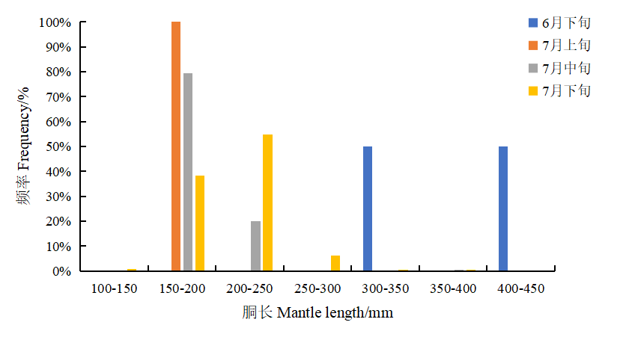

Blue Mackerel

2024

Neon flying squid

2024

Figure 5 The length distribution of four main species surveyed in 2024 fishery resources survey by RV Song Hang in the northwest Pacific.

**Some research examples based on previous surveys**

**Acoustic**

In the study by RV Song Hang from June to July 2022, the distribution and impacts of abiotic factors on small pelagic fish (mainly Chub mackerel, Pacific sardine) and cephalopods (mainly Boreopacific gonate squid, Neon flying squid) in the northwest Pacific Ocean were assessed (Zhu et al., 2024). Key findings include mean abundance and biomass densities of 3.12×105±1.42×106 ind/n mile2 and 5768.39±26224.76 kg/n mile2, with a notable concentration in the 0-50 m layer and aggregation near the Kuroshio Extension. Temperature significantly influences the fish density in all water layers (Figure 6).

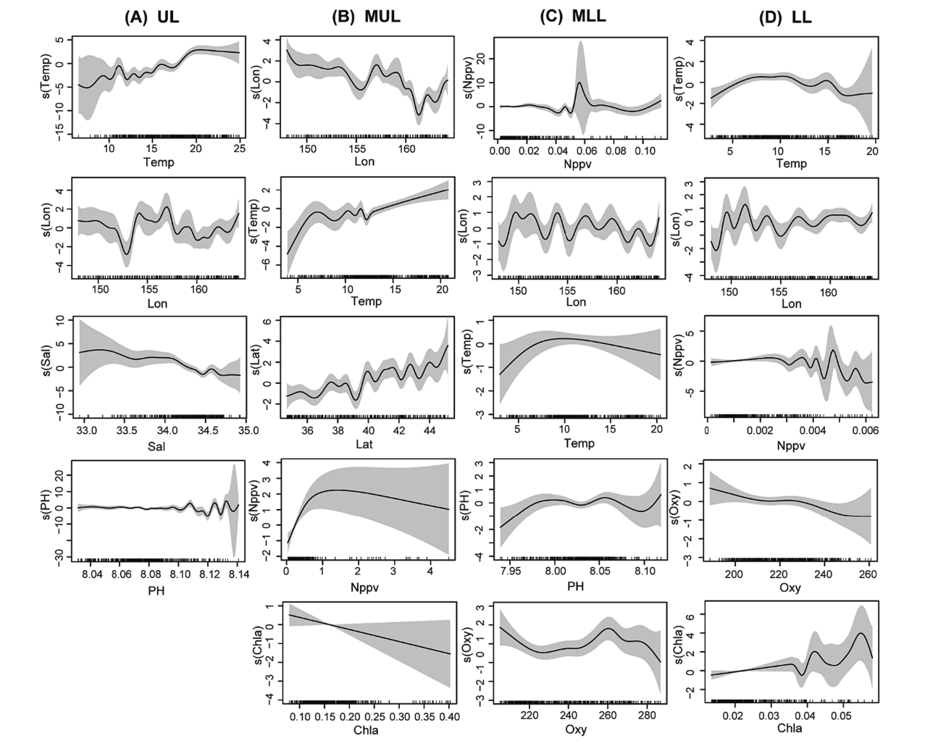

Figure 6 Effects of environmental factors on fish density in different water layers. (A) UL, (B) MUL, (C) MLL, (D) LL. Vertical coordinate represents the spline function s(x). Solid line is the influence curve and the shaded area shows the 95% confidence interval. Dotted line on the x-axis indicates the density of data points.

**eDNA**

Combining the results of trawl (39 stations) and eDNA (70 stations) surveys in 2023, a total of 103 fish species were identified, with the eDNA method detecting more orders, families, genera, and species than the trawl. Among these 103 species, 22 were found in both survey methods, accounting for 21.3% of the total (Figure 7). Additionally, 52 species were exclusively detected through the eDNA method, representing approximately 50.5% of the total, while 29 species were only discovered in the trawl survey, making up 28.2% of the total.

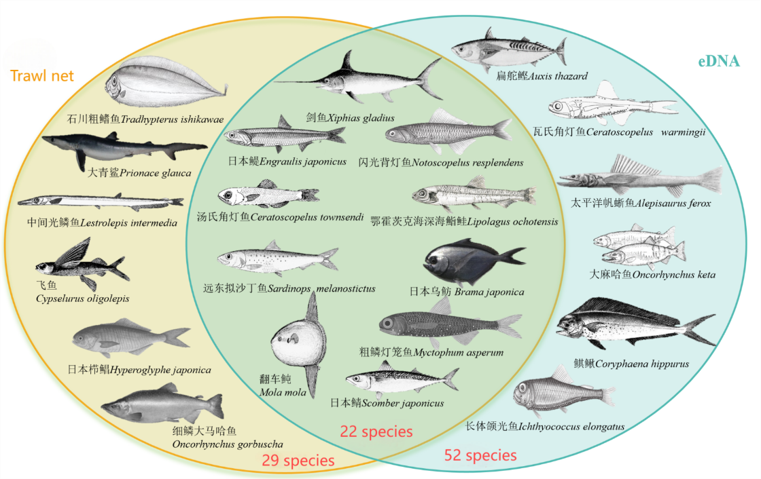

Figure 7 Fishes identified by trawl net and eDNA in 2023 survey.

**Feeding ecology**

Feeding habits and ecological niche changes of Chub mackerel (*Scomber japonicus*) in the northwest Pacific Ocean were investigated through stable isotope and fatty acid analyses, based on samples collected during RV Song Hang from June to August 2021 (Chen et al., 2024a). No significant difference among males and females was revealed, while both methods suggested the ecological niche and dietary sources changed as Chub mackerel grew (Figure 8).

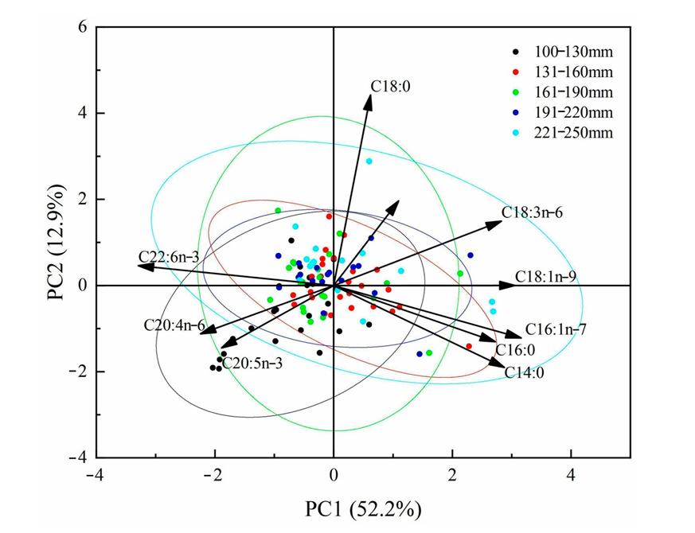

Figure 8 Principal component analysis of the fatty acid compositions among different body length groups of Chub mackerel *Scomber japonicus* in Northwest Pacific.

**Ecosytem model**

Based on the data collected in 2023, the Ecopath with Ecosim (EwE) model was constructed to analyze the trophic structure and characteristics of this pelagic ecosystem (Chen et al., 2024b). The overall ecosystem characteristics suggested that this ecosystem in NPFC convention area was at a low level of maturity and vulnerable to disturbance from external activities (Figure 9).

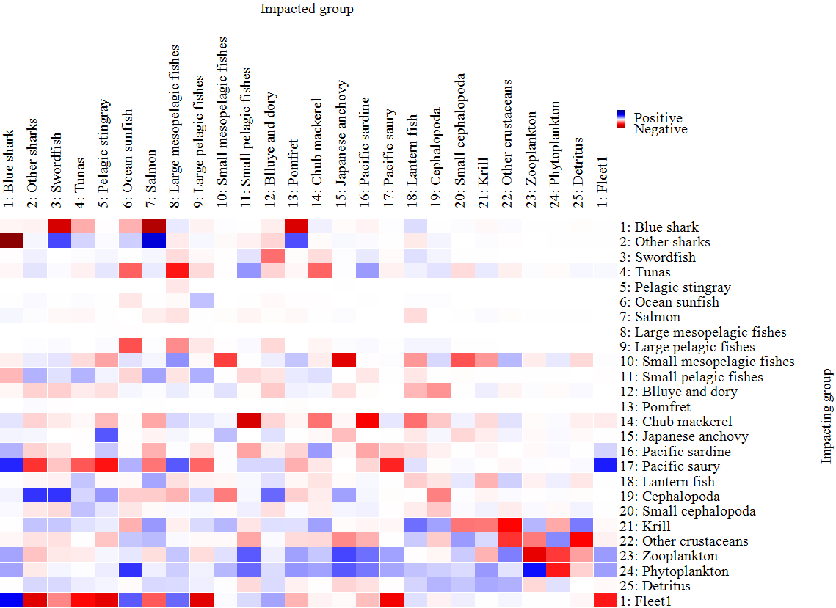

Figure 9 Mixed trophic impacts between functional groups in the pelagic ecosystem of Northwest Pacific.

**Plastic**

Microplastics and artificial cellulose particles were analyzed in bigfin lanternfish (*Symbolophorus californiensis*) from the northwest Pacific Ocean, revealing their ingestion and distribution within the fish (Gong et al., 2024). The analysis, conducted by comparing the abundance and characteristics of these particles in the stomach and intestine, showed that plastics were present in 29.2% of the specimens examined (Figure 10).

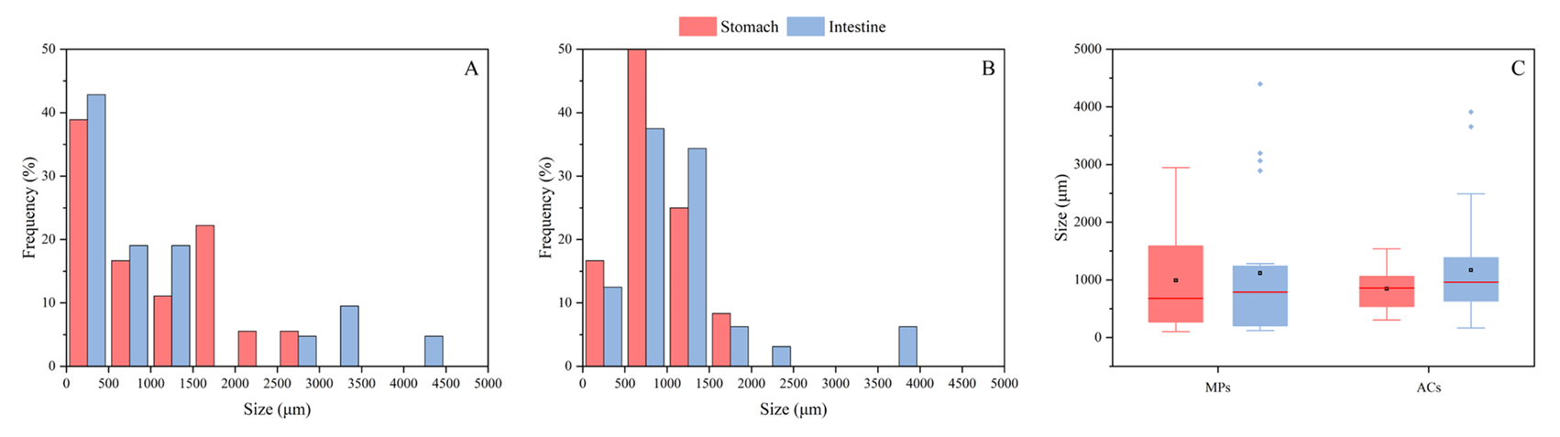

Figure 10 Size distribution of microplastics and artificial cellulose particles in the stomach and intestine of *Symbolophorus californiensis* (A, microplastics; B, artificial

cellulose particles; C, microplastics and artificial cellulose particles).

**Discussion**

In 2024, more than 60 species were surveyed alongside environmental parameters using various advanced methodologies. The survey focused on key species such as Chub mackerel, Blue mackerel, Japanese sardine, and Neon flying squid, which are of high priority for the NPFC. These species were extensively studied to understand their spatial distribution, abundance, and biological characteristics, contributing to the scientific database required for effective fisheries management. However, due to the limitations of the survey gear and the capacity of the RV Song Hang, some species, such as Pacific saury and Japanese flying squid, were less frequently collected. Despite these challenges, the survey provided critical insights into the population structure and ecological roles of the primary target species.

In addition to species-specific data, the survey collected fundamental biological samples and environmental data, including water temperature, salinity, dissolved oxygen, and nutrient concentrations. These data are pivotal for studying life history traits, population dynamics, spatial and temporal distribution, feeding ecology, interspecies relationships, and community structure. Advanced techniques, such as molecular analysis and acoustic surveys, further enriched the dataset, enabling detailed assessments of trophic dynamics and habitat associations. The incorporation of environmental DNA (eDNA) analysis also allowed for the identification of species diversity beyond traditional trawling methods, expanding the understanding of biodiversity in the surveyed region.

The findings presented here are part of an ongoing series of investigations conducted during scientific surveys in the Northwest Pacific. These studies aim to deepen the understanding of marine ecosystems, addressing key issues such as biodiversity, trophic dynamics, and environmental impacts. While this work involves marine plastic contamination and pelagic ecosystem, subsequent research will continue to explore related themes, expanding the scope of knowledge.

**Acknowledgement**

The document is supported by the National Natural Science Foundation of China (32202934), the National Key R&D Programs of China (2024YFD2400603), and Program on the Survey, Monitoring and Assessment of Global Fishery Resources (Comprehensive scientific survey of fisheries resources at the high seas) sponsored by the Ministry of Agriculture and Rural Affairs.

**References**

Chen Y C, Hu G Y, Zhao Z F, et al. Feeding Habits of *Scomber japonicus* Inferred by Stable Isotope and Fatty Acid Analyses. Journal of Marine Science and Engineering, 2024a, 12(8): 1335.

Chen G, Ma Q Y, Wang S Q, et al. 2024b. Study in the ecosystem structure and trophodynamics in the Kuroshio-Oyashio Extension area. NPFC-2024-SC09-WPXX.

Gong Y, Wang Q, Xiang Y, et al. Invisible threat to mesopelagic fish: Microplastics and artificial cellulose particles in Bigfin lanternfish *Symbolophorus californiensis* from the Northwest Pacific Ocean. Regional Studies in Marine Science, 2024, 78: 103799.

Zhu Z H, Tong J F, Xue M H, et al. Assessing the influence of abiotic factors on small pelagic fish distribution across diverse water layers in the Northwest Pacific Ocean through acoustic methods. Ecological Indicators, 2024, 158: 111563