NPFC-2024-SSC BFME05-WP08 (Rev. 1)

Life history parameters for Splendid Alfonsino (*Beryx splendens*) in the North Pacific

by

Ricardo Amoroso, Maite Pons, Satoi Arai, Christopher Gardner Ayer, Hyejin Song and Kota Sawada

December 2024

**This paper may be cited in the following manner:**

Amoroso, R., Pons, M., Arai, S., Aye, C., Song, H., and Sawada K. Life history parameters for Splendid Alfonsino (*Beryx splendens*) in the North Pacific. NPFC-2024-SSC BFME05-WP08. 21 pp. Available at https://www.npfc.int/

1 INTRODUCTION

Splendid Alfonsino (*Beryx splendens*) is a deep-sea fish widely distributed across the Atlantic, Indian, and Pacific Oceans, particularly around seamounts and underwater ridges. This species is highly valued in commercial fisheries due to its firm, white flesh and is often targeted by bottom trawls and deep-sea gillnet fisheries. In the North Pacific, Splendid Alfonsino is caught primarily by Japanese, Russian, and Korean fishing fleets using bottom trawls and gillnets. The largest catches come from operations using trawl (~95%). The fishery is often conducted on seamounts, where aggregations of this species occur, particularly during spawning periods (NPA-SA, 2001). Concerns exist regarding the status of the stock due to the life-history of the species and the concentrated nature of these which could lead to localized depletion. A life-history approach was suggested as a starting point towards producing a stock assessment for this species and help in decision making. The Yield per Recruit method suggested by the working group depends on life history data. Although previous studies have been conducted to estimate life-history parameters for this species, the objective of this paper is to assess information on somatic growth and sexual maturity using the most updated database. Here we also emphasize the data appropriateness for the analysis.

2 METHODS

## 2.1 The data sets

To update the life history information for Splendid Alfonsino (SA) two data sets were provided, including data from Japan, Korea and Russia:

* **Biological Data Set**: this dataset contains individual records for SA that include fork length, age, sex, body weight, maturity stage, and weight of the gonads. The type and amount of data collected differs by country (Table 1). Measurements were collected using various fishing gears during fishing operations and scientific surveys. The fork length was either measured directly or calculated using empirical relationships with other body size metrics, such as total length or standard length.

Table 1: Number of samples.

|  |  |  |  |
| --- | --- | --- | --- |
|  | Japan | Korea | Russia |
| Age-Length data | 7418 | 0 | 265 |
| Histological data | 603 | 4859 | 7259 |
| Gonadosomatic index data | 11787 | 240 | 0 |

* **Length Composition Data Set**: this data set contains length composition information from the Japanese fleet only, covering the period from 2013 to 2023. Individual fish lengths were recorded as fork lengths. Sampling took place across several seamounts, including Milwaukee, North Koko, Colahan, Kinmei, and Koko, with both gillnet and trawl operations documented in most areas. However, in Koko and North Koko, only trawl operations were conducted, as illustrated in Figure 1.

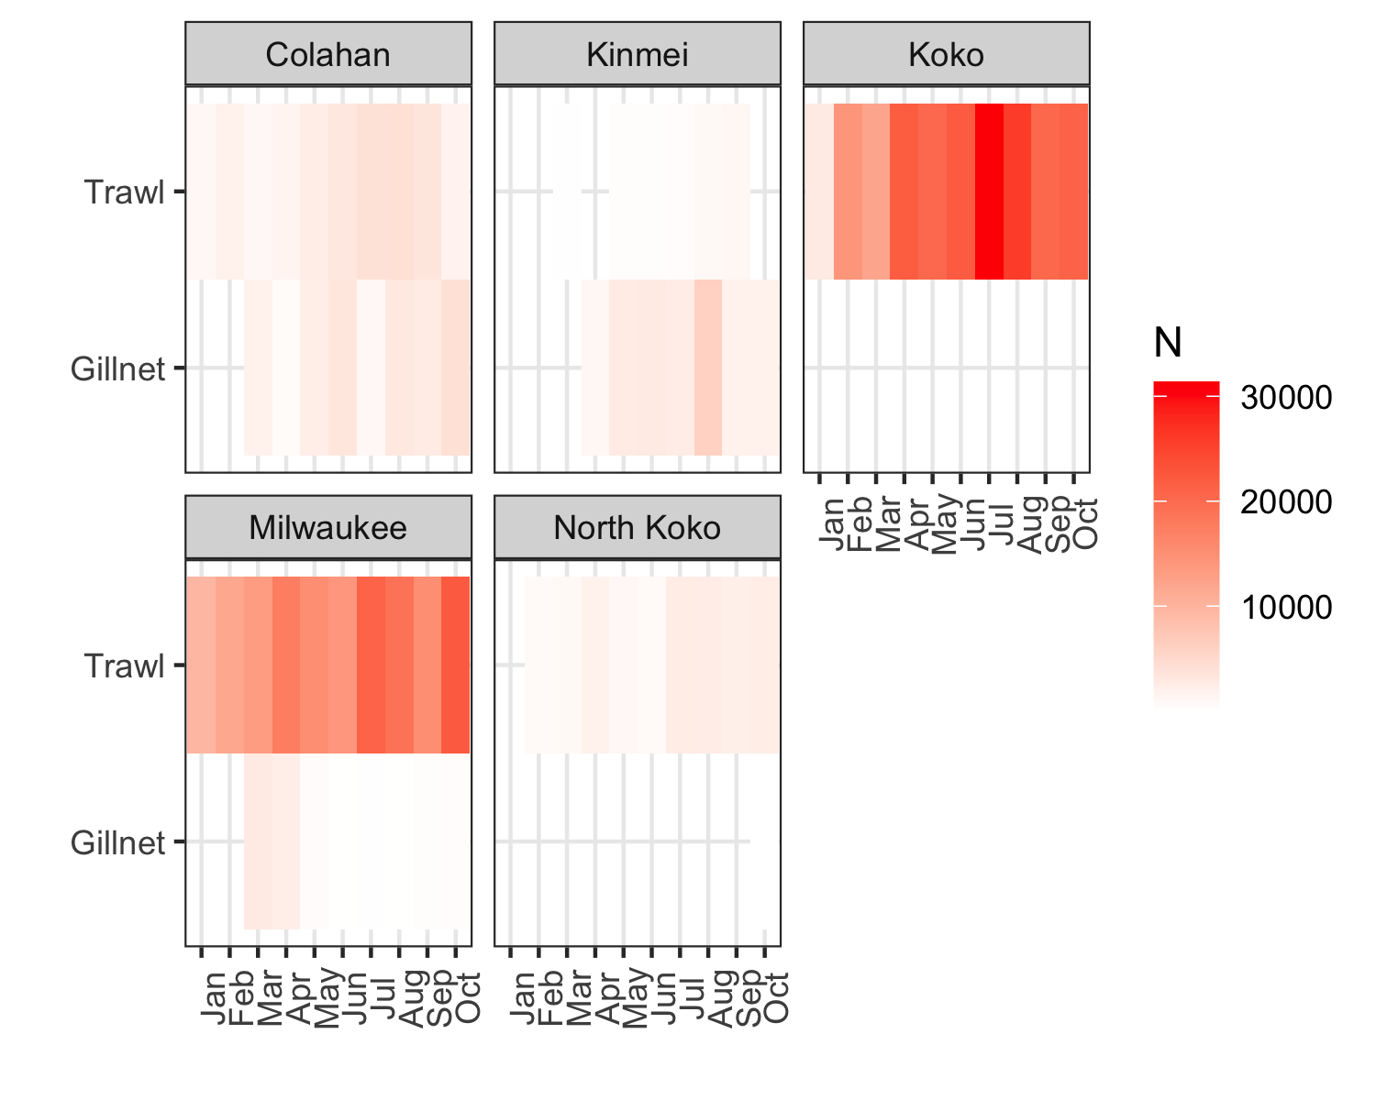

Figure 1: Number of individuals sampled by seamount, gear and month.

## 2.2 Growth Model Fitting

We assessed growth parameters by fitting a von Bertalanffy growth model (VBGM) to length-at-age data using both gillnet and trawl samples, as well as the combined dataset. The growth function was modeled as:

$$FL_{mm}=L_{∞}\left(1-e^{-K\left(\text{Age}-t_{0}\right)}\right)$$

where: $FL_{mm}$ is the predicted fork length in millimeters, $L_{∞}$ represents the asymptotic maximum length, $K$ is the growth coefficient, $t_{0}$ is the hypothetical age at zero length, and Age is the age of the fish.

### 2.2.1 Data

Data from Japan (n=7418) and Russia (n=265) were used. Despite the larger amount of overall length composition data (N=437240) compared to the number of lengths with paired otolith readings (N=7683), the age readings are, in general, representative of the catch samples (Figure 2).

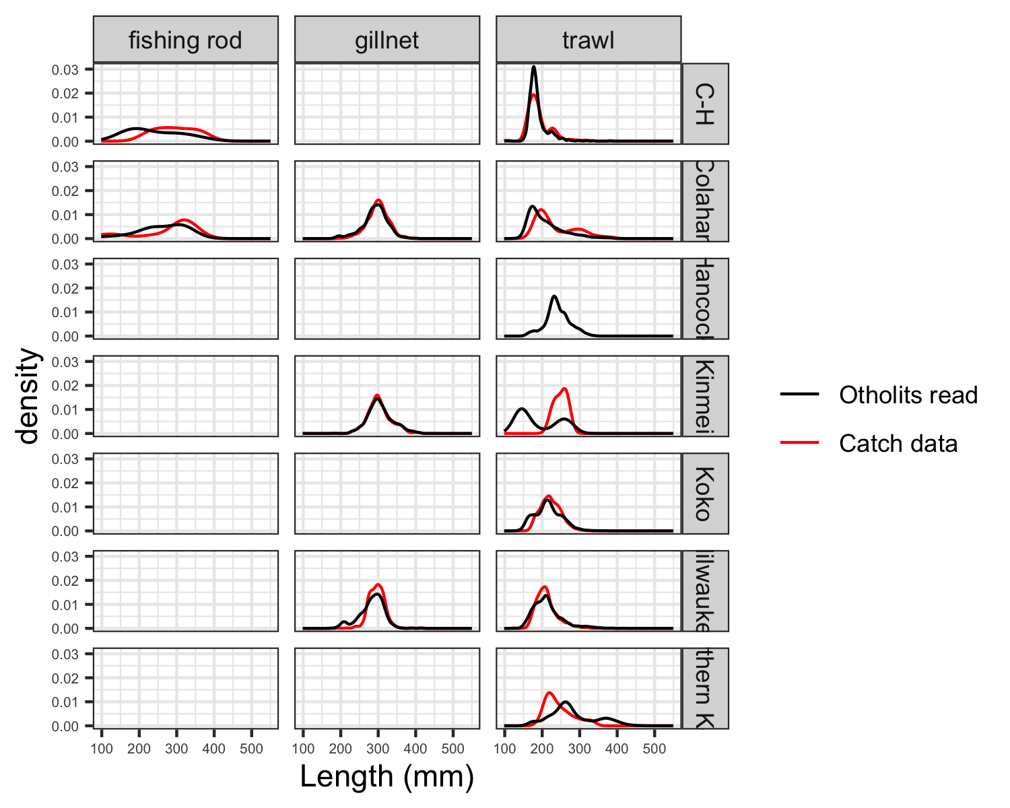

Figure 2: Length-at-age for samples obtained using different gears.

Differences in the length-at-age composition are evident between trawl and gillnet samples (Figure 3). The trawl samples show a maximum age of 8 years, while the gillnet samples reach a maximum age of 13 years, indicating different selection patterns for fish of various sizes and ages. Additionally, the length-at-age data from the trawl samples have larger variability, indicating greater variability in the sizes of fish at each age. The differences in the length-at-age composition of the catch are more likely attributed to the selectivity of the fishing gears. For smaller age groups, fish caught by the trawl tend to have smaller lengths at the same age compared to those from the gillnet. This suggests that the gillnet may selectively capture faster-growing, larger fish at younger ages.

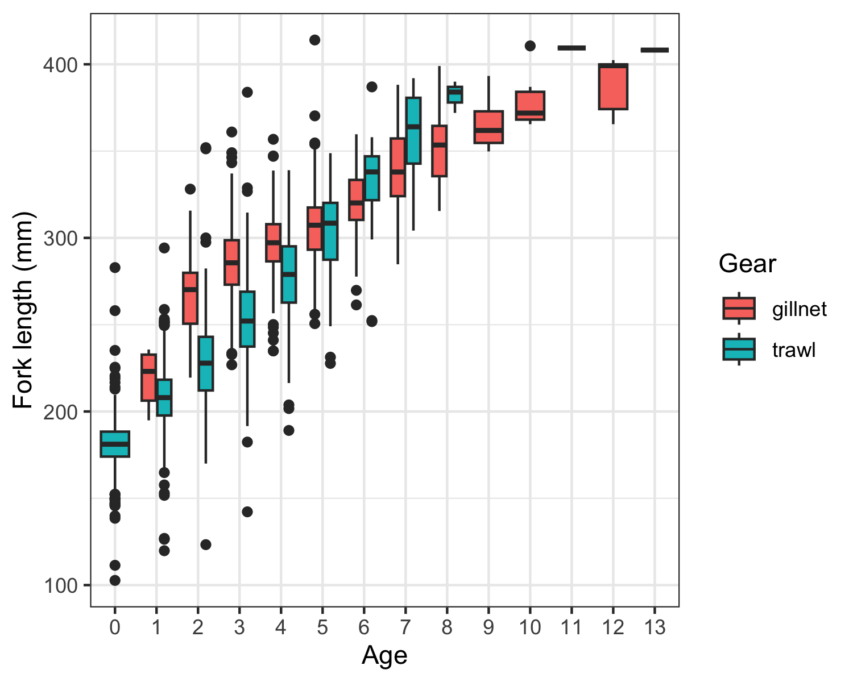

Figure 3: Length at age by gear.

For the same gear type, length-at-age differences between seamounts are minimal (Figure 4). This consistency across seamounts suggests that environmental or ecological differences may not significantly affect fish growth patterns when sampled with the same gear (or environmental and ecological differences occur at a larger scale than that of the local seamount).

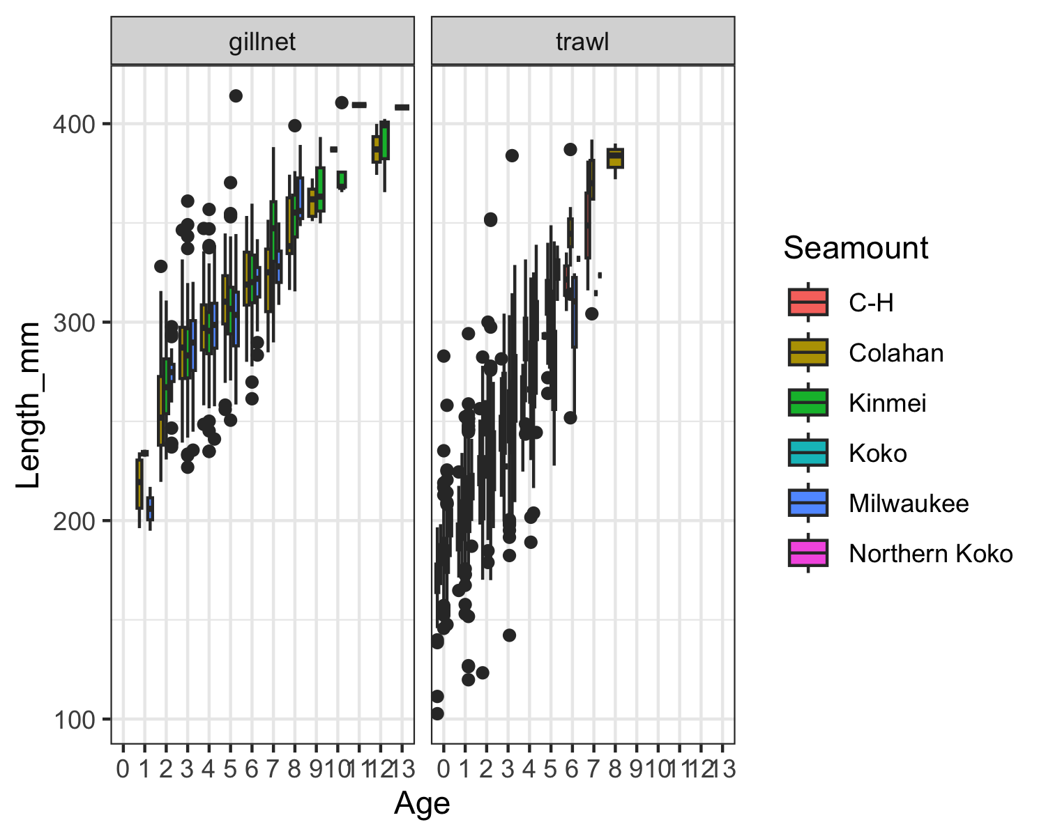

Figure 4: Length at age by seamount and gear.

### 2.2.2 Parameter Estimation Using Optimization and Nonlinear Regression

To estimate parameters $L_{∞}$, $K$, and $t_{0}$, we used a two-step approach involving the **optim** (R Core Team, 2023) function for initial estimates and the **nlsLM** function from the minpack.lm (Elzhov et al., 2016) package for refined estimates.

1. **Initial Parameter Estimation with Optimization**: We used the optim() function with the bounded L-BFGS-B method, a suitable optimization algorithm for constrained problems, to minimize the sum of squared errors (SSE) between observed and predicted fork lengths. The objective function for optimization was:

$$\text{SSE}=\sum_{i=1}^{n}{{\left(FL_{mm,i}-{\hat{FL}}_{mm,i}\right)}^{2}}$$

* where $FL_{mm,i}$ is the observed fork length, and ${\hat{FL}}_{mm,i}$ is the predicted length from the VBGM. Initial parameter values were set as $L_{∞}=350$, $K=0.2$, and $t_{0}=-2$. Bounds were specified to constrain $L_{∞}≥0$, $K≥0$, and $t_{0}$ as unbounded.

1. **Nonlinear Regression with nlsLM()**: Following initial optimization, we used the parameter estimates as starting values for a nonlinear least-squares fit using nlsLM(), which improves accuracy by minimizing the SSE with more iterative precision. The Levenberg-Marquardt algorithm in nlsLM() was used for more stable and robust parameter estimation, especially in cases where nls() might struggle to converge.

The model fit was conducted separately for the combined dataset, gillnet samples, and trawl samples.

### 2.2.3 Comparison with other studies

Growth parameters for Splendid Alfonsino have been estimated using different methods over different areas. López Abellán et al. (2007) summarized several of those estimates from the literature. We used these estimates and graphically compared the growth curves obtained from the literature with current estimates.

## 2.3 Maturity parameters

We estimated maturity parameters for Splendid Alfonsino by analyzing data from the Gonadosomatic Index (GSI) and histological examinations. To model the probability of an individual fish being mature at a given fork length ($FL_{mm}$), we used a logistic regression, resulting in maturity ogives from both GSI- and histology-based methods. Also, an empirical approch was used. The logistic regression model was implemented separately for the histological and GSI datasets. The model used was as follows:

$$\text{logit}\left(P\right)=β_{0}+β_{1}×FL_{mm}$$

where: $P$ is the probability of maturity, $β_{0}$ and $β_{1}$ are model coefficients representing the intercept and slope, respectively, and $FL_{mm}$ is the fork length of the fish in millimeters.

The model was fitted using a binomial family with a logit link function, which transforms the maturity probabilities to the log-odds scale. This approach allows us to estimate the likelihood of maturity across a continuous range of fork lengths. Key parameters of interest are the lengths at which 50% ($L_{50}$) and 95% ($L_{95}$) of the population are expected to be mature. Using the coefficients from the logistic regression, we calculated $L_{50}$ and $L_{95}$ as follows:

$$L_{p}=\frac{log\left(\frac{p}{1-p}\right)-β_{0}}{β_{1}}$$

where: - $L_{p}$ represents the fork length at a specific maturity probability $p$, $p=0.5$ for $L_{50}$ and $p=0.95$ for $L_{95}$.

To provide confidence intervals around the maturity ogive, we used the model’s standard error estimates on the log-odds scale. For each fork length, we calculated the predicted maturity probability along with its upper and lower confidence limits (at 95% confidence) as follows:

1. **Fitted Link Values**: We first calculated the fitted link values and their standard errors for each fork length.
2. **Confidence Interval Calculation**: Using the fitted values and standard errors, the upper and lower confidence bounds on the log-odds scale were calculated as:
$$\text{Upper Bound}=\text{fit}+\left(2×\text{SE}\right)$$

$$\text{Lower Bound}=\text{fit}-\left(2×\text{SE}\right)$$

3. **Inverse Link Transformation**: Finally, we transformed these bounds back to the probability scale using the inverse logit function, resulting in confidence intervals for the predicted probability of maturity at each length.

### 2.3.1 Data

The dataset for maturity estimation includes Gonadosomatic Index (GSI) samples collected from both Japan and Korea (Table 1). Most of these GSI samples, approximately 79%, were collected by Japan using trawl gear. In addition to GSI data, histological samples were available for the three countries: Japan, Korea, and Russia. However, the length composition of the histological samples collected using trawl gear in Japan does not fully represent the length distribution of the overall catch (Figure 6). This discrepancy may introduce bias in the maturity estimates, potentially leading to an overestimation of length at maturity parameters ($L_{50}$). For Korea and Russia, a similar comparison between sample lengths and catch lengths was not possible due to the absence of length composition data for the catch for these countries (Figure 6).

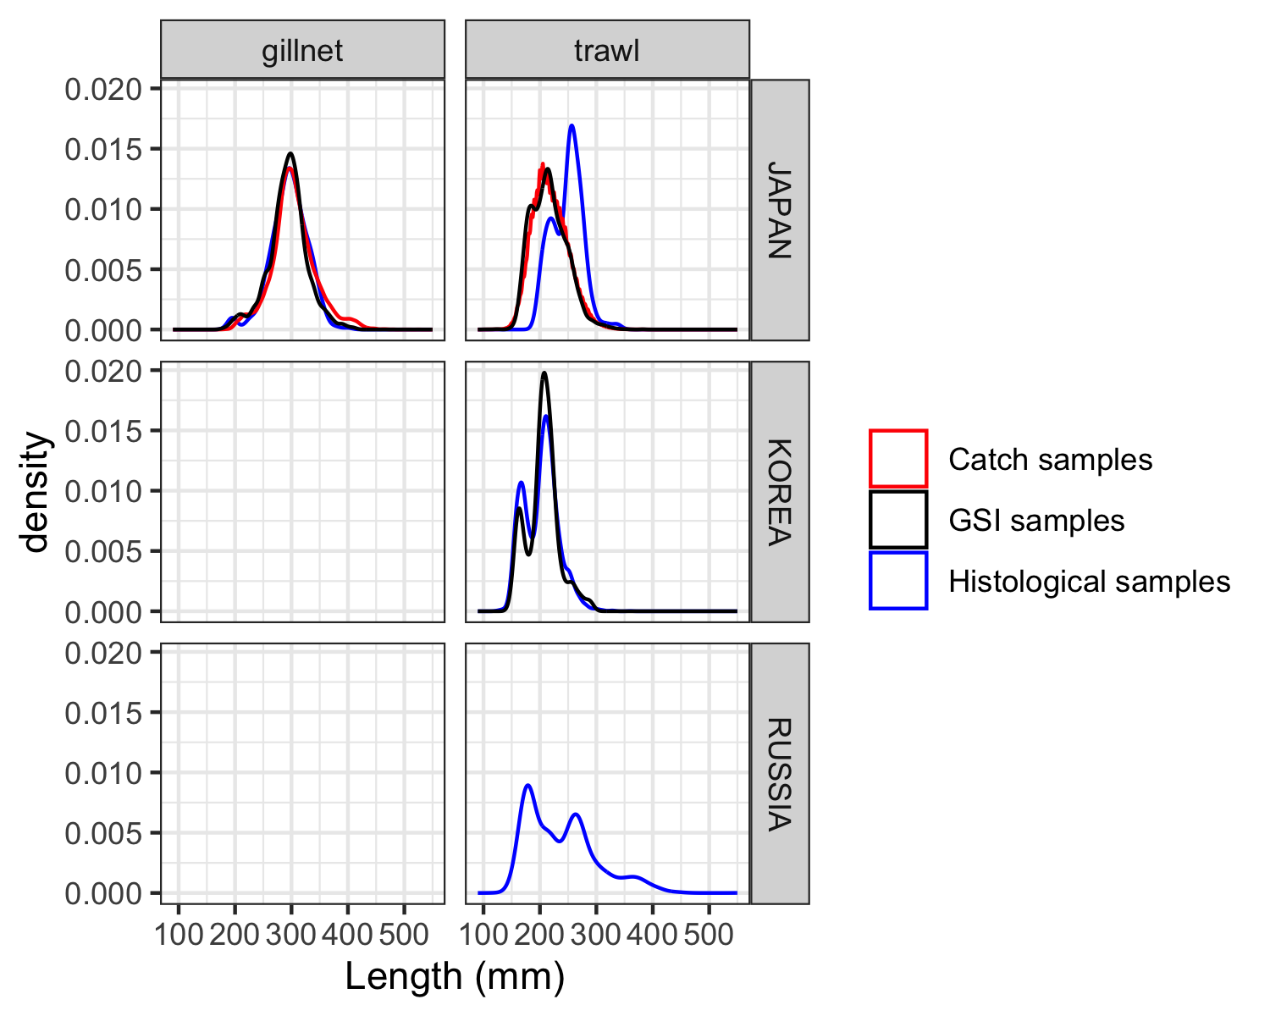

Figure 6: Comparison between the length composition of the catch and the samples used in the maturity analysis.

### 2.3.2 Gonadosomatic Index (GSI) Data

The GSI approach has been commonly used to estimate size at maturity for Splendid Alfonsino, as in previous studies (Ayer & Sawada, 2023; Flores et al., 2019). We applied a GSI threshold of 0.51 (Ayer & Sawada, 2023) to classify maturity status, coding fish as mature (Maturity = 1) if their GSI exceeded this value, and immature (Maturity = 0) otherwise. Using all available samples (January to December), we fitted a binomial logistic regression model to the GSI data to estimate the probability of maturity at different sizes. Given recommendations from (Flores et al., 2019) that GSI methods are best suited to pre-spawning samples, we also fitted a second logistic regression model restricted to data collected before August (January to July). This approach allowed us to explore how seasonality might impact maturity estimation.

### 2.3.3 Histological Data

Histological examination provides a direct method of assessing maturity based on gonadal development stages. Japan, Korea and Russia classified maturity using its own protocols, requiring us to standardize the classifications. We assigned a binary maturity code (Maturity = 1 for mature and Maturity = 0 for immature) for each country (see Table 2 for specific classifications).

Using this standardized maturity data, we fitted a logistic regression model across all samples (January to December) and a second model using only samples collected before August.

Table 2: Histological information available for Splendid Alfonsino.

|  |  |  |  |
| --- | --- | --- | --- |
| Member | Microscopic | Maturity | N individuals |
| JAPAN | chromatin nucleolus | Immature | 133 |
| JAPAN | peri-nucleolus | Immature | 162 |
| JAPAN | yolk vesicle | Immature | 184 |
| JAPAN | early yolk | Mature | 49 |
| JAPAN | late yolk | Mature | 17 |
| JAPAN | maturation | Mature | 23 |
| JAPAN | spawning | Mature | 31 |
| KOREA | 1 | Immature | 2070 |
| KOREA | 2 | Immature | 2276 |
| KOREA | 3 | Mature | 429 |
| KOREA | 4 | Mature | 68 |
| KOREA | 5 | Mature | 16 |
| RUSSIA | 10 | Immature | 1121 |
| RUSSIA | 20 | Immature | 5370 |
| RUSSIA | 23 | Immature | 127 |
| RUSSIA | 30 | Mature | 474 |
| RUSSIA | 34 | Mature | 39 |
| RUSSIA | 40 | Mature | 42 |
| RUSSIA | 45 | Mature | 3 |
| RUSSIA | 60 | Mature | 9 |
| RUSSIA | 62 | Mature | 74 |

### 

### 2.3.4 Empirical approach

In addition to the GSI and histological methods, we applied an empirical model to estimate the length at 50% maturity ($L_{50}$) for Splendid Alfonsino. This model, developed by Binohlan and Froese (Binohlan & Froese, 2009) uses a predictive equation based on a species’ asymptotic length ($L_{∞}$), offering a theoretically derived estimate of length at maturity. The equation used was as follows:

$$\text{Log}\left(L_{50}\right)=-0.1189+0.9157×\text{Log}\left(L_{max}\right)$$

where: $L_{max}$ is the maximum observed length for Splendid Alfonsino, set at 700 mm based on Sommer et al. (1996).

This empirical approach allows for an estimate of $L_{50}$ that can serve as a benchmark for comparison with maturity estimates obtained from GSI and histological data. By including this empirical model, we aim to incorporate a theoretically grounded maturity estimate that complements the direct observational data.

## 2.4 Length-weight relationship

The length-weight relationship of SA was estimated using the power function model:

$$W=a×L^{b}$$

where: $W$ is the body weight (in grams), $L$ represents fork length (FL, in millimeters), $a$ and $b$ are parameters to be estimated.

The relationship was modeled using nonlinear least-squares regression (nls).

3 RESULTS

## 3.1 Growth Model Fitting

### 3.1.1 Parameter Estimation

Growth parameter estimates obtained using the nlsLM and optim methods were generally similar when applied to the combined dataset (Table 3). However, when the data were analyzed by gear type, the nlsLM method produced a notably higher estimate for $L_{∞}$ (the asymptotic length) than optim (Figure 7). While nlsLM achieved a lower residual sum of squares (RSS), indicating a better overall fit, this higher $L_{∞}$ value may not be biologically realistic.

Table 3: Estimated growth parameters.

|  |  |  |  |  |
| --- | --- | --- | --- | --- |
| data | param | value | method | SSQ |
| all | Linf | 556.62 | optim | 3161706.9 |
| all | K | 0.08 | optim | 3161706.9 |
| all | t0 | -4.77 | optim | 3161706.9 |
| all | Linf | 567.56 | nls | 3161456.9 |
| all | K | 0.08 | nls | 3161456.9 |
| all | t0 | -4.82 | nls | 3161456.9 |
| gillnet | Linf | 483.57 | optim | 552174.6 |
| gillnet | K | 0.08 | optim | 552174.6 |
| gillnet | t0 | -8.48 | optim | 552174.6 |
| gillnet | Linf | 867.02 | nls | 549126.0 |
| gillnet | K | 0.02 | nls | 549126.0 |
| gillnet | t0 | -13.55 | nls | 549126.0 |
| trawl | Linf | 672.44 | optim | 2099523.7 |
| trawl | K | 0.05 | optim | 2099523.7 |
| trawl | t0 | -5.93 | optim | 2099523.7 |
| trawl | Linf | 3597.90 | nls | 2080390.5 |
| trawl | K | 0.01 | nls | 2080390.5 |
| trawl | t0 | -7.48 | nls | 2080390.5 |

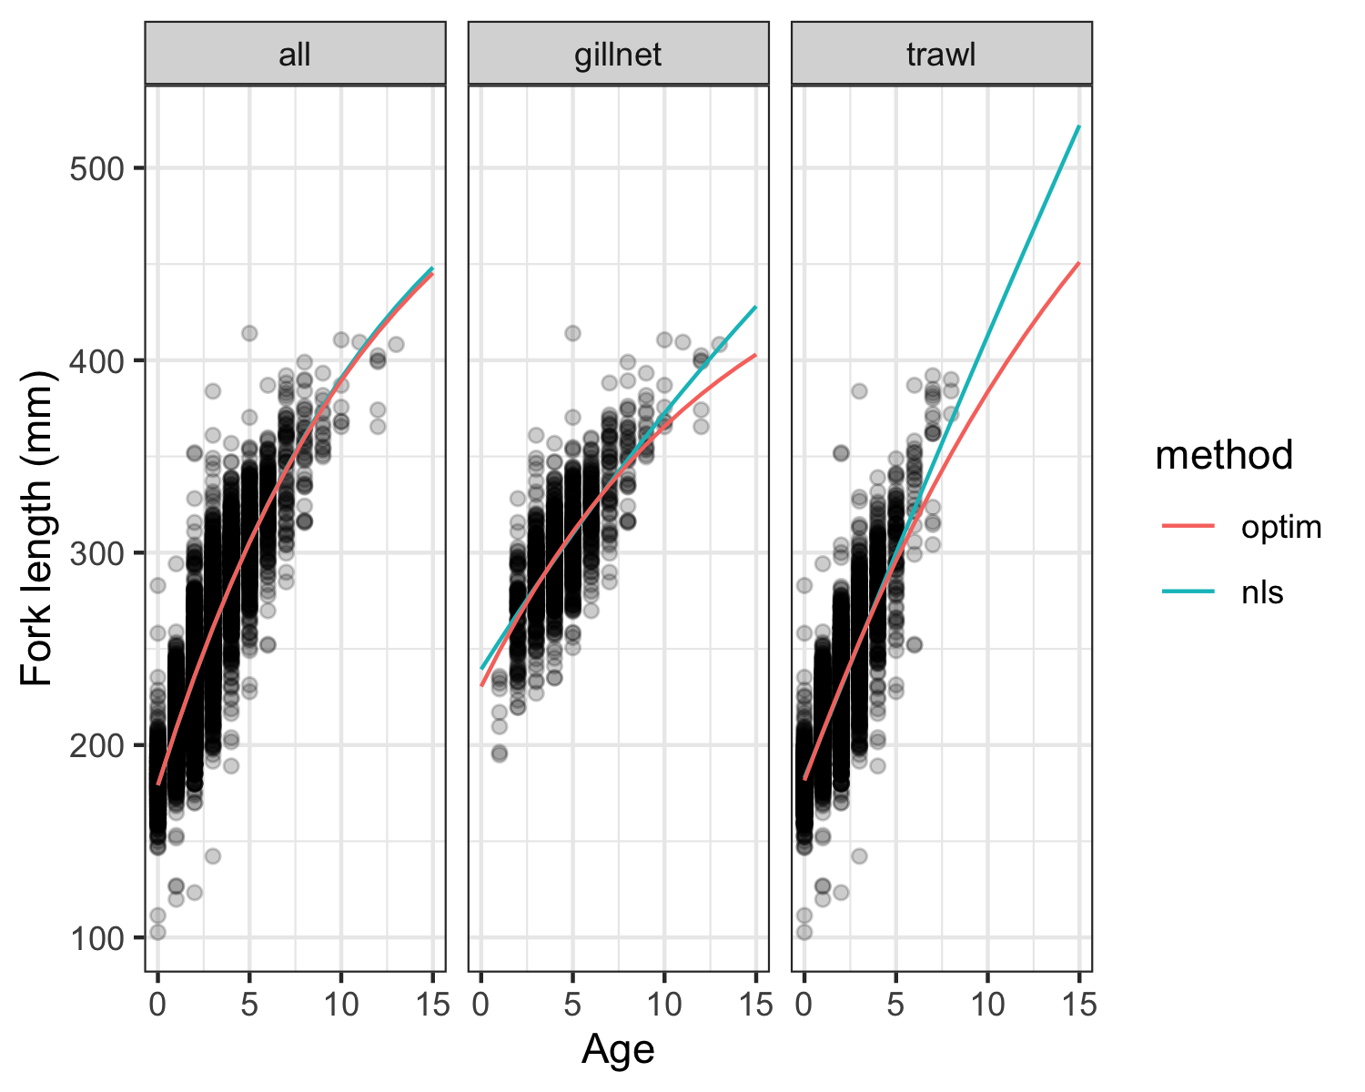

Figure 7: Growth model fits for Splendid Alfonsino using different estimation algorithms (optim and nlsLM) applied to combined, gillnet, and trawl datasets. Each panel represents growth by gear type, with lines showing model predictions.

### 3.1.2 Comparison with other studies

The growth estimates from this analysis (using the combined dataset and nlsLM method) aligned well with previously reported values in the literature for Splendid Alfonsino (Figure 8). However, the $t_{0}$ parameter was relatively high compared to values reported in other studies. This discrepancy may be due to the presence of unusually large fish recorded at age 0 in the dataset, as shown in Figure 7.

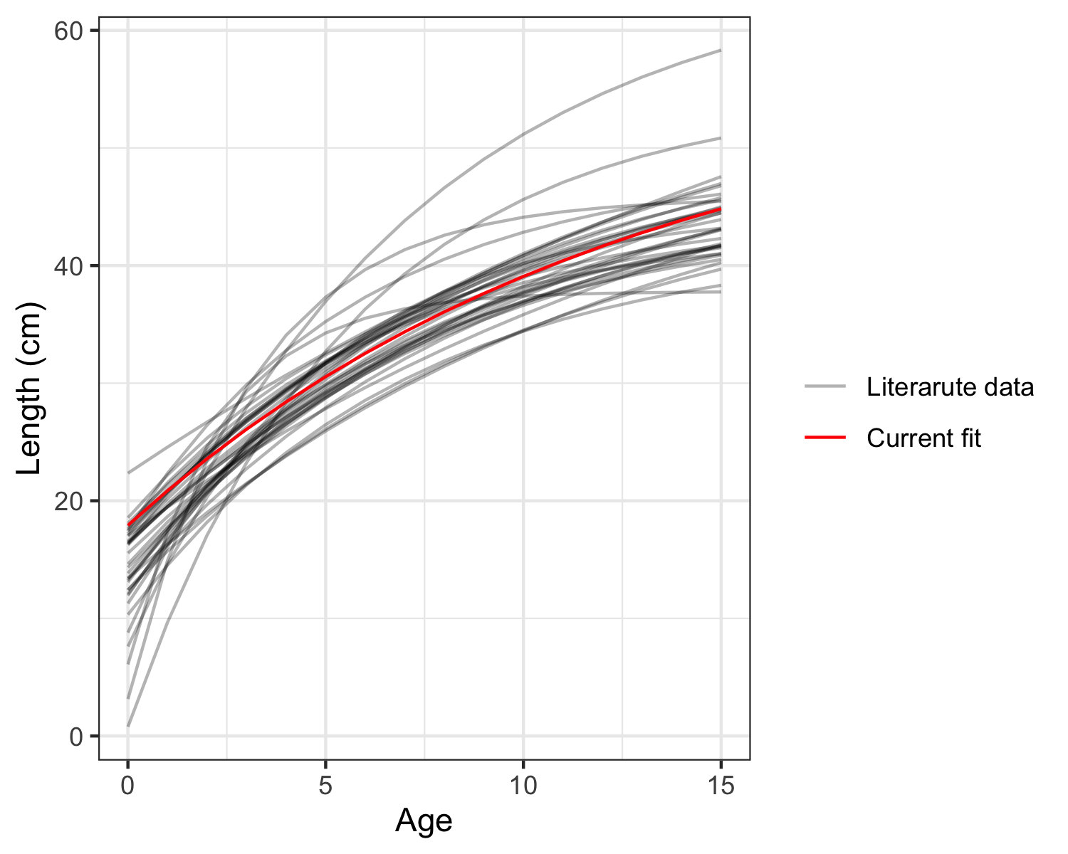

Figure 8: Growth model reported fits for Splendid Alfonsino.

## 3.2 Maturity parameters

### 3.2.1 Relationship between the Gonadosomatic Index and Histological Data

For the Japanese samples, we compared the classification of maturity based on a Gonadosomatic Index (GSI) cutoff of 0.51 with the corresponding classification based on histological criteria (Table 2). Figure 9 shows the monthly distribution of histological stages alongside GSI values. Some individuals classified as immature according to histological criteria were considered mature under the GSI-based classification (particularly from March to May). Conversely, individuals classified as spawning based on histology could be considered immature using the GSI cutoff criterion (October). This discrepancy suggests potential limitations of the GSI threshold, as it may not fully align with the more detailed histological assessments of reproductive status.

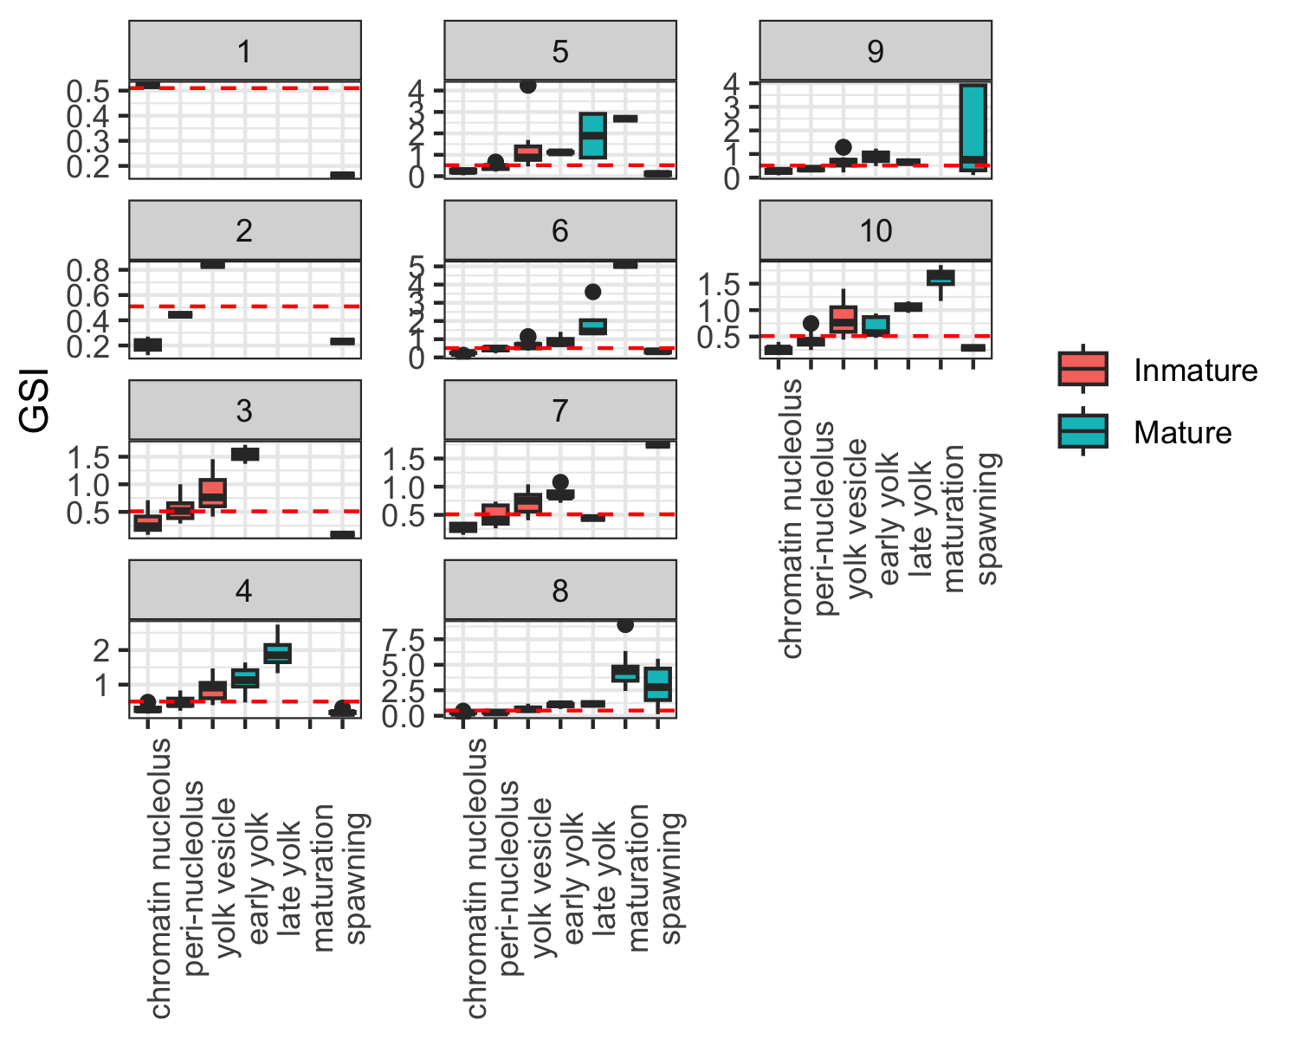

Figure 9: Monthly distribution of Gonadosomatic Index (GSI) values by histological maturity stage for Japanese samples. The red dashed line represents the GSI threshold of 0.51 used to classify individuals as mature or immature.

### 3.2.2 Maturity parameter using a logistic regression and an empirical estimator.

Logistic regression was used to estimate maturity parameters based on both GSI and histological data. The results from models using all data and those restricted to pre-spawning samples were comparable (Table 4). However, notable differences were observed depending on the data source: estimates of $L_{50}$ were lower for GSI-based data than for histological data (Figure 10). Additionally, the empirically derived $L_{50}$ value was intermediate between those obtained from GSI and histological methods.

Table 4: Estimated maturity parameters.

|  |  |  |
| --- | --- | --- |
| Model | L50 | L95 |
| Gonadosomatic all all data | 302.06 | 383.32 |
| Gonadosomatic all pre-spawning | 302.66 | 386.57 |
| Histological all all data | 379.15 | 555.25 |
| Histological all pre-spawning | 377.55 | 562.99 |
| Histological Jap all data | 397.20 | 640.01 |
| Histological Kor all data | 263.20 | 327.06 |
| Histological Rus all data | 385.16 | 528.32 |
| Empirical | 357.78 | NA |

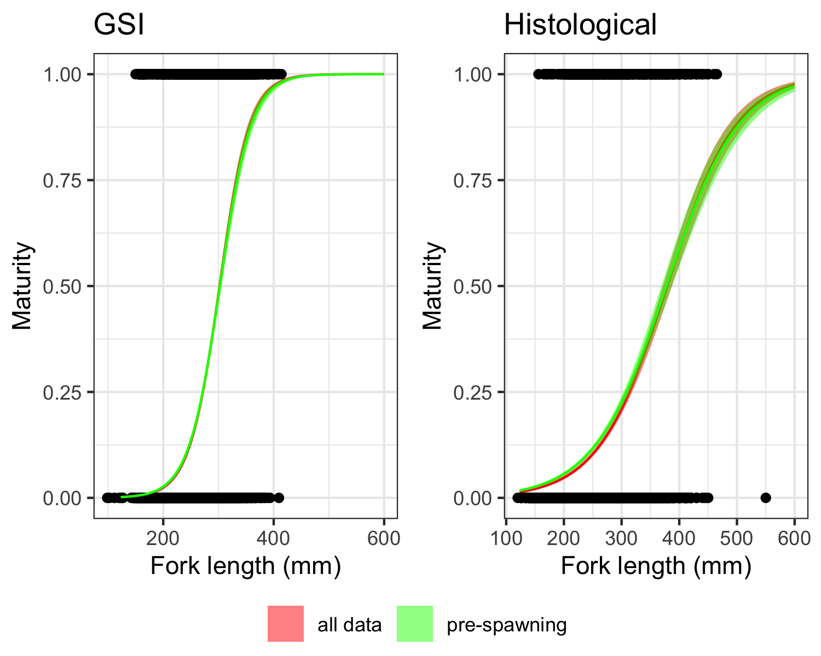

Figure 10: Comparison of maturity curves estimated from Gonadosomatic Index (GSI) and histological data for Splendid Alfonsino, using logistic regression. The curves represent models based on all data and pre-spawning samples only, with shaded areas indicating 95% confidence intervals.

When the histological data were analyzed by country, notable differences emerged (Table 4). The data from Japan produced very high $L_{50}$ values with considerable uncertainty (Figure 11). In contrast, the $L_{50}$ value for Russia was similar to Japan’s but had a much narrower confidence interval, indicating greater precision (Figure 11). The data from Korea yielded the smallest $L_{50}$ estimate among the three countries (Figure 11).

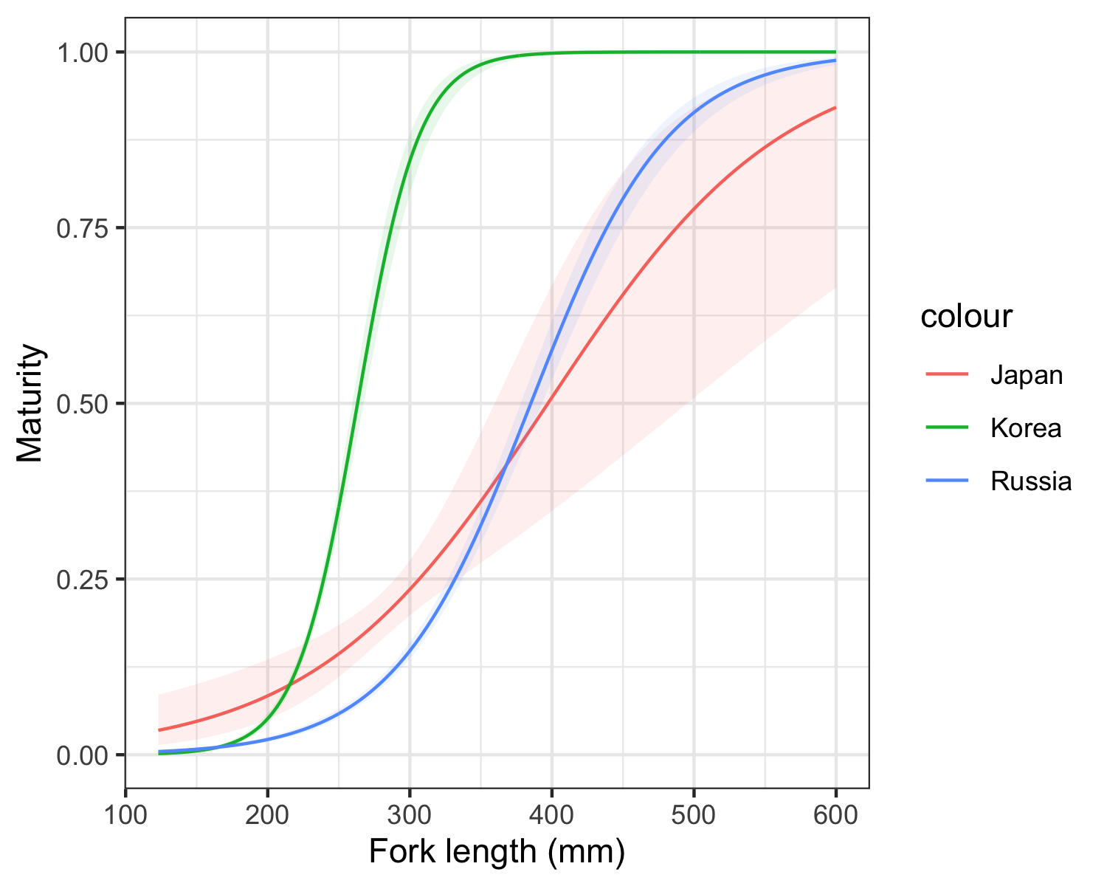

Figure 11: Country-specific maturity curves estimated from histological data for Splendid Alfonsino, showing the probability of maturity as a function of fork length. Shaded areas represent 95% confidence intervals for each country.

## 3.3 Length-Weight relationship

The length-weight relationship for Splendid Alfonsino was modeled using a power function, resulting in a good fit to the available data (Figure 12). The estimated parameters were *a*= 3.25E-05 and *b*=2.931.

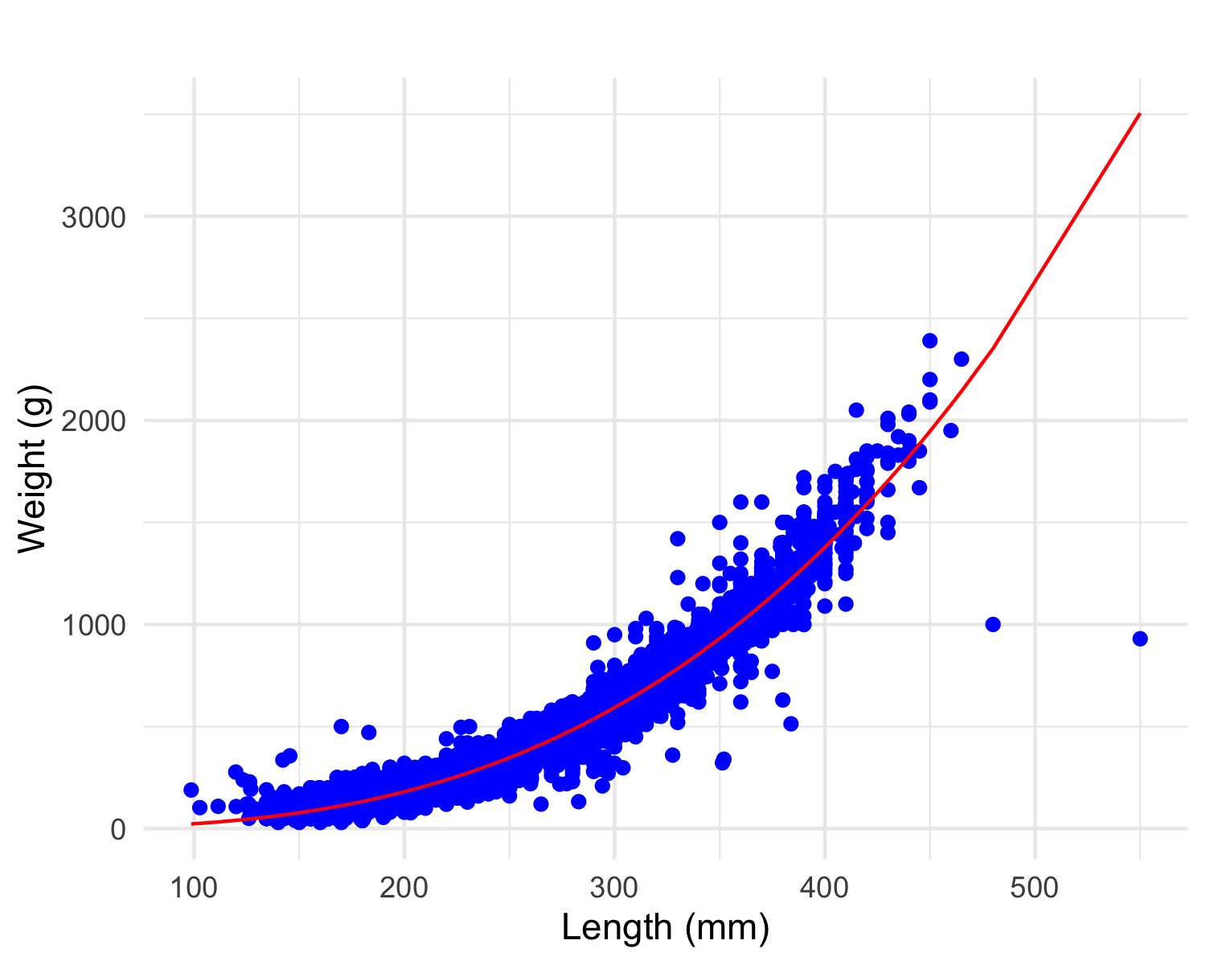

Figure 12: Length-Weight Relationship for Splendid Alfonsino

4 Discussion

This study provides updated life history parameters for Splendid Alfonsino in the North Pacific, specifically examining growth, maturity, and the length-weight relationship for this species. Our findings align with recent local studies (Sawada, 2023) on growth estimates. The estimation of *t0* is high compared with other studies at different places, primarily due to the elevated length-at-age observed for individuals at age 0. It would be advisable to review the aging protocol for this age group to ensure the reliability of this data. The estimated growth parameters, when all data were combined, were consistent with those reported in other studies around the world. However, the differences in growth parameters by gear type underscore the potential impact of gear selectivity, with gillnets appearing to sample faster-growing individuals compared to trawls. This sampling bias may influence growth assessments and has implications for accurately modeling the species’ growth. In a related study, Taylor et al. (2005) investigated the effects of gear selectivity and the cumulative impact of size-selective sampling on length-at-age data and potential biases in von Bertalanffy growth parameter estimates. While Taylor’s study employed a logistic selectivity model, future research could explore adapting similar approaches to account for dome-shape-selectivity-induced biases in estimating von Bertalanffy growth parameters.

The sensitivity of maturity estimates to data sources was also evident, with substantial variation observed between GSI-based and histology-based maturity ogives. The discrepancies between these methods suggest that GSI-based thresholds may not consistently capture reproductive status across different life stages. Additionally, the country-specific maturity estimates based on histological data reveal possible inconsistencies in protocols or representativeness of the data, as histological data from Japan does not align with the overall catch structure. However, the model using combined data from all countries appears to balance these differences, potentially providing an average estimate across regional variability (and similar to the empirical estimation). Regarding the data collection protocol, it would be advisable to ensure that both small and large individuals are well represented in the histological data. Additionally, establishing comparisons and standardizations among protocols across countries would enhance consistency.

Finally, the updated length-weight relationship for Splendid Alfonsino aligns closely with previous estimates.

# **References**

Ayer, A., C. G., & Sawada, K. (2023). Size at maturity of splendid alfonsino (*Beryx splendens*) from the emperor seamounts. <https://www.npfc.int/>

Binohlan, C., & Froese, R. (2009). Empirical equations for estimating maximum length from length at first maturity. *Journal of Applied Ichthyology*, *24*, 611–613.

Elzhov, T. V., Mullen, K. M., Spiess, A.-N., & Bolker, B. (2016). *Minpack.lm:* R interface to the levenberg-marquardt nonlinear least-squares algorithm found in MINPACK, plus support for bounds. <https://CRAN.R-project.org/package=minpack.lm>

Flores, A., Wiff, R., Ganias, K., & Marshall, C. T. (2019). Accuracy of gonadosomatic index in maturity classification and estimation of maturity ogive. *Fisheries Research*, *210*, 50–62. https://doi.org/<https://doi.org/10.1016/j.fishres.2018.10.009>

López Abellán, L. J., Santamaría, M. T. G., & Román, E. (2007). Estudio comparado del crecimiento del alfonsiño *Beryx splendens* Lowe, 1834 de las montañas submarinas del golfo de guinea y del Océano Indico Suroccidental. *Boletín Del Instituto Español de Oceanografía*, *23*(1-4), 33–44.

NPA-SA, S. (2001). Species summary of splendid alfonsino (*Beryx splendens*) in the emperor seamounts. *NPFC-2021-SSC BF-ME02-WP07*, 9 pp.

R Core Team. (2023). R: A language and environment for statistical computing. R Foundation for Statistical Computing. <https://www.R-project.org/>

Sawada, K. (2023). Working group on NPA and SA - summary for 2023. *NPFC-2023-SSC BFME04-WP09*, *December*.

Sommer, C., W., S., & Poutiers, J. M. (1996). FAO species identification field guide for fishery purposes. The living marine resources of Somalia. FAO.

Taylor, N. G., Walters, C. J., & Martell, S. J. (2005). A new likelihood for simultaneously estimating von Bertalanffy growth parameters, gear selectivity, and natural and fishing mortality. *Canadian Journal of Fisheries and Aquatic Sciences 62: 215–223.*