NPFC-2024-SSC PS14-WP07

**Preliminary projection of distribution shift for Pacific saury in the Northwestern Pacific Ocean under climate change**

Zi Yang1, Libin Dai1*, Chris Rooper2, Toshihide Kitakado3, Siquan Tian1

1Shanghai Ocean University

2Fisheries and Oceans Canada

3Tokyo University of Marine Science and Technology

*\*Corresponding author’s email address: lbdai@shou.edu.cn*

# **Abstract**

Pacific saury (*Cololabis saira*) is an economically and ecologically important pelagic species in the Northwestern Pacific Ocean. The spatial distribution of Pacific saury has been showing signs of shifting northeastward over the last decade, which potentially impacts its stock assessment and management due to the change of fish availability. By employing a spatio-temporal model, sdmTMB, we assessed the potential shift in the distribution pattern for Pacific saury under two future climate scenarios (SSP245 and SSP585). The sdmTMB model was developed based on the catch per unit effort (CPUE) data of stick-held dip net fisheries collected by China during 2013 to 2022 and environmental variables including sea surface temperature (SST) and mixed layer depth (MLD), as well as spatial and spatio-temporal random field components. The center of gravity (COG) movements manifested conspicuous annual fluctuations during 2013-2022. The inclusion of spatio-temporal random fields contributed to a northward shift of 0.14° and the latitudinal displacement of 0.03° under SSP245 and SSP585. The projected maps of the fitted models indicated potential shift in the distribution of Pacific saury. Future stock assessment and fishery management for Pacific saury should consider the spatial dynamics under changing environments.

**1. Introduction**

Climate and environment variability may have a noteworthy impact on the distribution and productivity of the marine species, which challenge the fishery stock assessment and management (Chang et al., 2018). As a highly migratory pelagic fish, Pacific saury (*Cololabis saira*) is recognized for its significant commercial value. In the Northwest Pacific, Pacific saury spawns in the Kuroshio region during spring, migrates northward through the Kuroshio-Oyashio transition zone in search of prey during summer, and returns to the fishing grounds in Japan during autumn (Liu et al., 2022; Hua et al., 2020). However, reports from multiple members of the North Pacific Fisheries Commission (NPFC) indicated that over the past decade, the Pacific saury population has been progressively shifting eastward (Hashimoto et al., 2023; Hsu et al., 2024), exhibiting distinct interannual patterns in their spatiotemporal distribution.

Numerous studies have characterized habitats of the Pacific saury attributes through abiotic factors, including sea surface temperature and mixed layer depth, as well as biotic factors such as chlorophyll-*a* concentration (Tseng et al., 2013; Chang et al., 2018; Fuji et al., 2021). Modelling species distributions and identifying the response of marine species to their environment can assist in monitoring fishing vessel dynamics and fish availability, which in turn affects catchability and selectivity and can be conducive to spatial management and conservation. Additionally, these models provide a theoretical basis for studying spatio-temporal dynamics of marine species in the context of future climate scenarios, enabling more effective stock assessment and fishery management, while enhancing the capacity to adapt to climate change.

To investigate the distribution shift of Pacific saury over the next 30 years, this study employs the spatio-temporal model sdmTMB to analyze the spatio-temporal distribution from 2013 to 2022. Based on the selected model, projections for the spatiotemporal distribution of Pacific saury from 2023 to 2052 are made to assess the potential climate impacts on the distribution shift under two future scenarios, thereby providing a scientific basis for the stock assessment and management in the future.

# **2. Methods and materials**

2.1 Data

Defined as catch in weight per number of hauls (tons/hauls) in a fishing operation conducted by one vessel, the catch per unit effort (CPUE) data of stick-held dip net fisheries was collected by China in the Northwestern Pacific Ocean during 2013 to 2022. Within the designated study region, encompassing latitudes from 36°N to 51°N and longitudes from 145°E to 177°E, the dataset was compiled on an annual and monthly basis, maintaining a spatial resolution of 1° × 1° in both latitude and longitude (Figure 1). It is assumed that this dataset encompasses the primary habitat of the Pacific saury stock targeted in the Northwestern Pacific Ocean from May to December throughout the period under investigation (lacking June in 2013). However, data in May and December were removed from the analysis due to having very few data points. In our study, we hypothesized that the CPUE data from China reflect the habitat of Pacific saury in the entire Northwest Pacific Ocean.

This study considered environmental factors including sea surface temperature (SST), and mixed layer depth (MLD), which have been commonly used to examine possible effects on the density of Pacific saury. The monthly environmental data were downloaded from the Copernicus Marine Environmental Monitoring Service (https://marine.copernicus.eu/), with the spatial resolution of 0.25° × 0.25°. We averaged the data in the spatial grid 1° × 1°. Variance Inflation Factor (VIF) among explanatory variables were calculated (Table 1).

Within the framework of the sixth phase of the Coupled Model Intercomparison Project (CMIP6), many atmosphere-ocean coupled models have been improved. The global coupled air-sea climate model GFDL-ESM4 in the CMIP6 is used in the study, which contains five future scenarios (SSP 119, SSP126, SSP245, SSP375, SSP585) designed depending on an estimate of the radiative forcing by the end of this century (Luo et al., 2022). SSP245 represents a scenario with moderate greenhouse gas emissions reduction in the future, while SSP585 represents a scenario with unconstrained and continuous greenhouse gas emissions. The different increase of SST between these two scenarios led to varying responses of fish species to the changing environment. Therefore, outputs under two scenarios were selected to assess future change in this study.

* 1. Model structure

The model started by creating a spatial mesh object over the study area, which contains matrices to apply the SPDE approach. We set 100 knots (mesh intersections) for approximating the spatial autocorrelated variations (Figure 2), after verifying that our results remain essentially consistent when using different numbers of spatial knots (50, 100, and 200 knots) in the model. Compared to other statistical distributions, such as the normal and log-normal distributions, identifying the CPUE data as following a Gamma distribution performed well in terms of model convergence, providing less biased and more robust estimates (Cadigan and Myers, 2001). We modelled pacific saury CPUE using sdmTMB with a Gamma distribution and a log link (Anderson et al., 2022), adopting the following form:

$${E(Y}_{s,t}) \sim Gamma( μ_{s,t} , σ) \\ μ_{s,t}= exp⁡(μ_{s,t}β+ ω_{s,t}+ ε_{s,t}) \\ ω_{s,t}=MVNormal (0,ϵ_{ω}) \\ ε_{s,t}=MVNormal (0,ϵ_{ε})$$

Where Y*s,t* and µ*s,t* are the predicted CPUE and the mean CPUE respectively. The parameter X*s,t* represents the design matrix of the covariates at station s, time t, and *β* is the vector of corresponding fixed effect parameters and modelled by penalized complexity cubic splines with three basis functions for the environmental factors. 𝜔𝑠*,t* and ε𝑠*,t* parameters refer to the spatial and spatio-temporal random field. The σ and ϵ represent standard deviations and covariance matrix, respectively. We fit the model adapting the R package sdmTMB (version 0.6.0.9004). The models were ranked based on Akaike information criterion (AIC) and the final selection was the one with the lowest AIC. We quantified the projection uncertainty arising from parameter uncertainty by calculating the width of the 95% confidence interval for each knot, which was estimated based on 500 simulations. To investigate annual changes of distribution patterns of Pacific saury, we also estimated the longitudinal and latitudinal of the yearly (t) center of gravities (COG) from the predicted relative abundance in the study area.

* 1. COG

To analyze the annual COG movement, the latitudes and longitudes of all fishing sites in each period were weighted with predicted CPUE. The annual COG was calculated as:

$${Lon}_{cog}= \sum_{i=1}^{n}{{Lon}_{i}*P_{i}}$$

$${Lat}_{cog}= \sum_{i=1}^{n}{{Lat}_{i}*P_{i}}$$

Where Loncog and Latco*g* are the latitude and longitude of the center of gravity; n is the total number of fishing sites; Xi, Yi represent the latitude and longitude of the site i; Pi is the predicted CPUE of the site i.

# **3. Results**

3.1 Model selection and diagnostic

Results suggested that using a spline function for SST and MLD resulted in the best fitting model, based on the AIC values (Table 2). The fitted model M5 corresponded to the lowest AIC. To further investigate the impact of spatio-temporal random effects on the model outcomes, the fitted model M4 with spatial random field only and M5 with spatial and spatio-temporal random field were selected for comparison of model performance.

The residuals exhibited a normal distribution centered around zero, indicating a good fit. The histograms and Q-Q plots for the selected models based on Gamma distributions in sdmTMB confirmed the appropriateness of the assumed error distribution (Figure 3). The spatial distribution patterns of the residuals for models M4 and M5 were similar, with high residuals predominantly clustered in the southern and eastern boundary regions. However, the residuals appeared to be higher at the boundary in M5 (Figure 4). Model uncertainty analysis suggested that M4 exhibited greater uncertainty in relative density estimates along the southern periphery, while model M5 showed higher overall uncertainty, with large areas exceeding 0.5 in the eastern and southern regions (Figure 5). Figure 6a indicated that the spatial variation of M4, which was highly influential in the southwest and northeast regions, was similarly reflected in the distribution of spatial random effects in model M5 (Figure 6b). Spatio-temporal random fields were less influential than spatial random fields in M5, positive effects were more pronounced on the western boundary, and negative effects were concentrated on the northern boundary (Figure 6c).

3.2 The spatial distribution of COG

For M4, the longitudinal displacement in COG was stably northward moving prior to 2019, and shifted southward rapidly during 2020–2022. Except for the period from 2015 to 2019, COG showed a consistent trend of shifting southward in other years. However, in M5, significant interannual fluctuations were observed in both the longitudinal and latitudinal displacement (Figure 7). COG for M5 experienced a significant shift southward and westward before 2016. During 2016 to 2019, it moved eastward and northward, with a sudden shift to the far south in 2019, followed by a subsequent movement southwest.

It is noteworthy that the predicted future annual COG movements for M4 and M5 were largely consistent. Under the SSP245, COG by M5 was consistently located farther north than that of M4, with an average shift of 0.14°. Except for the years 2024, 2040, and 2046, COG in M5 was generally shifted eastward, with an average displacement of 0.03° (Figure 8). Under the SSP585, the northward shift followed a similar pattern to that observed in SSP245. However, in terms of latitude, COG showed a westward displacement of the same magnitude, except for the years 2030 and 2050–2052 (Figure 9).

3.3 Effects of the environmental factors

The effects for the environmental factors were shown in Figure 10. Based on M4, low SST was associated with higher CPUE, displaying a decrease between 8 - 20°C. The plot deviated from the mainstream results regarding the impact of SST on Pacific Saury, possibly due to differences in the spatio-temporal coverage of the survey data (Hua et al., 2020; Liu et al., 2022). Additionally, the predicted CPUE peaked at MLD of around 30 m, which was consistent with the view of Liu et al. (2022). The curves for M5 closely resembled the result of M4, however, the variation above the 30m MLD range was minimal, and its impact on the CPUE value remained consistently stable at 20 tons/hauls. Overall, the curves of the environmental factors were biologically inexplicable. Using the environmental factors shown in Figure 11, we projected the future distribution patterns of Pacific saury for the period 2023–2052 based on the response curve. Given the annual average values of SST and MLD under future climate scenarios remain relatively low (except for the average MLD in November, which exceeds 50m), the predicted CPUE maintained a negative correlation with SST and a positive correlation with MLD (Appendix Figure 1-4). The interannual variation of environmental factors and predicted CPUE further confirmed this relationship. However, the November predictions under SSP245 from M4 revealed low correlation coefficients between SST, MLD, and CPUE, indicating a greater influence of random effects on the distribution of Pacific saury (Appendix Figure 1).

3.4 Spatial patterns of the Pacific saury in the present and future

During 2013-2022, the projected maps for M4 and M5 showed the same monthly variation, but differed in distribution patterns (Figure 11). Abundance was notably lower in July and August each year compared to other months. Starting in 2015, the area of high CPUE decreased and became primarily concentrated to the west of 160°E. In 2018, a brief recovery in resource abundance occurred. When spatio-temporal variations were included, the predicted spatial distribution pattern showed a significant eastward shift in 2021, with a clear eastward movement of high CPUE areas.

The predicted future monthly distribution patterns of Pacific saury for M5 were consistent with the current patterns (Appendix Figure 5-6). Under both SSP245 and SSP585, the distribution pattern in June to September illustrated interannual variations, with high CPUE shifting and shrinking in particular years (e.g. 2039, 2042, 2044, 2045, Appendix Figure 7-10). Predicted CPUE was much higher in October and November, while no significant interannual variability was observed.

# **4. Discussion**

Significant differences were observed between the model performance of the spatio-temporal and spatial model, illustrating the notable impact on the model outcomes raised by inclusion of the spatio-temporal random fields. However, subtle discrepancies were detected between M4 and M5 under future scenarios, particularly in the COG movements and projected distribution maps. This may be due to the fact that M4 and M5 have fitted similar environmental effect curves, which predominantly influencing the projected distribution, resulting in minimal variations. Besides, M4 already incorporating year as a factor, which accounts for interannual variations and substitutes the role of the spatio-temporal random fields to some extent. In general, the inclusion of spatial and spatio-temporal effects clearly highlighted the potential shift of Pacific saury, providing valuable scientific insights for the development of future fisheries management strategies.

Though random fields demonstrated strong impact on the distribution, environmental factors also contributed to the future projections. Given that SST and MLD under both the SSP245 and SSP585 scenarios are in a non-optimal range, these factors likely account for the lower projected abundance.

In this study, we assumed that the data from China represent the habitat of Pacific saury across the entire Northwest Pacific Ocean. However, a more rigorous approach would have involved using the all Members CPUE data for modeling, which could have yielded more comprehensive distribution patterns. We recommend this approach for future studies. Fishery-independent data would be preferable, but using the all Members CPUE data could broadened the spatio-temporal scope of the dataset and would also worth testing, despite the potential for missing information due to the feature of fishery-dependent data. To examine environmental response curves for temporal and spatial variation in the future, the response coefficients available in sdmTMB could be explored (Anderson et al., 2022).

# **Acknowledgement**

Z.Y. and L.D. were financially supported by the Shanghai Science and Technology Development Funds (No. 23YF1416800).

# **References**

Anderson, S. C., Ward, E. J., English, P. A., Barnett, L. A. K., & Thorson, J. T. (2022). sdmTMB: An R Package for Fast, Flexible, and User-Friendly Generalized Linear Mixed Effects Models with Spatial and Spatiotemporal Random Fields.

Cadigan. N. G. & Myers, R. A. (2001). A comparison of gamma and lognormal maximum likelihood estimators in a sequential population analysis. Canadian Journal of Fisheries and Aquatic Sciences, 58, 560–567.

Chang, Y. J., Lan, K. W., Walsh, W. A., Hsu, J., & Hsieh, C. (2018). Modelling the impacts of environmental variation on habitat suitability for Pacific saury in the Northwestern Pacific Ocean. Fisheries Oceanography, 28(3), 291–304.

Fuji, T., Kurita, Y., Suyama, S., & Ambe, D. (2021). Estimating the spawning ground of Pacific saury *Cololabis saira* by using the distribution and geographical variation in maturation status of adult fish during the main spawning season. Fisheries Oceanography, 30(4), 382–396.

Hashimoto, M., Suyama, S., Nakayama, S. I., Fuji, T., Miyamoto, H., Naya, M., & Kubota, H. (2023). Preliminary application of the VAST model in CPUE standardization for the Japanese fishery of Pacific saury. NPFC-2023-SSC PS11-WP07.

Hsu, J., Chang, Y. J., & Kitakado, T. (2024). Joint CPUE standardization of the Pacific saury in the Northwest Pacific Ocean by using the spatio-temporal modelling approach. NPFC-2024-SSC PS13-WP09.

Hua, C. X., Li, F., Zhu, Q., Zhu, G. P., & Meng, L. W. (2020). Habitat suitability of Pacific saury (*Cololabis saira*) based on a yield-density model and weighted analysis. Fisheries Research, 221, 105408.

Liu, S. G., Liu, Y., Li, J. C., Cao, C., Tian, H., Li, W. J., Tian, Y. J., Watanabe, Y., Lin, L. S., & Li, Y. (2022). Effects of oceanographic environment on the distribution and migration of Pacific saury (*Cololabis saira*) during main fishing season. Scientific Reports, 12(1), Article 1.

Luo, N., Guo, Y., Chou, J. M., & Gao, Z. B. (2022). Added value of CMIP6 models over CMIP5 models in simulating the climatological precipitation extremes in China. International Journal of Climatology, 42(2), 1148–1164.

Tseng, C. T., Su, N. J., Sun, C. L., Punt, A. E., Yeh, S. Z., Liu, D. C., & Su, W. C. (2013). Spatial and temporal variability of the Pacific saury (*Cololabis saira*) distribution in the northwestern Pacific Ocean. ICES Journal of Marine Science, 70(5), 991-999.

**Tables and Figures**

Table 1 Summary of explanatory variables used in sdmTMB

|  |  |  |  |
| --- | --- | --- | --- |
| **Variables** | **Number of categories** | **Detail** | **VIF** |
| Year | 10 | 2013-2022 |  |
| Month | 6 | June-November |  |
| Spatial knots | 100 | 36.5°N-50.5°N, 145.5°E-175.5°E |  |
| SST | 1 | Continuous variable (8 - 20℃) | 1.01 |
| MLD | 1 | Continuous variable (10.54 - 61.56 cm) | 1.01 |

Table 2 Model comparison for Pacific saury using sdmTMB. Models are selected based on AIC. The link function was, and spatial random fields were included.

|  |  |  |  |
| --- | --- | --- | --- |
|  | **Model structure** | **AIC** | **ΔAIC** |
| M1 | Spatial | 9662.43 | 0 |
| M2 | as.factor(Year) + Spatial | 9350.44 | -331.99 |
| M3 | as.factor(Year) + s(MLD) + Spatial | 9278.09 | -72.35 |
| M4 | as.factor(Year) + s(MLD) + s(SST) + Spatial | 9273.65 | -4.44 |
| M5 | as.factor(Year) + s(MLD) + s(SST) + Spatial + Spatio-temporal | 9153.313 | -120.33 |

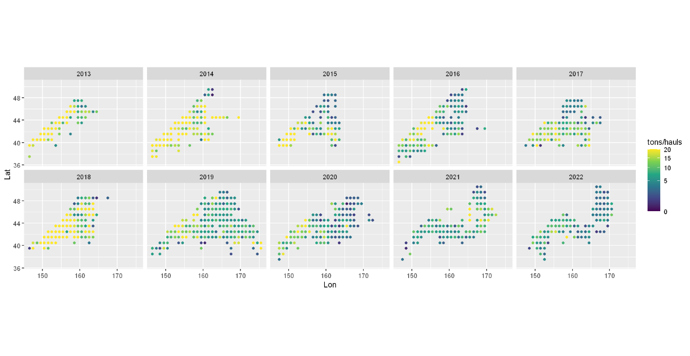

Figure 1 Spatial and temporal distribution of the Pacific saury mean annual CPUE (tons/hauls) during 2013-2022.

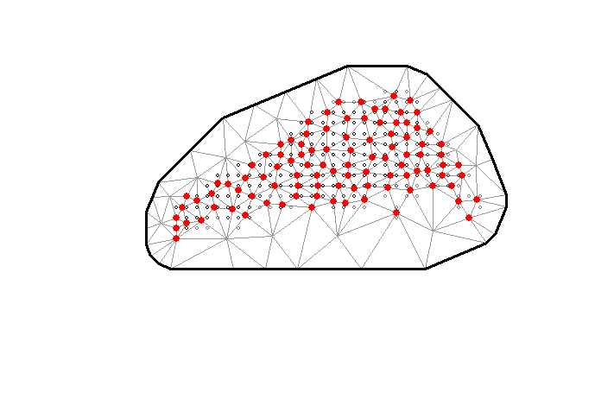

Figure 2 SPDE mesh constructed for fitting the model. The locations where lines intersect are referred to as “knots” (the red points).

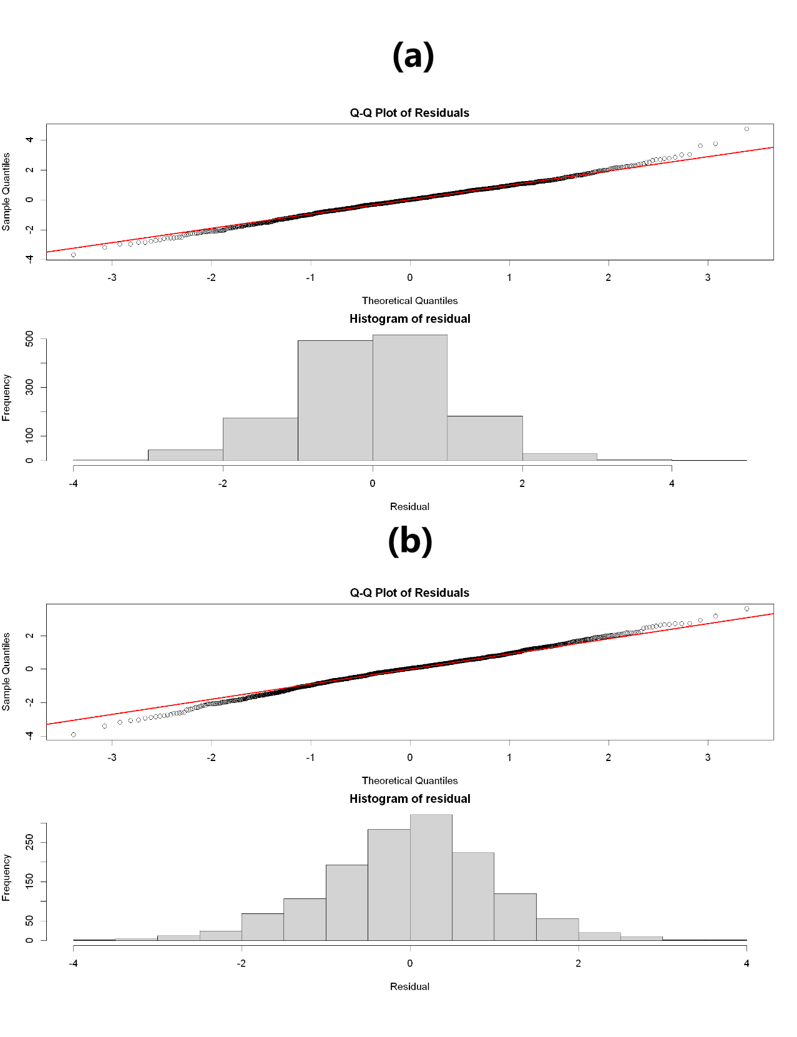

Figure 3 Diagnostic plots of the fitted M4 model (a) and M5 model (b).

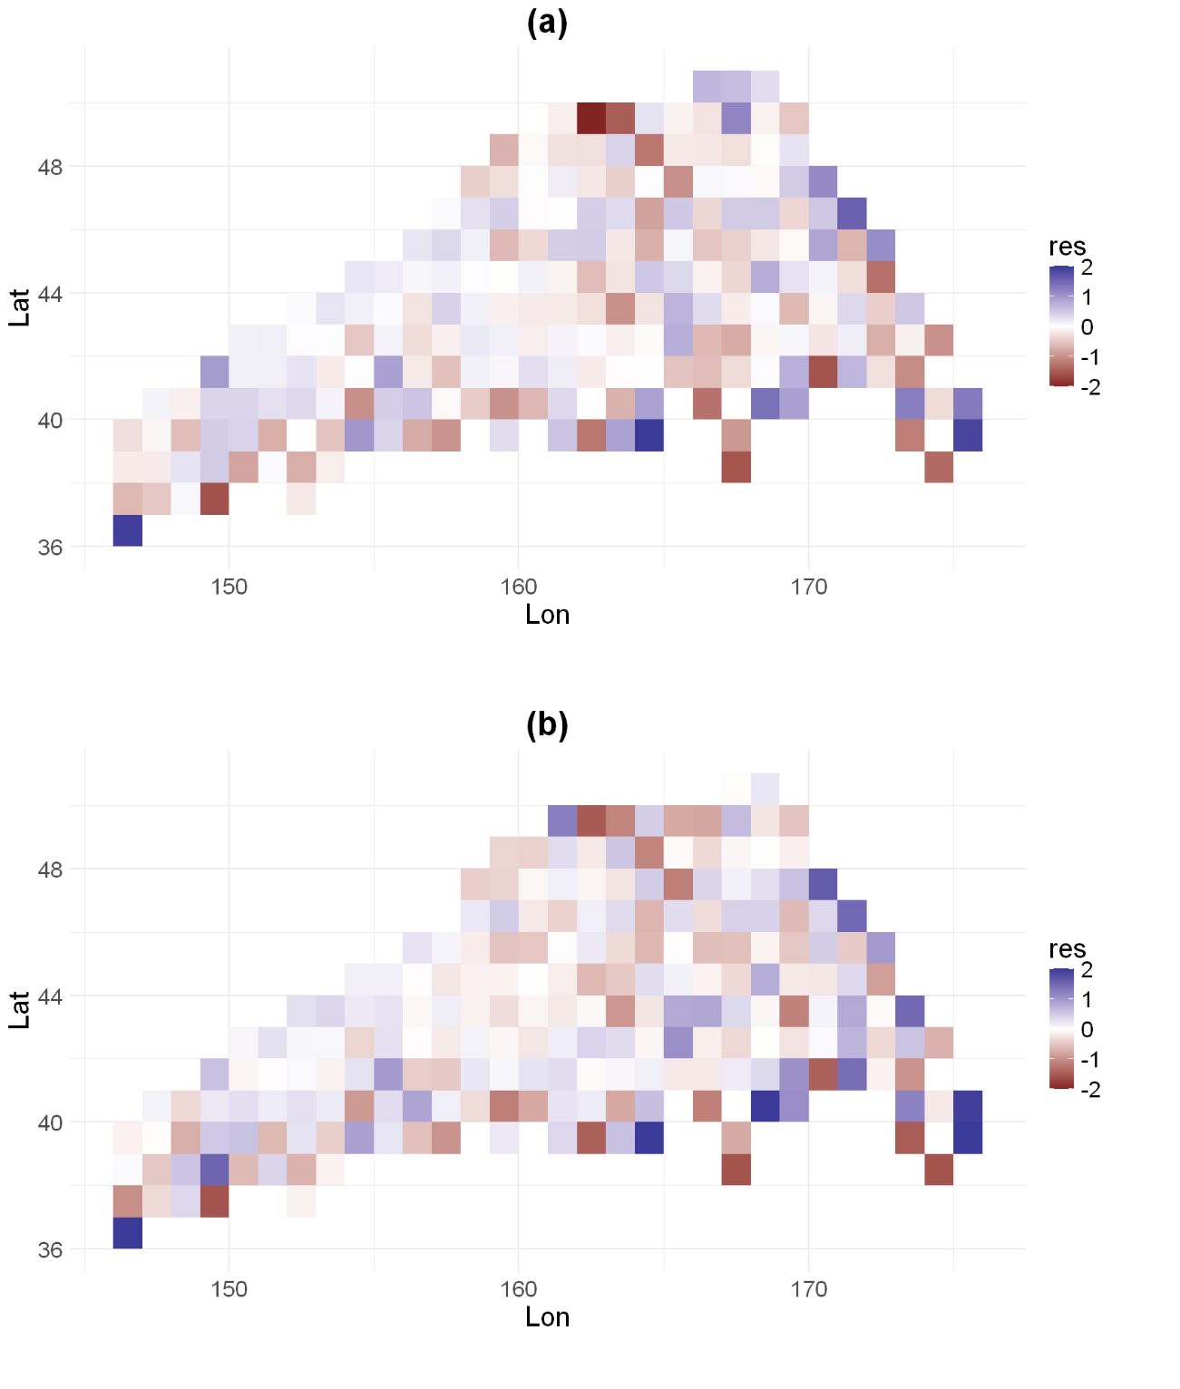

Figure 4 Spatial distribution of the residuals for the fitted M4 model (a) and M5 model (b).

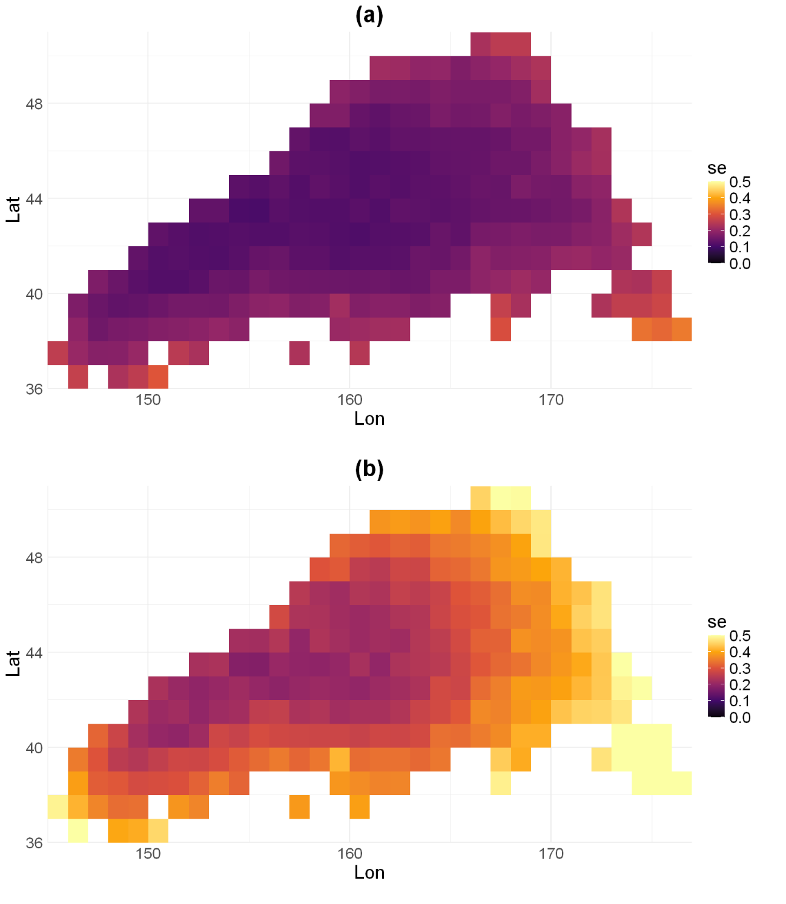

Figure 5 Maps of the projection uncertainty for the fitted M4 model (a) and M5 model (b).

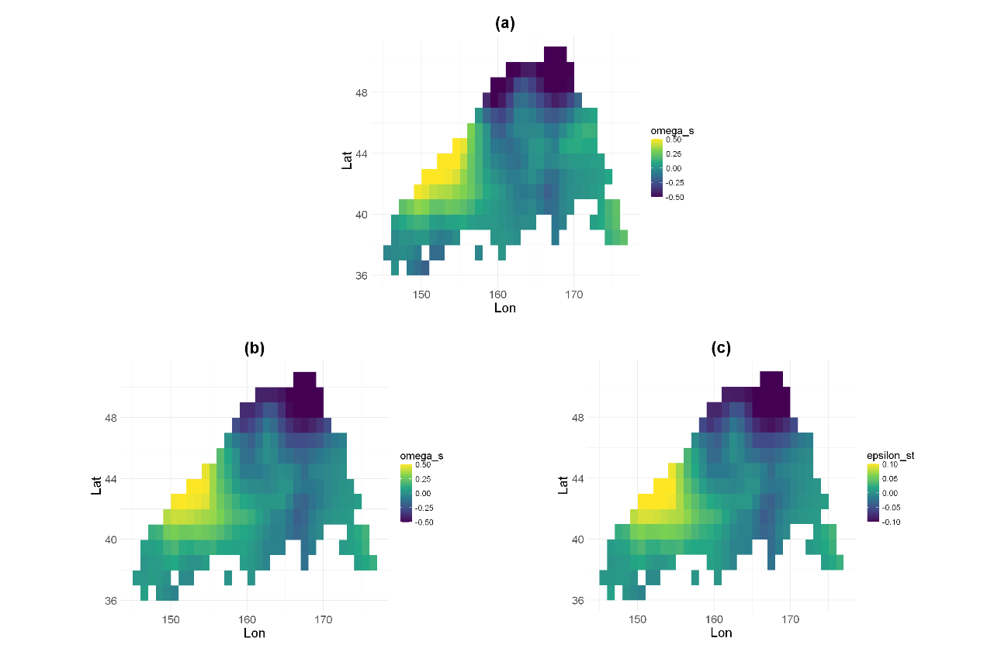

Figure 6 Map of the contributions of the random fields to projection. Panel (a) is the distribution of the spatial random field for the fitted M4 model while panel (b) and panel (c) are the distributions of the spatial and spatio-temporal random field for the fitted M5 model.

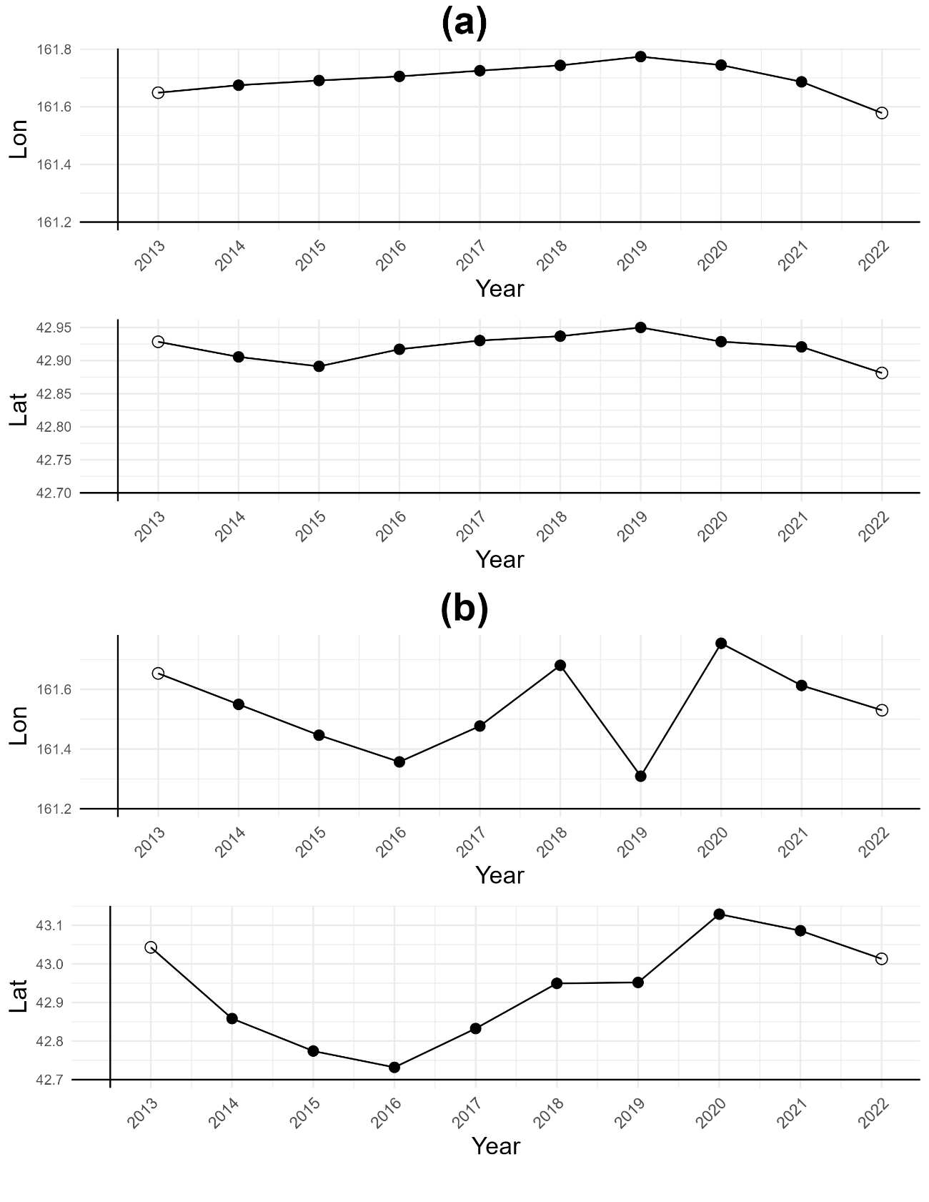

Figure 7 The annual center of gravity of spatial distribution for Pacific saury from the fitted M4 model (a) and M5 model (b) during 2013-2022 (3-year moving-average).

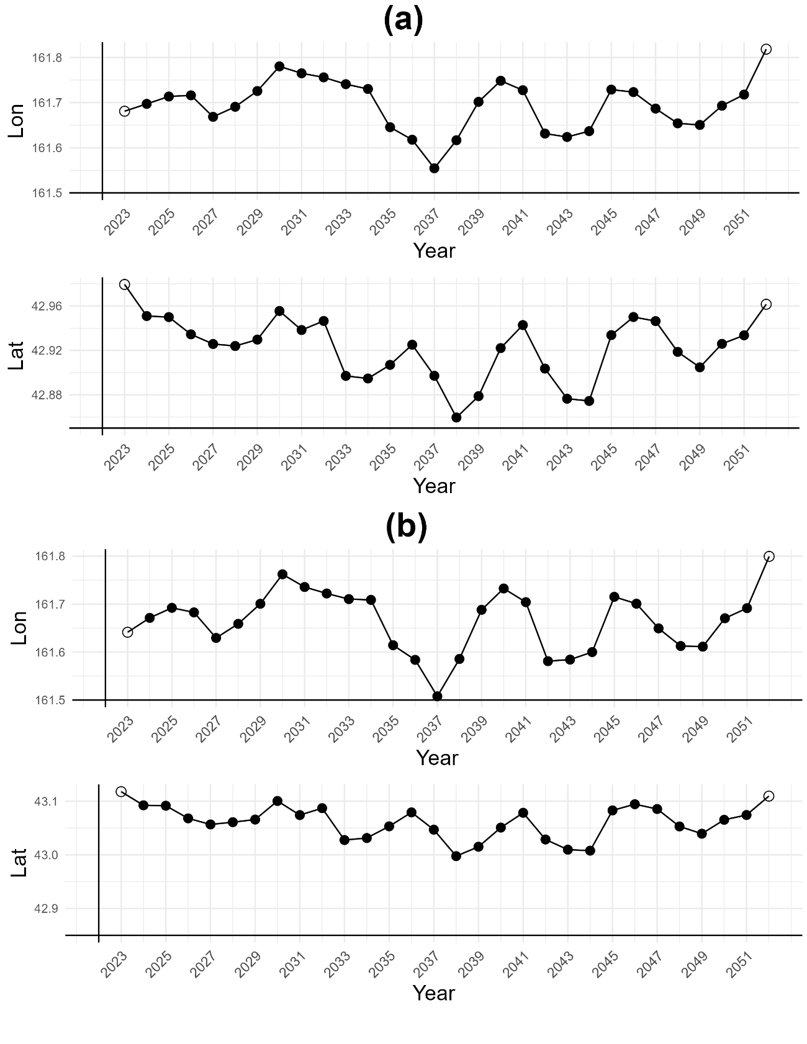

Figure 8 The annual center of gravity of spatial distribution for Pacific saury from the fitted M4 model (a) and M5 model (b) during 2023-2052 under SSP245 (3-year moving-average).

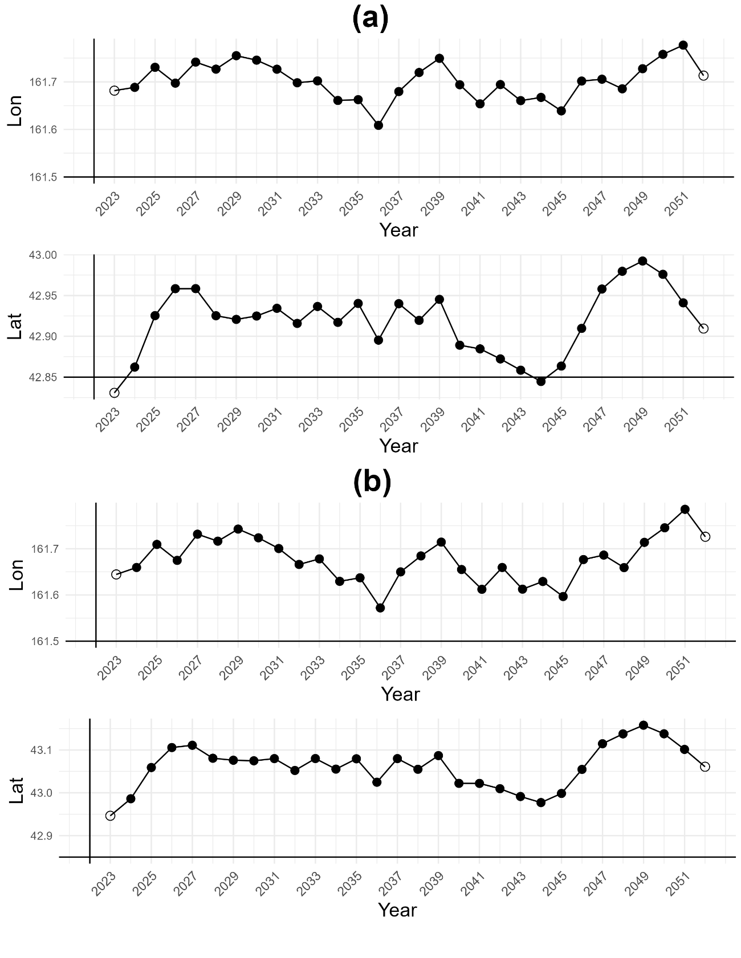

Figure 9 The annual center of gravity of spatial distribution for Pacific saury from the fitted M4 model (a) and M5 model (b)during 2023-2052 under SSP585(3-year moving-average).

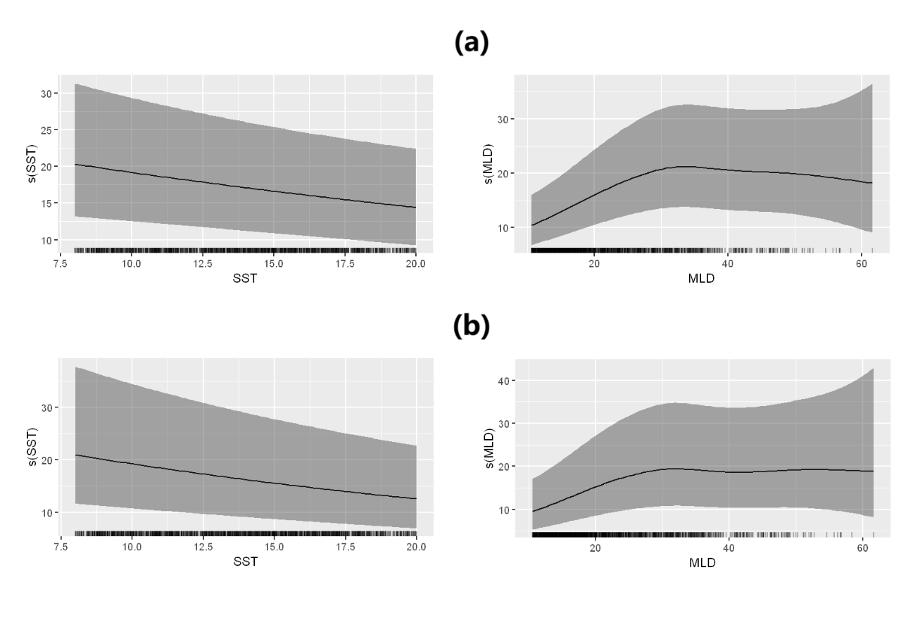

Figure 10 The effects of environmental factors to Pacific saury CPUE for the fitted M4 model (a) and M5 model (b).

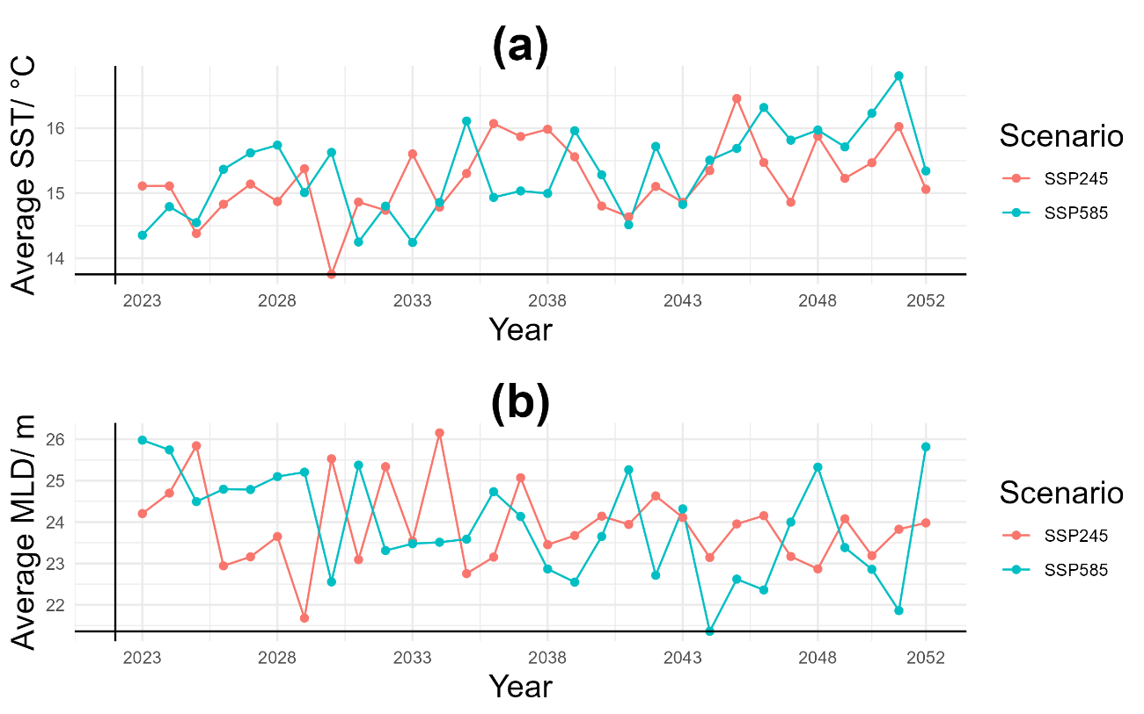

Figure 11 The annual variation of the SST (a) and MLD (b) under SSP245 and SSP585 during 2023-2052.

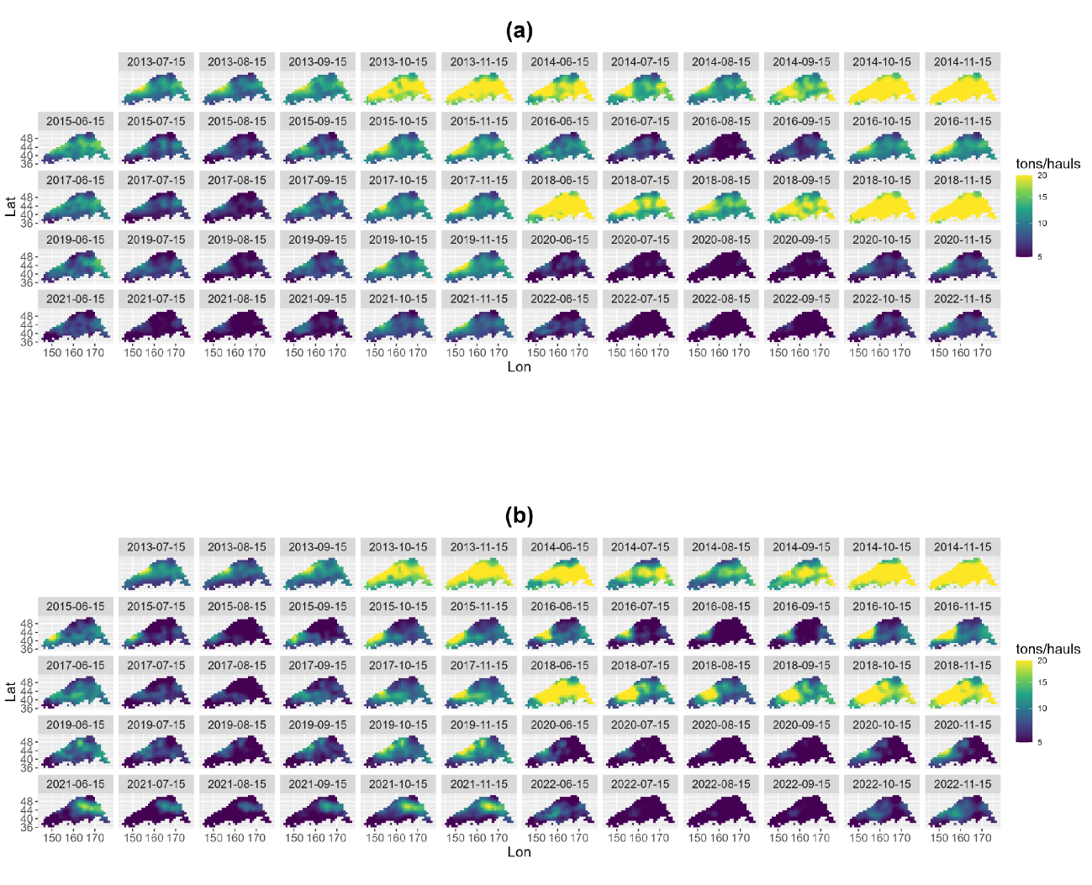

Figure 11 Maps of projected CPUE for Pacific saury at present for the fitted M4 model (a) and M5 model (b) during 2013-2022.

**Appendix**

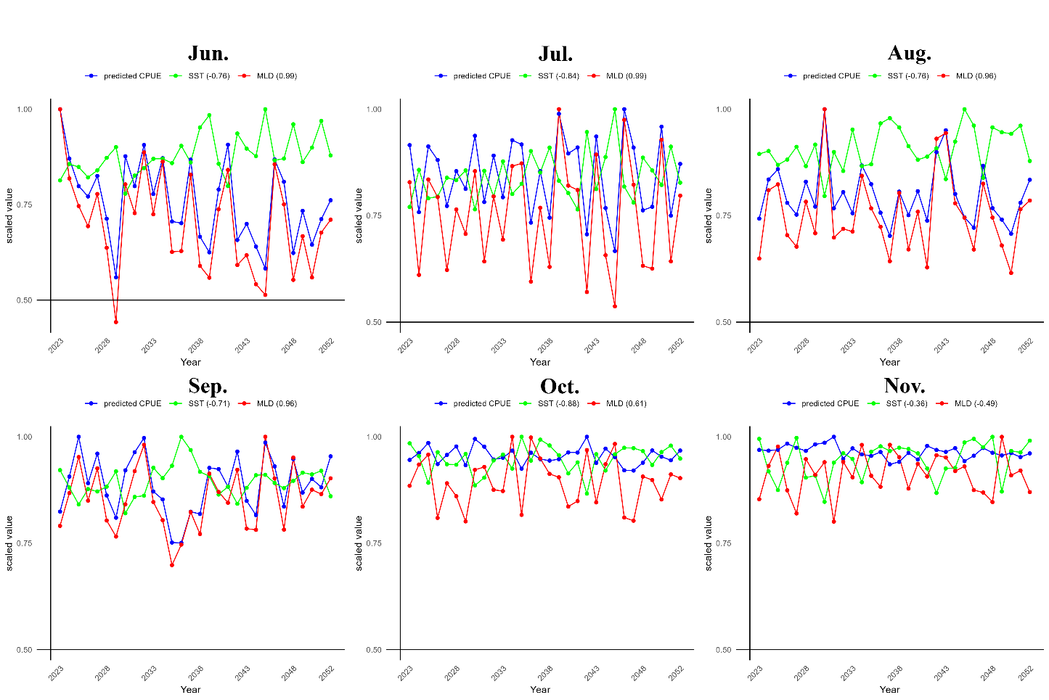

Figure1 Annual variations of SST, MLD and CPUE predicted by M4 in each month under the SSP245. The legend displayed the correlation coefficients of SST/MDL and predicted CPUE in parenthesis. 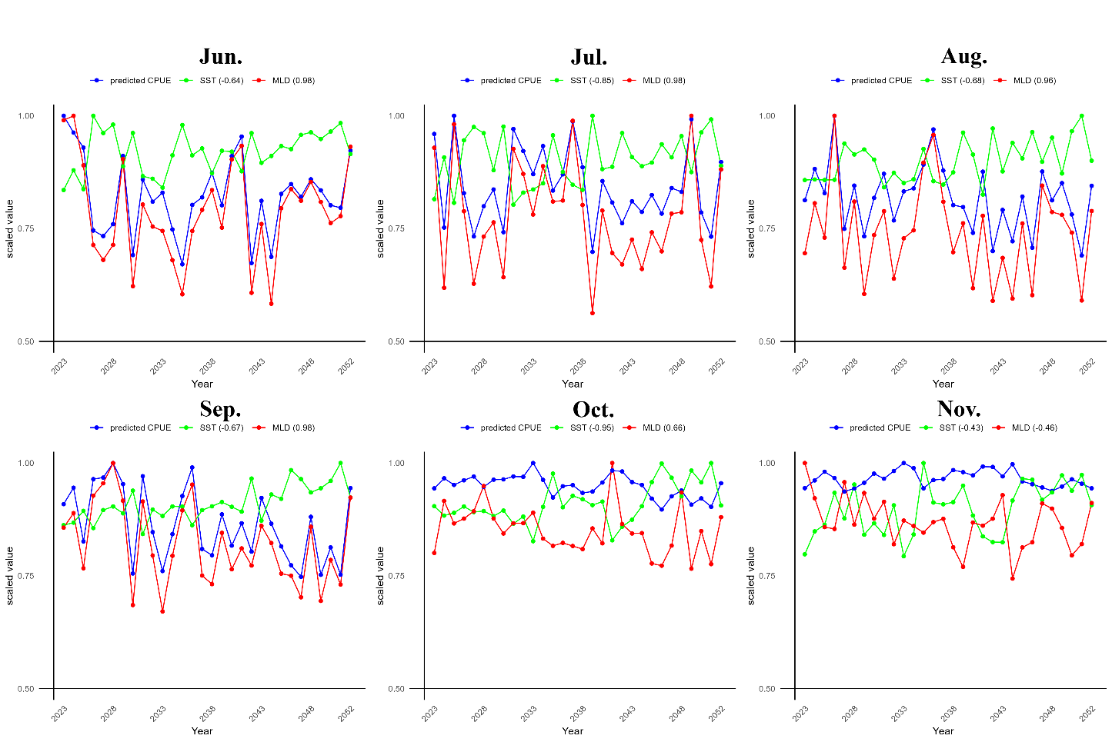

Figure2 Annual variations of SST, MLD and CPUE predicted by M4 in each month under the SSP585. The legend displayed the correlation coefficients of SST/MDL and predicted CPUE in parenthesis.

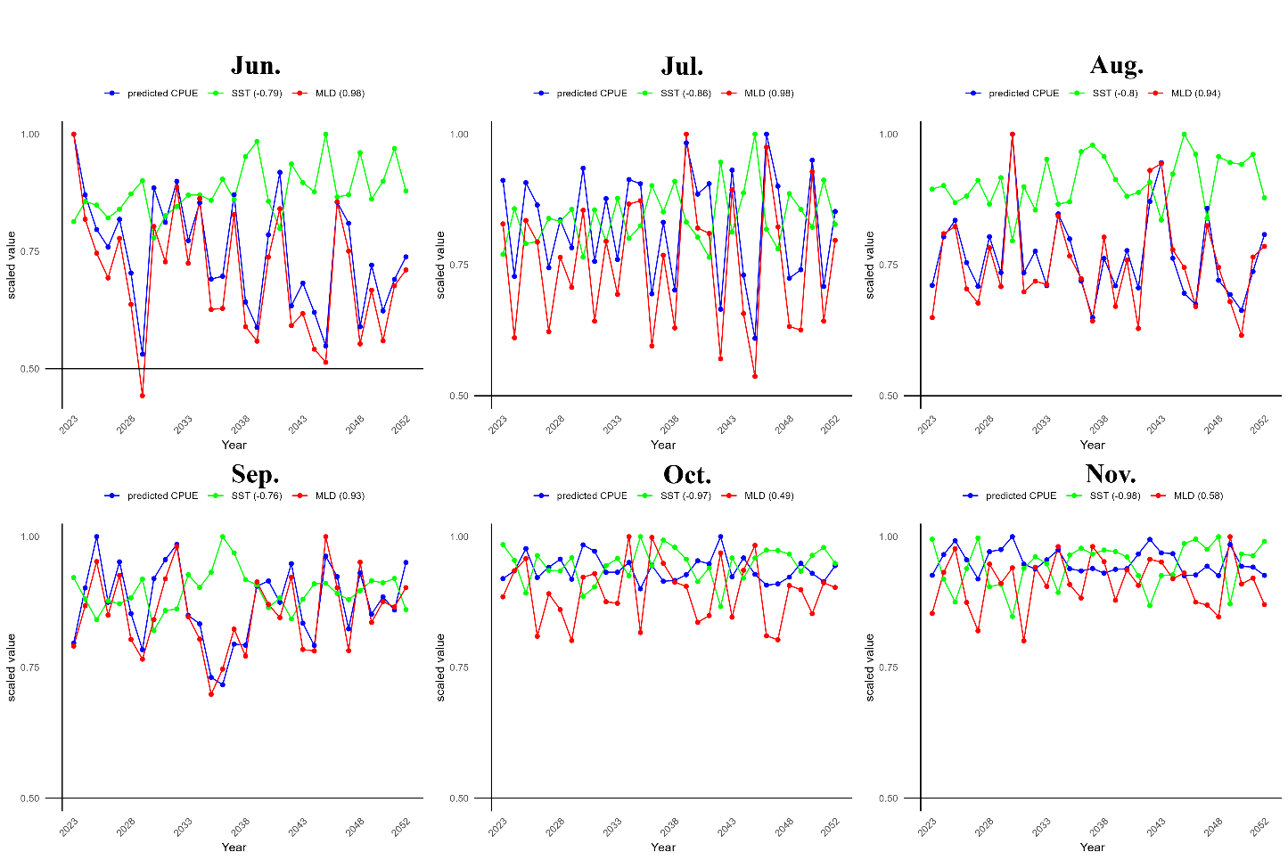

Figure3 Annual variations of SST, MLD and CPUE predicted by M5 in each month under the SSP245. The legend displayed the correlation coefficients of SST/MDL and predicted CPUE in parenthesis. 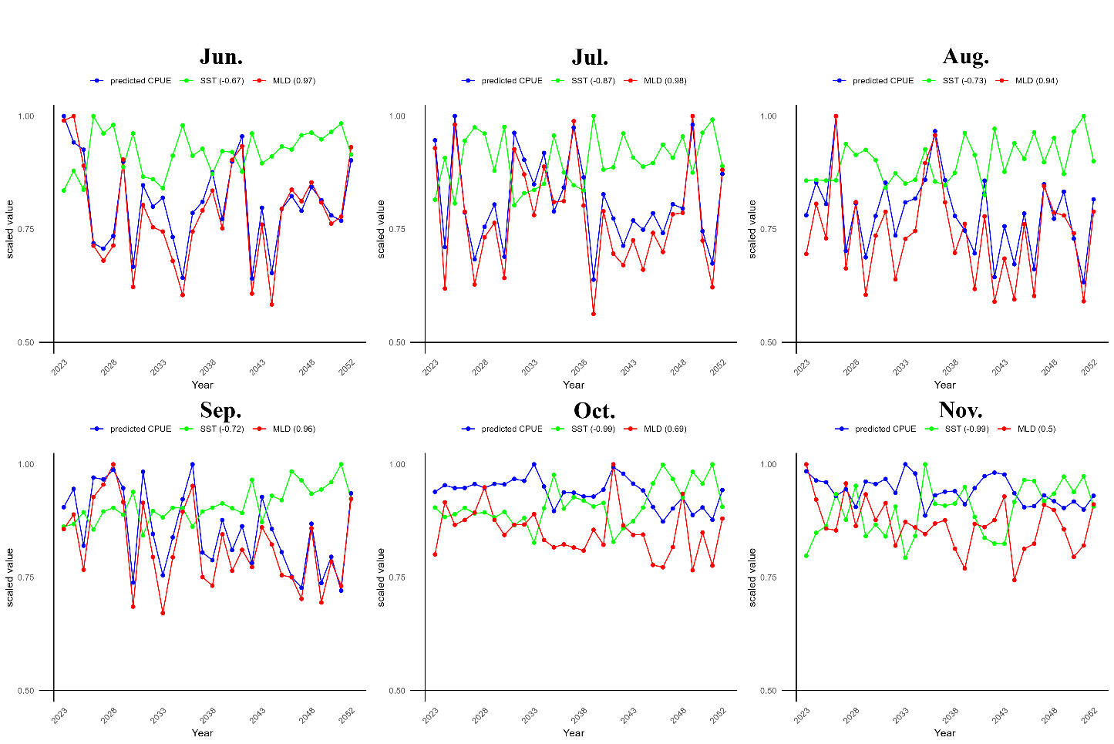

Figure 4 Annual variations of SST, MLD and CPUE predicted by M5 in each month under the SSP585. The legend displayed the correlation coefficients of SST/MDL and predicted CPUE in parenthesis.

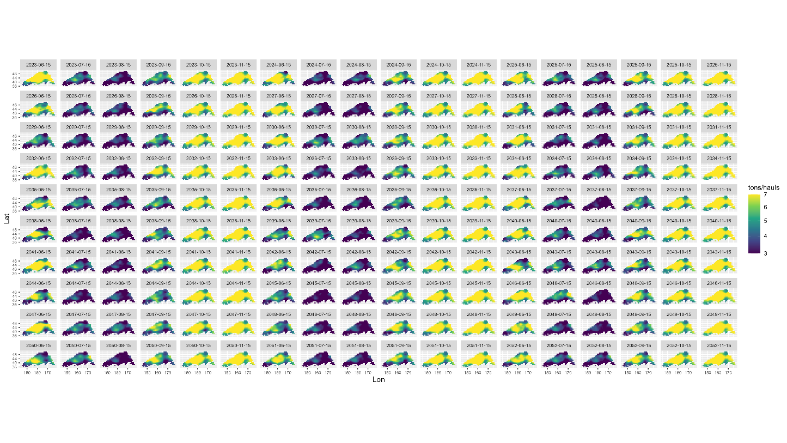

Figure 5 Maps of projected CPUE for Pacific saury at future under SSP245 for the fitted M5 model.

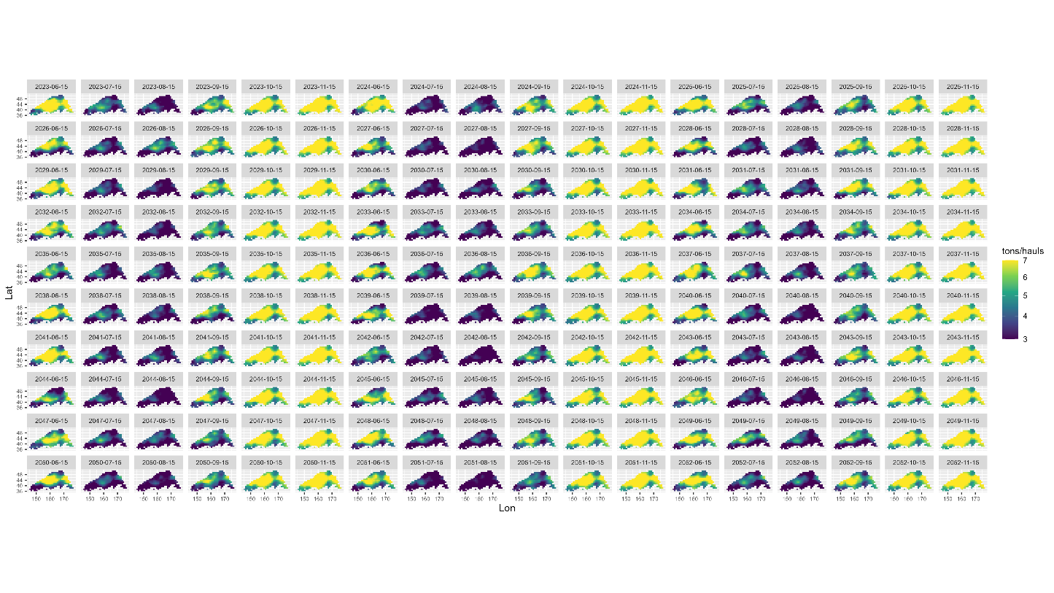

Figure 6 Maps of projected CPUE for Pacific saury at future under SSP585 for the fitted M5 model.

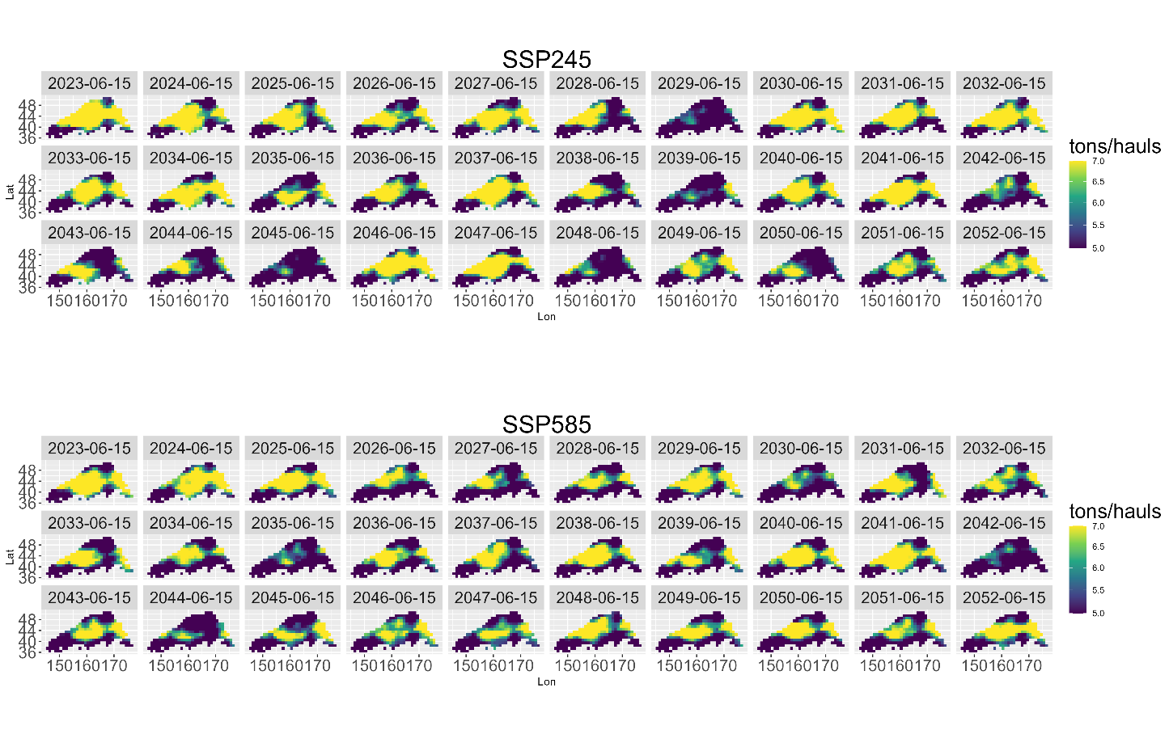

Figure 7 Interannual variation of distribution patterns in June under future scenarios.

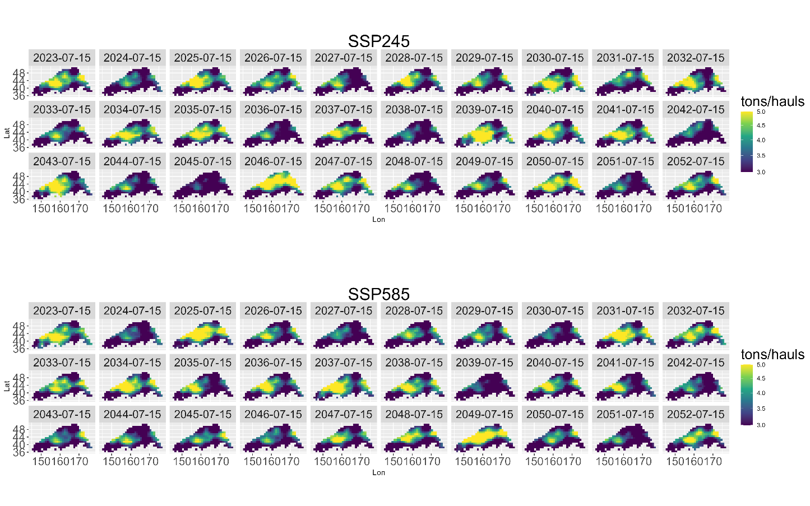

Figure 8 Interannual variation of distribution patterns in July under future scenarios.

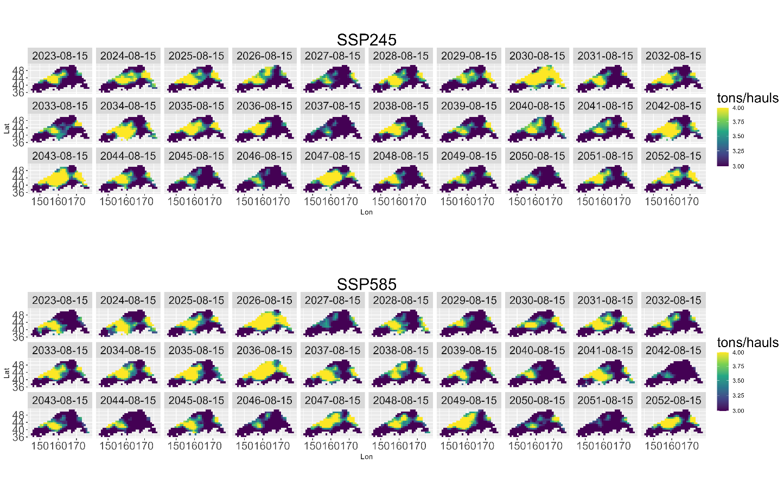

Figure 9 Interannual variation of distribution patterns in August under future scenarios.

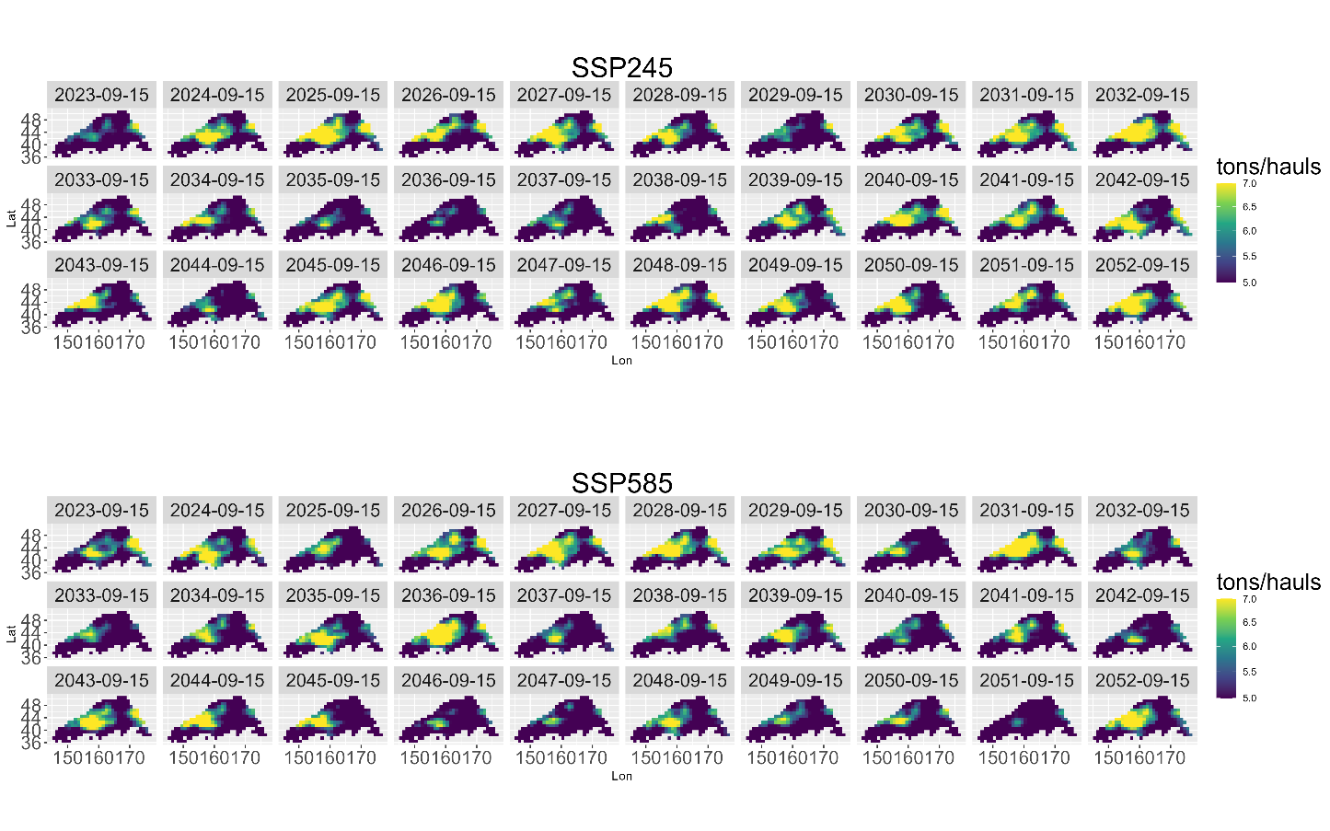

Figure 10 Interannual variation of distribution patterns in September under future scenarios.