NPFC-2024-SSC PS14-WP09

**Updates of stock assessment of Pacific saury (*Cololabis saira*) in the Western North Pacific Ocean through 2023**

Jhen Hsu1, Yi-Jay Chang1, Chih-hao Hsieh1, Wen-Bin Huang2, Tung-Hsieh Chiang3

1. Institute of Oceanography, National Taiwan University

2. Department of Natural Resources and Environmental Studies, National Dong Hwa University

3. Overseas Fisheries Development Council of Chinese Taipei

Summary

This paper describes the updates of stock assessment of the Pacific saury (*Cololabis saira*) in the Western North Pacific Ocean (WNPO) based on the guideline of the 2024 SSC PS14. The assessment consisted of applying the Bayesian state-space surplus production model for estimating the biomass from 1980 to 2024 with available catches from 1980 to 2023. Abundance indices available for WNPO Pacific saury consisted of updated standardized catch-per-unit-effort (CPUE) indices of stick-held dip net fisheries from Japan (1980 – 2023), early and late Chinese Taipei (2001 – 2010; 2011 – 2023), Russia (1994 – 2021), Korea (2001 – 2023), and China (2013 – 2023), joint CPUE (1994 – 2023), and biomass survey from Japan (2003 – 2024). Two base case models were considered for the assessment outputs, differing in their use of individual fleet CPUE indices versus the joint CPUE index. The results of two base case models indicated that the estimated biomass had a similar trend over years. The ensemble time-series of biomass is estimated to have an increasing pattern since 2000 with peak in mid-2000s, after then dramatically decreased overtime and below BMSY in 2009 – 2022. It should be noted that the models estimate the lowest biomass level in 2020 and 2021(median B2020/BMSY = 0.217, 80 percentile range 0.164 – 0.297; median B2021/BMSY = 0.219, 80 percentile range 0.162 – 0.303) and following a slight increase in 2022 and 2023 (median B2022/BMSY = 0.27, 80 percentile range 0.20 – 0.37; B2023/BMSY = 0.339, 80 percentile range 0.242 – 0.470). In the recent three years (2022 – 2024), the biomass was estimated below the BMSY (median B2022-2024/BMSY = 0.352, 80 percentile range 0.251– 0.482). The fishing mortality was below FMSY before 2007, and then the fishing mortality increased above FMSY andreached a high level in 2014 and 2018, respectively. A decreased trend in fishing mortality was found from 2021 to 2023, and the recent average fishing mortality is estimated to be close to FMSY (median F2021-2023/FMSY = 0.988, 80 percentile range 0.738 – 1.333). It should be noted that the models estimate a slightly decreasing in fishing mortality in 2023 (median F2023/FMSY = 0.903, 80 percentile range 0.643 – 1.301). The ensemble MCMC results from the two base cases indicated that the 2023 stock status is likely within the yellow quadrant (Prob [B2023<BMSY and F2023<FMSY] = 64%).

**1. Introduction**

Here, we present a preliminary stock assessment of Pacific saury in the WNPO of the North Pacific Fisheries Commission (NPFC) convention area through 2023. The assessment consisted of applying the Bayesian state-space surplus production model with available catches and standardized catch-per-unit-effort (CPUE) indices from the members from 1980 to 2023 and the Japanese biomass index from 2003-2024. The Bayesian method provided direct estimates of the uncertainty of the model parameters and management quantities.

**2. Material and methods**

Fishery catch data from 1950 to 2023 for assessing Western North Pacific Ocean (WNPO) saury were obtained from the most recent summary of available fishery-dependent data. Commercial catch data of Pacific saury by Japan, Chinese Taipei, Korea, China, Russia, and other members in the WNPO area were collected from 1950 to 2023 (**Figure 1**). Standardized fishery-dependent catch-per-unit-effort (CPUE) estimates for WNPO saury were available from Japan, Chinese Taipei, Korea, Russia, and China. Chinese Taipei provided the standardized CPUE data using a two-period approach (early period: 2001 to 2010; late period: 2011 to 2023) as input for the stock assessment. This approach accounted for changes in fishing efficiency resulting from the significant replacement of aging fishing vessels with newer ones (NPFC-2024-SSC PS13-WP08 (Rev. 1)). Furthermore, a joint CPUE index was available from 1994 to 2023.

Fishery-independent biomass index was available from Japanese scientific research surveys from 2003 – 2024 by using mid-water trawl (**Figure 2**). Comparison of input catch, standardized CPUE indices, and survey index between the 2023 and 2024 assessment models was shown in **Figure 3**. Based on the SSC PS13 recommended base case scenarios (NPFC-2024-SSC PS13-Final Report), the model specification was shown in **Table 1**. The Bayesian analysis requires prior probability distributions for each of the model parameters. These priors used in this study were summarized in **Table 2**.

We performed an Autocorrelation Function (ACF) Analysis to examine whether CPUE residuals exhibited temporal dependencies and annual patterns. In addition, retrospective analysis was conducted to examine the consistency among successive model estimates of population size, or related assessment variables obtained as new data are gathered. Within-model retrospective analysis which trims the most recent 5 years of data in successive model runs were used to examine changes in the estimates of exploitable biomass. Modified Mohn’s (1999) DR statistic was calculated as (Hurtado-Ferro et al., 2015):



where *X* denotes B, B/BMSY, F, and F/FMSY, *y* denotes year, *npeels* denotes the number of years that are dropped in successive fashion and the assessment rerun, *Y* is the last year in the full timeseries, *tip* denotes the terminal estimate from an assessment with a reduced time series, and *ref* denotes the assessment using the full time series.

**3. Results**

3.1 Convergence of base case and sensitivity models

The visual inspection of trace plots of the major parameters showed the good mixing of the three chains (i.e., moving around the parameter space), also indicative of convergence of the MCMC chains. It indicated that the posterior distributions of the model parameters were adequately sampled with the MCMC simulations.

3.2 Model fits to catch-per-unit-effort indices

Plots of residual diagnostics by fishery for the base and sensitivity case models were shown in **Figures 4 - 5 and Figures A1 - A2**. The ACF analysis revealed the significant temporal patterns (*p* < 0.05) in the CPUE residuals from late Japan and Russia for the base case1 (**Figure 4 and Figure A1**). For base model 2 and sensitivity case 2, the fits to all CPUE indices showed no significant residual patterns over the years (**Figure 5 and Figure A2**).

3.3 Posterior estimates of model parameters

Plots of posterior densities of the parameters *r* (intrinsic growth rate), *K* (carrying capacity), *M* (shape parameter), *σ*2 (observation error), *τ*2 (process error), *b* (hyper-depletion/stability), and *P*1 (biomass depletion in 1980) for each base and sensitivity cases were shown in **Figures 6 - 7 and Figures A3 - A4**. Summaries of parameter estimates of each of the base and sensitivity cases were provided in **Tables 3 - 4 and Tables A1 - A2**.

The time-series plots of process errors for the two base cases are shown in **Figures 8 and 9**. In general, the patterns of process error for both base cases were around 0 and exhibited fluctuations after 2000s. Notably, the process error pattern for both base cases tend to be higher than 0 in the mid-2000s, whereas they tend to be slightly lower than 0 after 2015.

3.4 Stock assessment results

Time-series of exploitable biomass (B), the ratio of biomass to BMSY (B/BMSY) and the biomass depletion (B/K) within each base and sensitivity cases were provided in **Figure 10 and Figures A5 - A8**. Although similar trends in biomass were observed in the two base cases, base case 2 exhibited a larger scale of exploitable biomass than base case 1 before 2003. In the sensitivity cases, the inclusion of early Japanese CPUE had minimal influence on biomass estimates before 1994, and the subsequent estimations did not differ significantly from the base case. This suggested that the inclusion of early Japanese CPUE index has negligible effects on the overall biomass results. The summary of estimated reference points for both base and sensitivity cases were provided in **Tables 5 - 6** and **Tables A3 - A4**.

The ensemble time-series of biomass from the two base cases is estimated to have an increasing pattern since 2000, with peak in mid-2000s, after then decreased overtime and below BMSY in 2009 – 2024. It should be noted that the models estimate the lowest biomass level in 2020 and 2021(median B2020/BMSY = 0.217, 80 percentile range 0.164 – 0.297; median B2021/BMSY = 0.219, 80 percentile range 0.162 – 0.303) and following a slight increase in 2022 and 2023 (median B2022/BMSY = 0.27, 80 percentile range 0.20 – 0.37; B2023/BMSY = 0.339, 80 percentile range 0.242 – 0.470). In the recent three years (2022 – 2024), the biomass was estimated below the BMSY (median B2022-2024/BMSY = 0.352, 80 percentile range 0.251– 0.482) (**Figure 11**).

Time-series of the fishing mortality (F) and the ratio of fishing mortality to (F/FMSY) within two base cases and sensitivity cases were shown in **Figure 12 and Figures A9 – A12**. The fishing mortality trend in base cases 1 and 2 exhibited similarities, but the fishing mortality in base case 1 was higher before 2003 compared to base case 2. This disparity is attributed to the lower estimated exploitable biomass in base case 1 in contrast to base case 2. In the sensitivity case, the fishing mortality trends aligned with their respective base cases.

The ensemble time-series of the fishing mortality ratio trend from two base cases was shown in **Figure 13**. The fishing mortality was below FMSY before 2007, and then the fishing mortality increased above FMSY andreached a high level in 2014 and 2018, respectively. A decreased trend in fishing mortality was found from 2021 to 2023, and the recent average fishing mortality is estimated to be close to FMSY (median F2021-2023/FMSY = 0.988, 80 percentile range 0.738 – 1.333). It should be noted that the models estimate a slightly decreasing in fishing mortality in 2023 (median F2023/FMSY = 0.903, 80 percentile range 0.643 – 1.301) compared to its 2022 level.

The quantities of management interest reference points from joint estimates of the base case 1 and 2 were shown in **Table 7**. Overall, the ensemble MCMC results from the two base cases indicated that the 2023 stock status is likely within the yellow quadrant (Prob [B2023<BMSY and F2023<FMSY] = 64%) (**Figure 14**). The ensemble MCMC results from two base cases in the last year and the recent three years were also shown in **Figure 15**, and it suggested that the stock status of Pacific saury is located at the yellow quadrant in the recent three years. Additionally, the Kobe phase plot of stock status derived from the sensitivity cases indicated that considering Japanese early CPUE would have minimal impact on the saury’s stock condition in recent years (**Figure A13**).

3.5 Retrospective analysis

Retrospective analyses for the two base cases showed that the time-series of B, B/BMSY, F and F/FMSY with the removal of most 5 years of data (catch: 2017– 2021; Japan biomass survey: 2018 – 2022) in successive model runs match very well within the full time series assessment (**Figures 16 and 17**). The DR statistic metrics for each quantity range from -0.08 to 0.10 in base case 1 (**Figure 16**) and from -0.05 to 0.03 in base case 2 (**Figure 17**). These values fall within the range of -0.22 to 0.30, as the rule of thumb for shorter-lived species suggested by Hurtado-Ferro et al. (2015). This suggested that there is no consistent pattern of bias in the estimates of the terminal quantiles.

Table 1. Specifications of the two base case models and four sensitivity case models. “JPN_early” = early Japan (1980-1993),“JPN_late” = late Japan (1994-2022), “CT_early” = early Chinese Taipei (2001-2010), ”CT_late” = late Chinese Taipei (2011 – 2023) “RUS” = Russia, “KOR” = Korea, “CHN” = China, “JPN_bio” = Japan biomass survey (NPFC-2024-SSC PS13-Final Report).

|  |  |  |  |  |
| --- | --- | --- | --- | --- |
| Model | Base case 1 (NB1) | Base case2 (NB2) | Sensitivity case1 (NS1) | Sensitivity case2 (NS2) |
| Initial year | 1980 | | | |
| Biomass survey |  | | | |
| Fleet CPUEs and Joint CPUE | CHN (2013-2023)  JPN_late (1994-2023)  KOR (2001-2023)  RUS (1994-2021)  CT_early (2001-2010)  CT_late (2011-2023)        where is computed except for the 2020 biomass survey (*c*=5) | Joint CPUE (1994-2023) | CHN (2013-2022)  JPN_early (1980-1993, time-varying *q*)  JPN_late (1994-2022)  KOR (2001-2022)  RUS (1994-2022)  CT_early (2001-2010)  CT_late (2011-2023)        where is computed except for the 2020 biomass survey (*c*=6) | JPN_early (1980-1993,  time-varying *q*)        Joint CPUE (1994-2023) |
| Hyper-depletion/stability | A common parameter for all fisheries with a prior  distribution, *b* ~ U(0, 1) | | A common parameter for all fisheries but JPN_early, with a prior distribution, *b* ~ U(0, 1)  [*b* for JPN_early is fixed at 1] | *b* ~ U (0, 1) for joint CPUE.  [*b* for JPN_early is fixed at 1] |
| Prior for other than *qbio* | Own preferred options | | | |

Table 2. Summary of the specified priors for the Bayesian state-space models. “JPN1” = early Japan (1980 – 1993), “JPN2” = late Japan (1994 – 2022), “CT1” = early Chinese Taipei (2001 – 2010), “CT2” = late Chinese Taipei (2011 – 2023), “RUS” = Russia, “KOR” = Korea, “CHN” = China, “JPN_bio” = Japan biomass survey.

|  |  |  |
| --- | --- | --- |
| **Parameter** | **Description** | **Prior** |
| *K* | Carrying capacity (10,000 mt) |  |
| *r* | Intrinsic growth rate (year-1) |  |
| *M* | Shape parameter |  |
| *q* | Catchability for fleets (JPN2; CT1; CT2; RUS; KOR; CHN and Joint CPUE) |  |
|  | catchability for Japanese survey biomass |  |
|  | Time-varying catchability for JPN1 in 1980 |  |
|  | Annual deviation of log-scale time-varying catchability |  |
|  | Hyperstability of CPUE during 1994 - 2023 |  |
|  | Common observation error of CPUE |  |
|  | Process error |  |
| *P*1 | Initial condition (*B*1/*K*) |  |

Table 3. Summary of parameter estimates of the base case 1.

|  |  |  |  |  |
| --- | --- | --- | --- | --- |
|  | Mean | Median | Lower 10th | Upper 10th |
| *r* | 0.781 | 0.711 | 0.4 | 1.218 |
| *K* | 274.117 | 248.3 | 166.5 | 412.97 |
| *q*CHN | 0.402 | 0.349 | 0.182 | 0.685 |
| *q*JPN2 | 0.048 | 0.042 | 0.022 | 0.082 |
| *q*KOR | 0.25 | 0.212 | 0.113 | 0.431 |
| *q*RUS | 0.028 | 0.024 | 0.013 | 0.047 |
| *q*CT1 | 0.035 | 0.029 | 0.014 | 0.063 |
| *q*CT2 | 0.077 | 0.067 | 0.035 | 0.131 |
| *qBio* | 0.562 | 0.553 | 0.347 | 0.794 |
| *M* | 0.99 | 0.869 | 0.365 | 1.775 |
| obser_error | 0.186 | 0.185 | 0.162 | 0.211 |
| obser_error_survey | 0.083 | 0.083 | 0.073 | 0.095 |
| process_error | 0.171 | 0.165 | 0.126 | 0.224 |
| FMSY | 0.326 | 0.316 | 0.186 | 0.477 |
| BMSY | 132.627 | 121.1 | 84.392 | 193.8 |
| MSY | 38.493 | 38.47 | 32.51 | 44.39 |
| *b* | 0.823 | 0.833 | 0.681 | 0.953 |

Table 4. Summary of parameter estimates of the base case 2.

|  |  |  |  |  |
| --- | --- | --- | --- | --- |
|  | Mean | Median | Lower 10th | Upper 10th |
| *r* | 0.704 | 0.64 | 0.322 | 1.146 |
| *K* | 296.671 | 262.4 | 162 | 477.99 |
| *q*Bio | 0.538 | 0.524 | 0.302 | 0.804 |
| *q*Joint | 0.047 | 0.038 | 0.396 | 2.104 |
| *M* | 1.141 | 0.999 | 0.015 | 0.089 |
| obser_error | 0.318 | 0.313 | 0.257 | 0.383 |
| obser_error_survey | 0.142 | 0.14 | 0.115 | 0.171 |
| process_error | 0.158 | 0.152 | 0.117 | 0.207 |
| FMSY | 0.317 | 0.302 | 0.152 | 0.507 |
| BMSY | 146.401 | 130.85 | 85.35 | 226.7 |
| MSY | 39.326 | 39.65 | 31.851 | 46.5 |
| *b* | 0.678 | 0.678 | 0.501 | 0.86 |

Table 5. Summary of reference points of the base case 1.

|  |  |  |  |  |
| --- | --- | --- | --- | --- |
|  | Mean | Median | Lower 10th | Upper 10th |
| F2021-2023 | 0.324 | 0.31 | 0.187 | 0.482 |
| F2023 | 0.294 | 0.283 | 0.174 | 0.43 |
| FMSY | 0.326 | 0.316 | 0.186 | 0.477 |
| MSY | 38.493 | 38.47 | 32.51 | 44.39 |
| F2023/FMSY | 0.936 | 0.902 | 0.664 | 1.239 |
| F2021-2023/FMSY | 1.018 | 0.994 | 0.761 | 1.298 |
| *K* | 274.117 | 248.3 | 166.5 | 412.97 |
| B2023 | 46.071 | 41.76 | 27.512 | 68.02 |
| B2024 | 59.757 | 54.58 | 36.7 | 87.238 |
| B2022-2024 | 47.688 | 43.43 | 29.201 | 69.727 |
| BMSY | 132.627 | 121.1 | 84.392 | 193.8 |
| BMSY/*K* | 0.491 | 0.487 | 0.426 | 0.563 |
| B2023/*K* | 0.174 | 0.169 | 0.118 | 0.234 |
| B2024/*K* | 0.229 | 0.222 | 0.147 | 0.317 |
| B2022-2024/*K* | 0.18 | 0.177 | 0.123 | 0.24 |
| B2023/BMSY | 0.354 | 0.344 | 0.251 | 0.466 |
| B2024/BMSY | 0.466 | 0.452 | 0.311 | 0.636 |
| B2022-2024/BMSY | 0.367 | 0.358 | 0.263 | 0.48 |

Table 6. Summary of reference points of the base case 2.

|  |  |  |  |  |
| --- | --- | --- | --- | --- |
|  | Mean | Median | Lower 10th | Upper 10th |
| F2021-2023 | 0.309 | 0.292 | 0.158 | 0.488 |
| F2023 | 0.284 | 0.27 | 0.151 | 0.437 |
| FMSY | 0.317 | 0.302 | 0.152 | 0.507 |
| MSY | 39.326 | 39.65 | 31.851 | 46.5 |
| F2023/FMSY | 0.968 | 0.904 | 0.62 | 1.372 |
| F2021-2023/FMSY | 1.025 | 0.98 | 0.715 | 1.372 |
| *K* | 296.671 | 262.4 | 162 | 477.99 |
| B2023 | 49.652 | 43.79 | 27.07 | 78.262 |
| B2024 | 61.854 | 55.83 | 35.2 | 93.958 |
| B2022-2024 | 50.741 | 45.045 | 28.507 | 78.513 |
| BMSY | 146.401 | 130.85 | 85.35 | 226.7 |
| BMSY/K | 0.504 | 0.5 | 0.431 | 0.584 |
| B2023/K | 0.174 | 0.168 | 0.113 | 0.242 |
| B2024/K | 0.224 | 0.214 | 0.132 | 0.328 |
| B2022-2024/K | 0.179 | 0.174 | 0.116 | 0.25 |
| B2023/BMSY | 0.347 | 0.334 | 0.234 | 0.473 |
| B2024/BMSY | 0.445 | 0.424 | 0.27 | 0.64 |
| B2022-2024/BMSY | 0.357 | 0.344 | 0.241 | 0.486 |

Table 7. Summary of joint estimates of reference points of the base cases 1 and 2.

|  |  |  |  |  |
| --- | --- | --- | --- | --- |
|  | Mean | Median | Lower 10th | Upper 10th |
| Catch2023 | 11.83 | 11.83 | 11.83 | 11.83 |
| F2021-2023 | 0.317 | 0.302 | 0.171 | 0.484 |
| F2023 | 0.289 | 0.277 | 0.163 | 0.434 |
| FMSY | 0.321 | 0.31 | 0.167 | 0.492 |
| MSY | 38.909 | 39.01 | 32.26 | 45.6 |
| F2023/FMSY | 0.952 | 0.903 | 0.643 | 1.301 |
| F2021-2023/FMSY | 1.022 | 0.988 | 0.738 | 1.333 |
| *K* | 285.394 | 254.5 | 164.1 | 447.38 |
| B2023 | 47.862 | 42.715 | 27.3 | 72.83 |
| B2024 | 60.805 | 55.145 | 35.99 | 90.624 |
| B2022-2024 | 49.215 | 44.163 | 28.831 | 73.946 |
| BMSY | 139.514 | 125.1 | 84.793 | 211.8 |
| BMSY/*K* | 0.539 | 0.49 | 0.311 | 0.804 |
| B2023/*K* | 0.174 | 0.169 | 0.115 | 0.238 |
| B2024/*K* | 0.226 | 0.218 | 0.139 | 0.322 |
| B2022-2024/*K* | 0.18 | 0.175 | 0.119 | 0.244 |
| B2023/BMSY | 0.35 | 0.339 | 0.242 | 0.47 |
| B2024/BMSY | 0.455 | 0.44 | 0.287 | 0.637 |
| B2022-2024/BMSY | 0.362 | 0.352 | 0.251 | 0.482 |

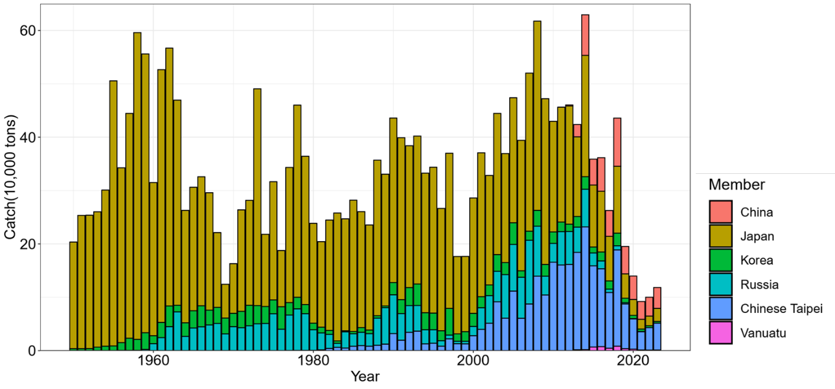

Figure 1. Time-series of Pacific saury historical catches by fleets during 1950 – 2023 in the Western North Pacific Ocean.

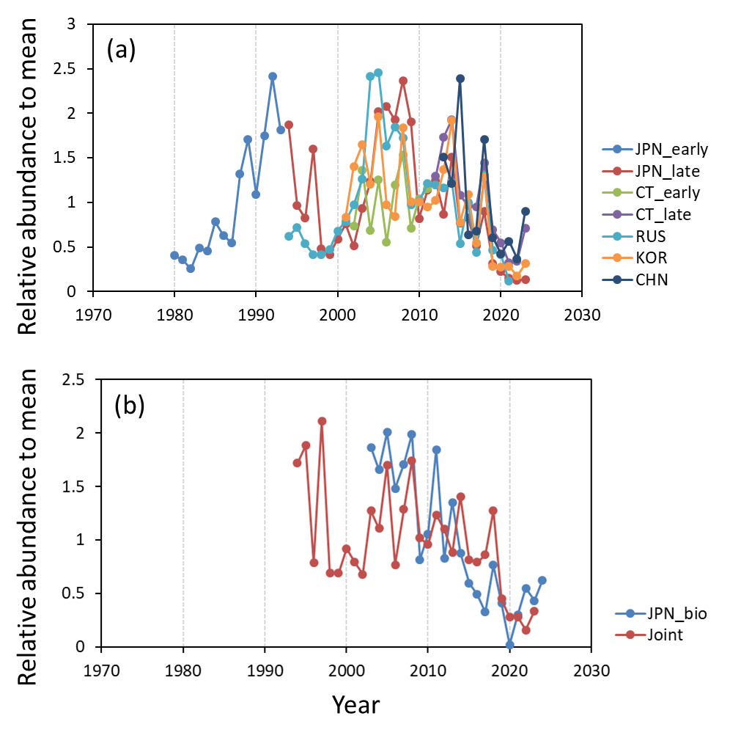

Figure 2. Time-series of (a) relative standardized CPUE indices by each member, and (b) relative joint CPUE index and fishery-independent biomass index.

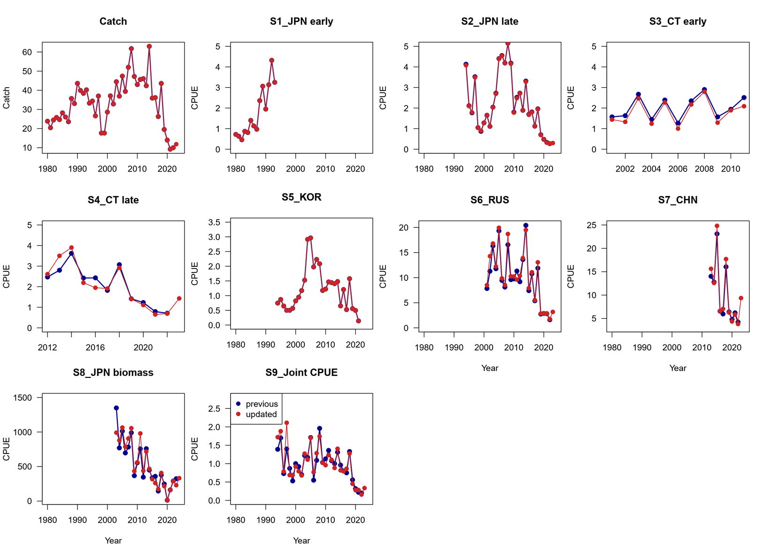

Figure 3. Comparison of input catch, standardized CPUE indices, and survey index between 2023 and 2024 for the Pacific saury assessment model.

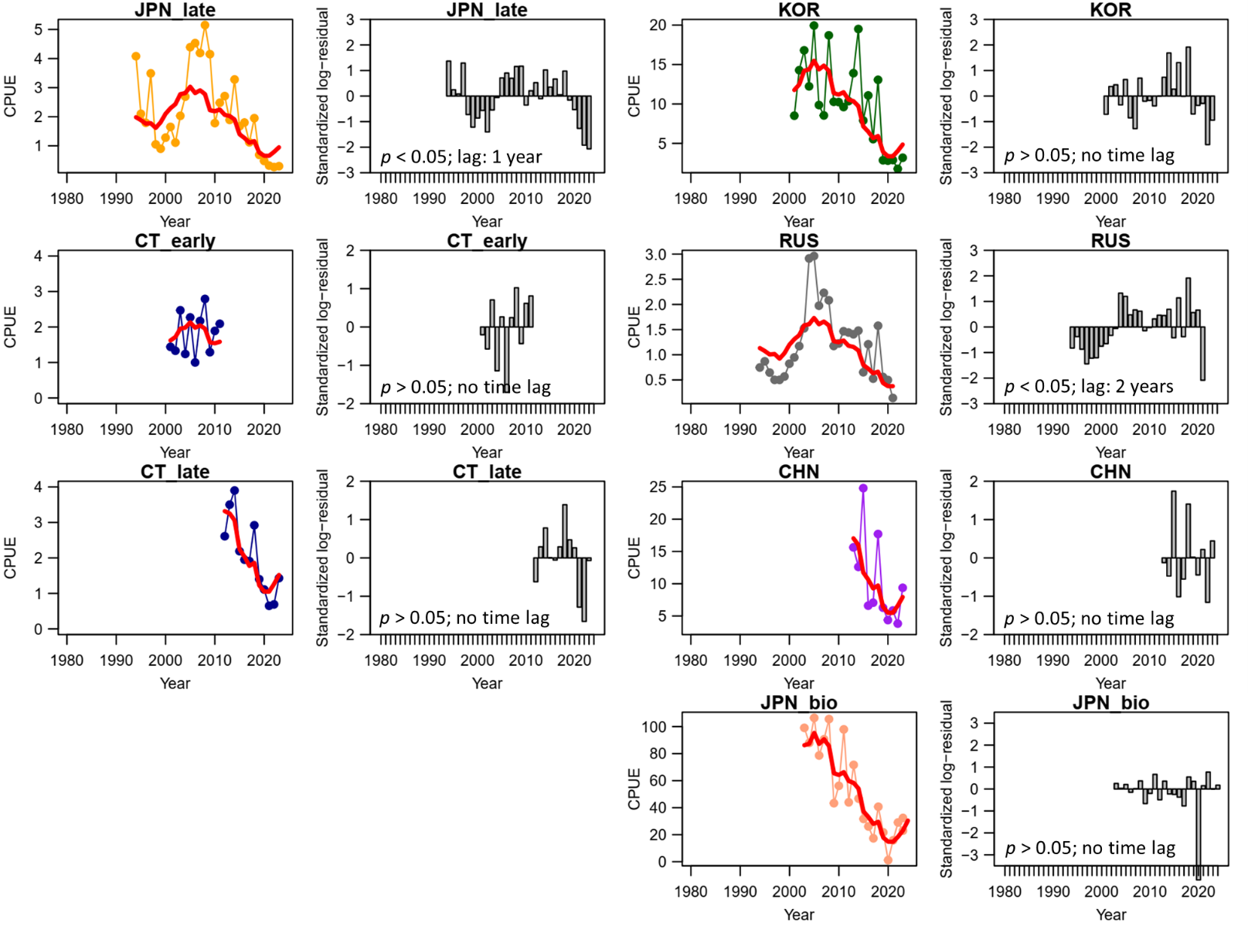

Figure 4. Time-series of observed (circle-line) and predicted (red solid line) catch-per-unit-effort (CPUE) of Western North Pacific saury and standardized log-residuals for the base case 1 production model. “JPN_late” = late Japan (1994-2023), “CT_early” = early Chinese Taipei (2001-2010), “CT_late” = late Chinese-Taipei (2011-2023), “RUS” = Russia, “KOR” = Korea, “CHN” = China, JPN_bio” = Japanese biomass survey.

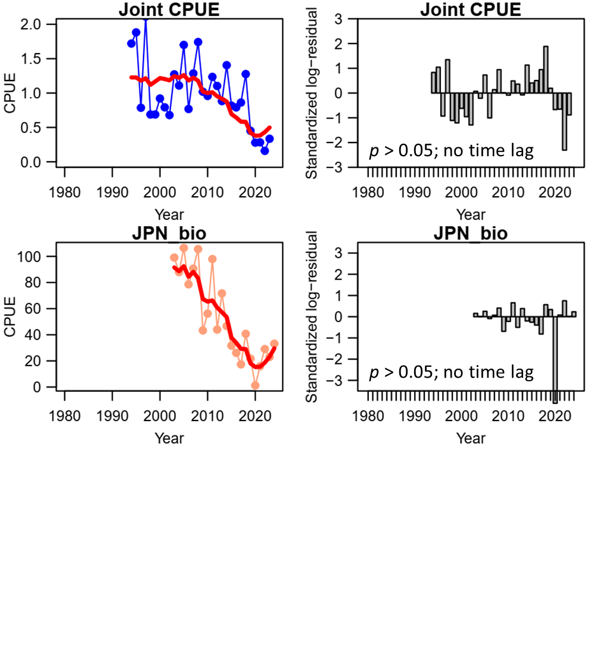

Figure 5. Time-series of observed (circle-line) and predicted (red solid line) catch-per-unit-effort (CPUE) of Western North Pacific saury and standardized log-residuals for the base case 2 production model. “Joint CPUE” = joint CPUE index (1994-2023), and “JPN_bio” = Japanese biomass survey (2003-2024).

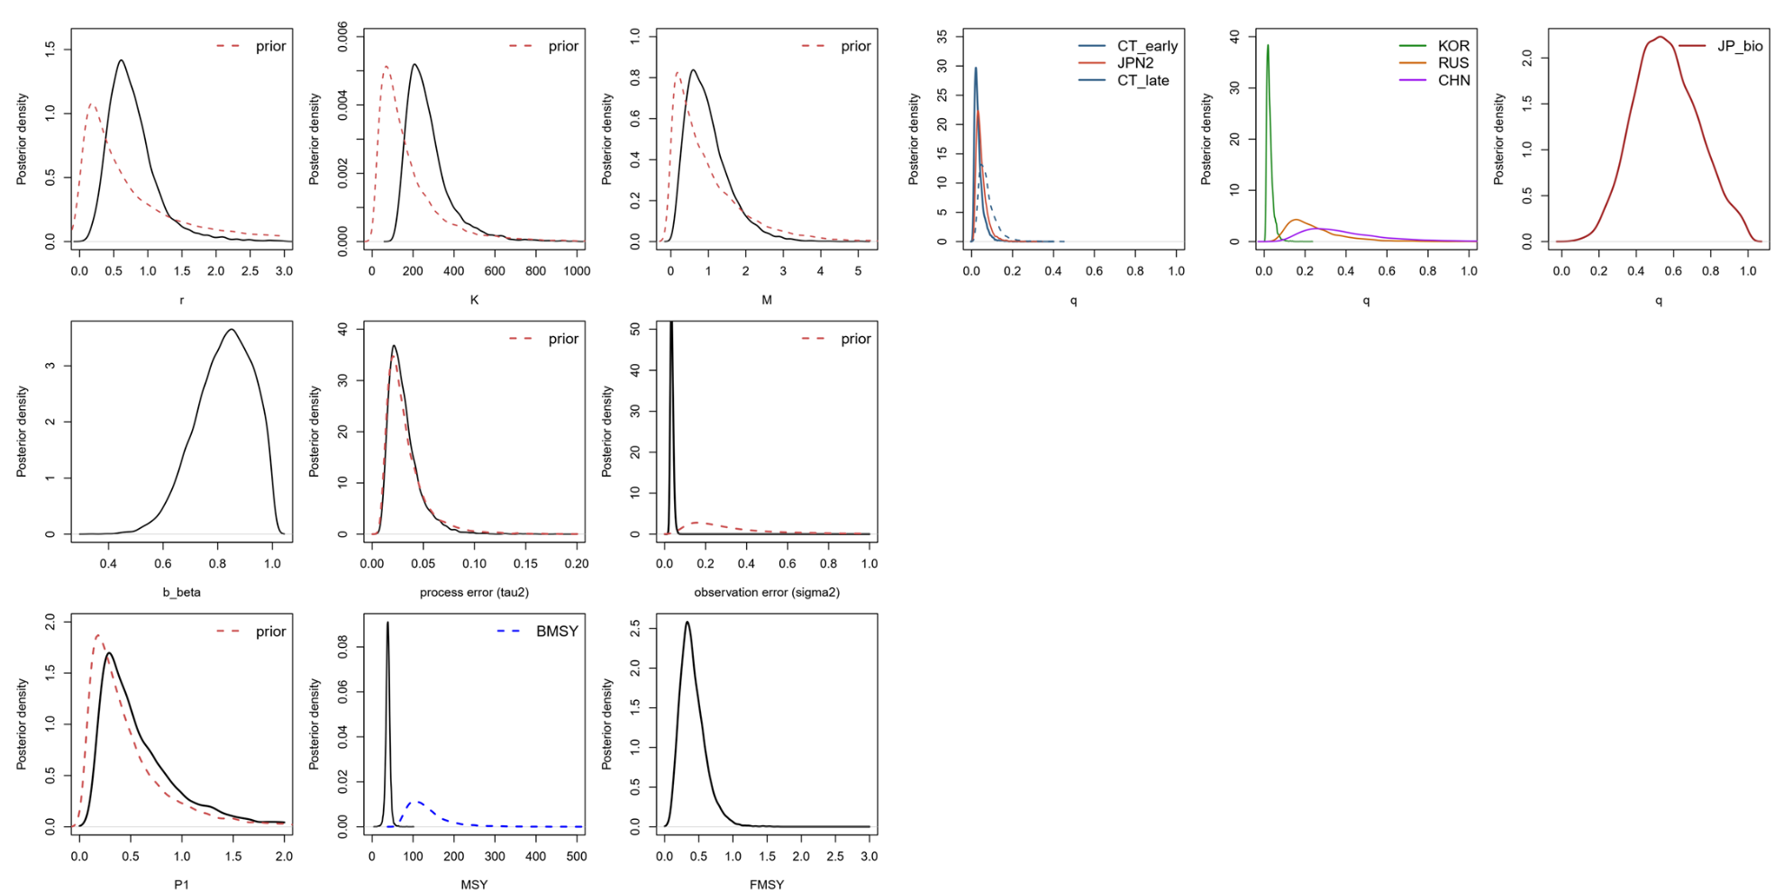

Figure 6. Kernel density estimates of the posterior distributions (solid lines) of various model parameters and management quantities for the base case 1 production model for the Pacific saury in the Western North Pacific Ocean. Proper prior densities are given by the dashed lines. “JPN2” = late Japan (1994-2022), “CT_early” = early Chinese Taipei (2001-2010), “CT_late” = late Chinese-Taipei (2011-2023); “RUS” = Russia, “KOR” = Korea, “CHN” = China, “JP_bio” = Japanese biomass survey.

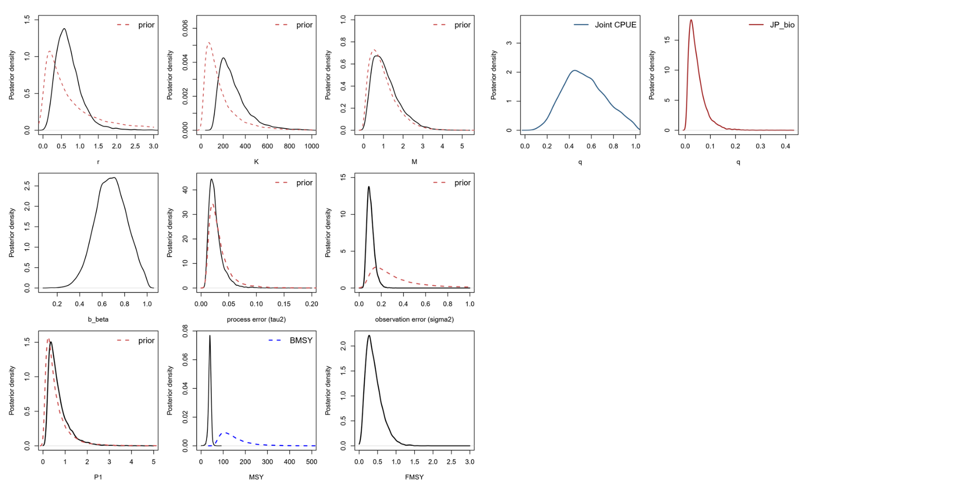

Figure 7. Kernel density estimates of the posterior distributions (solid lines) of various model parameters and management quantities for the base case 2 production model for the Pacific saury in the Western North Pacific Ocean. Proper prior densities are given by the dashed lines. “Joint CPUE” = Joint CPUE index, “JP_bio” = Japanese biomass survey.

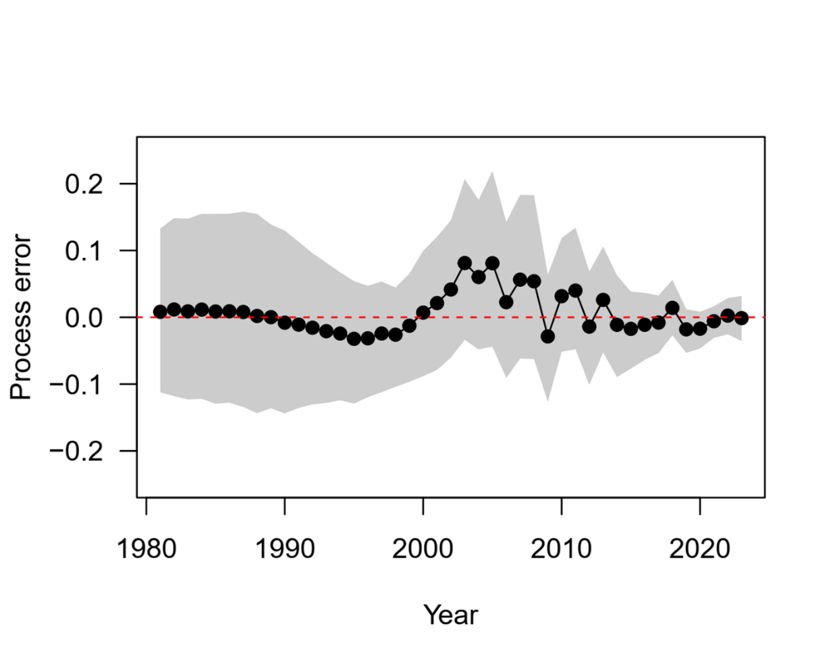

Figure 8. The time-series of the process error deviates on log-scale for base case 1. The polygon is the 80% confident interval.

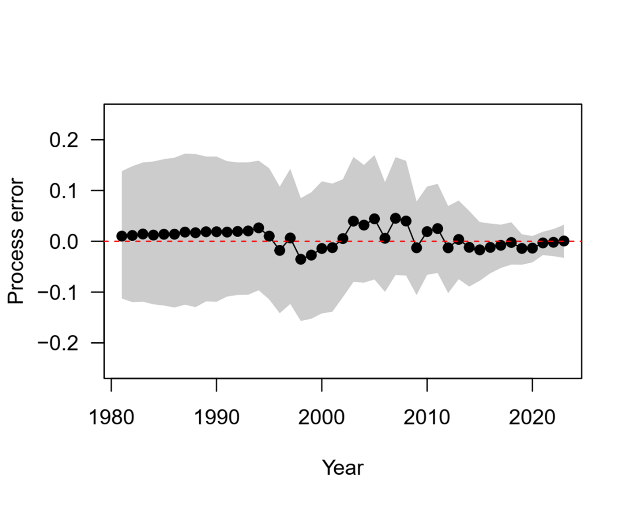

Figure 9. The time-series of the process error deviates on log-scale for base case 2. The polygon is the 80% confident interval.

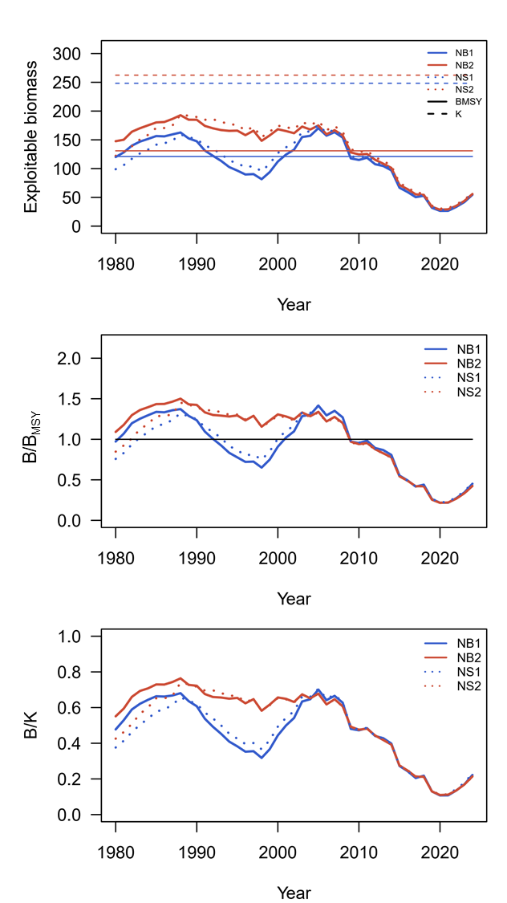

Figure 10. Time series of biomass (10,000 metric ton), the ratio of biomass to BMSY(B/BMSY), and the depletion ratio (B/K) of the western North Pacific saury for the base case 1-2 (NB1 and NB2) and sensitivity case 1-2 (NS1 and NS2).

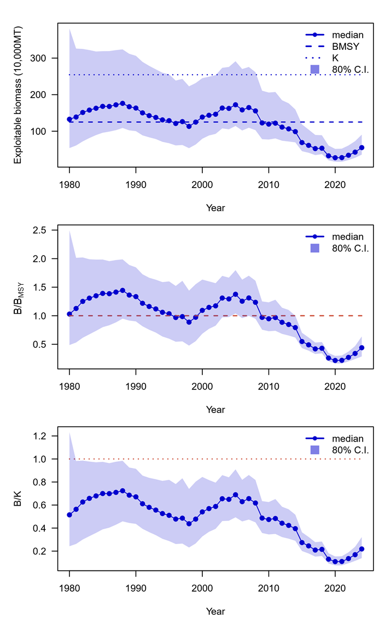

Figure 11. Time series of ensemble biomass (10,000 metric ton), the ratio of biomass to BMSY(B/BMSY), and the depletion ratio (B/K) of the western North Pacific saury for the median estimates of MCMC results from base cases 1-2.

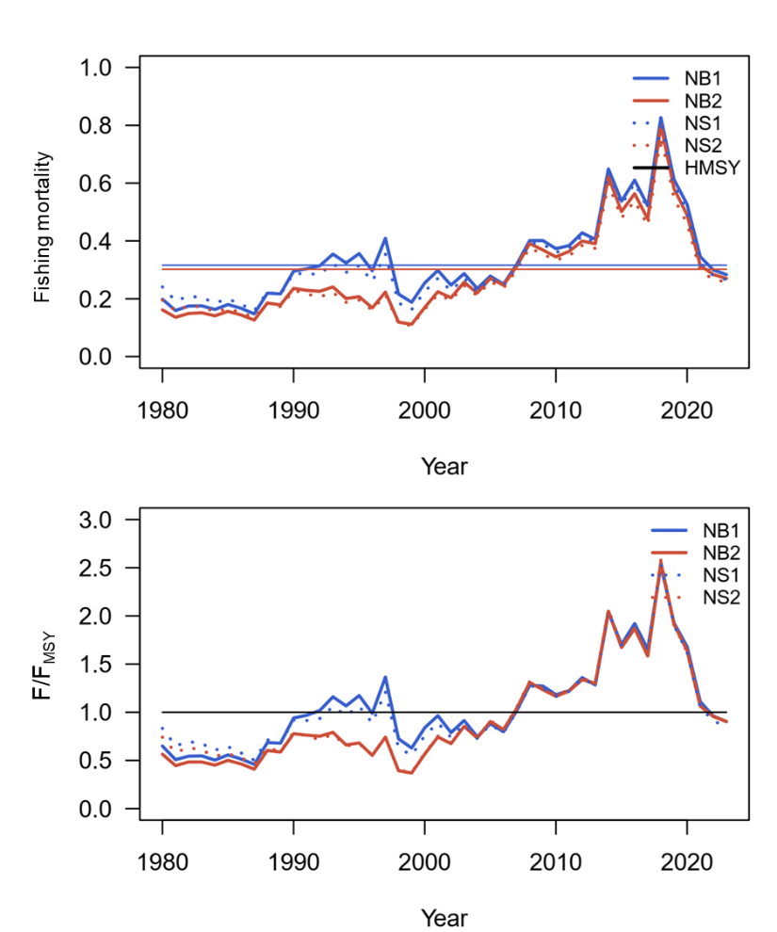

Figure 12. Time-series of fishing mortality (F) and the ratio of harvest rate to FMSY (F/FMSY) (b) of the western North Pacific saury for the base case 1-2 (NB1 and NB2) and sensitivity case 1-2 (NS1 and NS2).

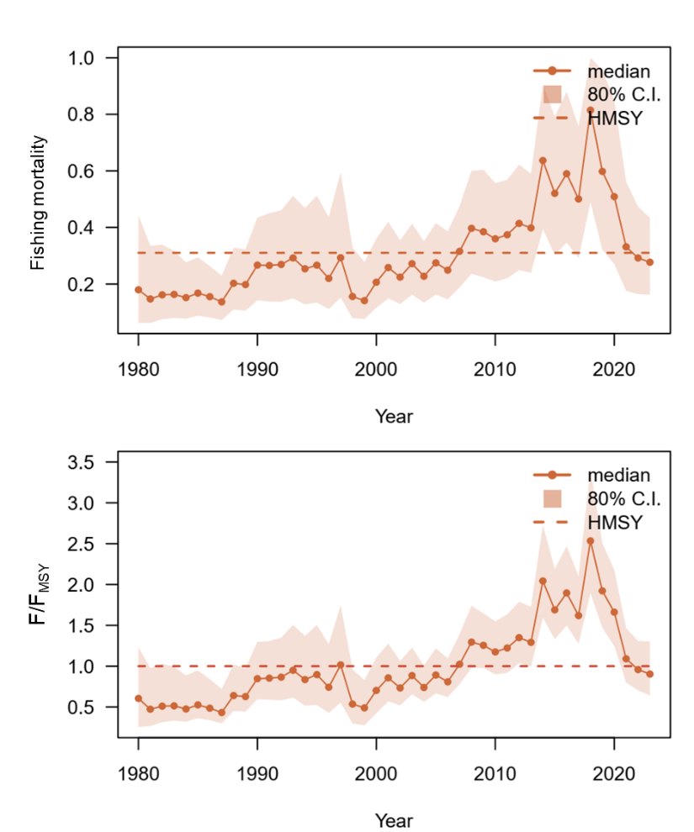

Figure 13. Time-series of fishing mortality and the ratio of fishing mortality to FMSY (F/FMSY) (b) of the western North Pacific saury for the median estimates of MCMC results from base cases 1 – 2.

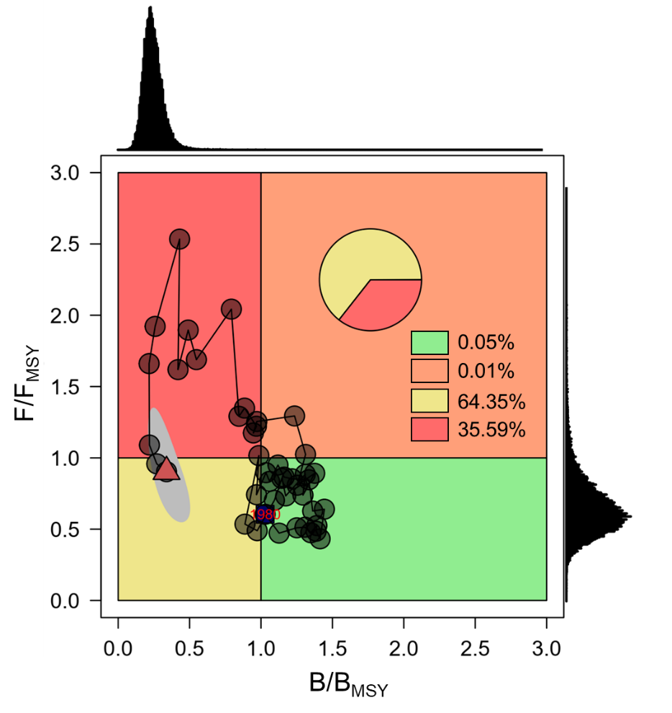

Figure 14. Ensemble Kobe phase plot of the stock trajectory of the western North Pacific saury from 1980 to 2023 (in a red triangle) with uncertainty estimate in 2023 (80% credible intervals, grey polygon) from the two base case models.

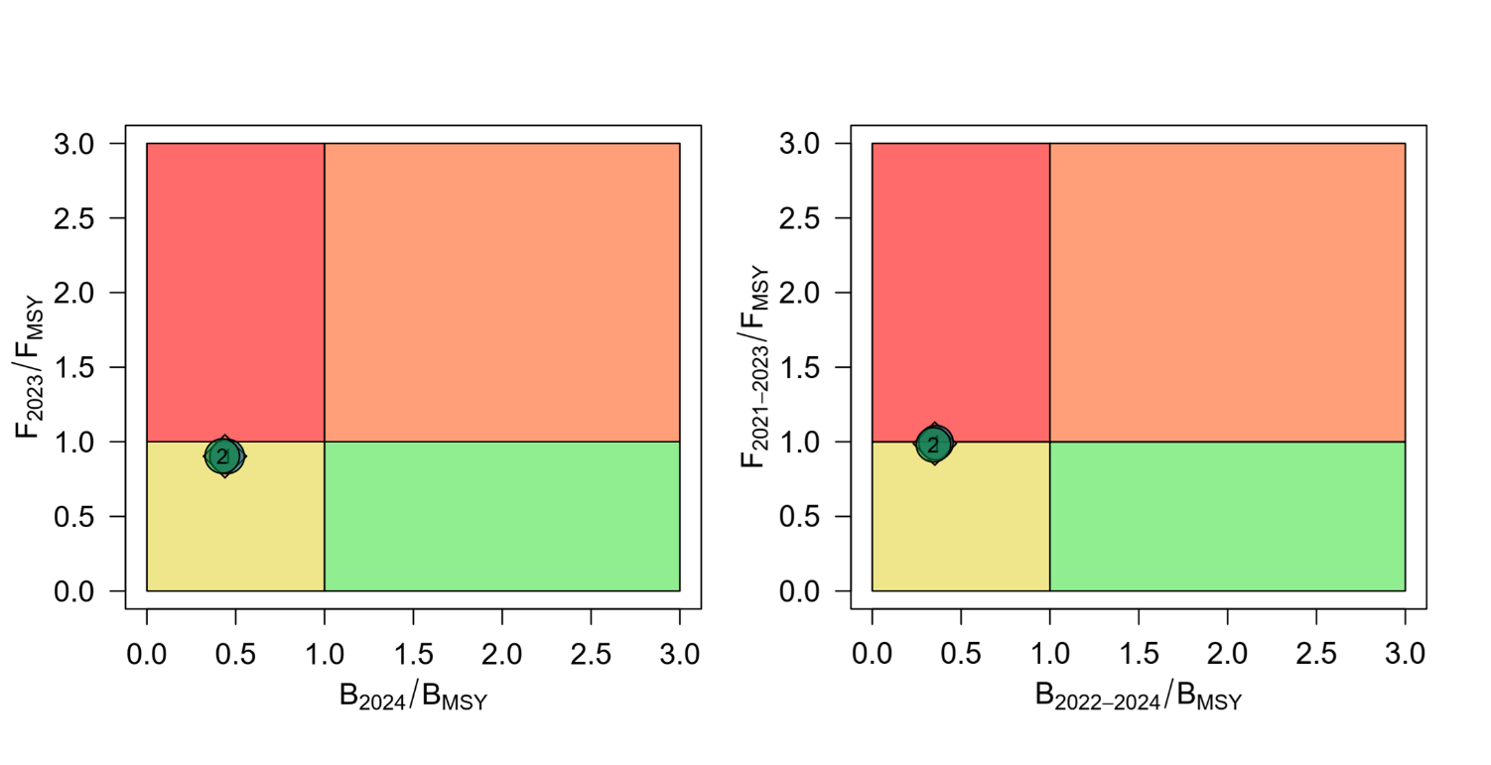

Figure 15. Kobe phase plot of stock status in the last year (2024 for B; 2023 for F) and recent three years (B2022 – 2024 and F2021 – 2023) of Pacific saury from the two base case models. The orange diamond is the median estimate of MCMC results from the two base case models.

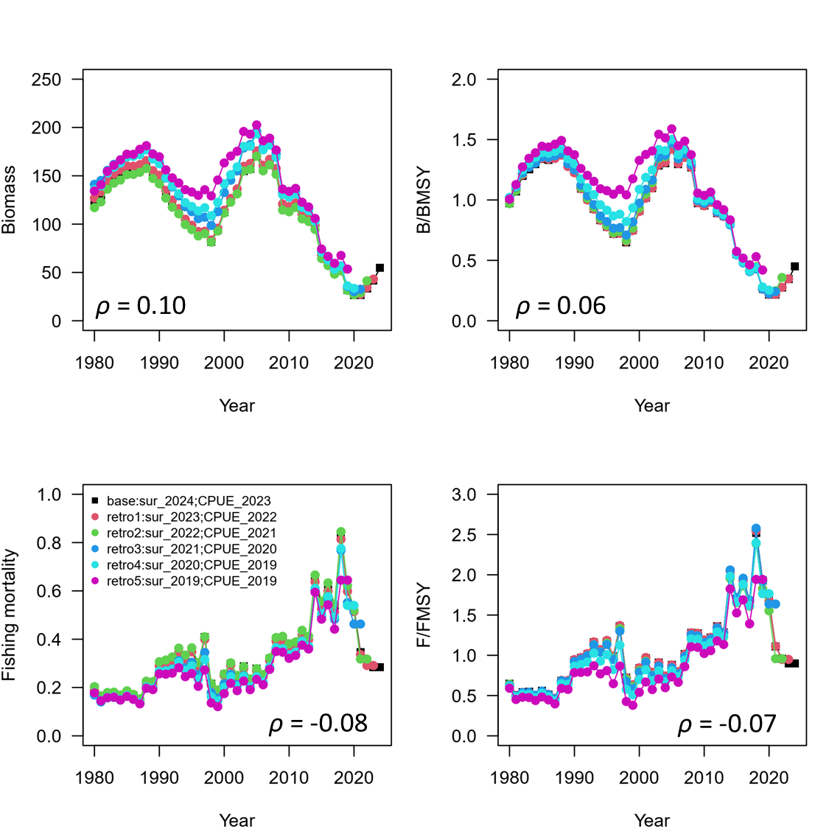

Figure 16. Five years within-model retrospective plots of the change in biomass, biomass to BMSY, harvest rate and harvest rate to FMSY of the western North Pacific saury from the base case 1.

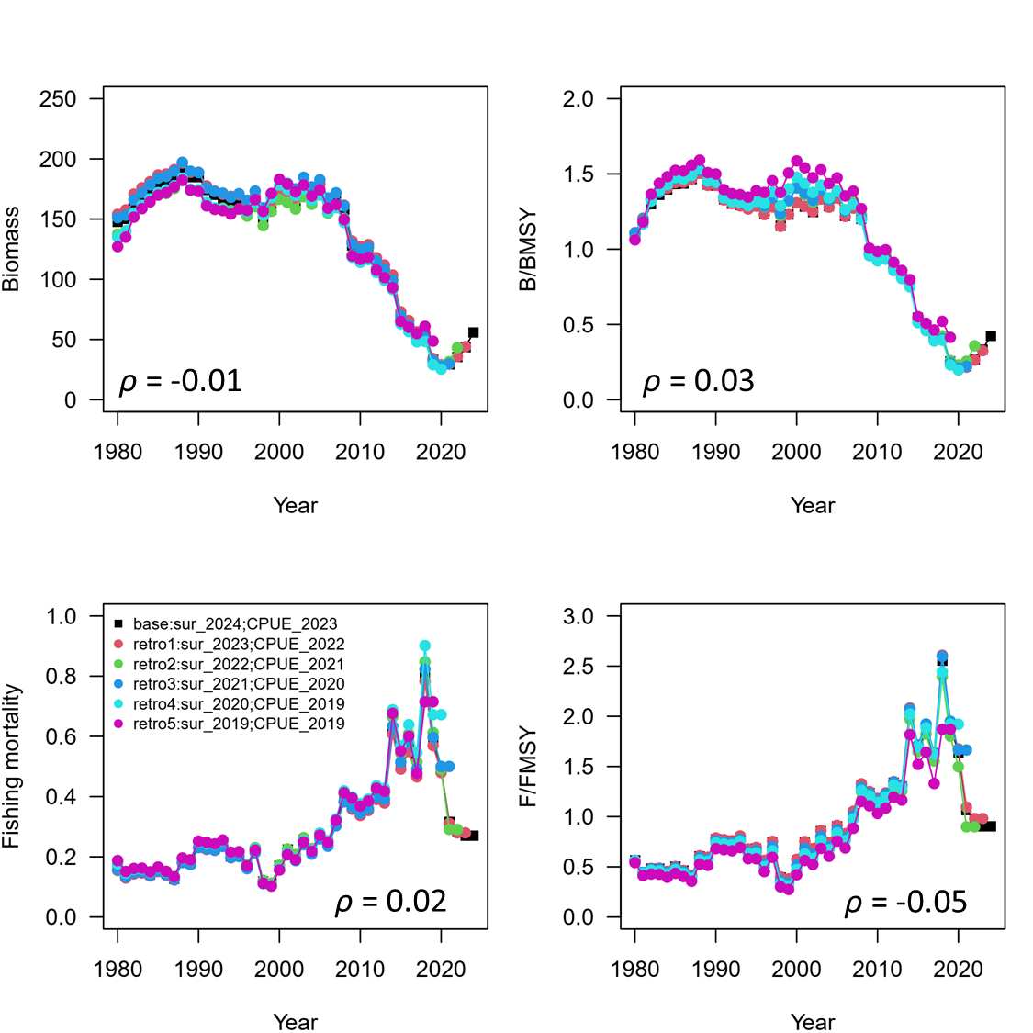

Figure 17. Five years within-model retrospective plots of the change in biomass, biomass to BMSY, harvest rate and harvest rate to FMSY of the western North Pacific saury from the base case 2.

**Appendix Tables**

Table A1. Summary of parameter estimates of the sensitivity case 1.

|  |  |  |  |  |
| --- | --- | --- | --- | --- |
|  | Mean | Median | Lower 10th | Upper 10th |
| *r* | 0.75 | 0.69 | 0.39 | 1.17 |
| *K* | 281.17 | 251.70 | 169.90 | 423.69 |
| *q*CHN | 0.45 | 0.38 | 0.19 | 0.78 |
| *q*JPN2 | 0.05 | 0.04 | 0.02 | 0.10 |
| *q*KOR | 0.28 | 0.23 | 0.12 | 0.50 |
| *q*RUS | 0.03 | 0.03 | 0.01 | 0.06 |
| *q*CT1 | 0.04 | 0.03 | 0.02 | 0.07 |
| *q*CT2 | 0.09 | 0.07 | 0.04 | 0.15 |
| *q*Bio | 0.54 | 0.53 | 0.33 | 0.77 |
| *M* | 1.02 | 0.90 | 0.37 | 1.81 |
| obser_error | 0.18 | 0.18 | 0.16 | 0.20 |
| obser_error_survey | 0.08 | 0.08 | 0.07 | 0.09 |
| process_error | 0.16 | 0.16 | 0.12 | 0.21 |
| FMSY | 0.32 | 0.31 | 0.18 | 0.47 |
| BMSY | 136.59 | 123.80 | 86.82 | 199.99 |
| MSY | 38.83 | 38.64 | 32.83 | 44.92 |
| *b* | 0.79 | 0.80 | 0.64 | 0.94 |
| *q*1980 | 0.0083 | 0.0065 | 0.0025 | 0.0162 |
| *q*1981 | 0.0079 | 0.0064 | 0.0027 | 0.0151 |
| *q*1982 | 0.0078 | 0.0064 | 0.0028 | 0.0146 |
| *q*1983 | 0.0084 | 0.007 | 0.0032 | 0.0152 |
| *q*1984 | 0.0089 | 0.0076 | 0.0036 | 0.0161 |
| *q*1985 | 0.0099 | 0.0085 | 0.0041 | 0.0175 |
| *q*1986 | 0.0106 | 0.0092 | 0.0045 | 0.0185 |
| *q*1987 | 0.0118 | 0.0103 | 0.0051 | 0.0202 |
| *q*1988 | 0.0141 | 0.0124 | 0.0062 | 0.0239 |
| *q*1989 | 0.0163 | 0.0143 | 0.0072 | 0.0278 |
| *q*1990 | 0.018 | 0.0158 | 0.0079 | 0.0309 |
| *q*1991 | 0.0208 | 0.0183 | 0.0089 | 0.0357 |
| *q*1992 | 0.0233 | 0.0202 | 0.0097 | 0.0405 |
| *q*1993 | 0.0247 | 0.021 | 0.0095 | 0.0445 |

Table A2. Summary of parameter estimates of the sensitivity case 2.

|  |  |  |  |  |
| --- | --- | --- | --- | --- |
|  | Mean | Median | Lower 10th | Upper 10th |
| *r* | 0.67 | 0.60 | 0.31 | 1.08 |
| *K* | 307.88 | 273.70 | 168.70 | 492.90 |
| *q*Bio | 0.52 | 0.50 | 0.30 | 0.78 |
| *q*Joint | 0.04 | 0.04 | 0.39 | 2.12 |
| *M* | 1.16 | 1.03 | 0.01 | 0.09 |
| obser_error | 0.30 | 0.29 | 0.24 | 0.35 |
| obser_error_survey | 0.13 | 0.13 | 0.11 | 0.16 |
| process_error | 0.15 | 0.15 | 0.12 | 0.20 |
| FMSY | 0.30 | 0.29 | 0.15 | 0.48 |
| BMSY | 152.43 | 137.50 | 88.80 | 234.59 |
| MSY | 39.22 | 39.53 | 32.00 | 46.18 |
| *b* | 0.68 | 0.69 | 0.50 | 0.87 |
| *q*1980 | 0.007 | 0.005 | 0.002 | 0.013 |
| *q*1981 | 0.006 | 0.005 | 0.002 | 0.011 |
| *q*1982 | 0.006 | 0.005 | 0.002 | 0.01 |
| *q*1983 | 0.006 | 0.005 | 0.002 | 0.011 |
| *q*1984 | 0.007 | 0.006 | 0.003 | 0.012 |
| *q*1985 | 0.008 | 0.007 | 0.003 | 0.013 |
| *q*1986 | 0.008 | 0.007 | 0.004 | 0.014 |
| *q*1987 | 0.009 | 0.008 | 0.004 | 0.014 |
| *q*1988 | 0.011 | 0.01 | 0.005 | 0.019 |
| *q*1989 | 0.014 | 0.012 | 0.006 | 0.022 |
| *q*1990 | 0.014 | 0.013 | 0.006 | 0.023 |
| *q*1991 | 0.017 | 0.016 | 0.008 | 0.028 |
| *q*1992 | 0.02 | 0.018 | 0.009 | 0.033 |
| *q*1993 | 0.02 | 0.018 | 0.009 | 0.034 |

Table A3. Summary of reference points of the sensitivity case 1.

|  |  |  |  |  |
| --- | --- | --- | --- | --- |
|  | Mean | Median | Lower 10th | Upper 10th |
| F2021-2023 | 0.30 | 0.29 | 0.17 | 0.45 |
| F2023 | 0.28 | 0.27 | 0.16 | 0.40 |
| FMSY | 0.32 | 0.31 | 0.18 | 0.47 |
| MSY | 38.83 | 38.64 | 32.83 | 44.92 |
| F2023/FMSY | 0.90 | 0.86 | 0.64 | 1.19 |
| F2021-2023/FMSY | 0.97 | 0.94 | 0.73 | 1.24 |
| *K* | 281.17 | 251.70 | 169.90 | 423.69 |
| B2023 | 48.70 | 44.60 | 29.46 | 72.20 |
| B2024 | 62.57 | 57.74 | 38.81 | 91.18 |
| B2022-2024 | 50.35 | 46.12 | 31.26 | 74.06 |
| BMSY | 136.59 | 123.80 | 86.82 | 199.99 |
| BMSY/K | 0.49 | 0.49 | 0.43 | 0.56 |
| B2023/K | 0.18 | 0.18 | 0.12 | 0.24 |
| B2024/K | 0.24 | 0.23 | 0.15 | 0.32 |
| B2022-2024/K | 0.19 | 0.18 | 0.13 | 0.25 |
| B2023/BMSY | 0.37 | 0.36 | 0.26 | 0.48 |
| B2024/BMSY | 0.48 | 0.46 | 0.32 | 0.65 |
| B2022-2024/BMSY | 0.38 | 0.37 | 0.27 | 0.49 |

Table A4. Summary of reference points of the sensitivity case 2.

|  |  |  |  |  |
| --- | --- | --- | --- | --- |
|  | Mean | Median | Lower 10th | Upper 10th |
| F2021-2023 | 0.30 | 0.28 | 0.15 | 0.47 |
| F2023 | 0.27 | 0.26 | 0.15 | 0.42 |
| FMSY | 0.30 | 0.29 | 0.15 | 0.48 |
| MSY | 39.22 | 39.53 | 32.00 | 46.18 |
| F2023/FMSY | 0.97 | 0.91 | 0.64 | 1.36 |
| F2021-2023/FMSY | 1.02 | 0.98 | 0.72 | 1.36 |
| *K* | 307.88 | 273.70 | 168.70 | 492.90 |
| B2023 | 51.18 | 45.90 | 28.22 | 79.49 |
| B2024 | 63.37 | 57.46 | 36.01 | 96.09 |
| B2022-2024 | 52.24 | 47.07 | 29.36 | 80.25 |
| BMSY | 152.43 | 137.50 | 88.80 | 234.59 |
| BMSY/K | 0.51 | 0.50 | 0.43 | 0.58 |
| B2023/K | 0.17 | 0.17 | 0.11 | 0.24 |
| B2024/K | 0.22 | 0.21 | 0.13 | 0.32 |
| B2022-2024/K | 0.18 | 0.17 | 0.12 | 0.25 |
| B2023/BMSY | 0.34 | 0.33 | 0.23 | 0.47 |
| B2024/BMSY | 0.44 | 0.42 | 0.27 | 0.63 |
| B2022-2024/BMSY | 0.35 | 0.34 | 0.24 | 0.48 |

**Appendix Figures**

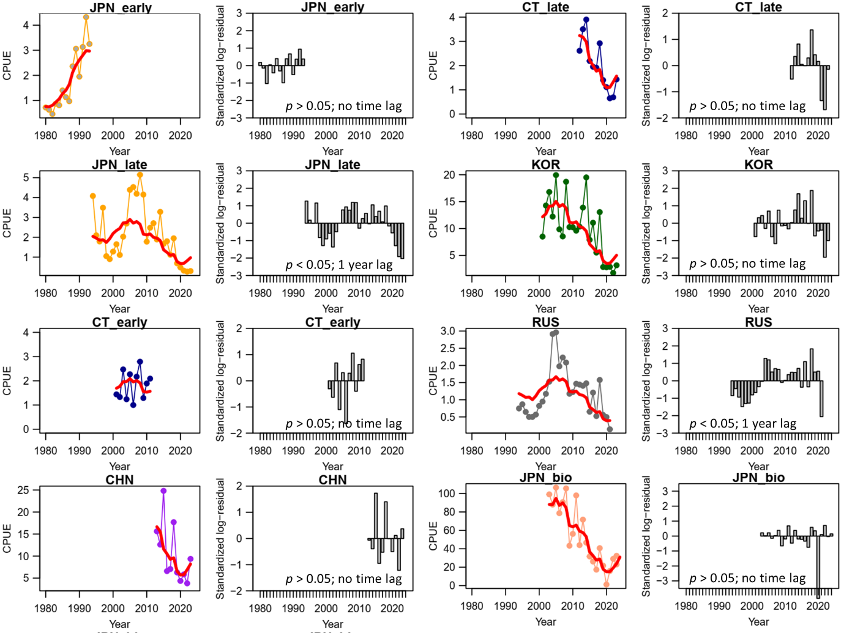

Figure A1. Time-series of observed (circle-line) and predicted (red solid line) catch per unit effort (CPUE) of Western North Pacific saury and standardized log-residuals for the sensitivity case 1 production model. “JPN_early = early Japan (1980-1993)”, “JPN_late” = late Japan (1994-2023), “CT_early” = early Chinese Taipei (2001-2010), “CT_late” = late Chinese-Taipei (2011-2023), “RUS” = Russia, “KOR” = Korea, “CHN” = China, JPN_bio” = Japanese biomass survey.

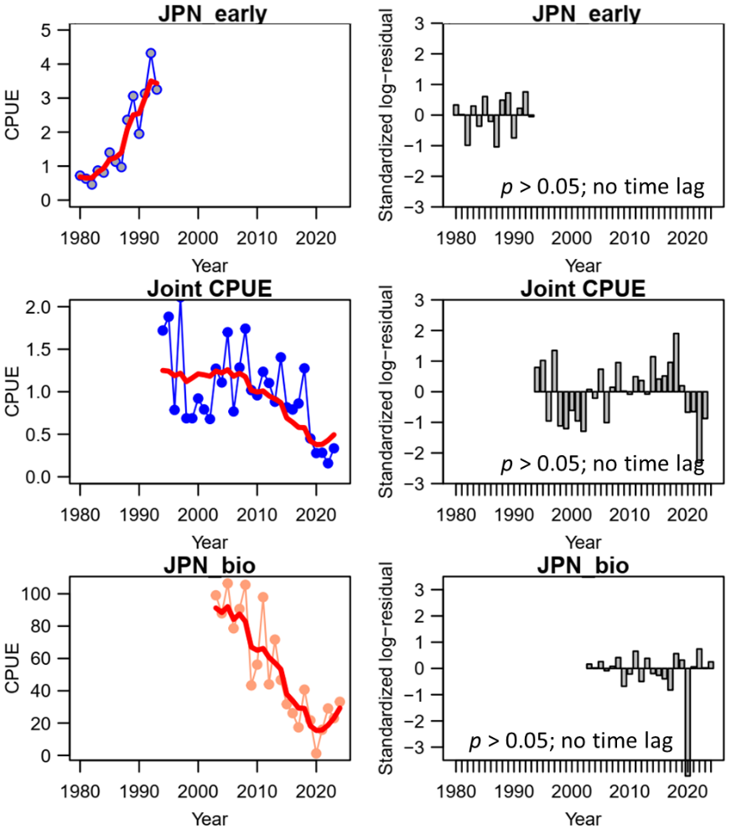

Figure A2. Time-series of observed (circle-line) and predicted (red solid line) catch per unit effort (CPUE) of Western North Pacific saury and standardized log-residuals for the sensitivity case 2 production model. “JPN_early = early Japan (1980-1993)”, “Joint CPUE” = joint CPUE index (1994-2023), and “JPN_bio” = Japanese biomass survey (2003-2024).

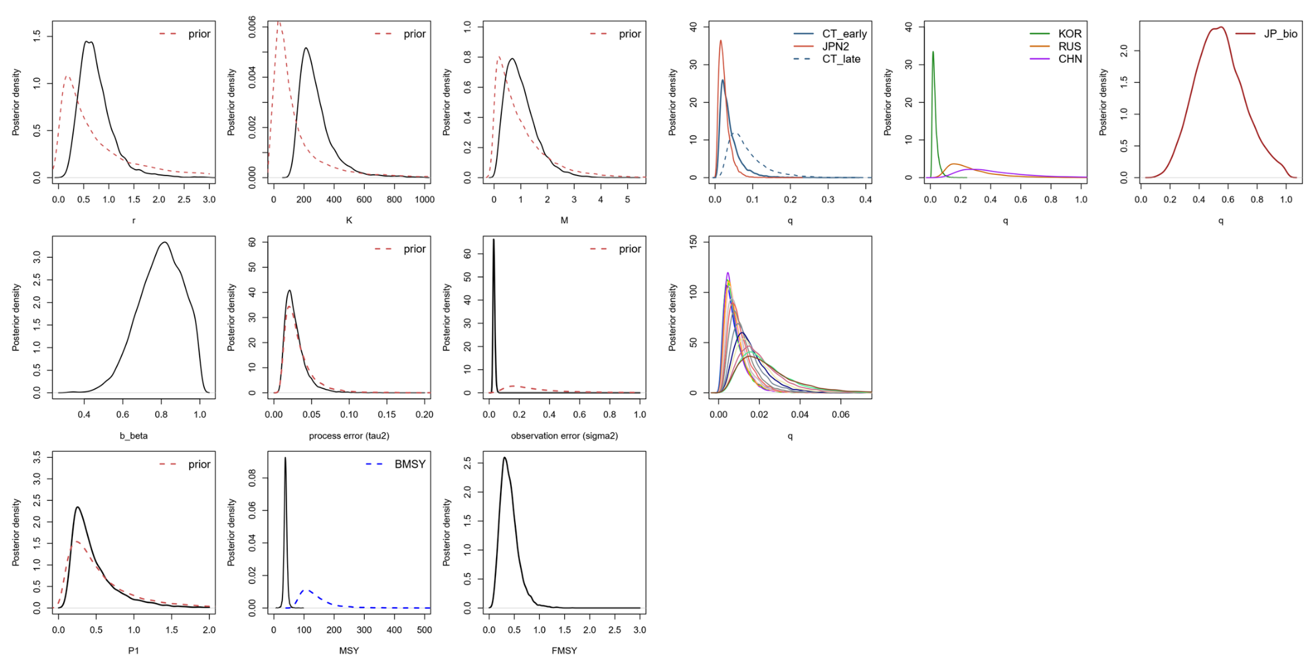

Figure A3. Kernel density estimates of the posterior distributions (solid lines) of various model parameters and management quantities for the sensitivity case 1 production model for the Pacific saury in the Western North Pacific Ocean. Proper prior densities are given by the dashed lines. “JPN2” = late Japan (1994-2022), “CT_early” = early Chinese Taipei (2001-2010), “CT_late” = late Chinese-Taipei (2011-2023); “RUS” = Russia, “KOR” = Korea, “CHN” = China, “JP_bio” = Japanese biomass survey.

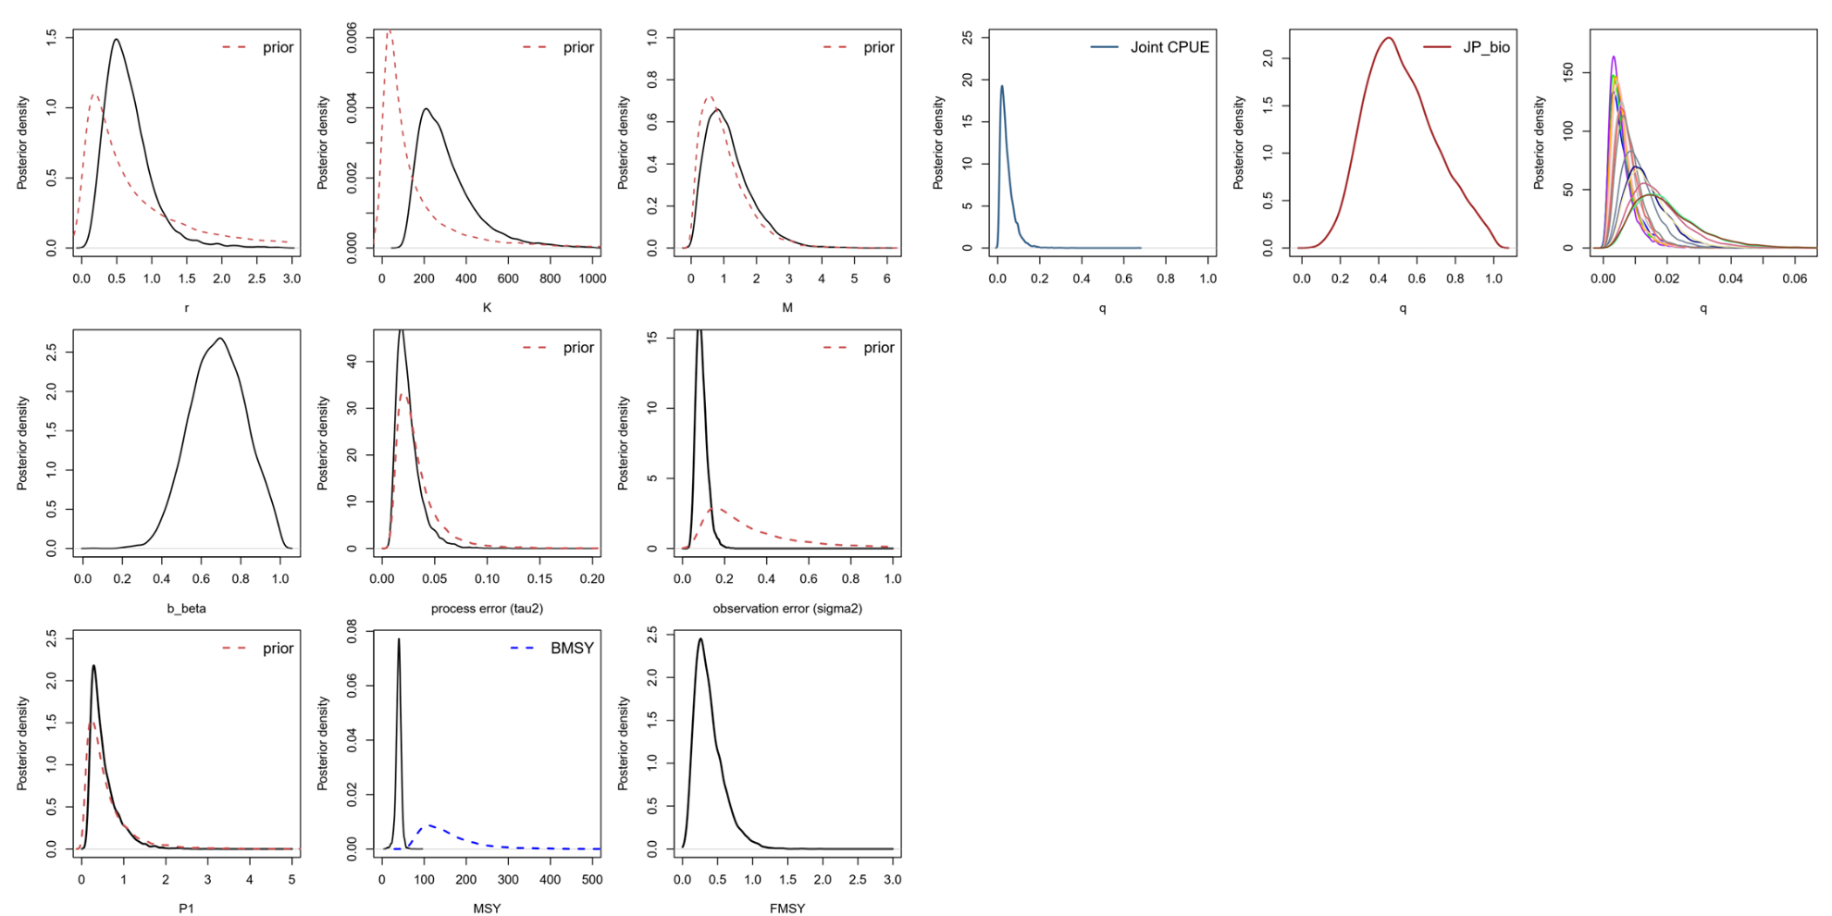

Figure A4. Kernel density estimates of the posterior distributions (solid lines) of various model parameters and management quantities for the sensitivity case 2 production model for the Pacific saury in the Western North Pacific Ocean. Proper prior densities are given by the dashed lines. “Joint CPUE” = Joint CPUE index, “JP_bio” = Japanese biomass survey.

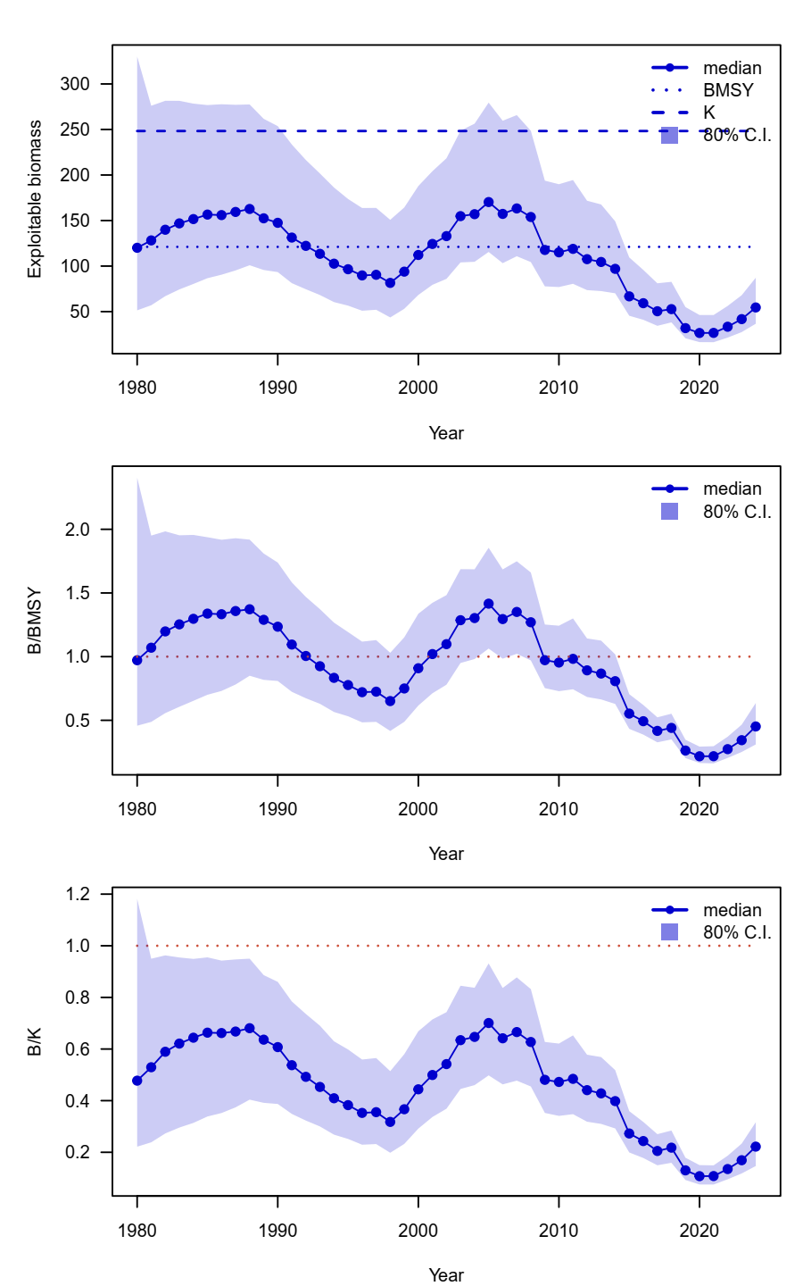

Figure A5. Time series of ensemble biomass (10,000 metric ton), the ratio of biomass to BMSY (B/BMSY), and the depletion ratio (B/K) of the western North Pacific saury for the median estimates of MCMC results from base case 1.

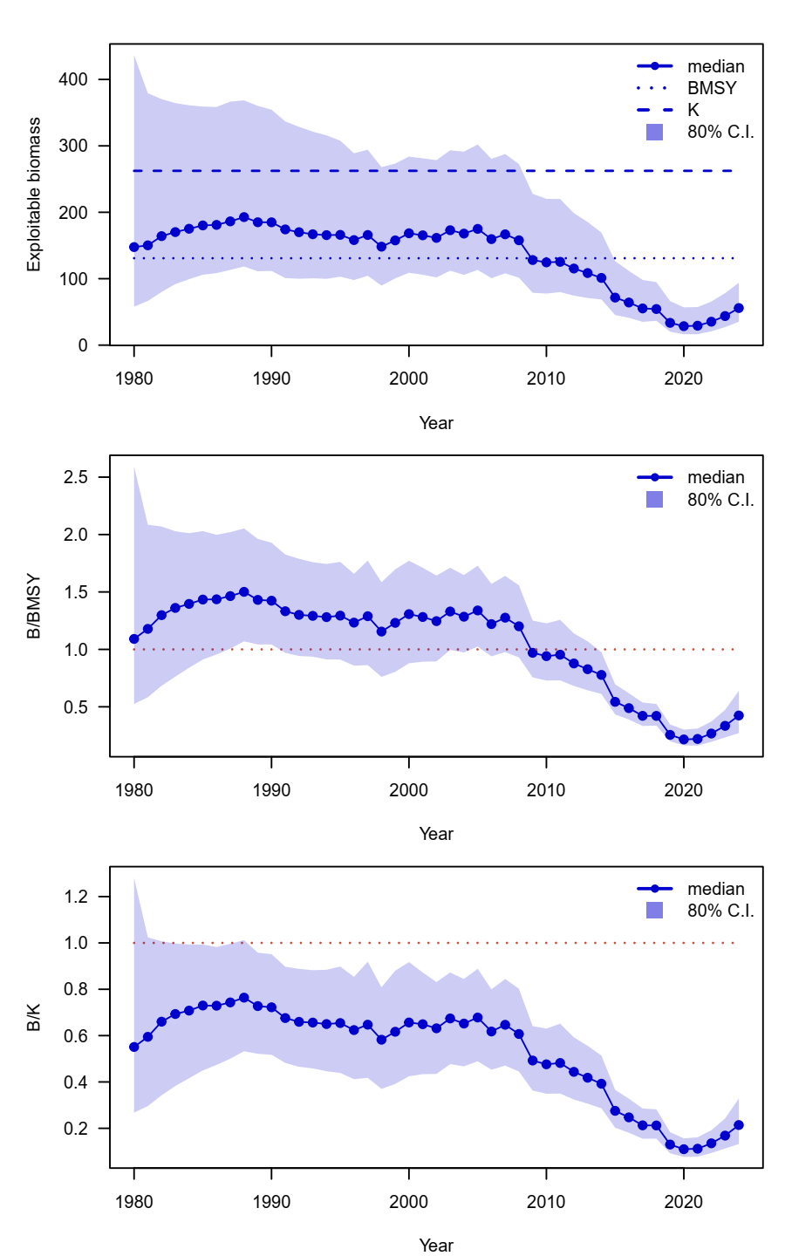

Figure A6. Time series of ensemble biomass (10,000 metric ton), the ratio of biomass to BMSY (B/BMSY), and the depletion ratio (B/K) of the western North Pacific saury for the median estimates of MCMC results from base case 2.

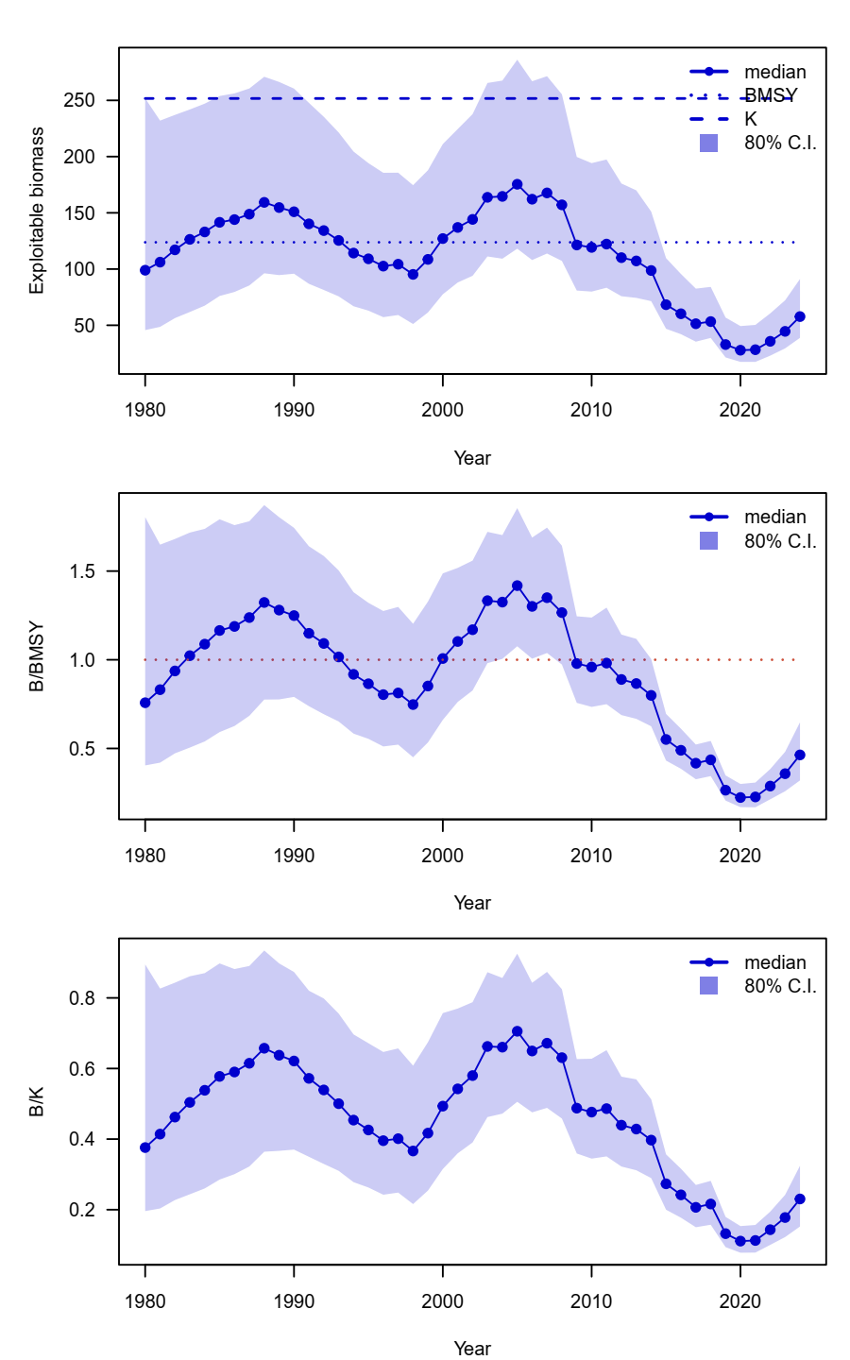

Figure A7. Time series of ensemble biomass (10,000 metric ton), the ratio of biomass to BMSY (B/BMSY), and the depletion ratio (B/K) of the western North Pacific saury for the median estimates of MCMC results from sensitivity case 1.

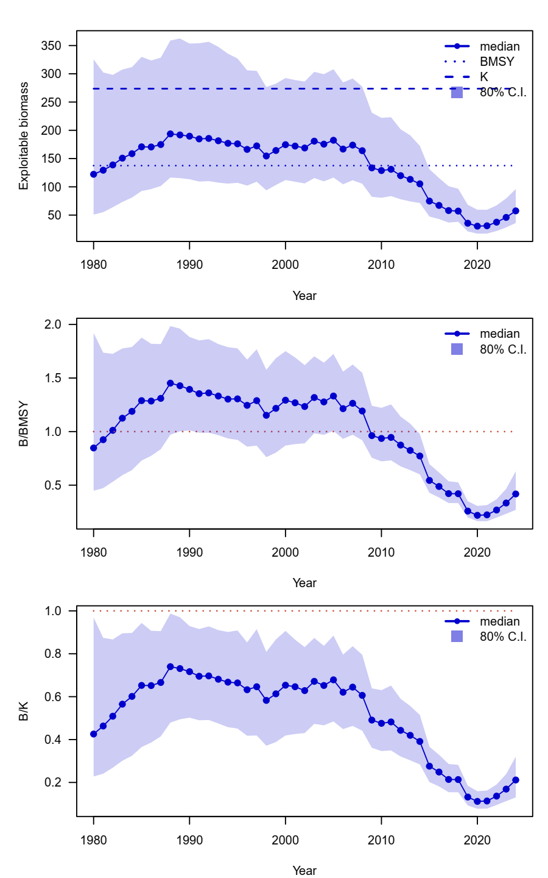

Figure A8. Time series of ensemble biomass (10,000 metric ton), the ratio of biomass to BMSY (B/BMSY), and the depletion ratio (B/K) of the western North Pacific saury for the median estimates of MCMC results from sensitivity case 2.

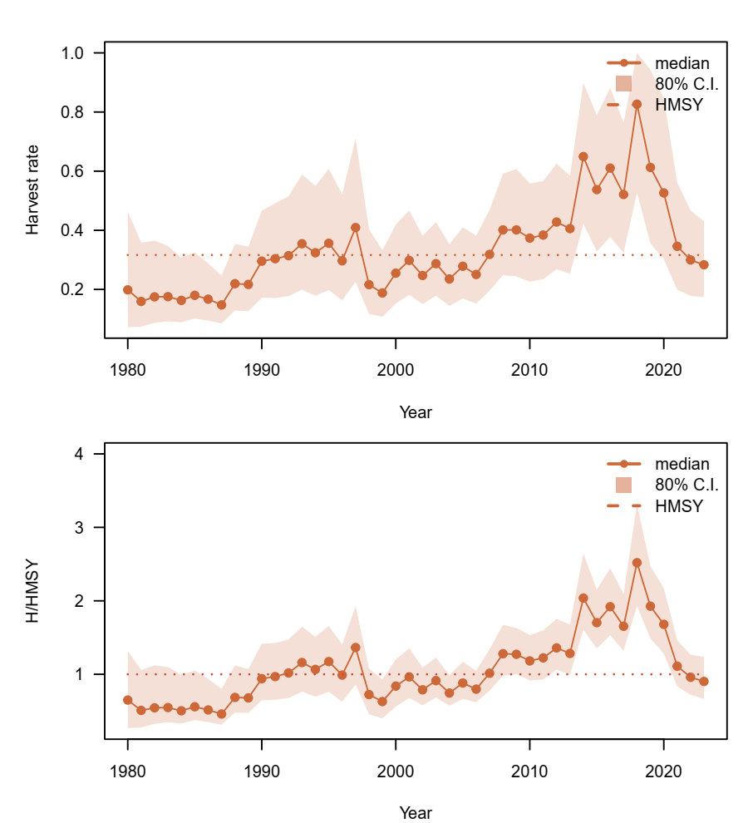

Figure A9. Time-series of fishing mortality and the ratio of fishing mortality to FMSY (F/FMSY) of the western North Pacific saury for the median estimates of MCMC results from base case1.

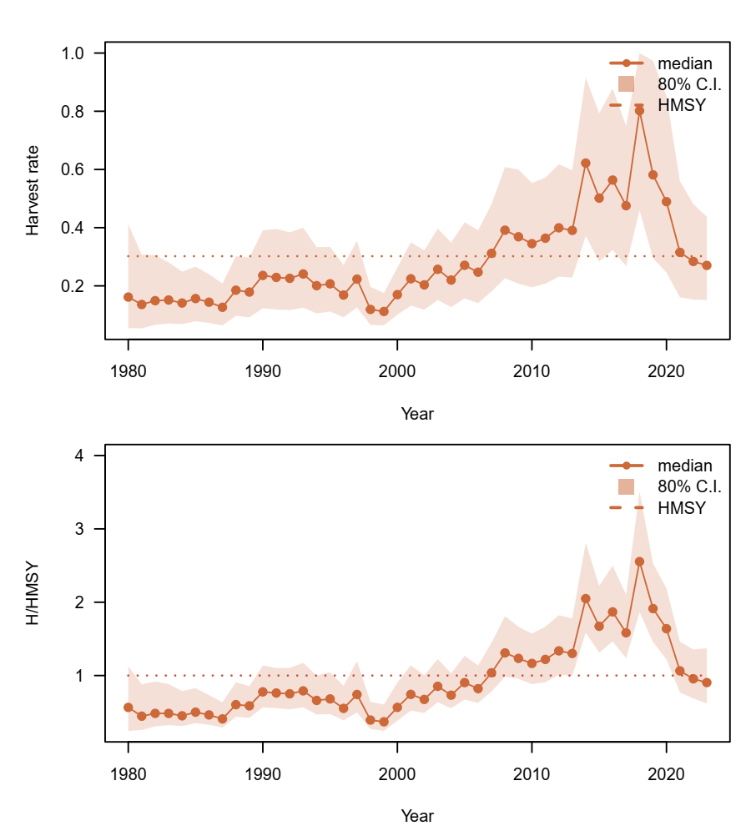

Figure A10. Time-series of fishing mortality and the ratio of fishing mortality to FMSY (F/FMSY) of the western North Pacific saury for the median estimates of MCMC results from base case2.

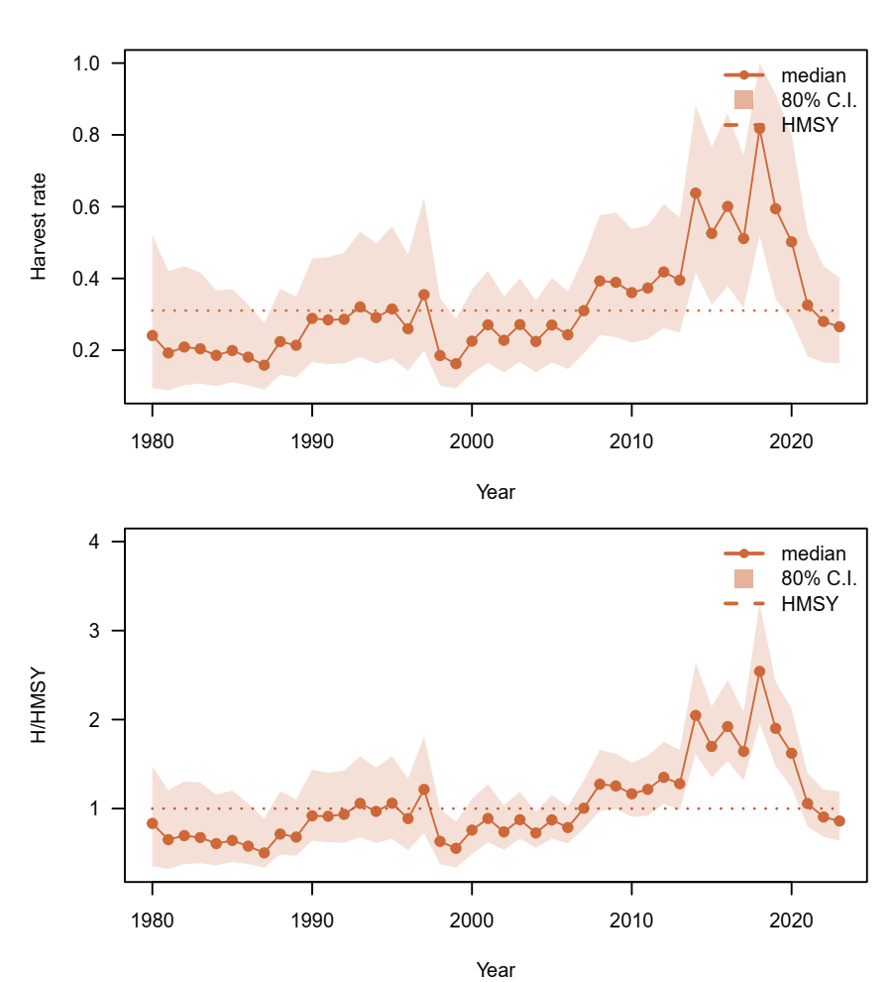

Figure A11. Time-series of fishing mortality and the ratio of fishing mortality to FMSY (F/FMSY) of the western North Pacific saury for the median estimates of MCMC results from sensitivity case1.

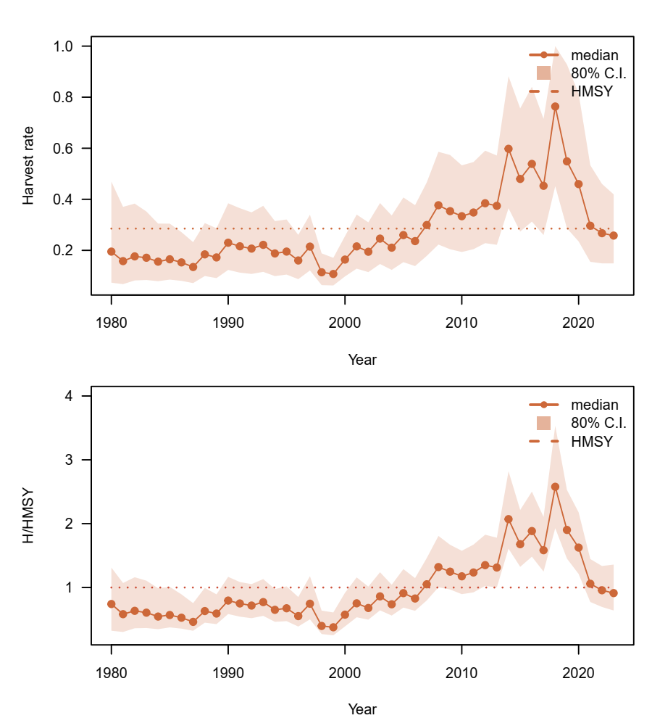

Figure A12. Time-series of fishing mortality and the ratio of fishing mortality to FMSY (F/FMSY) of the western North Pacific saury for the median estimates of MCMC results from sensitivity case2.

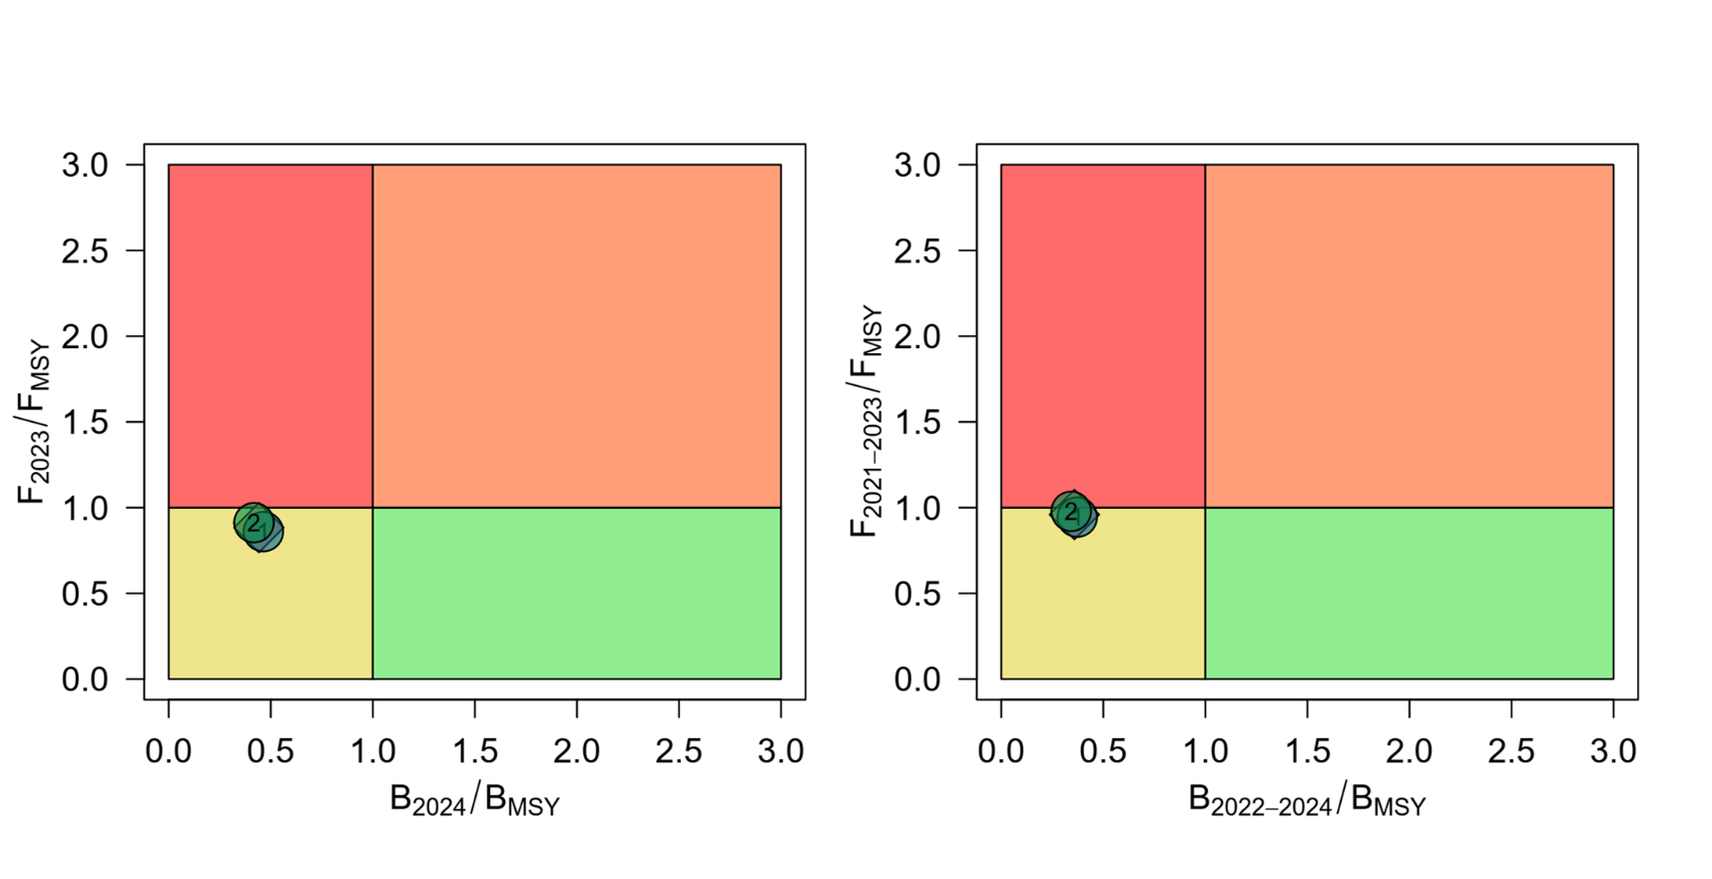

Figure A13. Kobe phase plot of stock status in the last year (2024 for B; 2023 for F) and recent three years (B2022 – 2024 and F2021 – 2023) of Pacific saury from the two sensitivity case models. The orange diamond is the median estimate of MCMC results from the two sensitivity case models