NPFC-2024-SSC PS14-WP10

Updates of stock assessment for Pacific saury in the North Pacific Ocean up to 2024

Libin Dai and Siquan Tian
College of Marine Living Resource Sciences and Management, Shanghai Ocean University

Summary
This working paper presents the update results of stock assessment for the North Pacific Ocean Pacific Saury stock using the Bayesian state-space production model. The assessment was conducted based on the model specification (2 base cases and 2 sensitivity cases) updated in the 13th Meeting of the Small Scientific Committee on Pacific saury. The model parameters were estimated based on Bayesian framework with a Markov chain Monte Carlo method. The assessment results were diagnosed with the Gelman and Rubin’s statistic, standardized residual plots, the shapes of posterior distributions for key parameters, and retrospective analysis. The main assessment results were concluded as follows:
The estimated median B₂₀₂₃ and B₂₀₂₄ over the two base case scenarios were 378,300 (80%CI 240,200-799,100) and 509,200 (80%CI 343,900-923,600) metric tons, respectively. The median B₂₀₂₄/B_{MSY} and F₂₀₂₃/F_{MSY} over the two base case scenarios were 0.43 (80%CI 0.25-0.62) and 0.92 (80%CI 0.66-1.51), respectively. For the most recent three years average values, B₂₀₂₂₋₂₀₂₄ was estimated below the B_{MSY} (B₂₀₂₂₋₂₀₂₄/B_{MSY}=0.34, 80%CI 0.23-0.46), and F₂₀₂₁₋₂₀₂₃ was estimated to be above F_{MSY} (F₂₀₂₁₋₂₀₂₃/F_{MSY}=1.01, 80%CI 0.77-1.52). Over the years, there have been decadal and interannual fluctuations in the biomass trend. Approximately after 2005, the biomass displayed a downward trajectory, albeit with interannual variation. The lowest biomass was recorded in 2020, but a recovery trend has been noted in from 2020 to 2024. Since 1999, the harvest rate has shown an upward trend, but it has rapidly declined since 2018. The probability of the 2023 stock status being in the yellow quadrant of Kobe plot (Prob[B₂₀₂₃<B_{MSY} and F₂₀₂₃<F_{MSY}]) was estimated to be 62%.

1.0 Introduction
Pacific saury (Cololabis sarira) is one of the most commercially important fish species in the North Pacific Ocean. The regular update of stock assessment for Pacific saury in each year is conducted by the Small Scientific Committee on Pacific saury (SSC PS) established under the Scientific Committee of the North Pacific Fisheries Commission (NPFC). Currently, the benchmark stock assessment model for Pacific saury stock assessment is Bayesian state-space production model (BSSPM). In the 9th SSC PS meeting, the model specification of BSSPM was revised. The group agreed to conduct a stock assessment update using two base cases and two sensitivity cases based on updated input data. In the 13th SSC PS meeting, members decided to maintain the framework of the existing model specification but with modifications: the Chinese Taipei standardized CPUE index was split into two periods, each with separate fixed catchability coefficients. Accordingly, the case scenarios were updated.
In this report, we conducted an update of stock assessment for Pacific saury by using BSSPM, and summarized the estimates of key parameters and biological reference points as well as other assessment results for all case scenarios.

2.0 Materials and methods
2.1 Input data
The input data used in this assessment included (Figure 1):
- The total catch from 1980 to 2023 were included.
- The Japanese fishery-independent survey biomass estimates up to 2024 were included.
- The fishery-dependent abundance indices, including Japanese early CPUE (1980-1993), Japanese late CPUE (1994-2023), Russian CPUE (1994-2021), Chinese Taipei CPUE (2001-2023), Korean CPUE (2001-2023), Chinese CPUE (2013-2023) and joint CPUE (1994-2023) were included.

2.2 Assessment methods
The assessment used a Bayesian state-space production model. The population dynamics were modeled by the following equations:
$B_{t}=B_{t-1}+r×B_{t-1}(1-{(\frac{B_{t-1}}{K})}^{M})-C_{t-1}$
$P_{t }=B_{t}/K$
$P_{t+1 }= (P_{t}+r×P_{t}×(1-P_{t}^{M})-\frac{C_{t}}{K})exp(μ_{t})$
$μ_{t}\sim N(0, τ^{2})$
Where $B_{t}$ and $C_{t}$ denote biomass and catch, respectively, in year t. Parameters r, K, M represent intrinsic population growth rate, carrying capacity, and production shape parameter respectively. $P_{t }$ and $μ_{t}$ denote the ratio between biomass and carrying capacity and the process error, respectively, in year t. $μ_{t}$ has a mean of zero and variance $τ^{2}$.
The multiple indices were modeled by the following equations:
$I_{i,t} = q_{i,t}{(KP_{t})}^{b_{i}}exp(ε_{i,t})$
$ε_{i,t}\sim N(0,σ_{i}^{2})$
Where $I_{i,t}$ is the relative abundance of index i at year t. $q_{i,t}$ is the catchability coefficient for index i at year t. $b_{i}$ is the hyperdepletion parameter. $ε_{i,t}$ is the observation error with a mean of zero and variance $σ_{i}^{2}$.
The four case scenarios were built based on SSC PS13 recommendation and used uniform prior distribution for catchability (q; besides the catchability of Japanese early CPUE), carrying capacity (K), intrinsic population growth rate (r), initial biomass as a proportion of carrying capacity (P1), and shape parameter (s) (Table 1-2). Inverse gamma prior distribution was used for the process (τ²) and observation (σ²) error variance (Table 2). Random walk approach was selected to estimate the time-varying catchability of Japanese early CPUE.

2.3 Model diagnostics
The convergence of the posterior distributions of model parameters was examined with Gelman and Rubin's statistics (Gelman and Rubin 1992). MSY-based biological reference points were estimated from the models. Mean error between predicted and observed indices was calculated to determine the model goodness of fit. Mean errors of each scenario were used to compare the performance of models. A lower mean error indicates a better fit. A retrospective analysis was conducted to verify whether any possible systematic inconsistencies exist among the model estimates of biomass and harvest rate based on increasing periods of data (Mohn 1999). The data were removed from the year 2024 to 2019 in the retrospective analysis. A sensitivity analysis was conducted to understand whether the assessment results were robust to the inclusion of Japanese early CPUE (S1-S2).

3.0 Assessment results
The posterior densities of model parameters from all case scenarios showed that the densities were smooth and unimodal (Appendix Figure 1-4). The estimated mean, median, and 80% CI of posterior estimates of reference points were summarized in Table 3 and Appendix Table 1-4. Mean, median, and 80% CI of the posterior estimates of model parameters from each scenario were summarized in Appendix Table 5-8. The time series of biomass and harvest rate, Bratio (B/B_{MSY}), Fratio (F/F_{MSY}), and B/K from each case scenarios were summarized in Figure 2-11.

- Diagnostics
All parameters from the base case and sensitivity case scenarios showed well convergence of posterior distributions with Gelman and Rubin’s statistic for all parameters equal to 1. The standardized residuals between predicted and observed indices from base case scenarios and sensitivity case scenarios showed similar patterns (Appendix Figure 5-8). Temporal patterns could be observed from Japanese late CPUE and Russian CPUE (Appendix Figure 5-8). The retrospective analysis suggested that case scenarios without Japanese early CPUE had a larger consistent pattern of bias in the estimates of the terminal exploitable biomass and harvest rate (Appendix Figure 9-16). The strong retrospective patten is likely to be induced by large model scale uncertainty. The sensitivity analysis results showed that the inclusion of Japanese early CPUE will impact the scale of estimated biomass and harvest rate during the early period. However, the scale difference is small in the recent years and the stock status and depletion level is consistent over all case scenarios (Figure 2, 4, 6, 8, 10).

5.0 Time series of stock size and harvest rate
The time series plots of biomass and harvest rate across the two base cases revealed both decadal and interannual fluctuations. Prior to the 2010s, the estimated biomass exceeded one million metric tons. There was a notable increase in biomass during the 1980s, followed by a decline throughout the 1990s, and subsequently, an increase in the 2000s. Approximately after 2005, the biomass displayed a downward trajectory, albeit with interannual variation. The lowest biomass was recorded in 2020, but a recovery trend has been noted in recent years. Meanwhile, the harvest rate demonstrated an upward trend since 1999 but has rapidly declined in recent years (Figures 3 and 5). The Kobe plots illustrated that the Bratio and Fratio for base case 1 and base case 2 in 2023 were situated in the yellow and red quadrants, respectively (Figure 12). The averaged Bratio (2022-2024) and Fratio (2021-2023) of the two base cases fell within the red quadrant of the Kobe plot (Figure 13). Figure 14 displays the Kobe plot with median Fratio and Bratio time series from 1980 to 2023 across two base cases. The probability of the stock being in the yellow quadrant of the Kobe plot in 2023 is 62%.

Acknowledgement
This study was supported by Program on the Survey, Monitoring and Assessment of Global Fishery Resources (Comprehensive scientific survey of fisheries resources at the high seas) sponsored by the Ministry of Agriculture and Rural Affairs of China.

References
Gelman, A., Rubin, D.B. 1992. Inference from iterative simulation using multiple sequences. Stat. Sci. 7, 457-511.
Mohn, R. 1999. The retrospective problem in sequential population analysis: An investigation using cod fishery and simulated data. ICES J. Mar. Sci. 56, 473-488.
Small Scientific Committee on Pacific Saury. 2019. 5th Meeting Report. NPFC-2019-SSC PS05-Final Report. 44 pp.
Small Scientific Committee on Pacific Saury. 2022. 9th Meeting Report. NPFC-2022-SSC PS09-Final Report. 23 pp.
Small Scientific Committee on Pacific Saury. 2024. 13th Meeting Report. NPFC-2024-SSC PS13-Final Report. 35 pp.

Table 1. Definition of base cases and sensitivity cases (NPFC-2024-SSC PS13-Final Report Annex G).
 | Base case (B1) | Base case (B2) | Sensitivity case (S1) | Sensitivity case (S2)
Initial year | 1980 | 1980 | 1980 | 1980
Biomass survey | $$I_{t,bio}=q_{bio}B_{t}e^{v_{t,bio}}$$  $$v_{t,bio}\sim N(0,{cv}_{t, bio}^{2}+σ^{2})$$  $$q_{bio}\sim U\left(0,1\right)$$  (2003-2024) | Same as left | Same as left | Same as left
CPUE | CHN(2013-2023)  JPN_late(1994-2023)  KOR(2001-2023)  RUS(1994-2021)  CT(2001-2011, 2012-2023)  $$I_{t,f}=q_{f}B_{t}^{b}e^{v_{t,f}}$$  $$v_{t,f}\sim N(0,σ_{f}^{2})$$  $σ_{f}^{2}=c∙(ave\left({cv}_{t,bio}^{2}\right)+σ^{2})$, c=5  $ave\left({cv}_{t,bio}^{2}\right)$ is computed except for 2020 survey | Joint CPUE (1994-2023)  $$I_{t,joint}=q_{joint}B_{t}^{b}e^{v_{t,joint}}$$  $$v_{t,joint}\sim N(0, {cv}_{t,joint}^{2}+σ^{2})$$ | CHN(2013-2023)  JPN_early(1980-1993, time-varying q)  JPN_late(1994-2023)  KOR(2001-2023)  RUS(1994-2021)  CT(2001-2011, 2012-2023)  $$I_{t,f}=q_{f}B_{t}^{b}e^{v_{t,f}}$$  $$v_{t,f}\sim N(0,σ_{f}^{2})$$  $σ_{f}^{2}= c∙(ave\left({cv}_{t,bio}^{2}\right)+σ^{2})$ c=6  $ave\left({cv}_{t,bio}^{2}\right)$ is computed except for 2020 survey | JPN_early(1980-1993, time-varying q)  $$I_{t,JE}=q_{t,JE}B_{t}^{b}e^{v_{t,JE}}$$  $$v_{t,JE}\sim N(0,σ_{JE}^{2})$$  $$σ_{JE}^{2}=c ∙(ave({cv}_{t,joint}^{2})+σ^{2})$$  Joint CPUE (1994-2023)  $$I_{t,joint}=q_{joint}B_{t}^{b}e^{v_{t,joint}}$$  $$v_{t,joint}\sim N(0,{cv}_{t,joint}^{2}+σ^{2})$$
Hyper-  depletion/  stability | A common parameter for all fisheries with a prior distribution, b~U(0, 1) | b~U(0, 1) | A common parameter for all fisheries but JPN_early, with a prior distribution, b~U(0, 1) [b for JPN_early is fixed at 1] | b~U(0, 1) for joint CPUE. [b for JPN_early is fixed at 1]
Prior for other than q_bio | Own preferred options | Own preferred options | Own preferred options | Own preferred options

Table 2. Prior assumptions of parameters that are not listed in SSC PS05 Report Annex G.
 | B1 | B2 | S1 | S2
q_CPUE | U(0,1) for qJPN_late, qRUS, qCT_early and qCT_late; U(0,5) for qKOR and qCHN | U(0,1) for qJoint | U(0,1) for qJPN_early, qJPN_late, qCT_early and qCT_late; U(0,5) for qRUS, qKOR and qCHN | U(0,1) for qJPN_early and qJoint
K | U(63,1890)
r | U(0,3)
P1 | U(0,1)
s | U(0,3)
σ² | 1/σ²~Gamma(0.001, 0.001)
τ² | 1/τ²~Gamma(0.001, 0.001)

Table 3. Summary of reference points over 2 base case scenarios.
 | Mean | Median | Lower | Upper
C2023 (10,000 tons) | 11.84 | 11.84 | 11.84 | 11.84
AveC2021-2023 | 10.35 | 10.35 | 10.35 | 10.35
AveF2021-2023 | 0.35 | 0.35 | 0.15 | 0.56
F2023 | 0.32 | 0.31 | 0.15 | 0.49
FMSY | 0.35 | 0.36 | 0.11 | 0.58
MSY (10,000 tons) | 40.31 | 40.15 | 32.04 | 48.22
F2023/FMSY | 1.15 | 0.92 | 0.66 | 1.51
AveF2021-2023/FMSY | 1.22 | 1.01 | 0.77 | 1.52
K (10,000 tons) | 346.45 | 234.1 | 142.49 | 694.22
B2023 (10,000 tons) | 47.31 | 37.83 | 24.02 | 79.91
B2024 (10,000 tons) | 60.14 | 50.92 | 34.39 | 92.36
AveB2022-2024 | 49.06 | 39.71 | 26.37 | 80.77
BMSY (10,000 tons) | 161.43 | 113.8 | 74.33 | 311.61
BMSY/K | 0.49 | 0.48 | 0.4 | 0.6
B2023/K | 0.16 | 0.16 | 0.1 | 0.22
B2024/K | 0.21 | 0.21 | 0.11 | 0.31
B2022-2024/K | 0.17 | 0.17 | 0.1 | 0.23
B2023/BMSY | 0.33 | 0.32 | 0.22 | 0.43
B2024/BMSY | 0.44 | 0.43 | 0.25 | 0.62
B2022-2024/BMSY | 0.34 | 0.34 | 0.23 | 0.46

Appendix table 1. Summary of reference points from base case scenario 1.
 | Mean | Median | Lower 10th | Upper 10th
C2023 (10,000 tons) | 11.84 | 11.84 | 11.84 | 11.84
AveC2021-2023 | 10.35 | 10.35 | 10.35 | 10.35
AveF2021-2023 | 0.44 | 0.44 | 0.28 | 0.60
F2023 | 0.38 | 0.38 | 0.23 | 0.51
FMSY | 0.44 | 0.45 | 0.28 | 0.62
MSY (10,000 tons) | 42.04 | 41.20 | 34.09 | 47.83
F2023/FMSY | 0.90 | 0.86 | 0.60 | 1.11
AveF2021-2023/FMSY | 1.02 | 0.98 | 0.73 | 1.24
K (10,000 tons) | 225.97 | 191.55 | 113.10 | 266.40
B2023 (10,000 tons) | 34.52 | 31.16 | 19.94 | 43.28
B2024 (10,000 tons) | 49.04 | 44.67 | 29.86 | 60.91
AveB2022-2024 | 37.10 | 33.46 | 22.62 | 45.28
BMSY (10,000 tons) | 106.17 | 92.23 | 62.36 | 125.40
BMSY/K | 0.49 | 0.48 | 0.39 | 0.55
B2023/K | 0.17 | 0.16 | 0.11 | 0.22
B2024/K | 0.24 | 0.23 | 0.15 | 0.32
B2022-2024/K | 0.18 | 0.18 | 0.12 | 0.23
B2023/BMSY | 0.34 | 0.33 | 0.23 | 0.43
B2024/BMSY | 0.49 | 0.48 | 0.33 | 0.63
B2022-2024/BMSY | 0.37 | 0.36 | 0.26 | 0.46

Appendix table 2. Summary of reference points from base case scenario 2.
 | Mean | Median | Lower 10th | Upper 10th
C2023 (10,000 tons) | 11.84 | 11.84 | 11.84 | 11.84
AveC2021-2023 | 10.35 | 10.35 | 10.35 | 10.35
AveF2021-2023 | 0.27 | 0.24 | 0.08 | 0.41
F2023 | 0.25 | 0.23 | 0.08 | 0.37
FMSY | 0.26 | 0.24 | 0.04 | 0.42
MSY (10,000 tons) | 38.57 | 38.71 | 29.91 | 47.41
F2023/FMSY | 1.40 | 1.00 | 0.54 | 1.52
AveF2021-2023/FMSY | 1.43 | 1.06 | 0.68 | 1.52
K (10,000 tons) | 466.93 | 337.85 | 108.40 | 664.70
B2023 (10,000 tons) | 60.09 | 50.95 | 21.24 | 80.15
B2024 (10,000 tons) | 71.24 | 61.39 | 28.53 | 91.17
AveB2022-2024 | 61.03 | 51.71 | 22.71 | 80.93
BMSY (10,000 tons) | 216.68 | 159.80 | 65.68 | 303.20
BMSY/K | 0.49 | 0.48 | 0.37 | 0.57
B2023/K | 0.15 | 0.15 | 0.08 | 0.22
B2024/K | 0.19 | 0.18 | 0.08 | 0.28
B2022-2024/K | 0.16 | 0.15 | 0.08 | 0.22
B2023/BMSY | 0.31 | 0.31 | 0.20 | 0.43
B2024/BMSY | 0.39 | 0.38 | 0.20 | 0.56
B2022-2024/BMSY | 0.32 | 0.32 | 0.19 | 0.44

Appendix table 3. Summary of reference points from sensitivity case scenario 1.
 | Mean | Median | Lower 10th | Upper 10th
C2023 (10,000 tons) | 11.84 | 11.84 | 11.84 | 11.84
AveC2021-2023 | 10.35 | 10.35 | 10.35 | 10.35
AveF2021-2023 | 0.42 | 0.41 | 0.28 | 0.55
F2023 | 0.37 | 0.36 | 0.24 | 0.47
FMSY | 0.42 | 0.42 | 0.27 | 0.57
MSY (10,000 tons) | 42.50 | 42.47 | 36.62 | 47.33
F2023/FMSY | 0.89 | 0.87 | 0.63 | 1.10
AveF2021-2023/FMSY | 1.01 | 0.98 | 0.73 | 1.22
K (10,000 tons) | 228.96 | 204.30 | 119.20 | 297.90
B2023 (10,000 tons) | 34.56 | 32.84 | 22.24 | 43.24
B2024 (10,000 tons) | 47.14 | 45.20 | 31.66 | 58.16
AveB2022-2024 | 36.28 | 34.51 | 24.09 | 44.36
BMSY (10,000 tons) | 108.44 | 100.20 | 63.80 | 132.30
BMSY/K | 0.49 | 0.48 | 0.39 | 0.56
B2023/K | 0.16 | 0.16 | 0.10 | 0.22
B2024/K | 0.22 | 0.22 | 0.13 | 0.30
B2022-2024/K | 0.17 | 0.17 | 0.10 | 0.23
B2023/BMSY | 0.33 | 0.33 | 0.23 | 0.42
B2024/BMSY | 0.46 | 0.45 | 0.30 | 0.59
B2022-2024/BMSY | 0.35 | 0.35 | 0.25 | 0.45

Appendix table 4. Summary of reference points from sensitivity case scenario 2.
 | Mean | Median | Lower 10th | Upper 10th
C2023 (10,000 tons) | 11.84 | 11.84 | 11.84 | 11.84
AveC2021-2023 | 10.35 | 10.35 | 10.35 | 10.35
AveF2021-2023 | 0.35 | 0.34 | 0.16 | 0.53
F2023 | 0.32 | 0.31 | 0.16 | 0.46
FMSY | 0.37 | 0.37 | 0.16 | 0.57
MSY (10,000 tons) | 42.25 | 42.44 | 35.06 | 47.86
F2023/FMSY | 0.91 | 0.85 | 0.57 | 1.14
AveF2021-2023/FMSY | 0.99 | 0.94 | 0.66 | 1.20
K (10,000 tons) | 280.30 | 220.35 | 109.10 | 367.00
B2023 (10,000 tons) | 44.92 | 38.35 | 20.69 | 57.50
B2024 (10,000 tons) | 57.67 | 50.20 | 27.74 | 72.78
AveB2022-2024 | 46.33 | 39.64 | 21.11 | 58.09
BMSY (10,000 tons) | 139.18 | 113.90 | 65.14 | 173.30
BMSY/K | 0.52 | 0.53 | 0.44 | 0.63
B2023/K | 0.18 | 0.17 | 0.11 | 0.24
B2024/K | 0.23 | 0.23 | 0.13 | 0.32
B2022-2024/K | 0.18 | 0.18 | 0.11 | 0.24
B2023/BMSY | 0.34 | 0.33 | 0.24 | 0.43
B2024/BMSY | 0.44 | 0.43 | 0.27 | 0.59
B2022-2024/BMSY | 0.35 | 0.34 | 0.24 | 0.44

Appendix table 5. Summary of parameter estimates from base case scenario 1.
 | Mean | Median | Lower 10th | Upper 10th
r | 1.23 | 1.05 | 0.45 | 1.77
K | 225.97 | 191.55 | 113.10 | 266.40
qCHN | 0.92 | 0.83 | 0.33 | 1.28
qJPN2 | 0.12 | 0.11 | 0.04 | 0.17
qKOR | 0.61 | 0.54 | 0.19 | 0.86
qRUS | 0.07 | 0.06 | 0.02 | 0.10
qCT_early | 0.09 | 0.08 | 0.03 | 0.13
qCT_late | 0.18 | 0.16 | 0.06 | 0.25
qBio | 0.72 | 0.73 | 0.57 | 1.00
Shape | 0.98 | 0.77 | 0.07 | 1.62
sigma_com | 0.08 | 0.07 | 0.02 | 0.11
sigma_Bio | 0.03 | 0.03 | 0.01 | 0.05
tau | 0.23 | 0.22 | 0.11 | 0.33
FMSY | 0.44 | 0.45 | 0.28 | 0.62
BMSY | 106.17 | 92.23 | 62.36 | 125.40
MSY | 42.04 | 41.20 | 34.09 | 47.83
b | 0.67 | 0.67 | 0.51 | 0.82

Appendix table 6. Summary of parameter estimates from base case scenario 2.
 | Mean | Median | Lower 10th | Upper 10th
r | 0.81 | 0.64 | 0.04 | 1.15
K | 466.93 | 337.85 | 108.40 | 664.70
qBio | 0.48 | 0.45 | 0.17 | 0.72
qJoint | 0.05 | 0.04 | 0.01 | 0.08
Shape | 1.07 | 0.84 | 0.01 | 1.93
sigma_com | 0.24 | 0.24 | 0.15 | 0.33
sigma_Bio | 0.24 | 0.24 | 0.15 | 0.33
tau | 0.11 | 0.09 | 0.02 | 0.16
FMSY | 0.26 | 0.24 | 0.04 | 0.42
BMSY | 216.68 | 159.80 | 65.68 | 303.20
MSY | 38.57 | 38.71 | 29.91 | 47.41
b | 0.63 | 0.63 | 0.43 | 0.79

Appendix table 7. Summary of parameter estimates from sensitivity case scenario 1.
 | Mean | Median | Lower 10th | Upper 10th
r | 1.12 | 0.97 | 0.47 | 1.54
K | 228.96 | 204.30 | 119.20 | 297.90
qCHN | 0.50 | 0.45 | 0.21 | 0.68
qJPN1_1980 | 0.02 | 0.02 | 0.01 | 0.03
qJPN1_1981 | 0.02 | 0.02 | 0.00 | 0.03
qJPN1_1982 | 0.02 | 0.02 | 0.00 | 0.03
qJPN1_1983 | 0.02 | 0.02 | 0.00 | 0.03
qJPN1_1984 | 0.02 | 0.02 | 0.00 | 0.03
qJPN1_1985 | 0.02 | 0.02 | 0.01 | 0.03
qJPN1_1986 | 0.02 | 0.02 | 0.01 | 0.03
qJPN1_1987 | 0.02 | 0.02 | 0.01 | 0.04
qJPN1_1988 | 0.03 | 0.03 | 0.01 | 0.04
qJPN1_1989 | 0.03 | 0.03 | 0.01 | 0.05
qJPN1_1990 | 0.03 | 0.03 | 0.01 | 0.05
qJPN1_1991 | 0.04 | 0.04 | 0.02 | 0.06
qJPN1_1992 | 0.05 | 0.04 | 0.02 | 0.07
qJPN1_1993 | 0.06 | 0.05 | 0.03 | 0.08
qJPN2 | 0.06 | 0.05 | 0.03 | 0.08
qKOR | 0.30 | 0.27 | 0.12 | 0.41
qRUS | 0.03 | 0.03 | 0.01 | 0.05
qCT_early | 0.04 | 0.04 | 0.01 | 0.06
qCT_late | 0.09 | 0.09 | 0.04 | 0.13
qBio | 0.72 | 0.73 | 0.55 | 0.94
Shape | 1.02 | 0.82 | 0.09 | 1.68
sigma_com | 0.07 | 0.06 | 0.02 | 0.10
sigma_Bio | 0.03 | 0.03 | 0.01 | 0.04
tau | 0.14 | 0.13 | 0.03 | 0.22
FMSY | 0.42 | 0.42 | 0.27 | 0.57
BMSY | 108.44 | 100.20 | 63.80 | 132.30
MSY | 42.50 | 42.47 | 36.62 | 47.33
b | 0.83 | 0.83 | 0.73 | 0.96

Appendix table 8. Summary of parameter estimates from sensitivity case scenario 2.
 | Mean | Median | Lower 10th | Upper 10th
r | 0.85 | 0.75 | 0.25 | 1.18
K | 280.30 | 220.35 | 109.10 | 367.00
qBio | 0.61 | 0.61 | 0.38 | 0.93
qJPN1_1980 | 0.01 | 0.01 | 0.00 | 0.02
qJPN1_1981 | 0.01 | 0.01 | 0.00 | 0.02
qJPN1_1982 | 0.01 | 0.01 | 0.00 | 0.02
qJPN1_1983 | 0.01 | 0.01 | 0.00 | 0.02
qJPN1_1984 | 0.01 | 0.01 | 0.00 | 0.02
qJPN1_1985 | 0.01 | 0.01 | 0.00 | 0.02
qJPN1_1986 | 0.01 | 0.01 | 0.00 | 0.02
qJPN1_1987 | 0.01 | 0.01 | 0.00 | 0.02
qJPN1_1988 | 0.02 | 0.01 | 0.00 | 0.02
qJPN1_1989 | 0.02 | 0.02 | 0.01 | 0.03
qJPN1_1990 | 0.02 | 0.02 | 0.01 | 0.03
qJPN1_1991 | 0.02 | 0.02 | 0.01 | 0.03
qJPN1_1992 | 0.02 | 0.02 | 0.01 | 0.03
qJPN1_1993 | 0.02 | 0.02 | 0.01 | 0.03
qJoint | 0.06 | 0.05 | 0.01 | 0.08
Shape | 1.38 | 1.31 | 0.07 | 2.32
sigma_com | 0.20 | 0.20 | 0.11 | 0.29
sigma_Bio | 0.20 | 0.20 | 0.11 | 0.29
tau | 0.12 | 0.10 | 0.02 | 0.19
FMSY | 0.37 | 0.37 | 0.16 | 0.57
BMSY | 139.18 | 113.90 | 65.14 | 173.30
MSY | 42.25 | 42.44 | 35.06 | 47.86
b | 0.66 | 0.66 | 0.48 | 0.83

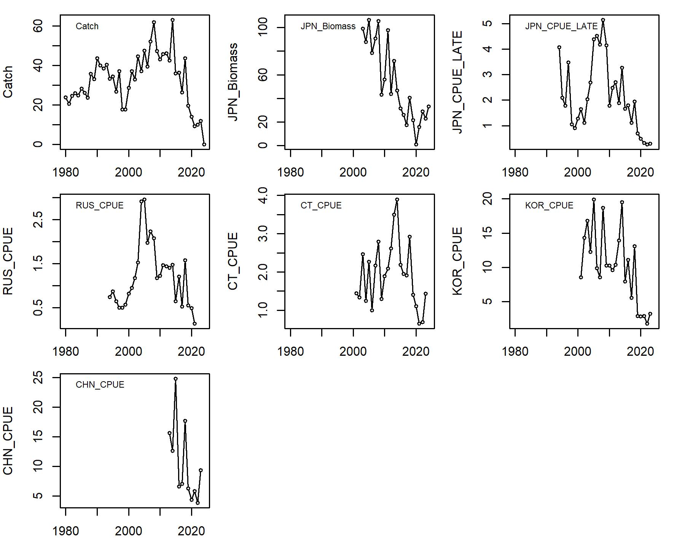
Figure 1. Input data for 2024 stock assessment. Note that the total catch in 2024 is set to 0 for model running purpose, which has no impact on the model output.

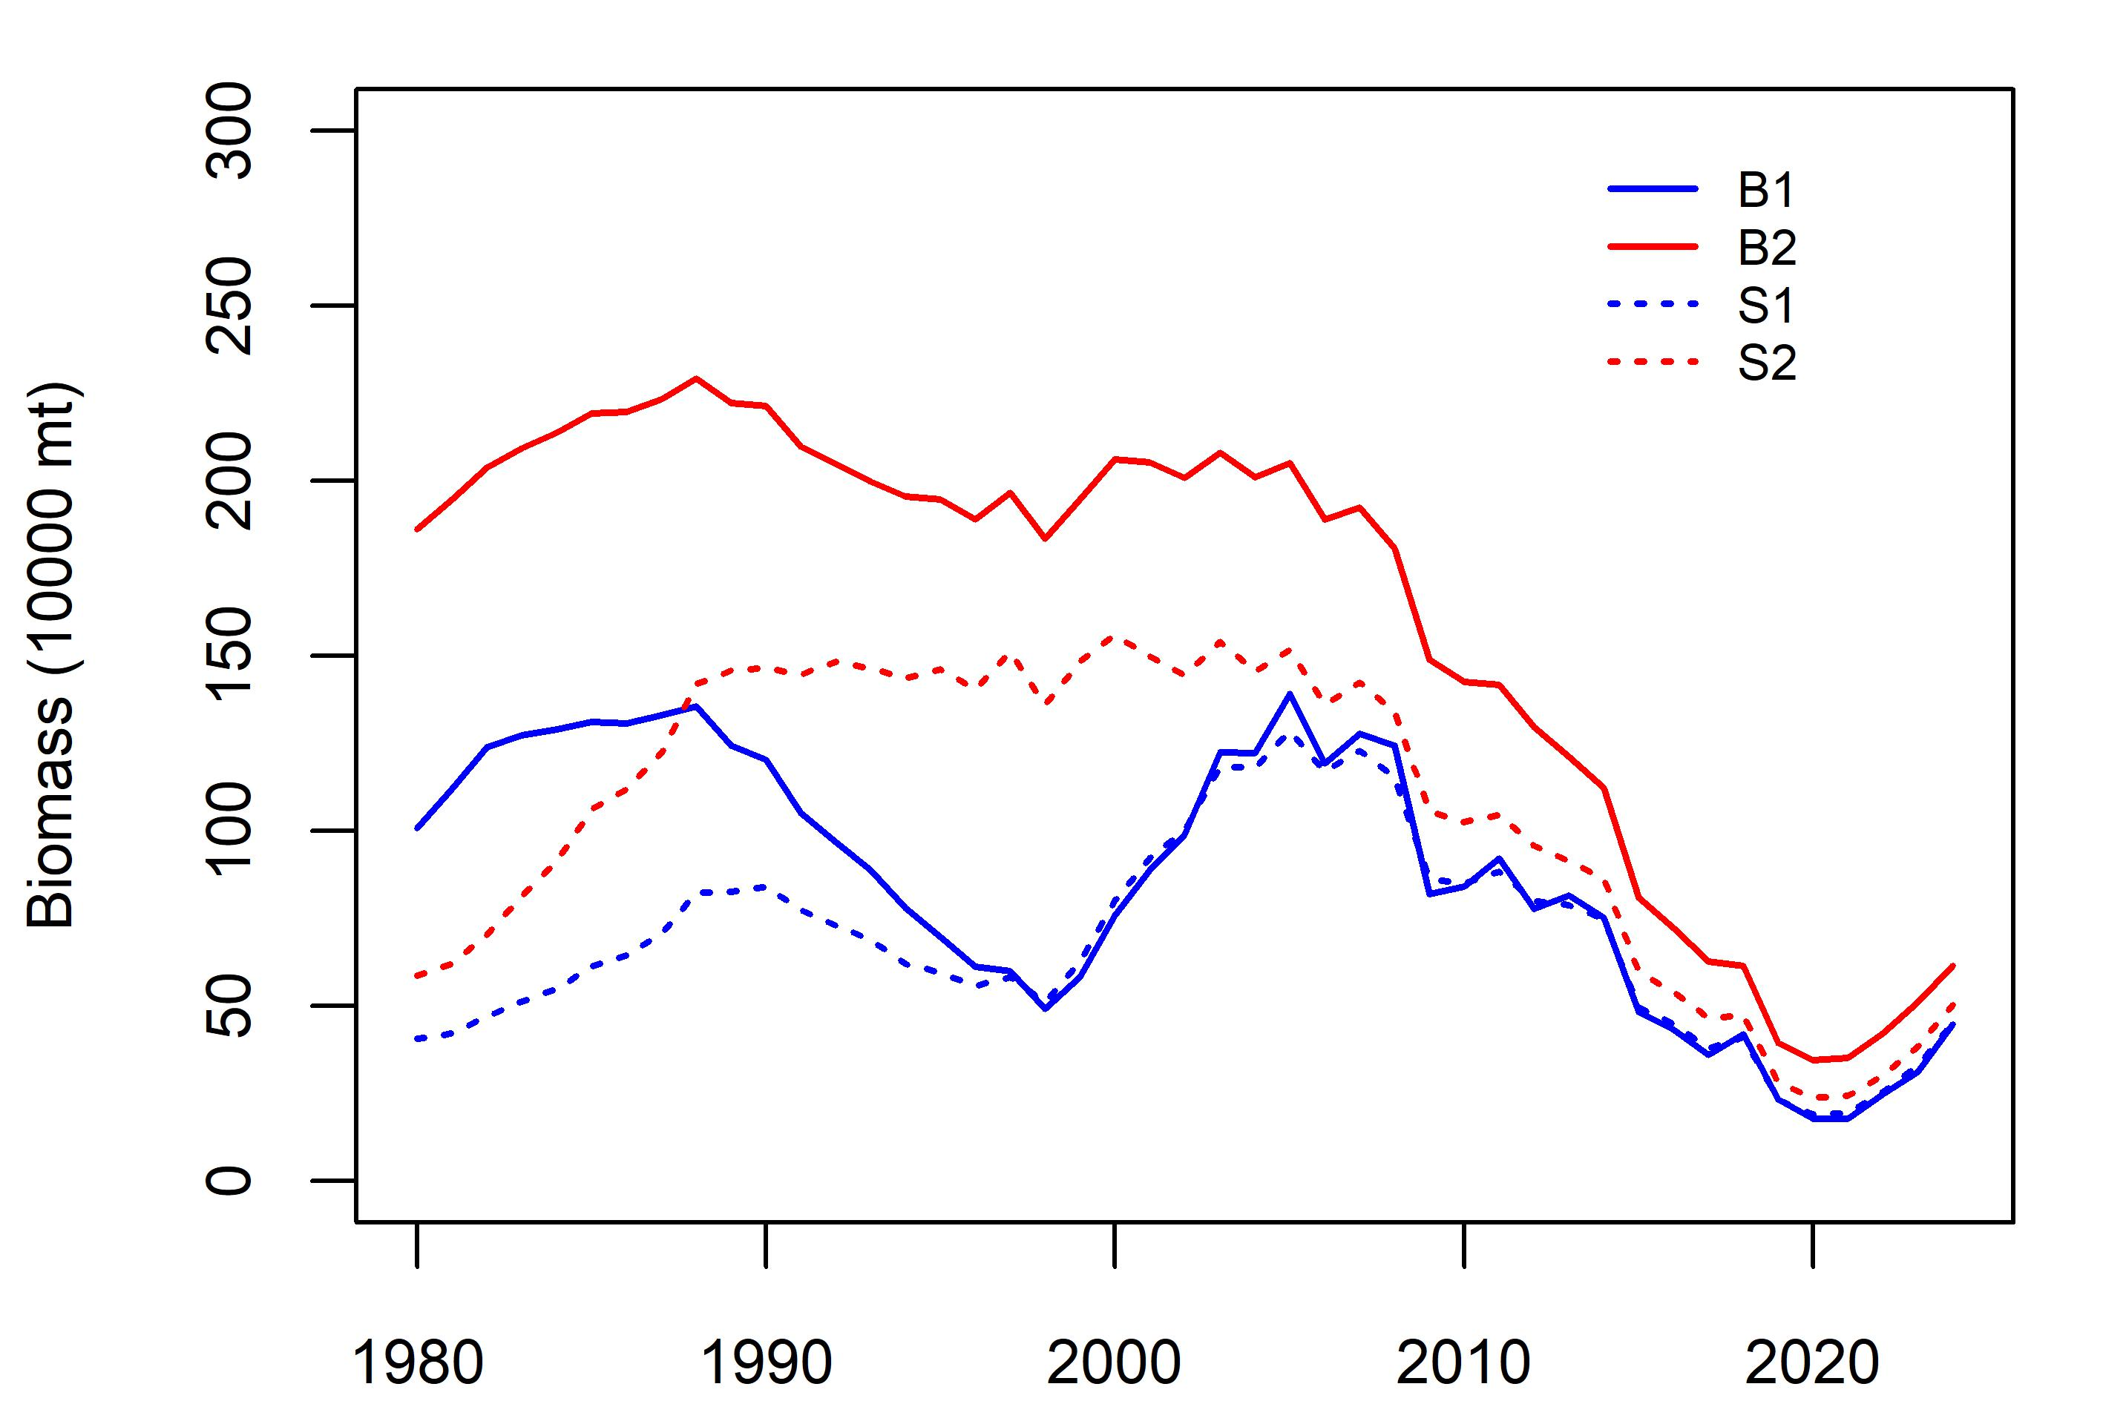
Figure 2. Median biomass over time from each case scenario.
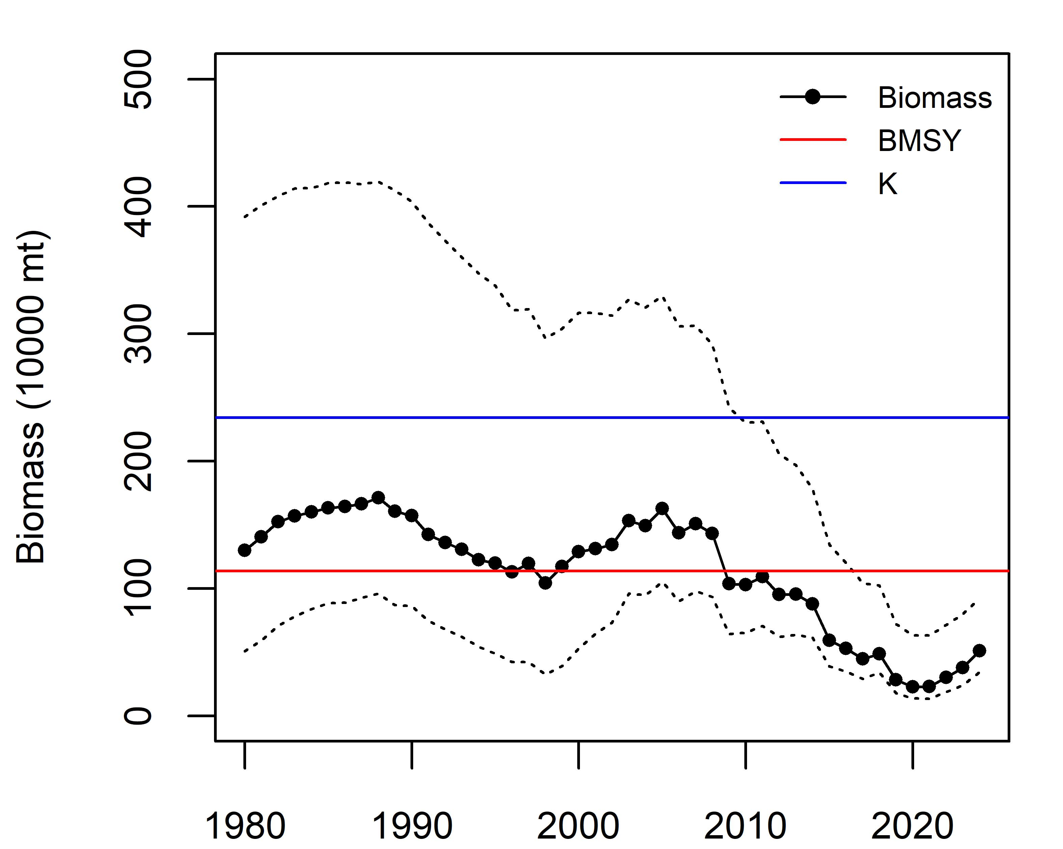
Figure 3. Median biomass and 80% CI over base case scenarios 1-2.
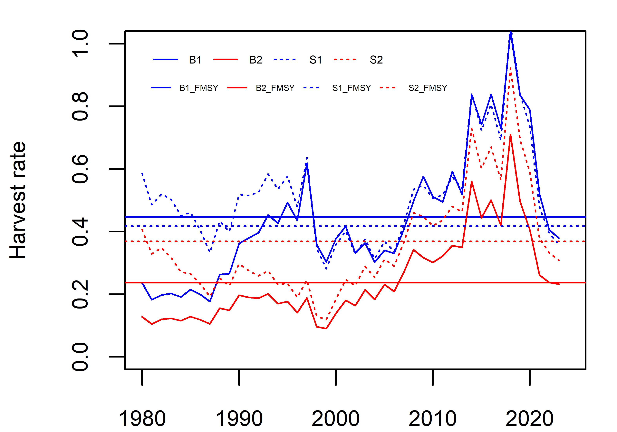
Figure 4. Median harvest rate over time from each case scenario.
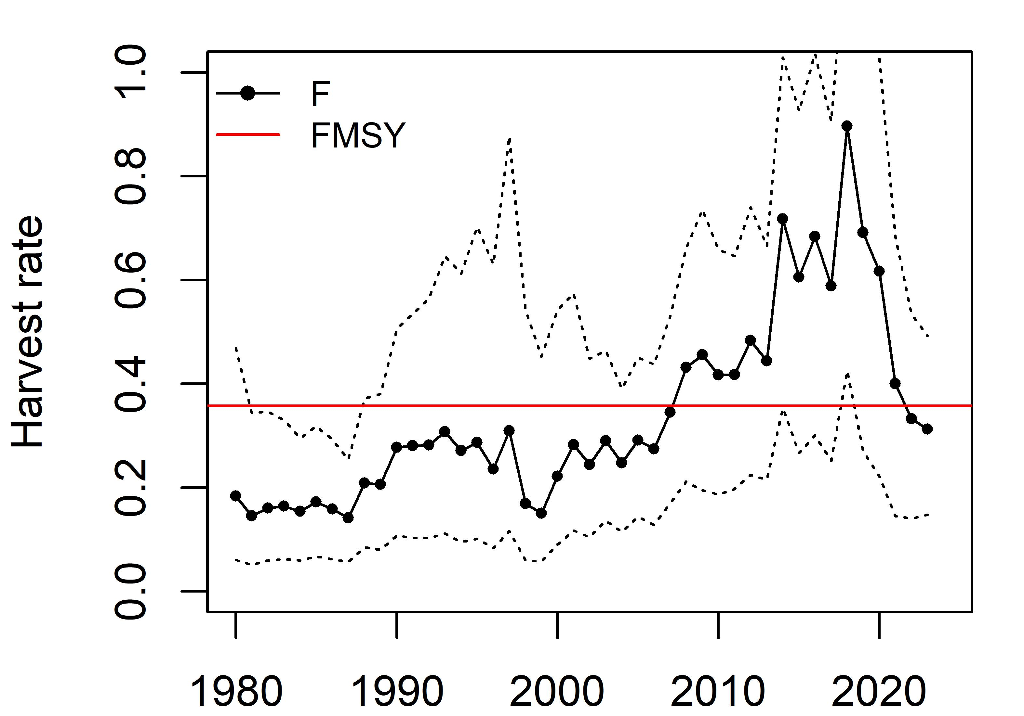
Figure 5. Median harvest rate and 80% CI over base case scenarios 1-2.
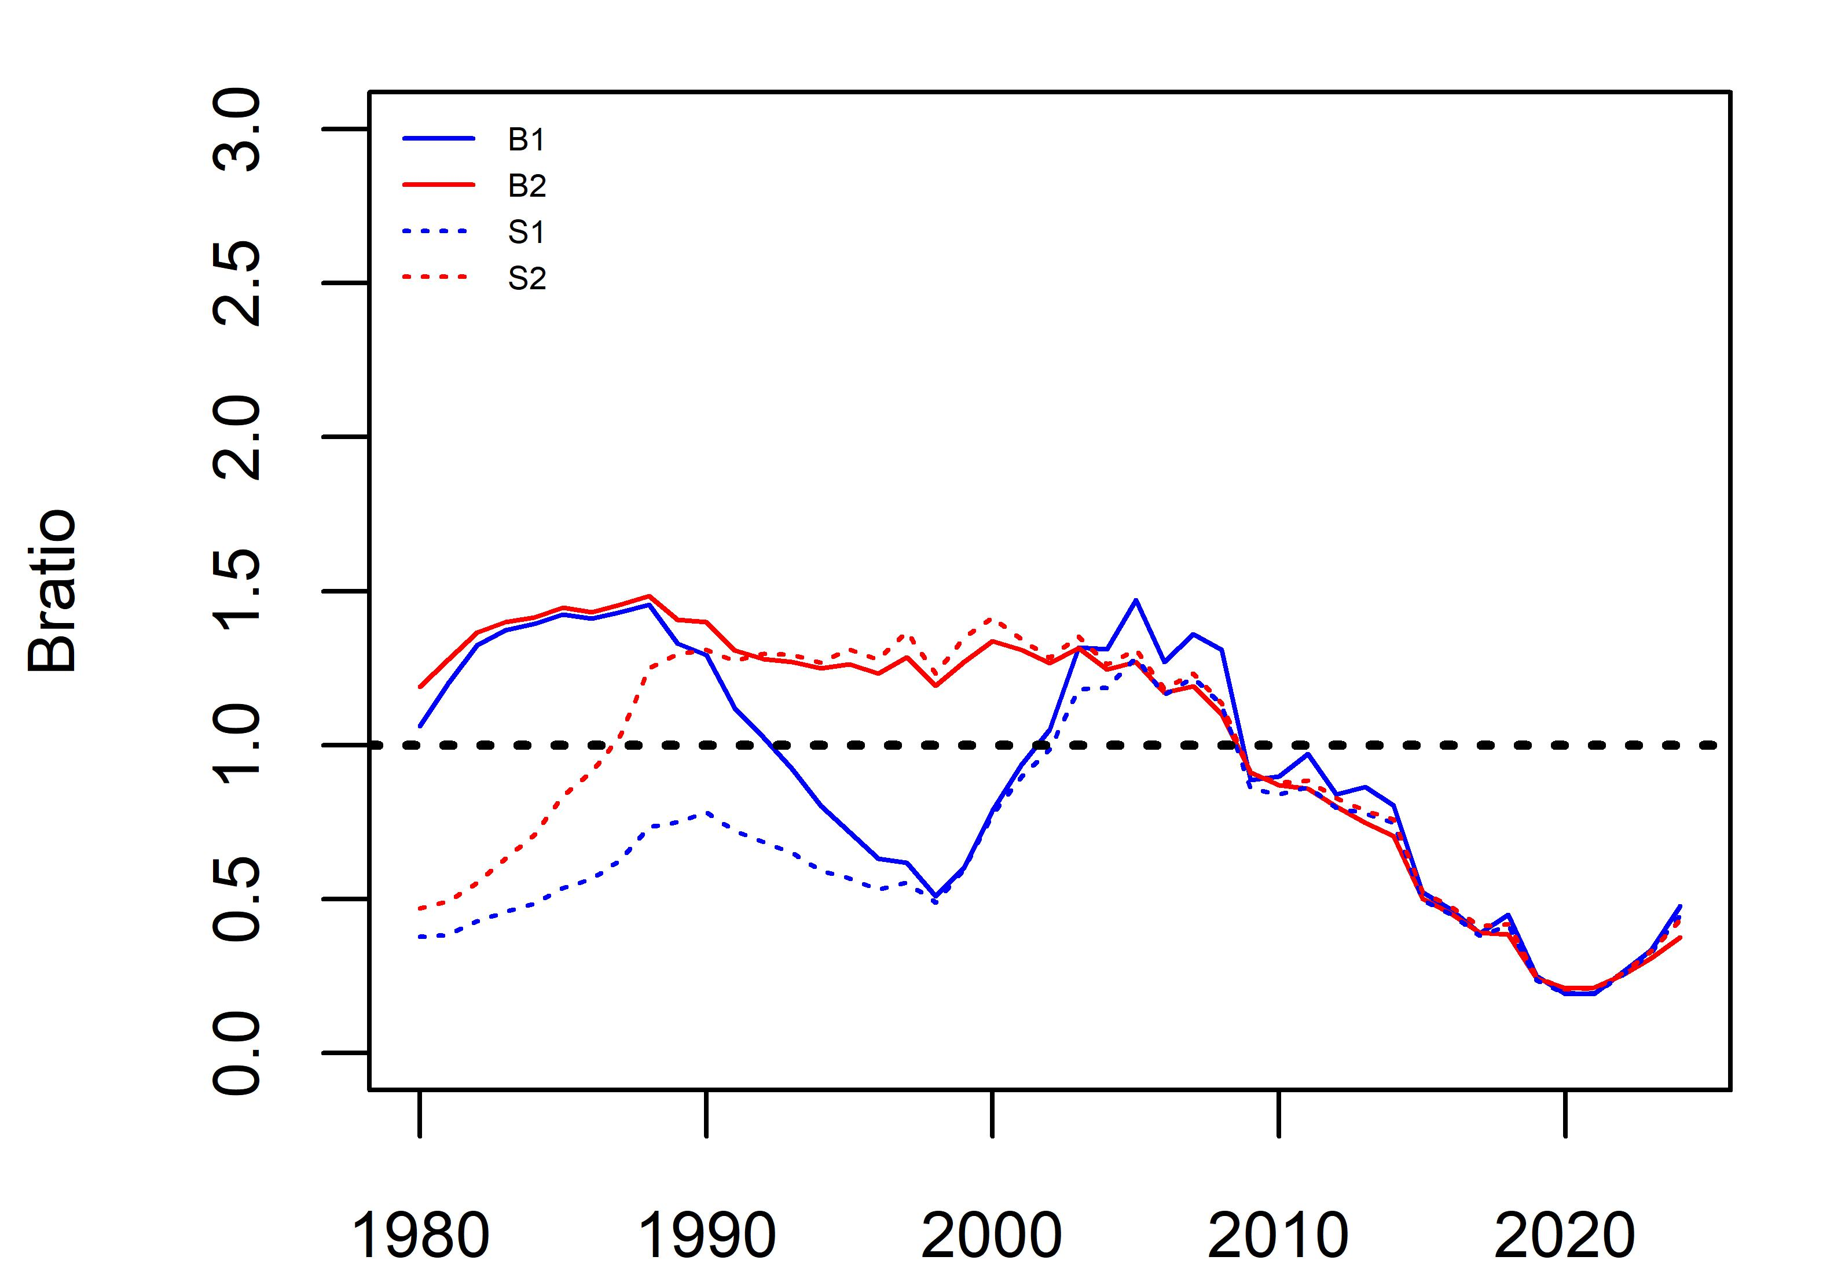
Figure 6. Median Bratio over time from each case scenario.

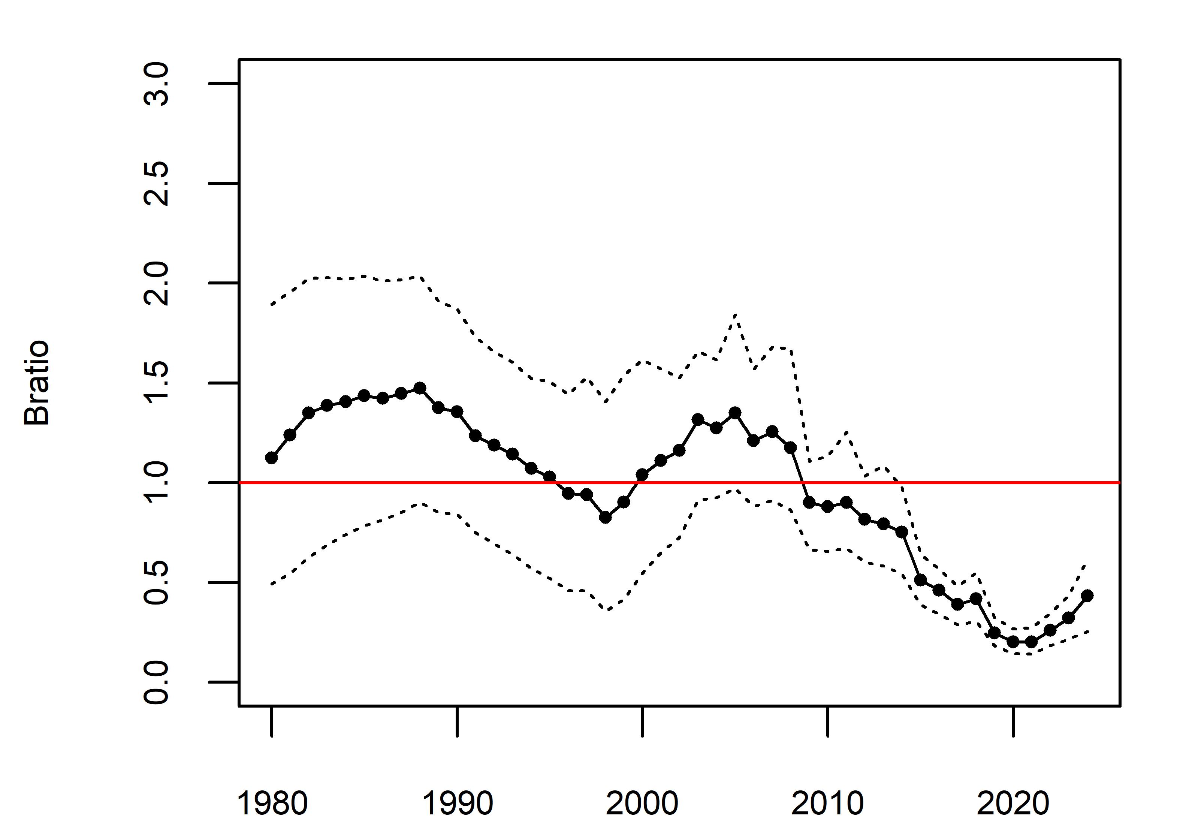
Figure 7. Median Bratio and 80% CI over base case scenarios 1-2.
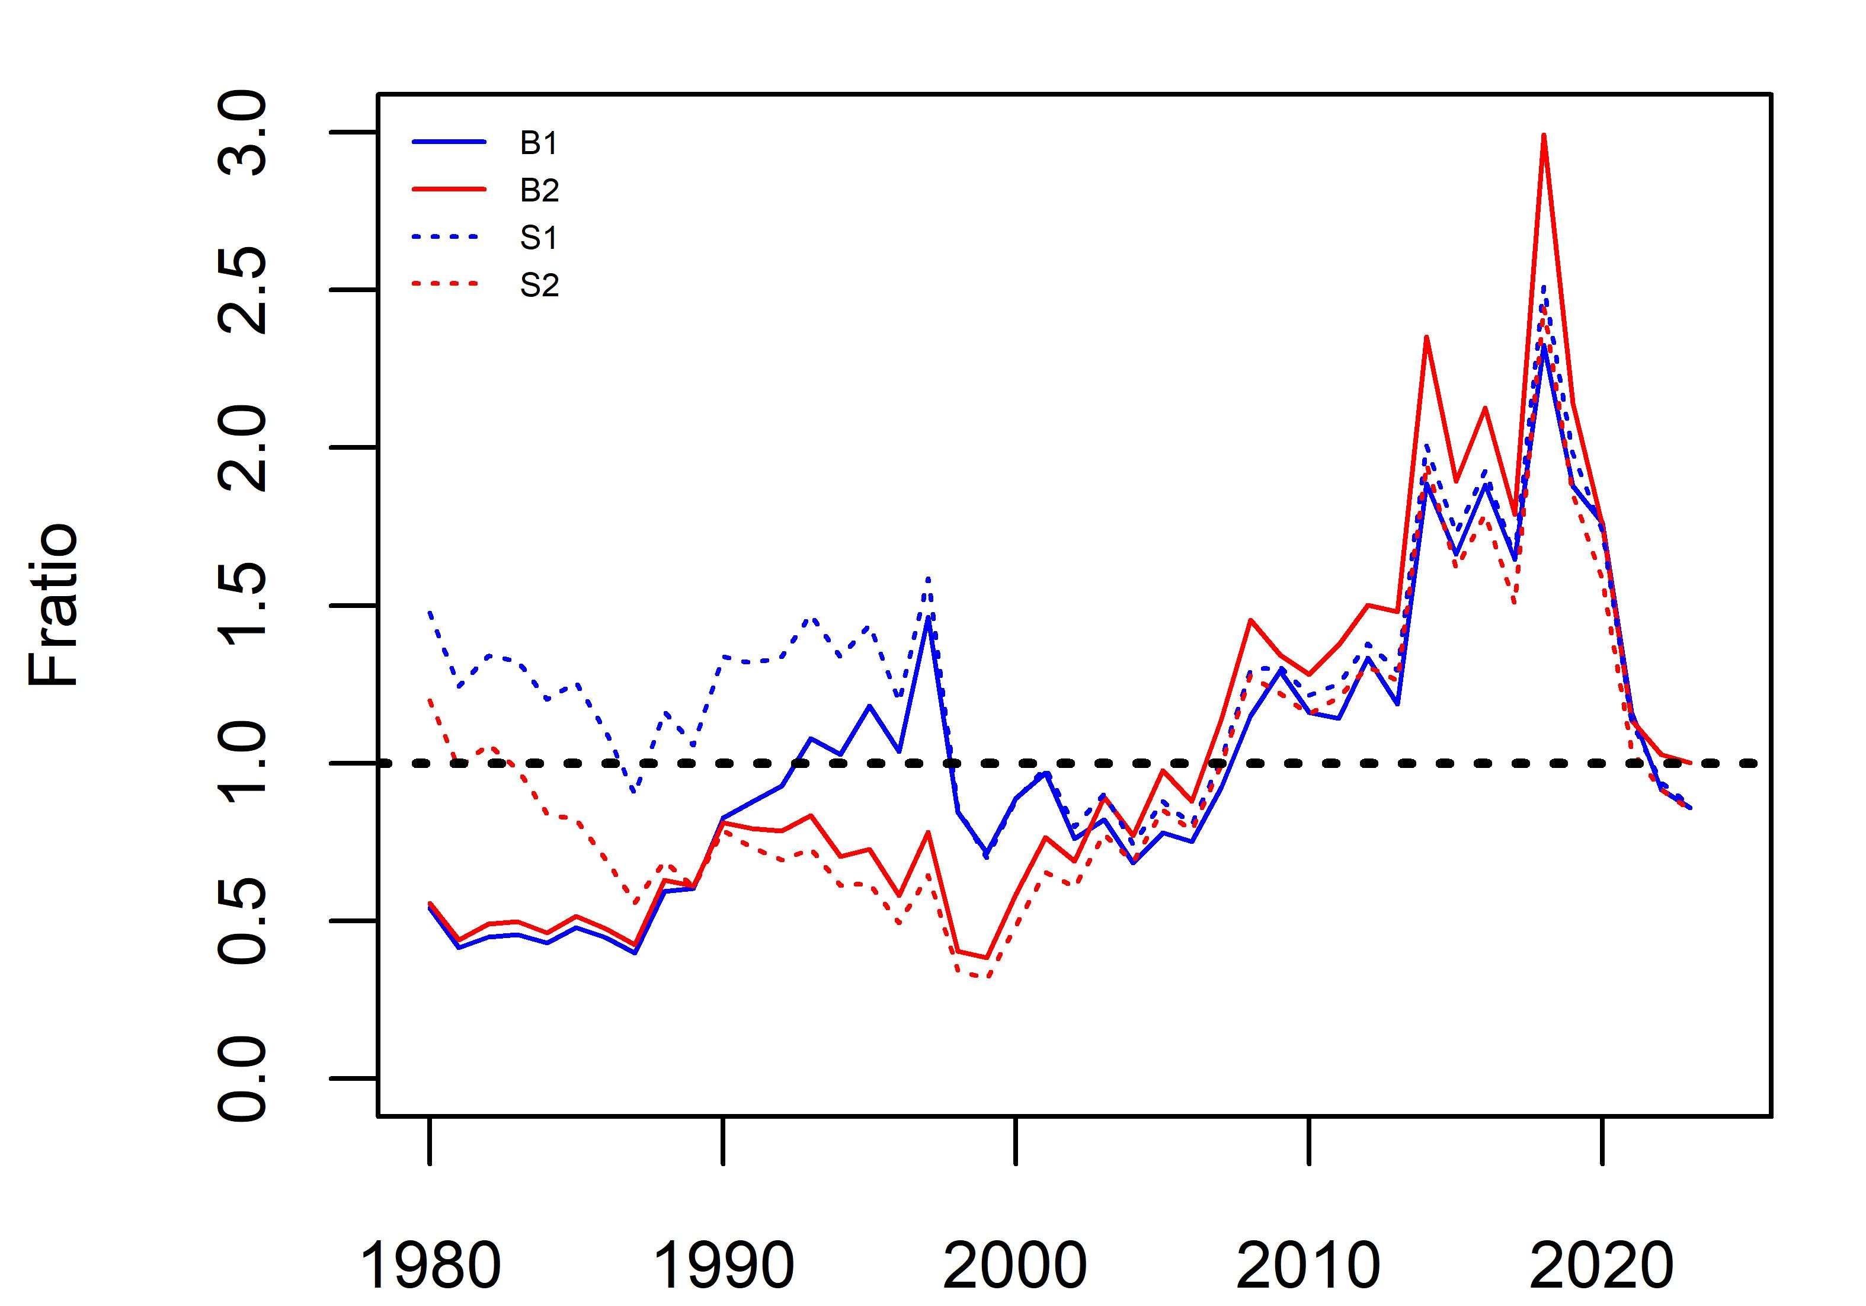
Figure 8. Median Fratio over time from each case scenario.

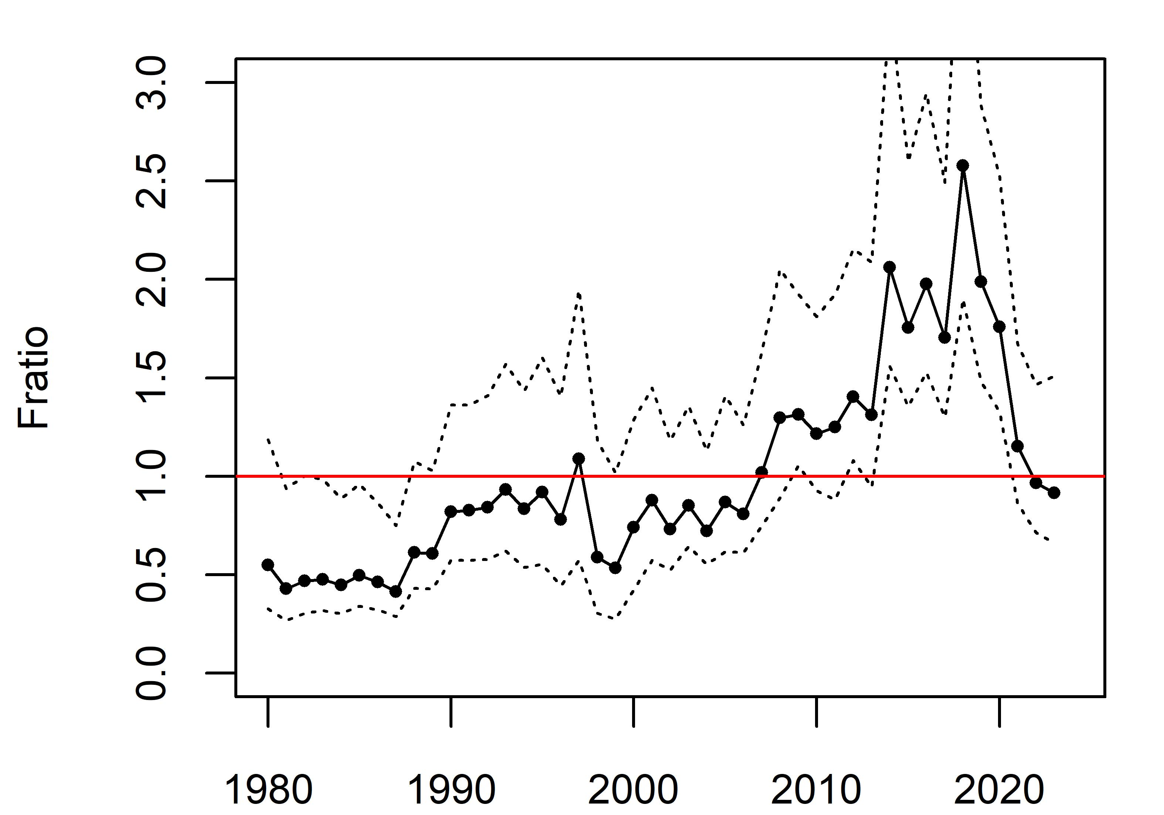
Figure 9. Median Fratio and 80% CI over base case scenarios 1-2.
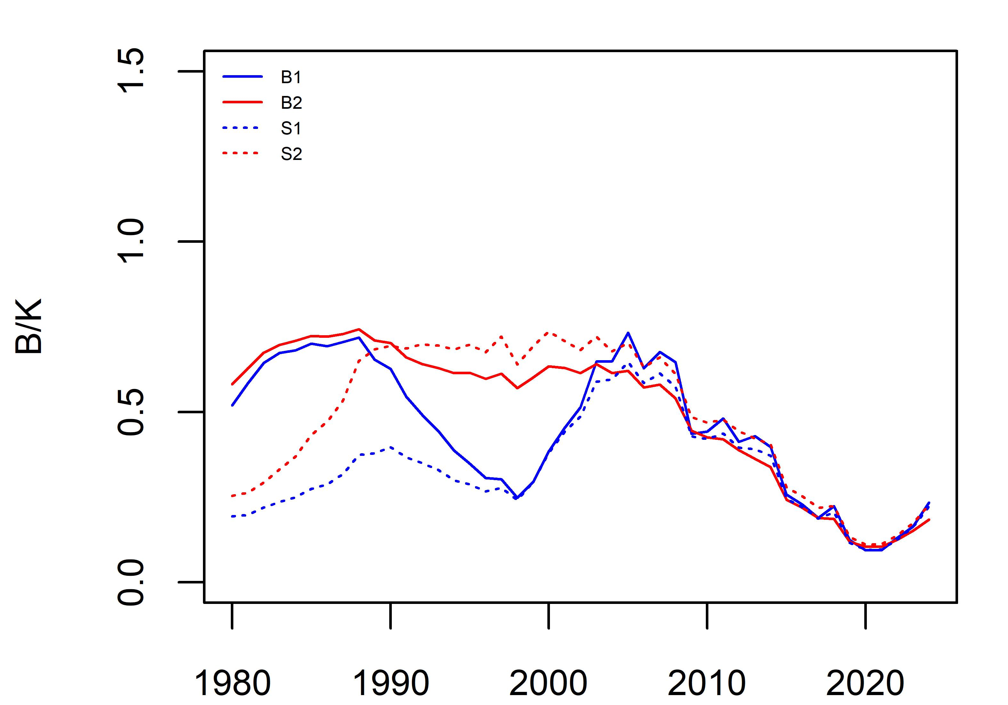
Figure 10. Median B/K over time from each case scenario.

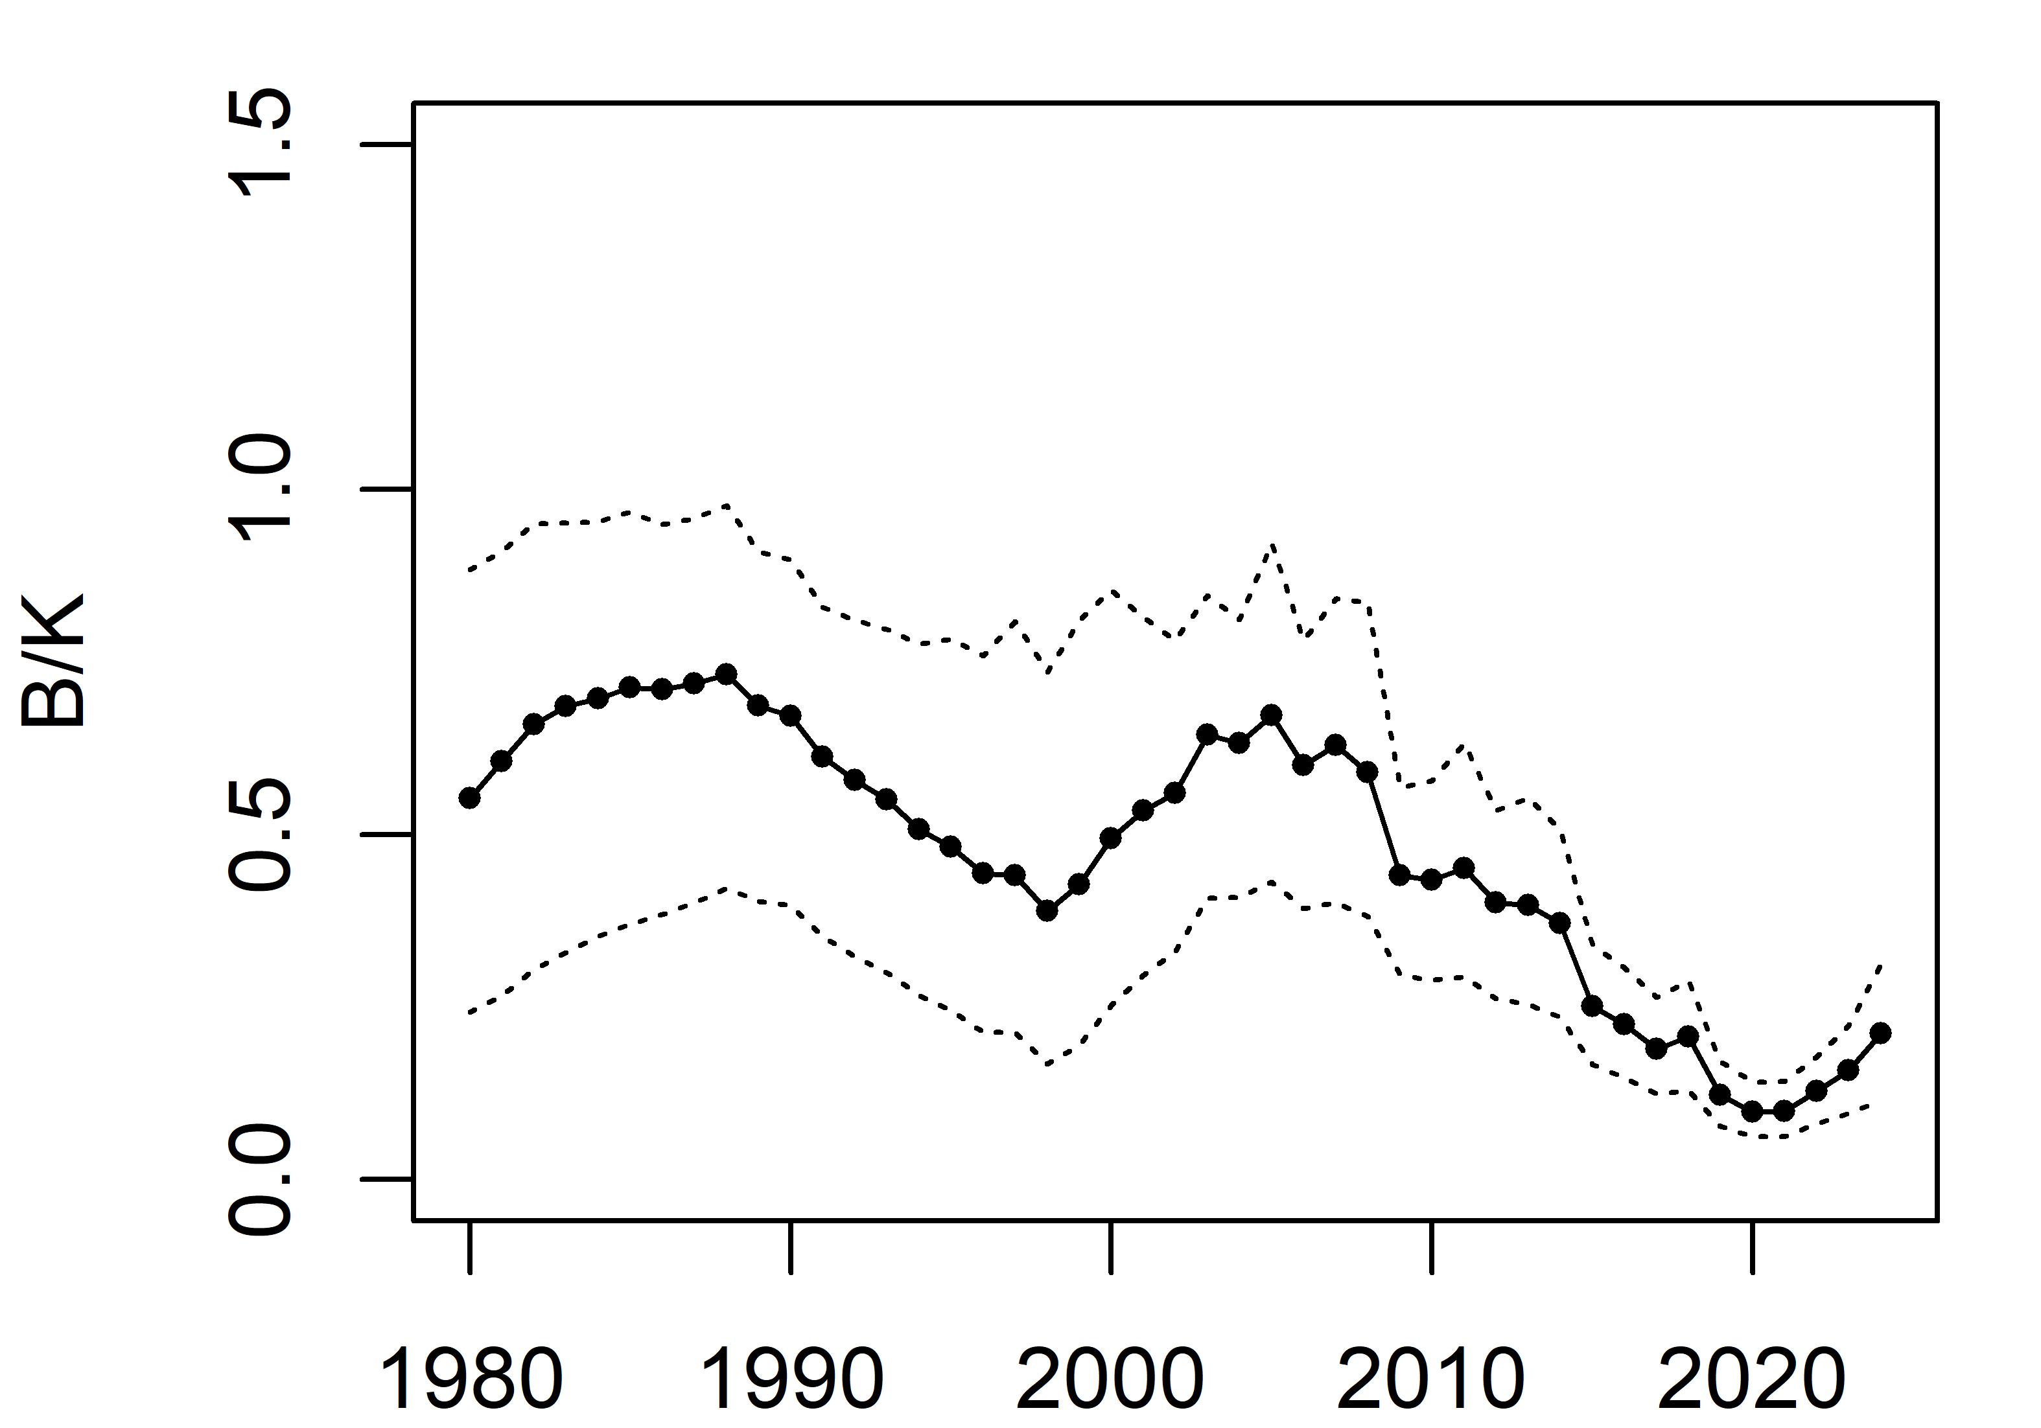
Figure 11. Median B/K and 80% CI over base case scenarios 1-2.

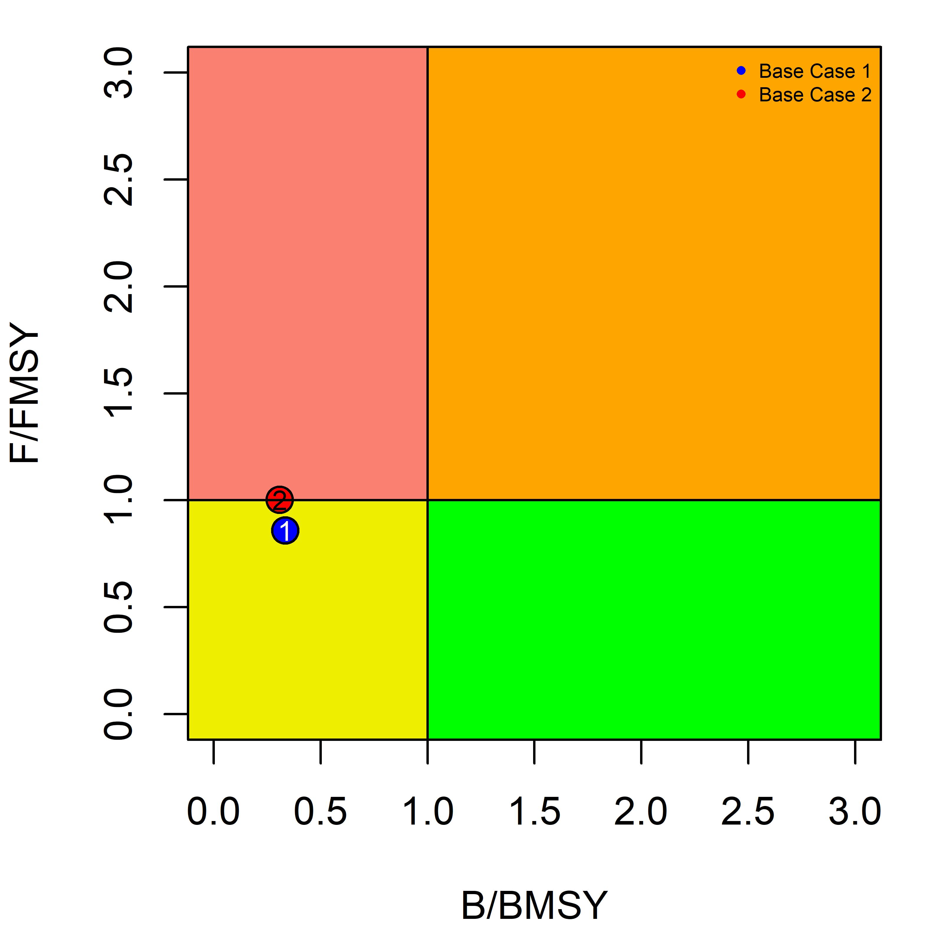
Figure 12. Median Fratio2023 and Bratio2023 calculated from each base case scenario (1-2).
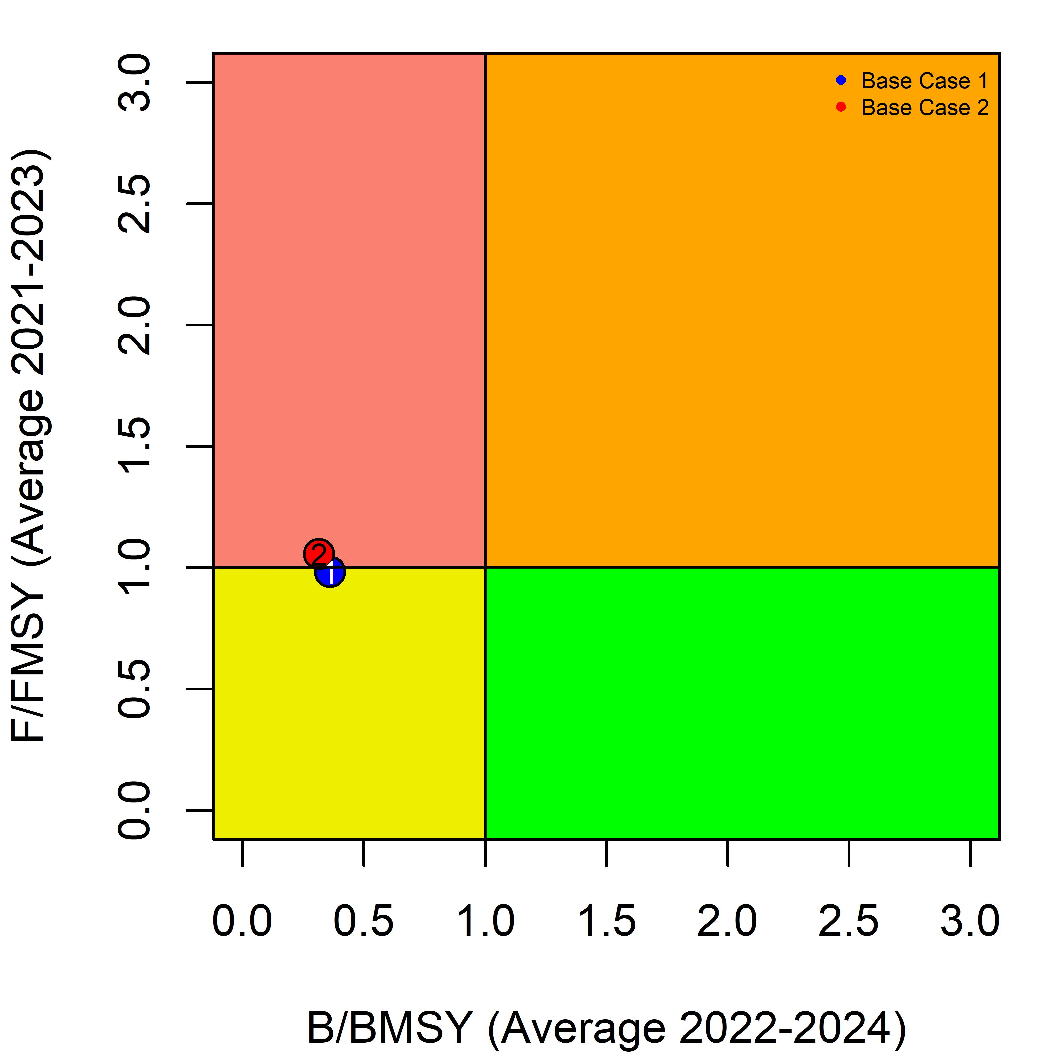
Figure 13. Median Fratio (average from 2021-2023) and Bratio (average from 2022-2024) calculated from each base case scenario (1-2).

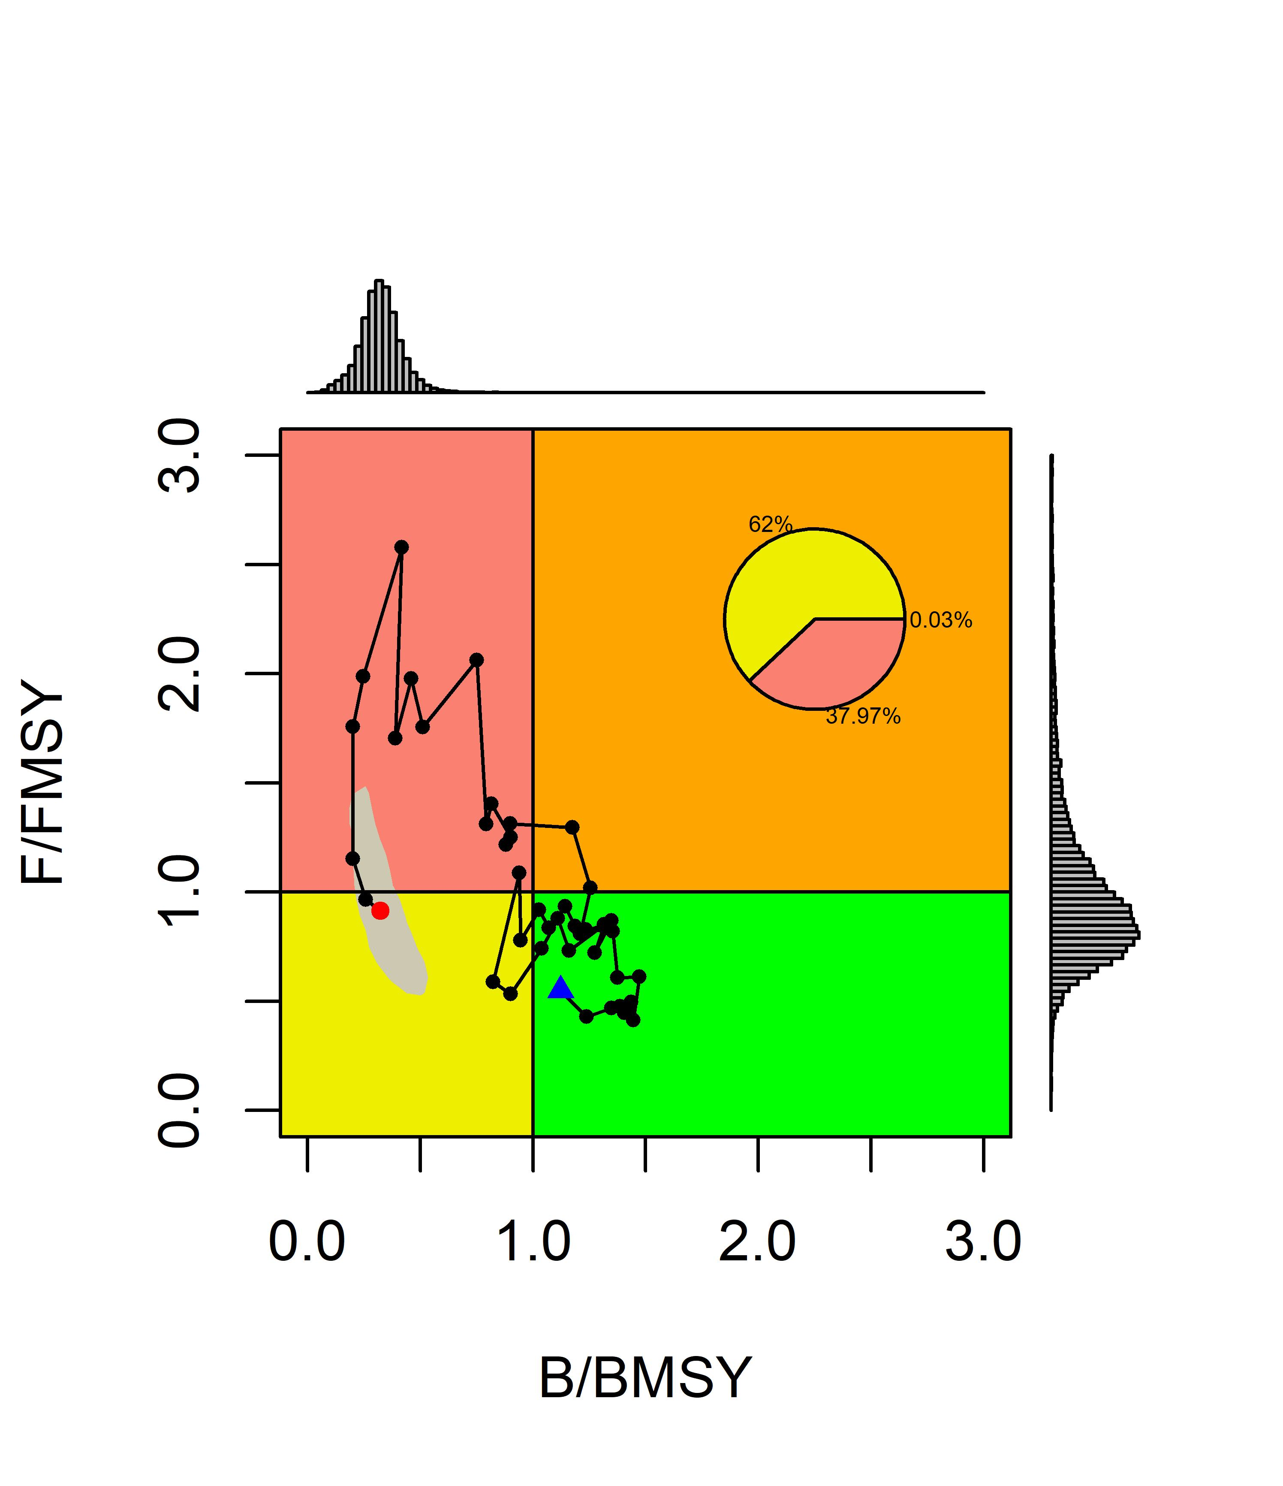
Figure 14. Kobe plot with median Fratio and Bratio time series from 1980 to 2023 over base case scenarios 1-2. The blue dot represents initial year 1980 and the red dot represents the terminal year 2023.

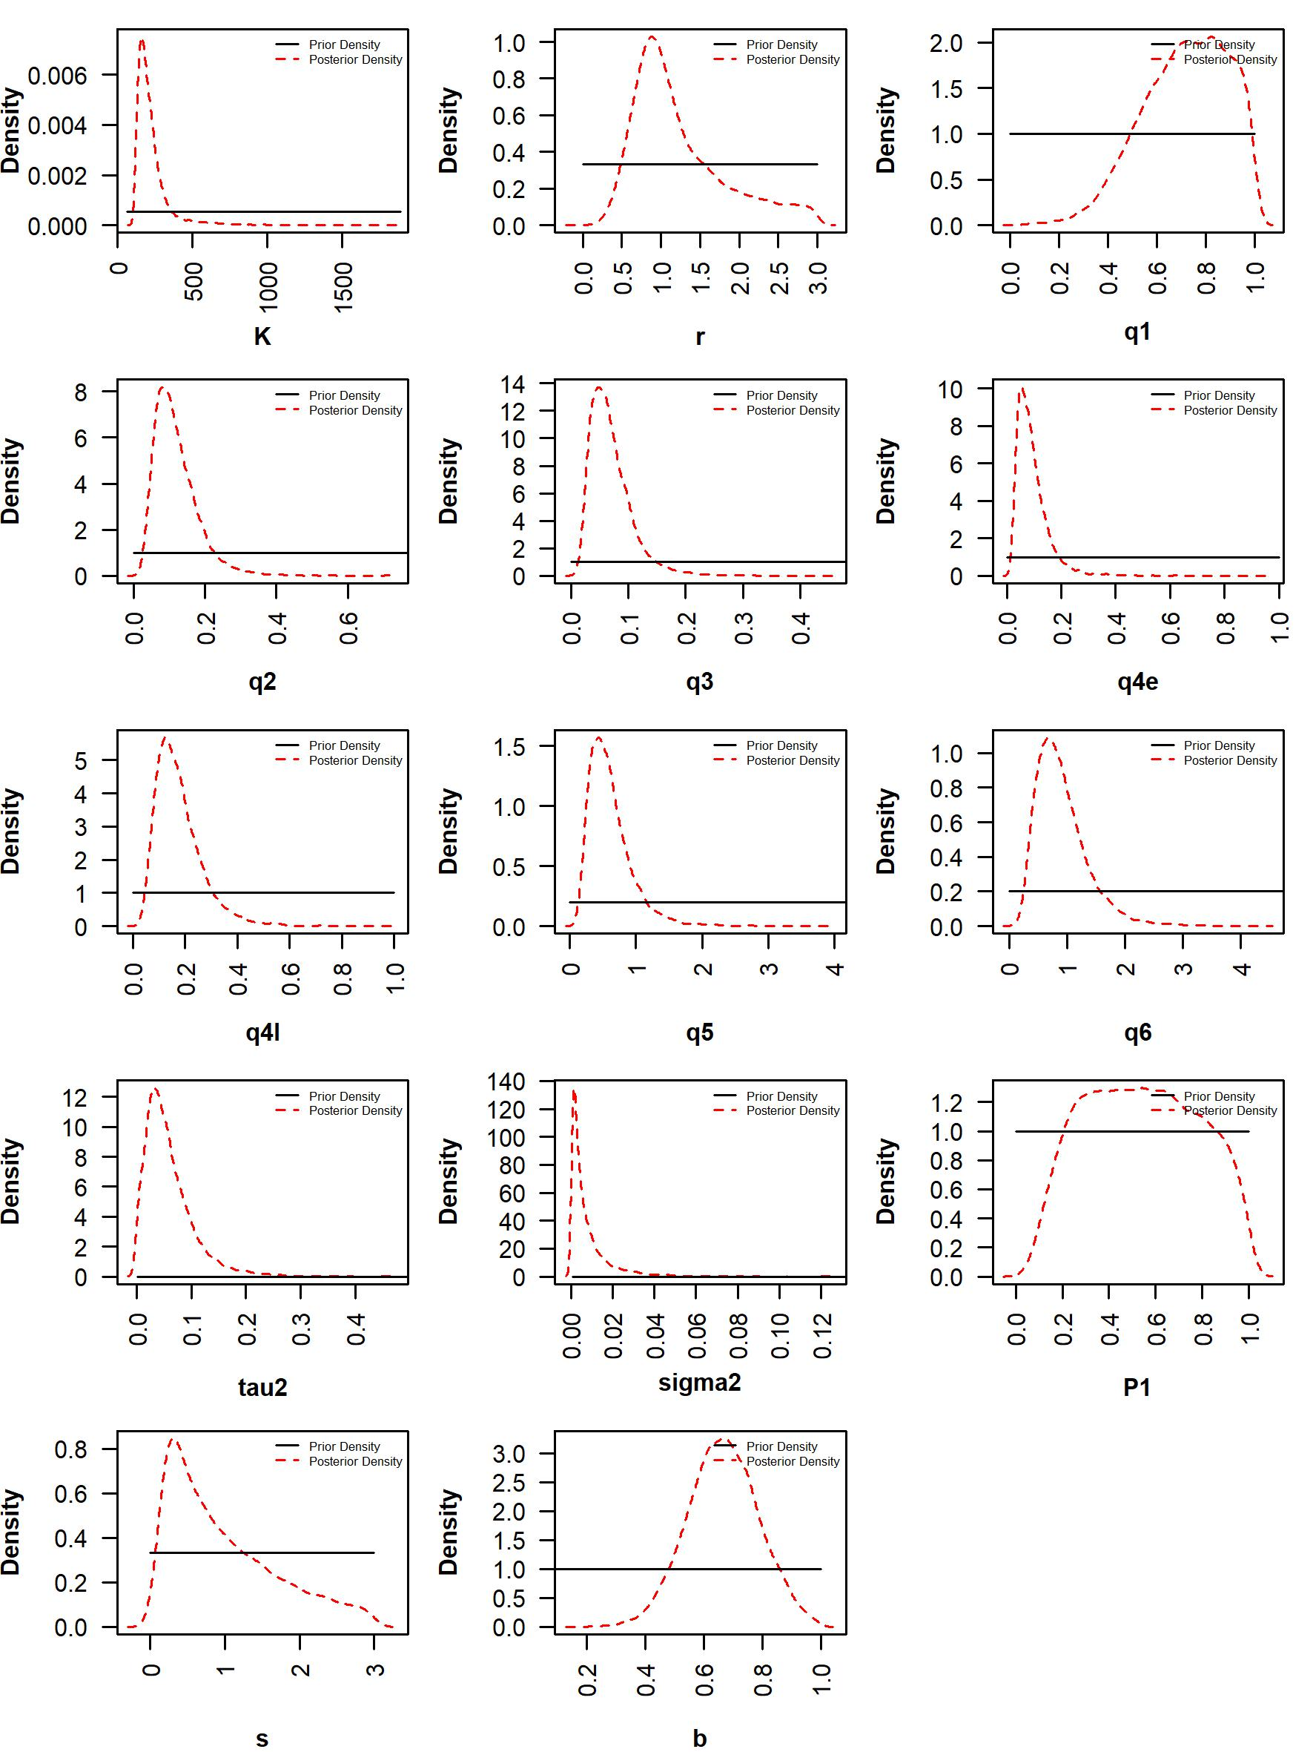
Appendix Figure 1. Prior and posterior distributions of parameters from base case scenario 1. q1 to q6 represent catchability of fishery-independent survey biomass index (q1), Japanese late CPUE (q2), Russian CPUE (q3), Chinese Taipei early CPUE (q4e), Chinese Taipei late CPUE (q4l), Korean CPUE (q5), and Chinese CPUE (q6), respectively. tau2 represents process error variance, sigma2 represents common observation variance of CPUE. P1 represents B₁₉₈₀/K, s represents shape parameter, and b represents hyperdepletion parameter.
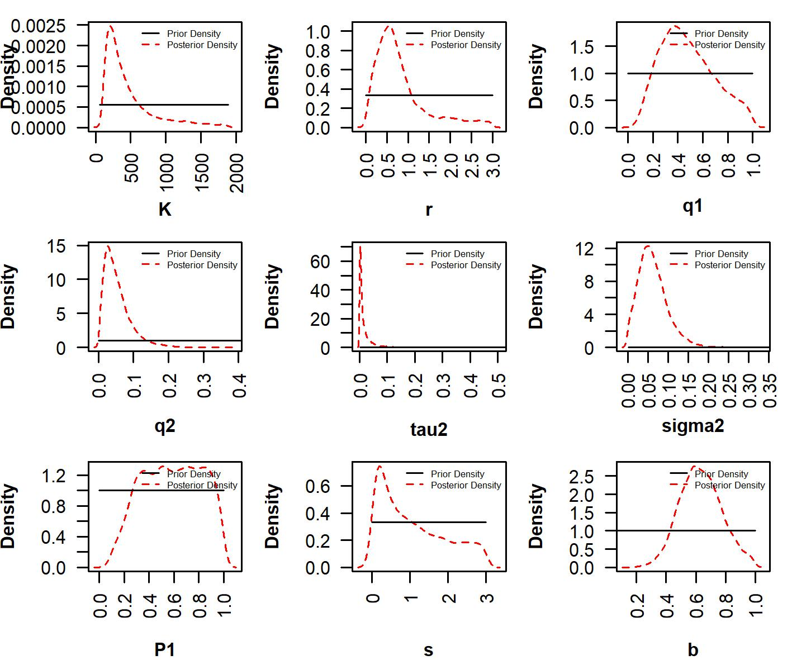
Appendix Figure 2. Prior and posterior distributions of parameters from base case scenario 2. q1 and q2 represent catchability of fishery-independent survey biomass index (q1) and joint CPUE (q2), respectively. tau2 represents process error variance, sigma2 represents common observation variance of CPUE. P1 represents B₁₉₈₀/K, s represents shape parameter, and b represents hyperdepletion parameter.

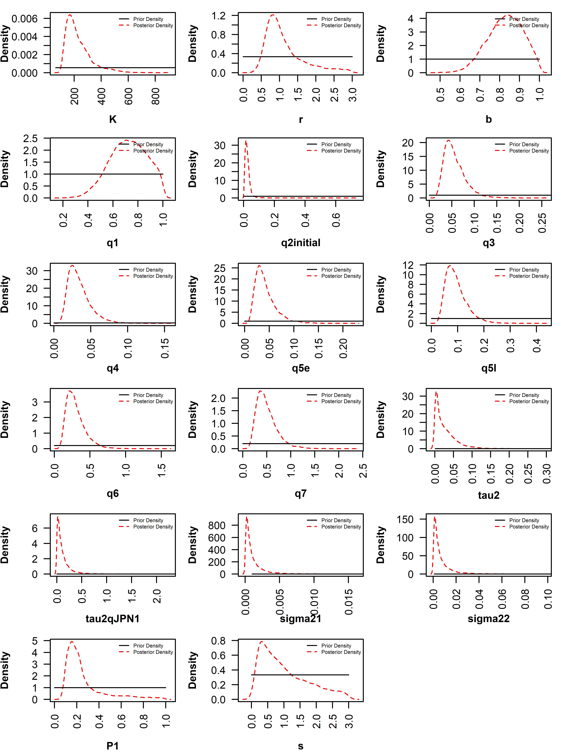
Appendix Figure 3. Prior and posterior distributions of parameters from sensitivity case scenario 1. q1 to q7 represent catchability of fishery-independent survey biomass index (q1), Japanese early CPUE (q2initial), Japanese late CPUE (q3), Russian CPUE (q4), Chinese Taipei early CPUE (q5e), Chinese Taipei early CPUE (q5l), Korean CPUE (q6), and Chinese CPUE (q7), respectively. q2initial represents q1980. tau2 represents process error variance, tau2qJPN1 represents error variance of Japanese early CPUE, sigma21 represents observation variance of biomass index, and sigma22 represents common observation variance of CPUE. P1 represents B₁₉₈₀/K and s represents shape parameter.
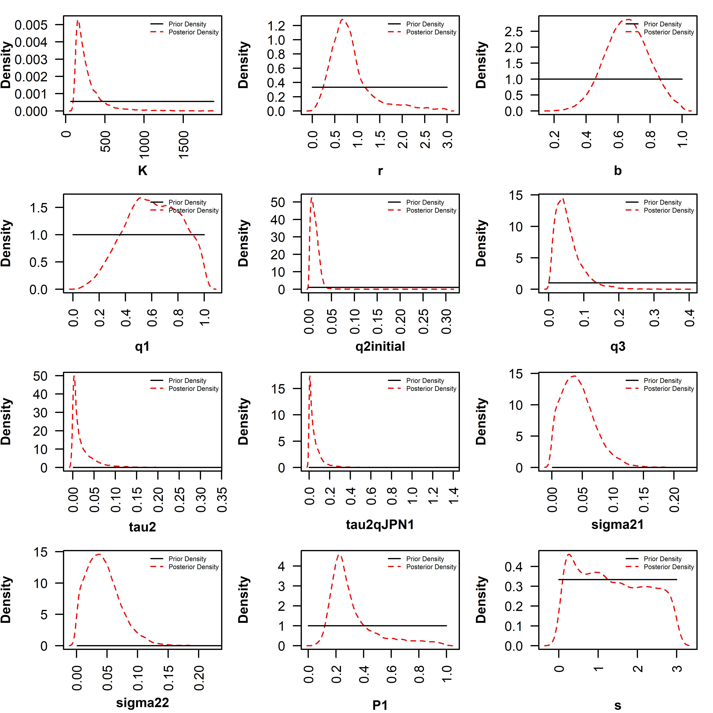
Appendix Figure 4. Prior and posterior distributions of parameters from sensitivity case scenario 2. q1-q3 represent catchability of fishery-independent survey biomass index (q1), Japanese early CPUE (q2initial), and joint CPUE (q3), respectively. q2initial represents q1980. tau2 represents process error variance, tau2qJPN1 represents error variance of Japanese early CPUE, sigma21 represents observation variance of biomass index, and sigma22 represents common observation variance of CPUE. P1 represents B₁₉₈₀/K and s represents shape parameter.

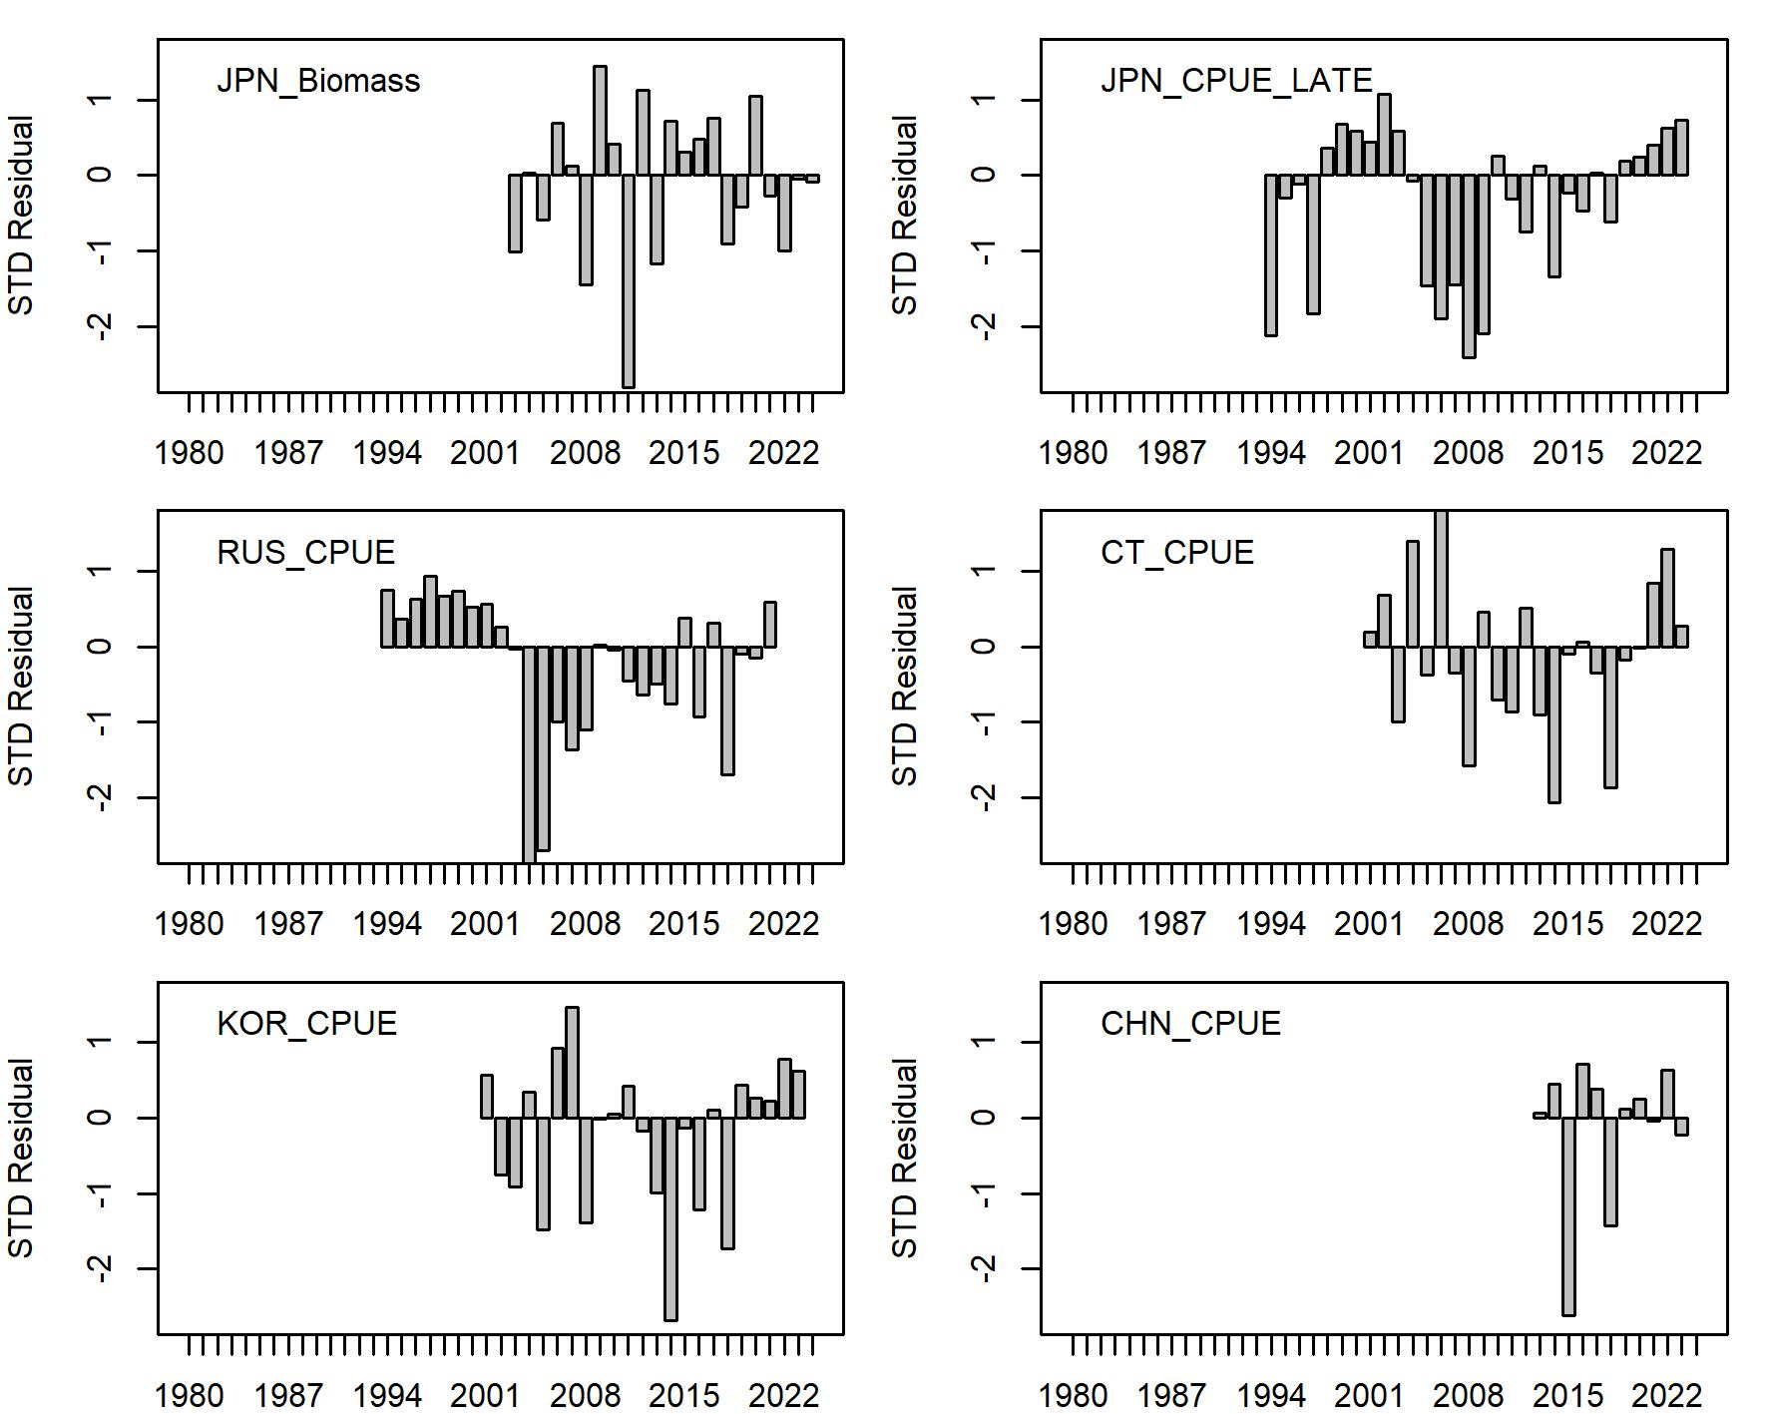
Appendix Figure 5. Standardized residuals between predicted and observed indices from base case scenario 1.

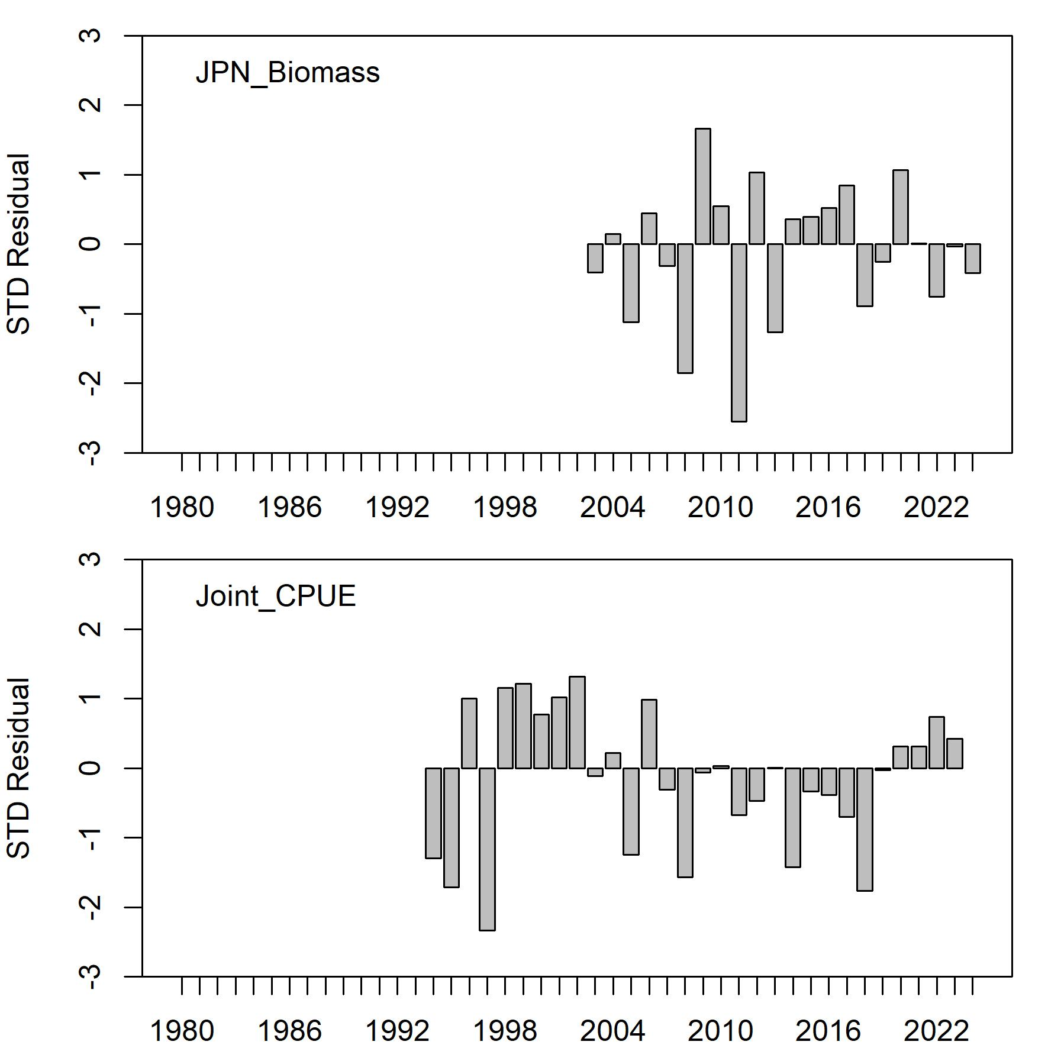
Appendix Figure 6. Standardized residuals between predicted and observed indices from base case scenario 2.
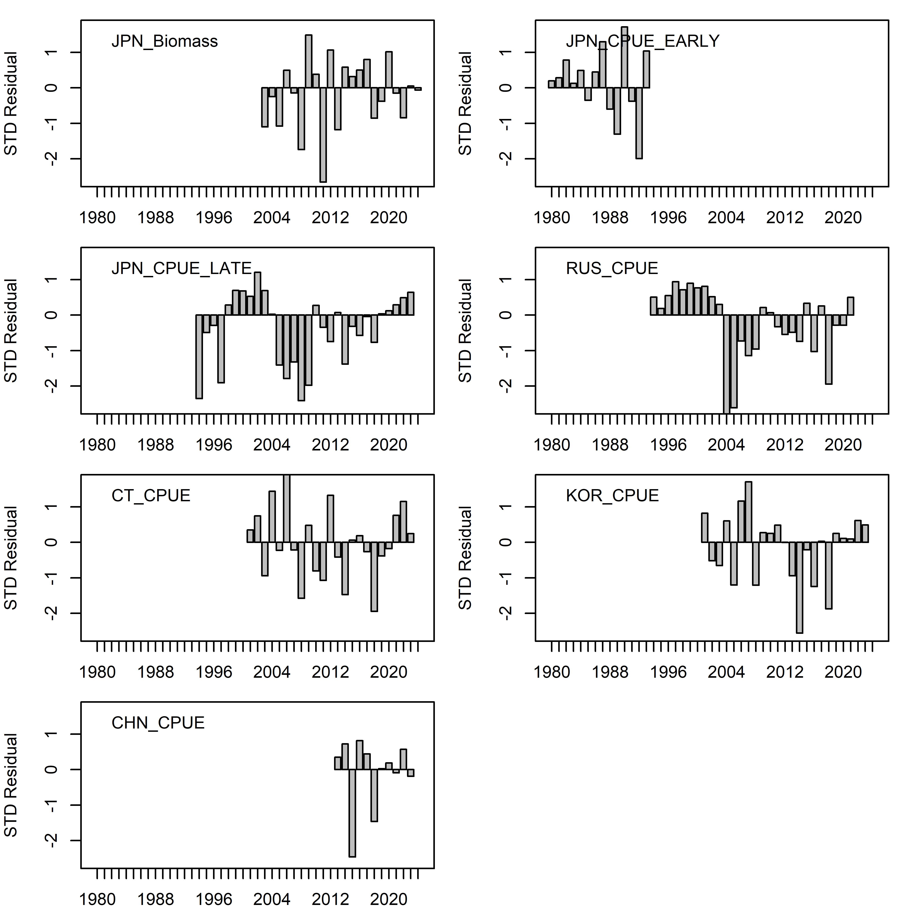
Appendix Figure 7. Standardized residuals between predicted and observed indices from sensitivity case scenario 1.

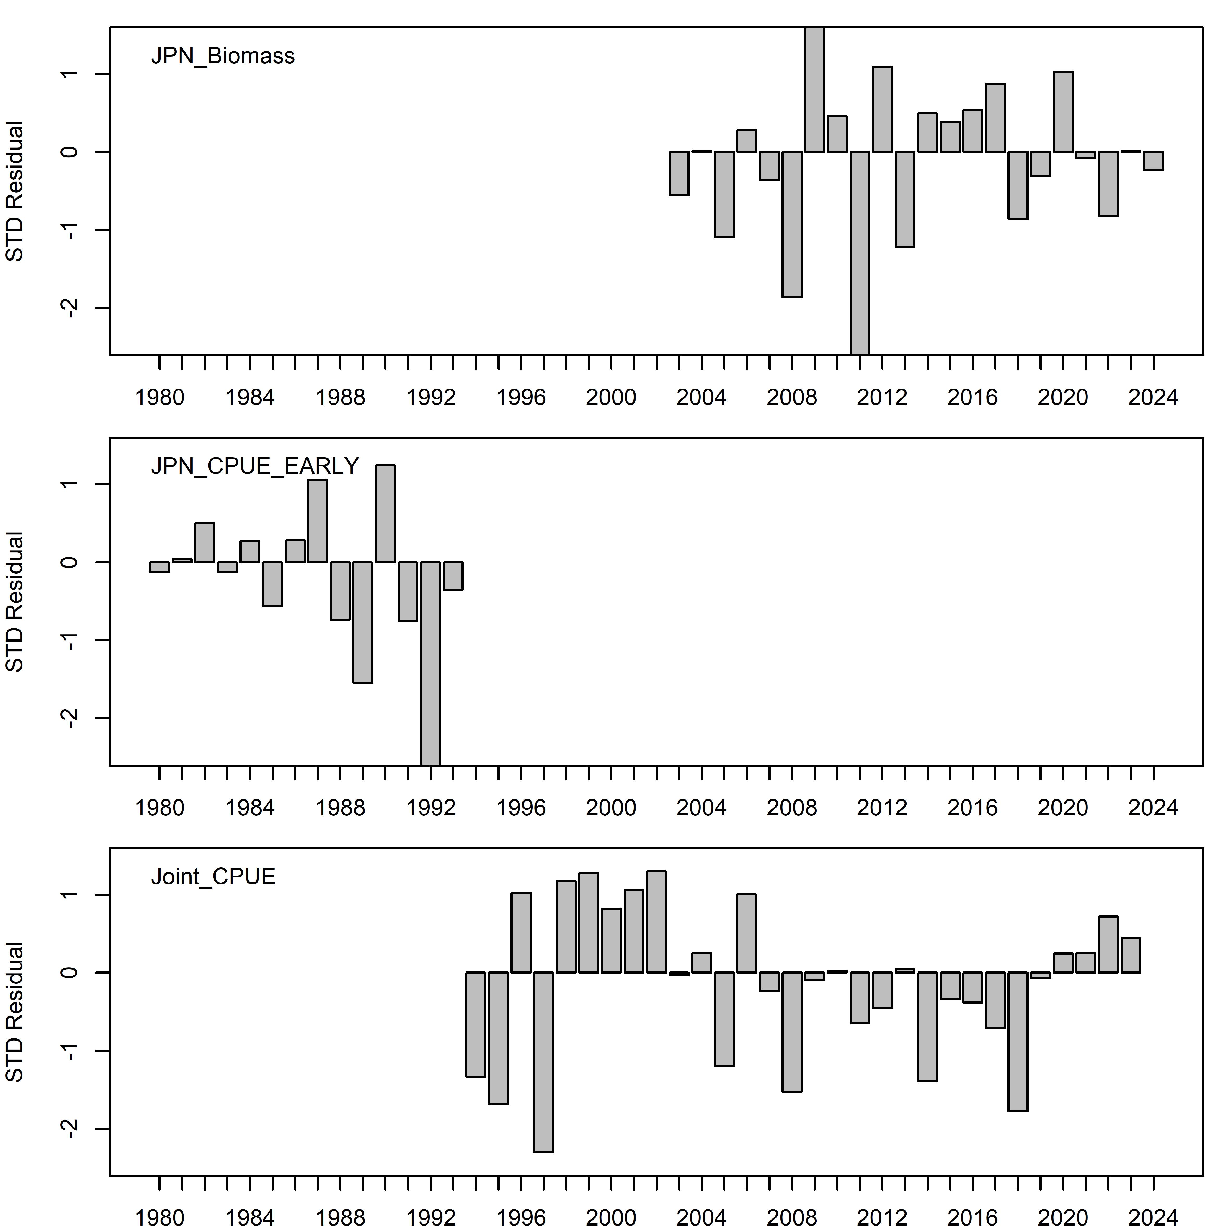
Appendix Figure 8. Standardized residuals between predicted and observed indices from sensitivity case scenario 2.

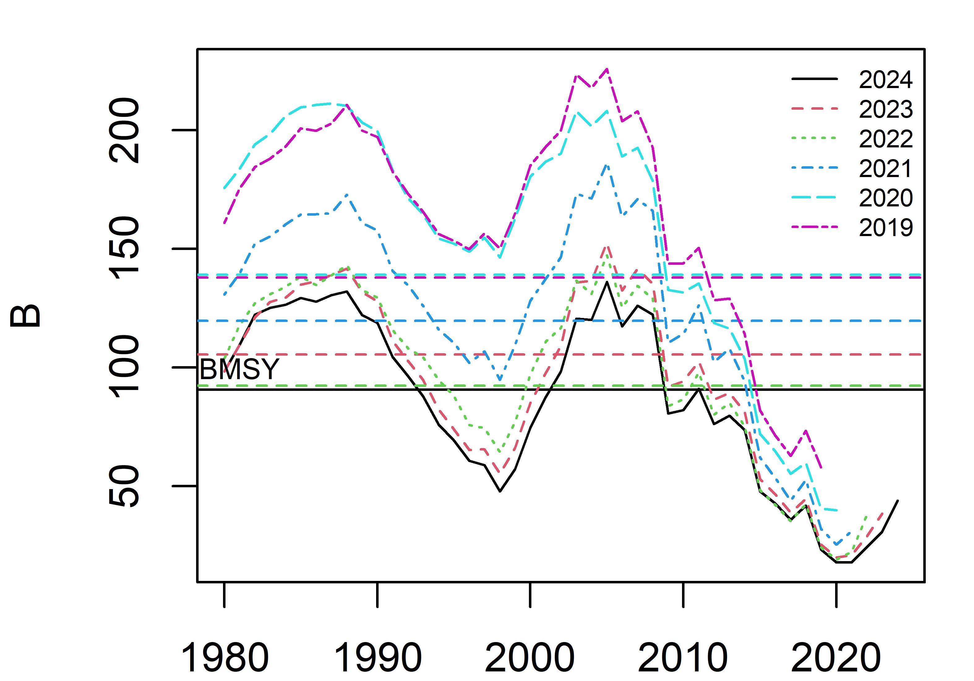
Appendix Figure 9. Retrospective pattern of biomass from base case scenario 1 (Mohn’s rho=0.85).

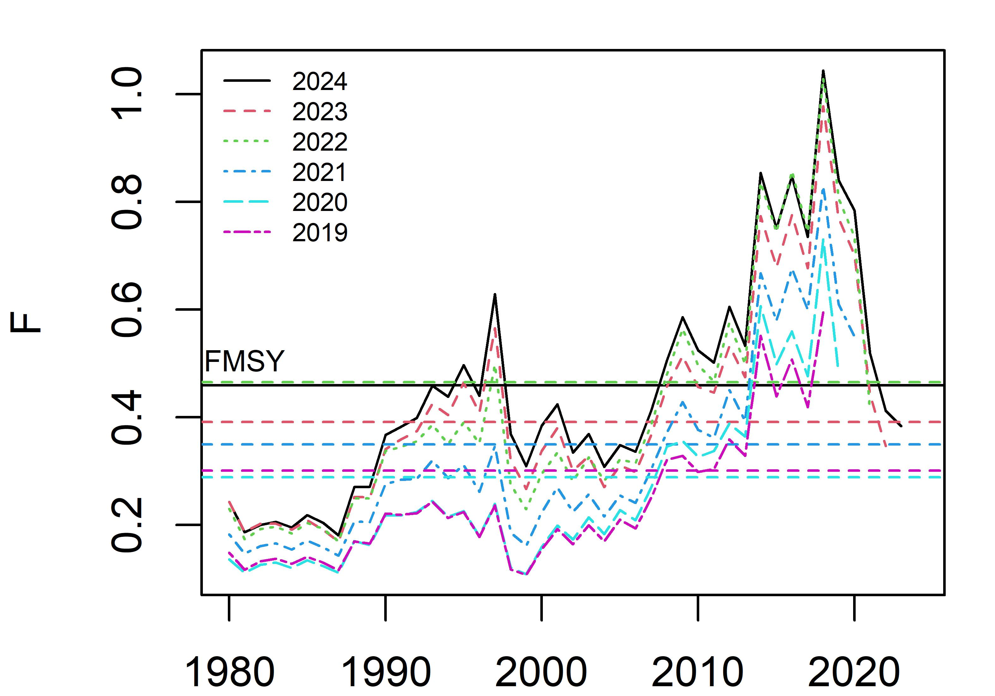
Appendix Figure 10. Retrospective pattern of harvest rate from base case scenario 1 (Mohn’s rho=-0.30).

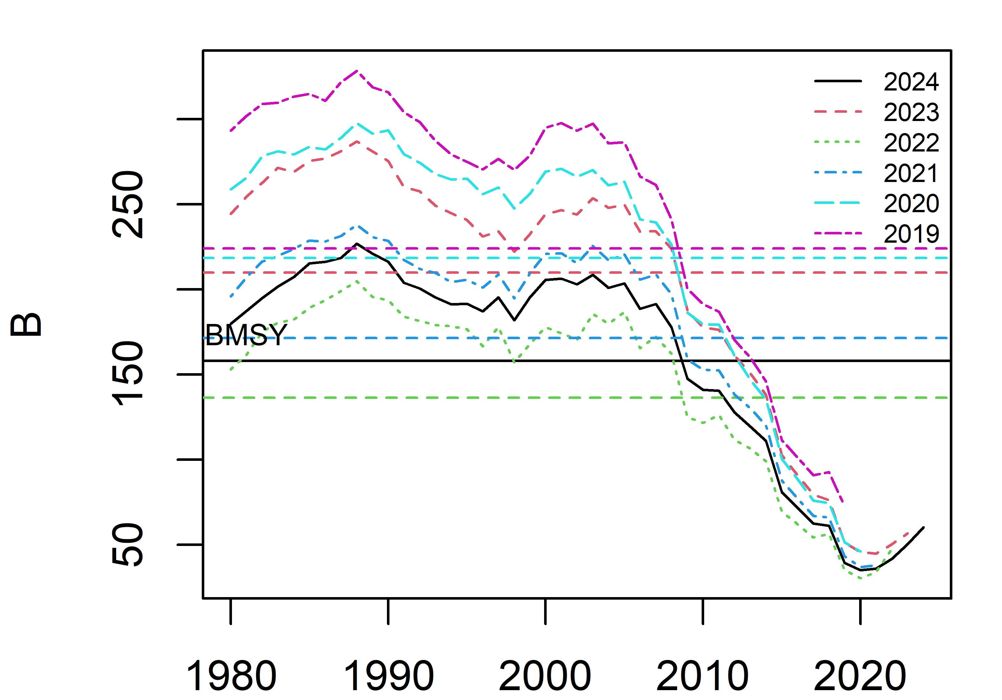
Appendix Figure 11. Retrospective pattern of biomass from base case scenario 2 (Mohn’s rho=0.30).

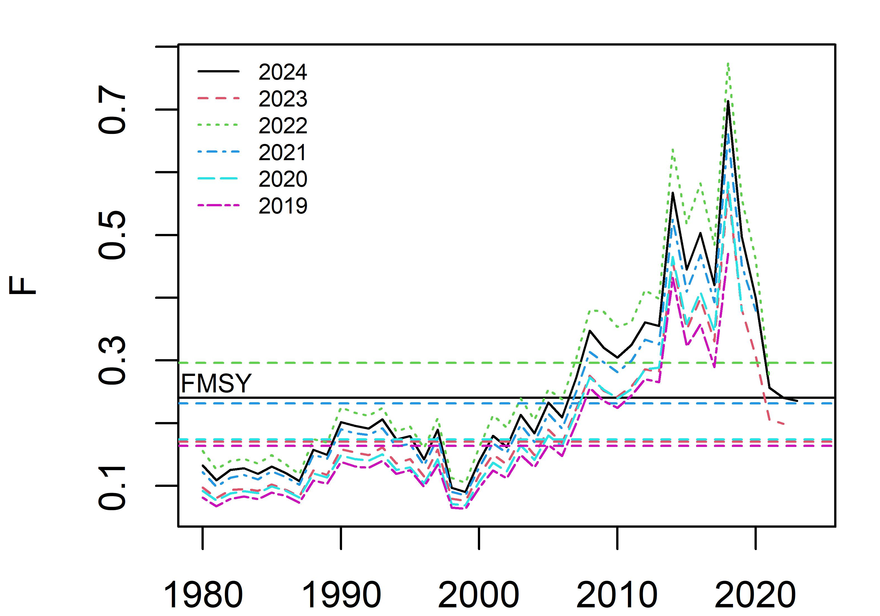
Appendix Figure 12. Retrospective pattern of harvest rate from base case scenario 2 (Mohn’s rho=-0.15).

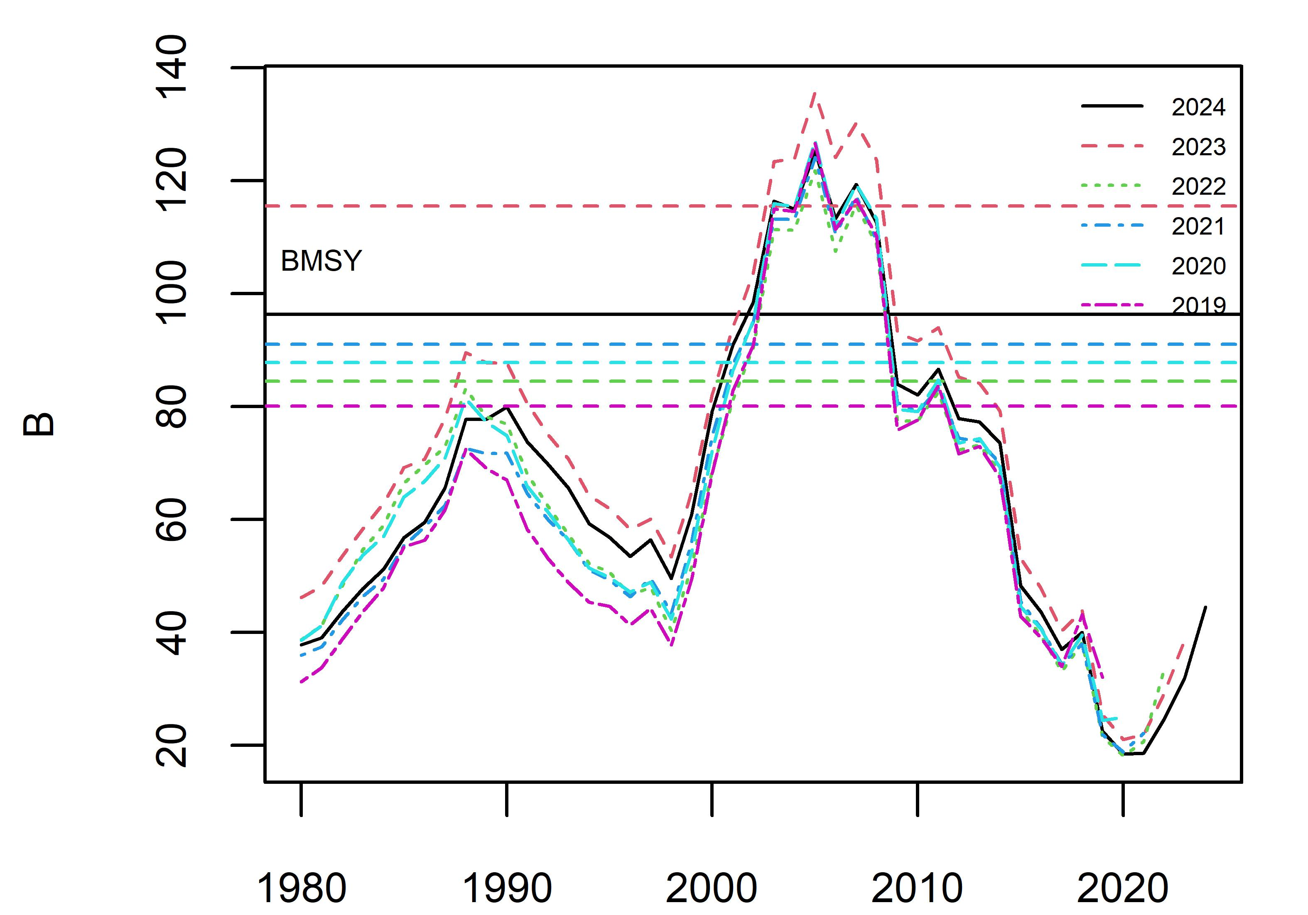
Appendix Figure 13. Retrospective pattern of biomass from sensitivity case scenario 1 (Mohn’s rho=0.31).

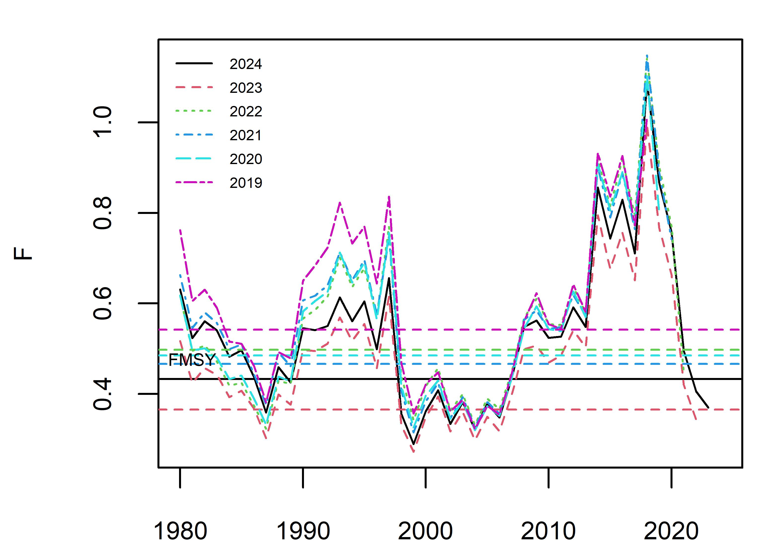
Appendix Figure 14. Retrospective pattern of harvest rate from sensitivity case scenario 1 (Mohn’s rho=-0.09).

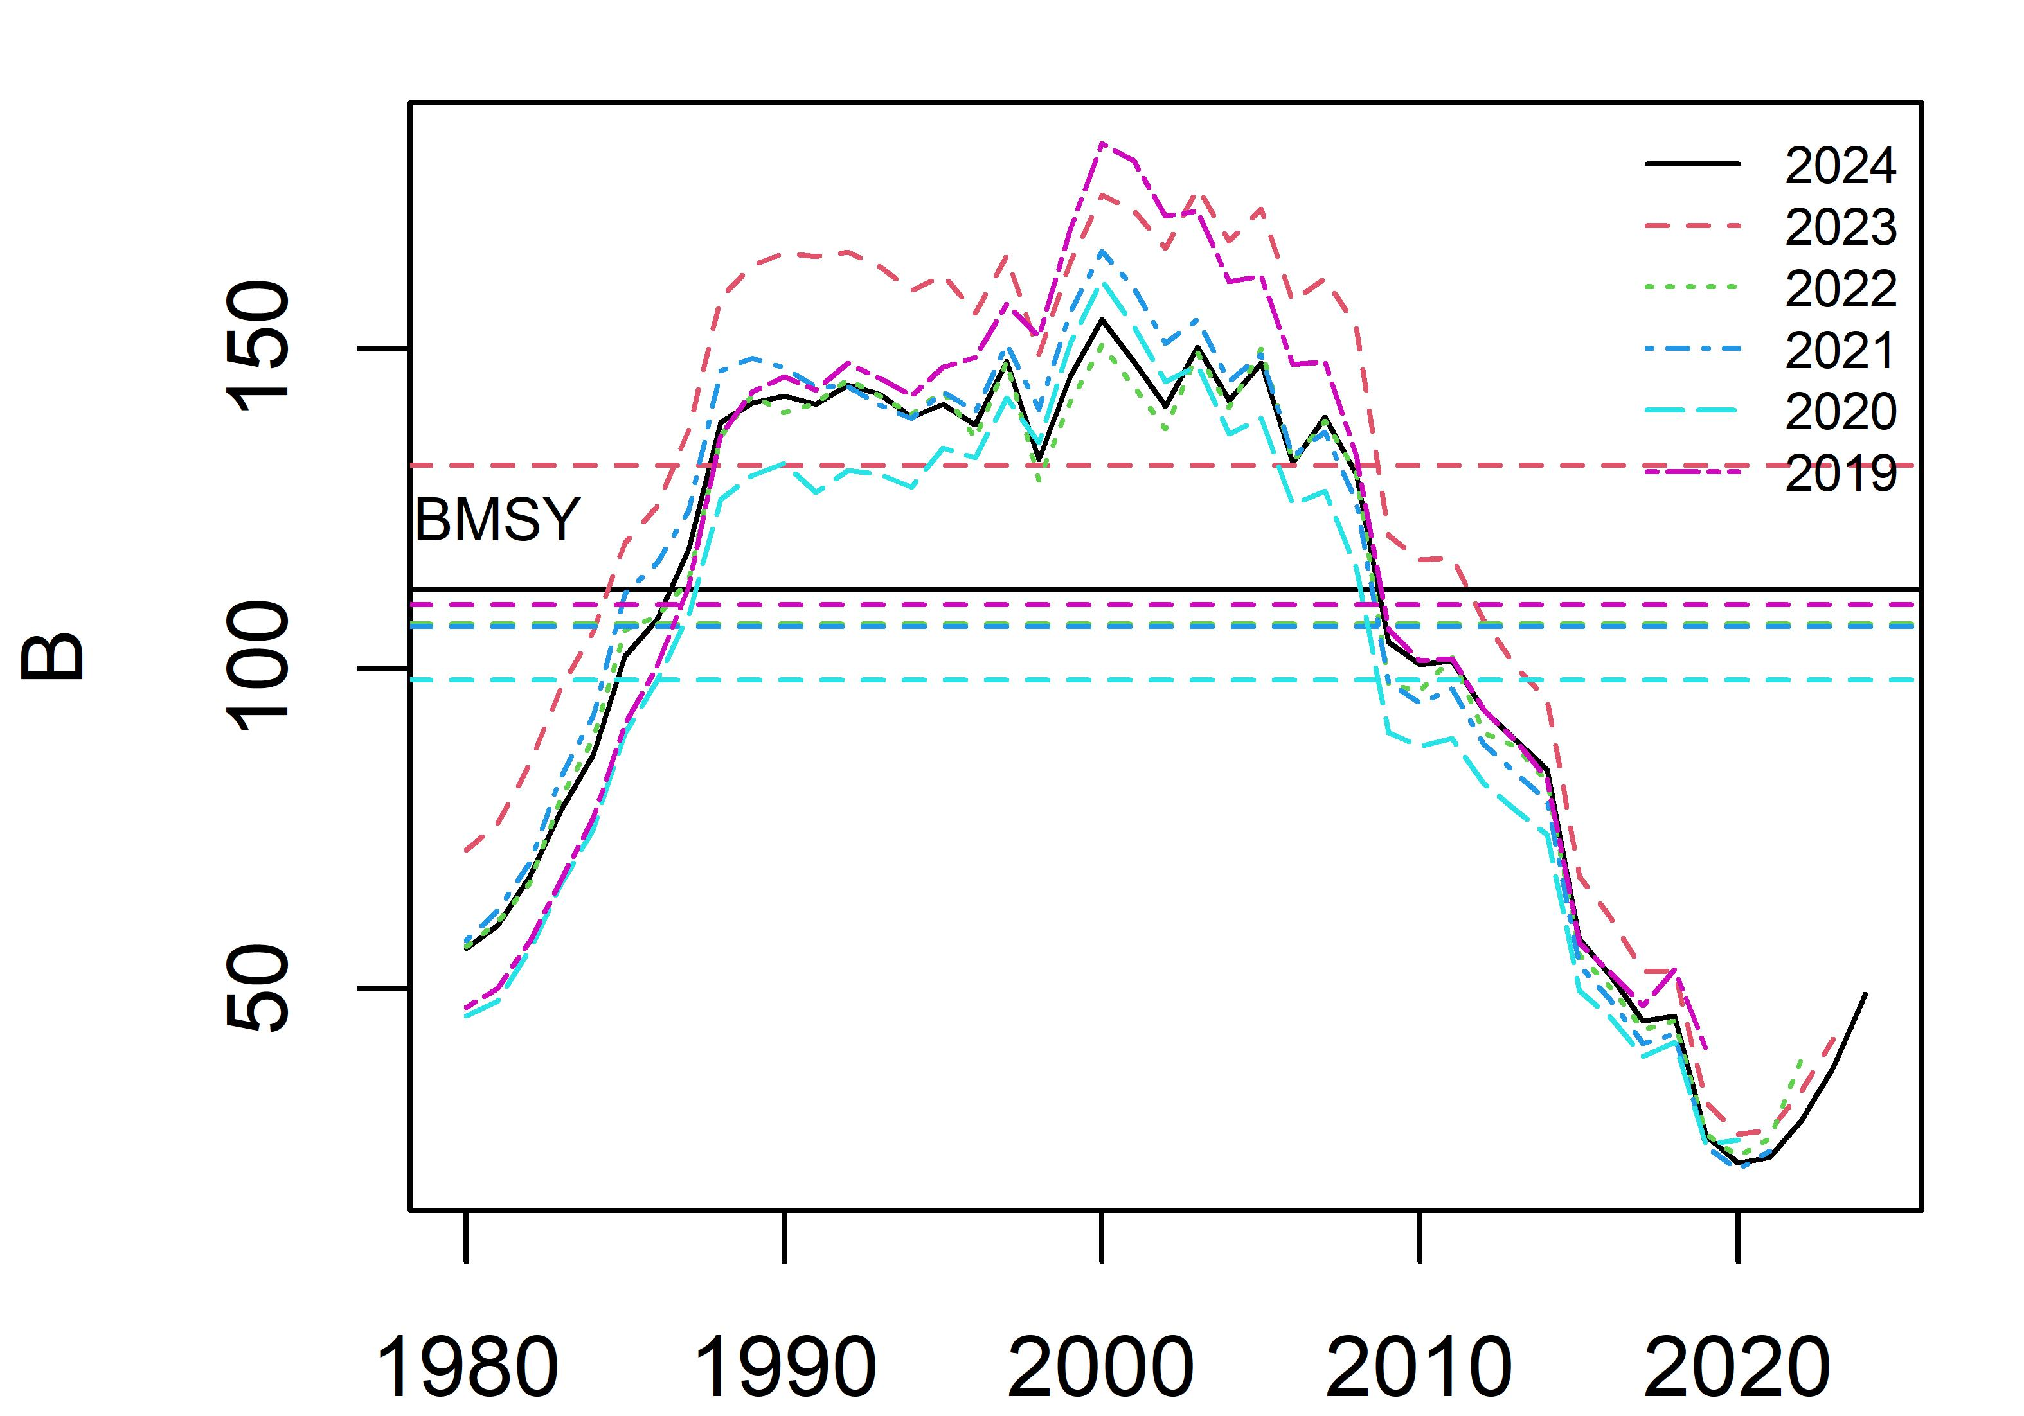
Appendix Figure 15. Retrospective pattern of biomass from sensitivity case scenario 2 (Mohn’s rho=0.23).

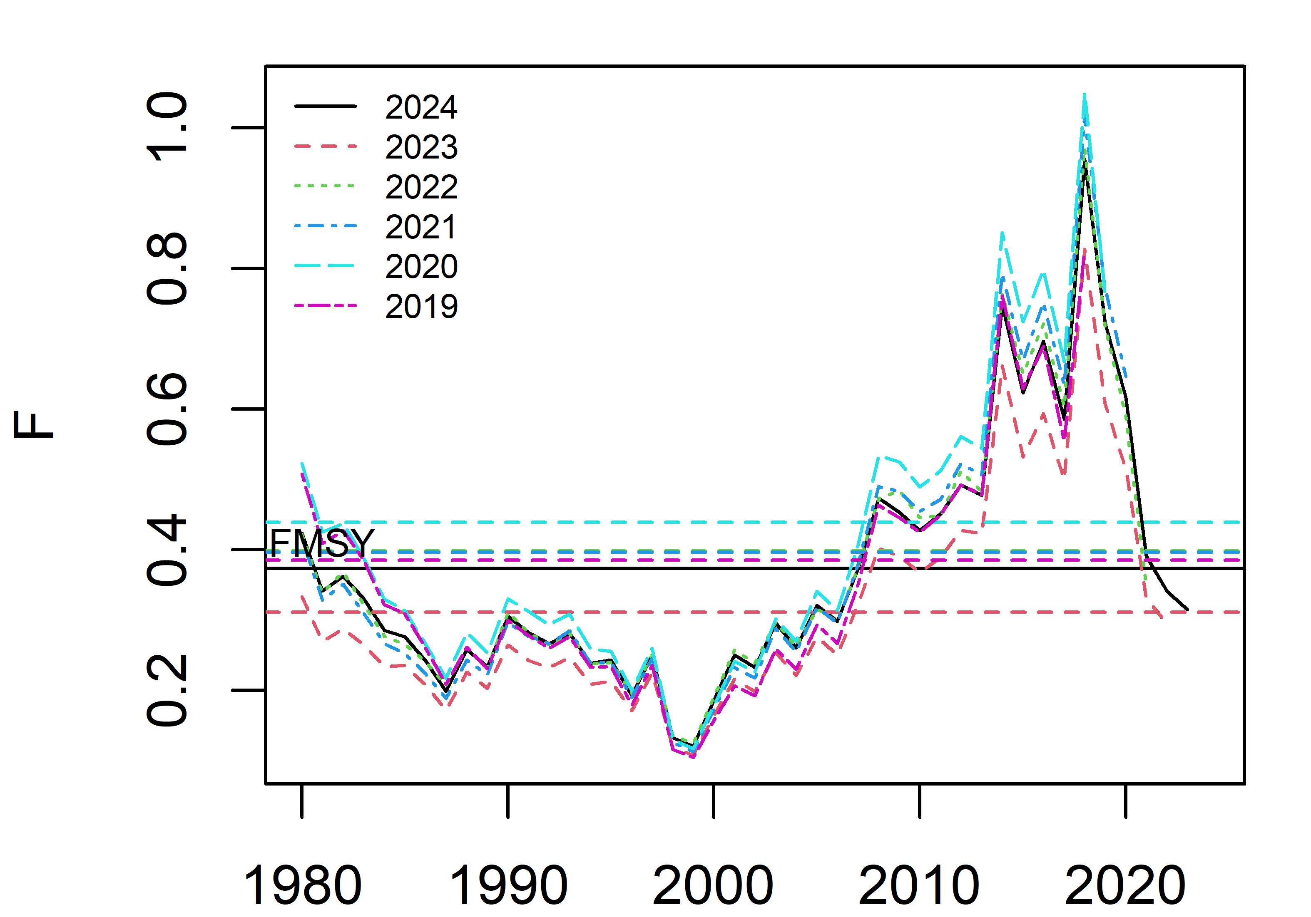
Appendix Figure 16. Retrospective pattern of harvest rate from sensitivity case scenario 2 (Mohn’s rho=-0.06).

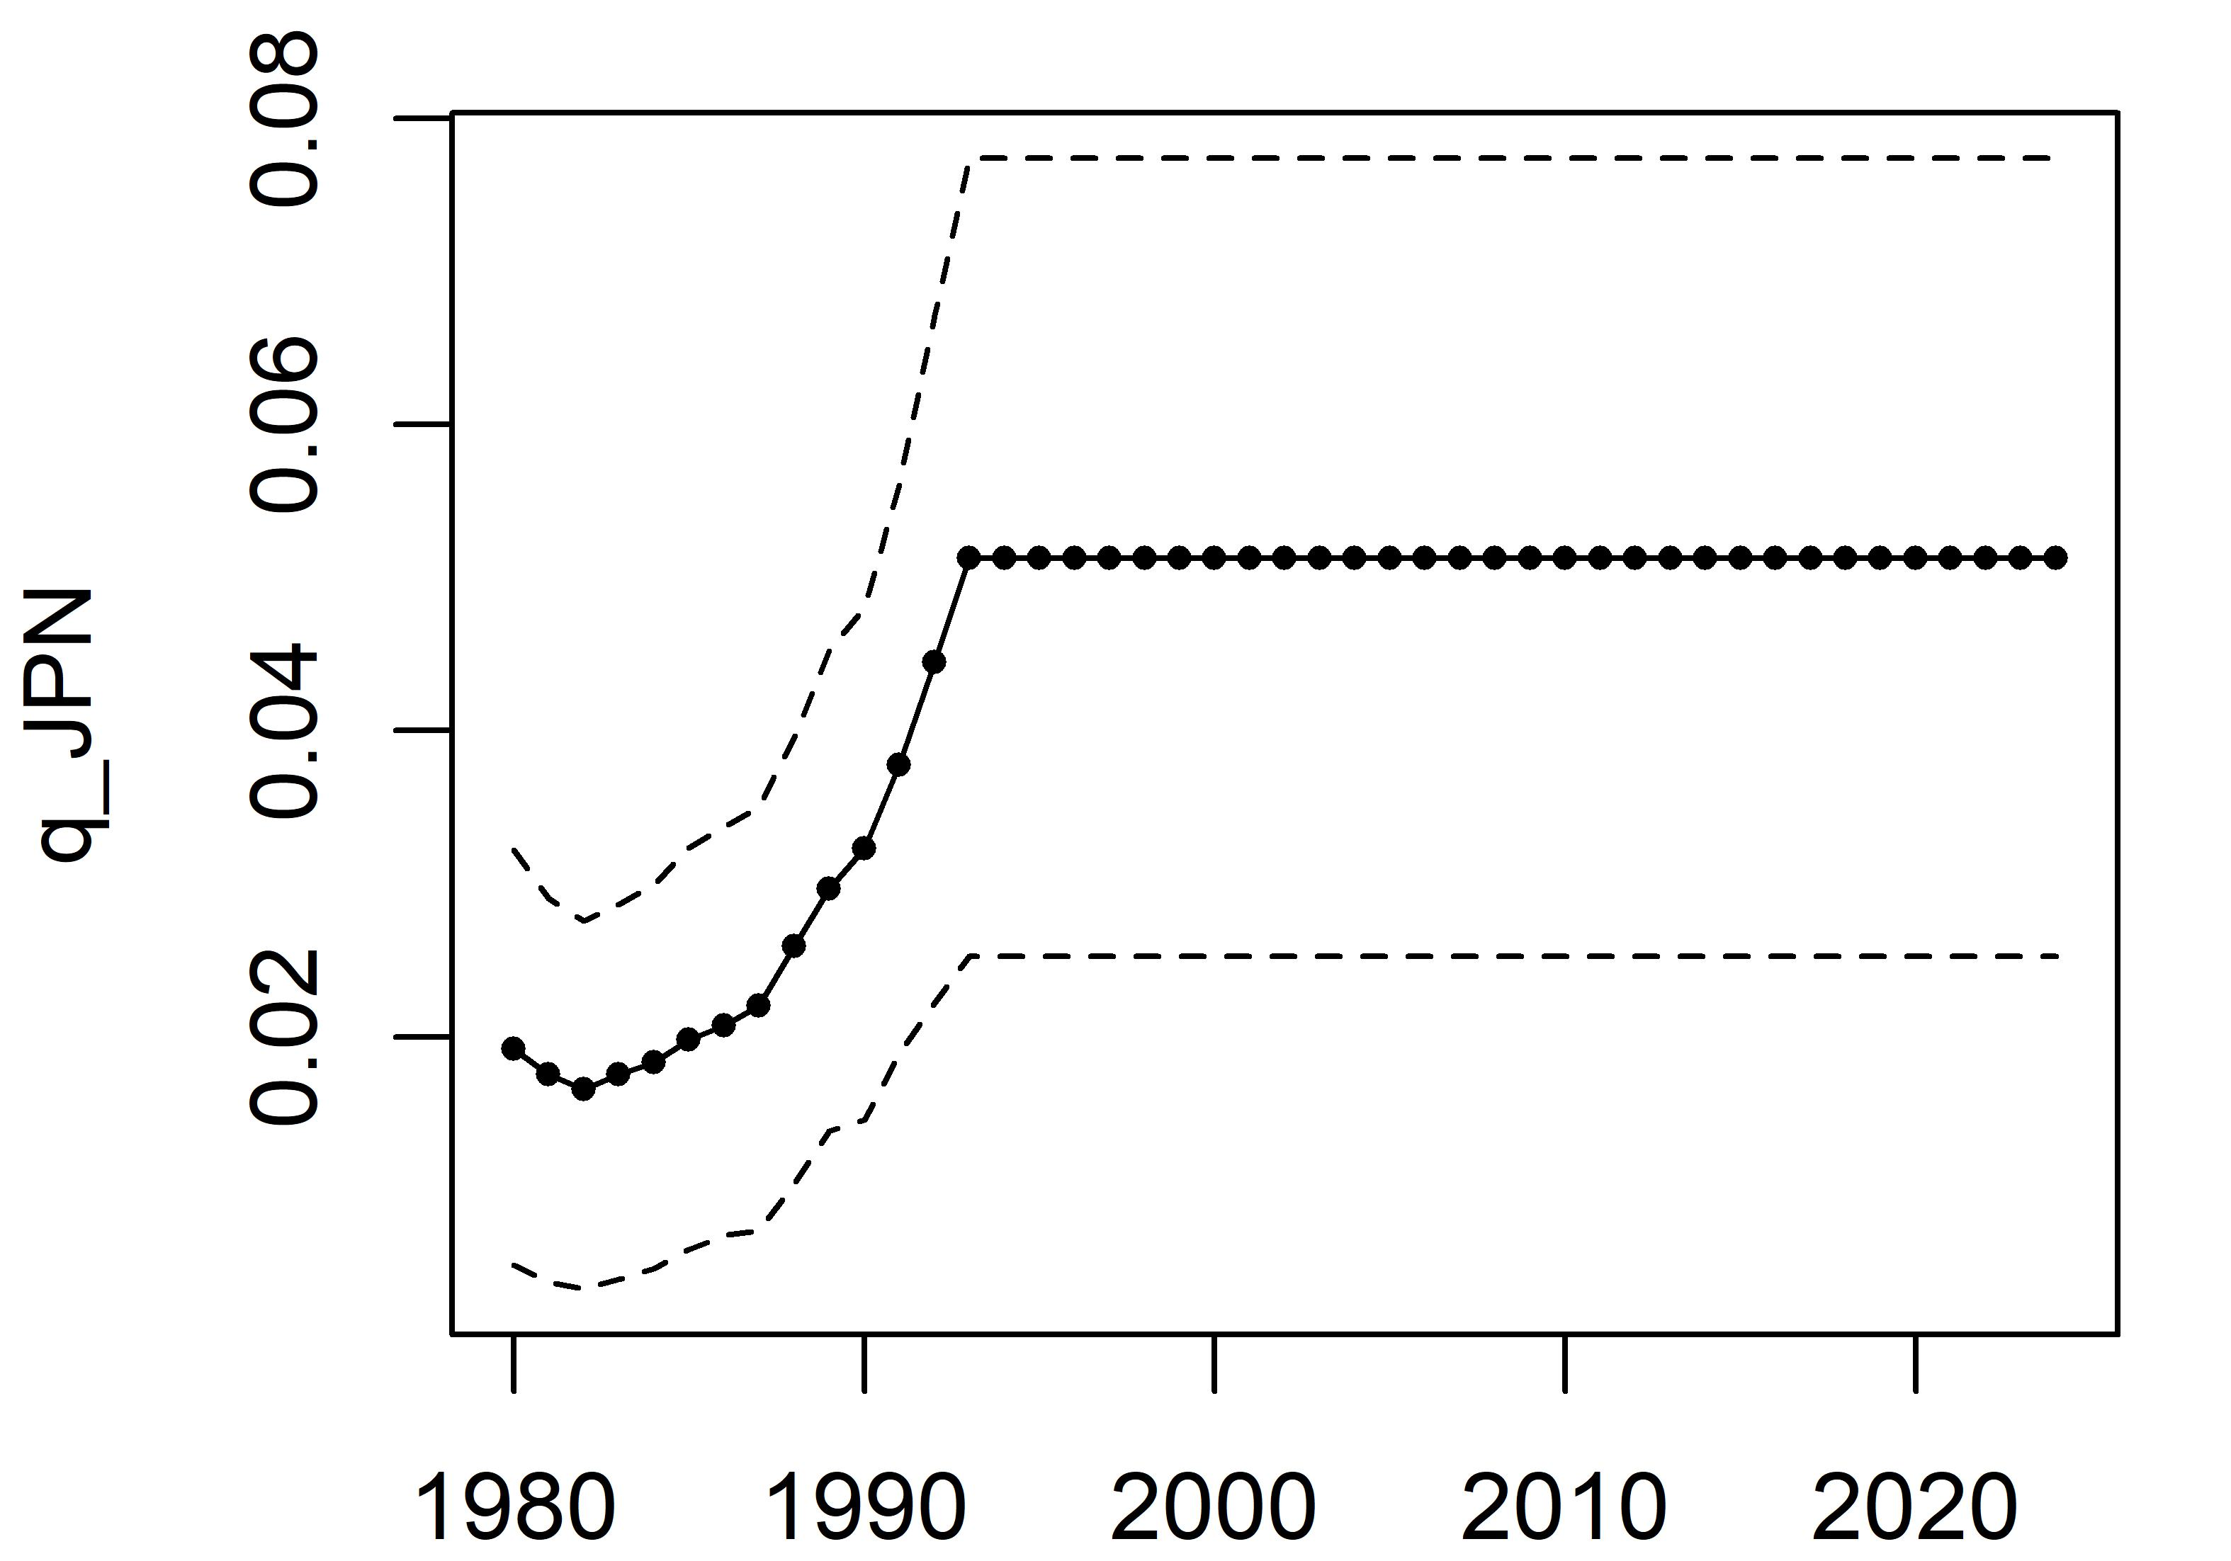
Appendix Figure 17. Time-varying catchability of Japanese early CPUE from sensitivity case scenario 1.

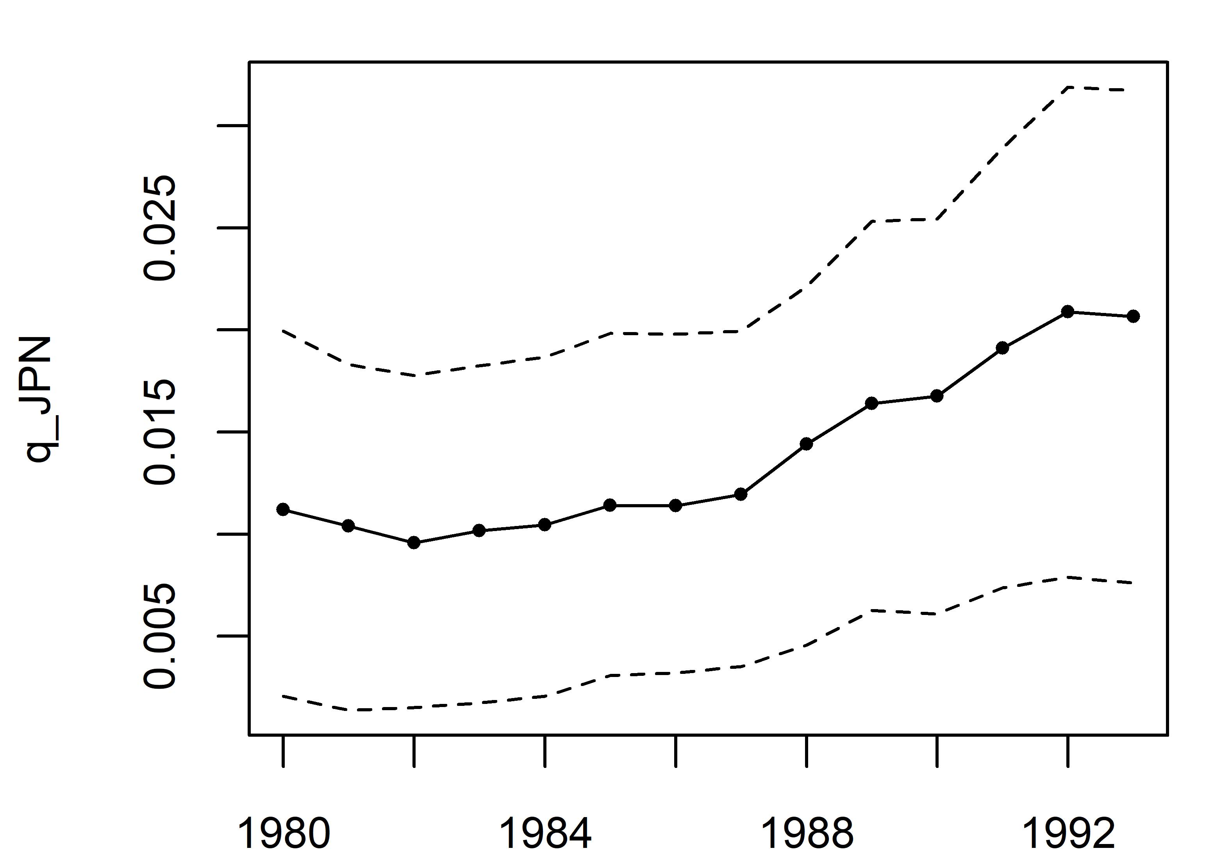
Appendix Figure 18. Time-varying catchability of Japanese early CPUE from sensitivity case scenario 2.

