NPFC-2024-SSC PS14-WP12

Evaluating the impacts of environmental variables on spatial density distributions of Pacific saury by using spatio-temporal modelling

Chih-Yi Cheng, Zi-Wei Yeh, Kuan-Chun Teng, Jhen Hsu, Yi-Jay Chang

Institute of Oceanography, National Taiwan University

Abstract

This study investigated the influence of environmental factors on Pacific saury distribution in the Northwestern Pacific Ocean using the spatiotemporal modeling framework sdmTMB. We analyzed the catch-per-unit-effort (CPUE) dataset compiled by North Pacific Fisheries Commission members and examined the variation of CPUE in related to multiple environmental variables through different functional relationships during 2001-2023 by using species distribution models. The quadratic function model provided the best fit, explaining 36.1% of variance. Results suggested that positive associations with net primary production and a dome-shaped response to sea surface salinity, peaking around 33 PSU. Spatial random effects showed distinct seasonal migration patterns, with distributions shifting from eastern offshore waters (160°-170°E) during May-July to coastal waters (40°-45°N) in August-September, followed by a southward coastal migration from October-December. In recent years (2021–2023), Pacific saury density has declined across the region, likely reflecting significant changes driven by environmental variations. This preliminary analysis provided insights how environmental factors and seasonal patterns influence Pacific saury habitats, with potential for model improvement through the exploration of additional environmental variables.

1. Introduction
Pacific saury (Cololabis saira) is a small, migratory pelagic fish widely distributed throughout the Northwestern Pacific Ocean. This species is commercially important in the Northwestern Pacific Ocean, targeted by stick‐held dip net fisheries from several members of the North Pacific Fisheries Commission (NPFC) that the offshore fishing vessels by Japan and Russia operate mainly within the exclusive economic zones while the distant-water vessels of China, Korea, and Chinese Taipei operate mainly east of Hokkaido and the Kuril Islands in the Northwestern Pacific Ocean. Given its commercial significance, considerable scientific attention has focused on understanding the factors influencing Pacific saury distribution. This species’ biological characteristics, including its two-year lifespan (Suyama et al., 2006) and extensive migrations between subtropical and subarctic zones (Fukushima, 1979; Suyama et al., 2012; Miyamoto et al., 2019), make it particularly responsive to environmental conditions in the Northwestern Pacific Ocean (Tseng et al., 2013; Chang et al., 2019). Previous research has investigated the effects of various environmental parameters on Pacific saury density and distribution, including sea surface temperature (SST; Watanabe et al., 2003; Hashimoto et al., 2020), sea surface height (SSH; Kuroda and Yokouchi, 2017), sea surface salinity (Takasuka et al., 2014), and net primary production (Chang et al., 2019).

Recent methodological advances in spatiotemporal analysis have enabled the development of continuous spatial models that account for spatial autocorrelation between observations across both space and time (Banerjee et al. 2008; Shelton et al. 2014; Thorson et al. 2015). These approaches enhance species density distribution estimates by improving the precision of temporal trend estimates (Thorson et al. 2015) and leveraging established frameworks such as mixed-effects models, where spatial or spatiotemporal components serve as random effects (Shelton et al. 2014; Finley et al. 2015). Within this framework, the spatial random effect represents a species’ fundamental niche (its average spatial distribution over time), and spatiotemporal variation reflects its environmental response (its reaction to unmodeled conditions). This approach effectively eliminates spatial confounding effects, thereby clarifying the relationship between environmental variables (e.g., marginal effect) and fish density.

This study employs the spatiotemporal modeling framework sdmTMB (Anderson et al., 2022) to examine how environmental variables influence Pacific saury density through various functional relationships (i.e., linear, quadratic, and spline functions). The analysis utilizes a comprehensive catch-per-unit-effort (CPUE) dataset jointly compiled by all NPFC members to understand the species’ spatiotemporal distribution patterns.

2. Methods

2.1 Fishery and environmental data

Fishery data, including catch (in metric tons) and effort (operating days) from stick-held dip net fisheries operated by NPFC members (China, Japan, Korea, Russia, Chinese Taipei, and Vanuatu), were collected during the fishing season (May to December) from 1994 to 2023. The joint dataset was aggregated by year and month with a spatial resolution of 1° × 1° in latitude and longitude. Data from 2001 to 2023 were selected to ensure comprehensive spatial coverage with consistent fishing effort distribution across all NPFC members (Figure 1).

Several environmental variables were considered in this study, including sea surface temperature (SST; °C), Sea water salinity (SSS; PSU), sea surface height (SSH; m), net primary production (NPP; mg C/ m³/day), and dissolved oxygen (O₂; mmol/m³), which are commonly used to examine potential effects on Pacific saury density and distribution (Tseng et al., 2013; Chang et al., 2018). These monthly environmental data were obtained from the Copernicus Marine Environment Monitoring Service (CMEMS) dataset (http://marine.copernicus.eu/).

2.2 Spatio-temporal modelling approach

The spatio-temporal modeling approach used in this study is implemented through the R package sdmTMB (https://github.com/pbs-assess/sdmTMB), developed by Anderson et al. (2022). The package uses Gaussian random fields to model spatial and spatiotemporal components, utilizing a Matérn covariance function. By estimating the correlation structure of the data, this model can interpolate abundance in unobserved strata while accounting for spatial and temporal dependencies. In this study, the spatial mesh comprised 129 knots (Figure 2) to approximate spatial random effects and capture underlying spatial and spatiotemporal autocorrelation patterns in the data.

We provided a brief description of how the sdmTMB is applied to the Pacific saury joint CPUE dataset below and refer the readers to the original reference for more technical details (see Anderson, 2022). The logarithm prediction of Pacific saury density, p(s,t), in location s and year t is described below:

(1)

where β(t) is the intercept for each year t as a fixed effect, ω(s) is a time-invariant spatial autocorrelated variation for location s, and ε(s, m) is a spatio-temporal autocorrelated variation for location s and in each month m (i.e., the interaction of spatial variation and month). γ(p) represents the impacts of several environmental variables p with value X(s, t, p) on density for location s and year t (please see the Eq.2 for details). η(v) are the random effects for each fleet.

In addition, we evaluated various marginal effects of the environmental variables on the CPUE variations using linear, quadratic, and spline functions to model their effects on Pacific saury density:

(2)

where f() is the linear, quadratic and spline function for each environmental variable in location s and year t.

Model convergence was evaluated by confirming that the absolute gradient values of the log-likelihood function were below 0.0001 for all parameters, with a positive definite Hessian matrix. Among the different functional treatments (linear, quadratic, and spline) applied to environmental variables, the best model was selected based on the lowest AIC and highest R² values (Table 1). The spatial distribution of residuals for each year was examined to assess normality in the sdmTMB.

3. Results and discussion
3.1 Model selection and diagnostic
While the three functional treatments on environmental variables showed similar performance based on AIC and R² values, the quadratic function provided the best fit (slightly improvement of AIC and R²) (Table 1), explaining 36.1% of the variance. Therefore, we employed this model for subsequent analyses and predictions of Pacific saury distribution. In general, the spatial distribution of aggregated residuals (Figure 3) showed values close to zero across years, indicating effective model performance in capturing the observed spatial patterns of Pacific saury density.
3.2 Response curve for each environment variable
The response curves and confidence intervals for each environmental variable from the best model are shown in Figure 4. Confidence intervals were narrower for mean SST and SSS values where observations were concentrated, while wider intervals in the higher ranges of SSH (> 1m), O₂ (>300 mmol/m³), and NPP (>40 mg C/ m³/day) reflected greater uncertainty due to sparse data coverage.
In general, our analysis revealed noticeable relationships between Pacific saury CPUEs and the selected environmental variables. NPP showed a positive relationship with CPUE, indicating Pacific saury’s preference for productive waters with higher food availability. Dissolved oxygen exhibits a slight negative relationship with CPUE. Dissolved oxygen levels in the studied area (250-300 mmol/m³) exceeded the typical suitable range for small pelagic fish (160-250 mmol/m³; approximately 3.5-5.5 mL/L; Bertrand et al., 2011). The observed negative relationship at higher oxygen concentrations (>250 mmol/m³) suggested these conditions may be not suitable for Pacific saury. While SSH and SST showed minimal influence on CPUE variation (i.e., flattened response curves), SSS exhibited a dome-shaped response with peak CPUE around 33 PSU, we found that the spatial distribution of the preferred SSS range for Pacific saury aligns with the Oyashio Current. This may be influenced by the fresher waters of the Oyashio Current originating from the subarctic region (Yasuda, 2003).
3.3 Spatial distributions of spatial random effects varied by months

The distributions of monthly spatial random effects (May to December) were shown in Figure 5. The spatial patterns indicated distinct monthly shifts in the Pacific saury density. Higher densities were distributed in eastern high seas (160°-170°E) from May to July. During August and September, the distribution showed a north-south shift, with higher densities concentrating in coastal waters of Japan around 40°-45°N. From October to December, the high-density areas gradually moved southward along the coast of Japan, reflecting the saury’s autumn migration toward lower latitudes (40ºN). This monthly pattern is consistent with the species’ migration from high seas to coastal spawning areas (Tian et al., 2004).

3.4 Estimated density of Pacific saury over historical period

The estimated density of Pacific saury was calculated after excluding the effect of the catchability covariate (i.e., fleet effect). Figure 6 showed the observed and predicted spatial distributions of Pacific saury density across five-year intervals during 2001 - 2023. High-density areas were consistently observed near Japanese coastal waters (140°-150°E) during 2001-2015. From 2016-2020, the distribution pattern began shifting eastward, showing more moderate densities extending into offshore waters. The most recent period (2021-2023) reveals a marked decline in density throughout the region. The model effectively captured these temporal changes, with predicted distributions closely matching observed patterns. This recent decline suggests significant changes in Pacific saury distribution and density.

As a preliminary analysis, this study provided insights into how environmental variability and seasonal patterns shape Pacific saury habitats. Future studies should improve the model by incorporating additional environmental factors (e.g., Eddy Kinetic Energy; EKE) to enhance predictions.

References

Anderson, S. C., Ward, E. J., English, P. A., and Barnett, L. A. K. (2022). sdmTMB: an R package for fast, flexible, and user-friendly generalized linear mixed effects models with spatial and spatiotemporal random fields. bioRxiv 2022.03.24.485545

Banerjee, S., Gelfand, A. E., Finley, A. O., and Sang, H. (2008). Gaussian predictive process models for large spatial data sets. Journal of the Royal Statistical Society Series B: Statistical Methodology, 70, 825-848.

Bertrand, A., Chaigneau, A., Peraltilla, S., Ledesma, J., Graco, M., Monetti, F., and Chavez, F. P. (2011). Oxygen: a fundamental property regulating pelagic ecosystem structure in the coastal southeastern tropical Pacific. PloS one, 6(12), e29558.

Chang, Y.J., Lan, K.W., Walsh, W.A., Hsu, J., Hsieh, C.H. (2019). Modelling the impacts of environmental variation on habitat suitability for Pacific saury in the Northwestern Pacific Ocean. Fish. Oceanogr. 28, 291–304.

Finley, A. O., Banerjee, S., and Gelfand, A. E. (2013). spBayes for large univariate and multivariate point-referenced spatio-temporal data models. arXiv preprint arXiv:1310.8192.

Fukushima, S. (1979). Synoptic analysis of migration and fishing conditions of saury in northwest Pacific Ocean. Bull. Tohoku Reg. Fish. Res. Lab. 41, 1-70.

Hashimoto, M., Kidokoro, H., Suyama, S., Fuji, T., Miyamoto, H., Naya, M., Kitakado, T. (2020). Comparison of biomass estimates from multiple stratification approaches in a swept area method for Pacific saury Cololabis saira in the western North Pacific. Fish.
Res. 1–12.

Latimer, A. M., Banerjee, S., Sang Jr, H., Mosher, E. S., and Silander Jr, J. A. (2009). Hierarchical models facilitate spatial analysis of large data sets: a case study on invasive plant species in the northeastern United States. Ecology letters, 12(2), 144-154.

Shelton, A. O., Thorson, J. T., Ward, E. J., and Feist, B. E. (2014). Spatial semiparametric models improve estimates of species abundance and distribution. Canadian Journal of Fisheries and Aquatic Sciences, 71(11), 1655-1666.

Suyama, S., Kurita Y., Ueno Y. (2006). Age structure of Pacific saury Cololabis saira based on observations of the hyaline zones in the otolith and length frequency distributions. Fish Sci 72: 742-749.

Suyama, S., Nakagami M., Naya M., Ueno Y. (2012). Migration route of Pacific saury Cololabis saira inferred from the otolith hyaline zone. Fisheries Science 78: 1179-1186.

Thorson, J. T., Shelton, A. O., Ward, E. J., and Skaug, H. J. (2015). Geostatistical delta-generalized linear mixed models improve precision for estimated abundance indices for West Coast groundfishes. ICES Journal of Marine Science, 72(5), 1297-1310.

Tian, Y., Akamine, T., Suda, M., 2004. Modeling the influence of oceanic-climatic changes on the dynamics of Pacific saury in the northwestern Pacific using a life cycle model. Fish. Oceanogr. 13, 125–137.

Tseng, C.T., Sun, C.L., Yeh, S.Z., Chen, S.C., Su, W.C., Liu, D.C., 2011. Influence of climate− driven sea surface temperature increase on potential habitats of the Pacific saury (Cololabis saira). ICES J. Mar. Sci. 68, 1105-1113.

Tseng, C.T., Su, N.J., Sun, C.L., Punt, A.E., Yeh, S.Z., Liu, D.C., Su, W.C., 2013. Spatial and temporal variability of the Pacific saury (Cololabis saira) distribution in the northwestern Pacific Ocean. ICES J. Mar. Sci. 70, 991–999

Watanabe, Y., Kurita, Y., Noto, M., Oozeki, Y., Kitagawa, D., 2003. Growth and survival of Pacific saury Cololabis saira in the Kuroshio-Oyashio transitional waters. J. Oceanogr. 59, 403-414.

Yasuda, I. (2003). Hydrographic structure and variability in the Kuroshio-Oyashio transition area. Journal of Oceanography, 59, 389-402.

Table 1. Summary of the model selection information from sdmTMB.
Functional treatment on environmental variables | Model structure | Degrees of Freedom | AIC | R²
Linear | Year + Spatial + Spatio-temporal (months) + Fleet + SST + SSS + SSH + O₂ + NPP | 33 | 94296 | 0.360
Quadratic | Year + Spatial + Spatio-temporal (months) + Fleet + poly(SST, 2) + poly(SSS, 2) + poly(SSH, 2) + poly(O₂, 2) + poly(NPP, 2) | 38 | 94294 | 0.361
Spline | Year + Spatial + Spatio-temporal (months) + Fleet + s(SST, 3)+ s(SSS, 3) + s(SSH, 3) + s(O₂, 3) + s(NPP, 3) | 38 | 94298 | 0.360

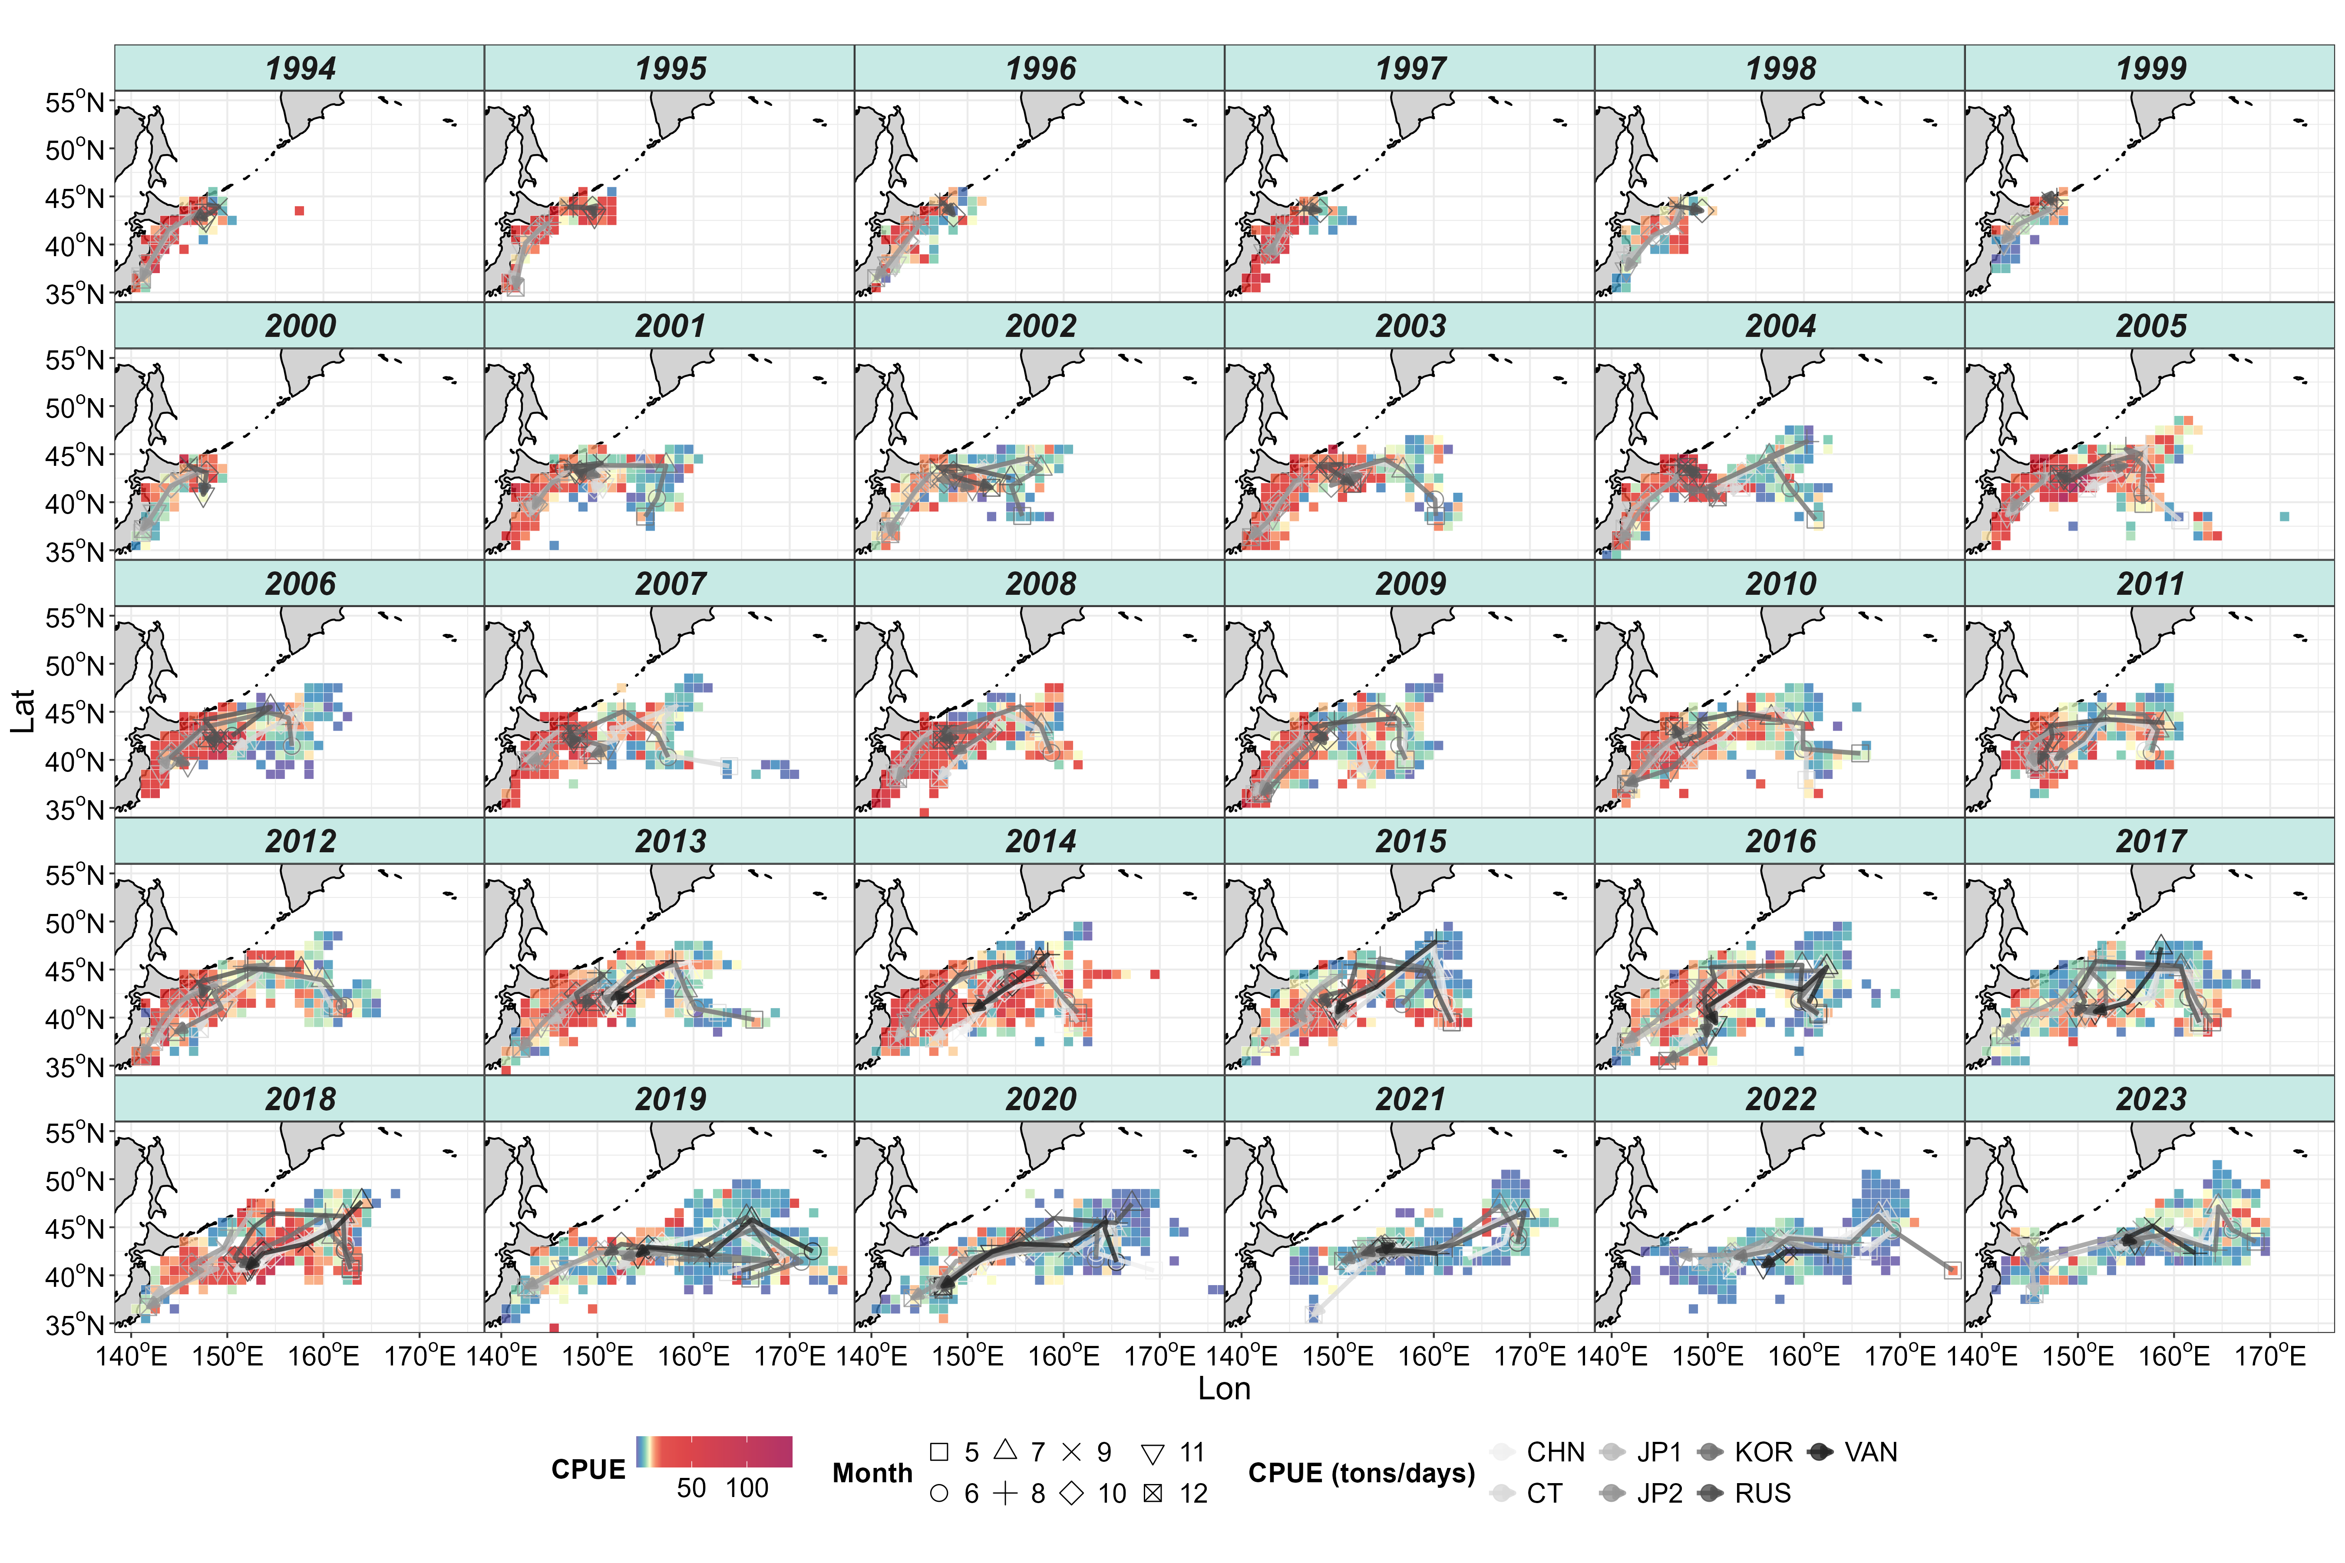

Figure 1: Spatial distribution of Pacific saury catch-per-unit-effort (in metric tons/operating day) in the Northwestern Pacific Ocean during 1994 - 2023, aggregated by 1° × 1° grid. The symbols on the map represent the monthly centroids of gravity for nominal CPUE across years, categorized by fleets.

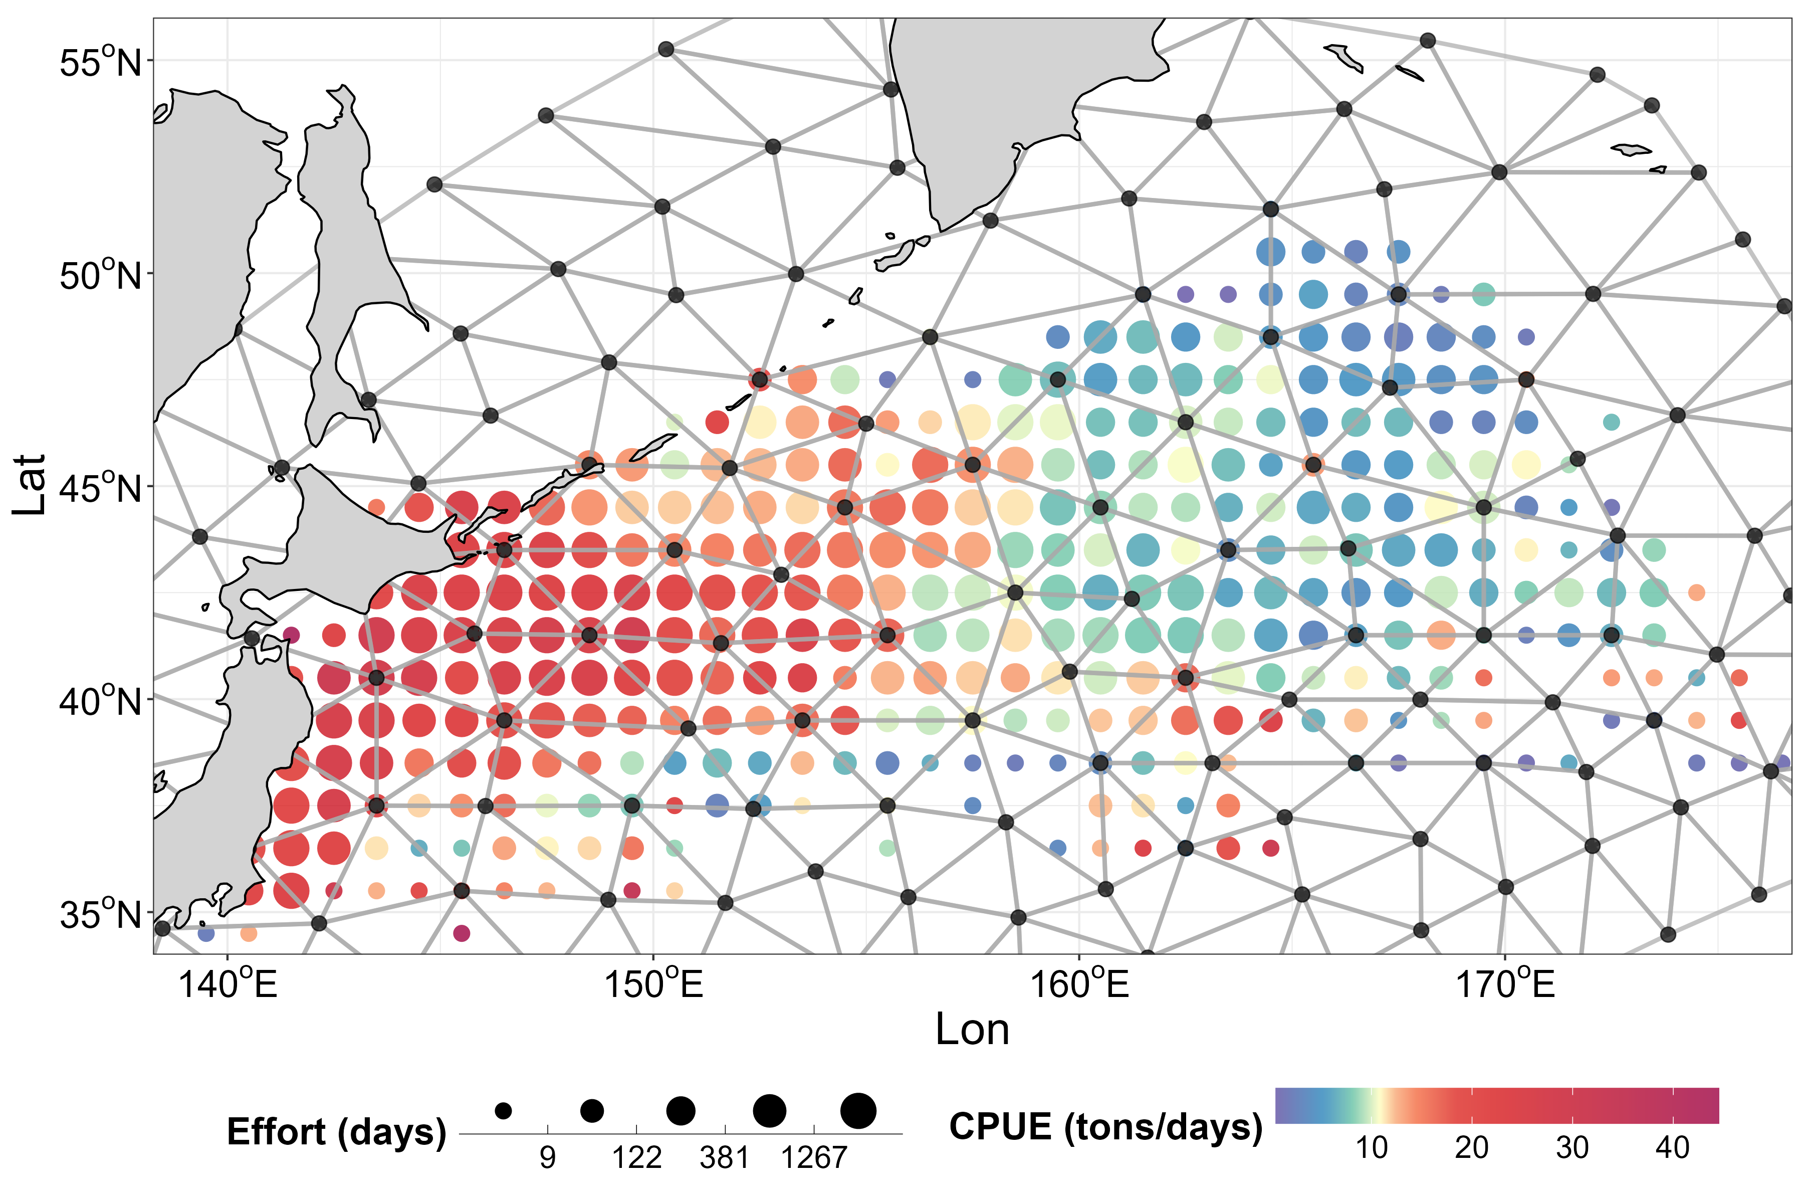

Figure 2: Mesh used for fitting the sdmTMB model. Black points represent the 129 spatial knots where effects are estimated. Colored circles indicate aggregated Pacific saury observations within 1° × 1° grids from 2001 to 2023. The size of the colored circles represents the level of fishing effort (in operating days).

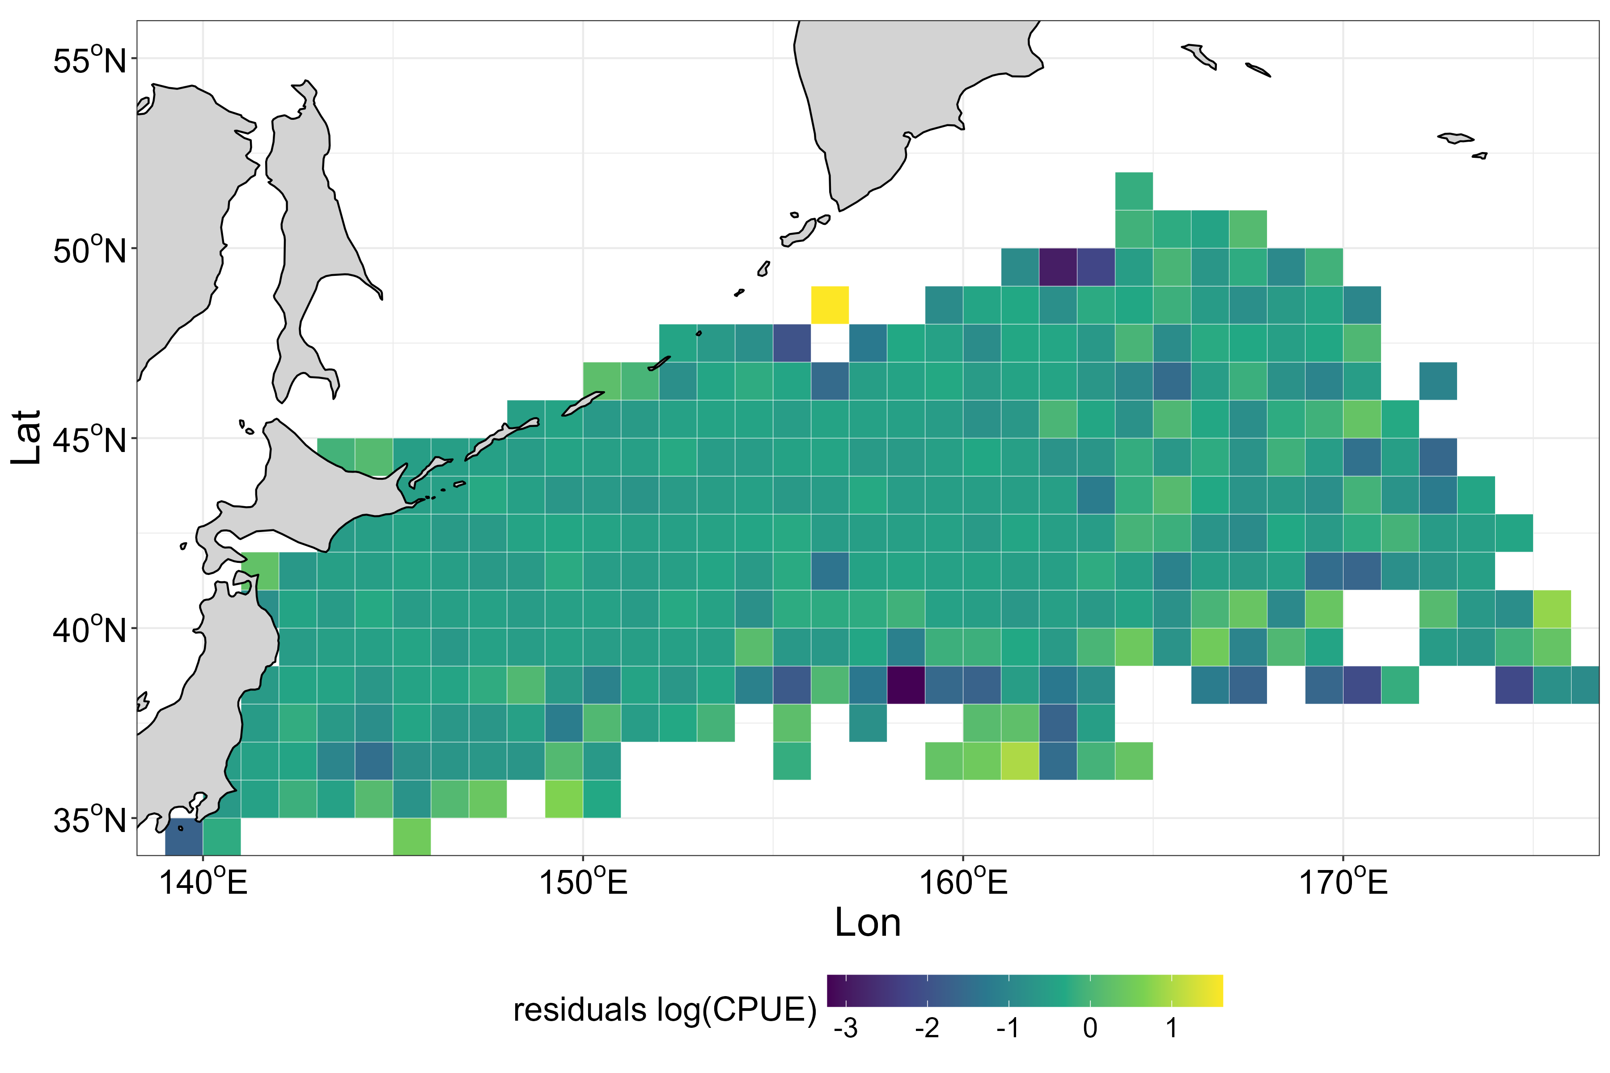

Figure 3. Spatial map of aggregated residual across all years (2001 – 2023) for each spatial grid. Positive residuals (yellow) indicate areas where the observed CPUE exceeded model predictions, while negative residuals (blue) indicate the opposite.
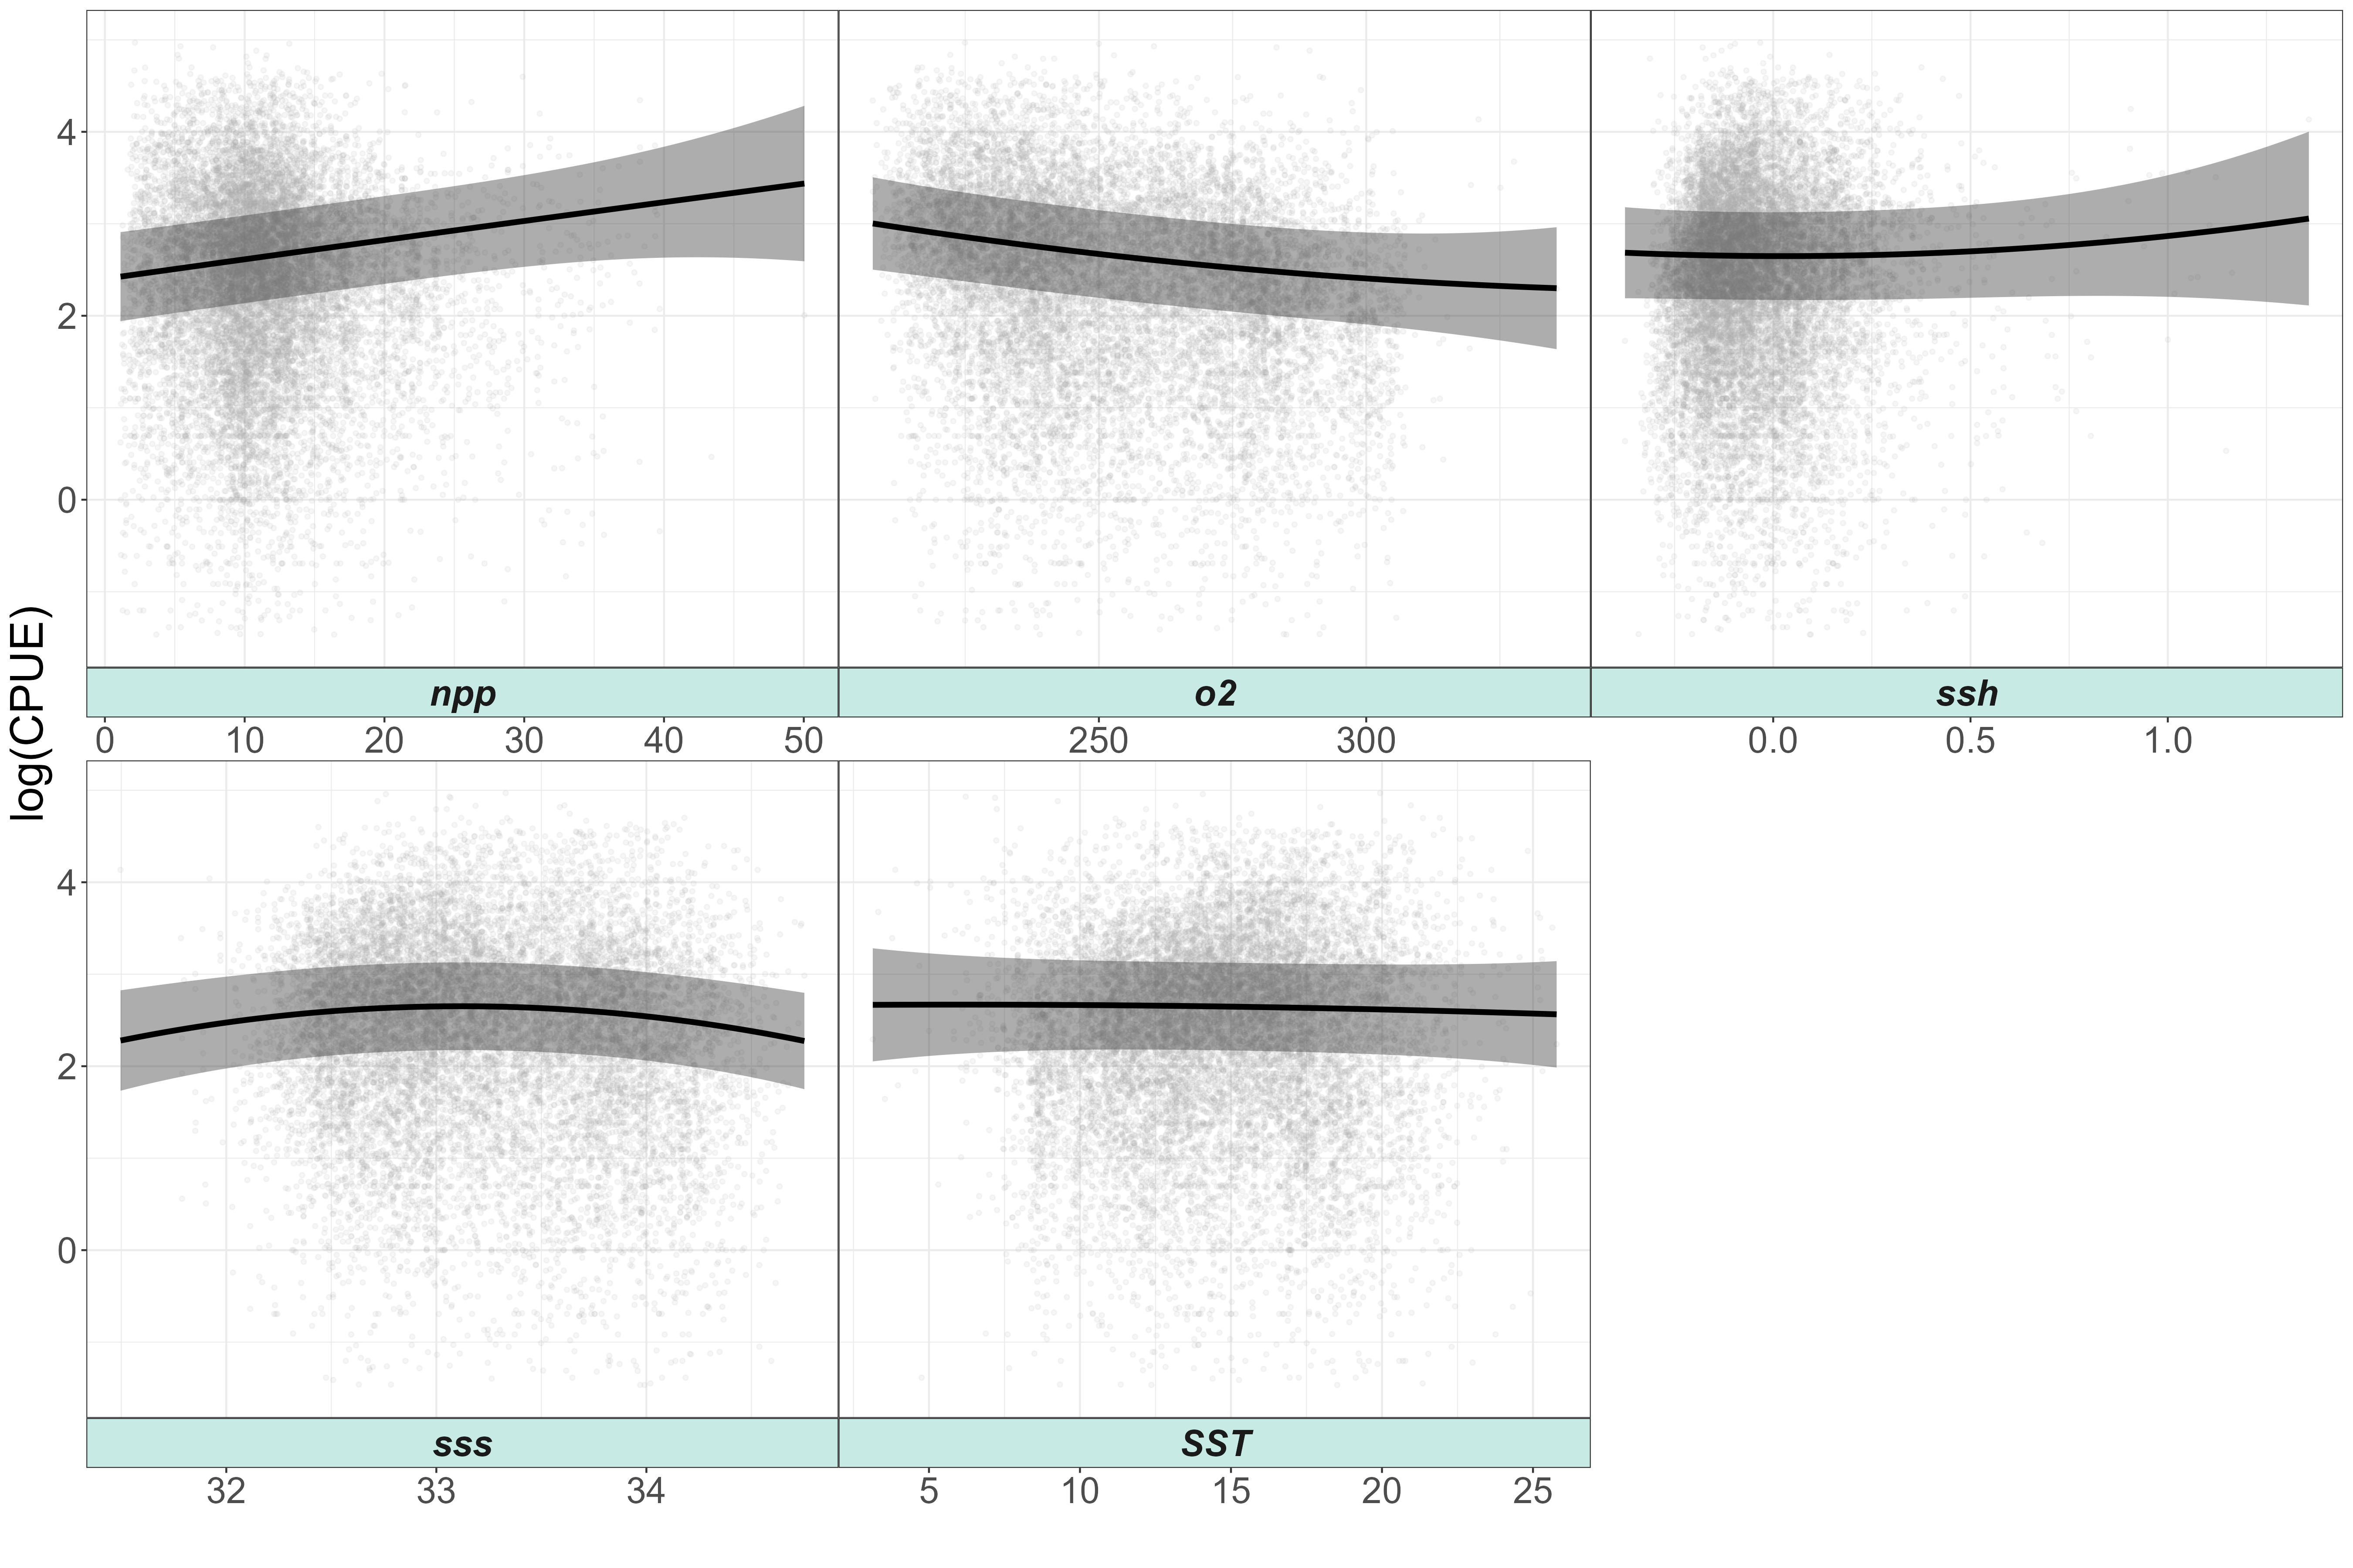

Figure 4. Response curves of environmental variables from the sdmTMB model: net primary production (NPP), dissolved oxygen (O₂), sea surface height (SSH), sea surface salinity (SSS), and sea surface temperature (SST). Grey polygons represent confidence intervals, and grey points show observed environmental data.

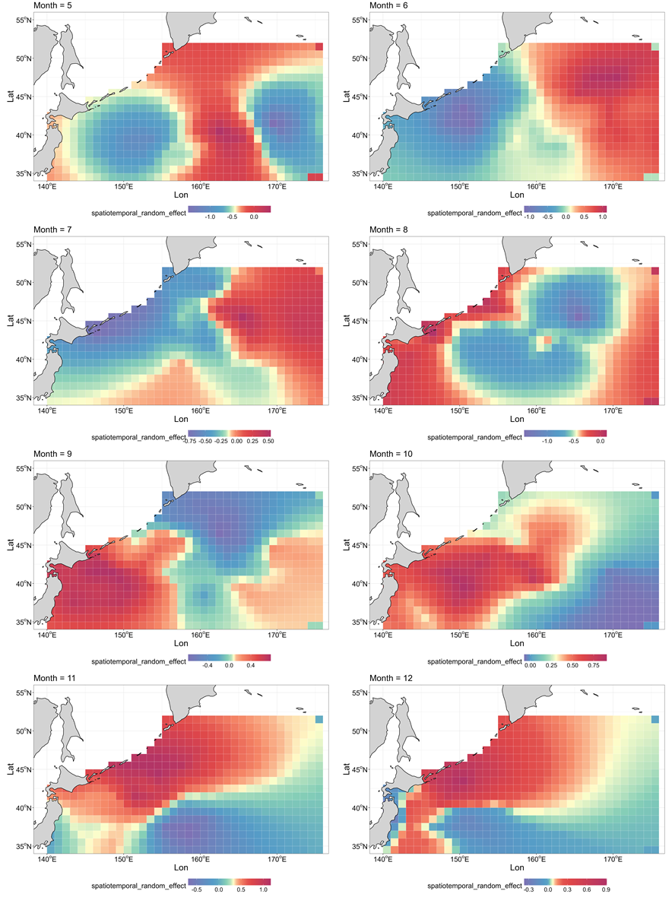

Figure 5. Spatial distribution of spatial random effect for each month (May to December) estimated by sdmTMB.

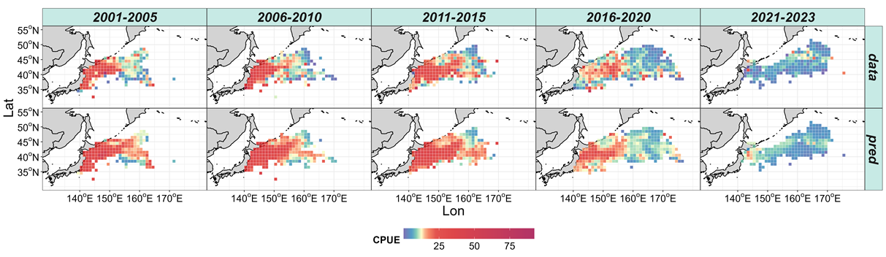

Figure 6. Spatial distribution of observed (upper panels) and predicted (lower panels) Pacific saury CPUE (metric tons/day) across five-time intervals from 2001 to 2023.

