NPFC-2024-SSC PS14-WP14

Bycatch information of Pacific saury from Chinese fisheries in the Northwestern Pacific Ocean

Libin Dai
College of Marine Living Resource Sciences and Management, Shanghai Ocean University

Summary
Pacific saury is primarily harvested by the Chinese stick-held dip nets fisheries operating in the high seas of Northwestern Pacific Ocean, with few catches reported from other fishing operations. While the Chinese stick-held dip nets fisheries primarily target Pacific saury, they also incidentally capture squids; however, the quantities of these bycatches remain historically minimal and are not officially documented in logbooks. Mackerel fisheries, employing purse seines and trawlers, constitute the primary fishing activities that historically have led to unintentional catches of Pacific saury. Nonetheless, when compared to the targeted species such as Chub mackerel and Japanese sardine, the proportion of Pacific saury caught is exceedingly small and considered insignificant.

1. Pacific saury catch from other fisheries
Pacific saury has been historically caught primarily by Chinese fleets using stick-held dip nets and its catch is quite small in Mackerel fisheries using trawls and purse seines. The average annual proportion of Pacific saury catch was 1.11% in Mackerel fisheries from 2014 to 2023 (Fig. 1).

2. Bycatch in the Chinese Pacific saury fisheries
The fishing fleets of Chinese Pacific saury fisheries target both Pacific saury and squids since they are often equipped with both stick-held dip nets and squid jigging gears. Some fleets may switch their fishing gears and target species over the fishing seasons since Pacific saury catch has a strong seasonal pattern. When the Chinese fishing fleets target Pacific saury by using stick-held dip nets, there was some bycatch of squids; however, the bycatch of squids is very low and records lack official statistics in the logbooks. Following the conclusion of the Pacific saury fishing season, some fleets shift their exclusive focus to targeting squids, utilizing their squid jigging gear. Catches from this targeted squid fishing are well recorded in logbooks, reflecting a more intentional and documented effort compared to the limited documentation of squid bycatch during the Pacific saury season.

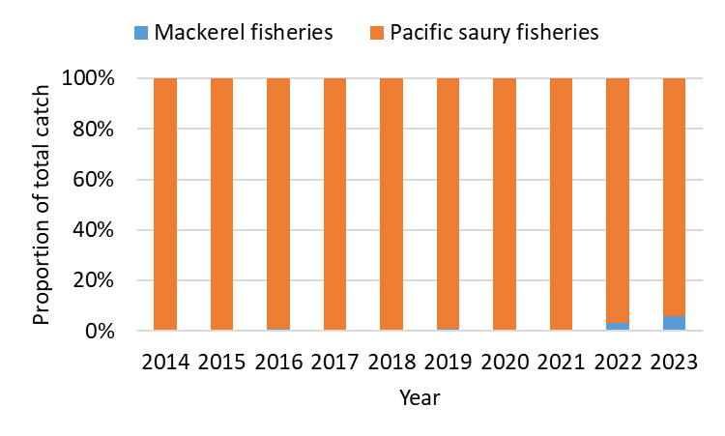
Figure 1 Historical proportion of Pacific saury catch from the different fisheries in China.

