# NPFC-2024-BFME05-WP21 (Rev. 1)

# **Bycatch information by Korean bottom fisheries in the Emperor Seamounts**

Hyejin Song and Jeongseok Park

*National Institute of Fisheries Science, Republic of Korea*

# **Introduction**

Korea operated bottom trawl fisheries targeting North Pacific armorhead (*Pentaceros wheeleri*) and splendid alfonsino (*Beryx splendens*) in the Emperor Seamounts from 2004 to 2019. Reliable information on discarded bycatch species during bottom trawling is available only through logbooks recorded by onboard observers from 2013 to 2019.

# **Method**

*Fishing Effort and Observer Coverage*

During the study period (2013-2019), bottom trawl fisheries in the Emperor Seamounts were conducted using one vessel per year, except in 2014 when two vessels operated. Each vessel carried one observer onboard to collect fisheries data.

*Data Collection and Processing*

Observer logbooks recorded information on discarded bycatch species from 2013 to 2019. For the analysis, only species listed in the NPFC Fish guide (2024) were included, while unclear or unidentified records were excluded.

*Calculation of CPUE*

The catch per unit effort (CPUE) for discarded bycatch species (kg/hr) was calculated annually by dividing the total weight of discarded bycatch species by the total trawling hours for each year.

# **Results and Discussion**

During the survey period, discarded bycatch species were recorded in the logbooks of observers onboard bottom trawl vessels in 2014, 2015, 2017, and 2018. A total of 14 families and 15 species were identified as bycatch during the study. The highest species richness was observed in 2018, with 13 species, followed by 12 species in 2015, 4 species in 2017, and 3 species in 2014 (Table 1).

A comparison of CPUE showed that *Epigonus denticulatus* had the highest value, followed by *Xenolepidichthys dalgleishi* and *Hyperoglyphe japonica*. Annual CPUE trends revealed that *Epigonus denticulatus* was dominant in 2014 and 2015, whereas *Xenolepidichthys dalgleishi* had the highest CPUE in 2017 and 2018 (Fig. 1). However, since these results rely solely on observer logbooks rather than expert species identification, making precise annual quantitative comparisons in challenging. Nevertheless, the study effectively identifies the primary discarded bycatch species in Korean bottom trawl fisheries at the Emperor Seamounts.

**References**

NPFC (2024) The Field Guide for Identifications of Fishes of the Emperor Seamount Chain Captured by Bottom Fisheries.

Table 1 List of bycatch species in Korean bottom fisheries at the Emperor Seamounts (2013- 2019)

|  |  |  |  |  |  |
| --- | --- | --- | --- | --- | --- |
| Family name | Scientific name | 2014 | 2015 | 2017 | 2018 |
| Squalidae | *Squalus mitsukurii* |  | + | + | + |
| Macroramphosidae | *Macroramphosus scolopax* |  | + |  | + |
| Lophiidae | *Lophiodes bruchius* |  | + | + | + |
| Grammicolepididae | *Xenolepidichthys dalgleishi* | + | + | + | + |
| Anoplopomatidae | *Erilepis zonifer* | + | + |  | + |
| Pentacerotidae | *Pentaceros japonicus* |  | + |  | + |
| Emmelichthyidae | Emmelichthyidae sp. |  |  |  | + |
| Serranidae | *Plectranthias kelloggi* |  | + |  | + |
| Caproidae | *Antigonia rubescens* |  | + |  |  |
| Scombridae | *Scomber australasicus* |  | + |  | + |
| Apogonidae | *Epigonus denticulatus* | + | + | + | + |
| Chlorophthalmidae | Chlorophthalmidae sp. |  | + |  |  |
| Gempylidae | *Ruvettus pretiosus* |  | + |  | + |
|  | *Promethichthys prometheus* |  |  |  | + |
| Centrolophidae | *Hyperoglyphe japonica* |  |  |  | + |
| Total number of species | | 3 | 12 | 4 | 13 |

* No recorded of discarded bycatch species are available for 2013, 2016 and 2019.

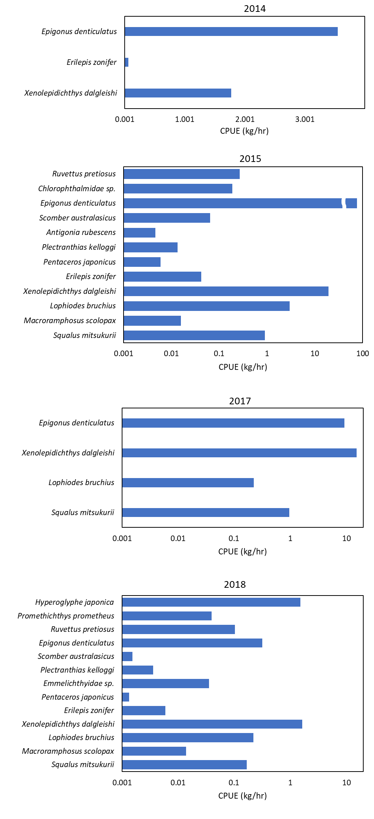Fig. 1. Annual comparison of discarded bycatch species in Korean bottom fisheries at the Emperor Seamounts (2013-2019).