NPFC-2025-TWG CMSA10-WP04

Bycatch information in chub mackerel fisheries from the Japanese fisheries

Kazunari HIGASHIGUCHI and Ryuji YUKAMI

Fisheries Resources Institute, Japan Fisheries Research and Education Agency

Summary
Chub mackerel has historically been caught by various fisheries, with a large proportion of the catch coming from large purse seine. In Japanese large purse seine fisheries targeting small pelagic fish species, including mackerels, several other pelagic fish species have been caught.

Introduction
During the Scientific Committee (hereafter, SC) meeting, the SC requested that Members share historical information on species bycaught in chub mackerel (hereafter, CM) fisheries and that the TWG CMSA continue discussions on this topic. This working paper summarizes the relevant information from Japanese fisheries.

1. The composition of chub mackerel fisheries
Chub mackerel has historically been caught by multiple fisheries, with a significant proportion of the catch coming from large purse seine operations (Figure 1). From 1994 to 2023, the average annual proportions of CM catch by fishery were 68.7% (large purse seine), 4.1% (small purse seine), 10.3% (dip net), and 12.0% (set net and others).

2. Species composition of the Japanese large purse seine fisheries
Given the historically high contribution of large purse seine to the total chub mackerel catch, this paper focuses on the species composition within large purse seine corresponding to a dominant CM fishery with the historically largest proportion in catches by fishery (Figure 1). In addition, owing to multi-species targeting capabilities of this fishery, it can target not only mackerels but also other small pelagic fish species. Hence, this document provides information on composition of small pelagic species using the logbook data from the large purse seine fishery (Table 1). It should be noted that not only the logbook data but also official catch statistics do not provide catch by mackerel species but total catch of both mackerel species (CM and blue mackerel) due to difficulty in species separation of mackerels at landing. Table 1 summarizes species-specific catch proportions, indicating that various fish species were caught alongside mackerels, with Japanese sardine being the most commonly caught species.

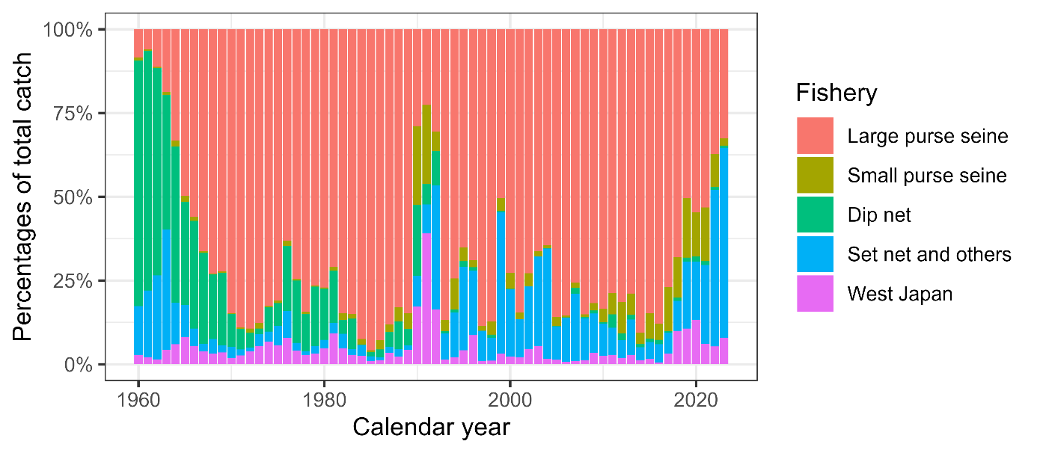
Figure 1 Historical proportion of chub mackerel catch from the different fisheries in Japan.

Table 1 Annual catch proportions (%) by species recorded in the logbooks of the Japanese large purse seine fishery where mackerels were caught. Due to the difficulty in distinguishing between chub mackerel and blue mackerel at landing, only the combined total catch of both species is listed.
Year | 2019 | 2020 | 2021 | 2022 | 2023
Mackerels | 96.41 | 92.85 | 80.38 | 49.50 | 65.21
Japanese sardine | 2.82 | 5.13 | 18.36 | 48.80 | 26.37
Japanese jack mackerel | 0.20 | 0.78 | 0.49 | 0.31 | 3.85
Round herring | 0.15 | 0.43 | 0.34 | 0.43 | 2.07
Japanese amberjack | 0.08 | 0.38 | 0.19 | 0.59 | 1.13
Japanese flying squid | 0.12 | 0.00 | 0.03 | 0.10 | 0.02
Japanese anchovy | 0.05 | 0.02 | 0.07 | 0.00 | 0.21
Japanese scad | 0.00 | 0.00 | 0.13 | 0.07 | 0.06
Large hairtail | 0.00 | 0.00 | 0.00 | 0.00 | 0.06
Decapterus muroadsi | 0.00 | 0.00 | 0.01 | 0.00 | 0.01
Pacific bluefin tuna | 0.00 | 0.00 | 0.00 | 0.00 | 0.01
Others | 0.15 | 0.40 | 0.00 | 0.19 | 0.97

